**LEARNER Guide**

**Outlook Intermediate**

**Enhance, edit and organise electronic messages using a Graphical User Interface (GUI)-based messaging application**

Unit Standard 116935

Level 2 Credits 2

TABLE OF CONTENTS

[TABLE OF CONTENTS 1](#_Toc341099937)

[PERSONAL INFORMATION 3](#_Toc341099938)

[INTRODUCTION 4](#_Toc341099939)

[Programme methodology 4](#_Toc341099940)

[What Learning Material you should have 5](#_Toc341099941)

[Different types of activities you can expect 7](#_Toc341099942)

[Learner Administration 8](#_Toc341099943)

[Assessments 8](#_Toc341099944)

[Learner Support 9](#_Toc341099945)

[Learner Expectations 10](#_Toc341099946)

[UNIT STANDARD 116935 11](#_Toc341099947)

[UNIT STANDARD 116935 14](#_Toc341099948)

[LEGAL, ETHICAL AND ORGANISATIONAL ISSUES 17](#_Toc341099949)

[Legislation 18](#_Toc341099950)

[PROATIA 18](#_Toc341099951)

[Formative Assessment 18](#_Toc341099952)

[The Constitution Of The Republic Of South Africa 18](#_Toc341099953)

[Formative Assessment 19](#_Toc341099954)

[Copyright 20](#_Toc341099955)

[Formative Assessment 22](#_Toc341099956)

[E-Mail And Privacy 22](#_Toc341099957)

[Computer Viruses 22](#_Toc341099958)

[What is a Computer Virus? 22](#_Toc341099959)

[What kind of files can spread viruses? 22](#_Toc341099960)

[How do viruses spread? 23](#_Toc341099961)

[What do viruses do to computers? 23](#_Toc341099962)

[What is a Trojan Horse program? 23](#_Toc341099963)

[Viruses and E-mail? 24](#_Toc341099964)

[What can I do to reduce the chance of getting viruses from e-mail? 24](#_Toc341099965)

[Tips on Avoiding Virus Infections 24](#_Toc341099966)

[Dealing with Virus Infections 25](#_Toc341099967)

[Application Security 25](#_Toc341099968)

[Digital Certificate 26](#_Toc341099969)

[SPAM And Junk Mail 26](#_Toc341099970)

[MANAGE E-MAIL MESSAGES 27](#_Toc341099971)

[The Navigation Pane and Folder List 28](#_Toc341099972)

[Outbox 28](#_Toc341099973)

[Sent Items 29](#_Toc341099974)

[Inbox 29](#_Toc341099975)

[Drafts 29](#_Toc341099976)

[Deleted Items 29](#_Toc341099977)

[Work With Folders 29](#_Toc341099978)

[Create A New Folder 29](#_Toc341099979)

[Move Messages To The New Folder 30](#_Toc341099980)

[Delete E-Mails 30](#_Toc341099981)

[Clear The Deleted Items Folder 31](#_Toc341099982)

[Sorting Messages 31](#_Toc341099983)

[Change the priority of a message 33](#_Toc341099984)

[Set The Importance Level 33](#_Toc341099985)

[Manipulate Text Between E-Mails 35](#_Toc341099986)

[Copy Text From Another Source 35](#_Toc341099987)

[OUTLOOK ADDRESS BOOKS 36](#_Toc341099988)

[Address Book 37](#_Toc341099989)

[Add A New Contact 37](#_Toc341099990)

[Add A Contact From An E-Mail 38](#_Toc341099991)

[Delete A Contact 39](#_Toc341099992)

[Find A Name 39](#_Toc341099993)

# PERSONAL INFORMATION

|  |  |
| --- | --- |
| **NAME** |  |
| **CONTACT ADDRESS** |  |
|  |
| **Code** |  |
| **Telephone (H)** |  |
| **Telephone (W)** |  |
| **Cellular** |  |
| **Learner Number** |  |
| **Identity Number** |  |
|  | |
| **EMPLOYER** |  |
| **EMPLOYER CONTACT ADDRESS** |  |
|  |
| **Code** |  |
| **Supervisor Name** |  |
| **Supervisor Contact Address** |  |
|  |
| **Code** |  |
| **Telephone (H)** |  |
| **Telephone (W)** |  |
| **Cellular** |  |

# **INTRODUCTION**

#### Welcome to the learning programme

Follow along in the guide as the training practitioner takes you through the material. Make notes and sketches that will help you to understand and remember what you have learnt. Take notes and share information with your colleagues. Important and relevant information and skills are transferred by sharing!

This learning programme is divided into sections. Each section is preceded by a description of the required outcomes and assessment criteria as contained in the unit standards specified by the South African Qualifications Authority. These descriptions will define what you have to know and be able to do in order to be awarded the credits attached to this learning programme. These credits are regarded as building blocks towards achieving a National Qualification upon successful assessment and can never be taken away from you!

### Programme methodology



The programme methodology includes facilitator presentations, readings, individual activities, group discussions and skill application exercises.

**Know what you want to get out of the programme from the beginning and start applying your new skills immediately. Participate as much as possible so that the learning will be interactive and stimulating.**

The following principles were applied in designing the course:

* Because the course is designed to maximise interactive learning, you are encouraged and required to participate fully during the group exercises
* As a learner you will be presented with numerous problems and will be required to fully apply your mind to finding solutions to problems before being presented with the course presenter’s solutions to the problems
* Through participation and interaction the learners can learn as much from each other as they do from the course presenter
* Although learners attending the course may have varied degrees of experience in the subject matter, the course is designed to ensure that all delegates complete the course with the same level of understanding
* Because reflection forms an important component of adult learning, some learning resources will be followed by a self-assessment which is designed so that the learner will reflect on the material just completed.

This approach to course construction will ensure that learners first apply their minds to finding solutions to problems before the answers are provided, which will then maximise the learning process which is further strengthened by reflecting on the material covered by means of the self-assessments.

#### Different role players in delivery process

* Learner
* Facilitator
* Assessor
* Moderator

### What Learning Material you should have

This learning material has also been designed to provide the learner with a comprehensive reference guide.

It is important that you take responsibility for your own learning process; this includes taking care of your learner material. You should at all times have the following material with you:

|  |  |
| --- | --- |
| **Learner Guide** | **This learner guide is your valuable possession:**  This is your textbook and reference material, which provides you with all the information you will require to meet the exit level outcomes.  During contact sessions, your facilitator will use this guide and will facilitate the learning process. During contact sessions a variety of activities will assist you to gain knowledge and skills.  Follow along in the guide as the training practitioner takes you through the material. Make notes and sketches that will help you to understand and remember what you have learnt. Take and share information with your colleagues. Important and relevant information and skills are transferred by sharing!  This learning programme is divided into sections. Each section is preceded by a description of the required outcomes and assessment criteria as contained in the unit standards specified by the South African Qualifications Authority. These descriptions will define what you have to know and be able to do in order to be awarded the credits attached to this learning programme. These credits are regarded as building blocks towards achieving a National Qualification upon successful assessment and can never be taken away from you! |
| **Formative Assessment Workbook** | The Formative Assessment Workbook supports the Learner Guide and assists you in applying what you have learnt.  The formative assessment workbook contains classroom activities that you have to complete in the classroom, during contact sessions either in groups or individually.  You are required to complete all activities in the Formative Assessment Workbook.  The facilitator will assist, lead and coach you through the process.  These activities ensure that you understand the content of the material and that you get an opportunity to test your understanding. |

### Different types of activities you can expect

To accommodate your learning preferences, a variety of different types of activities are included in the formative and summative assessments. They will assist you to achieve the outcomes (correct results) and should guide you through the learning process, making learning a positive and pleasant experience.



The table below provides you with more information related to the types of activities.

| **Types of Activities** | **Description** | **Purpose** |
| --- | --- | --- |
| **Knowledge Activities** | You are required to complete these activities on your own. | These activities normally test your understanding and ability to apply the information. |
| **Skills Application Activities** | You need to complete these activities in the workplace | These activities require you to apply the knowledge and skills gained in the workplace |
| **Natural Occurring Evidence** | You need to collect information and samples of documents from the workplace. | These activities ensure you get the opportunity to learn from experts in the industry.  Collecting examples demonstrates how to implement knowledge and skills in a practical way |

### Learner Administration



#### Attendance Register

You are required to sign the Attendance Register every day you attend training sessions facilitated by a facilitator.

#### Programme Evaluation Form

On completion you will be supplied with a “Learning programme Evaluation Form”. You are required to evaluate your experience in attending the programme.

Please complete the form at the end of the programme, as this will assist us in improving our service and programme material. Your assistance is highly appreciated.

### Assessments

The only way to establish whether a learner is competent and has accomplished the specific outcomes is through the assessment process. Assessment involves collecting and interpreting evidence about the learners’ ability to perform a task.

**To qualify and receive credits towards your qualification, a registered Assessor will conduct an evaluation and assessment of your portfolio of evidence and competency.**

**This programme has been aligned to registered unit standards. You will be assessed against the outcomes as stipulated in the unit standard by completing assessments and by compiling a portfolio of evidence that provides proof of your ability to apply the learning to your work situation.**



**How will Assessments commence?**

#### Formative Assessments

The assessment process is easy to follow. You will be guided by the Facilitator. Your responsibility is to complete all the activities in the Formative Assessment Workbook and submit it to your facilitator.

#### Summative Assessments

You will be required to complete a series of summative assessments. The Summative Assessment Guide will assist you in identifying the evidence required for final assessment purposes. You will be required to complete these activities on your own time, using real life projects in your workplace or business environment in preparing evidence for your Portfolio of Evidence. Your Facilitator will provide more details in this regard.

**To qualify and receive credits towards your qualification, a registered Assessor will conduct an evaluation and assessment of your portfolio of evidence and competency.**

### Learner Support

**The responsibility of learning rests with you, so be proactive and ask questions and seek assistance and help from your facilitator, if required.**



Please remember that this Skills Programme is based on outcomes based education principles which implies the following:

* You are responsible for your own learning – make sure you manage your study, research and workplace time effectively.
* Learning activities are learner driven – make sure you use the Learner Guide and Formative Assessment Workbook in the manner intended, and are familiar with the workplace requirements.
* The Facilitator is there to reasonably assist you during contact, practical and workplace time for this programme – make sure that you have his/her contact details.
* You are responsible for the safekeeping of your completed Formative Assessment Workbook and Workplace Guide
* If you need assistance please contact your facilitator who will gladly assist you.
* If you have any special needs please inform the facilitator

### Learner Expectations

Please prepare the following information. You will then be asked to introduce yourself to the instructor as well as your fellow learners



|  |
| --- |
| Your name: |
|  |
|  |
| The organisation you represent: |
|  |
|  |
| Your position in organisation: |
|  |
|  |
| What do you hope to achieve by attending this course / what are your course expectations? |
|  |
|  |
|  |
|  |
|  |

UNIT STANDARD 116935

Unit Standard Title

Enhance, edit and organise electronic messages using a Graphical User Interface (GUI)-based messaging application

NQF Level

2

Credits

2

Purpose

This unit standard is intended for people who need to use electronic mail to send and receive messages either as a user of computers or as basic knowledge for a career in the ICT industry.

The performance of all elements is to a standard that allows for further learning in this area.

Learning assumed to be in place

The credit value of this unit standard is calculated assuming a person has the prior knowledge and skills to:

* Read, write, communicate and comprehend at least at GET level
* Use electronic mail to send and receive messages

Unit standard range

This standard is applicable to any word processor application that runs on any Graphical User Interface(GUI) operating systems. Where wording is not exact for the chosen operating system, the learner can choose the equivalent item or option to demonstrate competence in the specific outcome or assessment criteria.

Any messaging application that operates in a Graphical User Interface (GUI)-based environment

Specific Outcomes and Assessment Criteria

**Specific Outcome 1:** Explain legal, ethical and organisational issues in relation to the use of Email.

**Assessment Criteria**

1. The explanation includes the implications of legislation to an organisation in terms of transmitting of information via the Internet. Includes but is not limited to: Promotion of Access to Information Act 2000; Public Service Act; Copyright Act 1979, Constitution of the Republic of South Africa Act. The implication in relation to at least two must be explained
2. The explanation includes key features of an organisation’s policy and procedures for Email use, including their rationale
3. The explanation includes implications to an organisation of providing Email facilities to individuals in the workplace, in terms of security, and virus protection
4. The explanation includes security considerations of using the Internet for transmitting messages. At least 2 of: Digital Certificate, Encryption, Viruses, Spam Filter, unsolicited mail

**Specific Outcome 2**: Manage E-mail messages.

**Assessment Criteria**

1. Default mail folders are identified and explained in terms of purpose: Inbox (messages received), outbox (messaged to be sent), sent messages (messages that have been sent), deleted messages, drafts (messages created but not sent)
2. New mail folders are created: Minimum of two new mail folders
3. E-mail messages are manipulated between mail folders: Moved, Copied
4. E-mail messages are sorted within a mail folder: By date, by sender, by subject; ascending and descending
5. The priority of an outgoing message is changed

**Specific Outcome 3:** Use the address book facilities of electronic mail applications.

1. Address books are identified and explained in terms of their purpose and use: At least one of: global address book, personal address book, special address books
2. An address is added to the personal address book: At least one of: Copied from another address book, added manually, added from an E-mail message
3. An address is removed from the personal address book

Unit Standard Accreditation And Moderation Options

The relevant Education and Training Quality Authority (ETQA) must accredit providers before they can offer programmes of education and training assessed against unit standards.

Moderation Process: Moderation of assessment will be overseen by the relevant ETQA according to the moderation guidelines in the relevant qualification and the agreed ETQA procedures

Unit Standard Essential Embedded Knowledge

* Proficient in relevant application packages.
* Performance of all elements is to be carried out in accordance with organisation standards and procedures, unless otherwise stated. Organisation standards and procedures may cover: quality assurance, documentation, security, communication, health and safety, and personal behaviour. An example of the standards expected is the standards found in ISO 9000 Certified Organisations.
* Performance of all elements complies with the laws of South Africa, especially with regard to copyright, privacy, health and safety, and consumer rights.
* All activities must comply with any policies, procedures and requirements of the organisations involved, the ethical codes of relevant professional bodies and any relevant legislative and/ or regulatory requirements.
* Performance of all elements is to be completed within the normal range of time and cost that would be expected in a professional environment (e.g. In a commercial or government organisation).

Critical Cross-field Outcomes (CCFO)

* **Unit Standard CCFO Identifying** Identify and solve problems in which responses display that decisions using critical and creative thinking have been made
* **Unit Standard CCFO Organising:** Organise and manage oneself and one`s activities responsibly and effectively
* **Unit Standard CCFO Collecting**: Collect, analyse, organise, and critically evaluate information
* **Unit standard CCFO Communicating**: Communicate effectively using visual, mathematical and/or language skills in the modes of oral and/or written persuasion when engaging with the subject
* **Unit Standard CCFO Science**: Use science and technology effectively and critically, showing responsibility towards the environment and health of others

# UNIT STANDARD 116935

Unit Standard Title

Enhance, edit and organise electronic messages using a Graphical User Interface (GUI)-based messaging application

NQF Level

2

Credits

2

Purpose

This unit standard is intended for people who need to use electronic mail to send and receive messages either as a user of computers or as basic knowledge for a career in the ICT industry.

The performance of all elements is to a standard that allows for further learning in this area.

Learning assumed to be in place

The credit value of this unit standard is calculated assuming a person has the prior knowledge and skills to:

* Read, write, communicate and comprehend at least at GET level
* Use electronic mail to send and receive messages

Unit standard range

This standard is applicable to any word processor application that runs on any Graphical User Interface(GUI) operating systems. Where wording is not exact for the chosen operating system, the learner can choose the equivalent item or option to demonstrate competence in the specific outcome or assessment criteria.

Any messaging application that operates in a Graphical User Interface (GUI)-based environment

Specific Outcomes and Assessment Criteria

**Specific Outcome 1:** Explain legal, ethical and organisational issues in relation to the use of Email.

**Assessment Criteria**

1. The explanation includes the implications of legislation to an organisation in terms of transmitting of information via the Internet. Includes but is not limited to: Promotion of Access to Information Act 2000; Public Service Act; Copyright Act 1979, Constitution of the Republic of South Africa Act. The implication in relation to at least two must be explained
2. The explanation includes key features of an organisation’s policy and procedures for Email use, including their rationale
3. The explanation includes implications to an organisation of providing Email facilities to individuals in the workplace, in terms of security, and virus protection
4. The explanation includes security considerations of using the Internet for transmitting messages. At least 2 of: Digital Certificate, Encryption, Viruses, Spam Filter, unsolicited mail

**Specific Outcome 2**: Manage E-mail messages.

**Assessment Criteria**

1. Default mail folders are identified and explained in terms of purpose: Inbox (messages received), outbox (messaged to be sent), sent messages (messages that have been sent), deleted messages, drafts (messages created but not sent)
2. New mail folders are created: Minimum of two new mail folders
3. E-mail messages are manipulated between mail folders: Moved, Copied
4. E-mail messages are sorted within a mail folder: By date, by sender, by subject; ascending and descending
5. The priority of an outgoing message is changed

**Specific Outcome 3:** Use the address book facilities of electronic mail applications.

1. Address books are identified and explained in terms of their purpose and use: At least one of: global address book, personal address book, special address books
2. An address is added to the personal address book: At least one of: Copied from another address book, added manually, added from an E-mail message
3. An address is removed from the personal address book

Unit Standard Accreditation And Moderation Options

The relevant Education and Training Quality Authority (ETQA) must accredit providers before they can offer programmes of education and training assessed against unit standards.

Moderation Process: Moderation of assessment will be overseen by the relevant ETQA according to the moderation guidelines in the relevant qualification and the agreed ETQA procedures

Unit Standard Essential Embedded Knowledge

* Proficient in relevant application packages.
* Performance of all elements is to be carried out in accordance with organisation standards and procedures, unless otherwise stated. Organisation standards and procedures may cover: quality assurance, documentation, security, communication, health and safety, and personal behaviour. An example of the standards expected is the standards found in ISO 9000 Certified Organisations.
* Performance of all elements complies with the laws of South Africa, especially with regard to copyright, privacy, health and safety, and consumer rights.
* All activities must comply with any policies, procedures and requirements of the organisations involved, the ethical codes of relevant professional bodies and any relevant legislative and/ or regulatory requirements.
* Performance of all elements is to be completed within the normal range of time and cost that would be expected in a professional environment (e.g. In a commercial or government organisation).

Critical Cross-field Outcomes (CCFO)

* **Unit Standard CCFO Identifying** Identify and solve problems in which responses display that decisions using critical and creative thinking have been made
* **Unit Standard CCFO Organising:** Organise and manage oneself and one`s activities responsibly and effectively
* **Unit Standard CCFO Collecting**: Collect, analyse, organise, and critically evaluate information
* **Unit standard CCFO Communicating**: Communicate effectively using visual, mathematical and/or language skills in the modes of oral and/or written persuasion when engaging with the subject
* **Unit Standard CCFO Science**: Use science and technology effectively and critically, showing responsibility towards the environment and health of others

LEGAL, ETHICAL AND ORGANISATIONAL ISSUES

Outcome

Explain legal, ethical and organisational issues in relation to the use of Email.

Assessment criteria

* Explain the implications of legislation to an organisation in terms of transmitting of information via the Internet. Explanation includes but is not limited to: Promotion of Access to Information Act 2000; Public Service Act; Copyright Act 1979, Constitution of the Republic of South Africa Act. The implication in relation to at least two must be explained
* Explain the key features of an organisation’s policy and procedures for Email use, including their rationale.
* Explain the implications to an organisation of providing Email facilities to individuals in the workplace, in terms of security, and virus protection
* Explain security considerations of using the Internet for transmitting messages. At least 2 of: Digital Certificate, Encryption, Viruses, Spam Filter, unsolicited mail

Legislation

### PROATIA

In handout 5 you will find a summary of the relevant aspects of PROATIA as it appeared in SA Computer of September 2005. In a group, do the following exercise:

### The Constitution Of The Republic Of South Africa

The Bill Of Rights of the Constitution states:

**Privacy**

14. Everyone has the right to privacy, which includes the right not to have ­

* their person or home searched;
* their property searched;
* *their possessions seized; or*
* **the privacy of their communications infringed**.

**Access to information**

32. (1) Everyone has the right of access to:

* any information held by the state; and
* any information that is held by another person and that is required for the exercise or protection of any rights.

(2) National legislation must be enacted to give effect to this right, and may provide for reasonable measures to alleviate the administrative and financial burden on the state.

Copyright

Herewith an article about copying website content and using it word for word without acknowledging the author of the content.

**Website copyright infringement beware**

**29th August 2005 –**

**In one of the first cases of its kind in South Africa, a company accused of online copyright infringement has paid an out-of-court cash settlement to the copyright owner. www.FindanAdvisor.co.za, billed as South Africa‚s premier online Financial Advisor directory, recently took legal action against another directory site, for what it saw as a direct breach of its intellectual property. The alleged wrongdoer purportedly copied, word for word, a large piece of text from FindanAdvisor’s website and distributed such as part of an email newsletter for its own marketing campaign.**

Up until now, website content has been pretty much a free-for-all. The ease of copying and pasting from millions of online sources has exploded. Copying images from the web also contravenes copyright.

Everybody, from plagiarising post-graduate students to bogus overnight medical experts, has participated. Many are unaware that they are in fact breaching the law, but, as internet business gets more serious, more litigation of this nature can be expected.

Specialist companies have even sprung up overseas that scout the web for copyright infringers and then report them to the original content owners (presumably for a commission). If found guilty, offenders can be sued for up to three or four years of royalty fees, or even more if financial loss can be proven.

**Parties making use of content from websites need to quote the source of the content, and preferably provide a link back to the source website.** Most web authors will be content with the publicity and incoming link. However, in order to be completely watertight, **express authorisation by the author of the content needs to be obtained**.

With the worldwide web being such a huge place, content authors who have had their work plagiarised are seldom aware that their rights have been infringed. A good way (but not guaranteed) to find out is to type a long sentence of your text into a few good search engines and see what comes up. In theory the search should render no results, unless of course somebody came up with the identical sentence on their own accord. If not speak to your lawyer!

FindanAdvisor.co.za is pleased with the settlement and is continuing to establish itself as a top class portal for members of the South African public needing to make an informed, un-pressured and proactive choice about which financial advisor or broker to appoint.

Reputable financial advisors around the country are also benefiting from the exposure they are getting to a growing, astute and affluent segment of the South African population.

In fact, the website has had such success that a sister site, FindanAccountant.co.za, is due to be launched in the next month. This information is distributed for and on behalf of FinandAdvisor. For further info please Contact Chris Preen Tel 021-7832183 or chris@FindanAdvisor.co.za

### E-Mail And Privacy

No privacy protection for communication exists for electronic messages sent within the workplace. In fact many companies take the position that they not only have a right, but the responsibility to review employees' e-mail. They reason that e-mail is no different than writing letters and memos on company letterhead. Because electronic communication represents the company and is done using company equipment over the company network, the argument is that they have a right to monitor how it is used.

While most large companies now use e-mail, many do not have an official e-mail policy. In the absence of a policy, employees often feel a false sense of security, particularly because many e-mail accounts are password protected. Passwords do offer some protection, but not from system administrators, who can usually access almost anyone's e-mail.

This comes as news to many employees who mistakenly believe that communication with colleagues is private. In fact in a number of cases, casual e-mail messages which criticized the company have landed on the boss's desk.

Computer Viruses

### What is a Computer Virus?

A computer virus is a program designed to spread itself by first infecting executable files or the system areas of hard and floppy disks and then making copies of itself. Viruses usually operate without the knowledge or desire of the computer user.

### What kind of files can spread viruses?

Viruses have the potential to infect any type of executable code, not just the files that are commonly called 'program files'. For example, some viruses infect executable code in the boot sector of floppy disks or in system areas of hard drives. Another type of virus, known as a **macro virus**, can infect word processing and spreadsheet documents that use macros. And it's possible for HTML documents containing JavaScript or other types of executable code to spread viruses or other malicious code.

Since virus code must be executed to have any effect, files that the computer treats as pure data are safe. This includes graphics and sound files such as .gif, .jpg, .mp3, .wav, and so on, as well as plain text in .txt files. For example, just viewing picture files will not infect your computer with a virus. The virus code has to be in a form, such as an .exe program file or a Word .doc file, that the computer will actually try to execute.

### How do viruses spread?

When you execute program code that's infected by a virus, the virus code will also run and try to infect other programs, either on the same computer or on other computers connected to it over a network. And the newly infected programs will try to infect yet more programs.

When you share a copy of an infected file with other computer users, running the file may also infect their computers; and files from those computers may spread the infection to yet more computers.

If your computer is infected with a boot sector virus, the virus tries to write copies of itself to the system areas of floppy disks and hard disks. Then the infected floppy disks may infect other computers that boot from them, and the virus copy on the hard disk will try to infect still more floppies.

Some viruses, known as 'multipartite' viruses, can spread both by infecting files and by infecting the boot areas of floppy disks.

### What do viruses do to computers?

Viruses are software programs, and they can do the same things as any other programs running on a computer. The actual effect of any particular virus depends on how it was programmed by the person who wrote the virus.

Some viruses are deliberately designed to damage files or otherwise interfere with your computer's operation, while others do not do anything but try to spread themselves around. But even the ones that just spread themselves are harmful, since they damage files and may cause other problems in the process of spreading.

**Tip** Viruses cannot do any damage to hardware: they will not melt down your CPU, burn out your hard drive, cause your monitor to explode, and so on. Warnings about viruses that will physically destroy your computer are usually hoaxes, not legitimate virus warnings.

### What is a Trojan Horse program?

A type of program that is often confused with viruses is a 'Trojan Horse' program. This is not a virus, but simply a program (often harmful) that pretends to be something else.

For example, you might download what you think is a new game; but when you run it, it deletes files on your hard drive. Or the third time you start the game, the program e-mails your saved passwords to another person.

**Note** Simply downloading a file to your computer will not activate a virus or Trojan horse; you have to execute the code in the file to trigger it. This could mean running a program file, or opening a Word/Excel document in a program (such as Word or Excel) that can execute any macros in the document.

### Viruses and E-mail?

You cannot get a virus just by reading a plain-text e-mail message. What you have to watch out for are encoded messages containing embedded executable code (i.e., JavaScript in an HTML message) or messages that include an executable file attachment (i.e., an encoded program file or a Word document containing macros).

In order to activate a virus or Trojan horse program, your computer has to execute some type of code. This could be a program attached to an e-mail, a Word document you downloaded from the internet, or something received on a floppy disk. There is no special hazard in files attached to e-mail messages: they are no more dangerous than any other file.

### What can I do to reduce the chance of getting viruses from e-mail?

Treat any file attachments that might contain executable code as carefully as you would any other new files: save the attachment to disk and then check it with an up-to-date virus scanner before opening the file.

If your e-mail or news software has the ability to automatically execute JavaScript, Word macros, or other executable code contained in or attached to a message, it is strongly recommend that you disable this feature. (Ask your IT support person to do this)

If an executable file shows up unexpectedly attached to an e-mail, you should delete it unless you can positively verify what it is, who it came from, and why it was sent to you.

The recent outbreak of viruses was a vivid demonstration of the need to be extremely careful when you receive e-mail with attached files or documents. Just because an e-mail appears to come from someone you trust, this does NOT mean the file is safe or that the supposed sender had anything to do with it.

### Tips on Avoiding Virus Infections

* Install anti-virus software from a well-known, reputable company, UPDATE it regularly, and USE it regularly. New viruses come out every single day; an a-v program that hasn't been updated for several months will not provide much protection against current viruses.
* In addition to scanning for viruses on a regular basis, install an 'on access' scanner (included in most good a-v software packages) and configure it to start automatically each time you boot your system. This will protect your system by checking for viruses each time your computer accesses an executable file.
* Virus scan any new programs or other files that may contain executable code before you run or open them, no matter where they come from. There have been cases of commercially distributed floppy disks and CD-ROMs spreading virus infections.
* Anti-virus programs are not very good at detecting Trojan horse programs, so be extremely careful about opening binary files and Word/Excel documents from unknown or 'dubious' sources. This includes posts in binary newsgroups, downloads from web/ftp sites that aren't well-known or do not have a good reputation, and executable files unexpectedly received as attachments to e-mail or during an on-line chat session.
* If your e-mail or news software has the ability to automatically execute JavaScript, Word macros, or other executable code contained in or attached to a message, it is strongly recommend that you disable this feature.
* Be extremely careful about accepting programs or other files during on-line chat sessions: this seems to be one of the more common means that people wind up with virus or Trojan horse problems. And if any other family members (especially younger ones) use the computer, make sure they know not to accept any files while using chat.
* Do regular backups. Some viruses and Trojan horse programs will erase or corrupt files on your hard drive, and a recent backup may be the only way to recover your data. Ideally, you should back up your entire system on a regular basis. If this is not practical, at least backup files that you cannot afford to lose or that would be difficult to replace: documents, bookmark files, address books, important e-mail, and so on.

### Dealing with Virus Infections

* If you have not used a good, up-to-date anti-virus program on your computer, do that first. Many problems blamed on viruses are actually caused by software configuration errors or other problems that have nothing to do with a virus.
* If you do get infected by a virus, follow the directions in your anti-virus program for cleaning it. If you have backup copies of the infected files, use those to restore the files. Check the files you restore to make sure your backups are not infected.
* For assistance, check the website and support services for your anti-virus software.

**Note** In general, drastic measures such as formatting your hard drive or using FDISK should be avoided. They are frequently useless at cleaning a virus infection, and may do more harm than good unless you are very knowledgeable about the effects of the particular virus you're dealing with**.**

Application Security

Modern software applications and operating systems are enormously complicated. Despite extensive testing by the manufacturers, problems (often called **bugs** or **security breaches**) can occur that can allow hackers access to private data files on a PC or computer network.

Some of these breaches mean that the security of your data is at risk **regardless of the anti-virus measures** that you take. It is important to monitor the information the manufacturer posts on their website.

Most security breaches are only ever **theoretical** - that is, they are discovered "in the lab" and not exploited by hackers. Fixes for the problem (often called **patches**) are then made available from the manufacturer's website. Also, most breaches affect the **server software** rather than userapplications such **as web browsers** and **e-mail clients**.

Security issues affecting Microsoft products are summarised at:

www.microsoft.com/security/bulletins

Digital Certificate

Many Internet sites are set up to prevent unauthorized people from seeing the information that is sent to or from those sites. These are called "secure" sites. Because Internet Explorer supports the security protocols used by secure sites, you can send information to a secure site with safety and confidence.

When you visit a secure Web site, it automatically sends you its certificate, and Internet Explorer displays a lock icon on the status bar. (A certificate is a statement verifying the identity of a person or the security of a Web site.)

If you are about to send information (such as your credit card number) to an insecure site, Internet Explorer can warn you that the site is not secure. If the site claims to be secure but its security credentials are suspect, Internet Explorer can warn you that the site might have been tampered with or might be misrepresenting itself.

A Web site's privacy policy tells you what kind of information the Web site collects, to whom it gives that information, and how it uses the information. Personally identifiable information is information that can be used to identify or contact you, such as your name, e-mail address, home or work address, or telephone number. However, a Web site only has access to the personally identifiable information that you provide, or to the choices you make while visiting a Web site. For example, a Web site cannot determine your e-mail name unless you provide it. A Web site cannot gain access to other information on your computer. If a Web site collects personally identifiable information, it may store the information in a cookie, a small file that it saves on your computer.

Many Web sites provide privacy statements as written documents that you can view on the Internet. Web sites also might provide a Platform for Privacy Preferences (P3P) privacy policy. If a Web site has a P3P privacy policy, Internet Explorer can display it. Internet Explorer also might be able to compare your privacy settings to a representation of the P3P privacy policy, and determine whether or not to allow the Web site to save cookies on your computer.

To view the Privacy Report: In Internet Explorer, on the View menu, click Privacy Report.

SPAM And Junk Mail

Once you are connected to the Internet and have an e-mail address, you will receive a lot of mail every day of which a lot will be junk mail. Some of this mail will be called spam- this is a sort of junk mail where businesses or people send you information about their products without you asking them to do so. You probably get a lot of it in you mail box at the Post Office – flyers about pizza deliveries and carpet cleaning services. Unfortunately, you will receive a lot of similar e-mails as well.

You will also receive chain mail, where you are promised rich rewards if your forward the mail to 10 or 20 other people and you will also from time to time receive e-mails where the original sender of the mail attempts to smear big corporate organisations. I personally have read mail about Nando’s KFC and Pantene hair products which, when investigated, was found to be untrue.

The message here is to be careful what you believe and to be very careful of forwarding such e-mails to other recipients. For all you know the e-mail may contain a virus which you are spreading to 10 or 20 other computer networks.

MANAGE E-MAIL MESSAGES

Outcome

Manage E-mail messages

Assessment criteria

* Identify and explain default mail folders in terms of purpose: Inbox (messages received), outbox (messaged to be sent), sent messages (messages that have been sent), deleted messages, drafts (messages created but not sent)
* Create new mail folders: Minimum of two new mail folders
* Manipulate e-mail messages between mail folders: Moved, Copied
* Sort e-mail messages within a mail folder: By date, by sender, by subject; ascending and descending
* Change the priority of an outgoing message

The Folder Banner and Folder List is where you store your mails. You will see the following folders in the Folder List: Inbox, Outbox, Sent Items, Drafts and Deleted Items.

### The Navigation Pane and Folder List

The **Navigation Pane** shows the name of the **folder** displayed in the **Information Viewer**.

By clicking the arrow on the **Navigation Pane**, you can view a list of all the components and folders available in Outlook. This list resembles the Explorer pane in Windows. You can use it to open different components in the Information Viewer. If the Navigation Pane is not open, it will appear minimised on the left of the screen.

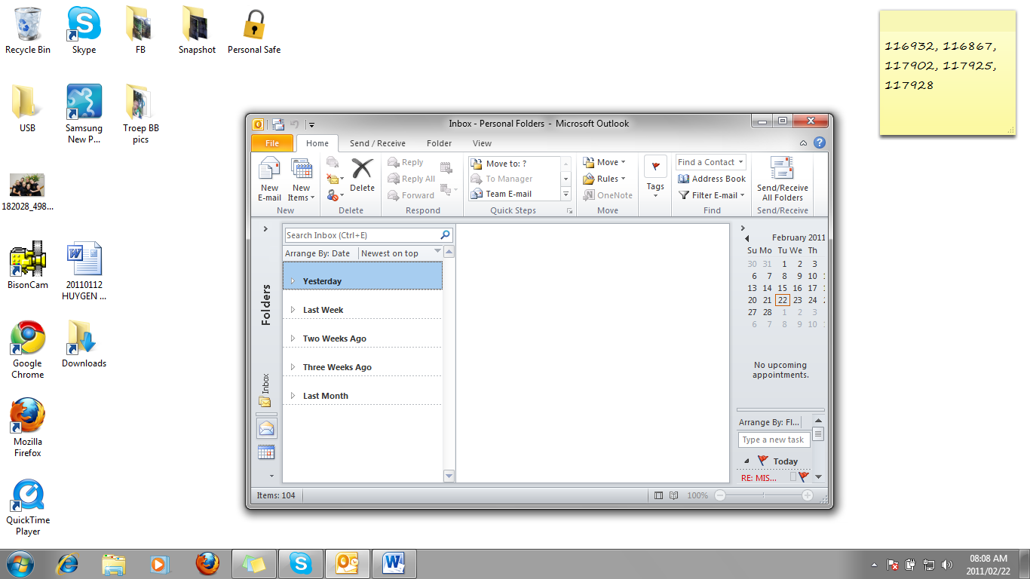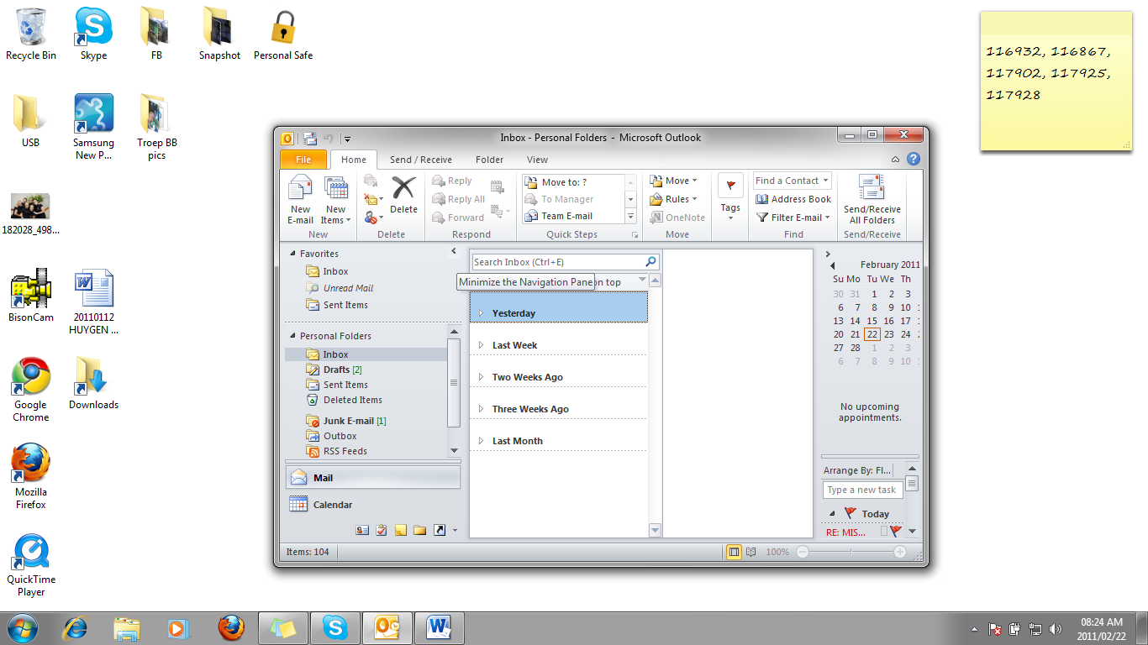

Navigate in the Folder List

* Click the arrow on the **Navigation Pane** to reveal the **Folder List**
* Click the arrow once more to minimise it again.
* Click an item in the folder list to open It
* the **Folder List**
* Click the **Push Pin** to keep the folder list open
* Click an item in the folder list to open It

### Outbox

bd04914_When You Want To Send Mail, you will write your letter, put it in an envelope and take it to the Post Office to mail it in the red mailbox. In Outlook, the Outbox takes the place of the red mailbox. Once you have created an e-mail, it is stored in the Outbox until you go online again, then it is sent to the recipient.

### Sent Items

When you go online, the messages in your Outbox are sent as soon as you click on Send and Receive on the Outlook toolbar. Once it has been sent, the e-mail will move from the Outbox to the Sent Items folder. The advantage of e-mail is that, once the message has been sent, you still have a record of it in the Sent Items folder of Outlook

### bd05137_Inbox

If you want to receive mail via the post office, you need a postal box in which to receive-mails. The Inbox folder in Outlook is where all your incoming mail will be stored. As soon as you connect to the Internet and click on Send And Receive in the toolbar, Outlook will send any messages in the Outbox folder and, after all the messages have been sent, incoming e-mails will be downloaded to your Inbox.

### Drafts

The Drafts folder works like a pending basket in the office. When you have composed an e-mail but are not quite ready to send it, it will be saved in the Drafts folder. As soon as you are ready to send it, open it in the Drafts folder, click on Send And Receive and the mail will be moved to the Outbox. The next time you connect to the Internet, the mail will be sent.

### Deleted Items

When you delete and e-mail from the Inbox, Outbox, Drafts or Sent Items folder, it will be moved to the Deleted Items folder. The Deleted Items folder acts like the Recycle Bin. The mail will remain in the Deleted Items folder until you permanently delete it.

Work With Folders

Once you have e-mail and start corresponding via the Internet, your Inbox will very quickly have many mails. You will soon need a filing system in which to store the mails you want to keep. Luckily, you can do this in Outlook – you can create subfolders in your Inbox and then move e-mails from the Information Viewer to the relevant subfolder.

### Create A New Folder

Folders provide a way to organize email messages, contacts, and tasks in Outlook. To add a folder to the [Navigation Pane (Navigation Pane: The column on the left side of the Outlook window that includes buttons for the Mail, Calendar, and Tasks views and the folders within each view. Click a folder to show the items in the folder.)](javascript:AppendPopup(this,'1638445636_1')), do the following:

* On the Folder ribbon, in the New group, click New Folder.
* Note:    When in the Calendar view, the New Folder command is replaced with New Calendar.
* In the Name box, enter a name for the folder.
* In the Select where to place the folder list, click the location for the new folder. The new folder will become a sub folder of the folder you select.
* Click OK.

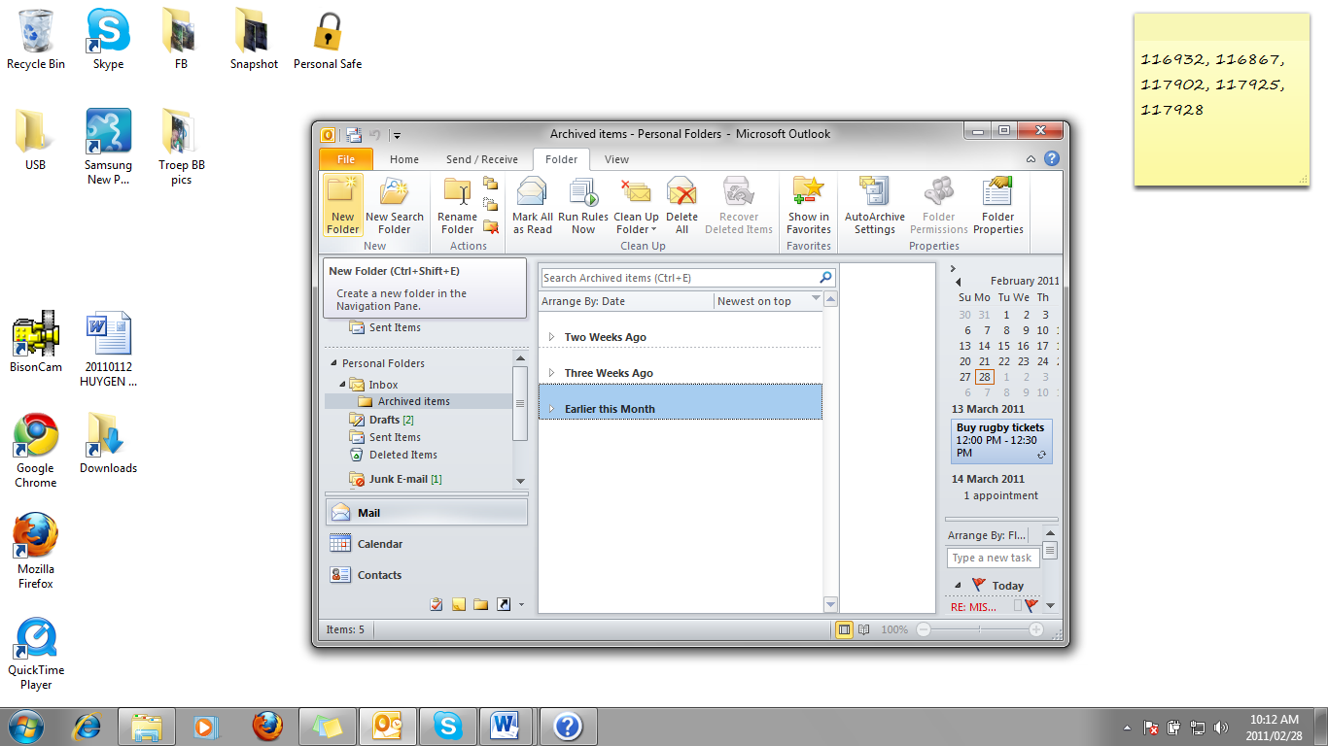

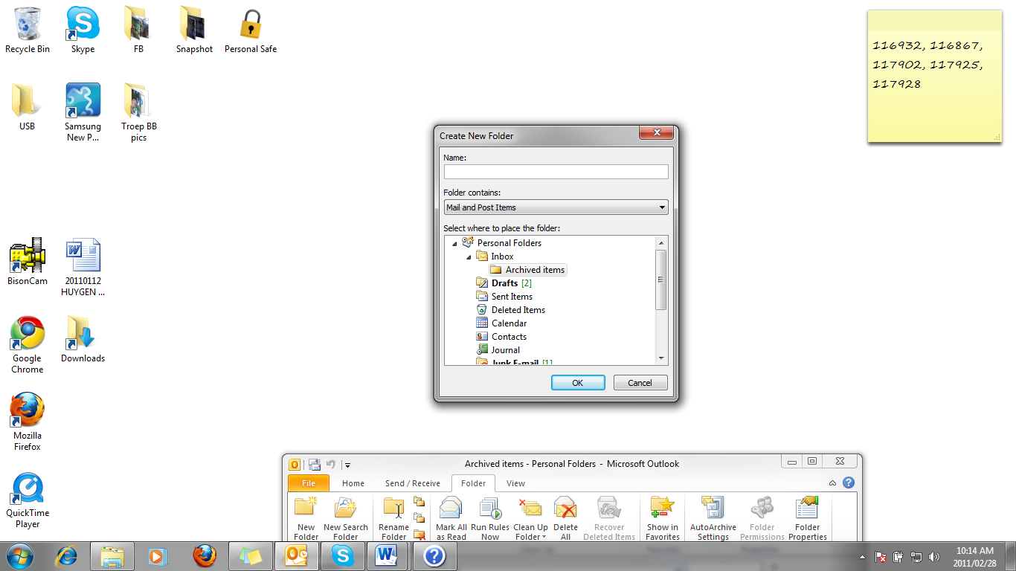

### Move Messages To The New Folder

* Click on the message and drag it to the new folder and the message will be moved to the folder.
* To copy the message, right-click on the message, select Copy, go to the folder where you want to copy the message to and click Paste. A copy of the message will be pasted in the folder.

### Delete E-Mails

As Outlook fills up with mail items, it takes up more and more disk space and starts to work more slowly. For this reason it is important to **delete** items you no longer need.

* Click on the message to select it
* Click the Delete button on the Home ribbon in the Delete Group.
* The message will be sent to the Deleted Items folder

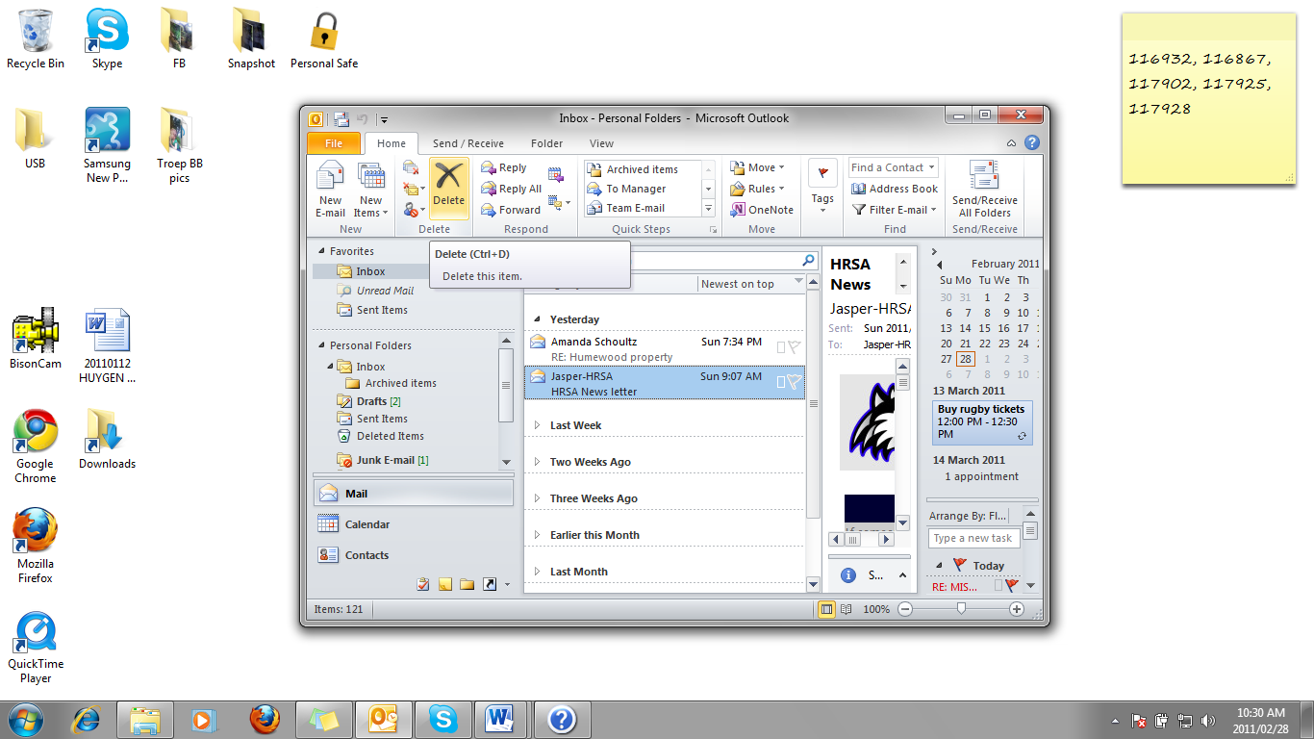

### Clear The Deleted Items Folder

* Select the item you want to delete permanently
* Click the Delete button on the Home ribbon in the Delete Group.
* A popup will appear asking if you are sure you want to delete this item permanently. If you are sure, click Yes if not click No.

Sorting Messages

Outlook tools allow you to organise your mail items in different folders. You can **sort** items by different fields (subject, sender, date and so on),

By default, your mail will display in the Information Viewer in the order of dates they were received. Outlook allows you to sort your mail in more ways than just the dates: you can also sort by subject, attachments, From (the senders of the mail), To (the receivers of mail), flags, and so on.

* Select the **View** ribbon**,** and click on the drop down arrow next to **Arrange By** in the Arrangement group. Select the option you require and Outlook will sort your mails accordingly.
* Or, in the **Inbox**, in the centre pane at the top, click on the arrange by date and a menu with the different options will appear.

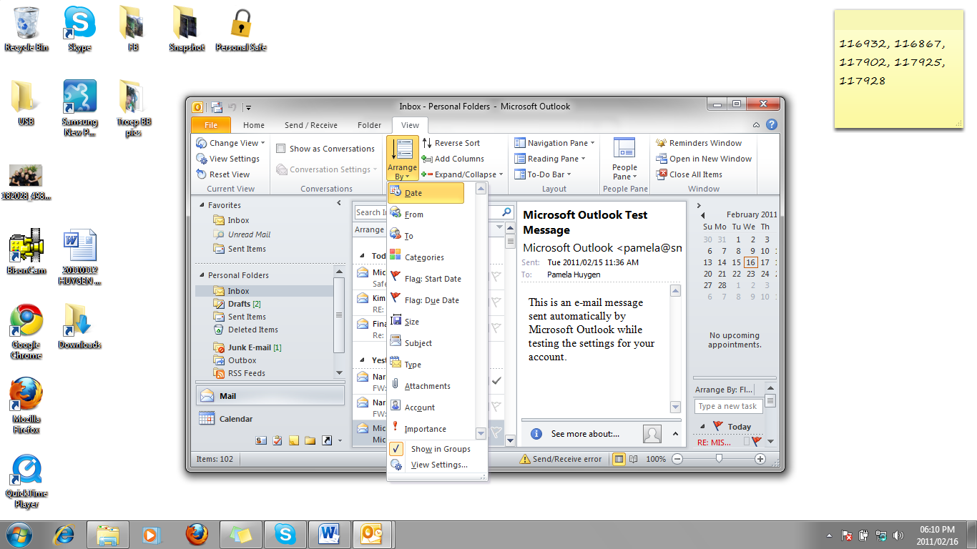

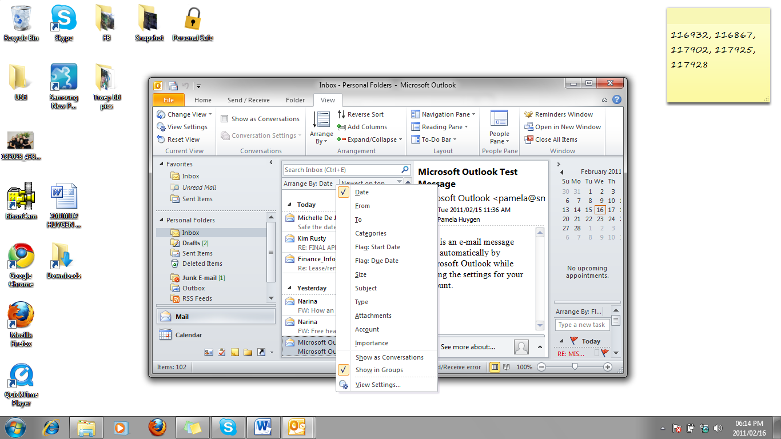

Change the priority of a message

When sending messages, you can set various options depending on how urgent the message is, when you want it delivered and whether you require confirmation of receipt for individual messages.

When a message is sent its importance can be set to High or Low (as opposed to Normal). The recipient can then decide in which order to deal with messages based upon their importance.

* **High importance** messages will have a red icon in the Importance column of the Inbox folder
* **Low importance** messages will have a blue icon in the Importance column of the Inbox folder
* **Normal importance** messages will have no icon in the Importance column of the Inbox folder

### Set The Importance Level

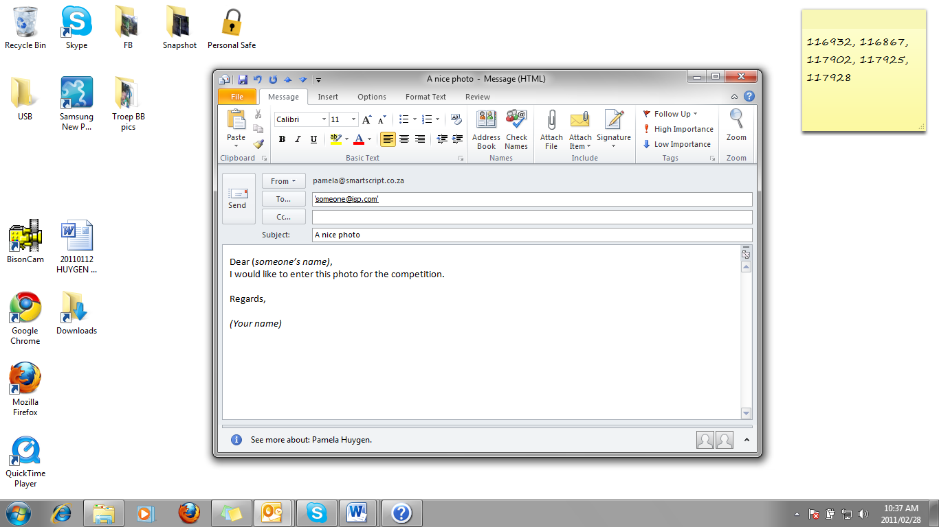For High importance, on the Message ribbon in the Tags group, click the High Importance button

**OR**

* For Low importance, on the Message toolbar, click the Low Importance button

**OR**

* To mark a message you have to follow up, click the Follow up button. You may also specify when you would like to follow up by clicking the down arrow next to Follow Up and selecting the appropriate option.



Manipulate Text Between E-Mails

MS Office enables you to copy and move text between e-mails. When you copy or cut text, it is placed in the Office Clipboard. You can place up to 12 items on the Office Clipboard and then paste them one by one in new locations, either in the same e-mail or in different e-mails.

* Once you have copied text or graphics to the Office Clipboard, do the following:
* If the Office Clipboard is not displaying in your window, go to the Message Ribbon, Clipboard group. Click the down pointing Office Clipboard and it will show in your window.

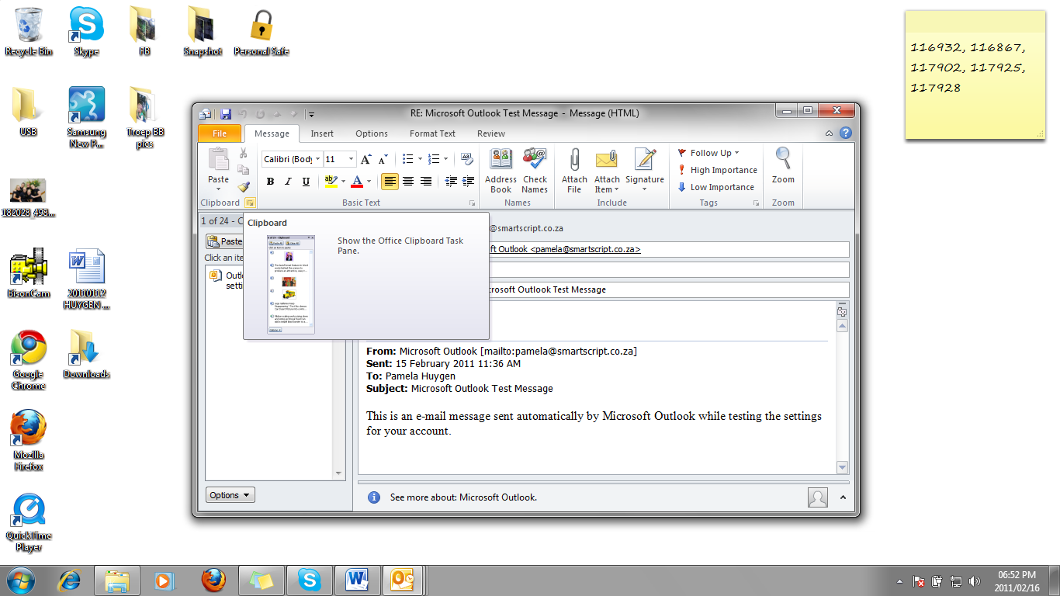

**Clipboard**

* Click in the other e-mail in the place where you want to paste the text or item, and click on the item you want to paste. The text or item will appear in the new place.
* The text or items will remain on the Office Clipboard until you either delete it from the Clipboard or until you close the application.

Copy Text From Another Source

The Office Clipboard allows you to copy and move text, graphics and other objects between Office applications.

To copy or move from another application such as Word or Excel, open the application that contains the text you want to copy or move. Select the text and copy or cut the text. It will be pasted to the Office Clipboard. Go to the place in the e-mail where you want to paste the text and follow the steps above.

OUTLOOK ADDRESS BOOKS

Outcome

Use the address book facilities of electronic mail applications

Assessment criteria

* Identify and explain address books in terms of their purpose and use: At least one of: global address book, personal address book, special address books
* Add an address to the personal address book: At least one of: Copied from another address book, added manually, added from an E-mail message
* Remove an address from the personal address book

Address Book

The **Outlook** **Address** **Book** is a directory of **address** **lists**.

An address list is simply a list of names that you can address mail to. These lists include names of Exchange users and distribution lists (a list of recipients that can be selected as one addressee, so that the message is delivered to all of them).

You have at least two address lists:

* Global Address List
* Contacts

The **Global** **Address** **List** contains the names of all Outlook users in your organisation and any distribution lists setup on the Exchange server.

**Contacts** are a list of names that you have created and maintain. You can also create Personal Distribution Lists as contact items.

### Add A New Contact

* Click on **Contacts** in the **Outlook Bar**
* Click on the **New** button
* Add the details of the contact
* Click **Save** and **Close**
* The new contact will be save alphabetically

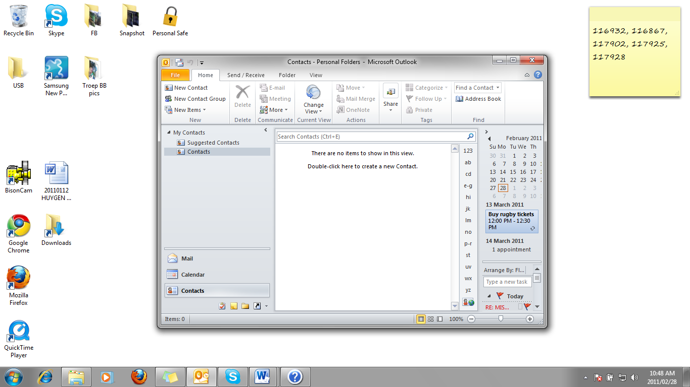

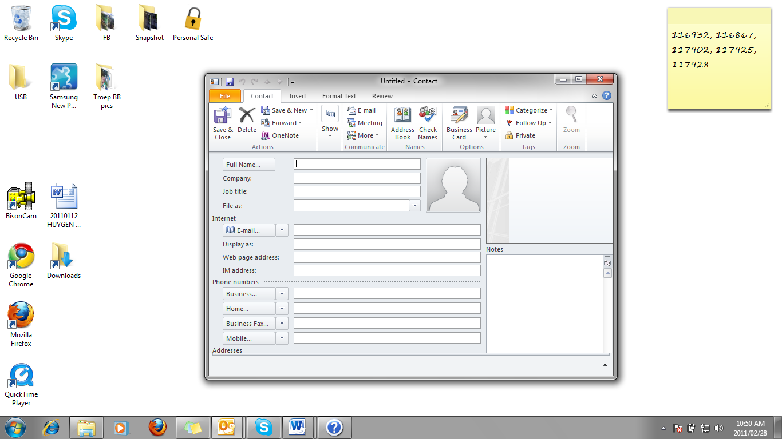

### Add A Contact From An E-Mail

* Click the **New Message** button to open a new message
* In the message headers, click any of the **To... **, **Cc... ** or **Bcc: ** field buttons

**OR**

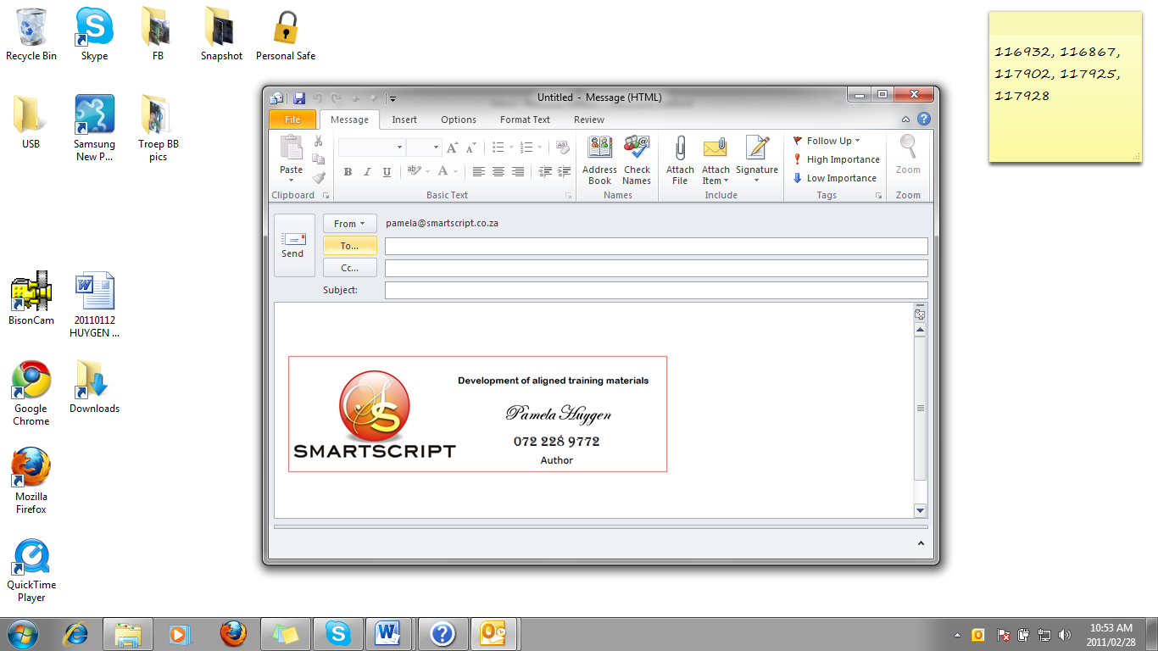

* On the **Message** toolbar, click **Address Book**

**OR**

* If you are adding the name to the **To** box, double-click the name
* Select further names as required and enter them into the recipients list(s)
* Click **OK** to add the recipients to your message

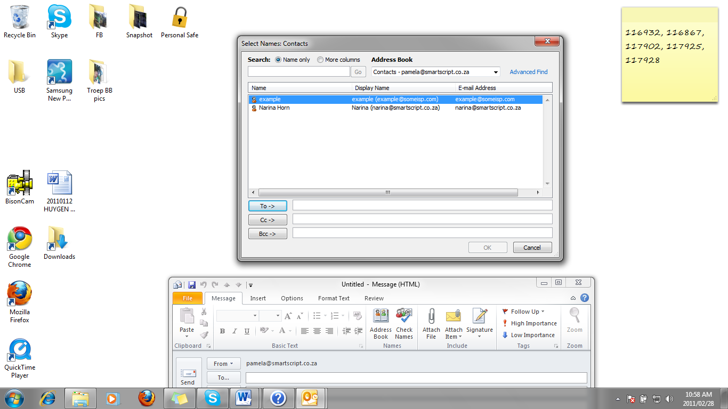

**Tip** If you know the spelling of your recipient names, you can type the names in the To or Cc box of your message instead of using the Address Book. Separate multiple names with a semicolon. You can then verify that the names are correct by clicking the Check Names button .

**Tip** You can select and add multiple names by clicking the first name, then clicking additional names while holding down the key, and then clicking the To or Cc button.

### Delete A Contact

* Select the contact
* Click the Delete button on the Home Ribbon

Find A Name

Using the **Find** command, you can **search** for items that meet specific conditions.

* Drag the scroll arrows until you find the name you want

**OR**

* In the **Search Contacts** box above the contact list, start typing a name
* The list scrolls to the location in the address list that contains the letters you typed.

**OR**

* Click in the **Find a Contact** box on the Home Ribbon in the **Find** group.

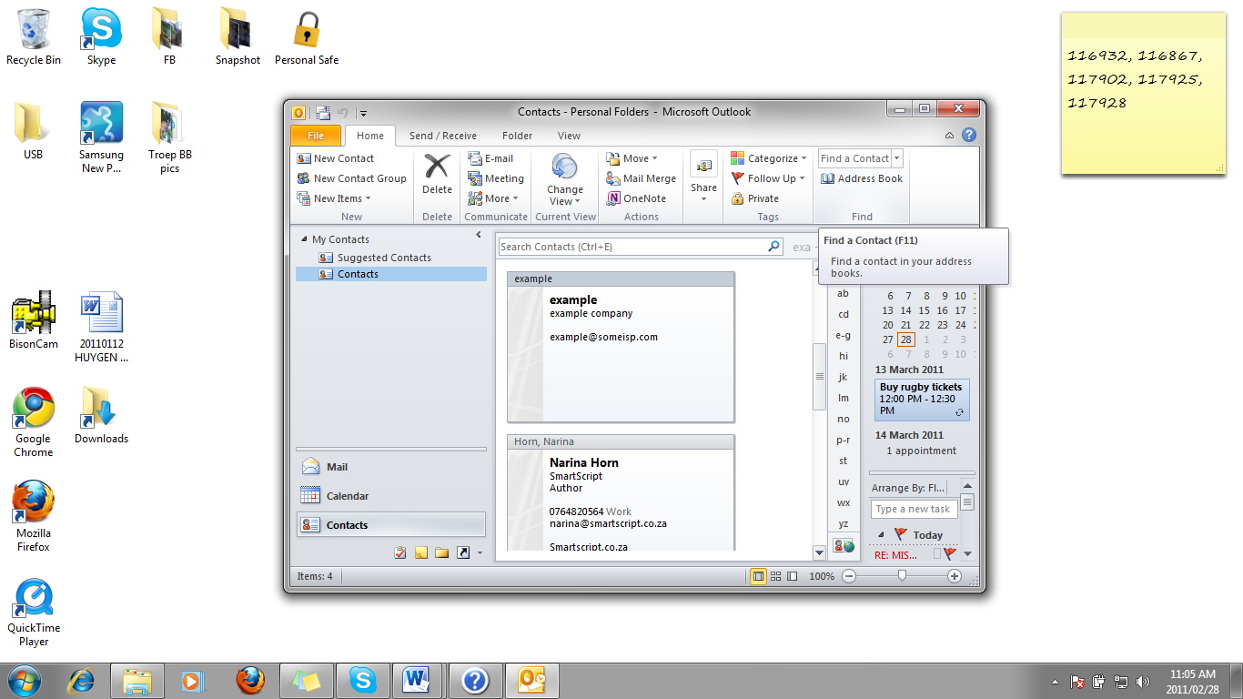

* Type the name of the contact you are looking for and press enter.