LEARNER Guide

Use computer technology to research a computer topic

Unit Standard 114076
Level 4 Credits 3

TABLE OF CONTENTS
TABLE OF CONTENTS 2
PERSONAL INFORMATION 3
INTRODUCTION 4
Programme methodology 4
What Learning Material you should have 5
Different types of activities you can expect 7
Learner Administration 8
Assessments 8
Learner Support 9
Learner Expectations 11
RESEARCH A COMPUTER TOPIC 12
UNIT STANDARD 114076 12
PLAN RESEARCH 14
Planning your research 15
Topic, objectives and scope 15
Plan research time 15
Research methods 15
Target audience 19
Formative assessment 20
CONDUCT RESEARCH 21
Organise The Material 22
Sorting and categorizing 22
Sifting for relevance 22
Validity and reliability 22
Analyse the information 23
Report on progress 23
Computer application 24
Presentation Aids 25
Guidelines for using presentation aids 29
Formative assessment 31
PRESENT THE RESULTS 32
Recording 33
Structure of the Presentation 33
Formative assessment 35

PERSONAL INFORMATION
NAME
CONTACT ADDRESS
Code
Telephone (H)
Telephone (W)
Cellular
Learner Number
Identity Number
EMPLOYER
EMPLOYER CONTACT ADDRESS
Code
Supervisor Name
Supervisor Contact Address
Code
Telephone (H)
Telephone (W)
Cellular

INTRODUCTION

Welcome to the learning programme

Follow along in the guide as the training practitioner takes you through the material. Make notes and sketches that will help you to understand and remember what you have learnt. Take notes and share information with your colleagues. Important and relevant information and skills are transferred by sharing!

This learning programme is divided into sections. Each section is preceded by a description of the required outcomes and assessment criteria as contained in the unit standards specified by the South African Qualifications Authority. These descriptions will define what you have to know and be able to do in order to be awarded the credits attached to this learning programme. These credits are regarded as building blocks towards achieving a National Qualification upon successful assessment and can never be taken away from you!

Programme methodology


The programme methodology includes facilitator presentations, readings, individual activities, group discussions and skill application exercises.
Know what you want to get out of the programme from the beginning and start applying your new skills immediately. Participate as much as possible so that the learning will be interactive and stimulating.
The following principles were applied in designing the course:
- Because the course is designed to maximise interactive learning, you are encouraged and required to participate fully during the group exercises
- As a learner you will be presented with numerous problems and will be required to fully apply your mind to finding solutions to problems before being presented with the course presenter’s solutions to the problems
- Through participation and interaction the learners can learn as much from each other as they do from the course presenter
- Although learners attending the course may have varied degrees of experience in the subject matter, the course is designed to ensure that all delegates complete the course with the same level of understanding
- Because reflection forms an important component of adult learning, some learning resources will be followed by a self-assessment which is designed so that the learner will reflect on the material just completed.
This approach to course construction will ensure that learners first apply their minds to finding solutions to problems before the answers are provided, which will then maximise the learning process which is further strengthened by reflecting on the material covered by means of the self-assessments.

Different role players in delivery process
- Learner
- Facilitator
- Assessor
- Moderator

What Learning Material you should have
This learning material has also been designed to provide the learner with a comprehensive reference guide.
It is important that you take responsibility for your own learning process; this includes taking care of your learner material. You should at all times have the following material with you:
  Learner Guide | This learner guide is your valuable possession:  This is your textbook and reference material, which provides you with all the information you will require to meet the exit level outcomes.  During contact sessions, your facilitator will use this guide and will facilitate the learning process. During contact sessions a variety of activities will assist you to gain knowledge and skills.  Follow along in the guide as the training practitioner takes you through the material. Make notes and sketches that will help you to understand and remember what you have learnt. Take and share information with your colleagues. Important and relevant information and skills are transferred by sharing!  This learning programme is divided into sections. Each section is preceded by a description of the required outcomes and assessment criteria as contained in the unit standards specified by the South African Qualifications Authority. These descriptions will define what you have to know and be able to do in order to be awarded the credits attached to this learning programme. These credits are regarded as building blocks towards achieving a National Qualification upon successful assessment and can never be taken away from you!
  Formative Assessment Workbook | The Formative Assessment Workbook supports the Learner Guide and assists you in applying what you have learnt.  The formative assessment workbook contains classroom activities that you have to complete in the classroom, during contact sessions either in groups or individually.  You are required to complete all activities in the Formative Assessment Workbook.  The facilitator will assist, lead and coach you through the process.  These activities ensure that you understand the content of the material and that you get an opportunity to test your understanding.

Different types of activities you can expect
To accommodate your learning preferences, a variety of different types of activities are included in the formative and summative assessments. They will assist you to achieve the outcomes (correct results) and should guide you through the learning process, making learning a positive and pleasant experience.

The table below provides you with more information related to the types of activities.
Types of Activities | Description | Purpose
Knowledge Activities   | You are required to complete these activities on your own. | These activities normally test your understanding and ability to apply the information.
Skills Application Activities   | You need to complete these activities in the workplace | These activities require you to apply the knowledge and skills gained in the workplace
  Natural Occurring Evidence | You need to collect information and samples of documents from the workplace. | These activities ensure you get the opportunity to learn from experts in the industry.  Collecting examples demonstrates how to implement knowledge and skills in a practical way

Learner Administration


Attendance Register
You are required to sign the Attendance Register every day you attend training sessions facilitated by a facilitator.

Programme Evaluation Form
On completion you will be supplied with a “Learning programme Evaluation Form”. You are required to evaluate your experience in attending the programme.
Please complete the form at the end of the programme, as this will assist us in improving our service and programme material. Your assistance is highly appreciated.

Assessments
The only way to establish whether a learner is competent and has accomplished the specific outcomes is through the assessment process. Assessment involves collecting and interpreting evidence about the learners’ ability to perform a task.
To qualify and receive credits towards your qualification, a registered Assessor will conduct an evaluation and assessment of your portfolio of evidence and competency.
This programme has been aligned to registered unit standards. You will be assessed against the outcomes as stipulated in the unit standard by completing assessments and by compiling a portfolio of evidence that provides proof of your ability to apply the learning to your work situation.



How will Assessments commence?

Formative Assessments
The assessment process is easy to follow. You will be guided by the Facilitator. Your responsibility is to complete all the activities in the Formative Assessment Workbook and submit it to your facilitator.

Summative Assessments
You will be required to complete a series of summative assessments. The Summative Assessment Guide will assist you in identifying the evidence required for final assessment purposes. You will be required to complete these activities on your own time, using real life projects in your workplace or business environment in preparing evidence for your Portfolio of Evidence. Your Facilitator will provide more details in this regard.
To qualify and receive credits towards your qualification, a registered Assessor will conduct an evaluation and assessment of your portfolio of evidence and competency.

Learner Support
The responsibility of learning rests with you, so be proactive and ask questions and seek assistance and help from your facilitator, if required.


Please remember that this Skills Programme is based on outcomes based education principles which implies the following:
- You are responsible for your own learning – make sure you manage your study, research and workplace time effectively.
- Learning activities are learner driven – make sure you use the Learner Guide and Formative Assessment Workbook in the manner intended, and are familiar with the workplace requirements.
- The Facilitator is there to reasonably assist you during contact, practical and workplace time for this programme – make sure that you have his/her contact details.
- You are responsible for the safekeeping of your completed Formative Assessment Workbook and Workplace Guide
- If you need assistance please contact your facilitator who will gladly assist you.
- If you have any special needs please inform the facilitator

Learner Expectations
Please prepare the following information. You will then be asked to introduce yourself to the instructor as well as your fellow learners


Your name:
The organisation you represent:
Your position in organisation:
What do you hope to achieve by attending this course / what are your course expectations?

RESEARCH A COMPUTER TOPIC
UNIT STANDARD 114076
Unit Standard Title
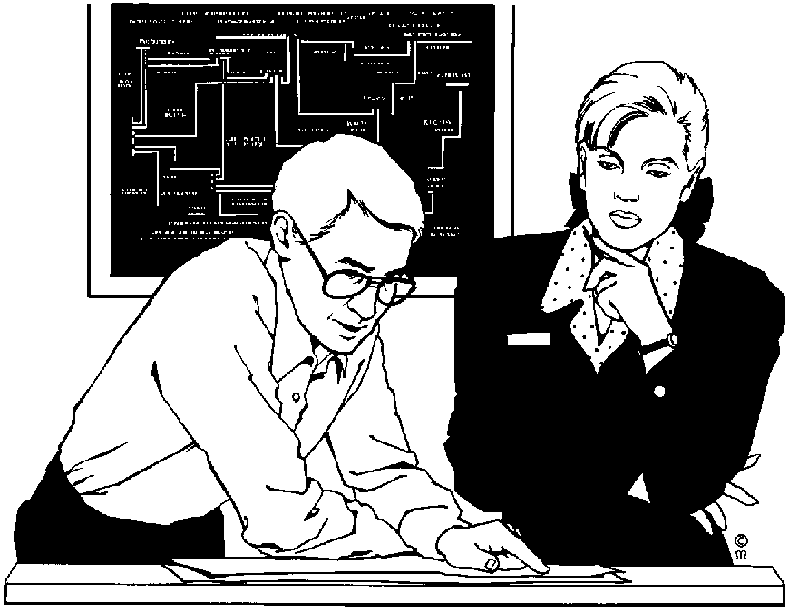
Use computer technology to research a computer topic
NQF Level
4
Credits
3
Purpose
This unit standard is intended
- To provide a competent knowledge of the areas covered
- For those working in, or entering the workplace in the area of End-User Computing
- As additional knowledge for those wanting to understand the areas covered
The performance of all elements is to a standard that allows for further learning in this area
Learning assumed to be in place
The credit value of this unit is based on a person having prior knowledge and skills to
- Operate a personal computer
- Produce presentation documents for business
- Demonstrate ability to use the World Wide Web
Specific Outcomes and Assessment Criteria
Specific Outcome 1: Plan the research of a computer topic
Assessment Criteria
- The plan identifies the topic, objectives, and scope of the research
- The plan identifies the time to be taken for the research, the research methods to be used, and the sources of information to be used
- The plan identifies the target audience, presentation methods, and the computer applications to be used for the analysis of data and the presentation of the results of the research
Specific Outcome 2: Conduct research of a computer topic using computer technology. Internet, Other computer applications
Assessment Criteria
- The research conducted accumulates data according to the research plan
- The research conducted provides data analysis with conclusions
- The description of the analysis methods allows the validity of the analysis to be assessed
- Research progress is indicated at intervals by reports, according to the research plan
- The research conducted uses a computer application to analyse the research data
Specific Outcome 3: Present the results of research of a computer topic using computer technology
Assessment Criteria
- The presentation is made using the computer application identified in the research plan
- The presentation communicates summarised research data and conclusions to the target audience
Unit Standard Essential Embedded Knowledge
- Performance of all elements is to be carried out in accordance with organisation standards and procedures, unless otherwise stated. Organisation standards and procedures may cover: quality assurance, documentation, security, communication, health and safety, and personal behaviour. An example of the standards expected is the standards found in ISO 9000 Certified Organisations.
- Performance of all elements complies with the laws of South Africa, especially with regard to copyright, privacy, health and safety, and consumer rights

Critical Cross-field Outcomes (CCFO)
- Organise and manage oneself and one`s activities responsibly and effectively
- Collect, analyse, organise, and critically evaluate information
- Use science and technology effectively and critically, showing responsibility towards the environment and health of others
- Demonstrate an understanding of the world as a set of related systems by recognising that problem solving contexts do not exist in isolation
- Contribute to one`s full personal development and the social and economic development of the society at large by being aware of the importance of: reflecting on and exploring a variety of strategies to learn more effectively, exploring education and career opportunities and developing entrepreneurial opportunities

PLAN RESEARCH

Outcome
Plan the research of a computer topic

Assessment criteria
- The plan identifies the topic, objectives, and scope of the research
- The plan identifies the time to be taken for the research, the research methods to be used, and the sources of information to be used
- The plan identifies the target audience, presentation methods, and the computer applications to be used for the analysis of data and the presentation of the results of the research

Planning your research

Topic, objectives and scope
When you do research, like everything else in life, it has to be planned.
The first thing you have to do is to identify the topic. Once you have the topic you must determine the scope of the research and the objectives.
To explain this, let us say you have to do research on strikes in South Africa. This topic is very broad, so you have to decide whether you are going to research strikes for the last 15 years, 50 years or 100 years. Then you have to decide whether you will research strikes in all business sectors or only strikes that affected mines, steelworkers, government departments, etc.
The scope of your research will determine the amount of time you need to finish researching the topic. If you look at all the strikes during the last 100 years you will need much more time than to research strikes in mines during the last 20 years.
Then you must also determine the objectives of your research – what do you want to achieve through your research? If we look at strikes again, do you want to research the factors that caused the strikes in order to make recommendations how to prevent similar strikes in the future? Do you want to research the effect strikes have on businesses, so that you can show statistics that will prove strikes are harmful to business? Or do you want to research the effect strikes have on communities where strikers have no income and sometimes resort to violence and criminal activities?

Plan research time
Once you have your topic, the objectives and the scope of the research, you have to determine the amount of time you are going to spend doing this research. Work out a timetable for yourself and stick to this timetable. This is very important – you have to learn to meet deadlines.

Research methods
Now you have to determine the research methods you will use. Will you gather information from business correspondence, written sources such as books and newspapers, the Internet, will you conduct surveys or will you use more than one method.
The best way to do research is to use as many methods as you can.
When doing research about a topic it is important that you gather as much information about a subject as possible. The more information you have, the better. Of course, the information and data must be relevant to the topic that you are going to write about.
You can gather information from resources listed below.

Information can be gathered from: | In the case of business correspondence, you will find information in:
Libraries | Minutes of meetings.
Encyclopaedias | Correspondence with clients and suppliers.
Manuals | Operations and procedures manuals
Magazines | Internal correspondence between departments, branches and regions.
Newspapers | Correspondence between management and their departments.
Interviews with experts
Internet
Newspapers and magazines
In South Africa the two biggest publishing organisations are Naspers and Media 24. Between them they publish the following magazines and newspapers:

Magazines | Frequency |  | Language
Business
Landbouweekblad | Weekly |  | Afrikaans
Finance Week | Weekly |  | English
Finansies & Tegniek | Weekly |  | Afrikaans
Newspapers | Region |  | Language
Dailies
Daily Sun | Gauteng  Eastern Cape  KwaZulu Natal  Free State |  | English
Beeld | Gauteng  Mpumalanga  Limpopo |  | Afrikaans
Die Burger | Western Cape  Eastern Cape |  | Afrikaans
Volksblad |  | Free State  North West |  | Afrikaans
Natal Witness |  | KwaZulu Natal |  | English
Weeklies
Soccer Laduuma |  | National |  | English
Son |  | Eastern Cape  Gauteng  Western Cape |  | Afrikaans
Sunday
Rapport |  | National |  | Afrikaans
City Press |  | National |  | English
Sunday Sun |  | National |  | English

Then, of course, there is also the:
Mail and Guardian | The Sowetan
The Citizen | Cape Argus
Cape Times | Durban News
Pretoria News | Sunday Independent
Business Day
And many other regional and local newspapers.
Most of the above newspapers have a business section which deals with news that affects the business world.
There are also many industry specific magazines and newspapers, that are published by independent publishers. Examples are:
Intelligence Publishing who publish the following magazines:
PC Format | Intelligence
Net Plus | T3
SL | Hype
Computer Active
Other magazines and newspapers that are available include:
SA Computer – about computer and related technology | Pix – and African photo journal about photography
iFashion – about the fashion industry
There are magazines about the mining industry, the transport industry, the HR industry, marketing and advertising, etc.
Internet Websites
The World Wide Web also has many web sites that will give you information about general news as well as news that influences the business world.
Certain web sites offer articles about general news and business world news, which are taken from a variety of newspapers and magazines. Web sites like these save you the trouble of reading all the newspapers and magazines that are available, since they give you the most important news articles of the day.
Many also offer a Forum, where you and other people can correspond on the web about news articles. This is handy if you need someone else’s opinion on a matter.
One of the drawbacks of making use of these websites is that they only offer general news and news that is dramatic. For general industry specific news, you will have to revert to magazines or newspapers, but at least you only have to read one or two and not the full range that is available.
Some websites that are available:
www.biz-community.com.
www.newspapers.co.za
www.media24.co.za
www.mg.co.za is the Mail and Guardian
www.news24.com
www.zoutnet.co.za is a regional newspaper
www.mediaweb.co.za
www.sabcnews.com
www.misa.org
www.communitylawcentre.org.za is an on line news site that gives advice to the community and is hosted by the University of the Western Cape.
www.businessreport.co.za
www.btimes.co.za
www.marketingweb.co.za
www.business2.co.za
www.gadget.co.za offers articles and hints about technology
www.brain.org.za
www.mediatoolbox.co.za
www.moneyweb.co.za
Conduct a survey
The basic process of conducting a survey is as follows:
- Determine the aim of the survey (also called research)
- Identify the population and sample: from which population group will you gather the information?
- Decide how to collect replies: how will you get their replies to your questionnaire: by phone, mail, verbally, etc.?
- Design your questionnaire: the questions you will ask in order to collect the information
- Run a pilot survey: a test survey to check the process, the questions, the aim and the information
- Carry out the main survey: the actual research
- Analyse the data: now you will analyse the data in order to find out what it tells you.

Target audience
Part of your research planning must also include who your target audience will be. If we look at strikes again, is your target audience going to be:
- Big corporate businesses
- Union members
- Trade unions
- Employees
- School children
- General public
Your audience will determine the angle of your research. You will not do the same research and give the same presentation to corporate business, the general public and school children.
Once you have determined your target audience, you must also determine your method of presentation: will you write a report, will you give a computer-based presentation, are you writing an article for a magazine or a newspaper or are you planning an information session?
What computer applications will you use to analyse the data and the results of the research for your presentation? Are you going to use graphs in a spreadsheet application, are you going to use slides in a presentation application, are you going to write a report with some visual graphs, etc.

Formative assessment
Choose a topic from the list quoted below. You are also welcome to choose a topic of your own or a topic that is related to your workplace.
- The 2007 Budget
- Any strikes that took place this year or proposed strikes
- The price of gold and platinum
- The 2010 World Cup
- The non-delivery of services by local municipalities
- The second telecommunications provider
- 3G
- Robots
- Digital music
- Internet security
- Wireless hotspot domains
- Or any other innovation or development you choose.
Write out a plan for your research. Make sure that the plan:
- Identifies the topic, objectives, and scope of the research
- identifies the time to be taken for the research, the research methods to be used, and the sources of information to be used
- identifies the target audience, presentation methods, and the computer applications to be used for the analysis of data and the presentation of the results of the research

CONDUCT RESEARCH

Outcome
Conduct research of a computer topic using computer technology

Assessment criteria
- The research conducted accumulates data according to the research plan
- The research conducted provides data analysis with conclusions
- The description of the analysis methods allows the validity of the analysis to be assessed
- Research progress is indicated at intervals by reports, according to the research plan
- The research conducted uses a computer application to analyse the research data

Now that you have formulated your plan, conduct the research according to your plan. You are welcome to use any research methods, but some of the research must be done via the Internet. Do as much research and collect as much information as possible in the time you allowed yourself. You must consult many resources if you want your findings to be valid.
Once you have collected the information, you have to organise the material.
Organise The Material
Once you have gathered information, the material you have collected has to be organised.

Sorting and categorizing
Arrange or organise the information with common features or characteristics systematically in groups.
All the information with similar content is grouped together. Your classification will depend on the order in which you are going to write the document: you can sort the information chronologically, using contrast or cause and effect.
You can use cause and effect, and contrast to help you arrange your paragraphs in a logical way.
- Contrast is when you contrast one theme, thought, opinion or product with another. Refer back to the introduction of the article about the gorillas: you can contrast the concern of conservationists who were worried about the gorillas, with the views of humanists who were more concerned about the people being killed.
- Cause and effect: referring back to the same text, you can progress from the causes of the war to the consequences(effect) of the civil war on ordinary people.
If you are writing about something that happens over a period of time, you can arrange your paragraphs chronologically: start with the earliest date and end with the latest date. When writing about droughts in South Africa you can start with the big drought in the 1930s and end with the current drought.

Sifting for relevance
Once you have classified the information and data, you have to sift through it for relevance. You should keep only the information that is relevant to your topic, everything else can be discarded. In other words, if you are writing about plants that flower in summer, all information about plants that flower in autumn is not relevant, you cannot use it to enhance your writing and you should discard it.

Validity and reliability
Now you have to check your information for validity and reliability. The obvious way of doing this is to check your facts with more than one source:
- check more than one manual,
- talk to more than one person,
- visit more than one website, to ensure that your facts are correct.
Preferably, you should use more than one manual, more than one website and the knowledge of more than one expert for each aspect that has to be checked. If most or all you sources state the same basic fact, you can be reasonably sure that the fact is correct.
Analyse the information
Once you have collected and sorted your information, analyse the information. What does the research tell you: are strikes bad for the community, do strikes cost businesses a lot of money and lost business from customers, etc. You will refer back to the objectives of your research when you analyse the data – does the information support your objectives?
Part of the analysing process is to determine how you present your findings. Let us leave strikes for a moment and let’s say you have researched your family history for the last 200 years. The ideal way of presenting this information would be in the form of a family tree.
If you have researched women’s clothing for the last 100 years, you might want to present your findings more graphically by inserting pictures of the length of women’s skirts in 1900, 1920, 1930, 1940, 1950, 1960, 1970, 1980, etc. to show how the length fluctuated from floor length to knee length to mid-thigh length to very short to mid-calf length and so on.
If you want to show the effects the price of petrol has on commuters, you can take the distance travelled in 2000, and make comparisons on a yearly basis to the present time. You can do this as a line graph or scatter plot, or you could add pictures of a car on a road, with the shorter and longer distances shown.
Be creative in thinking about how to present the findings of your research. Remember, however, that your visual representation of your research MUST display the true state of affairs. For example, if you use a picture of a car on a road to show the distance travelled, the cars must all be the same size. One car must not be bigger than the other, as this will distort your message.
Report on progress
Your research will usually be done at the request of your employer, so you have to give your supervisor regular reports about your progress. This will be done weekly, every second week or monthly, as discussed between you and the supervisor.
Make sure that you hand in your reports on time.
Computer application
In these days where we can do wonderful things on computers, it is wise to make use of computer applications to give your research and your findings impact. You can choose between
- programs where you can design or manipulate graphics,
- spreadsheets to design graphs
- presentation programs to computerise your presentation
- you can add animation to your presentation
- you can publish your presentation to the Web

Presentation Aids

Here are some tips about the visual aids for presentations

Because we rely on our visual sense so extensively, it is important to support your presentation with visual aids. Visual aids assist with understanding and attract attention. However, many presenters rely so heavily on their visuals that in effect the visuals give their presentation for them.
Presentation aids should support not dominate a presentation!

The more common reasons for visual aids dominating a presentation, are:
- Too much information;
- Reading the visuals;
- Putting too much information on the visual and/or making it too busy with far to many different colours and over animating objects / bullets, etc.;
- Having too many visuals;
- Revealing too much information all at once without co-ordinating what is seen with what is said. When this is done the audience does not obtain the all important combination of seeing and hearing to improve retention;

You are the presentation – visual support should never replace you

- Not having enough light on the presenter – “standing in the dark” – in which event the golden rule of YOU being the presentation is completely negated.

PRESENTATION AIDS
PRESENTATION AID | ADVANTAGES | DISADVANTAGES
Posters. | - Can be re-used  - Used to summarise Colourful  - Portable  - Easy to prepare  - Build up a library  - Relatively cheap  - No electricity needed  - Permanent display | - Can contain too much information  - Easily damaged or removed  - No movement or sound  - Leave marks on walls
- Overhead Projectors. Projecting transparencies on a screen | - Portable  - Transparencies can be colourful  - Transparencies can be kept (library)  - Easy manageable  - Can make transparencies yourself  - Image sharp enough for daylight use  - Presenter does not turn back on students  - Presenter has full control over sequence of material  - Presenter can point at, write on or make notes on the transparency | - Lamps can fuse  - No sound  - Time consuming to prepare transparencies  - Cord/extension could be in the way  - Dependable on electricity  - Too many Transparencies or information
Microphone | - Reach large audience  - Portable  - Cordless  - Convenient | - Expensive  - Breaks easily  - Distortions
Pictures | - Good for overall view  - Good for describing new processes, machinery, products, etc.  - Colourful  - Easy to handle  - Easy to prepare  - Interesting  - Pre-planned  - Used for individuals and groups  - No electricity is necessary | - No sound or movement  - Could be too small  - Can be lost or damaged  - Different interpretations  - Cultural context
Flipcharts | - Making lists of steps or main points  - New words, terminology, definitions  - Prepared in advance or during presentation  - Simple sketches  - Calculations  - Assignments  - Group work, brainstorming  - Easy and fast to prepare  - Easy to use User-friendly  - Used in daylight conditions | - Lose information when pages are flipped over  - Leave marks on walls if pasted  - Distracting  - Bad writing  - Can lose eye contact  - Spelling mistakes  - Tripping hazard  - Small audiences only  - Back could be turned to group  - Eye contact could be broken
Slides | - Re-usable  - Sequential  - Mobile  - Professional  - Colourful | - Electricity  - Depend on notebook and data projector.  - Needs electricity
Television and Video | - Professional  - Colourful  - Sound  - Can be repeated / rewind / re- used  - Can be stopped / paused  - Can build up a library  - Brings reality into the training room | - Depend on TV and video machine  - Takes time to set up  - Needs electricity  - Can be lost  - Expensive to make  - Small screen  - Audience must adjust to pace of video  - Passivity may develop  - Contact is lost with trainer  - Dim lights
Computer Graphics | - Update immediately  - Colourful  - Professional  - Immediate corrections  - Pre-planned  - Can repeat / look again  - Students can work at own pace  - Records on stiffy  - Can be used again and again  - Can be used in business and training presentations  - Can be used as alternative for slides or overhead transparencies  - They can provide video-like effects, such as wipes, animation, fades, etc.  - Portable (Note-book)  - Can be used for individual and groups | - Needs electricity  - Venue must be appropriate  - Need expertise  - Time consuming to set up  - Expensive  - Computer illiterates

Guidelines for using presentation aids
Guidelines when preparing visual aids:
- Case: Lower case – NOT CAPITALS – not joined
- Fonts. Use clear type-faces
  - Example: Arial versus Script MT Bold
  - Comic Sans versus Rage Italic
  - Times Roman versus Balckadder ITC
  - Do not mix your fonts

- Use big text (Between 18-36pt)
Never put more words on a visual than you would print on a T-shirt.

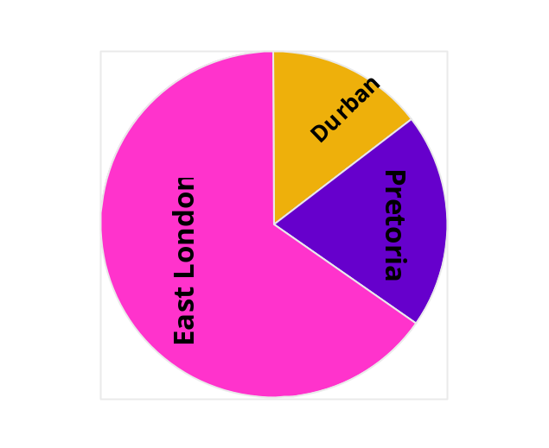

Horizontal text is easier to read.

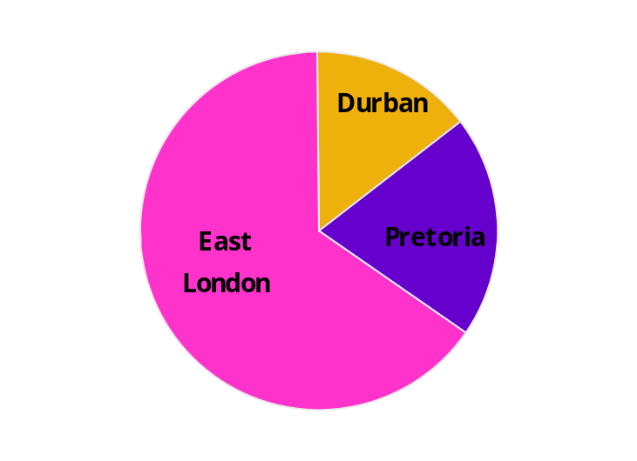

Make a graph/chart 4 times simpler than it would appear in print.
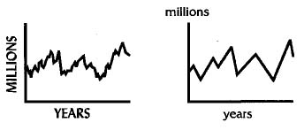

- One main idea per visual.
- Eliminate unnecessary words. Simplify to avoid visuals competing for brain time. Make the message clear.
- Do not mix horizontal and vertical visuals
- When developing material, colour can often be used for impact. Colours used must be BRIGHT and contrast well without “clashing”. Use dark colours on light coloured or clear backgrounds and vice-versa. Use a complimentary colour scheme of not more than seven colours. 30 % of the male population is red/green colour-blind, so be careful not to use these colours together in the same chart or background.

RED Blue Orange
Green Purple Yellow
Black

Formative assessment
Do your research as planned during the previous exercise. Make sure that
- The research conducted accumulates data according to the research plan
- The research conducted provides data analysis with conclusions
- The description of the analysis methods allows the validity of the analysis to be assessed
- Research progress is indicated at intervals by reports, according to the research plan
- The research conducted uses a computer application to analyse the research data

PRESENT THE RESULTS

Outcome
Present the results of research of a computer topic using computer technology

Assessment criteria
- The presentation is made using the computer application identified in the research plan
- The presentation communicates summarised research data and conclusions to the target audience

Now you have to present the results of your research in the format you decided during the planning stage. If you have to do a report, you now have to write the report. If you are doing a presentation, give the presentation, etc.

Recording
Once you have sifted and verified your information, record it in the categories you have selected. This recording is in draft form, usually in the form of rough notes.
Any arguments used in your document must be supported by sound reasons and facts. You have to justify your feeling about the matter with facts in order to persuade the reader to your point of view. Something your neighbour said about the matter is not fact – you have to verify the statement your neighbour made.
Write your first draft. Work through the entire presentation again and rewrite the presentation. Your first copy would never be the final one. You must always read through the report or presentation again.

Structure of the Presentation
Here are some tips about preparing a presentation.
The Opening
Get their attention. Too often in a speech, the first few minutes of the presentation are lost while people adjust their coats, drift in with coffee and finish the conversation they were having with the person next to them. You only have a limited time and every minute is precious to you - from the beginning, make sure they pay attention.
The opening must have two very important aspects:
- An opening statement that must gain the attention and interest of the audience. The opening statement is the first thing you must say and it happens before you “set the scene”. You can arouse curiosity with a thought provoking question or give a frightening or shocking fact.
- It must give a hint of what the speech is about and set the scene for what is to follow. This could be done perhaps by stating the objective in an interesting way Setting the scene could include a preview, stating the topic of your address, or stating your objective/viewpoint in a different way. Again make sure that the scene you set is of interest to the audience, so that they realise you are delivering a service that relates to their needs. Avoid describing exactly where you are going – in a detailed agenda for instance, rather let your presentation unfold as you progress.
- You could use HUMOUR in your introduction, providing that it fits easily – don’t “drag” it in.
- Some presenters very often lose their audience by waffling through an aimless and too long introduction – golden rule is get on with it!
- When you begin your presentation, don’t rush into your introduction. Catch your breath and start a little on the slow side. Make your sentences count. Your opening manner should be relaxed and congenial.

The Main Section
The introduction should lead into the main section and enlarge on the main idea. This can be done with examples, illustrations and visual aids, which support and make the subject clear. There should be continuity of thought and emphasis on the important points.
While preparing, do NOT write your presentation out word for word. All you want is an outline. By jotting down the main points on a set of index cards, you not only have your outline, but also a memory jogger for the actual presentation.
Keep the following in mind:

- As you arrange your points in logical order, critically examine each point for its contribution to your whole objective. Discard those points that do not relate to your main purpose.
- Keep your outline flexible. Each key point should be “self sufficient” and should be able to stand on it’s own, so that if you run out of time, you are able to discard points as you speak.
- Weave in your own experiences, humour, surprising facts or an interesting opinion to create the “change of pace” (or “rhythm”) of the address. Let the audience relax every now and then.
- Include audience involvement techniques.
- Ensure “content balance”. Check that you are putting your most exciting content towards the end of the body not at the beginning.
- After you are satisfied with your work, leave it for a couple of hours and then take a fresh, critical look at it. Are you still enthusiastic about what you are saying? Make any changes you wish and pay particular attention to the overall “balance” of your presentation.
The Conclusion
The conclusion is the section most likely to be remembered by your audience. Therefore, just as your introduction is vitally important, so is the quality of your conclusion. The conclusion should summarise the views expressed and emphasise the theme. This enables the audience to see the speech in perspective.
An effective conclusion has three components:
- The call to action – where you clearly state what it is you want your audience to do or experience as a result of this presentation. This is the whole purpose of your presentation so make sure you spell it out clearly and with conviction without “talking down” to your audience
- Summarize the main benefits in a final perspective (very important if your objective was to inform or if your subject was complicated). However, it is not always necessary.
- A closing statement that must be rousing, memorable and given in a positive, confident manner!
If you have a question and answer session at the end, then have a final closing after this session.

Formative assessment
Present the results of your research to your facilitator and fellow students. Make sure that your presentation:
- is made using the computer application identified in the research plan
- communicates summarised research data and conclusions to the target audience

