117925 practical/ observation

Observed by______________________date_____________________

## Problem solving assessment

|  |
| --- |
| Name the devices shown below and indicate whether they are input, output or input/output. (8) |
| 1. |
| 2. |
| 3. |
| 4. |

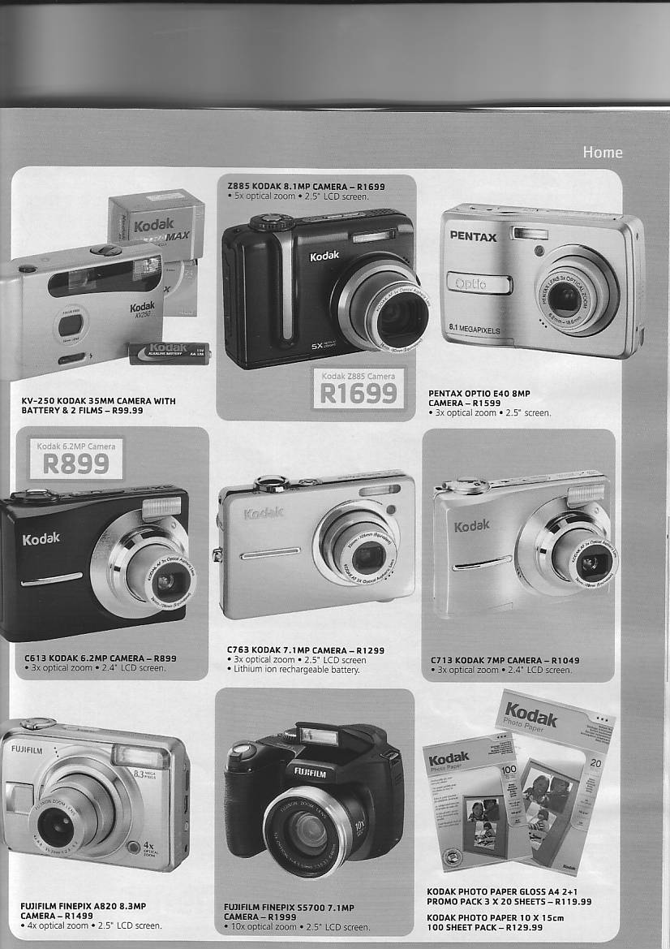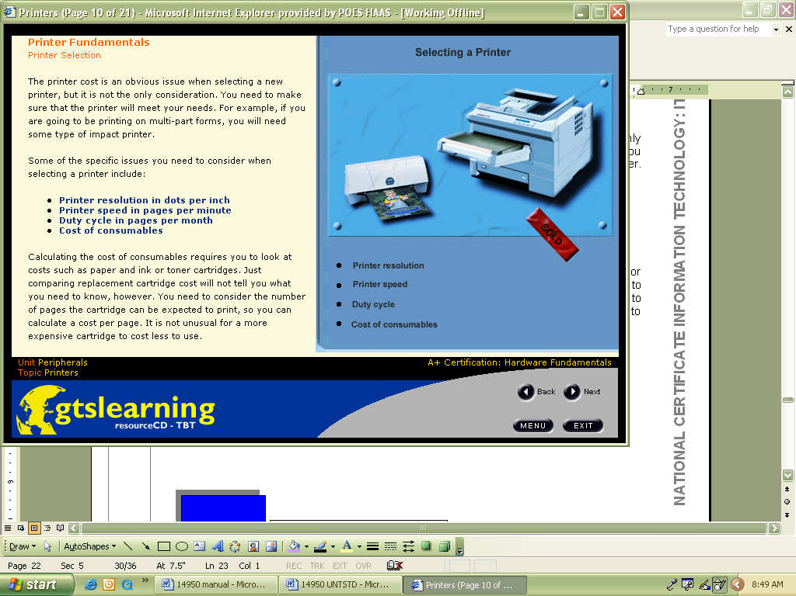

1

3

4

2

|  |  |
| --- | --- |
| Study the picture below and indicate which is (3)  1  2  3 | Number |
| A USB port (1) |  |
| A parallel port (1) |  |
| a serial port (1) |  |

|  |  |
| --- | --- |
| Identify this storage device (1) |  |
| Identify this storage device (1) |  |
| Identify this storage device (1) |  |
| Identify this storage device (1) |  |

**TOTAL 15**

|  |  |  |  |  |
| --- | --- | --- | --- | --- |
| Logbook | | | | |
| **Date** | **Assignment No** | **Start** | **Finish** | **Total Hours** |
|  |  |  |  |  |
|  |  |  |  |  |
|  |  |  |  |  |
|  |  |  |  |  |
|  |  |  |  |  |
|  |  |  |  |  |
|  |  |  |  |  |
|  |  |  |  |  |
|  |  |  |  |  |
|  |  |  |  |  |
|  |  |  |  |  |
|  |  |  |  |  |
|  |  |  |  |  |
|  |  |  |  |  |
|  |  |  |  |  |
|  |  |  |  |  |
|  |  |  |  |  |
|  |  |  |  |  |
|  |  |  |  |  |
| Date | Learner signature | Date | Mentor/supervisor signature | |
|  |  |  |  | |