Learner Guide

Module 1: 13872 Contact Centre Culture

US 13872: Instil in myself a personal Contact Centre culture
NQF level 2 4 Credits

Contents
UNIT 1: CONTACT CENTRES DEFINED .............................................................................................. 4
Unit Learning Outcomes ..................................................................................................................... 4
1.1 The Definition and Importance of a Contact Centre............................................................... 4
1.2 Transactional vs. Relational Way of Thinking ......................................................................... 8
1.3 South African Contact Centre Statistics ................................................................................ 10
1.3.1 The Size of the South African Contact Centre Industry ................................................ 10
1.3.2 Distribution ................................................................................................................... 11
1.3.3 South Africa – an Outsourced Contact Centre Destination .......................................... 12
1.4 International Contact Centre Statistics ................................................................................. 15
1.5 Key South African Stake-Holders in the Contact Centre Industry .............................................. 16
UNIT 2: THE CULTURE OF CONTACT CENTRES ............................................................................... 18 Unit Learning Outcomes ................................................................................................................... 18
2.1 The Culture of Contact Centres ............................................................................................ 18
2.2 Career Paths in the Contact Centre Industry ........................................................................ 20
2.3 Contact Centre Agent Job Profile .......................................................................................... 22
2.4 Contact Centre Code of Conduct .......................................................................................... 24
Unit 3: Contact Centre Technology ....................................................................................................... 29
3.1 Introduction .......................................................................................................................... 29
3.2 The Place of the Contact Centre in the Organisation ........................................................... 30
3.3 Technology ............................................................................................................................ 31
3.3.1 Automatic Call Distributor (ACD) .................................................................................. 31
3.3.2 Reporting ....................................................................................................................... 34
3.3.3 Real-time Reports ......................................................................................................... 35
3.3.4 Desktop (voice and data) .............................................................................................. 35
3.4 Business Applications and Databases ................................................................................... 37
3.5 Voice Processing ................................................................................................................... 38
3.5.1 Interactive Voice Response (IVR) .................................................................................. 38
3.5.2 Speech Recognition ....................................................................................................... 39
3.5.3 Voice Mail...................................................................................................................... 39
3.6 Contact Centre Equipment ................................................................................................... 42
3.7 Aspects of good design in a contact centre .......................................................................... 43
3.8 Health & Safety Issues .......................................................................................................... 44

UNIT 1: | CONTACT CENTRES DEFINED

Unit Learning Outcomes
On completion of this unit, you will be able to:
⇒ Identify and define what a Contact Centre is
⇒ Identify Contact Centre principles and concepts
⇒ Analyse South African and International Contact Centre statistics
⇒ Identify the key South African Contact Centre industry players
⇒ Identify the benefits of instilling in self, a Contact Centre Culture ⇒ Persuade others of the benefits of a Contact Centre culture

1.1 The Definition and Importance of a Contact Centre

There are several ways of defining a Contact Centre, however, the traditional definition of a contact centre is a
technologically set-up infrastructure with ten
or more agents, workstations, employing dedicated staff to make and take calls.

However, this commonly used definition is always changing as new trends emerge, in particular the move towards Contact Centres as multi-purpose ‘customer contact ‘ centres.
As defined by Wikipedia:
A call centre or contact centre is a centralised office used for the purpose of receiving and transmitting a large volume of requests by telephone. A contact centre is operated by a company to administer incoming product support or information inquiries from consumers. Outgoing calls for telemarketing, clientele, product services, and debt collection are also made. In addition to a contact centre, collective handling of letters, faxes, live chat, and e-mails at one location is known as a contact centre.

Contact Centres are referred to in a variety of ways, for example, communications centre, customer services centre, customer care centre, help desk.

Inbound contact centres can be defined as those where customers call into the contact centre for a service or assistance e.g. support or help desks.

Outbound contact centres are those contact centres where agents make outgoing calls to customers e.g. telesales.

Blended contact centre are those where agents make outgoing calls to customers and receive incoming calls from customers e.g. medical assistance, help desks, sales, technical centres. A blended contact centre can also do telesales and debt collection.

Picture: Typical set up and look of a contact centre

Cloud based contact centres are where contact centre data etc. that is stored in the cloud, rather than hosted on-site.
Cloud-based infrastructure is the fastest growing area in the contact centre sector, predicted to almost double between 2013 and 2015. This will see the proportion of call centre seats in the Cloud reach 18%, up from just 2.2% in 2008.
Cloud based contact centres offer:
minimal capital outlay/investment al investment cost-effective scalability high levels of reliability and security
24×7 technical support

CONTACT CENTRES – VARIATIONS ON A THEME
There are many activities associated with Contact Centres, although Contact handling is the core and common focus. Other functions will differ from one Contact Centre to the next. For example, the work content may be inbound or outbound calling, and sometimes several functions like marketing, sales or customer service are combined in the one centre. Within the core area of customer service, the work can differ. If one compares the work of a Contact Centre agent at a help desk providing technical support for a complex product with someone taking a hotel booking, one see the variety of work involved.

Marketing companies can also differ from a Contact Centre yet they could use the principles of a Contct Centre – for e.g. a Marketing Company that markets a product will have walk in area so that customers could view the product and would still operate a Contact Centre to answer queries e.g. Verimark

Contact Centres vary greatly in size and core activity, but despite these variations on a theme there is at least one fundamental aspect that distinguishes Contact Centres and the work they do.

The elements of a contact centre are the physical tools that a contact centre agent needs to perform his/her duties efficiently – for example:

- the work station – this must be comfortable width which is normally 1.100 cm to ensure that you are comfortable and are not too close to the next agent. Should work stations be too close together the noise from the other agent talking on the telephone could interfere with your call.
- adjustable chair – this is to ensure that the agent is comfortable and for correct sitting position.
- computer, keyboard, mouse, - to enable you to be efficient in your execution of duty
- Headphones – these must be of a good quality so that the agent is able to talk to and hear the customer clearly
- Air conditioner – to keep the Contact Centre cool and have free flowing air which enhances agent productivity

Every Contact Centre and its function can be placed somewhere along the following continuum:
Go to Activity 1 in your Assessment Pack and answer question 1.1, 1.2, 1.3, 1.4, 1.5, 1.8 & 1.13

1.2 Transactional vs. Relational Way of Thinking

In all, the Contact Centre agent is key to the business of processing caller requests. So how agents are selected, trained and managed will affect this. Where the emphasis is more on relational, there is greater opportunity to utilise the necessary soft skills required to deliver
quality customer service.

Some call handling work involves short transactions with the customer – one off interactions with customers, not known to each other and often about relatively straight forward matters.
An example is a response desk answering relatively simple customer enquiries, e.g. Telkom’s 1023 directory enquiries service.

Transactional Relational

Transactional refers to the tasks/activities that agents are required to perform in order to process the customer’s request, and include data processing.
Relational refers to the manner in which these transactions are carried out, i.e. Contact Centre soft skills in terms of professionalism, politeness and interpersonal skills etc.

On the other hand, building relationships with callers involves a different approach to call handling. Here the interactions are longer and may be sustained over a period of time. In some cases this results in a known customer talking to a known Contact Centre agent. This is commonly been termed CRM (Customer Relationship Management).

Go to Activity 1 in your Assessment Pack and answer question 1.6 & 1.7

1.3 South African Contact Centre Statistics

South Africa has a large, well established and sophisticated Contact Centre industry.

1.3.1 The Size of the South African Contact Centre Industry

A recently completed formal study sponsored by Trade and Investment South Africa
(TISA) confirms that there are at least 410 formal, ACD [Automatic Contact
Distributor] based Contact Centres in South Africa having at least 20 agent positions.
There are between 100 and 150 pocket Contact Centres, i.e. consisting of 4-9 seats (workstations). In addition there are several thousand micro Contact Centres, small telebusiness operations and help desks. But it is these 410 Contact Centres that account for marginally short of 48 000 agent positions or workstations and, taking shifts and multiple agents into account, the study concludes that we already employ in the region of 80 000 Contact Centre agents.

South Africa has a large, mature and sophisticated Contact Centre community. If South Africa was a European Union member country, it would be the 6th largest installed base of the fifteen member states.

South Africa has a similar number of Contact Centres to Belgium. It is only 20 % smaller than the Netherlands (Mitial Research Benelux Location Survey 2000). It has more than twice as many Contact Centres as both Northern Ireland and the Republic of Ireland combined (Mitial Research Isle of Ireland Country Report 2002).

The South African installed base is also bigger than the Scottish and
Welsh bases combined (Mitial Research UK Country Report Dec 2001).
Besides the 20+ seat call centres in this study, there are approximately 125 Pocket Contact Centres in South Africa. There are many more units using telephones, but most are not dedicated to taking and making calls.

The South African Contact Centre industry provides secure and sustainable employment to well over 100 000 individuals, including management, administrative, back office and support staff. This has been achieved in less than a decade!

1.3.2 Distribution
South Africa’s Contact Centre industry is dominated by centres serving a domestic market (91%) and primarily in-bound customer service calls, rather than outbound sales calls. Of the Contact Centres in this survey, 51% are located in Gauteng province, and another 38% in the Western Cape. A full 81% are operated as inhouse Contact Centres, and the average size was 77 Contact Centre agents. The Contact Centres operate across many different industries, with telecommunication, insurance, banking and financial services industries being the most prominent.

A key feature of the South African Contact Centre market has been that large local companies have built up their Contact Centre businesses over a 5-7 year period. These include finance houses Old Mutual, First National Bank, Standard Bank, Nedcor and ABSA, as well as Telkom's own Contact Centres of which there are 15.

As the South African Contact Centre industry grows, so the distribution of Contact
Centres within the country will become more widespread. Currently, however, Greater Johannesburg has the biggest Contact Centre community with 85 sites. This is without doubt the greatest concentration of Contact Centres in Africa and more than one quarter is in financial services.

In South Africa, two-thirds of the industry is made up of Contact Centres, while the remaining part includes financial accounting, IT support, data analytics and a variety of legal services. Gauteng dominates business process outsourcing employing about 35 000 people

Cape Town has the second biggest concentration of Contact Centres with 15% of the installed base or 62 sites.

Durban CBD is home to several Contact Centres and is in receipt of major infrastructure investment.

Port Elizabeth has three Contact Centres operating in the city, but Vodacom is the only significant known facility.

Distribution of Full Size Contact Centres in South Africa
By City/Area | Percentage of Total | Number of Sites
Greater Johannesburg | 58.0% | 238
Cape Town | 15.2% | 62
Other | 10.9% | 45
Greater Durban | 7.2% | 30
Pretoria | 5.1% | 21
Other Kwa Zulu Natal | 2.9% | 12
Port Elizabeth | 0.7% | 3
TOTAL | 100% | 410

1.3.3 South Africa – an Outsourced Contact Centre Destination

There were 410 full-size Contact Centres in South Africa at the end of 2001. As such, there are more Contact Centres in South Africa than Spain, which has about the same population.

The vast majority of sites - almost 60% (238) - are to be found in Greater Johannesburg. This is without a doubt the greatest concentration of Contact Centre in Africa. Johannesburg has by far the largest concentration of Contact Centre operators in South Africa. It is estimated that there are 18,000 seats distributed throughout its 238 Contact Centres. More than one quarter of Contact Centres in Johannesburg operate in the financial services market. Confidence in this location is very high and Mitial Research predicts that Contact Centre investment will continue to take place, particularly in districts centred around Sandton and Rivonia. India has also been recognised as a key outsource location.
In 2005 South Africa was ranked ahead of India, Mexico and the Philippines in an Ion Group poll of top UK companies' ideal offshore location.
In February 2006 leading UK telecoms firm TalkTalk announced plans to spend R200-million setting up two Contact Centres - in Cape Town and Johannesburg - in the South African contact-centre industry's biggest foreign investment yet.
The Western Cape alone has secured call centre deals worth R933-million since the beginning of 2004. Companies running Contact Centres in the Western Cape include Barclays, JP Morgan, Lufthansa, the Budget Group, Merchants/Asda, Dialogue and STA Travel, Amazon etc.
World fuel giant Royal Dutch Shell is to set up one of its global super customer service centres (super-SCSs) in Cape Town. The centre will be one of a handful globally, providing customer services and credit management support to its international business customers.
The South African government's accelerated growth strategy has identified outsourcing as one of two priority sectors (the other is tourism) with exceptional potential for expansion. The strategy aims to make South Africa the world's thirdbiggest outsourcing centre - after India and the Philippines - by 2008.

South Africa is the ideal location for servicing the British market because of the accents, cultural affinity, similar time zone and operational costs that are as much as 50% lower than the UK. While 2011 census figures show English is the mother tongue of less than 5-million South Africans – ranking it fourth behind Zulu, Xhosa and Afrikaans – about half the 53-million people in the former British colony have knowledge of the language. The government offers grants of as much as R88 000 for each new call centre post created and sustained for three years. The incentives, introduced in 2007, have helped attract more than R1.6-billion of direct investment and create at least 10 500 jobs in a country where one in four people are unemployed, according to the government.
New undersea telecommunications cables also spurred investment as data costs fell 85% between 2003 and 2009.

Go to Activity 1 in your Assessment Pack and answer question 1.10

Foreign Investors to date include Sykes (outsourcing business), Lufthansa (airline) and Mindpearl (Qualiflyer customer Contact Centres). South African Contact Centres offer state of the art technology and multi-lingual capability. A "follow the sun" approach is utilised, whereby all calls are switched between countries to take advantage of the regular business hours of that country.

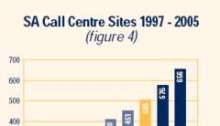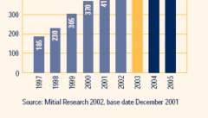

It can be seen that rapid expansion took place between 1997 and 2000. The increase in growth from 2002 to 2005 can be justified by likely Foreign Direct Investment which the Mitial Research forecasts will lead to an increase in sites. At the beginning of 2002, the Mitial Research forecast the establishment of 40 new sites within the year. In 2003 our forecast is for a little over 50 new facilities. In 2004 and 2005 some 70 new sites will start new operations in each year. This is based on the percentage growth in 2002 and the projections for new business development. In 2002 there was a growth of just 10%.
Currently, in 2015, South African contact centres employ about 210 000 people, with 9% of those working for offshore companies, industry data shows.

1.4 International Contact Centre Statistics

A comparison of the South African Contact Centre industry with other major European Contact Centre hubs:
According to the credible TISA-sponsored research, the South African Contact Centre industry is more than two and half times the size of the Contact Centre industry in the Republic of Ireland. The South African Contact Centre industry is also comparable with the combined Scottish and Welsh installed base. Both Belguim and Spain have fewer Contact Centres than South Africa.

The South African Contact Centre industry is also comparable in size with that of the Netherlands. Were South Africa a member of the European Union, we would have the fifth largest installed base of Contact Centres of the fifteen member states.

This research clearly indicates that the South African Contact Centre industry is on a par with virtually any European Contact Centre nation or region and is fast becoming the next international Contact Centre hub.

North American and European organisations invest in South Africa by internationally outsourcing their Contact Centre infrastructures in this country. As a result of this, the demand for qualified Contact Centre agents is rapidly increasing.

Formal research indicates that the South African Contact Centre industry can be expected to achieve at least a 14% per annum compound growth over the next few years. This adds up to marginally short of 100 000 new agent positions or workstations within five years! Taking the average of 1,6 agents per workstation, South Africa can conservatively look forward to employing roughly a further 150 000 agents and 50 000 management, back office and support personnel by 2007.

The following table shows the attractiveness of countries as an outsourced destination for a contact centre:

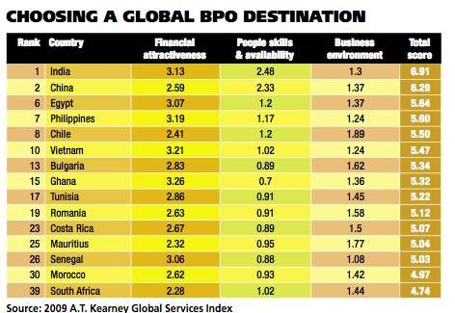

This confirms that South Africa is amongst the top 50 as being ranked at 39 in 2009 (could be higher in 2015).

1.5 Key South African Stake-Holders in the Contact Centre Industry

South Africa is a fast growing Contact Centre culture, with the majority of Contact Centres in Johannesburg, the Cape Town, KZN and Port Elizabeth. Over 80 000 seats are occupied by Contact Centre Agents making it a fast growing industry and Government has various initiatives to bring in more Contact Centres to South Africa by offering various tax relief breaks. In this way our Government

South Africa is a good investment for overseas Contact Centres for the following reasons:
- Cheaper Rand value
- Agents speak English
- Agents can be trained to speak Dutch and German
- Time Zone
- Large pool of unemployed persons that are readily available for employment

Some key players in the Contact Centre industry include:

Johannesburg in the areas of Rivonia and Sandton are where many of South Africa’s IT businesses are located, including Discovery Health which has Contact Centres comprising a total of 600 workstations. Other large Contact Centres in this region include, the AA (Automobile Association), Medscheme, Vodacom, Standard Bank, ABSA, Microsoft, MRI and Multichoice.

The biggest Contact Centre operator in the Western Cape is Old Mutual with 900 seats in two buildings in Pinelands. Within the Cape Town central business district
(CBD), Telkom’s and Engen’s first class Contact Centre facilities are located. Lufthansa also operate a German speaking facility in the Cape Town CBD.

Durban CBD is home to several Contact Centres. Citibank recently moved a noncontact centre business into the CBD. Umhlanga Ridge and Mount Edgcombe are part of a major Contact Centre development out of town which is home to Blake's (a debt recovery business) and also MTN (the cellular operator).

UNIT 2: | THE CULTURE OF CONTACT CENTRES

Unit Learning Outcomes

On completion of this unit, you will be able to:
⇒ Identify and discuss career opportunities that exist within the Contact Centre industry;
⇒ Draft a Contact Centre agent job profile;
⇒ Develop an understanding of the importance of teamwork within the culture and infrastructure of a Contact Centre;
⇒ Know your Contact Centre Code of Conduct and apply it in all areas of work.

“Although the best technology is a great enabler, it’s your people that will always make the difference. They have a vast capability to make up for any shortfalls in technology.”
“If I hear of a Contact Centre that is not doing well, it’s not the technology but their people. The people here differentiate the business.”
Extract from: It’s Your Call – Effective Contact Centre Management

2.1 The Culture of Contact Centres
The culture of Contact Centres varies from one to the next and managers and team leaders play an important role in building a particular culture. Culture is difficult to define and yet you can feel it the moment you enter an organisation. For many the source of culture lies in the set of beliefs shared by people, especially Contact Centre managers about how people should be organised and managed. These beliefs and assumptions drive all decisions and actions.

Effective agent development helps create a culture of:
- Continuous improvement
- Agent empowerment
- Personal accountability

Such culture has many benefits, namely:

1. Job Satisfaction
Any organisation that develops such a learning culture where employees are encouraged to fully develop their expertise and knowledge and then utilise their skills, is enriching the jobs of the employees. Job enrichment and agent empowerment result in job satisfaction and high level motivation.

2. Multi-skilling and Pooling Resources
In simple terms, multi-skilling means agents are trained to become one large group all answering all calls instead of several smaller groups of agents, each specialising in a different area. The benefits of this are extremely high and rewarding for everyone concerned. This equips agents with skills they would be able to generalise to other Contact Centre environments.

3. Agent Empowerment
Agent empowerment does not mean agents are authorised to make whatever decisions they like. It does mean that there are parameters and strict guidelines in place, which the agents use to make decisions. The agent will look at the criteria, check the information in the computer and will make a decision based on whatever it matches. The agent is then empowered to advise the customer of that decision. This means that the majority of decisions are dealt with by the agent and not passed on to the supervisor. The agent’s job becomes more fulfilling, the customer gets the service expected and the supervisor is freed up to concentrate on managing the team.

Where there is agent empowerment, there is also personal accountability (i.e. being responsible for one’s actions). This gives Contact Centre agents a feeling of responsibility and involvement, which again creates high motivation and leads to customer satisfaction. If each agent feels accountable, they are more likely to strive towards achieving goals and feel committed to the overall success of the Contact Centre.

As with all training, agent commitment will be gained through the creation of a personal plan with a performance agreement made jointly between themselves and their supervisor. This plan also creates a blueprint for each individual, detailing personal development and growth.

4. Supervisory Development
Many agents aspire to the role of supervisor/team leader within their Contact Centre. The role of the supervisor is to manage teams of agents and daily call flow. Therefore, agents most likely to reach this position have the potential to inspire and motivate people, develop their talents and increase productivity and are not necessarily those best at handling calls.

2.2 Career Paths in the Contact Centre Industry

There are almost 79,000 Contact Centre employees (40 hour per week equivalents) working in 20+ seat Contact Centres in South Africa. South African Contact Centre agents work shifts. Most smaller Contact Centres work on the basis of one agent per desk. As the Contact Centres become larger hot-desking becomes more popular. Hot desking is a work space sharing model in which employees outnumber desks. In some environments, each work station has its own computer and the worker logs into a virtual desktop.

Instead of using the Contact Centre as a stepping stone to other departments, many organisations and Contact Centre employees now see the Contact Centre as a career in its own right, and Contact Centre agents can now command a salary in line with their skills. Contact Centre organisations work hard to ensure job enrichment and career fulfillment. Good salaries, good working conditions and good management are becoming the norm.

Contact Centre managers are often heard to say, “our people are our greatest asset”. These companies see call handling as a core skill and as a result they invest heavily to get the right people at point of entry. Thereafter, they induct and train them in the skills, product, service and company knowledge needed to do a good job.

Training and qualifications are also necessary to raise the status of Contact Centre work, something of real concern to staff and managers. In most organisations, it takes a minimum of six weeks to train the Contact Centre agent followed by regular development thereafter. Some provide significantly more training.

There is an opportunity in Contact Centres for a great transfer in skill as, for example, team leaders can work alongside the Customer Service Manager to do ongoing team and individual development. There are also great opportunities to gain knowledge in the area of human resources as all agents are well supported by HR specialists. A number of Contact Centres have onsite learning centres and provide modular training to suit the difficulties of release and shift working.

Associated Careers Within The Contact Centre Industry

Companies know that to retain people they have to provide a career path or other job opportunities within the Contact Centre or the company as a whole. This is needed for those with ambition but also because call-handling work can be repetitive and there comes a time when people need a change.

Ongoing training and development is essential in order to support continuous improvement. This training will vary according to the needs of the individual and it should be linked to the performance management system. This is where evaluation of performance is supported with targeted training, which focuses on the individual’s particular weakness. This increases training effectiveness, reduces costs and targets relevant training maintaining interest and motivation in that person.

2.3 Contact Centre Agent Job Profile

The key competencies required of Contact Centre agents are as follows:
♦ Active listening
♦ Establishing and building rapport ♦ Problem resolution skills
♦ Managing customer expectations
♦ Selling skills
♦ Accurately capture client details
♦ Assertive telephone manner
♦ Probing skills
♦ Complaints handling
♦ Controlling the call
♦ Professional/business English
♦ Ability to work in a team

The following behavioral skills and attitude are required:

♦ Confidence/self esteem
♦ Decision making and critical thinking
♦ Accountability and ownership
♦ Self management motivation and high standards
♦ Patience
♦ Flexibility
♦ Enthusiasm

Go to Activity 2 in your Assessment Pack and answer question 2.1

The following picture shows how diverse the offerings of a Contact Centre can be:

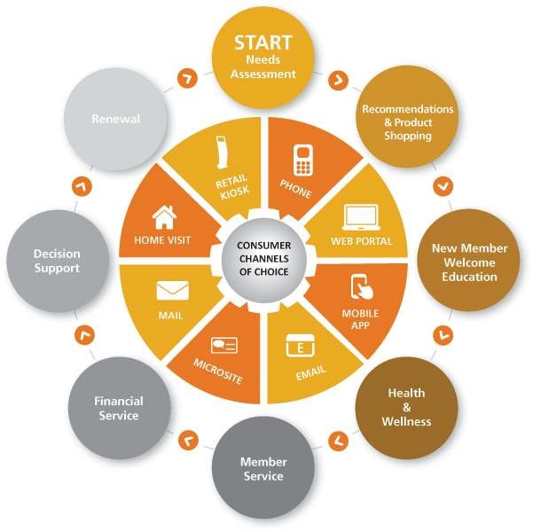

2.4 Contact Centre Code of Conduct

Most Contact Centre staff follows a Code of Conduct. This is a set of guiding principles that are known to all staff and are followed at all times. The following issues are important in a Contact Centre Code of Conduct:

Honesty
All services and offers must be stated clearly and honestly so that both parties know precisely what they have committed to and what they can expect in return. Some companies (like banks and insurance companies) even record all Contact Centre conversations so that clients can follow up in the future if they need to.

Proper Identification
All telemarketing calls should begin with the name of the company, followed by the name of the Contact Centre Agent. This is important so that the client can identify you and it makes a call more personal

Purpose of the Call
The telephone representative will disclose the principle reason for the call as soon as possible in the conversation. This is more important for outgoing calls (for example telesales calls).

Security
All security processes must be adhered to as per the Contact Centre Policies and Procedures e.g.

Teamwork
“It’s a great job working with good people and teams; there is lots of loyalty and you roll with the punches because the people are so good.”

The following is an Extract from: It’s Your Call – Effective Contact Centre Management

In most Contact Centres, Contact Centre agents and their technology are grouped into teams as work units. The team is particularly important in big Contact Centres as it allows people to interact with each other (face-to-face as opposed to only communicating telephonically).

Life in the team plays a big part in the Contact Centre agent’s overall experience at work and companies give a lot of time and attention to building a good team culture. The team leader/supervisor is key to achieving this. The culture of co-operation in the team helps to reduce the stresses and strains of the work. It acts like a safety valve to relieve the pressure.

The role of the teams is to give support to individual members by, for example, relieving them and taking work if the person needs to recover from a difficult call. Most teams run a “buddy system” in which experienced Contact Centre agents pair up with team colleagues to help and coach them as part of the induction period. In some cases, team feedback is part of an individual’s formal performance review process.

The team is also the main means by which companies get greater employee involvement. Many companies give time for weekly team meetings during which the team learn about company developments and discuss team matters. Contact Centre agents and team leaders feel it is a valuable way to give upward feedback to management.

In Contact Centres where most of the staff is young, the social side is a great attraction and, even when there is a mix of ages, teams have lunch together and arrange social events.

Building and maintaining teams is not easy when the agents work in shifts and where there is a mix of permanent and temporary staff. However, the benefits when teams are working well far outweigh the effort involved in building teams.

Hours of Operation

Outbound Calls:
Outbound calls to either businesses or consumers should not be placed during hours that may be perceived as unreasonable (that is before 8:00am or after 9:00pm). On Saturdays it is suggested that no calls be placed before 10:00am or after 9:00pm. On Sundays should be made before 12:00 pm. No calls should be made on public or religious holidays.
Inbound Calls:
The customer and the offer or agreement of the service provider determines the timing of inbound calls. Many Contact Centres operate a 24-hour service, while others only offer a service during working hours.

Training
Prior to making or receiving calls, all Contact Centre Agents should receive adequate training in professional telemarketing skills and adhere to recognised practices and procedures including adherence to any and all laws and regulations pertaining to Contact Centres and customer service.

Privacy
Telemarketing technology enables the effective collection and exchange of personal information. There is increased potential for violating the privacy of individuals or groups. It is the responsibility of the Contact Centre Agent to maintain the privacy and integrity of all data-describing individuals. This includes taking precautions to ensure the accuracy of the data collected, as well as protecting it from unauthorised access or accidental disclosure to inappropriate individuals. Procedures should be implemented to allow individuals to review their records and correct any inaccuracies.

Integrity
Honouring one's commitments is a matter of integrity and honesty. For the Contact Centre Agent this includes honouring contracts, agreements and assigned responsibilities. An agent will exercise integrity at all times, in other words, it is a quality an agent possesses in adhering to high moral principles and professional standards

Respect
Respect for ourselves, for others, and respect for our environment is of great importance. No client should be treated differently from any other client.

Client Privacy
Marketers will remove a customer's name from a call list when asked to do so by that customer. Customers who have an unlisted phone number will not be contacted unless they have given their consent to do so

Go to Activity 2 in your Assessment Pack and answer question 2.2

The best way to deal with each client (whether external or internal) is to believe and live by the following motto:

Every customer is important to me. Looking after every client to the best of my ability is my priority.

Every customer should be greeted promptly (i.e. no later than three telephone rings), pleasantly and made to feel welcome and an important part of my day.

I must keep myself up to date with all the products/services that the organisation offers. This ensures that my service is accurate and professional.

When I make a promise to a customer (and that does not just mean I say the words: "I promise..."), I make sure that I deliver.

Every customer is entitled to have any queries, problems or complaints dealt with and satisfied promptly, courteously and efficiently.

Always try to give the client "added value service", i.e. that little extra service or help which they may not expect.

No one ever "wins" an argument with a customer and if I am in the wrong or have made a mistake, I will admit to it and apologise.

I will treat every client, as I would like to be treated myself.

If you continually bear these above-mentioned points in mind when dealing with customers, you will have a solid grounding on which to begin giving service excellence.

Unit 3: Contact Centre Technology

Unit Learning Outcomes

On completion of this unit, you will be able to:
⇒ Identify and explain the importance of contact centre technology in a contact centre
⇒ Identify various contact centre technology and explain their uses;
⇒ Develop an understanding of technological reporting systems and their uses; ⇒ Use contact centre technology effectively.

3.1 Introduction

In the 1990’s we have seen an explosion in Contact Centre technology. Contact Centres can buy hardware and software to automate just about anything and everything they want. These won’t necessarily work together though!

Technology in a Contact Centre should be regarded as an enabler, helping Contact Centre employees to do their jobs effectively. In order to make decisions when purchasing technology, Contact Centre managers look at business needs and customer requirements.

Making a contact centre more efficient isn't enough to make it competitive.

Efficiency will never go out of style in business. But in an industry that's largely transitioned from one-dimensional Contact Centres to e-mail, Web chat and the full-fledged multimedia contact centre, making a contact centre more efficient isn't enough to make it competitive.

As technology continues to empower consumers with e-services and multimedia interaction options, efficiency-driven metrics such as average talk times don't always gauge an agent's actual performance. Nor do they reflect the customer pulse needed to improve service levels across multiple channels or the business processes behind them.

With the growing importance of multimedia agent skill sets and offering quality service no matter what media a customer chooses, the expanded role of today's contact centre workforce commands far more attention than just filling seats and improving call statistics.

3.2 The Place of the Contact Centre in the Organisation

We looked at contact centre principles in Module 2 and discussed the origins, types and evolution of contact centres. We now need to develop a key understanding of the how the contact centre fits into the organisation.

The contact centre is sometimes call the interface of an organisation. It is the most important business unit as it is the first point of contact with the customers of the organization. The contact centre links customers to all other departments of the business.

The contact centre is also the central point for collecting all the information about the customers. T his information may include:

- Customer dislikes or likes of the company and its products
- What competitors are offering by customers explaining what they have been comparing the company’s products or services to

CUSTOMERS -
Contact
Zone-
CONTACT
CENTRE
Finance
Operations
Marketing
Admin-
istration
Human
Resources

Go to Activity 3 in your Assessment Pack and answer question 3.1

3.3 Technology

3.3.1 Automatic Call Distributor (ACD)
The most crucial piece of technology in a Contact Centre is the ACD. This is the heart of the inbound Contact Centre, pumping incoming calls to wherever they need to go. Modern Contact Centres cannot function without an ACD.

The early ACD’s simply distributed calls evenly to all the agents available. Nowadays they are much more sophisticated. People dial the Contact Centre number, the call arrives via the exchange at the ACD and the ACD then tells that call exactly where it needs to go – this could be the first available agent, or the first who can speak French, or it may need to hold the call in queue and play music and messages, e.g. “ we are sorry, there are no available agents at the moment, but please stay on the line and we will be with you shortly”.

To help you understand what an ACD should do, below is a list of some of the minimum functions to be expected from an ACD:

- Management Resources – comprehensive and customisable real-time reporting to identify which agents are logged on, where they are and what they are doing.
- Call Routing – integrated voice subsystem and intelligent queuing announcements.
- Performance Monitoring – ability to print, fax, e-mail and merge reports as well as wallboard connectivity.
- Networking – true virtual Contact Centre capability with queuing across multiple sites and remote alarm reporting and diagnostic capabilities.
- Interfaces/Integration – Multi-media integration to enable the intelligent use of the ACD, Computer Telephony Integration (CTI), e-mail, Interactive Web Response and speech systems.

A standard universal model of a Contact Centre can be diagrammatically illustrated as follows:
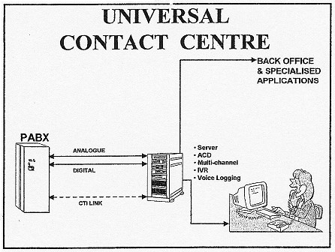

Whereas a multi-channel universal Contact Centre operates as follows:

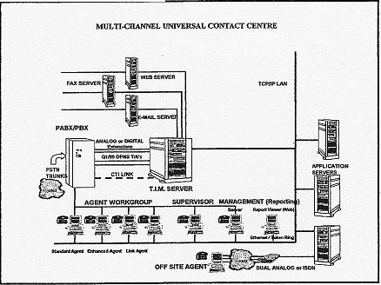
Reproduced with kind permission from: Rod Jones Strategic Services

3.3.2 Reporting

The ACD will offer standard reports with which to measure and manage the Contact Centre, both real-time and historic. Many now offer a degree of customisation enabling company specific requirements. Each ACD offers the information in a different way with completely different codes and jargon, but the basic information should be the same.

Historical Reports
Historical reports can be generated throughout the day to give an indication of what is going on now and these can be used to detect trends.

Standard reports can be divided into agent data, call data and trunk data. As they imply, agent data looks at what the agents are doing as individuals, teams and as an overall office average. Call data tracks inbound and outbound calls, identifying where they route to and when and where they are handled or lost. The trunk data looks at how busy the lines are and exposes line problems.

Reports can be pulled in a variety of ways:

Interval Reports
Detailed interval reports can be scheduled which normally show activity in half-hour segments throughout the day. Some examples of interval reports include:

• Call Data
These reports are usually supplied in half-hour intervals, hourly intervals, daily, weekly and monthly. Specific hours from x time to y time can also be requested.

Queue Profile
This reports on the average speed of answer, the time spent in queue waiting for an agent and the number of calls that held in queue.

Number of Calls
This can report on, for example, total number of calls answered, total number of calls lost or abandoned, number of calls offered (the total number of inbound calls that arrived at the ACD), and number of calls handled.

Daily Reports
These normally show the totals for the whole day and offer more of a “large picture” view of the day’s activities. Exceptionally useful are the abandoned call report, individual agent performance report and of course the day’s overall service level achievement.

3.3.3 Real-time Reports
On the screen the number of calls in queue is real-time (as it happens) as is longest current wait and current agent status. Real-time management involves prioritising the number of calls in queue and the longest wait.

This information as well as the number of calls being received, how many customers have put down telephone (lost calls), how long customers had to wait before a call was answered and which Contact Centre agents are available to take incoming calls are displayed on what is known as a wall board in the Contact Centre so that it is accessible to everyone. This information proves very valuable to Contact Centre supervisors and managers when anlaysing and forecasting data.

Go to Activity 3 in your Assessment Pack and answer question 3.2

3.3.4 Desktop (voice and data)
In simple terms Computer Telephony Integration (CTI) is where the computer and the telephone talk to each other and give each other information or instructions.

The most primitive forms of CTI started by simply joining the computer to the telephone, through the use of a device called a modem. This meant people could buy software, which would enable them to send faxes from their computers, use their computers to dial out rather than pick up the telephone handset and even get their computers to take e-mail messages for them. Point and click, the modem dials a requested number and you are connected.

The physical link between the personal computer (PC) and the telephone systems consists of a piece of wire and a language called a protocol, which they use to communicate with each other. Unfortunately every telephone systems uses a different protocol, thus you need a translator. This is an API (Application Programme Interface).

In order to marry the telephone with the PC, you need a “wedding”. The number of people you want to use CTI will normally dictate whether you have a simple ceremony for just a few guests, or a large event for everyone you know. These are called First Party (or desktop) and Third Party (or host/server) CTI.

Desktop – First Party
First Party or Desktop CTI sits in the PC and allows one PC to behave as if it is your telephone extension. It only knows what is happening on your own telephone and
therefore, is beneficial for personal applications such as desktop contact management packages and personal organisers.

Application System
ACD
CTI Software

Host/Server – Third Party
Unlike First Party CTI, Third Party CTI allows multiple networked workstations to share applications. It uses a single server platform on a local area network (LAN), connected to a telephony switch. The CTI application can be linked to any number of business databases, containing relevant information sources.

ACD
Database
Server
CTI Server
Application
Systems

3.4 Business Applications and Databases

All Contact Centres use a combination of business applications and databases to cater for company specific and customer needs. The database (where client and product information is stored) is the core upon which a Contact Centre’s customer relationship management model is based.

The CTI application can be linked to any number of business databases, containing relevant information sources, providing the agent with customer data, so they can respond immediately to each caller’s needs.

3.5 Voice Processing

Voice processing is defined as the digital storage of the human voice on computer disk. However, unlike data it demands huge amounts of disk space and therefore, has only recently become available due to the increasing size and falling cost of hard disks.

Voice processing is simply a generic term for a variety of applications which process voice transactions automatically. It enables the Contact Centre to automate tedious
transactions, to provide a 24 hour service to customers who might otherwise have to call back the next day, to handle overflow calls at peak times, and to give a personalised service to your regular callers.

3.5.1 Interactive Voice Response (IVR)

IVR is one of these applications which must have CTI to function. IVR is where the call is answered by a recorded message asking for a numeric response to specific questions or statements. If the caller has a touch-tone phone, he is able to drive the system by pressing buttons on the telephone keypad. The tones are recognised by the voice processing system, which tells the computer what to do. This may result in taking the call to an extension or voice mailbox, or to get information from the database which is then spoken back (through voice synthesis) over the phone. A script guides the caller through a menu of information, each time waiting for the caller’s response and then reacting accordingly.

An obvious example of an IVR application, is telephone banking where customers can make a call, are answered by a recording, they input their personal identification number (PIN) and are then able to receive information about their account with no live agent involved. Any application which requires remote access to stored data would be suitable for IVR. These could include stocks and parts ordering, student registrations, insurance quotations and flight enquiries.

IVR can really make a huge difference for the Contact Centre agents themselves. It can take away the really mundane and repetitive tasks, for example, looking up bank balances, leaving the agents with the more interesting and demanding work.

There are times however, when the caller will want to transfer to an agent, to query the information given through the IVR system or because they need information not available on the system. Therefore, these voice-processing systems should always have a backup enabling callers to press a number (e.g. 0) at any time if they want to cut through the system and speak with a live agent. At this point the IVR system will contact the Contact Centre, and before putting the caller through it will either state the caller’s account number in the agent’s headset or will screen pop the caller’s information.

3.5.2 Speech Recognition
For those callers who do not have touch-tone telephones, voice or speech recognition can be used. The caller is asked to state clearly the extension number or the name of the person they wish to speak with, over the telephone line. The voice processing system recognises the words and processes the call accordingly. Simpler systems may just require the caller to say yes or remain silent. Major users of this technology are directory enquiries.

3.5.3 Voice Mail
Voice mail is a voice processing application familiar to most people. Its primary purpose is the same as an answer phone, enabling the caller to leave a message. However, whereas all the answering machine can do is record messages and play them back, voice mail is far more sophisticated. It enables the recipient to handle a voice message in the same way as a paper one. The message can be reviewed, copied, stored and forwarded to one or more people with or without comments.

Within the context of the Contact Centre, voice mail can add extra value. At peak times, callers on hold can be offered the choice of leaving a message, in which case, they can be put through to a voice mailbox. Or another example is where supervisors can forward a message on to all agents in one hit, advising them of a change in product or service.

Go to Activity 3 in your Assessment Pack and answer question 3.3

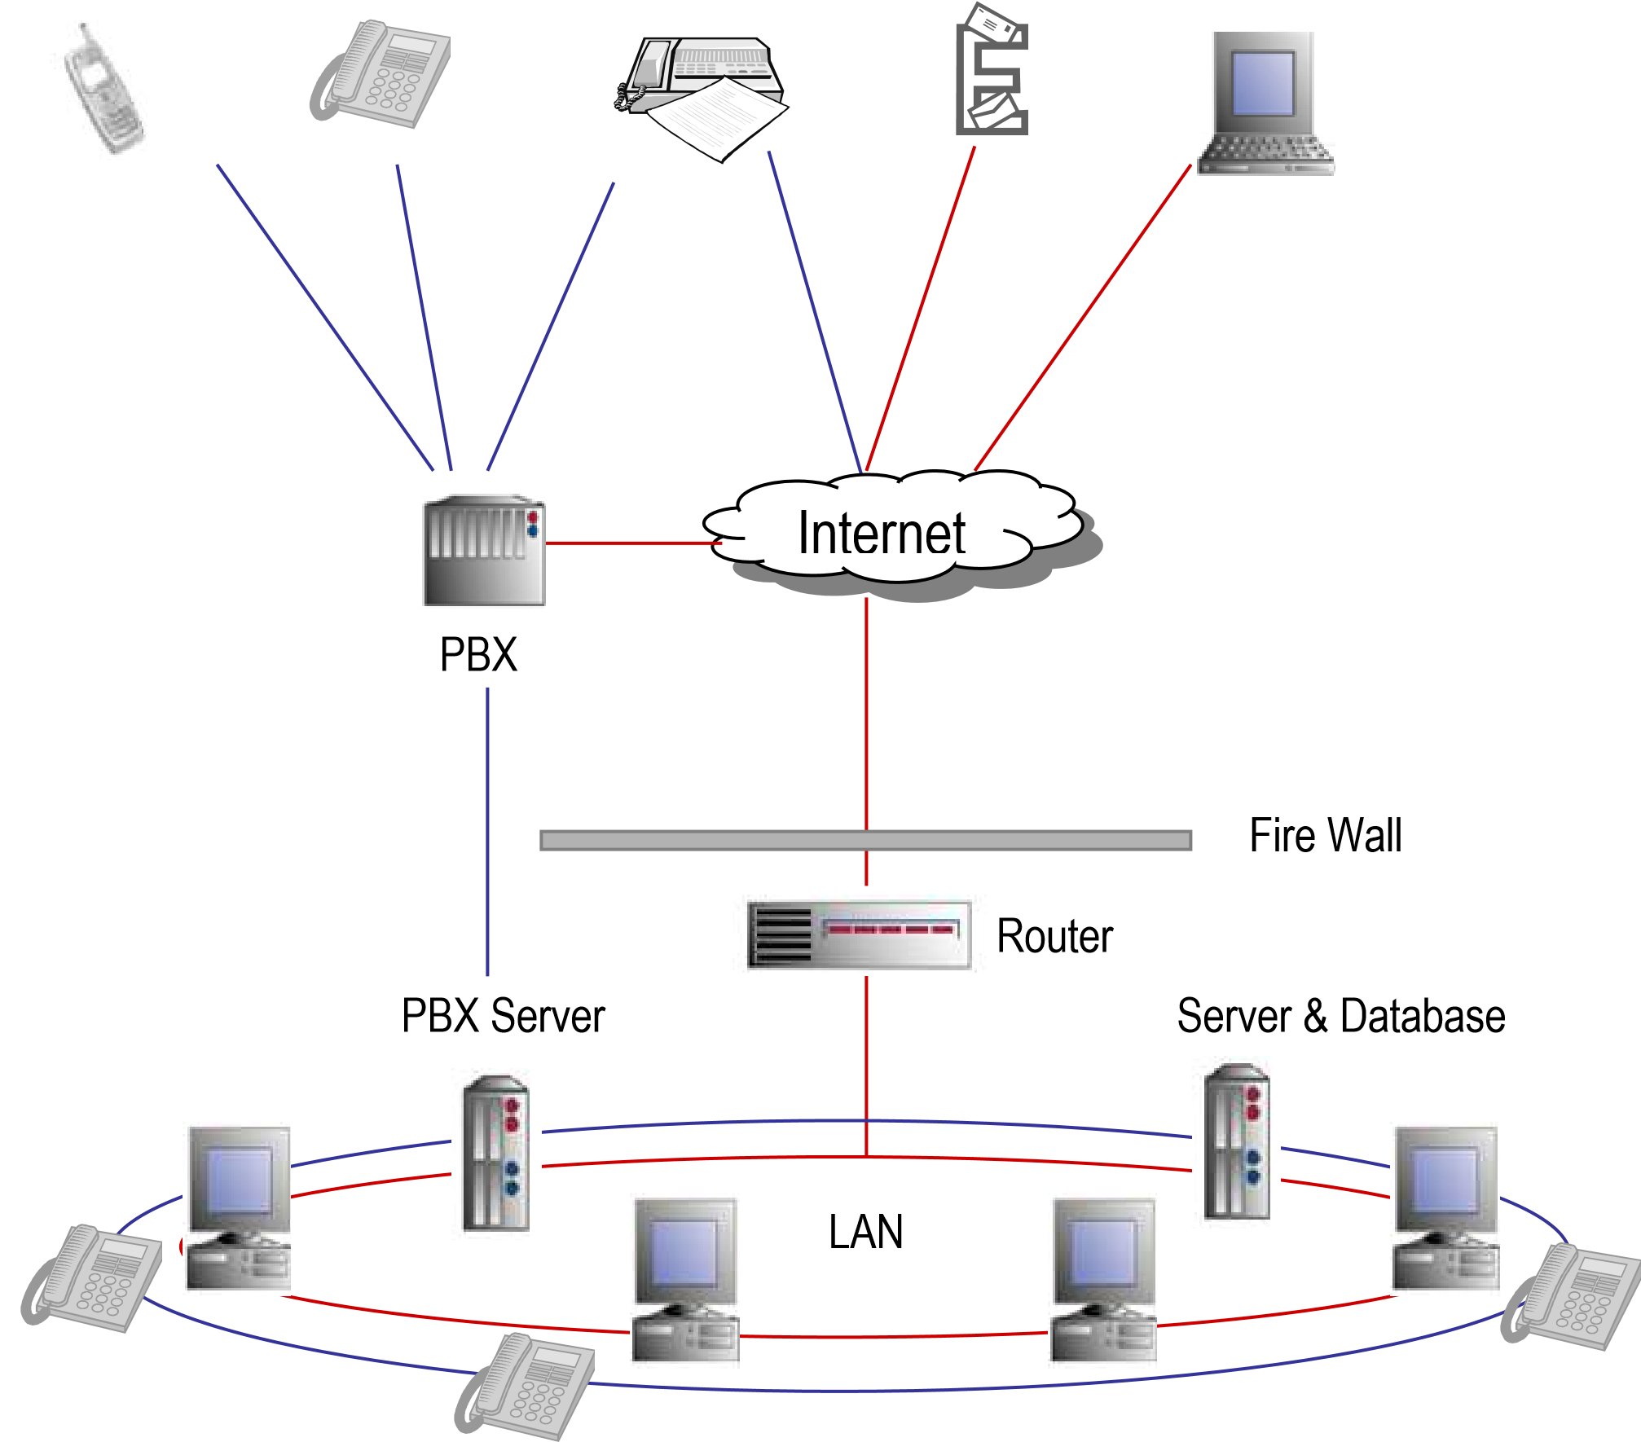

Go to Activity 3 in your Assessment Pack and answer question 3.4 & 3.5 In a cloud based contact centre, the contact center does not own, host, or operate the equipment that the call centre runs on. Instead, the contact centre pays a monthly or annual fee to a VoIP service provider to host the call centre telephony in their own data centre. This allows contact c enters to pay for only the service or minutes that they use, rather paying for the hardware, an IT director, and a place to store the equipment, making it a much more affordable solution.

3.6 Contact Centre Equipment
So, what equipment is essential to promote good ergonomics in a Contact Centre?

Adjustable Chair - This is the number one consideration. And since the center will purchase a chair for each agent anyway, it is important to take the time to research which chair fits your center's specific needs. The most important feature to look for is that it provides maximum adjustability. Well designed chairs should be used to help with good posture and minimize back pain.

Adjustable Keyboard Mechanism - The keyboard mechanism selected should also allow for maximum adjustability. The keyboard needs to be able to tilt and adjust to accommodate each agent's needs.

Wrist Rest - Although not resting your wrists on anything is optimal, human nature is to practice what is comfortable, like resting the wrist on the work surface. This puts unnecessary pressure on the wrist area. The best wrist rests should allow for some "give", such as the gel-filled rests. They provide a comfortable feel in the neutral position without putting unneeded stress on the carpal area.

Adjustable Height Monitor Riser - A monitor riser can save much of the stress put on an agent's neck and eyes. It is important that the monitor is not put in an awkward head position. Monitor risers are available with adjustable arms, optimal for multi-shift Contact Centres, or with simple riser blocks.

Headsets - When agents have to hold onto a telephone receiver, it is difficult to use a computer at the same time. As a result, agents often squeeze the hand piece between their ear and shoulder. This puts a great amount of pressure on the agent's neck. Headsets not only provide an ergonomic solution, they also allow the agent to be more productive. Other items
such as adjustable height workstations, footrests, glare screens and document holders assist in good ergonomics. The foremost thing to consider is that the ergonomic equipment should be tailored to the agents that will be using it, creating an exact ergonomic match to each person's specific needs.

Implement a training plan - Although poor site design is a contributing factor to serious injuries, 80 percent of all injuries are caused by damaging work behaviors. Contact Centres can equip their agents with all of the right equipment, but without proper training, it is all fruitless. The site assessment will point out which type of training program will fit your needs best. It's very important to not only implement the training program but also to use a follow-up plan that will continue to reinforce what the agents have been taught.

Relaxation areas – this includes breakaway rooms, chill areas, access to water fountain etc. to allow agents to distress and take a break during the working day.

Lost production, higher insurance premiums, OSHA fines, worker's compensation, employee turnover, medical costs; and the list goes on. These are just a few of the things employers can look forward to as a result of poor ergonomics.

Ergonomics is the relationship between a worker and his/her work environment or simply "fitting jobs to people". Unfortunately, not all of the hype surrounding ergonomics is a passing phase. It's a real problem that is crippling the lives of the people it affects, many of which are sitting in the Contact Centres we provide

3.7 Aspects of good design in a contact centre

The following factors are aspects of the design of a contact centre where staff work in a comfortable, productive environment and work well:

Lighting – lighting shouldn’t be too bright nor too dark. Lighting shouldn’t shine into the agent’s eyes when they are in front of their workstation screens. Direct light and glares from computer screens can cause eye damage.

Acoustics – refers to the way people hear things. It is important that agents can talk and hear the customers clearly without straining their voices. It is unprofessional to have customers hearing background noises.

Electrical Power – where power failures occur, it is important for the contact centre to have a back-up system (e.g. generator). Most companies install an uninterruptable power supply (UPS).

Workstations – most contact centres are designed in an open-plan style or clustered together in groups. It is advisable to have dividers between agents.

Ventilation & Temperature – Good ventilation is vital for health and comfort of staff. This includes comfortable controlled temperature and use of windows or air conditioners or fans.

Appearance – People work better in pleasant, attractive surroundings. A contact centre should look attractive so that agents and staff feel proud to be a part of and working in their environment. Plants, colours, posters etc. make a difference.

Health & Safety – Issues around health and safety include protecting staff from fire (i.e. easily accessible fire extinguishers).

3.8 Health & Safety Issues

According to the Bureau of Labor and Statistics, in 1981 there were 23,000 cases of job related injuries caused by repeat traumas such as carpal tunnel syndrome. Today, that number has soared to 332,000; over a 1400 percent increase! Experts attribute this to the explosion of computer use in the workplace. These numbers continue to escalate as the world becomes more computer dependent.

As one could guess, these repeat traumas aren't cheap. According to an article in the Wall Street Journal (America), the average carpal tunnel syndrome case requiring surgery costs an astounding $35,000.00. What's more, The Occupational Safety and Health Administration (OSHA) estimates that employers spend around $120 billion a year in direct and indirect costs related to poor ergonomics. Approximately one-third of workers compensation Rands are spent on repetitive motion injuries; injuries often found in Contact Centres.

There are also several non-quantifiable, indirect costs associated with poor ergonomics. They include higher insurance premiums, higher employee turnover, medical treatments (therapy, medications, surgery), OSHA fines, absenteeism, associated labor costs, production loss, legal fees, personnel replacement, claims, administrative costs, worker's compensation, lost benefits, etc… Because there is no steadfast method of measuring these indirect costs, it is very hard to pinpoint just how much these ergonomic injuries are costing Contact Centres.

Productivity is the staple in a successful Contact Centre. No industry understands that better than ours. Whether it is an inbound, outbound or blended center, without healthy, able-bodied employees, you might as well close your Contact Centre’s doors. In fact, it is estimated that ergonomically healthy employees are 20 - 40 more percent productive

PREVENTION - THE BEST MEDICINE
Just a few doses of preventative medicine can be thousands of Rands cheaper than the medical costs associated with a cumulative trauma disorder. To pay for one cumulative trauma, a Contact Centre would lose the productivity of almost two agents!

There are definite precautions that Contact Centre administrators can take to safeguard their centers from poor ergonomic injuries. They include conducting a site assessment of potentially hazardous work areas, modifying agent work areas to be conducive to good ergonomic positioning and posture, and implementing a training plan of all agents to properly use the ergonomic equipment already in place.

Conducting a site assessment - This is a service usually conducted by an occupational health care organization. Some Contact Centre design firms also offer this service. The important thing to remember is to make sure that whomever does the assessment must have the correct training and credentials for it to be truly valid.

Usually in a site assessment, the Contact Centre site is examined to identify situations that may cause agents to retain injuries that could otherwise be prevented with ergonomically correct equipment and work practices. In this process, everything should be accurately documented and later evaluated to submit an optimal recommendation for each unique individual.

Modifying agent work areas - After a complete assessment is made of each agent's work area, you may need to modify the workstation they sit at to make it
"ergonomically friendly" to each individual. The number one thing to consider when designing the workstation is that it should have maximum adjustability. This allows each agent on each shift to adjust the workstation for his/her own ergonomic needs.

In short, in an industry that relies so heavily on its labor pool, it is important that its laborers are in the best possible physical and mental condition as possible. By providing a work area that is ergonomically friendly and that the agents are correctly trained to use, you not only are saving their bodies, you could also be saving your Contact Centre thousands of Rands. Prevention, in this industry, just makes good business sense

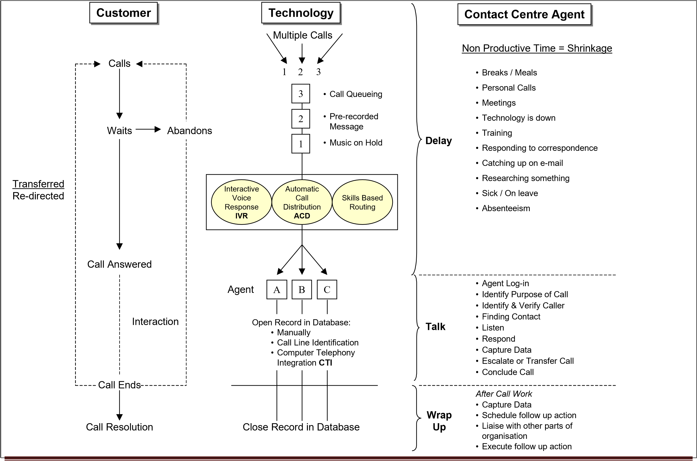
National Certificate: Contact Centre Support NQF 2
SAQA ID71490 LP 73269
Version 01 Page 47

Well Done!

You have completed this module of learning. You will be required to:

Complete your formative learning activities (if you have not already done so in class)
Complete a knowledge questionnaire to test your knowledge and understanding of concepts in this module.
Complete workplace activities to support your understanding – this will be given to you to complete in the workplace.
National Certificate: Contact Centre Support NQF 2 SAQA ID71490 LP 73269
Version 01 Page 48

http://www.mycustomer.com/feature/experience/cloud-based-contact-centres-pros-cons-andpractical-advice/165697
Source: www.geda.co.za
http://www.southafrica.info/about/416221.htm#ixzz1eVZJxOmj
http://mg.co.za/article/2013-12-02-south-africa-ripe-for-call-centre-expansion

