**LEARNER GUIDE**

**67465 National Certificate:**

**Business Administration Services**

**Level 3**

**Module 4 Customer Service**

Unit Standard 13928 Level 3 Credits 4

Monitor and control reception area

**TABLE OF CONTENTS**

**TABLE OF CONTENTS** i

**PERSONAL INFORMATION** 3

**INTRODUCTION** 4

***Programme methodology*** 5

**What Learning Material you should have** 5

**Different types of activities you can expect** 7

**Learner Administration** 8

**Assessments** 8

**Learner Support** 9

**Learner Expectations** 10

**UNIT STANDARD 13928** 11

**MAINTENANCE OF RECEPTION AREA** 13

***Housekeeping Standards*** 14

**Proper place for everything** 14

**Good housekeeping** 14

**Benefits of good housekeeping** 15

**Housekeeping in reception** 15

***Maintain housekeeping operations*** 16

**What is the purpose of workplace housekeeping?** 16

**Cleaning** 18

**Things other than cleanliness** 19

**Do's and Don'ts of housekeeping** 20

***Areas not meeting standards*** 20

**What should be reported?** 21

***Follow procedures*** 24

**Reporting** 24

**Monitor** 24

**Exercise 1 SO1, AC1-4 research activity** 24

**PRESENTATION OF RECEPTION AREA** 25

***Maintain reception area*** 25

***Note non-conformances*** 25

**Checklist** 26

***Identify remedial actions*** 28

***Deal with non-conformances*** 34

**Exercise 2 SO2, AC1-4 group research activity** 35

**SECURITY PROCEDURES** 36

***Security In The Office*** 36

**Securing Unauthorised Areas From Customer Access** 36

**Access Control** 38

**Demarcate Customer And Staff Areas Separately** 38

**Security Of Confidential Documents** 39

**Security Of Personal Items In The Office** 39

**General Office Security** 39

**Firearms** 40

**Emergency plan and evacuation procedure.** 40

***Discrepancies and problems*** 40

**Exercise 3 SO3, AC1-4 individual research activity** 41

**PERSONAL INFORMATION**

|  |  |
| --- | --- |
| *NAME* |  |
| *CONTACT ADDRESS* |  |
|  |
| *Code* |  |
| *Telephone (H)* |  |
| *Telephone (W)* |  |
| *Cellular* |  |
| *Learner Number* |  |
| *Identity Number* |  |
|  | |
| *EMPLOYER* |  |
| *EMPLOYER CONTACT ADDRESS* |  |
|  |
| *Code* |  |
| *Supervisor Name* |  |
| *Supervisor Contact Address* |  |
|  |
| *Code* |  |
| *Telephone (H)* |  |
| *Telephone (W)* |  |
| *Cellular* |  |

**INTRODUCTION**

***Welcome to the learning programme***

Follow along in the guide as the training practitioner takes you through the material. Make notes and sketches that will help you to understand and remember what you have learnt. Take notes and share information with your colleagues. Important and relevant information and skills are transferred by sharing!



This learning programme is divided into sections. Each section is preceded by a description of the required outcomes and assessment criteria as contained in the unit standards specified by the South African Qualifications Authority. These descriptions will define what you have to know and be able to do in order to be awarded the credits attached to this learning programme. These credits are regarded as building blocks towards achieving a National Qualification upon successful assessment and can never be taken away from you!

***Programme methodology***



The programme methodology includes facilitator presentations, readings, individual activities, group discussions and skill application exercises.

**Know what you want to get out of the programme from the beginning and start applying your new skills immediately. Participate as much as possible so that the learning will be interactive and stimulating.**

The following principles were applied in designing the course:

* Because the course is designed to maximise interactive learning, you are encouraged and required to participate fully during the group exercises
* As a learner you will be presented with numerous problems and will be required to fully apply your mind to finding solutions to problems before being presented with the course presenter’s solutions to the problems
* Through participation and interaction the learners can learn as much from each other as they do from the course presenter
* Although learners attending the course may have varied degrees of experience in the subject matter, the course is designed to ensure that all delegates complete the course with the same level of understanding
* Because reflection forms an important component of adult learning, some learning resources will be followed by a self-assessment which is designed so that the learner will reflect on the material just completed.

This approach to course construction will ensure that learners first apply their minds to finding solutions to problems before the answers are provided, which will then maximise the learning process which is further strengthened by reflecting on the material covered by means of the self-assessments.

***Different role players in delivery process***

* Learner
* Facilitator
* Assessor
* Moderator

**What Learning Material you should have**

This learning material has also been designed to provide the learner with a comprehensive reference guide.

It is important that you take responsibility for your own learning process; this includes taking care of your learner material. You should at all times have the following material with you:

|  |  |
| --- | --- |
| ***Learner Guide*** | ***This learner guide is your valuable possession:***  This is your textbook and reference material, which provides you with all the information you will require to meet the exit level outcomes.  During contact sessions, your facilitator will use this guide and will facilitate the learning process. During contact sessions a variety of activities will assist you to gain knowledge and skills.  Follow along in the guide as the training practitioner takes you through the material. Make notes and sketches that will help you to understand and remember what you have learnt. Take and share information with your colleagues. Important and relevant information and skills are transferred by sharing!  This learning programme is divided into sections. Each section is preceded by a description of the required outcomes and assessment criteria as contained in the unit standards specified by the South African Qualifications Authority. These descriptions will define what you have to know and be able to do in order to be awarded the credits attached to this learning programme. These credits are regarded as building blocks towards achieving a National Qualification upon successful assessment and can never be taken away from you! |
| ***Formative Assessment Workbook*** | The Formative Assessment Workbook supports the Learner Guide and assists you in applying what you have learnt.  The formative assessment workbook contains classroom activities that you have to complete in the classroom, during contact sessions either in groups or individually.  You are required to complete all activities in the Formative Assessment Workbook.  The facilitator will assist, lead and coach you through the process.  These activities ensure that you understand the content of the material and that you get an opportunity to test your understanding. |

**Different types of activities you can expect**

To accommodate your learning preferences, a variety of different types of activities are included in the formative and summative assessments. They will assist you to achieve the outcomes (correct results) and should guide you through the learning process, making learning a positive and pleasant experience.



The table below provides you with more information related to the types of activities.

| ***Types of Activities*** | ***Description*** | ***Purpose*** |
| --- | --- | --- |
| ***Knowledge Activities*** | You are required to complete these activities on your own. | These activities normally test your understanding and ability to apply the information. |
| ***Skills Application Activities*** | You need to complete these activities in the workplace | These activities require you to apply the knowledge and skills gained in the workplace |
| ***Natural Occurring Evidence*** | You need to collect information and samples of documents from the workplace. | These activities ensure you get the opportunity to learn from experts in the industry.  Collecting examples demonstrates how to implement knowledge and skills in a practical way |

**Learner Administration**



***Attendance Register***

You are required to sign the Attendance Register every day you attend training sessions facilitated by a facilitator.

***Programme Evaluation Form***

On completion you will be supplied with a “Learning programme Evaluation Form”. You are required to evaluate your experience in attending the programme.

Please complete the form at the end of the programme, as this will assist us in improving our service and programme material. Your assistance is highly appreciated.

**Assessments**

The only way to establish whether a learner is competent and has accomplished the specific outcomes is through the assessment process. Assessment involves collecting and interpreting evidence about the learners’ ability to perform a task.

**To qualify and receive credits towards your qualification, a registered Assessor will conduct an evaluation and assessment of your portfolio of evidence and competency.**

**This programme has been aligned to registered unit standards. You will be assessed against the outcomes as stipulated in the unit standard by completing assessments and by compiling a portfolio of evidence that provides proof of your ability to apply the learning to your work situation.**

***How will Assessments commence?***

***Formative Assessments***

The assessment process is easy to follow. You will be guided by the Facilitator. Your responsibility is to complete all the activities in the Formative Assessment Workbook and submit it to your facilitator.

***Summative Assessments***

You will be required to complete a series of summative assessments. The Summative Assessment Guide will assist you in identifying the evidence required for final assessment purposes. You will be required to complete these activities on your own time, using real life projects in your workplace or business environment in preparing evidence for your Portfolio of Evidence. Your Facilitator will provide more details in this regard.

**To qualify and receive credits towards your qualification, a registered Assessor will conduct an evaluation and assessment of your portfolio of evidence and competency.**

**Learner Support**

**The responsibility of learning rests with you, so be proactive and ask questions and seek assistance and help from your facilitator, if required.**



Please remember that this Skills Programme is based on outcomes based education principles which implies the following:

* You are responsible for your own learning – make sure you manage your study, research and workplace time effectively.
* Learning activities are learner driven – make sure you use the Learner Guide and Formative Assessment Workbook in the manner intended, and are familiar with the workplace requirements.
* The Facilitator is there to reasonably assist you during contact, practical and workplace time for this programme – make sure that you have his/her contact details.
* You are responsible for the safekeeping of your completed Formative Assessment Workbook and Workplace Guide
* If you need assistance please contact your facilitator who will gladly assist you.
* If you have any special needs please inform the facilitator

**Learner Expectations**

Please prepare the following information. You will then be asked to introduce yourself to the instructor as well as your fellow learners

|  |
| --- |
| Your name: |
|  |
|  |
| The organisation you represent: |
|  |
|  |
| Your position in organisation: |
|  |
|  |
| What do you hope to achieve by attending this course / what are your course expectations? |
|  |
|  |
|  |
|  |
|  |
|  |
|  |

**UNIT STANDARD 13928**

***Unit Standard Title***

Monitor and control reception area

***NQF Level***

3

***Credits***

4

***Purpose***

Learners will be learning towards obtaining a national qualification at level 3 or are working in an administrative environment, including SMME`s (Small, Medium and Micro Enterprises), where the acquisition of competence against this standard will add value to the learner`s job, or chances of finding employment.

Learners will be well positioned to extend their learning and practice into other areas in the business environment, or to strive towards professional standards and practice at higher levels.

***Learning assumed to be in place***

Learners will also have demonstrated competence in communication at NQF Level 2.

***Unit standard range***

Presentable will include neat, tidy and clean area

Housekeeping will include washing, polishing, vacuuming, scrubbing, dusting, sweeping, emptying bins, replacing dead flowers and out dated reading material (all interior and exterior surfaces)

Display area will include a structure, floor, ceilings, desks, windows, ashtrays, plants, merchandise area and storerooms

Security will include all stipulated organizational security requirements

***Specific Outcomes and Assessment Criteria***

***Specific Outcome 1:*** Monitor the maintenance of a clean and safe reception area as per organisational requirements

***Assessment Criteria***

Implementation of the housekeeping standards are maintained according to workplace policy.

Housekeeping operations are maintained to ensure no disruption to operational services.

Areas not meeting the required standards are identified and recorded for possible remedial action.

Actions and procedures required to rectify substandard areas are instituted and monitored to ensure minimum standards are met.

***Specific Outcome 2***: Monitor presentation of reception area 

***Assessment Criteria***

Presentation of reception area is maintained according to organisational standards.

Areas of non-conformance are identified, noted and recorded for possible remedial action.

Remedial actions are identified and presented for implementation.

 Areas of improvement are communicated to incumbents.

***Specific Outcome 3***: Monitor the implementation of security procedures in reception area

***Assessment Criteria***

Security procedures are outlined and all reception personnel are briefed verbally and a written summary provided to them.

Visitor’s cards and permits are obtained from security personnel.

Firearm procedures are monitored and maintained as per workplace policy.

Discrepancies and problems are reported and rectified to ensure safety of workplace.

***Unit Standard Accreditation And Moderation Options***

The Services Educational Training Quality Assurance Body (ETQA) will accredit providers offering learning towards these standard and register assessors.

***Unit Standard Essential Embedded Knowledge***

Methods and techniques for monitoring and controlling personnel

Relevant communication skills

Security procedures

***Critical Cross-field Outcomes (CCFO)***

***Unit Standard CCFO Identifying***: The Services Educational Training Quality Assurance Body (ETQA) will accredit providers offering learning towards these standard and register assessors.

***Unit Standard CCFO Working***: Work effectively with others to ensure that the reception area is maintained and that security procedures are adhered to.

***Unit Standard CCFO Collecting***: Collect, analyse, organise and critically evaluate information in order to draw conclusions regarding the required standards and security measures in the reception area.

***Unit Standard CCFO Communicating:*** Communicate effectively with personnel to enhance the maintenance of the reception area and ensure that all procedures are adhered to.

**MAINTENANCE OF RECEPTION AREA**

***Outcome***

Monitor the maintenance of a clean and safe reception area as per organisational requirements

***Assessment criteria***

On completion of this section you will be able to:

Implementation of the housekeeping standards are maintained according to workplace policy.

Housekeeping operations are maintained to ensure no disruption to operational services.

Areas not meeting the required standards are identified and recorded for possible remedial action.

Actions and procedures required to rectify substandard areas are instituted and monitored to ensure minimum standards are met.

***Housekeeping Standards***

Every organisation has housekeeping standards that have to be complied with. This is required by law and is also good business sense. When people visit your office or factory, they do not expect to see an untidy or even dirty place. This is why shops are always kept neat and tidy so that the customer has a pleasant experience when walking in.

When things are left lying around, it also creates health and safety risks and hazards. Your place of work should always be free of hazards and risks such as articles lying around creating the possibility of someone tripping over something and sustaining injuries.

**Proper place for everything**

In the plant or factory and even the office, it is essential that everything has its proper place, i.e., the workplace must be orderly and tidy so that

is no need to search for tools; and equipment

so that space is saved;

so that fire hazards are reduced;

and so that injuries are avoided.

If there is poor housekeeping, the incidence of accidents is bound to increase, e.g., tripping over loose objects; articles dropping from above or on a worker's head; slipping on greasy and dirty floors; staff running into protruding materials and objects; hands and other bodily parts being injured on projecting items such as nails; and fires.

***Definition of housekeeping: A place for everything and everything in its place.***

**Good housekeeping**

* CSAFE004Good lighting.
* Good ventilation
* Hygiene facilities to be kept clean
* All aisles and storage areas clearly marked
* Good stacking and storage practices
* Stacked goods must not endanger life
* Factory yards must be kept tidy
* All refuse to be placed in bins

***Poor housekeeping***

* Unnecessary rubbish, waste and vegetation in the yard
* Poor stacking/storage practices
* Unsafe handling of flammable liquids
* Compartments not kept in good condition.

***Remember the definition of housekeeping***; the following steps should be practiced in the housekeeping concept.

* Passages, aisles and walkways should be marked and kept clear of obstacles to prevent workers and visitors from injuries.
* Waste bins should be provided. If there is no waste bins workers tend to through waste materials and papers on the floor, this will create a fire hazard in the work place.
* All spillages must be cleared and cleaned immediately to prevent workers to slip, or be contaminated if chemicals are involved.
* Report any unusual parcels or packages to security
* Place everything in the correct place and store all products correctly.
* Clean up your work place at the end of every shift. (Do not leave it for the follow-up shift to clean.

**Benefits of good housekeeping**

The effect of good housekeeping on staff is that it improves both the working environment and morale of the workforce. This means more pleasant working conditions which will in the long-term increase efficiency, ineffectiveness and economy.

The main benefits of good housekeeping are as follows:

* Reduced operating costs
* Improved production control
* Production time is saved;
* Traffic flow is facilitated;
* There is higher employee morale
* Increased production materials and parts are conserved
* Space is better utilised;
* Accidents are reduced;
* Fire hazards are reduced.

**Housekeeping in reception**

The reception area of an organisation is ***very*** important. This is where the customer gets his/her first impression of the organisation.

You will find that different organisations have different standards and procedures, although all of them will demand neatness and cleanliness. Where some differences come in are for example, some organisations want fresh flowers on the reception desk every 3-4 days.

You can check on the following things:

Dust on the desk, in corners and on the floor

* Spider webs under the desk, in the corners near the roof and under chairs in the reception area
* See to it that the dustbin is not overflowing
* Furniture should be clean and stain free.
* See to it that there are no dishes such as dirty cups standing around.

Daily tasks include:

* Dusting
* Sweeping
* Vacuum cleaning
* Taking care of dishes
* Wiping down furniture with a damp cloth (other that dusting to get rid of thins such as coffee cup marks etc)
* Emptying dustbins.

Normally the cleanliness of any area in an office space is left up to the cleaning lady, but it will most probably be up to you to over see that these things are carried out properly.

If an area is not attended to, you should follow proper procedures to rectify the problem. Write down the areas that are not up to standard and the problems that you’ve noticed so that you can hand the problem to the superior of the cleaning lady with details.

***Note: Most of these procedures will be discussed with you in your induction training when you start your new job at an organisation.***

Once you have done so, the area will most probably be taken care of though you should still monitor the area.

***Maintain housekeeping operations***

**What is the purpose of workplace housekeeping?**

Poor housekeeping can be a cause of accidents, such as:

* tripping over loose objects on floors, stairs and platforms
* being hit by falling objects
* slipping on greasy, wet or dirty surfaces
* striking against projecting, poorly stacked items or misplaced material
* cutting, puncturing, or tearing the skin of hands or other parts of the body on projecting nails, wire or steel strapping

To avoid these hazards, a workplace must "maintain" order throughout a workday. Although this effort requires a great deal of management and planning, the benefits are many.

***You are responsible for keeping your work area neat and tidy.***

***Housekeeping order is "maintained" not "achieved."***

Cleaning and organization must be done regularly, not just at the end of the shift. Integrating housekeeping into jobs can help ensure this is done. A good housekeeping program identifies and assigns responsibilities for the following:

clean up during the shift

day-to-day cleanup

waste disposal

removal of unused materials

inspection to ensure cleanup is complete

***Surfaces***

Floors: Poor floor conditions are a leading cause of accidents so cleaning up spilled oil and other liquids at once is important. Allowing chips, shavings and dust to accumulate can also cause accidents. Trapping chips, shavings and dust before they reach the floor or cleaning them up regularly can prevent their accumulation. Areas that cannot be cleaned continuously, such as entrance ways, should have anti-slip flooring. Keeping floors in good order also means replacing any worn, ripped, or damaged flooring that poses a tripping hazard.

Walls: Light-coloured walls reflect light while dirty or dark-coloured walls absorb light. Contrasting colours warn of physical hazards and mark obstructions such as pillars. Paint can highlight railings, guards and other safety equipment, but should never be used as a substitute for guarding. The program should outline the regulations and standards for colours.

***Maintain Light Fixtures***

Dirty light fixtures reduce essential light levels. Clean light fixtures can improve lighting efficiency significantly.

***Aisles and Stairways***

Aisles should be wide enough to accommodate people and vehicles comfortably and safely. Aisle space allows for the movement of people, products and materials. Warning signs and mirrors can improve sight-lines in blind corners. Arranging aisles properly encourages people to use them so that they do not take shortcuts through hazardous areas.

Keeping aisles and stairways clear is important. They should not be used for temporary "overflow" or "bottleneck" storage. Stairways and aisles also require adequate lighting.

**Cleaning**

Most of the cleaning that takes place has to be done before the office opens as customers really do not want to walk into an office, shop or factory where the cleaners are still busy washing, vacuuming and polishing.

you have to therefore make sure that the following activities take place before the office or shop opens or after the office or shop has closed:

washing and polishing of floors

vacuuming of carpets and chairs

dusting of tables, counters and ornaments

Maintaining housekeeping also means that throughout the day you have to:

tidy your counter by removing unnecessary papers, staples and other rubbish and putting them into a dustbin

cleaning up spills or making sure that spills are cleaned immediately

wiping the counter with a CLEAN cloth – please do not use an old and dirty rag to clean the counter top with, customers will be put off by this.

arranging chairs, tables and other furntiture so that they appear neat

picking up and arranging magazines and newspapers where customers leave them and arranging them tidily again

picking up rubbish left by customers and placing them in a waste basket (dustbin or rubbish bin)

empltying out the rubbish bin continually throughout the day

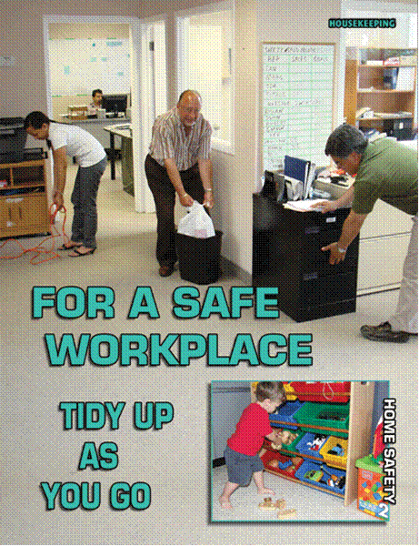

**Things other than cleanliness**

Decoration is somewhat up to you. Things such as flowers would be your responsibility and would be a nice extra to show you care as well.

Another contribution could be seeing to it that the latest magazines and the daily paper are available in the waiting area if there is one. This keeps the customers busy if they need to wait for an appointment.



**Do's and Don'ts of housekeeping**

|  |  |
| --- | --- |
| **DO:**  Keep floors clean and clear of waste.  Keep workplaces adequately lighted.  Keep light fixtures clean.  Inspect and clean machinery and tools regularly.  Clean up spills immediately. | **DON’T:**  Use aisles and stairways as storage areas.  Allow materials to build up on floors.  Block emergency exits, fire equipment or first aid stations with stored materials.  Store compressed gases near heat sources. |

***Areas not meeting standards***

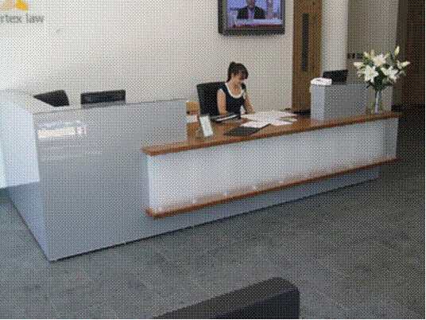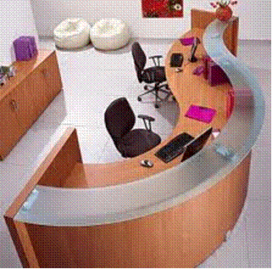

Reception should ***always*** be neat and tidy as shown above.

***If not, something must be done about it immediately.***

For example, when a customer has left the magazines in an untidy heap, you have to tidy them immediately.

Or when something has been spilt, have it cleaned immediately, even if you have to do it yourself.

if a colleague has helped a customer in reception and left files and other articles lying around, contact the person and request him/her to remove the items immediately. If not, arrange for someone to take the items to your colleague.

***Identify the remedial action that has to be taken and then do it or see that it is done***

Reception is the first thing anyone sees when they walk into the business. Your reception desk and area should ***never*** look like this!

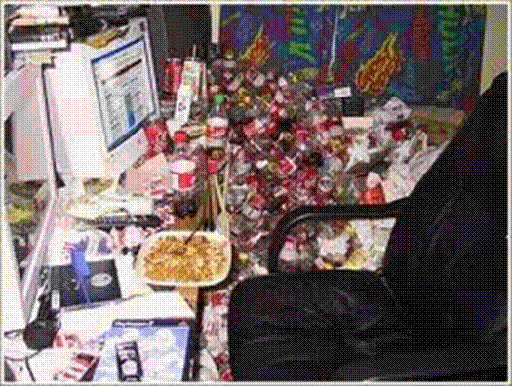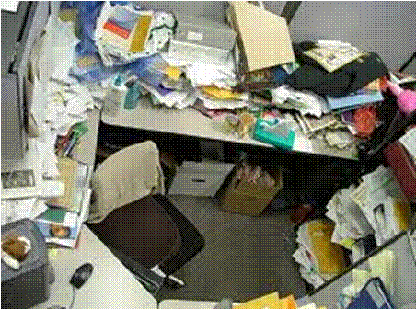

**What should be reported?**

When a carpet has stains that does not wash out when the cleaner washes the carpets

Floor or carpet tiles that are loose

Electical cables running over the floor that have not been protected

Lighting that is too dim – remember, one of the important aspects of housekeeping is proper lighting

Items stacked in aisles and other areas commonly used by people for walking

Electrical hazards such as too many electical plugs in a socket

Any other safety hazards

Anything else required by the policies and procedures of your organisation.

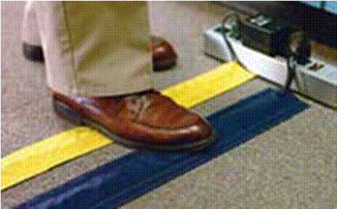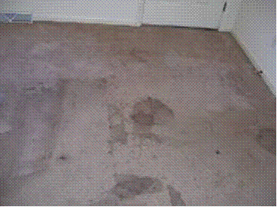



Look at all the hazards created by untidiness in the pictures below. Many of these hazards have to be rectified by reporting them.

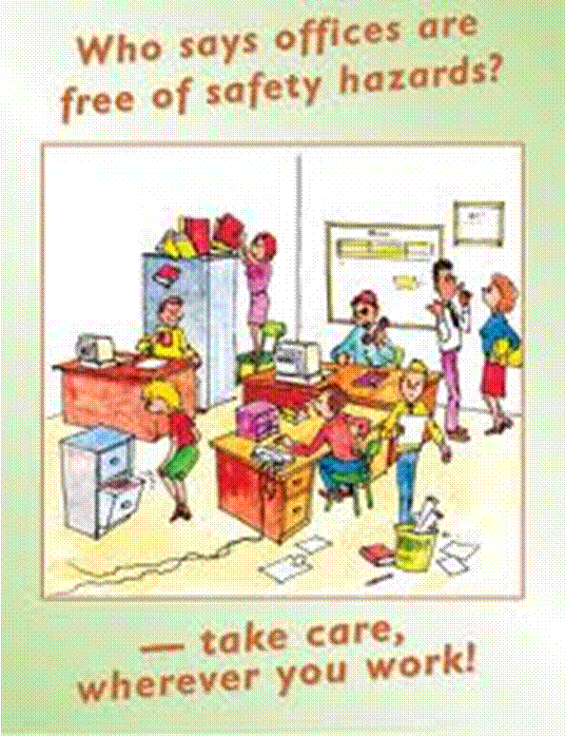

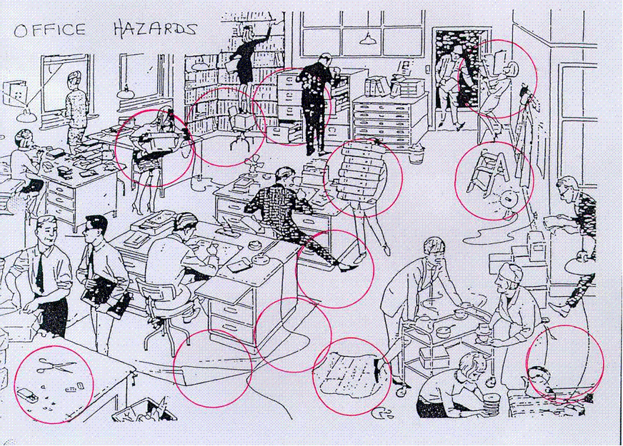

***Follow procedures***

**Reporting**

The Occupational Health And Safety Act 85, 1993 requires employees to report unsafe conditions, usually to the supervisor and the health and safety committee.

***Workplace safety procedures are designed to keep employees, visitors and customers safe while helping to reduce the stress associated with the work area.***

The procedure to follow could be any of the following:

completing a form and sending copies to your supervisor and the health and safety committee

send a memo to the person responsible

send an e-mail to the person responsible

bring the substandard area needing attention to the attention of the health and safety committee during weekly meetings

The procedure that has to be followed will depend on the urgency of the situation. Make sure that you report areas needing attention immediately.

**Monitor**

Just handing in a report is not enough – you also have to follow up to make sure that the specific problem will be attended to as soon as possible. This means that you have to contact the person who has to attend to the problem to find out when the situation will be resolved, until the hazard has been attended to.

**Exercise 1 SO1, AC1-4 research activity**

Complete the activity in the workbook

**PRESENTATION OF RECEPTION AREA**

***Outcome***

Monitor presentation of reception area

***Assessment criteria***

Presentation of reception area is maintained according to organisational standards.

Areas of non-conformance are identified, noted and recorded for possible remedial action.

Remedial actions are identified and presented for implementation.

Areas of improvement are communicated to incumbents

***Maintain reception area***

The process of monitoring the presentation of the reception area is ongoing and has to be done daily.

First you have to find out what the standards are that are required of the reception area:

must the area be vacuumed and dusted every day?

At what time of the day must this take place? Vacuuming and dusting should be done early in the morning, before visitors arrive, as it is disturbing to clients when someone is vacuuming around their feet.

How often should the flowers be replaced?

Is there a water container and, if so , how often should it be filled?

Do you offer visitors something to drink such as tea, coffee or cold drinks? If so, who is responsible for preparing the drinks?

When should the empty cups and glasses be removed and by whom?

What are the procedures to follow if any of the activities are not carried out promptly – who should report the matter and who should the matter be reported to?

Then you have to maintain the area as required.

***Note non-conformances***

Once you know what is required, you will be able to monitor the presentation of reception. A checklist will help you to monitor reception, although this procedure may be different in different organisations. The checklist is then used every day to tick off the tasks that were or were not carried out in order to keep reception clean, tidy and friendly.

This way non-conformances can be spotted quickly and action can be taken to rectify the matter.

**Checklist**

Following is a checklist that contains some things you should check every day:

***Floor:***

|  |  |
| --- | --- |
| Objects | Hazards |
| Floor surface | Highly polished floors or smooth surfaces may be a slip hazard  Patterns on floors can cause vertigo and alter depth perception  Plush carpet catches feet |
| Wet floor | Water carried inside onto floors during wet weather |
| Change in floor level or surface | Changes in floor level (e.g. step or ramp)  Interface between different floor materials (e.g. from tiled floor to a carpeted one) |
| Damaged flooring | Damaged flooring (e.g. cracked or broken tiles, holes in carpet, projecting edging strips) |
| Housekeeping | Tripping hazards left on floor (e.g. deliveries)  Rubbish left by visitors |
| Floor furnishings | Having rugs and other floor furnishings may introduce trip hazards  Possible allergies |

***Furniture***

|  |  |
| --- | --- |
| Objects | Hazards |
| Reception counter | Shape or area of counter workspace requires repetitive twisting and/or stretching to reach equipment or documents whilst seated  Insufficient counter space for establishing efficient method of work  Reception area not intended to be used for bulky deliveries which arrive there |
| Plants | Plants that have allergenic or poisonous qualities  Positioning of plants may obstruct vision of certain areas of office/access points |
| Toys / games / reading material | Transfer of germs / diseases  Sharp objects in reach of children who may injure themselves  Small toys / items may be swallowed by children |
| Visitor furniture | Transfer of germs / diseases  Furniture with sharp edges / corners |

***Electrical appliances***

|  |  |
| --- | --- |
| Objects | Hazards |
| Data cables and extension leads | Cables or leads located in trafficable area  Cables or leads with exposed wiring or damaged connections |
| Appliances | Electrical appliance or tool has developed a fault, or has defective insulation or exposed wiring  Coffee machines / urns / water coolers containing hot water |
| Outlets | Inserting objects (toys, spoons) into working outlets (children) |
| Liquid spillages | Electrically powered appliance or tool that may have become 'live' after having liquid spilt over it |

***Ventilation***

|  |  |
| --- | --- |
| Objects | Hazards |
| Air flow | Insufficient volume of air through the area |
| Air temperature | High or low indoor air temperatures |
| Humidity | High or low levels of relative humidity in workplace |
| Atmospheric contaminant | High levels of dust or other particles (e.g. pollen, printer emissions) in indoor air  Harmful levels of airborne contaminants (e.g. lead fumes, acid mist, solvent vapour) released by specific work processes |
| Disease control | Spread of harmful bacteria via central air-conditioning system (e.g. Legionnaire disease) |
| Odours from the street | Odours and airborne contaminants entering building from the street  Excess accumulation of odours inside the workplace |

***Entry and exit***

|  |  |
| --- | --- |
| Objects | Hazards |
| Automatic doors | Automatic doors which don't open quickly enough on approach  Automatic doors which close too quickly (especially when used by disabled persons) |
| Doors with no through visibility | Being struck by a door opened by a person from the other side |
| Glass doors | Failure to see a clear glass door immediately ahead |
| Deliveries | Goods delivered to reception area causing obstruction of doorways and passageways |
| Stairs and ramps | Insufficient disabled access  Uneven surfaces  Poor lighting of stairwells or ramps  Wet areas  Obstructions |

***Identify remedial actions***

Once you have identified the non conformance, you have to be able to state what has to be done to fix it.

We provide a checklist with indications of what can be done.

***Floor***

|  |  |  |
| --- | --- | --- |
| Objects | Hazards | Possible Controls |
| Floor surface | Highly polished floors or smooth surfaces may be a slip hazard  Patterns on floors can cause vertigo and alter depth perception  Plush carpet catches feet | Choose a non-slip floor material or one with a textured surface  Use a non-slip floor polish or cleaner  If terrazzo or similar surface, have walk areas abraded (roughened) to remove shine  Choose plain patterns without swirls or 3D images  Use short pile carpet to reduce the chance of tripping and allow delivery trolleys and carts ease of movement on the carpet |
| Wet floor | Water carried inside onto floors during wet weather | Use appropriate signage to warn of slip hazard when floors are wet  Ensure that floors are regularly checked and maintained to be free from water  Provide non-slip matting for people to wipe their feet before entry  Ensure appropriate drainage at entry to workplace |
| Change in floor level or surface | Changes in floor level (e.g. step or ramp)  Interface between different floor materials (e.g. from tiled floor to a carpeted one) | Where possible ensure that joins are flush with adjoining floor levels and are not raised at any point  Use rounded facing for joins not at same level  Display appropriate signage to identify the hazard to people using the area  Consider extra lighting and floor markings to identify the hazard to people using the area  Avoid having changes in surface where these occur at unexpected points in the walk area |
| Damaged flooring | Damaged flooring (e.g. cracked or broken tiles, holes in carpet, projecting edging strips) | Ensure any damaged flooring is repaired as soon as possible  Place appropriate warning signs over damaged area, or remove access to the area until repaired |
| Housekeeping | Tripping hazards left on floor (e.g. deliveries)  Rubbish left by visitors | Ensure there is adequate 'off-the-floor' storage and designated areas for deliveries  Process deliveries as soon as practicable  Provide a clearly marked bin for disposal of waste materials  Conduct regular housekeeping inspections |
| Floor furnishings | Having rugs and other floor furnishings may introduce trip hazards  Possible allergies | Ensure rugs and other floor furnishings are easily visible and have a low profile to reduce chance of tripping and that they are rubber backed to prevent slipping  Use hypo-allergenic rugs and floor furnishings to reduce the risk of allergic reactions |

***Furniture***

|  |  |  |
| --- | --- | --- |
| Objects | Hazards | Possible Controls |
| Reception counter | Shape or area of counter workspace requires repetitive twisting and/or stretching to reach equipment or documents whilst seated  Insufficient counter space for establishing efficient method of work  Reception area not intended to be used for bulky deliveries which arrive there | Identify all tasks expected to be performed and the actions and equipment used for these  Relocate frequently used items of equipment within optimum reach sector of  counter  Replace with a larger counter which has adequate space to perform all reception duties  Provide separate table or box to one side of reception counter clearly marked 'Deliveries' |
| Plants | Plants that have allergenic or poisonous qualities  Positioning of plants may obstruct vision of certain areas of office/access points | Choose plants that do not flower and are not poisonous  Discuss plant selection with plant provider or nursery  Ensure plants are positioned so they do not obstruct view |
| Toys / games / reading material | Transfer of germs / diseases  Sharp objects in reach of children who may injure themselves  Small toys / items may be swallowed by children | Clean toys regularly with anti bacterial cleaners  Ensure sharp objects are kept out of reach of children  Ensure toys are labelled for the appropriate age groups  Ensure small objects are kept out of reach of children  Consider signage requesting children are supervised at all times |
| Visitor furniture | Transfer of germs / diseases  Furniture with sharp edges / corners | Select furniture that is easily cleaned  Clean furniture and equipment  Consider providing antibacterial wipes / hand wash  Minimise furniture and storage in room  Where appropriate provide furniture with rounded edges otherwise consider providing corner guards for tables and sharp edges |

***Electrical appliances***

|  |  |  |
| --- | --- | --- |
| Objects | Hazards | Possible Controls |
| Data cables and extension leads | Cables or leads located in trafficable area  Cables or leads with exposed wiring or damaged connections | Use conduit to route cables and leads to reduce the risk of damage from traffic  Keep cables, leads and conduit out of trafficable areas where they may become damaged  Where leads and cables must be located in trafficable areas, secure appropriately to protect them from damage and to prevent tripping (e.g. using tape)  Regularly inspect and test cables and leads and keep records that are easily accessible to workers  Install power points close to appliances to avoid the use of extension leads  Use extension leads for temporary connection only  Remove damaged leads and cables |
| Appliances | Electrical appliance or tool has developed a fault, or has defective insulation or exposed wiring  Coffee machines / urns / water coolers containing hot water | Have electrical appliances inspected on a regular basis, and if required tested, and record this information  Where equipment is identified for repair, it should be immediately removed from service and appropriately labelled to prevent further use  Consider installing a safety switch on power supply  Keep potentially dangerous appliances out of reach of children |
| Outlets | Inserting objects (toys, spoons) into working outlets (children) | Ensure safety covers are installed on power outlets that are not in use  Consider installing a safety switch on power supply |
| Liquid spillages | Electrically powered appliance or tool that may have become 'live' after having liquid spilt over it | Ensure staff keep liquids well away from electrical appliances  Ensure appliance is disconnected from power before cleaning spill  Ensure appliances are not connected near sources of water  If equipment has been effected by liquid ensure it is inspected and tested prior to use and the details are recorded |

***Ventilation***

|  |  |  |
| --- | --- | --- |
| Objects | Hazards | Possible Controls |
| Air flow | Insufficient volume of air through the area | Arrange for rate of air flow to be measured and if necessary increase  Ensure placement of air-conditioning vents is appropriate to allow adequate air flow (i.e. within enclosed offices) |
| Air temperature | High or low indoor air temperatures | Have temperature in affected area measured and adjustments made to stabilise temperature in the area in consultation with the effected workers  Look at location of workstations in relation to ducts and openings |
| Humidity | High or low levels of relative humidity in workplace | Have humidity in affected area measured and adjusted to the appropriate level in consultation with the effected workers |
| Atmospheric contaminant | High levels of dust or other particles (e.g. pollen, printer emissions) in indoor air  Harmful levels of airborne contaminants (e.g. lead fumes, acid mist, solvent vapour) released by specific work processes | Ensure that filters are of the correct type to remove expected contaminants and that filters are clean and replaced regularly  Ensure local control measures such as exhaust ventilation are in place to remove contaminants at the source |
| Disease control | Spread of harmful bacteria via central air-conditioning system (e.g. Legionnaire disease) | Ensure that air-conditioning equipment is being serviced in accordance with manufactures instructions  Ensure that checks are being carried out for the detection and measurement of harmful bacteria |
| Odours from the street | Odours and airborne contaminants entering building from the street  Excess accumulation of odours inside the workplace | Implement a smoking policy to ensure employees and visitors do not smoke near access points or ventilation intakes  Consult with other relevant people in relation to smoking guidelines around the building  Utilise air-conditioning, ventilation systems and extraction units to ensure the air is adequately ventilated and excess odours removed from the workplace |

***Entry and exit***

|  |  |  |
| --- | --- | --- |
| Objects | Hazards | Possible Controls |
| Automatic doors | Automatic doors which don't open quickly enough on approach  Automatic doors which close too quickly (especially when used by disabled persons) | Have door-opening speed adjusted to ensure door opening matches normal approach speed  Have door sensors adjusted to delay closure until disabled persons are safely clear of doors |
| Doors with no through visibility | Being struck by a door opened by a person from the other side | Place warning signs next to doors on side which opens outwards (on both sides if a swing door)  Install a viewing window or install a glass door  Mark the footprint or opening pattern of the door on the ground (the space the door could swing through on opening and closing) |
| Glass doors | Failure to see a clear glass door immediately ahead | Apply decorative strip or branding across door to provide visible warning of presence of glass across path  Mark the opening pattern of the door on the ground |
| Deliveries | Goods delivered to reception area causing obstruction of doorways and passageways | Ensure receptionist is instructed to contact the addressee and arrange for immediate collection  Have larger deliveries redirected to another entrance (loading bay) if possible  Allocate a specific storage area for deliveries, away from trafficable areas |
| Stairs and ramps | Insufficient disabled access  Uneven surfaces  Poor lighting of stairwells or ramps  Wet areas  Obstructions | Ensure appropriate disabled access is available  Have policies or procedures for assisting disabled persons  Consider installing tactile ground surface indicators to warn people with a vision impairment they are approaching a hazard  Ensure stairways and ramps are well lit  Ensure trafficable areas are free from obstructions  Have appropriate support rails in place  Ensure appropriate drainage around stairs and walkways  Have non slip surfaces  Have appropriate signage to identify where a step may be present (e.g. 'watch your step') |

***Deal with non-conformances***

Once you have identified the non-conformance you have to report it, following the procedures laid down by your organisation.

It would usually inlcude completing a form that gives full details of the non-conformance.

Then, of course, you have to monitor progress until the non-conformance has been dealt with. if it takes too long or longer than everyone at first thought, report the matter to your supervisor and the health and safety committee.

***Remember – you are responsible for reception and you will be held accountable if non-conformances are not attended to.***

An example of a form that has to be completed follows

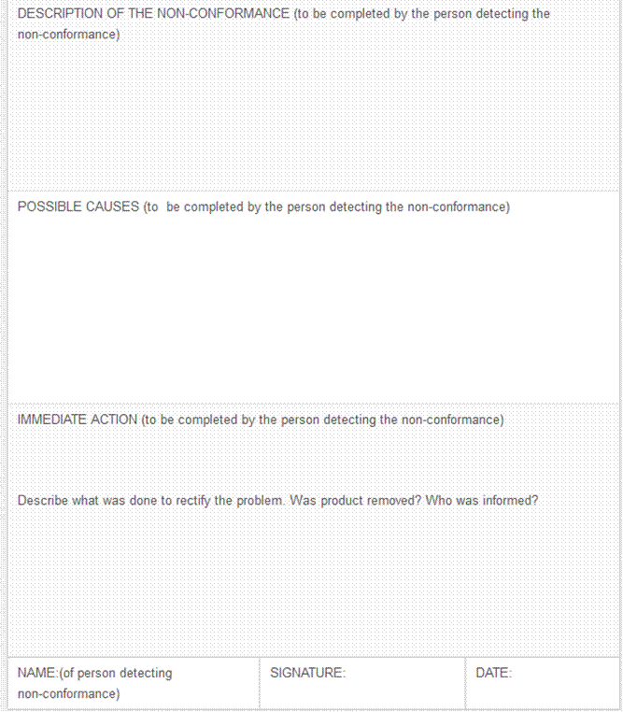

**Exercise 2 SO2, AC1-4 group research activity**

Complete the activity in the workbook

**SECURITY PROCEDURES**

***Outcome***

Monitor the implementation of security procedures in reception area

***Assessment criteria***

Security procedures are outlined and all reception personnel are briefed verbally and a written summary provided to them.

Visitor’s cards and permits are obtained from security personnel.

Firearm procedures are monitored and maintained as per workplace policy.

Discrepancies and problems are reported and rectified to ensure safety of workplace.

***Security In The Office***

**Securing Unauthorised Areas From Customer Access**

These security measures must be enforced in all customer-, staff- and storage areas. It is of no use to control access to certain areas, such as reception, while others, such as despatch, are exposed to breeches of security measures.

Often, criminals will pose as customers in order to get access to the premises. They can then see what security system is in place, and how to bypass these systems, especially if they are given access to unauthorised areas.

Typically, the fire exit, receiving and despatch and back doors of the premises will be observed in fine detail by criminals. What could be easier than to gain access to the premises through the front door and then leave through a back door that was left open?

While shopping at the mall you aren’t allowed access to all areas. You only visit those areas demarcated for customers. Other areas, such as stores, offices and maintenance facilities are out of bounds to customers, for good reason. You don’t know when a customer is really interested in buying something or is just in the building to spy.

During business operations there is a constant flow of goods in and out of the business. Before goods are presented to the customer, it has to be received, and often has to be processed or stored for some time. It is during this period that goods are not under constant staff- or public scrutiny, and thus exposed to theft and/or tampering, that unauthorised access to these goods can lead to loss of, or damage to goods.

Unauthorised access to offices exposes the operation to elements such as industrial espionage. It is also possible for the unwanted visitor to tamper with or remove important documents or get confidential information of the business operations from computers or files in the office area.

Likewise, someone with bad intent can access areas containing emergency power supply, air conditioning or communication systems, if they are not secured, and cause severe disruption of operations if he should want to sabotage any of these.

From the above it stands to reason that it is of the utmost importance that certain areas in a business must be secured against access to the general public.

It is unfortunately also necessary to subject all staff to the same security measures as a large portion of pilferage in a business is due to own staff’s unauthorised profit sharing (commonly known as ….“theft”).

Sometimes staff members work together with criminal gangs, enabling them to gain access to areas that they would otherwise not be able to get into. For this reason staff are also not allowed access to all areas in an organisation.

**Access Control**

A complete written security policy and procedures, which has been approved and signed off.

ID Card system on a database for all employees and permanent contractors, to give them access to the premises.

Visitor cards for all visitors. These would give visitors temporary access to the premises. At the same time, the ID numbers, contact details and at times even the photos of visitors would be on record, if needed.

Search and seizure procedures, which would authorise the security department to search vehicles and hand luggage, such as briefcases and handbags, of people entering and leaving the premises.

Goods movement procedures, (permits, etc.) to move goods into and out of the premises.

**Demarcate Customer And Staff Areas Separately**

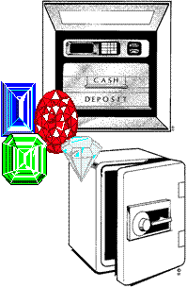Banks, jewellery shops and other high risk businesses have smaller customer access areas than a supermarket or a clothing store.

When you walk into a bank you can go as far as the counters and no further. Most of the staff work behind the counter, at times behind safety glass as well. Each teller has only enough cash to handle the daily transactions, most of the cash is kept in a safe, where most staff do not have access to it, with good reason. It follows, therefore, that in banks, customer and staff areas are demarcated separately. This is done to safeguard the employees as well as to protect the cash.

In jewellery stores, customer and staff areas are also separated by means of counters. Some items of jewellery are put on display behind locked glass counters, while the rest are kept at the back of the shop, outside customer view, presumably in a safe or other safe place. When you request to look at a specific item, it will be taken out, one piece at a time, for you to look at. You first have to give this piece back before the next piece will be handed to you. This is done to ensure that a casual robber will only go off with one piece of jewellery.

When an armed robbery takes place, the robbers will smash and grab the jewellery that is on display while the rest of the jewellery remains in the safe, hopefully. The same goes for banks.

Supermarkets on the other hand, have large customer areas, to enable customers to shop comfortably. However, their staff areas, such as administration, rest rooms and so on, are situated separately to ensure that customers do not have open access to these areas.

In this way, most organisations will have separate areas for customer access and staff access. This is done to ensure that customers do not accidentally end up in the staff or storage areas. The reason for this is to maximise the safety of goods and employees.

The security department will usually be consulted on how and where to demarcate customer and staff areas.

**Security Of Confidential Documents**

There will always be some documentary evidence of confidential matters and the leaking of confidential information can lead to very serious consequences for the organisation and its employees as well as the clients of the organisation.

This then means that confidential documents should be handled in such a way that the contents remain confidential and that they can only be accessed by authorised personnel.

All confidential files should normally locked away in a safe or filing cabinet and removed only when required

Only authorised personnel should have keys to the safe or the filing cabinet

Files that are removed should be signed for by authorised personnel

The person in charge of the files should ensure that files are returned speedily

All staff should sign a non-disclosure of confidential information agreement.

Everybody in the office should be tasked with issues regarding confidentiality and the correct handling of confidential information

Everybody in the office should ensure that confidential information does not lie around the office where unauthorised people can read the files

**Security Of Personal Items In The Office**

Carry as few as possible personal items with you when you go to work.

Handbags and briefcases should be kept in locked drawers or cupboards, with the key in your pocket or attached to your necklace.

Wear a minimum of jewellery to the office and, if you remove them during the day, place them in your handbag or briefcase, which you store in a locked cupboard.

Remember that you are the only person responsible for the security of your personal belongings.

**General Office Security**

Every person in the organisation is responsible for his own safety and security as well as that of every other member of the organisation and also of the organisation’s assets and business.

Confidential papers, as mentioned, should be locked away in fire proof cabinets or safes

Ensure that you are aware of the procedure to follow in case of a fire or bomb threat.

Fire extinguishers must be clearly marked, kept unblocked and fire doors must be left unlocked while staff is on the premises.

Torn or worn floor covering should be reported and replaced.

Security and other gates should be kept locked and the keys removed to a safe storage place. Remote controls must be issued with care and signed for by the recipients. They should be used responsibly and not handed over to just anyone.

Only designated staff, such as security or reception, should be allowed to operate entrance gates to allow visitors to gain entry to the premises.

Security or Reception should be notified of who is expected to visit the premises at any given time.

Visitors should not be allowed to wander around a firm unescorted. They should be collected from the reception area and taken to the person with whom they have an appointment.

Avoid answering questions from visitors about the organisation’s business. There are industrial spies who are trained to ask apparently trivial questions that may inadvertently reveal vital information.

Do not leave keys in doors. Think of what will happen if a key is stolen or duplicated by a dishonest person. One set of extra keys should be kept is a safe and one full set of keys must be left with a responsible member of staff in case of emergency.

Cash and petty cash should be locked away. If banking is done regularly, vary the time and route to avoid attempted theft.

Note the numbers on equipment so that they can be traced in the event of a theft.

Do not let unauthorised people remove office equipment. If the equipment has to be taken out of the office for repairs, ensure that arrangements to this effect has been made, ensure that the person taking the equipment is authorised to remove said equipment and make a copy of the person’s company ID as well as personal ID.

**Firearms**

Every organisation should have a policy about firearms that are brought onto the premises by staff as well as visitors. Normally, firearms will not be allowed, but have to be handed in at security or reception. The visitor will then receive a receipt that the firearm has been locked away for safe keeping.

The firearm should then be locked in a safe, with at least the receptionist or security guard and the owner of the firearm present.

When the visitor leaves, s/he will reclaim the firearm using the receipt that was issued. Once again, when the firearm is retrieved, the security guard or receptionist will be accompanied by the visitor to retrieve the firearm.

Some procedures do not allow visitors to accompany the employee locking away or retrieving the firearm, in which case at least 2 employees have to complete the procedures.

**Emergency plan and evacuation procedure.**

Each organisation should have emergency plans and evacuation procedures in order to evacuate the employees and any visitors quickly and efficiently in the case of:

Fire emergencies

Bomb scares.

Armed robberies.

Natural disasters.

The most common emergency plan in any organisation is the evacuation procedure in the case of a fire. This procedure is then followed for all other evacuation procedures.

***Discrepancies and problems***

All discrepancies and problems relating to security must be reported to the appropriate person immidately.

This includes:

broken locks: these must be repaired immediately as this affects the security of the entire office

lost keys: the keys could have been stolen so locks have to be replaced to ensure that old keys no longer work

visitors who are in the incorrect department or place in the buildings

visitors without visitors passes

visitors carrying firearms

customers or suppliers who are aggressive and threatening

any type of theft

**Exercise 3 SO3, AC1-4 individual research activity**

Complete the activity in the workbook