LEARNER GUIDE

67465 National Certificate:
Business Administration Services
Level 3

Module 6 Organisation Skills

Unit Standard 7706 Level 3 Credits 3
Maintain a Booking System

TABLE OF CONTENTS
• TABLE OF CONTENTS i
• PERSONAL INFORMATION 2
• INTRODUCTION 3
• UNIT STANDARD 7706 10
• SECTION 1: PROVIDE INFORMATION 13
b) Accurate Information 14
c) Keep Bookings Up To Date 14
d) Manual Diary 14
e) Electronic Diary 14
f) Keep Other Departments Informed 21
g) Provide An Efficient Service 22
h) Knowledge Of Services And Facilities 23
i) Taking Deposits For Possible “No Show” 24
j) Deal With Customers Politely And Efficiently 25
• SECTION 2: MAKE BOOKINGS 26
b) Meet The Enquiry Needs Of Customers 27
c) Promote Establishment’s Services And Facilities 27
d) Communicate Availability Of Services And Facilities To The Client 27
e) Offer Alternative Facilities To Customers 28
f) Take Down Details And Record A Booking 28
g) Confirm Bookings 33
h) Request Deposits From Customers 34
• SECTION 3: MAKE AMENDMENTS 35
b) Amending Procedures 36
c) System Failure Or Error In Manual Systems 36
• Prioritise work 36
a) Incorrect Cancellations 37
b) Adapt Performance According To The Establishment 37
c) Formative assessments Workbook 7706 38

9 Hours | 21 Hours | Level 3 | 3

Course content
The course content covers all the basics required for learners to achieve the outcomes, however, at times there is information that learners will have to obtain by themselves.
To this end, a glossary is also not included in the course material. It is expected of learners to compile their own glossaries, which will form part of outcomes for communication unit standards. Please encourage them to start compiling glossaries as soon as possible. The glossaries can be simple: they need only quote the word and the meaning, as long as they understand what it means.
Learners are required to start thinking for themselves and take control of the learning process as soon as possible. To this end, research projects will form part of some assessments.

Class Activities

During and after the initial training the learner will be required to complete a number of class activities. These activities will be both individual and group activities. The activities are numbered and are to be included in the learner’s portfolio of evidence. These activities will measure the progress of the learner through the programme. For authenticity reasons these activities must be handwritten, unless indicated otherwise.

PERSONAL INFORMATION
NAME
CONTACT ADDRESS
Code
Telephone (H)
Telephone (W)
Cellular
Learner Number
Identity Number
EMPLOYER
EMPLOYER CONTACT ADDRESS
Code
Supervisor Name
Supervisor Contact Address
Code
Telephone (H)
Telephone (W)
Cellular

INTRODUCTION

Welcome to the learning programme
Follow along in the guide as the training practitioner takes you through the material. Make notes and sketches that will help you to understand and remember what you have learnt. Take notes and share information with your colleagues. Important and relevant information and skills are transferred by sharing!

This learning programme is divided into sections. Each section is preceded by a description of the required outcomes and assessment criteria as contained in the unit standards specified by the South African Qualifications Authority. These descriptions will define what you have to know and be able to do in order to be awarded the credits attached to this learning programme. These credits are regarded as building blocks towards achieving a National Qualification upon successful assessment and can never be taken away from you!

Programme methodology

The programme methodology includes facilitator presentations, readings, individual activities, group discussions and skill application exercises.
Know what you want to get out of the programme from the beginning and start applying your new skills immediately. Participate as much as possible so that the learning will be interactive and stimulating.
The following principles were applied in designing the course:
- Because the course is designed to maximise interactive learning, you are encouraged and required to participate fully during the group exercises
- As a learner you will be presented with numerous problems and will be required to fully apply your mind to finding solutions to problems before being presented with the course presenter’s solutions to the problems
- Through participation and interaction the learners can learn as much from each other as they do from the course presenter
- Although learners attending the course may have varied degrees of experience in the subject matter, the course is designed to ensure that all delegates complete the course with the same level of understanding
- Because reflection forms an important component of adult learning, some learning resources will be followed by a self-assessment which is designed so that the learner will reflect on the material just completed.
This approach to course construction will ensure that learners first apply their minds to finding solutions to problems before the answers are provided, which will then maximise the learning process which is further strengthened by reflecting on the material covered by means of the self-assessments.

Different role players in delivery process
- Learner
- Facilitator
- Assessor
- Moderator

What Learning Material you should have
This learning material has also been designed to provide the learner with a comprehensive reference guide.
It is important that you take responsibility for your own learning process; this includes taking care of your learner material. You should at all times have the following material with you:
Learner Guide | This learner guide is your valuable possession:  This is your textbook and reference material, which provides you with all the information you will require to meet the exit level outcomes.  During contact sessions, your facilitator will use this guide and will facilitate the learning process. During contact sessions a variety of activities will assist you to gain knowledge and skills.  Follow along in the guide as the training practitioner takes you through the material. Make notes and sketches that will help you to understand and remember what you have learnt. Take and share information with your colleagues. Important and relevant information and skills are transferred by sharing!  This learning programme is divided into sections. Each section is preceded by a description of the required outcomes and assessment criteria as contained in the unit standards specified by the South African Qualifications Authority. These descriptions will define what you have to know and be able to do in order to be awarded the credits attached to this learning programme. These credits are regarded as building blocks towards achieving a National Qualification upon successful assessment and can never be taken away from you!
Formative Assessment Workbook | The Formative Assessment Workbook supports the Learner Guide and assists you in applying what you have learnt.  The formative assessment workbook contains classroom activities that you have to complete in the classroom, during contact sessions either in groups or individually.  You are required to complete all activities in the Formative Assessment Workbook.  The facilitator will assist, lead and coach you through the process.  These activities ensure that you understand the content of the material and that you get an opportunity to test your understanding.

Different types of activities you can expect
To accommodate your learning preferences, a variety of different types of activities are included in the formative and summative assessments. They will assist you to achieve the outcomes (correct results) and should guide you through the learning process, making learning a positive and pleasant experience.
The table below provides you with more information related to the types of activities.
Types of Activities | Description | Purpose
Knowledge Activities | You are required to complete these activities on your own. | These activities normally test your understanding and ability to apply the information.
Skills Application Activities | You need to complete these activities in the workplace | These activities require you to apply the knowledge and skills gained in the workplace
Natural Occurring Evidence | You need to collect information and samples of documents from the workplace. | These activities ensure you get the opportunity to learn from experts in the industry.  Collecting examples demonstrates how to implement knowledge and skills in a practical way

Learner Administration

Attendance Register
You are required to sign the Attendance Register every day you attend training sessions facilitated by a facilitator.

Programme Evaluation Form
On completion you will be supplied with a “Learning programme Evaluation Form”. You are required to evaluate your experience in attending the programme.
Please complete the form at the end of the programme, as this will assist us in improving our service and programme material. Your assistance is highly appreciated.

Assessments
The only way to establish whether a learner is competent and has accomplished the specific outcomes is through the assessment process. Assessment involves collecting and interpreting evidence about the learners’ ability to perform a task.
To qualify and receive credits towards your qualification, a registered Assessor will conduct an evaluation and assessment of your portfolio of evidence and competency.
This programme has been aligned to registered unit standards. You will be assessed against the outcomes as stipulated in the unit standard by completing assessments and by compiling a portfolio of evidence that provides proof of your ability to apply the learning to your work situation.

How will Assessments commence?

Formative Assessments
The assessment process is easy to follow. You will be guided by the Facilitator. Your responsibility is to complete all the activities in the Formative Assessment Workbook and submit it to your facilitator.

Summative Assessments
You will be required to complete a series of summative assessments. The Summative Assessment Guide will assist you in identifying the evidence required for final assessment purposes. You will be required to complete these activities on your own time, using real life projects in your workplace or business environment in preparing evidence for your Portfolio of Evidence. Your Facilitator will provide more details in this regard.
To qualify and receive credits towards your qualification, a registered Assessor will conduct an evaluation and assessment of your portfolio of evidence and competency.

Learner Support
The responsibility of learning rests with you, so be proactive and ask questions and seek assistance and help from your facilitator, if required.

Please remember that this Skills Programme is based on outcomes based education principles which implies the following:
- You are responsible for your own learning – make sure you manage your study, research and workplace time effectively.
- Learning activities are learner driven – make sure you use the Learner Guide and Formative Assessment Workbook in the manner intended, and are familiar with the workplace requirements.
- The Facilitator is there to reasonably assist you during contact, practical and workplace time for this programme – make sure that you have his/her contact details.
- You are responsible for the safekeeping of your completed Formative Assessment Workbook and Workplace Guide
- If you need assistance please contact your facilitator who will gladly assist you.
- If you have any special needs please inform the facilitator

Learner Expectations
Please prepare the following information. You will then be asked to introduce yourself to the instructor as well as your fellow learners

Your name:
The organisation you represent:
Your position in organisation:
What do you hope to achieve by attending this course / what are your course expectations?

UNIT STANDARD 7706

Unit Standard Title
Maintain a Booking System

Unit Standard ID
7706

NQF Level
3

Credits
3

Purpose
The learner will be able to maintain, determine, record and confirm bookings on a manual and computer system

Learning assumed to be in place
None.

Unit standard range
N/A

Specific Outcomes and Assessment Criteria
Specific Outcome 1: Explain the importance of giving accurate information to customers and the need to be aware of time.
Specific Outcome 2: Explain the reasons for providing an efficient service
Specific Outcome 3: Explain the need to meet customer expectations in terms of knowledge of services and facilities
Specific Outcome 4: Explain the importance of taking deposits in terms of `no shows
Specific Outcome 5: Explain the reasons for keeping bookings up to date and following up on unconfirmed bookings.
Specific Outcome 6: Explain the importance of keeping other departments informed of current and future bookings.
Specific Outcome 7: Given a range of customers, deal with customers politely and efficiently
Specific Outcome 8: Give customers accurate information and meet their enquiry needs.
Specific Outcome 9: Promote the establishment’s services and facilities at all appropriate times and explain why
Specific Outcome 10: Determine the availability of services and facilities correctly and communicate this clearly to the
Specific Outcome 11: Offer alternative facilities to customers and explain the importance of doing this.
Specific Outcome 12: Given a range of bookings, take down the details and record the booking
Specific Outcome 13: Provide customers with confirmations of bookings and all relevant information
Specific Outcome 14: Confirm the bookings and request deposits from customers
Specific Outcome 15: Given a range of amendments, choose a procedure and give reasons for the method chosen.
Specific Outcome 16: Given a system failure or error in manual systems, decide what action to take
Specific Outcome 17: Carry out all work in an organised and efficient manner taking account of priorities.
Specific Outcome 18: Describe situations where a guest’s booking has been cancelled incorrectly
Specific Outcome 19: In a different type of establishment describe how performance would be adapted
Assessment criteria applicable to all outcomes
- Arrange or create an environment in which the learner can be fairly assessed against the outcomes.
- This unit must be assessed in a realistic working environment.
- It is recommended that this unit standard be assessed in conjunction with other unit standards.
- Evaluate the learner’s ability to meet the outcomes consistently.
- This unit standard can be assessed by a combination of observation, product sample and questioning.
- Observation to cover the monitoring, maintaining and confirmation of bookings.
- Simulation to cover amendments and system failure. (Range of booking amendments: change in services or facilities required, change in date or time required, change in customers personal details, change in number of people, booking cancellations)
- Product sample relevant documentation.
- Provide specific feedback to the learner on assessments and the learner’s ability to meet the outcomes.
- Complete the declaration of competence and inform the appropriate ETQA once the learner has demonstrated the ability to meet all the outcomes.
- Counsel the learner on future assessments, necessary learning and further qualifications.

Unit Standard Essential Embedded Knowledge
Embedded knowledge and Critical cross-field outcomes have been included within the specific outcomes category. This has been done as it was deemed necessary to ensure holistic assessment occurred. The specific outcomes can be applied in a range of contexts.
Many of the outcomes have been written in such a way that competence must be demonstrated in the context as opposed to in isolation from a context.
The specific outcomes are comparable to outcomes used internationally.
We therefore structured outcomes using the format noun + verb + condition (modifying phrase) Specific outcomes have been split into three categories
- knowledge and understanding (what the learner must know and understand
- decision-making and acting (what the learner must do)
- adapting performance ( including reflexive competence)
In many instances there are more than six specific outcomes, as the inclusion of critical cross-field outcomes and embedded knowledge has increased the number of specific outcomes. If competencies are to be clustered in a meaningful way, then these unit standards cannot be split.

Critical Cross-field Outcomes (CCFO)
Essential embedded knowledge is dealt with under the outcomes section.
The following critical cross field outcomes are covered in this unit standard under the outcomes section:
- Identify and solve problems
- Work effectively with others as a member of a team
- Demonstrate an understanding of the world by recognising that problem-solving contexts do not exist in isolation

SECTION 1: PROVIDE INFORMATION

Specific outcomes
Specific Outcome 1: Explain the importance of giving accurate information to customers and the need to be aware of time.
Specific Outcome 2: Explain the reasons for providing an efficient service
Specific Outcome 3: Explain the need to meet customer expectations in terms of knowledge of services and facilities.
Specific Outcome 4: Explain the importance of taking deposits in terms of `no shows
Specific Outcome 5: Explain the reasons for keeping bookings up to date and following up on unconfirmed bookings.
Specific Outcome 6: Explain the importance of keeping other departments informed of current and future bookings.
Specific Outcome 7: Given a range of customers, deal with customers politely and efficiently

Accurate Information
For this part of the module, we will use a case study. Previously we looked at booking a venue for an end year function. Now, you are simply going to be on the other side of the transaction by being the one who receives the booking.

Case Study
Somehow, a client has been given the wrong date and the wrong time of the availability of one of your venues. The customer has made the booking but you realize a week before the event that there has been a double booking for that venue.

Formative assessment 1 SO1 individual activity
Complete formative assessment 1 in the workbook at the end of this unit standard.
Through this exercise, you can see that giving correct dates and times is extremely important! If you give the customer incorrect information, chances are that the customer will never make use your organisation’s facilities or services again. The customer will also not recommend your service to other prospective customers, which will give the organisation bad publicity by word of mouth.
A situation like this will also leave you feeling embarrassed, and in a world of trouble. What you wrote down on what to do about the situation will vary between you and your peers, but hopefully you have come up with a good plan. One of the things you could do is to give a venue complimentary on a different date with the permission of the organisation. This will hopefully help to make the customer feel better about the situation but if the venue hire was for something such a wedding, you are guaranteed that nothing could possibly make the situation better.
You can see that giving correct information is crucial! It is much better to avoid these situations by giving correct information and timeframes from the start. Next we will see how you can avoid such situations.

Keep Bookings Up To Date
In the previous section, we saw why it is important to keep bookings up to date. Now we will see how to keep bookings up to date.
The most effective way to keep bookings up to date is through a diary. You can keep a hardcopy diary or an electronic diary but it would be best to keep both and update them at the same time.

Manual Diary
Here’s how to keep a diary:

Formative assessment 2: Case study SO2 individual activity
Complete formative assessment 2
In a situation like this, you will use more than one diary. In this case study you would need to bring your diary for February along as well, since the customer would like to look at available dates in February 2008.

Electronic Diary
There are many choices when looking for an electronic diary. In this example, we will use Outlook since it the most popular.
- Open MS Outlook.
- Scroll to the date you require then click on the day that you are updating.

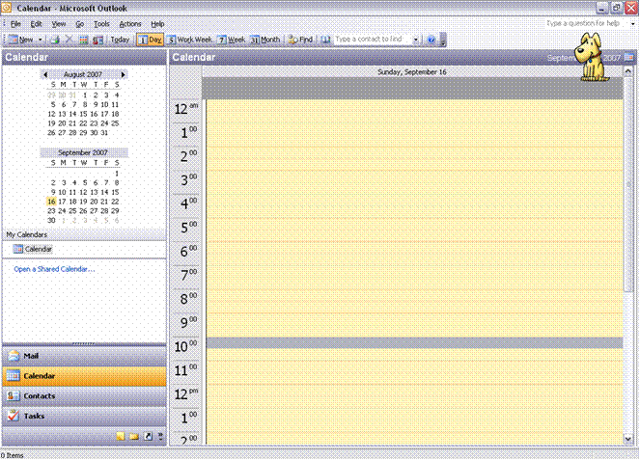

- Now right click on the time you would like to update and scroll to New Appointment.
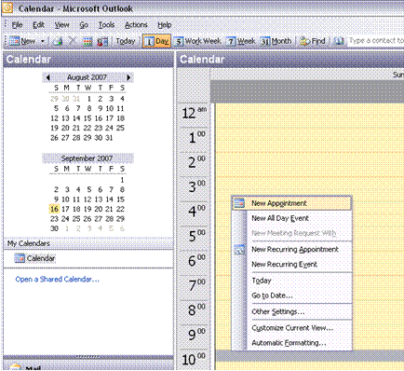
- This will bring up a window where you can update all the fields you need to.
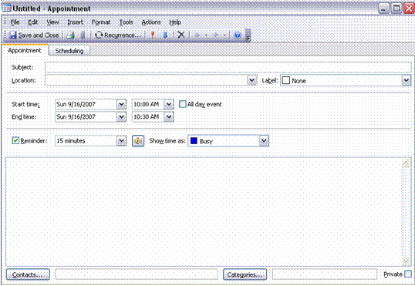

Populate the fields as follows:
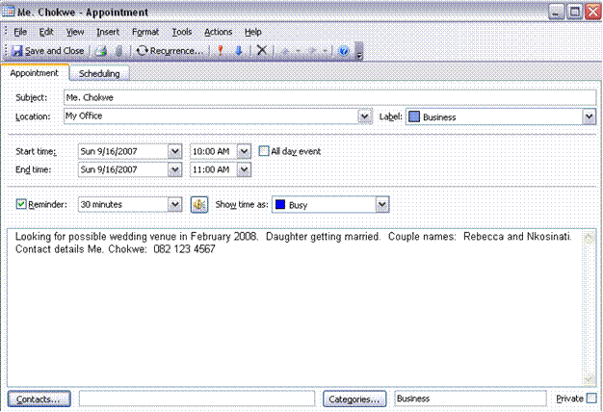
Type of meeting
Time of meeting, including start and end time.
Fill in the details of the meeting
Set a reminder to go off, 30min before the meeting
Meeting location
Client name or type of event

Once you are done, click Save and Close in the top left hand of the window

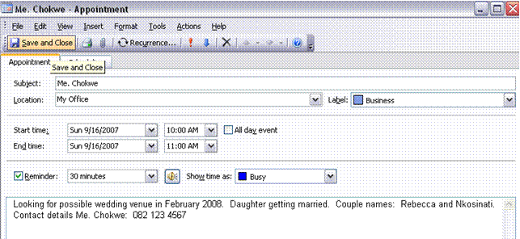
The appointment will now display like this:

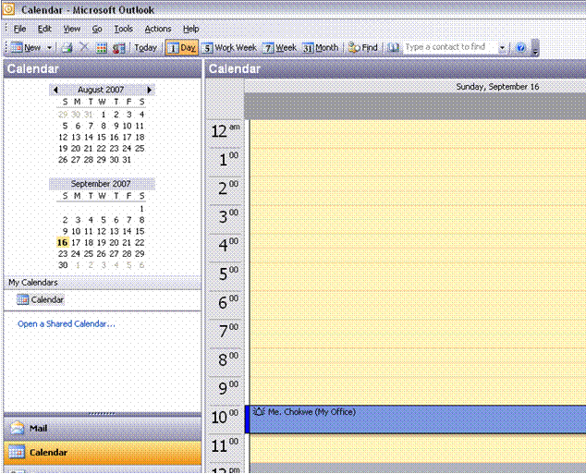

This is a great way to keep a diary, since you can set reminders and update easily. You can use these reminders for many things, such as:
- When the reminder goes off 30min before the appointment, you can phone Me. Chokwe and confirm whether she will still be attending the meeting. This is called a follow-up.
- If she has decided on a date in February, you can set a reminder for October 2007 to remind you to confirm her booking.

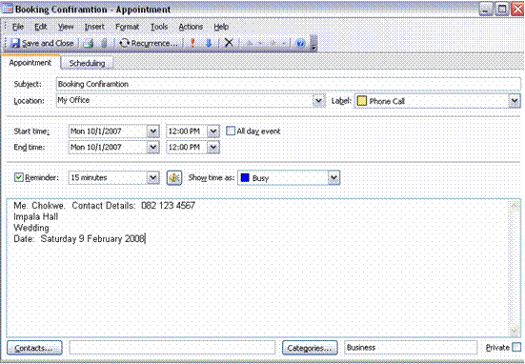
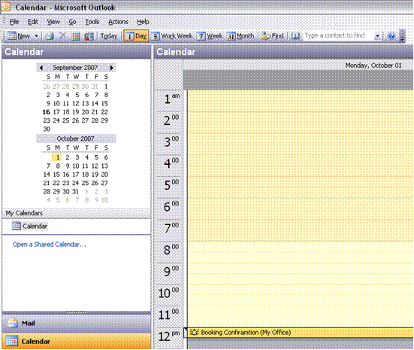

To change or edit an appointment:

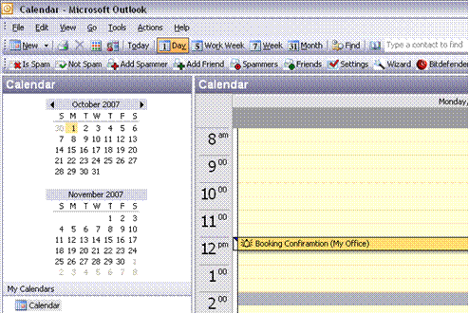
Point your mouse to the appointment and the time. Then right click on it. A menu will be displayed. On the menu click Open

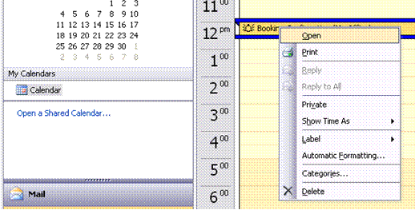

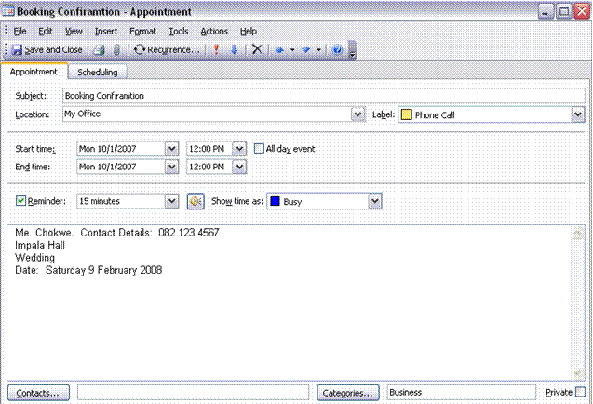
Now your appointment or reminder is open again and you can freely apply the necessary changes. Once you are done, you may Save and Close it and the changes are saved.

Formative assessment 3: SO2 individual activity
Complete formative assessment 3

Keep Other Departments Informed
The process of making and administering bookings needs a lot of coordination. Chances are, you will not be the only one making bookings. Because of this it is important to synchronise diaries with your co-workers.
This is very important! If you do not compare diaries and keep communication open as much as possible, you will end up with many double bookings and many, very unhappy clients.

You should also keep other departments informed of your bookings. A good example would be the finance department. They need information to balance the cash flow, salary payments etc.
The process of keeping fellow employees and other departments informed will be contained in the operating procedures of the organisation. Follow the procedures to communicate with other employees and departments. If no such procedure exists, you will have to develop such a procedure.

How could this affect a business?
You have 19 bookings for the month of March, but you have not sent any information to the finance department.
Here are a couple of things that could happen:
- The finance department could think business is going very badly since there are no venue bookings
- This incorrect information will be handed to management
- Management may decide to take certain steps such as assigning the marketing department an enormous task of planning a new marketing strategy.
- This could result in a lot of unnecessary money spent.
All this could happen, just because you have not communicated the information to relevant departments.

Formative assessment 4: SO6 group activity
Complete formative assessment 4
One of the ways that you could use to update all parties on bookings is to forward your diary confirmations. If you do this, make sure that your communication contains enough information. For example, rather than informing the catering department that there will be an event on the specified date, request them to put together a 5 course meal for a wedding for 200 guests. Since you discussed the details of the menu with the customer, the catering department will not have these details unless you inform them. This means that they must also know what the menu must consist of.

Provide An Efficient Service

Formative assessment 5: SO2 individual activity
Complete the assessment activity

Knowledge Of Services And Facilities

Formative assessment 6: Case study SO3 individual activity
Complete the assessment activities
Your answer would probably include things such as:
- They sell mobile phones,
- Mobile accessories,
- Sim cards,
- Handhelds
- And Cellular Contracts
As it happens, this business also sells the following products:
- Laptops,
- Computer and laptop 3g cards,
- 3g contracts,
- Internet bundles etc.,
You would not know this unless one of the employees has informed you about their other products.
This example shows you the importance of informing a customer about all the services and facilities a business offers. If you needed a laptop, you would never have considered Mobile Solutions because you didn’t know that they sell laptops. The same applies to the organisation you work for. If customers aren’t informed about what the organisation offers, they will not make use of the products or services.

Formative assessment 7: SO3 Role Play group activity
Complete the assessment activity
Note: The best way to go about informing customers is to pick the right time in the conversation. Do not try to give the client this information while they are trying to give you a date or confirm the booking, for example:

Susie: Good day, you have reached the Absa conference centre, Susie speaking, how may I help you?
Caller: Hello Susie, this is Celica from TSM. I would like to know if you have facilities available for a conference on the 20th of November 2007.
Susie: I will have a look for you in a moment Celica, how many people will be attending the conference?
Celica: So far 40, Susie
Susie: Could you please hold the line while I check for you, please Celica?
Celica: Certainly.

Susie: We do have the date available Celica, would you like me to reserve the date for you?
Celica: Yes please.
Susie: When would you like to see the venue Celica?
Celica: Friday, 30 March if possible Susie
Susie: Would 11:00 suit you?
Celica: 11 would be perfect, thank you
Susie: Thank you Celica, I will see you on Friday the 20th. We also offer Wedding facilities if you would like to view them while you are here.
Celica: No, thank you Susie, but I will keep them in mind. Have a good day. Good bye
Susie: Good bye Celica

This way, Susie got a “foot in the door”. If the conference was a success and left a good impression, Celica may mention your facilities to someone she knows who will need wedding facilities in the future.

Formative assessment 8 SO3 group activity
Complete the assessment activity

Taking Deposits For Possible “No Show”
In most businesses that are involved in making bookings there are many expenses to cover, for example: caterers, cleaning employees, admin employees, consultants who make the bookings etc. The list goes on and on.
If someone has made and confirmed a booking, the preparations and catering have been done. If the customer does not show for the event, the organisation will incur a loss since costs have already been incurred.
This is why most organisations in this line of business require an upfront deposit. The deposit is normally enough to cover most of their expenses. If the account isn’t paid in full there will still be a loss but at least the costs will have been covered.

Formative assessment 9 SO4 group activity
Complete the assessment activity

Deal With Customers Politely And Efficiently

Formative assessment 10: Role Play SO7
Complete the assessment activity
- Everyone requires bookings.
How did you handle the situation?

The correct way to deal with many customers at a time is to prioritise them.
For the purpose of the role play we will assume that all the customers arrived at the same time. You would prioritise them as follows:
1st VIP
2nd Customer with mobility difficulties
3rd Communication difficulties
4th Regular customers
If all the customers do not arrive at the same time, you would serve them on a first come first serve basis. People with disabilities should get served first, depending on their disability.

Research assessment 11 SO7 group activity
Complete the assessment activity

SECTION 2: MAKE BOOKINGS

Specific outcomes
Specific Outcome 8: Give customers accurate information and meet their enquiry needs.
Specific Outcome 9: Promote the establishment’s services and facilities at all appropriate times and explain why
Specific Outcome 10: Determine the availability of services and facilities correctly and communicate this clearly to the client
Specific Outcome 11: Offer alternative facilities to customers and explain the importance of doing this.
Specific Outcome 12: Given a range of bookings, take down the details and record the booking
Specific Outcome 13: Provide customers with confirmations of bookings and all relevant information

Meet The Enquiry Needs Of Customers
When clients contact your establishment, they expect you to be able to answer their enquiries satisfactorily. You should be able to tell them:
- What types of accommodation are available
- The rates of the various types of rooms
- The facilities and services available for each type of room
- When they can check in
- When they must check out
- What services are included in the price
- Whether meals are included or not
- If meals are not included, where they could go for meals and what the average cost is
- Whether the establishment has a shuttle service to and from airports
- Directions to the establishment
- Payment procedures
- How to get from the bus stop to the establishment, etc.
In the case of an airline, the client would want to know:
- The availability of flights on certain dates
- Arrival and departure times
- What seats are available
- Price of tickets
- What time they should check in
- What documentation they will need
- Payment procedures

Formative assessment 12 SO8 individual activity
Complete the activity

Promote Establishment’s Services And Facilities
You should promote the facilities and services of the establishment at every opportunity. When a client phones for information about accommodation, advise the client about the conferencing facilities, the excellent restaurant, and so on. When you reply to a client by fax or by e-mail, send a copy of a brochure with the original communication.
The client will not become aware of the services and facilities if you do not inform him/her. Make it your goal to be aware of all the services and facilities offered by your establishment and to inform all clients about them.

Research assessment 13 SO9 individual activity
Complete the activity

Communicate Availability Of Services And Facilities To The Client
As clients who are staying in your establishment will not be aware of meal times, when the swimming pool opens, at what time the hair dressers open and so on, you need to inform them. For example, when the client arrives, advise them that lunch or dinner is served at such and such a time, but that room service is available or that they can order snacks at the bar.
Should the client be staying for a couple of days, you should inform them if your establishment offers a laundry service. Also mention special services such as morning tours, afternoon tours, game drives, car rental arrangements, etc.
The communication of this information is usually done verbally and then you can also offer the client brochures about services and facilities that interest them. The appropriate time for you to advise clients is just after they have checked in, when they greet you on their way to the restaurant or when they hand in their keys just before going out and, of course, when they return and collect their keys. Greet the client and tell him/her about the special show or dance that the establishment is hosting, etc.

Formative assessment 14 SO10 individual activity
Complete the activity

Offer Alternative Facilities To Customers
Sometimes when a client enquires about one type of service or facility, which is not available, you can offer a similar service or facility to the client. For example, a client requests a single room for 2 nights and you do not have any available, offer the client a double room. Or, a couple request the honeymoon suite, which is not available, you can offer them a better suite, for example the presidential suite; or you can offer them a double room and add some extras such as complimentary champagne and a fruit basket. The client will often accept something different to what they required, if you advise them of the options available.
Or, if a client enquires about accommodation and you have nothing available, advise them of establishments close by that may have accommodation available.
It may happen that your establishment does not serve lunch or dinner, in which case you should be able to advise the client about suitable restaurants close by where their needs will be met.

Formative assessment 15 SO11 group activity
Complete the activity

Take Down Details And Record A Booking
Bookings include: bookings for flights, train journeys, bus trips, shows, sleeping accommodation, function facilities, restaurant facilities and conference facilities. Whether your clients do bookings in person, via the telephone, fax, e-mail or even a letter, you have to make sure that you obtain all the relevant details pertaining to the customer:
- Name
- Type of service required
- Date and time from when the service is required (arrival, flight dates, etc.)
- Date and time the service is required to: (departure)
- Contact details of the client
- How the client intends to pay
All these details are needed to ensure that the customers’ booking is done correctly and also to enable you to contact the client if you need information or if there is a problem that you have to communicate to the client.
The way the booking is recorded will depend on whether the establishment uses a manual or computerised booking system. An example of a manual booking system could look like this:

Booking form
Booking No |  | Deposit date |  | Tours consultant name
 | Surname | First Names | Title | Passport / ID No | Nationality | Date of Birth
1
2
3
4
Payment
We hereby authorise the amount of R paid by cheque or cash
We hereby authorise Nice Tours to debit our credit card (details provided below) with the amount of R
Credit card holders name |  |  |  | Type of card
Credit card number
CC control number (check digits at back of card)
Expiry date |  |  | ID number
Authorisation code (to be obtained by consultant)
Please debit my straight/budget account over months |  |  |  |  | Signature
Private residential address (not P.O. Box No) |  |  |  | Special requests
 |  |  |  | Meals
 |  |  |  | Smoking/non smoking
 |  | Postal code |  | Accommodation
Telephone |  | Fax |  | Loyalty program
Travel declaration (to be completed by travel agent)  We hereby accept full responsibility for collecting and verifying the following cardholders information on behalf of Nice Tours and/or have informed the client/s of the Nice Tours terms and conditions |  |  |  | Travel stamp
Date
Print name
Travel agent’s signature
We agree on behalf of the above that we have read and accept the Nice Tours terms and conditions
Client signature

Many establishments make use of Internet-based booking systems such as Galileo. This booking system is used by SAA and many hotels and other establishments. Galileo allows access to accurate global travel inventories, schedules, pricing information, and transaction processing systems.
Airline Products: Galileo provides choices from almost every published schedule in the world, thereby giving the biggest choice regarding flight schedules. The system searches
Examples of the AVIS, SAA and City Lodge websites that enable you to obtain quotes and make bookings online are shown. Note the information that has to be entered.

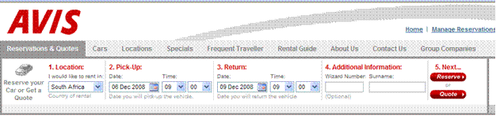
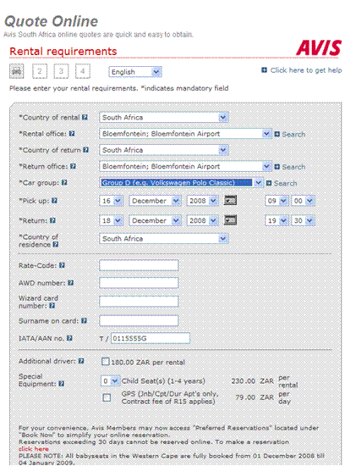

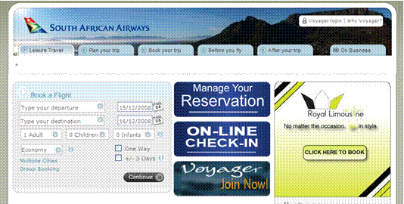

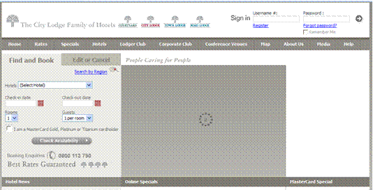

Formative assessment 16: Role Play SO12
Complete the activity

Confirm Bookings
Most establishments have some sort of confirmation form that is given to the client. These may be handed out over the counter, faxed or emailed to a client. It is a simple form that states that their booking has been made. The details of their booking are also included on the form
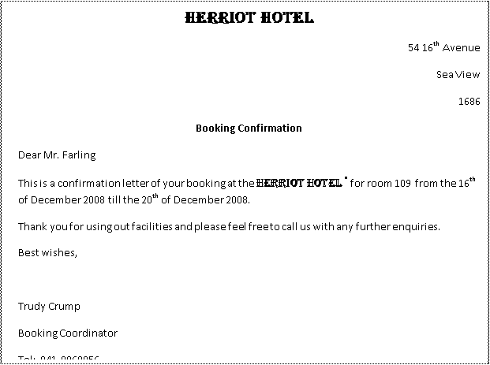
These details would contain things such as their room number, the hall or conference facility they booked etc. depending on the type of booking that’s been made.
An example of such a form is shown

In the case of travel arrangements, the confirmation could be done in the same format, but should include:

Airline travel
- Name of person undertaking the trip
- Where to collect the ticket
- Date and time of departure
- Latest time to report for the flight
- Documents needed such as ID book and passport in the case of international travel
- Prohibited and dangerous goods such as batteries, sharp instruments, aerosol cans
- Date and time of return trip
- Latest time to report for the flight

Car rental
- Name of person collecting the car
- Documents required such as ID book and possibly proof of payment
- Where the car should be collected
- What type of car will be available
- Date and time for collecting the car
- Date, time and place for returning the car
- Conditions for car rental, including insurance arrangement, price paid per kilometre travelled and costs for refuelling the car

Formative assessment 17 SO13 individual activity
Complete activity

Request Deposits From Customers
It is standard practice to request deposits from customers. The deposit could be different for different establishments, but the norm is 50% to 100%, depending on the type of booking, the time between the booking and the utilisation of the service and the policy of the organisation.
The booking system, whether it is a manual or computerised system, will provide space for the details of the deposit – see the example of the manual booking form.
Make sure that you request a deposit from the client and that you note the payment method of the deposit, as the actual payment of the deposit has to be followed up to make sure that payment was made. Deposits can be paid as follows:
- By cheque
- By direct bank deposit
- By Internet transfer
- By credit card

Assessment activity 18: Role play SO14
Complete the activity

SECTION 3: MAKE AMENDMENTS

Specific outcomes
Adapt performance:
Specific Outcome 15: Given a range of amendments, choose a procedure and give reasons for the method chosen.
Specific Outcome 16: Given a system failure or error in manual systems, decide what action to take
Specific Outcome 17: Carry out all work in an organised and efficient manner taking account of priorities.
Specific Outcome 18: Describe situations where a guest’s booking has been cancelled incorrectly
Specific Outcome 19: In a different type of establishment describe how performance would be adapted

Amending Procedures

System Failure Or Error In Manual Systems

In the case of a system failure, you should always have some sort of backup system handy, such as an additional registry or appointment book. In the case that your computer system fails, there should be a backup server so that you can make backups at least every second day, and can then access your information from the backup server.
If an organisation doesn’t have a backup server, it would be wise to make backups on CDs. Write your most recent data to a CD every second day at the least. This way you can access your data even if there was a failure on the system.

Assessment activity 19 SO15 group activity
Complete activity

Prioritise work
How should you prioritise?
Here’s a simple example of how to prioritise:
You have a new client who wants to stay in a certain room, but you also know that one of your regular clients will be arriving the same day without a reservation, but also likes to stay in that specific room.
In this case your regular customer would be your first priority and the new client will have to compromise. Before you keep the room for the regular customer, first give him/her a call and confirm a booking for them.
Now you won’t disappoint the new client if the regular customer does not show.

Incorrect Cancellations
In a situation where a guest’s booking has been changed or cancelled incorrectly you will most have a very angry and irritated client.
The first thing you should do; is just listen. Listen to the complaints of the client so that you can start repairing things by making the client feel heard. Do not interrupt the client by starting the apology or anything else. Wait for them to finish what they have to say.
Once the client has finished the complaint, you need to apologise for the mistake and make an alternative arrangement. The arrangement will also have to include something of value that is given to the client as a “peace offering”, such as their first night’s stay for free if it was an accommodation booking.
When clients hear the words free or complimentary they tend to lighten up a bit. Customers want to feel that an organisation values them and offering them something of value without them having to pay for it, will confirm to them that the organisation values their business.
In the case of a wedding the client might not be so easy to pacify, but this should not happen in the first place. If this happens it will show bad communication between you and an important client and terrible and inefficient customer service. Weddings have to be kept up to date regularly.

Adapt Performance According To The Establishment

Formative assessment 20 SO19 group activity
Complete the activity

Formative assessments Workbook 7706

Formative assessment 1 SO1 individual activity
Write down:
- What you would do about this situation.
- How you would feel when a situation like this occurs.
- How you think the customer will feel when s/he receives this information.
- How would this reflect on your organisation?
Discuss your answers in your groups.

Formative assessment 2: Case study SO2 individual activity
You have an appointment with Me. Chokwe at 10:00am on 15 September 2007. She would like to see you about a wedding venue for her daughter and also look at available dates for February. Her daughter’s name is Rebecca and she is getting married to Nkosinati.
Note: Be sure to ask the names of the parties involved and note them down in your diary. This will personalize the service you give the client and so doing add quality to your service.
How to enter this appointment in your hardcopy diary:
16 September 2007
Time | Appointment | Details | Meeting Location
08:00 | Mr. Chiba | End Year Function, 200 attendees for December. Contact Details: 076 456 7891 | My Office
09:00
11:00 | Wedding booking in the Leopard Hall | John and Sandy O’Carroll. To start at 12pm. Oversee all details, catering, and sound system.  Contact Details: (Groom’s father) 083 234 5678 | Leopard Hall
12:00 | O’Carroll Wedding
13:00 | O’Carroll Wedding
14:00 | O’Carroll Wedding
15:00 | O’Carroll Wedding
16:00 | O’Carroll Wedding
17:00 | O’Carroll Wedding
18:00 | Dinner with Nadine | Nadine’s birthday. Remember gift in office. (bottom drawer) | The Blue Cherry Grill.  R55, Kyalami Shopping Centre.
19:00
20:00

Formative assessment 3: SO2 individual activity
Make up a case study about a client who wants to make an appointment to see you.
- Enter the appointment in MS Outlook
- Enter a reminder with the following details:
- Do a follow-up call to make sure that they are still aware of the appointment
- To confirm that the date and time is still in order.
Next, design a plan to keep bookings up to date on a daily, weekly and monthly basis.

Formative assessment 4: SO6 group activity
- Write a memo why you think it is important to inform other departments of current and future bookings and why it is important to keep good and open communication between you and other departments.
- Discuss your memo in your groups
- Write down what you think could happen if you don’t inform the catering department of Me. Chokwe’s wedding booking
- Discuss your answers in your groups

Formative assessment 5: SO2 individual activity
Have you ever complained about a problem with a product or a service? Think about a time where the service was slow and you also got a negative response to your complaint. How did that make your feel?
You can see that your feeling towards the company is negative. Through this exercise you can see how important it is to provide an efficient service. Efficiency of service would include things such as:
- Fast, friendly service
- Speedy responses to requests or complaints,
- Follow-up calls for appointments, complaints or requests,
- Personalised service
What is meant by personalised service? For example, if you have a regular client, it is important to have certain information about your client such as their name and surname, birthday and other personal things such as when a baby is on the way, etc. Now you can send them a card on these important days phone them to congratulate them.

- Write down 5 reasons why it is important to provide efficient service.
- Once you have done this, divide into groups and share your reasons.
- Add any reasons that you don’t have on your list that other learners had on theirs.

Formative assessment 6: Case study SO3 individual activity
When you hear the name Mobile Solutions, what type of services do you associate with the business? Write down what you think and discuss it in your groups.

Formative assessment 7: SO3 Role Play group activity
Do the following role play in your groups:
Each person has a turn to receive a call as an employee of an organisation that offers conference facilities
Another group member is the customer. The customer needs conference facilities for 20 people.
The first person must inform the customer that your organisation also has wedding facilities
Note: The best way to go about informing customers is to pick the right time in the conversation. Do not try to give the client this information while they are trying to give you a date or confirm the booking, for example:

Susie: Good day, you have reached the Absa conference centre, Susie speaking, how may I help you?
Caller: Hello Susie, this is Celica from TSM. I would like to know if you have facilities available for a conference on the 20th of November 2007.
Susie: I will have a look for you in a moment Celica, how many people will be attending the conference?
Celica: So far 40, Susie
Susie: Could you please hold the line while I check for you, please Celica?
Celica: Certainly.

Susie: We do have the date available Celica, would you like me to reserve the date for you?
Celica: Yes please.
Susie: When would you like to see the venue Celica?
Celica: Friday, 30 March if possible Susie
Susie: Would 11:00 suit you?
Celica: 11 would be perfect, thank you
Susie: Thank you Celica, I will see you on Friday the 20th. We also offer Wedding facilities if you would like to view them while you are here.
Celica: No, thank you Susie, but I will keep them in mind. Have a good day. Good bye
Susie: Good bye Celica

This way, Susie got a “foot in the door”. If the conference was a success and left a good impression, Celica may mention your facilities to someone she knows who will need wedding facilities in the future.

Formative assessment 8 SO3 group activity
Write down 5 ways other than a telephone call that you could use to make customers aware of all the services your organisation offers.
Design a flyer or brochure to inform customers or potential customers of all the services or products the organisation of your choice offers.

Formative assessment 9 SO4 group activity
Phone at least 3 organisations and find out what percentage they charge for a deposit, for example for a total bill of R10 000. If they require 50%, the deposit will be R5000. Also find out which expenses will be covered by the deposit in the case of a ‘no show’.

Formative assessment 10: Role Play SO7
Do the following role play in the classroom:
Each learner takes a turn to be at reception and has to deal with 6 customers at the same time.
The roles of the customers are as follows:
- a customer with communication difficulties,
- customer with mobility difficulties,
- regular customers
- and a VIP (very Important Person)

Research assessment 11 SO7 group activity
Big organisations such as banks have procedures in place about which customers should be served first. Do research on the order in which customers are supposed to be served in terms of customers with communication difficulties, customers with mobility difficulties, regular customers and VIPs. Your research must include at least three organisations that deal with customers face to face.
Set time aside in class for a debate on who should be served first, the disabled customer or the VIP. Write down the conclusions and strongest points that were made

Formative assessment 12 SO8 individual activity
Judging by what you’ve learned thus far, why do you think it is important to give customers accurate information? Name at least 5 points.
What information do you think a client would request if you were taking bookings for a bus service that travels from Cape Town to Durban?

Research assessment 13 SO9 individual activity
Do research about how big hotel groups promote their services and facilities. If possible, request an appointment with the assistant of the person in charge of Public Relations of a hotel, conference centre or even an events planner to discuss PR.
Once you have all the necessary information, draw up a plan to promote a range of services and facilities such as accommodation, conference, function, exhibition rooms, and restaurants of a hotel/conference centre/events planner.
When and where would be appropriate times and places to promote an establishment’s services and facilities? Motivate your answers

Formative assessment 14 SO10 individual activity
Name the steps you would take and the people you need to communicate with to establish availability of services and facilities.
How would you ensure that you communicate this information clearly to a client? Demonstrate how you will advise the client about the availability of snacks at the bar or at the souvenir shop and how to inform the client that your establishment offers a laundry service.

Formative assessment 15 SO11 group activity
- Why is it important to offer or inform a client of alternative facilities? Name 5 and motivate your answers.
- Make a brochure with alternative facilities that you would like to have in an organisation.

Formative assessment 16: Role Play SO12
Do a role play with 7 people. Each person has to take a turn to take down the bookings of 6 clients.
The learner doing the bookings has to record the details and confirm the bookings of the 6 clients quickly and as fast, friendly and accommodating as possible.

- What have you learned in the role play about handling more than one client at a time?
- Did you record their details correctly?
- Were all the “clients” happy? If there were clients that weren’t happy, what do you think you could’ve done differently to ensure that they were satisfied?

Formative assessment 17 SO13 individual activity
List 5 reasons why it is important to confirm bookings.
You work for Fine Travel and have made the following arrangements for Mr. C. Ustomer:
SAA flight XZC123 departing from Cape Town on Tuesday at 08:00 to arrive at O.R.Tambo International airport on the same day at 09:45. The details for the return flight are: departing O.R. Tambo airport at 20:00 arriving Cape Town 22:00. Documents required are an ID book.
Car rental from Avis Rent A car: to be collected from their offices at the airport at 10:30 and returned to the same offices at 18:00. The car will be a Nissan Sentra. Documents required are an ID Book. Total amount of kilometres for the day 500k. Additional kilometres travelled will be charged at R1.50 per kilometre.
Develop a confirmation form for the above arrangements to send to Mr. C. Ustomer.

Assessment activity 18: Role play SO14
Two learners can take part in this role play. One of the learners has to confirm a booking and the other is a difficult customer who doesn’t understand the need to pay a deposit. The learner confirming the booking has to explain why deposits are required in a calm, friendly manner.

Individual activity
Why is it important for organisations to take deposits for bookings? Give 4 reasons and also explain what could happen if they don’t take deposits.

Assessment activity 19 SO15 group activity
Previously we saw how to change the details of a meeting or reminder. Write a procedure for changing each of the following booking amendments and give reasons why you chose the procedures you’ve decided on:
- Range of booking amendments:
- Change in services or facilities,
- Change in date or time,
- Change in customer’s personal details,
- Change in number of people,
- Booking cancellations.
Write down two more ways you can think of to ensure that you don’t lose data in the case of a system malfunction. Also write what decisions you would take in the case of a failure or error.

Case study SO16 individual activity
You have a function at 4pm and 300 people will be attending. At 2pm the electricity goes off and the municipality says they aren’t sure what time it will come back on, but it won’t be before 6pm.
Write what actions you would take to ensure that the function activities and preparation goes on as planned.

Formative assessment 20: Case study SO17 individual activity
You have a function to organise within two weeks. You have to arrange accommodation, flowers, seating for attendees at specific tables, a band to play at the function, catering, and cleaners for after the function, transport from the airport for 3 guests, decorations for the hall where the function will be held, confirmation of the booking for the function and a deposit to collect.
Write down how you would prioritise these duties from most urgent to least urgent. Number them from 1 to 10, 1 being the most urgent activity.
Think about what you would do if your VIP guest’s hotel suite has been cancelled incorrectly and they arrive at the hotel and there is no record of a booking for them.
Different types of establishments have different procedures for bookings and confirmations.
Do research on the booking and confirmation as well as problem solving procedures for the following:
- An airline for tickets
- A game lodge for accommodation
- A conference centre for booking a venue
Describe the different systems and how your service would have to be adapted in order to maintain the booking systems.

