LEARNER GUIDE

67465 National Certificate:
Business Administration Services
Level 3

Module 3 HR Skills

Unit Standard 8420 Level 2 Credits 4
Operate in a team

TABLE OF CONTENTS

TABLE OF CONTENTS i
PERSONAL INFORMATION 3
INTRODUCTION 4
Programme methodology 5
What Learning Material you should have 5
Different types of activities you can expect 7
Learner Administration 8
Assessments 8
Learner Support 9
Learner Expectations 10
UNIT STANDARD 8420 11
STRUCTURE AND PURPOSE OF A TEAM 13
Teamwork 13
What Is The Purpose Of A Team? 14
What do you think teamwork is all about? 15
Exercise 1: SO5, SO 1 group discussion 15
The Structure Of Teams 15
Teams In The Business Environment 15
Quality Circles 15
Production Line Teams 16
Training Forums 16
Types Of Teams 16
Problem-Solving Teams 16
Self-managed Work Teams 16
Cross-functional Teams 16
Study Groups 17
Exercise 2: SO1: group research and individual activity 17
AN EFFECTIVE TEAM 18
Factors that affect an effective team 18
Factors that affect an ineffective team 19
Exercise 3: SO3: group discussion and individual activity 20
Structure of the organisation 20
Production / Operational Department / Function 20
Purchasing Department / Function 20
Marketing Function 21
Financial Department / Function 21
Sales Department / Function 21
Administration Department / Function 21
Human Resources Department / Function 21
Public Relations Department / Function 21
Quality Control Department / Function 21
Teams 21
The Role of the Team Player 25
Advantages Of Teamwork 26
Advantages To Team Members 26
Advantages To The Organisation 26
Roles And Responsibilities Of Team Members 27
The Lesson Of The Geese 27
Work Toward a Mutual Goal 27
Accept Responsibility 28
Motivating the team 28
Team Vision 28
Exercise4: SO2: individual self-assessment 28
Conflict 29
Constructive Conflict 29
Negative Conflict 29
The Role Of The Team Leader 29
Exercise 5: SO2, SO4, SO5: self- assessment 30

PERSONAL INFORMATION
NAME
CONTACT ADDRESS
Code
Telephone (H)
Telephone (W)
Cellular
Learner Number
Identity Number
EMPLOYER
EMPLOYER CONTACT ADDRESS
Code
Supervisor Name
Supervisor Contact Address
Code
Telephone (H)
Telephone (W)
Cellular

INTRODUCTION

Welcome to the learning programme

Follow along in the guide as the training practitioner takes you through the material. Make notes and sketches that will help you to understand and remember what you have learnt. Take notes and share information with your colleagues. Important and relevant information and skills are transferred by sharing!

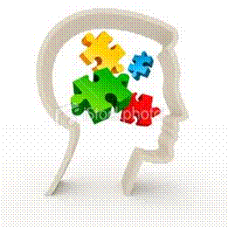

This learning programme is divided into sections. Each section is preceded by a description of the required outcomes and assessment criteria as contained in the unit standards specified by the South African Qualifications Authority. These descriptions will define what you have to know and be able to do in order to be awarded the credits attached to this learning programme. These credits are regarded as building blocks towards achieving a National Qualification upon successful assessment and can never be taken away from you!

Programme methodology

The programme methodology includes facilitator presentations, readings, individual activities, group discussions and skill application exercises.
Know what you want to get out of the programme from the beginning and start applying your new skills immediately. Participate as much as possible so that the learning will be interactive and stimulating.
The following principles were applied in designing the course:
- Because the course is designed to maximise interactive learning, you are encouraged and required to participate fully during the group exercises
- As a learner you will be presented with numerous problems and will be required to fully apply your mind to finding solutions to problems before being presented with the course presenter’s solutions to the problems
- Through participation and interaction the learners can learn as much from each other as they do from the course presenter
- Although learners attending the course may have varied degrees of experience in the subject matter, the course is designed to ensure that all delegates complete the course with the same level of understanding
- Because reflection forms an important component of adult learning, some learning resources will be followed by a self-assessment which is designed so that the learner will reflect on the material just completed.
This approach to course construction will ensure that learners first apply their minds to finding solutions to problems before the answers are provided, which will then maximise the learning process which is further strengthened by reflecting on the material covered by means of the self-assessments.

Different role players in delivery process
- Learner
- Facilitator
- Assessor
- Moderator

What Learning Material you should have
This learning material has also been designed to provide the learner with a comprehensive reference guide.
It is important that you take responsibility for your own learning process; this includes taking care of your learner material. You should at all times have the following material with you:
Learner Guide | This learner guide is your valuable possession:  This is your textbook and reference material, which provides you with all the information you will require to meet the exit level outcomes.  During contact sessions, your facilitator will use this guide and will facilitate the learning process. During contact sessions a variety of activities will assist you to gain knowledge and skills.  Follow along in the guide as the training practitioner takes you through the material. Make notes and sketches that will help you to understand and remember what you have learnt. Take and share information with your colleagues. Important and relevant information and skills are transferred by sharing!  This learning programme is divided into sections. Each section is preceded by a description of the required outcomes and assessment criteria as contained in the unit standards specified by the South African Qualifications Authority. These descriptions will define what you have to know and be able to do in order to be awarded the credits attached to this learning programme. These credits are regarded as building blocks towards achieving a National Qualification upon successful assessment and can never be taken away from you!
Formative Assessment Workbook | The Formative Assessment Workbook supports the Learner Guide and assists you in applying what you have learnt.  The formative assessment workbook contains classroom activities that you have to complete in the classroom, during contact sessions either in groups or individually.  You are required to complete all activities in the Formative Assessment Workbook.  The facilitator will assist, lead and coach you through the process.  These activities ensure that you understand the content of the material and that you get an opportunity to test your understanding.

Different types of activities you can expect
To accommodate your learning preferences, a variety of different types of activities are included in the formative and summative assessments. They will assist you to achieve the outcomes (correct results) and should guide you through the learning process, making learning a positive and pleasant experience.
The table below provides you with more information related to the types of activities.
Types of Activities | Description | Purpose
Knowledge Activities | You are required to complete these activities on your own. | These activities normally test your understanding and ability to apply the information.
Skills Application Activities | You need to complete these activities in the workplace | These activities require you to apply the knowledge and skills gained in the workplace
Natural Occurring Evidence | You need to collect information and samples of documents from the workplace. | These activities ensure you get the opportunity to learn from experts in the industry.  Collecting examples demonstrates how to implement knowledge and skills in a practical way

Learner Administration

Attendance Register
You are required to sign the Attendance Register every day you attend training sessions facilitated by a facilitator.

Programme Evaluation Form
On completion you will be supplied with a “Learning programme Evaluation Form”. You are required to evaluate your experience in attending the programme.
Please complete the form at the end of the programme, as this will assist us in improving our service and programme material. Your assistance is highly appreciated.

Assessments
The only way to establish whether a learner is competent and has accomplished the specific outcomes is through the assessment process. Assessment involves collecting and interpreting evidence about the learners’ ability to perform a task.
To qualify and receive credits towards your qualification, a registered Assessor will conduct an evaluation and assessment of your portfolio of evidence and competency.
This programme has been aligned to registered unit standards. You will be assessed against the outcomes as stipulated in the unit standard by completing assessments and by compiling a portfolio of evidence that provides proof of your ability to apply the learning to your work situation.

How will Assessments commence?

Formative Assessments
The assessment process is easy to follow. You will be guided by the Facilitator. Your responsibility is to complete all the activities in the Formative Assessment Workbook and submit it to your facilitator.

Summative Assessments
You will be required to complete a series of summative assessments. The Summative Assessment Guide will assist you in identifying the evidence required for final assessment purposes. You will be required to complete these activities on your own time, using real life projects in your workplace or business environment in preparing evidence for your Portfolio of Evidence. Your Facilitator will provide more details in this regard.
To qualify and receive credits towards your qualification, a registered Assessor will conduct an evaluation and assessment of your portfolio of evidence and competency.

Learner Support
The responsibility of learning rests with you, so be proactive and ask questions and seek assistance and help from your facilitator, if required.

Please remember that this Skills Programme is based on outcomes based education principles which implies the following:
- You are responsible for your own learning – make sure you manage your study, research and workplace time effectively.
- Learning activities are learner driven – make sure you use the Learner Guide and Formative Assessment Workbook in the manner intended, and are familiar with the workplace requirements.
- The Facilitator is there to reasonably assist you during contact, practical and workplace time for this programme – make sure that you have his/her contact details.
- You are responsible for the safekeeping of your completed Formative Assessment Workbook and Workplace Guide
- If you need assistance please contact your facilitator who will gladly assist you.
- If you have any special needs please inform the facilitator

Learner Expectations
Please prepare the following information. You will then be asked to introduce yourself to the instructor as well as your fellow learners

Your name:
The organisation you represent:
Your position in organisation:
What do you hope to achieve by attending this course / what are your course expectations?

UNIT STANDARD 8420

Unit Standard Title
Operate in a team

NQF Level
2

Credits
4

Purpose
A person assessed as competent against this unit standard will be able to
Operate in a team, understanding the structure of the team, and the roles and responsibilities of each team member. The learner will be able to identify and take into account external (environmental) factors that influence the workings and success of the team; and evaluate the success of the team
This competence will enhance the ability of learners and workers to participate in teams. It will also contribute to ensuring that teamwork is more effective in workplaces and in provider organisations, as well as contribute to transforming workplaces into sites of learning

Learning assumed to be in place
None

Unit standard range
Range statements are included with specific outcomes as necessary.

Specific Outcomes and Assessment Criteria
Specific Outcome 1: Identify the structure and purpose of a particular team in the work place and in the learning environment. Range:
Outlining team organisation, working relationships and goals
Quality circles, production line teams or training forums are examples of teams in the workplace.
Study groups are an example of teams in the learning environment
Specific Outcome 2: Describe and carry out the roles and responsibilities required to work in a team in the workplace and learning environment.
Specific Outcome 3 Identify factors affecting a team within workplace and learning environment and explain affect. Description is limited to structure of the organisation
Specific Outcome 4: Describe the workplace and learning environment organisation and identify its influence on team members and team
Specific Outcome 5: Review the effectiveness of a team and own participation in the team within the workplace and learning environments

Unit Standard Essential Embedded Knowledge
The qualifying learner is able to demonstrate a basic knowledge and understanding of:
Structure and functions of least one type of team
Factors influencing teamwork
At least one way of evaluating the effectiveness of a team and ones own role in a team
Influences which the structure of an organisation can have on teamwork

Critical Cross-field Outcomes (CCFO)
- Working effectively with others as a member of a team, group, organisation or community - relates to the all outcomes
- Organising and managing oneself effectively - relates to the all outcomes
- Communicate effectively - relates to the all outcomes
- Personal Development - relates to the all outcomes
- Contributing to the personal development of learners and the society and economy, by participating as responsible citizens in the life of local, national and global communities - relates to the all outcomes

STRUCTURE AND PURPOSE OF A TEAM

Outcome
Identify the structure and purpose of a particular team in the work place and in the learning environment. Range:
Outlining team organisation, working relationships and goals
Quality circles, production line teams or training forums are examples of teams in the workplace.

Teamwork
The most distinguishing characteristic of a team is that its members have, as their highest priority, the accomplishment of team goals.
To them, the most important business at hand is the success of the team in reaching the goal that its members, collectively and with one voice, have set. The members support one another, collaborate freely, and communicate openly and clearly with one another.
Groups on the other hand, tend to be collections of personalities with their own agendas.
Discussions and relationships in such groups are often characterized by shifting agendas, power subgroups, a going along with decisions rather than a wholehearted commitment, and even a win – lose orientation. One person or subgroup gains its wishes over another.
"A group of people who share common objectives and who need to work together to achieve them. "
Teams consist of small groups of people who work together and therefore communicate with each other on a daily basis. For a group of people to become a team, requires not just talking but also effective use of verbal and non-verbal communication.

Teams can provide unique opportunities: Why work in a team as opposed to alone?
Like a family they can provide support and help
They can co-ordinate the activities of the individual;
They can generate commitment;
Give a sense of belonging;
Provide learning opportunities;
Enhance communication;
And provide satisfying, stimulating and enjoyable working environments.
Team interactions become everything. They are the reasons people stick it out, give their all and overcome enormous obstacles.
While it is possible to work alone, progress is based on the human ability to work together. The team will achieve more than individuals working on their own.
Teamwork consists of individuals working together to accomplish more than they could alone, but more than that, it can be exciting, satisfying and enjoyable.

Importantly the success of the team would depend not only on the individual skills of the team members but also on the way those individuals support and work with each other.
Organisations are increasingly finding that the real key to success is the way in which individuals behave towards one another and the way in which groups of people relate to and work with each other, i.e. interpersonal relations. Teamwork improves these things.
In a team, the enjoyment people derive from the work is greater than what you'd expect, given the nature of the work itself.
the fact is that a team where member work well together has momentum
even if the goal seems arbitrary to individuals(not all members agree with the goal), the team enhances a team spirit which makes the team pursue that goal with enormous energy
team members become worked up (just look at what is happening on the sports fields). There is a lot of enthusiasm and energy.

What Is The Purpose Of A Team?
Teams are responsible for attaining the goals of different departments and, of course, ultimately, the goals of the organisation.
In other words, teams are started in order to work together to achieve the specific goals of the team, which are linked to the goals of the department, in order to achieve the goals of the organisation in the end.
The workplace environment has become very competitive in the twenty first century: South African companies have to compete with international organisations and they therefore have to think up new ways of improving productivity. South African companies also have to train and develop their human resources and reward employees for their achievements.
This is an area where teams are very effective.

What do you think teamwork is all about?

Exercise 1: SO5, SO 1 group discussion
Complete the assessment activity in the workbook

The Structure Of Teams
Teams are usually small, consisting of between five and twelve members. If a team has more than twelve members, the manager should think about breaking the team into two sub-teams.
Team member share leadership and responsibility. Role allocation is important. A sport team, such as Bafana Bafana, will have players with different personalities and preferences. A winning team needs a variety of skills: strong forwards, good defenders in the back line, fast attackers and a goalkeeper with safe hands. You can see that the goal is the performance of the team as a whole and not individual performances by the players. This can mean that the best attacker is left out of the team because his approach is selfish and individualistic for the team to be successful. Team members can work well together if the manager matches individual preferences to the demands of team work.
As can be seen from the example above, a team needs a variety of skills. In the workplace these skills are: technical, interpersonal, and conceptual skills. Technical skills have to do with the actual work that has to be performed, while interpersonal skills have to do with how team members work together. Conceptual skills have to do with how members understand and interpret things in the team: the goals, the timelines, the budget, how to achieve the goals, etc.
The team leadership will be determined by the specific purpose and goals of the team. By rotating and sharing leadership the team benefits through participation by all team members. Sharing and rotating leadership also facilitates the best learning opportunities for team members. Functional tasks are distributed among team members over a period of time, thus giving every member the opportunity to practice leadership. Sharing leadership makes a lot of sense and should be a part of our daily existence: in our homes, schools, with our friends and also at work.
Team members are usually rewarded for their performance individually and as a team.
Refer back to the team of the previous exercise and make notes about the structure of the team, the function of the team members and the skills required in the team. This can be any team that you are familiar with: at home, school church or any other team

Teams In The Business Environment

Quality Circles
These teams are groups of employees working in the same environment and who take responsibility as a team for quality processes in their own work environment. They ensure that the service to the customer is always outstanding and, when it doesn’t happen, they investigate the quality processes and, if necessary, institute new quality processes to ensure that the customer always gets the best service possible.

Production Line Teams
These teams work together on production lines. Examples are vehicle manufacturing teams, teams that work together to build furniture, bottle tomato sauce, pack peanuts. Everywhere where there is production or manufacturing, you will find these teams.
In the motor vehicle industry, these teams are responsible for the entire process to assemble vehicles and they take responsibility as a team for the quality of the work, the meeting of deadlines and the end product is delivered by the team.
As a team they also receive the benefits of achieving production goals, which may be bonuses or time off or whatever reward was agreed on.

Training Forums
The team members are selected from various departments and they have to make the decisions regarding training and development of the employees in their own departments. This is, of course done in consultation with the employees, the training forum and the Human Resources department. The suggestions are then put forward to management for implementation.

Types Of Teams
Teams can also be classified on the basis of their objectives or purpose. The three most common types of teams found in a business are:

Problem-Solving Teams
Teams that work in the same department and meet for a few hours per week to discuss ways of improving quality, efficiency and the work environment.
The production line teams for a motor vehicle manufacturer, can, for example, send representatives to weekly problem-solving meetings in order to address problems that affect every team and it’s achievement of goals.
In a restaurant or hotel, the kitchen staff can meet weekly to discuss customer complaints, more effective ways of preparing meals, the layout of the dining room, and so on. Similarly, the reception staff can meet weekly to discuss problems regarding the booking system of guests, the layout of the reception area, and so on. The suggestions are then laid before management for evaluation.
When a sports team has not performed well, a problem-solving team will get together to discuss errors made, in which area of the game should more training and Formative Assessment be focused on, etc.

Self-managed Work Teams
These are teams that function independently. They can make decisions and take steps to implement the decisions. They also take full responsibility for the outcomes of the decisions. These teams can employ new staff members, make equipment purchases, evaluate the performance of the team and even decide who should receive bonuses. Management of these teams is a responsibility of the whole team.

Cross-functional Teams
Team members are usually made up of people on the same level, such as financial managers, operations managers, despatch managers and so on. This type of team usually operates in situations where difficult problems have to be solved and the knowledge and experience of specialists with different backgrounds are needed. These teams could be made up of people in the same organisation, but people from other organisations can also be included.
For example, if your company bottles tomato sauce, the cross-functional team can consist of employees from your organisation, as well as the suppliers of the tomatoes and other products and even the clients that your organisation supplies to.

Study Groups
A study group is an example of a team in the learning environment. Whenever you break for a group activity, you become a member of a study group.
You may also have a study group at home or when you and a group of fellow students get together to study. In this team, you will find that the roles the team members play varies according to the subject being studied: one member may be more knowledgeable about finances, while another helps the other team members with human relations. Each team member usually has a unique contribution to make to the study group, even if it is only making the coffee.

Exercise 2: SO1: group research and individual activity
Complete the assessment activity in the workbook

AN EFFECTIVE TEAM

Outcomes
SO2: Describe and carry out the roles and responsibilities required to work in a team in the workplace and learning environment.
SO3: Identify factors affecting a team within workplace and learning environment and explain affect. Description is limited to structure of the organisation
SO4: Describe the workplace and learning environment organisation and identify its influence on team members and team

Factors that affect an effective team
- The structure of the organisation facilitates effective teamwork.
- The team knows what is expected of them, where they fit into the organisation and how they contribute to the goals and objectives of the organisation
- The team has the right balance of skills, ability and aspirations.
- People can and do express themselves honestly and openly. Conversation about work is the same inside and outside the organisation. Mistakes are openly faced and used as vehicles for learning and difficult situations are confronted.
- Good relationships exist with other teams and departments.
- Meetings are productive and stimulating with all participating and feeling ownership of the actions which result from the decisions made.
- Personal relationships are characterised by support and trust, with people helping each other whenever possible.
- Manager - subordinate relationships are sound, each helping the other to perform each role better, and the team feels that it is being lead in an appropriate way.
- There is a clear agreement about, understanding of objectives and of the roles which the team and its individual members play in achieving them.
- The team regularly reviews where it is going, why it needs to go there, and how it is getting there. If necessary it alters its practices in the light of the review.
- Communication is good, up, down and across the organisation and with the outside world.
- The team has a clear vision of who they are and what they wish to achieve.
- Team members have taken ownership of the goals and values of the team
- Informed decision-making takes place
- Leadership is shared, skills are shared and differences of opinion are settled constructively
- The team has a learning culture
- Team members accept responsibility for their own feelings
- Team members are committed to the tasks involved, as well as to other team members
- Outsiders’ view of the successful team:
There is a strong sense of identity in the team.
There is a sense of eliteness.
Feeling of joint ownership of the product.
The enjoyment team members take in working is obvious.
All the above means is that work is a happy place to be; people enjoy themselves wherever possible, but this enjoyment is conducive to achievement, not a barrier to it. People get satisfaction from their working lives and work is one of the places where they meet their needs and aspirations.

Factors that affect an ineffective team
It is important to note that poor teamwork has little to do with difficult tasks.
- The team can have the wrong balance in its membership; essential skills are lacking, tasks are continually not accomplished efficiently or effectively. (What is the difference between the two?)
- Poor communication. When individual team members moan and complain in corridors, lavatories and car parks rather than in meetings with the other team members.
- Unhealthy competition. While competition may be the life-blood of many organisations there is a great difference between the kind of healthy competition where people enjoy the just rewards of their deserved success and others can accept that the best person succeeded, and the kind of unhealthy competition where backbiting, dirty tricks and political infighting are everyday pastimes. Stop comparing your insides to other people's outsides. Stop being so concerned with your competitor's progress.
- A good indicator of poor teamwork is simply the expression which the employees wear on their faces. Effective teamwork breeds happiness. Is the uninformed visitor in danger of being killed in the rush at clocking off time?
- Unwillingness to participate: when employees are unwilling to participate in the attaining of the team’s goals and objectives, the team will not function effectively.
- Lack of coordination and commitment. When indadequate time, resources, effort and money is spent on teamwork training, failure to clarify roles and goals of teams, abandonment of projects under stressful conditions, it can form barriers to effective teamwork.
- Meetings are a key indicator of teamwork. The main reason for having the meeting is to utilise the collective skills of a group of people whilst working on common problems or opportunities. Too often meetings don't utilise the skills of the group and are more often occasions for laying down rules rather than utilising the resources of the team.
- The relationships between the team members themselves and with managers is so low that teamwork just cannot get off the ground. Where there is no trust or where problems are not addressed, then teamwork is unlikely to exist.
- Sometimes poor teamwork results in jobs getting done twice or not at all because:
- no clear understanding of roles within and between the teams exists
- sometimes although common problems exist people are just not able or willing to get together and work on them.
- The degree to which people help and use one another is another indicator. Where teamwork does not exist people tend to work in isolation and neither offer nor receive the help of their colleagues.
- Where managers do not trust the team, team members will have little inclination to bond together to form a co-operative team.
- Where team members are physically separated, there can be no immediate reinforcement and little chance of a team culture.
- Team conflict. Contrary to what we have been taught all our lives, conflict can be good or bad, productive or destructive and can actually lead to the growth of persons as well as relationships. When conflict leads to bad results, it impacts negatively on the tea.
- Where team members are involved in too many other teams at the same time, they lose track of all the human interactions involved. People cannot spend all their time changing gears.
- Spending valuable time on excessive planning.
- Even the suspicion of sabotage can undermine team efforts. The saboteurs are ingenious in their efforts to derail their teams. They give incorrect information. They challenge the information given by the team members. Saboteurs rearrange their team's focus and waste time by creating distractions and making irrelevant comments.
It should be noted that it is not necessary for negativity for a team to actually have a saboteur. The deciding factor is the amount of time and energy a team spends dealing with the mere idea of a saboteur in its midst. Teams that are most concerned with saboteurs always lose.

Exercise 3: SO3: group discussion and individual activity
Complete the assessment activity in the workbook

Structure of the organisation
Teams in the work place form part of the structure of the organisation. Each organisation has a structure, which explains the management structure of the organisation. The levels of work, power, authority, and responsibility is usually divided along the lines of the structure and the structure also determines the communication channels.
The structure of an organisation is also called the hierarchy and is represented as an organogram.
Most businesses are divided into departments, with a Manager to take responsibility for each one. Each of the levels from Directors downwards, are usually represented in each department in a business.

Production / Operational Department / Function
The production department is where the physical production of products takes place. Before production can take place, the department must be established and laid out in such a way that the production of products can take place. In the production department, raw materials and semi-finished products are converted into finished products for the market.

Purchasing Department / Function
The purchasing department has to ensure that goods and services of the right quality are purchased. The purchasing department is also responsible for the acquisition of all the materials, equipment, machinery as well as services such as maintenance, installation and transport services.

Marketing Function
The activities in the marketing function start and end with the customer. The marketing function includes all the activities involved in getting the product and/or service from the manufacturer or supplier to the customer.

Financial Department / Function
Activities in the financial function concern decisions on effectively applying funds and the best possible use of sources of finance.

Sales Department / Function
The sales department ensures that the products are sold to the customer, by making contact and building relationships with customers.

Administration Department / Function
The administration function controls the information systems within the business.

Human Resources Department / Function
The Human Resources function is concerned with the appointment, development and maintenance of the human resources of the business. It is responsible for the effective use of a competent, motivated work force.

Public Relations Department / Function
The public relations function creates a favourable, objective image of the business, establishing good relations with those directly or indirectly concerned with the business.
It comprises promoting the business image in the external environment. This ensures that people who are important to the business have a favourable impression of the business.

Quality Control Department / Function
The quality control function is involved in setting and monitoring the quality standards of the product or service.

Teams
Your team will typically fall in one of the departments, for example:
Production department: production team A producing products A-D, production team B producing products D to G, etc
Sales Department: Sales Team A: telephonic sales; Sales Team B, over the counter sales, etc.
The following pages show hierarchies of small, growing and a corporate business.
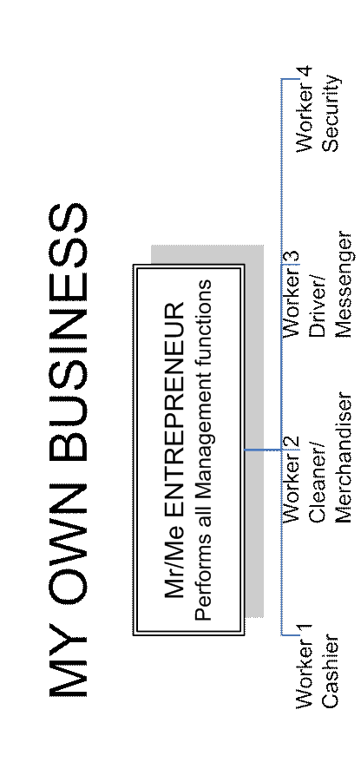
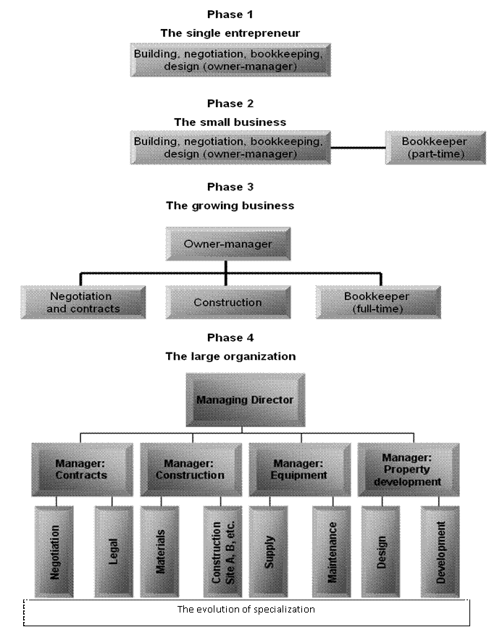
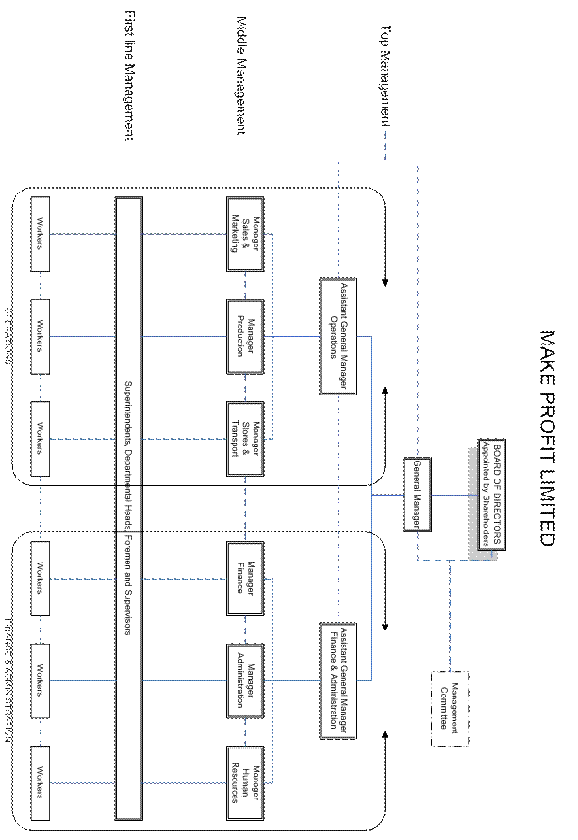

The structure of a team within a department:

The Role of the Team Player
To want to be a Team Player
To serve and support
To think creatively
To perform to the best of his / her ability
To achieve expectations, mutually agreed with the manager (these expectations need to be contracted with your manager)
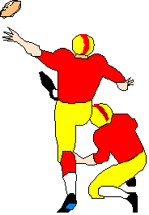
Support colleagues
To serve the customer
To take others by pleasant surprise
To manage his / her manager
Attitude: “two men looked through the prison bars, one saw the mud and the other saw the stars”. In other words, change your attitude to a positive attitude rather than a negative one. What can you do to make the team effective?
Taking responsibility for your own work and responsibilities and also to help a colleague who is battling with his/her tasks.
Avoid gossip: e.g. “Have you heard that Fred’s having an affair with ...?”
Do not carry baggage e.g. “I’m so mad with Mary, she ignored me three weeks ago”. You are part of a team. If you have a problem with Mary, talk to her about it, solve the problem and get on with the important business of making the team work.
Love yourself e.g. “I am great”. It is important that you believe in yourself and your capabilities.
Find something to love in others e.g. “I love the way John’s nose wrinkles when he laughs”. Nobody is just bad, there is good and bad in everyone.
If you want your team to trust you always tell the truth.
You can only build a TEAM when the team players have developed relationships with themselves.
Get each team member to recognise the role/s he or she plays on the team. They should think about the unique way that they each contribute to the teams overall success.
What could you, as an individual team member do, to increase the effectiveness of the team. Discuss the team you chose in the previous exercise.

Advantages Of Teamwork

Advantages To Team Members
Working In a team environment can mean that team members are expected to learn more and do more. There should therefore be kind of reward for the investment in time and energy that team members put into the successful operation of a team.
A sense of belonging: knowing that your team exists to share the workload, that someone in the team will help where necessary, makes everyone’s life a little easier.
Control and ownership of your work. You are personally responsible for your work and you can take pride in work well done. The structure of the team, where roles are rotated, usually leads to less formality and a more relaxed atmosphere in which to work.
Self-worth: teamwork gives workers many opportunities for personal enhancement and opportunities to take pride in your work, which leads to a growth in your personal self-worth. The work environment when you work in a team also leads to more opportunities for learning and this always enhances your self-esteem.
Tangible rewards: when your team functions successfully, it will ensure greater productivity and therefore more income for the organisation. Many organisations reward excellent teamwork that leads to tangible results, with tangible rewards.

Advantages To The Organisation
Productivity: good teamwork usually leads to increased productivity, which in turn leads to increased profitability.
When team members work well together, it also leads to cost-saving, in other words working more effectively in less time.
Another benefit is a reduction in wastage, since the team itself is responsible for reducing wastage.
Quality of work also improves, which means there is an improvement in the quality of the products, the service given to customers, etc.
Teamwork enhances the motivation, commitment, knowledge and morale of employees. Employees benefit from teamwork as there are so many learning opportunities. Teams are also more flexible and can respond to changes in the business environment faster.
Modern management practices, such as Quality management and Safety, rely heavily on teamwork. It follows then that teams, rather than groups, empower people in the modern organisation.

Roles And Responsibilities Of Team Members

The Lesson Of The Geese
Every year, just before winter, the geese in the northern hemisphere fly south for the winter. They always fly in a V-formation and scientists have discovered the reason why they fly this way. As each bird flaps its wings, it creates uplift for the bird immediately following. By flying in a V-formation, the flock adds at least 71% more flying range than if each bird flew on its own.
When we apply this to teamwork, we can say that people who share a common direction and sense of community can get where they are going quicker and easier because they are travelling on the thrust of one another.
Whenever a goose falls out of formation, it suddenly feels the drag and resistance of trying to fly alone and it quickly gets back into formation to take advantage of the lifting power of the bird immediately in front.
There is strength, power and safety in numbers when travelling in the same direction as others with whom we share a common goal.
When the goose in the lead gets tired, it rotates back in the formation and another goose flies in front.
It is worthwhile taking turns doing the hard jobs.
The geese from behind honk to encourage those in the front to keep their speed.
We all need to be encouraged with active support and praise.
When a goose gets sick or is wounded and falls out, two geese fall out of the formation and follow it down to help and protect. They stay with the goose unitl the problem is resolved and then they fly out on their own or with another formation to catch up with their group.
We must stand by each other and help each other in times of need.
(Source: Lussier, RN. 1997, Management: concepts, Applications, Skill Development. Cincinnati, OH: South Western,pp418-419)
To summarise, when you are working in a team each team member has to commit to the following in order to ensure the team functions effectively:
Commit to work together in a team, commit to the goals and purposes of a team, find your place in the team so that you can also feel you belong.
Ensure that all team members are travelling in the same direction – working towards the same goals and purposes.
Take turns doing the hard jobs, it will benefit the team in the long run and therefore also benefit individual team members.
Encourage, support and praise each other.
Stand by each other and help each other in times of need.

Work Toward a Mutual Goal
The team should have a clearly defined purpose. The purpose should be stated in goals and these goals should be defined clearly, the goals should be measurable and the team should be able to attain the goals. These goals should be aligned with the vision and mission of the team, which, in turn is aligned with the vision of the department and finally the organisation as a whole.
The goals should be important to each individual team member as well as this will lead to combined efforts to achieve the goal.
Examples of goals:
A production team might have a goal to achieve normal production against a tight deadline.
Heavy duty vehicle drivers may have a goal regarding accidents or fuel usage and maintenance cost saving to a specific amount.
The soccer team may have the goal of winning the 2010 Soccer World Cup, and are working towards this goal.
The church may have a goal to collect a specified amount by a certain date in order to enlarge the church.

Accept Responsibility
Team members have to take responsibility for their own jobs as well as the achievement of the goal or purpose of the team. Members support each other so that the objectives and goals can be met by entire team.
There should also be a culture of respect for each other and this is the responsibility of the entire team.

Motivating the team
When people are valued and rewarded for their knowledge and skill, they become self-motivating. Motivation also comes from sharing responsibility. Team members should always motivate each other through communication, acceptance and support of the team.
When a team successfully achieves it goals, every member in the team is highly motivated.

Team Vision
Every team should have a clear vision and meaningful purpose to which all members work. This vision should provide direction and guidance under all conditions.
The team vision should support the vision and strategic objectives of the organisation, so the team cannot draw up a vision in isolation.
Once the team has established a clear sense of its own purpose and reason for existence, it can begin to focus on the goals it has to achieve.

Exercise4: SO2: individual self-assessment
Complete the assessment activity in the workbook

Conflict
Conflict can be good or bad, productive or destructive.

Constructive Conflict
Positive conflict deals in facts. It helps individuals or the team to improve by talking problems through until a sound understanding is reached. This kind of conflict encourages both OPENNESS and trust.
To promote constructive use of conflict, team members should be encouraged to express their views and concerns.

Negative Conflict
Negative conflict relies on rumour and opinion. It wounds and divides team members and it breeds mistrust and hostility.
When you have a problem, don’t just moan and groan about it in corridors, voice your problems at the appropriate time, usually in meetings. This way the problem might actually be solved. If you, as a team member, to choose to complain to the wrong people, the problem will not be solved.
To be an effective team, the atmosphere surrounding the team needs to be characterised by an open dialogue in which there is a certain amount of conflict, confrontation and differing points of view to encourage new ideas and patterns of behaviour so that the organisation will not lose its ability to adjust to external competition.

The Role Of The Team Leader
What can you, as team leader (when your turn comes), do in order to promote the effectiveness of the team?
Be tolerant towards the team members, and promote and demonstrate this attitude of tolerance
Acknowledge you own faults and shortcomings. If team members have an insight into the mistakes of the team leader, they will be more inclined to confide their own mistakes to their leader.
Create a learning culture and not a knowing culture. The result of any exercise or task should be a learning result
Give credit and show appreciation for all contributions.
Stop taking decisions on behalf of team members. Involve the team in the decision making process.
Accept decisions made by team members.
Encourage differences of opinion.
Be consistent. Do not say one thing and do something else.
Trust your team members and encourage them to trust each other. It is important to note that when team members agree that trust is important, they invariably win. Teams that try to ignore the issue of trust rarely work. Trust is like customer relations. It takes a long time to achieve but it can be destroyed in a few seconds. Trust cannot be imposed and it only comes through experience some say. Definition of Trust: TRUST IS THE BELIEF THAT WORDS WILL BE TRANSLATED INTO ACTION AND THAT OTHERS WILL TAKE YOUR INTEREST INTO ACCOUNT
Support your team members and encourage them to support each other. Support and trust go together for without the one the other cannot exist. Both can best be achieved where individual members do not feel they have to protect their territory or function, and feel able to talk straight to other team members. With trust people can talk freely about their fears and problems and receive from others the help which they need to be more effective.
Do not avoid conflict, address the problem. Conflict and avoidance in the name of support is like building relationships on sand. People working together must sense that their shortcomings or mistakes will be accepted along with their strengths and weaknesses, if a healthy supportive climate is to exist.

Exercise 5: SO2, SO4, SO5: self- assessment
Complete the assessment activity in the workbook

