**UNIT STANDARD 12153**

***Unit Standard Title***

Use the writing process to compose texts required in the business environment

***NQF Level***

4

***Credits***

5

***Purpose***

The purpose of the unit standard requires learners to follow a process in writing texts and reports required in business. It is intended to promote clear, unambiguous communication in plain language and to improve the quality of written reports and other texts that are specific to a business environment, require a particular format and may include specified legislated requirements. The unit standard enables learners to recognise and effectively use textual conventions and features specific to business texts.

The qualifying learner is capable of:

* using textual features and conventions specific to texts
* identifying the intended audience for the communication
* identifying the purpose of a text
* selecting the appropriate text type, format and layout for the purpose
* organising and structuring a technical text appropriately
* using appropriate grammar conventions
* drafting and editing a technical text
* recognising errors and checking for accuracy
* presenting the same information in different ways
* using plain language in business

***Learning assumed to be in place***

There is open access to this unit standard. Learners should be competent in Communication at level 3.

***Unit standard range***

The typical scope of this unit standard is:

* Texts specific to a particular function in a business context include sector specific documents; written comparisons of products; reports on specifics of cover; historical reviews over a period of cover; claims reports; explanations of how changes in legislation will impact on the rules of the fund or pension benefit; financial needs analyses; financial plans; reports to investors; reports to statutory bodies; customised insurance policies; statistical reports; actuarial reports; promotional proposals and other texts used within the sector and field of learning.
* The audience may be internal for use within an organisation or external for wider publication.
* Appropriate use of layout includes visual presentation, headings, bullets, numbering and other layout features, appropriate phrasing for headings, stem sentence and phrases match where bullets are used.
* Over complex syntax refers to long constructions and inappropriate use of the passive voice.
* Different ways of presenting the same information include text, graphs, tables, flow charts and diagrams.

***Specific Outcomes and Assessment Criteria***

***Specific Outcome 1:*** Use textual features and conventions specific to business texts for effective writing

***Assessment Criteria***

* Texts specific to a particular function in a business environment are identified and an indication is given of industry specific and/or legislative requirements for each text
* Texts specific to a particular function in a business environment are produced in response to defined requirements
* The implications of not following the industry specific or legislative requirements for a specific type of text are explained and an indication is given of the possible consequences of non-compliance.
* Terminology and conventions specific to a particular function in a business environment are used appropriately

***Specific Outcome 2***: Identify and collect information needed to write a text specific to a particular function

***Assessment Criteria***

* The intended or incidental audience for whom the text is to be written, are identified for a specific field or sub field in order to focus the information needs.
* The purpose of the text is identified within a specific field or sub-field and according to the information
* Questions are asked to help understand client needs and to focus information gathering
* Information required for the document is accessed from a variety of sources
* Information accessed is checked for accuracy, bias, stereotypes, and other offensive details.
* The focus of the proposed text is defined and decision is made about what information should be included or omitted in order to ensure the focus
* A checklist is created to facilitate reflection and editing

***Specific Outcome 3***: Compose a text using plain language for a specific function

***Assessment Criteria***

* A format and structure is selected for the text that is appropriate for the intended audience and function
* The main points to be included in the text are identified and the necessary supporting details are added
* A first draft of the text is written that collates the necessary information in a rough framework

***Specific Outcome 4***: Organise and structure a text appropriately for a business function

***Assessment Criteria***

* The first draft is checked to ensure that appropriate grammar has been used and where necessary the draft is rewritten in plain language using clear accessible language that avoids over-complex syntax
* Different ways of presenting the same information are considered and used where these enhance the meaning of the text
* Technical or marketing terms and jargon are interpreted and rephrased in plain language or used appropriately in the correct context where the terminology is essential to the understanding of the text.
* All information is checked for accuracy, and factual correctness
* The document is ordered to ensure that the sequence is logical and meaningful

***Specific Outcome 5***: Present a written text for a particular function in a business environment

***Assessment Criteria***

* A text type, format and layout are selected that is appropriate for the audience and purpose
* Layout and formatting techniques are used correctly to enhance the readability of the text.
* Information in the document is evaluated in terms of its appropriateness for the intended audience and business function
* The final draft is proof read to check that it is completely correct
* The final copy is self assessed using a rubric or checklist based on the requirements of the writing task and the items on the checklist created in Specific Outcome to Identify and collect information needed to write a text specific to a particular function

***Critical Cross-field Outcomes (CCFO)***

* Make responsible decisions about format, layout and material to be included in the text. Reflect on and explore a variety of strategies to write more effectively for different audiences and purposes. Be culturally and aesthetically sensitive across a range of social contexts in carefully selecting words to create a variety of texts for different audiences and purposes. See the world as a set of related systems in understanding the consequences of non compliance with legislative and sector requirements for specific texts. ).
* Organise and manage his/her own learning activities responsibly and effectively
* Collect, organise and critically evaluate information from a variety of technical texts
* Communicate effectively using visual, mathematics and language skills in written texts

**TEXTUAL FEATURES AND CONVENTIONS**

***Outcome***

Use textual features and conventions specific to business texts for effective writing

***Assessment criteria***

On completion of this section you will be able to:

* Produce texts specific to a particular function in a business environment in response to defined requirements
* Explain the implications of not following the industry specific or legislative requirements for a specific type of text and give an indication of the possible consequences of non-compliance
* Use terminology and conventions specific to a particular function in a business environment appropriately

***Language Structures And Features***

Writers use language structures and features all the time, in order to influence what you, the reader, thinks when you have read the written piece.

Languge structures and features include

* The choice of words.
* Use of language.
* Symbols.
* Pictures.
* Tone.

**Text Type**

In the printed media, newspapers, magazines, brochures, text books, use is made of different techniques in order to

* get your attention,
* help the writer to get the message across,
* indicate a change of topic, a main point or sometimes both
* encourage you to read the written piece
* Different font types and sizes
* ***Bold***, *italics* and underline
* Visual aids, such as cartoons, diagrams, and so on
* Titles and subtitles
* Captions: a title or brief explanation printed with a visual aid, which can be a photo, an illustration, a diagram or a cartoon
* Photos
* The layout of the page
* A summary of a piece of the article is quoted

Below are examples

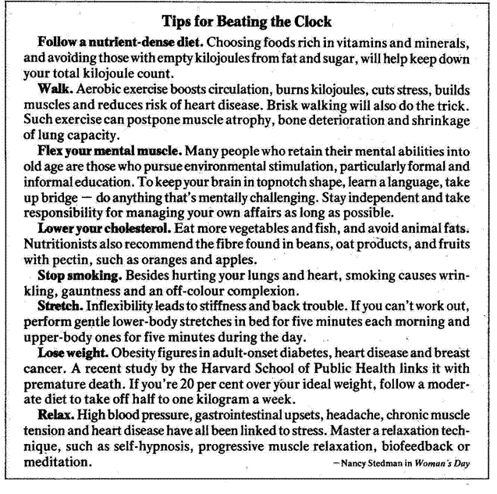

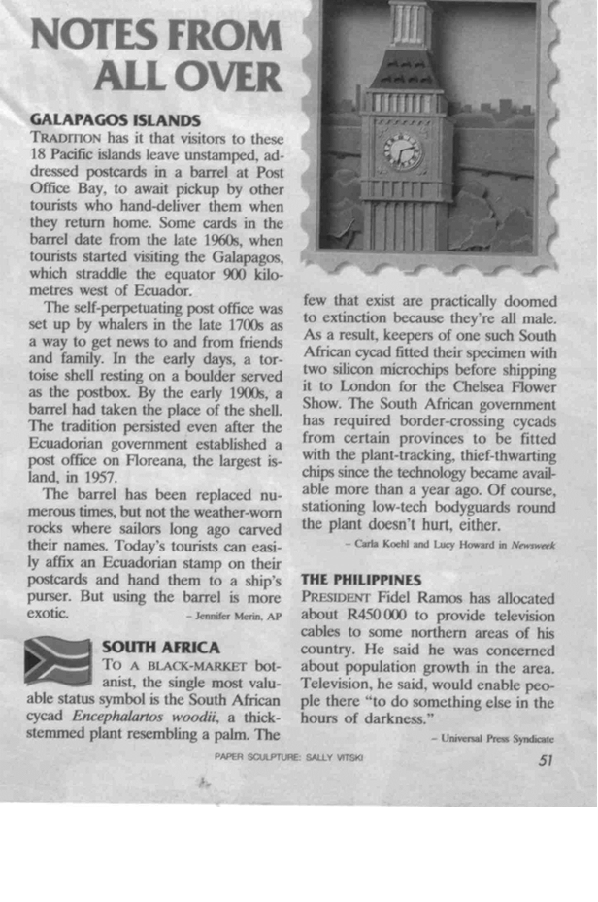

Advertisements are very good examples of using text and visuals to get a message across, using as little words as possible.

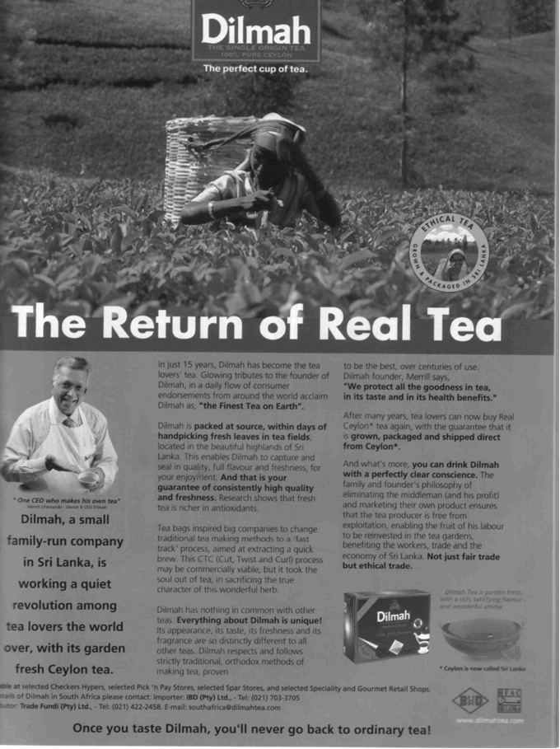

**Diction**

Diction is the choice and use of words in writing and speeches. If we look at the article about slavery, we can see some examples in the first paragraph.

*“But the blind Dinka woman could only pull her seven-year-old son and twelve-year-old daughter close. Shaking with fear, they hid in their windowless hut and prayed.”*

If the author had not told us that they were shaking with fear, we would have felt differently about the paragraph. We can also change the meaning of the sentence by changing one or two words:

*“But the cowardly Dinka woman could only pull her seven-year-old son and twelve-year-old daughter close. Shaking with fear, they hid in their windowless hut and prayed.”*

*“But the cowardly Dinka man could only pull his seven-year-old son and twelve-year-old daughter close. Shaking with fear, they hid in their windowless hut and prayed.”*

Always make sure that you know the meaning of words you use when composing texts. If you are unsure, consult a dictionary which will give you the meaning of the word.

There are various kinds of dictionaries available:

***Bilingual Dictionary***

A bilingual dictionary, e.g. an Afrikaans/English dictionary will give the word, in Afrikaans with the English equivalent, and vice versa.

A word like “walk” would, in an English/Afrikaans diary give the following information:

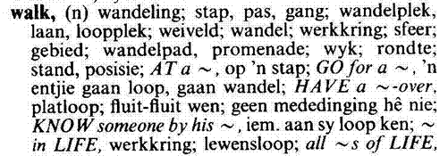

If we now look at the second word quoted, stap, the dictionary would give the following information:

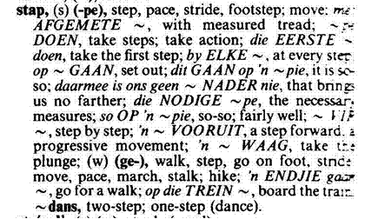

***Explanatory Dictionary***

An explanatory dictionary gives the word, its meaning as well as advice on how to use it in practice. This dictionary would be in one language only, English or Afrikaans or Sotho, etc. There is only one language involved, so there will not be references to the Afrikaans or Sotho equivalent. Dictionaries usually also tell you how to pronounce the word correctly.

If we look up the word walk in an explanatory dictionary, we will get the following information:

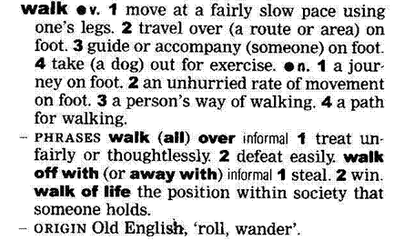

As you can see, the main word is quoted in bold, with variations of the same word quoted afterwards and then follow explanations of what the word means as well as how to use the word in a sentence.

Dictionaries usually also tell you how to pronounce the word correctly.

In the front of the dictionary you will find a guide on how to use the dictionary.

Many of these descriptions will sound like gobbledygook to you. What is important for now is that you can refer to the beginning of the dictionary in order to understand what the descriptions in the dictionary mean.

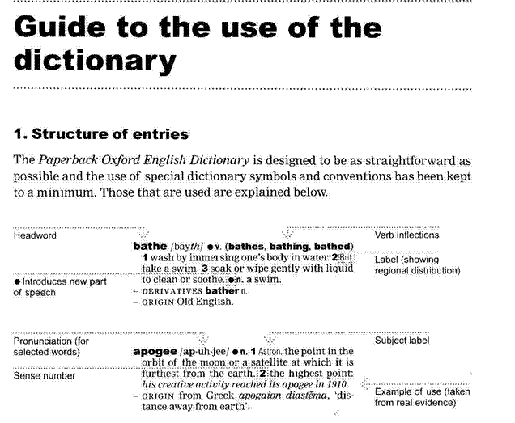

***Thesaurus***

A thesaurus is a dictionary that contains lists of words that have the same, similar or related meaning. If you look up the word walk in a thesaurus, you will find the following lists, usually with explanations of the words included:

|  |  |
| --- | --- |
| Saunter | Stroll |
| Amble | March |
| Stride | Pace |
| Hike | Toddle |
| Totter |  |

This will enable you to choose the exact word to use, or to determine the exact meaning of the word that was used in the piece of writing.

The sooner you get into the habit of looking up words that you don’t understand, the sooner you will improve your language and communication skills in general. If you don’t own a dictionary, you will probably find one at your place of employment and your local library will also have dictionaries.

***Structuring The Document***

A document is made up of sentences and paragraphs

**Sentences**

Too many short sentences will make your text appear choppy and curt. Too many long sentences will have the opposite effect, your text will appear confusing. Short sentences should be varied with longer sentences to give your text an even flow.

There are three basic types of sentences.

***Simple sentences***

These have a single verb and a single subject and object. “The boy is playing with the ball.”

***Compound sentences***

Are made up of two or more independent sentences or thoughts, that are interrelated.

They are connected by the following words: but, and, or. “The boy is playing with the ball, but his mother is calling him.” Sentences should have the same topic if you want to create a compound sentence.

The following two sentences are not related and should not be joined: “It is late.” and “I like reading.” “It is late and I like reading” does not make sense since the topic is not shared. “It is late and I am going to bed.” is a better example.

***Complex sentences***

Consist of one independent sentence with one or more dependent clause that relates to it. The sentence and the clauses are separated by a comma. “Although it is raining, the boy is playing outside.” “although it is raining” is not a full sentence, it does not have a subject, so it is called a clause and has to be added to a sentence. The clauses and the sentence must relate to the same topic if you want to create a complex sentence. “Although it is raining, I like reading.” Is a pointless sentence, since they do not share the same subject. “I have to go to the shop, even though it is raining,” is a better example of a complex sentence.

**Paragraphs**

The sentences in a paragraph should form a unit. The reader can easily see how a sentence follows on the one preceding it. A paragraph starts with a topic sentence, that introduces the topic of the paragraph to the reader. The topic sentence acts as a base and holds the paragraph together. Sentences that follow in the same paragraph should enlarge on the topic or theme introduced in the first sentence. We call them supporting sentences. Supporting sentences should provide specific details about the topic in order to clarify the topic sentence and make the paragraph interesting.

If the sentence does not contribute to the theme of the paragraph, it should not be included. You should also avoid adding data that is not relevant to the topic

***Hints for writing good paragraphs***

* Each paragraph should have only one theme.
* Do not write paragraphs that are longer than 10 or 12 lines, as longer paragraphs become boring and confusing.
* Mix long and short paragraphs in a document to create interest and attention with the reader.

**Document**

When you are writing a document, it will usually be about a specific topic or theme. The text you are writing will usually consist of more than one paragraph, each with its own topic but relating to the main topic of the document.

Your piece of writing should start with an introduction of the theme of the document. Your first paragraph would therefore be the introductory paragraph. The introductory paragraph should be short, relevant, it must introduce the theme of the document and it must get the attention of the reader.

Your paragraphs must follow each other in a logical way, from point A to point B to point C. The last sentence of the previous paragraph should lead to the next paragraph. One thought should be connected to the next thought in a logical way. Do not jump around from one topic to another without giving the reader some clues as to your purpose.

You can use ***cause and effect***, and ***contrast*** to help you arrange your paragraphs in a logical way.

***Contrast***

Contrast is when you contrast one theme, thought, opinion or product with another. Refer back to the introduction of the article about the gorillas: you can contrast the concern of conservationists who were worried about the gorillas, with the views of humanists who were more concerned about the people being killed.

***Cause and effect***

Cause and effect: referring back to the same text, you can progress from the causes of the war to the consequences(effect) of the civil war on ordinary people.

If you are writing about something that happens over a period of time, you can arrange your paragraphs chronologically: start with the earliest date and end with the latest date. When writing about droughts in South Africa you can start with the big drought in the 1930s and end with the current drought.

Any arguments used in your document must be supported by sound reasons and facts. You have to justify your feeling about the matter with facts in order to persuade the reader to your point of view. Something your neighbour said about the matter is not fact – you have to verify the statement your neighbour made.

Ensure that you state your point of view clearly. Remember other people also have to understand your point of view.

*A fragile home threatened by war.*

*Among the last of its kind, a young gorilla peers from its leafy refuge in Rwanda – a nation bloodied by ethnic slaughter. Conservationists fear that Rwanda’s instability could endanger the gorilla’s survival. Others ask: How should the plight of the world’s rarest ape be weighed against more than 500,000 human dead?*

As it stands the paragraph above is clear. If I leave out certain key words, I can change the paragraph so that it does not make any sense:

“A young gorilla peers from its leafy refuge and instability could endanger the gorilla’s survival.” What on earth am I talking about? Where is the gorilla, why would its survival be endangered and what is the instability that I wrote about?

If you want your writing to be clear, you have to ensure that you give the reader all the information he/she requires to understand your reasoning.

***“They said it is going to rain today.”*** This is a terrible sentence. Who are “they”, where did they get their information from, where is it going to rain, where do they live – do they even live in the same area as you and I? Always check your facts for correctness before you commit them to writing. Readers are very critical and will never forgive you if you get your facts wrong. Anything you write in future will be viewed with suspicion. “The Weather Bureau predicts that there is an 80% chance of rain in Gauteng today.” Now you have stated the source of your fact, you have backed your statement with an estimate of the possibility of rain and you have also made it clear where it will rain. If it doesn’t rain, your readers cannot be angry with you, since you only reported what the Weather Bureau predicted.

At the end of your document, you have to come to a conclusion, where you connect all the facts that you stated previously. State your conclusion or recommendation clearly and make sure that it is based on the facts your stated. The conclusion can be:

* A short summary of the main points of your document.
* A direct-approach conclusion where you show the reader how the message relates to him/her.
* Plan of action conclusion where you answer the question of what should be done about the matters discussed in the body of your document.

***Grammar***

Grammar is the whole structure of a language, including the rules for the way words are formed and their relationship to each other in sentences – in other words, where you place the words in sentences. This has to do with the words we use in sentences and also how we use them. Let us look at the following example:

*If you say: “ My husband and I have been nearly married for two years.” it literally means that for two years you and your husband have been almost married, but have not gotten married yet. You probably mean that for two years you have been thinking about getting married, but cannot make up your minds to actually do it.*

If you say: “My husband and I have been married for nearly two years” it means that you and your husband got married nearly two years ago and you are still together.

Below is a quote from the article about slavery, as written by the author.:

*Once the Arabs seized the cattle, they moved from hut to hut gathering grain, blankets, salt – and human booty. Deep in the shadows of one hut, they discovered Abuk. Grabbing the terrified woman by her bead necklace, a militiaman growled, “Now you belong to me!” In all, 282 Dinka, including Abuk’s mother, sister and niece were herded up and forced to march north.*

If I substitute the word “***booty***” in the first sentence with “***bodies***”, it would mean that the slave traders gathered the remains of dead people to take with them.

If I change the word order of the third sentence, I can change the meaning of the sentence as well:

*“Grabbing the woman by her bead necklace, a terrified militiaman growled ….”*

This, of course, means that the militiaman is terrified, and not the woman.

It is easy to change the meaning of a sentence or paragraph just by changing the order of the words in the sentence or paragraph. You must always be aware of this and ensure that, when you are writing something (especially your summaries) you use grammar correctly. If you don’t you can be misunderstood and this could sometimes have serious consequences.

People can be misquoted simply by changing the word order of the sentences. When we read and write text, we have to be careful of our use of grammar.

***Narrative Voice***

When you write text you also have to choose the voice that you are going to write in.

* Active or passive voice
* First person or third person

**Active And Passive Voice**

The difference between active and passive voice is in the form of the verb(the doing of something) and the relation to the subject (who is doing it).

“The boy kicked the ball.” Is active voice, because the subject performs the action. You can see that the sentence starts with the subject (the boy), then the verb follows (kicked) and then the object (the ball). This is active voice.

***Active voice expresses thoughts, ideas and facts more clearly than passive voice.***

“The ball was kicked by the boy.” Is passive voice, because the subject receives the action. The sentence starts with the subject (the ball), the verb follows (kicked) and then the subject receives the action (the boy). This is called passive voice.

When you write, it will mainly be in active voice. Only very formal business writing, scientific writing and legal documents such as affidavits will be in passive voice. “The victim was raped by Mr X.” This is done so that the recipient of the action (the victim) is the most important part of the sentence.

Passive voice is also used when the “who” or “what” that performs the action is not known. “The victim was raped.” Or “The ball was kicked.”

***Scientific and sometimes legal writing is done in passive voice.***

***Be aware that most business correspondence will be written in active voice. Using passive voice for business letters and reports is inappropriate.***

**First Person Or Third Person**

Most writing is done in the third person. The third person reports events as they happen to other people. If you look at the article about Nelson Mandela’s grandson in handout 1, you will find that the article was written by the reporter in the third person, in the discursive style.

If I rewrite the first paragraph of the article in the first person, it would look like this:

I am former President Nelson Mandela’s grandson. AIDS brought my wife and I together.

Can you see the difference?

***Business Correspondence***

There are many forms of business correspondence, however the types most used will be discussed shortly.

**Business Letters**

Business letters can be formal and informal and are sent to parties outside the business. Internal correspondence is usually done on a memorandum.

There are many kinds of business letters such as:

* Enquiries and replies
* Orders and follow-up letters
* Claims and adjustment letters
* Employment letters
* Letters giving information about products and services
* Letters to the press

The layout of the letters will all be more or less the same but the style and register will vary depending on the industry and the corporate culture. Banks, Insurance companies and legal firms tend to compose business letters using the formal register, while other companies and industries tend to use a less formal style that is a mix between the formal and informal register.

**The Parts Of A Business Letter**

***Letterhead***

Most businesses these days use letterheads that already have the name, address, telephone and fax numbers as well as the e-mail address printed on the letterhead. If not, it can be typed or written at the top left, middle or right hand side of the page.

***Date line***

Directly underneath the address the date is inserted in what is called the date line. It is better to write the date fully in any of the following formats, depending on the custom in the organisation:

* Year, month, day
* Day, month, year
* Month, day, year

***Reference line***

It is customary to quote reference numbers and/or initials next, but this may also be stated at the end of the letter.

Our ref XYZ/CK

Your ref BDX/LM

***Attention line***

If you are writing the letter for someone’s attention, you will quote that person’s name in the next line, which is called the attention line:

Attention Mr/Me …

***Inside address***

The inside address is quoted on the left hand side and this is of course the address of the receiver of the letter.

***Salutation line***

Greets the reader and sets the mood or tone of the letter:

Dear Sir/Madam

Or

Dear Mr Brown

These days you can also address the person as follows:

Sir/Madam

Or

Mr Brown

***Subject line***

The next part of a business letter is called the subject line where you give the reader an indication of what the letter is about and it is usually typed in capital letters or capital and lower case letters that are underlined:

QUOTE FOR EXAMINATION BOOKS

Or

Payments received

***The body of the letter***

This part contains the entire communication of the letter.

***The closing***

The tone of the closing should be the same as the tone of the message and the salutation. Sometimes it will be very formal, depending on who you are writing to and what the tone of the letter is:

Yours faithfully

or

Sincerely yours

It can also be informal, depending on the style and type of letter:

Best regards

***Signature***

Spaces are left open for the person who has to sign the letter. Then the person’s name is typed in and the status or position of the person in the organisation:

P Brown

MANAGING DIRECTOR

***Enclosures***

If you are sending enclosures, you will quote them underneath the signature

Enclosures (4)

**Plan a business letter**

A successful business letter is based on clear thinking, a clear and definite purpose and adequate planning.

* You have to read and reread all the correspondence that relate to the letter you want to write so that you can be sure your reply is complete.
* Note the main ideas of the correspondence that relate to the letter you want to write
* Collect background information to make sure that you are well-informed.
* Sort your ideas and keep only information and ideas that are valid and have bearing on the letter you want to write.

The first sentence of the body of the letter is the introductory sentence and will state (announce) or acknowledge something. If you plan your introductory sentence carefully, it will attract the attention and interest of the reader.

If you want someone to react favourably to your letter you have to convince them that it is to their advantage to do as you suggest. To do this, you will adopt the *‘you-attitude or approach’.*:

* I am pleased to tell you…
* In your letter of ….. you asked …
* I have good news …
* Thank you for your interest in …

The message of the letter: this will be the middle section of the letter.

Plan your paragraphs carefully and apply the principles of writing good paragraphs that you learnt in earlier modules. Use positive words in your body and avoid negative words. In the following table you will find examples of negative words that you must avoid.

|  |  |
| --- | --- |
| Inferior | Stupid |
| Unacceptable | Neglect |
| Blame | Cancel |
| No | Incompetent |
| Refuse | Failure |
| Defective | fault |
| ignorant | biased |

For example, when a client complains about something do not say:

*“We have received your letter in which you allege that the spare parts have been damaged..”*

Rather say:

*“Thank you very much for telling us about the problem you have with the spare parts…”*

Select words that are simple, clear and direct. Avoid fancy, smart and bombastic words that most people don’t understand. Remember not to use legalese, jargon, slang, etc unless you are sure your reader will understand or unless you ***have to*** use technical or legal language.

As soon as you have achieved the purpose of writing the letter, stop writing. The concluding paragraph in a business letter should convince the reader that he/she is a customer or client of value, it should promote goodwill and contribute to good public relations:

* Please tell us if you need more information
* We look forward to receiving your instructions.

***Memorandum***

A memorandum is an informal, written piece of information which is intended to remain within an organisation. These days the abbreviation memo is used for the short inter-office memorandum.

A memo would also usually be printed on a letterhead and will have a definite layout as required by the organisation.

Handout 3 contains an example of a memo. The same rules when composing a business letter will apply when you write a memo to someone else in the organisation:

* Plan what you want to say
* Collect background information
* Sort your ideas and facts
* Take care how you construct your paragraphs and sentences

Memos are not usually signed, unless required by the organisation.

***Report***

Report is a comprehensive term for written information based on facts and can cover many topics.

A report is an objective, well-structured, written document based on accurate facts with the purpose of conveying specific, useful information to its readers. A report is unique: no two reports are the same.

In the business world, a report will usually be as a result of something that was investigated or researched, such as the implementing of a new computer system. The custom in the organisation will determine whether the report is written in the formal or informal register.

Reports usually consist of the following: (see handout 4)

* A cover page
* A title page
* Introduction and statement of the aim of the report, also called the terms of reference
* A brief summary of the main contents
* A table of contents
* Procedure followed during the research or investigation
* Findings and conclusions as a result of the research or investigation
* Recommendations based on the research or investigation
* bibliography

Reports are usually long and lengthy documents. Remember to make use of the following:

* headings
* titles
* subtitles
* paragraphs
* numbers and bullets in your document
* visual aids

**EXAMPLE OF A FUNDING OR PROJECT PROPOSAL**

COVER PAGE

* Department of Public Works (Mpumalanga Province)
* Application to European Union by the Department of Public Works (Mpumalanga Province)to fund Project Management training for Senior Managers
* Date

1. **INTRODUCTION**

State the purpose of the report and the main intention for funding.

1. **BACKGROUND**
   * Give background information about the Department in relation to the request for funding
   * Provide background information about the project for which you require the money
2. **PROJECT DESCRIPTION**

* Describe the project in terms of its scope, location, overall timeframes, target group, etc.

1. **JUSTIFICATION FOR THE FUNDING / PROJECT**

* Explain why funding is so important
* Explain who will benefit and **how** they will benefit – refer to all stakeholders

1. **OBJECTIVES**

* Develop SMART objectives for the project or the issue that you wish to be funded
* This is important because the funder will use these objectives to monitor the extent to which the money was spent effectively.
* The funders’ brief should be incorporated into the objectives.

1. **ACTION PLAN OR WORK PLAN**

* Include an action plan or work plan that details how you intend to implement the objectives.
* Your action plan should cover the following categories: activity, person responsible, deadline time, resources required, budget, indicators of success and assumptions (optional).

1. **DURATION OF THE ASSISTANCE**

* Indicate the time frame for the funding – depending on the funders’ specifications, funding is usually given over a period of three years.

1. **PROJECT SUSTAINABILITY**

* Funders want to know that they will not be giving you money forever. It is therefore important to explain how you intend to be sustainable after the time frame has expired.

1. **MONITORING AND EVALUATION**

* Funders will tend to fund projects if they know that there is a secure monitoring and evaluation process in place.
* Monitoring is an on-going process, whereby usually a team of skilled people are selected / elected to monitor the way in which the objectives are met. Corrective action is usually taken based on the verbal and written recommendations of the monitoring team. Funders are satisfied if they receive regular (monthly) reports regarding progress.
* Evaluation occurs after the project has been implemented. Usually an independent and impartial person evaluates the project against the objectives and the brief provided by the funder.

1. **COST IMPLICATIONS**

* State the amount that you are requesting.
* Include a budget. If funding is requested for three years, your budget should reflect this.

1. **CONCLUSION**

It is proposed that the EU provides the Department of Public Works (Mpumalanga Province) with R100 000 for the training of Senior Managers in Project Management Skills. The Department will provide the EU with Progress Reports once a month and an Evaluation Report upon completion of the project. Ms R Sithole will be the contact person from the Department of Public Works (Mpumalanga Province).

|  |
| --- |
|  |
|  |
|  |
|  |
|  |
|  |
|  |
|  |
|  |
|  |
|  |
|  |
|  |
|  |
|  |
|  |
|  |
|  |
|  |
|  |
|  |
|  |
|  |
|  |
|  |
|  |
|  |
|  |
|  |
|  |
|  |
|  |
|  |
|  |
|  |
|  |
|  |
|  |
|  |
|  |

***Facsimile***

A fax is a method of sending business correspondence via a fax. Most organisations today have a standardised form for use when sending a fax. Faxes should usually be signed, since it is a document that represents the organisation and the person sending it. however, check what the custom in the organisation is before you sign a fax.

Handout 5 contains an example of a fax form.

***Resume Or Curriculum Vitae***

A curriculum vitae is a brief account of your qualifications and previous occupations (jobs) that is sent with a job application. These days, when you apply for a position, you only send the CV, as short as possible, without certificates and proof of employment, etc, unless otherwise requested.

The certificates and records of service all form part of your portfolio of evidence, which will be requested by the organisation only when and if they want to see it, usually when you go for the interview.

Handout 6 contains an example of a CV.

1. At the beginning of the CV you should quote your full names, ID number, physical and postal address and contact numbers.
2. Then follows a list of you work experience, starting with the latest job backwards to your first job. You will state the name and address of the company/organisation you worked for, the dates you worked for them, a contact person and telephone number, as well as a brief list of your tasks and duties and achievements.
3. Once you have quoted all your work experience, you will quote your educational qualifications, , once again from the latest qualification back to when you matriculated. State the name and address of the organisation, the time you studied there and the qualification you achieved.
4. Then, briefly, your interests and hobbies.
5. A CV should not be a long and complicated document, try to keep it to between 2 and four pages. As mentioned, if the organisation wants to view your portfolio of evidence, they will probably request you bring it with when you to go for an interview.

You will either fax or mail your CV to the appropriate place under cover of a letter that is called a letter of application.

The initial purpose of the letter of application is not to get the job but to make sure that you are selected for an interview. This means that your letter and the attached CV must attract the attention, arouse the interest and create a desire of the prospective employer to get you for an interview.

***Tips for writing a letter of application:***

* Use the first person “I” as little as possible and try not to sound arrogant and full of yourself.
* Write your letter on good quality paper
* Always rewrite your first draft after you have checked grammar, style, choice of words, neatness and layout.
* Write correctly, clearly, concisely, completely, courteously and considerately.
* Prove that you are efficient

***The format of the letter:***

* Identify yourself
* Identify the job: state the name of the vacancy as well as where and when the job was advertised.
* Create a favourable impression: in the firs paragraph state that you are enclosing your CV in application for the job as mentioned. In the second paragraph write a quick motivation why you are interested in the job and why you should be considered. Do not be or seek the sympathy of the employer.
* Close and sign the letter.

***Industry Specific And Legislative Requirements***

There are instances and industries where business documents MUST be prepared according to certain specific guidelines and WILL by their nature include text that is full of jargon, legalese and technical terms.

Examples of these industries and documents are:

* Manufacturing where you will find written comparisons of products with a lot of technical terms in the document
* Insurance industry where the following documents must contain technical and legal language: reports on specifics of cover; historical reviews over a period of cover; claims reports; explanations of how changes in legislation will impact on the rules of the fund or pension benefit; customised insurance policies;
* Financial sector, such as banks where certain documents will contain technical and legal text,: financial needs analyses; financial plans; reports to investors; statistical reports

These documents must contain certain specific technical or legal text so that:

* The terms and conditions of the service or product cannot be disputed and
* In the case of a dispute, the technical and legal terms of the document will determine the outcome of the dispute.

***This means that, whatever your industry and the custom in your industry, you must always make sure that you follow the conventions strictly and then also ensure that your information is correct. If you quote incorrect information in a business document you can leave yourself and your organisation open to legal action and acute embarrassment.***

**Jargon**

Words or expressions that are used by a specific trade, business or industry.

* A paper tiger: when a committee or other body is established to investigate an occurrence, and nothing much happens, it is called a paper tiger.
* It means that the committee is not doing what it is supposed to do, the members of the committee postpone actions and make up imaginary problems as to why they cannot do the work in time.
* In the training environment in South Africa we find a lot of jargon – words that are used in a context not previously used and existing words put together to mean something that is unique to the education and training environment.
* We talk about Unit Standards, which previously was called training courses, we talk about assessments rather than tests and we have standards generating bodies and standards governing bodies, and so on.

**Technical Terms**

Words or phrases that are complex and usually technical and relate to a specific industry or sector.

* ***Electrocardiograph***: monitors the heartbeat
* Government ***fiscal*** matters: to do with the government’s budget and how they spend the money that we pay in taxes.
* The ***metallurgist*** in charge is Karis Allen, 35, a specialist in fractions and corrosion: a metallurgist is a person who specialises in studying metals, fractions and corrosion in this instance means how metal, such as steel, breaks and corrodes.

**Legalisms**

Legalism can be broadly defined as jargon used in the legal profession. People involved in the legal profession love to quote legal terms in Latin, presumably so that the rest of us cannot understand a word they are saying.

Terms such as:

* Prima facie: it appears to be so when first looked at.
* Sub Judicae: means the investigation is still ongoing, no judgment has been given yet
* Crimen Injura: libel – when you say rude and unpleasant and, usually untrue, things about other people.

You can use jargon, legalisms and technical terms when writing, but only when the readers will understand, for example when they are also involved in your specific industry.

When you are writing for the general public, you have to be careful of using jargon and complex terms, unless you also enclose explanations.

All banks that are members of the Banking Council have agreed to adhere to the Code of Banking Practice (COBP) on a voluntary basis. The COBP is not a statutory code. It sets out minimum standards that the bank must adhere to in the relationship with a client. The COBP also provides valuable safeguards to bank clients. All member banks of the Banking Council are subject to the jurisdiction of the Ombudsman.

***There are two reasons why all the banks must adhere to the COBP:***

It is necessary that banks and their employees must have a set of minimum standards to comply with.

It is important that a client-focused culture be created in the banking industry and in the market.

***COBP in relation to other legislation***

Although the COBP is based on self-regulation and exists as a voluntary code of conduct, there is other legislation, which has an impact on the relationship between a bank and its clients, and therefore has an impact on the COBP.

Acts that have a bearing on the COBP include:

* FAIS Act: Financial Advisory and Intermediary Services Act of 2002
* FIC Act: Financial Intelligence Centre Act of 2001
* FSOS Bill: Financial Services Ombud Schemes Bill(This Bill has not been promulgated yet and therefore it is not legislation, but it might have far reaching effects on the banking industry).
* Promotion of Equality and Prevention of Unfair Discrimination Act of 2000
* Promotion of Access to Information Act of 2000

***Key commitments of the banks***

Banks undertake to honour the following key commitments to clients:

* Act fairly and reasonably, with uncompromising integrity, in all their dealings with clients
* Ensure that all products and services comply with the COBP
* Provide information and assist clients to understand the products and services
* Follow established Internal Dispute Resolution Procedures and inform clients regarding the Ombudsman where applicable

***Fundamental principles of the COBP***

The COBP sets out 23 basic principles in the relationship between a bank and its client. The principles contained in the COBP make a bold and committed statement to clients that banks are serious about treating them fairly in their relationship when a dispute arises.

 1  Act fairly and reasonably in all their dealings with the client.

2  Ensure that all the bank's services and products comply with the Code, even if these services and products have their own terms and conditions

3  Ensure that the procedures the staff follow reflect the commitments set out in the COBP and that they are aware of the internal procedures for handling complaints.

4  Make information available to the client on the bank's services and products in plain language (this will be provided in English and where appropriate in any of the other official languages) and offer assistance on any aspect, which the client does not understand.

5  Ensure that all written terms and conditions are fair and clearly set out the client's rights and responsibilities in plain language.

6  Assist the client to choose a service or product appropriate to his/her needs

7  Assist the client to understand the basic financial implications of the bank's products and services.

8  Assist the client to understand how his/her bank account(s) work(s).

9  Provide reliable banking and payment systems services and take reasonable care to make these services safe and secure

10  Correct the bank's errors and compensate the client where appropriate.

11  Inform the client about the bank's complaints procedures and handle complaints speedily.

12  Inform the client on enquiry and where appropriate to his/her circumstances if the bank offers products and services in different ways (for example electronic banking). The bank will advise the client how to get more information in this regard.

13  Take care to understand the client's financial difficulties and the reasons for arrears on his/her accounts if he/she approaches the bank timeously.

14  Comply with all applicable legislation, codes, rules and supervisory requirements, specifically those relating to banking, insurance,  market conduct and consumer protection. If the COBP imposes an obligation on the bank, which is not contained in a particular law, the bank will comply with the COBP, except where doing so could lead to a contravention of law.

15  Act with uncompromising integrity and fairness to promote complete trust and confidence in the bank, individually, and as an industry.

16  Ensure that the bank's lending criteria, products and services offered, are based and applied solely on commercial principles and do not discriminate against the client on any basis which is not permitted by law, taking into account the implications of commercial principles. The bank may, however, have certain special product or service offerings, which are specifically designed for members of a target market group.

17  The bank will recognise the banking needs of disabled clients and take reasonable measures to enhance their access to those services and facilities.

18  Advise the client what we expect of him/her in his/her relationship with the bank.

19  Provide a copy or a summary of the COBP, to an individual when he/she becomes a client or on request.

20  Clearly display and/or advertise the existence of this Code and the bank's adherence thereto, in the bank's branches.

21  Confirm to the client in writing, where reasonable and appropriate, any relaxation the bank grants or arrangement the bank permits in respect of the client's indebtedness to the bank.

22  Ensure that the client does not sign documents that he/she has not fully completed where required. When the client requests the bank to complete documentation on his/her behalf, the bank will ensure that it is a true reflection of the information he/she provided.

23  Generally only act on the client's written instructions, once the bank is satisfied that the client's identity has been established by means of his/her PIN (which he/she should not disclose to anyone), identity document, signature or other unique means of personal identification. The bank will accept other forms of authority in exceptional circumstances only or where the nature of the process so dictates, for example Internet, Telephone or ATM Banking.

***Disclosure by the bank***

The following must be disclosed by the bank:

* An explanation of terms and conditions of contracts
* All-inclusive information on key features of services, products and account operation
* Information on:

Methods of issuing a cheque

Difference between bank and bank guaranteed cheques

Clearance of cheques/lost cheques

Details and applicable charges with regard to foreign exchange services

The transfer of money

Commission or charges payable with regard to foreign exchange services

Operation of debit and stop orders

Electronic banking services (including special requirements)

What identification and verification documents are required

The recording of telephone conversations

The retention of documentation

* Safety measures on accounts
* Set-off
* Details of charges and fees as well as any changes to charges and fees
* Inform the client why an application for credit has been denied
* When, how and the purpose of disclosing personal information of the client to a third party and for credit screening purposes
* Copies of the COBP to all new clients
* Copies of the COBP available to existing clients

***Conduct by the bank***

The client can expect the bank to:

* Market and approve credit responsibly
* Correct errors and compensate the client where appropriate
* Take particular care in explaining all the relevant issues with regard to mortgage bonds and applicable insurance
* Take responsibility for losses in certain circumstances
* Give clients notice of closure of accounts, branches, ATM's and other outlets
* Publish contact details with regard to the reporting of stolen/lost cards
* Advise the client of set-off against an account
* Explain the impact of suretyships to both clients and sureties
* Confirm in writing (where reasonable and appropriate) any relaxation or arrangement with regard to indebtedness
* Ensure that the client does not sign documents unless fully completed
* Act only on the written instruction of a client

***Conduct by the client***

The bank expects the client to:

* Keep the bank informed of changes in his/her personal details and financial situation
* Take safety precautions when using:
* Cheque books
* Cards
* Internet, Cellphone, Telephone Banking and ATM’s
* Take due care when transacting
* Manage his/her banking products properly

|  |
| --- |
|  |
|  |
|  |
|  |
|  |
|  |
|  |
|  |
|  |
|  |
|  |
|  |
|  |
|  |
|  |
|  |
|  |
|  |
|  |
|  |
|  |
|  |
|  |
|  |
|  |
|  |
|  |
|  |
|  |
|  |
|  |
|  |
|  |
|  |

**IDENTIFY AND COLLECT INFORMATION**

***Outcome***

Identify and collect information needed to write a text specific to a particular function

***Assessment criteria***

On completion of this section you will be able to:

* The intended or incidental audience for whom the text is to be written, are identified for a specific field or sub field in order to focus the information needs.
* The purpose of the text is identified within a specific field or sub-field and according to the information
* Questions are asked to help understand client needs and to focus information gathering
* Information required for the document is accessed from a variety of sources
* Information accessed is checked for accuracy, bias, stereotypes, and other offensive details.
* The focus of the proposed text is defined and decision is made about what information should be included or omitted in order to ensure the focus
* A checklist is created to facilitate reflection and editing

***Collect Information***

Before you start writing your document, you have to plan what you are going to write. First, you are going to define the topic and then you have to gather information about the topic.

|  |  |
| --- | --- |
| ***Information can be gathered from***: | **In the case of business correspondence, you will find information in:** |
| Libraries | Minutes of meetings. |
| Encyclopaedias | Correspondence with clients and suppliers. |
| Manuals | Operations and procedures manuals |
| Magazines | Internal correspondence between departments, branches and regions. |
| Newspapers | Correspondence between management and their departments. |
| Interviews with experts |  |
| Internet |  |

When doing research about a topic it is important that you gather as much information about a subject as possible. The more information you have, the better. Of course, the information and data must be relevant to the topic that you are going to write about.

**Organise the material**

Once you have gathered information, the material you have collected has to be organised.

***Sorting and categorizing***

Arrange or organise the information with common features or characteristics systematically in groups. All the information with similar content is grouped together. Your classification will depend on the order in which you are going to write the document: you can sort the information chronologically, using contrast or cause and effect.

***Sifting for relevance***

Once you have classified the information and data, you have to sift through it for relevance. You should keep only the information that is relevant to your topic, everything else can be discarded. In other words, if you are writing about plants that flower in summer, all information about plants that flower in autumn is not relevant, you cannot use it to enhance your writing and you should discard it.

***Validity and reliability***

Now you have to check your information for validity and reliability. The obvious way of doing this is to check your facts with more than one source: check more than one manual, talk to more than one person, visit more than one website, to ensure that your facts are correct. Preferably, you should use more than one manual, more than one website and the knowledge of more than one expert for each aspect that has to be checked. If most or all you sources state the same basic fact, you can be reasonably sure that the fact is correct.

***Recording***

Once you have sifted and verified your information, record it in the categories you have selected. This recording is in draft form, usually in the form of rough notes.

Now you are ready to draft your first copy of the final document.

***Ask Questions***

When you are communicating, you are constantly interpreting the words you read or hear so that you can unpack or extract important information. This you do in order give an appropriate response. It is a process that you work through instinctively before you respond by writing text or even giving verbal feedback..

You first have to ***interpret*** what you have heard, or read before you can respond or give meaningful feedback. Your response or reaction demonstrates your interpretation, and your understanding of what you have heard, seen, felt, tasted, smelled, experienced or read.

When you interpret a message, whether it is a picture you look at; words someone is speaking; or the written word you are reading; your mind instinctively works through the following steps:

1. First you extract or **unpack** key words and key concepts so that you can speak about what is relevant. They can be extracted from your general knowledge bank or your experience, or from what you have heard and read about.

*Please note: Unpacking or extracting key ideas is like a brainstorm. Ideas are randomly thought of and not placed in a specific order. This is part of preparing a response starting with careful planning what you want to say.*

Example

*You are required to give feedback on the effect crime has on a community and how it can be minimised*

A Brainstorm to unpack or collect information

Dissatisfaction Community poverty

gangs

unemployment fear

boredom anger

power recreation

aggression

security

emotions

job creation

violence control

1. Secondly you **repack** or rearrange and restructure these key ideas (keywords and key concepts) into sentences. Sentences are developed into paragraphs and organised into a logical sequence so that the information you share is meaningful.

*Please note: In order to repack or make an interpretation of these key ideas you have to make use of questions (what, when where, why who and how) to rearrange or restructure the brainstorm into a mind map or a flow diagram. This you do by means of grouping key concepts or related key ideas to show how they link or flow into each other in a logical sequence, to make sense.*

Example

You have to write a detailed report on your findings regarding the criminal activities reported in the newspaper. For this purpose you purchased and read a newspaper, or a couple of newspapers, focusing on the topic of your report: It’s all about crime. Is it?

Buy a copy of the local newspaper e.g. The Sowetan; The Star; The Pretoria News; The Sunday Times, etc. read the newspaper focussing on the topic of your report: It’s all about crime. Is it?

You could use the following questions to direct you in your research:

* What type of crime is most reported on?
* Why is this type of crime so “popular”?
* Do you think there is a solution?
* Does the newspaper report on any “good news”?
* What are your findings?
* What are your recommendations?

**Common questions**

In order to make sure that you understand the needs of the client and to focus your information gathering, you will have to ask questions. The most common questions to ask when doing your research and preparing for your communication are:

* What?
* When?
* Where?
* Who?
* Why?
* How?

You will often find that one resource will not give you all the details you need, this is why you usually have to use more than one resource. A query or complaint from a customer will not always reveal all the details of what a problem is. It is then necessary to determine the full extent of the matter by asking relevant questions to clarify the need. Make sure that these questions are to the point and can be summarised in your own words to express your understanding.

Certain types of questions will be more helpful than others:

***Open Questions***

?

These generally begin ‘How …?’ ‘What …?’ “Where …?’ “Who …?’ They require a fuller answer than ‘Yes’ or ‘No’. They may be used to:

Gain information: ‘What happened as a result?’

* Explore thoughts, feelings, attitudes and opinions: ‘What were you hoping to achieve?’ “How are you feeling having done that?’ “What’s your view on that?’
* Consider hypothetical situations and explore options: ‘What would help?’; ‘How might you deal with …?’; ‘What are the possible options for …?’
* ‘Why?’ questions are useful open questions, but can sometimes be less helpful if they sound too much as if they are judgmental – seeking justification for action. In such circumstances they can sound demoralising: ‘Why did you do that?’

***Closed questions***

These invite a ‘Yes’ or ‘No’ answer and as such may unhelpfully close down the options for responding: ‘Did you not think of that possibility?’; ‘Do you get on well?’

Repeated use of closed questions can take the discussion along a downward spiral of awkward communication with the listener saying less and less and you becoming pressured to ask more and more questions.

There are times when closed questions are useful as a questioning summary: ‘So, overall, you are saying you were pleased with that session?’

***Elaboration questions***

These may or may not be open questions, and are used to encourage the person to elaborate on what has already been communicated: ‘Can you give me an example?’; ‘Can you say a little more about that?’

***Leading questions***

These suggest to the listener or reader that a particular answer is expected, and that there are particular beliefs or values that should be held: ‘Do you really think that …?’ ‘Shouldn’t you be considering …?’

?

***Multiple questions***

Several different questions are asked in one sentence leading to potential confusion for both the listener/reader and yourself: ‘Is it that you feel … or that you think it would be better if … or perhaps that she should …?

Usually, you would not use a mixture of the above questions when finding out what the listener’s needs are.

***Select The Format And Structure Of Your Text***

When you are writing a document for business, you always have to select the appropriate format. If a client writes to you to find out about a specific range of products or services, giving them a report of 20 pages about the advantages of wearing a specific shoe, will not help the client to decide which style or colour of shoe he wants. You would rather send the client a brochure giving details of a range of shoes, with the available colours, sizes and uses. Only if the client wants more details about a specific type of shoe will you think of sending a report.

The structure of the text should also suit the specific document you are writing. We do not usually include visual aids, slogans and sales hype in business letters –these are included in brochures and advertisements of the products.

Each kind of business document has its own purpose and depends on what the client is asking you and what the purpose of the communication is.

So, when you are writing a business document and you have to send it outside the company, before you start writing, consider:

* The purpose of the writing
* The needs of the client
* The type of business document you will use
* The register: formal or informal
* The style of writing
* What information to include and what to leave out

***Identify Main Points***

Once again, consider:

* The purpose of the writing
* The needs of the audience

So that you can identify the main points of your writing. Once you have identified the main points, you can add the supporting details. Remember to structure your sentences, paragraphs and document in a logical manner.

***Bias, Stereotyping And Accuracy***

**Bias**

What Does Bias Mean? An opinion or tendency to be strongly for or against a person or thing.

We are all biased in some way or other. We feel strongly about certain subjects, such as pornography, schooling in mother language, and many other subjects.

Then there are subjects over which are biased, but do not necessarily feel too strongly about it, so we don’t get all worked up about it. This could be school uniforms, what to wear to the movies, and so on.

We all have opinions about everything, some opinions are stronger than others. Unfortunately, although we would like it to be so, our opinions and views are not always the right ones and, when we do not want to be convinced otherwise, we are biased.

Unfortunately, not all biases are harmless. Bias can take many forms: it can be based on cultural or religious beliefs, it can show itself in a misrepresentation of facts, it can be discriminatory in terms of race, sex or age. It can also be due to peer preferences.

Whenever you read a written piece of text, you have to bear in mind that you yourself are biased and also that the author is also probably biased. You must always be able to determine the bias in yourself and the author.

Also, whenever you communicate in writing or verbally, bear in mind your own bias as well as the bias of your audience.

***When you write business documents, be aware of your own biases and make sure that your documents do not reflect your bias in any way. This could get you and the organisation you work for in trouble as the reader(s) of the document may take offence.***

**Stereotype**

Stereotype is an over-simplified idea of the typical characteristics of a person or thing.

All blondes are stupid. This is a stereotyping, since not all people with blonde hair are stupid. We just notice it, since blonde women are more noticeable to men, and when a blonde woman does something stupid, all blondes are called stupid.

Stereotyping can cause offence and is therefore not allowed in business correspondence at all.

**Accuracy**

A fact is a thing that is known to be true or information used as evidence or as part of a report. When you make a statement in business correspondence, you had better be sure that this statement is correct!

***Always check your facts for correctness*** before you commit them to writing. Readers are very critical and will never forgive you if you get your facts wrong. Anything you write in future will be viewed with suspicion

***Checklist***

When you are gathering information, organising your material and considering your audience, it is a good idea to start with a checklist. This will help to keep you focused so that you always bear in mind your purpose for writing, your audience and how to organise your writing.

For example, if you want to write a report about the perception of HIV/AIDS among the students of the college, you could draw up a checklist for yourself, asking the following questions:

1. Who is my audience?
2. What style should I write in?
3. What topics would I choose: perceptions regarding testing for HIV/AIDS, prevention of HIV/AIDS, rights of people with HIV/AIDS, support for people with HIV/AIDS, etc
4. What visual aids will I use?
5. Where will I gather information?
6. How will I organise information? Will I start with the impact of HIV/AIDS on the family or the community or the workplace?
7. And so on.

You will use this checklist when you start writing the report to make sure that you keep to the subject and the interest of the audience.

**COMPOSE TEXT**

***Outcome***

Compose a text using plain language for a specific function

***Assessment criteria***

* A format and structure is selected for the text that is appropriate for the intended audience and function
* The main points to be included in the text are identified and the necessary supporting details are added
* A first draft of the text is written that collates the necessary information in a rough framework

***The Ten Golden Rules Of Meaningful Written Communication***

***Correctness*** grammar, spelling, punctuation, style, format and composition

***Conciseness*** Brief, specific and to the point, include only what is really necessary. Don’t elaborate on facts and details.

***Completeness*** Include all the relevant information you want to share as well as what the reader wants to know

***Clearness*** Clarity and readability – choose words carefully to eliminate any assumptions and misinterpretations.

***Courtesy*** be considerate of the readers, respect their feelings and their rights. Test your approach by asking yourself; “Would I enjoy reading what I have written?”

***Simplicity*** Keep writing simple, use short yet detailed sentences, avoid using too many descriptive words ( adverbs and adjectives)

***Accuracy*** Always give accurate hones information – incorrect information can cost time and money.

***Concreteness*** be realistic, positive, appeal to the readers by keeping their background, needs, and level of understanding in mind.

***Personality*** the readers must know that you care about their interests

***Sincerity*** being sincere builds confidence, watch the tone of your writing, focus on expressing yourself clearly and creating a good impression.

***Pointers To Think Of Before You Write***

* If you are uncertain ask questions. Do not make assumptions make sure your interpretation is correct.
* Be well prepared. If you have a clear understanding of what is required of you, your feedback will be more meaningful. Know your topic or subject matter and you will command attention and respect.
* Choose your words carefully as they not only express your thoughts, they also impress the receiver. The impression your words make motivates the reaction you receive.
* Think before you write. Organise your thoughts and know what you want to say. Don’t just ramble on. Develop a logical pattern when putting pen to paper.
* Use clear simple language. Select vocabulary that your audience will relate to and understand.
* Be specific in your choice of words so that your message or information can be correctly interpreted. Focus on what you want to say.
* Give complete details- address all the relevant facts and answer all the questions and give the necessary explanatory information.
* Apply the KISS rule (Keep it Short and Simple) too much unnecessary information can lead to reading boredom.
* Focus on correctness. Correct facts, correct answers, correct language usage, correct grammar, correct spelling, correct punctuation, correct format and style. Always use a dictionary.
* Be polite and considerate respect the thoughts and opinions of others even if you do not agree.
* Always try to write as you would speak. Don’t make the written format too complicated.
* Avoid using slang (its cool) make sure you use appropriate jargon and subject vocabulary that is relevant.

***Write Effectively***

**Plan what you are going to write**

* BOOK054Who will you be writing for: your friends and family, the general public, a business document, a newspaper or magazine article, etc.
* In which register will you be writing the text: formal or informal
* Which writing style will you use: narrative, discursive, expository, etc.
* Will you write in the first person or the third person?
* Determine the research you will do
* Organise your writing: make sure ideas and facts flow logically

**Make your writing interesting**

* Use punctuation correctly
* BOOK032Use titles, subtitles, headings, contents and index
* Use an introduction and a conclusion
* Use visual images and captions with these images
* Vary the length of your sentences
* Structure your paragraphs correctly
* If any action is required, make suggestions about the actions
* Put ideas forward
* Use appendices or addenda if required

**Diction**

* Choose words that are familiar and easy to understand
* Make sure that you are using the correct words
* Do not use technical language, legalisms, etc. when writing for the general public. When it is a business document, use of technical terms and jargon will be acceptable
* Do not use slang or write in dialect unless you are writing to entertain

**Always**

Be ethical: readers must be able to trust your writing

Quote facts and substantiate your facts with evidence so that the readers can believe you

Be sensitive to the reader’s point of view, culture, etc.

**Bibliography**

A bibliography is a record of the resources and sources you used during your research. Follow the following format when quoting the sources of your information:

* Author surname and initials
* The year it was published
* The title of the book
* Where it was published
* The name of the publisher

When you quote the author directly, you have to add the following to your text where you use the quote: (Sayles & Chandler, 1971:185)

* Sayles & Chandler are the authors
* 1971 is the year the book was published
* 185 is the page number where the quote appears

Then, of course, you have to add the details of book to the bibliography.

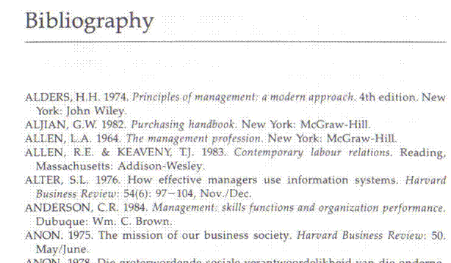

***First Draft***

To express yourself clearly in writing you should pay special attention to:

* Reading and understanding, also called comprehension.
* Assembling fact and constructing prose (text).
* Sentence structure.
* Paragraphing.
* Assembling paragraphs.
* Making a summary.
* Taking notes.
* Expanding notes.
* Paraphrasing.

Then you can use organizational features of text to assist you in making the document more understandable and pleasant to look at.

**Titles, Chapters, Contents**

The title of textbooks and manuals, such as you used in school will contain information about the subject of the textbook.

Textbooks are then divided into chapters. Each chapter will contain information about a specific subject that relates to the title or main subject of the text book.

The chapters can then be further subdivided into sections and, if the manual is comprehensive, even sub-sections.

**Contents Page**

The writers who compile text books always try to make it easy for us to find specific information about a certain subject. Every textbook will have a contents page, which will give the main headings of the different chapters of the textbook.

You can then go to that page and look at the contents from that page on. Now you can page through the chapter, looking only at the ***headings*** of sections until you find the information you are looking for.

All this makes it easy for you to find the information in the first place and also to refer back to the information afterwards.

**Introductions**

Most textbooks, chapters in textbooks and sometimes even sections in chapters will start with an introduction. The purpose of the introduction is exactly what the name implies: to introduce the subject to the reader. An example of an introduction is included in one of the pages for you.

**Foreword**

A foreword is found at the beginning of most books and is an introduction by the author of the book. It is different from the Introduction in that it is an explanation by the author of why the book was written.

**Appendices Or Addenda**

Are added at the end of a book and they usually contain extra information or exercises that pertain to certain chapters and sections in the book.

On the following pages you will find examples of a contents page, a foreword and a listing of addenda

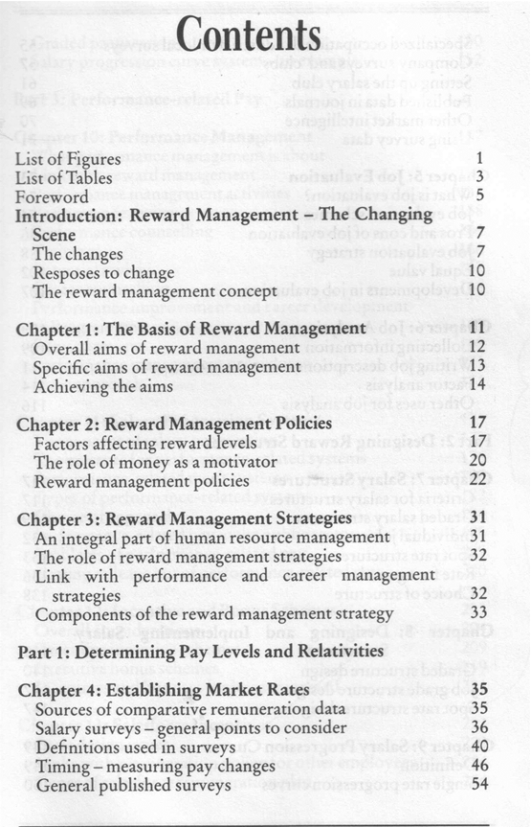

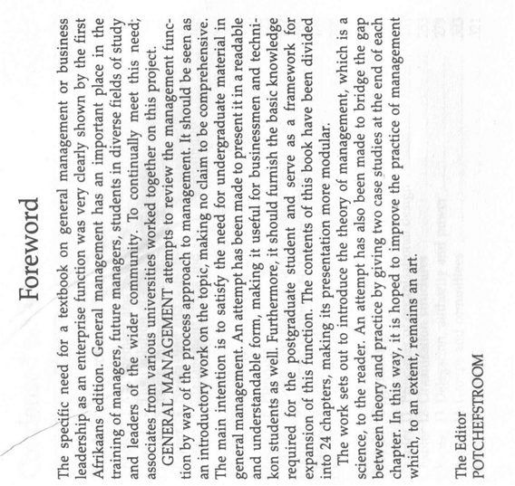

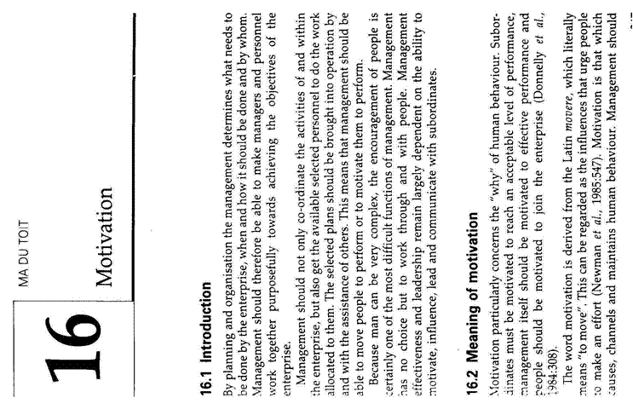

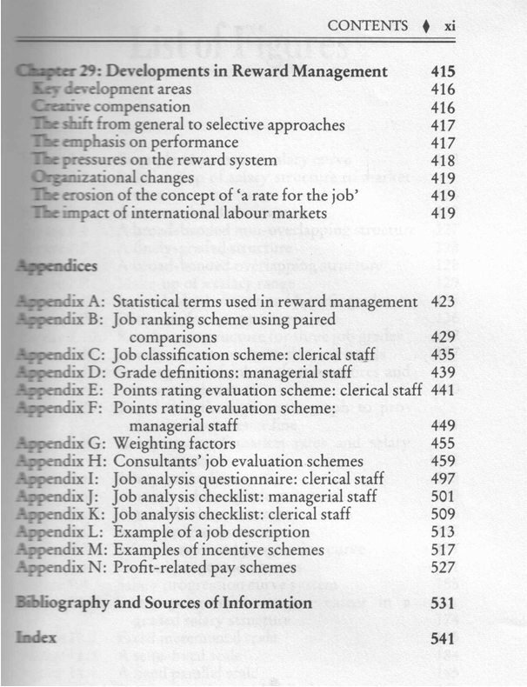

**Conclusions And Summaries**

Authors will many times include summaries at the end of sections or chapters. A summary is a brief overview of the main points of the content that was discussed during the section or chapter. At times the author will end the section or chapter with a conclusion in the place of a summary. The conclusion will be based on information discussed during the section or chapter.

The summary or conclusion should also give you a brief overview of the main points discussed in the section or paragraph.

**Paragraphs, Layout, Font**

In chapters and sections the written (or typed) contents will also be broken down into paragraphs. As seen in module 1, each paragraph should have its own subject, with the sentence of the previous paragraph leading into the subject of the second paragraph. The first sentence of the new paragraph should then introduce the new paragraph.

The layout of the page would usually also enable you to skim through the page if you quickly want to find out what the contents of the page are about. Many textbooks and other books will also be laid out in a way to make it easy for you to skim through the contents. At times the author will also highlight important words by using ***bold***, *italics* or underline. Look out for these visual clues when reading through a text book.

All the above are techniques that enable you to find out quickly what the book, chapter or section is about. Once you have satisfied yourself that the contents are relevant to what you want to do, you can start reading the contents in depth. This will make it easier for you to understand what the subject of the content is and will save you the time of rereading the entire contents many times.

**Visual Clues**

Authors also use visual clues in order to emphasize, illustrate or explain certain points.

***Diagrams***

A simplified drawing showing the appearance or structure of something.

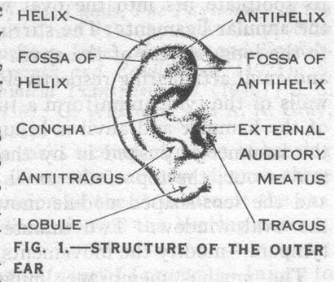

In school text books you would have found a lot of diagrams in biology and science. The diagram I remember best is the one of the grasshopper. Of course, a diagram is a sort of a mind map as well.

This diagram shows the outside of the ear.

And this one shows the inside of the ear.

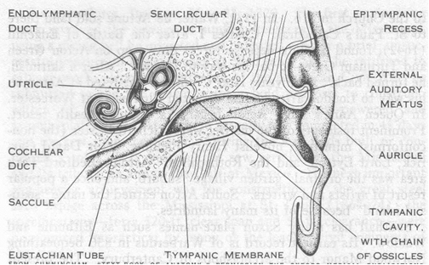

The diagram below shows the functions involved in the management process.

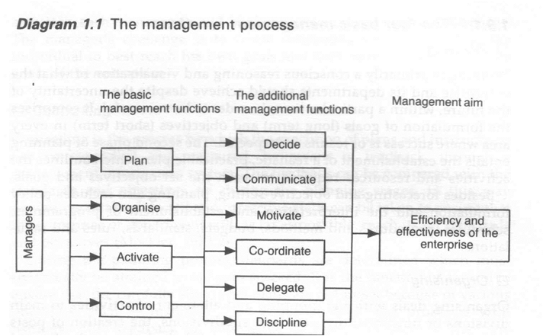

***Tables***

A table is a list where figures, facts or other information is given shortly.

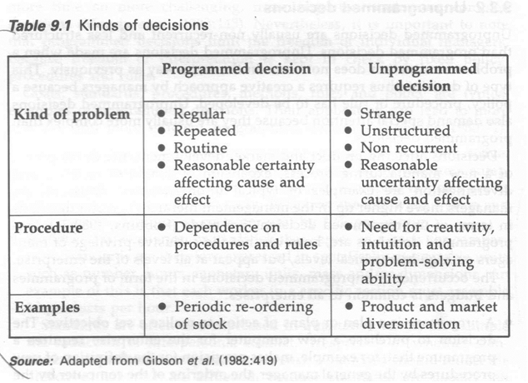

And this table gives details about types of business plans:

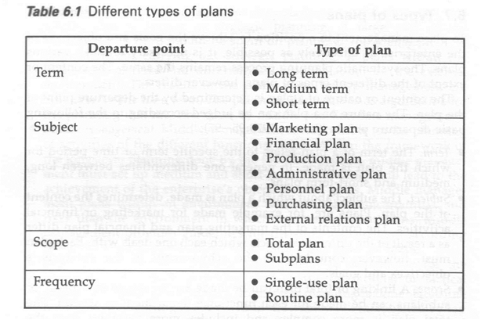

***Captions***

A caption is a title or brief explanation that is printed with a visual aid, which can be a photo, an illustration, a diagram or a cartoon.

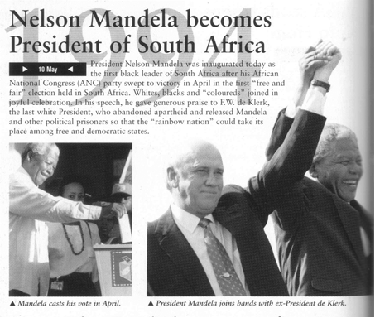

The captions to the photos states:

Mandela casts his vote in April and President Mandela joins hands with ex-President de Klerk.

Can you see that you only have to look at the photos and the captions to find out what the article is about? If you want more information, you would have to read the article, but you already have an idea what the article is about.

***Photographs And Other Graphics***

Authors use a wide range of visual images to enhance their text and to persuade the audience of their point of view. Photos and other visual images such as graphs, cartoons, drawings, paintings, etc. are also used to give the reader visual clues about the written piece.

When the manufacturer decided to advertise these shoes, they chose to use a photograph of the shoe to illustrate what it looks like, rather than saying to you, the reader:

“This is a lace-up shoe, with soles fit to walk or climb in, made from leather and suede, with added protection at the back for your heels, durable, long-lasting and comfortable. These shoes are made with your comfort in mind. Go out now and buy your Search and Enjoy Phaser Inferno climbing and hiking shoes.”

You can actually see all this from the photo.

***Pie Chart***

A pie chart is used to show how a total breaks down. For example, you have R3000 per month to spend on rent, transport, food, etc. You can use a pie chart to give a visual demonstration of how you spend your R3000. Or you could write an explanation of a paragraph or two to prove to your parents that you are not spending money on unnecessary things.

|  |  |
| --- | --- |
| Rent | 900 |
| Transport | 300 |
| Food | 800 |
| Clothes | 500 |
| Spending | 500 |
| Total | 3000 |

***Bar Graph***

Is used to compare values at intervals, the bars run horizontally. For example, you can compare your marks for your matric subjects per school term.

You can compare the results on paper, which is lengthy, or you can use a bar graph.

This example shows only your mathematics results.



This example shows all your subjects



***Pictures And Drawings***

Writers also use pictures to illustrate their points and to influence your thinking of the matter.

Not every presentation is successful

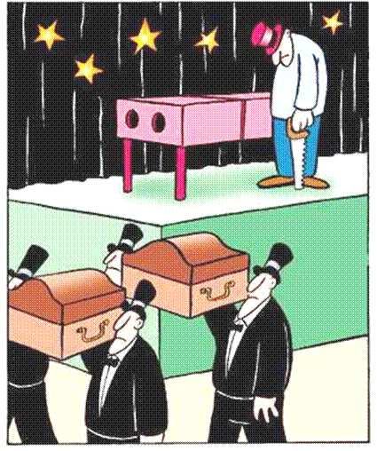

**ORGANISE AND STRUCTURE TEXT**

***Outcome***

Organise and structure a text appropriately for a business function

***Assessment criteria***

* The first draft is checked to ensure that appropriate grammar has been used and where necessary the draft is rewritten in plain language using clear accessible language that avoids over-complex syntax
* Different ways of presenting the same information are considered and used where these enhance the meaning of the text
* Technical or marketing terms and jargon are interpreted and rephrased in plain language or used appropriately in the correct context where the terminology is essential to the understanding of the text.
* All information is checked for accuracy, and factual correctness
* The document is ordered to ensure that the sequence is logical and meaningful

***It Is Important To Edit***

or read over the final product before you submit it. Decide how you must revise it by asking yourself:

1. Whether all the required aspects of the subject have been addressed?
2. If all the information is relevant
3. If you have achieved the purpose you had in mind?
4. Whether it will be suitable for the audience you have identified; Will they understand what you have written and will they be able to identify with the contents?
5. If the tone you have used is suitable to the audience?
6. If you your approach and writing style is user friendly approach
7. If the paragraphs link in a logical sequence
8. If your sentences are clear and easy to read and interpret?
9. Make sure your sentences are not too long or too short.
10. Is the vocabulary you have used applicable to the level of the audience?
11. Is the language polite and acceptable and without slang, jargon, clichés?
12. Make sure you have not repeated yourself.

**Putting pen to paper**

The format in which you present the final task makes a decisive impression. Each format has its own specific layout: There are certain features you have to take note of when putting pen to paper. Please note that not all the features listed below will be relevant in every written task you submit, it will depend on the required format.

**Features of a written document**

| ***Features*** | ***Purpose*** |
| --- | --- |
| ***Lay out*** | This will depend on the type of text and the purpose of the text, as well as the intended audience.  The layout must make the text clear and easy to read.  Make generous use of space so that it is easy to recognise the different section. |
| ***Table of contents*** | This is only required when you write a manual, workbook, guide or even a report. Indicate page numbers making it easy to find topics. |
| ***Title*** | This can be derived from the topic or the theme. The title tells you what the subject is all about. |
| ***Chapters or modules*** | The title of a module or chapter can be extracted from key components that have been grouped together.  These can be seen as sub sections if the title or main topic. |
| ***Sub headings and headings*** | These can be extracted from the keywords and key concepts that have been grouped together.  Use different weights for each heading as it will help to identify the structure of the text. |
| ***Paragraphs*** | They can be developed from the individual key words and key concepts (the puzzle pieces) starting with a single sentence and then using questioning techniques to develop it into a paragraph.. The purpose of a paragraph is to:  Develop the structure the whole text  Shape the argument/thought while you are writing  Ensure that the argument/thought flows through the text or links with other paragraphs making the text easy to read. |
| ***Font*** | Choose a font that is easy to read such as Arial, Times New Roman or Tahoma at 12pts.  Make sure your text is readable and that there are not too many words in a line. Limit to 15 words per line.  If you write free hand please write neatly and legibly. |
| ***Grammar*** | Remember to write as you speak. Watch your tenses and concord (when to use the singular or plural from of the verb) |
| ***Spelling*** | Use a dictionary to check spelling when you are uncertain. |
| ***Vocabulary*** | Take care to choose your words correctly and with care. Do not use slang. Keep your intended audience in mind when writing. Make sure you use subject vocabulary or jargon correctly. |
| ***Punctuation.*** | Do not over punctuate. Punctuation marks:- full stop., comma, question mark?, exclamation mark!, colon:, semi colon;, apostrophe’, inverted commas””. Capital letters. Hyphen - and a dash-. |
| ***Visuals photographs diagrams*** | When making use of visual aids make sure they are relevant and they supplement or define the written text. They must also be appealing to the audience. |
| ***Edit*** | Always read through your document or text when you have completed a first draft and revise where necessary. Revision can include the following changes to:  the structure or organization of the document  the choice of words and the construction of some sentences.  Spelling, punctuation, choice of vocabulary and the grammar used. |

***Rewrite The First Draft***

Once you have written the first draft, read through it at least two or three times. Make notes about the errors and changes you want to make as you go along:

* Make sure that your use of grammar is correct and right for the audience.
* Is your language clear enough?
* Play around with the layout of your document: change the style of the headings, titles and font, move the visual aids around – do they look better this way or that way?
* Check your use of technical language, legalese and jargon – will the audience understand your message?
* Is your information presented in a logical way?
* Are your facts correct? Are you sure?

Now rewrite the first draft, making the changes that you indicated.

**PRESENT YOUR FINISHED TEXT**

***Outcome***

Present a written text for a particular function in a business environment

***Assessment criteria***

* Select a text type, format and layout that is appropriate for the audience and purpose
* Use Layout and formatting techniques correctly to enhance the readability of the text.
* Evaluate information in the document in terms of its appropriateness for the intended audience and business function
* Proof read the final draft to check that it is completely correct
* Assess the final copy using a rubric or checklist based on the requirements of the writing task and the items on the checklist created in Specific Outcome 2 to Identify and collect information needed to write a text specific to a particular function

***The Finished Product***

Make sure that the layout of your document improves the text and the visual aids.

* Does your document look nice, attractive, neat, readable?
* Will it arouse the interest of the reader?
* Did you make use of headings and subheadings?
* Did you use numbers or bullets?
* Are your paragraphs not too long or too short?
* Do the visual aids enhance the value of your document?

Evaluate the content and information of your document

* Are the facts stated in your document correct?
* Did you stay with the purpose of the document or did you add unnecessary information that has no bearing on the document?
* Will the audience understand your writing?
* Did you choose the correct type of business document for your purpose?

Checklist

* Use your checklist from section 2 to check that you included everything you intended to include

***Lastly, proofread your document to make sure there are no errors.***