**LEARNER STUDY GUIDE**

*Environmental Management Tools*

Apart from any fair dealing for the purpose of research, criticism or review as permitted under the Copyright Act, no part of this document may be reproduced or transmitted in any form or by any means, electronic or mechanical including photocopying and recording, without permission in writing from the Copyright owner.



Name of Learner: ………………………………………………..

**INDEX**

*Conducting Baseline Assessments*

|  |  |  |  |  |  |  |
| --- | --- | --- | --- | --- | --- | --- |
| Introduction | |  |  |  |  |  |
| Learning Programme Schedule | | | |  |  |  |
| Unit Standard | |  |  |  |  |  |
|  |  |  |  |  |  |  |
| Lesson 1 – Understanding Impact | | | |  |  |  |
| What is Impact? | |  |  |  |  |  |
| Environmental Impact Assessments | | | |  |  |  |
|  |  |  |  |  |  |  |
| Lesson 2 – Assessment Tools | | |  |  |  |  |
|  |  |  |  |  |  |  |
| Lesson 3 – Management Tools | | |  |  |  |  |
| Checklists | |  |  |  |  |  |
| Benefits and Limitations of Checklists | | | |  |  |  |
| Considerations | |  |  |  |  |  |
|  |  |  |  |  |  |  |
| Lesson 4 – Recording Data | | |  |  |  |  |
| Storing Data | |  |  |  |  |  |
| Dealing with Anomalies | | |  |  |  |  |
|  |  |  |  |  |  |  |
| Lesson 5 – Immediate Causes of Impacts | | | |  |  |  |
| Immediate Causes | |  |  |  |  |  |
| Common Causes of Environmental Impacts | | | | |  |  |

**INTRODUCTION**

*Conducting Baseline Assessments*

Dear Learner

We welcome you to this learning programme – **ENVIRONMENTAL MANAGEMENT TOOLS.**

Congratulations on choosing to upgrade your skills. We believe that this is one of many learning programmes that will develop and improve your skills.

Over the past couple of years, South Africa has made a significant shift from the old dispensation in education (where learners used to be bombarded with theory and very little practical work) to an outcomes-based education model (based on competency rather than on theory). The aim of the shift is to make the South African labour force more productive and show them how to apply the knowledge that they have gained from training programmes.

The learning programme you are about to start is outcomes-based and in line with the outcomes as stipulated in the applicable unit standard. The assessment is also in line with the assessment criteria as stipulated in the unit standard. Once you have been declared competent on the outcomes of this unit standard, you will receive **credits** towards a nationally recognised qualification.

You will be assessed formatively and summatively. The **formative** assessment will be conducted as you work through the lessons of this Study Guide and the **summative** assessment will be conducted when you have completed your training. Assessment can also be defined as the method that is used to determine whether you have mastered the skills that you will be taught during this learning programme. Assessment usually consists of two components, namely **instructional learning**  (as conducted during this learning programme) and the **workplace assessment** – to determine your practical skills and your ability to implement what you have learnt.

The purpose with the Practical Guide Logbook (which will be handed to you by your assessor) will be to assess whether you can apply what you have learnt in the workplace.

Another added advantage to the new dispensation is the fact that recognition of prior learning is also considered and can count towards achieving credits towards a skills programme or qualification. Life experience, work experience and previous courses attended can be taken into consideration for recognition of prior learning purposes, should it relate to the specific learning programme or qualification you are working towards. This is merely a brief description to the new dispensation and barely covers what one can learn about this.

So, you will undergo theoretical training, receive your Practical Guide Logbook and Learner Assessment Workbook & Portfolio of Evidence. These documents contain the requirements for your summative assessments that must be included in the PoE. At this point, you and your assessor will sign the Assessment Plan and your assessment will commence! You will be guided all the way.

We hope that this makes you as excited as it does us and it is a real privilege for us to be able to facilitate and assess you on the outcomes of the unit standard that we are about to start.

Please feel free to communicate any questions to your facilitator or to your assessor.

Remember, look out for the following icons in your Study Guide:

This icon indicates an activity that must be completed in or during training (Class Work)

This icon indicates an activity that must be completed and placed in your Portfolio of Evidence (PoE).

**LEARNING PROGRAMME SCHEDULE**

*Conducting Baseline Assessments*

Learning Programme Name: **ENVIRONMENTAL MANAGEMENT TOOLS**

|  |  |  |  |
| --- | --- | --- | --- |
| **Unit Standard** | **Unit ID** | **US NQF Level** | **US Credits** |
| Apply environmental management tools to assess impact | 119554 | NQF Level 2 | 5 Credits |

**Details of the Learning Programme Schedule:**

* This learning programme will be trained over a period of 1 DAY
* The learner has 10 HOURS (2 DAYS) in which to complete the FORMATIVE and SUMMATIVE Assessments
* The learner has to spend a minimum of 35 HOURS (6 DAYS) in the work environment in the form of practical work

*Good Luck and enjoy your learning experience!*

**UNIT STANDARD**

*Conducting Baseline Assessments*

|  |  |
| --- | --- |
| SAQA | *All qualifications and part qualifications registered on the National Qualifications Framework are public property. Thus the only payment that can be made for them is for service and reproduction. It is illegal to sell this material for profit. If the material is reproduced or quoted, the South African Qualifications Authority (SAQA) should be acknowledged as the source.* |

|  |  |  |  |  |
| --- | --- | --- | --- | --- |
| **SOUTH AFRICAN QUALIFICATIONS AUTHORITY** | | | | |
| **REGISTERED UNIT STANDARD:** | | | | |
| **Apply environmental management tools to assess impacts** | | | | |
| **SAQA US ID** | | **UNIT STANDARD TITLE** | | | | |
| 119554 | | Apply environmental management tools to assess impacts | | | | |
| **ORIGINATOR** | | | **ORIGINATING PROVIDER** | | | |
| SGB Environmental Sc/Mgt & Waste Mgt | | |  | | | |
| **QUALITY ASSURING BODY** | | | | | | |
| - | | | | | | |
| **FIELD** | | | | **SUBFIELD** | | |
| Field 10 - Physical, Mathematical, Computer and Life Sciences | | | | Environmental Sciences | | |
| **ABET BAND** | | **UNIT STANDARD TYPE** | **PRE-2009 NQF LEVEL** | **NQF LEVEL** | **CREDITS** | |
| Undefined | | Regular | Level 2 | NQF Level 02 | 5 | |
| **REGISTRATION STATUS** | | | **REGISTRATION START DATE** | **REGISTRATION END DATE** | **SAQA DECISION NUMBER** | |
| Reregistered | | | 2012-07-01 | 2015-06-30 | SAQA 0695/12 | |
| **LAST DATE FOR ENROLMENT** | | | **LAST DATE FOR ACHIEVEMENT** | | | |
| 2016-06-30 | | | 2019-06-30 | | | |

|  |
| --- |
| *In all of the tables in this document, both the pre-2009 NQF Level and the NQF Level is shown. In the text (purpose statements, qualification rules, etc), any references to NQF Levels are to the pre-2009 levels unless specifically stated otherwise.* |
| This unit standard does not replace any other unit standard and is not replaced by any other unit standard. |

|  |
| --- |
| **PURPOSE OF THE UNIT STANDARD** |
| In order for me to perform effectively in the field of environmental science, environmental management and waste management, I will be able to:  • Identify components of the environment and describe their interrelationships.  • Use appropriate terminology when speaking about environmental issues.  • Recognise the impacts of events and human activities on the environment.  • Gather information related to environmental impacts.  • Use an environment tool to assess impact.  • Record and report results.   I will also know and understand:  • Components of the environment and their interrelationships.  • Terminology related to the environment and environmental issues.  • The effects of various human activities on the environment.  • Principles and concepts related to using tools to assess environmental impacts (a basic level of understanding is required).   I can be assessed against this unit standard in the context of any activity which is related to managing environmental issues, such as:  • Waste management related activities, eg  > Materials recovery and buy back centres  > Waste reception  > Landfill operations  • Water course cleaning, care and maintenance.  • Care of public places, open areas, cultural and natural heritage sites.  • Maintenance of parks and sports fields.  • Involvement in community projects and job creation schemes relating to environmental practice.  • General industrial or extraction, ie activities with an environmental care or improvement focus.   The skill, the knowledge and the values reflected in this unit standard form part of the exit level outcomes required for the National Certificate in Environmental Practice NQF Level 2. |

|  |
| --- |
| **LEARNING ASSUMED TO BE IN PLACE AND RECOGNITION OF PRIOR LEARNING** |
| It is assumed that the learner is competent in Communication and Mathematical Literacy at NQF level 1. |

|  |
| --- |
| **UNIT STANDARD RANGE** |
| The scope and level of this unit standard is indicated by range statements related to the Specific Outcomes.   The degree of complexity required in the use of the tools should be appropriate to NQF Level 2. The purpose is to alert the learner to the role of the tools in environmental management.   Tools include risk assessment, incident reports, checklists, statistical process control charts, maps, layout plans, workflow diagrams, TREM cards.   This unit standard deals only with assessment of impacts - addressing the impacts is covered in a companion unit standard. |

|  |
| --- |
| **Specific Outcomes and Assessment Criteria:** |
| **SPECIFIC OUTCOME 1** |
| Identify a variety of potential and actual impacts on the environment and use the correct terminology to describe them. |
| **OUTCOME RANGE** |
| Variety: 2 or 3 specific impacts in the learner's work, domestic or community context. |
| **ASSESSMENT CRITERIA** |
| **ASSESSMENT CRITERION 1** |
| General components of the environment and their interrelationships are identified and described appropriately and accurately. |
| **ASSESSMENT CRITERION 2** |
| General impacts of human activities on the biophysical environment are identified and described appropriately and accurately. |
| **ASSESSMENT CRITERION 3** |
| Specific impacts of human activities on the environment in the learner's context are identified and described appropriately and accurately. |
| **ASSESSMENT CRITERION 4** |
| Environmental terminology is used correctly. |

|  |
| --- |
| **SPECIFIC OUTCOME 2** |
| Explain the reasons for using particular assessment tool(s). |
| **OUTCOME RANGE** |
| Particular assessment tools: includes the tools used to conduct the assessments related to Specific Outcome: 'Explain the reasons for using particular assessment tool(s)' of this unit standard, as well as other environmental management tools typically used in the learner's context. |
| **ASSESSMENT CRITERIA** |
| **ASSESSMENT CRITERION 1** |
| The difference between predictive and monitoring tools is explained. |
| **ASSESSMENT CRITERION 2** |
| Typical applications of a variety of types of tool are identified and described accurately. |
| **ASSESSMENT CRITERION RANGE** |
| Described: an awareness of the role of the tools and a basic understanding of their application is required. |

|  |
| --- |
| **SPECIFIC OUTCOME 3** |
| Use environmental management tools to assess the impacts. |
| **OUTCOME RANGE** |
| Tools: at least 2 different tools relevant to the context. The tools should be used in a simplified form at a level appropriate to NQF 2 - the purpose is for learners to be aware of the tools and to have a basic understanding of their role in environmental management.   Tools include preventive, predictive and monitoring tools. |
| **ASSESSMENT CRITERIA** |
| **ASSESSMENT CRITERION 1** |
| Relevant tools are used correctly to assess a selection of impacts on the environment. |
| **ASSESSMENT CRITERION 2** |
| Assessments are made that are adequate, accurate and relevant. |

|  |
| --- |
| **SPECIFIC OUTCOME 4** |
| Record and maintain data and identify anomalies. |
| **OUTCOME RANGE** |
| Maintain data includes update, hand on, file and store. |
| **ASSESSMENT CRITERIA** |
| **ASSESSMENT CRITERION 1** |
| Data is recorded accurately and as required by the tools. |
| **ASSESSMENT CRITERION 2** |
| Data is maintained in accordance with requirements. |
| **ASSESSMENT CRITERION 3** |
| Anomalies in the data are identified and reported accurately. |

|  |
| --- |
| **SPECIFIC OUTCOME 5** |
| Determine the immediate causes of the identified impacts. |
| **ASSESSMENT CRITERIA** |
| **ASSESSMENT CRITERION 1** |
| The immediate causes of selected environmental impacts in the learner's context are identified correctly. |
| **ASSESSMENT CRITERION 2** |
| The causes identified are recorded and reported accurately. |

|  |
| --- |
| **UNIT STANDARD ACCREDITATION AND MODERATION OPTIONS** |
| To obtain credits I must be assessed. The assessment will be based on evidence that I produce. My assessment will be governed by the policies and guidelines of a relevant Education and Training Quality Assurance body (ETQA), which has jurisdiction over this field of learning. The policies and procedures of the relevant ETQA will also determine:  > How my assessment is moderated  > How I can appeal against the outcome of the assessment   Any institution or company which offers learning that will enable me to achieve the purpose of this unit standard must be accredited as a provider through the relevant ETQA.   My assessment against this standard should meet all the requirements of established principles. It should include practical assessment activities, which are appropriate to the contents of this unit standard. These activities should include an appropriate combination of self and peer assessment, practical and oral assessments, observations, etc.   I can be assessed in the language of my choice although if I have to report incidents or conditions to someone else, I will be assessed on my ability to report in the language commonly used in my working environment.   I will be assessed on all the Specific Outcomes, Critical Cross-Field Outcomes and Essential Embedded Knowledge. The Specific Outcomes must be assessed in their own right, through oral and practical evidence. My assessment will not only be based on observation but also on other evidence which I compile into a portfolio of evidence. I cannot be assessed only through a written or oral test.   The Specific Outcomes and Essential Embedded Knowledge will be assessed in relation to each other. If I am able to explain the items which fall under the heading of Essential Embedded Knowledge, but am unable to perform the Specific Outcomes, then I cannot be assessed as 'competent'. Similarly, if I am able to perform tasks described under the Specific Outcomes, but cannot explain or justify them in terms of the fundamental concepts, principles and practice relevant to the level of the unit standard that underpins my skill, then I cannot be assessed as 'competent'.   I will also be assessed on my ability to apply the principles and techniques related to the Critical Cross-Field Outcomes, not only in terms of what I can demonstrate, but also in terms of what I know and can discuss.   My assessment for this unit standard can be done in conjunction with the assessment of other unit standards related to a qualification, and even in conjunction with my assessment for the qualification as a whole. |

|  |
| --- |
| **UNIT STANDARD ESSENTIAL EMBEDDED KNOWLEDGE** |
| The following items reflect the type of knowledge that the assessor will evaluate   1. Names & functions of:  • components of the environment and their interrelationships  • natural resources  • environmental management tools   2. Purpose of:  • applying environmental management tools for assessing environmental impacts  • wise use of resources   3. Attributes, descriptions, characteristics & properties:  • components of the environment and the interrelationships between them  • environmental impact of human activities (and other causes)  • environmental issues at local, regional, national and global levels, ie soil, water and air pollution, land degradation (desertification), loss of biodiversity, global warming  • environmental management tools for assessing and monitoring   4. Processes and events:  • assessing environmental impacts  • droughts, floods and other natural events  • pollution and environmental degradation   5. Causes and effects, implications of:  • effects of human activities on the environment  • effects of droughts, floods and other natural events  • pollution and environmental degradation, e.g. soil erosion, global warming, climate change  • implications of not applying the tools appropriately   6. Procedures and techniques:  • for applying the environmental management tools to assess impacts (at a basic level)  • for recording and reporting information   7. Sensory cues:  • related to identifying impacts  • related to using the tools   8. Regulations, legislation, agreements, policies, standards:  • related to assessing environmental impacts   9. Theory: rules, principles, laws:  • environmental principles  • legislation; regulations; science and technology related to using the tool to assess environmental impacts  • waste hierarchy  • biophysical cycles  • ecosystem processes   10. Categories:  • environmental management tools  • environmental impacts  • natural resources  11. Relationships, systems:  • relationship between the accuracy of the assessments and the value of the data collected  • relationship between human activities and environmental components |
| **Critical Cross-field Outcomes (CCFO):** |
| **UNIT STANDARD CCFO IDENTIFYING** |
| Identify and solve problems  • Recognise the environmental impact  • Select and apply the appropriate tool |
| **UNIT STANDARD CCFO ORGANISING** |
| Organise and manage myself and my activities  • Use the tool correctly |
| **UNIT STANDARD CCFO COLLECTING** |
| Collect, analyse, organise and critically evaluate information  • apply the tool to assess environmental impacts  • record data |
| **UNIT STANDARD CCFO COMMUNICATING** |
| Communicate effectively  • use terminology related to environmental principles and concepts  • use terminology related to the tool |
| **UNIT STANDARD CCFO SCIENCE** |
| Use science and technology effectively and critically  • apply knowledge of environmental components and principles to identify and assess impacts  • use of assessment tools |
| **UNIT STANDARD CCFO DEMONSTRATING** |
| Demonstrate an understanding of the world as a set of related systems  • understand how human activities impact on the environment  • understand how to apply environmental management tools to assess impacts |

**LESSON 1**

**Understanding Impact**

This Learning Unit is aligned to US 119554 Specific Outcome 1:

**Identify a variety of potential and actual impacts on the environment and use the correct terminology to describe them**

This Learning Unit comprises the theoretical component of your learning and includes activities that are class-based and of a formative nature.

**After completing this Lesson, you should be able to:**

* Describe general impacts on the environment and how these can be addressed
* Understand and use environmental terminology accurately and effectively

**WHAT IS AN IMPACT?**

In order to assess any impact in relation to Occupational Health, Safety and the Environment, we need to understand the meaning of “impact”. This could be a simple result of non-compliance to OHS requirements in relation to legislation – or it could be far more complex such as becoming “environmentally friendly” in order to ease the impact of health, safety, and hygiene on the environment in general.

When we think of impact we need to analyse the following:

* What is the effect on the natural environment?
* Do we have a management tool in place to assess the impact?
* This tool should be a formal process of identifying, predicting, evaluating and mitigating the biophysical, social and other relevant effects of the risk or hazard to major decisions being taken and commitments made.

What types of impact assessments are there?

* Health Impact Assessment
* Social Impact Assessment
* Strategic Environmental Assessment
* Climate Impact Assessment

There are two stages to follow:

* Preliminary Assessment
* Detailed Assessment

The first stage should include scoping which determines and identifies the following:

* Key issues and concerns of the interested parties
* Who is concerned
* What the concerns are
* Why they are concerns

 **TASK 1 – This Task needs to be completed and placed in your PoE**

Look around your workplace and identify general components of the environment that have relationships – what are these? What could potentially be general impacts of human activities on the biophysical environment?

This Task is aligned to **Specific Outcome 1, Assessment Criterion 1 and 2**

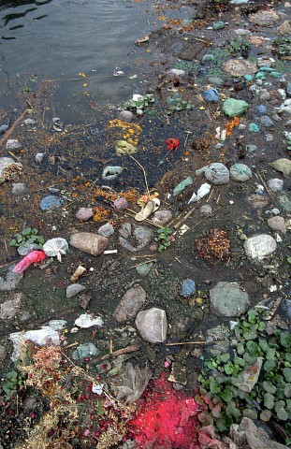**ENVIRONMENTAL IMPACT ASSESSMENTS**

Assessments on environmental impacts have to be made as some of these have an effect on the natural environment. Any assessment conducted must be done through a management tools. The process of environmental impact assessments includes identifying, predicting, evaluating and mitigating the biophysical, social and other relevant effects of any process / development.

Environmental Impact Assessments (EIA) can be considered as a mechanism which maximises the efficient use of natural and human resources. It can also reduce costs and time taken to reach a decision by ensuring that subjectivity and duplication of effort are minimised, as well as identifying and attempting to evaluate the primary and secondary consequences which might require the introduction of expensive pollution control equipment or compensation and other costs at a later date.

It is thus an assessment of the possible positive or negative impact that a proposed project may have on the environment, together consisting of the environmental, social and economic aspects. The purpose of the assessment is to ensure that decision makers consider the ensuing environmental impacts when deciding whether to proceed with a project.

There are various methods to conduct out EIAs. Some are industry specific and some general methods:

* **Industrial Products –** product environmental life cycle analysis is used for identifying and measuring the impact on the environment of industrial products. These EIAs consider technological activities used for various stages of the product extraction of raw material for the product and for ancillary materials and equipment, through the production and use of the product, right up to the disposal of the product, the ancillary equipment and material.
* **Genetically Modified Plants –** there are specific methods available to perform EIAs of genetically modified plants.
* **Fuzzy Arithmetic –** EIA methods needs specific parameters and variables to be measured to estimate values of impact indicators.

At the end of the project, an EIA should be followed by an audit. An EIA audit evaluates the performance of an EIA by comparing actual impacts to those that were predicted. The main objective of these audits is to make future EIAs more valid and effective. The two main considerations are:

* Scientific – to check the accuracy of predictions and explain errors
* Management – to assess the success of mitigation in reducing impacts

The flow diagram on the next page reflects a clearer picture of environment impacts:

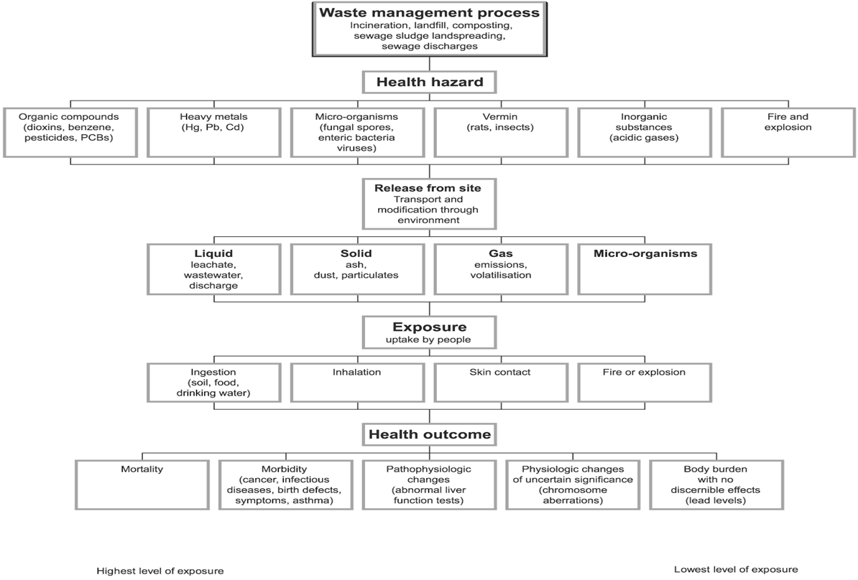

**LESSON 2**

**Assessment Tools**

**LESSON 2**

**assessment tools**

This Learning Unit is aligned to US 119554 Specific Outcome 2:

**Explain the reasons for using particular assessment tools**

This Learning Unit comprises the theoretical component of your learning and includes activities that are class-based and of a formative nature.

**After completing this Lesson, you should be able to:**

* Describe the different assessment tools that can be used

What are the tools for an Environmental Impact Assessment?

* Surveillance and supervision to oversee adherence to and implementation of the terms and conditions
* Effects or impact monitoring to measure the environmental changes
* Compliance monitoring to ensure that applicable regulatory standards and requirements are being met.

 **TASK 2 – This Task needs to be completed and placed in your PoE**

Find out what the difference between predictive and monitoring tools are.

This Task is aligned to **Specific Outcome 2, Assessment Criterion 1**

* Environmental auditing to verify the implementation of terms and conditions, the accuracy of the predictions made, the effectiveness of mitigation measures and the compliance
* Ex-post evaluation required to evaluate the effectiveness and performance of the process
* Post project analysis to evaluate the overall results of project development and to draw lessons for the future.

What are the benefits?

* Environmentally sound and sustainable design
* Better compliance with standards
* Savings in capital and operating costs
* Reduced time and costs for approvals
* Increase acceptance
* Better protection of the environment and human health

The steps in Impact Assessment include the following:

* Conduct baseline study
* Identify and evaluate alternatives
* Identify potential impacts
* Predict impacts
* Determine impact significance
* Consider mitigation options
* Determine residual impacts and environmental risks
* Prepare environmental management plan

The following diagram reflects the process that must be followed in an environmental impact assessment process:

**LESSON 3**

**Management Tools**

This Learning Unit is aligned to US 119554 Specific Outcome 3:

**Use environmental management tools to assess the impacts**

This Learning Unit comprises the theoretical component of your learning and includes activities that are class-based and of a formative nature.

**After completing this Lesson, you should be able to:**

* Develop tools to assess impacts
* Conduct impact assessments

 **TASK 3 – This Task needs to be completed and placed in your PoE**

Obtain copies of at least two assessment studies that have been undertaken in your workplace in relation to environmental impacts.

This Task is aligned to **Specific Outcome 3, Assessment Criterion 1**

**CHECKLISTS**

There are a variety of methods that can be used to conduct impact assessments, varying in complexity and characteristics. Most methodologies applied share the common basis of an index of environmental factors or development activities that must be considered. Checklists may be:

* Simple checklists
* Descriptive checklists
* Questionnaire checklists
* Weighting-scaling checklists

These provide the assessor with a list of factors that must be considered. They are also used as a memory aid to identify impacts. Checklists can provide structure to the initial part of the scoping stage.

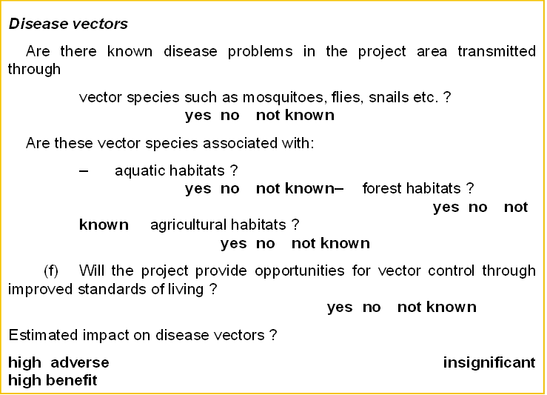

* + **Provide assessor with a list of factors to be considered.**
  + **Used as a memory aid to identify impacts.**

**BENEFITS AND LIMITATIONS OF CHECKLISTS**

|  |  |
| --- | --- |
| **Benefits** | **Limitations** |
| Comparatively simple method | Can never be considered as definite or complete |
| Not necessarily project specific | Does not assist to identify secondary / higher order impacts |
| Once established, can be used in many different situations | Tends to compartmentalise |

**CONSIDERATIONS**

Considerations in impact identification:

* Direct and indirect impact – is the impact being assessed direct or indirect?
* Long-term impacts
* Cumulative impacts

Tools must be selected on the bases of available resources and the nature of the impact. The tools must also include predictive, preventative and monitoring methodologies.

 **TASK 4 – This Task needs to be completed and placed in your PoE**

Identify an environmental impact in your workplace. Develop a simple tool / checklist to assess the impact of this problem.

This Task is aligned to **Specific Outcome 3, Assessment Criterion 1 and 2**

**LESSON 4**

**Recording Data**

This Learning Unit is aligned to US 119554 Specific Outcome 4:

**Record and maintain data and identify anomalies**

This Learning Unit comprises the theoretical component of your learning and includes activities that are class-based and of a formative nature.

**After completing this Lesson, you should be able to:**

* Record data collected
* Maintain the data
* Identify anomalies

 **TASK 5 – This Task needs to be completed and placed in your PoE**

Conduct the impact assessment with the tool you have developed for Task 4. Explain the following:

* How is data recorded that has been collected in your workplace?
* How is the data maintained, e.g. computer, files, etc?
* How is the data used and for what?

This Task is aligned to **Specific Outcome 4, Assessment Criterion 1 and 2**

**STORING DATA**

Once impact assessments have been conducted, the data that is collected needs to be recorded and stored. In some workplace – in most, that is – data is stored electronically and through hard copy. This means that there will be various ways to access this data for use by different stakeholders within the process.

Data also needs to be stored in line with organisational requirements – this is dependent on the type of workplace it is.

Data needs to be stored for several reasons:

* Action plans that need to be developed and implemented to address the impact
* Anomalies that have been found within the impact study – these need to be addressed and possibly action plans developed for further action and remedy
* Stakeholders may require access to certain information
* Reports that need to be compiled – the data is used as evidence for reference purposes

 **TASK 6 – This Task needs to be completed and placed in your PoE**

When a problem has been identified through the impact assessment – explain how it is dealt with in your own workplace.

This Task is aligned to **Specific Outcome 4, Assessment Criterion 1 and 2**

**DEALING WITH ANOMALIES**

In all EIA processes, effective mitigation measures must be identified and included in the assessments to avoid, minimise or reduce the adverse effects of all potentially significant impacts. However, one an EIA has been conducted, certain other areas may arise, which are often referred to as anomalies. These too, have to be dealt with, although in the initial planning phase no mitigation measures were built in to effectively deal with these.

**LESSON 5**

**Immediate Causes of Impacts**

This Learning Unit is aligned to US 119554 Specific Outcome 5:

**Determine the immediate causes of the identified impacts**

This Learning Unit comprises the theoretical component of your learning and includes activities that are class-based and of a formative nature.

**After completing this Lesson, you should be able to:**

* Identify the immediate causes of the environmental impacts
* Record the causes identified
* Report on the causes identified

**IMMEDIATE CAUSES**

There may be causes of the environmental impacts that are obvious and easy enough to correct. If this is the case, these must be addressed immediately to ensure the impact is eliminated, corrected and prevented in the future.

 **TASK 6 – This Task needs to be completed and placed in your PoE**

What environmental impacts can you identify in your community that have immediate causes?

This Task is aligned to **Specific Outcome 5, Assessment Criterion 1**

**COMMON CAUSES OF ENVIRONMENTAL IMPACTS**

Environmental changes may be driven by many factors including economic growth, population growth, urbanisation, agriculture, rising energy use and transportation. Poverty still remains a problem at the root of several environmental problems.

**Social Factors**

Population is an important source of development, yet it is a major source of environmental degradation. Population impacts on the environment primarily through the use of natural resources and production of wastes and is associated with environmental stresses like loss of biodiversity, air and water pollution and increased pressure on arable land.

Poverty is said to be both cause and effect of environmental degradation. The circular link between poverty and the environment is a complex aspect. Inequality may foster unsustainability because the poor, who rely on natural resources more than the rich, deplete natural resources faster as they have no real prospects of gaining access to other types of resources.

Lack of opportunities for gainful employment in rural areas and the ecological stresses is leading to an ever increased movement of poor families to towns and cities. Mega cities are emerging and urban slums are expanding. Rapid and unplanned expansion of cities has resulted in degradation of urban environments. It has widened the gaps between demand and supply of infrastructural services such as energy, housing, transport, communication, education, water supply and sewerage and recreational amenities, therefore depleting the previous environmental resource base of the cities. The result is the growing trend in deterioration of air and water quality, generation of wastes, the proliferation of slums and undesirable land use changes, all of which contribute to urban poverty.

**Economic Factors**

To a large extent the environmental degradation is the result of market failure. For example, the non-existent or poorly functioning markets for environmental goods and services. In this context, environmental degradation is a particular case of consumption or production externalities reflected by divergence between private and social costs or benefits.

The level and pattern of economic development also affect the nature of environmental problems. The country’s policies and programmes for economic growth and social welfare play an important role.

Transport activities have a wide variety of effects on the environment such as air pollution, noise from road traffic and oil spills from marine shipping. Direct impacts of agricultural development on the environment arise from farming activities which contribute to soil erosion, land salination and loss of nutrients. The spread of green revolution has been accompanied by over exploitation of land and water resources, and use of fertilisers and pesticides have increased also.

 **TASK 7 – This Task needs to be completed and placed in your PoE**

How should the causes of environmental impacts be recorded and reported on and why?

This Task is aligned to **Specific Outcome 5, Assessment Criterion 2**