2020
National Certificate:
Contact Centre Support
NQF 2 – 71490 LP 73269

13885 – Providing Information to Customers in a Contact Centre

Contents
Section One: US 13885 – Providing Information to Customers in a Contact Centre 2
Learning Outcomes 2
1.1 Defining Quality and Quality Customer Service 3
The Importance of Providing Quality Customer Service 5
1.2 Customer Experience (CX) 5
1.3 The Quality Service Connection 7
1.4 Quality Service Components 9
1.5 The Quality Staircase 12
1.6 Who Are Your Customers? 16
1.7 Meeting Customer Needs 17
1.8 Meeting Customer Expectations 19
Presenting Yourself Properly 20
1.9 Standards 21
1.10 Telephone Etiquette 21
1.11 Taking a Message 23
1.12 Personalizing Service 24
1.13 Product Specifics 25
1.14 Company Specific Timeframe 26

Section One: US 13885 – Providing Information to Customers in a Contact Centre

Learning Outcomes

On completion of this section, you will be able to:

- Identifying customer needs in a Contact Centre.
- Providing information to customers.

Customer service is the most critical role player in the Contact Centre industry – if a company does not offer a good customer service and company may as well close its doors, so what is Customer Service:

Customer’s demands and expectations have increased over a short period of time.
With the introduction of internet-based services and Customer Service Centre customer have come to expect that their questions/concerns be responded to in a short time
Customers are the livelihood of a Contact Centre
It the service industry it is easier to lose a customer than it is to gain one. It is also easier to sell more to a satisfied customer than a dissatisfied customer
A Contact Centre must both anticipate and react to customers’ changing needs and demands to achieve strategic customer service.

People who provide good customer service (regardless of the nature of their business) earn psychological benefits (e.g., self-esteem, confidence, job satisfaction) in addition to any rewards offered by their company.

If you are unhappy in your job, take an objective look at the kind of service you are giving. In almost every case, your job satisfaction mirrors the satisfaction people feel when doing business with you. Giving poor service is a way of beating up on yourself.

1.1 Defining Quality and Quality Customer Service

Good customer service is meeting and exceeding the customer needs and expectation.

“Customer service is a way of life that involves putting the customer first in every aspect of the business. It is characterised by an obsession to achieve complete customer satisfaction in each encounter. It is an obsession that is shared by everyone in a company, from the chairman of the board and down.” “Quality and satisfaction are, like beauty, in the eye of the beholder.”

There is no one definition of quality customer service. Quality is defined by the customer. Customer Service is a function of your customer’s perceptions, not your quality service standards. In other words, a customer gets to decide if he / she has received good customer service. Even if all your service standards have been met, if the customer doesn’t feel well served, your customer service is poor.

If you have met or exceeded a customer’s expectations, then you know that you have delivered quality customer service!

Customer service is not something that you provide just for external customers. Quality customer service begins with how you deal with your co-workers, the tea lady, subordinates and managers etc. If you are not committed to treating internal customers (fellow staff and colleagues) with the same level and quality customer service you would with your external customers (customers, suppliers etc.), service to these external customers will surely suffer!

Customer service is an area where one is able to differentiate from competitors, become smarter, more effective and to ensure that we instill life-long memories and relationships with our customers. Product quality is becoming more and more difficult as a single means of differentiating one’s product. A high-quality product is becoming more and more of an automatic given to customers.

Quality customer service entails providing efficient, quick and friendly service, building strong relationships with customers, handling
complaints quickly and responding to customers' issues on time. Quality customer service is the best way to keep customers coming back, thus ensuring long-term success.

Why is effective customer service a means of differentiating and why is it not as easy for competitors to copy such initiatives?
- Customer service is intangible. Unlike a physical product, one cannot physically touch or see the service.
- Customer service is varied. It is very difficult to replicate each service delivery. Every customer and employee are different and the service delivery will vary for each transaction. This makes it so much more difficult to control.
Customer service is inseparable in that one cannot divorce it from an employee and hence, human behaviour. Your employees are very much part of the delivery process.

Different definitions for Quality Service include:

“Quality is … doing what you have to do, only doing it well enough to satisfy the customer.”
“Quality is a degree of excellence”
“Quality is working without hassles”
“Quality is meeting the customer’s expectations”
“Quality is not something extraordinary, it’s something ordinary, done extraordinarily well”

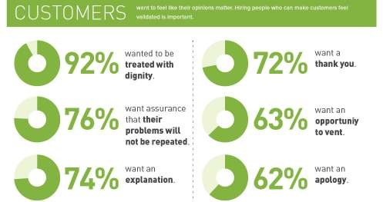

A survey carried out to determine the attitude and mindset of 1000 people who had applied for customer service-related jobs revealed the following:

45% agreed with the statement that the customer is not always right;
27% said that they often had a negative attitude when dealing with customers;
15% felt that most customers are too demanding, and
13% said that they find it difficult to get their jobs done as they are having to deal with customers!

The Importance of Providing Quality Customer Service

If you provide poor service:

♦ 95% of dissatisfied customers will never complain, but they will tell 9 other people how bad your service is.
♦ 13% of those will tell at least 20 other people how bad your service is.
♦ 90% of those originally dissatisfied customers will never return.

Good customer care is important because it is what makes one organisation stand out from others. If a customer receives the same service at the same price from a number of different suppliers, the one more likely to obtain the customer’s repeat business is the supplier providing the best service.

Customers don’t just buy a product or service, they also buy the many aspects which are indefinable, such as professionalism, helpfulness, responsiveness, friendliness, empathy and good communication skills. Remember when you deal with a customer, you represent the entire company, its people, product and service.

1.2 Customer Experience (CX)

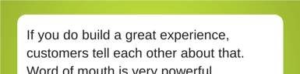

Customer experience is much more than providing the after-sale service you promise with the sale of any product on your shelf.
Customer experience goes beyond the phone calls delivered by your customer service department when customers are calling in with their varied uncomfortable issues.
Customer experience is as essential as knowing the uniqueness of each customer and harmonising every department within the organisation to deliver a great experience beyond the customers’ expectations. Customer Experience is defined as…
… the practice of designing and reacting to customer interactions for the purpose of meeting or exceeding customer expectations, thereby, increasing customer satisfaction, loyalty and advocacy.

Product or service awareness, discovery, cultivation, advocacy as well as purchases and service are some points of interaction that contribute to a customer’s experience.
Customer experience plays a vital role in an organisation, this role includes:
- Improving customer satisfaction
- Fostering repeat customers and customer loyalty
- Increasing customer advocacy and referrals
- Reducing customer churn
- Creating competitive advantage
- Increasing revenue and sales
- Building stronger customer relationship

It is no longer enough for an organisation to say that it is in customer service but must invest in its interactions with its customers more with an intention of building lasting relationships.

Let’s look at the lifecycle of a customer and how it relates to customer experience and the customer journey. At each point, you can see the importance of providing a good experience rather than the result of the customer not completing the cycle and looking for better service elsewhere.

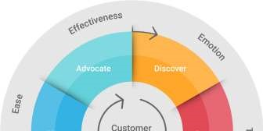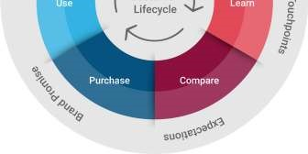
The way in which we do business and interact with our customers has changed.
- A vast majority (86%) of buyers would pay more for better service.
- Brands need to provide a more consistent experience according to 87% of today’s buyers.
- 75% of online customers expect a response within five minutes.
Businesses are now competing for better service.
- In 2016, 89% of organisations will compete for customer experience.
- 89% of marketers think customer experience will be their main differentiator by 2019.
Perfecting the customer experience can do wonders for business.
- Improved experience can grow revenue by 5 to 10%—and cost 15 to 20% less—over a span of 3 years.
- Loyal customers are seven times as likely to test an offering, five times as likely to buy again and four times as likely to refer.
- Three out of four people have spent more with a company because of a history of positive experiences.

One bad experience can be devastating for brands.
- People talk: 95% of customers tell others about a bad experience.

Customers want to be loyal to brands and give their input.
- Nearly 40% of retail leaders say that earning the loyalty of millennials is their greatest challenge.
- 97% of global consumers cite customer service as important in their brand choice and loyalty.
- In the U.S. alone, there are 3.3 billion loyalty program memberships—an average of 29 per family.

1.3 The Quality Service Connection

We have covered the distinction between internal versus external customers. However, it is essential to see the connections that exist in order to provide quality customer service.

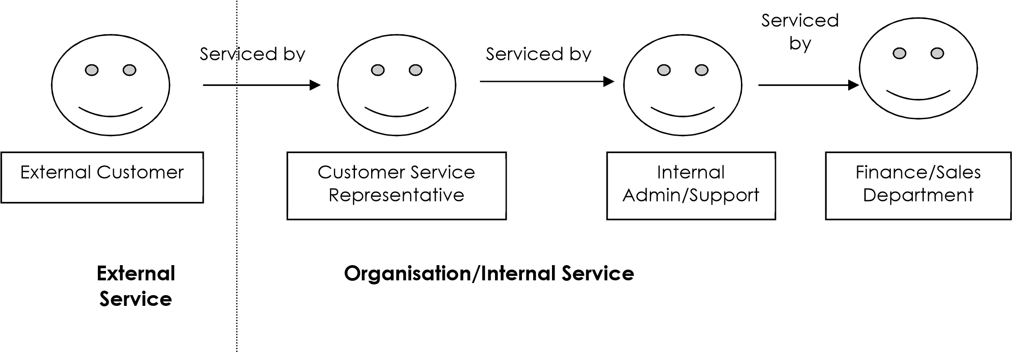
To provide quality customer service to external customers, quality customer service must be provided internally first. If all these connections are functioning the way they should, you can guarantee quality service to your external customers.

However, if one link in this chain is absent (i.e. the finance department has generated an invoice for a new client, however, the admin department has not passed this onto the customer service representative who, in turn, is unable to present the invoice to the external client and, as a result, the client is unable to pay for the goods ordered and therefore does not receive them).

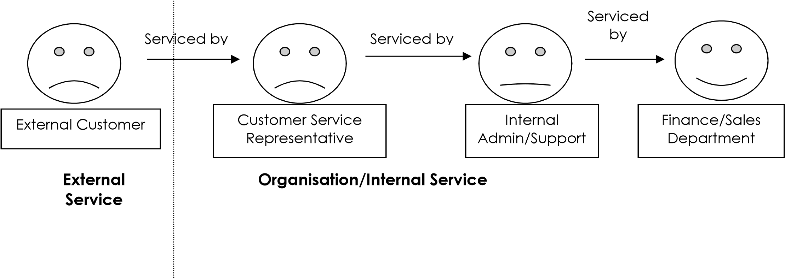
The result is an unhappy customer service representative and an unhappy external customer whose expectations were not met and who may well decide to never buy from the same company again!

The chain of quality service has now been broken! The finance department as well as the customer service representative is dissatisfied and unhappy with the service they received from admin, as it prevented them from doing their jobs properly. This will cause internal conflict and mistrust. If this problem is not resolved and the weak link is not repaired, this can have a damaging effect on the service provided to new and existing external customers.

1.4 Quality Service Components

Quality service consists of the following components and staff attitudes:

ATTITUDE/MINDSET | Ensure that customer needs are met by putting the customer first.  Goes out of one’s way to ensure customer satisfaction.  Display responsiveness and enthusiasm (positive attitude, polite, approachable, friendly etc.).  Take action quickly and follow through with promises to customers.  View situations from the perspective of the customer.
RELIABILITY/ ACCURACY | Your customers must trust you.  Demonstrate to the customer that you are dependable.  Accuracy is essential in developing an environment of reliability.
RESPECT | Communicate and behave respectfully with customers (internal and external).
RESOURCEFULLNESS | Use common sense to resolve problems and suggest alternatives.  Empowered staff can bend the rules appropriately to avoid or resolve problems.
PRODUCT  KNOWLEDGE | In order to service customers, in-depth knowledge of job specific issues is essential.  Knowledgeable about company products, services and processes and ability to communicate these effectively to customers.  Always remain aware of areas where knowledge is lacking or required and strive to acquire it (self-study and sharing of knowledge).  Realise when not equipped to help and know whom to approach and be willing to do so.
PEOPLE  ORIENTATION | Empathy is always required when dealing with people.  Establish rapport by demonstrating a personal interest in customers and their needs.
ACCOUNTABILITY & PROFESSIONALISM | Be responsible for own actions.  Take ownership of problems/complaints.  Maintain corporate and personal professionalism at all times.

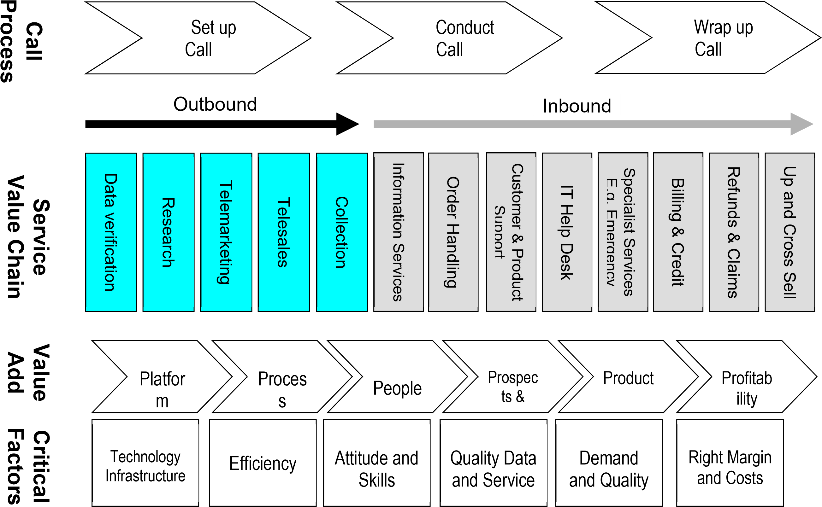
National Certificate: Contact Centre Support NQF 2 71490 LP 73269 Sakhisisizwe © Vn 4 (2015)
SAQA ID 13885, US 10348, 13873 Page 12

1.5 The Quality Staircase

The first step to meeting customer expectations is to determine what they are and try to understand them. Understanding the needs and expectations of the consumer and designing products and services to meet these is a relatively straightforward concept, but it is also vital to consider the factors of cultural background and conditioning.
Customer loyalty is often affected by the perception of the level of service provision. It is this perception that will ultimately affect their repeat purchase decisions. Service quality perception and satisfaction is affected by a person’s cultural background.

The six-step process is suggested by Phil Baguley in “Teach Yourself Performance Management”, to create products and services that meet customer needs. As you can see from these steps, this process involves what is known as Customer Relationship Management (CRM). At the base of the steps - knowing who your customers are and what their needs are.

 |  |  |  |  | STEP 6 CREATE | Product/ Service which meets customer needs
 |  |  |  | STEP 5 DESIGN | Taking into account customer needs and organisational capability
 |  |  | STEP 4 DETAIL | Key characteristics of product / service
 |  | STEP 3 DECIDE | Which part of that need will be answered
 | STEP 2 IDENTIFY | What his / her real needs are
STEP 1 FIND OUT | Who your customer is

Page 13

Step 1: Find out who your customer is
Factual data collection: this includes accessing all of the customer’s current information such as demographics.

Step 2: Identify what his / her needs are

Gathering information or data
Customer profile information: this information includes the objectives and goals that the customer has in mind

Before being able to develop a service or product, the goals of the customer need to be clearly understood. This means getting to know the following about the customer:
- Personal information
- Current situation regarding your product offering (E.g. If you are in financial services, what are customer financial needs; if you are in IT services, what are customer technological needs, etc.)
- Personal objectives and how these are prioritised
- Time frames for results
- Available finances and resources

Tips for clarifying objectives, goals and concerns
- Ask structured questions
- Try to ascertain the customer’s true situation through attitudes, concerns and feelings
- Observe body language
- Be aware of differences in cultural background, age, sex and personality type • Listen to what the customer is saying and is not saying

Step 3: Decide what part of that need will be answered

Analysing information:
Once all the information has been gathered from a customer, both in terms of the customer profile and the factual information, the next step is to analyse the information. The main objective of this is to assess the customer’s current situation and determine how best, through the various vehicles at your disposable, you can make recommendations to meet your customer’s goals and objectives.

Step 4: Detail key characteristics of the product / service

It is crucial that you keep abreast of industry issues that could impact the design of your product or service. This step could include creating a competitor intelligence system so that you are informed on pricing, product benefits and features, technical assistance, product quality, etc.
If you are uninformed on industry issues or competitors’ products, you run the risk of not considering all issues or possible options available to customers when considering your product or service. It is important that you keep up-to-date with available products and industry related issues by:
Attending training courses, product launches and industry forums.
Reading technical guides, product supplier and industry-related publications, product brochures and marketing material.

Using competitor intelligence systems: Competitor intelligence has grown dramatically over the last few years and is your key to survival in today’s competitive world. An article in Fortune lists over twenty techniques used to collect competitor intelligence. These techniques fall into these major categories.

Getting information from recruits and competitors’ employees: Companies can obtain intelligence through job interviews or from conversations with competitors’ employees. Companies can send product development specialists or engineers to conferences and trade shows to question competitors’ technical people. Companies sometimes advertise and hold interviews for jobs that don’t exist to pump competitors’ employees for information.
Companies hire key executives from competitors to find out what they know. Getting information from published materials and public documents: Keeping track of seemingly meaningless published information can provide competitor intelligence. For example, the types of people sought in help-wanted ads can indicate something about a competitor’s technological thrusts and new product development.

Getting information from people who do business with competitors: Key customers can keep the company informed about competitors – they might even be willing to request and pass information on competitors’ products. This helps with understanding what new products competitors are pitching.

Getting information by observing competitors or analysing physical evidence: Companies increasingly buy competitors’ products and take them apart to determine production costs. Some companies even buy their competitors’ garbage. Once it has left company premises, refuse is legally considered abandoned property.

Ethics: Though most techniques are legal, many involve questionable ethics. The company should take advantage of the publicly available information, but responsible companies should avoid practices that might be considered illegal or unethical. A company does not have to break the law or violate accepted codes of ethics to collect intelligence, as the benefits gained from using such techniques are not worth the risks.

Step 5: Design (customer needs and organisational capability)

Using the information, you have gathered, identify what services your customers’ value? What gaps are there currently in your service offering (refer to your pre-work unit activities for additional information on what your customers expect). What would make you stand out from your competitors? Ensure that you have the capability to deliver these services.

Step 6: Create the service that meets the customer needs

Make this service a reality. What processes, resources, authorisation, advertising, policies, etc., do you need to put in place to deliver the new improved service to your customer?

Small Group Exercise: There are some important concepts that we need to understand about customer service before we can do a really good job of
providing it. What do the beliefs listed below mean to you?

Service is an attitude — not a department, a program or a policy.

Service means exceeding customer expectations.

Service is not natural, automatic, or coincidental.

1.6 Who Are Your Customers?

Who are our customers? For many of us, customers are easy to identify. They buy something from us, or we serve them in some way. But some people will say, “I don’t work directly with customers.” Before you accept this idea, I suggest taking a closer look at who our customers are.

In most organizations and agencies, customers take two forms: internal and external.

Internal customers are those people, departments, or agencies served by what we do. The only person who might have no internal customers is the individual who works completely alone. For the rest of us, internal customers are a fact of life. A word processing clerk or copy centre worker within an organization serves other workers’ needs for documents.

As individuals, we all have at least one internal customer: our boss. We may also have internal customers in the form of people we supervise. They rely on us to meet their needs.

External customers are those people or departments, or tenants who are the end users of our organization’s products or services. This is, of course, the traditional use of the term customer.

What do people want? Well, at the simplest level, our customers have some basic needs.
- They want to be understood.
- They want to feel welcome.
- They want to feel important.
- They want to feel comfortable.

.

1.7 Meeting Customer Needs

A customer’s expectations should always be met – when you say you will do something and even if the task is challenging (it might be that you are depending on someone else to do complete the task), remember to stick to your promise and deadline given to the customer. In saying this, try and give yourself the benefit of the doubt and give yourself leeway of time (an extra day or so) if you have any doubt that you will not be able to deliver the service on time. In doing this, you safeguard yourself and quality of service as well as ultimately satisfying the customers’ needs.

All customers are different. Some customers are easy to work with and others are not! We get on with some customers but others are extremely difficult. If you can assess what personality type your customers are in order to understand what kind of person you are dealing with you will be more likely to establish a good rapport with them enabling you to:

- Help the customer to buy
- Work in a professional manner
- Enjoy work more
- Sell more

Four basic types of customer can be identified:

Type 1 - Socialisers

Socialisers are friendly, smiley and chatty. They are enthusiastic and easy – going using lots of face and hand gestures when communicating speaking quickly and becoming quite excitable. They give you lots of information (some of which is relevant) and like to talk about unrelated topics such as the weather and traffic etc.
When talking to socialisers, they like you to give examples of the point that you are making and they do not need much detail preferring you to make points with stories. They usually make decisions quickly.

Type 2 - Generals
Generals are direct, straight talking and know exactly what they want expecting you to provide the solution. They are assertive and formal in their communicative style and tend to be unfriendly and distant although not unpleasant. They are assertive in their approach and may talk ‘down’ at you as they want to be in charge.

When talking to generals they will give the impression that they are
short of time. They become impatient with people who are not decisive and are poor listeners so they want you to get to the point quickly. Being extremely results oriented, generals might say something along the lines of “Will this do what I want: Yes or No?”

Type 3 - Team Players

Team Players are kind, warm and supportive. When communicating they use few hand gestures and tend to be quiet. They are generally unassertive and are soft – hearted wanting to remain friends with everyone. Team players always want to co-operate and may begin
sentences with something like “Sorry to be a nuisance”.

When talking to team players, bear in mind that they will be indecisive and look to you for help. They tend to listen to you and make decisions on your recommendation. If unhappy with your service, they won’t complain, however they will also not be back. Team players are slow moving and slow to make decisions as they tend to rely on input from others.

Type 4 - Detectives

Detectives are precise, detail-oriented and suspicious which makes them critical. They are serious and distant when communicating and tend to be unfriendly but not rude. They are concerned with order and will investigate and test everything you say in order to arrive at a precise conclusion that they feel is detailed enough.

When talking to detectives, make sure that you can provide precise, accurate answers for the many questions that they will ask you. They will be slow to make decisions as they don’t know what they want but expect you to work it out! They are good listeners but once you’ve worked out what they require, they then test your decision with questions to see if you are right.

To summarise:

Socialisers  They are friendly, smiley and chatty | Generals  They are direct, straight talking and know exactly what they want
Detectives  They are precise, detailorientated and suspicious | Team Players  They are kind, warm and supportive

1.8 Meeting Customer Expectations

Every individual’s needs are important. Each customer wants to be treated like he/she is your only customer. They know that isn’t true, just as well as you do, but they still want that kind of attention. The only way for you to be successful is to help other people get what they want

In the larger sense, customers expect us to meet expectations in four critical areas.

Timeliness - Relevance

Quality

Consistency - Reliability

First Impressions

Presenting Yourself Properly

Check yes or no for each question.
 |  | YES | NO
1) | Do people usually buy from someone they dislike?
2) | Do you understand the power of a smile?
3) | Do you show sincere interest in your customer and engage in preliminary small talk?
4) | Do you grant people time alone before asking for the order?
5) | Are you aware that a negative first impression may turn a prospect off of your product?
6) | Do you open with a sincere compliment?
7) | Do you promptly offer a prospect refreshment and a comfortable seating arrangement?
8) | Do you pay attention to your attire and personal grooming?
9) | Do you welcome buyers with a firm handshake?
10) | Are you congenial no matter what the outcome?

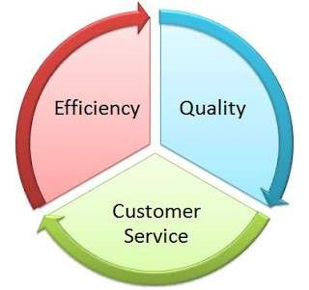

1.9 Standards

What are Standards are they Company Specifics and Company Procedures?

Company Procedures or Specifics can be called Standards – these Standards or expectations, or targets are set by management, are good, because they give us something to strive for, they tell us what we have to do to have our supervisors/managers say our work is satisfactory.

However, we should make certain that our standards are meeting or exceeding the expectations of our customers. And the only way to do this is to ask our customers, on an ongoing basis, if they are satisfied with the service.

In the Contact Centre industry there are golden rules that has to be followed and no matter whether it is an Inbound, Outbound or Blended that you are working in – all Standards will be the same – the only time changes to the will take place is when you start entering your Contact Centre specifics for example if you are a debt collection Contact Centre or a Marketing Research or a Help Line etc.

1.10 Telephone Etiquette

For most of us, the telephone is a vital source of communication. The use of cell phones and instant conversation is commonplace in our life today. However, the way you conduct yourself on the phone may be a key factor in building successful relationships.

These Standards will show you how paying attention to detail may make a big difference in others’ impressions of you, both personally and professionally.

Identify your Company. When calling someone or someone calling you, you need to identify the Company name clearly so that the customer immediately identifies that he/she is talking to the Company he/she wanted to.
Identify yourself. When calling someone or someone calling you, you need to identify yourself after they've said hello?
Confirm your client’s details – inbound or outbound you need to confirm details.
o Confirm callers, name, surname and identity number o Confirm Address
o Confirm Telephone details
Explain to your customer why you are confirming all the above details.
Respect your customer’s time. When placing a call, after identifying yourself, do you ask, "Do you have a minute?" or "Is this a good time to reach your?" before explaining the reason for your call? (Debt collecting company are the biggest defaulters of this – because they feel once they have the client on the line they need to get straight to what they need to – and nine times out of ten it is not convenient for the customer to discuss his/her personal finance).
Always ask rather than just place someone on hold.
After placing someone on hold and returning to the line, say "Thanks for waiting," rather than, "I'm back."
When screening calls, do you ask, "Who's calling, please?" rather than, "Who is this?"

Telephone Techniques

One of the biggest misconceptions on the phone is that people can’t see your expressions. However, this is not always the case. Our voice and tone can convey exactly what our face is expressing.

The most important thing to remember about telephone communication is your tone. The reason is that tone accounts for 87% of how the receiver interprets your message. Your words account for only 12% of the response, and body language counts for only 1%.

The Initial Greeting

Identify the organization, the department, and yourself. Be careful about verbal shorthand or internal jargon. Don't make the caller say, "Is this Joe Soap?" or "To whom am I speaking?" By the tone of a few words, you can convey a friendly welcome, which will imply your willingness to be helpful. As well, you should always personalize service.

What are the situations you should keep in mind when you answer your phones?
- The person they want isn’t there.
- You have to transfer a call.
- You have to put a caller on hold, give progress reports, and return to the line.
- You have to take a message.

Transferring Telephone Calls

An impression of poor service and lack of interest often results when calls are transferred improperly within an organization.

A call should only be transferred when the person transferring it cannot help the caller and is reasonably sure the person to whom the call is transferred will be able to help the caller.

The reason for the transfer should be explained, along with the name of the person to whom the caller will be transferred. This prepares the caller for what is about to happen, and doesn't look like you are giving him/her the run-around.

Here’s an example: "Mark Jenson in Fire Prevention handles that. I'll transfer you to him, Mrs. Smith."

Then the person transferring the call should announce the call to the person receiving it. This will prepare him and eliminates the need for the caller to repeat information.

Putting Callers on Hold

If you are handling a call and you must put the caller on hold, ask their permission and explain why you are putting them on hold. You should also give them your best estimate of how long they will be on hold.

If you think the waiting time might be more than 3 minutes, give the caller the option of holding or having you call back. Waiting time always seems longer than it actually is.

Progress Reports

A progress report means informing the waiting person what progress is being made on the call. Here’s an example: "Mr. Johnson, I'm still checking the code for that. Do you mind waiting a little longer or should I call you back?"

Proper Return to the Line

Attract the person's attention by calling them by name or using a suitable introductory expression, so you won't have to repeat any of the information. Thank them for waiting.

1.11 Taking a Message

Taking a message for your supervisor or another employee should be relatively simple. However, a great deal of business is lost each year by incomplete or forgotten messages. A courteous person returns telephone calls. Accurate messages reduce errors and eliminate unnecessary calls.

Taking Messages Accurately and Completely

- Keep a pad handy.
- Write while you are on the line. Take notes as you handle the call, not after you hang up the receiver.
- Request, don’t demand information. Say, “If I may have your name, please...” rather than, “What is your name and number?”
- Verify spelling. o Get the first name too. o Spell out phonetically if the name is difficult.
- Give feedback for verification. (For example, “So that’s spelled J-a-y-s-o-n?”)

What to Record o To whom: The name of the person called.
- From whom: The name of the call and his business connection. o Where: The caller’s telephone number and extension number. o What: The message itself.
- Why: Action requested and the action promised. o By whom: Name of the person who recorded the message.
- When: Date and hour of the call.

Other Tips

To assure the accuracy and completeness of a message, you might consider the following suggestions:
- Listen attentively to the message.
- Check to be sure all telephone numbers are correct and use feedback for verification.
- Verify the spelling of difficult names, using phonetic helpers – people are sensitive.
- After the telephone call has been completed, make additional notes from memory.
- Attach to the message any papers, reports, lists of information that would be helpful to the called party.

When asking to take a message, if the caller says, “No, I’ll call back,” courteously ask one more time. For example, you could say, “If I could just tell him who called, I’m sure he will be interested. Of course, you can call back if that would be more convenient.”

Use Good Speech Habits Phrases to use:
- “One moment please”
- “Yes”
- “All right”
- “She’s not available now”
- “Good-bye”

Phrases not to use:
- “Hang on”
- “Hey”
- “Okey-Doke”
- “Uh, I dunno where he is.”

1.12 Personalizing Service

All customers are important. Together, they represent the sum total of our reason for being. However, each individual customer craves to have his uniqueness recognized and acknowledged in the process of being served. We can appreciate each customer’s importance by getting and using their name.

A Quick Formula to Practice o Prepare to hear the name. o Write it down immediately. o If you miss it, ask the person to repeat it. o Repeat the name immediately in your next comment to the person.
- Use the name occasionally in the conversation. It’s an attention getter at the beginning of the sentence.
- Ask, “Let me be sure I’ve spelled your name right. Is that J-a-y-s-o-n?” o Thank the person and use the name again as you are parting.

Addressing a Person

Should you call a person Mr., Ms., or Mrs., or use their first name? It really depends on the company and whether you have spoken to this person before. Usually, it’s best to err on the side of caution and use “Mr.” or “Ms.” until the customer says otherwise.

1.13 Product Specifics

Most Contact Centres work according to a product. Below is a few examples regarding the different products different Contact Centres offer.

Type of Contact Centre | Product
Market Research | Research Customer Satisfaction  Research new product launch  Research for statistical purposes
Debt Collecting | Any client that would like to outsource their  ‘book’ to the specialist in debt collection  e.g., Edgars, Woolworths etc – the ‘book’ can be 1 to 10 years old
Help Line | Looking for a telephone number
Technical | Example Pastel software – this would have specifically trained technicians available to assist clients in a specific product
Can you name a few more
Once a Company obtains a new Mandate or Campaign the agents will be trained on the specific product knowledge which will allow the agent to offer a good customer service by:

Ensuring that all agents are competent and confident in the current product knowledge.
Ensuring that agents are kept up to date with new developments
Ensuring that the product knowledge is specific to the mandate
Agents must ensure full understanding of the product – if unsure they must advise their Supervisor/Training department so that they are able to meet Customer’s needs.

1.14 Company Specific Timeframe

All Contact Centres are driven by time and results. What does this mean to you as an agent?

It means that the Company has already worked out how long it should take an agent to answer a specific call and allow for admin.

Can you answer the following questions?

- How long should a phone ring before you answer the call?
_________________________________________________
- How long do you have to complete the admin after a
_________________________________________________

Every Manager’s Desk Reference, Penguin Group, 2002

