

LEARNER GUIDE

Manoeuvre materials safely by hand in a workplace
Core

Unit Standard 259620

Level 2

Credits 2
Learner First name: Learner Surname: Learner ID Number Company / Project:
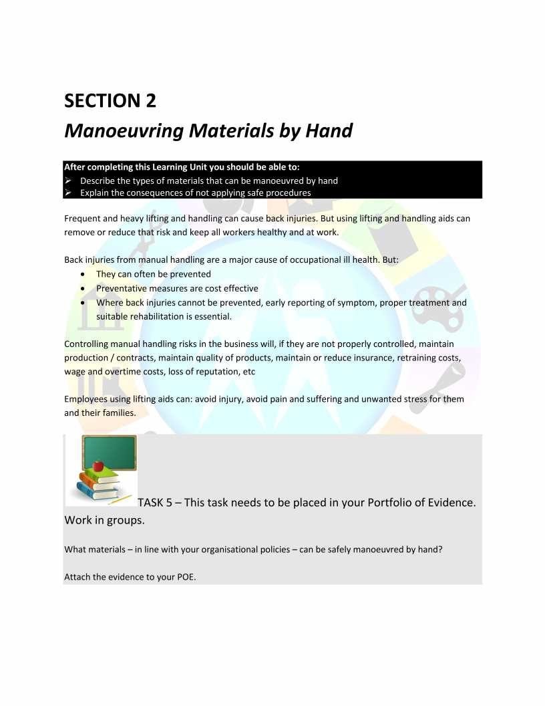

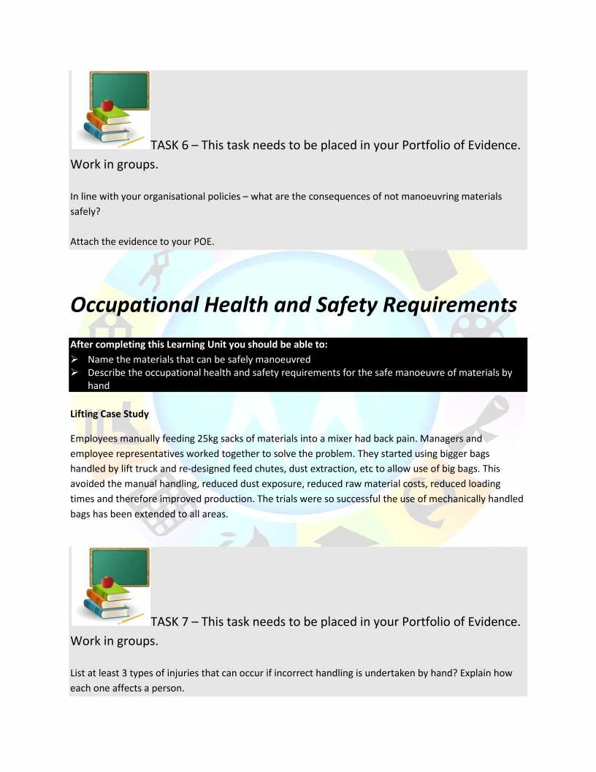

Manual Handling
Manual handling causes over a third of all workplace injuries. These include work-related musculoskeletal disorders (MSDs) such as pain and injuries to arms, legs and joints, and repetitive strain injuries of various sorts.
The term manual handling covers a wide variety of activities including lifting, lowering, pushing, pulling and carrying. If any of these tasks are not carried out appropriately there is a risk of injury.

Why is dealing with manual handling important?
Manual handling injuries can have serious implications for the employer and the person who has been injured. They can occur almost anywhere in the workplace and heavy manual labour, awkward postures, repetitive movements of arms, legs and back or previous/existing injury can increase the risk.

What do I have to do?
To help prevent manual handling injuries in the workplace, you should avoid such tasks as far as possible. However, where it is not possible to avoid handling a load, employers must look at the risks of that task and put sensible health and safety measures in place to prevent and avoid injury.

For any lifting activity
Always take into account:
- individual capability
- the nature of the load
- environmental conditions
- training
- work organisation

If you need to lift something manually
- Reduce the amount of twisting, stooping and reaching
- Avoid lifting from floor level or above shoulder height, especially heavy loads
- Adjust storage areas to minimise the need to carry out such movements
- Consider how you can minimise carrying distances
- Assess the weight to be carried and whether the worker can move the load safely or needs any help – maybe the load can be broken down to smaller, lighter components

If you need to use lifting equipment
- Consider whether you can use a lifting aid, such as a forklift truck, electric or hand-powered hoist, or a conveyor
- Think about storage as part of the delivery process – maybe heavy items could be delivered directly, or closer, to the storage area
- Reduce carrying distances where possible

Good handling technique for lifting
There are some simple things to do before and during the lift/carry:
- Remove obstructions from the route.
- For a long lift, plan to rest the load midway on a table or bench to change grip.
- Keep the load close to the waist. The load should be kept close to the body for as long as possible while lifting.
- Keep the heaviest side of the load next to the body.
- Adopt a stable position and make sure your feet are apart, with one leg slightly forward to maintain balance
Think before lifting/handling. Plan the lift. Can handling aids be used? Where is the load going to be placed? Will help be needed with the load? Remove obstructions such as discarded wrapping materials. For a long lift, consider resting the load midway on a table or bench to change grip.
Adopt a stable position. The feet should be apart with one leg slightly forward to maintain balance (alongside the load, if it is on the ground). Be prepared to move your feet during the lift to maintain your stability. Avoid tight clothing or unsuitable footwear, which may make this difficult.
Get a good hold. Where possible, the load should be hugged as close as possible to the body. This may be better than gripping it tightly with hands only.
Start in a good posture. At the start of the lift, slight bending of the back, hips and knees is preferable to fully flexing the back (stooping) or fully flexing the hips and knees (squatting).
Don’t flex the back any further while lifting. This can happen if the legs begin to straighten before starting to raise the load.
Keep the load close to the waist. Keep the load close to the body for as long as possible while lifting. Keep the heaviest side of the load next to the body. If a close approach to the load is not possible, try to slide it towards the body before attempting to lift it.
Avoid twisting the back or leaning sideways, especially while the back is bent. Shoulders should be kept level and facing in the same direction as the hips. Turning by moving the feet is better than twisting and lifting at the same time.
Keep the head up when handling. Look ahead, not down at the load, once it has been held securely.
Move smoothly. The load should not be jerked or snatched as this can make it harder to keep control and can increase the risk of injury.
Don’t lift or handle more than can be easily managed. There is a difference between what people can lift and what they can safely lift. If in doubt, seek advice or get help.
Put down, then adjust. If precise positioning of the load is necessary, put it down first, then slide it into the desired position.


