10349 & 10353 Final Summative Assessment
NQF 2 Contact Centre Support ID 71490 LP 73269
Name:
ID Number:
Workplace:
Region:
Date:
Signature (to verify this is my own work)

Marking Grid: (For Office Use ONLY)
Marked By:
Date:
Competent | Not Yet Competent
Assessor Sign off:
Notes:

Activity 1: Workplace Evidence/Activities

In preparing for your final summative assessment which are observation and workplace based, you will be required to show evidence to demonstrate your skill and competence in using your computer skills and customer service knowledge. To assist the assessor in evaluating this, it is important you include:

- Write down/provide a record of any computer or internal systems/computer training you may have attended from your workplace. This will assist in demonstrating you have the knowledge to operate the systems and packages.

- Supply copies of emails or any written communication as proof of following up with customers.

- Explain your time and other quality targets for your calls so that all company guidelines being observed are confirmed.

Make sure you sign all your evidence and that your workplace coach validates (makes sure what you are providing from the workplace is true), checks and signs off anything you provide from the workplace.

Activity 2: US 10349 Workplace Observation Sign Off
You are required to be observed in handling data and the computer system for at least four customer interactions/calls. Your workplace coach or QA supervisor will need to observe this and complete the following checklist for each interaction.
Where possible, you are encouraged to include screen dumps or evidence of accurate capturing data for at least one observation and all evidence must be signed by yourself and your workplace coach.
10349 - Input data received onto appropriate computer packages within a Contact Centre
I _______________________________________(in my capacity as workplace coach), I confirm that ______________________________________________ has achieved/not achieved the following outcomes:
Obseration Number: | 1
Date of Observation:
Time of Observation:
Call Reference Number:

Assessment Criteria |  | Coach  Signature  (initials) | Outcome &  Criteria Met?  {Y/N} | Comments – please include  DETAILED COMMENTS as  feedback to the learner (for praise/improvement)
SO 1: Knowledge, Understanding and Application of computer packages within a contact centre
AC1  AC2  AC3 | Learner is able to demonstrate knowledge and understanding of company specific computer packages by accurately applying, using and navigating the system correctly.
AC4 | Learners shows self confidence when working with company specific packages
SO 2: Input data onto computer specific packages within a contact centre
AC1  AC2  AC5 | Learner inputs data accurately and within company specific timeframes
AC3 | Data captured is relevant and consistent with company specific formats and requirements
AC4 | Learner applies critical and closest routes when inputting data onto packages
Assessment Criteria |  | Coach  Signature  (initials) | Outcome &  Criteria Met?  {Y/N} | Comments – please include  DETAILED COMMENTS as  feedback to the learner (for praise/improvement)
SO 3: Verify data onto company specific packages within a contact centre
AC1 | Learner verifies data against the source of information
AC2 | Learner correctly identifies and rectifies inaccuracies
AC3 | Learner follows company specific follow up and close procedures
Essential Embedded Knowledge – did the learner show application and understanding of in this interacation:
- A general understanding of the methods and techniques for communication and listening.
- A basic understanding of customer service principles.
- An in-depth understanding of company specific packages.
- An in-depth understanding of company products and services.
- A comprehensive understanding of Contact Centre specific computer packages

Learner’s feedback or response to workplace coach comments. What can I improve on:

Supporting evidence referenced (if any):

Learner Signature:

Assessor Sign Off:
Competent | Not yet competent
Assessor | Moderator
 | Re-assessed
Re-assessed | Final Outcome

I _______________________________________(in my capacity as workplace coach), I confirm that ______________________________________________ has achieved/not achieved the following outcomes:
Obseration Number: | 2
Date of Observation:
Time of Observation:
Call Reference Number:

Assessment Criteria |  | Coach  Signature  (initials) | Outcome &  Criteria Met?  {Y/N} | Comments – please include  DETAILED COMMENTS as  feedback to the learner (for praise/improvement)
SO 1: Knowledge, Understanding and Application of computer packages within a contact centre
AC1  AC2  AC3 | Learner is able to demonstrate knowledge and understanding of company specific computer packages by accurately applying, using and navigating the system correctly.
AC4 | Learners shows self confidence when working with company specific packages
SO 2: Input data onto computer specific packages within a contact centre
AC1  AC2  AC5 | Learner inputs data accurately and within company specific timeframes
AC3 | Data captured is relevant and consistent with company specific formats and requirements
AC4 | Learner applies critical and closest routes when inputting data onto packages
SO 3: Verify data onto company specific packages within a contact centre
AC1 | Learner verifies data against the source of information
AC2 | Learner correctly identifies and rectifies inaccuracies
AC3 | Learner follows company specific follow up and close procedures
Essential Embedded Knowledge – did the learner show application and understanding of in this interacation:
- A general understanding of the methods and techniques for communication and listening.
- A basic understanding of customer service principles.
- An in-depth understanding of company specific packages.
- An in-depth understanding of company products and services.
- A comprehensive understanding of Contact Centre specific computer packages

Learner’s feedback or response to workplace coach comments. What can I improve on:

Supporting evidence referenced (if any):

Learner Signature:

Assessor Sign Off:
Competent | Not yet competent
Assessor | Moderator
 | Re-assessed
Re-assessed | Final Outcome

I _______________________________________(in my capacity as workplace coach), I confirm that ______________________________________________ has achieved/not achieved the following outcomes:
Obseration Number: | 3
Date of Observation:
Time of Observation:
Call Reference Number:

Assessment Criteria |  | Coach  Signature  (initials) | Outcome &  Criteria Met?  {Y/N} | Comments – please include  DETAILED COMMENTS as  feedback to the learner (for praise/improvement)
SO 1: Knowledge, Understanding and Application of computer packages within a contact centre
AC1  AC2  AC3 | Learner is able to demonstrate knowledge and understanding of company specific computer packages by accurately applying, using and navigating the system correctly.
AC4 | Learners shows self confidence when working with company specific packages
SO 2: Input data onto computer specific packages within a contact centre
AC1  AC2  AC5 | Learner inputs data accurately and within company specific timeframes
AC3 | Data captured is relevant and consistent with company specific formats and requirements
AC4 | Learner applies critical and closest routes when inputting data onto packages
SO 3: Verify data onto company specific packages within a contact centre
AC1 | Learner verifies data against the source of information
Assessment Criteria |  | Coach  Signature  (initials) | Outcome &  Criteria Met?  {Y/N} | Comments – please include  DETAILED COMMENTS as  feedback to the learner (for praise/improvement)
AC2 | Learner correctly identifies and rectifies inaccuracies
AC3 | Learner follows company specific follow up and close procedures
Essential Embedded Knowledge – did the learner show application and understanding of in this interacation:
- A general understanding of the methods and techniques for communication and listening.
- A basic understanding of customer service principles.
- An in-depth understanding of company specific packages.
- An in-depth understanding of company products and services.
- A comprehensive understanding of Contact Centre specific computer packages

Learner’s feedback or response to workplace coach comments. What can I improve on:

Supporting evidence referenced (if any):

Learner Signature:

Assessor Sign Off:
Competent | Not yet competent
Assessor | Moderator
 | Re-assessed
Re-assessed | Final Outcome

I _______________________________________(in my capacity as workplace coach), I confirm that ______________________________________________ has achieved/not achieved the following outcomes:
Obseration Number: | 4
Date of Observation:
Time of Observation:
Call Reference Number:

Assessment Criteria |  | Coach  Signature  (initials) | Outcome &  Criteria Met?  {Y/N} | Comments – please include  DETAILED COMMENTS as  feedback to the learner (for praise/improvement)
SO 1: Knowledge, Understanding and Application of computer packages within a contact centre
AC1  AC2  AC3 | Learner is able to demonstrate knowledge and understanding of company specific computer packages by accurately applying, using and navigating the system correctly.
AC4 | Learners shows self confidence when working with company specific packages
SO 2: Input data onto computer specific packages within a contact centre
AC1  AC2  AC5 | Learner inputs data accurately and within company specific timeframes
AC3 | Data captured is relevant and consistent with company specific formats and requirements
AC4 | Learner applies critical and closest routes when inputting data onto packages
SO 3: Verify data onto company specific packages within a contact centre
AC1 | Learner verifies data against the source of information
AC2 | Learner correctly identifies and rectifies inaccuracies
AC3 | Learner follows company specific follow up and close procedures
Essential Embedded Knowledge – did the learner show application and understanding of in this interacation:
- A general understanding of the methods and techniques for communication and listening.
- A basic understanding of customer service principles.
- An in-depth understanding of company specific packages.
- An in-depth understanding of company products and services.
Assessment Criteria |  | Coach  Signature  (initials) | Outcome &  Criteria Met?  {Y/N} | Comments – please include  DETAILED COMMENTS as  feedback to the learner (for praise/improvement)
• A comprehensive understanding of Contact Centre specific computer packages

Learner’s feedback or response to workplace coach comments. What can I improve on:

Supporting evidence referenced (if any):

Learner Signature:

Assessor Sign Off:
Competent | Not yet competent
Assessor | Moderator
 | Re-assessed
Re-assessed | Final Outcome

Activity 3: US 10353 Workplace Observation Sign Off
You are required to be observed in handling data and the computer system for at least four customer interactions/calls (these can be the same calls/observations as Activity 2). Your workplace coach or QA supervisor will need to observe this and complete the following checklist for each interaction.
Where possible, you are encouraged to include screen dumps or evidence of accurate capturing data for at least one observation and all evidence must be signed by yourself and your workplace coach.
10353 - Meet performance standards within a Contact Centre (NQF 2; 6 Credits)

I _______________________________________(in my capacity as workplace coach), I confirm that ______________________________________________ has achieved/not achieved the following outcomes:
Obseration Number: | 1
Date of Observation:
Time of Observation:
Call Reference Number:

Assessment Criteria |  | Assessor  Signature | Outcome &  Criteria Met?  {C/NYC} | Comments
SO 1: Use a computerized system
AC1 | Learner inputs data accurately into specific Contact Centre packages
AC2 | Learner retrieves data accurately from specific Contact Centre packages
AC3 | All logging procedures are correctly used as per company specific systems
AC4 | Industry specific security & confidentiality requirements are complied with
AC5 | Specific statistical data is understood. (May include but not be limited to quantity, duration, wrap, hold and dropped Contacts)
SO 2: Respond to calls or other forms of communication
Assessment Criteria |  | Assessor  Signature | Outcome &  Criteria Met?  {C/NYC} | Comments
AC5  AC7 | Learner answers calls according to company specific greeting and communicated with in the appropriate language or medium
AC1 | Company specific time targets are met. (May incl. but not be limited to quantity, duration, wrap, hold & dropped calls.)
AC2  AC3 | The customer’s requests are understood and requests are responded to according to company specific procedures
AC4 | Other forms of communication are considered and applied using standard industry practices. (May include but not be limited to quantity, duration, wrap, hold and dropped Contacts.)
AC6 | Learner closes calls in accordance with the context of the call with a call centre procedures
SO 3: Follow – up customer queries
AC1 | Learner uses electronic communication systems effectively. (Includes but is not limited to faxing, emailing, printing, photocopying, telephone
AC2 | Learner completes manual administrative information accurately as per company specific procedures and time frames
Essential Embedded Knowledge – did the learner show application and understanding of in this interacation:
- A basic knowledge and understanding of various computer applications, including but not limited to Internet and e-mail
- A general understanding of Contact Centre guidelines and industry specific products
- A basic understanding of customer service principles
- An in-depth understanding of the methods and techniques for communication, listening and call closing
- A thorough understanding of company specific greetings

Learner’s feedback or response to workplace coach comments. What can I improve on:

Supporting evidence referenced (if any):
Learner Signature:

Assessor Sign Off:
Competent | Not yet competent
Assessor | Moderator
 | Re-assessed
Re-assessed | Final Outcome

Obseration Number: | 2
Date of Observation:
Time of Observation:
Call Reference Number:

Assessment Criteria |  | Assessor  Signature | Outcome &  Criteria Met?  {C/NYC} | Comments
SO 1: Use a computerized system
AC1 | Learner inputs data accurately into specific Contact Centre packages
AC2 | Learner retrieves data accurately from specific Contact Centre packages
AC3 | All logging procedures are correctly used as per company specific systems
AC4 | Industry specific security & confidentiality requirements are complied with
AC5 | Specific statistical data is understood. (May include but not be limited to quantity, duration, wrap, hold and dropped Contacts)
SO 2: Respond to calls or other forms of communication
AC5  AC7 | Learner answers calls according to company specific greeting and communicated with in the appropriate language or medium
AC1 | Company specific time targets are met. (May incl. but not be limited to quantity, duration, wrap, hold & dropped calls.)
AC2  AC3 | The customer’s requests are understood and requests are responded to according to company specific procedures
AC4 | Other forms of communication are considered and applied using standard industry practices. (May include but not be limited to quantity, duration, wrap,
 | mailing, printing, photocopying, telephone
AC2 | Learner completes manual administrative information accurately as per company specific procedures and time frames
Essential Embedded Knowledge – did the learner show application and understanding of in this interacation:
- A basic knowledge and understanding of various computer applications, including but not limited to Internet and e-mail
- A general understanding of Contact Centre guidelines and industry specific products
- A basic understanding of customer service principles
- An in-depth understanding of the methods and techniques for communication, listening and call closing
- A thorough understanding of company specific greetings

Learner’s feedback or response to workplace coach comments. What can I improve on:

Supporting evidence referenced (if any):

Learner Signature:

Assessor Sign Off:
Competent | Not yet competent
Assessor | Moderator
 | Re-assessed
Re-assessed | Final Outcome

Obseration Number: | 3
Date of Observation:
Time of Observation:
Call Reference Number:

Assessment Criteria |  | Assessor  Signature | Outcome &  Criteria Met?  {C/NYC} | Comments
SO 1: Use a computerized system
AC1 | Learner inputs data accurately into specific Contact Centre packages
AC2 | Learner retrieves data accurately from specific Contact Centre packages
AC3 | All logging procedures are correctly used as per company specific systems
AC4 | Industry specific security & confidentiality requirements are complied with
AC5 | Specific statistical data is understood. (May include but not be limited to quantity, duration, wrap, hold and dropped Contacts)
SO 2: Respond to calls or other forms of communication
AC5  AC7 | Learner answers calls according to company specific greeting and communicated with in the appropriate language or medium
AC1 | Company specific time targets are met. (May incl. but not be limited to quantity, duration, wrap, hold & dropped calls.)
AC2  AC3 | The customer’s requests are understood and requests are responded to according to company specific procedures
AC4 | Other forms of communication are considered and applied using standard industry practices. (May include but not be limited to quantity, duration, wrap,
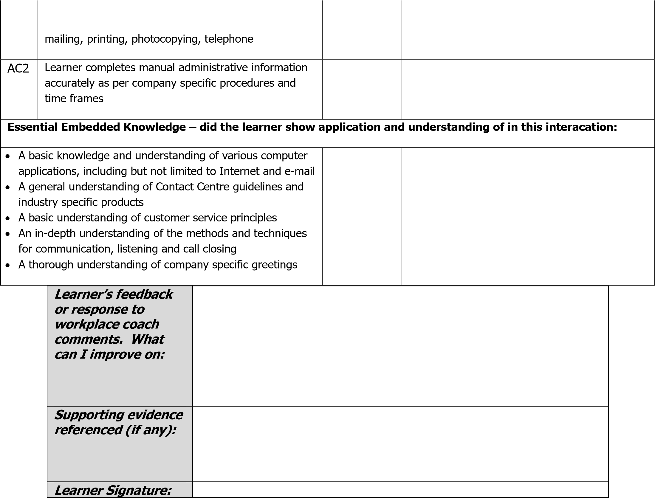

Assessor Sign Off:
Competent | Not yet competent
Assessor | Moderator
 | Re-assessed
Re-assessed | Final Outcome

Obseration Number: | 4
Date of Observation:
Time of Observation:
Call Reference Number:

Assessment Criteria |  | Assessor  Signature | Outcome &  Criteria Met?  {C/NYC} | Comments
SO 1: Use a computerized system
AC1 | Learner inputs data accurately into specific Contact Centre packages
AC2 | Learner retrieves data accurately from specific Contact Centre packages
AC3 | All logging procedures are correctly used as per company specific systems
AC4 | Industry specific security & confidentiality requirements are complied with
AC5 | Specific statistical data is understood. (May include but not be limited to quantity, duration, wrap, hold and dropped Contacts)
SO 2: Respond to calls or other forms of communication
AC5  AC7 | Learner answers calls according to company specific greeting and communicated with in the appropriate language or medium
AC1 | Company specific time targets are met. (May incl. but not be limited to quantity, duration, wrap, hold & dropped calls.)
AC2  AC3 | The customer’s requests are understood and requests are responded to according to company specific procedures
AC4 | Other forms of communication are considered and applied using standard industry practices. (May include but not be limited to quantity, duration, wrap,

Assessor Sign Off:
Competent | Not yet competent
Assessor | Moderator
 | Re-assessed
Re-assessed | Final Outcome

