**LEARNER GUIDE**

**Module 2**

Communication Level 2

**Access and use information from texts**

Unit Standard 119463, Level 2 Credits 5

**Write for a defined context**

Unit Standard 119456, Level 2 Credits 5

# TABLE OF CONTENTS

[TABLE OF CONTENTS i](#_Toc81390574)

[PERSONAL INFORMATION 1](#_Toc81390575)

[INTRODUCTION 2](#_Toc81390576)

[Welcome to the learning programme 2](#_Toc81390577)

[Programme methodology 3](#_Toc81390578)

[What Learning Material you should have 4](#_Toc81390579)

[Different types of activities you can expect 5](#_Toc81390580)

[Learner Administration 6](#_Toc81390581)

[Assessments 6](#_Toc81390582)

[Learner Support 7](#_Toc81390583)

[Learner Expectations 8](#_Toc81390584)

[UNIT STANDARD 119463 & 119456 9](#_Toc81390585)

[Unit standard 119463 9](#_Toc81390586)

[Unit standard 119456 15](#_Toc81390587)

[SECTION 1: READING AND VIEWING STRATEGIES 20](#_Toc81390588)

[Introduction 20](#_Toc81390589)

[Reading Skills 22](#_Toc81390590)

[Reading Strategies 22](#_Toc81390591)

[Skim 22](#_Toc81390592)

[Scan 22](#_Toc81390593)

[Sift 23](#_Toc81390594)

[Prediction 23](#_Toc81390595)

[Re-Reading 23](#_Toc81390596)

[Pre reading 23](#_Toc81390597)

[Highlighting 23](#_Toc81390598)

[Retell And Summarise 24](#_Toc81390599)

[Use Questions 24](#_Toc81390600)

[Research the information 24](#_Toc81390601)

[Record the information 25](#_Toc81390602)

[Sorting and categorizing 25](#_Toc81390603)

[Sifting for Relevance 25](#_Toc81390604)

[Validity and Reliability 26](#_Toc81390605)

[Aids for recording information 26](#_Toc81390606)

[Summaries 26](#_Toc81390607)

[Paraphrasing 27](#_Toc81390608)

[Point Form 27](#_Toc81390609)

[Mind-map 27](#_Toc81390610)

[Notes 30](#_Toc81390611)

[Annotations 30](#_Toc81390612)

[Diagram 30](#_Toc81390613)

[Tree Diagram 30](#_Toc81390614)

[Cause and effect diagrams 32](#_Toc81390615)

[Timelines 34](#_Toc81390616)

[Flow chart 35](#_Toc81390617)

[Venn diagram 36](#_Toc81390618)

[Pie chart 36](#_Toc81390619)

[Bar graph 37](#_Toc81390620)

[Structural features of text 38](#_Toc81390621)

[Reference Materials 39](#_Toc81390622)

[Dictionaries 39](#_Toc81390623)

[Textbooks 42](#_Toc81390624)

[Instruction Manuals 46](#_Toc81390625)

[Encyclopaedias 48](#_Toc81390626)

[Internet 50](#_Toc81390627)

[What Do We Read? 50](#_Toc81390628)

[Read Instructions 51](#_Toc81390629)

[Games 51](#_Toc81390630)

[Repairing objects 52](#_Toc81390631)

[Forms 52](#_Toc81390632)

[Maps 53](#_Toc81390633)

[Recipes 53](#_Toc81390634)

[Schedules 53](#_Toc81390635)

[Procedures 54](#_Toc81390636)

[Activity 1(119463 SO1, AC1-7) 55](#_Toc81390637)

[SECTION 2: IDENTIFY MAIN IDEAS 56](#_Toc81390638)

[Determine The Author’s Purpose 56](#_Toc81390639)

[Present ideas from the text 56](#_Toc81390640)

[Role play 56](#_Toc81390641)

[Simulation 56](#_Toc81390642)

[Identify socio-cultural issues 57](#_Toc81390643)

[Idioms and Proverbs 57](#_Toc81390644)

[Jargon 57](#_Toc81390645)

[Slang 58](#_Toc81390646)

[Activity 2 (119463 SO2, AC1-4) 58](#_Toc81390647)

[SECTION3: READ/VIEW AND RESPOND TO TEXT 59](#_Toc81390648)

[Reading and viewing resources 59](#_Toc81390649)

[Text Types 60](#_Toc81390650)

[Purpose and different points of view 60](#_Toc81390651)

[Own ideas 61](#_Toc81390652)

[Relevance of text 61](#_Toc81390653)

[Implicit and Explicit Text 61](#_Toc81390654)

[Activity 3 (119463 SO3, AC1-6) 61](#_Toc81390655)

[SECTION4: LANGUAGE STRUCTURES AND FEATURES 63](#_Toc81390656)

[Language Structures And Features 63](#_Toc81390657)

[Dealing With Bias 63](#_Toc81390658)

[Humour 64](#_Toc81390659)

[Irony and sSarcasm 64](#_Toc81390660)

[Hyperbole 65](#_Toc81390661)

[Generalisations 65](#_Toc81390662)

[Stereotyping 65](#_Toc81390663)

[Figurative Expressions 65](#_Toc81390664)

[Repetition 66](#_Toc81390665)

[Grammar 66](#_Toc81390666)

[Captions 67](#_Toc81390667)

[Pictures 67](#_Toc81390668)

[Typography 68](#_Toc81390669)

[Omissions and Silence 68](#_Toc81390670)

[Sentence structures 68](#_Toc81390671)

[Sentence Length 68](#_Toc81390672)

[Simple Sentences 69](#_Toc81390673)

[Compound Sentences 69](#_Toc81390674)

[Complex Sentences 69](#_Toc81390675)

[Activity 4 (119463 SO4, AC1-2) 69](#_Toc81390676)

[SECTION 5: AUDIENCE, PURPOSE & CONTEXT 71](#_Toc81390677)

[Styles Of Writing 71](#_Toc81390678)

[Narrative 71](#_Toc81390679)

[Discursive 71](#_Toc81390680)

[Reflective 71](#_Toc81390681)

[Argumentative 72](#_Toc81390682)

[Descriptive 72](#_Toc81390683)

[Expository 72](#_Toc81390684)

[Transactional 72](#_Toc81390685)

[Business correspondence 72](#_Toc81390686)

[Electronic texts 72](#_Toc81390687)

[Multi-Media Presentations 73](#_Toc81390688)

[Structure your writing 76](#_Toc81390689)

[There are many reasons why authors write texts 76](#_Toc81390690)

[Before you start writing/signing your text you have to plan what you are going to write 76](#_Toc81390691)

[Make your writing/signing interesting 77](#_Toc81390692)

[Diction 77](#_Toc81390693)

[Produce Writing/Signing That Is Appropriate 77](#_Toc81390694)

[A clear point of view 79](#_Toc81390695)

[The ten golden rules of meaningful written communication 79](#_Toc81390696)

[Pointers to think of before you write 79](#_Toc81390697)

[Use critical thinking skills 80](#_Toc81390698)

[Mind maps 80](#_Toc81390699)

[Highlights 80](#_Toc81390700)

[Brainstorming 80](#_Toc81390701)

[Activity 5 (119456 SO1, AC1-2) 81](#_Toc81390702)

[SECTION 6: GRAMMATICAL STRUCTURES 82](#_Toc81390703)

[Register 82](#_Toc81390704)

[Informal Register 82](#_Toc81390705)

[Formal Register 82](#_Toc81390706)

[Punctuation/NMF’s 83](#_Toc81390707)

[Period 83](#_Toc81390708)

[Comma 83](#_Toc81390709)

[Ellipses 84](#_Toc81390710)

[Semi-colons 84](#_Toc81390711)

[Dash 85](#_Toc81390712)

[Sentences 85](#_Toc81390713)

[Paragraphs 85](#_Toc81390714)

[Document 85](#_Toc81390715)

[Arranging The Paragraphs In A Logical Order 86](#_Toc81390716)

[Organise the material 87](#_Toc81390717)

[Activity 6 (119456 SO 2, AC 1-7 88](#_Toc81390718)

[SECTION 7: ADAPT LANGUAGE 89](#_Toc81390719)

[Activity 7 (119456 SO3, AC 1-2) 89](#_Toc81390720)

[SECTION 8: EDIT WRITING 90](#_Toc81390721)

[Redrafting 90](#_Toc81390722)

[Bibliography 91](#_Toc81390723)

[Activity 8 (119456 SO4, AC 1-6) 92](#_Toc81390724)

# PERSONAL INFORMATION

|  |  |
| --- | --- |
| **NAME** |  |
| **CONTACT ADDRESS** |  |
|  |
| **Code** |  |
| **Telephone (H)** |  |
| **Telephone (W)** |  |
| **Cellular** |  |
| **Learner Number** |  |
| **Identity Number** |  |
|  | |
| **EMPLOYER** |  |
| **EMPLOYER CONTACT ADDRESS** |  |
|  |
| **Code** |  |
| **Supervisor Name** |  |
| **Supervisor Contact Address** |  |
|  |
| **Code** |  |
| **Telephone (H)** |  |
| **Telephone (W)** |  |
| **Cellular** |  |

# **INTRODUCTION**

### Welcome to the learning programme

Follow along in the guide as the training practitioner takes you through the material. Make notes and sketches that will help you to understand and remember what you have learnt. Take notes and share information with your colleagues. Important and relevant information and skills are transferred by sharing!



This learning programme is divided into sections. Each section is preceded by a description of the required outcomes and assessment criteria as contained in the unit standards specified by the South African Qualifications Authority. These descriptions will define what you have to know and be able to do in order to be awarded the credits attached to this learning programme. These credits are regarded as building blocks towards achieving a National Qualification upon successful assessment and can never be taken away from you!

### Programme methodology



The programme methodology includes facilitator presentations, readings, individual activities, group discussions and skill application exercises.

Know what you want to get out of the programme from the beginning and start applying your new skills immediately. Participate as much as possible so that the learning will be interactive and stimulating.

The following principles were applied in designing the course:

Because the course is designed to maximise interactive learning, you are encouraged and required to participate fully during the group exercises

As a learner you will be presented with numerous problems and will be required to fully apply your mind to finding solutions to problems before being presented with the course presenter’s solutions to the problems

Through participation and interaction the learners can learn as much from each other as they do from the course presenter

Although learners attending the course may have varied degrees of experience in the subject matter, the course is designed to ensure that all delegates complete the course with the same level of understanding

Because reflection forms an important component of adult learning, some learning resources will be followed by a self-assessment which is designed so that the learner will reflect on the material just completed.

This approach to course construction will ensure that learners first apply their minds to finding solutions to problems before the answers are provided, which will then maximise the learning process which is further strengthened by reflecting on the material covered by means of the self-assessments.

#### Different role players in delivery process

* Learner
* Facilitator
* Assessor
* Moderator

### What Learning Material you should have

This learning material has also been designed to provide the learner with a comprehensive reference guide.

It is important that you take responsibility for your own learning process; this includes taking care of your learner material. You should at all times have the following material with you:

|  |  |
| --- | --- |
| **Learner Guide** | **This learner guide is your valuable possession:**  This is your textbook and reference material, which provides you with all the information you will require to meet the exit level outcomes.  During contact sessions, your facilitator will use this guide and will facilitate the learning process. During contact sessions a variety of activities will assist you to gain knowledge and skills.  Follow along in the guide as the training practitioner takes you through the material. Make notes and sketches that will help you to understand and remember what you have learnt. Take and share information with your colleagues. Important and relevant information and skills are transferred by sharing!  This learning programme is divided into sections. Each section is preceded by a description of the required outcomes and assessment criteria as contained in the unit standards specified by the South African Qualifications Authority. These descriptions will define what you have to know and be able to do in order to be awarded the credits attached to this learning programme. These credits are regarded as building blocks towards achieving a National Qualification upon successful assessment and can never be taken away from you! |
| **Formative Assessment Workbook** | The Formative Assessment Workbook supports the Learner Guide and assists you in applying what you have learnt.  The formative assessment workbook contains classroom activities that you have to complete in the classroom, during contact sessions either in groups or individually.  You are required to complete all activities in the Formative Assessment Workbook.  The facilitator will assist, lead and coach you through the process.  These activities ensure that you understand the content of the material and that you get an opportunity to test your understanding. |

### Different types of activities you can expect

To accommodate your learning preferences, a variety of different types of activities are included in the formative and summative assessments. They will assist you to achieve the outcomes (correct results) and should guide you through the learning process, making learning a positive and pleasant experience.



The table below provides you with more information related to the types of activities.

| **Types of Activities** | **Description** | **Purpose** |
| --- | --- | --- |
| **Knowledge Activities** | You are required to complete these activities on your own. | These activities normally test your understanding and ability to apply the information. |
| **Skills Application Activities** | You need to complete these activities in the workplace | These activities require you to apply the knowledge and skills gained in the workplace |
| **Natural Occurring Evidence** | You need to collect information and samples of documents from the workplace. | These activities ensure you get the opportunity to learn from experts in the industry.  Collecting examples demonstrates how to implement knowledge and skills in a practical way |

### Learner Administration

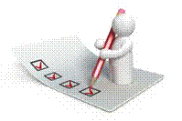

#### Attendance Register

You are required to sign the Attendance Register every day you attend training sessions facilitated by a facilitator.

#### Programme Evaluation Form

On completion you will be supplied with a “Learning programme Evaluation Form”. You are required to evaluate your experience in attending the programme.

Please complete the form at the end of the programme, as this will assist us in improving our service and programme material. Your assistance is highly appreciated.

### Assessments

The only way to establish whether a learner is competent and has accomplished the specific outcomes is through the assessment process. Assessment involves collecting and interpreting evidence about the learners’ ability to perform a task.

To qualify and receive credits towards your qualification, a registered Assessor will conduct an evaluation and assessment of your portfolio of evidence and competency.

This programme has been aligned to registered unit standards. You will be assessed against the outcomes as stipulated in the unit standard by completing assessments and by compiling a portfolio of evidence that provides proof of your ability to apply the learning to your work situation.



**How will Assessments commence?**

#### Formative Assessments

The assessment process is easy to follow. You will be guided by the Facilitator. Your responsibility is to complete all the activities in the Formative Assessment Workbook and submit it to your facilitator.

#### Summative Assessments

You will be required to complete a series of summative assessments. The Summative Assessment Guide will assist you in identifying the evidence required for final assessment purposes. You will be required to complete these activities on your own time, using real life projects in your workplace or business environment in preparing evidence for your Portfolio of Evidence. Your Facilitator will provide more details in this regard.

To qualify and receive credits towards your qualification, a registered Assessor will conduct an evaluation and assessment of your portfolio of evidence and competency.

### Learner Support

The responsibility of learning rests with you, so be proactive and ask questions and seek assistance and help from your facilitator, if required.



Please remember that this Skills Programme is based on outcomes based education principles which implies the following:

You are responsible for your own learning – make sure you manage your study, research and workplace time effectively.

Learning activities are learner driven – make sure you use the Learner Guide and Formative Assessment Workbook in the manner intended, and are familiar with the workplace requirements.

The Facilitator is there to reasonably assist you during contact, practical and workplace time for this programme – make sure that you have his/her contact details.

You are responsible for the safekeeping of your completed Formative Assessment Workbook and Workplace Guide

If you need assistance please contact your facilitator who will gladly assist you.

If you have any special needs please inform the facilitator

### Learner Expectations

Please prepare the following information. You will then be asked to introduce yourself to the instructor as well as your fellow learners



|  |
| --- |
| Your name: |
|  |
|  |
| The organisation you represent: |
|  |
|  |
| Your position in organisation: |
|  |
|  |
| What do you hope to achieve by attending this course / what are your course expectations? |
|  |
|  |
|  |
|  |
|  |

# UNIT STANDARD 119463 & 119456

### Unit standard 119463

|  |
| --- |
| **SOUTH AFRICAN QUALIFICATIONS AUTHORITY** |
| **Access and use information from texts** |

|  |  |  |  |  |
| --- | --- | --- | --- | --- |
| **SAQA US ID** | **UNIT STANDARD TITLE** | | | |
| 119463 | Access and use information from texts | | | |
| **ORIGINATOR** | | **ORIGINATING PROVIDER** | | |
| SGB GET/FET Language and Communication | |  | | |
| **QUALITY ASSURING BODY** | | | | |
| - | | | | |
| **FIELD** | | | **SUBFIELD** | |
| Field 04 - Communication Studies and Language | | | Language | |
| **ABET BAND** | **UNIT STANDARD TYPE** | **PRE-2009 NQF LEVEL** | **NQF LEVEL** | **CREDITS** |
| Undefined | Regular-Fundamental | Level 2 | NQF Level 02 | 5 |
| **REGISTRATION STATUS** | | **REGISTRATION START DATE** | **REGISTRATION END DATE** | **SAQA DECISION NUMBER** |
| Passed the End Date -  Status was "Reregistered" | | 2004-10-13 | 2006-02-09 | SAQA 0356/04 |
| **LAST DATE FOR ENROLMENT** | | **LAST DATE FOR ACHIEVEMENT** | | |
| 2007-02-09 | | 2010-02-09 | | |

|  |
| --- |
| In all of the tables in this document, both the pre-2009 NQF Level and the NQF Level is shown. In the text (purpose statements, qualification rules, etc), any references to NQF Levels are to the pre-2009 levels unless specifically stated otherwise. |

|  |
| --- |
| This unit standard is replaced by: |

|  |  |  |  |  |  |
| --- | --- | --- | --- | --- | --- |
| **US ID** | **Unit Standard Title** | **Pre-2009 NQF Level** | **NQF Level** | **Credits** | **Replacement Status** |
| 119463 | Access and use information from texts | Level 2 | NQF Level 02 | 5 | Complete |

|  |
| --- |
| **PURPOSE OF THE UNIT STANDARD** |

|  |
| --- |
| Learners at this level are able to read or view, understand and respond to texts on a range of topics.   Learners credited with this unit standard are able to:  • identify the main ideas in different text types  • read and respond to texts for a variety of purposes  • use a range of reading and viewing strategies to make meaning of texts  • identify and discuss how language structures and features may influence a reader. |

|  |
| --- |
| **LEARNING ASSUMED TO BE IN PLACE AND RECOGNITION OF PRIOR LEARNING** |

|  |
| --- |
| The credit calculation is based on the assumption that learners are already competent in terms of the full spectrum of language knowledge laid down in the national curriculum statements up to and including GETC or NQF level 1.   Learners can:  • read and view for information and enjoyment, and respond critically to the aesthetic, cultural and emotional values in texts. |

|  |
| --- |
| **UNIT STANDARD RANGE** |

|  |
| --- |
| Written and visual texts appropriate to the needs and interests of learners.   Specific range statements are provided in the body of the unit standard where they apply to particular specific outcomes or assessment criteria. |

|  |
| --- |
| **Specific Outcomes and Assessment Criteria:** |

|  |
| --- |
| **SPECIFIC OUTCOME 1** |

|  |
| --- |
| Identify the main ideas in different text types. |

|  |
| --- |
| **ASSESSMENT CRITERIA** |

|  |
| --- |
| **ASSESSMENT CRITERION 1** |

|  |
| --- |
| 1. The main ideas are identified and distinguished from supporting information. |

|  |
| --- |
| **ASSESSMENT CRITERION 2** |

|  |
| --- |
| 2. The author's purpose is identified and the identification is justified by reference to the text. |

|  |
| --- |
| **ASSESSMENT CRITERION 3** |

|  |
| --- |
| 3. Information or ideas from the text are presented in a form appropriate to a learning task or activity. |

|  |
| --- |
| **ASSESSMENT CRITERION RANGE** |

|  |
| --- |
| Summary (e.g. mind-map, point-form, sub-headings, paragraph form), paraphrase, illustrations, role-play, dramatised key scenes. |

|  |
| --- |
| **ASSESSMENT CRITERION 4** |

|  |
| --- |
| 4. Socio-cultural beliefs in texts are identified and explained with reference to relevant passages or extracts from the text. |

|  |
| --- |
| **ASSESSMENT CRITERION RANGE** |

|  |
| --- |
| Idioms, jargon (language specific to a trade, business or industry), proverbs. |

|  |
| --- |
| **SPECIFIC OUTCOME 2** |

|  |
| --- |
| Read and respond to texts for a variety of purposes. |

|  |
| --- |
| **OUTCOME RANGE** |

|  |
| --- |
| Textbooks, magazines, newspapers, brochures, policies, questionnaires, notices, memoranda, agendas, application forms, documentaries, novels, photographs, diagrams, blueprints, films, and any other appropriate types. |

|  |
| --- |
| **ASSESSMENT CRITERIA** |

|  |
| --- |
| **ASSESSMENT CRITERION 1** |

|  |
| --- |
| 1. Different text types categorised in terms of their intended target audience. |

|  |
| --- |
| **ASSESSMENT CRITERION 2** |

|  |
| --- |
| 2. The purpose of the text is identified and the identification is justified by reference to the text and context. |

|  |
| --- |
| **ASSESSMENT CRITERION 3** |

|  |
| --- |
| 3. Different points of view in texts are identified and observations are justified by reference to the text and context. |

|  |
| --- |
| **ASSESSMENT CRITERION 4** |

|  |
| --- |
| 4. One's ideas and/or arguments are supported with a simple range of reasons and facts relevant to the topic of discussion. |

|  |
| --- |
| **ASSESSMENT CRITERION 5** |

|  |
| --- |
| 5. The relevance of texts is evaluated and justified in terms of meaning to self and others in peer, community or work group. |

|  |
| --- |
| **ASSESSMENT CRITERION 6** |

|  |
| --- |
| 6. Implicit and explicit messages in texts are identified and explained with reference to the purpose of the text. |

|  |
| --- |
| **SPECIFIC OUTCOME 3** |

|  |
| --- |
| Use a range of reading and viewing strategies to make meaning of texts. |

|  |
| --- |
| **ASSESSMENT CRITERIA** |

|  |
| --- |
| **ASSESSMENT CRITERION 1** |

|  |
| --- |
| 1. Reading and viewing strategies employed in searching for meaning in texts are flexible and appropriate to the particular text and nature of the search. |

|  |
| --- |
| **ASSESSMENT CRITERION RANGE** |

|  |
| --- |
| Skimming, scanning, pre-reading, re-reading, predicting and sifting. |

|  |
| --- |
| **ASSESSMENT CRITERION 2** |

|  |
| --- |
| 2. Simple questions used are appropriate to the context; the type of information required and/or attempts to clarify meaning. |

|  |
| --- |
| **ASSESSMENT CRITERION RANGE** |

|  |
| --- |
| Who; what; when; where; why and how questions. |

|  |
| --- |
| **ASSESSMENT CRITERION 3** |

|  |
| --- |
| 3. Information from texts is recorded logically and coherently according to the purpose of the task or learning activity. |

|  |
| --- |
| **ASSESSMENT CRITERION RANGE** |

|  |
| --- |
| Use and effect patterns; summaries; notes; annotations; time-lines; tree diagrams; highlighting; paraphrasing; flow charts; pie charts; bar graphs; Venn diagrams. |

|  |
| --- |
| **ASSESSMENT CRITERION 4** |

|  |
| --- |
| 4. Simple instructions and directions are read and interpreted and subsequent explanations are consistent with the intention of the text. |

|  |
| --- |
| **ASSESSMENT CRITERION RANGE** |

|  |
| --- |
| Games; repairing objects; classroom, workplace or laboratory procedures; recipes; schedules; forms; maps; and warranties. |

|  |
| --- |
| **ASSESSMENT CRITERION 5** |

|  |
| --- |
| 5. The structural features of texts are identified and their uses in accessing meaning are explored. |

|  |
| --- |
| **ASSESSMENT CRITERION RANGE** |

|  |
| --- |
| Title, sub-title, font, size of font, index page, layout, resume, summary, use of visuals/ bold/ italics/underlining, captions. |

|  |
| --- |
| **ASSESSMENT CRITERION 6** |

|  |
| --- |
| 6. Reference materials are used to clarify meanings of words, concepts, language structures and conventions. |

|  |
| --- |
| **ASSESSMENT CRITERION RANGE** |

|  |
| --- |
| Dictionaries; instruction manuals; textbooks; thesaurus; encyclopaedia; the internet. |

|  |
| --- |
| **SPECIFIC OUTCOME 4** |

|  |
| --- |
| Identify and discuss how language structures and features may influence a reader. |

|  |
| --- |
| **ASSESSMENT CRITERIA** |

|  |
| --- |
| **ASSESSMENT CRITERION 1** |

|  |
| --- |
| 1. The choice of words, language usage, symbols, pictures and tone is described in terms of how a point of view is shaped or supported. |

|  |
| --- |
| **ASSESSMENT CRITERION RANGE** |

|  |
| --- |
| Bias (cultural, religious or peer preferences, misrepresentation, discrimination, racist, sexist, ageist); humour; irony; sarcasm, use of omission and silence, figurative expressions, repetition; hyperbole; generalisations; stereotyping; pictures and captions; typography and grammar. |

|  |
| --- |
| **UNIT STANDARD ACCREDITATION AND MODERATION OPTIONS** |

|  |
| --- |
| Providers of learning towards this unit standard will need to meet the accreditation requirements of the GENFETQA.   Moderation Option: The moderation requirements of the GENFETQA must be met in order to award credit to learners for this unit standard. |

|  |
| --- |
| **UNIT STANDARD ESSENTIAL EMBEDDED KNOWLEDGE** |

|  |
| --- |
| The following essential embedded knowledge will be assessed through assessment of the specific outcomes in terms of the stipulated assessment criteria:   Learners can understand and explain that language have certain features and conventions which can be manipulated. Learners can apply this knowledge and adapt language to suit different contexts, audiences and purposes.   Candidates are unlikely to achieve all the specific outcomes, to the standards described in the assessment criteria, without knowledge of the stated embedded knowledge. This means that for the most part, the possession or lack of the knowledge can be directly inferred from the quality of the candidate`s performance. Where direct assessment of knowledge is required, assessment criteria have been included in the body of the unit standard. |

|  |
| --- |
| **Critical Cross-field Outcomes (CCFO):** |

|  |
| --- |
| **UNIT STANDARD CCFO IDENTIFYING** |

|  |
| --- |
| Identify and solve problems: using context to decode and make meaning individually and in groups in oral, reading and written activities. |

|  |
| --- |
| **UNIT STANDARD CCFO WORKING** |

|  |
| --- |
| Work effectively with others and in teams: using interactive speech in activities, discussion and research projects. |

|  |
| --- |
| **UNIT STANDARD CCFO ORGANISING** |

|  |
| --- |
| Organise and manage oneself and one`s activities responsibly and effectively through using language. |

|  |
| --- |
| **UNIT STANDARD CCFO COLLECTING** |

|  |
| --- |
| Collect, analyse, organise and critically evaluate information: fundamental to the process of developing language capability across language applications and fields of study. |

|  |
| --- |
| **UNIT STANDARD CCFO COMMUNICATING** |

|  |
| --- |
| Communicate effectively using visual, mathematical and/or language skills: in formal and informal communications. |

|  |
| --- |
| **UNIT STANDARD CCFO SCIENCE** |

|  |
| --- |
| Use science and technology effectively and critically: using technology to access and present texts. |

|  |
| --- |
| **UNIT STANDARD CCFO DEMONSTRATING** |

|  |
| --- |
| Understand the world as a set of inter-related parts of a system: through using language to explore and express links, and exploring a global range of contexts and texts. |

|  |
| --- |
| **UNIT STANDARD CCFO CONTRIBUTING** |

|  |
| --- |
| Contribute to the full development of self by engaging with texts that stimulate awareness and development of life skills and the learning process. |

### Unit standard 119456

|  |
| --- |
| **SOUTH AFRICAN QUALIFICATIONS AUTHORITY** |
| **Write for a defined context** |

|  |  |  |  |  |
| --- | --- | --- | --- | --- |
| **SAQA US ID** | **UNIT STANDARD TITLE** | | | |
| 119456 | Write for a defined context | | | |
| **ORIGINATOR** | | **ORIGINATING PROVIDER** | | |
| SGB GET/FET Language and Communication | |  | | |
| **QUALITY ASSURING BODY** | | | | |
| - | | | | |
| **FIELD** | | | **SUBFIELD** | |
| Field 04 - Communication Studies and Language | | | Language | |
| **ABET BAND** | **UNIT STANDARD TYPE** | **PRE-2009 NQF LEVEL** | **NQF LEVEL** | **CREDITS** |
| Undefined | Regular-Fundamental | Level 2 | NQF Level 02 | 5 |
| **REGISTRATION STATUS** | | **REGISTRATION START DATE** | **REGISTRATION END DATE** | **SAQA DECISION NUMBER** |
| Passed the End Date -  Status was "Reregistered" | | 2004-10-13 | 2006-02-09 | SAQA 0356/04 |
| **LAST DATE FOR ENROLMENT** | | **LAST DATE FOR ACHIEVEMENT** | | |
| 2007-02-09 | | 2010-02-09 | | |

|  |
| --- |
| In all of the tables in this document, both the pre-2009 NQF Level and the NQF Level is shown. In the text (purpose statements, qualification rules, etc), any references to NQF Levels are to the pre-2009 levels unless specifically stated otherwise. |

|  |
| --- |
| This unit standard is replaced by: |

|  |  |  |  |  |  |
| --- | --- | --- | --- | --- | --- |
| **US ID** | **Unit Standard Title** | **Pre-2009 NQF Level** | **NQF Level** | **Credits** | **Replacement Status** |
| 119456 | Write/present for a defined context | Level 2 | NQF Level 02 | 5 | Complete |

|  |
| --- |
| **PURPOSE OF THE UNIT STANDARD** |

|  |
| --- |
| Learners credited with this unit standard are able to write to suit a range of contexts. They use complex sentence structures and show some control of style and register. Writers can match the choice of text type, structure, tone and word selection in their writing to the needs of specific audiences. They express themselves reasonably clearly and precisely when writing, and they are willing to explore new forms of writing in thoughtful and organised ways.   Learners at this level also use appropriate language in familiar and unfamiliar situations in their writings and in their written observations and responses based on texts they encounter. They use language appropriate to the socio-cultural, learning or workplace/technical environment as required.   Learners credited with this unit standard are able to:  • write for a specific purpose and audience  • use grammatical structures and writing conventions to produce coherent and cohesive texts for specific contexts  • adapt language to suit context  • draft and edit own writing. |

|  |
| --- |
| **LEARNING ASSUMED TO BE IN PLACE AND RECOGNITION OF PRIOR LEARNING** |

|  |
| --- |
| The credit calculation is based on the assumption that learners are already competent in terms of the following outcomes or areas of learning when starting to learn towards this unit standard: NQF level 1 or GETC language standards.   Learners can:  • write different kinds of texts for a wide range of purposes. |

|  |
| --- |
| **UNIT STANDARD RANGE** |

|  |
| --- |
| Appropriate language patterns and structures, which take account of aspects of context, purpose and audience, are used.   Specific range statements are provided in the body of the unit standard where they apply to particular specific outcomes or assessment criteria. |

|  |
| --- |
| **Specific Outcomes and Assessment Criteria:** |

|  |
| --- |
| **SPECIFIC OUTCOME 1** |

|  |
| --- |
| Write for a specific audience and purpose. |

|  |
| --- |
| **OUTCOME RANGE** |

|  |
| --- |
| Narrative, discursive, reflective, argumentative, descriptive, expository, transactional, business correspondence, electronic texts, multi-media presentations. |

|  |
| --- |
| **ASSESSMENT CRITERIA** |

|  |
| --- |
| **ASSESSMENT CRITERION 1** |

|  |
| --- |
| 1. A range of appropriate texts is selected and produced in response to tasks or learning activities. |

|  |
| --- |
| **ASSESSMENT CRITERION 2** |

|  |
| --- |
| 2. Form and content are appropriate to the conventions of the text type, and to the nature and level of the target audience, as well as to the task. |

|  |
| --- |
| **ASSESSMENT CRITERION RANGE** |

|  |
| --- |
| Format, visual presentation (headings, sub-headings, bullets, numbering, font, etc.) |

|  |
| --- |
| **SPECIFIC OUTCOME 2** |

|  |
| --- |
| Use grammatical structures and writing conventions. |

|  |
| --- |
| **OUTCOME NOTES** |

|  |
| --- |
| Use grammatical structures and writing conventions to produce coherent and cohesive texts for specific contexts. |

|  |
| --- |
| **ASSESSMENT CRITERIA** |

|  |
| --- |
| **ASSESSMENT CRITERION 1** |

|  |
| --- |
| 1. Clear, simple sentences are used. |

|  |
| --- |
| **ASSESSMENT CRITERION 2** |

|  |
| --- |
| 2. A variety of sentence lengths and types are employed where appropriate. |

|  |
| --- |
| **ASSESSMENT CRITERION 3** |

|  |
| --- |
| 3. Paragraphs showing awareness of topic sentence are constructed. |

|  |
| --- |
| **ASSESSMENT CRITERION 4** |

|  |
| --- |
| 4. Punctuation conventions are used appropriately. |

|  |
| --- |
| **ASSESSMENT CRITERION 5** |

|  |
| --- |
| 5. Register is chosen to suit audience and purpose. |

|  |
| --- |
| **ASSESSMENT CRITERION 6** |

|  |
| --- |
| 6. Link devices are used correctly to write sustained pieces. |

|  |
| --- |
| **ASSESSMENT CRITERION 7** |

|  |
| --- |
| 7. Different sentence beginnings and clause structure options are correctly employed. |

|  |
| --- |
| **ASSESSMENT CRITERION 8** |

|  |
| --- |
| 8. Texts are organised and structured so that they have a clearly defined beginning, middle and end. |

|  |
| --- |
| **SPECIFIC OUTCOME 3** |

|  |
| --- |
| Adapt language to suit context. |

|  |
| --- |
| **OUTCOME RANGE** |

|  |
| --- |
| Socio-cultural, technical/workplace. |

|  |
| --- |
| **ASSESSMENT CRITERIA** |

|  |
| --- |
| **ASSESSMENT CRITERION 1** |

|  |
| --- |
| 1. Inappropriate language is identified and adapted. |

|  |
| --- |
| **ASSESSMENT CRITERION RANGE** |

|  |
| --- |
| Excessive use of jargon, insensitive choice of words, (gender; rank; hierarchies in familiar settings or organisations; family; sports; wealth), offensive or incorrect register. |

|  |
| --- |
| **ASSESSMENT CRITERION 2** |

|  |
| --- |
| 2. Complex ideas are reworded more simply. |

|  |
| --- |
| **SPECIFIC OUTCOME 4** |

|  |
| --- |
| Draft and edit own writing. |

|  |
| --- |
| **ASSESSMENT CRITERIA** |

|  |
| --- |
| **ASSESSMENT CRITERION 1** |

|  |
| --- |
| 1. The planning, drafting, editing and redrafting of texts improves its suitability for the intended purpose and audience. |

|  |
| --- |
| **ASSESSMENT CRITERION 2** |

|  |
| --- |
| 2. Cohesive devices to link parts of texts with other parts and to link ideas are checked and adapted to promote overall coherence of the text. |

|  |
| --- |
| **ASSESSMENT CRITERION 3** |

|  |
| --- |
| 3. Major grammatical errors are identified and changes improve structure and readability of text. |

|  |
| --- |
| **ASSESSMENT CRITERION 4** |

|  |
| --- |
| 4. Spelling, punctuation, register, sentence and paragraph structure are checked and corrected where necessary, and the selection of vocabulary is appropriate to content. |

|  |
| --- |
| **ASSESSMENT CRITERION 5** |

|  |
| --- |
| 5. Points of view, where expressed, are supported with a simple range of reasons and facts. |

|  |
| --- |
| **ASSESSMENT CRITERION 6** |

|  |
| --- |
| 6. Sources used in writing are acknowledged and accurately recorded in format appropriate to the task or learning activity. |

|  |
| --- |
| **UNIT STANDARD ACCREDITATION AND MODERATION OPTIONS** |

|  |
| --- |
| Providers of learning towards this unit standard will need to meet the accreditation requirements of the GENFETQA.   Moderation Option: The moderation requirements of the GENFETQA must be met in order to award credit to learners for this unit standard. |

|  |
| --- |
| **UNIT STANDARD ESSENTIAL EMBEDDED KNOWLEDGE** |

|  |
| --- |
| The following essential embedded knowledge will be assessed through assessment of the specific outcomes in terms of the stipulated assessment criteria:   Learners can understand and explain that language have certain features and conventions which can be manipulated. Learners can apply this knowledge and adapt language to suit different contexts, audiences and purposes.   Candidates are unlikely to achieve all the specific outcomes, to the standards described in the assessment criteria, without knowledge of the stated embedded knowledge. This means that for the most part, the possession or lack of the knowledge can be directly inferred from the quality of the candidate`s performance. Where direct assessment of knowledge is required, assessment criteria have been included in the body of the unit standard. |

|  |
| --- |
| **Critical Cross-field Outcomes (CCFO):** |

|  |
| --- |
| **UNIT STANDARD CCFO IDENTIFYING** |
| Identify and solve problems: using context to decode and make meaning individually and in groups in oral, reading and written activities. |
| **UNIT STANDARD CCFO WORKING** |
| Work effectively with others and in teams: using interactive speech in activities, discussion and research projects. |
| **UNIT STANDARD CCFO ORGANISING** |
| Organise and manage oneself and one`s activities responsibly and effectively through using language. |
| **UNIT STANDARD CCFO COLLECTING** |
| Collect, analyse, organise and critically evaluate information: fundamental to the process of developing language capability across language applications and fields of study. |
| **UNIT STANDARD CCFO COMMUNICATING** |
| Communicate effectively using visual, mathematical and/or language skills: in formal and informal communications. |
| **UNIT STANDARD CCFO SCIENCE** |
| Use science and technology effectively and critically: using technology to access and present texts. |
| **UNIT STANDARD CCFO DEMONSTRATING** |
| Understand the world as a set of inter-related parts of a system: through using language to explore and express links, and exploring a global range of contexts and texts. |
| **UNIT STANDARD CCFO CONTRIBUTING** |
| Contribute to the full development of self by engaging with texts that stimulate awareness and development of life skills and the learning process. |

SECTION 1: READING AND VIEWING STRATEGIES

#### Outcome

Use a range of reading and/or viewing strategies make meaning of texts

#### Assessment criteria

On completion of this section you will be able to ensure that:

* Reading and/or viewing strategies employed in searching for meaning in texts are flexible and appropriate to the particular text and nature of the search: Skimming, scanning, pre-reading, re-reading, predicting and sifting
* Questions used are appropriate to the context, the type of information required and/or attempts to clarify meaning: Who, what, when, where, why and how questions
* Information from texts researched is recorded logically and coherently according to the purpose of the task or learning activity: Cause and effect patterns, summaries, notes, annotations, time-lines, tree diagrams, highlighting, paraphrasing, flow charts, pie charts, bar graphs, Venn diagrams
* Instructions and directions are read/viewed and interpreted and subsequent explanations are consistent with the intention of the text: Classroom/workplace/laboratory procedures, games, repairing objects, recipes, schedules, forms, maps
* The structural features of texts are identified and their use in accessing meaning are explored: Title, sub-title, font, size of font, index page, layout, resume summary, use of visuals/ bold/ italics/underlining, captions
* Reference materials are used to clarify meanings of words/signs, concepts, language structures and conventions: Dictionaries, instruction manuals, textbooks, thesauruses, encyclopaedias, the internet
* The research process is focused, logical and effective

## Introduction

BOOK064**Reading is an essential part of communication.** When a writer (the communicator) wants to communicate with a recipient (the reader) and they are not in direct contact with each other, the writer will communicate his message in writing.

We see this every day in the form of advertisements, newspapers, magazines, CD covers, comic books, etc.

When you are reading something it is important to remember that the **writer wants to give a specific message**: when Game sends out flyers about special offers, they want you, the reader, to consider buying one or more of their products.

This is true of all forms of advertisement: the advertiser wants to introduce himself and his products to you in such a way that you are persuaded to buy from him, rather than from his competition.

A newspaper, on the other hand, contains articles that have at least two purposes: to inform you, the reader, and also to convince you, the reader, of the writer’s point of view. They use various methods to persuade you to buy the newspaper, so that you can read it: they have big advertisements about the headlines or main stories in the paper, they also print their headlines in big, bold letters in order to grab your attention.

You must always be aware that the writer’s purpose is to persuade you that their point of view is the right one. This is true of advertisements, magazines, newspapers, anything you read, even company policy.

What needs to be remembered is that in the case of company policy, you have to follow the rules as laid down.

With almost everything you read, that is not directly work related, especially in newspapers and magazines, you have to remember that the writer wants to persuade you to believe his point of view.

Some writers are very good at this, so you must always analyse what you are reading in order to come to your own conclusions about the matter. One way of doing this is, of course, to read more than one writer’s point of view. You can do this by reading more than one newspaper or magazine that has articles of the same subject and you will be surprised by the differing points of view that are put forward.

An excellent example could be a newspaper headline that reads:

**ALL WHITE RUGBY TEAM**

This could mean that the Springbok rugby team was chosen with only white players. It could also mean that the coach, Jake White, has the right to put together the team without interference from the rugby administrators. It could also be a humorous play with words in order to grab your attention.

This means that whenever you read something, you have to be able to analyse what you are reading. You also have to be able to “read between the lines” – when things are not stated directly, but only hinted at.

If we look at the newspaper headline that was quoted as an example, we could take the headline to be a speculation that, if Jake White was able to choose players for the team, he would only choose white players.

So, how would you know what the headline means? By reading the article and then analysing it, taking into consideration

* What the writer states in the article,
* Who would probably read the article
* And very importantly, what the writer’s normal point of view is about the choice of rugby players for the Springbok rugby team.

Only then can you really determine what the writer is trying to tell you.

## Reading Skills

Taking into account the various reading strategies that we employ, as well as the strategies that are used to capture our attention, how do we analyse written material to ensure that we understand what the writer is trying to say?

To start off, you would use more than one strategy when reading an article in a newspaper, for example.

You could **skim or scan**, in order to determine the main points, **read and then reread** in order to ensure that you are reading correctly and then you would **summarise** the main points:

* BOOK033Who
* What
* When
* Where
* Why
* How

## Reading Strategies

Whenever we read something, we employ a certain strategy:

* When you are in a hurry, you might **skim** over the reading material
* Sometimes we also **predict** what the writer is going to say, before we get to the section where he actually says it
* Scanning
* Sifting

Skim

A type of reading/viewing used to identify only the main idea or ideas or to pick out any words in capitals/ in italics/underlined, as well as any visuals or font indicators that would help a reader/viewer to understand a passage.

When you read through something very quickly, noting only the main points, you are skimming. We tend to do this when we are in a hurry, or when we are not interested enough in the writing to read the whole article. We skim, looking only for the main points, and do not take notice of the body of the writing.

Skimming allows you to go through a lot of reading material, that might not be relevant to your need for information, in a very short time.

### Scan

SCHMS029A type of reading/viewing used to locate a particular piece of information without necessarily attending to other parts of a text.

This is different from skimming: when you skim, you look for the main points of the reading material, when you scan you look for information that is important to you. This information may not be included in the main points.

As an example let’s take a newspaper article about a crime that took place. Very often, I only read the basic details of the crime: what happened, where and when did it happen, were the criminals caught. I do not read what witnesses and bystanders or even the victims of the crime had to say about it. I am only interested in certain aspects of the article and I therefore skim through it.

This morning I skimmed the newspaper article about the crime, now it’s evening and I want to know what one specific eye witness said. I’m not going to read the entire article, instead I scan only for the witness’s name in order to get to the part that I am interested in.

### Sift

Selecting the most important ideas, words, facts or finding only those details relevant to a task or purpose. This is similar to scanning, but you sift out facts or details that are not relevant to your purpose or task.

### Prediction

When you anticipate what the writer is going to say next, or further on in the article or other piece, you are predicting. We often do this when we have read items from the same author a number of times and we more or less know what his views on the subject are.

This can happen often with sports writers and writers of political text, especially when they tend to put across their own points of view. If you read this person’s work often enough, you can predict what he is going to say about the match over the weekend or the political rally that took place.

Re-Reading

When you read something more than once in order to ensure that you understand the meaning and can answer questions about the piece or even quote from the written piece in some writing of your own.

Sifting and re-reading are often used together, especially when you want to quote from the written piece: you would read it more than once and then extract the important points or facts.

Pre reading

This is when you look at the title of the book or text, the Index or, in the case of magazine and newspaper articles, and you guess what the book or article is about. For example, if the title of a newspaper article says:”Bafana Tops”, you will guess that the article is about a win for our national soccer team.

Or, it the title of the article says:”Fresh vs canned vs frozen” and the sub title reads:”Does fresh food pack more punch?” you can guess that the article is about the benefits of fresh food as opposed to canned or frozen.

Then you can decide if you want to read the article or if the aricle is relevant to your work, etc.

Highlighting

While you are reading text you are always looking for the main points. You can make notes of the main points while reading, or you can highlight them. Highlighting can be done by making a note in the margin of the book, by underlining the relevant passages or you can use a highlighting pen.

If the book is your property or belongs to your organisation, feel free to highlight important points. When the book belongs to someone else or a library, please don’t use the highlighting technique – make photo copies of the pages you require and highlight important points on these.

You can also use various coloured highlighters to distinguish between different main points or headings and sub headings. How you use the different colours is up to you, as long as there is method and order in the way you use colour.

You can, for example, highlight all the points relating to one topic in blue, all the points relating to another topic in yellow and so on. Or you can highlight all the main points, irrespective of topic, in blue, all the supporting information in yellow.

Feel free to experiment but make sure that you have your system worked out before you start using your highlighter.

Retell And Summarise

Retelling the text in your own words clears up language issues; it challenges you to aim for complete retention. Summarising allows you to discriminate between main ideas and supplementary information.

* While reading, make a note of the main ideas or events. Put a check mark in the book or write a note to point out a main idea.
* At the ends of chapters or sections, review the information or story. Note main ideas or events and the details that support them.
* After reading, retell or summarise the text. Focus on the important points and support them with relevant details.
* Refer to the book to check the retelling or summary.

## Use Questions

You should also use questions to identify the type of information you need and/or to clarify meaning. The typical questions to ask are:

* Who: who is involved, who must do something, who is affected?
* What: what happened, what is the procedure to follow, what should be done to connect an appliance, etc.
* When: When did it happen, when should the procedure be followed, when should the appliance be connected?
* Where: where did it happen, where should the procedure be followed, where should the appliance be connected?
* Why: why did it happen, why should the procedure be followed, why should the appliance be connected?
* How: how do we know that it happened, how should the procedure be followed, how should the appliance be connected?

## Research the information

To research a topic, follow these steps:

1. Decide what information you need
2. Collect the material
3. Sort it into groups

In order to decide what information you need, it is often useful to brainstorm or mind map

Before you start writing your document, you have to plan what you are going to write. First, you are going to define the topic and then you have to gather information about the topic.

|  |  |
| --- | --- |
| **Information can be gathered from:** | **In the case of business correspondence, you will find information in:** |
| Libraries | Minutes of meetings. |
| Encyclopaedias | Correspondence with clients and suppliers. |
| Manuals | Operations and procedures manuals |
| Magazines | Internal correspondence between departments, branches and regions. |
| Newspapers | Correspondence between management and their departments. |
| Interviews with experts |  |
| Internet |  |

When doing research about a topic it is important that you gather as much information about a subject as possible. The more information you have, the better. Of course, the information and data must be relevant to the topic that you are going to write about.

## Record the information

To record your information logically, follow these steps:

1. Organise information into groups (chronological; in order of importance; by geographical location)
2. Organise these groups into a logical sequence
3. Organise the information within each group into a logical sequence

### Sorting and categorizing

Arrange or organise the information with common features or characteristics systematically in groups.

All the information with similar content is grouped together. Your classification will depend on the order in which you are going to write the document: you can sort the information chronologically, using contrast or cause and effect.

You can use cause and effect, and contrast to help you arrange your paragraphs in a logical way.

* **Contrast** is when you contrast one theme, thought, opinion or product with another. Refer back to the introduction of the article about the gorillas: you can contrast the concern of conservationists who were worried about the gorillas, with the views of humanists who were more concerned about the people being killed.
* **Cause and effect**: referring back to the same text, you can progress from the causes of the war to the consequences(effect) of the civil war on ordinary people.

If you are writing about something that happens over a period of time, you can arrange your paragraphs chronologically: start with the earliest date and end with the latest date. When writing about droughts in South Africa you can start with the big drought in the 1930s and end with the current drought.

Sifting for Relevance

Once you have classified the information and data, you have to sift through it for relevance. You should keep only the information that is relevant to your topic, everything else can be discarded. In other words, if you are writing about plants that flower in summer, all information about plants that flower in autumn is not relevant, you cannot use it to enhance your writing and you should discard it.

Validity and Reliability

Now you have to check your information for validity and reliability. The obvious way of doing this is to check your facts with more than one source: check more than one manual, talk to more than one person, visit more than one website, to ensure that your facts are correct. Preferably, you should use more than one manual, more than one website and the knowledge of more than one expert for each aspect that has to be checked. If most or all you sources state the same basic fact, you can be reasonably sure that the fact is correct.

## Aids for recording information

The reason for reading is often to do research or for the purposes of study. This means that you want a record of the information when you have done your research or read the text. There are many aids to use when you are recording (writing down) the information you have gathered. These aids will help you to record your notes logically (in the correct order) and coherently (so that you and others can understand it).

Some of these aids will be discussed now.

Summaries

A summary is a **brief statement** of the **main points** of something.

The purpose of using reading strategies and then rereading a piece of written word is to separate the main ideas from supporting information and also to identify the author’s purpose.

“At the first cracks of gunfire, the villagers of Nyamlell in southern Sudan dropped their hoes and scattered into the bush. Abuk Marou Keer also heard the guns. But the blind Dinka woman could only pull her seven-year-old son and twelve-year-old daughter close. Shaking with fear, they hid in their windowless hut and prayed.”

If we take the first paragraph of the article about slavery, we can summarise as follows, using the who what where when how and why questions:

What happened? Where did it happen? Who fled? Why did Abuk not flee with her children?

“During the day, the villagers heard gunfire and fled. A blind Dinka woman could not flee, so she and her children hid in their hut.”

I have now summarised a 54-word paragraph into a 24-word paragraph, quoting only the main ideas of the paragraph.

Everything else is supporting information:

* The villagers dropping their hoes indicate that they were working in the fields, so it must be daytime. The blind woman’s name is supporting information, as well as the ages of her children.
* The last sentence is also supporting information.

The **purpose** of a summary is to take a big piece of text and break it into smaller parts that are easy to understand and, when you are learning something, memorise it easily, separating main ideas from supporting information.

**In everyday life we break big things into smaller parts all the time**: when you have a big piece of steak in your plate, you don’t put the whole steak into your mouth, you cut it into smaller pieces so that you can eat it.

We also do this with big tasks: doing the weekly washing, we break it into smaller pieces by sorting clothes into colours and materials and then we wash them, using more than one load. When we mow the lawn, we start with one piece, once that is finished we do the next piece, and so on.

It therefore makes sense to do this with reading material as well.

A **summary** can take many forms:

* As per the example above, which is called paraphrasing. Paraphrasing is when you rewrite something using different words.
* You can summarise in point form
* When you are summarising a big piece of text, you will make use of headings and sub-headings. This manual is an example of using headings and sub-headings to break a big piece of text into smaller pieces

### Paraphrasing

As mentioned, paraphrasing is rewriting something using different words.

You can also rewrite the entire text in your own words, without summarising it: in other words quoting main ideas as well as supporting information. Then you rewrite the entire text, using your own words. A paraphrase of a document is usually longer than the original document.

“One day, while the villagers of Nyamlell, a village in southern Sudan, were busy tilling their fields, they heard gunfire. Everybody dropped their hose and fled helter-skelter into the surrounding bush. Unfortunately, one blind woman named Abuk Marou Keer could not flee. She and her children, a seven-year-old son and a twelve-year-old daughter, took shelter in their hut, where they sat in the dark, praying that they would not be found. You could smell their fear in the windowless hut.”

Now I have rewritten the entire paragraph, using my own words. Can you see that the paragraph still means the same thing, the message is still the same. This is paraphrasing.

### Point Form

This is when you summarise, using points. If we use the same example, it would look like this:

1. The villagers heard gunfire and fled.
2. A blind woman could not flee, so she and her children hid in their hut.

### Mind-map

A mind-map is a summary that looks like a diagram. When you are learning and trying to memorise facts, a mind-map is your easiest and best method of summarising.

A mind-map is more effective for studying than summarising facts in points, underneath each other, since the human brain is capable of absorbing facts in all directions, not only from top to bottom, but also from left to right.

With a mind-map, you follow ;the same procedures as for any other summary. You take a big piece of writing, break it into smaller parts by using headings and sub-headings, and then you summarise in point form or paragraph form.

A mind-map looks different, since it resembles a diagram. The one main point of the summary is quoted in the middle. This would be a heading in your summary.

The sub-headings are written on lines that flow out of the main point. Any further points would branch out from the lines that contain sub-headings.

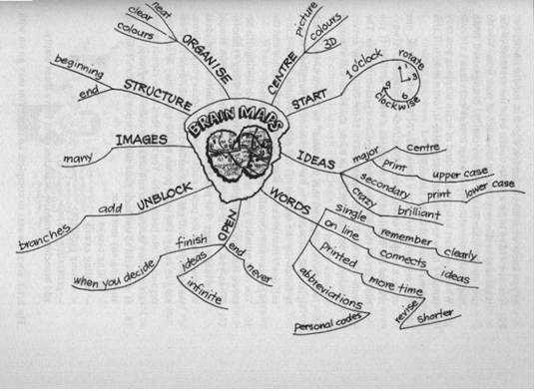

If we were to summarise our example in a mind-map, it would look like this:

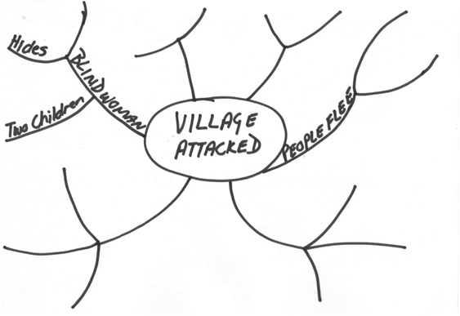

Notes

A note is a brief written record that is used as an aid to memory. You would make notes when you are doing your research, but you can also add notes to a page, this is called footnotes. See the bottom of a page for an example. footnotes are used to indicate which resource was used, or to indicate where a full explanation of the term can be found. Footnotes are usually numbered.

You can also add notes to the page by placing the notes in a box.

A note is a brief written record

Annotations

When you add annotations to your text, it means that you add explanatory notes to the text. As an example, in the section about questions, I stated the type of question and then added explanations:

**Who: who is involved, who must do something, who is affected**?

Diagram

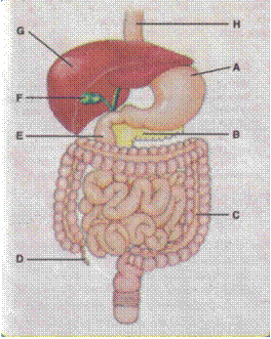A simplified drawing showing the appearance or structure of something.

This is a diagram of a human’s insides.

Tree Diagram

A tree diagram is a tree-shaped drawing showing a structure of something. The best examples are to be found in family trees, where you list you grandparents from your mother’s side and your father’s side, then your parents and then yourself, your brothers and sisters. Of course, the diagram can be bigger than this – you could start with your great-grandparents or even further back, and you can also include aunts, uncles, nephews and nieces.

It is called a tree diagram, because it starts big at the top and then becomes smaller with the next lines. On the next page is an example of a family tree starting with your grandparents.

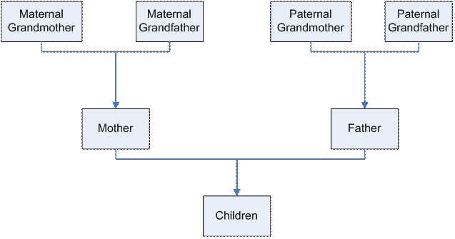

You can also use a tree diagram to make decisions or to solve problems. A **problem tree analysis** is a quick and effective way of analysing a problem. This analysis identifies the causes and symptoms of a problem and presents them in a logical cause-effect sequence. The question *why* is asked several times consecutively, in order to discover the root causes of the problem. These causes are then arranged into a cause-effect relationship.

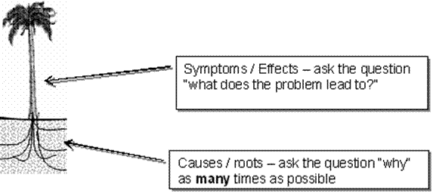

Example of a Problem Analysis Tree

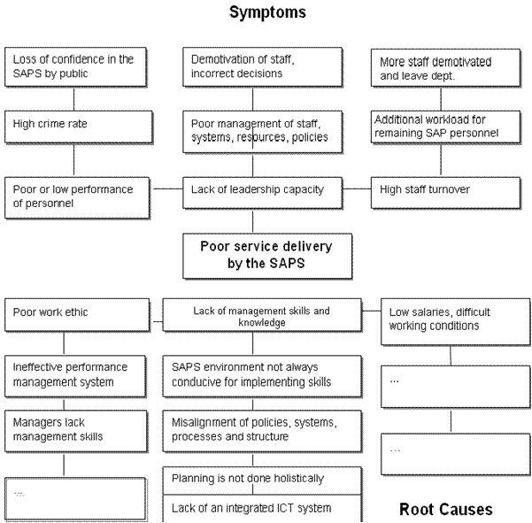

Cause and effect diagrams

A cause and effect diagram demonstrates the relationship between the effects of a problem and the categories of the causes of the problem. As the arrangement of the diagram lets it look like a fishbone, it is also known as a fish-bone diagram. The technique allows one to determine the Effect or Problem you would like to examine, categorize the possible causes thereof and find subcategories of these causes in order to arrive at the root causes of a problem or effect

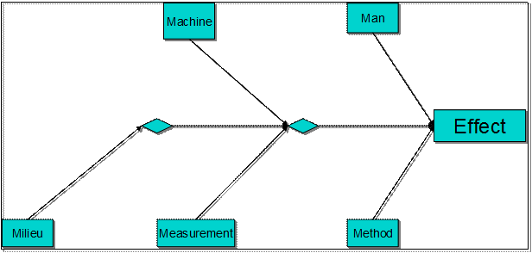

Above is an example of a fishbone diagram also called an Ishikawa diagram, showing factors of men, machines, milieu (workplace), materiel, methods, measurement, all affecting the overall problem.

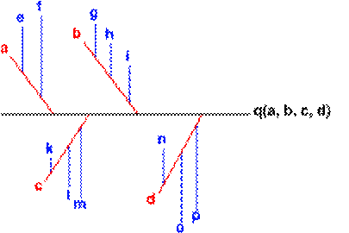

You can use smaller arrows to connect the sub-causes to major causes

Source: Quality Tools (2005)

When constructing a fishbone diagram, you must start with stating the problem in the form of a question, such as:

**‘Why is the Water Point not being used successfully by the village**

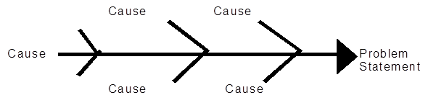By stating the problem in the form of a question, you will be able to brainstorm the causes.

The team must agree on the problem statement and once this is done it must then be placed in the ‘fish head box’.

The rest of the fish bone consists of a spine leading to the head and ‘bones’ leading from the spine. Each bone represents a contributing cause or category. Agree with the rest of the team the labels for these categories.

Once you have labelled each bone/cause, then you are able to ask ‘why does that happen’ or ‘ what has contributed to this cause’. Place your insight or observation onto a smaller bone leading from the category bone.

Once you have completed your fishbone, you will have a good understanding of what is the real cause of the problem. You will now be able to start brainstorming solutions to the problem.

Timelines

The time allowed for or taken by a process or sequence of events

A timeline displays a sequence of events from left to right in relation to time, on a timescale. Your examination schedule looks as follows:

* Study for maths exam 2 days, 1 to 2 August
* Write maths exam 1 day 3 August
* Study for history exam 2 days, 4 to5 August
* Write history exam, 1 day 8 August
* Study for English exam 1 day 9 August
* Write English exam 1 day 10 August

You can scribble all over your calendar, or you can do a timeline:

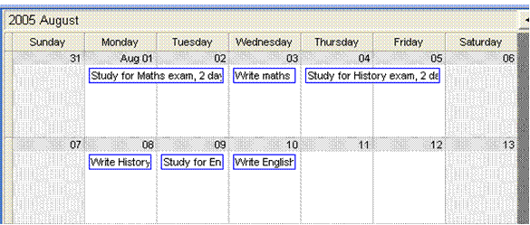

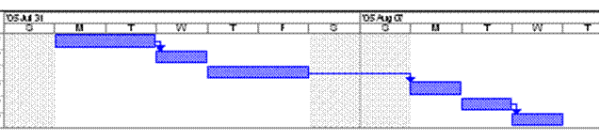

Flow chart

**A diagram showing a sequence of stages making up a complex process**

A soccer team’s preparation for a match, could look like this: Practice attack – practice defence – practice skills – rest – travel to destination – prepare for the match – match – celebrate victory – discuss match.

The flow chart could look like this:

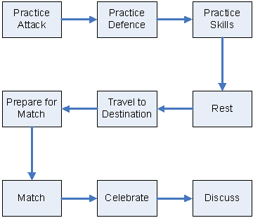

Venn diagram

A diagram representing mathematical sets as circles, common elements of the sets being represented by overlapping sections of the circles.

It is used when the common elements influence each other or have an effect upon each other.

The example below illustrates the management of resources of an organisation. and how the resources overlap and influence each other.

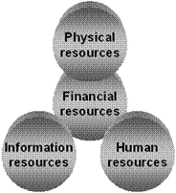

Source: Management principles, Smit and Cronje

Pie chart

A pie chart is used to show how a total breaks down. For example, you have R3000 per month to spend on rent, transport, food, etc. You can use a pie chart to give a visual demonstration of how you spend your R3000.

|  |  |
| --- | --- |
| Rent | 900 |
| Transport | 300 |
| Food | 800 |
| Clothes | 500 |
| Spending | 500 |
| **Total** | **3000** |

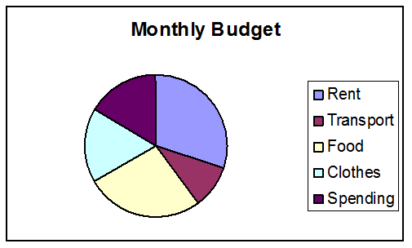

Bar graph

Is used to compare values at intervals, the bars run horizontally. For example, you can compare your marks for your matric subjects per school term.

This example shows only your mathematics results.

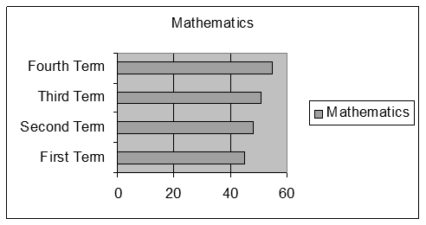

This example shows all your subjects

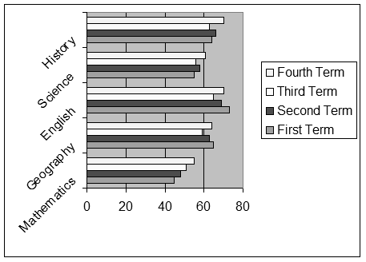

## Structural features of text

In the printed media, newspapers, magazines, brochures, text books, use is made of different techniques in order to

* get your attention,
* help the writer to get the message across,
* indicate a change of topic, a main point or sometimes both
* encourage you to read the written piece

They use:

* Different font Types and sizes
* **Bold**, *italics* and underline
* Visual aids, such as cartoons, diagrams, and so on
* Titles and subtitles
* Captions: a title or brief explanation printed with a visual aid, which can be a photo, an illustration, a diagram or a cartoon
* Photos
* The layout of the page
* A summary of a piece of the article is quoted

Advertisements are very good examples of using text and visuals to get a message across, using as little words as possible.

## Reference Materials

You will use reference materials to clarify the meanings of words/signs, concepts, language structures and conventions, and also for information about the topic you are researching.

Dictionaries

If reading is a form of communication then you, as the reader, have certain responsibilities in order to ensure that the communication process is successful. One of the actions that you will have to take is to ensure that you understand what the writer is trying to say to you.

One of the most common problems in communication is that the recipient of the communication – in this instance you as the reader – does not understand the message. If this is due to words being used that you don’t understand, it is your responsibility to find out what the words mean.

There are various resources that you could use to find out what words mean. You could use a dictionary or a thesaurus.

There are various kinds of dictionaries available:

#### Bilingual Dictionary

A bilingual dictionary, e.g. and Afrikaans/English dictionary will give the word, in Afrikaans with the English equivalent, and vice versa. A word like “walk” would, in an English/Afrikaans diary give the following information:

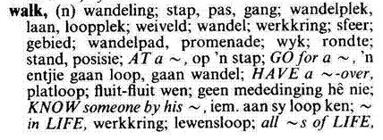

If we now look at the second word quoted, stap, the dictionary would give the following information:

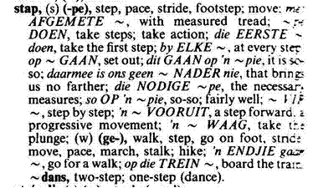

#### Explanatory Dictionary

An explanatory dictionary gives the word, its meaning as well as advice on how to use it in practice. This dictionary would be in one language only, English or Afrikaans or Sotho, etc. There is only one language involved, so there will not be references to the Afrikaans or Sotho equivalent.

If we look up the word walk in an explanatory dictionary, we will get the following information:

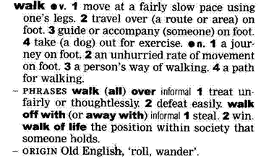

In the front of the dictionary you will find a guide on how to use the dictionary.

Many of these descriptions will sound like gobbledygook to you. What is important for now is that you can refer to the beginning of the dictionary in order to understand what the descriptions in the dictionary mean.

As you can see, the main word is quoted in bold, with variations of the same word quoted afterwards and then follow explanations of what the word means as well as how to use the word in a sentence.

Dictionaries usually also tell you how to pronounce the word correctly.

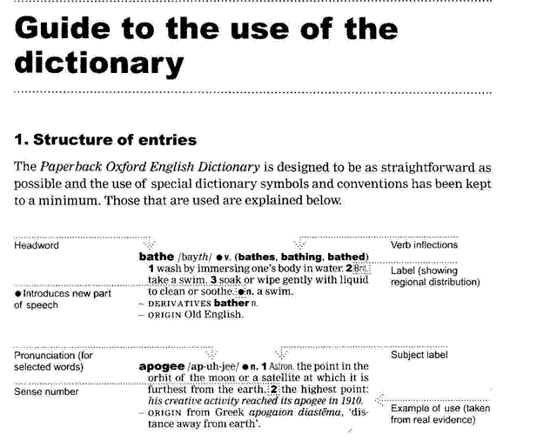

#### Thesaurus

A thesaurus is a dictionary that contains lists of words that have the same, similar or related meaning. If you look up the word walk in a thesaurus, you will find the following lists, usually with explanations of the words included:

|  |  |
| --- | --- |
| Saunter | Stroll |
| Amble | March |
| Stride | Pace |
| Hike | Toddle |
| Totter |  |

This will enable you to choose the exact word to use, or to determine the exact meaning of the word that was used in the piece of writing.

The sooner you get into the habit of looking up words that you don’t understand, the sooner you will improve your language and communication skills in general. If you don’t own a dictionary, you will probably find one at your place of employment and your local library will also have dictionaries.

This is an outcome, so you will be requested to look up words and their meanings as part of your assessment. Start using a dictionary now, so that you can get used to it.

Textbooks

A textbook is a book that is used as a standard work for the study of a subject. We all used textbooks in school in order to study the grammar, spelling and language rules for English, Afrikaans, Sotho or Zulu, we also used textbooks to study economics, history, geography and so on.

Having a textbook for a language is a valuable reference resource, because you can refer to the textbook to solve issues such as language structure. If you are unsure how to structure a sentence in English, a textbook will help you with this.

As an example, if you say: “ My husband and I have been nearly married for two years.” it literally means that for two years you and your husband have been almost married, but have not gotten married yet. You probably mean that for two years you have been thinking about getting married, but cannot make up your minds to actually do it.

If you say: “My husband and I have been married for nearly two years” it means that you got married almost two years ago.

This is a silly example, used to show you how important it is to state words in a sentence in the correct order. If you don’t, the recipient of the message can easily get the wrong message.

Of course, you get more kinds of textbooks than language textbooks. As stated, you get textbooks about geography, history, architecture, interior decorating, garden landscaping, computer software and hardware. There are textbooks about arts and crafts, woodworking, driving, just about anything that you want to learn about.

If you look up the word textbook in a thesaurus, you will find the following list:

* Schoolbook
* Manual
* Workbook

In other words, a textbook, or manual, contains information about a subject. This means that you can use a textbook to look up information about a subject. This learner guide is an example of a textbook or manual.

#### How would you look up information in a textbook?

You could read the entire book and hope you get the specific information you are looking for, but there are easier ways. Textbooks are divided into chapters. Each chapter will contain information about a specific subject. The chapters can be subdivided into sections and, if the manual is comprehensive, even sub-sections.

#### Contents Page

The writers who compile text books always try to make it easy for us to find specific information about a certain subject. Every textbook will have a contents page, which will give the main headings of the different chapters of the textbook. You can then go to that page and look at the contents from that page on. Following is a contents page of a textbook about General Management.

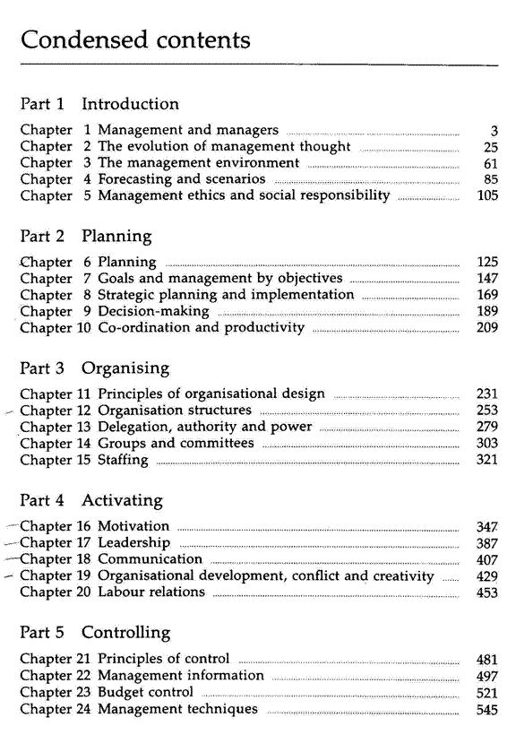

Can you see that subjects are grouped together in a sensible manner? Can you see that it is easy to obtain information about a specific subject?

If I need information about motivation, I will go to page 347, as indicated in the contents page. Here I will see that the chapter is further divided into sections, which are indicated by text typed in bold.

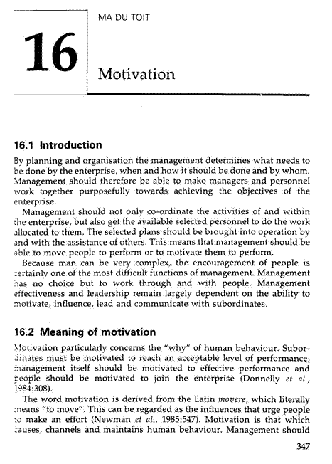

Now I can page through the chapter, looking only at the headings of sections until I find the information I am looking for.

Did you notice that the headings in this textbook are also numbered? All this is done to make it easy for you to find the information again. I would make a note of the page number, as well as the heading number: p347, 16.2 Meaning of motivation. All this makes it easy for me to find the information the first time and also to refer back to the information afterwards.

#### Index

Most textbooks also contain an Index, situated at the back of the book. Using the Index, you can look up information by looking for a specific word. The Index is always sorted alphabetically, so if I want to look up the word motivation, I will have to go to M in the Index.

From the Index, under M, (shown on the next page) I can see that there are references to motivation on pages 10 as well as 347. I can therefore find information about motivation on page 10 and 347.

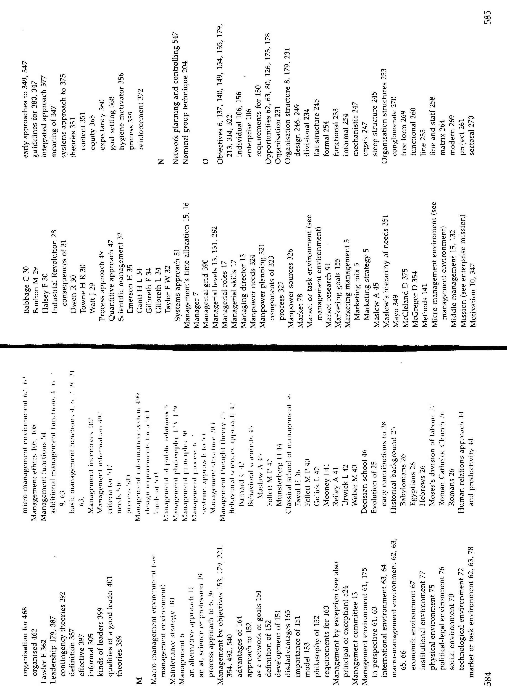

Instruction Manuals

When you buy a new appliance, such as a cell phone, a music centre or a washing machine, you will find an instruction manual included with the product. It can also be called a user’s manual. Whatever it is called, it has a specific purpose: to help you install and use the equipment.

It is very important to read the instruction manual thoroughly. If you don’t install and use the appliance properly, you can void the guarantee and your appliance will not work properly.

You are the user and you have to make sure that you understand the instruction manual. The manufacturer cannot be held responsible if you install and use the equipment incorrectly.

This also applies to medicine that has to be taken. If you go to the doctor and you get medicine that has to be taken three times a day, this means that you have to take the medicine every eight hours. If you take less than the prescribed dosage, for example you take your medicine every twelve hours, you will not feel better. If you take more, say every six or four hours, you will overdose yourself. Both situations can have serious consequences.

Going back to the instruction manual, if the manual says you must not put the electric kettle near water, you must not do this. If you place in near water, the electrical connections can get wet. At the least, the kettle will sustain damage, at the worst you can be electrocuted.

As an example, let us take a look at the instruction manual for a sandwich press.

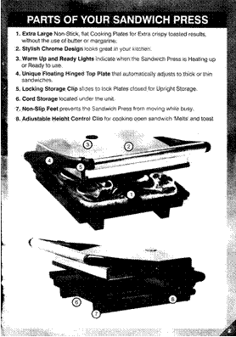

From this example you can see that an instruction manual is also divided into sections. The sections are indicated by means of headings and the contents tell you how to install and operate your appliance.

In the example, we showed you three sections and the cover page of the manual. The three sections are:

* User instructions,
* Parts of your sandwich press and
* Operating your sandwich press.

In the user instructions section, you will find information about the installation of the appliance and how to install the appliance. Safety procedures will also be included here.

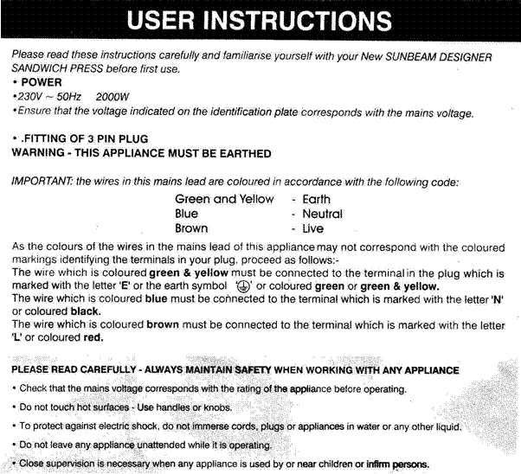

Operating your sandwich press: here you will find the guidelines for using the sandwich press.

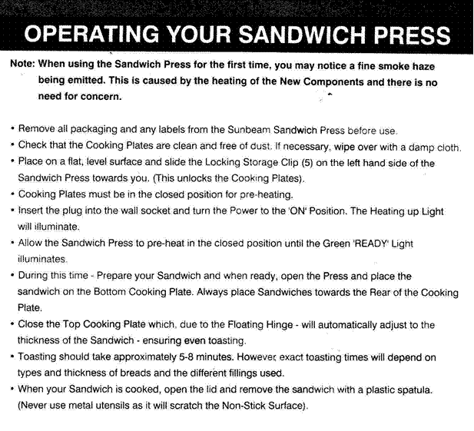All instruction manuals will be divided into sections or chapters. A big instruction manual will also have a contents page and an Index.

Encyclopaedias

An encyclopaedia is a book or a set of books giving information about many subjects.

Encyclopaedias are organised alphabetically, according to subject, from A to Z. When you are looking for information in an encyclopaedia, you have to refer to the Index Book first.

The Index Book is organised like an index in a text book. It is a lot bigger, since an encyclopaedia contains information about every known subject.

You will use the Index Book in an encyclopaedia the same way as the Index section in a textbook. First, you will identify the subject you are looking for: helicopters. Then you go to the Index Book and look under H for helicopters.

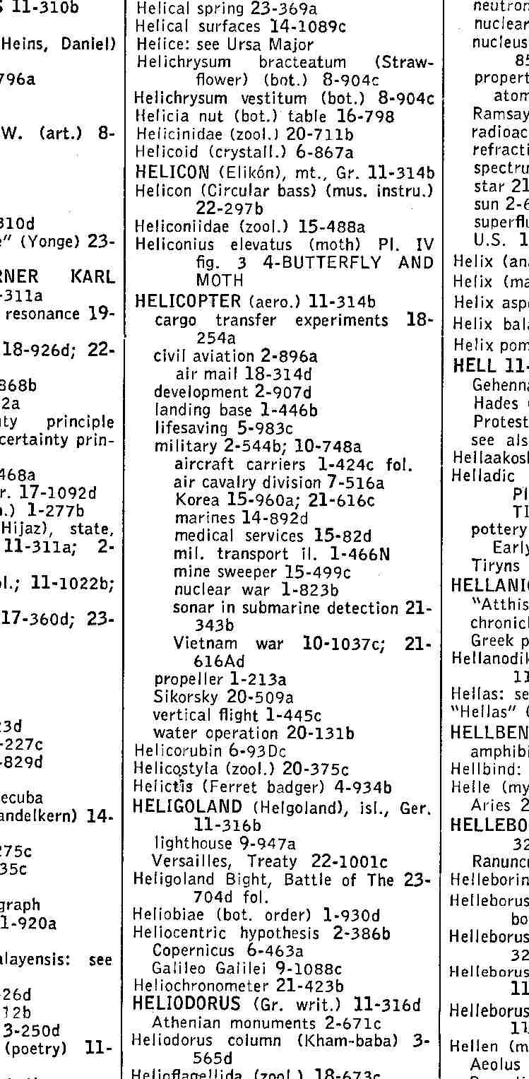The Index Book will then tell you in which book, on which page and where on the page you will find the information you require on the subject, in this case helicopters.

From this example of an Index book, you can see what information you can find about helicopters.

If you want information about military helicopters, you will go to book 2 of the encyclopaedia, then page 544, section b of the page.

This particular encyclopaedia is called Encyclopaedia Britannica and it consists of 27 books filled with information, plus the Index book.

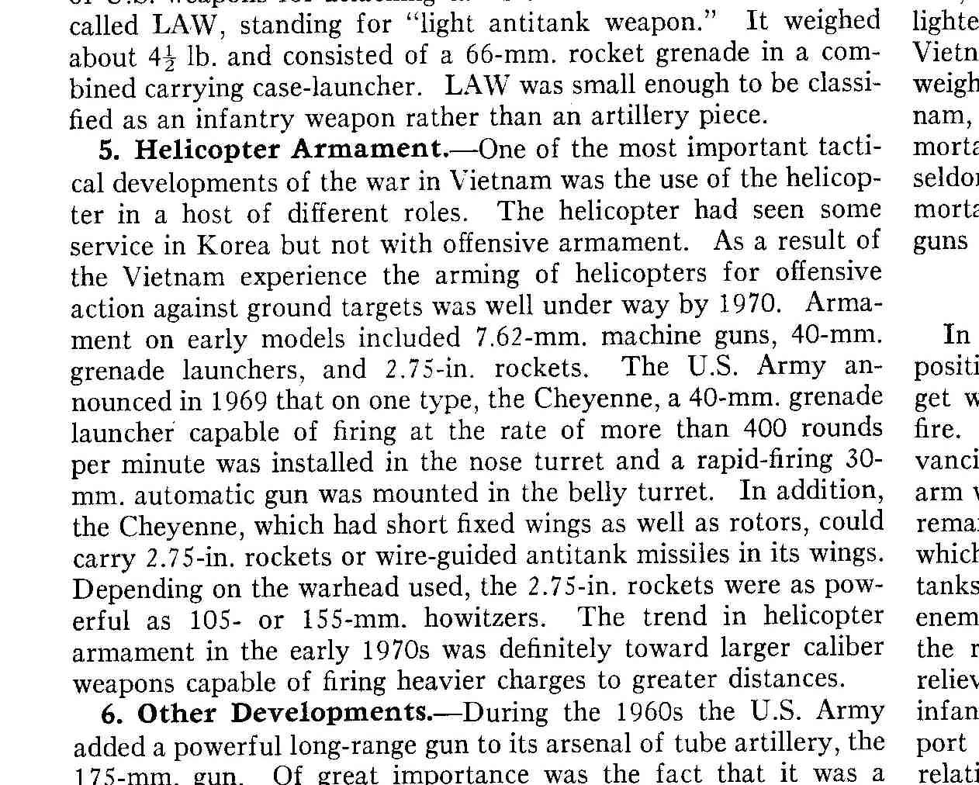

Many people are fortunate enough to own encyclopaedias. If you don’t own one, you can go to your local library and use their encyclopaedias to look for information.

Internet

You can also search the Internet for information. The Internet is like a very large library. Where a library is filled with books containing information, the Internet is made up of web sites that are filled with information.

Searching the Internet is a lot like using an Index book: you go online to a website such as Mweb or MSN and you will find a Search option somewhere on the first page, that is also called the Home page of the website. The Search option will give you space in which to enter a keyword or keywords, just like you would look in an Index. You then click on a button and the computer searches for websites that contain information about the word you typed in.

Because the Internet is a worldwide resource of information, there is an awful lot of information to be found out there, so you have to be very specific when you search for information on the Internet.

If you, for example, enter dogs as your keyword, you will end up with a couple of million hits. It is impossible for you to visit all those websites, so you have to narrow down your search, for example by typing in the specific breed of dog you want information on: golden retriever or whatever breed of dog you want information on. This will give you less hits, hopefully only about twenty or thirty websites, which is much more manageable.

## What Do We Read?

We read, or look at and interpret a variety of written and visual material during our lives, including:

* Textbooks
* Magazines: a periodical publication containing articles and pictures
* Newspapers: a daily or weekly publication containing news, articles and advertisements
* brochures: a leaflet containing information about a product or service
* policies: a document containing the course of action adopted or proposed by an organisation – how the organisation goes about its business
* questionnaires: a document containing printed questions that have to be completed, usually done to conduct a survey
* notices: announcements or advertisements printed in the media
* memorandum: a note sent from one person to another in an organisation
* agenda: a list of matters that have to be discussed and/or dealt with in a meeting
* application forms: forms similar to questionnaires, that have to be completed when you are applying for something – job applications, credit applications at shops and so on
* documentary: a factual report of real events where use is made of documents, film, photographs and sound recordings in order to convey the message
* novel: a story of book length about imaginary people and events
* photographs: still pictures made with cameras
* diagrams: are discussed fully later on
* blueprints: design plans or other technical drawings
* films: a story or event recorded by a camera and shown in a cinema or on television

We also read the following in order to familiarise ourselves with the instructions and directions given:

* instructions to play games and effect basic repairs to objects
* classroom and workplace procedures
* recipe: a list of ingredients and instructions for preparing a dish
* schedule: a plan for doing something, giving lists of intended events and times
* map: a diagram of an are showing physical features, cities, roads, etc
* warranties: a written guarantee that promises to repair or replace an article if necessary within a certain period, if certain conditions are met.
* Simple instructions and directions are read and interpreted and subsequent explanations are consistent with the intention of the text

Each of the above serves a different purpose, but all of them influence how we read and look at things.

## Read Instructions

Games

Whenever you buy a game, it will contain instructions on how to play the game. The example below shows the instructions for a word game called Boggle.

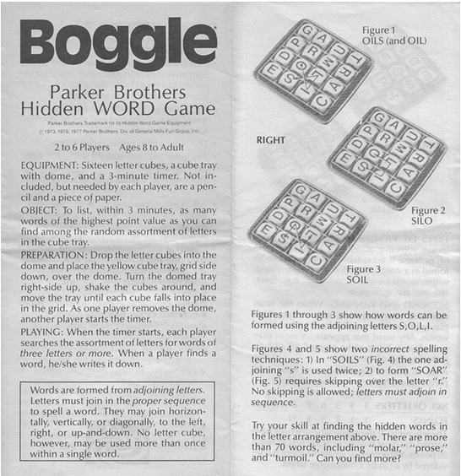

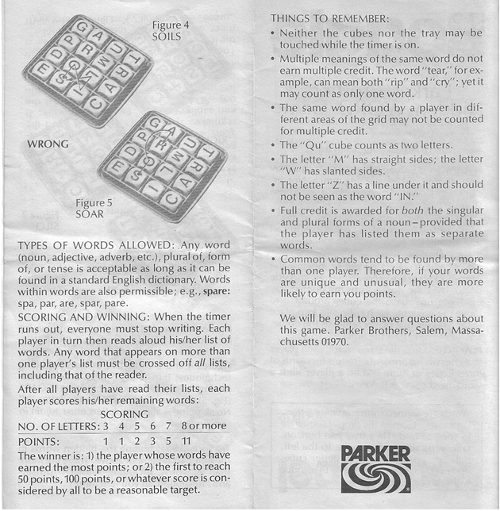

Repairing objects

To repair something you would usually need a set of instructions that tell you what to do and what tools or equipment you will need. Examples are changing a flat tyre or replacing a plug on an electrical device.

Forms

We have to read and complete forms all the time:

* to apply for a banking account
* to apply for a vehicle registration
* to apply for a driver’s licence
* to apply for an ID book, etc.

When we complete forms, we have to read the instructions carefully so that we do not complete areas of the form that do not apply to us.

Maps

It is much easier to explain a route through using a map than giving long written instructions.

Recipes

Recipes give clear instructions on how to prepare a dish, what ingredients you need and how long the dish will take to cook or bake.

Schedules

Schedules can be a list of activities that have to be completed, as per the example below.

|  |  |  |  |
| --- | --- | --- | --- |
| **Activity** | **Person Responsible** | **Resources required** | **Deadline date** |
| Invite all the participants | Jabu | List and contact details of all participants | 15 March 2005 |
| Book the venue | Jabu | List of venues | 1 April 2005 |
| Book the facilitator | Jabu | List of facilitators | 15 April 2005 |
| Develop the programme for the workshop | Jabu | Consultation with the facilitator | 30 April 2005 |
| Secure the budget for the workshop | Jabu | Budget line items | 1 May 2005 |

A schedule can also be a list of items that are available to be sold:

|  |  |  |  |  |  |
| --- | --- | --- | --- | --- | --- |
| **Code** | **Title** | **Pages** | **ISBN** | **Version** | **CD?** |
| Csac597x | Access 97 Expert User Part 1 | 236 | 1840050896 | 76 | CD |
| Csac597y | Access 97 Expert User Part 2 | 308 | 1840052554 | 78 | CD |
| Csac800p | Access 2000 | 320 | 1840051612 | 76 | CD |
| Csac800x | Access 2000 Expert | 350 | 1840052465 | 78 | CD |
| Csol800p | MS Outlook 2000 | 300 | 1840052643 | 79 | CD |
| Cspp597x | PowerPoint 97 Expert User | 318 | 1840051086 | 76 | CD |
| Cspp800p | PowerPoint 2000 | 300 | 1840050500 | 76 | CD |
| Cspp800x | PowerPoint 2000 Expert | 258 | 1840052007 | 74 | CD |
| Cswd597p | Word 97 Proficient User | 338 | 1840051167 | 75 | CD |
| Cswd597x | Word 97 Expert | 344 | 1840052198 | 74 | CD |
| Cswd800p | Word 2000 | 342 | 1840050594 | 75 | CD |
| Cswd800x | Word 2000 Expert | 350 | 1840052090 | 74 | CD |
| Csxl597p | Excel 97 Proficient User | 298 | 1840051434 | 76 | CD |
| Csxl597x | Excel 97 Expert | 288 | 1840052376 | 74 | CD |
| Csxl800p | Excel 2000 | 294 | 1840050691 | 76 | CD |
| Csxl800x | Excel 2000 Expert | 324 | 1840052287 | 74 | CD |
| Ssiei50i | Internet Explorer 5.0 | 216 | 1840050799 | 74 | CD |
| Sswn200i | MS Windows 2000 | 232 | 1840051914 | 74 | No |
| Sswn500i | MS Windows 95/98 | 202 | 184005171X | 75 | No |
| Sspc500i | Basic Concepts of IT | 246 | 1840052732 | 79 | No |
| Diof200i | ECDL with MS Office 2000 | 762 | 1840052813 | 88 | CD |
| Diof897i | ECDL with MS Office 97 | 764 | 1840052902 | 88 | CD |

Procedures

In the classroom or workplace, there are always procedures that have to be followed. These procedures are usually recorded in a manual that has to be read and understood so that you know what to do.

For example, the procedure below details the typical filing process:

There are eight basic steps in a typical filing routine.

#### Collecting the items to be filed.

If this is your responsibility, ensure that you collect the filing every day.

#### Inspecting.

* Make sure that the items are intended for filing.
* Also ensure that confidential items do not lie around for everyone to see, they should preferably be placed in a separate folder and filed immediately.

#### Indexing.

* Which indexing system is used, where will the correspondence be placed?
* Allocating a file reference number to the correspondence, according to the recognized filing system used by your organization.
* Make very sure that you allocate the correct reference to correspondence, as a document that was indexed incorrectly can be lost for a long period of time.
* Certain files and correspondence will be confidential and only certain staff members will be allowed access to these files. Ensure that they are coded correctly and also that a notation is made on the outside of the file.

#### Cross referencing.

* If the correspondence refers to more than one file, use a cross-referencing system,
* or, depending on the procedure in your company, add a copy of the correspondence to the other file as well.

#### Sorting.

* Sort the filing in the method of classification used by your organization – alphabetical, numerical, alpha-numerical.
* Having the filing sorted in the correct order will speed up the filing process.
* There are various types of sorters that can be used to help you sort the correspondence for filing:
* Concertina file: it has 26 partitions, one for each letter of the alphabet. It is convenient for temporary sorting or storing as the file can expand when it becomes fuller.
* Pigeon hole: this is a shelf with 26 pigeon holes, one for each letter of the alphabet. It is mainly used in a mail room for sorting mail and is seldom used for general filing.
* Flap sorter, also known as an alphabetical sorter: this commonly called Long John Sorter. It is a thick cardboard strip with 26 flaps, one for each letter of the alphabet. Correspondence is sorted in the flaps before being placed in file folders.

pe01496_

#### Filing.

* File the correspondence, ensuring that you place the documents in the correct file.
* Looking for correspondence that has been misfiled is a big waste of time for you and your co-workers looking for the information.
* Ensure that you file confidential documents first
* Documents must be filed chronologically, with the most recent date on top.
* Ensure that you file the documents with their attachments and enclosures

Activity 1(119463 SO1, AC1-7)

SECTION 2: IDENTIFY MAIN IDEAS

#### Outcome

Identify the main ideas in different text types: textbooks, magazines, newspapers, brochures, policies, questionnaires, notices, videos.

#### Assessment criteria

On completion of this section you will be able to ensure that:

* The main ideas are identified and distinguished from supporting information
* The author’s purpose is identified and the identification is justified by reference to the text
* Information and/or ideas from the text are presented in a form appropriate to a learning task or activity: Summary (e.g. mind-map, point-form, sub-headings, paragraph form), paraphrase, illustrations, role-play and simulation
* Socio-cultural issues in texts are identified and explained with reference to relevant passages or extracts from the text: Idioms, slang, jargon (language specific to a trade, business or industry), proverbs

## Determine The Author’s Purpose

One of the reasons why we read written text is to determine the purpose of the text – why did the author write this specific article, textbook, instruction manual or whatever you are reading.

Once we have determined what we think is the purpose of the text, we have to be able to justify what we think in terms of what is written in the article, textbook, etc.

In other words, we have to be able to understand what the author means, and we must be able to support out argument from what the author writes.

## Present ideas from the text

Once you have determined the purpose of the text, you can present your ideas and impressions, using the following ways:

* summary: has been discussed previously
* paraphrase: has been discussed previously
* illustrations: discussed previously – you can add illustrations in the form of diagrams, charts, cartoons, photos, etc.

Role play

Role-plays: participants are presented with a situation, often a problem or an incident, to which they have to respond, by assuming a specific role.

Simulation

Simulations: mirror actual activities or conditions. This is used by airline pilots and astronauts, where the flying conditions are simulated in a flying chamber so that the pilots can get used to flying conditions without actually flying an aeroplane.

## Identify socio-cultural issues

Idioms and Proverbs

**An idiom is a group of words/signs that, through usage, has taken on a special meaning different from the literal meaning (e.g. "keep your shirt on!” or "It’s raining cats and dogs”)**

According to the dictionary, an idiom is an expression that is natural to a specific language, while a proverb is a short saying stating a general truth or piece of advice.

Many proverbs and idioms can be translated into other languages, but many cannot, since what is applicable in Germany is not necessarily important in South Africa. Idioms and proverbs tend to be culturally based, as they originate as a saying that is popular with the people who speak the same language and undergo similar experiences.

#### Examples of proverbs

* Beauty is in the eye of the beholder. This means that everybody has his own idea about beauty.
* Business is business. In business, there should be no other considerations.
* Easy come easy go. When you have not earned it, you tend to be wasteful
* To be green with envy. To be very envious of what someone else has or has achieved. This is a good example of differences in language, since in Afrikaans envy and jealousy is yellow, not green. So, if you were making this statement in Afrikaans, you would say that someone is yellow with envy – the actual expression is to wear a yellow jacket. (die geel baadjie aanhê)
* To be as like as two peas. To be similar. In Afrikaans, we would say: soos twee druppels water op mekaar lyk (to look as similar as two drops of water)
* To cross the Rubicon. To commit oneself to an enterprise or a course of action.
* Long absent, soon forgotten: we do not miss what we have not seen or had for a long time
* To live in grand style. To lead a life of wealth and luxury. In Afrikaans this is stated as: “op groot voet lewe”, which, when translated literally would state: “living in a big foot”.

#### Examples of idioms

* to cause bad blood: to cause ill feeling
* to get in by the back door: to obtain a privileged position in an irregular manner
* his bar is worse than his bite: his gruff manner conceals a friendly nature
* the Cape Doctor: the south-east wind that blows in the Cape
* to put someone back on his feet: to help someone recover from a setback

Jargon

Words or expressions that are used by a specific trade, business or industry.

* **A paper tiger:** when a committee or other body is established to investigate an occurrence, and nothing much happens, it is called a paper tiger.

It means that the committee is not doing what it is supposed to do, the members of the committee postpone actions and make up imaginary problems as to why they cannot do the work in time.

* In the training environment in South Africa we find a lot of jargon – words that are used in a context not previously used and existing words put together to mean something that is unique to the education and training environment.

We talk about Unit Standards, which previously was called training courses, we talk about assessments rather than tests and we have standards generating bodies and standards governing bodies, and so on.

* **Electrocardiograph**: monitors the heartbeat
* **Government fiscal matters**: to do with the governments budget and how they spend the money that we pay in taxes.
* The **metallurgist** in charge is Karis Allen, 35, a specialist in fractions and corrosion: a metallurgist is a person who specialises in studying metals, fractions and corrosion in this instance means how metal, such as steel, breaks and corrodes

Slang

Casual, very informal speech/signing, using expressive but informal words and expressions

Slang is usually related to age or social group rather than to trade or profession (jargon). It is used to stress an identity for those in the know and to exclude those who do not know the terms, for example, words to describe money, grown-ups, police, and activities.

* My Bra
* Howzit Broe
* Whazzup

Activity 2 (119463 SO2, AC1-4)

SECTION3: READ/VIEW AND RESPOND TO TEXT

#### Outcome

Read/View and respond to texts for a variety of purposes.

**Outcome Range**

Textbooks, magazines, newspapers, brochures, policies, questionnaires, notices, memoranda, signed texts, agendas, application forms, documentaries, novels, photographs, diagrams, blueprints, films, official documents and any other appropriate types

#### Assessment criteria

On completion of this section you will be able to ensure that:

* Different text types are categorised in terms of their intended target audience
* The purpose of the text is identified and the identification is justified by reference to the text
* Different points of view in texts are identified and observations are justified by reference to the text
* Own ideas and/or arguments are supported with a range of reasons and facts relevant to the topic of discussion
* The relevance of texts is evaluated and justified in terms of meaning to self and others in peer, community or work group
* Implicit and explicit messages in texts are identified and explained with reference to the purpose of the text

## Reading and viewing resources

As mentioned previously, we read much more than we think we read.. In the course of a typical day we may read the following for our entertainment and pleasure:

* magazines
* newspapers
* notices: this could be a notice of a special offer in a shop, or a notice of a sport event, or a notice of any other type of entertainment
* novels: a novel is basically a long short story. The dictionary defines it as a prose story of book length about imagery people and events.

We also view or look at the following:

* photographs: in magazines, newspapers, and on notices, etc.
* documentaries: on television or in the movies, a documentary is a factual report of real events that uses film, photographs and sound recordings. The DVD of the famous 438 cricket game that the Proteas won against Australia is an example of a documentary.

At work and while studying we may be required to read the following:

* textbooks: discussed in a previous section
* brochures: a booklet containing information about a product or service
* policies: this could be an insurance policy or a workplace policy about HIV/AIDS assistance to employees
* questionnaires: a set of written questions, such as for a test or for a survey
* memoranda: a memorandum is a form of internal correspondence in a business where employees and departments communicate with each other
* agendas: a list of items to be discussed at a meeting
* application forms: discussed previously
* diagrams: discussed previously
* blueprints: a design plan or technical drawing, called a blueprint because the overall colour used to be blue. Includes architectural designs, drawings of equipment, machinery and tools
* official documents: includes all business correspondence such as reports, business letters, minutes of meetings, tender documents, government publications such as tender publications, etc.

## Text Types

In the printed media, newspapers, magazines, brochures, text books, use is made of different techniques in order to

* get your attention,
* help the writer to get the message across,
* indicate a change of topic, a main point or sometimes both
* encourage you to read the written piece

They use:

* Different font Types and sizes
* **Bold**, *italics* and underline
* Visual aids, such as cartoons, diagrams, and so on
* Titles and subtitles
* Captions: a title or brief explanation printed with a visual aid, which can be a photo, an illustration, a diagram or a cartoon
* Photos
* The layout of the page
* A summary of a piece of the article is quoted

## Purpose and different points of view

There are many reasons why authors write texts

* To **persuade** readers to his/her point of view: the article about the behaviour of Mr Zuma’s supporters outside the court was written to persuade readers. When an author is writing to persuade, he wants you to accept his opinion about issues, policies and situations.
* To **inform** readers: in SA Computer you will find a lot of articles that inform readers about new developments in Information Technology. In other magazines you will find fashion articles, articles about healthy eating and fitness, etc. These articles were all written to inform readers.
* To **entertain** readers: the short stories found in magazines were written to entertain. Fables, fairy tales, fictional novels, cartoons, short, funny pieces in magazines were all written to entertain.

Just as we each have our own point of view about matters such as crime, the role of the husband and wife in a marriage, the performance of our sport teams, etc. authors also have differing points of view.

This is why it is important to read more than one article about any subject – so that you can get different views about the subject.

## Own ideas

When you write text, you have the right to include your own ideas or arguments about a subject, unless it is business correspondence and you were not asked for your ideas.

When you put forward your own views on the subject, make sure that you support your ideas with a range of reasons and facts that are relevant to the topic of discussion.

For example, if you feel that Mr Zuma was treated unfairly by the press, you have to explain clearly why you feel so and you have to support your point of view with facts and justify you point of view by explaining your reasons.

## Relevance of text

The text you read for your research or write to put forward your own ideas has to be about the topic that is being discussed. If you feel that Mr Zuma was treated unfairly by the press at the time of the trial where he was accused of rape, you have to stick to the subject.

Reading about truck hijackings has no relevance to the subject. On the other hand, writing about another rape case also has no relevance to the subject at hand.

When you read or write text, always evaluate the text to find out if the text has meaning to yourself and others.

Reading about slavery in Sudan might interest you, but it is possible that it will not interest your friends or co-workers at all. Members of the community you live in will probably also not be interested in the subject.

This is a silly example, but it helps to show you that when you read and write for research or your work, you have to stick to the subject and then also make sure that the content of the text will be relevant to the audience you are writing for.

## Implicit and Explicit Text

Whenever an author writes some text, certain facts will stated clearly, while others are not stated clearly, only hinted at.

When facts are stated clearly, we call them explicit. Explicit means clear and detailed, with no room for confusion. In the article about slavery, the name of the blind woman is stated clearly, as well as the fact that she is blind. These are stated explicitly.

The opposite of explicit is implicit. Implicit means suggested, though not directly expressed. In other words, it is hinted at and you, the reader, should be able to identify what the author means. Referring back to the article about slavery, the writer states:

*At the first cracks of gunfire, the villagers of Nyamlell in southern Sudan dropped their hoes and scattered into the bush.*

The author does not say that it happened during the day, he also does not say that the villagers were working in their fields, yet we know this.

How do we know this? The author says the villagers dropped their hoes. A hoe is a long-handled gardening tool with a thin metal blade that is used to turn earth and cut through weeds. So, in one sentence the author tells us implicitly that it was daytime and that the villagers were working in their fields.

Activity 3 (119463 SO3, AC1-6)

SECTION4: LANGUAGE STRUCTURES AND FEATURES

#### Outcome

Identify and discuss how language structures and features may influence a reader.

#### Assessment criteria

On completion of this section you will be able to ensure that:

* The choice of words/signs, language usage, symbols, pictures and tone/sign size and pace is described in terms of how a point of view is shaped or supported: Bias (cultural, religious or peer preferences, misrepresentation, discrimination, racist, sexist, ageist); humour; irony; sarcasm, use of omission and silence, figurative expressions, repetition; hyperbole; generalisations; stereotyping; pictures and captions; typography and grammar
* Sentence structures are identified, analysed and related to purpose, audience, and text

## Language Structures And Features

Writers use language structures and features all the time, in order to influence what you, the reader, thinks when you have read the written piece.

Languge structures and features include

* The choice of words.
* Use of language.
* Symbols.
* Pictures.
* Tone.

If we look at the article about slavery, we can see some examples in the first paragraph.

“But the blind Dinka woman could only pull her seven-year-old son and twelve-year-old daughter close. Shaking with fear, they hid in their windowless hut and prayed.”

If the author had not told us that they were shaking with fear, we would have felt differently about the paragraph.

Dealing With Bias

What Does Bias Mean? An opinion or tendency to be strongly for or against a person or thing.

We are all biased in some way or other. We feel strongly about certain subjects, such as pornography, schooling in mother language, and many other subjects.

Then there are subjects over which are biased, but do not necessarily feel too strongly about it, so we don’t get all worked up about it. This could be school uniforms, what to wear to the movies, and so on.

We all have opinions about everything, some opinions are stronger than others. Unfortunately, although we would like it to be so, our opinions and views are not always the right ones and, when we do not want to be convinced otherwise, we are biased.

I have a bias- I hate school uniforms and believe that it should be done away with totally. Children should be allowed to wear what they choose to school. I feel strongly about this and I refuse to be convinced otherwise. This is, of course based totally on my own dislike of uniforms and having to look like anyone else, so I am not necessarily right in my point of view, especially since most other people seem to like school uniforms. Luckily, this bias of mine is relatively harmless.

Unfortunately, not all biases are harmless. Bias can take many forms: it can be based on cultural or religious beliefs, it can show itself in a misrepresentation of facts, it can be discriminatory in terms of race, sex or age. It can also be due to peer preferences.

Most of us have suffered from other people’s biases in some way or other. I have suffered from bias because I am a woman, it was thought that I cannot do what a man can do and, further, that I should not be allowed to prove that I can do administrative and managerial work as good as my male counterparts. To me, it was not a pleasant experience.

If I were biased against Muslims, I would interpret the article about slavery as meaning that all Muslim Arabs are kidnapping people to use and sell as slaves, even though the author of the article does not state this. My bias would then end in me disliking all Arabs and all Muslims, since, in my view they are all slave traders. Clearly, this is not true, since most races and nations have good and bad people and there are slave traders in South Africa as well, who are not Muslims or Arabs.

Whenever you read a written piece of text, you have to bear in mind that you yourself are biased and also that the author is also probably biased. You must always be able to determine the bias in yourself and the author.

Also, whenever you communicate in writing or verbally, bear in mind your own bias as well as the bias of your audience.

Lastly, remember your painful experience at the hands of some other person and his/her bias, before you treat people with disrespect because they disagree with you.

Whenever you read a written piece of text, you have to bear in mind that you yourself are biased and also that the author is also probably biased. You must always be able to determine the bias in yourself and the author.

Also, whenever you communicate in writing or verbally, bear in mind your own bias as well as the bias of your audience.

Lastly, remember your painful experience at the hands of some other person and his/her bias, before you treat people with disrespect because they disagree with you.

Humour

In the dictionary, humour is stated as being:” the quality of being amusing”. Jokes are humorous, so can text in an article be humorous or even a novel (long story) or parts of a novel.

Irony and sSarcasm

Irony and sarcasm are very similar. When an author uses irony, he states one thing, while meaning the opposite. Irony can be funny, but it does not have to be.

* as funny as cancer
* as clear as mud
* as pleasant as a root-canal

An example of irony in real life is when John Hinckley tried to assassinate (kill) President Ronald Reagan (a previous American president), all of his shots initially missed the President; however a bullet ricocheted off (bounced off) the bullet-proof windows of the Presidential limousine and struck Reagan in the chest. Thus, the windows made to protect the President from gunfire were partially responsible for his being shot.

If someone were to go on a trip and decide not to take a plane because they are worried about crashing, and take a bus instead, it would be ironic if a plane hit the bus they took, thereby realizing their fears of crashing with a plane, despite measures taken at the outset of the journey to avoid such a fate.

**Sarcasm**is stating the opposite of an intended meaning especially in order to sneeringly, slyly, jest or mock a person, situation or thing. It is strongly associated with irony. Sarcasm is a particular kind of personal criticism leveled against a person or group of persons. If you were talking to one of the team players that lost the game badly, and you say to him: “Well, you guys really played well” you are being sarcastic.

Sarcasm is can be used in a humorous manner, but can also express annoyance or anger. It is often in the place of other forms of expression. For example, instead of becoming angry and yelling at someone in a conflict, a person might choose to use sarcasm as an alternative.

"Shut up, will you?" "Oh, I'm sorry, Your Highness, should I go get you your coffee and tea now?"

In this case it is implied that the first person was treating the second like a servant. Instead of directly pointing this out, however, the second person plays the part, so to speak, in the situation created by the first person.

This is normally used where the two people in question do not see eye to eye. Therefore the second person does not like the tone and phrasing of the first person's remark. The second person uses sarcasm to make fun of the first person to amuse themselves, and any possible bystanders who share the same feeling towards person one.

Hyperbole

An exaggerated statement that is not meant to be taken in the strict sense of the words.

“I have told **you ten million times** that it is a bat habit to exaggerate.”

Generalisations

Make a general or broad statement based on specific cases.

“Nobody from the Cape eats pap”

This is not true, most people from the Cape prefer to eat something else, but some of them do eat pap as much as anyone else.

When the soccer or rugby team loses two or three games in a row, we tend to say things like: “We can’t play soccer or rugby, we always lose”. This is also not true, since they do win games.

Beware of general statements when you read or write something. Writers should be careful of using general statements, as readers tend to believe what they read.

Stereotyping

An over-simplified idea of the typical characteristics of a person or thing.

**All blondes are stupid**. This is a stereotyping, since not all people with blonde hair are stupid. We just notice it, since blonde women are more noticeable to men, and when a blonde woman does something stupid, all blondes are called stupid.

Figurative Expressions

A word or phrase used in a non-literal sense to add interest to speech or writing.

* Food for thought. We cannot really eat our thoughts. The expression means that it is something to think about.
* He is as strong as an ox. He is not really as strong as an ox, we only say this in order to illustrate how strong he is

Repetition

The saying of the same thing over again in different words. This is incorrect use of grammar.

We tend to get into the bad habit of using more than one word that has the same meaning, to illustrate what we are saying:

* Milk dairy
* Reverse backwards
* I will kill you dead
* They arrived one after the other in succession
* Hurry up quickly
* We smell it in our noses

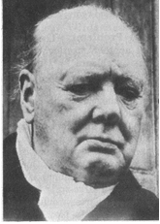There is also another use for repetition, where the writer or speaker repeats words and phrases. This is very effective to emphasise the importance of the statement. Sir Winston Churchill made very good use of repetition in his famous speeches during World War 11.

On 22 May 1940, after the British soldiers had been evacuated from Dunkirk, he said:

“***We shall fight*** on the beaches, ***we shall fight*** on the landing-grounds, ***we shall fight*** in the fields and in the streets, ***we shall fight*** in the hills; *we shall* never surrender…

On 13 May 1940, just after he was elected prime Minister, he said that he had one aim:

“**Victory – victory** at all costs, **victory** in spite of terror; **victory**, however long and hard the road may be.”

Of course, he said many more memorable things and it is worthwhile reading about him. He was the Prime Minister of Britain during World War 11 and he was a rather colourful character – just what the British needed during wartime.

Grammar

Grammar is the whole structure of a language, including the rules for the way words are formed and their relationship to each other in sentences.

This has to do with the words we use in sentences and also how we use them.

In the section about textbooks I quoted the following example:

If you say: “ My husband and I have been nearly married for two years.” it literally means that for two years you and your husband have been almost married, but have not gotten married yet. You probably mean that for two years you have been thinking about getting married, but cannot make up your minds to actually do it.

If you say: “My husband and I have been married for nearly two years” it means that you and your husband got married nearly two years ago and you are still together.

Below is a quote from the article about slavery, as written by the author.:

Once the Arabs seized the cattle, they moved from hut to hut gathering grain, blankets, salt – and human booty. Deep in the shadows of one hut, they discovered Abuk. Grabbing the terrified woman by her bead necklace, a militiaman growled, “Now you belong to me!” In all, 282 Dinka, including Abuk’s mother, sister and niece were herded up and forced to march north.

If I substitute the word “booty” in the first sentence with “bodies”, it would mean that the slave traders gathered the remains of dead people to take with them.

If I change the word order of the third sentence, I can change the meaning of the sentence as well:

“Grabbing the woman by her bead necklace, a terrified militiaman growled ….”

This, of course, means that the militiaman is terrified, and not the woman.

It is easy to change the meaning of a sentence or paragraph just by changing the order of the words in the sentence or paragraph. You must always be aware of this and ensure that, when you are writing something (especially your summaries) you use grammar correctly. If you don’t you can be misunderstood and this could sometimes have serious consequences.

People can be misquoted simply by changing the word order of the sentences. When we read and write text, we have to be careful of our use of grammar.

Captions

A caption is a title or brief explanation printed with an illustration or cartoon.

Captions can be added to a photo, an illustration, a cartoon, a graph or any other picture.

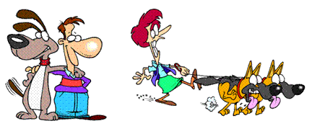

I can add the following captions to the above pictures, and with each different caption the meaning of the pictures change:

* My father is laughing at our neighbour, whose dogs are taking her for a walk.
* My uncle, looking at our neighbour because he likes her and wants to date her.
* Our neighbour, whose dogs have been scared off by our dog.
* The person on the left’s dog has been to doggy school and knows how to behave, whereas the person on the right’s dogs obviously have not been to doggy school.

I hope that in future, when you see a picture with captions, you will analyse the picture and take into consideration that captions can influence what you think.

Pictures

Writers also use pictures to illustrate their points and to influence your thinking of the matter.

Typography

Typogrpahy is the style and appearance of printed material. This has already been discussed and includes:

* The type and size of the font
* Headings, sub-headings, etc.
* Titles
* Paragraphs
* Numbers and bullets, etc.

Omissions and Silence

Two of the tactics most used by journalists who write for newspapers and magazines are omissions and silence. Many people are misquoted in this way.

**Omission is something that has been left out.**

Below is a paragraph from the article about slavery. If I leave something out, it changes the entire meaning of the paragraph.

*Once the Arabs seized the cattle, they moved from hut to hut gathering grain, blankets, salt – and human booty. Deep in the shadows of one hut, they discovered Abuk. Grabbing the terrified woman by her bead necklace, a militiaman growled, “Now you belong to me!” in all, 282 Dinka, including Abuk’s mother, sister and niece were herded up and forced to march north.*

Now read the paragraph where human booty and the last sentence has been left out:

*Once the Arabs seized the cattle, they moved from hut to hut gathering grain, blankets and salt. Deep in the shadows of one hut, they discovered Abuk. Grabbing the terrified woman by her bead necklace, a militiaman growled, “Now you belong to me!”*

Do you see that the whole meaning of the paragraph has now changed and that there is now no reference to slavery?

**Silence means not saying or writing anything.**

If the author of the article about slavery did not write the article, we would never have known that it is going on. Silence can be just as dangerous as omission. If we don’t write and talk about what is going on in the world around us, we will never be able to identify problems. If problems are not identified, solutions cannot be found.

## Sentence structures

Sentence Length

The sentence may be regarded as the core of language communication, because a sentence is a complete thought that conveys (gives) a meaning. In other words, you use a sentence to explain yourself to other people, or to give your opinion about something. The end of a sentence is indicated by a full stop, called a period these days.

A sentence must make sense, therefore a sentence must express a complete thought. In order to do this a sentence must contain a verb (doing something) and a noun ( a subject) and the sentence must contain a thought that includes an idea that is relevant to the subject or the doing.

If you say: “The accident happened as I crossed the road.”, it makes sense to everyone who hears it and reads it. If you say: My dog was run over and Vin Diesel visited South Africa.”, it will not make much sense to other people. The two concepts have nothing to do with each other. In an instance like this, you will have to use two or more sentences or even two paragraphs.

A short sentence could be: Thabo takes the dog for a walk.

Authors use short sentences to heighten (increase) tension in a written piece. Longer sentences make a written piece more relaxed and not as filled with tension. If you are writing about strikes and unrest, your sentences would be shorter, while the sentence in a written piece about farming would be longer to create a more relaxed atmosphere.

Generally, we would try to vary the length of sentences in any written piece. A written piece that has only long or short sentences can be tiring to read.

There are three basic types of sentences.

Simple Sentences

These have one verb and one subject and object. “The boy is playing with the ball.”

Compound Sentences

but, and, or

A compound sentence is made up of two or more thoughts or sentences that are related to each other. The thoughts or sentences are then connected to each other to form one sentence by using the following words: **but, and, or**.

“The boy is playing with the ball, but his mother is calling him.”

“the boy is playing with the ball and some other children are watching.”

Sentences should have the same topic if you want to create a compound sentence. The following two sentences are not related to each other and should not be joined: “It is late.” and “I like reading.” “It is late and I like reading” does not make sense, since they do not share the same topic: lateness and reading do not have anything to do with each other.

“It is late and I am going to bed.” is a better example.

Complex Sentences

Consist of one independent sentence with one or more dependent clause that relates to it. The sentence and the clauses are **separated by a comma.**

,

“Although it is raining, the boy is playing outside.” Can you see that*: “Although it is raining”* is not a full sentence, it does not have a subject, so it is called a clause and has to be added to a sentence.

The clauses and the sentence must relate to the same topic if you want to create a complex sentence. “Although it is raining, I like reading.” Is a pointless sentence, since they do not share the same subject. “I have to go to the shop, even though it is raining,” is a better example of a complex sentence.

**Remember:**

* **Too many short sentences will make your text appear choppy and curt.**
* **Too many long sentences will have the opposite effect, your text will appear confusing.**
* **Short sentences should be varied with longer sentences to give your text an even flow.**

Activity 4 (119463 SO4, AC1-2)

SECTION 5: AUDIENCE, PURPOSE & CONTEXT

#### Outcome

Write/sign for a specific audience, purpose and context.

**Outcome Range**

Write/sign for a specific audience, purpose and context: Narrative, discursive, reflective, argumentative, descriptive, expository, transactional, business correspondence, electronic texts, multi-media presentations.

#### Assessment criteria

On completion of this section you will be able to ensure that:

* A range of appropriate texts is identified and produced in response to tasks or learning activities
* Format and content are appropriate to the conventions of the text type, and to the nature and level of the target audience, as well as to the task.: Format, visual presentation (headings, sub-headings, bullets, numbering, font, etc), appropriate dress

## Styles Of Writing

Written/signed forms may include narratives (folklore/short stories/novels/dramas), dialogues, sets of instructions, advertisements, editorials, brochures, manuals, agendas and minutes, diary entries, journals, lists, charts, plays, reports, journals, essays/signed narratives, poems and letters.

We have already covered some of these topics, such as reading and understanding, paraphrasing and so on. We will now move on to actual writing of text.

### Narrative

Narrative style means to tell the story without using dialogue. It is also used to provide a commentary for a film or television programme.

“Scared but holding steady, a Brazilian boy offers his arm for vaccination against the mosquito-born yellow fever virus. Bringing misery to the vulnerable, viruses cause diseases ranging from the common cold and measles to hepatitis and AIDS. Viruses appear to infect all living things – yet are not quite alive themselves. Particles of genetic material – the essence of life – they lie as inert as the dead until an opportunity arises to invade a host.”

### Discursive

Write/sign about a topic in detail, similar to when you are having a discussion with friends about a topic. It might also happen that you include unrelated topics in the text.

### Reflective

Thoughtful. In the following text, the person is thinking about growing up.

“As my stepfather’s postings and later my own were all at the whim of the Foreign Office, I’d mostly lived those twenty years abroad in scattered three- or four-year segments, some blazing, some boring, from Caracas to Lima, from Moscow to Cairo to Madrid, housed in Foreign Office lodgings from one-bedroom concrete to gilt-decked mansions, counting nowhere home. I was rootless and nomadic, well used to it and content.”

### Argumentative

A set of reasons given in support of something. Following is an extract from National Geographic October 1995, when civil war was raging in Rwanda with devastating effects not only on the people but also on the wildlife.

A fragile home threatened by war

“Among the last of its kind, a young gorilla peers from its leafy refuge in Rwanda – a nation bloodied by ethnic slaughter. Conservationists fear that Rwanda’s instability could endanger the gorilla’s survival. Others ask: How should the plight of the world’s rarest ape be weighed against more than 500,000 human dead?”

### Descriptive

Describing without expressing judgement. In the following passage, the writer does not try to persuade you to buy the item, he merely states the features of the product.

“The Nokia HS-12W Wireless Stereo Headset has been designed for people who listen to MP3s on their phones and need to effortlessly switch between music and phone mode in an instant. The display serves to provide music information, caller ID and MMS/SMS notification, while the built-in stereo FM RDS radio provides automatic channel search.”

### Expository

A full description and explanation of a theory. Usually used in the media to reveal something discreditable. Any scandal that is reported in the media is written in expository style.

### Transactional

Relating to a business transaction. This would usually be invoices, debit and credit notes, notes to purchase and so on.

### Business correspondence

Will include all business correspondence: letters, faxes, memos, buying orders, invoices, credit notes, debit notes and so on.

### Electronic texts

Would be sent via e-mail. There is a specific set of rules regulating e-mails.

#### Professional e-mail

* Keep it short and simple
* Don’t be over concerned about spelling, punctuation or grammar
* Use the subject line if some action is expected
* For a list of items, use bullets
* If you cannot avoid sending a long message, attach the file as an enclosure

#### E-mail Etiquette

* Only send carbon copies (Cc) to people who need to see the information
* Don’t send blind copies (Bcc) unless necessary
* Use the “urgent message” only if it is URGENT
* Don’t use all capital letters
* Put addresses in the “To”, “Copies”, space and always in alphabetical order by the addressee’s surname
* If your message is of great importance, urgent, confidential or could be misconstrued – do not use e-mail
* If you are feeling upset or angry rather wait to calm down before verbalizing your thoughts on e-mail

### Multi-Media Presentations

A multi-media presentation is what it says: a presentation using more than one medium. In other words, you include a visual presentation on a PC, you can also use a projector or a TV and video combination, or even photos and other visual images posted against the wall, as long as you use more than one medium. The first medium is usually paper-based in the form of a manual, a book, notes and so on. Multi-media presentations are very effective since they make use of more senses than just our eyes.

to give examples of media that can be used to enhance your communication, we used the learning environment as an example.

You should determine which media would be most effective during the delivery of learning. But, what media are available? In the table below some of the available media in open learning are provided.

**Available media in open learning**

|  |  |
| --- | --- |
| **Print-based** | **Audiovisual or technology-based** |
| Books, pamphlets and, reports already published. | Audio cassettes, CD’s. |
| Self-sufficient learner guides specially written. | Radio broadcasts. |
| Learner guides written to “wrap around” already published material. | Slides or film. |
| Workbooks for use along with other multimedia such as audiotape, video, computer-based programmes. | Video programmes. |
| Maps, charts, photographs, posters. | Television broadcasts. |
| Articles from newspapers, periodicals, journals. | CBT or multimedia. |
| Handwritten material. | Interactive video |
| Information published on the Inter-net. | Human interaction (at a distance) |
| Practical or project work | Telephone, fax, mail and e-mail communication. |
| Materials, equipment, specimens for practical application or experiments. | Video, telephone or computer conferencing. |
| Practical workplace assignments. |  |

#### Selection criteria

When selecting media there are important criteria to which it must adhere to, to be effective in the learning environment. What will follow is a list of criteria that may be useful in the media selection process.

|  |  |
| --- | --- |
| **Criteria for Media Selection** | **Measured against each medium.** |
| Does it support the outcomes? |  |
| Is it accurate and current? |  |
| Is it aesthetically pleasing? |  |
| Does it arouse motivation and maintain interest. |  |
| Does it endeavour to stimulate the use of all the senses? |  |
| Does it allow learner participation? |  |
| Is the technical quality good? |  |
| Does it support the overall learning experience? |  |
| Does it relate to your learner profile? |  |
| Have you considered using more than one medium? |  |

An additional table of learning media is provided. From this table select suitable media for a specific learning event that you will present in the next week.

|  |
| --- |
|  |
|  |
|  |
|  |
|  |
|  |
|  |
|  |

Table of learning media

|  |  |  |  |
| --- | --- | --- | --- |
| **MEDIUM** | **USES** | **ADVANTAGES** | **DISADVANTAGES** |
| AUDIO TAPE | Language instruction  Provide factual information  Guide on walking tour | Easily made, duplicated and used. Literacy not required. Very portable. Cheap | No visual stimulation. Concentration tends to wander. Limited application |
| CHALKBOARD WHITEBOARD | Recording information. Sketches, points for discussion and calculations | Common in training rooms. Easy to use. Relatively cheap  Colours can be used. | Not permanent.  Limited to small audience. Not portable.  No movement  Review is not possible |
| FLIPCHART | Same as whiteboard  Brainstorming | Compact, cheap and portable. Can prepare.  Review is easy. | Limited audience size.  No movement  Pages become tatty |
| OVERHEAD PROJECTOR | Similar to board and flip chart  Can use Polaroid materials to show movement  Build progressive visuals | Very versatile and portable. Face audience. Movement is possible. Attractive transparencies  Review is easy. Cheap | Needs electricity and screen.  Movement not possible without correct equipment |
| SLIDES AND AUDIO TAPE | Teaching factual information and procedures.  Project realistic pictures and use real sounds  Very versatile uses | Professional synchronised presentation. Utilise programmed instruction method. Suitable for large audience. | Needs electricity. Slides costly to duplicate. No movement. Dark room needed for large screen. |
| VIDEO | Brings the ‘real’ world to the audience.  Teach processes, procedures, operation skills. Record role plays and provide feedback on practical activities | Programmed instruction format can be used. Easy to make copies. Immediate replay. Shows movement. Can be very objective. Use under normal lighting. | Complex and expensive production process. Expensive replay equipment. With a monitor the audience size is limited. Video projector suitable for large audience but very expensive |
| COMPUTER AIDED INSTRUCTION | Can be used for all of the above where multi media programmes are used. | Branching programmed instruction is possible creating an interactive approach. Captivating for the learners. Instant evaluation and feedback. Records can be kept. | Hardware and authoring soft wear is very expensive. Expertise and much time are needed for programme production. Can intimidate unfamiliar learners. |
| SIMULATORS | All of the above. Developing psychomotor skill. Practise procedures, which are complex, expensive/dangerous. Learn to cope with crisis | Very realistic and engrossing. Practise difficult, dangerous tasks in a safe way. Immediate evaluation and feedback provided. Develop confidence. | As for computer aided instruction. May instil a false sense of security in learners. Design and set up costs are very high. |

## Structure your writing

One of the reasons why we read written text is to determine the purpose of the text – why did the author write this specific article, textbook, instruction manual or whatever you are reading.

Once we have determined what we think is the purpose of the text, we have to be able to justify what we think in terms of what is written in the article, textbook, etc.

In other words, we have to be able to understand what the author means, and we must be able to support out argument from what the author writes.

In the same way, when you write text, you have to make sure that

You know the **purpose** for writing/signing the text

Who the **target audience** is that you are writing/signing for

That the **context** of your writing is clear in relation to the learning task or activity

There are many reasons why authors write texts

* To **persuade** readers to his/her point of view: the article in handout 1 about the behaviour of mr Zuma’s supporters outside the court was written to persuade readers. When an author is writing to persuade, he wants you to accept his opinion about issues, policies and situations.
* To **inform** readers: in SA Computer you will find a lot of articles that inform readers about new developments in Information Technology. In other magazines you will find fashion articles, articles about healthy eating and fitness, etc. These articles were all written to inform readers.
* To **entertain** readers: the short stories found in magazines were written to entertain. Fables, fairy tales, fictional novels, cartoons, short, funny pieces in magazines were all written to entertain.

BOOK054Before you start writing/signing your text you have to plan what you are going to write

* Who will you be writing for: your friends and family, the general public, a business document, a newspaper or magazine article, etc.
* In which register will you be writing the text: formal or informal
* Which writing style will you use: narrative, discursive, expository, etc.
* Will you write in the first person or the third person?
* Determine the research you will do
* Organise your writing: make sure ideas and facts flow logically

Make your writing/signing interesting

* Use numbers and bullets to separate ideas, facts and paragraphs. You will find examples of bullets and numbers in this learner guide
* Use punctuation correctly: commas, periods, etc.
* Use titles, subtitles, headings, contents and index

BOOK032Use an introduction and a conclusion

* Use visual images and captions with these images
* Vary the length of your sentences
* Structure your paragraphs correctly
* If any action is required, make suggestions about the actions
* Put ideas forward
* Use appendices or addenda if required
* Use NMF’s (non manual features) appropriately

Diction

* Choose words or signs that are familiar and easy to understand
* Make sure that you are using the correct words or signs
* Do not use technical language, legalisms, etc. when writing/signing for the general public. When it is a business document, use of technical terms and jargon will be acceptable
* Do not use slang or write in dialect unless you are writing to entertain

## Produce Writing/Signing That Is Appropriate

When you write/sign, you always have to take the audience into consideration. For a letter to friends, you will use the **informal register**, you can use slang and jargon freely and your layout will be informal. The diction, language features and structures, pictures and sentence lengths will all be more informal than you would use for a business document.

When you are writing/signing a document for the Information Technology department, your presentation will be formal, so you will use the **formal register**. You can use jargon and technical language freely, without explanatory notes. Your diagrams and other visual aids can be technical, as long as it relates to the IT industry.

When you are writing/singing a note or a message to a friend, telling him/her about something funny that happened to you, you will use the **comedic register**: something funny is always written in the comedic register.

When you are writing/signing to a client who is not an expert in IT, you will still use the **formal register**. You will, however, use less jargon and technical language and, where you have to, you will add explanations. Language structure and features will be formal.

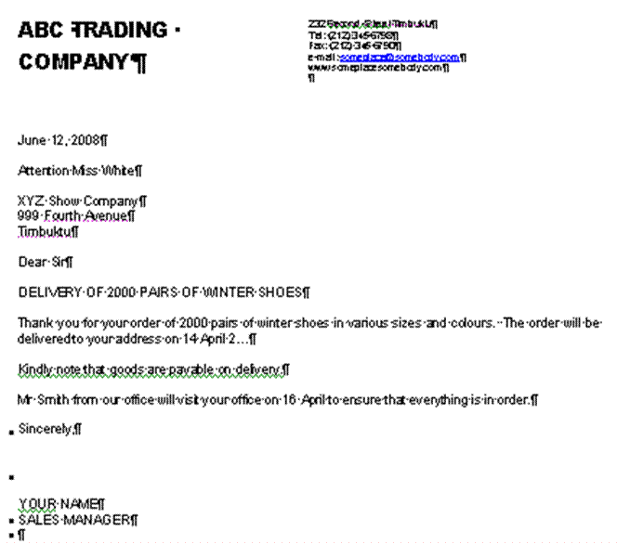

This is a layout of a letter done in the **formal register**. Your choice of words/signs will be formal, you will use headings and sub headings, you will use bold or italic fonts, (or NMF’s to emphasise certain aspects) and so on. Can you see that this letter does not look the same as the letter to your friend? It is important to use the register that is appropriate to the audience you are writing to. If you don’t, the reader can feel insulted or even refuse to take you seriously.

The form that your writing takes must also be appropriate to the context and purpose. For example, a friend’s mother has died and you must write/sign a **letter of condolence**. Your writing will be more formal than if you were writing to the friend, although not quite as formal as when you are writing to our President. You will not use humour, jargon, technical or ambiguous words. The style will be sympathetic.

When you are inviting a client to a Christmas function, you will use the formal register but you will tone down the formality. You could introduce the theme of the party with a little humour or a funny picture, you will not use titles, heading and so on.

If you are unsure of the difference in the registers, go to a stationer that sells cards and look at birthday cards, cards about illness and death, invitations.

There will be more than one example of each and some will be more formal than others. Take note of the tone and style that is used, note the diction and the language structure. Make notes, if necessary and refer back to your notes when necessary.

To express yourself clearly in writing/signing you should pay special attention to:

* Reading and understanding, also called comprehension.
* Assembling facts and constructing prose (text).
* Sentence structure.
* Paragraphing.
* Assembling paragraphs.
* Making a summary
* Taking notes.
* Expanding notes.
* Paraphrasing.
* NMF’s

## A clear point of view

Make sure that your writing shows a clear point of view. If you confuse the reader, that person will stop reading your text. follow these rules to make sure that you clearly state your point of view

The ten golden rules of meaningful written communication

1. **Correctness**: grammar, spelling, punctuation, style, format and composition
2. **Conciseness** Brief, specific and to the point, include only what is really necessary. Don’t elaborate on facts and details.
3. **Completeness** Include all the relevant information you want to share as well as what the reader wants to know
4. **Clearness** Clarity and readability – choose words carefully to eliminate any assumptions and misinterpretations.
5. **Courtesy** be considerate of the readers, respect their feelings and their rights. Test your approach by asking yourself; “Would I enjoy reading what I have written?”
6. **Simplicity** Keep writing simple, use short yet detailed sentences, avoid using too many descriptive words ( adverbs and adjectives)
7. **Accuracy** Always give accurate hones information – incorrect information can cost time and money.
8. **Concreteness** be realistic, positive, appeal to the readers by keeping their background, needs, and level of understanding in mind.
9. **Personality** the readers must know that you care about their interests
10. **Sincerity** being sincere builds confidence, watch the tone of your writing, focus on expressing yourself clearly and creating a good impression.

Pointers to think of before you write

* If you are uncertain ask questions. Do not make assumptions make sure your interpretation is correct.
* Be well prepared. If you have a clear understanding of what is required of you, your feedback will be more meaningful. Know your topic or subject matter and you will command attention and respect.
* Choose your words carefully as they not only express your thoughts, they also impress the receiver. The impression your words make motivates the reaction you receive.
* Think before you write. Organise your thoughts and know what you want to say. Don’t just ramble on. Develop a logical pattern when putting pen to paper.
* Use clear simple language. Select vocabulary that your audience will relate to and understand.
* Be specific in your choice of words so that your message or information can be correctly interpreted. Focus on what you want to say.
* Give complete details- address all the relevant facts and answer all the questions and give the necessary explanatory information.
* Apply the KISS rule (Keep it Short and Simple) too much unnecessary information can lead to reading boredom.
* Focus on correctness. Correct facts, correct answers, correct language usage, correct grammar, correct spelling, correct punctuation, correct format and style. Always use a dictionary.
* Be polite and considerate respect the thoughts and opinions of others even if you do not agree.
* Always try to write as you would speak. Don’t make the written format too complicated.
* Avoid using slang (its cool) make sure you use appropriate jargon and subject vocabulary that is relevant.

## Use critical thinking skills

Use the following critical thinking skills to help you organise your thoughts and thereby your writing:

Mind maps

Discussed in a previous session

Highlights

Discussed in a previous session

Brainstorming

This is a highly effective way of finding solutions to problems, provided you implement the process correctly. You can also use it to clarify your thinking about a topic. It involves the generation of a large number of unconventional ideas whilst eliminating the usual tendencies to criticise or prematurely reject these unusual ideas.

Brainstorming usually done in groups.

**The Brainstorming Process**

#### Selection

Select a topic for brainstorming and also select the members of the group.

#### The Topic

The group is given advance notice of the topic in the form of a brief description of one or two sentences. The group facilitator discusses with the group a limited amount of background information relating to the problem.

#### Warm-Up Session

Members are introduced to the concepts of brainstorming in a relaxed manner.

The group discussion should try to identify the barriers of creative thinking and show how they can be overcome.

The purpose of brainstorming is to generate as many ideas as possible in a short period of time. It does not matter if the ideas are silly, this is actually the purpose of brainstorming.

When using brainstorming, creative thinking is very important, as is overcoming the barriers to creative problem-solving.

The actual brainstorming process is explained, together with the four rules of brainstorming:

1. Free association: participants must state the first idea that came into their heads, no matter how silly or absurd it may seem.
2. Clarification: the person whose idea it was can elaborate on the idea, or someone else can, as one idea leads to another. No evaluation of the idea is allowed at this time.
3. Suspension of judgement: nobody is allowed to pass any comment on anyone else’s ideas. This is not the purpose of brainstorming at all.
4. Speed: brainstorming should happen as quickly as possible.

Short practice-runs will demonstrate how little time it takes to produce 50 to 100 ideas. At the end of the warm-up session, the original problem is restarted in as many ways as possible. For example, the problem of reduced profit could be redefined as how to beat competitors, or how to improve marketing. All statements are written down by the leader.

It should develop in a light-hearted, easy-going atmosphere. Brainstorming is a fun thing to do and it should be so for everyone.

#### Brainstorm

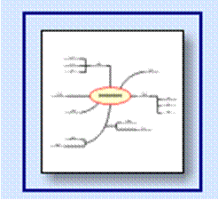The facilitator reads out the statements and calls for ideas. As they flow, they are numbered and written up on a large flipchart with a large felt-tip pen.

Each sheet is torn off when full and displayed elsewhere in the room. Freedom of expression should be encouraged. The ideas may number from 150 to 600, or more.

There should be pre-set timescale for this session.

Now the solutions can be considered for practicality and so on.

Activity 5 (119456 SO1, AC1-2)

SECTION 6: GRAMMATICAL STRUCTURES

#### Outcome

Use grammatical structures and writing/signing conventions to produce coherent and cohesive texts for specific contexts.

#### Assessment criteria

On completion of this section you will be able to ensure that:

* Clear, well-structured sentences are used
* A variety of sentence structures, lengths and types is employed where appropriate
* Paragraph/chunks of signing conventions are constructed showing awareness of topic
* Punctuation/non-manual features (NMFs) are used appropriately
* Register is chosen to suit audience and purpose
* Link devices are used correctly to write/sign sustained pieces
* Texts are organised and structured to have a clearly defined beginning, middle and end

## Register

Register refers to the type and style of written work produced by writers.

Informal Register

This kind of writing is informal. It would include letters to your friends, e-mails to friends and colleagues. It would also include internal correspondence in an organisation.

If you write a note to your facilitator about one of your assignments, this would fall under the informal register.

While your grammar and punctuation should still be correct, you can use a more informal tone and style and also more informal words. Newspaper and magazine articles are usually written in the informal register.

Formal Register

Letters to the head of a department or branch or head office of an organisation and also letters to clients would be more formal, therefore you will use the formal register.

If you write a letter to the head of the college the format of the letter, the grammar, words and style would be formal.

For example, if you are writing a letter to the president of our country, you will not write like this:

Howzit Thabo, my Bra

I just want to tell you that the trains are late everyday. You must do something about it or I will not vote for you again.

If the trains are late again tomorrow, I am going to set fire to it, because my boss has said that he will fire me if I am late again.

Bye

When he has a meeting in your city or town and you are addressing him personally, you can certainly talk to him like this. Writing, however, is always more formal than talking so you have to choose the correct register if you want people to take you seriously.

A letter to our president should rather be written as follows:

Dear Mr Mbeki

I live in Soweto and have to travel to the centre of Johannesburg every day. When I arrive late for work, I get into trouble.

For the past two weeks, the trains have been late every day and I have been late for work every day. My supervisor is now threatening me with disciplinary steps if the situation does not improve.

Please look into the matter from your end.

Yours faithfully

## Punctuation/NMF’s

* Punctuation/NMF’s should **clarify the meaning** of text
* Punctuation/NMF’s should make the written material **more readable**
* Punctuation/NMF’s should be reader-oriented: the most important reason for using full stops (periods) is to **help your reader understand** you. Of course, when you use periods (full stops) in the right places, your work will automatically be grammatically correct.
* Punctuation marks/NMF’s indicate the **emphasis**, **tone** and **undertone** in a piece of writing

Writers are not free to punctuate as they wish, certain rules have to be followed:

* A period or full stop at the end of a sentence indicates a long pause.
* A question is always indicated by a question mark. (?)
* An exclamation mark always indicates an exclamation. (!)
* A quote **must** always be placed within quotation marks. (“…”)

Period

* Use at the end of a sentence.
* Use after a declarative or imperative statement: Write in pencil.
* Used after certain abbreviations: etc.

Do not use periods at the end of a heading or a theme title.

Comma

Commas are used to:

* Separate an introductory phrase from the body of the sentence: “During the discussions in parliament, it was decided that ….” Doing this, tells the reader that the introductory phrase is less important than the main part of the sentence. In the example, the important part of the sentence is the decision that was made, the place where it was made is not that important.

,

* Separate two independent clauses that are joined by a conjunction. Examples of conjunctions are: “and”, “but”, “or”, “nor”, “for”, “yet”, “so”. You will place the comma after the first independent clause and before the conjunction: “I have finished reading this book, and I am taking it back to my friend. “It is raining outside, but inside the room it is dry and warm.”
* A separable (non-restrictive) clause from the principal clause. This is when you insert an interesting clause, word or phrase into a sentence: “The water, polluted by industrial waste, is poisonous.” The clause that was inserted is interesting, but not essential to the point of the sentence. Of course, when the clause is essential to the sentence, you will not use commas.
* Separate elements in a simple series. When you quote a list or series of things in a sentence, you must separate them with a comma: “All the furniture, domestic appliances, office equipment and other business articles must be included in the inventory.” “I want to buy the red dress, yellow jersey, white slacks and black shoes.”
* Separate transitional words or phrases such as: “well”, “yes”, “no” and “finally” from the rest of the sentence. “Yes, I will make the opening speech for the debate.” “No, the blue jacket does not look good with the brown slacks.”

Ellipses

The ellipse (…) is three spaced periods that indicate the intentional omission of words in a quotation, a remark that is not complete or to show that the author did not cite all the information: “I understand your problem…”

...

When you use an ellipse with other punctuation marks, such as a question mark, the ellipse follows the question mark: “Why don’t you tell me what is bothering you?...”

Semi-colons

;

The semi-colon (;) is a stronger punctuation mark than a comma, but not as strong as a period. When you use a semi-colon, you are indicating a longer pause than a comma, but the pause is not as long that of the full stop.

* Use a semi-colon when you want to separate ideas that are related that follow a colon: “the secretary should: prepare the chairman’s agenda; take minutes of the meeting; read the minutes …”
* Semi-colons are also used if items in a series contain a comma: “Are you going to Parys, Free State; or Paris, France?”

Dash

* Use the dash sparingly. To many dashes in a piece of writing is bad style.

(-)

* The dash shows an abrupt break in the thought or construction of a sentence: “I believe – no, I am sure – that he is responsible.”
* A dash takes the place of **to**: “January – March” or “1994 – 2004”.

## Sentences

Use clear, well-structured sentences by using punctuation marks or NMF’s. Also vary the length of your sentences as discussed in a previous sentence.

## Paragraphs

During the previous unit standard we discussed sentences and how they should be formed. As an introduction to writing your own texts, herewith an overview about writing paragraphs and documents.

The sentences in a paragraph should form a unit. The reader must be able to easily see how a sentence follows on the one preceding it. A paragraph starts with a topic sentence, that introduces the topic of the paragraph to the reader. The topic sentence acts as a base and holds the paragraph together. Sentences that follow in the same paragraph should enlarge on the topic or theme introduced in the first sentence. We call them supporting sentences. Supporting sentences should provide **specific details** about the topic in order to clarify the topic sentence and make the paragraph interesting.

If the sentence does not contribute to the theme of the paragraph, it should not be included. You should also avoid adding data that is not relevant to the topic

ü

**Hints for writing good paragraphs**

1. Each paragraph should have only one theme.
2. Do not write paragraphs that are longer than 10 or 12 lines, as longer paragraphs become boring and confusing.
3. Mix long and short paragraphs in a document to create interest and attention with the reader.

## Document

When you are writing a document, it should be about a specific topic or theme. The text you are writing will usually consist **of more than one paragraph**, each with its own topic but relating to the main topic of the document.

Your piece of writing should start with an **introduction** of the theme of the document. Your first paragraph would therefore be the introductory paragraph. Keep your introductory paragraph short, relevant, and introduce the theme of the document. The introductory paragraph must get the **attention of the reader**.

Your paragraphs must follow each other in a logical way, from point A to point B to point C. The last sentence of the previous paragraph should lead to the next paragraph. One thought should be connected to the next thought in a logical way. Do not jump around from one topic to another without giving the reader some clues about your purpose.

## Arranging The Paragraphs In A Logical Order

You can use cause and effect and contrast to help you arrange your paragraphs in a logical way.

* **Contrast** is when you contrast one theme, thought, opinion or product with another.
* **Cause and effect**: you can, for example, progress from the causes of war to the consequences(effect) of the civil war on ordinary people.
* If you are writing about something that happens over a period of time, you can arrange your paragraphs **chronologically**: start with the earliest date and end with the latest date. When writing about droughts in South Africa you can start with the big drought in the 1930s and end with the current drought.

1930 - 2006

Any arguments used in your document must be **supported by sound reasons and facts**. You have to justify your feeling about the matter with facts in order to persuade the reader to your point of view. Something your neighbour said about the matter is not fact – you have to verify the statement your neighbour made.

Ensure that you **state your point of view clearly**. Remember other people also have to understand your point of view.

***A fragile home threatened by war.***

*Among the last of its kind, a young gorilla peers from its leafy refuge in Rwanda – a nation bloodied by ethnic slaughter. Conservationists fear that Rwanda’s instability could endanger the gorilla’s survival. Others ask: How should the plight of the world’s rarest ape be weighed against more than 500,000 human dead?*

PRIMA002

As it stands the paragraph above is clear. If I leave out certain key words, I can change the paragraph so that it does not make any sense:

“A young gorilla peers from its leafy refuge and instability could endanger the gorilla’s survival.” What on earth am I talking about? Where is the gorilla, why would its survival be endangered and what is the instability that I wrote about?

If you want your writing to be clear, you have to ensure that you give the reader **all the information** he/she requires to understand your reasoning.

“They said it is going to rain today.” This is a terrible sentence. Who are “they”, where did they get their information from, where is it going to rain, where do they live – do they even live in the same area as you and I?

ü

**Always check your facts for correctness** before you commit them to writing. Readers are very critical and will never forgive you if you get your facts wrong. Anything you write in future will be viewed with suspicion

“The Weather Bureau predicts that there is an 80% chance of rain in Gauteng today.” Now you have stated the source of your fact, you have backed your statement with an estimate of the possibility of rain and you have also made it clear where it will rain. If it doesn’t rain, your readers cannot be angry with you, since you only reported what the Weather Bureau predicted.

At the end of your document, you have to come to a **conclusion**, where you connect all the facts that you stated previously. State your conclusion or recommendation clearly and make sure that it is based on the facts you stated. The conclusion can be:

* A short **summary** of the main points of your document.
* A **direct-approach** conclusion where you show the reader how the message relates to him/her.
* **Plan of action** conclusion where you answer the question of what should be done about the matters discussed in the body of your document.

Organise the material

Before you start writing a document, you have to gather information. This is called research. Once you have gathered information, the material you have collected has to be organised. Follow these steps:

#### Sorting and categorizing

Arrange or organise the information with common features or characteristics systematically in groups.

All the information with similar content is grouped together. Your classification will depend on the order in which you are going to write the document: you can sort the information **chronologically**, using **contrast** or **cause and effect**.

#### Sifting for relevance

Once you have classified the information and data, you have to sift through it for relevance.

Keep only the information that is **relevant** to your topic, everything else can be discarded. In other words, if you are writing about plants that flower in summer, any information about plants that flower in autumn is not relevant, you cannot use it to enhance your writing and you should throw it away or put it to one side in case you need it in the future.

#### Validity and reliability

Now you have to check your information for **validity and reliability**. The obvious way of doing this is to **check your facts with more than one source**:

* check more than one manual,
* talk to more than one expert,
* visit more than one website, to ensure that your facts are correct.

Preferably, you should use more than one manual, more than one website and the knowledge of more than one expert for each aspect that has to be checked. If most of or all your sources state the same basic fact, you can be reasonably sure that the fact is correct.

#### Recording

Once you have sifted and verified your information, record it in the categories you have selected. This recording is in draft form, usually in the form of rough notes.

Now you are ready to draft your first copy of the final document.

You will never use your first draft for the final document without reading and rereading and making changes.

Your first draft is never good enough for the final product, you have to check and recheck and recheck again in order to make corrections to your writing that is an improvement on the original.

When you are checking your document, check the following:

* Your use of grammar.
* Diction.
* The sentence and paragraph structure.

If necessary, which it usually is, make changes to ensure consistency.

Ensure that your ideas and topics **flow logically** from one to the other in the sentences as well as the paragraphs.

Identify and remove inappropriate or potentially offensive language.

Be on the lookout specifically for jargon and technical language. Don’t use them too much, replace them with other explanatory words. Too much jargon and technical language confuses a reader who is not familiar with it. The reader will lose interest and stop reading. I am sure you have stopped reading an article or document because of excessive use of jargon and technical language.

Beware of using offensive language with regards to gender, rank, family, sports and wealth

You might find a sexist joke funny, the other party might not. Do not make fun of a person’s gender or rank. Also, do not refer to “that old woman”, she might be someone’s mother. Do not call your boss the “Big Chief”, call him by his proper rank.

Activity 6 (119456 SO 2, AC 1-7

# SECTION 7: ADAPT LANGUAGE

#### Outcome

Adapt language to suit context

**Outcome Range**

Socio-cultural, inclusivity, human rights, technical/workplace, environmental contexts

#### Assessment criteria

On completion of this section you will be able to ensure that:

* Inappropriate language is identified and adapted: Excessive use of jargon, insensitive choice of words/signs, (gender; rank; hierarchies in familiar settings or organisations; family; sports; wealth) offensive or incorrect register
* Complex wording/signing of ideas is simplified where necessary

When you write, make sure that you adapt the language to suit the context you are writing for. Contexts include:

* Socio-cultural: refer to the section about socio-cultural language
* inclusivity: include everything expected or required of your text. In other words, state the opinion of more than one person or expert, include all the facts that are needed to make a decision, etc.
* human rights: refer to the section about bias
* technical/workplace: refer to the section about jargon and words used in specific workplaces
* environmental contexts: bear in mind the environment of the people you are writing for, e.g. is it business correspondence, are you writing to a friend, etc.

Identify inappropriate language and remove this language from your text. For example, do not include jargon when writing for the general public, avoid bias and make sure that you use the correct register.

Where you have to use complex words, make sure that you explain them.

Activity 7 (119456 SO3, AC 1-2)

# SECTION 8: EDIT WRITING

#### Outcome

Draft and edit own writing

#### Assessment criteria

On completion of this section you will be able to ensure that:

* Planning, drafting, editing and redrafting improve the suitability of the intended purpose and audience
* Cohesive devices to link parts of texts with other parts and to link ideas are checked and adapted to promote overall coherence of the text.
* Major grammatical errors are identified and changes improve structure and readability/viewability of text
* Spelling/handshape, punctuation/non-manual features (NMFs), register, sentence and paragraph structure are checked and corrected where necessary, and the selection of vocabulary is appropriate to content
* Points of view, where expressed, are supported with a simple range of reasons and facts
* Sources used in writing/signing are acknowledged and accurately recorded in format appropriate to the task or learning activity

## Redrafting

You will never use your first draft for the final document without reading and rereading and making changes.

Your first draft is never good enough for the final product, you have to check and recheck and recheck again in order to make corrections to your writing that is an improvement on the original.

When you are checking your document, check the following:

* Your use of grammar.
* Diction
* Spelling/handshape
* The sentence and paragraph structure.

If necessary, which it usually is, make changes to ensure consistency.

Ensure that your ideas and topics flow logically from one to the other in the sentences as well as the paragraphs.

Identify and remove inappropriate or potentially offensive language/signs. Be on the lookout specifically for jargon and technical language. Don’t use them too much, replace them with other explanatory words. Too much jargon and technical language confuses a reader who is not familiar with it.

The reader will lose interest and stop reading. I am sure you have stopped reading an article or document because of excessive use of jargon and technical language.

Beware of using offensive language with regards to gender, rank, family, sports, wealth and obfuscation.

You might find a sexist joke funny, the other party might not. Do not make fun of a person’s gender or rank. Also, do not refer to “that old woman”, she might be someone’s mother. Do not call your boss the “Big Chief” call him by his proper rank.

**Obfuscation** means to make unclear or hard to understand. “I will horizontalise your perpendicularity” actually means that I will knock you over. Perpendicular means upright and horizontal means parallel to the ground. When you write something, do not make it more difficult than it has to be.

While you are redrafting your piece, experiment with the layout: use titles, headings, colour and so on. This way you can see what the finished product will look like. Add pictures, captions and visual effects at the appropriate places. Visualise what it will look like. Move them around until you are happy with the result – all the graphics, for example, should not be on the same side of the page. Vary their positions from the left to the centre to the right and so on.

Bibliography

Make sure that you acknowledge sources that were used in composing your texts. A bibliography is a record of the resources and sources you used during your research. Follow the following format when quoting the sources of your information:

* Author surname and initials
* The year it was published
* The title of the book
* Where it was published
* The name of the publisher

When you quote the author directly, you have to add the following to your text where you use the quote: (Sayles & Chandler, 1971:185)

Sayles & Chandler are the authors

1971 is the year the book was published

185 is the page number where the quote appears

Then, of course, you have to add the details of book to the bibliography.

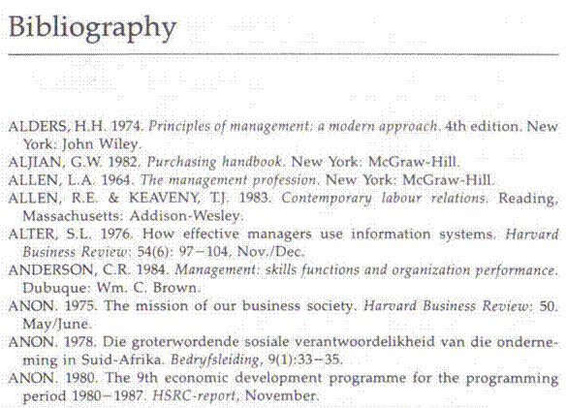

**Keep your rough copies for your portfolio of evidence, as you have to prove that you did redraft your work.**

Activity 8 (119456 SO4, AC 1-6)