**LEARNER GUIDE**

Numeracy Level 2

Unit Standard 9008 Level 2 Credits 3

# TABLE OF CONTENTS

[TABLE OF CONTENTS i](#_Toc80279925)

[PERSONAL INFORMATION 1](#_Toc80279926)

[INTRODUCTION 2](#_Toc80279927)

[Structure 3](#_Toc80279928)

[Programme methodology 3](#_Toc80279929)

[What Learning Material you should have 4](#_Toc80279930)

[Different types of activities you can expect 5](#_Toc80279931)

[Assessments 6](#_Toc80279932)

[Learner Support 7](#_Toc80279933)

[Learner Administration 7](#_Toc80279934)

[Learner Expectations 8](#_Toc80279935)

[UNIT STANDARD 9008 9](#_Toc80279936)

[Estimate, Measure and Calculate 12](#_Toc80279937)

[Length 12](#_Toc80279938)

[Ruler 13](#_Toc80279939)

[Measuring Tape 13](#_Toc80279940)

[Mass 13](#_Toc80279941)

[Spring Balance 14](#_Toc80279942)

[Measuring fluids 14](#_Toc80279943)

[Time 15](#_Toc80279944)

[Clocks And Wristwatches 15](#_Toc80279945)

[Units Of Time 15](#_Toc80279946)

[Digital Time 16](#_Toc80279947)

[Thermometer 16](#_Toc80279948)

[Symmetry 17](#_Toc80279949)

[Geometric Formulae 18](#_Toc80279950)

[Two-dimensions (2D) and areas 18](#_Toc80279951)

[The area and perimeter of a rectangle 19](#_Toc80279952)

[The Area and Perimeter of a Square 19](#_Toc80279953)

[Circle 20](#_Toc80279954)

[Parallelogram 21](#_Toc80279955)

[Observations for square, rectangle, parallelogram and rhombus 22](#_Toc80279956)

[Trapezium 22](#_Toc80279957)

[Theorem of Pythagoras 23](#_Toc80279958)

[Combining areas 23](#_Toc80279959)

[SI Units 24](#_Toc80279960)

[Using the SI system 26](#_Toc80279961)

[The imperial (UK) number system 28](#_Toc80279962)

[Approximations and estimations 29](#_Toc80279963)

[Temperature scales: 31](#_Toc80279964)

[Convert from Fahrenheit to Celsius using the formulae 31](#_Toc80279965)

[Activity 1 (SO1, AC1-7) 32](#_Toc80279966)

[Rough Sketches 32](#_Toc80279967)

[Sketching in general 33](#_Toc80279968)

[Scale Drawings 36](#_Toc80279969)

[Adding detail to scale drawings 37](#_Toc80279970)

[Using rectangular grids 37](#_Toc80279971)

[Legend to sketch 39](#_Toc80279972)

[Two Dimensional Geometric Figures 40](#_Toc80279973)

[Transformation 41](#_Toc80279974)

[Rotate 41](#_Toc80279975)

[Mirror image (reflection) 42](#_Toc80279976)

[Translation 43](#_Toc80279977)

[Other transformations 43](#_Toc80279978)

[Tessellation 45](#_Toc80279979)

[Activity 2 (SO2, AC1-5) 47](#_Toc80279980)

**PERSONAL INFORMATION**

|  |  |
| --- | --- |
| ***NAME*** |  |
| ***CONTACT ADDRESS*** |  |
|  |
| ***Code*** |  |
| ***Telephone (H)*** |  |
| ***Telephone (W)*** |  |
| ***Cellular*** |  |
| ***Learner Number*** |  |
| ***Identity Number*** |  |
| ***EMPLOYER*** |  |
| ***EMPLOYER CONTACT ADDRESS*** |  |
|  |
| ***Code*** |  |
| ***Supervisor Name*** |  |
| ***Supervisor Contact Address*** |  |
|  |
| ***Code*** |  |
| ***Telephone (H)*** |  |
| ***Telephone (W)*** |  |
| ***Cellular*** |  |

**INTRODUCTION**

***Welcome to the learning programme***

Follow along in the guide as the training practitioner takes you through the material. Make notes and sketches that will help you to understand and remember what you have learnt. Take notes and share information with your colleagues. Important and relevant information and skills are transferred by sharing!



This learning programme is divided into sections. Each section is preceded by a description of the required outcomes and assessment criteria as contained in the unit standards specified by the South African Qualifications Authority. These descriptions will define what you have to know and be able to do in order to be awarded the credits attached to this learning programme. These credits are regarded as building blocks towards achieving a National Qualification upon successful assessment and can never be taken away from you!

## Structure

### Programme methodology



The programme methodology includes facilitator presentations, readings, individual activities, group discussions and skill application exercises.

**Know what you want to get out of the programme from the beginning and start applying your new skills immediately. Participate as much as possible so that the learning will be interactive and stimulating.**

The following principles were applied in designing the course:

* Because the course is designed to maximise interactive learning, you are encouraged and required to participate fully during the group exercises
* As a learner you will be presented with numerous problems and will be required to fully apply your mind to finding solutions to problems before being presented with the course presenter’s solutions to the problems
* Through participation and interaction the learners can learn as much from each other as they do from the course presenter
* Although learners attending the course may have varied degrees of experience in the subject matter, the course is designed to ensure that all delegates complete the course with the same level of understanding
* Because reflection forms an important component of adult learning, some learning resources will be followed by a self-assessment which is designed so that the learner will reflect on the material just completed.

This approach to course construction will ensure that learners first apply their minds to finding solutions to problems before the answers are provided, which will then maximise the learning process which is further strengthened by reflecting on the material covered by means of the self-assessments.

***Different role players in delivery process***

* Learner
* Facilitator
* Assessor
* Moderator

### What Learning Material you should have

This learning material has also been designed to provide the learner with a comprehensive reference guide. It is important that you take responsibility for your own learning process; this includes taking care of your learner material. You should at all times have the following material with you:

|  |  |
| --- | --- |
| ***Learner Guide*** | ***This learner guide is your valuable possession:***  This is your textbook and reference material, which provides you with all the information you will require to meet the exit level outcomes. During contact sessions, your facilitator will use this guide and will facilitate the learning process. During contact sessions a variety of activities will assist you to gain knowledge and skills.  Follow along in the guide as the training practitioner takes you through the material. Make notes and sketches that will help you to understand and remember what you have learnt. Take and share information with your colleagues. Important and relevant information and skills are transferred by sharing!  This learning programme is divided into sections. Each section is preceded by a description of the required outcomes and assessment criteria as contained in the unit standards specified by the South African Qualifications Authority. These descriptions will define what you have to know and be able to do in order to be awarded the credits attached to this learning programme. These credits are regarded as building blocks towards achieving a National Qualification upon successful assessment and can never be taken away from you! |
| ***Formative Assessment Workbook*** | The Formative Assessment Workbook supports the Learner Guide and assists you in applying what you have learnt.  The formative assessment workbook contains classroom activities that you have to complete in the classroom, during contact sessions either in groups or individually.  You are required to complete all activities in the Formative Assessment Workbook. The facilitator will assist, lead and coach you through the process. These activities ensure that you understand the content of the material and that you get an opportunity to test your understanding. |

### Different types of activities you can expect

To accommodate your learning preferences, a variety of different types of activities are included in the formative and summative assessments. They will assist you to achieve the outcomes (correct results) and should guide you through the learning process, making learning a positive and pleasant experience.



The table below provides you with more information related to the types of activities.

| ***Types of Activities*** | ***Description*** | ***Purpose*** |
| --- | --- | --- |
| ***Knowledge Activities*** | You are required to complete these activities on your own. | These activities normally test your understanding and ability to apply the information. |
| ***Skills Application Activities*** | You need to complete these activities in the workplace | These activities require you to apply the knowledge and skills gained in the workplace |
| ***Natural Occurring Evidence*** | You need to collect information and samples of documents from the workplace. | These activities ensure you get the opportunity to learn from experts in the industry.  Collecting examples demonstrates how to implement knowledge and skills in a practical way |

### Assessments

The only way to establish whether a learner is competent and has accomplished the specific outcomes is through the assessment process. Assessment involves collecting and interpreting evidence about the learners’ ability to perform a task.

**To qualify and receive credits towards your qualification, a registered Assessor will conduct an evaluation and assessment of your portfolio of evidence and competency.**

**This programme has been aligned to registered unit standards. You will be assessed against the outcomes as stipulated in the unit standard by completing assessments and by compiling a portfolio of evidence that provides proof of your ability to apply the learning to your work situation.**

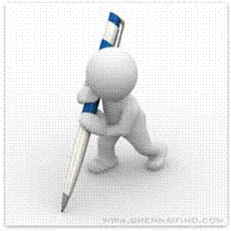

***How will Assessments commence?***

***Formative Assessments***

The assessment process is easy to follow. You will be guided by the Facilitator. Your responsibility is to complete all the activities in the Formative Assessment Workbook and submit it to your facilitator.

***Summative Assessments***

You will be required to complete a series of summative assessments. The Summative Assessment Guide will assist you in identifying the evidence required for final assessment purposes. You will be required to complete these activities on your own time, using real life projects in your workplace or business environment in preparing evidence for your Portfolio of Evidence. Your Facilitator will provide more details in this regard.

**To qualify and receive credits towards your qualification, a registered Assessor will conduct an evaluation and assessment of your portfolio of evidence and competency.**

### Learner Support

**The responsibility of learning rests with you, so be proactive and ask questions and seek assistance and help from your facilitator, if required.**



Please remember that this Skills Programme is based on outcomes based education principles which implies the following:

* You are responsible for your own learning – make sure you manage your study, research and workplace time effectively.
* Learning activities are learner driven – make sure you use the Learner Guide and Formative Assessment Workbook in the manner intended, and are familiar with the workplace requirements.
* The Facilitator is there to reasonably assist you during contact, practical and workplace time for this programme – make sure that you have his/her contact details.
* You are responsible for the safekeeping of your completed Formative Assessment Workbook and Workplace Guide
* If you need assistance please contact your facilitator who will gladly assist you.
* If you have any special needs please inform the facilitator

## Learner Administration

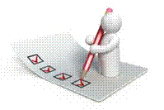

***Attendance Register***

You are required to sign the Attendance Register every day you attend training sessions facilitated by a facilitator.

***Programme Evaluation Form***

On completion you will be supplied with a “Learning programme Evaluation Form”. You are required to evaluate your experience in attending the programme.

Please complete the form at the end of the programme, as this will assist us in improving our service and programme material. Your assistance is highly appreciated.

### Learner Expectations

Please prepare the following information. You will then be asked to introduce yourself to the instructor as well as your fellow learners

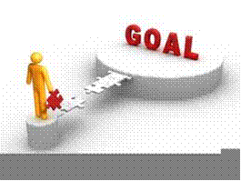

|  |
| --- |
| Your name: |
|  |
|  |
| The organisation you represent: |
|  |
|  |
| Your position in organisation: |
|  |
|  |
| What do you hope to achieve by attending this course / what are your course expectations? |
|  |
|  |
|  |
|  |
|  |
|  |
|  |
|  |

UNIT STANDARD 9008

#### Unit Standard Title

Identify, describe, compare, classify, explore shape and motion in 2- and 3-dimensional shapes in different contexts

#### NQF Level

2

#### Credits

3

#### Purpose

This unit standard is designed to provide credits towards the mathematical literacy requirements of the NQF at level 2. The essential purposes of the mathematical literacy requirements are that, as the learner progresses with confidence through the levels, the learner will grow in:

* An insightful use of mathematics in the management of the needs of everyday living to become a self-managing person.
* An understanding of mathematical applications that provides insight into the learner’s present and future occupational experiences and so develop into a contributing worker.
* The ability to voice a critical sensitivity to the role of mathematics in a democratic society and so become a participating citizen

#### Learning Assumptions

The credit value is based on the assumption that people starting to learn towards this unit standard are competent in Mathematics and Communications at NQF level 1.

#### Range

The scope of this unit standard includes symmetry, transformations; making conjectures; measurement in practical situations and calculations involving plane figures. Situations should preferably be related to the teenager, peer groups and the school or work community. More detailed range statements are provided for specific outcomes and assessment criteria as needed.

#### Specific Outcomes and Assessment Criteria

**Specific outcome 1:** Estimate, measure and calculate physical quantities to solve problems in practical situations

**Range:**

* Basic instruments to include those readily available such as rulers, measuring tapes, measuring cylinders or jugs, thermometers, spring or kitchen balances, watches and clocks
* Quantities to estimate or measure to include length, mass, time and temperature
* The quantities should range from the low or small to the high or large
* Mass, volume and temperature values are used in practical situations relevant to learners or the workplace
* Calculate lengths using Pythagoras` theorem
* Calculate perimeters and areas of rectangles, parallelograms, circles, trapesia, from measurements in practical situations
* Use rough sketches to interpret represent and describe situations
* Use and interpret scale drawings of plans (e.g., teenager rooms, factory floors; in painting walls, designing gardens)
* SI units to be used but conversions from imperial to SI included

**Assessment criteria**

* Scales on the measuring instruments are read correctly.
* Quantities are estimated to a tolerance acceptable in the context of the estimation.
* The appropriate instrument is chosen to measure a particular quantity.
* Calculations are carried out correctly.
* Appropriate units are used in measurement and calculation.
* Rough sketches are interpreted or used correctly to represent and describe situations.
* Scales are used correctly in interpreting and describing situations through scale diagrams.

**Specific outcome 2:** Explore transformations of two-dimensional geometric figures

**Range:**

* Use parallelism, symmetry, translation, reflection and rotation in describing artefacts
* Make conjectures about mathematical relationships found in artefacts
* Use transformations and symmetry in describing objects
* Use transformations and symmetry in designing patterns in 2 dimensions (e.g., tessellations, dress material, logos) of interest to teenagers

**Assessment criteria**

* Properties of symmetrical shapes are recognised and described.
* The concept of lines of symmetry in 2-dimensional figures is explored using paper folding and reflections in the lines of symmetry.
* The concept of transformation in terms of reflections, translations and rotations is identified and explained using concrete materials.
* The descriptions are based on correct application of transformations and other geometrical properties.
* Designs, based on transformations and other geometrical properties are innovative, and correct geometrically.

#### Essential embedded knowledge

The following essential embedded knowledge will be assessed through assessment of the specific outcomes in terms of the stipulated assessment criteria. Candidates are unlikely to achieve all the specific outcomes, to the standards described in the assessment criteria, without knowledge of the listed embedded knowledge. This means that the possession or lack of the knowledge can be inferred directly from the quality of the candidate’s performance against the standards.

* Properties of geometric shapes
* Length, area, mass, temperature, time
* Scale drawing

#### Critical cross field outcomes

* Identify and solve problems using critical and creative thinking: Solve a variety of problems relevant to the learner involving physical quantities and time using geometrical techniques.
* Collect, analyse, organise and critically evaluate information: Gather, organise, and interpret information about objects and processes.
* Communicate effectively: Use everyday language and mathematical language and drawing or geometrical diagrams to describe geometric and other physical properties, and processes relevant to the learner and the workplace
* Use mathematics: Use mathematics to describe and represent realistic situations and to solve practical problems

# Estimate, Measure and Calculate

#### Outcome

Estimate, measure and calculate physical quantities to solve problems in practical situations

#### Outcome Range

* Basic instruments to include those readily available such as rulers, measuring tapes, measuring cylinders or jugs, thermometers, spring or kitchen balances, watches and clocks
* Quantities to estimate or measure to include length, mass, time and temperature
* The quantities should range from the low or small to the high or large
* Mass, volume and temperature values are used in practical situations relevant to learners or the workplace
* Calculate lengths using Pythagoras` theorem
* Calculate perimeters and areas of rectangles, parallelograms, circles, trapesia, from measurements in practical situations
* Use rough sketches to interpret represent and describe situations
* Use and interpret scale drawings of plans (e.g., teenager rooms, factory floors; in painting walls, designing gardens ).
* SI units to be used but conversions from imperial to SI included

#### Assessment criteria

* Scales on the measuring instruments are read correctly
* Quantities are estimated to a tolerance acceptable in the context of the estimation
* The appropriate instrument is chosen to measure a particular quantity.
* Calculations are carried out correctly
* Appropriate units are used in measurement and calculation
* Rough sketches are interpreted or used correctly to represent and describe situations
* Scales are used correctly in interpreting and describing situations through scale diagrams

## Length

We measure lengths in millimetres (mm), centimetres (cm), meters (m) and kilometres (km), These are the units of length in the SI (System International) Metric System.

The relations are: 1m = 100 cm = 1000mm and 1km = 1000m

### Ruler

0

10

20

30

40

mm

A ruler is a straight rigid strip of plastic, wood, metal, marked at regular intervals and used to draw straight lines or measure distances.

Each smallest increment (an increase in a number) represents 1 millimetre. Each 10th increment is marked with the relevant value. To measure the length of any straight line, place the ruler along that line so that one end of the line is at the zero mark. The other end will be at the number indicating its length.

### N0014Measuring Tape

A measuring tape will have similar markings and applications as a ruler. The main difference is that a measuring tape is designed for use over longer lengths. As a result increments of 100 mm and 1000 mm are also distinguished.

The length of a measuring tape usually starts at 1 metre (1000 millimetre) and some can be as long as 100 metres. The measuring tape used by dress makers is usually 1 metre or 1.5 metres long and the very long measuring tapes are used by people in the construction business.

## Mass

What is the difference between weight and mass?

We say that the weight (“heaviness”) of an object depends on its mass. The bigger the mass, the bigger the pull of the earth is on it.

To measure mass we choose a unit of mass and express the mass of an object in this unit. In the metric system we use the gram (g) and the kilogram (kg) as units of mass. 1kg = 1000g, 1g = 1000 mg

Remember to use the same units when comparing the masses of different objects.

### Spring Balance

A balance is an instrument for comparing the weights of two bodies to determine the difference in mass.

30

25

20

15

10

5

**kg**

A spring balance is a balance that measures weight by the tension of a spring, in other words you hang the object you want to weigh from the spring balance. Fishermen use this to weigh the fish they have caught in competitions. Butchers also use spring balances to weigh carcasses.

Hang a spring balance like this from any support strong enough for the object to be weighed. Attach the bottom hook to the object. The indicator shows the mass of the object.

## Measuring fluids

200

100

ml

In this case each small increment represents 10 millilitres. Every 100 ml has its value indicated.

To acquire a certain amount of a liquid or powdery solid it is poured into the measuring cylinder. The marking next to the flat level of the substance would indicate the volume contained.

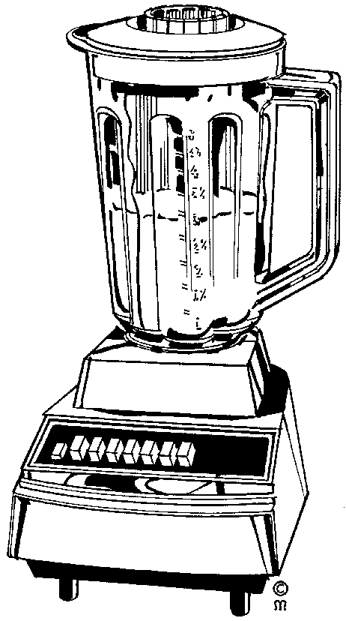Measuring cylinders are used every day by people baking cakes, cooking, as well as by hairdressers, laboratory technicians, pharmacists, students studying chemical science, chemical scientists and at times even barmen.

Measuring cylinders are used to measure the amount of water or liquid and/or powdery solid in order to:

Mix hair colouring

* Mix batter for cake, where you would add milk or water to flour, salt, sugar and other powdery solids
* Mix the amounts of alcoholic beverages to make a cocktail or other drink
* Mix chemical substances which can be in liquid or powder form.

In the metric system, the units used to measure capacity are the litre and millilitre. When a solid is dropped into water, the object takes the place of some of the water. We see that the level of the water rises. One millilitre (1 ml) of water is the volume of water that is displaced by 1 cm3. Or we can say that 1 ml of water fills 1 cm3.

Fluids such as water, milk and cold drinks are measured in millilitres or litres.

One litre = 1 000 ml.

For big volumes of fluid we can use the kilolitre (kl) as unit. 1 kl = 1 000 l.

**Example**: 5 ml of fluid fills 5 cm3

¼ l = 250 ml

1 kl of fluid fills 1 000 000 cm3 or 1 m3

## Time

### Clocks And Wristwatches

A clock is an instrument that measures and indicates the time. A watch is a small timepiece usually worn on a strap on one’s wrist. So we use watches and clocks to tell the time.

Clocks like these indicate the minutes between hours with the long arm and the hours with the short one. The numbers are indicated in Roman Numerals.

Every hour marking indicates the hour to be read with the short arm. It also indicates 5 minute increments to be read with the long arm.

The minute indication starts with 5 minutes past the hour at 1, and ends with 55 minutes past (5 minutes before) at 11.

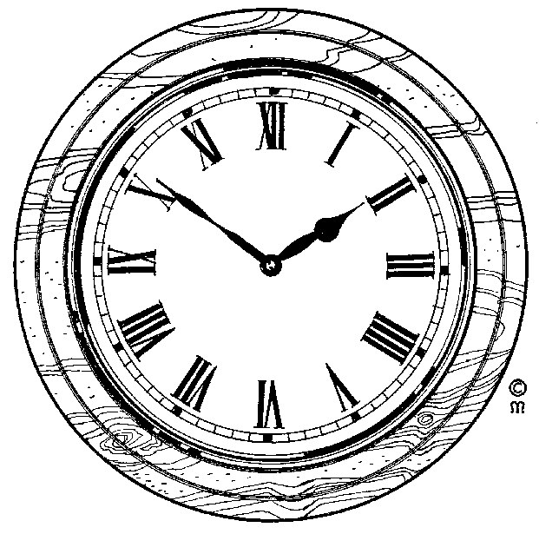Before wristwatches were common, most people, churches and government buildings used clocks to tell the time. These days, clocks are not commonly found, except in church towers and government buildings. Most of us use watches to tell the time.

Luckily, watches are no longer commonly numbered in Roman numerals, but rather the numbers as we use them from day to day. This watch only indicates hours (12), half hours (6) and quarter hours (3) and (9). It is left up to the wearer of the watch to work out when it is 5 past 10 or 20 to 7.

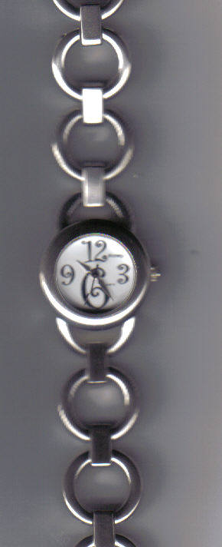

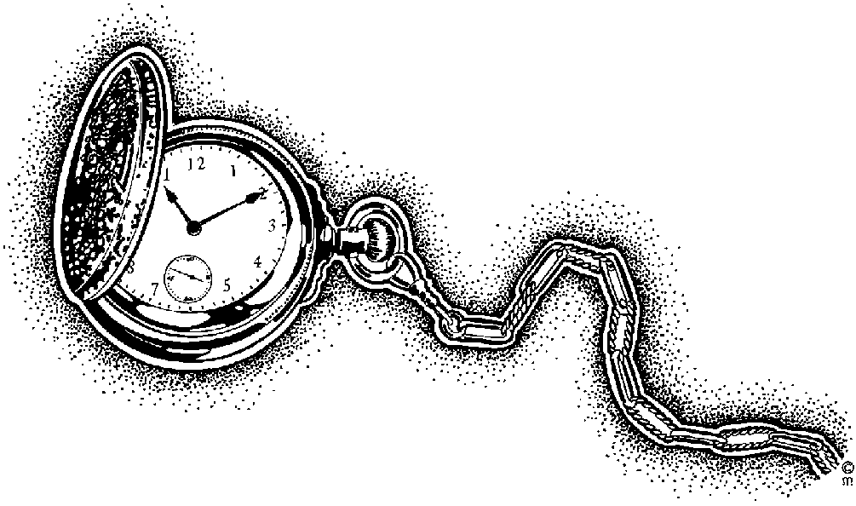

### Units Of Time

The basic unit of time is the second (s). We can also measure time in minutes (min), hours (h), days, weeks and so on. There are 7 days in a week, 24 hours in a day, 60 minutes in an hour and 60 seconds in a minute.

The face of a watch with hands is divided into 12 divisions. The hours between 12 o’clock midday and 12 o’clock midnight used to be written as 1 p.m., 2 p.m. etc up to 12 p.m. (midnight). The hours after midnight used to be written as 1 a.m., 2 a.m. etc up to 12 a.m. (midday).

### Digital Time

Today we use the international system of time. In this system the hours after midnight are counted 01:00, 02:00 and so on. Midday is 12:00 and midnight is 24:00. The digits before the “:” show the hours and the digits after the “:” show the minutes. Digital watches sow time in this way.

**16:30:00**

Digital watches do the same thing as ordinary wristwatches, the only difference is that they show the time differently. The time on your cell phone or PC screen is shown digitally:

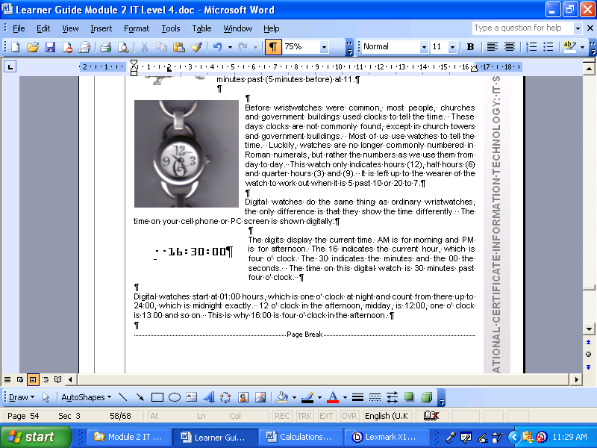The digits display the current time. AM is for morning and PM is for afternoon. The 16 indicates the current hour, which is four o’ clock. The 30 indicates the minutes and the 00 the seconds. The time on this digital watch is 30 minutes past four o’ clock.

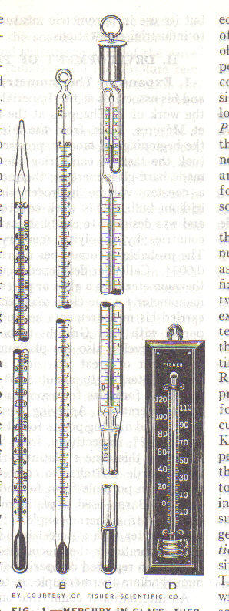The time as shown on a PC screen.

## Thermometer

40

37

36

38

35

39

34

33

41

42

ºC

A thermometer is an instrument for measuring or sensing temperature, typically consisting of a graduated glass tube containing mercury or alcohol which expands when heated.

Thermometers are used by doctors, nurses and medical staff to determine the temperature of a patient. A patient with a higher than normal temperature, **36ºC,** would indicate illness, as 36 degrees Celsius is the normal body temperature for human beings.

Thermometers are also used by the weather bureau to determine the daily temperatures. You can also buy a thermometer to determine the temperature in your house on a day to day basis and swimming pool owners use them to find out what the water temperature is.

The example on the previous page looks like a typical thermometer used to measure body temperature. It contains mercury or a coloured liquid where the level indicates the ambient temperature.

Some thermometers used by medical staff and found in households are shown on the right. You may have seen one or more of them during visits to the doctor or hospital.

Thermometers that make use of digital display have temperature influenced components that generate code. This code is processed and the relevant temperature is displayed as follows: **36ºC**

In some countries, such as the USA, temperature is measured in Fahrenheit, but in South Africa temperature is measured in Celsius.

In Celsius, **0ºC** is the point at which water freezes and **100ºC** is the point at which water boils. Of course, the freezing and boiling point of water as indicated above is at sea level, the exact temperature changes a little bit as you move farther inland and higher than sea level.

## Symmetry

A symmetrical object is one that remains identical if rotated or reflected (‘flipped’) around a line through its centre. There may be many angles of rotation for an object.

Using symmetry reduces the amount of work you must do when calculating areas and volumes. Use symmetry to your advantage. If you draw an object that has symmetry, draw the portion you need then place copies in the correct places by rotating or reflecting them about their axis of symmetry.

When we talk about seeing things in three dimensions, it means the following:

The first two dimensions are height (or length) and width on a flat surface. If you look at a rectangle, you have height (length) and width. A piece of paper has a length and a width that you can measure.

The third dimension is shown by introducing depth. A box has length, width and depth. This drawing shows you a box shape in three dimensions: length, width and depth.

Width

Depth

Height

Length

width

## Geometric Formulae

The purpose of this section is to introduce you to two-dimensional objects in terms of their various shapes in order to determine their areas and symmetries.

Areas are always in demand for many different uses. This section shows you how to calculate some of these so that you can estimate the surface areas when you need them.

### Two-dimensions (2D) and areas

Below is a summary various 2D shapes. The name, a small drawing and a short description of each shape is shown in order to provide you with an overview of what follows.

|  |  |  |
| --- | --- | --- |
| **Name** | **Drawing** | **Description** |
| Circle | circle-1 | The edge of the circle is at a constant distance from the middle. This distance is called the radius. |
| Triangle | triangle-1 | A triangle has three straight sides. |
| Square | quadrilateral-2 | A square has four equal sides and four right angles. |
| Rectangle | quadrilateral-3 | A rectangle has the opposite sides of equal length and four right angles. |
| Trapezium | quadrilateral-5 | A trapezium has one parallel pair of opposite sides. |
| Parallelogram | quadrilateral-6 | A parallelogram has both opposite sides equal and parallel. |

Various 2D shapes

Note that small lines drawn through the edges of an item indicate that those edges (lines) have the same length. The parallelogram is an example that shows two pairs of equal lines. A small square in a corner indicates a right angle of 90 degrees (90°). The square is an example that has four right angles. The greater than signs **(>)** indicate lines that are parallel to one another. The parallelogram has two parallel sides.

There are many geometric formulas, relating height, width, length, or radius to perimeter, area, surface area volume. Some of the formulas are rather complicated, and you have hardly seen them, let alone used them. But there are some basic formulas you have to remember.

### The area and perimeter of a rectangle

A plane figure with four straight sides and four right angles and with unequal adjacent sides.

**l**

**a**

**w**

**Area(a) = l × w (unit: m ²)**

#### The Perimeter of a Rectangle

If you look at the picture of a rectangle, and remember that “perimeter” means “length around the outside”, you’ll see the rectangle’s perimeter is the sum of the top and bottom lengths (*l*) and the left and right widths (*w*):

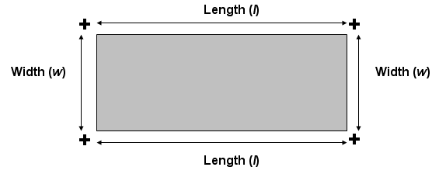

***Prect =2l +2w***

### The Area and Perimeter of a Square

A square is a four-sided figure in which all four sides are the same length, they are parallel to one another and the angle between each adjacent side is at right angles to its neighbour. It’s a lot easier to see a square than to describe one.

Square

A square showing all sides are equal, parallel and at right angles to one another

The sides all have the same length, A, and each side is parallel to the opposite side and at 90 degrees to its neighbours. The square in each corner indicates that these are right angles.

**Area(a) = l × w (unit: m ²)**

If the side of a square is 12 centimetres, what is its area? The area is 12 × 12 = 144 so its area is 144 square centimetres (cm2).

Squares are therefore simpler, because their lengths and widths are identical. The area and perimeter of a square versus length (*s*) are given by:

***Psqr = 4s***

### Circle

A round plane figure whose boundary is made up of points at an equal distance from the centre. The area of a circle is a bit more complicated to calculate but not difficult. Below is a circle with a radius, r.

The radius is the measurement from the centre of the circle to its boundary. Note that the radius is always the same in the same circle no matter the angle it is drawn at. The diameter is the cross section of the circle and is always twice the length of the radius.

An irrational number, π (Greek letter ‘pi’), is used in circular calculations. An irrational number is one that has an infinite number of digits after the decimal point. In addition, the decimal portion of an irrational number does not have a pattern of digits that repeat and never ends in zero. Furthermore, irrational numbers cannot be represented by a fraction.

**r**

**a**

**Area (a) = π × r ² (unit: m ²)**

The area of the circle is **π × r2, where π** = 3.14159265, or simply 3.14, approximately.

So the area of a circle is **3.14 × r2.**

For an example, if the radius of a circle is 8 metres, the area would be **3.14 × 82 = 3.14 × 64 = 200.96 square metres (m2)**, approximately.

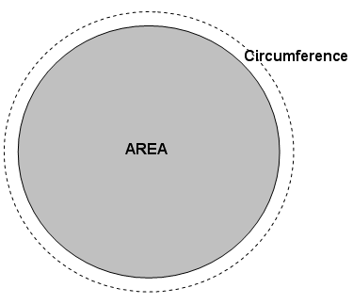Many people use  as an approximation for π.

 = 3.1429 rounded to 4 decimal places (ten-thousandth)

You should know the formula for the circumference *C* and the area *A* of a circle, or given the radius *r:*

***Acir = (pi)r2***

**Circumference: *Ccir = 2(pi)r***

(“pi” is the number approximated by 3.14159)

The circumference of the circle is **2** **× π × r, where π** = 3.14 and **2 × π = 6.28**, approximately. So the circumference of a circle is **6.28 × r.**

For an example, if the radius of a circle is 8 metres, the circumference would be **6.28 × 8 = 6.26 × 8 = 50.08 metres (m)**, approximately.

Remember that the radius is the distance from the centre to the outside of the circle. In other words, the radius is *halfway* across. If you deal with the diameter of a circle, the length of a line going all the way across, then you have to divide in half to apply the above formulas.

### Parallelogram

A parallelogram is rectangle with a tilt. All sides are parallel but the angles between the sides differ.

Parallelogram

In order to help you visualize a parallelogram, I drew in vertical lines to form a right-angled triangle from the intersection of the sides A and B to the opposite side. Notice what this figure is showing us. If I cut the left triangle off the parallelogram and stick it on the right side, I have a rectangle! Therefore, the parallelogram is nothing but a rectangle with a tilt. The tilt is called a ‘shear’ in many industries. (And it has nothing to do with sheep!) You won’t find parallelograms with the dashed lines so don’t expect to see them. However, you should be able to look at a parallelogram, or something close to one, by putting in the dashed lines mentally.

In order to calculate the area of a parallelogram I use exactly the same formula to calculate the area of a rectangle: Area = A × B.

### Observations for square, rectangle, parallelogram and rhombus

The rectangle, square and parallelogram have the same characteristics: each has two pairs of parallel sides. Therefore, each one is simply a variation on the parallelogram and all their areas are calculated as base × height. The square is a rectangle with its base and height equal. The rectangle is a parallelogram with straight sides and the rhombus is a parallelogram with an equal base and height.

The most general of these four figures is the parallelogram: it has two parallel sides. And nothing is said about the lengths of these sides or the angle between the two sets of parallel sides. A rectangle is a parallelogram with right angles (90 degrees). A square and a rhombus have equal sides.

### Trapezium

**Trapezium** is a quadrilateral: a closed shape with four linear sides that has one pair of parallel lines for sides. Some [define it as a quadrilateral having *exactly* one pair of parallel sides, so that parallelograms can be excluded, but most mathematicians use the inclusive definition.

[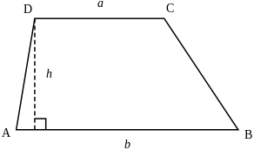](http://en.wikipedia.org/wiki/Image:Trapezoid.svg)

The area of a trapezoid can be computed as the length of the mid-segment, multiplied by the distance along a perpendicular line between the parallel sides. Thus, if a and b are the two parallel sides and h is the distance (height) between the parallels, the area formula is as follows:

A= h\frac{a + b}{2}.

The quantity \frac{a + b}{2}is the average of the horizontal lengths of the trapezoid, so the area can be understood to be the product of the height and average length of the shape.

## Theorem of Pythagoras

RightTriangle_1RightTriangle

The Greek mathematician, Pythagoras, made a very important discovery about the sides of a right-angled triangle. A right-angled triangle is one in which two of the three legs are at right angles to one another, that is, they are 90° to one another.

All triangles have three sides. In this triangle the three sides are named ‘A’, ‘B’ and ‘C’. The little square at the bottom left and inside the triangle indicates the angle between side B and side C is 90° making this a right-angled triangle.

Pythagoras discovered that the relationships between the sides of a right-angled triangle are related in a specific way: A2 = B2 + C2. That is, the length of side B squared (multiplied by itself) plus the length of side C squared equals the square of the length of A. Side A is also called the hypotenuse.

#### Hypotenuse example

Calculate the hypotenuse of the right-angled triangle:

The hypotenuse is equal to the square root of the sum of the square of the other two sides: A2 = B2 + C2. Therefore: A2 = 52 + 122.= 25 + 144 = 169. Since 13 × 13 = 169, the hypotenuse is 13 metres.

### Combining areas

We now know enough about rectangles and triangles to work out some simple problems. The figure below shows a rough drawing of the side of a large building. Calculate the surface area of this building so you know how much paint to order so that it may be painted.

SimpleHouse

The house basically consists of a rectangle and a triangle. The area of the rectangle is 16 × 8 = 128 square metres (m2). The area of the triangle is (16 × 4) = 32 square metres **(m2).** Adding these figures we obtain 160 square metres (m2). If we knew that we use about 5 litres of paint for each 20 m2 we could calculate that we need about 8 tins each of 5 litres of paint. This would be 40 litres altogether. Check if I’m correct!

Noticing symmetry often allows quicker and simpler calculations to be made. So if you have to measure something that looks symmetrical, take advantage of it. You will not only save yourself some time but may make fewer mistakes because you have less to do.

## SI Units

The SI or **Systéme International** consists of 7 base units, which were taken into use in order to have a worldwide acknowledged unit system. This has significantly simplified the sharing of information between countries with different traditional units.

|  |  |  |
| --- | --- | --- |
| **Quantity** | **Unit** | **Abbreviation** |
| Mass | Kilogram | kg |
| Length | Meter | m |
| Time | Second | s |
| Temperature | Kelvin | K |
| Current | Ampére | A |
| Light | Candela | cd |
| Chemical standard unit | Mole | mol |

It is VERY important to always indicate a unit. The unit is what gives meaning to a number. Just think 3000 tells you nothing about what this number is for or what it does, but R3000 is very useful! Also remember to indicate the unit EXACTLY as it is shown above. Km is wrong and so is S, if the unit is not given exactly right your answer will be wrong!

The symbols in the last column are not abbreviations (hence, no periods are used), and they are exactly the same in all languages. Prefixes may be added to these symbols in order to conveniently refer to very large or very small quantities. The prefixes are listed below:

|  |  |  |  |
| --- | --- | --- | --- |
| Prefix | Symbol | Factor | Power of 10 |
| Exa | E | 1,000,000,000,000,000,000 | 18 |
| Peta | P | 1,000,000,000,000,000 | 15 |
| Tera | T | 1,000,000,000,000 | 12 |
| Giga | G | 1,000,000,000 | 9 |
| Mega | M | 1,000,000 | 6 |
| Kilo | k | 1,000 | 3 |
| Hecto | h | 100 | 2 |
| Deka | da | 10 | 1 |
| Deci | d | 0.1 | -1 |
| Centi | c | 0.01 | -2 |
| Milli | m | 0.001 | -3 |
| Micro | µ | 0.000001 | -6 |
| Nano | n | 0.000000001 | -9 |
| Pico | p | 0.000000000001 | -12 |
| Femto | f | 0.000000000000001 | -15 |
| Atto | a | 0.000000000000000001 | -18 |

These prefixes are used for every unit (supplementary or derived) with the exception of the kilogram. Examples are millimetre (mm), kilometre/hour (km/h), megawatt (MW), and picofarad (pF). Because double prefixes are not used, and because the base unit kilogram already contains a prefix, prefixes are not used with kilogram, although they are used with gram.

The prefixes **hecto, deka, deci and centi** are used only rarely, and then usually with metre to express areas and volumes. Because of established usage, the centimetre is retained for body measurements and clothing.

Converting between units is straightforward as these examples show. Remember that you are only moving a decimal point and changing a name. You don’t have any real arithmetic to do.

**1kg (kilogram) = 1,000g (grams) = 100dag (dekagrams) = 10hg (hectograms).**

**1kl (kilolitre) = 1,000l (litres) = 100dal (decilitres) = 10hl (hectolitres).**

Although the values of the factors differ by multiples of 10, some symbols and names are rarely used. Of the six symbols and names in this example, I have only seen kg (kilogram), g (gram) and l (litre). So let’s look at some common uses.

If I travel 1,000km I say: ‘I travelled 1,000kms.’ I don’t say: ‘I travelled 1Mm (megametre)’. It is not incorrect to use megametre for 1,000km but nobody I know uses that phrase. However, you may see a few other uses that at first glance appear strange. The contents of bottles may contain 750ml or 75dl but not usually 0.75l and medication may contain 600mg of a substance but not usually 0.6g. These values refer to the same measurements (750ml = 75dl = 0.75l and 600mg = 0.6g).

### Using the SI system

The SI system uses the metric (decimal) system and uses a number of standard prefixes for units of length and mass that were covered in the previous section. Using the SI system means that we should know the most important ones. The three most important ones are:



The SI unit of time is the second. Time measured in intervals less that one second follow the factors defined by the SI system. However, time is not completely decimal and intervals greater than a second are measured differently. Below are the relationship between the different time units based on the second.

|  |  |
| --- | --- |
| **Unit** | **Consists of** |
| 1 minute | 60 seconds |
| 1 hour | 60 minutes |
| 1 day | 24 hours |
| 1 week | 7 days |
| 1 year | 12 months |
| 1 decade | 10 years |
| 1 century | 100 years |
| 1 millennium | 1000 years |

Note that one year consists of 12 months but the month has not been defined. As an approximation, a month consists of 30 days and 22 workdays. For calculations of intervals less than one week the second is accurate and may be used. However, the second is rarely used for intervals greater than one day.

The relationship of a week, day, hour and minute calculated in terms of seconds.

|  |  |
| --- | --- |
| **Unit** | **Calculation to seconds** |
| 1 minute | 60 seconds |
| 1 hour | 60 minutes  3600 seconds (60 × 60) |
| 1 day | 24 hours  1,440 minutes (24 × 60)  86,400 seconds (24 × 60 × 60) |
| 1 week | 7 days  168 hours (7 × 24)  10,080 minutes (7 × 24 × 60)  604,800 seconds (7 × 24 × 60× 60) |

## 

## The imperial (UK) number system

The imperial system, now called the UK system, was used, until very recently, for all weights and measures throughout the UK. There are many aspects of everyday life where the system is still in common usage. Road signs are an obvious example where miles instead of kilometres are used.

The UK system measurement of length:

|  |  |  |
| --- | --- | --- |
| **Length** | | |
| 12 inches | = | 1 foot |
| 3 feet | = | 1 yard |
| 22 yards | = | 1 chain |
| 10 chains | = | 1 furlong |
| 8 furlongs | = | 1 mile |
| 5280 feet | = | 1 mile |
| 1760 yards | = | 1 mile |

UK system for length

The UK system for area.

|  |  |  |
| --- | --- | --- |
| Area | | |
| 144 sq. inches | = | 1 square foot |
| 9 sq. feet | = | 1 square yard |
| 4840 sq. yards | = | 1 acre |
| 640 acres | = | 1 square mile |

The UK system for volume

|  |  |  |
| --- | --- | --- |
| Volume | | |
| 1728 cu. inches | = | 1 cubic foot |
| 27 cu. feet | = | 1 cubic yard |

The UK system for capacity.

|  |  |  |
| --- | --- | --- |
| Capacity | | |
| 20 fluid ounces | = | 1 pint |
| 4 gills | = | 1 pint |
| 2 pints | = | 1 quart |
| 4 quarts | = | 1 gallon (8 pints) |

The UK system for mass(avoirdupois)

|  |  |  |
| --- | --- | --- |
| Mass (Avoirdupois) | | |
| 437.5 grains | = | 1 ounce |
| 16 ounces | = | 1 pound (7000 grains) |
| 14 pounds | = | 1 stone |
| 8 stones | = | 1 hundredweight [cwt] |
| 20 cwt | = | 1 ton (2240 pounds) |

### Approximations and estimations

Before looking at approximations, there are a number of definitions between the UK system of measurement and the SI system of measurement that must be mentioned. The definitions in the table below marked with an asterisk (\*) are exact and have been agreed upon by the international agencies that regulate and define the methods of measurements. Only the commonly used units are given in this manual.

|  |  |
| --- | --- |
| Factors for converting customary UK units to SI units | |
| 1 yard | 0.9144 metre\* |
| 1 foot | 0.3048 metre\* |
| 1 inch | 0.0254 metre\* |
| 1 statute mile | 1,609.344 metres\* |
| 1 nautical mile (international) | 1,852 metres |
| 1 pound (avdp.) | 0.45359237 kilogram\* |
| 1 oz (avdp.) | 0.02834952 kilogram |
| 1 pound force | 4.44822 newtons |
| 1 slug | 14.5939 kilograms |
| 1 foot pound | 1.35582 joules |
| Temperature (Fahrenheit) | 32 + (9/5) Celcius\* |

Common conversion factors from UK and US units to SI units

To convert between the two systems, do the following:

To convert from Imperial to S1, multiply the imperial unit by the factor in the S1 column, e.g. if you want to know what 25 yards are in metres, multiply 25 by 0.9144 = 22.86 metres.

To convert from S1 to Imperial, divide the S1 unit by the factor shown in the S1 column, e.g. if you have a distance of 25 metres and you want to know what that distance is in yards, divide 25 by 0.9144 = 27.34 yards.

if someone weighs 300 pounds, multiply 300 by 0.45359237 = 136.07 kg. If someone weighs 75kg, divide 120 by 0.45359237 = 165.35 pounds.

### Temperature scales:

There are three commonly used temperature scales:

1. The Celsius scale is the most commonly used temperature scale.
2. The Fahrenheit scale is used in the United States.
3. The absolute or Kelvin scale is used in scientific work.

The Fahrenheit and Celsius scales assign arbitrary values to both freezing and boiling points of water at atmospheric pressure.

|  |  |  |
| --- | --- | --- |
|  | Celsius | Fahrenheit |
| Freezing point | 0.00°C | 32.0°F |
| Boiling point | 100°C | 212°F |

Between these two reference points the Celsius scale is divided into 100 equal units and the Fahrenheit scale into 180 equal units. This makes it easy to convert from Celsius to Fahrenheit or vice versa, as each value of Celsius has a corresponding Fahrenheit value, 1°F = 9/5°C. The conversion formulas are as follows:

**T(°C) = 9/5[T(°F)-32] or T(°F) = 9/5T(°C) + 32**

It may be easier to simply remember that 0°C=32°F and that 5°C=9°F.

### Convert from Fahrenheit to Celsius using the formulae

**T(°C) = 9/5[T(°F)-32]**

**°F = 98.6**

**°C = ?**

Substitute in formulae above

**T(°C) = 9/5 x [98.6 – 32]**

**T(°C) = 9/5 x [66.6]**

**T(°C) = 37°C**

**Convert Fahrenheit into Celsius using the formula:**

**T(°F) = 9/5T(°C ) + 32**

**°C = 37**

**°F = ?**

Substitute in formulae given above **T(°F) = 9/5 x 37°C + 32**

**T(°F)= 66.6°C + 32**

**T(°F) =98.6 °F**

It is important to remember that different thermometers are made from various materials and filled with different substances, in practice this means that they all expand and contract differently in response to changes in temperature. Because of this most thermometers are only reliable within a set range of temperatures.

## Activity 1 (SO1, AC1-7)

## Rough Sketches

A rough sketch is a quick drawing of something that gives you a reasonable impression of a scene, object or surroundings but without much detail. The following is an example of a top view of a scene or incident that may be typical in a security situation.

A rough sketch is normally not according to scale but rather in proportion or in relation to size. This means that you may use a tape measure to indicate distances in relation to vital points or may even pace the distance between objects. The sketch may or may not be very accurate. However, the essentials have been captured in the sketch.

Some important elements must be displayed on such a rough sketch, such as:

* The direction north always pointing towards the top or at least like on a clock 10 to 2 or 10 past 10.

N

N

N

N

* The title “Rough sketch” on top of the drawing.
* The name of streets or buildings clearly displayed.
* Alphabetical numbering of critical elements on or at the scene if you are sketching a crime scene or incident scene.
* The name of the person drawing the sketch.
* The date and time of the sketch.
* Clear indication of grass, road surfaces and any other information that may assist the user of the sketch.
* Signature of the originator.

The sketch should have a separate sheet containing a key or explanation to the sketch. This we call the key or legend to the sketch. In the legend you set out measurements between points or distances.

### Sketching in general

Sketches may be very rough, giving only a few small details, to very detailed enabling an item to be manufactured. The difference between a rough sketch and a sketch that is precise is not well defined. Additional information must be supplied with a sketch to provide enough detail to serve the purpose of the drawing.

So the ‘roughness’ of sketch may vary from a few lines drawn in the dirt with a stick to precision drawings used in fine engineering. A soccer team planning its strategy will sketch only the details required so that each player knows his function and the action he must take in order to work as a team. The important thing to remember is that the detail that must be included in a sketch must suit the user of the sketch. The sketch must contain all the necessary information to convey the information required by the person using it.

#### Example 2

A woman making her own clothes or clothing for her children uses rough sketches to make the garment. Whether she draws the sketches herself or purchases them as a pattern in a shop, she still works with a rough drawing. A typical pattern for a girl’s garment is shown below.

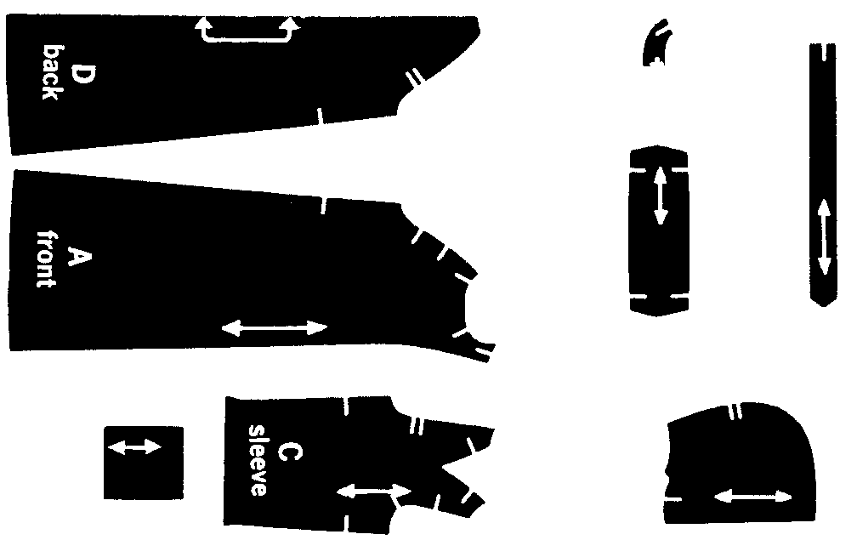

The ‘documentation’, ‘report’, or whatever you want to call it, consists of the metric measurements and information on how to layout, cut and sew the pieces together. As an aid to the seamstress who is making this garment, the original packet has illustrations of several variations of finished items.

#### Example 3

Imagine that you and your colleagues want to improve communications within your organization, church or local charity. In order to do this you decide that a monthly newsletter would help keep everyone in touch. In order to publish the newsletter you first want to get an idea of what the finished product would look like. You and your colleagues may discuss your needs but until you sketch a rough copy of its layout you really don’t know what to expect.

The documentation that accompanies these rough sketches would probably include the size of paper to use, whether the newsletter was folded or stapled, the use of one or both sides of the page, the number of columns and the font types and sizes to be used.

See the next page for the visual of the example.

#### Example 4

A physics teacher might want to convey the action and reaction of forces and decides that a demonstration of a man fishing would be suitable. Below is the rough drawing that the teacher used to explain the concepts.

In this case the teacher does not need to show the person or fish in any detail nor does his scale need to be accurate. His ‘report’ would describe the forces involved. He would probably show his learners how to perform the calculations as well.

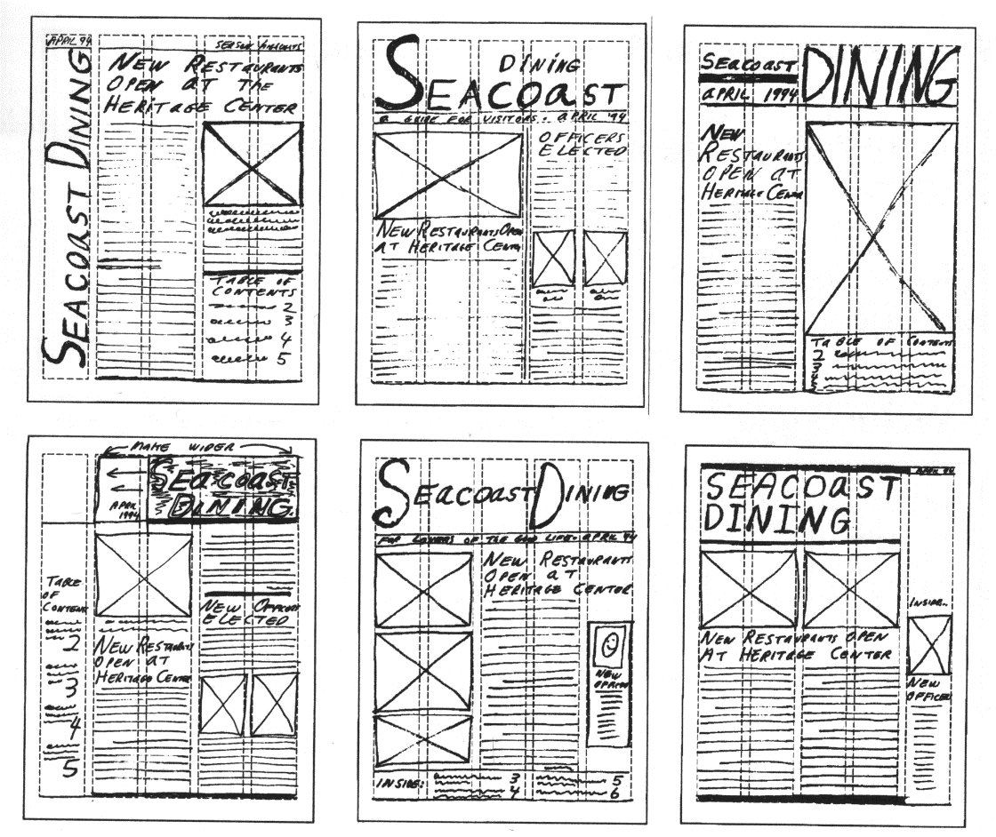

A rough sketch of a newsletter

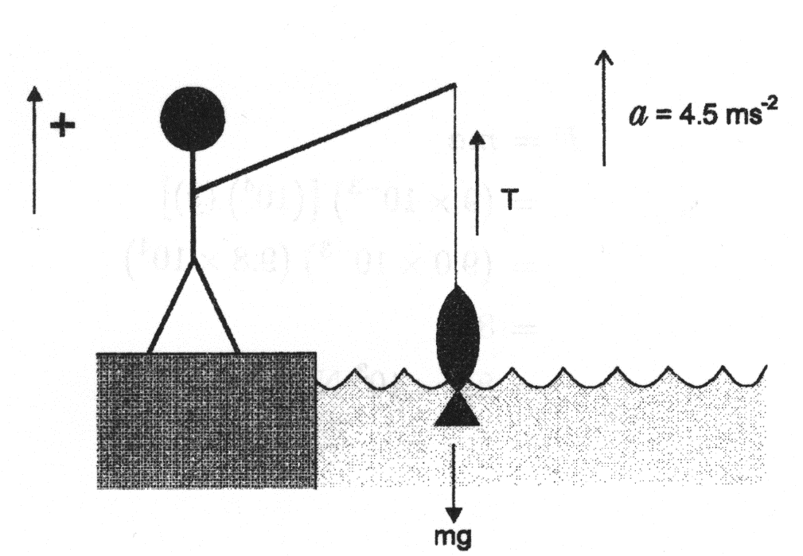

A rough sketch for a physics lesson

#### Example 5

The concept of a computer network.

network1

## ComputerChair_2Scale Drawings

A scale drawing is a reduced or enlarged drawing of an original but it is drawn true to scale. Below is a scale drawing of a chair that was done on a computer. Notice how realistic it looks. Closer inspection will show that it is indeed a drawing and not a photograph.

Although it shows a realistic drawing of a chair, it may be considered a rough sketch by some. A manufacturer can’t build the chair from this sketch. There are no scale or size measurements that go with the chair.

The difference between a realistic drawing and a rough sketch is determined by the user of the sketch. The person creating the sketch may put too little or too much detail in the drawing for it to satisfy the needs of the user of the sketch.

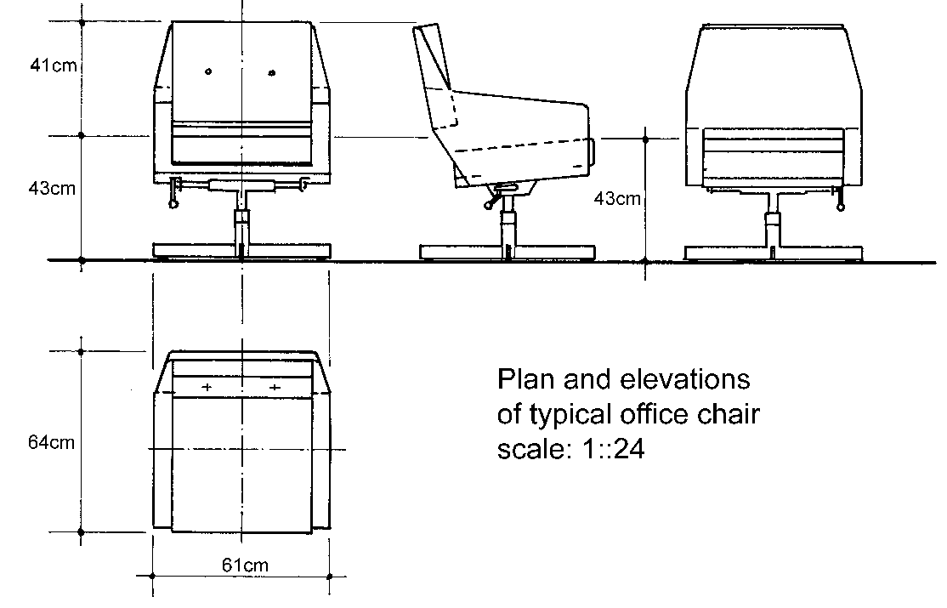

Another typical office chair that answers some of the criticism concerning the previous drawing.

Is this sketch better or worse than the previous one? Why? Can I build this chair in my factory? Why not?

### Adding detail to scale drawings

In order to understand scale drawings it is a good idea to start from the known and proceed to the unknown. We are going to start with geometric shapes that are drawn to scale then proceed all the way to an introduction to engineering drawings.

The steps that take us from the rough to the precise involve four steps:

1. Learn how to make square and isometric drawings of geometrical shapes.
2. Learn what plans and elevations are when making drawings.
3. Learn what is meant by ‘nets’ of objects and use these nets to visualize and measure three-dimensional objects.
4. See examples of engineering drawings and the detail they contain.

Let’s look at the simple geometric drawings that were used in previous sections. Two-dimensional items must be drawn to scale in order to appreciate what they are telling us.

There are several ways to represent two-dimensional objects. Annexure A contains a standard square grid while the second page contains an isometric grid. The first page is obviously a page of squares, but what is the second page a picture of? The second page is a pattern of triangles! Look at this page again and you will see that the dots make up triangles with the edges removed.

### grid-squareUsing rectangular grids

Both square and isometric grids may be used to assist with 2D or 3D drawings. On the right is a square drawn on a square grid and the next figure shows a triangle drawn on a square grid.

grid-triangle

A triangle drawn on a square grid

Square grid paper is usually just referred to as grid paper. Some grid paper provides subdivisions that allow you to sketch very accurately. A popular grid is the millimetre grid that has very thin lines placed every millimetre and slightly thicker lines marking the centimetre. Some versions of the millimetre grid use slightly differently coloured lines to identify the different spacing.

Not only can you draw accurately using grid paper but you may use the grid to measure items as well. In addition, you may trace an item directly on the grid paper and have an accurate drawing that you can measure.

What is the area of the square and the area of the triangle? The area of the square is 16 units2 and the area of the triangle is 12.5 units2. I use the term ‘units’ because I do not have any information concerning the size of each square.

These drawings may be scale drawings of real items or they might be the real sizes of these items. If the squares represent centimetres then the area is given in cm2. If the squares represent metres then the areas of the items are measured in m2.

**N**

Room 12

Second floor

Kagiso building

James street

Coco town

**Rough Sketch**

**Table**

**Desk**

A

Cabinet

B

Compiled by: SO John Dlamini

On 31 April 2005 22:00

### Legend to sketch

Point A: Place of entry, broken window on northern side of office.

Point B: Location of cabinet (where money was stored).

**Distances on rough sketch**

Point A to B: 2.4 m

With of room 12: 2 m

Length of room 12: 2.5 m

# Two Dimensional Geometric Figures

#### Outcome

Explore transformations of two dimensional geometric figures

#### Outcome Range

* Use parallelism, symmetry, translation, reflection and rotation in describing artefacts
* Make conjectures about mathematical relationships found in artefacts
* Use transformations and symmetry in describing objects
* Use transformations and symmetry in designing patterns in 2 dimensions (e.g., tessellations, dress material, logos) of interest to teenagers

#### Assessment criteria

* Properties of symmetrical shapes are recognised and described
* The concept of lines of symmetry in 2-dimensional figures is explored using paper folding and reflections in the lines of symmetry
* The concept of transformation in terms of reflections, translations and rotations is identified and explained using concrete materials
* The descriptions are based on correct application of transformations and other geometrical properties
* Designs, based on transformations and other geometrical properties are innovative, and correct geometrically

## Transformation

All the geometrical shapes can be transformed (changed) by reflections (a mirror image) or rotating the image:

### Rotate

Rotation is a transformation in a plane or in space that describes the motion of a rigid body around a fixed point: the entire image is rotated by a certain number of degrees from 1 to 360. It retains its shape, but is turned sideways or upside down.

All these rotations are **90º** left or right.

SimpleHouse

SimpleHouse

Partial rotations are also possible:

A rotation, a reflection and a translation transformation are isometries, meaning that, they leave the distance between any two points unchanged after the transformation.

[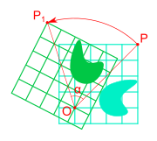](http://en.wikipedia.org/wiki/Image:Rotation_illustration2.svg)

### Mirror image (reflection)

A reflection "flips" the bodies it is transforming

ComputerChair_2ComputerChair_2

ComputerChair_2

Mirror images can also be rotated:

### Translation

A translation has no fixed point, so it changes the position of an object, without changing the shape of the object.

### Other transformations

These images can also be transformed in different ways:

Circles can become ovals:

Rectangles can become squares and squares can become rectangles:

Parallelograms can become rectangles or squares

And shapes and images can be skewed (drawn out of proportions)

ComputerChair_2

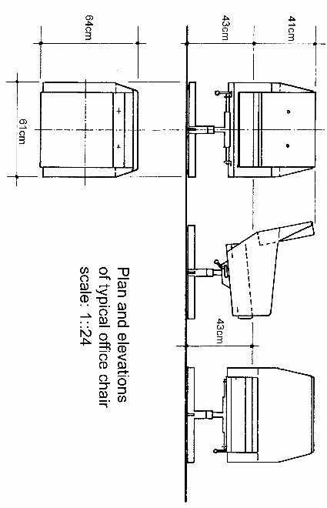Drawings can be rotated, mirrored or skewed:

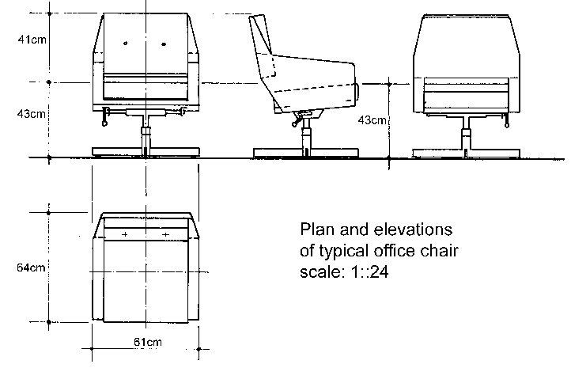

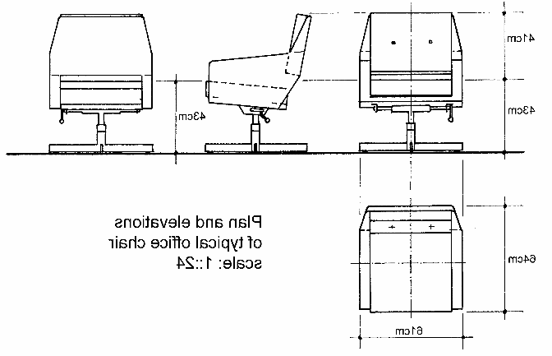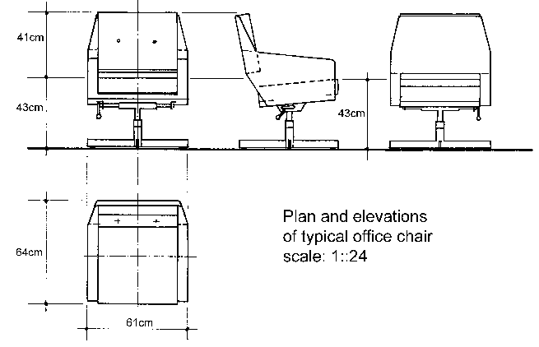

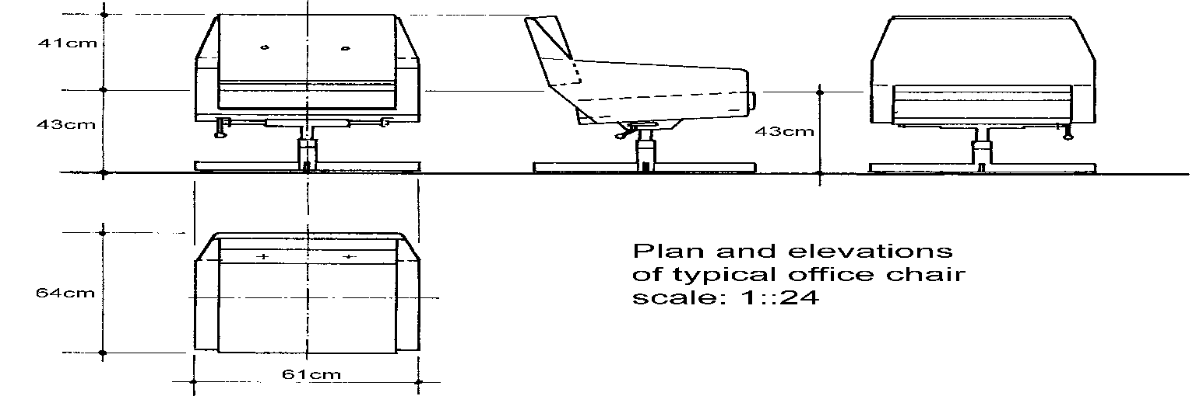

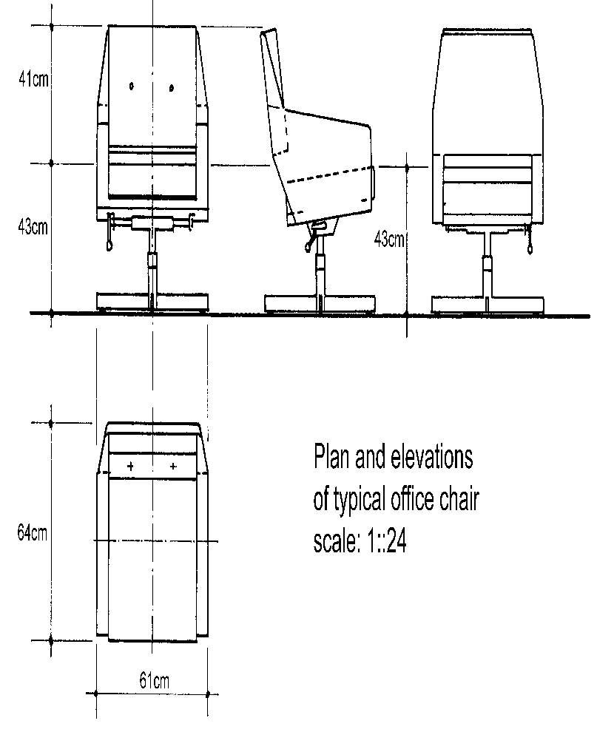

### Tessellation

Another word for a tessellation is a tile. Actually, a tessellation refers to a set of tiles that make up a pattern. The tiles are like those you may see every day on floors and walls. Tessellations are the ultimate in symmetrical displays.

A dictionary will tell you that the word ‘tessellate’ means to form or arrange small squares in a chequered or mosaic pattern. The word ‘tessellate’ is derived from the Ionic version of the Greek word ‘tesseres’ which in English means "four." The first tilings were made from square tiles.

A regular polygon has 3 or 4 or 5 or more sides and angles and all sides and angles are equal. A regular tessellation means a tessellation made up of congruent regular polygons. A regular polygon is a polygon in which sides all the same length. ‘Congruent’ means that the polygons that you put together are all the same size and shape.

Only three regular polygons tessellate, that is, are able to be put together so that none overlap and there are no gaps between the tiles. Here are three simple examples of tessellations made from triangles, squares and hexagons (A triangle is a three-sided polygon, a square is a four-sided polygon and a hexagon is a six-sided polygon. The work ‘polygon’ means many sides.

tess-triangles2

A tessellation of triangles

tess-squares

A tessellation of squares

tess_hex

A tessellation of hexagons

When you look at these three figures you notice that the squares are lined up with each other while the triangles and hexagons are not. In addition, if you take six triangles and put them together you will notice that they form a hexagon. Look at the shape of the hexagon then look at the row of triangles. If you can’t see the hexagon, take the first six triangles, three from each row, and cover the rest of the line. Tiling, or tessellating, triangles and hexagons are similar.

Tessellations have been used for thousands of years and every culture uses them. The following figures show a few tessellations.

tess-rect

A tessellation made from groups of five squares

tess-triangles

A tessellation consisting of triangles

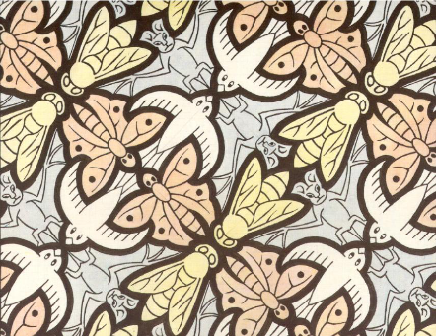

A tessellation of bats, birds, butterflies and bees (MC Escher)

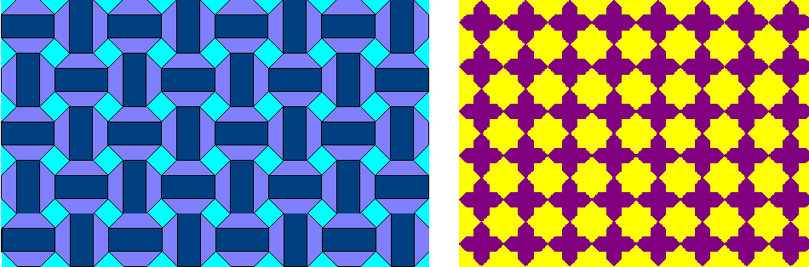

Two tessellations from North Africa

Note the symmetry in each tessellation. Identify the shapes that are contained in each tessellation and see if you can make a simple one yourself.

An interesting word that is used to describe repeating tile patterns is ‘rep-tiles’ or ‘reptiles’. The term has nothing to do with snakes, lizards or crocodiles but is frequently encountered when reading about tessellations.

## Activity 2 (SO2, AC1-5)

grid

isometric