**LEARNER Guide**

**Principles of the Internet**

Unit Standard 115391

Level 4 Credits 3

TABLE OF CONTENTS

TABLE OF CONTENTS 2

PERSONAL INFORMATION 4

INTRODUCTION 6

Programme methodology 6

What Learning Material you should have 7

Different types of activities you can expect 10

Learner Administration 12

Assessments 12

Learner Support 13

Learner Expectations 14

PRINCIPLES OF THE INTERNET 16

UNIT STANDARD 115391 16

PRINCIPLES OF THE INTERNET AND THE WWW 18

History of the Internet 19

Who controls the Internet? 20

Internet applications 21

Instant communication 21

File sharing 21

Streaming media 21

VoIP 22

Internet access 22

Wi-Fi 22

Social networking 23

Advertising 23

HOW THE WWW INCORPORATES INTERNET APPLICATIONS 24

History of the WWW 25

Who controls the WWW? 25

Physical content of web pages 25

Perceived (rendered) information: 27

Intranet and extranet 31

Intranet 31

Extranet 31

Incorporating Internet applications in the WWW 32

Web-based e-mail 32

Instant messaging 33

VoIP 34

Formative assessment 36

PERSONAL INFORMATION

|  |  |
| --- | --- |
| **NAME** |  |
| **CONTACT ADDRESS** |  |
|  |
| **Code** |  |
| **Telephone (H)** |  |
| **Telephone (W)** |  |
| **Cellular** |  |
| **Learner Number** |  |
| **Identity Number** |  |
|  | |
| **EMPLOYER** |  |
| **EMPLOYER CONTACT ADDRESS** |  |
|  |
| **Code** |  |
| **Supervisor Name** |  |
| **Supervisor Contact Address** |  |
|  |
| **Code** |  |
| **Telephone (H)** |  |
| **Telephone (W)** |  |
| **Cellular** |  |

**INTRODUCTION**

#### Welcome to the learning programme

Follow along in the guide as the training practitioner takes you through the material. Make notes and sketches that will help you to understand and remember what you have learnt. Take notes and share information with your colleagues. Important and relevant information and skills are transferred by sharing!

This learning programme is divided into sections. Each section is preceded by a description of the required outcomes and assessment criteria as contained in the unit standards specified by the South African Qualifications Authority. These descriptions will define what you have to know and be able to do in order to be awarded the credits attached to this learning programme. These credits are regarded as building blocks towards achieving a National Qualification upon successful assessment and can never be taken away from you!

### Programme methodology



The programme methodology includes facilitator presentations, readings, individual activities, group discussions and skill application exercises.

**Know what you want to get out of the programme from the beginning and start applying your new skills immediately. Participate as much as possible so that the learning will be interactive and stimulating.**

The following principles were applied in designing the course:

* Because the course is designed to maximise interactive learning, you are encouraged and required to participate fully during the group exercises
* As a learner you will be presented with numerous problems and will be required to fully apply your mind to finding solutions to problems before being presented with the course presenter’s solutions to the problems
* Through participation and interaction the learners can learn as much from each other as they do from the course presenter
* Although learners attending the course may have varied degrees of experience in the subject matter, the course is designed to ensure that all delegates complete the course with the same level of understanding
* Because reflection forms an important component of adult learning, some learning resources will be followed by a self-assessment which is designed so that the learner will reflect on the material just completed.

This approach to course construction will ensure that learners first apply their minds to finding solutions to problems before the answers are provided, which will then maximise the learning process which is further strengthened by reflecting on the material covered by means of the self-assessments.

#### Different role players in delivery process

* Learner
* Facilitator
* Assessor
* Moderator

### What Learning Material you should have

This learning material has also been designed to provide the learner with a comprehensive reference guide.

It is important that you take responsibility for your own learning process; this includes taking care of your learner material. You should at all times have the following material with you:

|  |  |
| --- | --- |
| **Learner Guide** | **This learner guide is your valuable possession:**  This is your textbook and reference material, which provides you with all the information you will require to meet the exit level outcomes.  During contact sessions, your facilitator will use this guide and will facilitate the learning process. During contact sessions a variety of activities will assist you to gain knowledge and skills.  Follow along in the guide as the training practitioner takes you through the material. Make notes and sketches that will help you to understand and remember what you have learnt. Take and share information with your colleagues. Important and relevant information and skills are transferred by sharing!  This learning programme is divided into sections. Each section is preceded by a description of the required outcomes and assessment criteria as contained in the unit standards specified by the South African Qualifications Authority. These descriptions will define what you have to know and be able to do in order to be awarded the credits attached to this learning programme. These credits are regarded as building blocks towards achieving a National Qualification upon successful assessment and can never be taken away from you! |
| **Formative Assessment Workbook** | The Formative Assessment Workbook supports the Learner Guide and assists you in applying what you have learnt.  The formative assessment workbook contains classroom activities that you have to complete in the classroom, during contact sessions either in groups or individually.  You are required to complete all activities in the Formative Assessment Workbook.  The facilitator will assist, lead and coach you through the process.  These activities ensure that you understand the content of the material and that you get an opportunity to test your understanding. |

### Different types of activities you can expect

To accommodate your learning preferences, a variety of different types of activities are included in the formative and summative assessments. They will assist you to achieve the outcomes (correct results) and should guide you through the learning process, making learning a positive and pleasant experience.



The table below provides you with more information related to the types of activities.

| **Types of Activities** | **Description** | **Purpose** |
| --- | --- | --- |
| **Knowledge Activities** | You are required to complete these activities on your own. | These activities normally test your understanding and ability to apply the information. |
| **Skills Application Activities** | You need to complete these activities in the workplace | These activities require you to apply the knowledge and skills gained in the workplace |
| **Natural Occurring Evidence** | You need to collect information and samples of documents from the workplace. | These activities ensure you get the opportunity to learn from experts in the industry.  Collecting examples demonstrates how to implement knowledge and skills in a practical way |

### Learner Administration



#### Attendance Register

You are required to sign the Attendance Register every day you attend training sessions facilitated by a facilitator.

#### Programme Evaluation Form

On completion you will be supplied with a “Learning programme Evaluation Form”. You are required to evaluate your experience in attending the programme.

Please complete the form at the end of the programme, as this will assist us in improving our service and programme material. Your assistance is highly appreciated.

### Assessments

The only way to establish whether a learner is competent and has accomplished the specific outcomes is through the assessment process. Assessment involves collecting and interpreting evidence about the learners’ ability to perform a task.

**To qualify and receive credits towards your qualification, a registered Assessor will conduct an evaluation and assessment of your portfolio of evidence and competency.**

**This programme has been aligned to registered unit standards. You will be assessed against the outcomes as stipulated in the unit standard by completing assessments and by compiling a portfolio of evidence that provides proof of your ability to apply the learning to your work situation.**



**How will Assessments commence?**

#### Formative Assessments

The assessment process is easy to follow. You will be guided by the Facilitator. Your responsibility is to complete all the activities in the Formative Assessment Workbook and submit it to your facilitator.

#### Summative Assessments

You will be required to complete a series of summative assessments. The Summative Assessment Guide will assist you in identifying the evidence required for final assessment purposes. You will be required to complete these activities on your own time, using real life projects in your workplace or business environment in preparing evidence for your Portfolio of Evidence. Your Facilitator will provide more details in this regard.

**To qualify and receive credits towards your qualification, a registered Assessor will conduct an evaluation and assessment of your portfolio of evidence and competency.**

### Learner Support

**The responsibility of learning rests with you, so be proactive and ask questions and seek assistance and help from your facilitator, if required.**



Please remember that this Skills Programme is based on outcomes based education principles which implies the following:

* You are responsible for your own learning – make sure you manage your study, research and workplace time effectively.
* Learning activities are learner driven – make sure you use the Learner Guide and Formative Assessment Workbook in the manner intended, and are familiar with the workplace requirements.
* The Facilitator is there to reasonably assist you during contact, practical and workplace time for this programme – make sure that you have his/her contact details.
* You are responsible for the safekeeping of your completed Formative Assessment Workbook and Workplace Guide
* If you need assistance please contact your facilitator who will gladly assist you.
* If you have any special needs please inform the facilitator

### Learner Expectations

Please prepare the following information. You will then be asked to introduce yourself to the instructor as well as your fellow learners



|  |
| --- |
| Your name: |
|  |
|  |
| The organisation you represent: |
|  |
|  |
| Your position in organisation: |
|  |
|  |
| What do you hope to achieve by attending this course / what are your course expectations? |
|  |
|  |
|  |
|  |
|  |

PRINCIPLES OF THE INTERNET

UNIT STANDARD 115391

Unit standard title

Demonstrate an understanding of the principles of the internet and the world-wide-web

NQF Level

4

Credits

3

Purpose

People credited with this unit standard are able to:

* Explain the principles of the internet and the world-wide-web
* Explain how the world-wide-web incorporates the various internet applications

The performance of all elements is to a standard that allows for further learning in this area

Learning assumed to be in place

The credit value of this unit is based on a person having prior knowledge and skills to:

* Demonstrate PC competency skills (End-User Computing unit Standards, at least up to NQF level 3.)

Unit standard range

N/A

Specific outcomes and assessment criteria

**Specific outcome 1:** Explain the principles of the internet and the world-wide-web

**Assessment criteria**

* The explanation outlines the origins and history of the internet
* The explanation identifies the major applications of the internet
* The explanation demonstrates the use of major internet applications
* The explanation describes the history and development of the world-wide-web

**Specific outcome 2:** Explain how the world-wide-web incorporates the various internet applications

**Assessment criteria**

* The explanation provides a comprehensive understanding of the physical context of web pages
* The explanation identifies how the world-wide-web can be applied in an intranet and extranet
* The explanation describes the latest internet applications, including web-based email, instant messaging and Voice-over-IP (VoIP)

Critical cross field outcomes

* Identify, solve problems and make decisions in relation to the current systems development environments
* Organise and manage him/her self and his/her activities responsibly and effectively
* Communicate effectively using visual, mathematical and or language skills in the modes of oral and/ or written persuasion when engaging with systems development
* Contribute to his/her full personal development and the social and economic development of the society at large by being aware of the importance of: reflecting on and exploring a variety of strategies to learn more effectively, exploring education and career opportunities and developing entrepreneurial opportunities

PRINCIPLES OF THE INTERNET AND THE WWW



Outcome

Explain the principles of the internet and the world-wide-web

Assessment criteria

* C0069The explanation outlines the origins and history of the internet
* The explanation identifies the major applications of the internet
* The explanation demonstrates the use of major internet applications
* The explanation describes the history and development of the world-wide-web

History of the Internet

The Internet and the World Wide Web are not one and the same. The Internet is a collection of interconnected computer networks, linked by copper wires, fibre-optic cables, wireless connections, etc.

In contrast, the Web is a collection of interconnected documents and other resources, linked by hyperlinks and URL’s. The World Wide Web is one of the services accessible via the Internet, along with various others including e-mail, file sharing, online gaming and so on.

When the USSR’s 's launched Sputnik ( a spaceship), it they won the first leg of the so-called space race – they were the first county to launch a space ship. This encouraged the USA to create the Advanced Research Projects Agency, known as ARPA, in February 1958 so that they could regain the technological lead.

ARPA was a segment of the Department of Defence, charged with ensuring US leadership in science and technology, with military applications. In 1969, ARPA started ARPANET, the forerunner of the Internet.

Arpanet was a network that connected major computers at the following institutions: University of California at Los Angeles as well as Santa Barbara, Stanford Research Institute and the University of Utah. Within a couple of years, several other educational and research institutions joined the network.

ARPANET was designed to allow continued communication if one or more sites were destroyed; ARPANET also only served computer professionals, engineers and scientists who knew how it worked.

Throughout the seventies, developers created the protocols used to transfer information over the Internet. By the early 1980’s, Usenet newsgroups and electronic mail had been born. Most users were affiliated with universities and libraries started to connect their catalogues to the Internet.

The opening of the network to commercial interests began in 1988. The US Federal Networking Council approved the interconnection of the NSFNET to the commercial MCI Mail system in that year and the link was made in the summer of 1989. Other commercial electronic e-mail services were soon connected, including OnTyme, Telemail and Compuserve.

In that same year, three commercial Internet Service Providers were created:UUNET, PSINET and CERFNET. Various other separte networks were formed and later merged with the Internet. Also, commercial and educational networks, such as Usenet and BITNET were merged with the Internet.

Telenet, (later called Sprintnet) was a large privately funded national computer network with free dial-up access in cities throughout the U.S. that had been in operation since the 1970s. This network was eventually interconnected with the others in the 1980s as the TCP/IP protocol became increasingly popular.

The following factors made it easy for the Internet to grow:

* The ability of TCP/IP to work over virtually any pre-existing communication networks
* The availability of commercial routers from companies such as Cisco Systems, Proteon and Juniper
* The availability of commercial Ethernet equipment for local-area networking
* The widespread implementation of TCP/IP on the UNIX operating system.

Throughout the seventies, developers created the protocols used to transfer information over the Internet. By the early 1980’s, Usenet newsgroups and electronic mail had been born. Most users were affiliated with universities and libraries started to connect their catalogues to the Internet.

By 1996 usage of the word Internet had become commonplace. During the 1990s, it was estimated that the Internet grew by 100% per year, with a brief period of explosive growth in 1996 and 1997. In June 1993, there were only 130 sites on the Web, a year later the number had risen to almost 3000. As of April 1998, there were more than 2.2 million sites on the Web. According to Internet World Stats, 1.319 billion people used the Internet as at 30 December 2007.

The prevalent language for communication on the Internet is English.

### Who controls the Internet?

One of the greatest things about the Internet is that nobody really owns it. It is a global collection of networks, both big and small. These networks connect together in many different ways to form the single entity that we know as the Internet. In fact, the very name comes from this idea of interconnected networks

Since its beginning in 1969, the Internet has grown from four host computer systems to tens of millions. Anyone with a computer and access to the Internet can post a Web site, using the right authoring tools.

However, just because nobody owns the Internet, it doesn't mean it is not monitored and maintained in different ways. The Internet Society, a non-profit group established in 1992, oversees the formation of the policies and protocols that define how we use and interact with the Internet.

The Internet Society provides leadership in addressing issues that confront the future of the Internet, and is the organisation home for the groups responsible for Internet infrastructure standards, including the Internet Engineering Task Force (IETF) and the Internet Architecture Board (IAB).

The Society is governed by its Board of Trustees, elected by its membership around the world.

How to Contact the Society:

Internet Society International Secretariat

1775 Wiehle Ave., Suite 102

Reston, VA 20190

Tel: +1 703 326 9880

Fax: +1 703 326 9881

USA

Internet applications

### Instant communication

Because of the low cost and almost immediate sharing of ideas, knowledge and skills, collaboration between people and groups has become very easy. For example, to start a study group where researching of academic topics and sharing of ideas, knowledge and skills is easy.

Version control systems allow collaborating teams to work on shared sets of documents without either accidentally overwriting each other's work or having members wait until they get "sent" documents to be able to add their thoughts and changes

Easy and quick social and business contact

Internet chat rooms, e-mails and instant messaging systems allow colleagues, friends and relatives to stay in touch. If you have access to a computer, you can send messages or chat – you don’t have to travel great distances any more.

### File sharing

A computer file can be e-mailed to customers, colleagues and friends as an attachment. It can be uploaded to a website or FRP server for easy download by others.

It can be put into a "shared location" or onto a file server for instant use by colleagues. The load of bulk downloads to many users can be eased by the use of “mirror" servers or peer-to-peer networks.

### Streaming media

Many existing radio and television broadcasters provide Internet "feeds" of their live audio and video streams. They also provide features for visitors to their websites, such as Preview, Classic Clips and Listen Again.

You will also find pure Internet "broadcasters" who never had on-air licenses. This means that an Internet-connected device, such as a computer or something more specific, can be used to access on-line media in much the same way as was previously possible only with a television or radio receiver.

Many broadcasting organisations also make use of podcasting, where material is first downloaded in full and then may be played back on a computer or shifted to a digital audio player to be listened to on the move. The material is usually audio material. These techniques using simple equipment allow anybody, with little censorship or licensing control, to broadcast audio-visual material on a worldwide basis.

For video material, webcams can be used. While some webcams can give full-frame-rate video, the picture is usually either small or updates slowly. Internet users can watch video clips of news events and other interesting subjects live and in real time. Youtube has a vast amount of users (people who visit the website) and has become very popular. It was founded on 15 February 2005 and is now the leading website for free streaming video. It uses a flash-based web player which streams video files in the format FLV. Users are able to watch videos without signing up; however, if users do sign up they are able to upload an unlimited amount of videos and they are given their own personal profile. It is currently estimated that there are 64,000,000 videos on YouTube, and it is also currently estimated that 825,000 new videos are uploaded every day.

Video chat rooms, video conferencing remote controllable webcams are also popular. Many uses can be found for personal webcams in and around the home, with and without two-way sound.

### VoIP

Voice over Internet Protocol has also become popular. It is easy to use and as convenient as a normal telephone. The Internet carries the actual voice traffic, so VoIP can be free or can cost much less than a normal telephone call. This is especially true for long distance calls or people who have access to always-on Internet connections such as cable or ADSL.

VoIP is becoming a viable alternative to traditional telephones. Interoperability between different providers has improved and the ability to call or receive a call from a traditional telephone is available. Since simple, inexpensive VoIP modems are now available users don’t even need a PC.

### Internet access

Users now have access to the Internet as follows:

* Dial up connections through a modem and an ordinary telephone
* Land line broadband access that increases the speed with which communication takes place. Landline broadband communication is transmitted over coaxial cable, fibre-optic cable or copper wires
* Wi-Fi
* Satellite
* 3G technology cell phones

### Wi-Fi

You also don’t have to own a computer for access to the Internet. Public places to use the Internet include libraries and Internet cafes, where computers with Internet connections are available. There are also Internet access points in many public places such as airport halls and coffee shops, in some cases just for brief use while standing. These terminals are widely used to make bookings, make on-line payments, etc.

Through Wi-Fi users can gain wireless access to computer networks, and therefore can to the Internet itself. Users need to bring their own wireless-enabled devices such as a laptop or PDA.

Many high-end mobile phones come with Internet access through the phone network. Web browsers are available on the phones., and they can also run a wide variety of other Internet software. More mobile phones have Internet access than PCs.

### Social networking

Today we have a new form of socialising and interaction between people. Websites such as Facebook and MySpace allow users to add a variety of items, for example common interest, to their personal pages. This makes it easy to connect with people who share your interests and hobbies.

### Advertising

The Internet also allows companies to reach out to a big number of people at the same time, advertise their goods and even conduct e-commerce. On-line shopping, where you access a company’s website, order goods and pay for them, is becoming very popular. The goods are then sent to you via mail or courier.

HOW THE WWW INCORPORATES INTERNET APPLICATIONS



Specific outcome

Explain how the world-wide-web incorporates the various internet applications

Assessment criteria

* C0069The explanation provides a comprehensive understanding of the physical context of web pages
* The explanation identifies how the world-wide-web can be applied in an intranet and extranet
* The explanation describes the latest internet applications, including web-based email, instant messaging and Voice-over-IP (VoIP)

History of the WWW

The World Wide Web (commonly shortened to the Web) is a system of interlinked hypertext documents that users access via the Internet through a Web browser, such as Internet Explorer.

On 6 August 1991, CERN, which straddles the border between France and Switzerland, publicized the new World Wide Web project. The Web was invented by English scientist **Tim** **Berners-Lee** in 1989. Berners-Lee and others at the European Library for Particle Physics created the protocol based on hypertext that makes it possible to connect on the Web with hyperlinks.

Since then, he has played an active role in guiding the development of Web standards (such as the markup languages in which Web pages are composed).

There were a couple of web browsers such as Viola WWW which was replaced by Mosaic. In 1993, the National Center for Supercomputing Applications, situated at the University of Illinios, released version 1.0 of Mosaic, and by late 1994 there was growing public interest in the previously academic, technical Internet.

On 30 April 1993, CERN announced that the World Wide Web would be free to anyone, with no fees due.

It is generally agreed that the turning point for the WWW began the Mosaic Web browser was introduced in 1993. Before this Web browser was released, graphics were not usually mixed with text in Web pages and it was therefore less popular than other protocols in use over the Internet. Mosaic's graphical user interface allowed the Web to become, by far, the most popular Internet protocol.

It is estimated that over 100.1 million Websites operated in March 2008.

### Who controls the WWW?

To quote the developer, Tim Berners-Lee: “The dream behind the Web is of a common information space in which we communicate by sharing information. Its universality is essential.”

The World Wide Web Consortium, (W3C), oversees the development of Web technology but no one authority controls the Web. Anyone with a computer and access to the Internet can post a Web site, using the right authoring tools.

The World Wide Web Consortium (W3C) was founded by Tim Berners-Lee after he left the European Organization for Nuclear Research (CERN) in October, 1994

Physical content of web pages

A Web page or webpage contains information that can be accessed by users through a web browser. The format of the information is typically HTML or XHTML format. A well designed web page contains text, images, videos and other multimedia. Users can navigate to other web pages via hyperlinks.

Because a web page is a source of information, it can contain many kinds of information that can be seen or heard by the end user. Web pages where the user interacts with the page is common practice today.

### Perceived (rendered) information:

Textual information

This is the text of the web page that contains the information.

Non-textual information

* Static images such as GIF, JPG, PNG or vector formats such as Flash
* Animated images, including Flash, Shockwave, Java applet, SVG and Animated GIF
* Video: WMV (Windows), Real Media (RM), Flash Video (FLV) MPG, MOV (Quicktime)
* Audio: MIDI, WAV formats and Java Applets

Interactive information

* Interactive text
* Interactive illustrations such as “click to play”
* Between pages interaction for example hyperlinks to navigate to other pages, and forms that the user has to complete. Forms provide interaction with the server and server-side databases.

Internal information

This information is hidden and includes:

* Comments
* Metadata: Meta elements provide information about a given webpage, most often to help search engines categorize them correctly. They are inserted into the HTML document, but are often not directly visible to a user visiting the site.
* Diagramation and style information: information about rendered items (like image size attributes) and visual specifications, as Cascading style sheets (CSS).
* Scripts, usuallyJ avaScript, that helps the interactivity and functionality of the web page. Scripting languages, also called script languages, are programming languages that are interpreted or compiled each time they run

Navigation bars

To quickly go to a different page in the same website, a navigation bar is added to a website. A navigation bar contains grouped elements.

Scroll bars

Scrollbars allow you to move down in the window so that the user can see all the content. Vertical scrolling is more common than horizontal scrolling, as horizontal scrolling is inconvenient to the user.

#### Index page

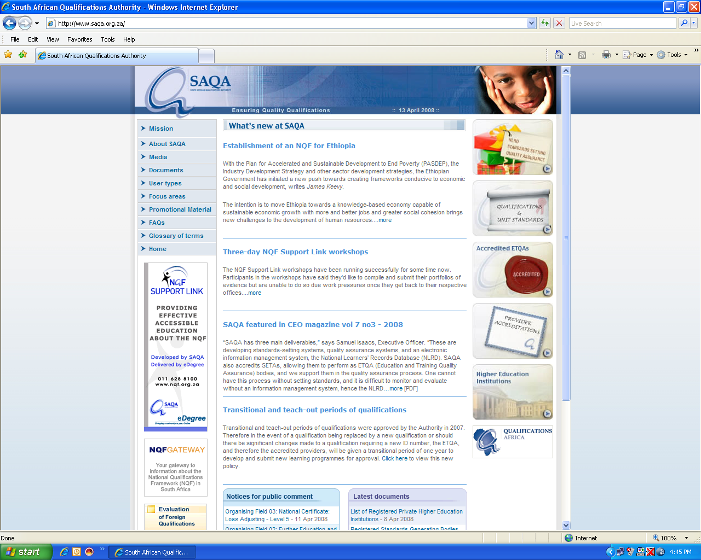

Static text

Hyperlink

Navigation bars

When a couple of web pages are stored in a common directory of a web server, they are called a website. So, a website is a group of web pages that are linked together.

This is the most important page to have on a website. When a browser visits the homepage of a website, the web server will serve the index page to the browser. If no index page is defined in the configuration, or no such file exists on the server, either an error or directory listing will be served to the browser.

Intranet and extranet

### Intranet

An intranet is a private version of the Internet, typically available only to the people who work in the organisation. It uses Internet protocols and network connectivity to share information within an organisation. An intranet is also sometimes called an internal website.

When building an intranet, you would use the same concepts and technology as used for the Internet:

* Clients
* Servers
* Internet protocol suite
* HTTP

Advantages of intranets

1. Workforce productivity: Intranets can help users to locate and view information faster and use applications relevant to their roles and responsibilities.
2. Time: information is made available to employees in a quick and easy way. There is no need to send many e-mails, as employees can link to the relevant information when it suits them – called making information available on a pull basis. Communication: Intranets can serve as powerful tools for communication within an organization, vertically and horizontally.
3. Web publishing: corporate knowledge such as company policies, training manuals, operations manuals can be updated easily and accessed by users.
4. Business operations and management: Intranets are also being used as a platform for developing and deploying applications to support business operations and decisions across the internetworked enterprise.
5. Cost-effective: physical documents such as phone lists, requisition forms, attendance registers, etc. can be viewed via a web browser. This saves time and money.
6. Promote common corporate culture: Every user is viewing the same information within the Intranet.
7. Enhance Collaboration: With information easily accessible by all authorised users, teamwork is enabled.

### Extranet

An extranet is also a private version of the Internet. An extranet uses Internet protocols, network connectivity and the public telephone system to share a part of an organisation’s information. This information is shared in a secured way with suppliers, vendors, partners, customers or other businesses Internet applications. It is therefore a part of an organisation’s intranet that has been extended to provide users outside the organisation access to information.

The information that is made available to outsiders could include:

* Employees’ contact details, departments, etc.
* Order forms
* Stock levels
* Product prices
* Delivery dates, etc.

An extranet must be made secure and private and access must be restricted only to those aspects that customers need to know. Information such as employees’ ID numbers, home addresses, private telephone numbers, salaries, banking account balances of the organisation, etc. MUST be secure and private.

Security measures can include firewalls, server management, digital certificates, other means of user authentication, encryption of messages, etc.

Disadvantages

1. When the organisation hosts the extranet internally, it can be expensive to implement. Cost items include hardware, software, employee training costs, maintenance of the system, etc.
2. Security of extranets are a big concern when dealing with valuable information. Access to the system has to be controlled very carefully.
3. When an organisation uses an extranet for certain customer transactions, it reduces personal contact with customers. Lack of personal contact between a company and its customers can hurt the business.

Incorporating Internet applications in the WWW

### Web-based e-mail

When you access a website through a web browser to send an e-mail, this is called web-based e-mail. From this website, you can then send e-mails to anyone you wish. A web-based e-mail does not need an email client such as Microsoft Outlook to send e-mails.

The user can access his/her inbox from any Internet-connected computer. Unfortunately, you cannot access old messages when you are not connected to the Internet.

You connect to the website that offers web-based e-mail, access your e-mail account and send and receive e-mails.

There are many software packages that allow an organization to offer email through the web for their associates. Some solutions are open source software like Microsoft Exchange, Outllook Web Access, Squirrel Mail, etc.

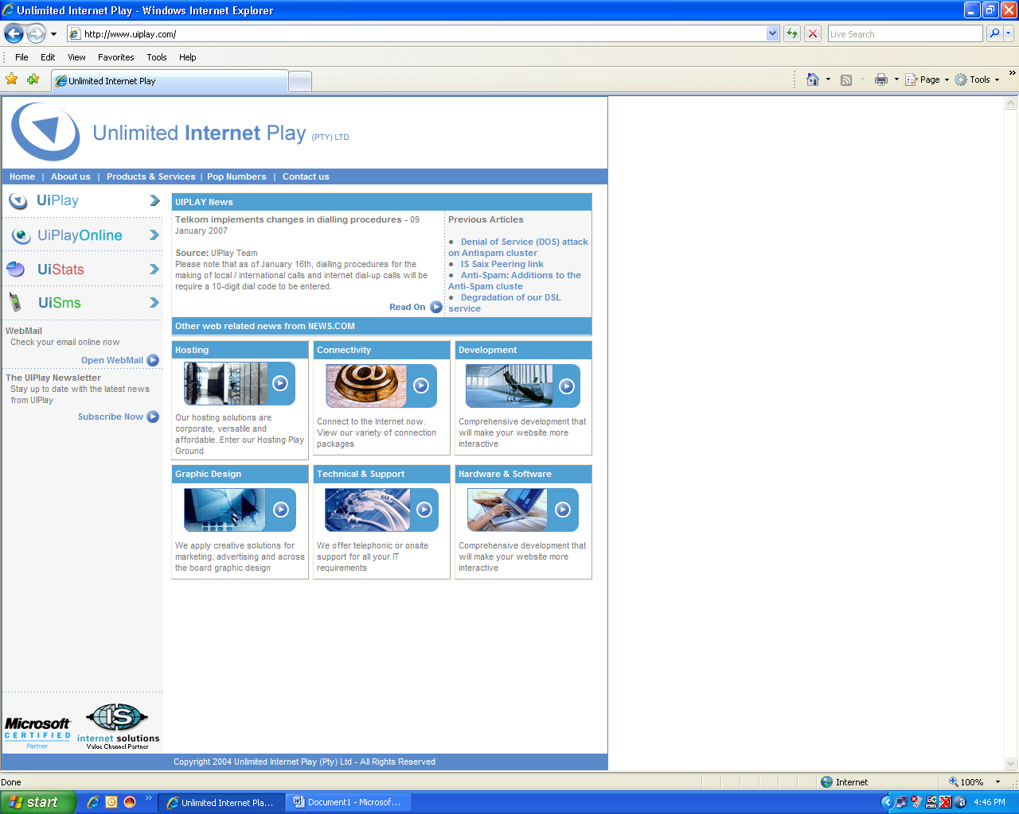

### Instant messaging

Instant messaging is real-time communication between two (or more) people, based on typed text. The text is sent via computers over a network, such as the Internet.

When you send a message using IM, it happens instantly before your eyes in real-time. Some people feel that using IM is less intrusive than making a telephone call.

Many IM systems make provision for sending of offline messages to users that are not logged on. Webcams and microphones can also be used with some IM systems, which means that users can see the other people. Users also talk for free over the Internet.

Other features include:

* the immediate receipt of acknowledgment or reply
* group chatting
* conference services (including voice and video)
* conversation logging
* file transfer.
* Save a conversation for later reference, as instant messages are logged in a local message history.

### VoIP

With VoIP, you can make a call from anywhere you have broadband connectivity. Since the IP phones send information over the Internet, they can be administered by the provider anywhere there's a connection. So business travellers can take their phones or with them on trips and always have access to their home phone.

Another alternative is the softphone. A softphone is client software that loads the VoIP service onto your desktop or laptop. As long as you have a headset/microphone, you can place calls from your laptop anywhere in the broadband-connected world.

Once the call is received by a gateway on the other side of the call, it's decompressed, reassembled and routed to a local circuit switch.

IP telephony just makes sense, in terms of both economics and infrastructure requirements. Many phone companies use VoIP to streamline their networks. By routing thousands of phone calls through a circuit switch and into an IP gateway, they can seriously reduce the bandwidth they're using. More and more businesses are installing VoIP systems.

A big advantage of VoIP is that the VoIP companies provide extra features free:

* Caller ID
* Call waiting
* Call transfer
* Repeat dial
* Return call
* Three-way calling

With many VoIP services, you can also check voice mail via the Web or attach messages to an e-mail that is sent to your computer or handheld.

How does a VoIP phone call work?

The user picks up the receiver, which sends a signal to the ATA. The ATA receives the signal and sends a dial tone. Now the user knows that s/he has a connection to the Internet.

Dial the phone number of the party you wish to talk to. The tones are converted by the ATA into digital data and temporarily stored. The phone number data is sent in the form of a request to your VoIP company's call processor. The call processor checks it to ensure that it's in a valid format.

The call processor determines to whom to map the phone number. In mapping, the phone number is translated to an IP address. The soft switch connects the two devices on either end of the call. On the other end, a signal is sent to your friend's ATA, telling it to ask the connected phone to ring.

Once your friend picks up the phone, a session is established between your computer and your friend's computer. This means that each system knows to expect packets of data from the other system. In the middle, the normal Internet infrastructure handles the call as if it were e-mail or a Web page. Each system must use the same protocol to communicate. The systems implement two channels, one for each direction, as part of the session.

You talk for a period of time. During the conversation, your system and your friend's system transmit packets back and forth when there is data to be sent. The ATAs at each end translate these packets as they are received and convert them to the analogue audio signal that you hear. Your ATA also keeps the circuit open between itself and your analogue phone while it forwards packets to and from the IP host at the other end.

You finish talking and hang up the receiver. When you hang up, the circuit is closed between your phone and the ATA. The ATA sends a signal to the soft switch connecting the call, terminating the session.

What is ATA?

An analogue telephone adapter, (ATA) is a device used to connect one or more standard analogue telephones to a digital and/or non-standard telephone system such as VoIP.

[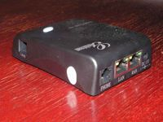](http://en.wikipedia.org/wiki/Image:Grandstream_HT488.jpg)

Soft switch

The central call processor is a piece of hardware running a specialized database/mapping program called a soft switch