Activity 1: Business environments
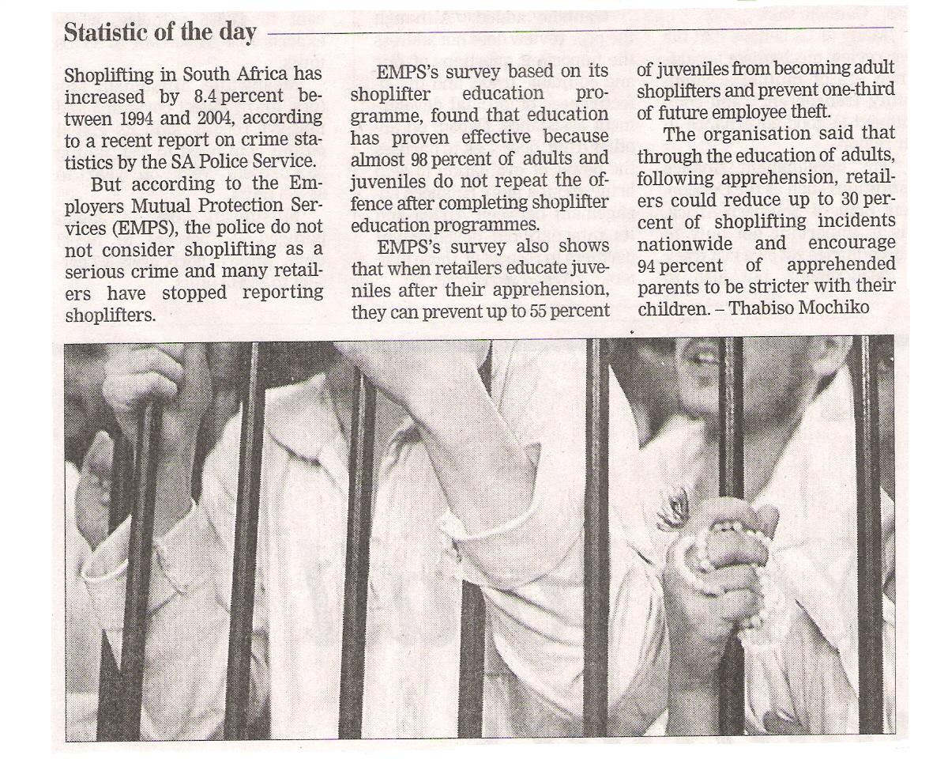
Name the 3 types of business environments in which every organisation functions:
1.

2.

3.

The shoplifters pictured in the article are products of the ___________ environment in which a retail organisation operates:
Explain how their environment could have driven these people to steal:
What effect does shoplifting have on the individual shops, as well as on the economy as a whole?
Individual shops:

Economy as a whole:

How have certain retailers successfully counteracted the threat of shoplifting, according to this article?
Describe 3 other ways in which retailers protect their goods from losses through shoplifting.
1.

2.

3.

Evaluate each of the preventative methods mentioned in terms of advantages and disadvantages:
Method | Advantages | Disadvantages
EMPS education programme

Identify a threat from the macro environment that your company faces and say how management are dealing/ should deal with it in such a way that it is both cost effective and sustainable:
Threat:

How management are dealing/ should deal with it:

Identify an opportunity for your company that has arisen from changes in the macro environment and say how management are taking/ should take advantage of the opportunity:
Opportunity:

How management are taking/ should take advantage of it:

Describe the market environment your company operates in:
Market | Description (who are they?) | Opportunities (how do they benefit your company?) | Threats (how do they threaten your company?)
Consumers
Competitors
Middlemen

Suppliers
Labour unions
Describe how your company manages TWO of the abovementioned threats:
1.

2.

