Activity 2: The physical (ecological) environment
What political event caused crude oil prices to skyrocket in the year referred to in this report?
Explain why this event caused oil prices to rise so dramatically?
How have Airlines been affected by the rising oil prices?
Which other industries are under threat from rising oil prices?
Name industries that could benefit from the rising oil prices. Explain how this could happen:
Briefly discuss any other events in the macro or physical environment that could have an impact on the profitability of Airlines:

How is your company affected by rising oil prices? Explain how your company is meeting the challenge of rising oil prices.

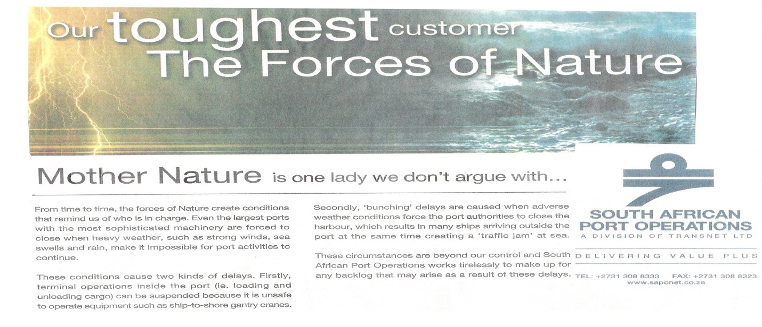
In another type of transport industry, namely shipping, the natural environment can cause delays, which can lead to loss of profits. Explain how the physical environment impacts on your organisation’s profitability.

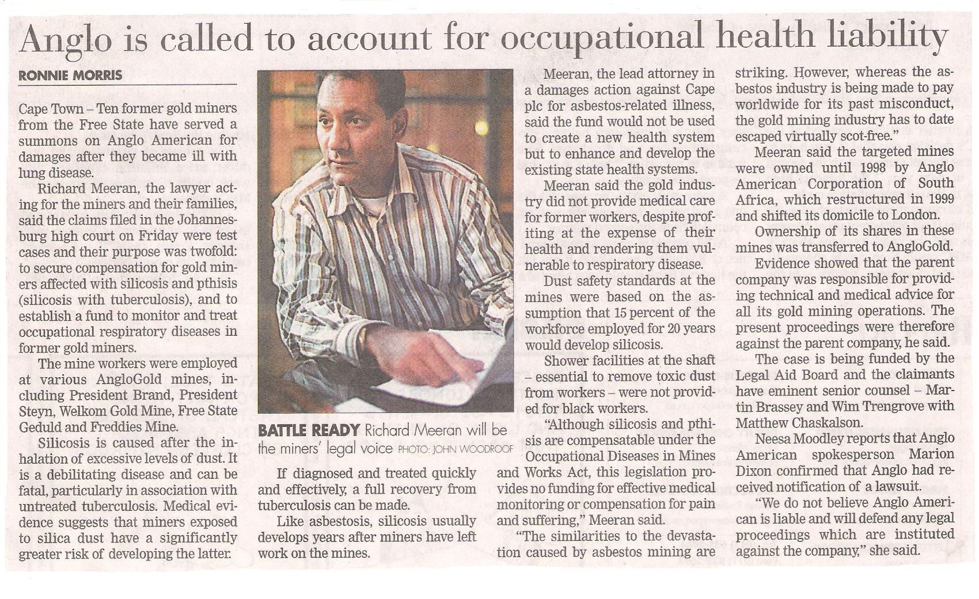
Did the management of Anglo American know about the environmental health threat to their workers? Quote a sentence, which proves your answer.
Yes/ No:

Quote:

Describe two actions they could have taken to counteract this threat. Why do you think they did not take these actions?
1.

2.

Reason:

What are the consequences to the company of management not taking the abovementioned precautions?

Are there any threats in the area of health and safety that you feel your company’s management is not taking seriously enough? Explain your answer by giving at least two examples and possible solutions.
Health and safety threats | Solutions
1.

2.

