Activity 3: The socio-political environment
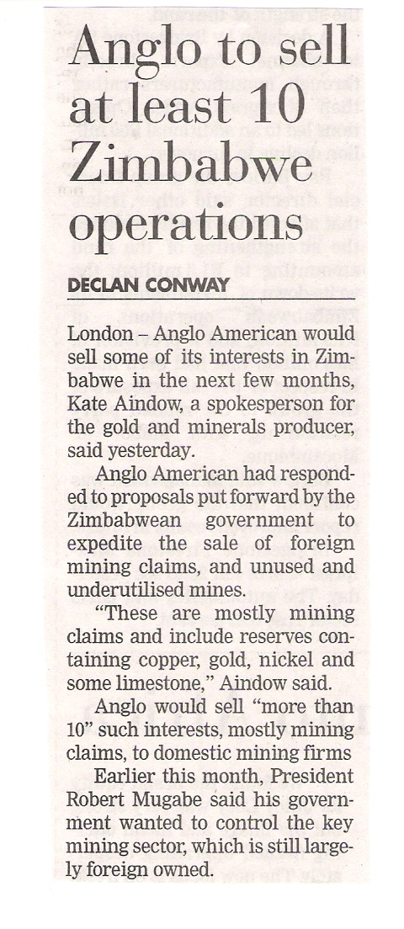
The writer of this article uses terms like “Anglo American had responded to proposals put forward by the Zimbabwean government…” and “President Robert Mugabe said his government wanted to control…”.
These terms suggest that Anglo American have a choice in the matter of selling the mines. Do you think that they really have a choice? Give a reason, based on political events and the political environment in Zimbabwe, for your answer.
Yes/ No:
Reason:

Describe any political changes or laws and regulations in South Africa that have had an impact on the way your company operates in terms of resources/ markets/ labour/ productivity.

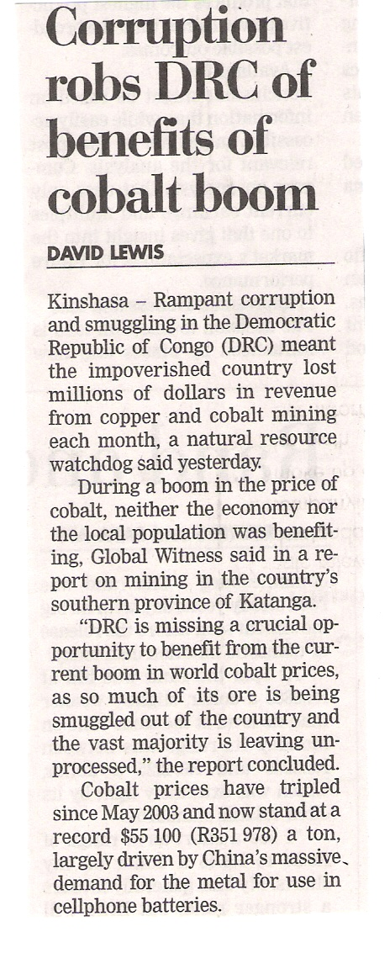
Describe how political and societal pressures are robbing the local population of the DRC and the country as a whole of wealth.

