Activity 4: The economic environment

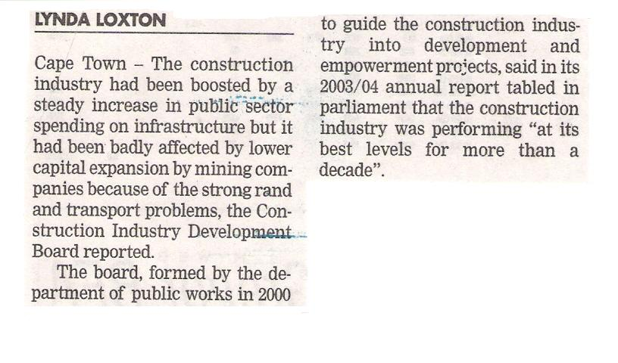
Due to lower inflation, the construction industry has boomed. Explain how this has happened:
Explain why the exact same economic environment has had a negative impact on the mining industry:
How has the stronger Rand and lower inflation impacted your organisation in terms of the cost of goods or services?
