Activity 5: The technological and institutional environment

Globalisation has caught up with South African institutions with Britain’s Barclays Bank intending to buy a controlling stake in Absa, the country’s biggest retail lender.
Describe how the political environment at the time forced Barclays to pull out of South Africa in the 1980s.
List two opportunities Barclays sees for growth in its acquisition of Absa.
1.

2.

List the opportunities for the consumer, the banking sector and the South African economy as a whole.
Consumer:

Banking sector:

SA economy:

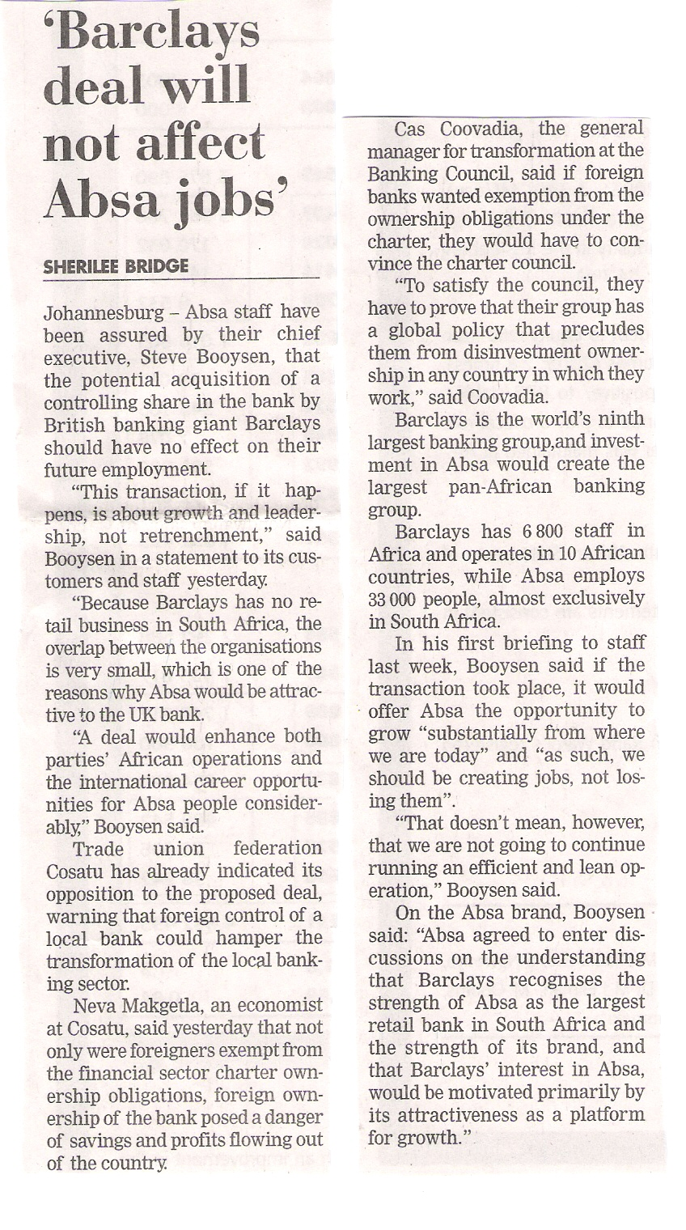

What threats could the takeover pose for Absa staff, the customer, the banking sector and the economy as a whole?
Absa staff:

Customer:

Banking sector:

SA economy:

Tabulate 3 threats and 3 opportunities that will arise for you and/ or your company as a result of institutional changes:
Possible institutional change:

Threats | Opportunities
1.  2.  3. | 1.  2.  3.

