

**LEARNER Guide**

****Investigate and explain the structure of a selected workplace or organisation****

Unit Standard 13919

242814

Level 3 Credits 10

# TABLE OF CONTENTS

TABLE OF CONTENTS i

PERSONAL INFORMATION 1

INTRODUCTION 2

Structure 2

Programme methodology 2

What Learning Material you should have 3

Different types of activities you can expect 4

Learner Administration 4

Assessments 5

Learner Support 5

Learner Expectations 6

UNIT STANDARD 13919 8

SECTION 1: CORE BUSINESS ACTIVITIES 10

Peter 10

The birth of an organisation: 11

Phase 1 11

Phase 2 11

Phase 3 12

Phase 4 12

What is an organisation? 12

Organisational Theory: Determinants of Structure 15

Contingency Theory 15

Mechanistic vs. Organic Structures 16

Environment 17

Adaptation 17

Natural Selection 17

Dependence 17

Institutionalisation 18

SECTION 2: ROLE OF DEPARTMENT 19

Departmentation (Grouping) 19

Common Bases For Departmentation 19

Matrix & Project-based Organisations 20

Criteria for Choosing 21

What is our core business? 23

Formative Assessment 1 - 9 23

SECTION 3: EXPLAIN SUPPORT FUNCTIONS 24

Coordination 24

Division of Labour 24

Coordinating 25

Fitting Coordinating Mechanisms to Tasks 27

Where does my job fit in? 27

Janine 27

Formative Assessment 10 - 13 28

SECTION 4: THE ROLE OF A SELECTED TEAM 28

Compiling a job profile 28

Koos 28

Shift Supervisor 29

Formative Assessment 14 - 16 29

SECTION 5: DIFFERENT TYPES OF WORK DONE IN THE ORGANISATION 30

21st Century Organisational Trends: where are we going? 30

Summary and implications for managers 32

Formative Assessment 17 33

FORMATIVE ASSESSMENTS WORKBOOK 33

Formative Assessment 1 33

Formative Assessment 2 33

Formative Assessment 3 34

Formative Assessment 4 34

Formative Assessment 5 34

Formative Assessment 6 34

Formative Assessment 7 34

Formative Assessment 8 35

Formative Assessment 9 35

Formative Assessment 10 35

Formative Assessment 11 35

Formative Assessment 12 35

Formative Assessment 13 36

Formative Assessment 14 36

Formative Assessment 15 36

Formative Assessment 16 36

Formative Assessment 17 36

PERSONAL INFORMATION

|  |  |
| --- | --- |
| **NAME** |  |
| **CONTACT ADDRESS** |  |
|  |
| **Code** |  |
| **Telephone (H)** |  |
| **Telephone (W)** |  |
| **Cellular** |  |
| **Learner Number** |  |
| **Identity Number** |  |
|  | |
| **EMPLOYER** |  |
| **EMPLOYER CONTACT ADDRESS** |  |
|  |
| **Code** |  |
| **Supervisor Name** |  |
| **Supervisor Contact Address** |  |
|  |
| **Code** |  |
| **Telephone (H)** |  |
| **Telephone (W)** |  |
| **Cellular** |  |

INTRODUCTION



#### Welcome to the learning programme

Follow along in the guide as the training practitioner takes you through the material. Make notes and sketches that will help you to understand and remember what you have learnt. Take notes and share information with your colleagues. Important and relevant information and skills are transferred by sharing!

This learning programme is divided into sections. Each section is preceded by a description of the required outcomes and assessment criteria as contained in the unit standards specified by the South African Qualifications Authority. These descriptions will define what you have to know and be able to do in order to be awarded the credits attached to this learning programme. These credits are regarded as building blocks towards achieving a National Qualification upon successful assessment and can never be taken away from you!

Structure

### Programme methodology



The programme methodology includes facilitator presentations, readings, individual activities, group discussions and skill application exercises.

Know what you want to get out of the programme from the beginning and start applying your new skills immediately. Participate as much as possible so that the learning will be interactive and stimulating.

The following principles were applied in designing the course:

* Because the course is designed to maximise interactive learning, you are encouraged and required to participate fully during the group exercises
* As a learner you will be presented with numerous problems and will be required to fully apply your mind to finding solutions to problems before being presented with the course presenter’s solutions to the problems
* Through participation and interaction the learners can learn as much from each other as they do from the course presenter
* Although learners attending the course may have varied degrees of experience in the subject matter, the course is designed to ensure that all delegates complete the course with the same level of understanding
* Because reflection forms an important component of adult learning, some learning resources will be followed by a self-assessment which is designed so that the learner will reflect on the material just completed.

This approach to course construction will ensure that learners first apply their minds to finding solutions to problems before the answers are provided, which will then maximise the learning process which is further strengthened by reflecting on the material covered by means of the self-assessments.

#### Different role players in delivery process

* Learner
* Facilitator
* Assessor
* Moderator

### What Learning Material you should have

This learning material has also been designed to provide the learner with a comprehensive reference guide.

It is important that you take responsibility for your own learning process; this includes taking care of your learner material. You should at all times have the following material with you:

|  |  |
| --- | --- |
| **Learner Guide** | **This learner guide is your valuable possession:**  This is your textbook and reference material, which provides you with all the information you will require to meet the exit level outcomes.  During contact sessions, your facilitator will use this guide and will facilitate the learning process. During contact sessions a variety of activities will assist you to gain knowledge and skills.  Follow along in the guide as the training practitioner takes you through the material. Make notes and sketches that will help you to understand and remember what you have learnt. Take and share information with your colleagues. Important and relevant information and skills are transferred by sharing!  This learning programme is divided into sections. Each section is preceded by a description of the required outcomes and assessment criteria as contained in the unit standards specified by the South African Qualifications Authority. These descriptions will define what you have to know and be able to do in order to be awarded the credits attached to this learning programme. These credits are regarded as building blocks towards achieving a National Qualification upon successful assessment and can never be taken away from you! |
| **Formative Assessment Workbook** | The Formative Assessment Workbook supports the Learner Guide and assists you in applying what you have learnt.  The formative assessment workbook contains classroom activities that you have to complete in the classroom, during contact sessions either in groups or individually.  You are required to complete all activities in the Formative Assessment Workbook.  The facilitator will assist, lead and coach you through the process.  These activities ensure that you understand the content of the material and that you get an opportunity to test your understanding. |

### Different types of activities you can expect

To accommodate your learning preferences, a variety of different types of activities are included in the formative and summative assessments. They will assist you to achieve the outcomes (correct results) and should guide you through the learning process, making learning a positive and pleasant experience.



The table below provides you with more information related to the types of activities.

| **Types of Activities** | **Description** | **Purpose** |
| --- | --- | --- |
| **Knowledge Activities** | You are required to complete these activities on your own. | These activities normally test your understanding and ability to apply the information. |
| **Skills Application Activities** | You need to complete these activities in the workplace | These activities require you to apply the knowledge and skills gained in the workplace |
| **Natural Occurring Evidence** | You need to collect information and samples of documents from the workplace. | These activities ensure you get the opportunity to learn from experts in the industry.  Collecting examples demonstrates how to implement knowledge and skills in a practical way |

### Learner Administration



#### Attendance Register

You are required to sign the Attendance Register every day you attend training sessions facilitated by a facilitator.

#### Programme Evaluation Form

On completion you will be supplied with a “Learning programme Evaluation Form”. You are required to evaluate your experience in attending the programme.

Please complete the form at the end of the programme, as this will assist us in improving our service and programme material. Your assistance is highly appreciated.

### Assessments

The only way to establish whether a learner is competent and has accomplished the specific outcomes is through the assessment process. Assessment involves collecting and interpreting evidence about the learners’ ability to perform a task.

To qualify and receive credits towards your qualification, a registered Assessor will conduct an evaluation and assessment of your portfolio of evidence and competency.

This programme has been aligned to registered unit standards. You will be assessed against the outcomes as stipulated in the unit standard by completing assessments and by compiling a portfolio of evidence that provides proof of your ability to apply the learning to your work situation.



**How will Assessments commence?**

#### Formative Assessments

The assessment process is easy to follow. You will be guided by the Facilitator. Your responsibility is to complete all the activities in the Formative Assessment Workbook and submit it to your facilitator.

#### Summative Assessments

You will be required to complete a series of summative assessments. The Summative Assessment Guide will assist you in identifying the evidence required for final assessment purposes. You will be required to complete these activities on your own time, using real life projects in your workplace or business environment in preparing evidence for your Portfolio of Evidence. Your Facilitator will provide more details in this regard.

To qualify and receive credits towards your qualification, a registered Assessor will conduct an evaluation and assessment of your portfolio of evidence and competency.

### Learner Support

The responsibility of learning rests with you, so be proactive and ask questions and seek assistance and help from your facilitator, if required.



Please remember that this Skills Programme is based on outcomes based education principles which implies the following:

* You are responsible for your own learning – make sure you manage your study, research and workplace time effectively.
* Learning activities are learner driven – make sure you use the Learner Guide and Formative Assessment Workbook in the manner intended, and are familiar with the workplace requirements.
* The Facilitator is there to reasonably assist you during contact, practical and workplace time for this programme – make sure that you have his/her contact details.
* You are responsible for the safekeeping of your completed Formative Assessment Workbook and Workplace Guide
* If you need assistance please contact your facilitator who will gladly assist you.
* If you have any special needs please inform the facilitator

### Learner Expectations

Please prepare the following information. You will then be asked to introduce yourself to the instructor as well as your fellow learners



|  |
| --- |
| Your name: |
|  |
|  |
| The organisation you represent: |
|  |
|  |
| Your position in organisation: |
|  |
|  |
| What do you hope to achieve by attending this course / what are your course expectations? |
|  |
|  |
|  |
|  |
|  |

# UNIT STANDARD 13919

#### Unit Standard Title

Investigate and explain the structure of a selected workplace or organisation

#### NQF Level

3

#### Credits

10

#### Purpose

This unit standard provides a broad introduction to a workplace or organisation with a view to relating leadership of a team to the learner’s own context and experience of the world of work.

The qualifying learner is capable of:

* Explaining the core business of a selected organisation.
* Explaining the support functions in a selected organisation or workplace..
* Explaining the contribution of a team to be effectiveness of an organisation.
* Investigating types of work done in an organisation.

#### Learning Assumed To Be In Place And Recognition Of Prior Learning

There is open access to this unit standard. Learners should

* Hold a GETC or equivalent qualification. Or
* Be competent in Communication and Mathematical Literacy NQF level 1. Change if level 3.

#### Unit Standard Range

* Core business activities directly related to incomes generated by an organisation.
* Support functions include Human Resources, Training and development, Salaries, IT, Auditing, Marketing, Legal, Accounting/Credit Control, Communications and PRO Maintenance.

#### Specific Outcomes And Assessment Criteria:

**Specific Outcome 1**

Identify and explain the core business activities of an organisation or workplace

**Assessment Criteria**

* The concept of core business is explained with examples.
* Core business activities are named with reference to a selected organisation.
* The relationships between the different core activities of an organisation or workplace are described and compared in terms of importance and value added to the organisation.
* A system of process within a selected work unit or team is described in the correct sequence.

**Specific Outcome 2**

Explain the role of a selected department or section in an organisation

**Outcome Notes**

Explain the role of a selected department or section in an organisation and its contribution to the effectiveness of the organisation.

**Assessment Criteria**

* The main function of the selected department or section within a department is explained in relation to core business or support.
* The role of another department or section that interacts with the selected section or department is explained and an indication is given of how the efficiency of the departments or sections impact on each other.
* .The most senior person in the department or section is identified with, where applicable, the title of his/her position.
* The line is identified from the senior person in the department or section to the Board of Directors.
* The line from the learner to the senior person in the department or section is explained and an indication is given when it is appropriate to refer a matter to a higher authority.
* The effect on the organisation if the department of section did not function effectively is described with examples.
* The value that the department or section adds to the organisation is identified with examples.

**Specific Outcome 3**

Identify and explain the support functions within a selected organisation

**Assessment Criteria**

* The concept of a support function is explained with examples.
* Specific support functions are named and an indication is given of the departments or people responsible for each function in a selected organisation.
* The relationship between a work team and the support units or personnel is explained and an indication is given of how a manager can utilize the assistance of personnel responsible for the support functions.

**Specific Outcome 4**

Investigate and explain the role of a selected team and its contribution

**Outcome Notes**

Investigate and explain the role of a selected team and its contribution to the effectiveness of an organisation.

**Assessment Criteria**

* The main function of a selected team is explained in relation to core business or support.
* The role of another team that interacts with the selected team is explained and an indication is given of how the efficiency of the teams impact on each other.

**Specific Outcome 5**

Investigate the different types of work done in the organisation

**Assessment Criteria**

* The different roles an organisation are identified and an outline is written of the kind of work done by three people.
* The work done in the organisation is categorised according to its purpose.
* The importance of each category of work is discussed with reference to the efficiency of the organisation.
* The work in the organisation is identified as a part of a set of related systems each with a role and a value.

#### Unit Standard Accreditation And Moderation Options

This Unit Standard will be internally assessed by the provider and moderated by a moderator registered by Services SETA or a relevant accredited ETQA.

# SECTION 1: CORE BUSINESS ACTIVITIES

**Specific Outcome 1**

Identify and explain the core business activities of an organisation or workplace

**Assessment Criteria**

* The concept of core business is explained with examples.
* Core business activities are named with reference to a selected organisation.
* The relationships between the different core activities of an organisation or workplace are described and compared in terms of importance and value added to the organisation.

A system of process within a selected work unit or team is described in the correct sequence

# Peter

Meet Peter Khumalo, Managing Director of **Moova**, and a transport company with branches countrywide.

Peter started his business 3 years ago after he was retrenched from the mines. He used part of his package and borrowed money from a family member and bought himself an old 2-ton truck. He transported household goods for people in the township in which he lived, loading the goods himself and also driving the truck himself.

He soon found the demand for his services growing and he had to buy a second vehicle. He also had to employ another driver and people to load and unload the goods.

As his business grew and became known in other areas, he rented offices, bought more vehicles, employed more people, such as receptionists, bookkeepers, tax consultants, cleaners, supervisors, etc. to help him carry the load.

Nowadays Peter does not drive any of the many trucks the business owns. He spends most of his time in meetings with clients and management. Sometimes he misses the good old days when business was a lot simpler!



## The birth of an organisation:

**How did Peter get from here to here?**





### Phase 1

#### The single entrepreneur

When Peter started his business, he started as a **sole trader**. As the **owner-manager** hewas responsible for all aspects of the business: driving, loading, advertising, negotiation and bookkeeping.

This type of business ownership has the advantage that the entrepreneur has total control of his business and only pays tax in his personal capacity. That means that he pays a maximum of 40% tax, but the disadvantages are that he has no help and that he has to carry all the risks associated with a business; for example, if people do not pay their debts, or if the business goes under, he loses everything.

### Phase 2

#### The Small Business

As his income grew, Peter was advised to establish a **close corporation (cc).**

He would still be the **owner-manager**, but his business would be a separate legal entity. That means that the business would carry all risks, as his own private finances would be separate from the business’s finances and contracts would be signed in the name of the business.

He had to employ a bookkeeper to complete his yearly financial statements that had to be submitted to **SARS** for tax purposes.

Bookkeeper **(Part-time)**

### Phase 3

#### The growing business

**Full-time Bookkeeper**

As Peter’s business expanded, he employed people to take over the functions he could no longer manage. As the **owner-manager** he needed to devote more time to the general management of his business.

Maintenance and operations

Sales and Marketing

### Phase 4

#### The large organisation

Peter is now the **Managing Director** of a large organization and, together with his management team, still determines the objectives and goals of his business.

**Manager: HR**

**Manager: Operations**

**Manager: Finance**

**Manager: Marketing**

**Advertising**

**Sales**

**Tax**

**Salaries**

**Transport**

**Maintenance**

**Wellness**

**Recruitment**

Each of the above can be further divided into more specific categories, as **each task is broken up into smaller units** in order to take advantage of specialised skills or knowledge in order to increase productivity. This type of diagram is called an **organogram** andwill differ from organisation to organisation.

## What is an organisation?

To satisfy **(supply)** the needs or wants **(demand)** of society, groups of people started working together to perform tasks that individuals could not perform effectively on their own, and so the organisation was born.

Therefore, **an organisation is two or more people working together in a coordinated way to achieve common goals**.

We also refer to an organisation as a company.

“Business organisations bring together society’s **resources**, namely people, raw materials, money and knowledge, to produce the **products and services** for its many needs.”

*PJ Smit and GJ De J Cronjé****[1]***

**We know the following about a company or organisation:**



* A business is started and exists to make a **profit**.
* **Income (turnover) - (costs + expenses) = profit**
* Business organisations exist to serve society.

A business continues to exist if it can adequately **supply** consumer needs or wants (called **demand**).

Organisations bring together **resources** to produce the **products** and **services** that society needs or wants.

* Organisations exist to achieve certain goals or objectives
* An organisation consists of people

The people in an organisation have to work together

* The way the people work together is organised

**Employees** have certain basic rights according to the Basic Conditions of Employment Act, such as the right to certain benefits, training, etc.

When people work together in an organisation, there is always the potential for **conflict.**

Employees and projects have to be **supervised** and **managed.**

DEFINITION: What are resources?

Resources are the means to supply a want. Resources can be raw materials, money, knowledge, people, or anything that is used to produce a product or supply a service.

Peter’s company supplies a **service**, namely transporting goods. The **resources** he uses in the process are trucks for transportation, petrol to get the trucks moving, people to load and unload the trucks, money to pay for the petrol, servicing of the trucks and workers’ wages, etc.

Other service companies would be insurance companies, travel agents, hotels, educational institutions, etc.

A company, which manufactures cars, produces a **product**. It uses raw materials, such as steel, rubber, lead, etc. to manufacture the components, which are then assembled in its factories.

However, a manufacturing company will also need financial and human resources, just like its service counterparts.

**The following table shows some of the resources used by two different organisations. Vaal Technikon supplies a service, namely education, while Ford SA is a manufacturing company:**

|  |  |  |  |  |
| --- | --- | --- | --- | --- |
| **Organisation** | **Human resources** | **Financial resources** | **Physical resources** | **Information resources** |
| Vaaltech | Lecturers  Administrative staff | State subsidies  Fees | Buildings  Lecture halls  Libraries  Computers | Educational expertise  Research reports  Annual reports |
| Ford SA | Managers  Engineers  Technicians  Administrative staff | Shareholders  Loans  Profits | Assembly plants  Buildings  Equipment  Computers | Data on the market  Environmental information  Statistics  Skills in car manufacturing |

## Organisational Theory: Determinants of Structure[2]

### Contingency Theory

Most theorists today believe that there is no one best way to organise. What is important is that there be a fit between the **organisation's structure, its size, its technology, and the requirements of its environment**.

This perspective is known as "**contingency theory**" and contrasts with the perspective of classical theorists like Weber, Taylor, Fayol, etc. who thought that there probably was one way to run organisations that was the best.

#### Size

This refers to capacity, number of personnel, outputs (customers, sales), and resources (wealth).

Studies show that **differentiation** (number of levels, departments, job titles) **increases with size**, but at a decreasing rate. In contrast, the percentage of the organisation that is involved in administrative overhead declines with size, leading to economies of scale.

Increasing size is also related to increased structuring of organisations’ activities but decreased concentration of power.

Managerial practices, such as flexibility in personnel assignments, extent of delegation of authority, and emphasis on results rather than procedures, are related to the size of the unit managed.

#### Technology/Task

Consider cheque processing at a bank. This activity is usually performed by a business unit that is highly formalised, has a great deal of specialisation and division of labour, and high centralisation of decision-making. In contrast, the creative section of an advertising agency is usually not formalised at all, the division of labour is often blurry, and it is highly decentralised.

It appears that certain activities naturally "go with" certain structures. By knowing an organisation's primary system of production, you could predict its structure:

**Unit production/small batch:**

Usually companies that make one-of-a-kind custom products, or small quantities of products (e.g., ship building, aircraft manufacture, furniture makers, tailors, printers of engraved wedding invitations, surgical teams, etc.)

Typically, they:

* Attach more importance to people's skills and knowledge than the machines used
* Are relatively expensive to operate: work process is unpredictable, hard to pre-program or automate
* Have a flat organisation (few levels of hierarchy)
* Have a CEO with a low span of control (direct reports)
* Have a relatively low percentage of managers
* Have an organic structure (see table below)

**Mass production/large batch:**

These are usually companies that sell huge volumes of identical products (e.g., cars, razor blades, aluminium cans, toasters, etc.)

These companies make extensive use of automation and assembly lines.

Typically, they:

* Are bigger than small batch
* Have taller hierarchies
* Have a huge bottom level (supervisor span of control is about 48)
* Have a relatively greater number of managers (because hierarchy is so tall)
* Have a mechanistic, bureaucratic structure (see table below)
* Are relatively cheap to operate

**Continuous Production:**

These are primarily companies that refine liquids and powders (e.g., chemical companies, oil refineries, bakeries, dairies, distilleries/breweries, electric power plants, etc.)

Machines do almost everything; humans just monitor the machines and plan changes:

* These organisations’ hierarchies are tall and thin or even an inverted pyramid: there is almost nobody at the bottom
* At the very top there is an organic structure (see table below)
* Lower levels are more mechanistic, but because machines do everything, there is not much paper work, lower level supervision, etc.

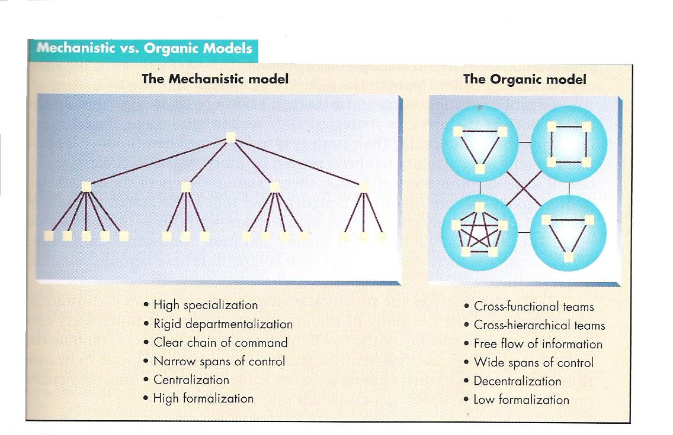

**Fig.1[3]**

# Mechanistic vs. Organic Structures

| **Mechanistic** | **Organic** |
| --- | --- |
| Individual specialisation: Employees work separately and specialise in one task | Joint Specialisation: Employees work together and  coordinate tasks |
| Simple integrating mechanisms: Hierarchy of authority well-defined | Complex integrating mechanisms: task forces and teams are primary integrating mechanisms |
| Centralisation: Decision-making kept as high as possible. Most communication is vertical. | Decentralisation: Authority to control tasks is delegated. Most communication lateral |
| Standardisation: Extensive use made of rules & Standard Operating Procedures (SOPs) | Mutual Adjustment:  Face-to-face contact for coordination. Work process tends to be unpredictable |
| Much written communication | Much verbal communication |
| Informal status in organisation based on size of empire | Informal status based on perceived brilliance |
| Organisation is a network of positions,  corresponding to tasks. Typically each  person corresponds to one task | Organisation is network of persons or teams. People work in different capacities simultaneously and over time |

## Environment

### Adaptation

Organisations actively adapt to their environments. For example, organisations facing complex, highly uncertain environments typically differentiate so that each organisational unit is facing a smaller, more certain problem. For example, if Japanese tastes in cars are quite different from South African tastes, it is really hard to make a single car that appeal to both markets. It is easier to create two separate business units, one that makes cars for the Japanese market, and the other that makes cars for the SA market.

### Natural Selection

Organisations whose structures are not fitted to the environment (which includes other organisations, communities, customers, governments, etc.) will not perform well and will fail. Most new organisations fail within the first few years.

If the environment is stable, this selection process will lead to most organisations being well-adapted to the environment, not because they all changed themselves, but because those that were not well-adapted will have died off.

### Dependence

The economy is a giant network of organisations linked by buying and selling relationships. Every company has suppliers (inputs) and customers (outputs). Every company is dependent on both their suppliers and their customers for resources and money. To the extent that a company needs its suppliers less than the suppliers need it, the company has power. That is, power is a function of asymmetric mutual dependence. Dependence is itself a function of the availability of alternative supply. A depends on B to the extent that there are few alternatives to B that are available to A. Dependence is also a function of how much A needs what B has got. If the Post It's company starts to play hardball with you, and there are no good alternatives, it's still not a big deal because Post It's are just not that important.

Organisations that have power over others are able to impose elements of structure on them. For example, General Motors is notorious in America for imposing accounting systems, cost controls and manufacturing techniques on their suppliers.

The sets of entities in an organisation's environment that play a role in the organisation's health and performance, or which are affected by the organisation, are called **stakeholders**. Stakeholders have interests in what the organisation does, and may or may not have the power to influence the organisation to protect their interests. Stakeholders are varied and their interests may coincide on some issues and not others. Therefore you find stakeholders both cooperating with each other in alliances, and competing with each other.

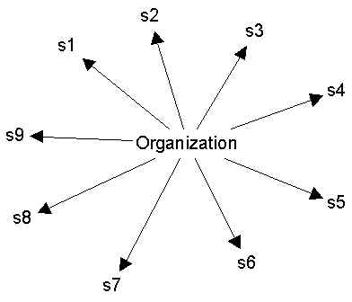

**Figure 2. Unconnected stakeholders.**

When stakeholders are unconnected to each other (as in Figure 1), the organisation usually has an easier time of playing the different parties off against one another.

For example, it can represent its goals and needs differently to each stakeholder, without fear of being found out. Furthermore, when the stakeholders are unconnected, they cannot coordinate their efforts, and so have trouble controlling the organisation.

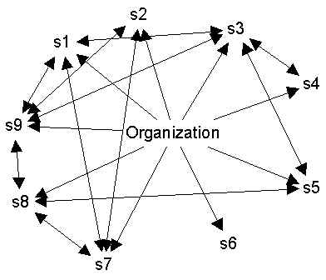

**Figure 3. Well-connected stakeholders.**

In contrast, when the stakeholders are well-connected (as in Figure 2), the organisation cannot represent itself differently to each one, or it will be found out. Furthermore, if the bonds among the stakeholders are closer than the bonds with the organisation, the stakeholders may side with each other against the organisation, and won't act in ways that negatively affect other stakeholders.

### Institutionalisation

In conditions of uncertainty, organisations imitate others that appear to be successful. In other words, if nobody really knows what makes a movie successful, and then somebody has a blockbuster hit, everybody else copies the movie, as well as the organisational structure that produced the movie, hoping that they will get the same results. This can cause whole industries to adopt similar structural features.

One reason why this happens is the fear of litigation or simply blame. If several well-known, successful companies start adopting some new management style -- say, self-governing teams -- and you don't because you know it’s not appropriate for your company, and then things start to go wrong for your company, people will say, “See? You should have adopted self-governing teams. We told you so'. So to avoid that, if the top companies in a field all adopt some new style, then all the others do too to avoid being blamed.

# SECTION 2: ROLE OF DEPARTMENT

#### *****Specific Outcome 2*****

Explain the role of a selected department or section in an organisation

#### *****Outcome Notes*****

Explain the role of a selected department or section in an organisation and its contribution to the effectiveness of the organisation.

#### *****Assessment Criteria*****

* The main function of the selected department or section within a department is explained in relation to core business or support.
* The role of another department or section that interacts with the selected section or department is explained and an indication is given of how the efficiency of the departments or sections impact on each other.
* .The most senior person in the department or section is identified with, where applicable, the title of his/her position.
* The line is identified from the senior person in the department or section to the Board of Directors.
* The line from the learner to the senior person in the department or section is explained and an indication is given when it is appropriate to refer a matter to a higher authority.
* The effect on the organisation if the department of section did not function effectively is described with examples.
* The value that the department or section adds to the organisation is identified with examples.

## Departmentation (Grouping)[4]

One reason organisations exist, is to do things that would be hard for one person to do by him/herself. For example, it's hard to conceive of one person building an office building. Instead, we have organisations of thousands of people with diverse skills that work together to build buildings. However, coordinating, controlling and just keeping track of a lot of individuals introduces its own problems.

One way to solve these problems is to create a hierarchical system of supervision, so that small groups of workers (up to 50 people) are supervised by coordinators (managers). Depending on how many people there are in the organisation, the coordinators themselves need to be organised into groups supervised by higher level managers, and so on. Part and parcel of this hierarchical supervisory system is the cutting up of the organisation into groups (departments).

The question arises: On what basis should we carve up the members of the organisation into subunits? What would happen if we did it randomly, without regard for tasks? One problem would be that each manager would have to be aware of what needed to be done in every area of the organisation, in order to direct his/her workers. This would be impossible in most cases.

### Common Bases For Departmentation

What organisations actually do is group people in a way that relates to the task they perform. This still leaves a lot of possibilities. Here are six common bases for departmentation:

* **Knowledge and Skill**. People are grouped by what they know. For example, hospitals have departments like Neurology, Allergy, Cardiology, Internal Medicine, Gastro-Enterology, etc.
* **Work Process**. Workers are grouped based on the process or activity used by the worker. For example, a manufacturing company may create separate casting, welding and machining groups. Often, it is the underlying technology that determines the departmentation. For example, a print shop may have separate letterpress and offset departments -- two different processes for getting the same outputs.
* **Business Function**. Grouping by the basic function in the organisation: purchase supplies, raise capital, generate research, etc. This leads to the familiar departments of manufacturing, marketing, engineering, finance, and so on.
* **Time**. When work is done. For example, shifts in a factory or hospital or hotel.
* **Output**. Grouping based on the products or services that the employee works on. For example, a manufacturer may have different divisions for each of its product lines.
* **Client**. Grouping based on the type of clients their work is ultimately sold to. For example, computer companies often have different sales departments for home, small business, educational, government and large business customers.
* **Place**. Groups are based on the geographical areas that they serve. For example, Post Offices are often divided by regions and postal codes.

### Matrix & Project-based Organisations

Sometimes management attempts to organise a company according to both function and market dimensions simultaneously, so that each person belongs to both a functional department and a product/market department. Some people therefore report to two managers.

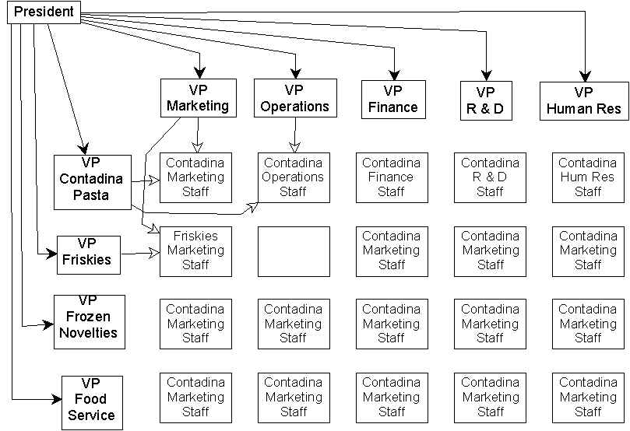

The big advantage of matrix organisations is that they are great for sharing information and enabling people to coordinate their efforts with larger organisational goals and strategies.

The problem, of course, is that having two managers can be confusing, and is a situation that is easily exploited by subordinates, who can pit their managers against each other. The subordinates can also be the unwitting victims of power struggles among the bosses.

The matrix form works best when one dimension is a permanent affiliation (typically functional), and the other is a temporary dimension, such as a client project. So a person is, say, a marketing research analyst, and is presently assigned to the Carnation project, which will take 6 weeks, and will then be assigned to the R.J. Reynolds project, and so on.

### Criteria for Choosing

An organisation can divide itself into departments any way it wants, using any criteria it wants -- there is no law about it. It doesn't have to be rational. However, there is a theory (developed by James Thompson) about what is the best way to do it. According to the theory, there are 4 basic rational criteria for choosing the bases for departmentation:

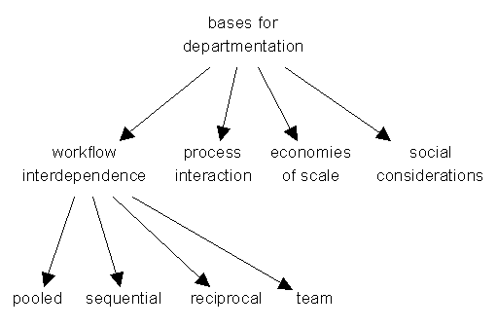

#### Work-flow interdependence:

This refers to the flow of product from person to person as it is being constructed. There are four kinds of increasingly tight interdependence:

* Pooled: sharing of resources and consequences only. In other words, the positions have really nothing to do with each other; they are only interdependent in the general sense of being part of the same company, so they are funded by the same budget.
* Sequential: work is fed from one position to the next, like an assembly line
* Reciprocal: work passed back and forth between a pair of positions/tasks
* Team: work flows around and through a network of positions, like the ball in a football game.

Now here is the key idea: where work-flow interdependence is critical, rational organisations try to **group tasks/positions together which are more tightly interdependent**. That is, operations which are team-interdependent should be grouped first (i.e., at the lowest levels in the organisation); operations that are reciprocal-interdependent should be grouped second, and so on. This is illustrated in the figure below, which gives the **organisation chart of a** **hypothetical manufacturing organisation**:

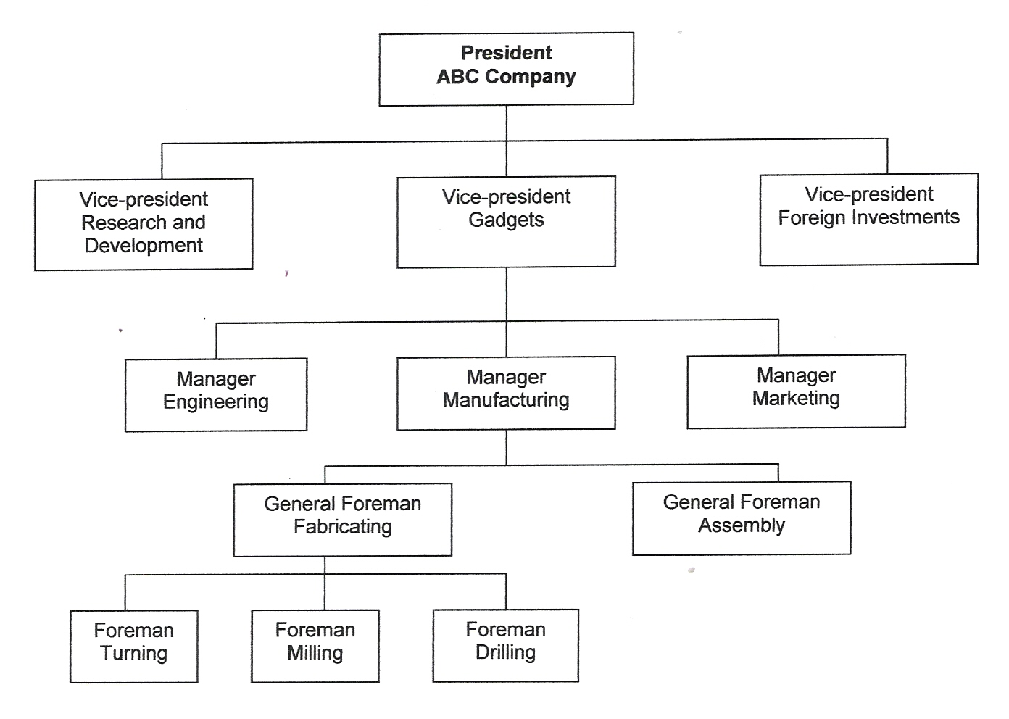

Counting from the bottom up, the first and second groupings are by work process, the third is by business function, and the fourth is by output (product).

Now think about it in terms of interdependencies. The tightest interdependencies are between the turning, milling and drilling operations. These are team or reciprocal interdependencies. So they are the first to be grouped together (under "General Foreman: Fabricating").

The next tightest interdependencies are the sequential interdependencies between fabrication and assembly, since first you make the materials, and then you assemble them. So these are grouped together under "Manager: Manufacturing".

There are also sequential interdependencies between the business functions of design (engineering), manufacturing, and marketing. So at the next level up, we merge all of these under "Vice-President: Gadgets".

Above this level, most of the workflow interdependencies are only of the pooled variety: the gadget department really has little to do with the research and development department, except that they all dip into the same general pool of organisational resources (capital, management talent, physical assets, etc.).

#### Process interaction

This refers to consultations among people about how to do things. For example, lawyers in a corporation consult each other to take advantage of specialised skills and to develop a common approach to things.

**Economies of scale**

Groups are formed in order to achieve economies of scale. For example, if each department in a factory has a maintenance person, it may be inefficient because the small departments don’t have quite enough work for a fulltime maintenance person, while the big departments have too much.

This approach also encourages specialisation, as within a central maintenance department there can be specialists for different kinds of problems.

#### Social considerations

Groups are formed in order to minister to people's social needs. This often leads to functional groupings because people are comfortable with their "own kind" (as in technical people prefer technical people, sales types like sales types, etc.)

Often there are individual concerns, like two people who don't get along, that force certain departments to be placed under other departments, or not to be placed under certain departments.

## What is our core business?



Even though Peter does not drive a truck any more, Moova’s **core (central or main) business** is still transporting goods.

In fact, many of Peter’s employees do not even know how to drive a truck, yet they all contribute to getting goods transported effectively and efficiently.

Therefore, in order to run the business efficiently, Peter needs **support** from various people who have been organised into **departments**, depending on the **type of support** they give, for example, the secretaries, data capturers, receptionists and general assistants make up the **Administration Department** and they are all in offices close to one another.

There is also the **Human Resources Department**, which deals with employees’ well being, for example development through training, Employee Assistance Programmes and certain legal issues.

Peter’s company does not have a separate **Training Department**, as they have decided to **outsource** training and certain other functions, such as cleaning services.

The **Finance Department** deals with salary issues and takes care of the accounting and tax issues.

The **Marketing and Sales Departments** regard their jobs as the most important in the company, as they deal directly with clients and seem to be the only ones bringing in money.

**Operations** often look at the other departments and wonder exactly what it is that they are doing, as the drivers and packers seem to be the only ones doing the actual work, namely driving, packing, loading and unloading.

Of course, without the **Maintenance Department** the trucks, and the business, would come to a standstill!

Formative Assessment 1 - 9

# SECTION 3: EXPLAIN SUPPORT FUNCTIONS

#### *****Specific Outcome 3*****

Identify and explain the support functions within a selected organisation

#### *****Assessment Criteria*****

* The concept of a support function is explained with examples.
* Specific support functions are named and an indication is given of the departments or people responsible for each function in a selected organisation.
* The relationship between a work team and the support units or personnel is explained and an indication is given of how a manager can utilize the assistance of personnel responsible for the support functions.

## Coordination[5]

Any collection of people who are faced with accomplishing some complex task faces two issues: how to **divide up the labour**, and how to **coordinate** their efforts.

How this is done is at the heart of what we mean by organisational **structure.**

### Division of Labour

There are two aspects to this issue. First, there are technical aspects of the task which determine in what way and to what extent you can break up the task into subtasks that can be performed by a single person. This often determines what jobs or positions may exist in the organisation.

Second, there is the allocation of people to jobs. People have different competencies, and are better placed in certain jobs rather than others. They also have different interests, and so have different levels of motivation for different jobs. Placing people in the right jobs is a crucial strategic issue. Misusing talent, such as promoting the best engineer in the company to a pure management job that he or she has no interest or competence in, is a waste at best and dangerous at worst.

In the 21st century, the source of competitive advantage for organisations is increasingly human resources. This may sound strange in a technological age where machines do more and more of the work, but it is precisely technology that creates this dependence on human resources.

This is because technology is knowledge-driven. It is all about understanding how things work and being able to exploit that knowledge to solve client problems. The most important resource most organisations have is human capital (exceptions are oil companies and other natural resource exploiters).

Given that the key problem in division of labour is the assignment of people with certain competencies and interests to tasks, part and parcel of the division of labour is the notion of **specialisation**. Suppose you are photocopying a set of handouts for the class. Let's say there are 21 people in the class and each one must receive a 5-page document, which has been stapled together. That's 21 copies of 5 pages that have to be unstapled, photocopied and then stapled together again (because the stapler built into the copy machine never works).

Suppose you have two assistants (there are therefore three of you doing this). There are two obvious ways to divide up the labour:

One is to have each person handle seven of the sets of handouts and then have them each do three steps on their seven sets: 1) unstaple the original; 2) make 7 copies; 3) staple each of the copies. Assume that you have only one copier. So everyone starts unstapling their originals. Then, one person gets to use the copier, while the others wait. When she's through, she starts stapling the copies while another person starts copying. This could take quite a while.

The other way to divide up the labour is to have everyone unstaple, then one person starts copying, another person starts stapling a moment later, and the third person ferries new copies from the copier to the stapler. This could be done much faster than the other way. This is the method of specialisation into jobs or roles.

You'll see that **these two ways of dividing the labour correspond to departmentation by product/market** (the first one) **and by function** (the second one).

Note that one of the reasons why the second method works better is that there was only one copier. What if there had been three copiers? Well, then there wouldn't be so much difference between the two methods of dividing up the labour, though it is probable that the second method would still be a bit faster.

One reason is that by restricting each person's job to just one task, which is performed repetitively, you eliminate switching time (finding the unstapler, then moving the stuff over to the copier, then moving it all back, etc.).

Another reason is that when people do one thing over and over again, they get really good at it. They have a chance to develop job competency. In combination with pairing up people who have certain talents with the jobs that need those talents, this can really result in productivity gains.

Of course there is also the really slow way to do this task: each person takes each copy all the way through the process. In other words, she starts with the first original, unstaples it, then makes one copy, and then staples that. Then she makes another copy, and then staples that, and so on seven times. Then the second person starts with the original. Nobody would do it this way because we automatically group similar tasks together to be done consecutively.

### Coordinating

There are three basic coordinating mechanisms:

* Mutual adjustment
* Direct supervision
* Standardisation:
* of work processes
* of work outputs
* of worker skills

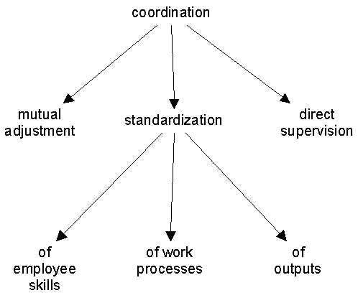

#### Mutual Adjustment

This mechanism is based on the simple process of informal communication. It is used in very small companies, such as a 5-person software shop, or for very, very complicated tasks. Mutual adjustment is the same mechanism used by furniture movers to manoeuvre through a house, or paddlers to take a canoe downriver, or jazz musicians playing a live engagement.

#### Direct Supervision

Achieves coordination by having one person take responsibility for the work of others, issuing instructions and monitoring their actions. An example is the offensive unit of an American football team. Here, there is marked division of labour and specialisation, and the efforts of the players are coordinated by a quarterback calling specific plays.

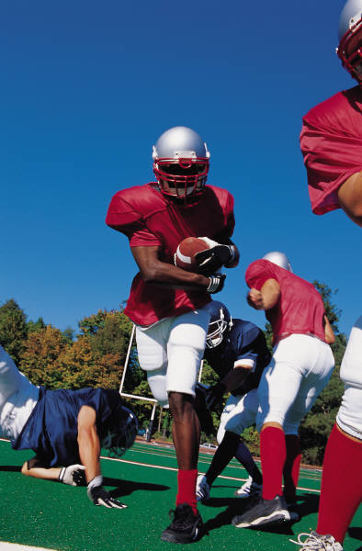

If the organisation is large enough, one person cannot handle all the members, so multiple leaders or managers must be used, then the efforts of these people (the managers) are coordinated by a manager of managers, and so on.

#### Standardisation

A third mechanism of coordination is standardisation. The coordination is pre-programmed in one of three ways:

* **Work Processes**. An example is the set of assembly instructions that come with a child's toy. Here, the manufacturer standardises the work process of the parent. Often, the machinery in a factory effectively standardises work by automatically providing only, say, blue paint when blue paint is needed, and only red paint when red paint is needed.
* **Outputs**. Standardised outputs mean that there are specifications that the product or work output must meet, but aside from that the worker is free to do as she/he wishes.

Stereo equipment manufacturers have a lot of freedom in designing their products, but the interface portions of the product (the connections to other stereo devices like CD's, speakers, tape-recorders, etc.) must be the same as everyone else's, or else it would be hard to put together a complete system.

* **Worker Skills**. Professional schools (like medical schools, law school, and business school) produce workers that do stuff exactly the same way. How do you treat a staphyloccocus infection? You use one of the following antibiotics. It's a series of recipes that are memorised. Employers (e.g. hospitals) can rely on these employees (physicians) to do things the standard way, which allows other employees (e.g. nurses) to coordinate smoothly with them.
* When a surgeon and an anaesthesiologist meet for the first time in the operating room, they have no problem working together because, by virtue of their training, they know exactly what to expect from each other.

### Fitting Coordinating Mechanisms to Tasks

Simple tasks are easily coordinated by mutual adjustment. As organisational work becomes more complicated, direct supervision tends to be added and takes over as the primary means of coordination.

When things get even more complicated, standardisation of work processes (or, to a lesser extent, of outputs, or of skills) takes over as primary, but in combination with the other two.

Then when things become really complicated, mutual adjustment tends to become primary again, but in combination with the others.

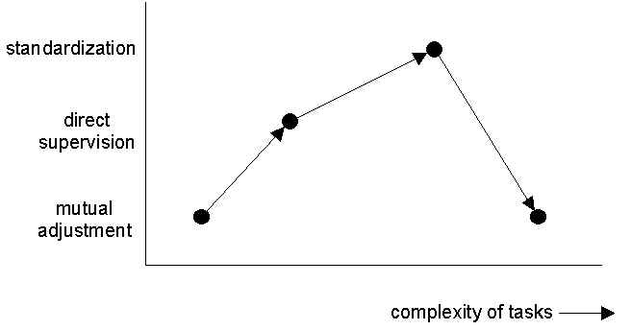

## Where does my job fit in?

# Janine

Meet Janine Lee. She has been working for **Moova** as a **data capturer** for one year now. She also doubles up as the **receptionist**.

She has to deal with the arrogant Sales and Marketing staff and the impatient Operations staff on a daily basis.

She is the one who answers the phone and has to explain to clients why their goods have not arrived on time.

She also has to tell people that a manager is in a meeting, when in fact he’s out playing golf.

As you can see from her photo, she is not very motivated at present.

Janine applied for her job on the basis of the following newspaper advertisement:

**DATA CAPTURER**

**Requirements**:⚫ Grade 12 certificate ⚫ Computer literacy ⚫ Experience in data capturing and administrative work ⚫ Experience in Microsoft Office ⚫ Accuracy in data capturing ⚫ Excellent interpersonal skills, professionalism and reliability ⚫ Ability to work independently and handle a number of tasks simultaneously ⚫ Ability to work under pressure.

**Duties:** ⚫ Provide general administrative support to the MD’s PA ⚫ Develop and maintain an effective and efficient system to ensure the smooth flow of work ⚫ Maintain and update the filing system ⚫ General reception duties ⚫ Attend to relevant tasks as assigned by the supervisor.

Formative Assessment 10 - 13

# SECTION 4: THE ROLE OF A SELECTED TEAM

#### *****Specific Outcome 4*****

Investigate and explain the role of a selected team and its contribution

#### *****Outcome Notes*****

Investigate and explain the role of a selected team and its contribution to the effectiveness of an organisation.

#### *****Assessment Criteria*****

* The main function of a selected team is explained in relation to core business or support.
* The role of another team that interacts with the selected team is explained and an indication is given of how the efficiency of the teams impact on each other.

## Compiling a job profile



# Koos

Koos van Staden has been a supervisor for 10 years and has been with Moova for almost two years. He supervises the maintenance team.

He is a very competent mechanic, but has a very short temper and has been involved in quite a few conflict situations.

The Operations Manager has decided to counsel Koos and coach him on exactly what his job entails.



**Study the following advertisements and their descriptions of the supervisory job:**

Reporting to the Mining, Drill and Blast Superintendent, you will be part of a highly motivated team responsible for all design work related to drilling and blasting. This will cover short-term planning and monitoring of overburden, coal, and parting blasts in preparation for removal by large walking electric draglines. An emphasis will be placed on practical support to the blast crew and ongoing improvements to the blasting process.

A degree in civil/mining engineering and/or extensive blasting experience is essential, along with a high level of computer literacy. The ability to communicate effectively at all levels of the organization and a demonstrated commitment to safety are essential. Previous supervisory experience will be advantageous.

Candidates will be required to pass a Coal Board Medical and Drug and Alcohol test and possess a current driver’s licence. Shift work may be required.

The candidate should have:

* At least 10-15 years’ concrete construction experience
* At least 5 years’ proven supervisory skills, in particular to be able to show the ability to lead a team of carpenters and steel-fixers to meet production targets
* Good communication skills with the ability to interact at all levels within the Company, with a high priority placed on the interaction with consulting engineering site staff
* The ability to speak and write in English
* A valid code 8 driver’s licence

# Shift Supervisor

Supervise the operation of the entire BDO plant. Meet the required production level in accordance with quality, safety, reliability and cost control. Ensure the adherence to safety rules and practices. 12 - 15 years experience in process petrochemical plants. 3 - 5 years experience as a shift supervisor. Good communication skills, plus leadership and PC skills.

Formative Assessment 14 - 16

# SECTION 5: DIFFERENT TYPES OF WORK DONE IN THE ORGANISATION

#### *****Specific Outcome 5*****

Investigate the different types of work done in the organisation

#### *****Assessment Criteria*****

* The different roles an organisation are identified and an outline is written of the kind of work done by three people.
* The work done in the organisation is categorised according to its purpose.
* The importance of each category of work is discussed with reference to the efficiency of the organisation.
* The work in the organisation is identified as a part of a set of related systems each with a role and a value.

## 21st Century Organisational Trends: where are we going?



There are five key organisational trends that you should be aware of:

#### Globalisation

* Increasingly globalised sales, manufacturing, research and management
* Movement from direct exports to having sales offices in different countries to having all functions spread across the globe
* Increasingly globalised labour market
* Due to:
* reduced cost and improved quality of international transportation and communication
* search for unsaturated markets
* exploiting regional cost and expertise differences

#### Diversity

* Workforce getting more heterogeneous sexually, racially, culturally, individually, etc.
* Source of both innovation and conflict/communication problems
* Need to cope with different styles of interaction, dress, presentation, physical appearance
* Due to:
* changing demographics
* globalisation of the labour market

#### Flexibility

* Organisational systems and processes and people that can respond differently to different situations
* Fewer detailed rules and procedures
* Greater autonomy, encouragement for initiative
* Customisable employment relationships: telecommuting, job sharing, pay for skills
* Lifetime employability, not lifetime employment
* Due to:
* differentiated customer needs -- filling them exactly is source of competitive advantage
* increasing diversity in workplace
* increased pace of change in technology and markets

#### Flat Hierarchies

* Fewer levels of management,
* Workers empowered to make decisions
* Fewer differences in responsibility (not in pay) across levels
* Due to:
* need for speed, which makes it helpful to empower employees to make decisions, which means fewer managers are needed
* changes in information technology mean less need for the communication and control functions of middle managers
* globalisation means intensified competition, which increases the need to cut costs

#### Networking

* Direct communication across unit & firm boundaries, ignoring chain of command
* Cross-unit team structures
* Outsourcing & downsizing
* Strategic alliances with competitors and others
* Now have firms that are your competitors, customers and collaborators all at the same time
* Close coordination among firms (e.g. JIT systems) and information sharing (open computer systems)
* Across the board contact with customers
* Customisation
* Decentralisation
* Due to:
* new information technologies, especially groupware, client-server, distributed computing
* fast changing customer needs and competitor offerings
* more complicated products require better integration of manufacturing, design, and marketing functions

**Here is a diagram linking up all the concepts above:**

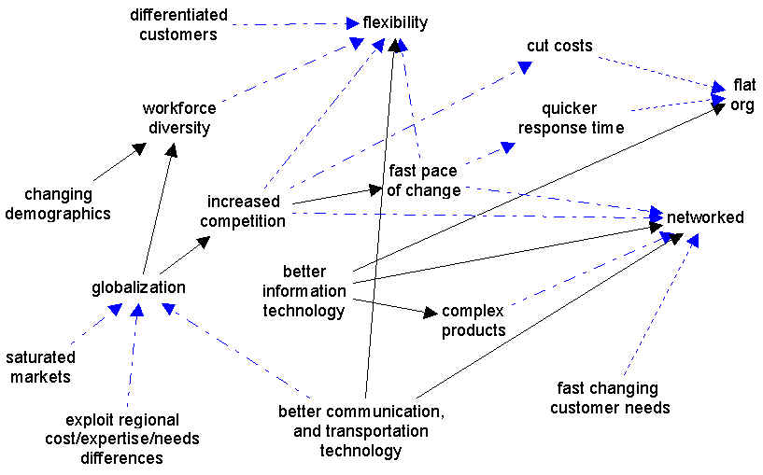

(The dashed arrows with blue heads mean "creates the need for", while the solid arrows with black heads mean "causes" or "enables")

### Summary and implications for managers

An organisation’s internal structure contributes to explaining and predicting the behaviour of employees.

Robbins[6] argues that an organisation’s internal structure has an impact on both the attitudes and behaviour of employees, “to the degree that an organisation’s structure reduces ambiguity for employees and clarifies such concerns as “What am I supposed to do?” “How am I supposed to do it?” “Whom do I report to?” and “Whom do I go to if I have a problem?” It shapes their attitudes and facilitates and motivates them to higher levels of performance.” However, structure also limits and controls what employees may and may not do.

Employees tend to form their own subjective view of the organisational structure, based on unscientific observations, such as comments made by peers, descriptions of management and the organisation in the media, their own past experiences with other organisations and their experience of their own immediate superiors. This perception may be far removed from the objective reality and can impact on employees’ overall performance and commitment.

The diagram below illustrates how strategy, size, technology and environment determine the type of structure an organisation will have. This, in addition to individual preferences, affects the performance and satisfaction of employees:

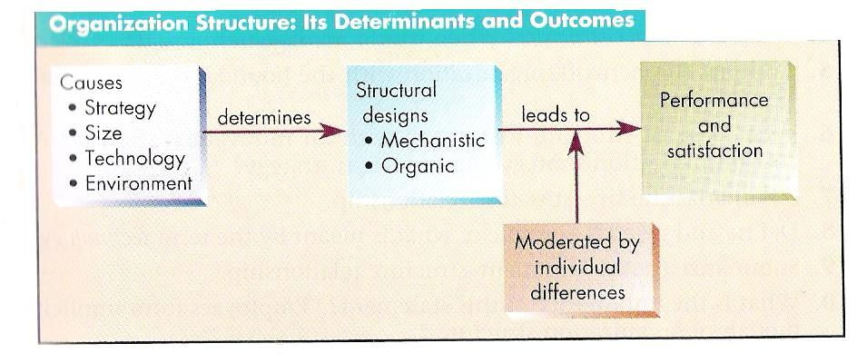

***Fig. 2[7]***

Formative Assessment 17

# FORMATIVE ASSESSMENTS WORKBOOK

Formative Assessment 1

1. What do you understand by the concept of **core business**?

|  |
| --- |
|  |

1. Give three examples from the South African economy.

|  |
| --- |
|  |

1. Name your company’s **core business:**

|  |
| --- |
|  |

Formative Assessment 2

1. Which **department(s**) in your company is/are involved in the **core business** of the company?

|  |
| --- |
|  |

1. Describe the relationships between the different core activities of your organisation and compare them in terms of importance and value added to the organisation

|  |
| --- |
|  |

Formative Assessment 3

1. Explain the concept of a **support function**. Give three examples.

|  |
| --- |
|  |
|  |

1. As in Peter’s business, your company also has various **departments** that **support** the core activities. **List** these departments within your organisation.

|  |
| --- |
|  |

Formative Assessment 4

1. Explain the relationship between a work team and the support units or personnel

|  |
| --- |
|  |

1. Is your department/section part of the core business of the organisation, or is it part of the support function? Give a reason for your answer.

|  |
| --- |
| **Choose support or core** |
|  |

Formative Assessment 5

1. Why do you think your **department** is important in running the business effectively? Give two examples.

|  |
| --- |
|  |

Formative Assessment 6

1. Why do you think your **team** is important in running the business effectively? Give two examples.

|  |
| --- |
|  |

Formative Assessment 7

1. How would it affect other departments and the organisation as a whole, if your team **did not work properly**? Give two examples.

|  |
| --- |
|  |

Formative Assessment 8

1. Name another team that interacts with your team. In what way do the teams work together? How would it affect your team if the other team did not perform well? Give two examples.

|  |
| --- |
|  |
|  |
|  |

Formative Assessment 9

1. Using the example in your Learner Guide, complete the following table to show the basic resources your team uses:

|  |  |  |  |
| --- | --- | --- | --- |
| **Human resources** | **Financial resources** | **Physical resources** | **Information resources** |
|  |  |  |  |

Formative Assessment 10

1. Do you think that the work Janine is doing now is described in the advertisement as part of her duties? Explain your answer by referring to the advertisement.

|  |
| --- |
|  |
|  |

Formative Assessment 11

1. Do you think that Janine is performing well in her job? Give reasons for your answer.

|  |
| --- |
|  |
|  |

Formative Assessment 12

1. Name the two people to whom Janine reports.

|  |
| --- |
|  |

Formative Assessment 13

1. If you were her supervisor, what steps would you take to help her improve her performance?

|  |
| --- |
|  |

Formative Assessment 14

1. List the requirements that all three supervisory positions have in common:

|  |
| --- |
|  |

Formative Assessment 15

1. If you were Koos’s Manager, on which aspects of his performance would you focus?

|  |
| --- |
|  |

Formative Assessment 16

1. Some of the workers in Peter’s company feel that they are the only ones actually doing the real work. Do you agree that some jobs are more important than others? Give a reason for your answer.

|  |
| --- |
|  |

Formative Assessment 17

1. Checklist upon completion of Module:

|  |  |
| --- | --- |
| I know | **✓** |
| What the core business of my organisation is |  |
| What support functions exist in my organisation and how they contribute to the core business activities |  |
| What role my department plays in the effective running of the organisation |  |
| What role my team plays in the effective running of the department and the organisation |  |
| What different types of jobs are done in the organisation |  |

1. ***Management Principles*,**  p.4
2. Stephen P. Borgatti
3. Robbins, p 569
4. Stephen P. Borgatti
5. Stephen P. Borgatti
6. p. 575
7. Robbins, p.575