Exercise 10
- In your table document, draw a table and add the following information:
Learner Name | Demographic Form | Copy of ID | Copy of Licence | Copy of PrDP
Golele H.A | Yes | Yes | Yes | Yes
Duma T.P | Yes | Yes | Yes | Yes
Gabathole G.S | Yes | Yes | Yes | Yes
Khanji H.R | Yes | Yes | Yes | Yes
Baloyi P. | Yes | Yes | Yes | Yes
Dhlamini G.M | Yes | Yes | Yes | Yes
- Draw a line in the first column from the second to the last rows and move the initials from the firs column to the second column
Learner Name |  |  | Demographic Form | Copy of ID | Copy of Licence | Copy of PrDP
Golele |  | H.A | Yes | Yes | Yes | Yes
Duma |  | T.P | Yes | Yes | Yes | Yes
Gabathole |  | G.S | Yes | Yes | Yes | Yes
Khanji | H.R |  | Yes | Yes | Yes | Yes
Baloyi. | P |  | Yes | Yes | Yes | Yes
Dhlamini | G.M |  | Yes | Yes | Yes | Yes

Format A Table

Merge cells into one cell in a table
You can combine two or more cells in the same row or column into a single cell. For example, you can merge several cells horizontally to create a table heading that spans several columns.
- Select the cells and then select the Table Merge Cells menu
- You can quickly merge multiple cells by selecting them and clicking Merge Cells on the Format menu

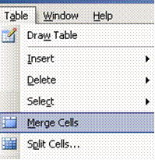
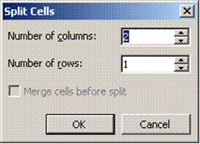

Split a cell into multiple cells in a table
- Select the cells and then select the Table Split Cells menu
- To quickly split multiple cells, select them, and then click Split Cells
- Select the options you need

Change the column width in a table
- Rest the pointer on the column boundary you want to move until it becomes, and then drag the boundary until the column is the width you want.
- To change a column width to a specific measurement, click a cell in the column. On the Table menu, click Table Properties, and then click the Column tab. Choose the options you want.
- To make the columns in a table automatically fit the contents, click a table, point to AutoFit on the Table menu, and then click AutoFit to Contents.

Change the row height in a table
- Rest the pointer on the row boundary you want to move until it becomes a resize pointer, and then drag the boundary.
- To change a row height to a specific measurement, click a cell in the row. On the Table menu, click Table Properties, and then click the Row tab. Select the options you want.

Tip To display row height measurements, click a cell, hold down ALT as you drag the markers on the vertical ruler

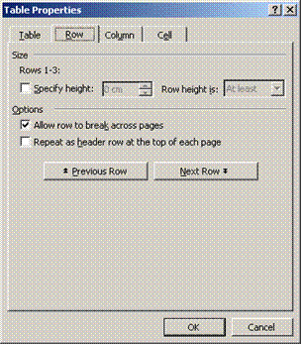

Make multiple columns or rows the same size
- Select the columns or rows you want to make the same size.
- On the Tables and Borders toolbar, click Distribute Columns Evenly or Distribute Rows Evenly

