Exercise 2
- Point the mouse at the vertical line to the right of the column header of column B until it turns into a double-headed arrow, then click and drag the mouse to the right until the text in the cells is fully visible.
- Select Row 1. Select the Format, Row menu and click height. Enter a height of 25 in the box and click OK. The height of the row will increase.

Enter Data Into Cells
Entering data into cells: When you type numbers into a cell, they are automatically aligned to the right. If the number is too long, Excel will automatically widen the column. To enter a negative amount, either type a minus (-) before the amount or enclose it within a parentheses (1234).
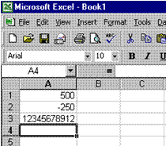
- Now click in Cell A1 to select it, then type 500 and press enter. In cell A2 type (minus) –250 and press the down arrow to select cell A3. In cell A3 type: 12345678912. See how Excel widens the column for the last set of numbers. Please note that you have to tell the PC when you have finished entering data in a cell by moving out of the cell. This is what you do when you press Enter or use the keyboard arrows.
- When you open a new worksheet, all the cells have general format. The format of the cell determines what the numbers, text, dates and so on in the cell look like after you have entered data into a cell.
A general format means that the cells have no specific number format. Let's find out what this means. In cell B1 type: Mrs B. Otto; in cell B2 type PO Box 1620; in cell B3 type Timbuktu; in cell B4 type the postal code 0026. See what happens to the postal code? In order to display the postal code correctly, we have to change the format of the cell. This will be done in the next step.

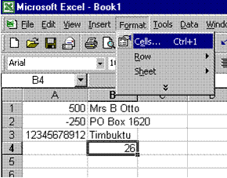
The format of a cell is changed via the format menu on the menu bar. Before we can change the format of a cell, we first have to tell the PC which cell we want to change. Click on cell B4, where the postal code should be. Then click on the format menu and click on cells.

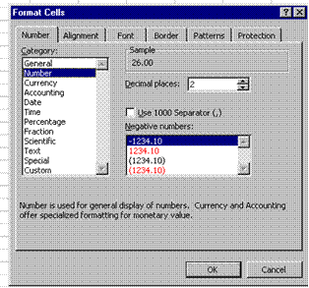
The explanation given says that: "Number is used for general display of numbers." Click OK and watch what happens. Oops, this is not what you wanted! But at least now you know that the Numbers format gives two decimal points and that it is used for a general display of numbers.

