Exercise 3

In your practice file enter the following amounts in cells C1 to C5: C1: 28443; C2: 31296; C3: 8543; C4: 12; C5: 96.
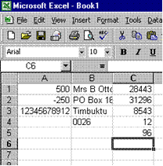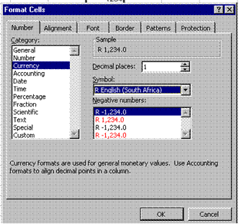

Then select these cells, click the Format menu from the menu bar and click cells. Click on the Numbers tab and then click on the currency category. The explanation reads: "Currency formats are used for general monetary values."
Set the number of decimal places to zero and the currency to R English.
Select the first figure in red in the box as the format for negative numbers. Click OK.

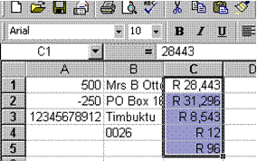
See how the appearance of the cells has changed.

If you look at the formula bar, the number appears unformatted (it does not show the R in front of the amounts). Excel uses the number in the formula bar when performing any calculations on this cell, in other words it uses the number only, not the currency.

