Exercise 6
- In cell A1 type 250; in cell A2 type 320; in cell A3 type 125.
- Start your calculation (your sum) by entering an = in cell A4
- Click cell A1 and press + .See how the formula shows in cell A4
- Click cell A2 and press+ .See how the formula shows in cell A4 as well as the Formula Bar
- Click cell A3 and press Enter - DO NOT PRESS + IN CELL A3!!! Press Enter!!!
- The answer will display in cell A4.
- If you press + and then Enter in cell A3, an error message will display. You can click on Yes and Excel will make the corrections as proposed, or you can click No and make the corrections yourself.
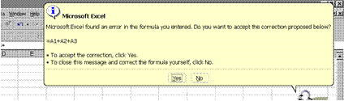

Error Messages
When you are adding in Excel, it is similar to adding on a calculator. You will type + in all the cells except the last one, where you press enter. Excel will automatically calculate and display your answer in the cell nominated by you, where you typed the =.
If a formula cannot properly evaluate a result, Microsoft Excel will display an error value. Each error type has different causes, and different solutions. Error messages display in two ways: via the Office Assistant as in the example above and then as a message in a cell.
##### Occurs when a column is not wide enough, or a negative date or time is used. Enlarge the column
#VALUE! Occurs when the wrong type of argument or operand is used. There is something wrong with your formula, check the formula again. Also check that you used the correct cell formatting.
#NAME? Occurs when Microsoft Excel doesn't recognize text in a formula. Usually this happens when you used a label in a formula, without labels being allowed. This is covered later in the manual.
#REF! Occurs when a cell reference is not valid
This lesson is important, because if you do not do the calculations in the right sequence, Excel will not be able to display the answer.

