Add A Column Using The Autosum Button

Exercise 7
- You will find the Autosum button on the toolbar. Autosum will add totals in columns or rows for you:
- Click and drag down the cells in the column that you wish to add. End one cell below the last number. Then click the AutoSum button on the toolbar.
- Excel will add the total of the column automatically. Columns can only be added from the top to the bottom and rows from the left to the right
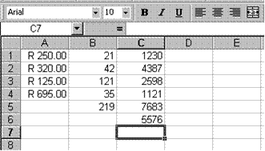

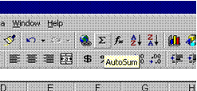
- You are still working in sheet 3, so enter the following amounts in column C:
- C1:1230; C2: 4387; C3:2598; C4: 1121; C5: 7683; C6: 5576.

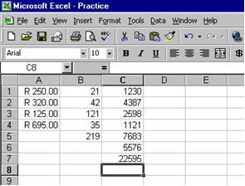
Click and drag from cell C1 to cell C7. Click on the Autosum button. The answer will be displayed in cell C7

Adding Using The SUM Function
You can find the SUM function in two ways: through the Paste Function button or through the SUM function:
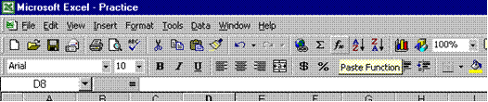
The SUM function appears in the Name box as soon as you click on the = sign on the formula bar.

Exercises
- In column D enter the following amounts: D1 : 121; D2: 354; D3 no amount; D4: 478; D5: 299; D6: 35; D7: 99.
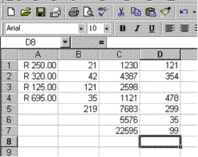
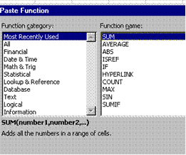

- Click in cell D8 and then click the Paste Function button on the toolbar.
- In the FunctIon Name box select SUM and click OK.
- In Number 1 of the SUM box, type the following: D1:D7.
- The Name box will now display the word SUM and the formula bar will display the following:
- =SUM (D1:D7)
- This is the correct way of using the SUM function. We will discuss functions again later in the manual
- Click OK and the answer will be displayed in cell D8.

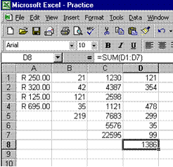
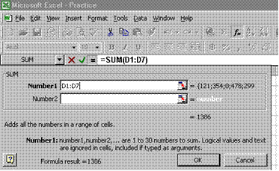

Exercises: Using The Sum Function In Rows
You can, of course, also use the Sum Function to do calculations in rows rather than in columns.
- In row 18, enter the following amounts: cell A18 : 257; cell B18 :799; cell C18 147.
- Click in cell D18, click the = sign on the formula bar, select Sum in the name box and click OK.
- In Number 1 of the Sum box, type A18:C18 and click OK.
- The answer will be displayed in cell D18.

