Exercise 9
In your table document, do the following:
- Add a column to the left of the first column
- Insert numbers from the first row
- Delete the last row

 | Learner Name | Demographic Form | Copy of ID | Copy of Licence | Copy of PrDP
 | Rasephya M.A. | Yes | Yes | Yes | No
 | Khoza C | Yes | Yes | Yes | No
 | Modise P | Yes | Yes | Yes | Yes
 | Makgatho J.S | Yes | Yes | Yes | Yes
 | Mogoane A.M | Yes | Yes | Yes | Yes
 | Khoza C

Insert a tab in a table cell
- Press CTRL+TAB.

Use the Convert Table menu to create a table
- Select the text you want to convert to a table
- Select the Table, Convert Text to Table menu
- Make your selections

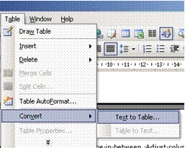
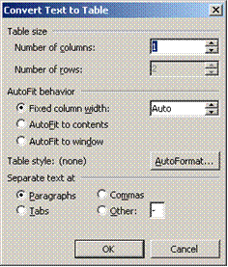

Note a comma, full stop or tab will start a new cell. If this is not what you want, remove commas, full stops and tabs from text.

Draw A Table
Use the Draw Table tool to quickly create a more complex table, for example, one that contains cells of different heights or a varying number of columns per row.
Using Draw Table is similar to drawing a rectangle on graph paper: first, draw a line from one corner of the table to the corner diagonally opposite in order to define the boundary of the entire table, and then draw the column and row lines inside.
- Click where you want to create the table.
- On the Tables and Borders toolbar, click Draw Table
- The pointer changes to a pencil.
- To define the outer table boundaries, draw a rectangle. Then draw the column and row lines inside the rectangle.
- To erase a line or block of lines, click Eraser and then drag over the line.
- When you finish creating the table, click a cell and start typing or insert a graphic.
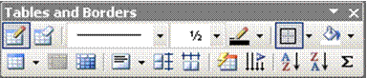
Tip: Hold down CTRL to automatically apply text wrapping while you draw the table.

