Exercises 1: Column Width
The standard width of a column is 8,43 characters.

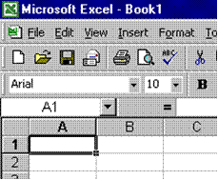
Excel offers two methods of changing the column width: through the format menu or by using the mouse.
Point the mouse at the vertical line to the right of the column header until it turns into a double-headed arrow, then click and drag the mouse to the right or left

Using the Format menu: Select column A, or any cell from column A and select the Format, Column menu and click on width. Enter 15 in the dialogue box to increase the width of column C and click OK. The width will have increased on your screen.

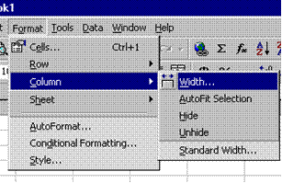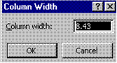

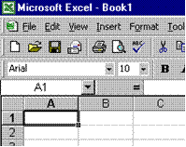
To change the column width of the entire sheet, Click the Select All button, in the top left hand corner of the worksheet, where the rows and columns meet. Select the format, column menu; enter the desired width and click OK. The column width for the entire sheet will change

Exercises: Row Height
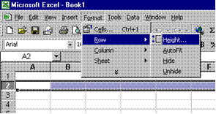
Format menu: Select the Row that you want to change, select the Format, Row menu and click height. Enter the height you require into the dialogue box and click OK.

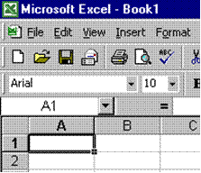
Using the Mouse: Point the mouse to the vertical line at the bottom edge of the row heading until it turns into a double-headed arrow, then click and drag the vertical line to the desired height.
To change the row height of the entire sheet, Click the Select All button, in the top left hand corner of the worksheet, where the rows and columns meet. Select the format, row menu; enter the desired height and click OK. The row height for the entire sheet will change.

