Exercises 16
- Create a new file and save it as PICTURES
- Start with a blank page, slide, or worksheet
- On the Drawing toolbar, click Insert Clip Art
- From the Search in: list box, uncheck all the boxes then expand the Web Collections category and check the categories such as Concepts and Emotions
- From the Results should be box, uncheck Photographs, Movies, and Sounds
- Type the keywords cartoon and confused then click Go
- Browse the results for this clip then click it to insert it
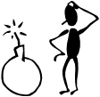
- Change the search text to cartoon happy and click Go
- Insert the clip shown below
- Close the Clip Art task pane
- Select the first picture then on the Picture toolbar, click the Crop tool
- Crop to remove the bomb part of the picture
- From the Tools menu, select Options
- When the dialogue box is displayed, press $\boxed{Alt}$+$\boxed{Print Scrn}$
- Press $\boxed{Esc}$ to close the dialogue box then press $\boxed{Ctrl}$+$\boxed{V}$ to paste the graphic

Tips To move and resize a picture, click-and-drag it. To resize a graphic, click-and-drag the handles on its border. If you want one picture to appear in front of another, right-click it and select Order then Bring to Front.
To flip the puzzled man picture, use the Draw button on the Drawing toolbar. If you are using Word and the pictures appear with black handles, click each picture then on the Picture toolbar, click Text Wrapping and select In Front of Text.

- Save and close the file
- Create another blank file and save it as FALCON
- On the Drawing toolbar, click Insert Clip Art
- Using the Web Collection again, search the Animals category for Photographs
- Insert the picture of a falcon
- Select the picture then on the Picture toolbar, click the Crop tool
- Point to each handle in turn and click-and-drag to crop the picture as shown
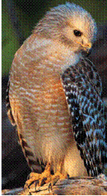
- Save and close the document

