Formative Assessment 9

Activity 1
Read the local newspaper and identify the articles that make use of manipulative language to impress an opinion on you the reader. Discuss your reactions to these articles.

Activity 2
Read the following for enjoyment and to improve your reading skills.
Read also to appreciate healthy eating habits.
A wellness diet for healthy living
(Cross-curricular Life Orientation LO 1 Health Promotion)
- Aim for variety and include at least five fresh fruits or vegetables in your daily diet
- Minimize consumption of processed and fast food
- Include carbohydrates, fat and protein in every meal
- Adults need between 2 000 and 3 000 calories daily
- Women and smaller and less active people require smaller amounts
- The distribution of calories should be:
- 40% - 50% from carbohydrates
- 30% from fat
- 20% - 30% from protein
- Carbohydrates
- eat whole grains, beans, squashes and sweet potatoes
- cook pasta al dente
- avoid products made with high-fructose corn syrup
Fat
- reduce your intake of saturated fat by eating less butter, cream, cheese and other full-creamed dairy products, unskinned chicken, fatty meats and coconut and palm kernel oil
- use extra virgin olive oil
Protein
- eat less protein if you have liver or kidney problems, allergies or if you have autoimmune disease

Fibre
- try to eat 49 g of fibre daily
- eat fruit, vegetables (especially beans) and whole grains
Avoid
- sunflower oil, corn oil, cottonseed oil and mixed vegetable oil
- margarine and all products made with hydrogenated oils
Include
- avos and nuts especially walnuts, cashews and almonds
- for omega-3-fatty acids eat salmon, sardines, herring, black cod or take a fish oil supplement

Activity 3
Answer these questions on the article in Activity 3 to test your comprehension skills:
- Name at least ten fresh fruits and vegetables that could be included in your diet.
- What oils and products should one avoid consuming?
- What ailments which you have, should make you cautious about eating protein?
- Name foodstuffs which include saturated fats.
- What is the healthiest oil to eat?
- What excellent oils do salmon and sardines contain?
- Name the food categories which should be included in every meal.
- Why do you think fast food is unhealthy?

Activity 4
Listening, Speaking, and Reading and Viewing
Now let us read purely for enjoyment and to expand your vocabulary. Try to create your own sound effects.
Sea Fever
I must go down to the sea again, to the lonely sea and the sky,
And all I ask is a tall ship and a star to steer her by,
And the wheel's kick and the wind's song and the white sails shaking,
And a grey mist on the sea's face, and a grey dawn breaking.

I must go down to the sea again, for the call of the running tide
Is a wild call and a clear call that may not be denied;
And all I ask is a windy day with the white clouds flying,
And the flung spray and the blown spume, and the sea-gulls crying.

I must go down to the sea again, to the vagrant gypsy life,
To the gull's way and the whale's way where the wind's like a whetted knife;
And all I ask is a merry yarn from a laughing fellow-rover,
And a quiet sleep and a sweet dream when the long trick's over.
John Masefield
(Enjoying More Poetry Sadler & Haylar)

This poem is the basis for the next activity.

Activity 5
Speaking (as a way of expanding your vocabulary).
Discuss the poem:
Words
- fever is like a disease has taken possession of him
- lonely sea and the sky are carefully chosen words
- wheel's kick is “kicked” as the current hits the rudder: the wheel's kick is the steering helm
- the running tide is the rising and falling of the surface of the ocean twice daily caused by the gravitational attraction of the sun and moon, occurring unequally on different parts of the earth
- the flung spray is water flying in small drops
- the blown spume is the froth and foam blown from the waves
- the vagrant wanders from place to place: a gypsy, originally from India migrated to Europe and the USA in the fourteenth and fifteenth century and leads a migratory life
- whet is to sharpen by rubbing on or with something like a stone
- a yarn is a “tall” tale

Activity
Answer these questions to practise your skills in understanding poetry:
- The poet keeps repeating “I must go down to the sea again” What is it about the sea which makes him say this?
- The terms “the sea's face” and “the wind's song” are examples of personification. Explain in what way the sea and the wind have become human.
- Why is the life of a sailor “the vagrant gypsy life”?
- What quality of the wind is the poet emphasising when he describes it as “like a whetted knife”?
- Why is “Sea Fever” a good title for Masefield's poem?

Activity 7
Further practise reading to improve your reading and comprehension skills
The sly fox
There was once a lion who lay sick in his den. He said to his beloved neighbour, the fox,”If you want me to live, use your clever tongue to bring a fat deer within reach of my claws. I am very hungry.”
The sly old fox thought for a minute, then off he trotted into a nearby forest. Soon he came up with a handsome, big deer who was frisking among the trees.
“Pardon me, my friend,” said the fox, I have good news for you. Our king , the lion, is dying. He is worried about an heir to the throne, for as you know, he is a bachelor. The pig is too ugly, the elephant too stupid, the bear too lazy, the tiger brags too much and the leopard has too quick a temper. But you are tall, strong and handsome. We all admire your splendid horns. You are to be the new king of the animals.”
And with that the sly old fox bowed low and continued, “I think you should come and say goodbye to the lion before he dies. He wishes to speak to you.” The deer felt very proud indeed so he followed the fox.

Something for you to do
Read the fable again and answer the following questions to test your skills in comprehending a story.
- Where was the lion?
- What was wrong with him?
- Who was his neighbour?
- Did the lion like his neighbour?
- What did the sick lion want to eat?
- Where did the fox look for the deer?

Activity 8
Read the following poem by Oswald Mthali to test your sensitivity culturally and emotionally and to improve your reading skills:

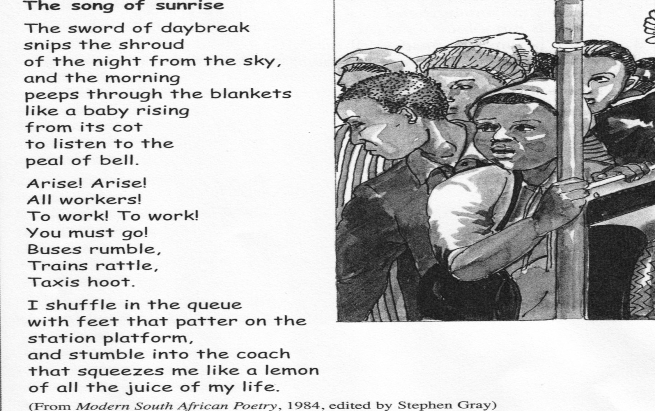

Activity 9
Discuss then write the answers in full sentences.
- What do you think of the title? If you happened to just read the title without reading the poem or seeing the illustration would you think it could be a happy poem? Why?
- Lines 1 and 2 are examples of two figures of speech. Say which figures of speech are being used and briefly explain how each one works.
- “... the morning peeps through the blankets like a baby rising from its cot ...” This is an example of ................. and ..................... because .....................
- What is the tone in stanza 3? Explain how the poet uses punctuation in this stanza in order to create atmosphere.
- The last three lines of stanza 2 are examples of ................ as the poet uses verbs to imitate sounds made.
- In the final stanza the poet concentrates on verbs depicting .............. to portray the feeling of being trapped.
- Explain the simile found in the final line of the poem.
- What is the effect achieved by appealing to people's sense of taste? What does the image of the lemon being squeezed tell you about the space in the compartment.
- What means of transport does the speaker make use of ?
- What does the image of the lemon being squeezed tell you about the space in the compartment?
- Name the three examples of transport mentioned in this poem.

Activity 10
Look at the advertisements on the following pages and answer the following questions about them:

What is being advertised?
What was the first thing you noticed?
How did they make use of font types and sizes to make key points stand out?
Is the layout of the page done in a way that is interesting and gets your attention? Why do you think so?
Was it easy to understand the message? Why do you think so?

What is being advertised?
What was the first thing you noticed?
How did they make use of font types and sizes to make key points stand out?
Is the layout of the page done in a way that is interesting and gets your attention? Why do you think so?
Was it easy to understand the message? Why do you think so?

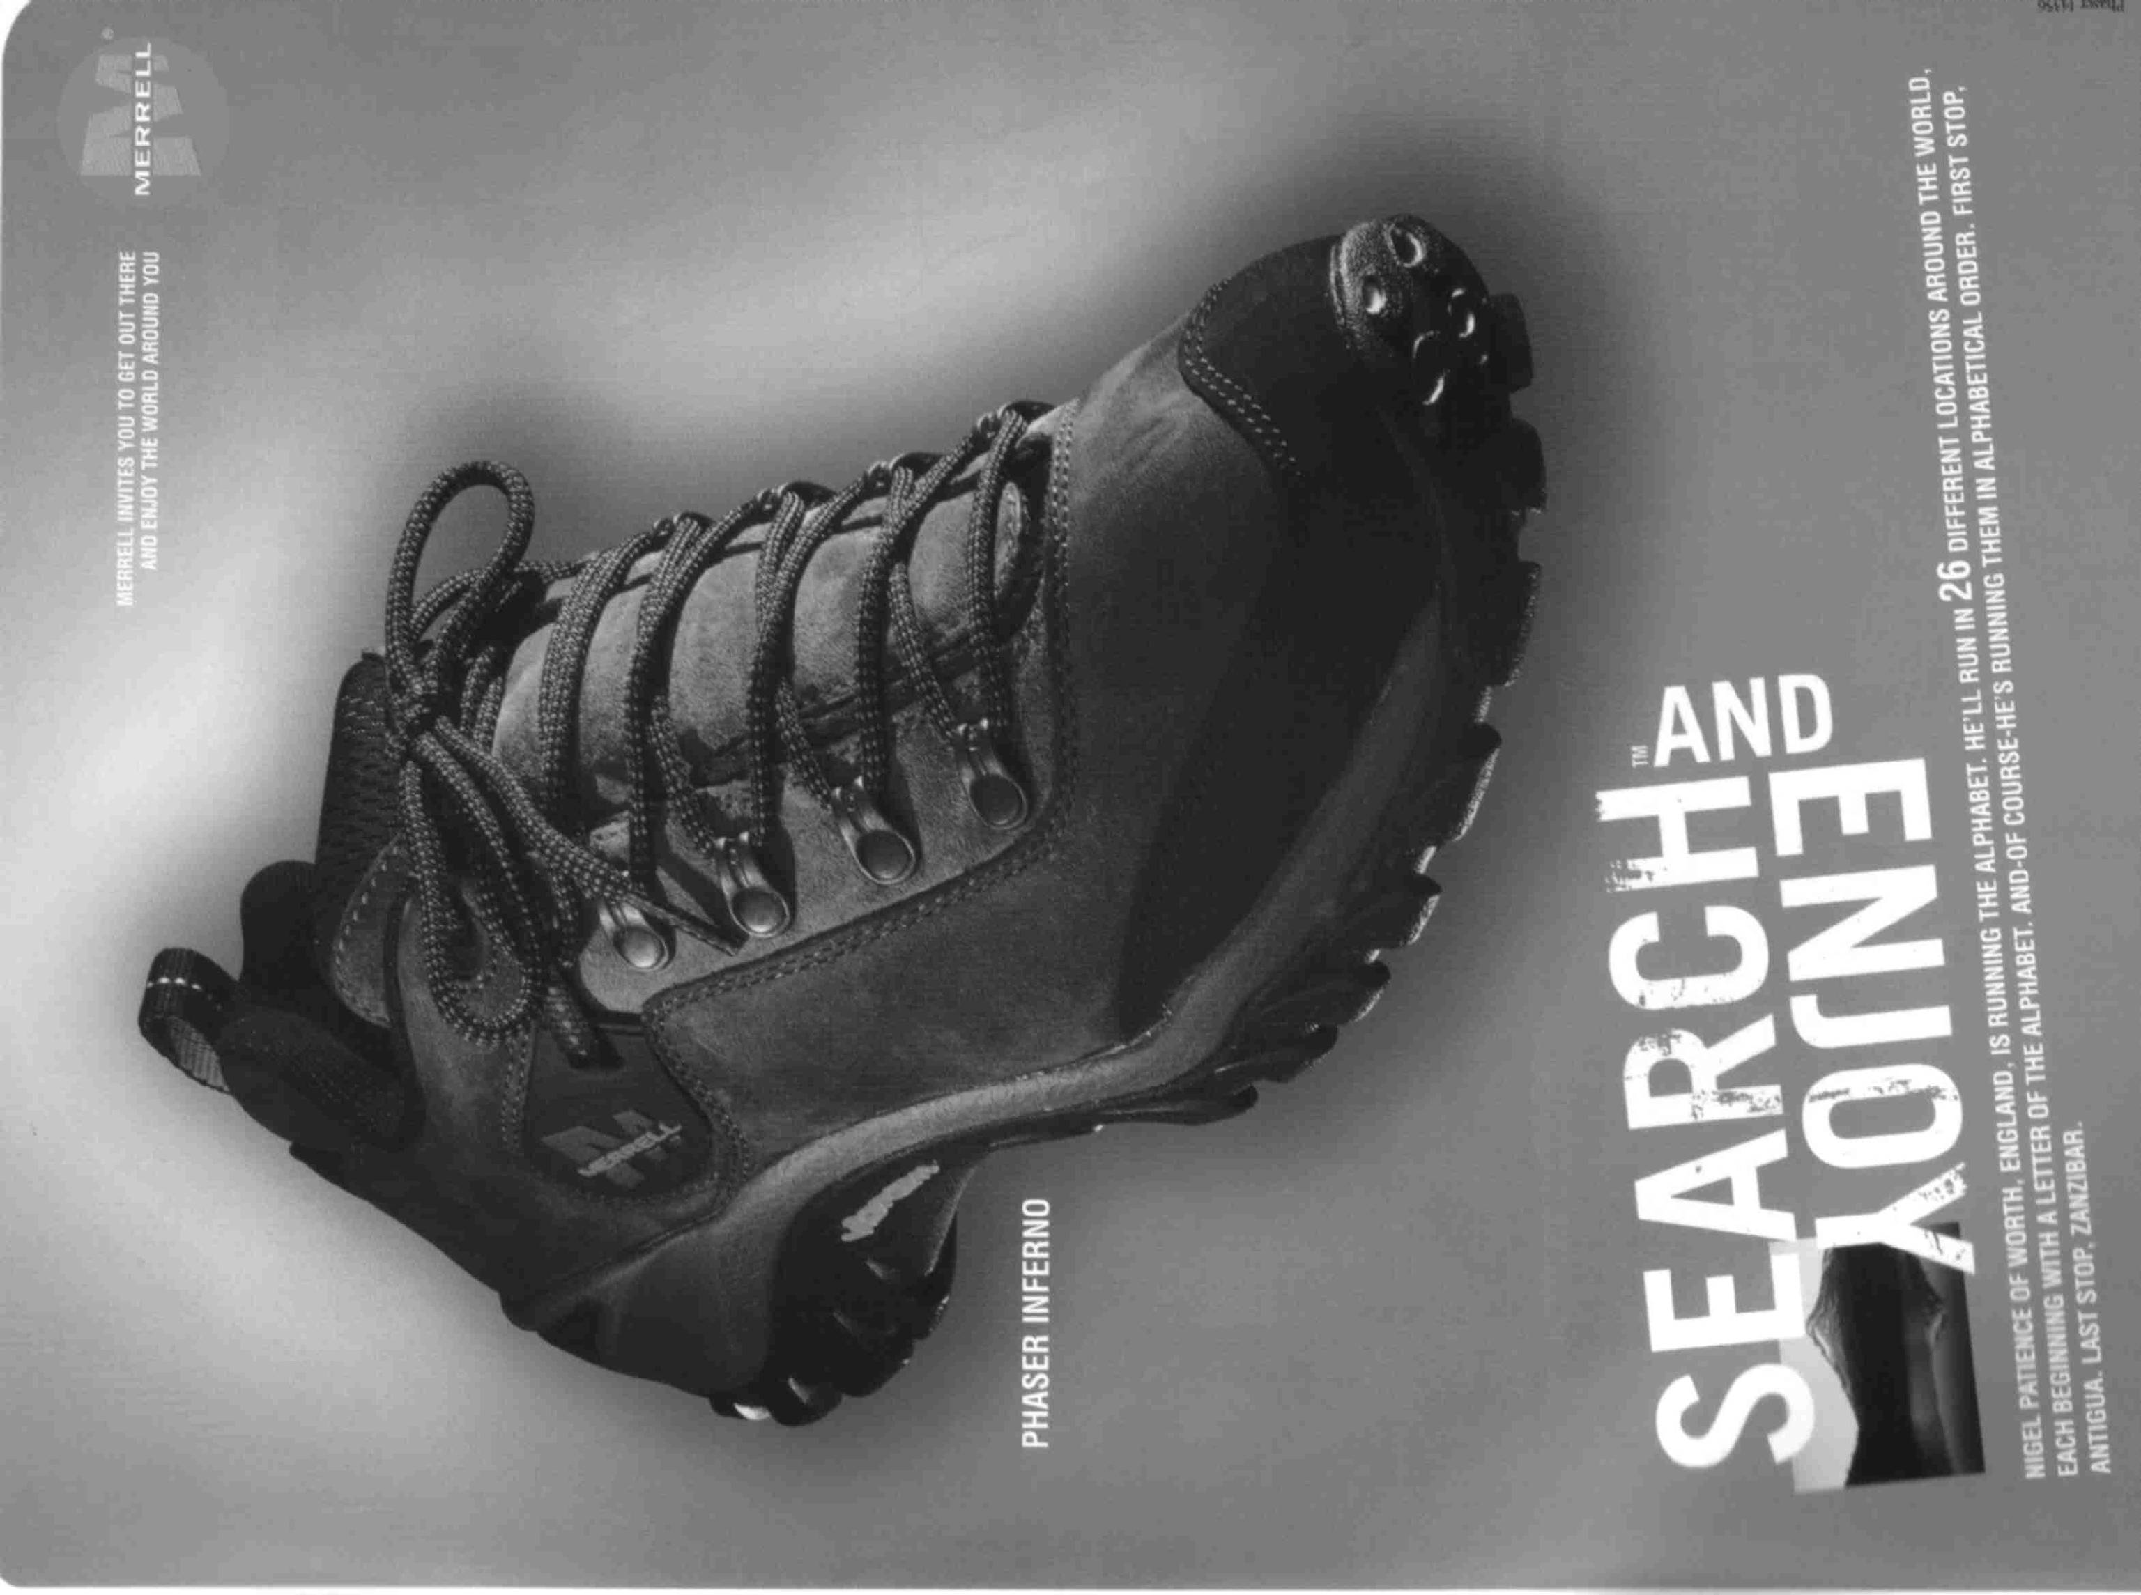

Look at the cover page of a novel that tells you at a glance what the story is about. The novel is called “THEY’RE ALL MY CHILDREN”. Answer the following questions:
Who wrote the book?
What do you think the book is about? A mother writing about her children, a grandmother writing about her children and grandchildren, a teacher writing about the schoolchildren she taught or someone saving war orphans?
Why do you think so?
There are two clues in this cover page that helps you identify what the story is about. What are they?
What do you think of the page layout?

The next piece of writing is called: “Notes from all over”.
Note how titles, subtitles and visual aids are used to highlight main points and helps you to decide whether to read the article or simply skim until you get to something that interests you.
Which part of the written piece would you read first?
Why?

Which technique is used to indicate main points in the article: “Tips for Beating the Clock”?

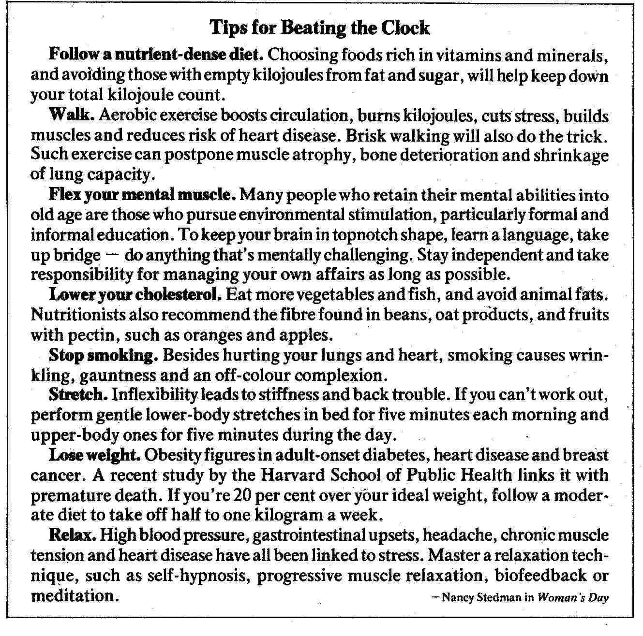

On the next page is the first page of a magazine article about slavery.
Answer the following questions about this page:
Who wrote the article?
Which techniques are used to catch your attention and encourage your to read further?
To which continent did slavery return, according to the author?
Why do you think so?
Who is being taken prisoner?

Activity 11

Refer back to the article on slavery, what do you think is the author’s purpose in writing this article? Motivate your answer by quoting from the article.
Identify at least two examples of explicitly stated facts in the article about slavery.
Identify at least three examples of implicitly stated points in the article about slavery.

