Formative assessment 2 (SO2, AC1-3)

Individual activities
Look at the advertisements and answer the following questions about them:
What is being advertised?
What was the first thing you noticed?
How did they make use of font types and sizes to make key points stand out?
Is the layout of the page done in a way that is interesting and gets your attention? Why do you think so?
Was it easy to understand the message? Why do you think so?

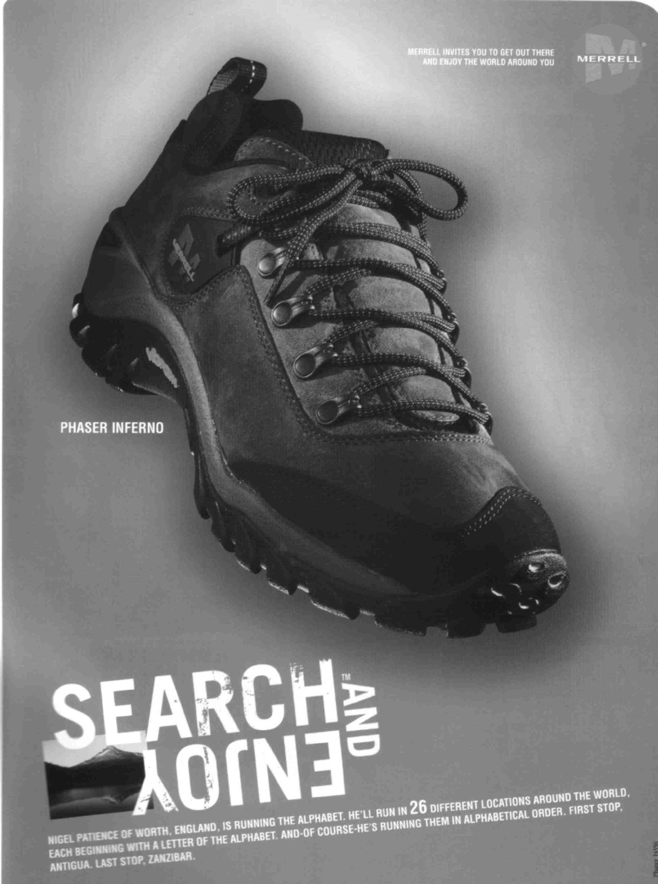

What is being advertised?
What was the first thing you noticed?
How did they make use of font types and sizes to make key points stand out?
Is the layout of the page done in a way that is interesting and gets your attention? Why do you think so?
Was it easy to understand the message? Why do you think so?

