Assessment: Questionnaire
Read through the article and then answer the questions that follow.
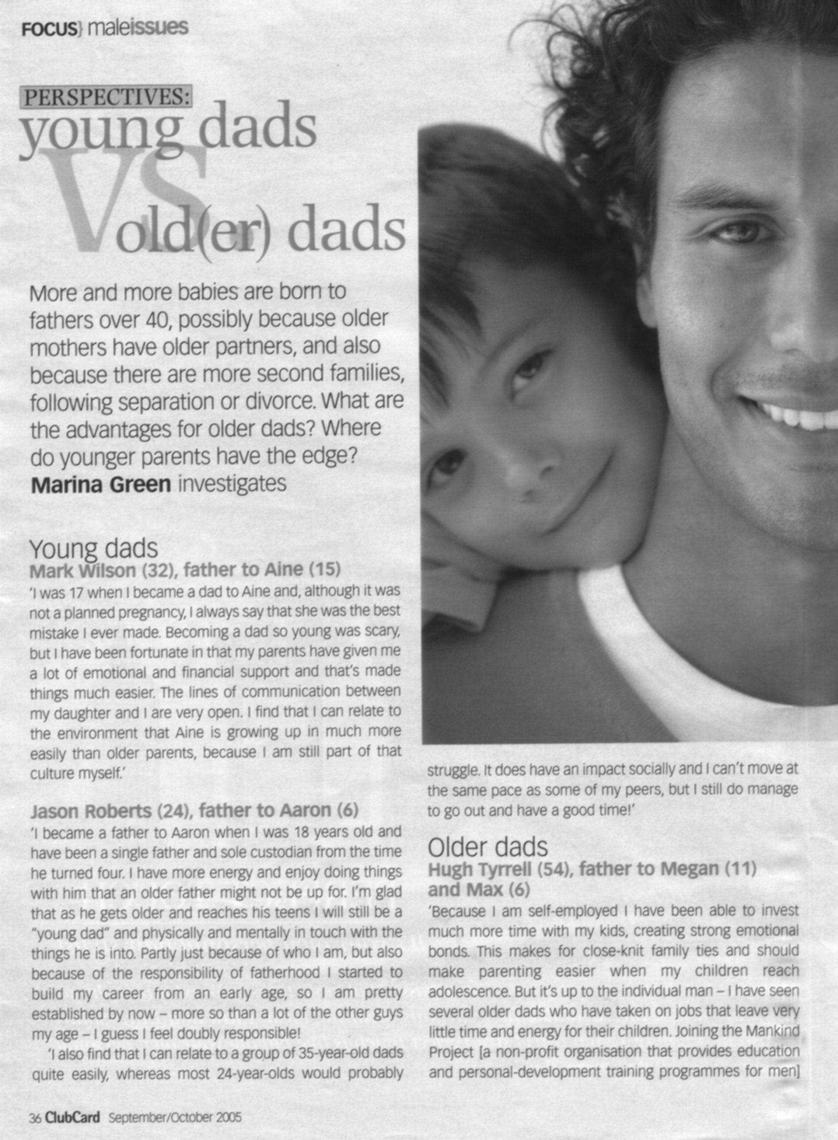

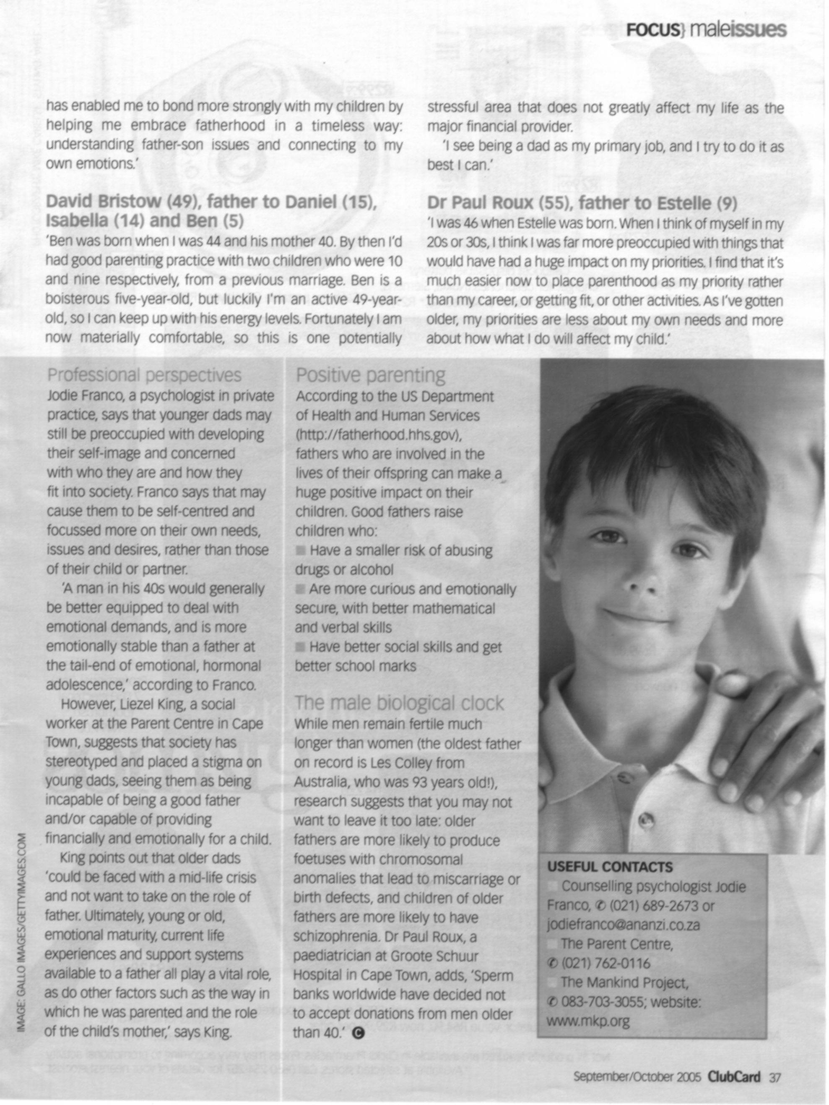

- Underline at least three unfamiliar words. Explain the process you followed to determine their meanings.(6)
- List the words and their meanings. (3)
- In the paragraph about Mark Wilson, father to Aine, Mark says: ‘she was the best mistake I ever made.” This is an ambiguous phrase, as mistakes are not usually good. What does he mean? Explain how you came to this conclusion. (3)
- Why did they include photos of men and boys? (1)
- Do the photos explain the topic of the article? Motivate your answer. (2)

- Did the photos capture your attention? Motivate your answer. (2)
- Did the photos encourage you to read the article? Motivate your answer. (2)
- Who is the author of the article? (1)
- Do you think the author is biased? Motivate your answer with at least three quotes from the article. (4)
- Does the author have a point of view about older or younger fathers? Motivate your answer. (2)
- Is Jason Robert’s view expressed directly or indirectly? Motivate your answer. (2)
- What is the purpose of the article? (1)

- Who is the article aimed at? Motivate your answer. (2)
- How does the author vary the length of the sentences? Motivate your answer by stating whether there are long and short sentences and whether there are more short sentences than long sentences. (2)
- Does the author’s diction make the article easy to read? Motivate your answer. (1)
- Identify jargon and technical words. Give at least two. (2)
- Does the author discriminate against older fathers? Motivate your answer. (2)
- Do you think the author is biased? Motivate your answer with at least three quotes from the article. (4)
- Does the author use repetition in the article? Motivate your answer. (2)

- Is the author sarcastic? Motivate your answer. (2)

- Summarise the article. (1)

Total: 47

