## Practical Assessment: Summary

Following this assessment is an article called Young Dads VS Older Dads, from the Clicks ClubCard magazine dated October 2005. Follow the instructions below.

**SO1 AC 2-6**

1. Summarise the article. Start your first draft by drawing a mind-map. Attach the mind-map to your assessment.
2. Write the first draft of your summary. Attach the first draft to your assessment.

**SO3 AC 1-6**

1. Rewrite the summary. Did you check and adapt your choice of words? Attach the second draft to your assessment.
2. Did you correct your grammar in the second draft?
3. Did you identify and remove inappropriate or potentially offensive language?
4. Did you experiment with the layout of your summary?

**SO1 AC2-6**

**SO2 AC1-3**

**SO3 AC1-3**

1. Write the final summary. Ensure that you make use of long and short sentences in your summary.
2. Make use of simple sentences.
3. Make use of compound sentences.
4. Make use of complex sentences.

**SO1 AC2-6**

**SO2 AC1-3**

**SO3 AC1-5**

1. Does your summary have an introductory paragraph?
2. Does your introductory paragraph introduce the main topic?
3. Do your paragraphs follow each other logically?
4. Which method did you use to help you arrange your paragraphs in a logical way?
5. Does the first sentence of each paragraph introduce the topic of the paragraph?
6. Is your conclusion clearly formulated?

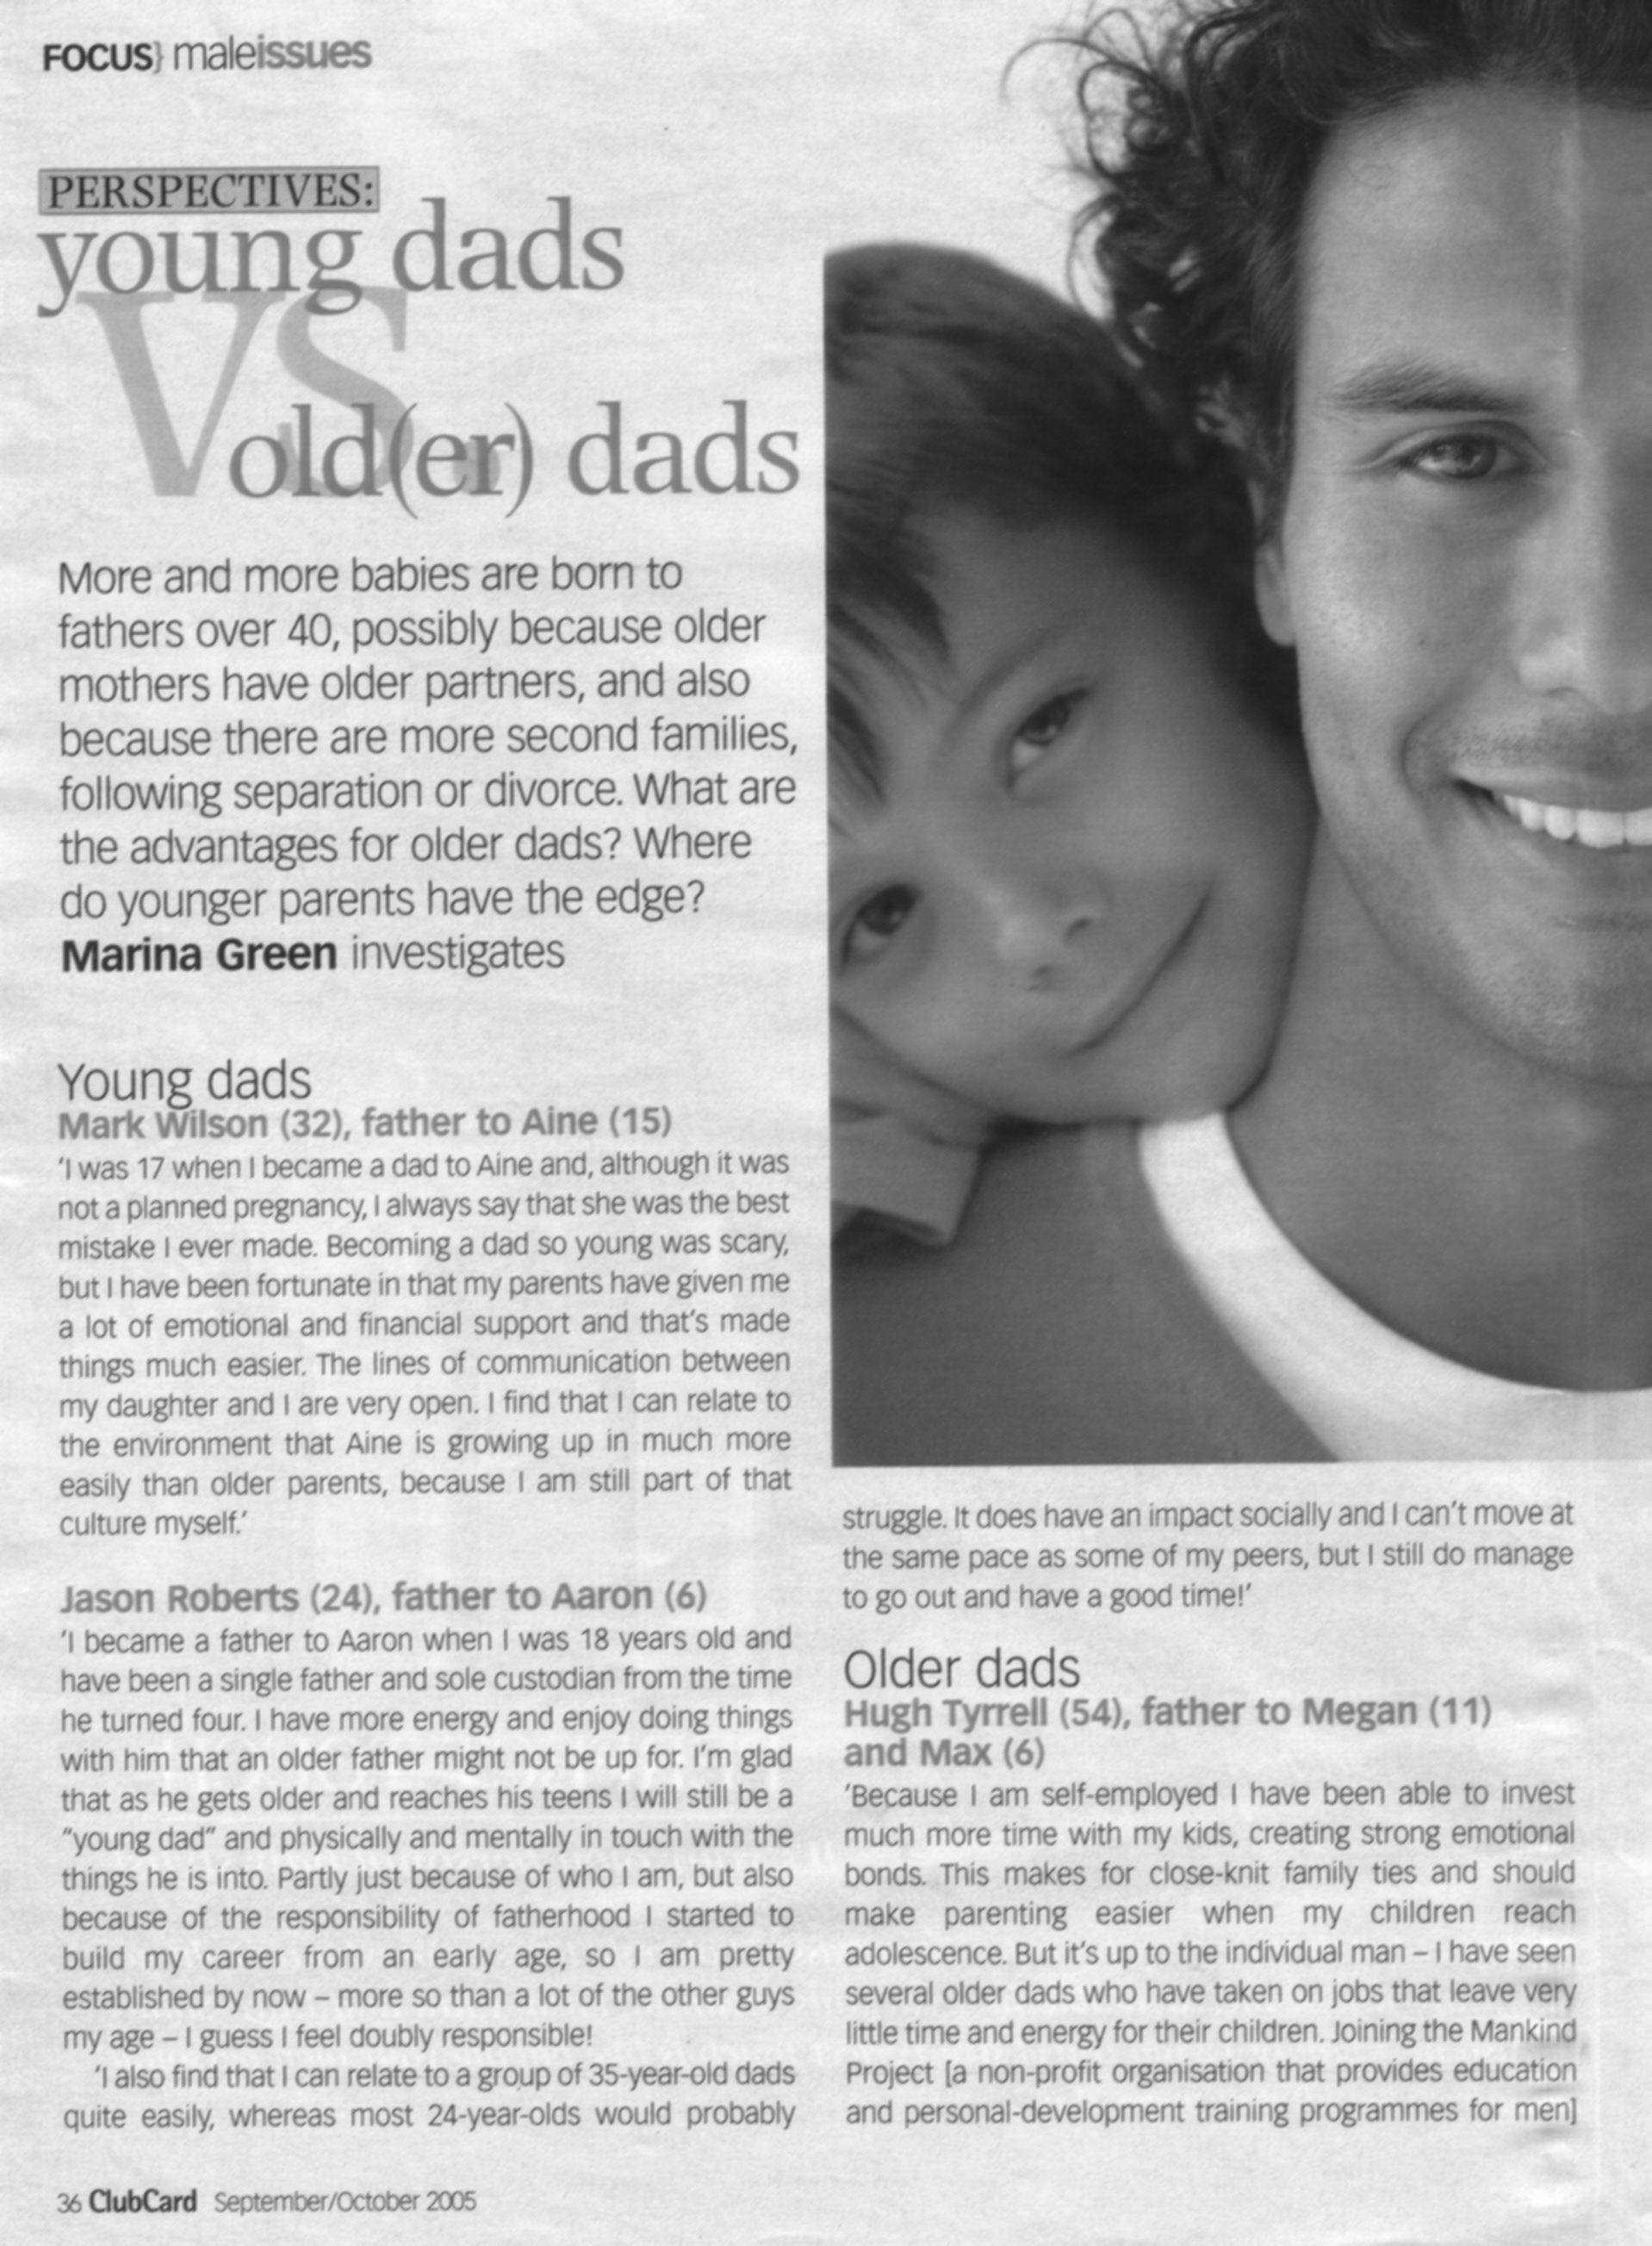

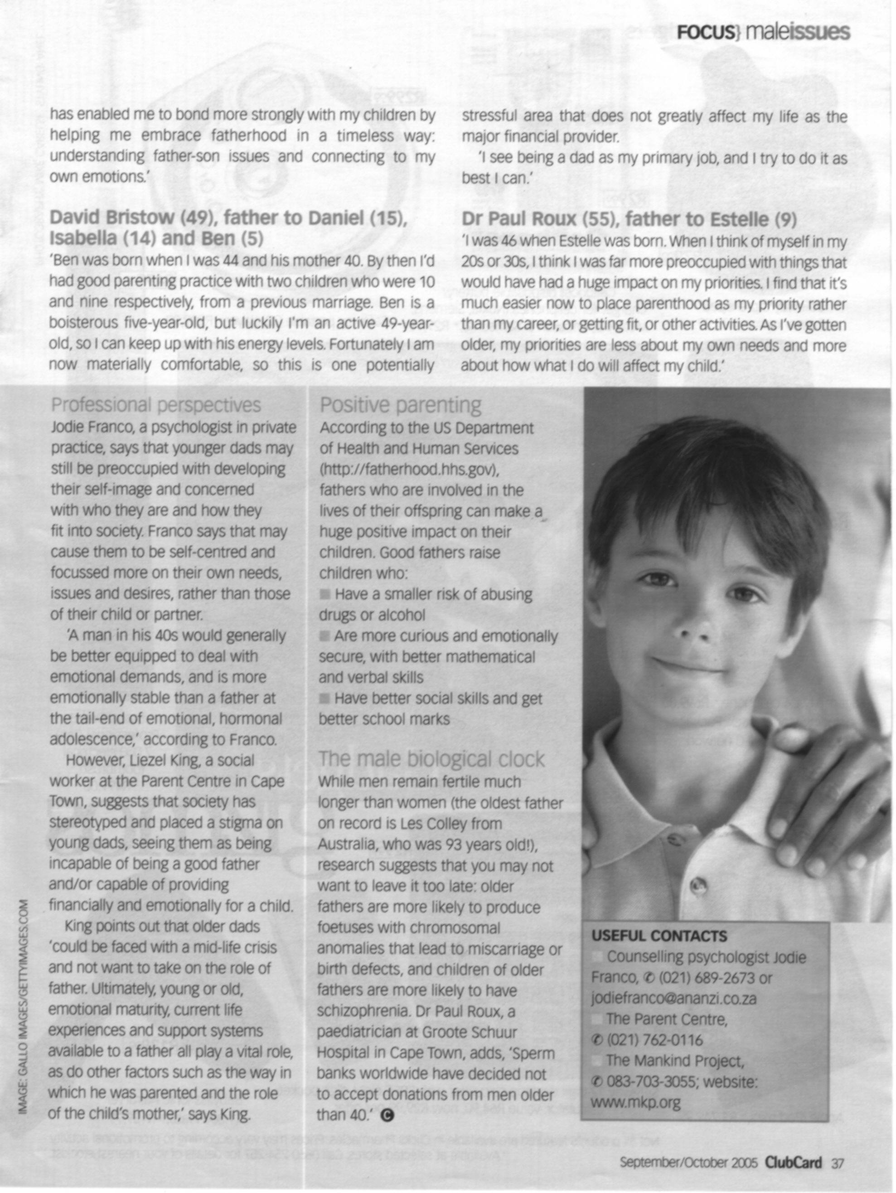

## Workplace Project

**SO1 AC1-4, 6**

**SO2, AC 1-3**

1. At the end of the assessment you will find factual writing about funeral customs across cultures and religions. Summarise the contents of this piece in the narrative style (no dialogue). Include an introductory paragraph, a conclusion and make use of headings or titles. Also ensure that your facts and ideas follow logically. Attach your summary to the assessment.

**SO1 AC1-4, 6**

**SO2, AC 1-3**

1. Write/sign a personal interest text in the discursive style about any subject that interests you: a hobby, sport, a film, an event or even a book that you read. The text should not be shorter than 150 words and not longer than 300 words. Write to inform the reader. . Make use of an introductory paragraph, a conclusion, titles and visual aids. Attach your text to the assessment.

**SO1 AC1-4, 6**

**SO2, AC 1-3**

1. Write/sign a short piece of about 3 to 4 paragraphs about your life after you finished school. What has happened to you, what are your plans, ambitions, aims and where would you like to be in 10 year’s time? Write in the reflective style. Send this to your facilitator by e-mail.

**SO1 AC1-4, 6**

**SO2, AC 1-3**

1. You have to write a memo relating to work. This could be anything related to work, as long as it is your own work. Your supervisor must sign the memo to confirm that it is your work. Attach a copy of the memo to your assessment.

**SO1 AC1-7**

**SO2, AC 1-3**

**SO3 AC 1-4, 6**

1. Do research about career paths in your organisation. Select the path you would like to follow. Find out what knowledge and skills are needed for promotion and what you should do in order to acquire the knowledge and skills. Write a report to your supervisor in the argumentative style explaining what career path you have chosen, why you have chosen this path and what training you need to do in order to get the knowledge and skills needed. Attach the report to your assignment. You have to:

* show what resources you used during your research,
* explain how you checked your sources for validity and reliability
* attach your rough notes to show how you sorted and categorized your information
* formulate a conclusion, supported by the facts obtained during your research

**SO1 AC1-4, 6**

**SO2, AC 1-3**

1. Select a cell phone that you would really like to have. Write a descriptive text about the features of the cell phone as well as why you would really like to have the cell phone.

**SO1 AC1-4, 6**

**SO2, AC 1-3**

1. At work, you have to write transactional text. This may relate to any transaction, for example confirmation of an order, a price quote, a report about the kilometres travelled in a vehicle of the organisation, or anything else as long as it is transactional text. Attach the text, signed by your supervisor, to the assignment.

**SO1 AC1- 6**

**SO2, AC 1-3**

1. Plan a one week holiday for the end of the year. Estimate what the following would cost: travel; accommodation; spending money for food, movies and so on. Find out what the actual costs would be and develop a spider chart where you compare your estimation with the actual values. Attach the chart to this assignment.

**SO1 AC1-7**

**SO2, AC 1-3**

**SO3, AC1-4, 6**

1. Following is an extract from an article about slavery in Africa. Highlight the main ideas and rewrite the article in the expository style

“At the first cracks of gunfire, the villagers of Nyamlell in southern Sudan dropped their hoes and scattered into the bush. Abuk Marou Keer also heard the guns. But the blind Dinka woman could only pull her seven-year-old son and twelve-year-old daughter close. Shaking with fear, they hid in their windowless hut and prayed.

Minutes later 300 men on foot, horseback and camels crashed through the fields of maize. Clad in turbans and the long, white robes of the desert, they brandished rifles, pangas and spears. Soon 80 village men lay dead.”

The invaders were Muslim Arabs from northern Sudan; the victims darker-skinned Dinka tribes people who are Christians or practice native religions

“Once the Arabs seized the cattle, they moved from hut to hut gathering grain, blankets, salt – and human booty. Deep in the shadows of one hut, they discovered Abuk. Grabbing the terrified woman by her bead necklace, a militiaman growled, “Now you belong to me!” in all, 282 Dinka, including Abuk’s mother, sister and niece were herded up and forced to march north.

Two days later Abuk and the rest of the prisoners reached a compound, which she was told would be her “home.” Like the other Dinka women and children, she was ordered to carry water, wash clothes and collect firewood for her Arab masters. Abuk had become a slave.”

**SO3, AC5**

1. At work or at home or even with your friends, identify words and terms that are could be seen as offensive and that should never be used when communicating in writing or through signing. Identify one offensive word for each of the following categories, and suggest a replacement for the offensive word:

* gender (e.g. bitch)
* rank (think of nicknames given to superiors)
* hierarchies in familiar settings or organisations
* family (e.g. Fat Louise)
* sports (e.g. stupid Radebe)
* wealth (think of nicknames given to rich and famous people)

**SO3, AC5**

1. Search for articles in newspapers and/or magazines that contain obfuscation and excessive jargon. Attach copies of the article(s). Rewrite the article(2) using language that everyone can understand.

**SO3, AC5**

1. Identify at least two examples of jargon used at your place of work. Quote the word as well as the explanation.

**BURIALS AND FUNERALS**

|  |  |
| --- | --- |
| **RELIGION** | **FUNERAL CUSTOMS ACROSS CULTURES AND RELIGIONS** |
| http://www.brentbrain.org.uk/brain/braincf.nsf/images/taoist_symbol2/$file/taoist_symbol2_content.jpg | While death is universal, ways of dealing with it are as varied as the languages people speak and the ways they think. Some cultures, such as those of the **Mediterranean**, encourage strong emotional reactions at funerals; others favour the ***stiff upper lip***.  The **Balinese**, who are not known to cry at all, at least in public, actually encourage laughter at funerals by dropping the coffin into a ***creek*** – sometimes more than once. The **Samoans** have an extremely brief period of mourning, whereas in **Greece**, widows are expected to wear black for the rest of their lives.  In **Southeast Asia**, emotional reactions are considered perfectly acceptable in public but in private mourners are expected to maintain some control. The **English** generally take the opposite approach.  What feels natural to one group may seem deeply unnatural to another; what is meant to be comforting in one tradition may, in the context of another, appear disrespectful. Styles of mourning vary widely. At the funeral and during the period of mourning that follows, behaviours considered utterly natural and important by one group, such as wearing black or visiting the grave, may strike another group as unnecessary.  Among **Africans**, funerals are occassions for large family and community gatherings, and attendance is given enormous emphasis, even for distant relations. Even within the ***context*** of a single ethnic heritage, patterns can vary markedly as families develop their own styles.  The goal in every era and in every culture is the same: **to provide a proper conclusion to a life and to begin the process of living without the deceased**. Those tasks are genererally considered to fall into the realm of religion.  Whether the service takes place in a **church, synagogue, or funeral home** (as is increasinly the case), the solemnity of the proceedings, the religious trappings, and the presence of clergy underscore the gravity of the event. |
| http://www.customrugco.com/images/fishrug2.jpg | **Protestant** customs vary, depending on the denomination. Generally, there is a brief service at the church or funeral home that includes a reading from the Bible, prayers, organ music, possibly the singing of hymns, and a funeral sermon or ***meditation***. Selections of poetry or prose are sometimes read. The ***casket*** may be open or closed, depending on the ***denomination***, and there may or may not be a ***eulogy***.  At the grave there is a brief committal service. Afterwards, as in other groups, people usually gather together for a meal. |

|  |  |
| --- | --- |
| http://www.jsboard.co.uk/etac/etbb/benchbook/images/christianity_symbol.gif | **In Catholicism,** the rites ideally begin prior to death, when the dying person receives the final ***sacraments***. (When death is sudden, the priest is permitted to give ***penance*** and extreme ***unction*** up to several hours after death.)  The funeral itself is comprised of three parts: The ***wake***, the ***funeral mass***, and the ***grave side service***. The wake, which occurs the night before the funeral, is conducted in the presence of the body, which is in an open casket. Held either in the funeral parlour or in the mourners’home, the wake service mayinclude psalms, prayers, a rosary, and a short ***homily*** on the meaning of life, death and ***resurrection***. For many hours, friends and relatives come to offer ***condolences***, to pray, and to view the body; indeed, the term “viewing” is somethimes used intead of “wake”.  The next day, there is a funeral or ***requiem*** mass. The coffin is closed and covered with a white pall upon which a cross might be placed. Holy Water, incense, and candles accent the solemnity of the highly structured service, which emphasizes the concept of the new life the deceased has found with God.  After the funeral mass, the “final commendation and farewell” takes place either in church or at the grave site, which is blessed in advance. It is used to be that the family would avoid watching the casket being lowered into the earth. Today, the tendency is to stay, so that the reality of death cannot be denied. |
| http://www.riverstonebead.com/images/imagesinstone/Images%20Star%20of%20David2gif.gif | In **Judaism**, burial takes place immediately – within twenty four hours, if possible.  The simple, wooden coffin is closed, and there are few flowers. At the funeral, which is a short one including prayers and a eulogy, members of the immediate family are given a black ribbon which is then cut to indicate their grief.  After the funeral, there is a brief service at the cemetary during which the casket is lowered into the ground and the mourners shovel dirt on it.  “Shoveling the dirt is an incredibly healing thing to do. Although I would never require it, I encourage it very strongly because I find that the actual act of burying is the beginning of the acknowledgement that this horrible thing has happened and the world is forever different,” states Rabbi Laura Geller, director of Hillel at the University of Southern California.  Following the burial, friends and relatives gather for a traditional “meal of ***condolence***.” Perhaps the most distinctive aspect of the Jewish tradition is not the funeral but the mourning period that follows, when mourners return home for seven days of “sitting shiva” (shiva means “seven”). Traditionally they light a candle that burns for seven days, sit on wooden stools or benches, and receive visitors. All activities cease except for one: mourning. |
| http://gbgm-umc.org/missionstudies/interfaith/images/sym-islam-240.gif | The **Islamic religion** specifies **five** rituals concerning death: washing the body in a ***ceremonial*** manner; wrapping the entire body in clean, preferably white, cloth; prayer; the funeral itself, during which music and crying are forbidden; and burial.  If possible, the body is buried directly in the ground, without a casket, and with the face turned toward Mecca. A stone, a few bricks, or some soil can be put under the head, but nothing else is ***permitted*** in the grave.  Afterward, people bring food to the family. Death is expected to be met with equanimity. Consequently, the mourning period is short. For a three-day period after the funeral, known as Azah, mourners accept condolences. After that, talking about the deceased with the mourners is not encouraged.  After three days a return to normal life is expected (The sole exception occurs when a husband dies, in which case the wife is expected to stay home for three months and ten days.) Mourners are not supposed to become so immersed in their grief that it distracts them from their relationship with God. |
| http://www.akshin.net/images/dharmawheel2.gif | **Buddhists and Hindus** believe that life, death, and rebirth are part of the same ***continuum***, waves on the ocean of existence. The body dies; consciousness remains.  The traditional purpose of the funeral, which includes chanting, prayers, the reciting of sacred texts, and eulogies, is to help the deceased adjust to the after death state and prepare for rebirth.  At a Buddhist funeral, the priest speaks directly to the deceased. The funeral is followed by a forty-nine day period during which the person who died ***theoretically*** completes the journey from death to rebirth. During that time, mourners repeat prayers intended to ease the ***transition***. |