**LEARNER GUIDE**

**67465 National Certificate:**

**Business Administration Services**

**Level 3**

**Module 6 Organisation Skills**

Unit Standard 13934 Level 3 Credits 4

Plan and prepare meeting communications

# TABLE OF CONTENTS

[TABLE OF CONTENTS i](#_Toc66790552)

[PERSONAL INFORMATION 1](#_Toc66790553)

[INTRODUCTION 2](#_Toc66790554)

[UNIT STANDARD 13934 9](#_Toc66790555)

[SECTION 1: THE AGENDA 11](#_Toc66790556)

[Introduction 12](#_Toc66790557)

[Notice Of Meeting 14](#_Toc66790558)

[The Agenda 15](#_Toc66790559)

[SECTION 2: THE MINUTES 21](#_Toc66790560)

[Importance of Minutes 22](#_Toc66790561)

[Purpose of minutes 23](#_Toc66790562)

[Types Of Minutes 23](#_Toc66790563)

[Note Taking 32](#_Toc66790564)

[Presentation Of The Minutes 33](#_Toc66790565)

[Minute Book 37](#_Toc66790566)

[General Notes Re Meetings 37](#_Toc66790567)

[SECTION 3: DISTRIBUTION LISTS 39](#_Toc66790568)

[Formative Assessments workbook 43](#_Toc66790569)

|  |  |  |  |
| --- | --- | --- | --- |
| 9 Hours | 21 Hours | Level 3 | 3 |

#### Course content

The course content covers all the basics required for learners to achieve the outcomes, however, at times there is information that learners will have to obtain by themselves.

To this end, a glossary is also not included in the course material. It is expected of learners to compile their own glossaries, which will form part of outcomes for communication unit standards. Please encourage them to start compiling glossaries as soon as possible. The glossaries can be simple: they need only quote the word and the meaning, as long as they understand what it means.

Learners are required to start thinking for themselves and take control of the learning process as soon as possible. To this end, research projects will form part of some assessments.

#### Class Activities



During and after the initial training the learner will be required to complete a number of class activities. These activities will be both individual and group activities. The activities are numbered and are to be included in the learner’s portfolio of evidence. These activities will measure the progress of the learner through the programme. For authenticity reasons these activities must be handwritten, unless indicated otherwise.

# PERSONAL INFORMATION

|  |  |
| --- | --- |
| **NAME** |  |
| **CONTACT ADDRESS** |  |
|  |
| **Code** |  |
| **Telephone (H)** |  |
| **Telephone (W)** |  |
| **Cellular** |  |
| **Learner Number** |  |
| **Identity Number** |  |
|  | |
| **EMPLOYER** |  |
| **EMPLOYER CONTACT ADDRESS** |  |
|  |
| **Code** |  |
| **Supervisor Name** |  |
| **Supervisor Contact Address** |  |
|  |
| **Code** |  |
| **Telephone (H)** |  |
| **Telephone (W)** |  |
| **Cellular** |  |

# **INTRODUCTION**

#### Welcome to the learning programme

Follow along in the guide as the training practitioner takes you through the material. Make notes and sketches that will help you to understand and remember what you have learnt. Take notes and share information with your colleagues. Important and relevant information and skills are transferred by sharing!



This learning programme is divided into sections. Each section is preceded by a description of the required outcomes and assessment criteria as contained in the unit standards specified by the South African Qualifications Authority. These descriptions will define what you have to know and be able to do in order to be awarded the credits attached to this learning programme. These credits are regarded as building blocks towards achieving a National Qualification upon successful assessment and can never be taken away from you!

### Programme methodology



The programme methodology includes facilitator presentations, readings, individual activities, group discussions and skill application exercises.

Know what you want to get out of the programme from the beginning and start applying your new skills immediately. Participate as much as possible so that the learning will be interactive and stimulating.

The following principles were applied in designing the course:

* Because the course is designed to maximise interactive learning, you are encouraged and required to participate fully during the group exercises
* As a learner you will be presented with numerous problems and will be required to fully apply your mind to finding solutions to problems before being presented with the course presenter’s solutions to the problems
* Through participation and interaction the learners can learn as much from each other as they do from the course presenter
* Although learners attending the course may have varied degrees of experience in the subject matter, the course is designed to ensure that all delegates complete the course with the same level of understanding
* Because reflection forms an important component of adult learning, some learning resources will be followed by a self-assessment which is designed so that the learner will reflect on the material just completed.

This approach to course construction will ensure that learners first apply their minds to finding solutions to problems before the answers are provided, which will then maximise the learning process which is further strengthened by reflecting on the material covered by means of the self-assessments.

#### Different role players in delivery process

* Learner
* Facilitator
* Assessor
* Moderator

### What Learning Material you should have

This learning material has also been designed to provide the learner with a comprehensive reference guide.

It is important that you take responsibility for your own learning process; this includes taking care of your learner material. You should at all times have the following material with you:

|  |  |
| --- | --- |
| **Learner Guide** | **This learner guide is your valuable possession:**  This is your textbook and reference material, which provides you with all the information you will require to meet the exit level outcomes.  During contact sessions, your facilitator will use this guide and will facilitate the learning process. During contact sessions a variety of activities will assist you to gain knowledge and skills.  Follow along in the guide as the training practitioner takes you through the material. Make notes and sketches that will help you to understand and remember what you have learnt. Take and share information with your colleagues. Important and relevant information and skills are transferred by sharing!  This learning programme is divided into sections. Each section is preceded by a description of the required outcomes and assessment criteria as contained in the unit standards specified by the South African Qualifications Authority. These descriptions will define what you have to know and be able to do in order to be awarded the credits attached to this learning programme. These credits are regarded as building blocks towards achieving a National Qualification upon successful assessment and can never be taken away from you! |
| **Formative Assessment Workbook** | The Formative Assessment Workbook supports the Learner Guide and assists you in applying what you have learnt.  The formative assessment workbook contains classroom activities that you have to complete in the classroom, during contact sessions either in groups or individually.  You are required to complete all activities in the Formative Assessment Workbook.  The facilitator will assist, lead and coach you through the process.  These activities ensure that you understand the content of the material and that you get an opportunity to test your understanding. |

### Different types of activities you can expect

To accommodate your learning preferences, a variety of different types of activities are included in the formative and summative assessments. They will assist you to achieve the outcomes (correct results) and should guide you through the learning process, making learning a positive and pleasant experience.



The table below provides you with more information related to the types of activities.

| **Types of Activities** | **Description** | **Purpose** |
| --- | --- | --- |
| **Knowledge Activities** | You are required to complete these activities on your own. | These activities normally test your understanding and ability to apply the information. |
| **Skills Application Activities** | You need to complete these activities in the workplace | These activities require you to apply the knowledge and skills gained in the workplace |
| **Natural Occurring Evidence** | You need to collect information and samples of documents from the workplace. | These activities ensure you get the opportunity to learn from experts in the industry.  Collecting examples demonstrates how to implement knowledge and skills in a practical way |

### Learner Administration



#### Attendance Register

You are required to sign the Attendance Register every day you attend training sessions facilitated by a facilitator.

#### Programme Evaluation Form

On completion you will be supplied with a “Learning programme Evaluation Form”. You are required to evaluate your experience in attending the programme.

Please complete the form at the end of the programme, as this will assist us in improving our service and programme material. Your assistance is highly appreciated.

### Assessments

The only way to establish whether a learner is competent and has accomplished the specific outcomes is through the assessment process. Assessment involves collecting and interpreting evidence about the learners’ ability to perform a task.

To qualify and receive credits towards your qualification, a registered Assessor will conduct an evaluation and assessment of your portfolio of evidence and competency.

This programme has been aligned to registered unit standards. You will be assessed against the outcomes as stipulated in the unit standard by completing assessments and by compiling a portfolio of evidence that provides proof of your ability to apply the learning to your work situation.



**How will Assessments commence?**

#### Formative Assessments

The assessment process is easy to follow. You will be guided by the Facilitator. Your responsibility is to complete all the activities in the Formative Assessment Workbook and submit it to your facilitator.

#### Summative Assessments

You will be required to complete a series of summative assessments. The Summative Assessment Guide will assist you in identifying the evidence required for final assessment purposes. You will be required to complete these activities on your own time, using real life projects in your workplace or business environment in preparing evidence for your Portfolio of Evidence. Your Facilitator will provide more details in this regard.

To qualify and receive credits towards your qualification, a registered Assessor will conduct an evaluation and assessment of your portfolio of evidence and competency.

### Learner Support

The responsibility of learning rests with you, so be proactive and ask questions and seek assistance and help from your facilitator, if required.



Please remember that this Skills Programme is based on outcomes based education principles which implies the following:

* You are responsible for your own learning – make sure you manage your study, research and workplace time effectively.
* Learning activities are learner driven – make sure you use the Learner Guide and Formative Assessment Workbook in the manner intended, and are familiar with the workplace requirements.
* The Facilitator is there to reasonably assist you during contact, practical and workplace time for this programme – make sure that you have his/her contact details.
* You are responsible for the safekeeping of your completed Formative Assessment Workbook and Workplace Guide
* If you need assistance please contact your facilitator who will gladly assist you.
* If you have any special needs please inform the facilitator

### Learner Expectations

Please prepare the following information. You will then be asked to introduce yourself to the instructor as well as your fellow learners



|  |
| --- |
| Your name: |
|  |
|  |
| The organisation you represent: |
|  |
|  |
| Your position in organisation: |
|  |
|  |
| What do you hope to achieve by attending this course / what are your course expectations? |
|  |
|  |
|  |
|  |
|  |

# UNIT STANDARD 13934

#### Unit Standard Title

Plan and prepare meeting communications

#### NQF Level

3

#### Credits

4

#### Purpose

Learners will be learning towards obtaining a national qualification at level 3 or are working in an administrative environment, including SMME`s (Small, Medium and Micro Enterprises), where the acquisition of competence against this standard will add value to the learner’s job, or chances of finding employment.

Learners will be well positioned to extend their learning and practice into other areas in the business environment, or to strive towards professional standards and practice at higher levels.

The qualifying learner is capable of:

* Demonstrating an understanding of the agenda of meetings
* Explaining the purpose and objective of minutes of meetings
* Taking minutes of meetings

#### Learning assumed to be in place

Learners will have demonstrated competence in communication at NQF level 2 or equivalent.

#### Unit standard range

* Resources for agenda will include chairperson, committees, members, matters arising from previous minutes.
* Resources for minute taking will include sufficient paper, pen, pencils, eraser, tapes, tape recorder, extension cord, note book, minute book, resolutions and agenda

#### Specific Outcomes and Assessment Criteria

**Specific Outcome 1:** Demonstrate an understanding of the agenda of meetings

**Assessment Criteria**

* The advantages of a well-constructed agenda are explained
* Matters on agenda appear in a logical and systematical order
* Sources of agenda matters are identified and explained
* An agenda is produced in the required format and time frame

**Specific Outcome 2**: Explain the purpose and objective of minutes of meetings

**Assessment Criteria**

* Types of minutes are identified and explained
* The importance of accurate recording and producing of minutes is explained
* The distribution list is described
* Methods of distributing minutes is explained
* The reasons for distributing minutes promptly is explained

**Specific Outcome 3**: Take minutes of meetings

**Assessment Criteria**

* Resources required for minute taking are identified, listed and explained
* Items to be included in minutes of meeting are listed and explained
* Attendees to meeting are identified
* The characteristics of good minutes are identified and explained
* Minutes are concise and accurate and reflect proceedings
* Minutes are produced and distributed in required format and time frame

#### Unit Standard Essential Embedded Knowledge

The knowledge underpinning the above specific outcomes is:

* Methods and techniques for taking minutes
* Resources required for agenda and meeting
* Listening techniques

#### Critical Cross-field Outcomes (CCFO)

* Identify and solve problems pertaining to taking of minutes
* Work effectively with others in the preparing of the meeting agenda.
* Organise oneself and one’s activities in order to have an organised agenda and for the preparation of minute taking
* Collect, analyse, organise and critically evaluate information during the meeting in order to write concise and accurate minutes
* Communicate effectively with all stakeholders of the meeting.
* Understand the world as a set of related systems understanding the consequences of poor minutes.

# SECTION 1: THE AGENDA

#### Outcome

Demonstrate an understanding of the agenda of meetings

#### Assessment criteria

* Explain the advantages of a well-constructed agenda
* Ensure that matters on agenda appear in a logical and systematic order
* Identify and explain sources of agenda matters
* Produce an agenda in the required format and time frame

This section serves as an introduction to meetings. Topics discussed will include why meetings are held and the types of meetings that are commonly conducted in organisations.

We will also discuss Agendas in detail.

## Introduction

Meetings are an integral part of life today. Without meetings, how would

* departments communicate with each other
* we communicate with each other
* we share problems
* resolve conflict

Not everyone attends meetings regularly, but consider the following: a typical supervisor spends more than 25% of their time in meetings, while middle to upper level management will often spend more than 40% of their time in meetings.

Whether meetings are used as a management tool, an instrument of government or a forum of friends, they provide the means to make informed decisions. The format of the meeting should allow the participants the opportunity to:

* Share information
* Resolve a problem
* Make suggestions
* Express criticism
* Express opinions

For meetings to run efficiently, they must be governed by rules. Sometimes the rules take the form of laws decreed by Acts of Parliament, sometimes in the form of company regulations and sometimes, in the case of a voluntary society, by a written constitution and set of standing rules.

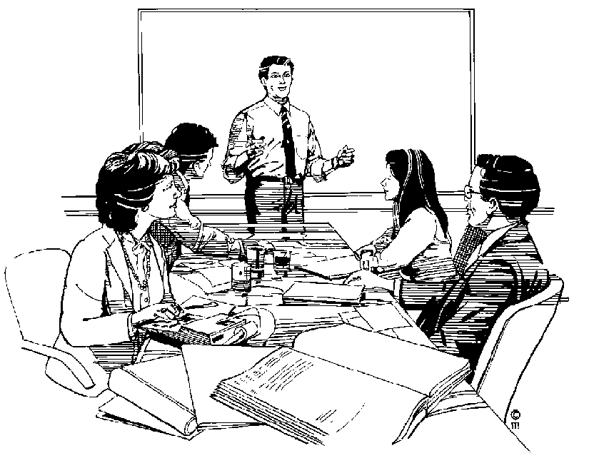

To understand the importance of meetings, we have to take a look at the functions or purposes of meetings:

### Reasons for holding meetings

#### Informative/Advisory

This meeting is intended to

* give and receive information
* to keep in touch with what is happening in other departments and in the organisation as a whole
* co-ordinate activities
* record progress towards goals

#### Consultative

* to resolve objections
* to involve people in changes or new courses of action
* to get to know people and develop a team spirit in the organisation

#### Problem-solving

* to create ideas
* 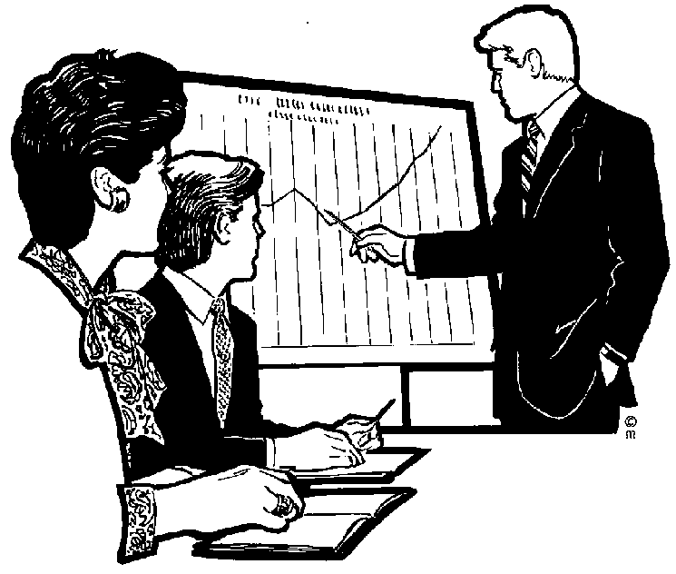to identify various courses of action
* to get things moving

#### Decision-taking

* to generate commitment
* to take decisions
* to share responsibility
* to initiate action

#### Negotiating

* to create an agreement or contract
* to find the best solution
* to achieve compromise

### Types of meetings

A meeting is a group activity and as such it belongs to the Chairman and the members. The chairman may have special duties, but the responsibility to ensure that the meeting achieves its purpose falls on everyone.

Meetings should be rewarding for everyone involved. When a meeting is organised well and managed well, it can be rewarding for everyone involved.

* Training meetings
* Sales Meetings
* Executive Meetings
* Seminars
* Committee/Team meetings
* Departmental meetings

### Formative assessment SO1 AC3 group activity

## Notice Of Meeting

The Notice of Meeting is a written invitation and reminder to attend a company meeting. This must be sent out in time so that all the members can attend the meeting, usually not more than three weeks and not less than two weeks before the meeting. If the date was set at the previous meeting, the notice could be sent up to one week before the meeting.

The notice can take the form of a short letter or memorandum.

#### Example

COMPANY LETTERHEAD

Date

Name and address of member

Dear XXX

The next meeting of the Board of Directors of the above company will be held on Friday 14 November 20… at 10.00, in the head office Boardroom at the above address.

Yours truly,

Nomisa Berry

Personal Assistant to Mr T. Sand

Managing Director

### Formative assessment SO1 AC4 individual activity

## The Agenda

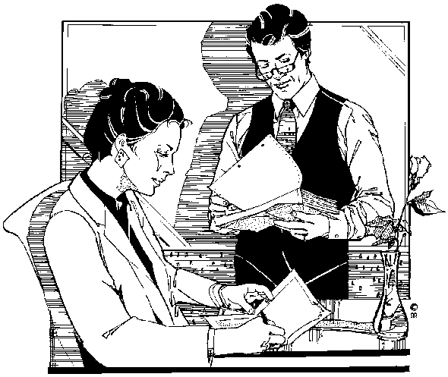The Agenda is a list, or programme of the items of business to be discussed at a meeting. The items of business are set out in the order in which they are to occur.

Setting the agenda is a crucial task, as it defines the boundaries of the discussion that will proceed during the course of a meeting. A carefully prepared and managed agenda will keep the group focused on achieving the desired outcomes. It can serve as a route map of the meeting that everyone can refer to.

In theory, the Chairman of the meeting draws up the Agenda, but in practice the Secretary usually does this. The Chairman must still agree the Agenda before it is distributed.

### Drawing Up The Agenda

Refer to the following:

* Minutes of the previous meeting: for any unfinished business left over from the previous meeting, called matters arising.
* Propositions received: who wants to add items to the Agenda
* Correspondence: which may relate to the previous or the coming meeting
* Action taken following the previous meeting

These sources of information will help you derive the main items of business for the Agenda.

#### Information that must appear on the Agenda

* Title, date, time and place of the meeting
* Purpose of meeting
* Apologies for absence
* Minutes of the previous meeting
* Matters arising from the previous meeting (Unfinished business)
* Other items to be discussed and decided
* Any other business

Always ensure that the Agenda is neat and well laid out. Write in a clear, concise style, check grammar, punctuation and spelling. You can even ask a colleague to review your draft and make suggestions for improvement.

#### Items that may appear regularly on the Agenda:

* Minutes of the previous meeting
* Matters arising from the previous meeting’s minutes
* Date of the next meeting
* General – can also be called any other business
* Closure of the meeting

#### General notes regarding Agendas

* BD18210_Next to each item on the agenda, briefly describe what is to be discussed so that its purpose is clear to member who will be attending the meeting. Also state who will discuss the topic.
* Allocate a time for the discussion of each topic, for example 5 minutes, 10 minutes and so on. Discuss time allocations with the people responsible for the discussion, to make sure that you do not allocate too much or too little time per topic. By allocating a time, you also help to ensure that meetings finish on time.
* The Agenda should be kept as short as possible, it should be consistent (reliable), and unambiguous (clear, no double meanings)
* Any relevant additional papers should accompany the Agenda and they should be clearly referred to in the Agenda. These are known as Agenda papers.
* When drawing up the Agenda, think about what information can be presented in the form of appendices, such as additions and attachments, and agenda papers, rather than having lengthy description in the Agenda itself.

### Combined Notice of Meeting and Agenda

It is quite usual to circulate the notice and the agenda as one document. This saves time and costs.

#### Example:

**COMPANY LETTERHEAD**

The next meeting of the Board of Directors of the company will be held on Friday 12 November 20… at 10.00, in the head office Boardroom at the above address.

**Notice of Meeting and Agenda**

1. Apologies for absence
2. Minutes of previous meeting
3. Matters arising from previous minutes
   1. Minute no. 4 should be amended as follows: for Mr. K Sand read Mr T Sand
   2. Minute no. 7 – Annual General Meeting.

The Chairman confirmed by e-mail correspondence that the Annual General Meeting will be held in the head office boardroom.

1. Blue Investment: Managing Director, P Pumpkin, to report on investment options resulting from recent trip to New York.
2. Date of the next meeting
3. Any other business

### Agenda layout

The layout of the Agenda is very important, as the order of the Agenda normally determines the order that discussions will take place in during the meeting.

The Agenda will usually appear on an official letterhead. The heading of the Agenda should answer the questions:

* who
* where
* when

**THE NEXT TRAINING COMMITTEE MEETING WILL TAKE PLACE IN THE BOARDROOM ON WEDNESDAY 17 JUNE 2---- AT 10:00 AM**

1. Apologies for absence
2. Minutes of the last meeting. Copy of minutes attached Addendum A
3. Matters arising. See copy of minutes.
4. Annual WSP due date. Update from SETA attached. Addendum B
5. Annual Training plan due date. Update from SETA attached. Addendum C
6. Training progress report. Report attached. Addendum D
7. Learnership progress report. Report attached. Addendum E
8. New learnerships registered. List attached. Addendum F
9. Training providers. Updated list attached. Addendum G
10. General
11. Next meeting date
12. Adjournment

#### Explanatory Notes

|  |  |  |
| --- | --- | --- |
| **Agenda Item** | | **Explanation** |
| 1. | Apologies for absence | Having declared the meeting open, the chairman will announce any apologies from members unable to attend the meeting |
| 2. | Minutes of the last meeting. Copy of minutes attached Addendum A | The chairman will ask members if there are any corrections. After making the necessary corrections, the minutes are signed as being a true record of the meeting. |
| 3. | Matters arising. See copy of minutes | In this section, any developments arising from the previous meeting will be discussed. |
| 4. | Annual WSP due date. Update from SETA attached. Addendum B | This item will be discussed by the members concerned and a plan of action will be drafted, if required, with tasks allocated to members where necessary. |
| 5. | Annual Training plan due date. Update from SETA attached. Addendum C | As above. |
| 6. | Training progress report. Report attached. Addendum D | The training report will be discussed and corrective action steps noted where applicable. |
| 7. | Learnership progress report. Report attached. Addendum E | As above |
| 8. | New learnerships registered. List attached. Addendum F | New learnerships will be discussed. Possible points of discussion could be which learnerships will be appropriated to the organisation and which employees will be eligible for the learnerships. |
| 9. | Training providers. Updated list attached. Addendum G | The possibility of using new training providers, as well as their company profiles could be discussed here. |
| 10. | General | This is the opportunity for members to raise additional matters for discussion. |
| 11. | Next meeting date | Announcement of the date for the next meeting. |
| 12. | Adjournment |  |

### Chairman’s Agenda

This is the same as the Agenda for the meeting, with added notes and space for the Chairman to write his/her comments.

Keep at least three copies, if possible:

* One for use by the Chairman at the meeting should he forget his own copy, or for use by the Vice-Chairman in the absence of the Chairman
* One for your own use
* One for filing and record-keeping purposes



### Formative assessment SO1 AC1-4 group activity

# SECTION 2: THE MINUTES

#### Outcomes

* Explain the purpose and objective of minutes of meetings
* Take minutes of meetings

#### Assessment criteria

* Identify and explain the types of minutes
* Explain the importance of accurate recording and producing of minutes
* Identify, list and explain the resources required for minute taking
* Explain and list items to be included in minutes of meeting
* Identify attendees to meeting
* Identify and explain the characteristics of good minutes
* Ensure that minutes are concise and accurate and reflect proceedings

Minutes are extremely important to meetings and during this section the purpose and importance of meetings will be laid out, as well as the types of minutes. How to take notes and develop minutes of meetings, as well as resources needed for minute taking will be explained.

## Importance of Minutes

The secretary usually takes the minutes of the meeting, however, these days this job can be handed to just about any member of the meeting. Producing the minutes of a meeting could possibly be the most demanding task a secretary or office clerk will have to perform.

* This document is called ‘minutes’, because it is a **minute-by-minute record** of procedures taking place at the meeting.
* The minutes must be an **accurate record** of the meeting’s business. Members will read them carefully, looking for potential errors, slights or inaccuracies.
* The person taking the minutes must **appreciate the value of discretion**. Many people will say things in the heat of the moment that are later regretted. These comments are normally not recorded verbatim.
* Minutes serve as a **reminder of responsibility** and tend to encourage courteous behaviour on the part of committee members.
* Furthermore, minutes form the **recorded and legal history of the organisation** and can always be referred back to, so they can also be used as a source of reference.
* The minutes of a meeting provide a vital function in an organisation. An accurate and ongoing set of minutes provides a **source of reference** and confirms approval for action taken.
* The minutes also prevent democratically made decisions being overlooked or “railroaded” into oblivion by more determined personalities.
* Minutes can also be **used to resolve conflict**, as they form a permanent record of decisions that were taken.

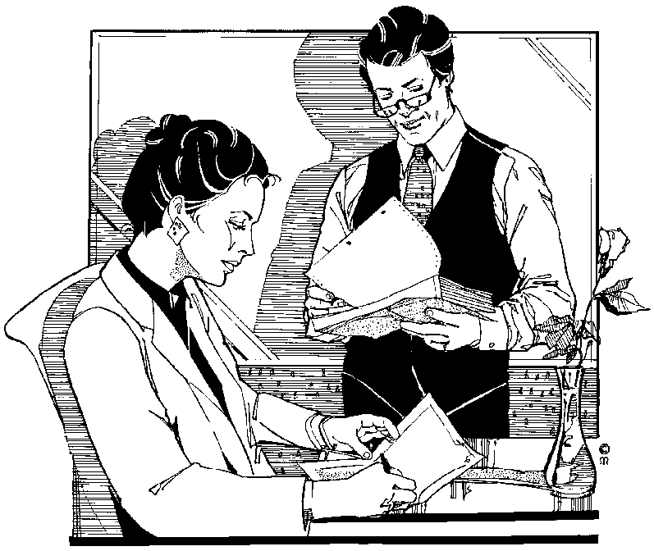

## Purpose of minutes

Minutes have three purposes:

### Constitutional

Minutes serve as a record of the proceedings of a meeting and are often legally required.

### Executive

Minutes often provide the basis for action – somebody has to do something, and the person responsible is named and a due date for the action to be completed is set.

### Progressive

Minutes can serve as a basis for developing policy.

Note You can sum up by saying that the sole purpose of minutes is the recording and presentation of facts.

## Types Of Minutes

### Resolution Minutes

Some types of meeting, those of boards of directors, for example, record only the decision reached, usually after a vote.

The arguments, disagreements, conflicts or lengthy discussions that lead to the decision are not detailed. All the hours of debate that preceded the decision could be reduced to a few brief words:

* 1. RESOLVED: that the company’s Southside branch is closed with immediate effect.

OR

* 1. It was RESOLVED that the company’s Southside branch be closed with immediate effect.

**View the example of minutes**

**MINUTES OF THE BUSINESS SYSTEMS BOARD OF DIRECTORS’ MEETING**

Held at the registered offices of Business Systems Ltd on Thursday 16 July 20… at 10:30 am

PRESENT: EA Black Chairman

A Milne Director

J Pillay Director

T Timms Director

N Jones Company Secretary

APOLOGIES: K Frost

1. MINUTES OF THE LAST MEETING

The minutes of the last meeting, previously circulated, were taken as read and signed as a true record

1. MATTERS ARISING

There were no matters arising

1. COMPANY LOGO

It was RESOLVED that the Downtown Advertising Agency be appointed to develop a new company logo as part of the company’s policy to update its corporate image.

1. INTRODUCTION OF FLEXIBLE WORKING HOURS AT HEAD OFFICE

It was RESOLVED that the system of flexible working hours as agreed, be introduced in the company’s head office with effect from 1 September 20…

1. RELOCATION OF REGIONAL OFFICE

It was RESOLVED that the company’s regional office be relocated at 397 Chamberlain Road, Jacobs, Durban. The office to be fully operational by 15 August 20…

1. DATE OF NEXT MEETING

The date of the next meeting of the board of directors was scheduled for Thursday 13 August 20…

Signed:

EA Black

Managing Director

Date:

Some organisations add a narrative style to their Resolution minutes. This can be a satisfactory middle course. The resolutions in this type of Minutes will contain two parts:

**The preamble**

And then

**The resolution**

* 1. BOKSBURG DRAINAGE

The Engineer reported that Boksburg Drainage Ltd had completed the first contract for connecting 100 dwellings to main sewerage. They had now submitted a quotation at the same rate for an additional 100 connections and in view of the satisfactory standard of workmanship the Engineer recommended acceptance of this quotation.

RESOLVED: that the quotation referred to be accepted.

### Narrative Minutes

Narrative minutes tell more of the story of what happened at a meeting and who said what. The main points of the background and discussion leading to a decision are often included and anyone reading minutes of this kind would be able to form a much more detailed picture of what the meeting was about.

Narrative minutes are recorded in reported speech – this means meeting members are referred to in the third person or by the office they hold.

Care must be taken when recording narrative minutes that verb tenses are appropriate and that the time interval between the actual discussion at the meeting and the later recording of the minutes does not lead to confusion.

**He said that he would contact the suppliers next week.**

At the time this statement was made, ‘next week’ was true, but if the minutes were distributed and read a fortnight after the meeting took place, it would no longer be accurate. It is recommended to quote the week as ‘during the week of 4 to 8 June’ or to use expressions like ‘the following week’.

Voluntary bodies often use narrative minutes – we all enjoy seeing our names in print. Committee members usually give up their spare time to attend meetings and when they see their contributions and concepts given value by being mentioned in the official record of the proceedings, it enhances their commitment and provides a motivational boost.

**An example of narrative minutes:**

**TRIDENT ENGINEERING SOCIAL CLUB**

Minutes of the committee meeting held on Monday 23 April 20… in the clubhouse committee room at 7.30pm.

Present: Greg White Chairman

Kevin Pillay Vice-Chairman

Paul Simpson Secretary

Rita Naidoo Treasurer

1. APOLOGIES John Brown
2. MINUTES OF THE LAST MEETING

The Chairman pointed out a typographical error. In item 6 – the figure of R520 should read R250. Members were asked to amend their copies accordingly and the minutes were then approved and signed by the Chairman.

*OR the minutes were approved as amended and signed by the Chairman*

1. MATTERS ARISING FROM THE MINUTES

The secretary reported that following the committee’s request, she had written to ACE Industries to ask them if they would be prepared to sponsor the forthcoming sport tournament. A reply was awaited.

1. FINALISING THE SOCCER FIXTURE LIST

John French (Fixtures secretary) informed the committee that there were only four fixtures still not arranged. He had spoken to the secretary of Northdene Sport club who had promised to confirm within the week. The fixtures secretary wondered whether the club would wish to meet Ladysmith Sport Club again, in view of the distance and cost associated with the away fixture. It was decided to cancel this match and the fixtures secretary was asked to write an appropriate letter. The chairman requested that the finalised details be sent to the printers before 7 May, so that the information would be available to club members in good time.

1. PROPOSAL TO INCREASE BAR PRICES

The chairman referred the committee to the proposal put forward by Rita Naidoo and Sam Mkhize “That the current bar prices be increased by 10% to supplement club funds”. Mr Mkhize advised of a comparative study he had made of prices charged at clubs and public bars in the area, nearly all of which charged prices more than 15% higher than the club’s. Mrs Davis was concerned that the increase might have the opposite effect to the one desired, i.e. causing less people to use the facilities. Miss Naidoo supported the motion, since club funds were down when compared to the same time last year. After a full discussion it was unanimously agreed that club bar prices be increased by 10% with effect from 1 May.

Mr Saunders raised the matter of the state of some of the chairs in the club lounge. His wife had cut her leg and torn an expensive skirt because of a splitting chair leg. The chairman asked Mr Saunders if he would make a careful examination of the lounge furniture and report back to the committee at the next meeting. It was agreed that the club would meet the costs of repairs to Mrs Saunders’ skirt.

1. DATE OF NEXT MEETING

The next committee meeting was scheduled for Monday 21 May 20…, in the clubhouse committee room at 7.30pm

Signed

Chairman

Date 21 May 20…

### Action Minutes

In some organisations a compromise between the brevity of resolution minutes and the detail of narrative minutes is reached. Here the proceedings are reported briefly and the name of the person delegated to act on a particular item is entered in a column, usually on the right-hand side of the minutes page, opposite the item itself.

The advantage of such a format is that it is very clear who has undertaken or been asked to perform a specific task. When the minutes are circulated, it is immediately clear to a member whether he is required to take any action in any way, or whether he may read and file the minutes on an ‘information only’ basis.

The use of Action Minutes is very effective in the workplace. Action minutes should be judged carefully when used in the context of a voluntary organisation, as members could feel that they are being coerced and driven rather than wooed and led by the chairman.

**An example of Action Minutes***:*

**TRIDENT ENGINEERING SOCIAL CLUB**

Minutes of the committee meeting held on Monday 23 April 20… in the clubhouse committee room at 7.30pm.

Present: Greg White Chairman

Kevin Pillay Vice-Chairman

Paul Simpson Secretary

Rita Naidoo Treasurer

|  |  |
| --- | --- |
| **ITEM** | ACTION |
| 1. APOLOGIES | John Brown |
| 1. MINUTES OF THE LAST MEETING   The Chairman pointed out a typographical error. In item 6 – the figure of R520 should read R250. Members were asked to amend their copies accordingly and the minutes were then approved and signed by the Chairman. |  |
| 1. MATTERS ARISING FROM THE MINUTES   The secretary reported that following the committee’s request, she had written to ACE Industries to ask them if they would be prepared to sponsor the forthcoming sport tournament. A reply was awaited |  |
| 1. FINALISING THE SOCCER FIXTURE LIST   John French (Fixtures secretary) informed the committee that there were only four fixtures still not arranged. He had spoken to the secretary of Northdene Sport club who had promised to confirm within the week. The fixtures secretary wondered whether the club would wish to meet Ladysmith Sport Club again, in view of the distance and cost associated with the away fixture. It was decided to cancel this match and the fixtures secretary was asked to write an appropriate letter. The chairman requested that the finalised details be sent to the printers before 7 May, so that the  information would be available to club members in good time | Fixtures Secretary |

|  |  |  |
| --- | --- | --- |
| 1. PROPOSAL TO INCREASE BAR PRICES   The chairman referred the committee to the proposal put forward by Rita Naidoo and Sam Mkhize ‘That the current bar prices be increased by 10% to supplement club funds”. Mr Mkhize advised of a comparative study he had made of prices charged at clubs and public bars in the area, nearly all of which charged prices more than 15% higher than the club’s. Mrs Davis was concerned that the increase might have the opposite effect to the one desired, i.e. causing less people to use the facilities. Miss Naidoo supported the motion, since club funds were down when compared to the same time last year. After a full discussion it was unanimously agreed that club bar prices be increased by 10% with effect from 1 May. | Treasurer | |
| 1. ANY OTHER BUSINESS   Mr Saunders raised the matter of the state of furniture in the club lounge. His wife had cut her leg and torn an expensive skirt because of a splitting chair leg. The chairman asked Mr Saunders if he would make a careful examination of the lounge furniture and report back to the committee at the next meeting. It was agreed that the club would meet the costs of repairs to Mrs Saunders’ skirt. | Mr Saunders |
| 1. DATE OF NEXT MEETING   The next committee meeting was scheduled for Monday 21 May 20…, in the clubhouse committee room at 7.30pm |  |

Signed:

Chairman

Date: 21 May 20…

### Verbatim Minutes

This style of minutes is used when every word spoken has to be recorded, e.g. in court or in parliament. Verbatim means ‘word for word’.

We are now going to compare two examples of articles published in *The Times* of 1 February 1972, of an incident that took place in the English parliament.

**Example 1 full reporting**

Miss Bernadette Devlin, arms flailing and fists flying, launched herself across the House of Commons today in an attack on the Home Secretary, Mr Maudling, as that normally unflappable minister was answering questions on the events in Northern Ireland at the weekend.

Mr Maudling’s glasses were sent flying as the diminutive mini-skirted MP for Mid-Ulster threw herself at the government front bench. The Home Secretary had already been called a liar several times by Miss Devlin, but words, for once, appeared to fail her as she was about to embark on another verbal attack. “that murdering hypocrite” was all that could be heard above the uproar as she took off from her seat on the Opposition back benches…

As she leapt on the Home Secretary, one flying elbow caught Mr Heath who was sitting beside Mr Maudling. The latter seemed to make little to defend himself except to throw up his arms to protect his face.

Finally, Miss Devlin, her long dark tresses flying, was carried from the chamber by MP’S. To the astonishment of all, she returned a few minutes later and defiantly resumed her seat.

**Example 2: abbreviated reporting**

A subsequent report quoted Miss Devlin as follows:

My only regret is that I didn’t seize Mr Maudling by the throat while I had the change. I was not allowed to have my say on the brutal murder of thirteen people yesterday. Is walked up to Mr Maudling and hit him across the face as hard as I could with my fist. I was cold and calm and the blow was a calculated one. I did not lose my temper.

**The official record of parliamentary proceedings gives a very different picture of the matter. This is a genuine example of Verbatim Minutes:**

Miss Devlin: On a point of order, Mr Speaker

Mr Speaker At the end of the statement, please. I should like the Right Honourable gentleman to finish his statement.

Miss Devlin Is it in order for the Minister to lie to this House?

Mr Speaker Order …

Miss Devlin On a point of order, Mr Speaker. That is the second time the Minister has stood up and lied to the house. Nobody shot at the paratroops, but somebody will shortly.

Mr Speaker That is not a point of order…

Miss Devlin On a point of order, I am the only person in this House who was present yesterday when, whatever the facts of the situation might be said – *(Interruption)* Shut up! I have a right, as the only representative of this house who was an eye-witness, to ask a question of this murdering hypocrite –

Honourable Members Order!

Miss Devlin I will ask him a question –

Mr Speaker Order. The Honourable Lady has no such right. She has that right only if she is called by me.

Miss Devlin rose *- (Interruption)*

The term **interruption**, shown in parentheses, indicates that there was a confused blur of sound.

Verbatim minutes are not often used in the workplace.

## Note Taking

* Do not write all the time. Spend plenty of time listening, following the general points which are made.
* Record important points about a topic when the discussion moves to another topic, when arrangements are being made for a vote, or at another time when the discussion is less concentrated.
* Always think about main points, not individual words
* Take care to record the exact wording of every motion and amendment
* The minutes must be impartial and balanced, so you must record differing points of view
* Keep your notes as short as possible, but remember that you will need to be able to read them at a later date
* Record the names of the person speaking. They will not always be included in the minutes, but are useful as a reference point
* Make sure a list is made of all those who are present
* Connect your minute items to the agenda items
* Distinguish between items under “General” or “Any other business”
* Draft the minutes as soon as possible, while you can still remember the meeting, but do not rely on your memory alone
* Keep your notes until the minutes have been signed
* You are allowed to ask for clarification if you cannot follow or hear what is being discussed
* Check your notes carefully after the meeting and write out in full any abbreviations you may have used before you forget what they stand for.
* Go through the minutes with the chairman to see if you both have the same impression of what happened at the meeting.
* Write up the minutes in a simple, factual style. For example, instead of a passage such as this:

In a witty and incisive speech, Mr Finsbury argued for the institution of a flexible working scheme for all office employees, and such was his eloquence that everyone voted in favour of his motion.

You should write:

Mr Finsbury proposed that flexible working hours be implemented for all office employees. The motion was seconded by Mrs Nott and carried unanimously.

## Presentation Of The Minutes

### Style

The sole purpose of minutes is the recording and presentation of facts. The style of writing should be precise and accurate.

### Use of names

In the general body of the minutes, names are normally omitted. However, there are occasions when they could be included, as follows:

List of members present

This list is usually headed by the Chairman’s name, with the other names following in alphabetical order of surname:

Present: W Black Chairman

J Blue

C Green

Y Orange

B Red

A Yellow Secretary

Apologies for absence

It is very important to record the names of the members who cannot attend and send in their apologies before the meeting. This is to ensure they retain their seats, or the right to attend further meetings. These names are listed under the heading of *Apologies*. Members who do not attend and fail to send advance notice that they will not be able to attend, are listed under the heading of *Absent*.

Any member whose name appears under Absent three times will lose his/her seat at the meeting. Board members can be voted off the Board for the same reason.

Absentees are listed in the same way as those present – alphabetically, according to surname:

Absent with apologies Aplogies T Pink

R Violet

D White

Absent without apologies Absent Q Lime

S Orange

Elections

Record the names of persons elected to office (positions on the Board of Directors, or similar)

Resolutions

Names of **proposers** and **seconders** are often included. Proposers are persons who put names or suggestions forward, i.e. offered names or suggestions for consideration. Seconders are persons confirm the names and suggestions put forward by the proposers.

**Example: recording a resolution**

It was proposed by Mr J Blue, seconded by Y Orange, that: ‘the meeting should adopt the secretary’s report without amendment”. The motion was carried unanimously.

The last sentence in this item means that nobody was against the resolution, i.e. everybody agreed. If some disagree, but the majority are in favour, the term *Resolved* may be used instead. Resolved means agreed.

The resolution could be recorded in even simpler terms and without using names, for example:

The Secretary’s report was received and unanimously adopted without amendment.

Action

The names of those who have agreed to perform duties or take certain actions will either be minuted or included in a separate action column.

### Layout

The layout of minutes is similar to that of reports. There should be a heading, followed by details of time, date and venue of the meeting. These details appear on the cover page of the minutes, if one is used. They are repeated on the first page, followed by the lists of members present at the meeting, the apologies and the absentees. Lastly, the proceedings of the meeting are recorded.

### Numbering

Minutes can be numbered in one of the following formats:

* **Consecutively**, starting with number 1 for the first item of each set of minutes
* The first set of minutes is numbered, as described above. The numbering of the second set starts after the last number of the first set, the third starts after the last number of the second set and so on. In other words, if the last item of the first meeting is numbered 7, the first item of the second meeting will be number 8. If it ends with number 19, the third set will start with number 20. The advantage of using this method is that no two sets of minutes will have the same numbers.
* The same as described above, except that the numbers run for one year. At the beginning of the New Year, the minutes will again start with number 1.

Minute items usually follow the same order as that used for the agenda of the meeting, except in the case of Matters Arising.

***bd05092_***

### Any other business

Although this item may appear on the agenda, it should not appear as a heading in the minutes. Any discussion under it will be given an appropriate place in the minutes, as a separate and distinct item or items.

The following example illustrates how you could make a note of such discussions then record them as items in the minutes.

|  |  |
| --- | --- |
| Secretary’s Notes | Minutes |
| 7. AOB  Mr Brown: complaints re canteen prices. Up 20% in 18 months. Beyond a joke.  Mr Green: Still subsidised  Miss Pink: Should complain. Disgraceful.  Chairman: Do you want us to complain formally?  AGREED | 7. Canteen Prices  The attention of the meeting was drawn to the further increase in canteen prices. Although subsidised, they were now 20% higher that eighteen months ago. The meeting agreed that a formal complaint should be made. |
| Mr Green: Tennis in Summer. Can we use local courts again? Plenty of people would like to.  Chairman: Hope so. Ask Sec to enquire. Are we going to hire as an association again?  YES  Chairman: How many nights a week? Which months?  Miss Pink: One enough – didn’t use two most of last year.  Mr Green: Yes, we did – except for August.  Chairman: Shall we try for two then.  YES | 8. Use of tennis courts  The secretary was asked to enquire about the possibility of the association hiring the Park tennis courts for two nights a week for months of May to September inclusive. |

### Repetition

Discussions at meetings often sway back and forth between agenda items and people sometimes repeating themselves. Pay attention and make notes as this happens, but when you type out the minutes, leave out the repetitive matter and rearrange the discussion to fit logically, under the appropriate headings. Again, follow the order of the agenda.

### Signature and copies

Once the minutes have been carefully checked, a draft copy is printed. Give the draft copy to the Chairman for his approval. He may or may not require you to make changes and/or corrections. When these are done and approved, print the minutes. This is regarded as the original version of the minutes. Make a photocopy as per the distribution list, plus three to five extra copies.

The minutes are usually bound.

* If they consist of only a few pages, they could be bound in a folder or simply stapled together.
* If they are bulky, they would be bound in book form, with a spiral or wire binder.

The original version of the minutes becomes the **Minute Book copy**. At the next meeting, the Minute Book copy is placed before the Chairman. Once the meeting has agreed that the minutes are a true and correct record, the Chairman is authorised to sign them.

## Minute Book

The Minute Book is where the Minute Book copies are filed. The Companies Act makes it a legal requirement to maintain a Minute Book. Ensure that the Minute Book is always stored in a safe place, where the minutes cannot be tampered with.

## General Notes Re Meetings

### Resources Required For The Meeting

Ensure that you have extra copies of the Agenda and the minutes of the previous meeting in case members have forgotten theirs

* Ensure that you have extra pen and paper for members attending the meeting in case it is needed
* Ensure that you have sufficient pen, paper, pencils, erasers for taking the minutes
* If your organisation usually tapes the proceedings of the meeting, ensure that you have the tape recorder, extra tapes and an extension cord
* Ensure that you have a note book, the minute book and a copy of the agenda for yourself
* If your organisation keeps a separate record of resolutions made at meetings, ensure that you have copy of the resolutions handy
* Draw up an attendance register. Each member must sign this as proof of his/her physical presence at the meeting.

**Business Training College**

**Training Committee Meeting**

held in the boardroom

on Wednesday 17 June 2- at 10:00 am

**Attendance Register**

|  |  |
| --- | --- |
| **Member** | **Signature** |
|  |  |
|  |  |
|  |  |
|  |  |
|  |  |

Formative assessment SO1 AC1-4; SO2 AC1-2; SO3 AC1-5 group activity

Formative assessment SO3 AC 1- meeting resources group activity

# SECTION 3: DISTRIBUTION LISTS

#### Outcomes

* Explain the purpose and objective of minutes of meetings
* Take minutes of meetings

#### Assessment criteria

* Ensure that minutes are produced and distributed in required format and time frame
* Describe the distribution list
* Explain methods of distributing minutes
* Explain the reasons for distributing minutes promptly

During this section the importance and purpose of using distribution lists will be explained. Examples of distribution lists will be provided.

### When Should Minutes Of A Meeting Be Sent?

The minutes of a meeting should be distributed (sent) to the concerned parties as soon as possible after the meeting, preferably within two or three days after the meeting:

* So that they can action (do) the tasks required of them in time for the next meeting
* So that they have the information contained in the meeting regarding resolutions and decisions as soon as possible after the meeting. Some resolutions and decisions can influence their work and decision-making directly and they therefore need the information as quickly as possible.
* So that people who did not attend the meeting, but whose work and decision-making is influenced by the resolutions and decisions taken at the meeting, have the information as soon as possible. If they do not receive the information on time, it could happen that they carry out their work in the old way, therefore not following company procedure, and they can get into trouble.
* People who were absent from the meeting also need the minutes as soon as possible, for the reasons stated above and also in case some resolutions or decisions were taken that contravene company policy.

### Who Do You Send The Minutes Of A Meeting To?

Until you are familiar with the procedures in the organisation, you will have to request a list of recipients of minutes from your manager, so that you know who to send the minutes to.

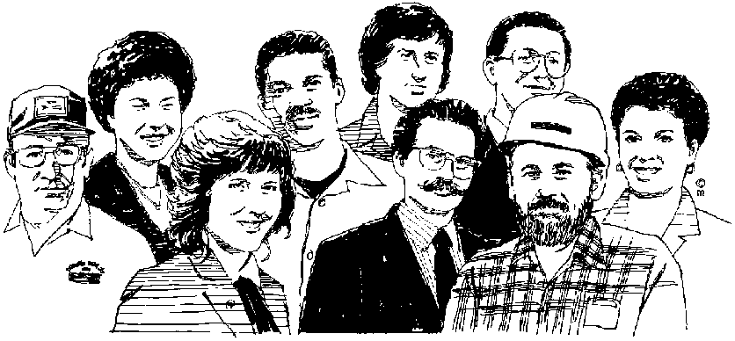

A distribution list is used to send the minutes of the meeting to the recipients, who could be:

* All staff members who attended the meeting
* Those members who were absent
* At times, to staff who are required to do something related to the meeting even though they did not attend the meeting or do not normally attend the meetings. This could be a secretary or admin clerk working in the department of a manager who did attend the meeting and has been allocated a task that has to be carried out as noted in the meeting. The manager would not do the task himself, but would require on of his staff members to action the task, and therefore that person should also receive a copy of the minutes in order to know the details of the task. If the organisation you work for, requires this to happen, your manager will usually advise you to send the specific admin clerk or secretary a copy as well.
* People who need to know the contents of the meeting, even though they do not normally attend the meetings. This could be the branch manager, the managing director of the company, a departmental manager from another department. These people would not be required to attend the meetings but need the information contained in the minutes.

### How do you send the distribution list?

Depending on company policy, you could send the minutes, under cover of the distribution list:

* By mail
* By courier
* By messenger
* Deliver it yourself
* By e-mail

j0186348

### Format of the distribution list

The purpose of the distribution list is to:

* Ensure that everybody who should receive a copy of the minutes does receive one
* Ensure that everyone who does receive a copy of the minutes signs in acknowledgement of receipt

Typically, the distribution list would be done on an internal company letterhead, with the details of the minutes as the header. Then will follow a list of people who should receive the copies, with space provided for their signatures as well as the date they received the minutes.

The layout could look as follows:

**COMPANY LETTERHEAD**

DISTRIBUTION LIST FOR MINUTES OF TRAINING MANAGEMENT MEETING HELD ON 17 JUNE 20… AT 09.30

Recipients:

|  |  |  |  |
| --- | --- | --- | --- |
| **Designation** | **Name** | **Date Received** | **Signature** |
| Chairman | Jay Naidoo |  |  |
| Vice-Chairman | Anne Smith |  |  |
| Secretary | Diane Kelsey |  |  |
| Manager Sales Department | Brian Wood |  |  |
| Despatch Manager | Kurt Khoza |  |  |
| Office Manager | Sally Mahlangu |  |  |
| Training Manager | Nina Brown |  |  |
| Finance Manager | Solly Jantjes |  |  |

Formative assessment SO2 AC3-6 group activity