Formative assessment SO2 All assessment criteria

1. In a group, analyse the responses to the questions that you received from the other group during your pilot survey. Write down your conclusions.

|  |
| --- |
|  |
|  |
|  |
|  |
|  |
|  |
|  |
|  |

1. Study the chart on the next page and answer the questions below:

|  |  |
| --- | --- |
| How many ice creams were sold during January? |  |
| During which month were the most ice creams sold? |  |
| In which month were 70 ice creams sold? |  |
| What was the total number of ice creams sold for the period? |  |
| What is the range of the data set? |  |

Ice Cream Chart 1



Ice Cream Chart 2

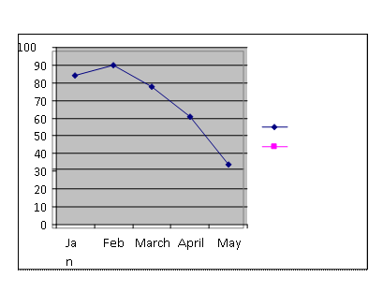

1. The example above is a line chart indicating how many ice creams were sold from January to May. Study the column chart and answer the questions below

|  |  |
| --- | --- |
| What tendencies do you pick up from this graph? |  |
| When would be a good time to start a new ice cream business? |  |

1. Study the chart on the next page and answer the questions below:

|  |  |
| --- | --- |
| Which company sold most cars? |  |
| Which company sold the smallest percentage of cars? |  |
| How many cars did Chevrolet sell during 1996? |  |
| What is the range of the data set? |  |



1. In a group draw a column chart or a bar chart for the following information. Use the grid below to help you.

|  |  |  |
| --- | --- | --- |
| Why do you use a taxi to and from work | Cheap | 1631 |
| Fast | 1091 |
| Safe | 312 |
| Convenient | 1849 |

|  |  |  |  |  |
| --- | --- | --- | --- | --- |
| 2200 |  |  |  |  |
| 2000 |  |  |  |  |
| 1800 |  |  |  |  |
| 1600 |  |  |  |  |
| 1400 |  |  |  |  |
| 1200 |  |  |  |  |
| 1000 |  |  |  |  |
| 800 |  |  |  |  |
| 600 |  |  |  |  |
| 400 |  |  |  |  |
| 200 |  |  |  |  |
|  | Cheap | Fast | Safe | Conve-nient |

1. In a group, draw a pie chart for the following information. A total of 2000 replies were received. Use the pie below to help you.

|  |  |  |
| --- | --- | --- |
| Which taxi route do you use every day? | Route A | 755 |
| Route B | 830 |
| Route C | 415 |

1. In a group, display the information you collected during the survey that was conducted in the class in the form of a chart.

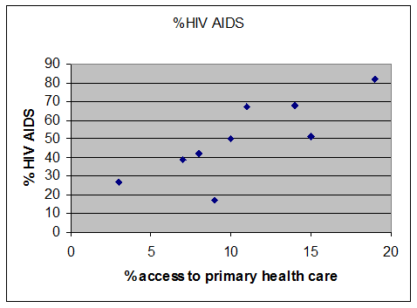

1. In a group, refer to the correlation plot on and discuss the following statement, noting your conclusions:

What conclusions do you come to regarding the relationship between the occurrence of HIV AIDS and access to primary health care?

|  |
| --- |
|  |
|  |
|  |