**LEARNER GUIDE**

**Numeracy Level 4**

**Physical Quantities and Geometrical Relationships**

Unit Standard 9016

NQF Level 4 Credits 4

# TABLE OF CONTENTS

TABLE OF CONTENTS i

PERSONAL INFORMATION 5

INTRODUCTION 7

Programme methodology 7

What Learning Material you should have 8

Different types of activities you can expect 10

Learner Administration 12

Assessments 12

Learner Support 13

Learner Expectations 14

UNIT STANDARD 9016 15

MEASURE, ESTIMATE AND CALCULATE 19

SI units 19

Length and distance 20

Ruler 20

Measuring Tape 21

Inside Caliper 21

Outside Caliper 22

Vernier caliper 23

Using The Vernier Caliper 24

Micrometer Screws 24

Formative Assessment 1 28

Speed 29

Formative Assessment 2 29

Velocity 29

Acceleration 30

Formative Assessment 3 30

Area 30

The use of formulae 31

Formative Assessment 4 35

Volume 35

Formative Assessment 5 35

Mass 36

Spring Balance 36

Chemical balances 38

Laboratory Balances 39

Formative Assessment 6 41

Measuring Fluids 41

Formative Assessment 7 42

Measuring Cylinders 42

Time 42

Clocks And Wristwatches 42

Units Of Time 43

Digital Time 43

Stopwatches 43

Formative Assessment 8 44

Temperature scales 44

Change Of Temperature 46

Instruments used 47

Thermometer 47

Formative Assessment 9 48

Two-dimensions (2D) and areas 49

The area and perimeter of a rectangle 50

The Area and Perimeter of a Square 51

Circle 51

Parallelogram 53

Observations for square, rectangle, parallelogram and rhombus 54

Formative assessment 10: Using the SI system 54

GEOMETRICAL RELATIONSHIPS 56

Two and Three Dimensional Geometric Situations 56

Symmetry 56

Surface Areas and Volumes of Right Prisms 57

Right prism 58

Right Triangle 58

Other Triangles 59

Rectangle and Square 59

Circle 59

Cylinder 61

Cone 61

Sphere 62

Geometrical Relationships 63

Geometric shapes 63

Formative Assessment 11 63

The Theorem Of Pythagoras 64

Formative Assessment 12 65

Ratio 65

Formative Assessment 13 66

Scale drawings and scale models 66

Formative Assessment 14 67

Rough Sketches 67

Sketching in general 68

Scale Drawings 72

Adding detail to scale drawings 74

Using rectangular grids 76

Legend to sketch 77

House Plans 79

Formative Assessment 15 82

Household Appliances 82

Formative Assessment 16 84

Linkages And Mechanisms 84

Aids For Drawing Objects In Three Dimensions 84

Software Applications 85

Drawing Instruments 85

Packaging material 87

Box With Overlap Lid 87

Formative Assessment 17 88

Cartography 88

World Maps 89

Map Of South Africa 92

Formative Assessment 18 93

Cartesian Coordinates 93

Road Maps 96

Formative Assessment 19 99

# PERSONAL INFORMATION

|  |  |
| --- | --- |
| ****NAME**** |  |
| ****CONTACT ADDRESS**** |  |
|  |
| ****Code**** |  |
| ****Telephone (H)**** |  |
| ****Telephone (W)**** |  |
| ****Cellular**** |  |
| ****Learner Number**** |  |
| ****Identity Number**** |  |
| ****EMPLOYER**** |  |
| ****EMPLOYER CONTACT ADDRESS**** |  |
|  |
| ****Code**** |  |
| ****Supervisor Name**** |  |
| ****Supervisor Contact Address**** |  |
|  |
| ****Code**** |  |
| ****Telephone (H)**** |  |
| ****Telephone (W)**** |  |
| ****Cellular**** |  |

# **INTRODUCTION**

#### Welcome to the learning programme

Follow along in the guide as the training practitioner takes you through the material. Make notes and sketches that will help you to understand and remember what you have learnt. Take notes and share information with your colleagues. Important and relevant information and skills are transferred by sharing!

This learning programme is divided into sections. Each section is preceded by a description of the required outcomes and assessment criteria as contained in the unit standards specified by the South African Qualifications Authority. These descriptions will define what you have to know and be able to do in order to be awarded the credits attached to this learning programme. These credits are regarded as building blocks towards achieving a National Qualification upon successful assessment and can never be taken away from you!

### Programme methodology



The programme methodology includes facilitator presentations, readings, individual activities, group discussions and skill application exercises.

Know what you want to get out of the programme from the beginning and start applying your new skills immediately. Participate as much as possible so that the learning will be interactive and stimulating.

The following principles were applied in designing the course:

* Because the course is designed to maximise interactive learning, you are encouraged and required to participate fully during the group exercises
* As a learner you will be presented with numerous problems and will be required to fully apply your mind to finding solutions to problems before being presented with the course presenter’s solutions to the problems
* Through participation and interaction the learners can learn as much from each other as they do from the course presenter
* Although learners attending the course may have varied degrees of experience in the subject matter, the course is designed to ensure that all delegates complete the course with the same level of understanding
* Because reflection forms an important component of adult learning, some learning resources will be followed by a self-assessment which is designed so that the learner will reflect on the material just completed.

This approach to course construction will ensure that learners first apply their minds to finding solutions to problems before the answers are provided, which will then maximise the learning process which is further strengthened by reflecting on the material covered by means of the self-assessments.

#### Different role players in delivery process

* Learner
* Facilitator
* Assessor
* Moderator

### What Learning Material you should have

This learning material has also been designed to provide the learner with a comprehensive reference guide.

It is important that you take responsibility for your own learning process; this includes taking care of your learner material. You should at all times have the following material with you:

|  |  |
| --- | --- |
| **Learner Guide** | **This learner guide is your valuable possession:**  This is your textbook and reference material, which provides you with all the information you will require to meet the exit level outcomes.  During contact sessions, your facilitator will use this guide and will facilitate the learning process. During contact sessions a variety of activities will assist you to gain knowledge and skills.  Follow along in the guide as the training practitioner takes you through the material. Make notes and sketches that will help you to understand and remember what you have learnt. Take and share information with your colleagues. Important and relevant information and skills are transferred by sharing!  This learning programme is divided into sections. Each section is preceded by a description of the required outcomes and assessment criteria as contained in the unit standards specified by the South African Qualifications Authority. These descriptions will define what you have to know and be able to do in order to be awarded the credits attached to this learning programme. These credits are regarded as building blocks towards achieving a National Qualification upon successful assessment and can never be taken away from you! |
| **Formative Assessment Workbook** | The Formative Assessment Workbook supports the Learner Guide and assists you in applying what you have learnt.  The formative assessment workbook contains classroom activities that you have to complete in the classroom, during contact sessions either in groups or individually.  You are required to complete all activities in the Formative Assessment Workbook.  The facilitator will assist, lead and coach you through the process.  These activities ensure that you understand the content of the material and that you get an opportunity to test your understanding. |

### Different types of activities you can expect

To accommodate your learning preferences, a variety of different types of activities are included in the formative and summative assessments. They will assist you to achieve the outcomes (correct results) and should guide you through the learning process, making learning a positive and pleasant experience.



The table below provides you with more information related to the types of activities.

| **Types of Activities** | **Description** | **Purpose** |
| --- | --- | --- |
| **Knowledge Activities** | You are required to complete these activities on your own. | These activities normally test your understanding and ability to apply the information. |
| **Skills Application Activities** | You need to complete these activities in the workplace | These activities require you to apply the knowledge and skills gained in the workplace |
| **Natural Occurring Evidence** | You need to collect information and samples of documents from the workplace. | These activities ensure you get the opportunity to learn from experts in the industry.  Collecting examples demonstrates how to implement knowledge and skills in a practical way |

### Learner Administration

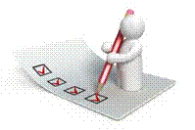

#### Attendance Register

You are required to sign the Attendance Register every day you attend training sessions facilitated by a facilitator.

#### Programme Evaluation Form

On completion you will be supplied with a “Learning programme Evaluation Form”. You are required to evaluate your experience in attending the programme.

Please complete the form at the end of the programme, as this will assist us in improving our service and programme material. Your assistance is highly appreciated.

### Assessments

The only way to establish whether a learner is competent and has accomplished the specific outcomes is through the assessment process. Assessment involves collecting and interpreting evidence about the learners’ ability to perform a task.

To qualify and receive credits towards your qualification, a registered Assessor will conduct an evaluation and assessment of your portfolio of evidence and competency.

This programme has been aligned to registered unit standards. You will be assessed against the outcomes as stipulated in the unit standard by completing assessments and by compiling a portfolio of evidence that provides proof of your ability to apply the learning to your work situation.

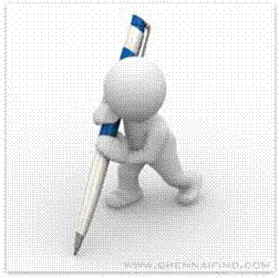

**How will Assessments commence?**

#### Formative Assessments

The assessment process is easy to follow. You will be guided by the Facilitator. Your responsibility is to complete all the activities in the Formative Assessment Workbook and submit it to your facilitator.

#### Summative Assessments

You will be required to complete a series of summative assessments. The Summative Assessment Guide will assist you in identifying the evidence required for final assessment purposes. You will be required to complete these activities on your own time, using real life projects in your workplace or business environment in preparing evidence for your Portfolio of Evidence. Your Facilitator will provide more details in this regard.

To qualify and receive credits towards your qualification, a registered Assessor will conduct an evaluation and assessment of your portfolio of evidence and competency.

### Learner Support

The responsibility of learning rests with you, so be proactive and ask questions and seek assistance and help from your facilitator, if required.



Please remember that this Skills Programme is based on outcomes based education principles which implies the following:

* You are responsible for your own learning – make sure you manage your study, research and workplace time effectively.
* Learning activities are learner driven – make sure you use the Learner Guide and Formative Assessment Workbook in the manner intended, and are familiar with the workplace requirements.
* The Facilitator is there to reasonably assist you during contact, practical and workplace time for this programme – make sure that you have his/her contact details.
* You are responsible for the safekeeping of your completed Formative Assessment Workbook and Workplace Guide
* If you need assistance please contact your facilitator who will gladly assist you.
* If you have any special needs please inform the facilitator

### Learner Expectations

Please prepare the following information. You will then be asked to introduce yourself to the instructor as well as your fellow learners

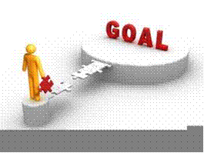

|  |
| --- |
| Your name: |
|  |
|  |
| The organisation you represent: |
|  |
|  |
| Your position in organisation: |
|  |
|  |
| What do you hope to achieve by attending this course / what are your course expectations? |
|  |
|  |
|  |
|  |
|  |

# 

# UNIT STANDARD 9016

#### Unit Standard Title

Represent analyse and calculate shape and motion in 2-and 3-dimensional space in different contexts.

#### NQF Level

4

#### Credits

4

#### Purpose

This unit standard is designed to provide credits towards the mathematical literacy requirements of the NQF at level 4. The essential purposes of the mathematical literacy requirements are that, as the learner progresses with confidence through the levels, the learner will grow in:

* An insightful use of mathematics in the management of the needs of everyday living to become a self-managing person.
* An understanding of mathematical applications that provides insight into the learner’s present and future occupational experiences and so develop into a contributing worker.
* The ability to voice a critical sensitivity to the role of mathematics in a democratic society and so become a participating citizen.

People credited with this unit standard are able to:

* Measure, estimate, and calculate physical quantities in practical situations relevant to the adult with increasing responsibilities in life or the workplace
* Explore analyse and critique, describe and represent, interpret and justify geometrical relationships and conjectures to solve problems in two and three dimensional geometrical situations.

#### Learning assumed to be in place

The credit value is based on the assumption that people starting to learn towards this unit standard are competent in Mathematical Literacy and Communications at NQF level 3

#### Unit standard range

* The scope of this unit standard includes length, surface area, volume, mass, speed ; ratio, proportion; making and justifying conjectures.
* Contexts relevant to the adult, the workplace and the country.
* More detailed range statements are provided for specific outcomes and assessment criteria as needed.

#### Specific Outcomes and Assessment Criteria

**Specific Outcome 1:** Measure, estimate, and calculate physical quantities in practical situations relevant to the adult.

Range:

* Basic instruments to include those readily available such as rulers, measuring tapes, measuring cylinders or jugs, thermometers, spring or kitchen balances, watches and clocks.
* In situations which necessitate it such as in the workplace, the use of more accurate instruments such as vernier callipers, micrometer screws, stop watches and chemical balances.
* Quantities to estimate or measure to include length/distance, area, mass, time, speed acceleration and temperature.
* Distinctions between mass and weight, speed and acceleration.
* The quantities should range from the low or small to the high or large.
* Mass, volume temperature, distance, and speed values are used in practical situations relevant to the young adult or the workplace.
* Calculate heights and distances using Pythagoras` theorem.
* Calculate surface areas and volumes of right prisms (i.e., end faces are polygons and the remaining faces are rectangles)
* Cylinders, cones and spheres from measurements in practical situations relevant to the adult or in the workplace.

**Assessment Criteria**

* Scales on the measuring instruments are read correctly
* Quantities are estimated to a tolerance justified in the context of the need
* The appropriate instrument is chosen to measure a particular quantity
* Quantities are measured correctly to within the least step of the inst
* Appropriate formulae are selected and used
* Calculations are carried out correctly and the least steps of instruments used are taken into account when reporting final values
* Symbols and units are used in accordance with SI conventions and as appropriate to the situation

**Specific Outcome 2:** Explore, analyse & critique, describe & represent, interpret and justify geometrical relationships and conjectures to solve problems in two and three dimensional geometrical situations.

Range:

* Applications taken from different contexts such as packaging, arts, building construction, dressmaking.
* The operation of simple linkages and mechanisms such as car jacks.
* Top, front and side views of objects are represented.
* Use rough sketches to interpret, represent and describe situations.
* The use of available technology (e.g., isometric paper, drawing instruments, software) to represent objects
* Use and interpret scale drawings of plans (e.g., plans of houses or factories; technical diagrams of simple mechanical household or work related devices,
* Road maps relevant to the country.
* World maps.
* International time zones.
* The use of the Cartesian co-ordinate system in determining location and describing relationships in at least two dimensions.

**Assessment Criteria**

* Descriptions are based on a systematic analysis of the shapes and reflect the properties of the shapes accurately, clearly and completely
* Descriptions include quantitative information appropriate to the situation and need.
* 3-dimensional objects are represented by top, front and side view.
* Different views are correctly assimilated to describe 3-dimensional object
* Available and appropriate technology is used in producing and analysing representations.
* Relations of distance and positions between objects are analysed from different views.
* Conjectures as appropriate to the situation, are based on well-planned investigations of geometrical properties.
* Representations of the problems are consistent with and appropriate to the problem context. The problems are represented comprehensively and in mathematical terms
* Results are achieved through efficient and correct analysis and manipulation of representations.
* Problem-solving methods are presented clearly, logically and in mathematical terms.
* Reflections on the chosen problem solving strategy reveal strengths and weaknesses of the strategy
* Alternative strategies to obtain the solution are identified and compared in terms of appropriateness and effectiveness.

#### Unit Standard Essential Embedded Knowledge

The following essential embedded knowledge will be assessed through assessment of the specific outcomes in terms of the stipulated assessment criteria. Candidates are unlikely to achieve all the specific outcomes, to the standards described in the assessment criteria, without knowledge of the listed embedded knowledge. This means that the possession or lack of the knowledge can be inferred directly from the quality of the candidate’s performance against the standards.

* Properties of geometric shapes
* Surface area and volume
* Mathematical argument and evaluation based on logical deduction
* Spatial interrelationships

Critical Cross-field Outcomes (CCFO)

**Unit Standard CCFO Identifying**: Solve a variety of problems relevant to the adult with increasing responsibilities involving space, shape and time using geometrical techniques

**Unit Standard CCFO Collecting**: Gather, organise, evaluate and critique information about objects and processes

**Unit Standard CCFO Communicating**: Use everyday language and mathematical language to describe properties, processes and problem solving methods.

**Unit Standard CCFO Science**: Use mathematics to analyse, describe and represent realistic and abstract situations and to solve problems relevant to the adult with increasing responsibilities

# MEASURE, ESTIMATE AND CALCULATE

#### Specific outcome

Measure, estimate, and calculate physical quantities

#### Assessment criteria

* Scales on the measuring instruments are read correctly
* Quantities are estimated to a tolerance justified in the context of the need
* The appropriate instrument is chosen to measure a particular quantity.
* Quantities are measured correctly to within the least step of the instrument.
* Appropriate formulae are selected and used.
* Calculations are carried out correctly and the least steps of instruments used are taken into account when reporting final values.
* Symbols and units are used in accordance with SI conventions and as appropriate to the situation.

## SI units

The SI or Systéme International consists of 7 base units which were taken into use in order to have a worldwide acknowledged unit system. This has simplified the sharing of information between countries with different traditional units significantly.

|  |  |  |
| --- | --- | --- |
| **Quantity** | **Unit** | **Abbreviation** |
| Mass | Kilogram | kg |
| Length | Meter | m |
| Time | Second | s |
| Temperature | Kelvin | K |
| Current | Ampére | A |
| Light | Candela | cd |
| Chemical standard unit | Mole | mol |

It is **VERY** important to always indicate a unit. The unit is what gives meaning to a number. Just think 3000 tells you nothing about what this number is for or does, but R3000 is very useful! Also remember to indicate the unit **EXACTLY** as it is shown above. Km is wrong and so is S, if the unit is not given exactly right your answer will be wrong!

## Length and distance

We measure lengths in millimetres (mm), centimetres (cm), meters (m) and kilometres (km), These are the units of length in the SI (System International) Metric System.

The relations are: 1m = 100 cm = 1000mm and 1km = 1000m

The distance between two points is the path length between the two points

### Ruler

0

10

20

30

40

mm

A ruler is a straight rigid strip of plastic, wood, metal, marked at regular intervals and used to draw straight lines or measure distances.

Each smallest increment (an increase in a number) represents 1 millimetre. Each 10th increment is marked with the relevant value. To measure the length of any straight line, place the ruler along that line so that one end of the line is at the zero mark. The other end will be at the number indicating its length.

### Measuring Tape

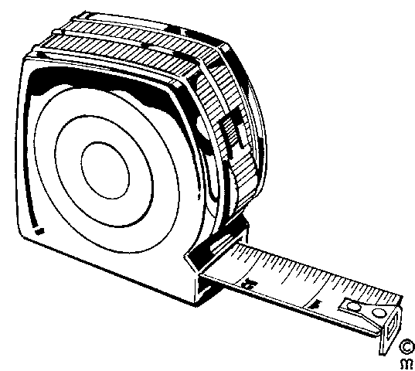A measuring tape will have similar markings and applications as a ruler. The main difference is that a measuring tape is designed for use over longer lengths. As a result increments of 100 mm and 1000 mm are also distinguished.

The length of a measuring tape usually starts at 1metre (1000 millimetre) and some can be as long as 100 metres. The measuring tape used by dress makers is usually 1metre or 1.5 metres long and the very long measuring tapes are used by people in the construction business.

### Inside Caliper

Inside calipers are used to measure the internal size or internal cavity of an object

* To use the upper caliper in the image you have to make manual adjustments before fitting or measuring. To finely set the caliper, you have to tap the caliper legs lightly on a handy surface until they will *almost* pass over the object. A light push against the resistance of the central pivot screw then spreads the legs to the correct dimension and provides the required, consistent *feel* that ensures a repeatable measurement.
* The lower caliper in the image has an adjusting screw that makes it possible to carefully adjust the tool without removing it from the work piece.
* Make sure that you do not accidentally adjust the vernier when moving it between the measured object and ruler
* The advantage of using a caliper is that its measurement is more accurate than many other measuring instruments.

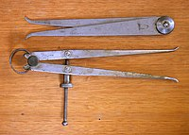

### Outside Caliper

Outside calipers are used to measure the external size of an object (the outer diameter of an object.)

The same observations and technique apply to this type of caliper, as for the inside caliper. Calipers can provide a high degree of accuracy and repeatability. They are especially useful when measuring over very large distances, for example when measuring a large diameter pipe. A vernier caliper (discussed next) does not have the depth capacity to straddle this large diameter while at the same time reach the outermost points of the pipe’s diameter.

Three outside calipers.

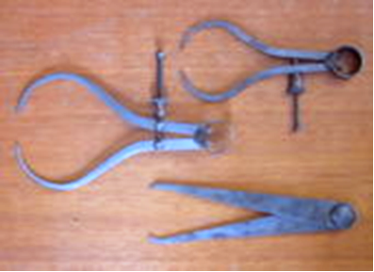

### Vernier caliper

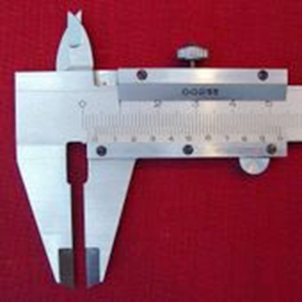A variation to the more traditional caliper is the inclusion of a vernier scale, this makes it possible to directly obtain an accurate measurement.

Vernier calipers can measure internal dimensions (using the uppermost jaws in the picture at right), external dimensions using the pictured lower jaws, and depending on the manufacturer, depth measurements by the use of a probe that is attached to the movable head and slides along the centre of the body. This probe is slender and can get into deep grooves that may prove difficult for other measuring tools.

The vernier scales will often include both metric and Imperial measurements on the upper and lower part of the scale.

Vernier calipers commonly used in industry provide a precision to a hundredth of a millimetre (10 micrometres), or one thousandths of an inch.

A more accurate instrument used for the same purpose is the micrometer.

#### Parts Of A Vernier Caliper:

1. **Outside jaws:** used to measure external lengths
2. **Inside jaws:** used to measure internal lengths
3. **Depth probe:** used to measure depths
4. **Main scale** (cm)
5. **Main scale** (inch)
6. **Vernier** (cm)
7. **Vernier (inch)**
8. **Retainer: used to block movable part to allow the easy transferring of a measurement.**

### Parts of a vernier caliper: Outside jaws: used to measure external lengths Inside jaws: used to measure internal lengths Depth probe: used to measure depths Main scale (cm) Main scale (inch) Vernier (cm) Vernier (inch) Retainer: used to block movable part to allow the easy transferring a measurement Using The Vernier Caliper

A caliper must be properly applied against the part in order to take the desired measurement. For example, when measuring the thickness of a plate a vernier caliper must be held at right angles to the piece. Some practice may be needed to measure round or irregular objects correctly.

Accuracy of measurement when using a caliper is highly dependent on the skill of the operator. Regardless of type, a caliper's jaws must be forced into contact with the part being measured. As both part and caliper are always to some extent elastic, the amount of force used affects the indication. A consistent, firm touch is correct. Too much force results in an under indication as part and tool distort; too little force gives insufficient contact and an over indication. This is a greater problem with a caliper incorporating a screw, which lends mechanical advantage.

Simple calipers are uncalibrated; the measurement taken must be compared against a scale. Whether the scale is part of the caliper or not, all analog calipers -- verniers and dials -- require good eyesight in order to achieve the highest precision. Digital calipers have the advantage in this area.

Calibrated calipers may be mishandled, leading to loss of zero. When a caliper’s jaws are fully closed, it should of course indicate zero. If it does not, it must be recalibrated or discarded. It might seem that a vernier caliper cannot get out of calibration but a drop or knock can be enough. Sometimes a careful tap is enough to restore zero. Digital calipers have zero set buttons.

### Micrometer Screws

Micrometer is a name generally given to any device for measuring small angles or dimensions, usually smaller than 1mm.

A micrometer screw displaces the pointer uniformly by turning a screw. If, for example, the step of the screw is 0.5mm and the screw head is read to 1/1000 of a revolution, we measure to 0.0005mm, which is about equal to the wave length of light.

#### History

The first ever micrometric screw was invented by William Gascoigne in the 17th century, as an enhancement of the Vernier; it was used in a telescope to measure angular distances between stars. Its adaptation for the measurement of the small dimension was made by Jean-Louis Palmer; this device is therefore often called palmer in France. In 1888 Edward Williams Morley added to the precision of micrometric measurements and proved their accuracy in a complex series of experiments.

#### Micrometer (Device)

External, internal, and depth micrometers

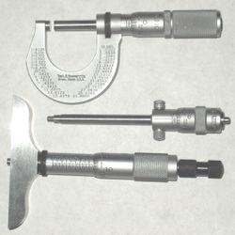

A micrometer is a widely used device in mechanical engineering for precisely measuring thickness of blocks, outer and inner diameters of shafts and depths of slots. Appearing frequently in metrology, the study of measurement, micrometers have several advantages over other types of measuring instruments like the Vernier caliper.

#### Types

The image shows three common types of micrometers, the names are based on their application:

An external micrometer is typically used to measure wires, spheres, shafts and blocks. An internal micrometer is used to measure the opening of holes, and a depth micrometer typically measures depths of slots and steps.

The precision of a micrometer is achieved by a using a fine pitch screw mechanism.

An additional interesting feature of micrometers is the inclusion of a spring-loaded twisting handle. Normally, one could use the mechanical advantage of the screw to force the micrometer to squeeze the material, giving an inaccurate measurement. However, by attaching a handle that will ratchet at a certain torque, the micrometer will not continue to advance once sufficient resistance is encountered.

#### Reading A Metric Micrometer

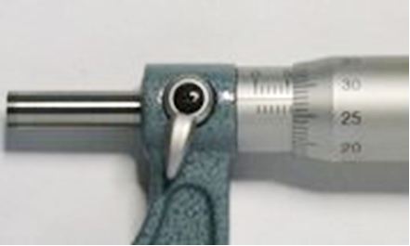Micrometer thimble reading 5.78mm

The spindle of an ordinary metric micrometer has 2 threads per millimetre, and thus one complete revolution moves the spindle through a distance of 0.5 millimetre. The longitudinal line on the frame is graduated with 1 millimetre divisions and 0.5 millimetre subdivisions. The thimble has 50 graduations, each being 0.01 millimetre (one-hundredth of a millimetre). To read a metric micrometer, note the number of millimetre divisions visible on the scale of the sleeve, and add the total to the particular division on the thimble which coincides with the axial line on the sleeve.

Suppose that the thimble were screwed out so that graduation 5, and one additional 0.5 subdivision were visible (as shown in the image), and that graduation 28 on the thimble coincided with the axial line on the sleeve. The reading then would be 5.00 +0.5 +0.28 = 5.78 mm.

#### Reading A Vernier Micrometer

Micrometer sleeve (with vernier) reading 5.783mm

Some micrometers are provided with a vernier scale on the sleeve in addition to the regular graduations. These permit measurements within 0.001 millimetre to be made on metric micrometers, or 0.0001 inches on inch-system micrometers.

Metric micrometers of this type are read as follows: First determine the number of whole millimetres (if any) and the number of hundredths of a millimetre, as with an ordinary micrometer, and then find a line on the sleeve vernier scale which exactly coincides with one on the thimble. The number of this coinciding vernier line represents the number of thousandths of a millimetre to be added to the reading already obtained.

Thus, for example, a measurement of 5.783 millimetres would be obtained by reading 5.5 millimetres on the sleeve, and then adding 0.28 millimetre as determined by the thimble. The vernier would then be used to read the 0.003 (as shown in the image).

Inch micrometers are read in a similar fashion.

Note: 0.01 millimetre = 0.000393 inch, and 0.002 millimetre = 0.000078 inch (78 millionths) or alternately, 0.0001 inch = 0.00254 millimetres. Therefore, metric micrometers provide smaller measuring increments than comparable inch unit micrometers—the smallest graduation of an ordinary inch reading micrometer is 0.001 inch; the vernier type has graduations down to 0.0001 inch (0.00254 mm). When using either a metric or inch micrometer, without a vernier, smaller readings than those graduated may of course be obtained by visual interpolation between graduations.

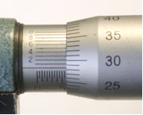

### Formative Assessment 1

## Speed

Speed = 

Example

You take 5 minutes to walk the 900 m from your house to the mall. Your average speed was

Speed =  = 3 m/s

Note that we do not know your speed at any specific point on your journey. To know that, we need to know what distance was covered in a very short time period around that point.

Important: Speed is measured in m/s therefore minutes must be converted to seconds.

### Formative Assessment 2

### Velocity

Velocity =. (  = )

Velocity is again a vector therefore we measure a size as well as direction.

Example: you take 5 minutes to walk the 900 m from your house to the mall. However the displacement is 400m in a NE direction.

Velocity =  = 1.33 m/s in a NE direction.

### Acceleration

Simplify the problem and look only at movement in straight lines. Speed and velocity becomes equal (if it is in a straight line) and we need not mention the direction.

All movement can be divided into two groups: movement with constant velocity and movement with changing velocity.

We define acceleration as the measure of the rate of change in velocity. If the acceleration of a body is large, we say that there is a huge increase in velocity every second. If the acceleration is uniform (the same amount of velocity increase or decrease per second) we can measure the acceleration by measuring the change in velocity during a time interval.

Acceleration = 



Where a = acceleration, v = end velocity, u = initial velocity, t = time taken for change in velocity to take place.

The unit is m/ssince  = m/s.

Also note that velocity can be a negative number. (If velocity decreases, the acceleration is negative since the beginning velocity is bigger than the end velocity).

### Formative Assessment 3

## Area

The amount of surface covered by a flat figure is called the area of the figure.

We measure area by counting the number of unit squares that cover the figure. A unit square with sides of 1 cm each has an area of 1 cm2.

### The use of formulae

Formulae are supplied in Table 1 to use in calculations.

1. Decide which shape it is to choose the relevant formula.
2. Write down the appropriate formula
3. Write down what you want to calculate and information given to you.
4. Substitute in appropriate formula
5. Calculate your answer (Remember to use the correct unit)

**Example**

**a). Calculate the area of the figure:**

1. Decide which shape –Area of Rectangle:

2. Area = l x w

3. Area =?

*5m*

*3m*

L = 5m

W = 3m]3.

4. Area = l x w

=(5m x (3m)

5. =15 m2

**b). Calculate the area of the** figure:

1. Decide which shape –Area of Triangle:

Base 3 cm

Height

(5cm)

2. Area =  (From Table 1)

3. Area =? (Write down what we want and have)

b = 3cm

h = 5cm

4. Area = 

= x 3cm x 5cm (Substitute in formula)

5. =7.5cm2 (Answer in correct units)

**Table 1:**

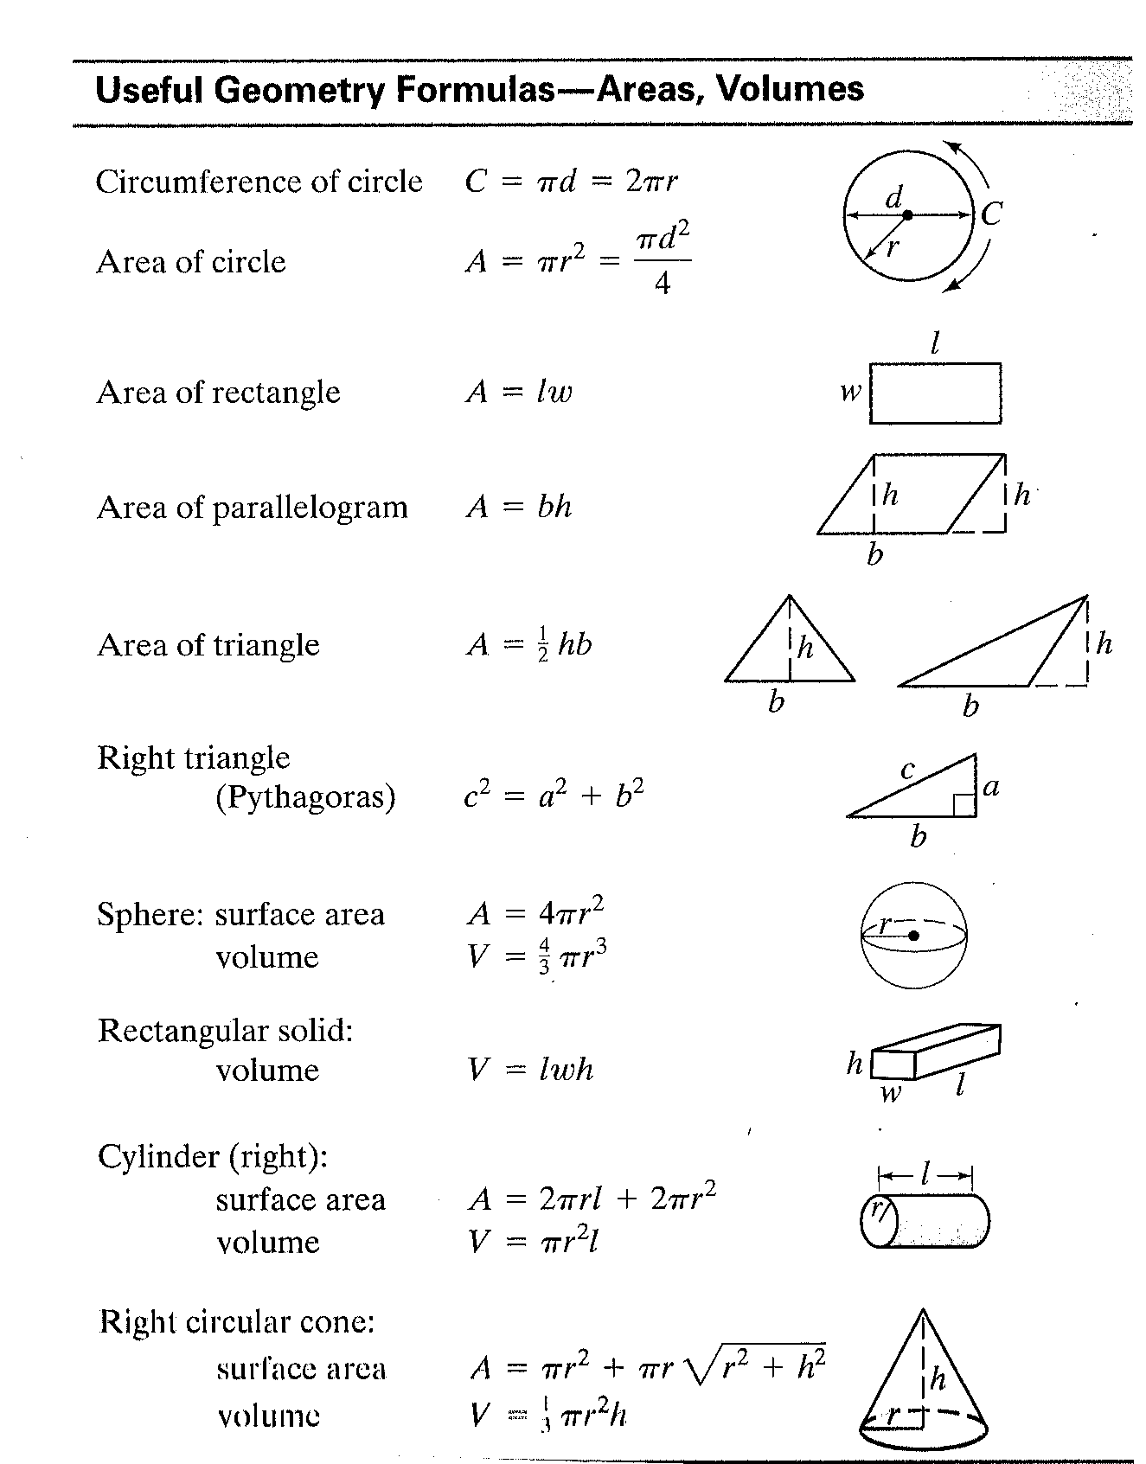

### Formative Assessment 4

## Volume

1 cm

1 cm

1 cm

A cube with sides of 1 cm each is a unit cube with volume 1 cm3 (one cubic centimetre). We measure the volume of a container or solid in terms of the number of unit cubes needed to fill it.

The volume (in cm3) of any rectangular box with length l (in cm), width w (in cm) and height h (in cm) is: *V = l x w x h*

For very small volumes, we can use unit cubes of 1 mm3 (one cubic millimetre). For big volumes, we can use unit cubes of 1 m3 (one cubic metre). The relationship between these cubes is:

1 cm3 = 1 000 mm3

1 m3 = 1 000 000 cm3

### Formative Assessment 5

## Mass

What is the difference between weight and mass?

We say that the weight (“heaviness”) of an object depends on its mass. The bigger the mass, the bigger the pull of the earth is on it.

To measure mass we choose a unit of mass and express the mass of an object in this unit. In the metric system we use the gram (g) and the kilogram (kg) as units of mass. 1kg = 1000g, 1g = 1000 mg

Remember to use the same units when comparing the masses of different objects.

### Spring Balance

30

25

20

15

10

5

**kg**

A balance is an instrument for comparing the weights of two bodies to determine the difference in mass.

A spring balance is a balance that measures weight by the tension of a spring, in other words you hang the object you want to weigh from the spring balance. Fishermen use this to weigh the fish they have caught in competitions. Butchers also use spring balances to weigh carcasses.

Hang a spring balance like this from any support strong enough for the object to be weighed. Attach the bottom hook to the object. The indicator shows the mass of the object.

A spring scale (or spring balance) is a weighing scale often used to measure force, such as the force of gravity, exerted on a mass or the force of a person's grip or the force exerted by a towing vehicle. This force is commonly measured in newtons.

Many spring scales are marked right on their face "Not Legal for Trade" or words of similar import. Some spring scales can be calibrated for the accurate measurement of mass in the location in which they are used. The spring scale works on Hooke's Law.

If the two spring scales are hung one below the other both will read the weight of the body hung on the lower scale.

Spring scales come in different sizes. Generally, small scales that measures newtons will have a weaker spring than larger ones that measures 10's, 100's or 1000's of newtons

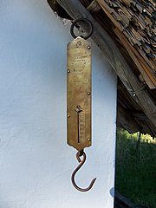

### Chemical balances

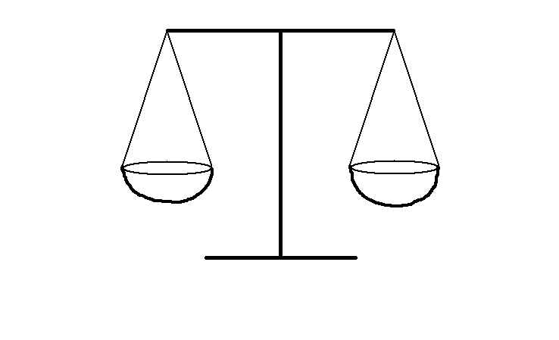We have said that a balance is an instrument for comparing the weights of two bodies to determine the difference in mass. In the old days a balance consisted of a machine where weights were added to a pan on one side and the goods that had to be weighed were placed in a pan on the other side until the pans were at the same height.

So, if you want to measure 500g flour, you would put 500g weights in one pan, which would cause that pan to be heavier and sink to the bottom. You would then add flour in the other pan until both pans are level, then you should have 500g worth of flour.

A chemical balance is a very sensitive balance designed to measure very small weights accurately. A pharmacist or laboratory technician would have to measure powder and other substances weighing as little as 5grams or 1 gram and they would use a chemical balance.

### Laboratory Balances

Mettler digital analytical balance with 0.1 mg precision.

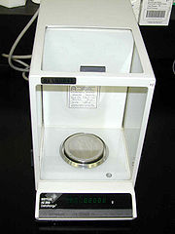

An analytical balance is an instrument used to measure mass to a very high degree of precision. The weighing pan(s) of a high accuracy (0.1 mg or better) analytical balance are inside a see-through enclosure with doors so dust does not collect and so any air currents in the room do not affect the delicate balance. Also, the sample must be at room temperature to prevent natural convection from forming air currents inside the enclosure, affecting the weighing.

Very precise measurements are achieved by ensuring that the fulcrum of the beam is friction-free (a knife edge is the traditional solution), by attaching a pointer to the beam which amplifies any deviation from a balance position; and finally by using the lever principle, which allows fractional weights to be applied by movement of a small weight along the measuring arm of the beam.

#### Sources Of Error

Some of the sources of potential error in a high-precision balance include the following:

* Buoyancy, due to the fact that the object being weighed displaces a certain amount of air, which must be accounted for. High-precision balances are often operated in a vacuum.
* Air gusts, even small ones, may push the scale up or down.
* Friction in the moving components may prevent the scale from reaching equilibrium.
* Settling airborne dust may contribute to the weight.
* Scale may be mis-calibrated.
* Mechanical components may be mis-aligned.
* Magnetic fields from nearby electrical wiring may act on iron components.
* Magnetic disturbances to electronic pick-up coils or other sensors.
* Forces from electrostatic fields, for example, from feet shuffled on carpets on a dry day.
* Chemical reactivity between air and the substance being weighed (or the balance itself, in the form of corrosion).
* Condensation of atmospheric water on cold items.
* Evaporation of water from wet items.
* 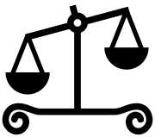Convection of air from hot or cold items.
* The Coriolis force from Earth's rotation.
* Vibration and seismic disturbances; for example, the rumbling from a passing truck.

#### Symbology

The weighing scales (specifically, a beam balance) are one of the traditional symbols of justice, as wielded by statues of Lady Justice. This corresponds to the use in metaphor of matters being "weighed up" or "held in the balance".

### Formative Assessment 6

200

100

ml

30

25

20

10

5

**kg**

15

## Measuring Fluids

In the metric system, the units used to measure capacity are the litre and millilitre. When a solid is dropped into water, the object takes the place of some of the water. We see that the level of the water rises. One millilitre (1 ml) of water is the volume of water that is displaced by 1 cm3. Or we can say that 1 ml of water fills 1 cm3.

Fluids such as water, milk and cold drinks are measured in millilitres or litres.

One litre = 1 000 ml.

For big volumes of fluid we can use the kilolitre (kl) as unit. 1 kl = 1 000 l.

Example: 5 ml of fluid fills 5 cm3

¼ l = 250 ml

1 kl of fluid fills 1 000 000 cm3 or 1 m3

### Formative Assessment 7

### Graduated cylinder. Ring at top is used to prevent breakage if knocked over.Measuring Cylinders

In this case each small increment represents 10 millilitre. Every 100 ml has its value indicated.

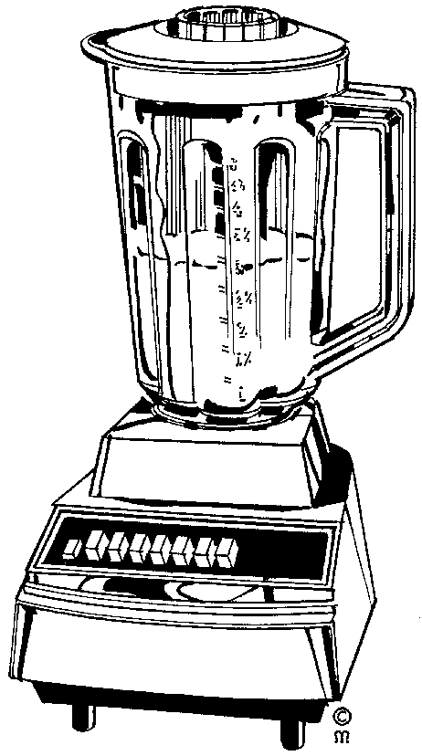To acquire a certain amount of a liquid or powdery solid it is poured into the measuring cylinder. The marking next to the flat level of the substance would indicate the volume contained.

Measuring cylinders are used every day by people baking cakes, cooking, as well as by hairdressers laboratory technicians, pharmacists, students studying chemical science, chemical scientists and at times even barmen.

Measuring cylinders are used to measure the amount of water or liquid and/or powdery solid in order to:

* Mix hair colouring
* Mix batter for cake, where you would add milk or water to flour, salt, sugar and other powdery solids
* Mix the amounts of alcoholic beverages to make a cocktail or other drink
* Mix chemical substances which can be in liquid or powder form.

## Time

### Clocks And Wristwatches

A clock is an instrument that measures and indicates the time. A watch is a small timepiece usually worn on a strap on one’s wrist. So we use watches and clocks to tell the time.

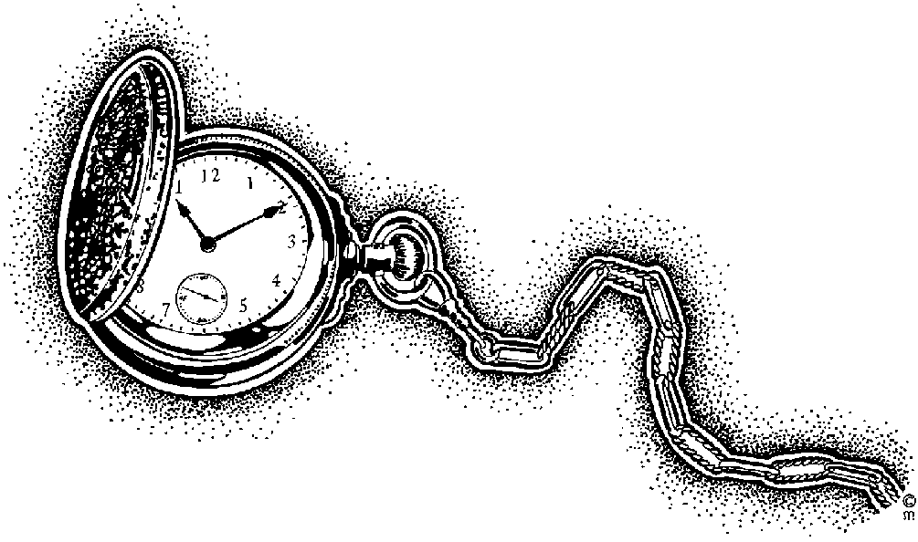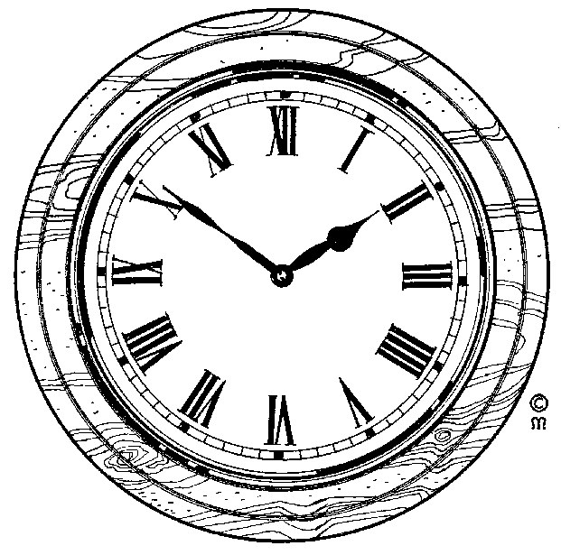

Clocks like these indicate the minutes between hours with the long arm and the hours with the short one. The numbers are indicated in Roman Numerals.

Every hour marking indicates the hour to be read with the short arm. It also indicates 5 minute increments to be read with the long arm.

The minute indication starts with 5 minutes past the hour at 1, and ends with 55 minutes past (5 minutes before) at 11.

Before wristwatches were common, most people, churches and government buildings used clocks to tell the time. These days clocks are not commonly found, except in church towers and government buildings. Most of us use watches to tell the time.

Luckily, watches are no longer commonly numbered in Roman numerals, but rather the numbers as we use them from day to day. This watch only indicates hours (12), half hours (6) and quarter hours (3) and (9). It is left up to the wearer of the watch to work out when it is 5 past 10 or 20 to 7.

### Units Of Time

The basic unit of time is the second (s). We can also measure time in minutes (min), hours (h), days, weeks and so on. There are 7 days in a week, 24 hours in a day, 60 minutes in an hour and 60 seconds in a minute.

The face of a watch with hands is divided into 12 divisions. The hours between 12 o’clock midday and 12 o’clock midnight used to be written as 1 p.m, 2 p.m etc up to 12 p.m (midnight). The hours after midnight used to be written as 1 a.m., 2 a.m. etc up to 12 a.m (midday).

### Digital Time

Today we use the international system of time. In this system the hours after midnight are counted 01:00, 02:00 and so on. Midday is 12:00 and midnight is 24:00. The digits before the “:” show the hours and the digits after the “:” show the minutes. Digital watches sow time in this way.

**16:30:00**

Digital watches do the same thing as ordinary wristwatches, the only difference is that they show the time differently. The time on your cell phone or PC screen is shown digitally:

The digits display the current time. AM is for morning and PM is for afternoon. The 16 indicates the current hour, which is four o’ clock. The 30 indicates the minutes and the 00 the seconds. The time on this digital watch is 30 minutes past four o’ clock.

The time as shown on a PC screen.

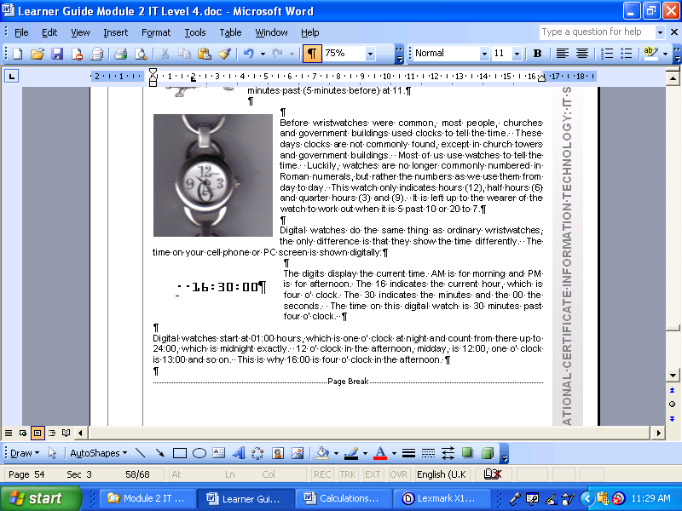

### Stopwatches

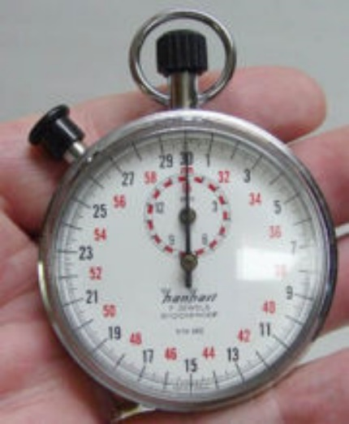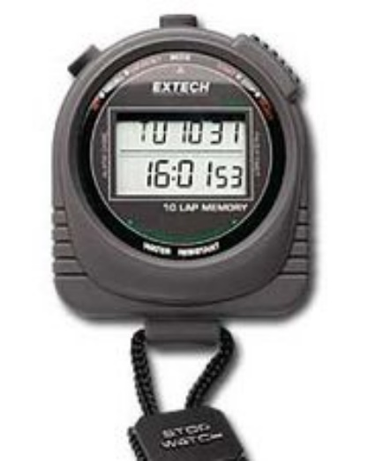

**00:00:00**

A stopwatch takes the time of an event chosen by the user. An example of this would be the time between the beginning and end of a race. Most stopwatches can measure split seconds as small as 1/1000 of a second. The ‘00’ on the left indicates minutes. The figure in the middle indicates the seconds and the figure on the right indicates the split seconds.

### Formative Assessment 8

## Temperature scales

There are three commonly used temperature scales:

* The **Celsius** scale is the most commonly used temperature scale.
* The **Fahrenheit** scale is used in the United States.
* The absolute or **Kelvin** scale is used in scientific work.

The Fahrenheit and Celsius scales assign arbitrary values to both freezing and boiling points of water at atmospheric pressure.

|  |  |  |
| --- | --- | --- |
|  | Celsius | Fahrenheit |
| Freezing point | 0.00°C | 32.0°F |
| Boiling point | 100°C | 212°F |

Between these two reference points the Celsius scale is divided into 100 equal units and the Fahrenheit scale into 180 equal units. This makes it easy to convert from Celsius to Fahrenheit or vice versa as each value of Celsius has a corresponding Fahrenheit value, 1°F = 5/9°C. The conversion formulas are as follows:

T(°C) = 5/9[T(°F)-32] or T(°F) = 9/5T(°C) + 32

EXAMPLE: **Taking your temperature**

Normal body temperature is 98.6°F. What is this in °C? And what is the temperature in Fahrenheit back from °C?

Solution:

#### Convert from Fahrenheit to Celsius using the formulae:

**T(°C) = 9/5[T(°F)-32]**

**°F = 98.6**

**°C = ?**

Substitute in formulae above

**T(°C) = 5/9 x [98.6 – 32]**

**T(°C) = 5/9 x [66.6]**

**T(°C) = 37°C**

#### Convert Celsius into Fahrenheit using the formula:

**T(°C) = 9/5[T(°F)-32]**

**°C = 37**

**°F = ?**

Substitute in formulae given above

**T(°F) = 9/5 x 37°C + 32**

**T(°F)= 66.6°C + 32**

**T(°F) =98.6 °F**

It is important to remember that different thermometers are made from various materials and filled with different substances, in practice this means that they all expand and contract differently in response to changes in temperature. Because of this most thermometers are only reliable within a set range of temperatures.

### Change Of Temperature

**Changes of temperature** in time can be calculated as follows:

Δt (change in temperature) = hf (heating factor ºC/s) × time

Note that this formula expresses any type of linear quantity change with respect to time, and can be used in various applications.

## Instruments used

### Thermometer

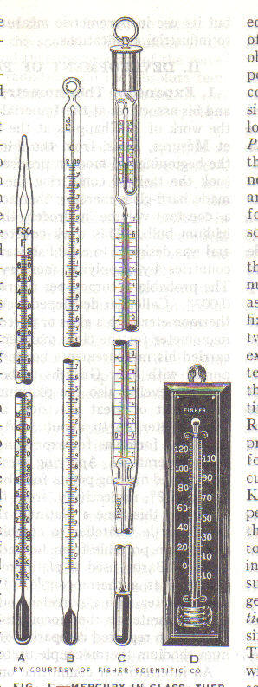

40

37

36

38

35

39

34

33

41

42

ºC

The example left looks like a typical thermometer used to measure body temperature. It contains mercury or a coloured liquid where the level indicates the ambient temperature.

A thermometer is an instrument for measuring or sensing temperature, typically consisting of a graduated glass tube containing mercury or alcohol which expands when heated.

Thermometers are used by doctors, nurses and medical staff to determine the temperature of a patient. A patient with a higher than normal temperature, **36ºC,** would indicate illness, as 36 degrees Celsius is the normal body temperature for human beings.

Thermometers are also used by the weather bureau to determine the daily temperatures. You can also buy a thermometer to determine the temperature in your house on a day to day basis and swimming pool owners use them to find out what the water temperature is.

Some thermometers used by medical staff and found in households are shown on the right. You may have seen one or more of them during visits to the doctor or hospital.

Thermometers that make use of digital display have temperature influenced components that generate code. This code is processed and the relevant temperature is displayed as follows: **36ºC**

In some countries, such as the USA, temperature is measured in Fahrenheit, but in South Africa temperature is measured in Celsius.

In Celsius, **0ºC** is the point at which water freezes and **100ºC** is the point at which water boils. Of course, the freezing and boiling point of water as indicated above is at sea level, the exact temperature changes a little bit as you move farther inland and higher than sea level.

### Formative Assessment 9

## Two-dimensions (2D) and areas

The purpose of this section is to introduce you to two-dimensional objects in terms of their various shapes in order to determine their areas and symmetries.

Areas are always in demand for many different uses. This section shows you how to calculate some of these so that you can estimate the surface areas when you need them.

Below is a summary various 2D shapes. The name, a small drawing and a short description of each shape is shown in order to provide you with an overview of what follows.

|  |  |  |
| --- | --- | --- |
| **Name** | **Drawing** | **Description** |
| Circle |  | The edge of the circle is at a constant distance from the middle. This distance is called the radius. |
| Triangle |  | A triangle has three straight sides. |
| Square |  | A square has four equal sides and four right angles. |
| Rectangle |  | A rectangle has the opposite sides of equal length and four right angles. |
| Trapezium |  | A trapezium has one parallel pair of opposite sides. |
| Parallelogram |  | A parallelogram has both opposite sides equal and parallel. |

Various 2D shapes

Note that small lines drawn through the edges of an item indicate that those edges (lines) have the same length. The parallelogram is an example that shows two pairs of equal lines. A small square in a corner indicates a right angle of 90 degrees (90°). The square is an example that has four right angles. The greater than signs **(>)** indicate lines that are parallel to one another. The parallelogram has two parallel sides.

There are many geometric formulas, relating height, width, length, or radius to perimeter, area, surface area volume. Some of the formulas are rather complicated, and you have hardly seen them, let alone used them. But there are some basic formulas you have to remember.

### The area and perimeter of a rectangle

A plane figure with four straight sides and four right angles and with unequal adjacent sides.

**l**

**a**

**w**

**Area(a) = l × w (unit: m ²)**

#### The Perimeter of a Rectangle

If you look at the picture of a rectangle, and remember that “perimeter” means “length around the outside”, you’ll see the rectangle’s perimeter is the sum of the top and bottom lengths (*l*) and the left and right widths (*w*):

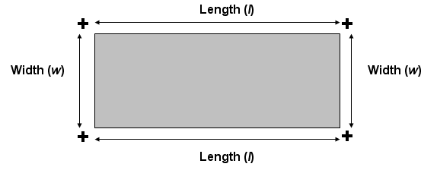

***Prect =2l +2w***

### The Area and Perimeter of a Square

A square is a four-sided figure in which all four sides are the same length, they are parallel to one another and the angle between each adjacent side is at right angles to its neighbour. It’s a lot easier to see a square than to describe one.



**A square showing all sides are equal, parallel and at right angles to one another**

The sides all have the same length, A, and each side is parallel to the opposite side and at 90 degrees to its neighbours. The square in each corner indicates that these are right angles.

**Area(a) = l × w (unit: m ²)**

If the side of a square is 12 centimetres, what is its area? The area is 12 × 12 = 144 so its area is 144 square centimetres (cm2).

Squares are therefore simpler, because their lengths and widths are identical. The area and perimeter of a square versus length (*s*) are given by:

***Psqr = 4s***

### Circle

A round plane figure whose boundary is made up of points at an equal distance from the centre.

The area of a circle is a bit more complicated to calculate but not difficult. Below is a circle with a radius, r.

The radius is the measurement from the centre of the circle to its boundary. Note that the radius is always the same in the same circle no matter the angle it is drawn at. The diameter is the cross section of the circle and is always twice the length of the radius.

An irrational number, π (Greek letter ‘pi’), is used in circular calculations. An irrational number is one that has an infinite number of digits after the decimal point. In addition, the decimal portion of an irrational number does not have a pattern of digits that repeat and never ends in zero. Furthermore, irrational numbers cannot be represented by a fraction.

**r**

**a**

**Area (a) = π × r ² (unit: m ²)**

The area of the circle is **π × r2, where π** = 3.14159265, or simply 3.14, approximately.

So the area of a circle is **3.14 × r2.**

For an example, if the radius of a circle is 8 metres, the area would be **3.14 × 82 = 3.14 × 64 = 200.96 square metres (m2)**, approximately.

Many people use  as an approximation for **π.**

 = 3.1429 rounded to 4 decimal places (ten-thousandth)

You should know the formula for the circumference *C* and the area *A* of a circle, or given the radius *r:*

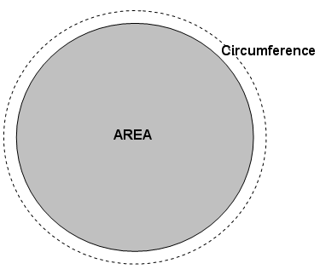***Acir = (pi)r2***

**Circumference: *Ccir = 2(pi)r***

(“pi” is the number approximated by 3.14159)

The circumference of the circle is **2** **× π × r, where π** = 3.14 and **2 × π = 6.28**, approximately. So the circumference of a circle is **6.28 × r.**

For an example, if the radius of a circle is 8 metres, the circumference would be **6.28 × 8 = 6.26 × 8 = 50.08 metres (m)**, approximately.

Remember that the radius is the distance from the centre to the outside of the circle. In other words, the radius is *halfway* across. If you deal with the diameter of a circle, the length of a line going all the way across, then you have to divide in half to apply the above formulas.

### Parallelogram

A parallelogram is rectangle with a tilt. All sides are parallel but the angles between the sides differ.



In order to help you visualize a parallelogram, I drew in vertical lines to form a right-angled triangle from the intersection of the sides A and B to the opposite side. Notice what this figure is showing us. If I cut the left triangle off the parallelogram and stick it on the right side, I have a rectangle! Therefore, the parallelogram is nothing but a rectangle with a tilt. The tilt is called a ‘shear’ in many industries. (And it has nothing to do with sheep!) You won’t find parallelograms with the dashed lines so don’t expect to see them. However, you should be able to look at a parallelogram, or something close to one, by putting in the dashed lines mentally.

In order to calculate the area of a parallelogram I use exactly the same formula to calculate the area of a rectangle: Area = A × B.

### Observations for square, rectangle, parallelogram and rhombus

The rectangle, square and parallelogram have the same characteristics: each has two pairs of parallel sides. Therefore, each one is simply a variation on the parallelogram and all their areas are calculated as base × height. The square is a rectangle with its base and height equal. The rectangle is a parallelogram with straight sides and the rhombus is a parallelogram with an equal base and height.

The most general of these four figures is the parallelogram: it has two parallel sides. And nothing is said about the lengths of these sides or the angle between the two sets of parallel sides. A rectangle is a parallelogram with right angles (90 degrees). A square and a rhombus have equal sides.

### Formative assessment 10: Using the SI system

The SI system uses the metric (decimal) system and uses a number of standard prefixes for units of length and mass that were covered in the previous section. Using the SI system means that we should know the most important ones. The three most important ones are:



# GEOMETRICAL RELATIONSHIPS

#### Specific outcome

Explore, analyse & critique, describe & represent, interpret & justify geometrical relationships

#### Assessment criteria

* Descriptions are based on a systematic analysis of the shapes and reflect the properties of the shapes accurately, clearly and completely.
* Descriptions include quantitative information appropriate to the situation and need.
* Three-dimensional objects are represented by top, front and side views
* Different views are correctly assimilated to describe 3-dimensional objects
* Relations of distance and positions between objects are analysed from different views.
* Representations of the problems are consistent with and appropriate to the problem context. The problems are represented comprehensively and in mathematical terms.
* Results are achieved through efficient and correct analysis and manipulation of representations.
* Problem-solving methods are presented clearly, logically and in mathematical terms.
* Reflections on the chosen problem solving strategy reveal strengths and weaknesses of the strategy.
* Alternative strategies to obtain the solution are identified and compared in terms of appropriateness and effectiveness.

## Two- and Three-Dimensional Geometric Situations

### Symmetry

A symmetrical object is one that remains identical if rotated or reflected (‘flipped’) around a line through its centre. There may be many angles of rotation for an object.

Using symmetry reduces the amount of work you must do when calculating areas and volumes. Use symmetry to your advantage. If you draw an object that has symmetry, draw the portion you need then place copies in the correct places by rotating or reflecting them about their axis of symmetry.

**When we talk about seeing things in three dimensions, it means the following:**

The first two dimensions are height (or length) and width on a flat surface. If you look at a rectangle, you have height (length) and width. A piece of paper has a length and a width that you can measure.

The third dimension is shown by introducing depth. A box has length, width and depth. The drawing shows a box shape in three dimensions: length, width and depth.

Width

Depth

Height

Length

Width

## Surface Areas and Volumes of Right Prisms

In this section we will look at calculating surface areas and volumes of right prisms and other bodies.

**In all calculations the value of pi** **(π) should be 3.141593**

A prism is a solid geometric figure whose two ends are parallel ( side by side and having the same distance continuously between them) and of the same size and shape, and whose sides are parallelograms ( a plane figure with four straight sides and opposite sides parallel).

The end faces consist of a compilation of known shapes such as triangles, rectangles and circles.

Each side surface is a rectangle. The following are possible types of shapes holding these characteristics.

It is easiest to calculate surfaces and volumes by breaking up each prism’s face end into its most basic shapes. Let us review the surface area equations relevant to these basic shapes.

### Right prism

This is what a right prism looks like

### Right Triangle

A plane figure with three straight sides and three angles. Many houses have roofs that look like triangles.

**a**

**x**

**Area(a) = ½x × y (unit: m ²)**

**y**

A slice of pizza or pie is usually in the shape of a triangle

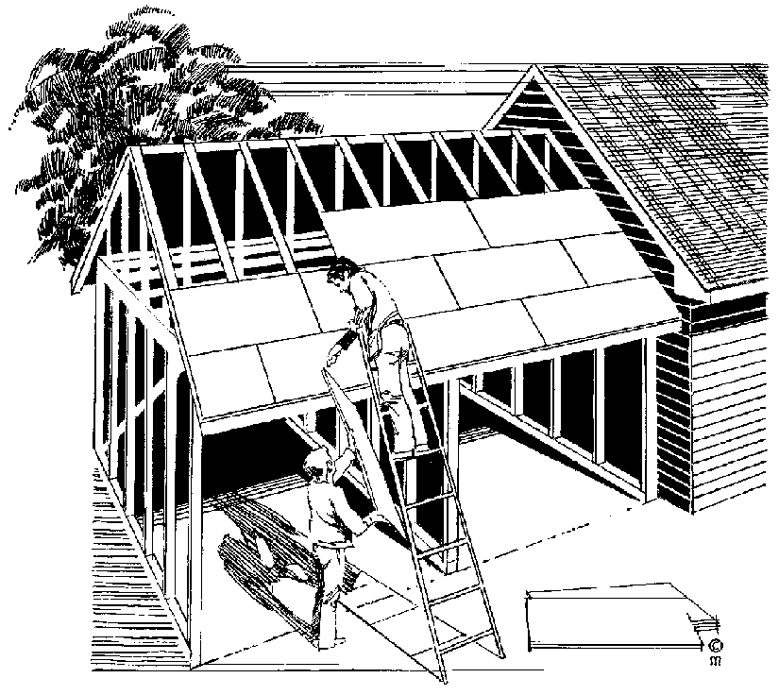

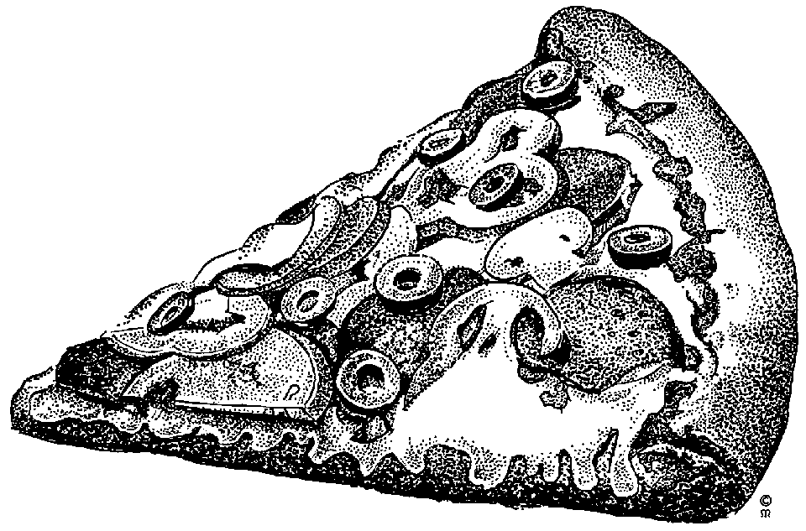

### Other Triangles

**y**

**x**

**a**

**Area (a) = ½x × y**

### Rectangle and Square

A plane figure with four straight sides and four right angles and with unequal adjacent sides.

**Area(a) = l × w (unit: m ²)**

**l**

**a**

**w**

A square is a plane figure with four equal straight sides and four right angles

**Note: We will treat the square as a rectangle with the same length and width.**

### Circle

A round plane figure whose boundary is made up of points at an equal distance from the centre.

**Area (a) = π × r ² (unit: m ²)**

**r**

**a**

### Cylinder

Three dimensional shape with straight parallel lines and circular or oval ends. A pipe is a good example of a cylinder.

**h**

**r**

**Volume = π × r ² × h**

**Surface area =** **(2 × π × r × h) + (2 × π × r ²)**

### Cone

An object which tapers from a circular base to a point. An ice cream cone is a good example, although they would probably not be mathematically correct.

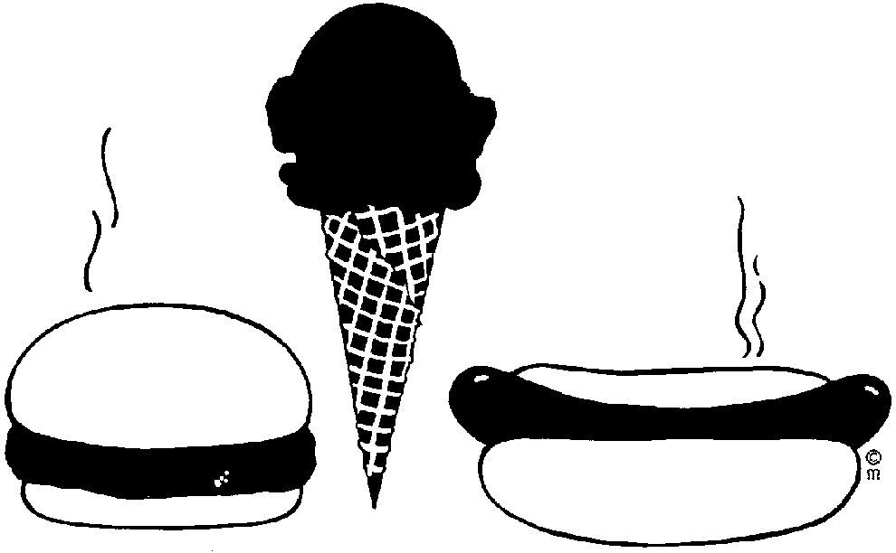

**r**

**s**

**h**

**Volume = ⅓ × π × r ² × h**

**Surface area = (π × r × s) + (π × r ²)**

### Sphere

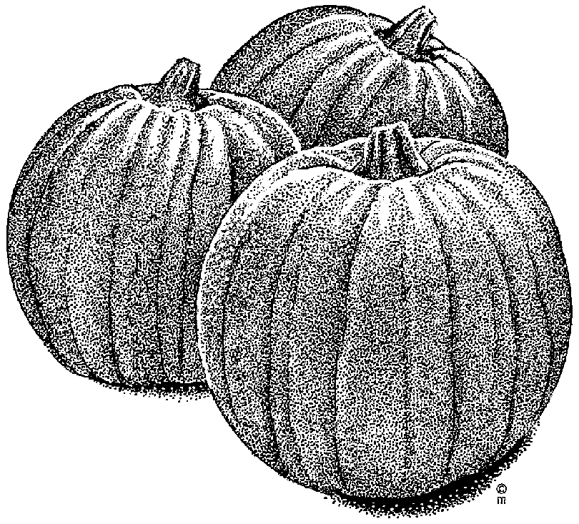A round solid figure in which every point on the surface is at an equal distance from the centre. A round ball is a good example.

**r**

**Volume = 4/3 × π × r ³**

**Surface area = 4 × π × r ²**

Pumpkins, oranges, apples, tomatoes and so on have spherical forms, although they are not exactly mathematically spherical.

## Geometrical Relationships

### Geometric shapes

Cylinder

Pyramid

Sphere

Cube

Rectangular prism

(Rectangle)

### Formative Assessment 11

## The Theorem Of Pythagoras

In any right-angled triangle the following applies:

A

B

The square on the hypotenuse side is equal to the sum of the squares on the other two sides (AC) = (AB)+ (BC)

If AB = 4 cm and BC = 3 cm, how long will AC be?

C

According the theorem:

(AC) = (AB)+ (BC)

= 4+ 3cm

= 5

And we see that AC = 5 cm

### Formative Assessment 12

## Ratio





Figure A

Figure B

**3** **:** **1**

The above figures have the ***same shape*** but ***not the same size***.

There exists a mathematical relationship between the corresponding lengths on the two figures.

This relationship can be obtained as follows:

|  |  |  |  |
| --- | --- | --- | --- |
|  | Figure A (y mm) | Figure B (x mm) |  |
| Length of top of roof | 6,0m | 2,0m | 3/1 = 3 |
| Length of door | 1,8m | 0,6m | 3/1 = 3 |
| Length of total bus | 6,6m | 2,2m | 3/1 = 3 |

Thus we find that y:x = 3:1 and that the ratio of y to x is as 3 is to 1.

**Say we find that y:x = 3:1 and say that the ration of y to x is as 3 is to 1.**

### Formative Assessment 13

### Scale drawings and scale models

Maps, plans of buildings, design drawings of machinery, etc. are seldom drawn to full size, but are usually reduced in size. We call these scale drawings.

When a scale drawing is made or a scale model is built, the shape of the actual object must be retained, i.e. every dimension on the actual object must be multiplied by the same scale factor:

Length on actual object x k = corresponding length on scale drawing where k is the scale factor.

In scale drawings and scale models it is usual to refer to the scale factor as the scale.

Scale has the same meaning as scale factor. But where the scale factor is expressed as a fraction, for example, 2 or ½, the scale is usually given in colon notation, i.e. 2:1 or 1:2

Scale = length on drawing (model): length on actual object

**Important:**

In order to **compare two quantities** by division we must **express them in the same unit**. The result is a number without any unit of measurement.

It is preferable to write a ratio in simplest form. A ratio is in simplest form if the numbers in the ration have no common factor.

Ratio, as the comparison of quantities, gives the number of times one quantity is contained in another.

For example:

6 cm:2 cm: = 3:1 means 6 cm is 3 times as long as 2 cm

600 mm:900 mm = 2:3 means 600 mm is 2/3 as long as 900 mm.

### Formative Assessment 14

## Rough Sketches

A rough sketch is a quick drawing of something that gives you a reasonable impression of a scene, object or surroundings but without much detail. The following is an example of a top view of a scene or incident that may be typical in a security situation.

A rough sketch is normally not according to scale but rather in proportion or in relation to size. This means that you may use a tape measure to indicate distances in relation to vital points or may even pace the distance between objects. The sketch may or may not be very accurate. However, the essentials have been captured in the sketch.

Some important elements must be displayed on such a rough sketch, such as:

* The direction north always pointing towards the top or at least like on a clock 10 to 2 or 10 past 10.

N

N

N

N

* The title “Rough sketch” on top of the drawing.
* The name of streets or buildings clearly displayed.
* Alphabetical numbering of critical elements on or at the scene if you are sketching a crime scene or incident scene.
* The name of the person drawing the sketch.
* The date and time of the sketch.
* Clear indication of grass, road surfaces and any other information that may assist the user of the sketch.
* Signature of the originator.

The sketch should have a separate sheet containing a key or explanation to the sketch. This we call the key or legend to the sketch. In the legend you set out measurements between points or distances.

### Sketching in general

Sketches may be very rough, giving only a few small details, to very detailed enabling an item to be manufactured. The difference between a rough sketch and a sketch that is precise is not well defined. Additional information must be supplied with a sketch to provide enough detail to serve the purpose of the drawing.

So the ‘roughness’ of sketch may vary from a few lines drawn in the dirt with a stick to precision drawings used in fine engineering. A soccer team planning its strategy will sketch only the details required so that each player knows his function and the action he must take in order to work as a team. The important thing to remember is that the detail that must be included in a sketch must suit the user of the sketch. The sketch must contain all the necessary information to convey the information required by the person using it.

#### Example

A woman making her own clothes or clothing for her children uses rough sketches to make the garment. Whether she draws the sketches herself or purchases them as a pattern in a shop, she still works with a rough drawing. A typical pattern for a girl’s garment is shown below.

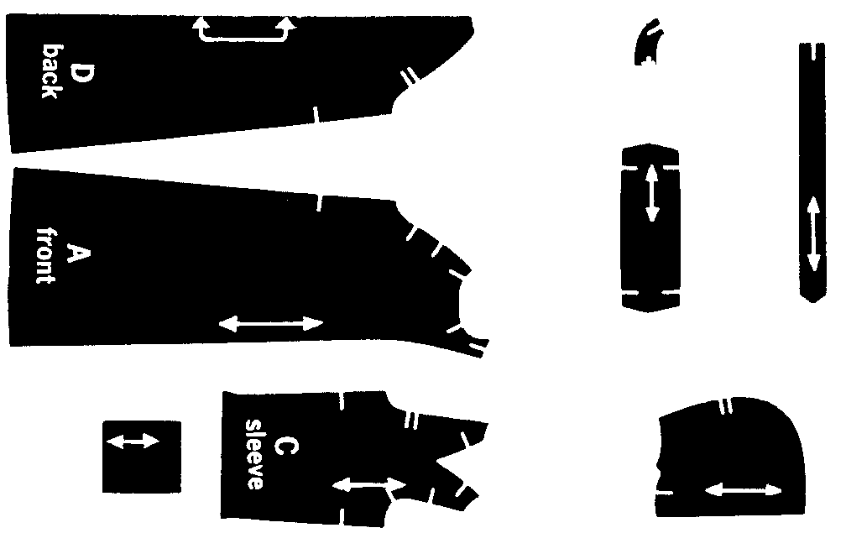

The ‘documentation’, ‘report’, or whatever you want to call it, consists of the metric measurements and information on how to layout, cut and sew the pieces together. As an aid to the seamstress who is making this garment, the original packet has illustrations of several variations of finished items.

#### Example

Imagine that you and your colleagues want to improve communications within your organization, church or local charity. In order to do this you decide that a monthly newsletter would help keep everyone in touch. In order to publish the newsletter you first want to get an idea of what the finished product would look like. You and your colleagues may discuss your needs but until you sketch a rough copy of its layout you really don’t know what to expect.

The documentation that accompanies these rough sketches would probably include the size of paper to use, whether the newsletter was folded or stapled, the use of one or both sides of the page, the number of columns and the font types and sizes to be used.

See the next page for the visual of the example.

#### Example

A physics teacher might want to convey the action and reaction of forces and decides that a demonstration of a man fishing would be suitable. Below is the rough drawing that the teacher used to explain the concepts.

In this case the teacher does not need to show the person or fish in any detail nor does his scale need to be accurate. His ‘report’ would describe the forces involved. He would probably show his learners how to perform the calculations as well.

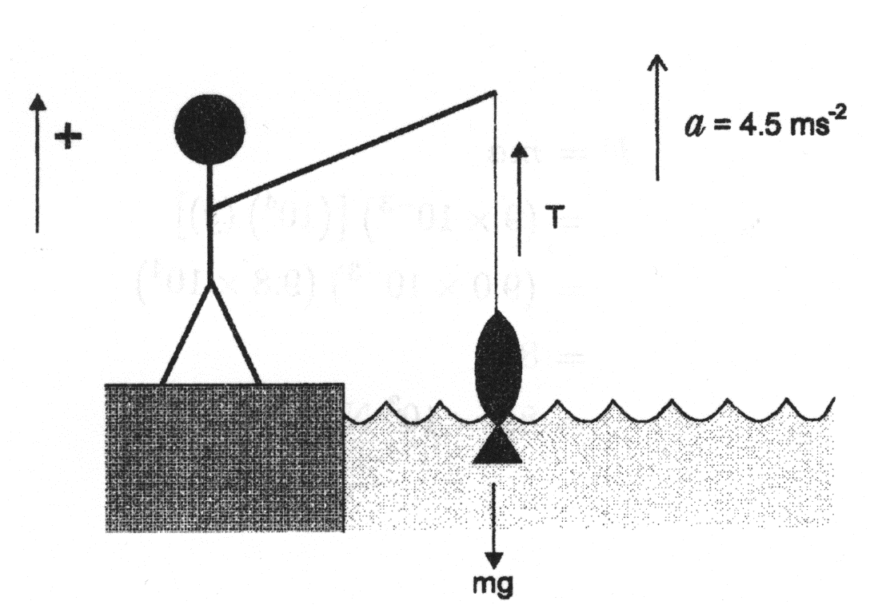

A rough sketch for a physics lesson

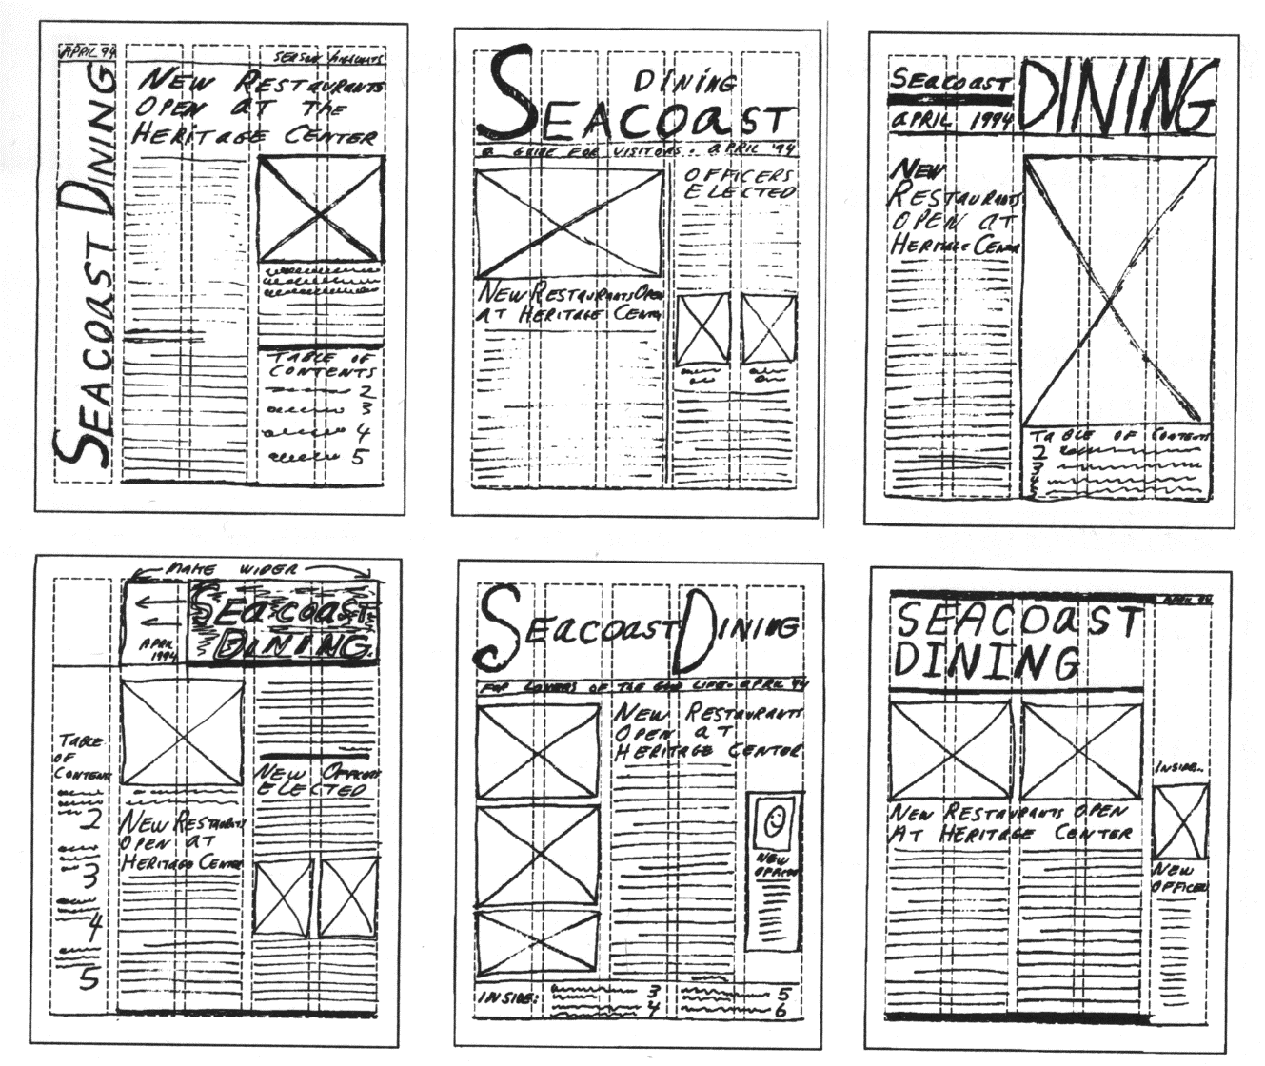

A rough sketch of a newsletter

#### Example

The concept of a computer network.



## Scale Drawings

A scale drawing is a reduced or enlarged drawing of an original but it is drawn true to scale. Below is a scale drawing of a chair that was done on a computer. Notice how realistic it looks. Closer inspection will show that it is indeed a drawing and not a photograph.

Although it shows a realistic drawing of a chair, it may be considered a rough sketch by some. A manufacturer can’t build the chair from this sketch. There are no scale or size measurements that go with the chair.

The difference between a realistic drawing and a rough sketch is determined by the user of the sketch. The person creating the sketch may put too little or too much detail in the drawing for it to satisfy the needs of the user of the sketch.

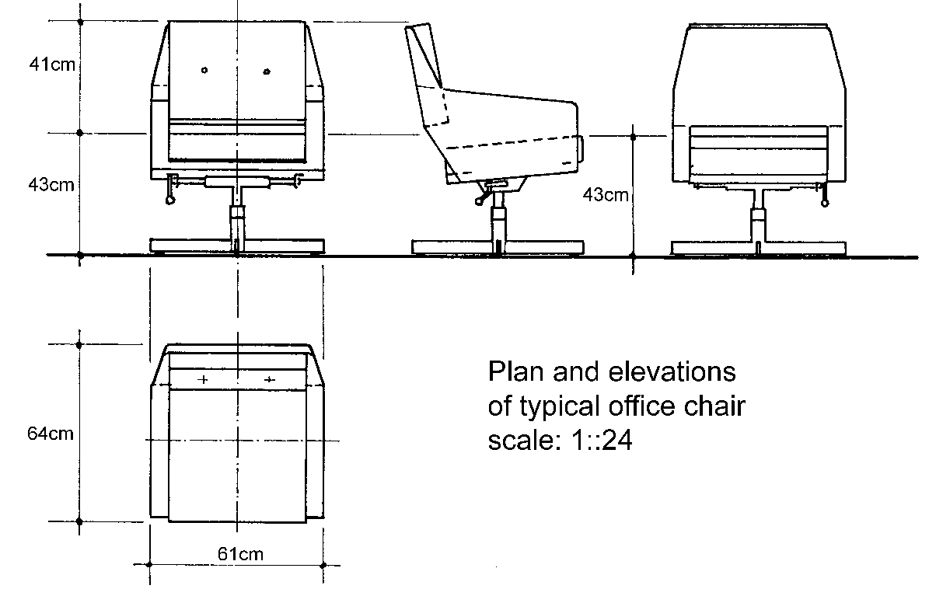

Another typical office chair that answers some of the criticism concerning the previous drawing.

Is this sketch better or worse than the previous one? Why? Can I build this chair in my factory? Why not?

### Adding detail to scale drawings

In order to understand scale drawings it is a good idea to start from the known and proceed to the unknown. We are going to start with geometric shapes that are drawn to scale then proceed all the way to an introduction to engineering drawings.

The steps that take us from the rough to the precise involve four steps:

1. Learn how to make square and isometric drawings of geometrical shapes.
2. Learn what plans and elevations are when making drawings.
3. Learn what is meant by ‘nets’ of objects and use these nets to visualize and measure three-dimensional objects.
4. See examples of engineering drawings and the detail they contain.

Let’s look at the simple geometric drawings that were used in previous sections. Two-dimensional items must be drawn to scale in order to appreciate what they are telling us.

There are several ways to represent two-dimensional objects. Annexure A contains a standard square grid while the second page contains an isometric grid. The first page is obviously a page of squares, but what is the second page a picture of? The second page is a pattern of triangles! Look at this page again and you will see that the dots make up triangles with the edges removed.

### Using rectangular grids

Both square and isometric grids may be used to assist with 2D or 3D drawings. On the right is a square drawn on a square grid and the next figure shows a triangle drawn on a square grid.



Square grid paper is usually just referred to as grid paper. Some grid paper provides subdivisions that allow you to sketch very accurately. A popular grid is the millimetre grid that has very thin lines placed every millimetre and slightly thicker lines marking the centimetre. Some versions of the millimetre grid use slightly differently coloured lines to identify the different spacing.

Not only can you draw accurately using grid paper but you may use the grid to measure items as well. In addition, you may trace an item directly on the grid paper and have an accurate drawing that you can measure.



A triangle drawn on a square grid

What is the area of the square and the area of the triangle? The area of the square is 16 units2 and the area of the triangle is 12.5 units2. I use the term ‘units’ because I do not have any information concerning the size of each square.

These drawings may be scale drawings of real items or they might be the real sizes of these items. If the squares represent centimetres then the area is given in cm2. If the squares represent metres then the areas of the items are measured in m2.

### Legend to sketch

Point A: Place of entry, broken window on northern side of office.

Point B: Location of cabinet (where money was stored).

**Distances on rough sketch**

Point A to B: 2.4 m

With of room 12: 2 m

Length of room 12: 2.5 m

**N**

Room 12

Second floor

Kagiso building

James street

Coco town

**Rough Sketch**

**Table**

**Desk**

A

Cabinet

B

Compiled by: SO John Dlamini

On 31 April 2005

22:00

## House Plans

Plans for houses are usually drawn flat, giving only the length and width of the area of the house and the individual rooms in the house.



Door

Windows

The figure above shows a basic plan, without any measurements.

This plan does not show built-in cupboards in the bedrooms, bath and basin in the bathroom or stove, sink, cupboards and fridge in the kitchen.

The plan on the left shows cupboards in the bedrooms, bath and basin in the bathrooms and stove, sink, fridge and cupboards in the kitchen.

This house also has a garage and the plan furthermore also shows details of shrubs and trees.

A house plan shows a view of the house from the top.

If you look at the kitchen, you will see a view of the sink and the stove as it will look when you look at it from the top. The same is true of the bath and basins, the cupboards as well as the car in the garage and the shrubs and trees in the garden.

The bathroom adjoining the main bedroom does not have a bath, but a shower, a basin and a toilet. Can you see that the view of the shower is different to that of the bath in the other bathroom?

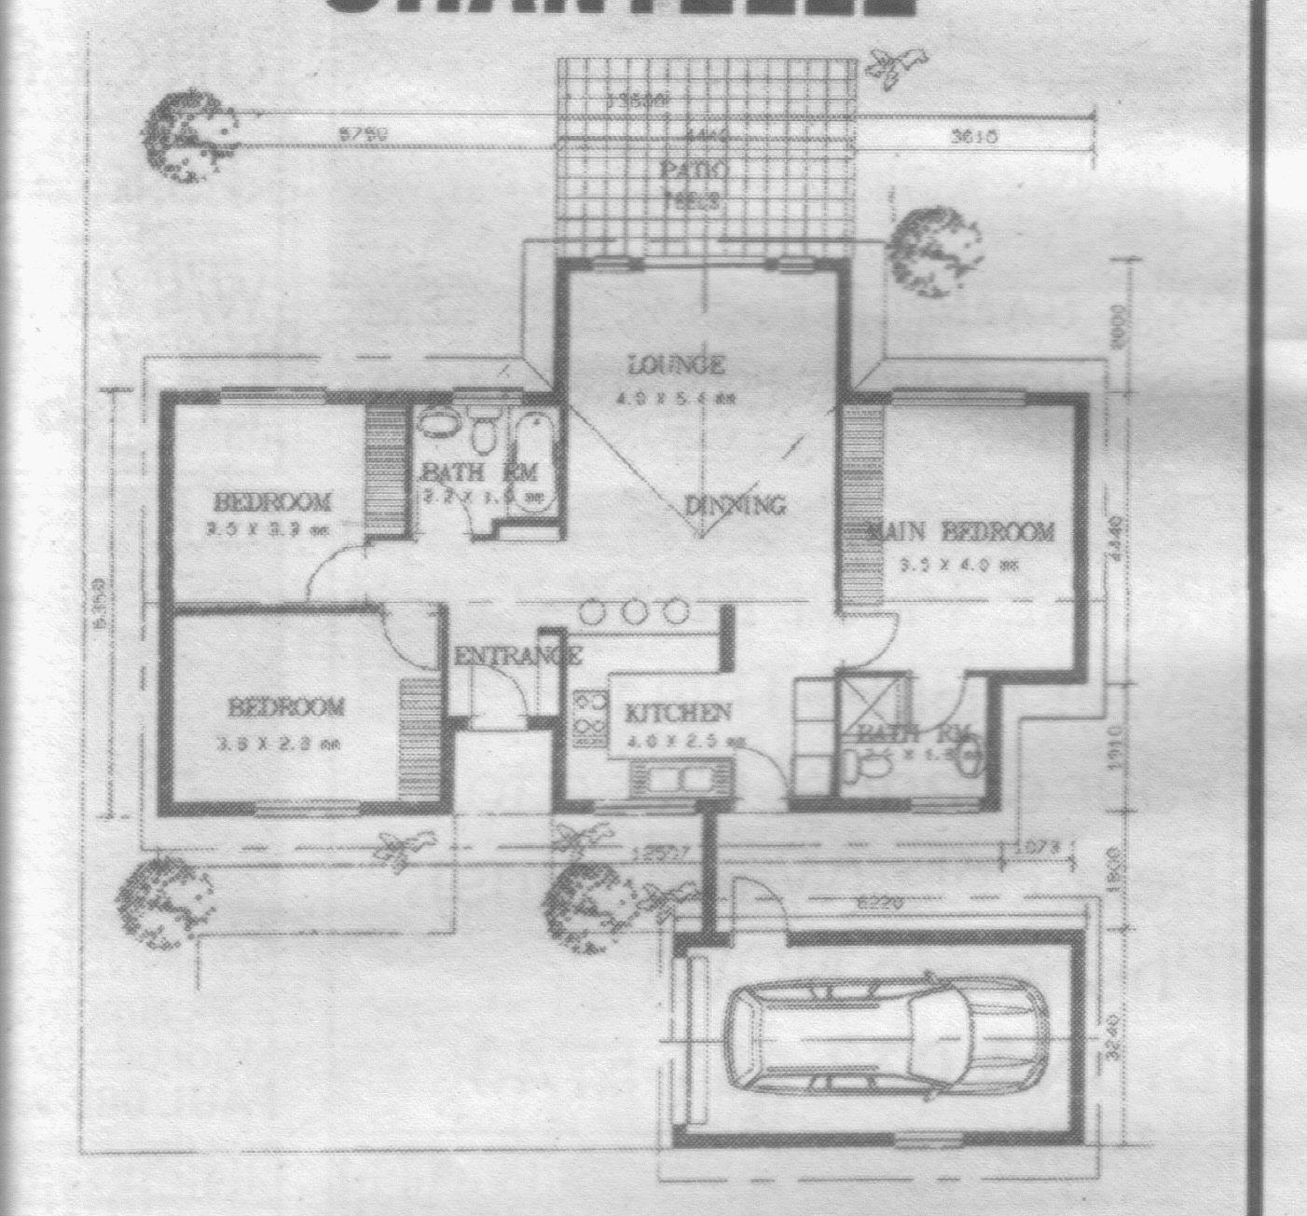

Of course, once a house is built we don’t look at it from the top anymore, we look at it from the front or the side.

The houses on the left and right show a side view of a house with a patio, while the one in the middle shows a frontal view of a house with a patio and a water feature in front of it.

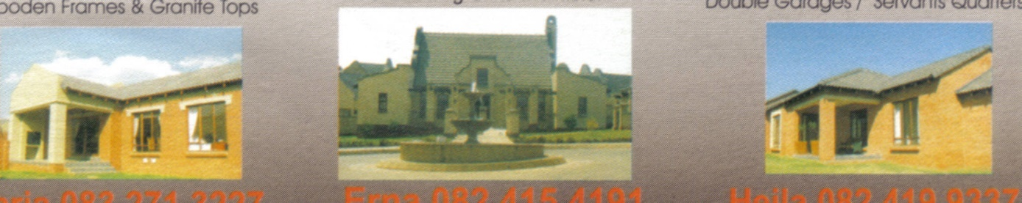

Once the house has been built, the view from the top looks different, since the roof has been added. This photo is, of course, of a very large house.

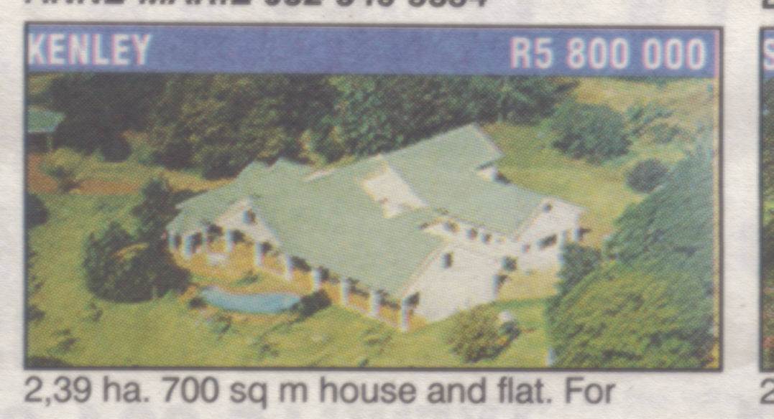

The purpose of the plan of the house is to give you an idea of the dimensions of the house and the individual rooms.

The house plan from the previous page has reasonably sized rooms, but it is not a large house like the one on the photo.

Of course, the builders also use the plans to build the house. They have to insert doors at the places indicated on the plan. The cupboards, bath, basins and kitchen cupboards and appliances are also built according to the plan.

You can also see from the plan that all the doors except the door from the garage to the courtyard open to the inside of the room. The door from the garage opens to the outside, as indicated on the plan.

### Formative Assessment 15

## Household Appliances

Household appliances always come with instruction booklets giving details of how and where the appliance should be installed. You must always first read the instructions before you install and use the appliance. The instruction booklet will include photos and drawings of the appliance to help you understand the instructions.

Also, before you buy an appliance such as a stove, fridge, freezer, washing machine or tumble dryer, you have to ensure that you have the space available for it. It will be silly to buy a big, double door fridge if your kitchen only has space for a single door fridge.

This is a picture of a tumble dryer. The view is a side view. The dimensions of the tumble dryer are as follows:

* Width 600 mm
* Depth 500 mm
* Height 850 mm

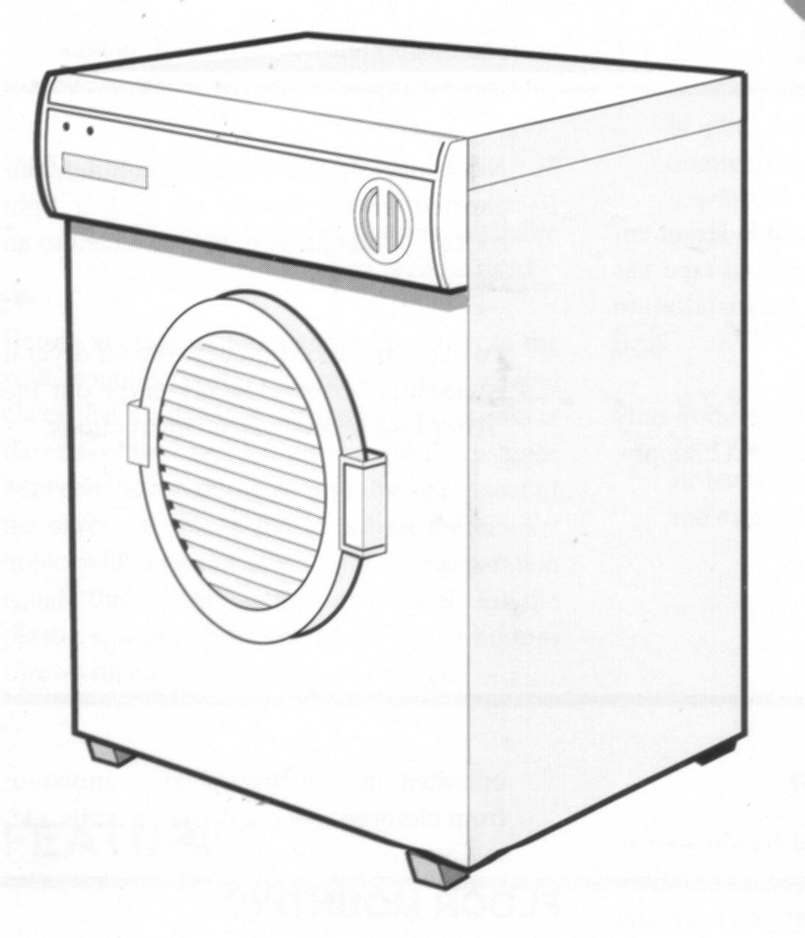

### Formative Assessment 16

## Linkages And Mechanisms

**Handout 7**

A car jack is a good and simple example of a tool that performs the action of linking that operates partly mechanically and is partly driven by the action of a hand.

The purpose of a jack is to lift the car from the ground, it therefore becomes the link between the car and the ground as well as the link between you and the car.

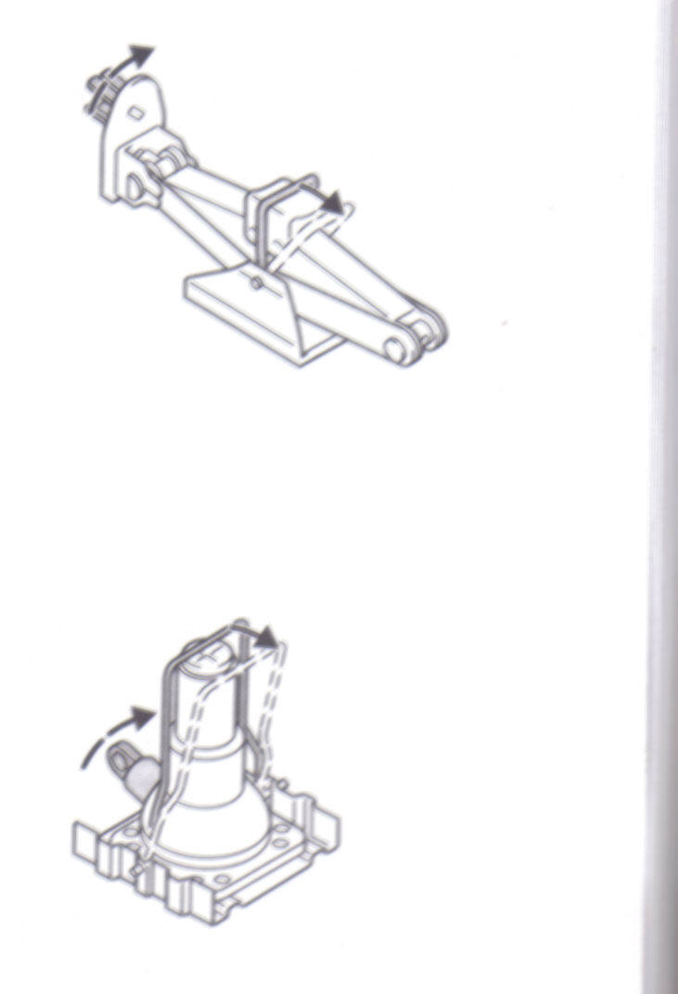

Linkages

Insert the jack handle and turn to expand.

You want to lift the car from the ground because you want to change a flat tyre. You could, of course, get someone to hold the car in the air for you, but chances are that that person will become tired. Using something mechanical such as a jack is a more practical way. The jack will not get tired and will probably hold the car more steady than another person.

Of course, the jack in itself is also a system of links that enable it to expand upwards while you are jacking up the car so that the weight of the car rests on the jack. Once you have changed the tyre, you will wind down the jack so that it retracts to its original shape. The system of links in the jack will allow it to retract.

On the left is a picture of a scissor jack in its retracted (flat) position. You can clearly see the linkages in the jack.

To use the jack, place it under the car body in the appropriate place as directed by the car handbook. It is important that you place the jack in the correct place under the car to prevent the car from falling off the jack. If the ground is soft, you have to put something solid under the jack, such as a firm, flat piece of wood or a brick. Remember, you are transferring the weight of the car onto the jack, which is smaller than the car and the ground or support under the jack has to carry all that weight.

To expand the jack, insert the handle that you get with the jack and turn the handle. once you have changed the tyre, turn the handle in the other direction to retract the jack to its original position.

## Aids For Drawing Objects In Three Dimensions

Of course, you don’t have to battle with three dimensional drawings any more. You can use the following:

* Isometric paper
* Drawing Instruments
* Software applications

### Software Applications

Most software applications such as Microsoft Word, Excel and PowerPoint have some three dimensional shapes that you can use to assist you.

There are also software applications that were developed especially for drawing in 2 and 3 dimensions, such as Microsoft Visio, Corel Draw and AutoCAD. There are many more applications available and all of them help you to draw whatever you need in 2 and 3 dimensions.

Since most of us have Microsoft applications we will show you where to find these shapes:

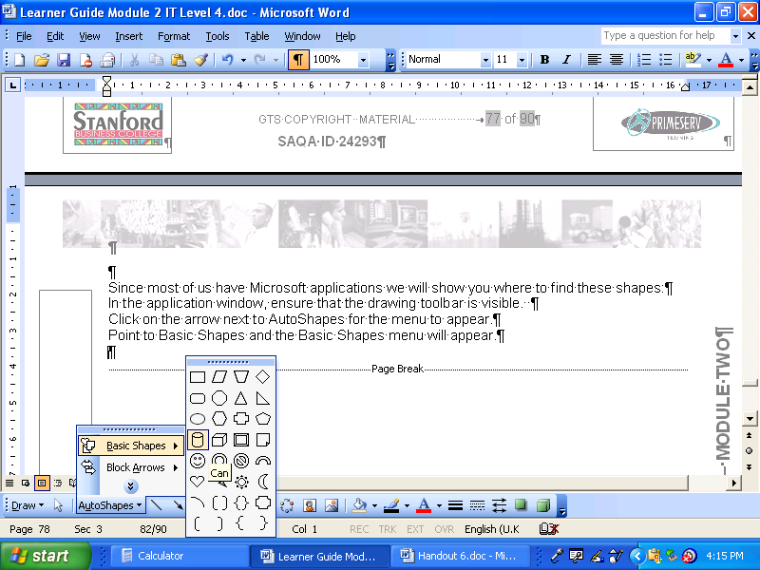In the application window, ensure that the drawing toolbar is visible.

Click on the arrow next to AutoShapes for the menu to appear.

Point to Basic Shapes and the Basic Shapes menu will appear.

There are two 3 dimensional shapes available: can and cube. Click on the one you require and then click and drag in your application for the shape to appear.

Once you have drawn the shape, you can resize it, rotate it, change the line width or fill the shape.

### Drawing Instruments

**Handout 8**

Pair of compasses: enables you to draw circles

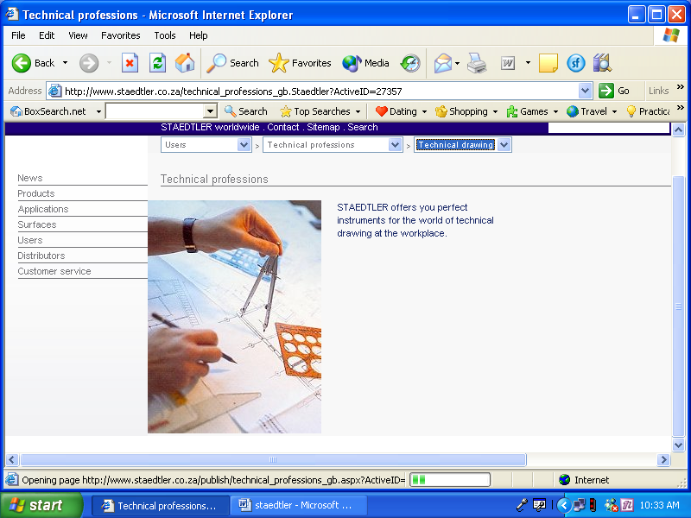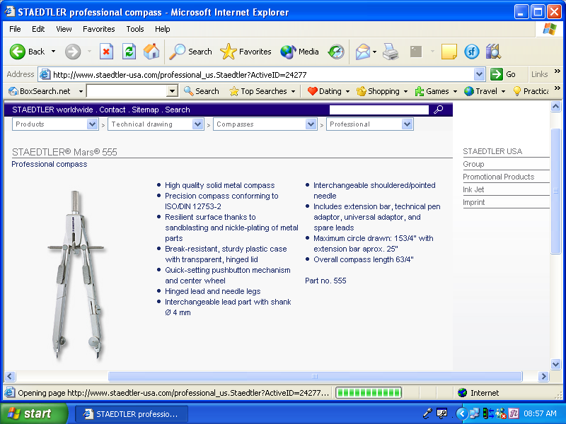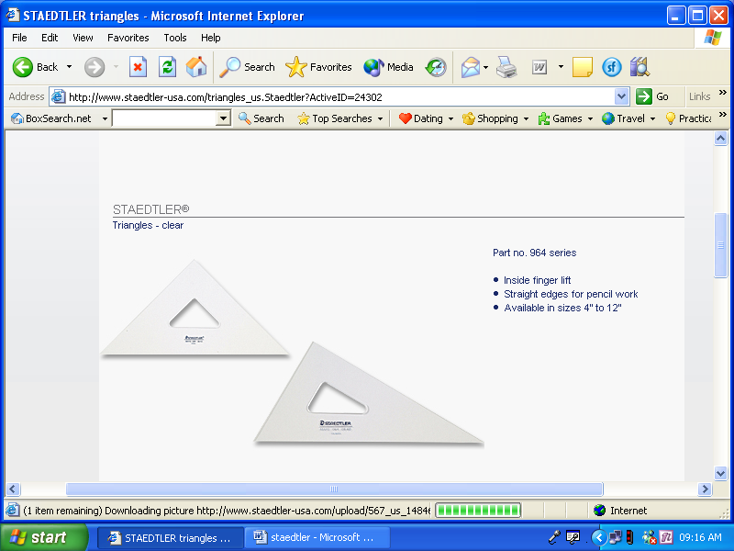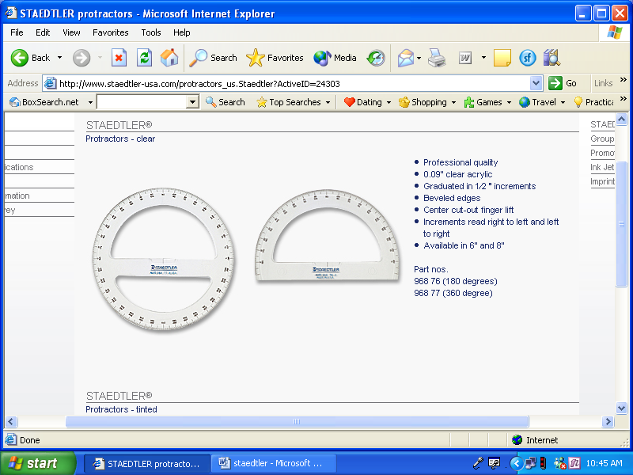

* Graduated arc: enables you to determine the exact number of degrees of a corner, etc.
* Drawing triangles: 60 º or 90º: enables you to draw triangles. Adjustable triangles are also available.
* Scale rule: enables you to draw at scale. Scale rules are available in the following formats: 1:2, 1:5, 1:10, 1:20, 1:25, 1:33.33 and so on up to 1: 2500

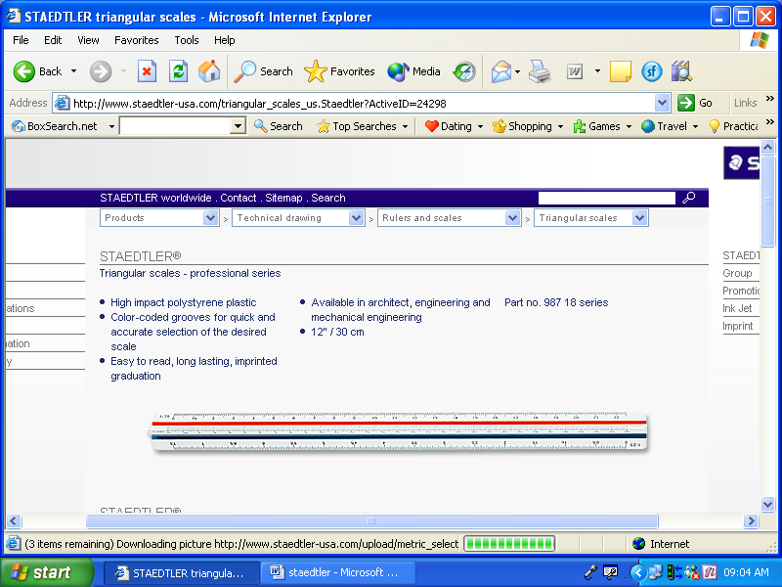

* Rulers: plastic, wood or metal
* A rolling scale ruler is also produced. This allows you to roll the ruler along the paper.
* Stencils: contain shapes to draw.
* T-square
* Pens and pens for technical drawings

## Packaging material

Boxes and cartons are the most commonly found packaging materials. They are also easy to make and decorate if you want to use them for gifts.

We will show you how to a gift box. The material you need is not expensive, for the first try you can make the box out of paper. It will not be as sturdy as using thin card paper, but is excellent to practice on.

### Box With Overlap Lid

This box is based on a square and you can make the box in any size, as long as each side has the same width.

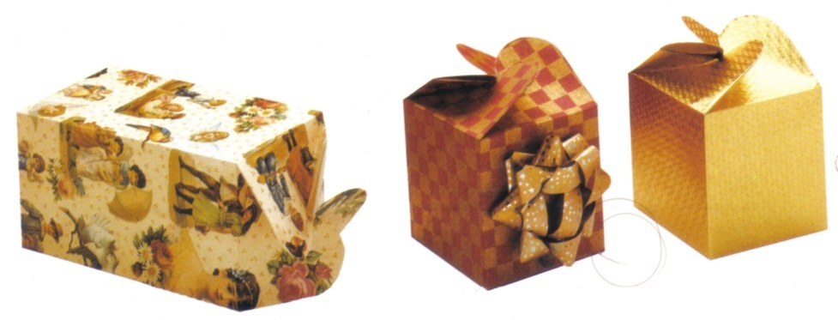**You will need:**

* Thin card
* Tracing paper and carbon paper (optional)
* Ruler
* Pencil and eraser
* Glue
* Scissors

**Handout 2**

The box shape can be drawn directly on to card or transferred as follows:

* take a tracing of the box and transfer on to graph paper.
* Scale up or down by copying the shapes on to a larger or smaller grid as required then take a tracing of the finished box shape.
* 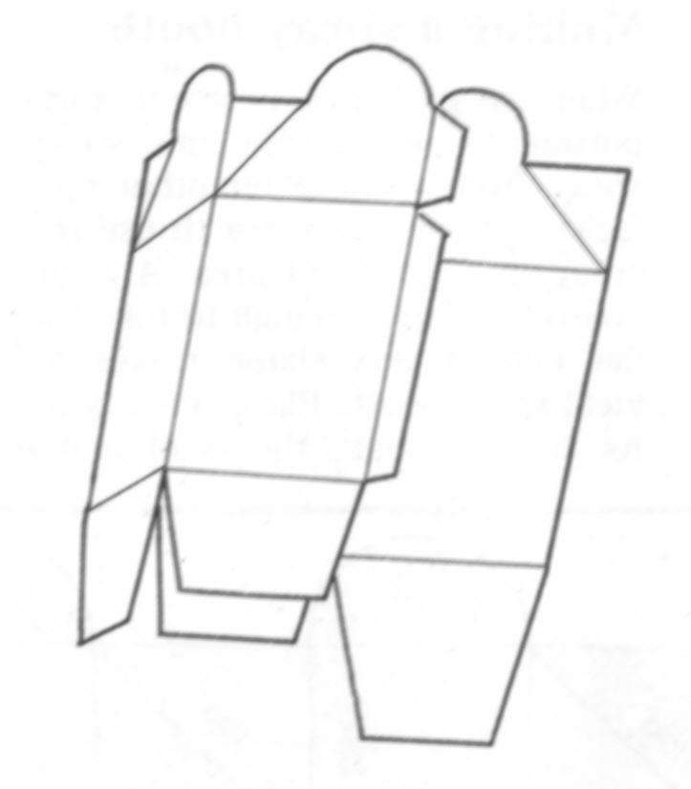You can also enlarge or reduce your pattern on a photo copier.

**To make:**

**Handout 3**

* Draw or trace the box shape on to paper (or card) and cut along straight lines and curves.
* Gently fold along all the fold lines to shape
* Erase any pencil lines as required
* Ease box into shape
* Run glue along the side flaps and press into position
* Fold in base flaps, shortest first
* Stick one large flap over the other with glue
* To close box, gently push top sections together and push flat

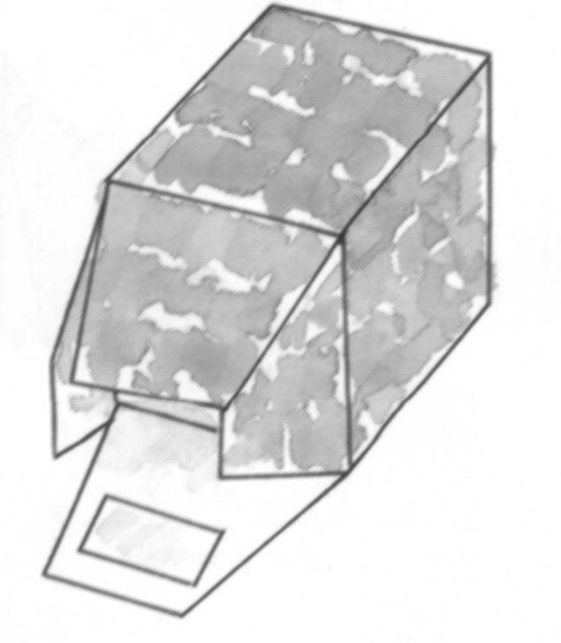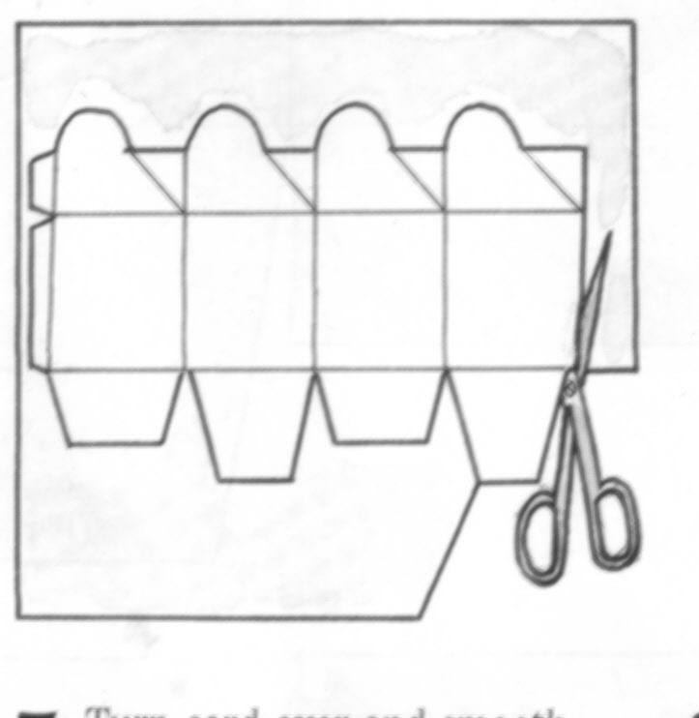

### Formative Assessment 17

## Cartography

Cartography is the practice of drawing maps. A map is a diagram of an area showing physical features, cities, roads, etc. Maps vary in size from maps of the world, maps of continents maps of countries, maps of cities and even maps of shopping centres.

### World Maps

Maps of the world come in more than one form:

* Political maps which give details of countries and capital cities of these countries
* Physical maps of the world that show mountains, major rivers, deserts or drier areas and tropical forests or areas that get more rain.

Maps are always drawn with north at the top, south at the bottom, east to the right and west to the left. World maps are divided into latitudes and longitudes.

#### Latitudes

Latitudes start with the equator and divide the earth in horizontal bands north or south. The equator is at 0º, in other words in the middle of the earth.

The most common latitudes are the Tropic of Cancer and the arctic circle in the northern hemisphere and the Tropic of Capricorn in the southern hemisphere. Every year the sun moves from the equator north, causing summer in the northern hemisphere and winter in the southern hemisphere. When it reaches the Tropic of Cancer it reaches the northernmost part of its journey and it will be the longest day and shortest night in the northern hemisphere and the longest night and shortest day in the southern hemisphere. This happens on 21 June. Then the sun moves back to the southern hemisphere, reaching its southernmost point on 21 December every year.

This is then the longest day and shortest night in the southern hemisphere and the shortest day and longest night in the northern hemisphere.

Of course, it’s not really the sun that moves, but the earth that revolves around the sun and the angle at which the earth is aligned to the sun that changes. It is just common to talk about the sun moving north and south.

From the above it is clear that the latitudes have to do with seasons: summer, winter, etc.

#### Longitudes

Longitudes have to do with the earth revolving around its own axis and determine day and night and times. Longitudes divide the earth in vertical bands, from north to south, starting with 0º, which is situated at Greenwich and is known as Greenwich Mean Time. The longitudes then move in degrees east and west until they meet up at the other side of the earth at 180º. This longitude is known as the International Date Line.

This means that when the sun shines in South Africa, it is night in Australia and the USA. The day starts in the western hemisphere, in Australia and Japan. When the sun rises there, it is the night of the previous day in South Africa and late afternoon of the previous day in the USA.

As the sun moves around its axis, it becomes late afternoon in Australia, early morning in South Africa and night of the previous day in the USA.

When it is late afternoon in South Africa, it is early morning in the USA and night in Australia.

These time differences are determined by latitudes.

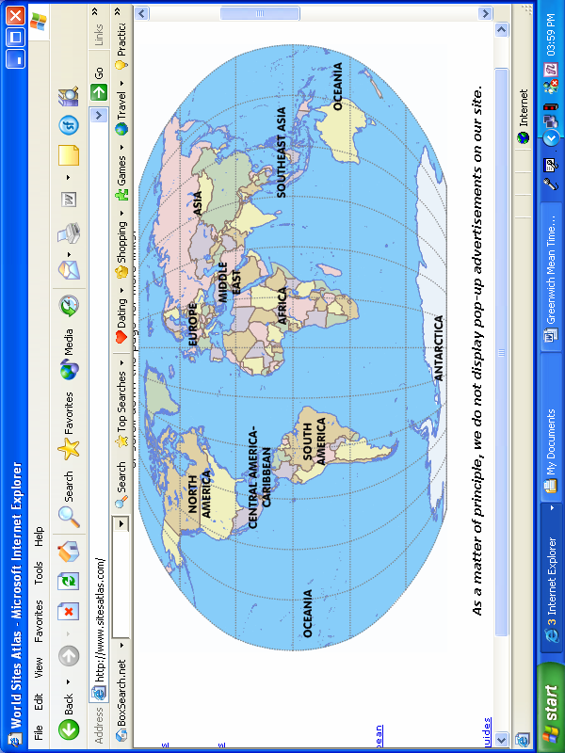

### Map Of South Africa

Maps on a smaller scale, such as maps of countries and provinces, have legends where they explain the different symbols used, as well as the scale of the map.

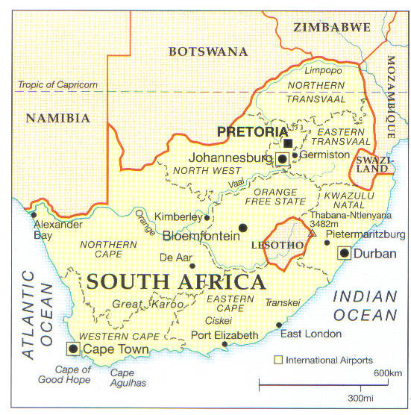

The legend for this map is very basic, it only explains the scale of the map. However, we can deduce the following from the symbols on the map:

* Big cities
* International borders
* Provincial borders
* Names of provinces
* International airports

The map also shows the Orange and Vaal rivers.

### Formative Assessment 18

### Cartesian Coordinates

Any position on earth can be specified by its latitude, longitude and height above sea level. For the purpose of this unit standard, we will focus only on two dimensions: latitude and longitude. Most coordinate readings are given as a series of numbers and letters as follows:

10° 05' 45"W

51° 28' 38"N

The first row indicates the longitude and the second the latitude. Both rows consists of 3 values, each followed by a sign.

The first value of the longitude indicates degrees away from Greenwich. As previously discussed, this value is divided into 180° in directions east or west. In our example, the degrees away from Greenwich is10º.

The second value of the longitude, 5’, indicates minutes. Note that in Cartesian coordinates this minute does not reflect minutes as we know them when telling time, but is merely one part in 60 of a degree. This means that each degree is divided into 60 minutes. In our example, the latitude is 10º and 5minutes.

The third value of the longitude, 45’’, indicates the seconds. Once again, this value is not used as a time factor but as one part in 60 of a minute. In this case each minute is divided into 60 seconds. As per our example, 10º, 5minutes, 45 seconds.

The last letter, W, indicates whether the location is to the west or east of Greenwich, so our location is 10º, 5 minutes, 45 seconds west of Greenwich.

Now we have one half of our coordinates to find out where our location is: we have the exact latitude coordinates. Remember, a latitude runs from north to south across the surface of the earth, and we can be anywhere on that latitude. To plot ourselves exactly, we need the longitude

Latitude use the same division types as longitude except for the last letter which, in the case of latitude, indicates whether the location is to the north or south of the equator. In our example, 51° 28 minutes, 38 seconds north.

Now we will be able to plot ourselves accurately on any map.

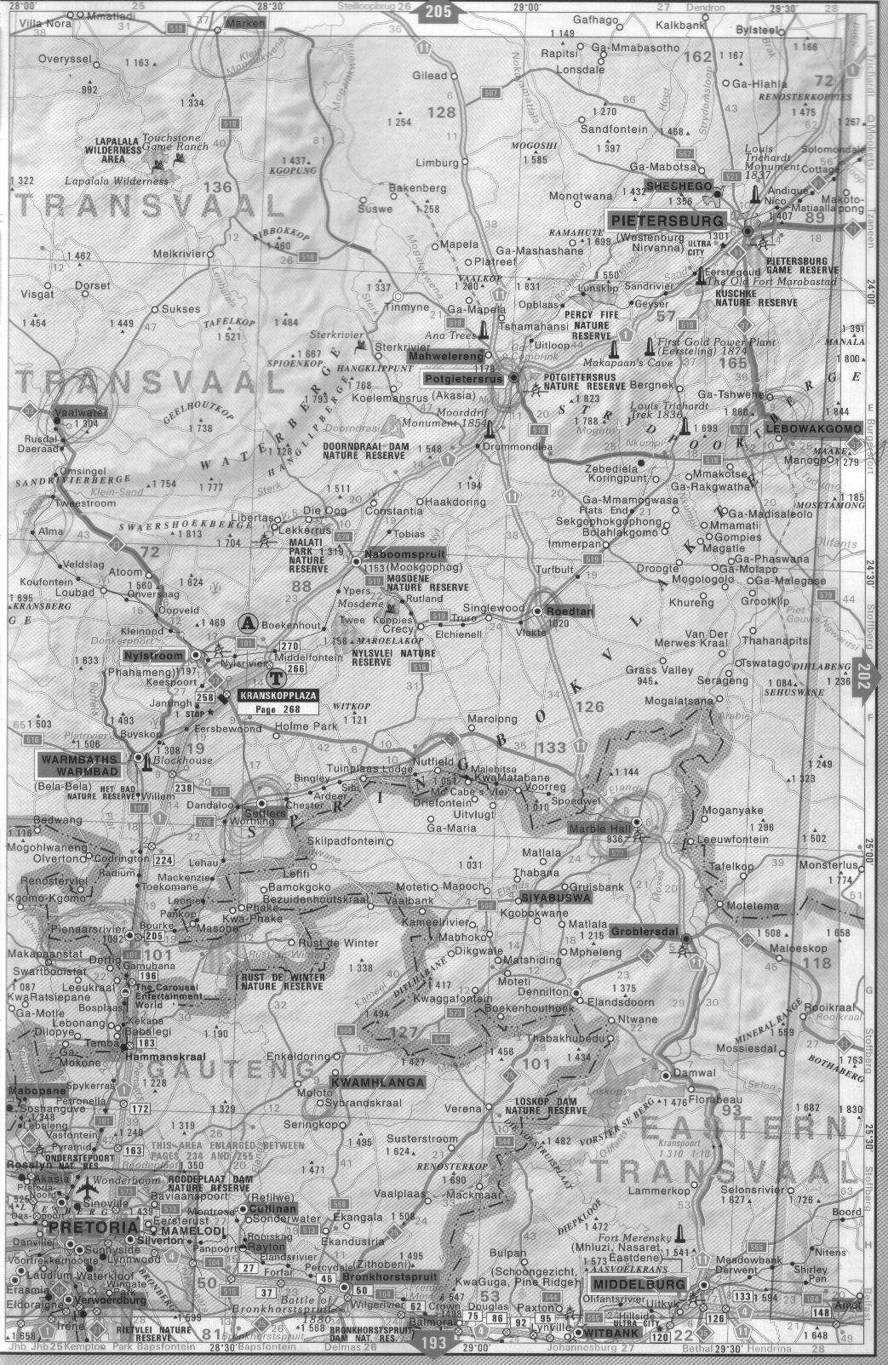

Major metropolitan area

Major provincial route

National Road

Provincial boundary

This is a portion of a road map, showing the route from Pretoria to Polokwane (Pietersburg.)

Regional road maps and road maps of cities and towns are more commonly used than countrywide road maps.

As with all other maps, the orientation of the map is always north at the top, south at the bottom, east to the right and west to the left. You will also always find a legend that explains how to use the map and what the symbols mean.

### Road Maps

Road maps can be countrywide, for a specific region or for a specific city or town. It stands to reason that countrywide road maps will only show major roads such as national roads (freeways), major provincial routes, minor provincial roads, etc.

National roads or freeways are indicated with the colour blue, major provincial roads with a thick red line and minor provincial roads with a thin red line.

Each map will have a legend explaining the colour coding of the roads, the signs and other relevant information.

The legend below, taken from the Reader’s Digest Book of the Road, has the following information:

|  |  |
| --- | --- |
| National road | National route |
| Dual carriageway | Major provincial route |
| Minor provincial road | Link road |
| Toll road | Interchange with number |
| Point to point distance | Aggregate distance |
| Mountain pass | Scenic drive |
| International boundary | Provincial boundary |
| Lighthouse | Wreck |
| National Sea Rescue Institute | Battlefield |
| Spot height | Airport |
| Landing strip | A legend giving details about facilities available at towns |

Of course, there is more information than quoted above.

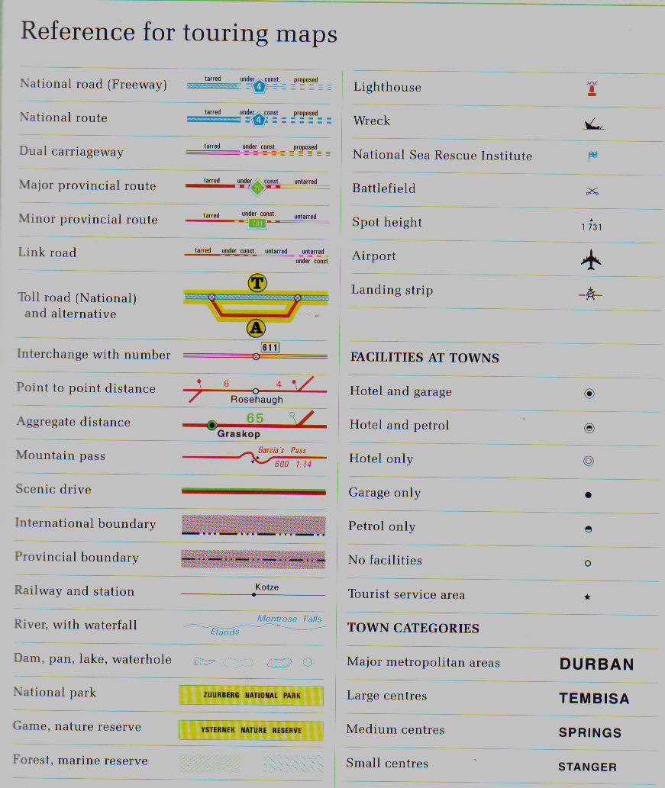

**Handout 1**

All road maps typically divide the area into sections, which are called pages. At the back of the map, you will find an index to street names, as well as an index to suburb names. Once you have the address of the place you want to go to, you look up the street name(s) in the index, where you will find the following information: page number and grid reference numbers. The grid reference numbers are quoted numerically for longitudinal references and alphabetical for latitudinal references:

If you are looking for Ben Steyn Street in Boksburg West, the references will be quoted as follows:

Ben Steyn Street Boksburg West 113 DV 124

Street suburb page grid ref

If we look at page 1 of handout 1, which is also page 1 of the road map of the Witwatersrand, issued by Map Studio, 12th edition, you will find a full explanation of how to use the road map.

#### Reference panel

At the top is an explanation of the reference panel found on the top of all the pages of the map. This map, incidentally, divides the Witwatersrand area into pages from 2 to 207, in total 206 pages, and covers the following area: from Midrand in the north, Nigel in the west, Randfontein in the east and Lenasia in the south. This is a very large area, that is why 206 pages are necessary to give a detailed and readable road map.

#### Key plan

The key plan is a plan of all the pages that cover the entire area, an example is found on page 4 of the handout, included to give you an example of a key plan.

#### GPS coordinates

The GPS (Global Positioning System) coordinates are quoted at the top and bottom of the pages. The GPS system is based on the Cartesian coordinates. The grid lines are at an interval of half a minute, which makes it easy to work out co-ordinates on the map.

#### Index

There is an explanation of how to use the index pages.

#### Grid reference system

An explanation, also quoted above, of how the grid reference system works.

#### Legend

Once again, a legend that explains the colour coding of the roads and the symbols used in the maps.

There is also an indication of the scale of the map, in this case 1:20 000 (one to twenty thousand). Next to the scale indication is a scale legend, which gives you an indication of distance of the map compared to actual distance. In our map, every 5mm equals 100m or 1cm equals 200m.

### Formative Assessment 19