**learner GUIDE**

**Communication Level 4**

**Read, Analyse And Respond To A Variety Of Texts**

Unit Standard 119469

Level 4 Credits 5

**Write For A Range Of Contexts**

Unit Standard 119459

Level 4 Credits 5

**Engage In Sustained Oral Communication**

**And Evaluate Spoken Texts**

Unit Standard 119462

Level 4 Credits 5

**Use The Writing Process To Compose Texts Required In The Business Environment**

Unit Standard 12153

Level 4 Credits 5

# TABLE OF CONTENTS

TABLE OF CONTENTS 1

FORMATIVE ACTIVITIES 14

Exercise 1 14

Exercise 2 14

Exercise 3 14

Exercise 5 15

Exercise 6 15

Exercise 7 15

Exercise 8 15

Exercise 9 16

Exercise 10 16

119459,Exercise 1 17

Exercise 2 17

Exercise 3 17

Exercise 4 20

119462,Exercise 1: Rumour clinic 20

Exercise 2 22

✓ Formative Assessment 1 SO 1, AC 1, 3, 4 23

**Formative assessment 1 SO1 AC1, 3, 4** 23

Formative Assessment 2 SO1, AC 1-2 23

Formative Assessment 3 SO1 AC 1-4 26

Formative Assessment 4 SO1 AC 1-4 26

Formative Assessment 5 SO1 AC 1-5 26

Formative Assessment 6 SO1 AC1-4 28

Formative Assessment 7 SO2 AC1-7 28

Formative Assessment 10 SO4 AC 1-5 43

Formative Assessment 11 SO5 AC 1-5 46

PERSONAL INFORMATION 49

INTRODUCTION 50

*Structure* 51

**Programme methodology** 51

**What Learning Material you should have** 52

**Different types of activities you can expect** 53

**Assessments** 54

**Learner Support** 55

*Learner Administration* 55

**Learner Expectations** 56

UNIT STANDARD 119469 57

ANALYSE AND CRITICISE TEXTS 60

Reading Strategies 61

Skim 61

Scan 61

Prediction 61

Text Type 61

Genres 62

Organisational Features Of Text 62

Titles, Chapters, Contents 62

Contents Page 62

Introductions 63

Foreword 63

Outcome Statements 63

Index 63

Appendices Or Addenda 63

Glossary 67

Conclusions And Summaries 68

Paragraphs, Layout, Font 68

Hyper-Links And Icons 68

Visual Clues 69

VALUES, ATTITUDES AND ASSUMPTIONS IN TEXTS 73

Surface And Embedded Meaning In Texts 74

Surface 74

Embed 74

Values and Views 74

Belief system 74

Views and perspective 77

Authors’ views and values 78

EFFECTS OF CONTENT, LANGUAGE AND STYLE 80

Outline Content 81

Writing Techniques 81

Sentence Length 81

Diction 83

Figurative Language 83

Jargon, Technical Terms, Legalisms 83

Slang And Dialect 84

Irony, Humour, Satire, Sarcasm 85

Language Structures And Features 85

Bias 85

Omission And Silence 86

Repetition; Hyperbole; Generalisations; Stereotyping 86

Typography And Grammar. 87

Styles Of Writing 89

Narrative 89

Discursive 89

Reflective 89

Argumentative 90

Descriptive 90

Expository 91

Transactional 91

Business correspondence 91

Electronic texts 91

Multi-media presentations 94

Production Techniques In Visual Aids 97

Photographs And Slides 97

Transparencies 98

Posters 99

Videos and Films 99

UNIT STANDARD 119459 100

LANGUAGE STRUCTURES AND FEATURES 103

Paragraphs 104

Document 104

Arranging the paragraphs in a logical order 104

Organise the material 106

Make Your Writing More Interesting 107

Punctuation 107

Rhetorical Devices 109

Stylistic Devices 110

Understatement 110

Logos and Symbols 110

WRITE EFFECTIVELY AND CREATIVELY ON A RANGE OF TOPICS 111

Narrative Voice 112

Active and Passive Voice 112

First Person Or Third Person 112

Imaginative Texts 113

Personal Interests 113

Factual/Expository 113

Write Effectively 113

The ten golden rules of meaningful written communication 113

There are many reasons why authors write texts: 114

Plan what you are going to write 114

Pointers to think of before you write 114

Make your writing interesting: 116

Bibliography 118

EDIT WRITING FOR FLUENCY AND UNITY 122

Rewrite your first draft 123

Writing and revising 123

Edit your work 123

Putting pen to paper 124

Features of a written document 124

UNIT STANDARD 119462 126

RESPOND AS A LISTENER 129

Communication 130

The Communication Process 131

What you do when you communicate: 132

Various methods of communication 135

Respond to communication 136

Determine The Emotional State Of The Speaker 136

Nonverbal messages 138

Active listening 138

Adjust own tone, pitch and volume 139

Extract the main idea from verbal communication 140

Ask questions 140

Record the main idea and supporting details 142

Handling Conflict 142

Corrective measures 144

Order and Creativity 144

Recognise Contributions 145

Keep the Discussion Moving 145

ANALYSE OWN RESPONSE 147

Your own responses 148

Responses To Differing Socio-Cultural Contexts 149

Pointers for Intercultural communication 149

EFFECTIVE SPEAKING 151

Strategies for effective speaking 152

Pointers before you speak 154

Guidelines for better explaining 155

Speeches 156

Stage fright 156

Describe the Experience 157

Effective Speaking 157

Elements Of Speech 158

Select the Topic 159

Determine the Purpose 159

Preparing a speech 160

Delivery of talks 164

Questions from the audience 167

Audience apathy 167

Effective listening 168

Barriers to Effective Listening 169

EVALUATE SPOKEN DISCOURSE 170

Manipulative Use Of Language 171

Fact And Opinion 171

Omission Of Necessary Information 171

UNIT STANDARD 12153 174

TEXTUAL FEATURES AND CONVENTIONS 177

*Language Structures And Features* 177

**Text Type** 177

**Diction** 181

*Structuring The Document* 184

**Sentences** 184

**Paragraphs** 184

**Document** 185

*Grammar* 186

*Narrative Voice* 187

**Active And Passive Voice** 187

**First Person Or Third Person** 187

*Business Correspondence* 187

**Business Letters** 187

**The Parts Of A Business Letter** 188

**Plan a business letter** 190

*Memorandum* 191

*Report* 191

*Facsimile* 194

*Resume Or Curriculum Vitae* 194

*Industry Specific And Legislative Requirements* 195

**Jargon** 197

**Technical Terms** 197

**Legalisms** 197

IDENTIFY AND COLLECT INFORMATION 203

*Collect Information* 203

**Organise the material** 204

*Ask Questions* 204

**Common questions** 206

*Select The Format And Structure Of Your Text* 207

*Identify Main Points* 207

*Bias, Stereotyping And Accuracy* 208

**Bias** 208

**Stereotype** 208

**Accuracy** 208

*Checklist* 208

COMPOSE TEXT 210

*The Ten Golden Rules Of Meaningful Written Communication* 210

*Pointers To Think Of Before You Write* 211

*Write Effectively* 211

**Plan what you are going to write** 211

**Make your writing interesting** 212

**Diction** 212

**Always** 212

**Bibliography** 212

*First Draft* 213

**Titles, Chapters, Contents** 213

**Contents Page** 213

**Introductions** 214

**Foreword** 214

**Appendices Or Addenda** 214

**Conclusions And Summaries** 218

**Paragraphs, Layout, Font** 218

**Visual Clues** 218

ORGANISE AND STRUCTURE TEXT 224

*It Is Important To Edit* 224

**Putting pen to paper** 224

**Features of a written document** 225

*Rewrite The First Draft* 226

PRESENT YOUR FINISHED TEXT 226

*The Finished Product* 227

TABLE OF CONTENTS i

DOCUMENT CHECKLIST viii

YOUR ROLE AS FACILITATOR ix

*Training Venue And Training Aid Compliance* x

*Structure And Strategy Of The Programme* xi

**The Facilitator Guide** xi

**Timelines** xii

**Course content** xiii

**Class Activities** xiii

**Assessment** xiv

*Upon Completion Of The Programme* xvi

PERSONAL INFORMATION 1

INTRODUCTION 2

*Structure* 3

**Programme methodology** 3

**What Learning Material you should have** 4

**Different types of activities you can expect** 5

**Assessments** 6

**Learner Support** 7

*Learner Administration* 7

**Learner Expectations** 8

UNIT STANDARD 119469 9

ANALYSE AND CRITICISE TEXTS 12

Reading Strategies 13

Skim 13

Scan 13

Prediction 13

Text Type 13

Genres 14

Exercise 1 14

Organisational Features Of Text 15

Titles, Chapters, Contents 15

Contents Page 15

Introductions 15

Foreword 15

Outcome Statements 15

Index 15

Appendices Or Addenda 16

Glossary 20

Conclusions And Summaries 21

Paragraphs, Layout, Font 21

Hyper-Links And Icons 21

Visual Clues 22

VALUES, ATTITUDES AND ASSUMPTIONS IN TEXTS 26

Surface And Embedded Meaning In Texts 27

Surface 27

Embed 27

Values and Views 27

Belief system 27

Views and perspective 30

Authors’ views and values 31

Exercise 2 31

Exercise 3 31

Exercise 4 33

EFFECTS OF CONTENT, LANGUAGE AND STYLE 34

Outline Content 35

Exercise 5 35

Writing Techniques 35

Sentence Length 35

Exercise 6 36

Exercise 7 36

Diction 37

Figurative Language 37

Jargon, Technical Terms, Legalisms 38

Slang And Dialect 39

Irony, Humour, Satire, Sarcasm 39

Language Structures And Features 40

Bias 40

Exercise 8 40

Omission And Silence 41

Repetition; Hyperbole; Generalisations; Stereotyping 41

Typography And Grammar. 42

Exercise 9 42

Exercise 10 44

Styles Of Writing 44

Narrative 44

Discursive 44

Reflective 45

Argumentative 45

Descriptive 45

Expository 46

Transactional 46

Business correspondence 46

Electronic texts 46

Multi-media presentations 49

Production Techniques In Visual Aids 53

Photographs And Slides 53

Transparencies 54

Posters 55

Videos and Films 55

UNIT STANDARD 119459 56

LANGUAGE STRUCTURES AND FEATURES 59

Paragraphs 60

Document 60

Arranging the paragraphs in a logical order 60

Organise the material 62

Make Your Writing More Interesting 63

Punctuation 63

Rhetorical Devices 65

Stylistic Devices 66

Understatement 66

Logos and Symbols 66

Exercise 1 66

WRITE EFFECTIVELY AND CREATIVELY ON A RANGE OF TOPICS 67

Narrative Voice 68

Active and Passive Voice 68

First Person Or Third Person 68

Exercise 2 68

Imaginative Texts 69

Personal Interests 69

Factual/Expository 70

Write Effectively 70

The ten golden rules of meaningful written communication 70

There are many reasons why authors write texts: 70

Plan what you are going to write 71

Pointers to think of before you write 71

Make your writing interesting: 72

Bibliography 74

Exercise 3 75

EDIT WRITING FOR FLUENCY AND UNITY 81

Rewrite your first draft 82

Writing and revising 82

Edit your work 82

Putting pen to paper 83

Features of a written document 83

Exercise 4 85

UNIT STANDARD 119462 86

RESPOND AS A LISTENER 89

Communication 90

The Communication Process 91

What you do when you communicate: 92

Various methods of communication 95

Respond to communication 96

Determine The Emotional State Of The Speaker 96

Nonverbal messages 98

Active listening 98

Exercise 1: Rumour clinic 99

Adjust own tone, pitch and volume 101

Extract the main idea from verbal communication 102

Ask questions 102

Record the main idea and supporting details 104

Handling Conflict 104

Corrective measures 106

Order and Creativity 106

Recognise Contributions 107

Keep the Discussion Moving 107

ANALYSE OWN RESPONSE 109

Your own responses 110

Responses To Differing Socio-Cultural Contexts 111

Pointers for Intercultural communication 111

EFFECTIVE SPEAKING 113

Strategies for effective speaking 114

Pointers before you speak 116

Guidelines for better explaining 117

Speeches 118

Stage fright 118

Describe the Experience 119

Effective Speaking 119

Elements Of Speech 120

Select the Topic 121

Determine the Purpose 122

Preparing a speech 123

Delivery of talks 126

Questions from the audience 129

Audience apathy 130

Effective listening 131

Barriers to Effective Listening 131

EVALUATE SPOKEN DISCOURSE 133

Manipulative Use Of Language 134

Fact And Opinion 134

Omission Of Necessary Information 134

Exercise 2 135

UNIT STANDARD 12153 138

TEXTUAL FEATURES AND CONVENTIONS 141

*Language Structures And Features* 141

**Text Type** 141

**Diction** 145

*Structuring The Document* 148

**Sentences** 148

**Paragraphs** 148

**Document** 149

*Grammar* 150

Formative Assessment 1 SO 1, AC 1, 3, 4 151

**Formative assessment 1 SO1 AC1, 3, 4** 151

*Narrative Voice* 151

**Active And Passive Voice** 152

**First Person Or Third Person** 152

Formative Assessment 2 SO1, AC 1-2 152

*Business Correspondence* 155

**Business Letters** 155

**The Parts Of A Business Letter** 155

Formative Assessment 3 SO1 AC 1-4 157

**Plan a business letter** 157

*Memorandum* 158

*Report* 159

Formative Assessment 4 SO1 AC 1-4 159

*Facsimile* 162

*Resume Or Curriculum Vitae* 162

Formative Assessment 5 SO1 AC 1-5 163

*Industry Specific And Legislative Requirements* 165

**Jargon** 166

**Technical Terms** 166

**Legalisms** 166

Formative Assessment 6 SO1 AC1-4 167

IDENTIFY AND COLLECT INFORMATION 172

*Collect Information* 172

**Organise the material** 173

*Ask Questions* 173

**Common questions** 175

*Select The Format And Structure Of Your Text* 176

*Identify Main Points* 176

*Bias, Stereotyping And Accuracy* 177

**Bias** 177

**Stereotype** 177

**Accuracy** 177

*Checklist* 177

Formative Assessment 7 SO2 AC1-7 178

COMPOSE TEXT 184

*The Ten Golden Rules Of Meaningful Written Communication* 184

*Pointers To Think Of Before You Write* 185

*Write Effectively* 185

**Plan what you are going to write** 185

**Make your writing interesting** 186

**Diction** 186

**Always** 186

**Bibliography** 186

*First Draft* 187

**Titles, Chapters, Contents** 187

**Contents Page** 187

**Introductions** 188

**Foreword** 188

**Appendices Or Addenda** 188

**Conclusions And Summaries** 192

**Paragraphs, Layout, Font** 192

**Visual Clues** 192

ORGANISE AND STRUCTURE TEXT 209

*It Is Important To Edit* 209

**Putting pen to paper** 209

**Features of a written document** 210

*Rewrite The First Draft* 211

Formative Assessment 10 SO4 AC 1-5 211

PRESENT YOUR FINISHED TEXT 215

*The Finished Product* 215

Formative Assessment 11 SO5 AC 1-5 216

# FORMATIVE ACTIVITIES

### Exercise 1

* In a group, find out what the difference is between prose and novels.
* What is meant by historiography?
* There is a very subtle difference between fairy tales and fables. Find out what the difference is.
* Look at two different magazines and compare the layout of the magazine in terms of: font type and size, the use of bold italics and underline and how titles and subtitles are used. Each magazine has it’s own style and you should be able to recognise it. Note the differences for your assessments.
* In most magazines and newspapers a summary or a short quote from the article is often emphasized by enlarging the quote. This is called a copy break. Compare the use of copy breaks between the two magazines: how many do they use, what font type and style is used, where is it placed in the article, does it arouse interest?

### Exercise 2

In a group, discuss the article about farmers guarding a jail and determine the views that the author states clearly – views that are on the surface

Then determine the embedded meaning in the text.

### C0253Exercise 3

Write a summary of the author’s point of view, both surface and embedded. Quote evidence from the text to support your statements.

Exercise 4

Read the article below and answer the questions that follow:

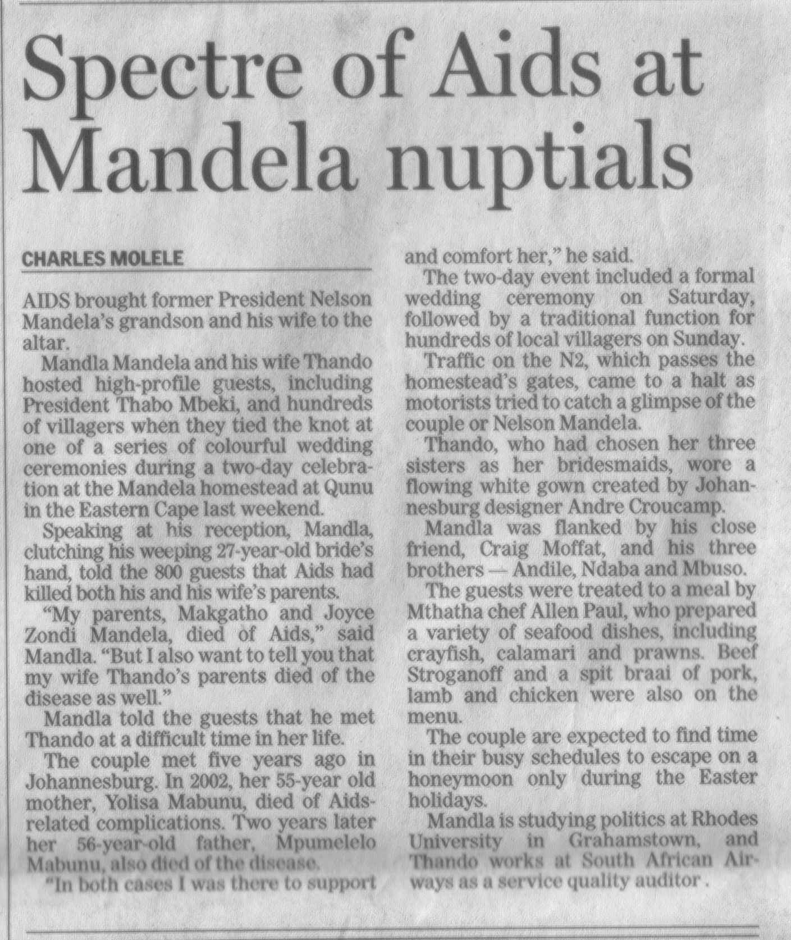

* Who is the author?
* Does the author express any view of his own?
* Who got married?
* When did they meet?
* Who died of AIDS and AIDS related complications?
* Could you find any embedded meaning in the text?

### Exercise 5

During exercise 2 and 3 you were asked to analyse the articles

In your own words, describe the effect you think the articles may have on:

* People who have family in jail
* People who know the farmers who guarded the jail
* People suffering from AIDS
* People who know the couple that were married

### Exercise 6

In a group, analyse the article about farmers guarding the jail.

* How many short sentences are used in the article?
* How many long sentences?
* Give one example of a complex sentence
* Give one example of a compound sentence.

### Exercise 7

Analyse the article called: Spectre of AIDS at Mandela Nuptials.

* How many short sentences are used in the article?
* How many long sentences?
* Give one example of a complex sentence
* Give one example of a compound sentence.

### Exercise 8

Refer back the article about the farmers guarding the jail.

* Would you say they are biased against prisoners in general?
* Do you think the behaviour of the prisoners was correct?
* Do you think that stronger action should have been taken against the prisoners?
* What does this tell you about yourself – are you biased in favour of the prisoners or the guards?

### Exercise 9

* Refer back to your notes of Exercise 1.
* Which magazine’s layout, titles, copy break and use of typography did you prefer? Explain why you preferred it. in your explanation refer to their use of titles, subtitles, bold, italics, underline, the layout of the page, the font types and sizes and their use of copy breakers. What about this combination made the article pleasing to read?

### Exercise 10

Rewrite any paragraph of the article about farmers guarding the jail and leave something out to change the meaning of the article.

### 119459,Exercise 1

Find articles in newspapers and identify:

* Hyperboles, understatements, repetition, questioning. Write a short paragraph about each example, quoting the source and explaining how the technique added interest to the article.
* Compare the logos of the following banks with each other: ABSA, Nedbank, Standard Bank and First National Bank. What does the logo say about the organisation?
* Businesses each have their own logo. Find out what the logos of two businesses look like and make a drawing of each. Write a paragraph about each logo: what they mean to you.

### Exercise 2

1. Refer to the article about the marriage of Mr. Mandela’s grandson in handout 1 from the previous unit standard. Rewrite the article in the first person, as though you were the grandson or granddaughter. Write in the narrative style, without any dialogue.
2. Rewrite the following extracts from the article in passive voice:

* Thandi wore a flowing white gown.
* Mandla is studying politics at Rhodes University in Grahamstown.
* Thando chose her three sisters as bridesmaids.

1. Are the following sentences active voice or passive voice?

* The guests were treated to a meal by Mthatha chef Allen Paul.
* Beef stroganoff and a spitbraai of pork, lamb and chicken were also on the menu.

1. Are the following sentences active voice or passive voice?

* The guests were treated to a meal by Mthatha chef Allen Paul.
* Beef stroganoff and a spitbraai of pork, lamb and chicken were also on the menu.

1. Rewrite the following passage in the third person.

I rang the doorbell and instantly the afternoon peace was shattered by a distant baying like a wolf pack in full cry. The upper half of the door was of glass and, as I peered through, a river of dogs poured round the corner of a long passage and dashed itself with frenzied yells against the door. If I hadn’t been used to animals, I would have turned and run for my life. As it was I stepped back warily and watched the dogs as they appeared, sometimes two at a time, at the top of their leap, eyes glaring, jaws slavering. After a minute or two of this I was able to sort them out and I realised that my first rough count of about fourteen was exaggerated. There were, in fact, five.

### Exercise 3

* Write an imaginative text about any subject of your choice. Choose a subject that you are comfortable with. It can be your version of a fable or child’s story that was told to you. The text should be between 200 and 250 words, roughly 5 paragraphs. Remember to make your writing interesting through the use of punctuation, sentence structure and paragraph structure. The writing must be imaginary – fiction in other words. Write the text in the first person. The purpose of the written piece must be to entertain the readers.
* Write a personal interest text about any subject that interests you: a hobby, sport, a film, an event or even a book that you read. The text should not be shorter than 150 words and not longer than 300 words. Write to inform the reader. Your writing should be in the third person. Make use of an introductory paragraph, a conclusion, titles and visual aids.
* Following you will find factual writing about funeral customs across cultures and religions. Read through the text and then follow the instructions in Sections A, B and C. When you write your newspaper article, write in the third person. Include at least one sentence in passive voice. Write to inform the reader of the funeral practice in your culture. Include an introductory paragraph, a conclusion and make use of headings or titles. Also ensure that your facts and ideas follow logically.

**SECTION A**

* Which religion doesn’t bury the dead in a casket or coffin?
* In which religion does the Priest speak directly to the dead?
* How many rituals are there in an Islamic funeral?
* Explain how the Muslims care for the dead body before burial.
* How long does it take to bury a Jewish body?
* What is a wake and which religion holds a wake?
* What happens at a Protestant funeral?
* Explain how the Balinese hold a funeral.
* Explain how the Samoans mourn.
* Explain African funerals.
* Explain in detail how Buddhists and Hindus handle a death.
* In which direction do Muslims bury their dead?
* Explain the mourning period of a Muslim Wife whose husband dies?

**SECTION B**

Write a newspaper report, expressing funerals in your own culture. Ask your parents, grandparents for information. Also do some kind of research, such as Library books or internet.

Include a bibliography of research.

### Exercise 4

During exercise 3 you were requested to produce three pieces of writing. These were your draft copies. Do the following for each written piece, you may consult with the facilitator if you are unsure:

* Check your writing for coherence, logical structure and sequence. Ask one of your fellow learners to read your written piece and comment on it: is the piece coherent, is the structure and sequence logical
* Rearrange the information so that it becomes more interesting and has more impact.
* Check the layout of the written piece, check the spelling of the words, check the punctuation, and make the necessary corrections.
* Is your written piece accurate and readable?
* Is your use of grammar correct?
* While you are redrafting your piece, experiment with the layout: use titles, headings, colour and so on. This way you can see what the finished product will look like. Add pictures, captions and visual effects at the appropriate places. Visualise what it will look like. Move them around until you are happy with the result – all the graphics, for example, should not be on the same side of the page. Vary their positions from the left to the centre to the right and so on.
* Check the completed text against your purpose for writing it and make sure that you have achieved your purpose.

**Keep your rough copies for your portfolio of evidence, as you have to prove that your did redraft your work.**

Find articles in newspapers and identify:

* Hyperboles, understatements, repetition, questioning. Write a short paragraph about each example, quoting the source and explaining how the technique added interest to the article.
* Compare the logos of the following banks with each other: ABSA, Nedbank, Standard Bank and First National Bank. What does the logo say about the organisation?

### 119462,Exercise 1: Rumour clinic

In groups of two, explore your ability to listen effectively, in the following way:

Step 1 A puts forward views about a particular conflict, without interruption. (approximately 5 minutes)

Step 2 B then restates or summarises what she/he has heard, without interruption.

Step 3 A then corrects, clarifies and expands B's version.

Step 2 and 3 should be repeated until agreement is reached on what was actually said in Step 1.

In groups, stage a rumour clinic

Accident report: “I cannot wait to report this accident to the police. I must get to the hospital as soon as possible.”

“The delivery truck, heading south, was turning right at the intersection when the sports car, heading north, attempted to turn left. When they saw that they were turning into the same lane, they both honked their horns, but continued to turn without slowing down. In fact, the sports car seemed to be accelerating just before the crash.”

|  |  |  |  |
| --- | --- | --- | --- |
| **Volunteer** | **Additions** | **Deletions** | **Distortions** |
| **1** |  |  |  |
| **2** |  |  |  |
| **3** |  |  |  |
| **4** |  |  |  |
| **5** |  |  |  |
| **6**  **(Policeman)** |  |  |  |

**RUMOUR-CLINIC OBSERVATION FORM**

|  |  |  |  |
| --- | --- | --- | --- |
| **Messengers** | **Additions** | **Deletions** | **Distortions** |
| **1** |  |  |  |
| **2** |  |  |  |
| **3** |  |  |  |
| **4** |  |  |  |
| **5** |  |  |  |
| **6** |  |  |  |

### Exercise 2

In your group, have a debate about a controversial subject, such as practicing safe sex to prevent HIV/AIDS, abortions or any other subject that the members of the group have opposing views of.

Divide the members of the group into two groups, for and against. The groups must be equal in number, which could mean that some of the members of the group have to take a side that they do not necessarily agree with. This is fine, it is only role play.

You have 30 minutes in which to select the group leader and prepare for the debate.

The rules of the debate are as follows:

* The leader of the group in favour of whatever the subject is speaks first. He/she gives a three minute talk about why s/he is in favour of the subject. Nobody may interrupt the speaker. The group on the opposing side must take notes of points they with to challenge or ask questions about.
* Once the speaker has finished, one person from the opposing group asks one question or makes one statement about one point the speaker has made. Just that, nothing more. Nobody may interrupt while the person is talking – make notes about statements you would like to ask questions on.
* The speaker has the opportunity to reply to the question or statement. Nobody may interrupt the speaker – make notes if you have a question.
* Then the leader of the other group talks for three minutes about why s/he is against the subject. Nobody may interrupt the speaker.
* Once the speaker has finished, one member of the other group asks one question or makes one statement about one point the speaker has made. Just that, nothing more. Nobody may interrupt while the person is talking – make notes about statements you would like to ask questions on.
* The speaker has the opportunity to reply to the question or statement. Nobody may interrupt the speaker.
* Now the members of each group each have one opportunity to ask questions of the other group. Each person is allowed one chance to ask a question or make an opposing statement. Nobody may interrupt another person speaking or make any comments while that person is speaking.
* Start with a member of the opposing group asking one question or making one statement. One member of the other group may reply.
* Then a member of the group in favour asks a question or makes a statement. A member of the opposing group replies.
* This process carries on until every member of each group has had an opportunity to ask a question and reply to a question or statement of the other group.
* Your facilitator will monitor the process.
* Everyone has to take notes of points that are important, since you will be evaluated on your notes.
* Formative Assessment 1 SO 1, AC 1, 3, 4

**Formative assessment 1 SO1 AC1, 3, 4**

In groups, try to decipher the instructions that were received with products.

***Problem 1***

Made in China

Product use information

1. Add water 400g on the product. about 4 hours it will grow up
2. one clear beauty satiety face will grow up
3. when the flower want to oxygen and nutrition I will help you to much

***Problem 2***

**Useful instructions on the imported Aiwa digital padlock.**

To unlock, “Please make sure whether all the ‘Press Button’ set up already. Press your secret number button. Push the slide button which is underneath this combination lock and press it down. Then it will be OK.” To lock, “Press down the curve. Just push up the back side button is OK.” –

*Financial Mail - 11 February 2000.*

|  |
| --- |
|  |
|  |
|  |
|  |
|  |
|  |
|  |

Formative Assessment 2 SO1, AC 1-2

This is an individual activity

Refer to the article about the marriage of Mr Mandela’s grandson in handout 1 Rewrite the article in the first person, as though you were the grandson or granddaughter.

|  |
| --- |
|  |
|  |
|  |
|  |
|  |
|  |
|  |
|  |
|  |
|  |
|  |
|  |
|  |
|  |
|  |
|  |
|  |
|  |

Rewrite the following extracts from the article in passive voice:

* + Thandi wore a flowing white gown.

|  |
| --- |
|  |

* + Mandla is studying politics at Rhodes University in Grahamstown.

|  |
| --- |
|  |

* + Tandi chose her three sisters as bridesmaids.

|  |
| --- |
|  |

Are the following sentences active voice or passive voice?

* + The guests were treated to a meal by Mthatha chef Allen Paul.

|  |
| --- |
|  |

* + Beef stroganoff and a spitbraai of pork, lamb and chicken were also on the menu.

|  |
| --- |
|  |

Rewrite the following passage in the third person.

*I rang the doorbell and instantly the afternoon peace was shattered by a distant baying like a wolf pack in full cry. The upper half of the door was of glass and, as I peered through, a river of dogs poured round the corner of a long passage and dashed itself with frenzied yells against the door. If I hadn’t been used to animals, I would have turned and run for my life. As it was I stepped back warily and watched the dogs as they appeared, sometimes two at a time, at the top of their leap, eyes glaring, jaws slavering. After a minute or two of this I was able to sort them out and I realised that my first rough count of about fourteen was exaggerated. There were, in fact, five.*

|  |
| --- |
|  |
|  |
|  |
|  |
|  |
|  |
|  |
|  |
|  |
|  |
|  |
|  |
|  |
|  |
|  |
|  |
|  |
|  |
|  |

Formative Assessment 3 SO1 AC 1-4

This is an individual activity

In handout 2 you will find an example of a business letter. On the letter, identify the following:

Letterhead

Date line

Reference line

Attention line

Inside address

Salutation line

Subject line

The body of the letter

The closing

Signature

There is an error in the letter – identify the error.

Formative Assessment 4 SO1 AC 1-4

This is a group activity. Below is an example of a report for project funding. In groups, do the following:

Use the layout shown in handout 4 and transfer the information into a proper layout.

Formative Assessment 5 SO1 AC 1-5

This is an individual activity

Write a letter of application for one of the jobs advertised in handout 7.

Compile your CV in order to attach it to the letter.

|  |
| --- |
|  |
|  |
|  |
|  |
|  |
|  |
|  |
|  |
|  |
|  |
|  |
|  |
|  |
|  |
|  |
|  |
|  |
|  |
|  |
|  |
|  |
|  |
|  |
|  |
|  |
|  |
|  |
|  |
|  |
|  |
|  |
|  |
|  |
|  |
|  |
|  |
|  |
|  |
|  |
|  |
|  |
|  |
|  |
|  |
|  |

Formative Assessment 6 SO1 AC1-4

This is a group activity.

Below is an extract from the Code of Banking Practice. In groups, summarise the Code by developing a leaflet that banks can give to their customers. Each group will present their summary to the entire class. At the end, compare the summaries to the summary made by First National Bank. Also state which Acts relate to this Code.

Formative Assessment 7 SO2 AC1-7

This is a group activity.

You have to write a report to the Human Resources Manager to make a recommendation about which of the following cell phones should be purchased by the company to be used by truck drivers, supervisors and sales people.

Do the following:

1. Identify your audience: who will your audience be?
2. Identify the purpose of your report
3. Collect the evidence you will need and state the resources you used to collect the evidence.
4. Are you sure your evidence is factually correct? What did you do to check this?
5. Use a checklist to sort your information. Attach your checklist

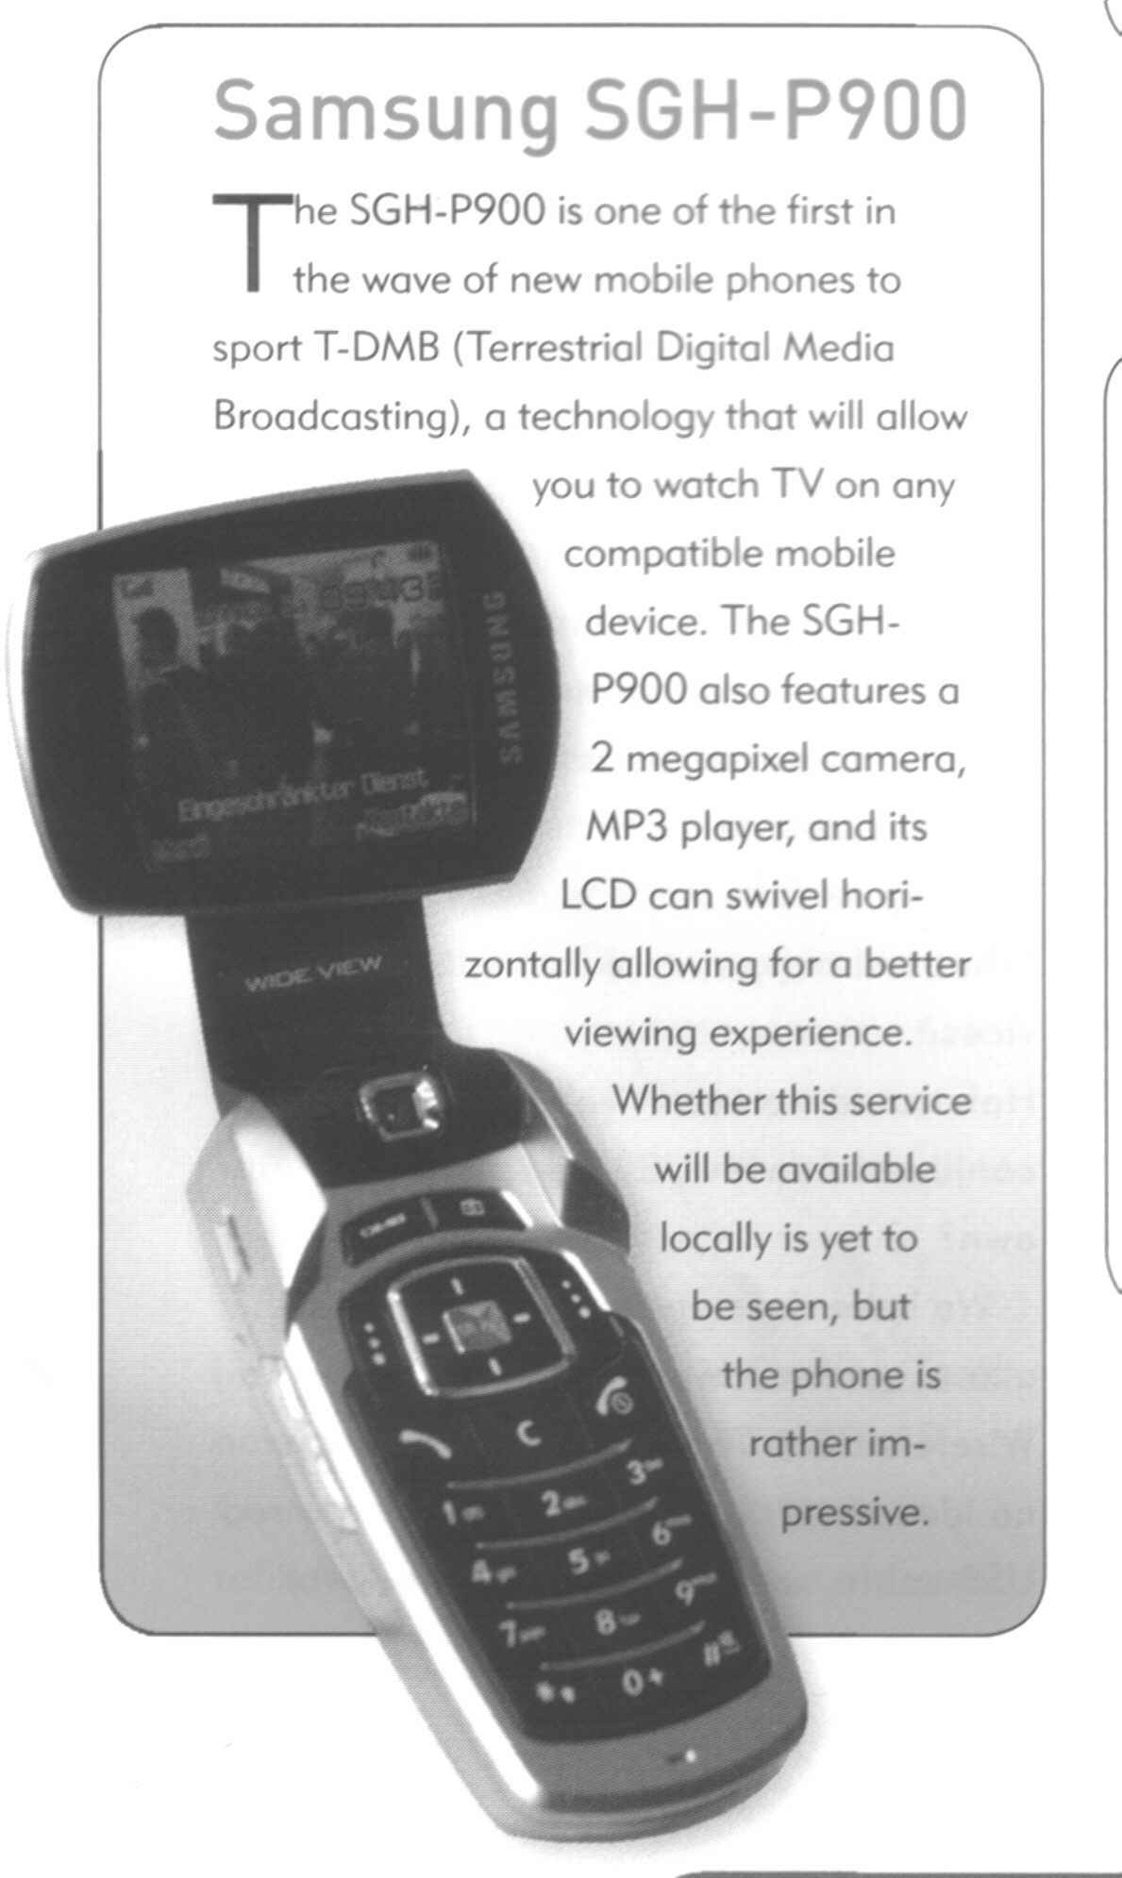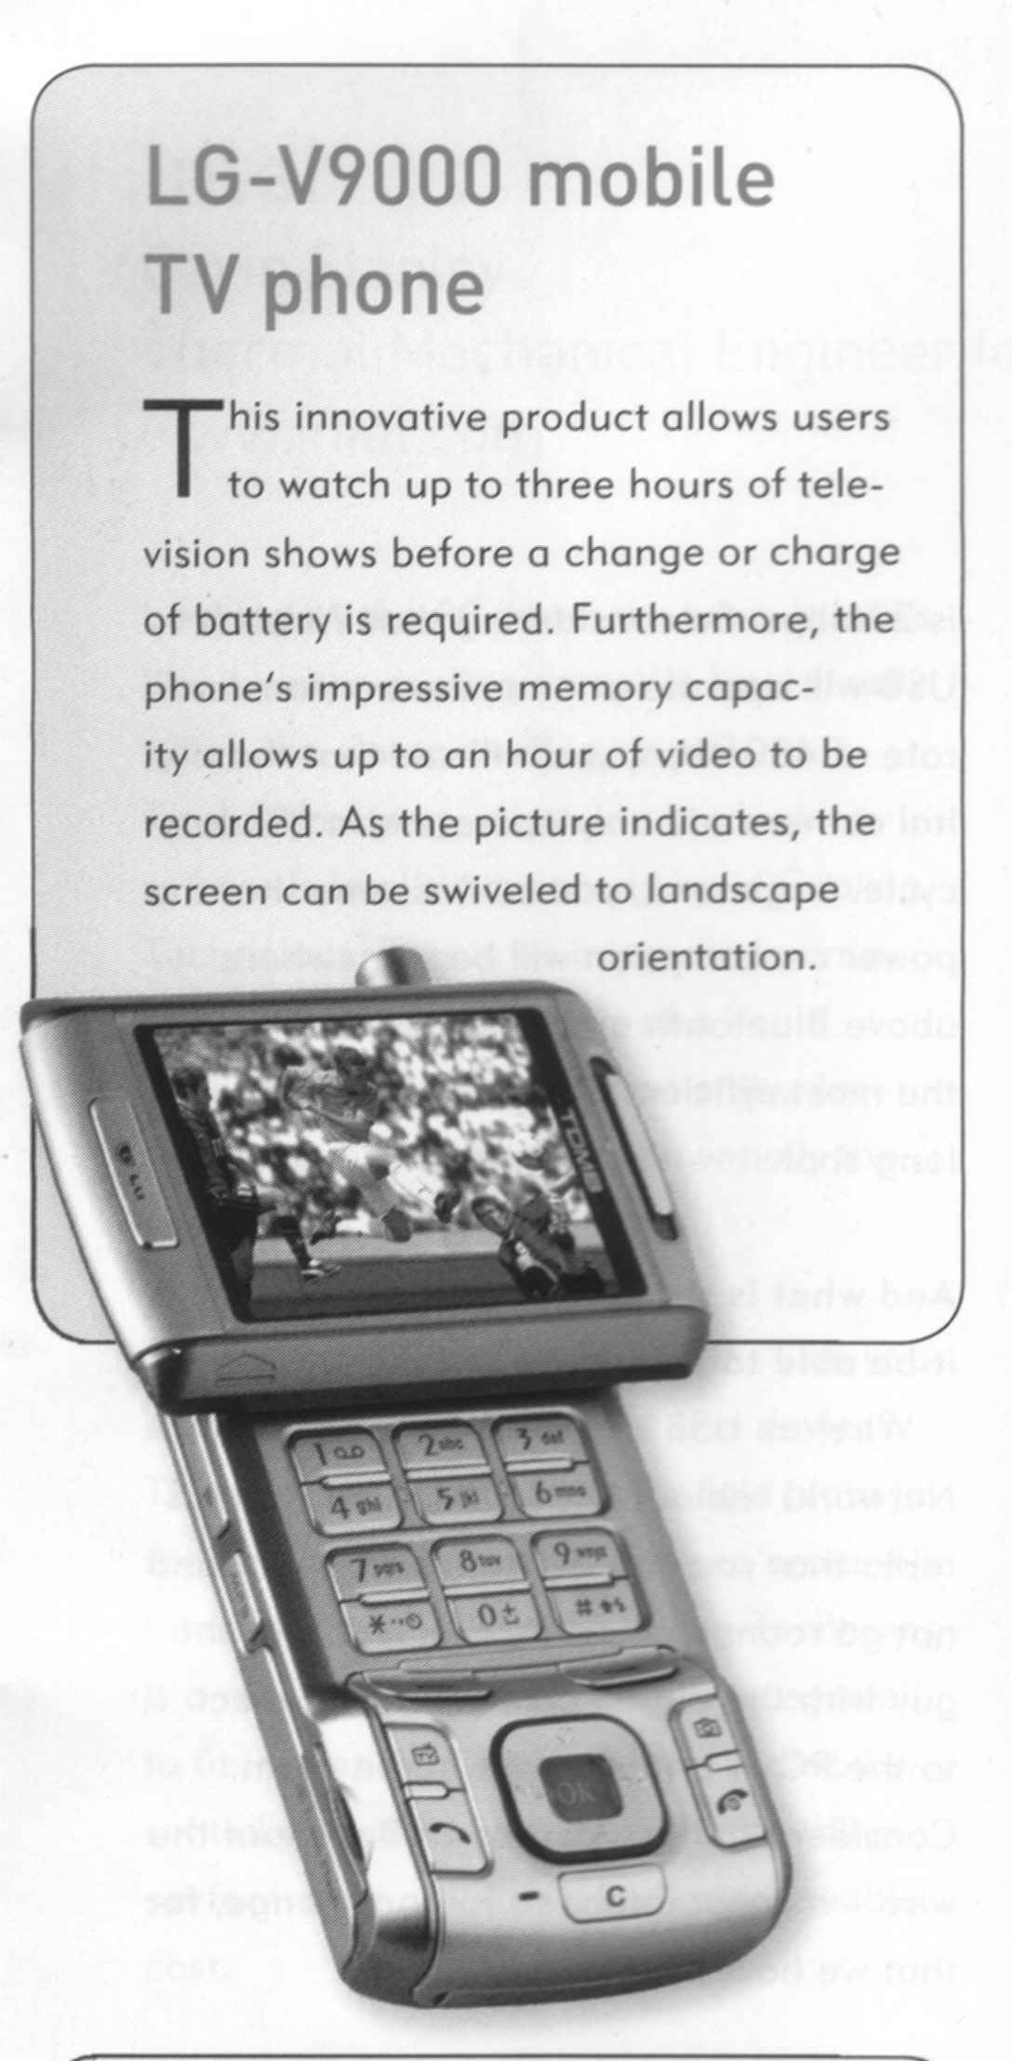

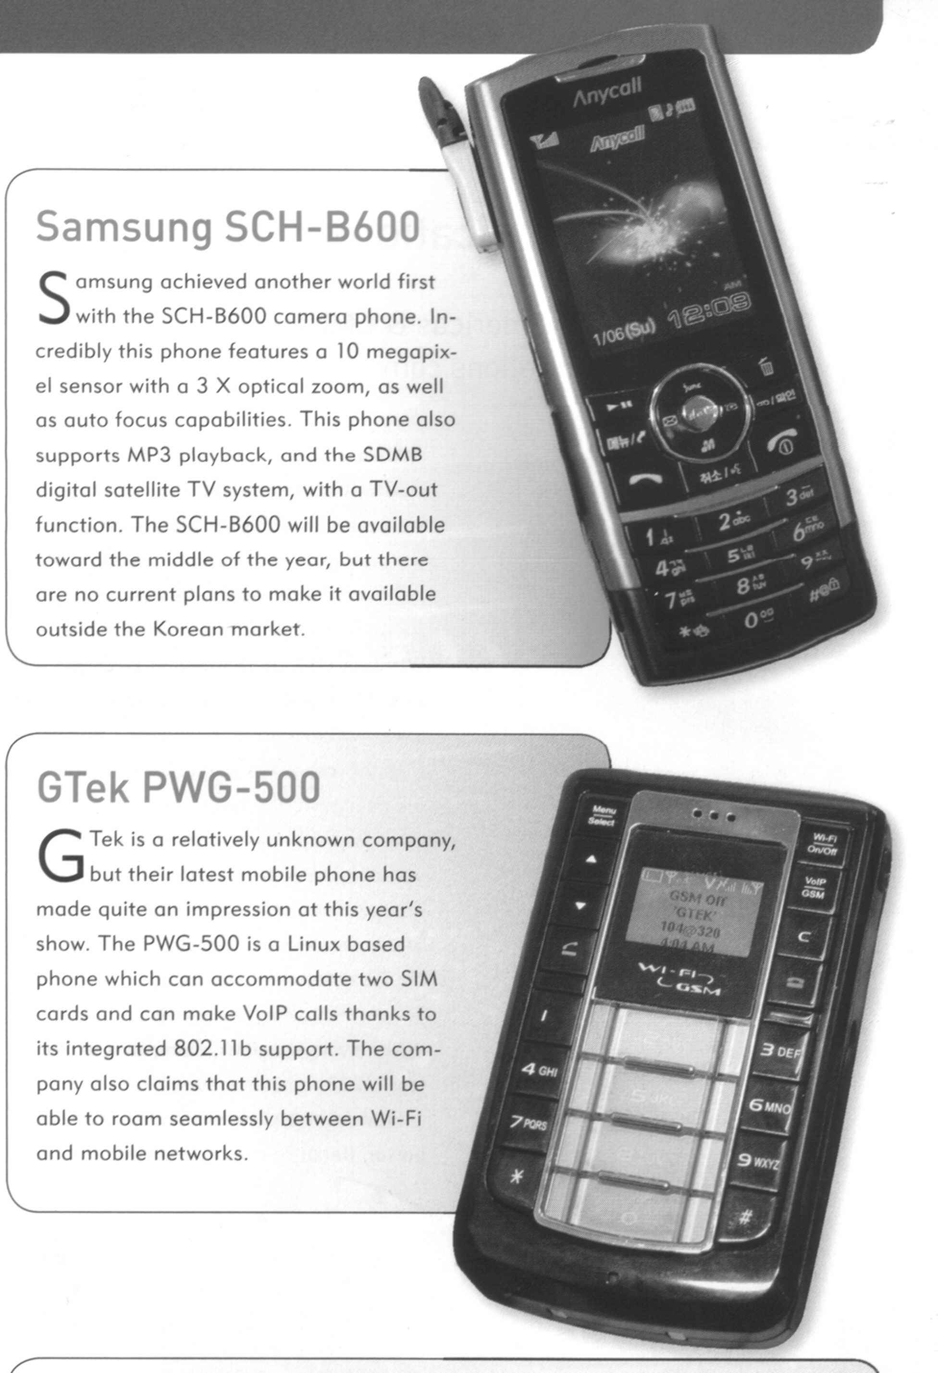

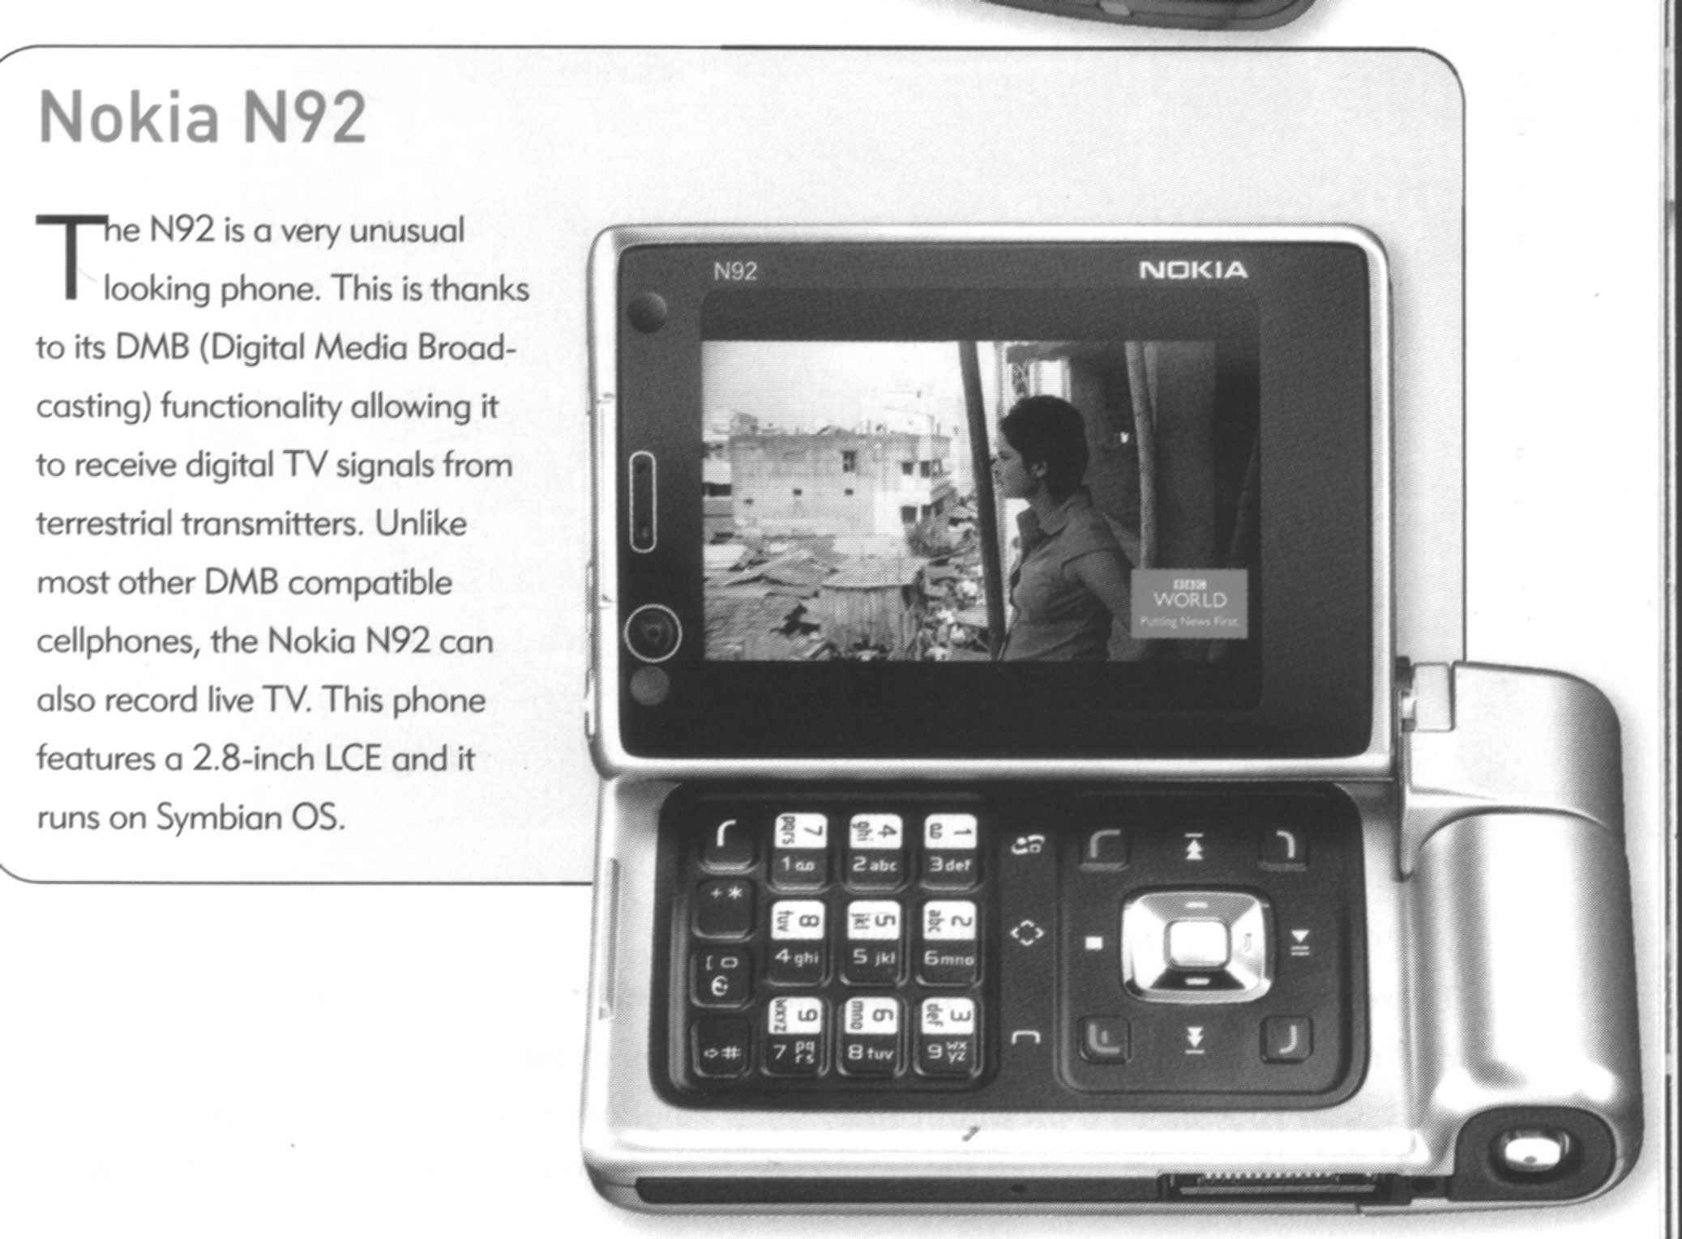

|  |
| --- |
|  |
|  |
|  |
|  |
|  |
|  |
|  |
|  |
|  |
|  |
|  |
|  |
|  |
|  |
|  |
|  |
|  |
|  |
|  |
|  |
|  |
|  |
|  |
|  |
|  |
|  |
|  |
|  |
|  |
|  |
|  |
|  |
|  |
|  |
|  |
|  |
|  |
|  |
|  |
|  |
|  |
|  |
|  |
|  |
|  |
|  |
|  |
|  |
|  |
|  |
|  |
|  |
|  |
|  |
|  |
|  |
|  |
|  |
|  |
|  |

Formative Assessment 8 SO2 AC 1-6; SO3 AC 2

This is an individual activity.

What do you think of when you look at the following pictures? Write down your observations. Also write down why you think so.

Picture 1 Picture 2



Picture 3 Picture 4



Picture 5



|  |
| --- |
|  |
|  |
|  |
|  |
|  |
|  |
|  |

This is a group activity

In a group, discuss the following scene and answer the questions:

What do you think is happening in the scene below?

Why do you think so?

I put three pictures of the previous exercise together. How does your feeling about what is happening differ from the previous pictures?



|  |
| --- |
|  |
|  |
|  |
|  |
|  |
|  |
|  |
|  |
|  |
|  |
|  |
|  |
|  |
|  |
|  |

In a group, discuss the following scene and answer the questions:

What do you think of when you look at the scene below?

Why do you think so?

I put two pictures of the previous exercise together. How does your feeling about the picture differ from the previous pictures?





|  |
| --- |
|  |
|  |
|  |
|  |
|  |
|  |
|  |
|  |
|  |
|  |
|  |
|  |
|  |
|  |
|  |
|  |
|  |

In a group, discuss the following scene and answer the questions:

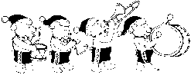What do you think is happening in the scene below?

Why do you think so?



|  |
| --- |
|  |
|  |
|  |
|  |
|  |
|  |
|  |
|  |
|  |
|  |
|  |
|  |
|  |
|  |
|  |
|  |
|  |

**Formative Assessment 9 SO3 AC 1-3**

This is a group exercise.

Refer back to Formative Assessment 7 where you have to write a report to the Human Resources Manager to make a recommendation about which of the following cell phones should be purchased by the company to be used by truck drivers, supervisors and sales people

1. Select a format and structure for the first draft that you will write. Choose headings, subheadings, titles, font type and style and colour, visual aids and so one.
2. Identify the main points of your document
3. Add the supporting details
4. Compare the features of the different cell phones in a table
5. Write your first draft of the report
6. Make sure that you make a recommendation
7. Identify technical words and jargon that is used

|  |
| --- |
|  |
|  |
|  |
|  |
|  |
|  |
|  |
|  |
|  |
|  |
|  |
|  |
|  |
|  |
|  |
|  |
|  |
|  |
|  |
|  |
|  |
|  |
|  |
|  |
|  |
|  |
|  |
|  |
|  |
|  |
|  |
|  |
|  |
|  |
|  |
|  |
|  |
|  |
|  |
|  |
|  |
|  |
|  |
|  |
|  |
|  |
|  |
|  |
|  |
|  |
|  |
|  |
|  |
|  |
|  |
|  |
|  |
|  |
|  |
|  |
|  |
|  |

This is a group exercise.

Refer back to Formative Assessment 7 where you have to write a report to the Human Resources Manager to make a recommendation about which of the following cell phones should be purchased by the company to be used by truck drivers, supervisors and sales people

1. Select a format and structure for the first draft that you will write. Choose headings, subheadings, titles, font type and style and colour, visual aids and so one.
2. Identify the main points of your document
3. Add the supporting details
4. Compare the features of the different cell phones in a table
5. Write your first draft of the report
6. Make sure that you make a recommendation
7. Identify technical words and jargon that is used

|  |
| --- |
|  |
|  |
|  |
|  |
|  |
|  |
|  |
|  |
|  |
|  |
|  |
|  |
|  |
|  |
|  |
|  |
|  |
|  |
|  |
|  |
|  |
|  |
|  |
|  |
|  |
|  |
|  |
|  |
|  |
|  |
|  |
|  |
|  |
|  |
|  |
|  |
|  |
|  |
|  |
|  |
|  |
|  |
|  |
|  |
|  |
|  |
|  |
|  |
|  |
|  |
|  |
|  |
|  |
|  |
|  |
|  |
|  |
|  |
|  |
|  |
|  |
|  |

Formative Assessment 10 SO4 AC 1-5

This is an individual activity

Refer back to Formative Assessments 7 and 9

1. Make notes about the errors and changes you want to make as you go along:

Check your first draft for grammar, spelling, etc. Is it right for your audience?

Is your language clear enough? Does your facilitator understand the meaning of your document?

Play around with the layout of your document: change the style of the headings, titles and font, move the visual aids around. Show your facilitator what changes you want to make

Check your use of technical language, legalese and jargon – will the audience understand your message?

Is your information presented in a logical way? Does your facilitator agree

Are your facts correct? Are you sure?

Check your text for bias and stereotyping

|  |
| --- |
|  |
|  |
|  |
|  |
|  |
|  |
|  |
|  |
|  |
|  |
|  |
|  |
|  |
|  |
|  |
|  |
|  |
|  |
|  |
|  |
|  |
|  |
|  |
|  |
|  |
|  |
|  |
|  |
|  |
|  |
|  |
|  |
|  |
|  |
|  |
|  |
|  |
|  |
|  |
|  |
|  |
|  |
|  |
|  |
|  |
|  |
|  |
|  |
|  |
|  |
|  |
|  |
|  |
|  |
|  |
|  |
|  |
|  |
|  |
|  |
|  |
|  |

Formative Assessment 11 SO5 AC 1-5

This is an individual activity.

Refer to assessments 7, 9 and 10. Rewrite the report. Prepare the finished product and hand it to the facilitator. Answer the following questions:

Does your document look nice, attractive, neat, readable?

Will it arouse the interest of the reader?

Did you make use of headings and subheadings?

1. Did you use numbers or bullets?

Are your paragraphs not too long or too short?

Do the visual aids enhance the value of your document?

Are the facts stated in your document correct?

Did you stay with the purpose of the document or did you add unnecessary information that has no bearing on the document?

Will the audience understand your writing?

Did you choose the correct type of business document for your purpose?

Did you use the checklist?

|  |
| --- |
|  |
|  |
|  |
|  |
|  |
|  |
|  |
|  |
|  |
|  |
|  |
|  |
|  |
|  |
|  |
|  |
|  |
|  |
|  |
|  |
|  |
|  |
|  |
|  |
|  |
|  |
|  |
|  |
|  |
|  |
|  |
|  |
|  |
|  |
|  |
|  |
|  |
|  |
|  |
|  |
|  |
|  |
|  |
|  |
|  |
|  |
|  |
|  |
|  |
|  |
|  |
|  |
|  |
|  |
|  |
|  |
|  |
|  |
|  |
|  |

**PERSONAL INFORMATION**

|  |  |
| --- | --- |
| ***NAME*** |  |
| ***CONTACT ADDRESS*** |  |
|  |
| ***Code*** |  |
| ***Telephone (H)*** |  |
| ***Telephone (W)*** |  |
| ***Cellular*** |  |
| ***Learner Number*** |  |
| ***Identity Number*** |  |
| ***EMPLOYER*** |  |
| ***EMPLOYER CONTACT ADDRESS*** |  |
|  |
| ***Code*** |  |
| ***Supervisor Name*** |  |
| ***Supervisor Contact Address*** |  |
|  |
| ***Code*** |  |
| ***Telephone (H)*** |  |
| ***Telephone (W)*** |  |
| ***Cellular*** |  |

**INTRODUCTION**

***Welcome to the learning programme***

Follow along in the guide as the training practitioner takes you through the material. Make notes and sketches that will help you to understand and remember what you have learnt. Take notes and share information with your colleagues. Important and relevant information and skills are transferred by sharing!



This learning programme is divided into sections. Each section is preceded by a description of the required outcomes and assessment criteria as contained in the unit standards specified by the South African Qualifications Authority. These descriptions will define what you have to know and be able to do in order to be awarded the credits attached to this learning programme. These credits are regarded as building blocks towards achieving a National Qualification upon successful assessment and can never be taken away from you!

***Structure***

**Programme methodology**

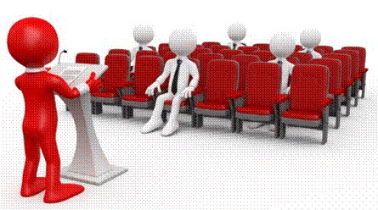

The programme methodology includes facilitator presentations, readings, individual activities, group discussions and skill application exercises.

**Know what you want to get out of the programme from the beginning and start applying your new skills immediately. Participate as much as possible so that the learning will be interactive and stimulating.**

The following principles were applied in designing the course:

* Because the course is designed to maximise interactive learning, you are encouraged and required to participate fully during the group exercises
* As a learner you will be presented with numerous problems and will be required to fully apply your mind to finding solutions to problems before being presented with the course presenter’s solutions to the problems
* Through participation and interaction the learners can learn as much from each other as they do from the course presenter
* Although learners attending the course may have varied degrees of experience in the subject matter, the course is designed to ensure that all delegates complete the course with the same level of understanding
* Because reflection forms an important component of adult learning, some learning resources will be followed by a self-assessment which is designed so that the learner will reflect on the material just completed.

This approach to course construction will ensure that learners first apply their minds to finding solutions to problems before the answers are provided, which will then maximise the learning process which is further strengthened by reflecting on the material covered by means of the self-assessments.

***Different role players in delivery process***

* Learner
* Facilitator
* Assessor
* Moderator

**What Learning Material you should have**

This learning material has also been designed to provide the learner with a comprehensive reference guide. It is important that you take responsibility for your own learning process; this includes taking care of your learner material. You should at all times have the following material with you:

|  |  |
| --- | --- |
| ***Learner Guide*** | ***This learner guide is your valuable possession:***  This is your textbook and reference material, which provides you with all the information you will require to meet the exit level outcomes. During contact sessions, your facilitator will use this guide and will facilitate the learning process. During contact sessions a variety of activities will assist you to gain knowledge and skills.  Follow along in the guide as the training practitioner takes you through the material. Make notes and sketches that will help you to understand and remember what you have learnt. Take and share information with your colleagues. Important and relevant information and skills are transferred by sharing!  This learning programme is divided into sections. Each section is preceded by a description of the required outcomes and assessment criteria as contained in the unit standards specified by the South African Qualifications Authority. These descriptions will define what you have to know and be able to do in order to be awarded the credits attached to this learning programme. These credits are regarded as building blocks towards achieving a National Qualification upon successful assessment and can never be taken away from you! |
| ***Formative Assessment Workbook*** | The Formative Assessment Workbook supports the Learner Guide and assists you in applying what you have learnt.  The formative assessment workbook contains classroom activities that you have to complete in the classroom, during contact sessions either in groups or individually.  You are required to complete all activities in the Formative Assessment Workbook. The facilitator will assist, lead and coach you through the process. These activities ensure that you understand the content of the material and that you get an opportunity to test your understanding. |

**Different types of activities you can expect**

To accommodate your learning preferences, a variety of different types of activities are included in the formative and summative assessments. They will assist you to achieve the outcomes (correct results) and should guide you through the learning process, making learning a positive and pleasant experience.



The table below provides you with more information related to the types of activities.

| ***Types of Activities*** | ***Description*** | ***Purpose*** |
| --- | --- | --- |
| ***Knowledge Activities*** | You are required to complete these activities on your own. | These activities normally test your understanding and ability to apply the information. |
| ***Skills Application Activities*** | You need to complete these activities in the workplace | These activities require you to apply the knowledge and skills gained in the workplace |
| ***Natural Occurring Evidence*** | You need to collect information and samples of documents from the workplace. | These activities ensure you get the opportunity to learn from experts in the industry.  Collecting examples demonstrates how to implement knowledge and skills in a practical way |

**Assessments**

The only way to establish whether a learner is competent and has accomplished the specific outcomes is through the assessment process. Assessment involves collecting and interpreting evidence about the learners’ ability to perform a task.

**To qualify and receive credits towards your qualification, a registered Assessor will conduct an evaluation and assessment of your portfolio of evidence and competency.**

**This programme has been aligned to registered unit standards. You will be assessed against the outcomes as stipulated in the unit standard by completing assessments and by compiling a portfolio of evidence that provides proof of your ability to apply the learning to your work situation.**



***How will Assessments commence?***

***Formative Assessments***

The assessment process is easy to follow. You will be guided by the Facilitator. Your responsibility is to complete all the activities in the Formative Assessment Workbook and submit it to your facilitator.

***Summative Assessments***

You will be required to complete a series of summative assessments. The Summative Assessment Guide will assist you in identifying the evidence required for final assessment purposes. You will be required to complete these activities on your own time, using real life projects in your workplace or business environment in preparing evidence for your Portfolio of Evidence. Your Facilitator will provide more details in this regard.

**To qualify and receive credits towards your qualification, a registered Assessor will conduct an evaluation and assessment of your portfolio of evidence and competency.**

**Learner Support**

**The responsibility of learning rests with you, so be proactive and ask questions and seek assistance and help from your facilitator, if required.**

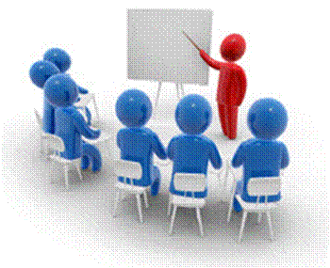

Please remember that this Skills Programme is based on outcomes based education principles which implies the following:

* You are responsible for your own learning – make sure you manage your study, research and workplace time effectively.
* Learning activities are learner driven – make sure you use the Learner Guide and Formative Assessment Workbook in the manner intended, and are familiar with the workplace requirements.
* The Facilitator is there to reasonably assist you during contact, practical and workplace time for this programme – make sure that you have his/her contact details.
* You are responsible for the safekeeping of your completed Formative Assessment Workbook and Workplace Guide
* If you need assistance please contact your facilitator who will gladly assist you.
* If you have any special needs please inform the facilitator

***Learner Administration***



***Attendance Register***

You are required to sign the Attendance Register every day you attend training sessions facilitated by a facilitator.

***Programme Evaluation Form***

On completion you will be supplied with a “Learning programme Evaluation Form”. You are required to evaluate your experience in attending the programme.

Please complete the form at the end of the programme, as this will assist us in improving our service and programme material. Your assistance is highly appreciated.

**Learner Expectations**

Please prepare the following information. You will then be asked to introduce yourself to the instructor as well as your fellow learners



|  |
| --- |
| Your name: |
|  |
|  |
| The organisation you represent: |
|  |
|  |
| Your position in organisation: |
|  |
|  |
| What do you hope to achieve by attending this course / what are your course expectations? |
|  |
|  |
|  |
|  |
|  |
|  |
|  |
|  |

# UNIT STANDARD 119469

#### Unit Standard Title

Read analyse and respond to a variety of texts

#### Unit Standard ID

119469

#### NQF Level

4

#### Credits

5

#### Purpose

Competence at this level will enable learners to use analytical skills to make informed judgements about complex human and social issues. They are aware of both the functions of language and of its drama and power.

#### Learning assumed to be in place

The credit calculation is based on the assumption that learners are already competent in terms of the following outcomes or areas of learning when starting to learn towards this unit standard: NQF Level 3 unit standards US: FET-C/05 Interpret and use information from texts.

#### Unit standard range

A wide variety of complex and extended written and visual texts from socio-cultural, learning and workplace contexts. Specific range statements are provided in the body of the unit standard where they apply to particular specific outcomes or assessment criteria.

#### Specific Outcomes and Assessment Criteria

**Specific Outcome 1:** Analyse and criticise texts produced for a range of purposes, audiences and contexts

**Assessment Criteria**

* Reading strategies appropriate to the purposes for reading are adopted. Range: Skim, scan, prediction, knowledge of form of text types and different genres
* Organisational features of texts are identified. The role of each of the features is explained in relation to usefulness in making meaning of readings and viewing. Range: Role of titles, headings, introductions, paragraphs, conclusions, outcome statements, chapters, summaries, contents, diagrams, appendices or addenda, foreword, index, content lists glossary, hyper-links, layout, icons, tables, graphics, font size and/or type, photographs, captions, visuals
* Synthesis of information from texts, and generalisation of patterns and trends, result in appropriate conclusions about purpose and audience

**Specific Outcome 2**: Identify and explain the values, attitudes and assumptions in texts. Range: Socio-cultural, learning and/or workplace contexts

**Assessment Criteria**

* An understanding of surface and embedded meaning in the text is reflected in presentations of viewpoints.
* The effect of an author’s values and views on selected texts is identified and explained in terms of the impact on meaning and target audience.
* Evidence cited from texts in defence of a position is relevant.

**Specific Outcome 3**: Evaluate the effects of content, language and style on readers` responses in specific texts.

**Assessment Criteria**

* Content is outlined and its possible effects on different readers are explored.
* The impact of different writing techniques on reader perspective are identified and explained in terms of the particular effect produced by each. Range: Length of sentence, punctuation, diction/choice of words, use of figurative language/jargon/technical terms/slang/dialect/irony/humour/satire/sarcasm/legalisms.
* The influence of specific language structures and features is analysed. Range: Bias (cultural, religious or peer preferences, misrepresentation, discrimination, racist, sexist, ageist); humour; irony; sarcasm, use of omission and silence, figurative expressions. Repetition; hyperbole; generalisations; stereotyping; pictures and captions; typography and grammar.
* The effect of selected production techniques in visuals is explained. Range: Visuals: Photographs, transparencies, slides, posters, graphics, videos, films. Techniques: Use of colour/black and white, borders, layout features, cinematographic devices, foregrounding, backgrounding, overlays, selection and/or omission, scale, size.

#### Unit Standard Essential Embedded Knowledge

The following essential embedded knowledge will be assessed through assessment of the specific outcomes in terms of the stipulated assessment criteria: Learners can understand and explain that language has certain features and conventions which can be manipulated. Learners can apply this knowledge and adapt language to suit different contexts, audiences and purposes.

#### Critical Cross-field Outcomes (CCFO)

**Unit Standard CCFO Identifying:** Identify and solve problems: using context to decode and make meaning individually and in groups in oral, reading and written activities..

**Unit Standard CCFO Working**: Work effectively with others and in teams: using interactive speech in activities, discussion and research projects.

**Unit Standard CCFO Organizing**: Organise and manage oneself and one`s activities responsibly and effectively through using language.

**Unit Standard CCFO Collecting**: Collect, analyse, organise and critically evaluate information: fundamental to the process of developing language capability across language applications and fields of study

**Unit Standard CCFO Communicating**: Communicate effectively using visual, mathematical and/or language skills: in formal and informal communications.

**Unit Standard CCFO Science**: Use science and technology effectively and critically: using technology to access and present texts..

**Unit Standard CCFO Demonstrating**: Understand the world as a set of inter-related parts of a system: through using language to explore and express links, and exploring a global range of contexts and texts

**Unit Standard CCFO Contributing**: Contribute to the full development of self by engaging with texts that stimulate awareness and development of life skills and the learning process.

# ANALYSE AND CRITICISE TEXTS

#### Specific outcome

Analyse and criticise texts produced for a range of purposes, audiences and contexts

#### Assessment criteria

* Adopt reading strategies that are appropriate to the purposes for reading
* Identify organisational features of texts. Explain the role of each of the features in relation to usefulness in making meaning of readings and viewing.
* Ensure that synthesis of information from texts, and generalisation of patterns and trends, result in appropriate conclusions about purpose and audience

## Reading Strategies

Whenever we read something, we employ a certain strategy:

* When you are in a hurry, you might **skim** over the reading material
* Sometimes we also **predict** what the writer is going to say, before we get to the section where he actually says it
* Scanning

### Skim

BOOK033When you read through something very quickly, noting only the main points, you are skimming. We tend to do this when we are in a hurry, or when we are not interested enough in the writing to read the whole article. We skim, looking only for the main points, and do not take notice of the body of the writing.

As an example let’s take a newspaper article about a crime that took place. Very often, I only read the basic details of the crime: what happened, where and when did it happen, were the criminals caught. I do not read what witnesses and bystanders or even the victims of the crime had to say about it. I am only interested in certain aspects of the article and I therefore skim through it.

Skimming allows you to go through a lot of reading material, that might not be relevant to your need for information, in a very short time.

### Scan

Look at quickly in order to find relevant features or information. This is different from skimming: when you skim, you look for the main points of the reading material, when you scan you look for information that is important to you. This information may not be included in the main points.

For example, this morning I skimmed the newspaper article about the crime, now it’s evening and I want to know what one specific eye witness said. I’m not going to read the entire article, instead I scan only for the witness’s name in order to get to the part that I am interested in.

### Prediction

SCHMS029When you anticipate what the writer is going to say next, or further on in the article or other piece, you are predicting. We often do this when we have read items from the same author a number of times and we more or less know what his views on the subject are.

This can happen often with sports writers and writers of political text, especially when they tend to put across their own points of view. If you read this person’s work often enough, you can predict what he is going to say about the match over the weekend or the political rally that took place.

## Text Type

In the printed media, newspapers, magazines, brochures, text books, use is made of different techniques in order to

* get your attention,
* help the writer to get the message across,
* indicate a change of topic, a main point or sometimes both
* encourage you to read the written piece

Different font types and sizes

* **Bold**, *italics* and underline
* Visual aids, such as cartoons, diagrams, and so on
* Titles and subtitles
* Captions: a title or brief explanation printed with a visual aid, which can be a photo, an illustration, a diagram or a cartoon
* Photos
* The layout of the page
* A summary of a piece of the article is quoted

Advertisements are very good examples of using text and visuals to get a message across, using as little words as possible.

## Genres

Genre refers to the style of writing. In literature, you get different genres such as poetry, prose, plays, fairy tales, fables, historiography, novels and then of course newspaper and magazine articles.

## Organisational Features Of Text

### Titles, Chapters, Contents

The title of textbooks and manuals, such as you used in school will contain information about the subject of the textbook.

Textbooks are then divided into chapters. Each chapter will contain information about a specific subject that relates to the title or main subject of the text book.

The chapters can then be further subdivided into sections and, if the manual is comprehensive, even sub-sections.

### Contents Page

The writers who compile text books always try to make it easy for us to find specific information about a certain subject. Every textbook will have a contents page, which will give the main headings of the different chapters of the textbook.

You can then go to that page and look at the contents from that page on. Following is a contents page of a textbook about Reward Management.

Can you see that subjects are grouped together in a sensible manner? Can you see that it is easy to obtain information about a specific subject?

If you need information about market rates of pay, you will go to page 35, as indicated in the contents page. Here you will see that the **chapter** is further divided into **sections**.

Now you can page through the chapter, looking only at the **headings** of sections until you find the information you are looking for.

All this makes it easy for you to find the information in the first place and also to refer back to the information afterwards.

well as 347. You can therefore find information about motivation on pages 10 and 347.

### Introductions

Most textbooks, chapters in textbooks and sometimes even sections in chapters will start with an introduction. The purpose of the introduction is exactly what the name implies: to introduce the subject to the reader. An example of an introduction is included in one of the pages for you.

### Foreword

A foreword is found at the beginning of most books and is an introduction by the author of the book. It is different from the Introduction in that it is an explanation by the author of why the book was written.

An example of a foreword can be found on the next page.

### Outcome Statements

An outcome statement is found in training manuals, learner guides and assessment guides. It is a statement of the outcomes that must be achieved in order to be awarded the credits due for a specific unit standard.

Each section in your learner guide starts with an outcome statement.

### Index

Most textbooks also contain an Index, situated at the back of the book. Using the Index, you can look up information by looking for a specific word. The Index is always sorted alphabetically, so if you want to look up the word motivation, you will have to go to M in the Index.

From the Index, under M, (shown on one of the following pages,) you can see that there are references to motivation on pages 10 as well as 347.

### Appendices Or Addenda

Are added at the end of a book and they usually contain extra information or exercises that pertain to certain chapters and sections in the book.

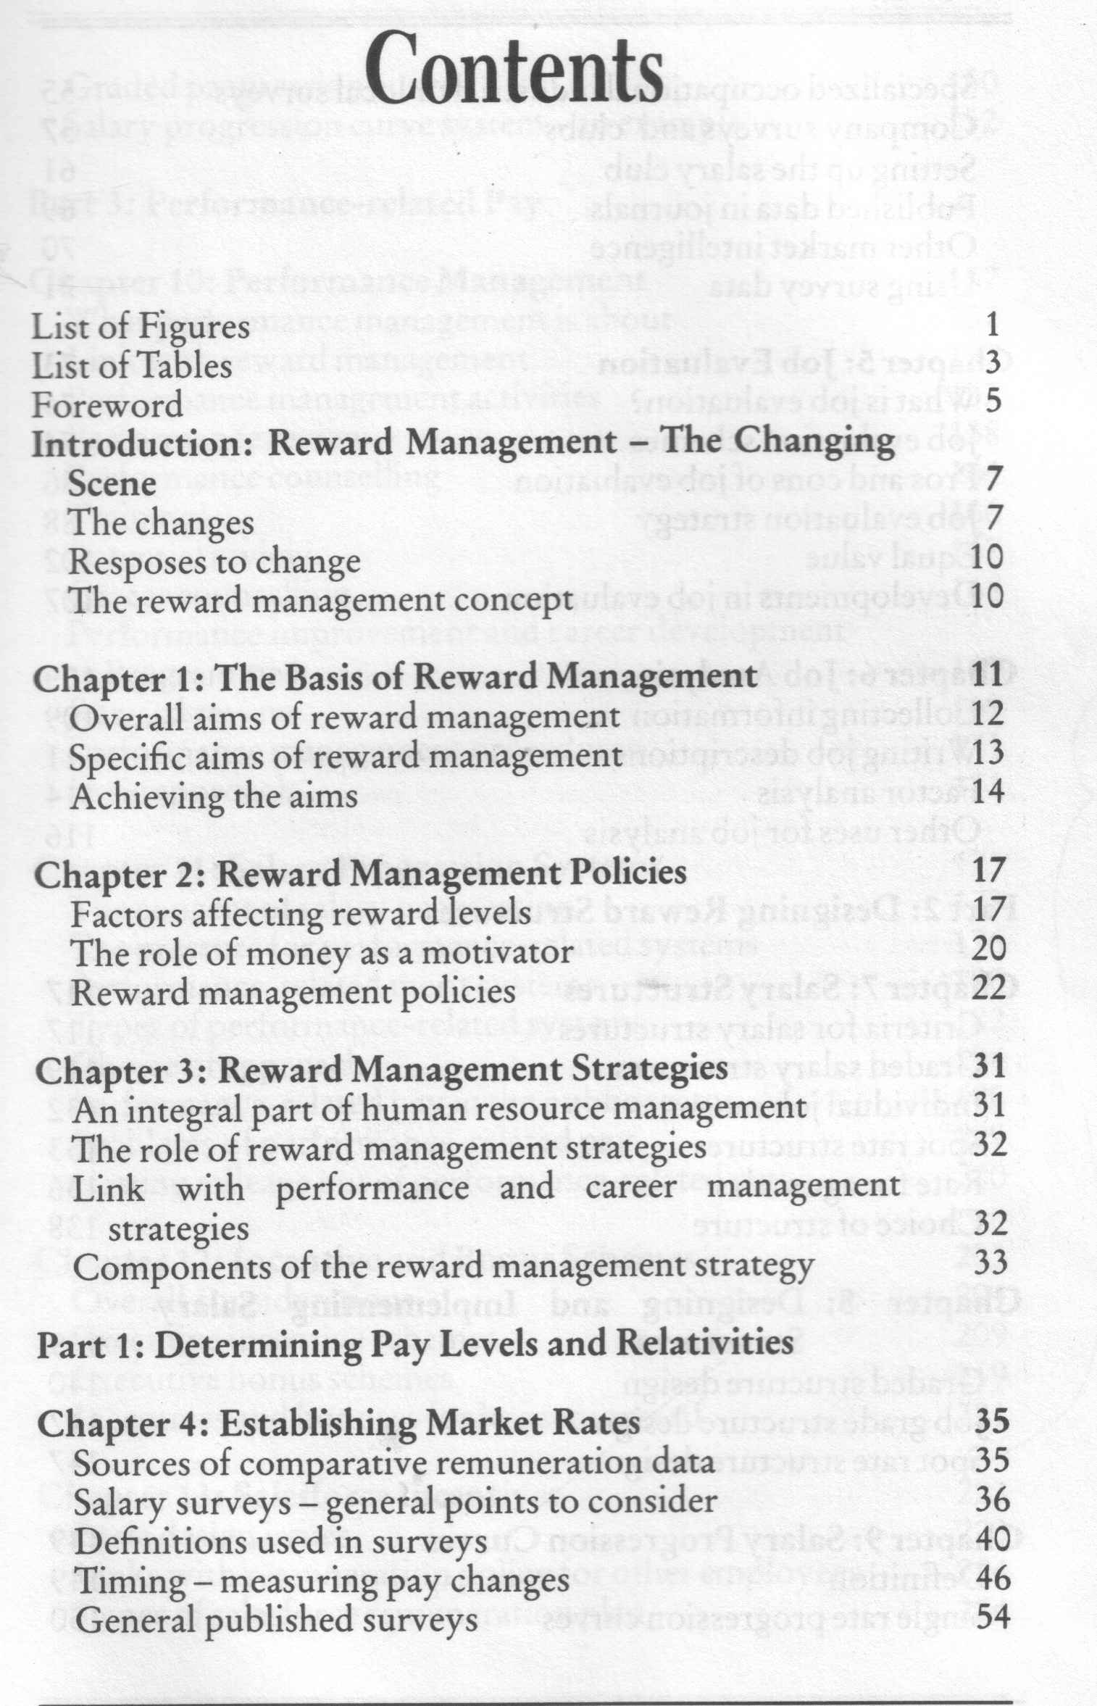

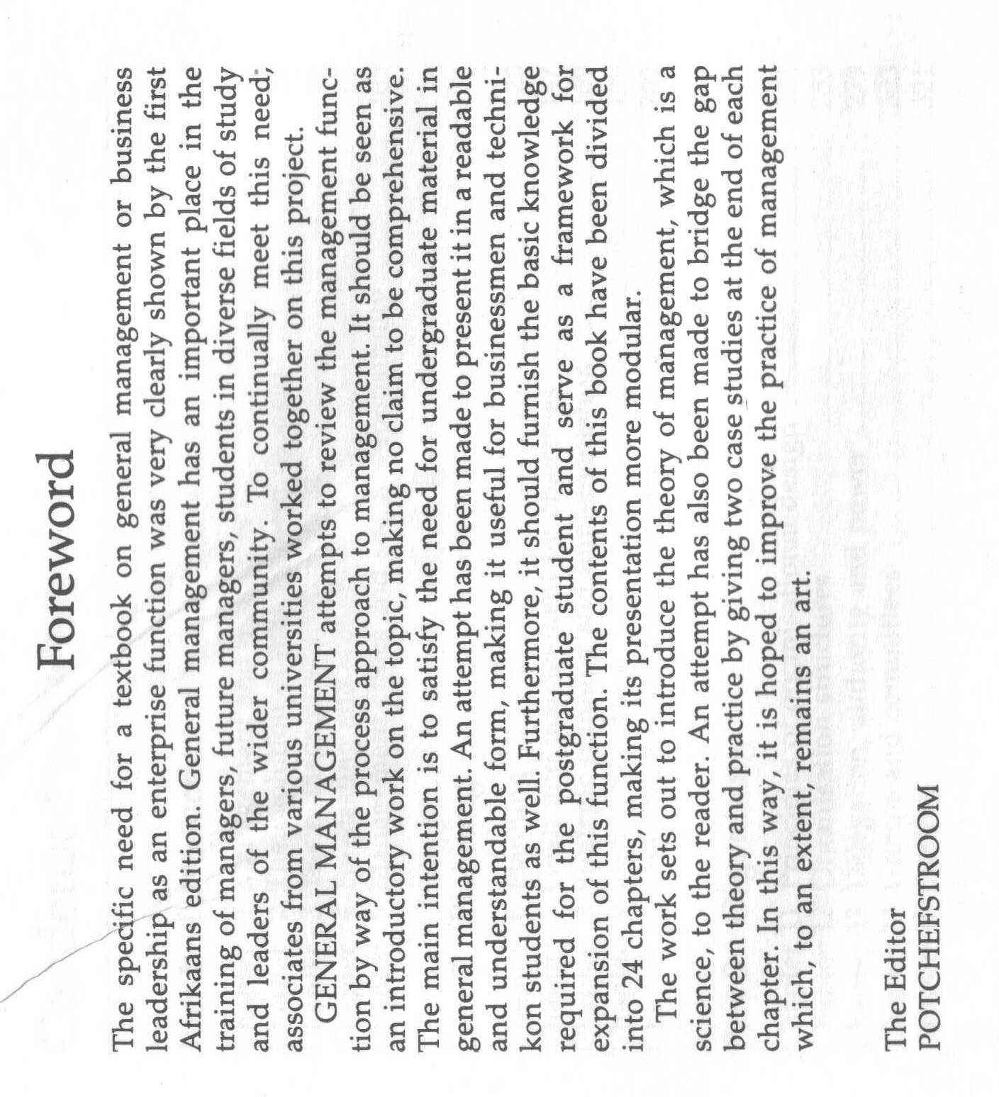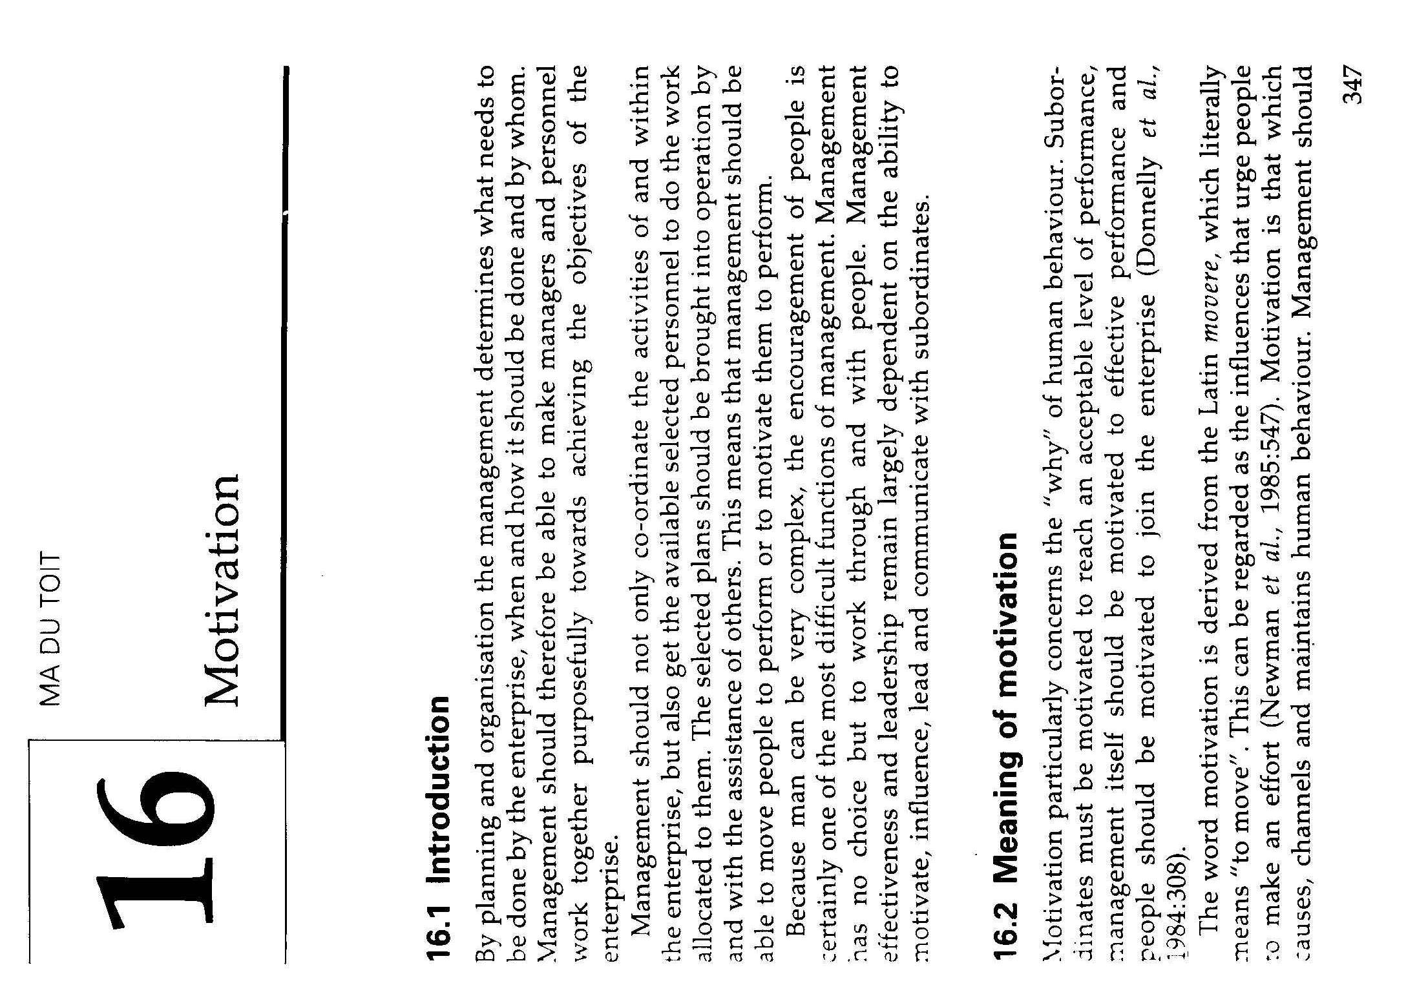

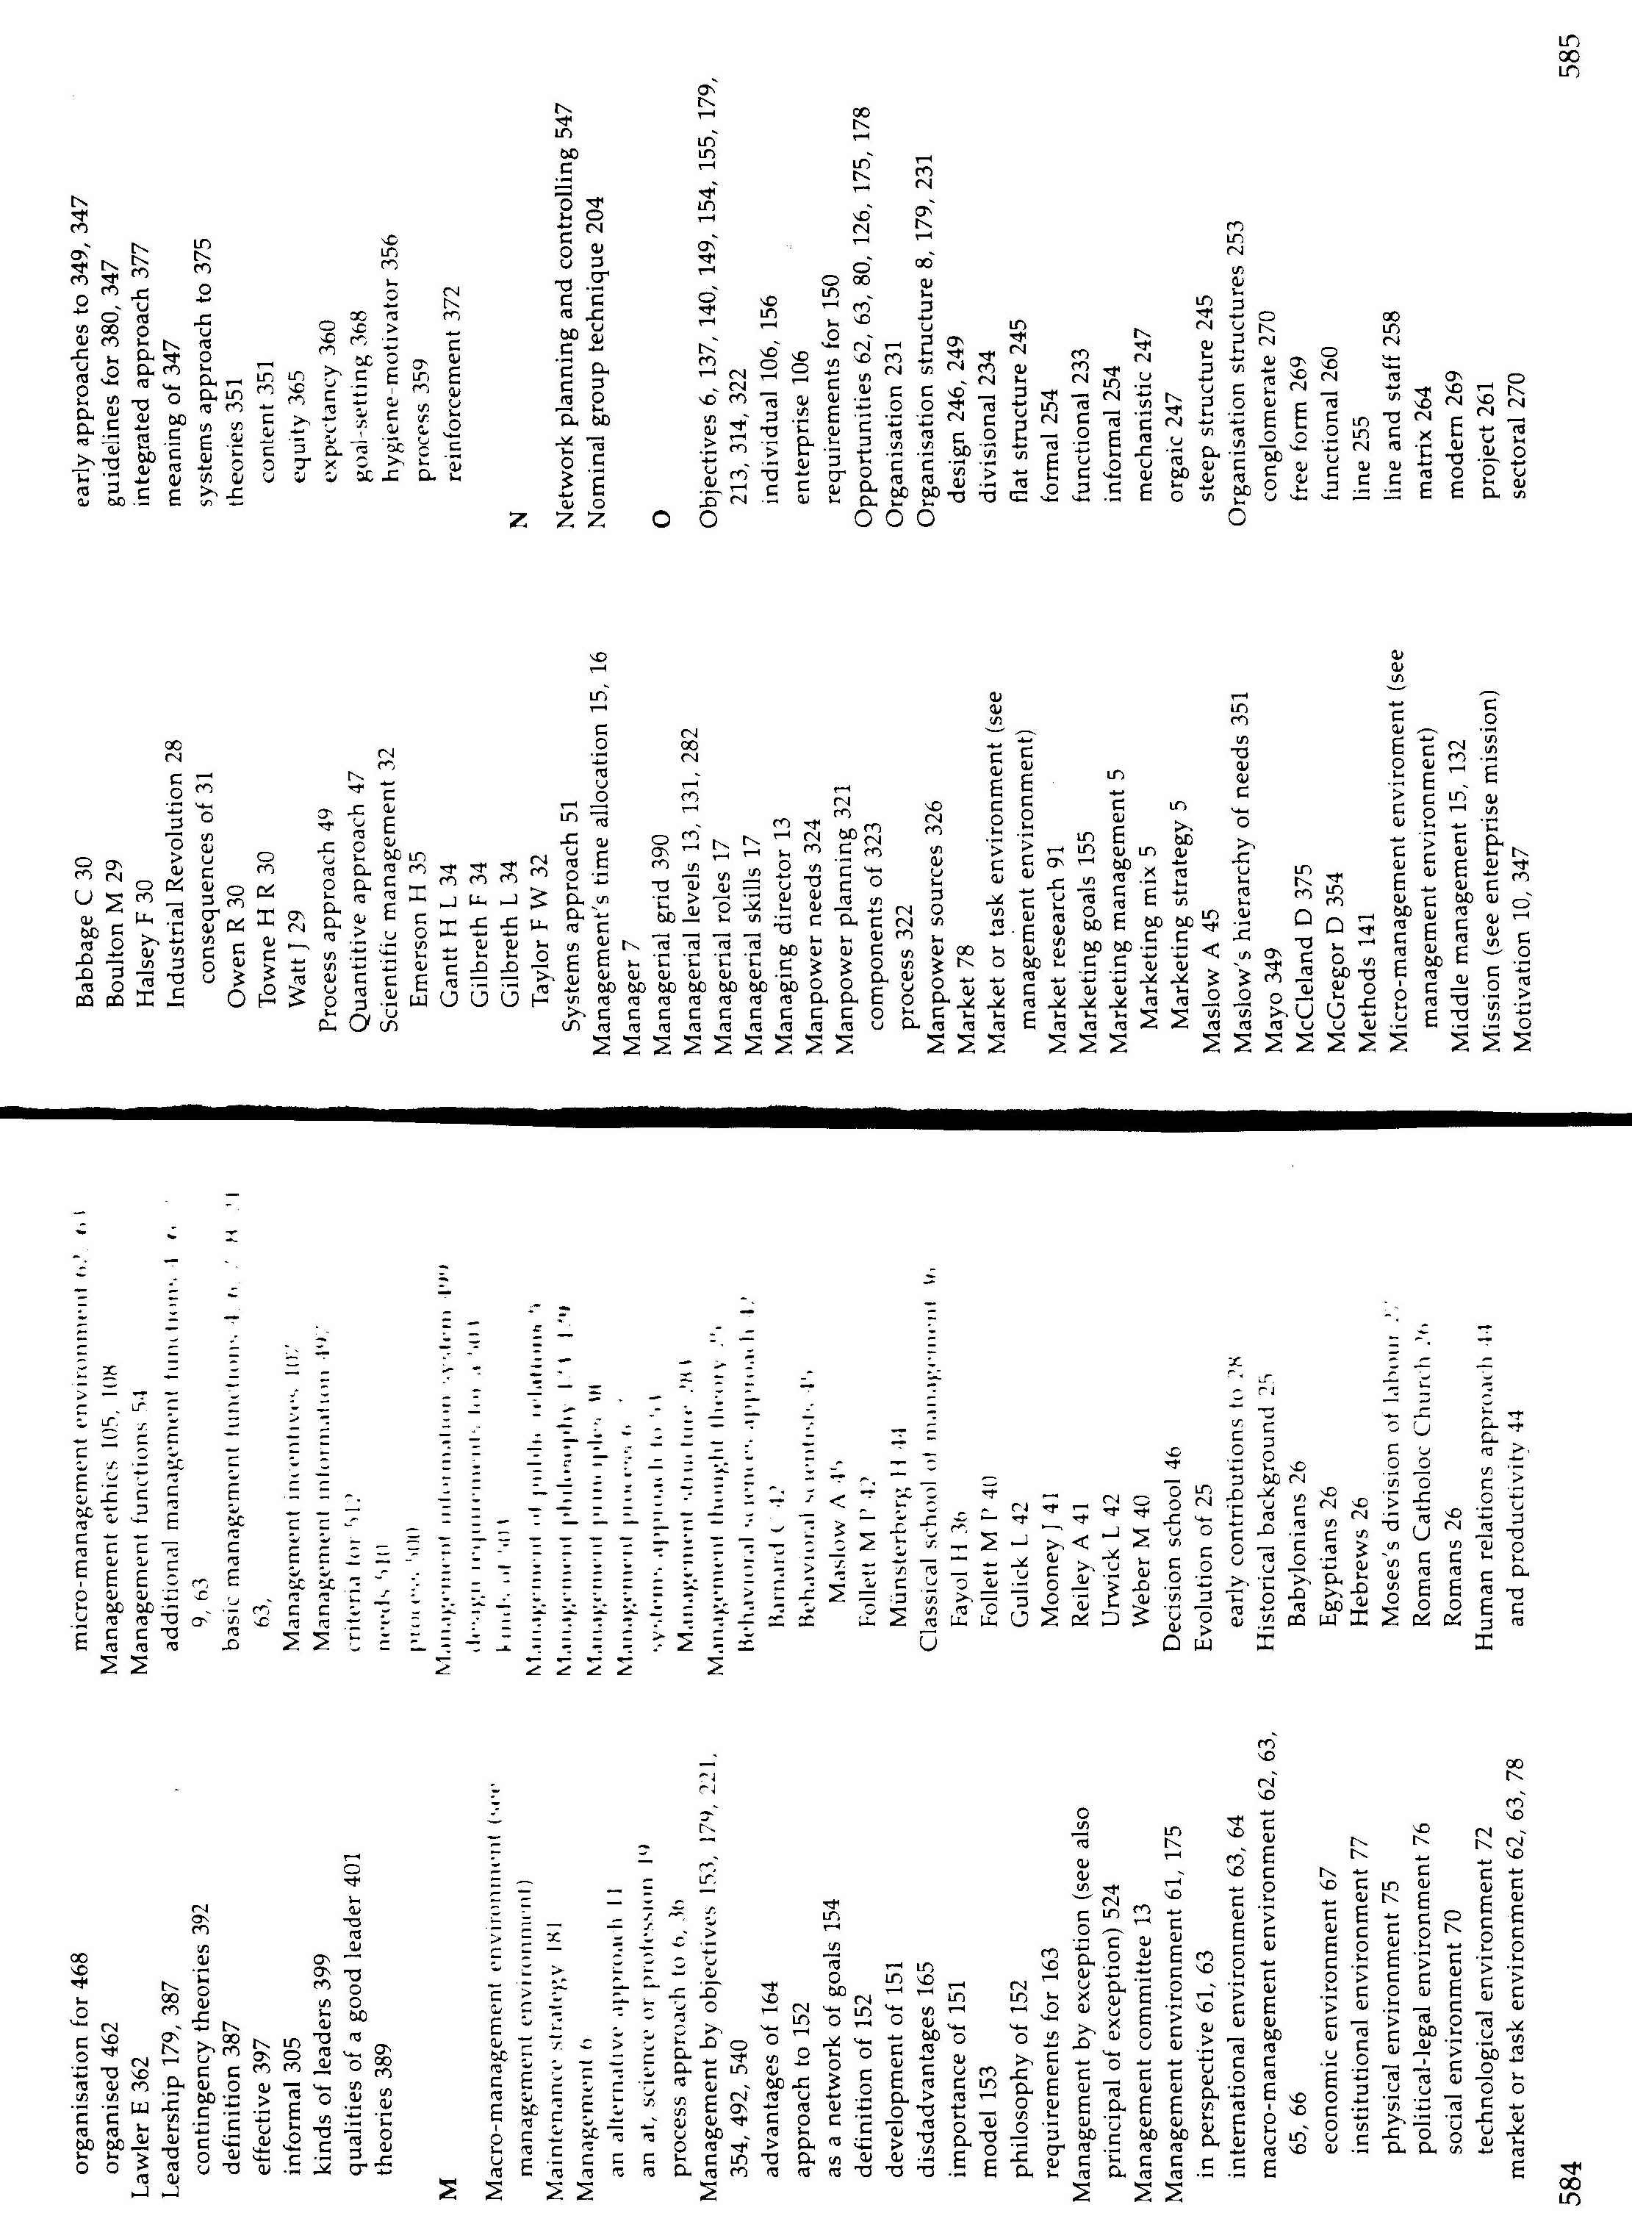

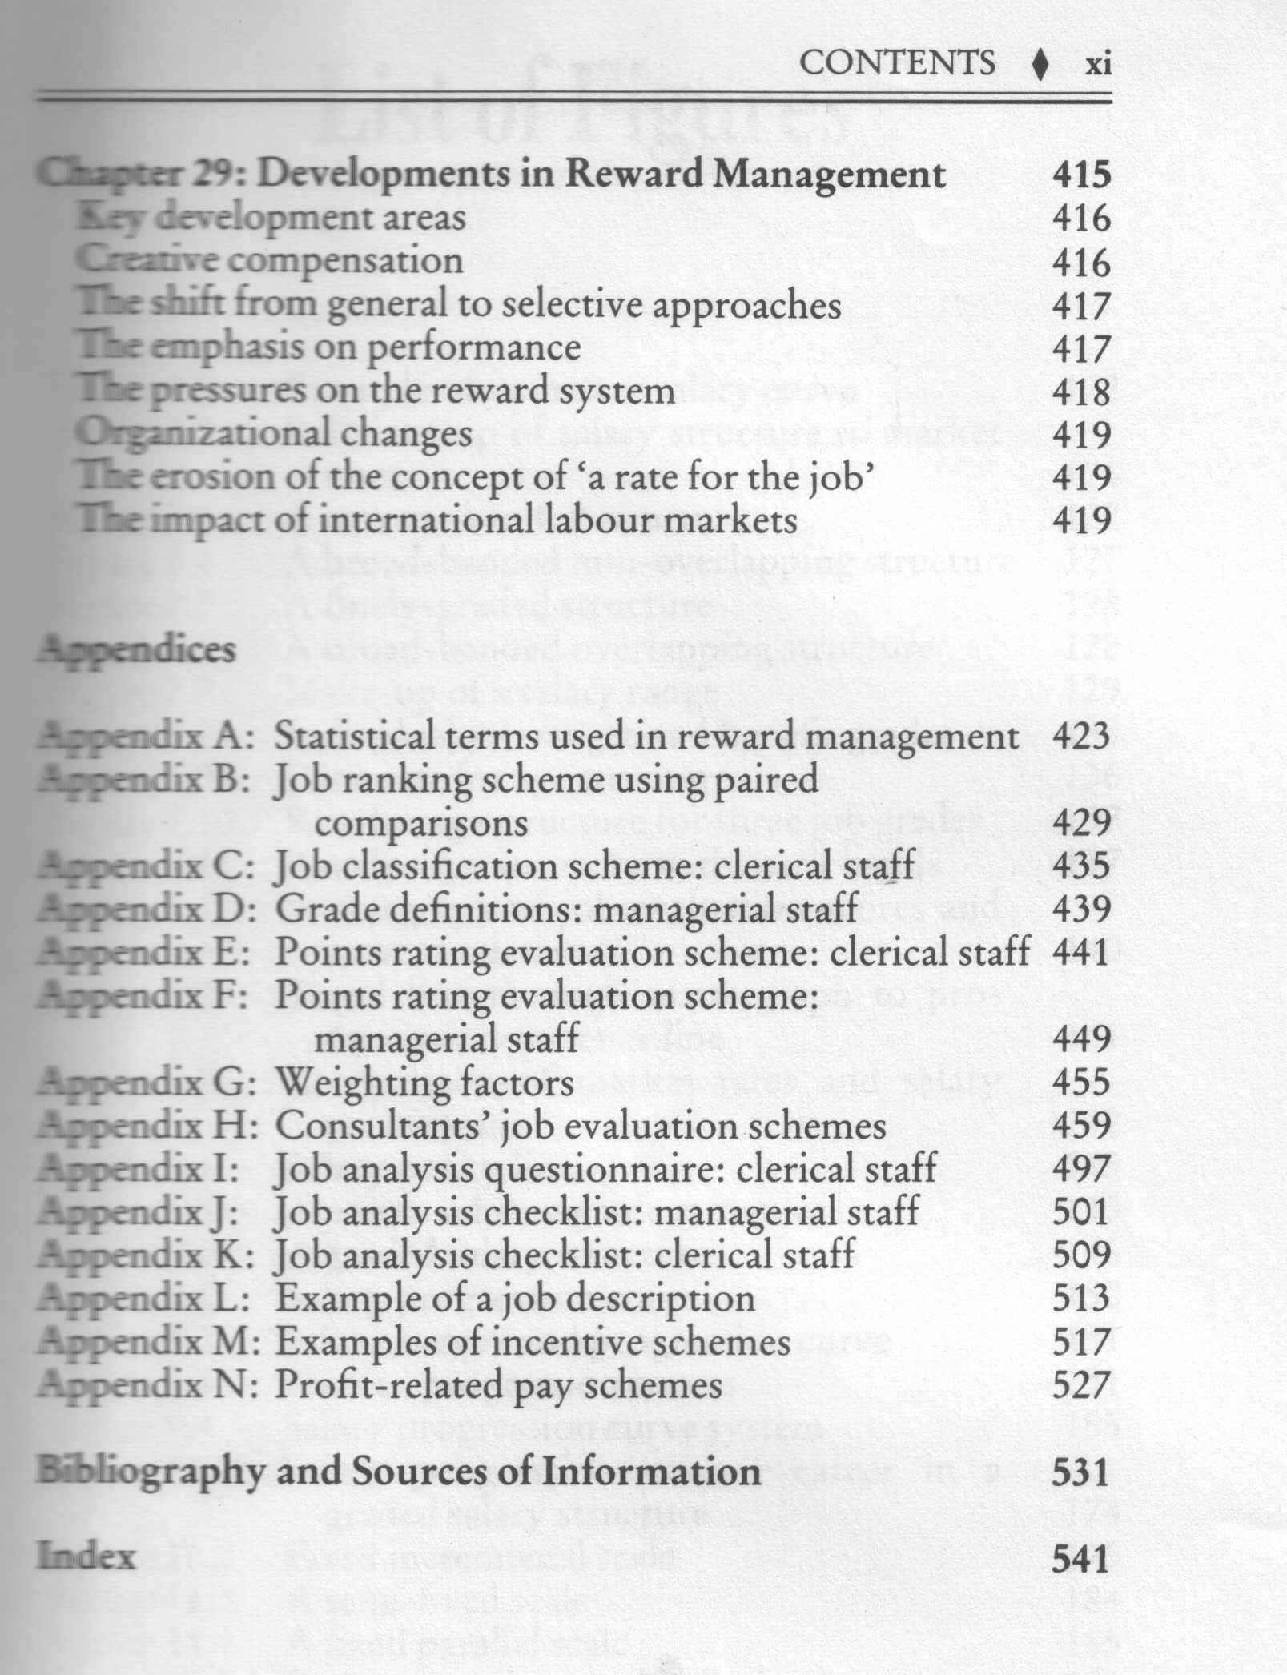

### Glossary

A glossary is usually found at the back of a text book. It is a list of words, usually unusual words, that are used in the manual, with an explanation of their meanings.

An example of a glossary can be found on the next page. When you find an unfamiliar word while working through the text book, you can refer to the glossary to find out the meaning of the word, if it is stated there.

| Term | Definition |
| --- | --- |
| Address Book | A list of names and email addresses. |
| Appointment | A reminder to do something on a particular date at a particular time (and optionally in a particular place). |
| Archiving | Removing old items from Outlook folders by either deleting them or storing them in a compressed file. |
| Attachment | A file sent by email. |
| AutoSignature | An Outlook tool for inserting text into a message. An AutoSignature can be a line or block of text and can be added to all new messages by default. |
| Bcc | Blind Carbon Copy - sending a copy of a message to another recipient without other Bcc recipients knowing. |
| Calendar | The diary component of Outlook. |
| Categories | A tool for grouping related items together. |

### Conclusions And Summaries

Authors will many times include summaries at the end of sections or chapters. A summary is a brief overview of the main points of the content that was discussed during the section or chapter. At times the author will end the section or chapter with a conclusion in the place of a summary. The conclusion will be based on information discussed during the section or chapter.

The summary or conclusion should also give you a brief overview of the main points discussed in the section or paragraph.

### Paragraphs, Layout, Font

In chapters and sections the written (or typed) contents will also be broken down into paragraphs. As seen in module 1, each paragraph should have its own subject, with the sentence of the previous paragraph leading into the subject of the second paragraph. The first sentence of the new paragraph should then introduce the new paragraph.

The layout of the page would usually also enable you to skim through the page if you quickly want to find out what the contents of the page are about. During exercise 1 you were requested to analyse two different magazines in terms of font type, headings, layout and copy breaks. Did you see how the layout of the page helped you to find out more about the subject without reading the entire article in depth? Many textbooks and other books will also be laid out in a way to make it easy for you to skim through the contents. At times the author will also highlight important words by using **bold**, *italics* or underline. Look out for these visual clues when reading through a text book.

All the above are techniques that enable you to find out quickly what the book, chapter or section is about. Once you have satisfied yourself that the contents are relevant to what you want to do, you can start reading the contents in depth. This will make it easier for you to understand what the subject of the content is and will save you the time of rereading the entire contents many times.

### Hyper-Links And Icons

In web sites and web pages and some online manuals you will find hyperlinks. A hyperlink takes you to a specified place on the web site or web page. You will go to the hyperlink by clicking the mouse on the hyperlink.

Almost all web pages have hyperlinks. These links connect:

* One page to another part of the same page (useful if it is a really large page)
* One page to another page somewhere on the web
* A page to a file, such as a sound clip, video, a spreadsheet or a Word document

These links to other pages can be links to things stored anywhere on the internet. **Hypertext** links are indicated by underlined text highlighted in blue (usually). Hyperlinks are also frequently in the form of buttons, graphics or pictures.

To find hyperlinks on a page move your mouse pointer over the page and where there is a hyperlink the pointer will turn into a hand with a pointing finger.

In the example shown, both the graphic and the underlined text link to the same page. You could click either to follow the link.

Icons are found in GUI- based software applications that you do your work in, such as Outlook, MS Word and MS Excel. The icon is usually a picture that you click on and it will execute a command, such as Save, Open, Print, etc. You will learn more about this in the End User Computing modules.

### Visual Clues

Authors also use visual clues in order to emphasize, illustrate or explain certain points.

#### Diagrams

A simplified drawing showing the appearance or structure of something.

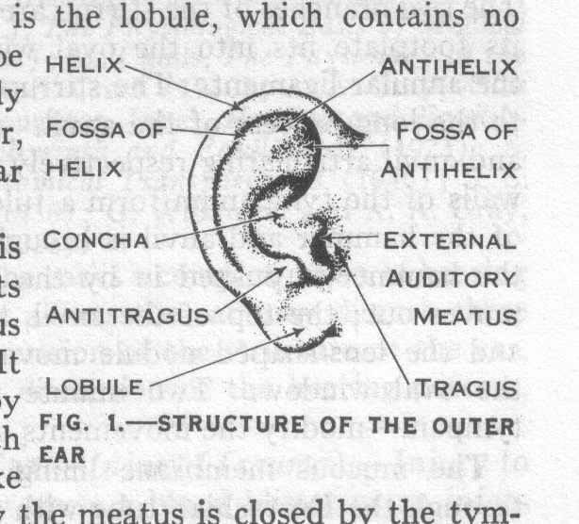In school text books you would have found a lot of diagrams in biology and science. The diagram I remember best is the one of the grasshopper. Of course, a diagram is a sort of a mind map as well.

This diagram shows the outside of the ear.

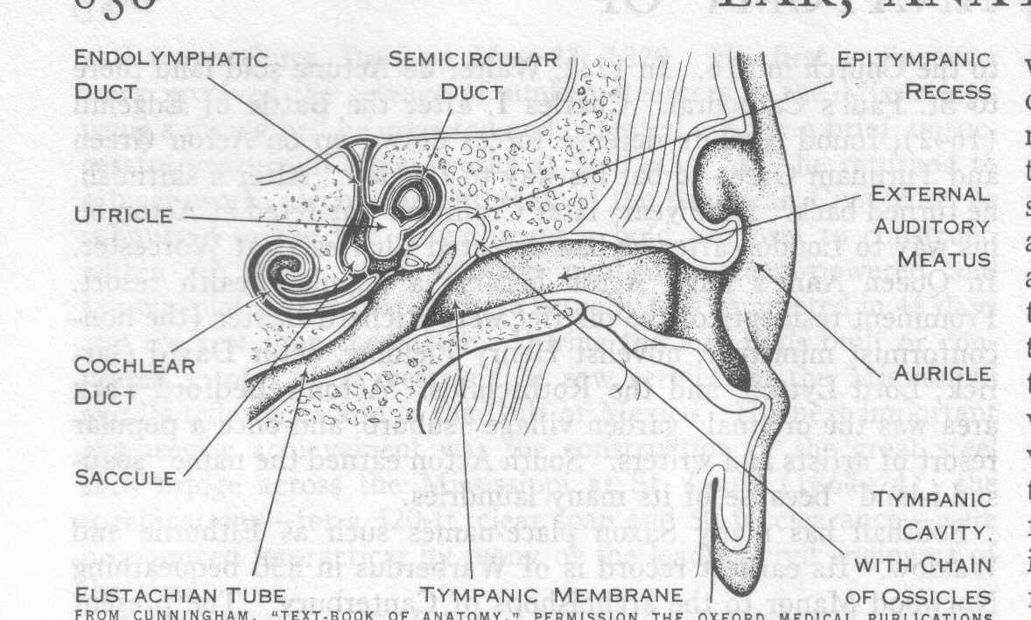And this one shows the inside of the ear.

The diagram below shows the functions involved in the management process.

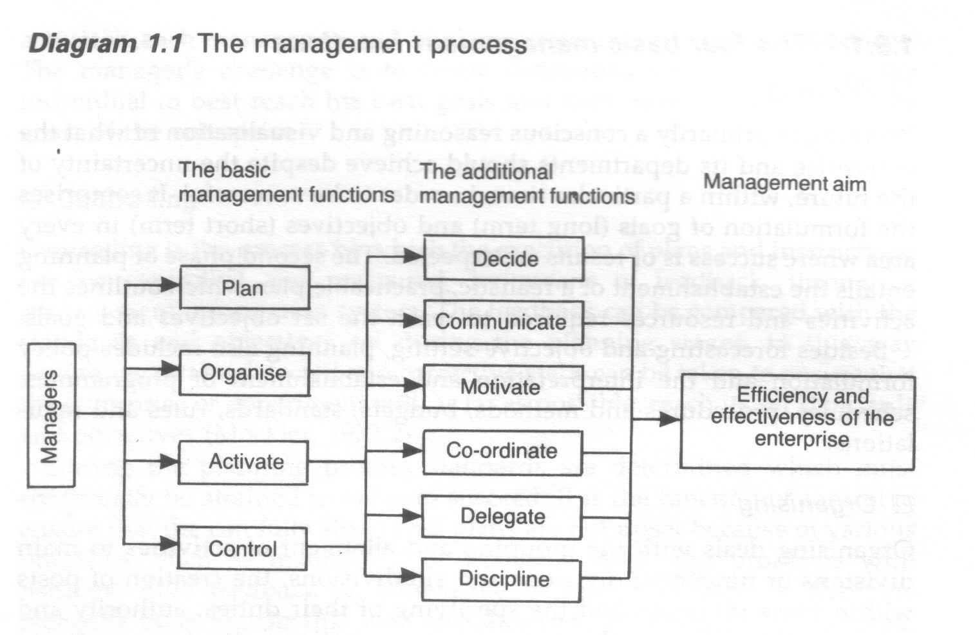

#### Tables

A table is a list where figures, facts or other information is given shortly.

The table below details the types of decisions usually made when solving problems.

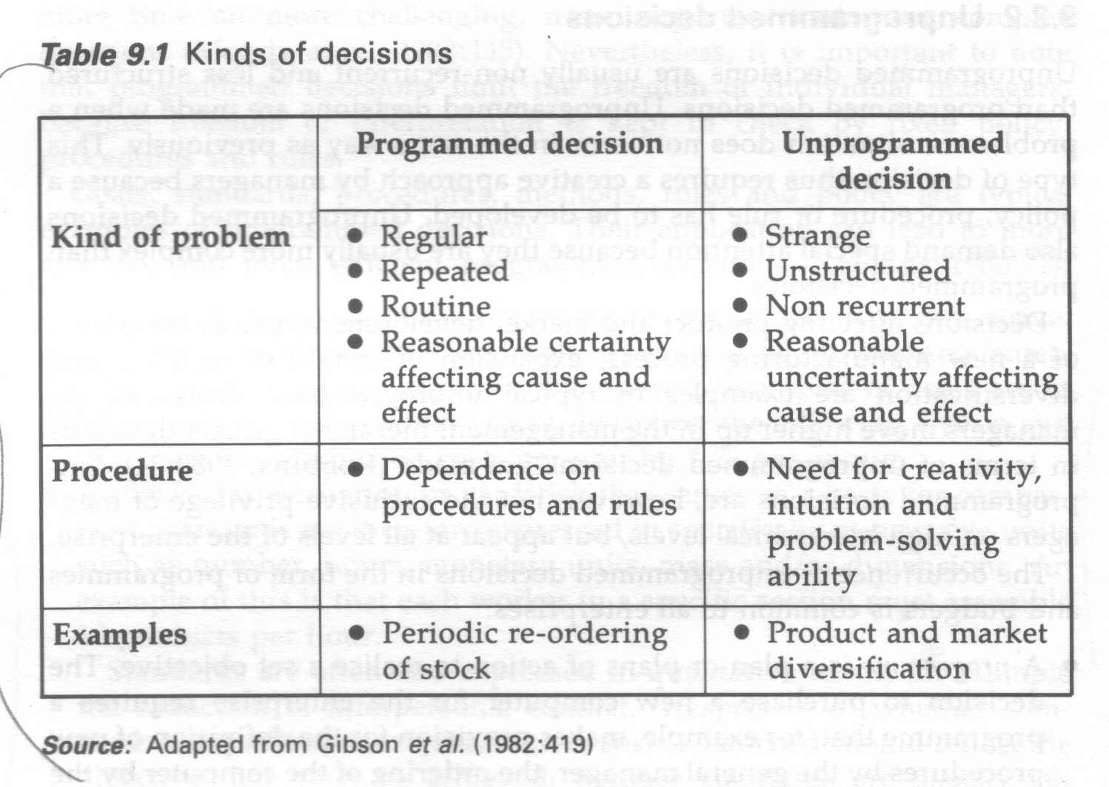

And this table gives details about types of business plans:

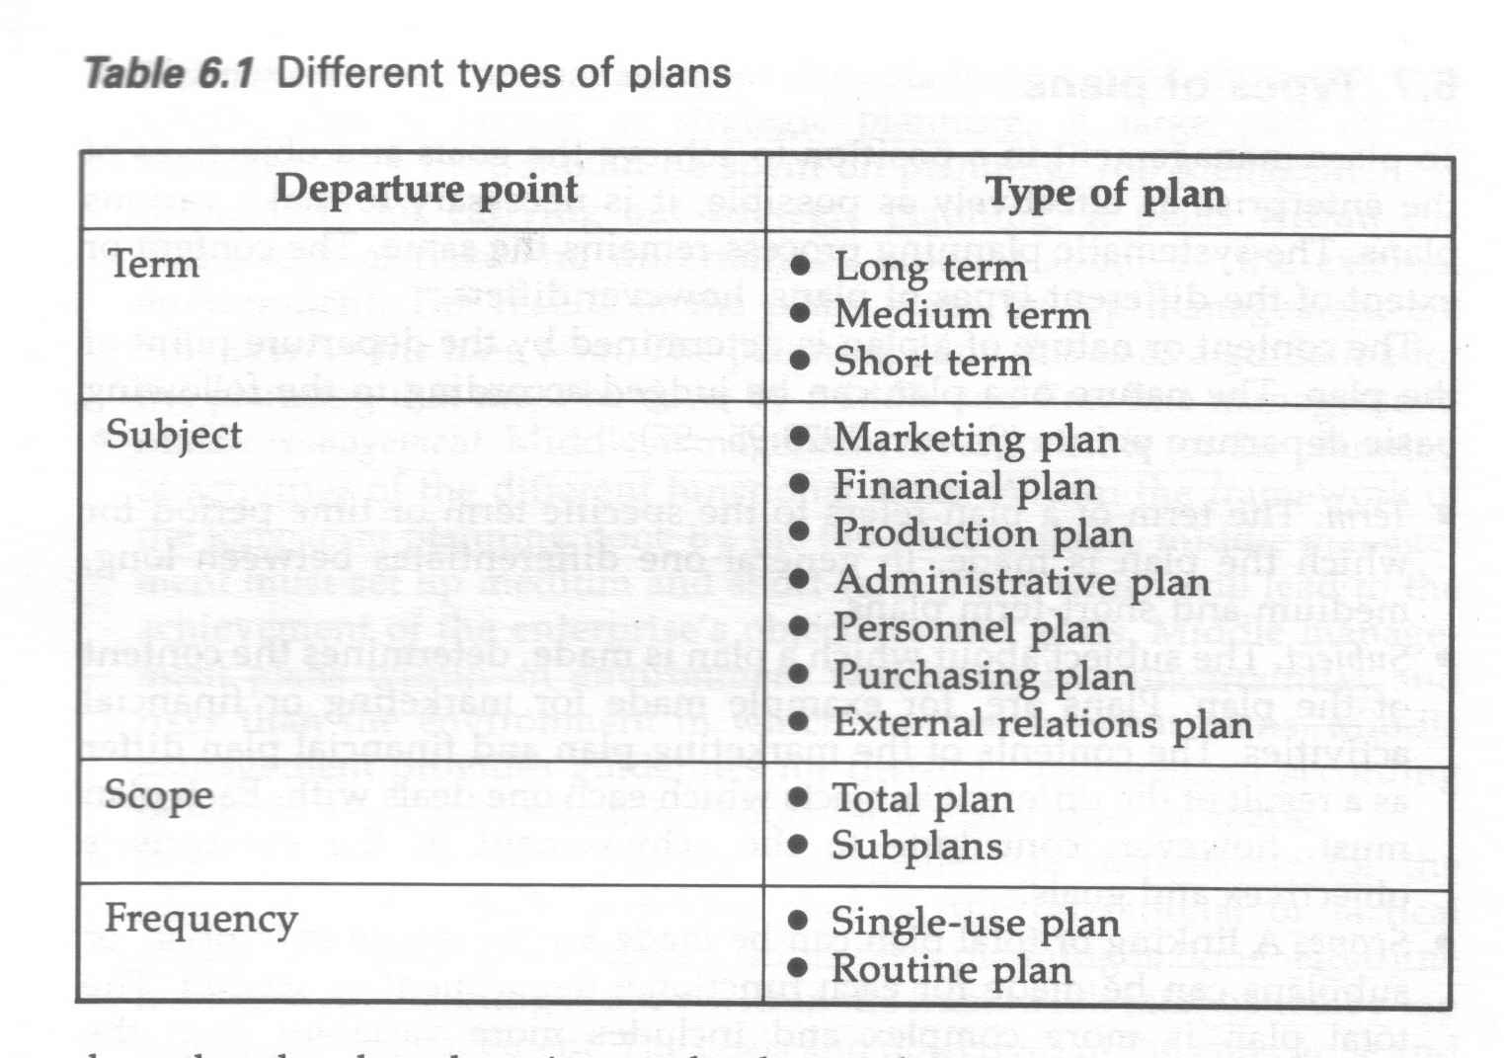

#### Captions

A caption is a title or brief explanation that is printed with a visual aid, which can be a photo, an illustration, a diagram or a cartoon.

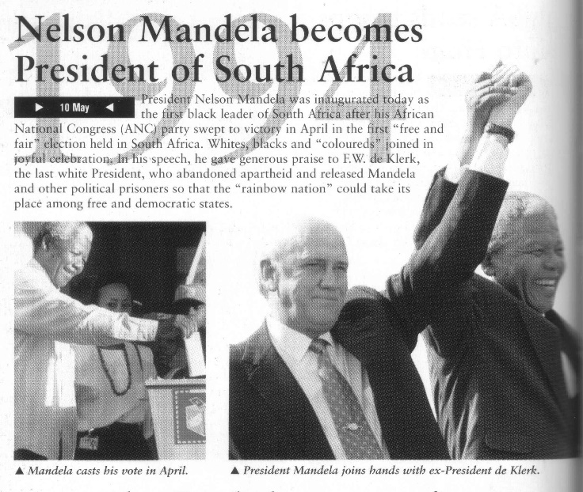

The captions to the photos state:

**Mandela casts his vote in April and President Mandela joins hands with ex-President de Klerk.**

Can you see that you only have to look at the photos and the captions to find out what the article is about? If you want more information, you would have to read the article, but you already have an idea what the article is about.

#### Photographs And Other Graphics

Authors use a wide range of visual images to enhance their text and to persuade the audience of their point of view. Photos and other visual images such as graphs, cartoons, drawings, paintings, etc. are also used to give the reader visual clues about the written piece.

As can be seen in the example, the photos of Nelson Mandela and F.W. de Klerk are used to add impact to the short piece about the elections and the outcome of the elections in April 1994.

# VALUES, ATTITUDES AND ASSUMPTIONS IN TEXTS

#### Specific outcome

Identify and explain the values, attitudes and assumptions in texts. Range: Socio-cultural, learning and/or workplace contexts

#### Assessment criteria

* Reflect an understanding of surface and embedded meaning in the text in the presentations of viewpoints.
* Identify and explain the effect of an author’s values and views on selected texts in terms of the impact on the meaning and the target audience.
* Cite relevant evidence from texts in defence of a position.

## Surface And Embedded Meaning In Texts

### Surface

According to the dictionary, surface refers to the outward appearance of something as distinct from less obvious aspects:

* the external or superficial aspect of something, or
* appearing to be such on the surface only **:** superficial**,** for example friendships

If we look at a lake on a nice summer day with no wind, we see only the surface of the water and we do not know what is hidden beneath the surface.

Writers often use this technique when they do not wish to discuss something unpleasant that may be hidden below the surface of something, for example to describe someone’s appearance or dress without going into the details of that person’s personality.

This is done to put something or someone or even an action by someone in a good light.

If you look at earth from outer space it looks pleasant and peaceful, as you cannot see

* all the wars
* the effects of bad weather on our planet and its people
* the things people do to each other

### Embed

The dictionary explains embed as:

* To fix firmly in a surrounding mass
* to make something an integral part of, for example the prejudices *embedded* in our society

In other words, when some idea or point of view is so much a part of you that it becomes a part of you, for example when you truly believe that one race is superior or that stealing is right or even when you believe in a Higher Being.

We all have embedded points of view that become obvious when we communicate with other people and this applies to authors as well.

Whenever you read something in a magazine, newspaper or even on the Internet, you must always be on the lookout for embedded meanings in the text.

To illustrate this, compare the articles written by authors who are supporters of opposing sport sides – each person has his/her own view of the game that took place over the weekend and their embedded views will show in their writings.

## Values and Views

### Belief system

Taken together, your ethics and values form your belief system. **Ethics** are what you as a person believe and **values** are what the group believes is right and wrong and, because you are part of that group, you also believe in those values.

**Beliefs** indicate the manner in which people think about Divinity (God), the nature of human life, the spirit world, forms of magic, ancestral spirits and generally the nature of life after death.

Belief systems are important because they influence people's behaviour, hence it is critical to understand these beliefs and values

#### Ethics

Ethics is also called moral philosophy.

How should we live? Shall we aim at happiness or at knowledge, virtue, or the creation of beautiful objects? If we choose happiness, will it be our own or the happiness of all?

And what of the more particular questions that face us: is it right to be dishonest in a good cause? Can we justify living in opulence while elsewhere in the world people are starving?

Is going to war justified in cases where it is likely that innocent people will be killed? What are our environmental obligations, if any, to the generations of humans who will come after us and to the nonhuman animals with whom we share the planet?

Ethics deals with such questions at all levels. Its subject consists of the fundamental issues of practical decision making, and its major concerns include the nature of ultimate value and the standards by which human actions can be judged right or wrong.

Therefore, we can say that ethics concerns itself with what is morally good or bad and what is right or wrong.

The word ethics is derived from the Greek word **ethos**. Ethics deal with the morality of persons as individuals and also that of groups of individuals. Ethics assess not only what people are seen to be doing, but also examines what they think is right, fitting and just.

People are often judged by what **they do or are seen to be doing**, but their actions do not necessarily reflect their **thoughts or feelings**, or what they are often saying.

People often act within the context of **traditions and customs**, but, and this is important, ethics always involve 'reflective evaluation', that is, a serious thought process takes place before action takes place. **In other words, individuals like to feel that what they do is right, just and/or accepted as correct.**

The concept of ethics remains the same, whether it is applied in your personal life or in the workplace, because it is a choice you make and you know what is right and what is wrong.

#### Personal value and belief systems

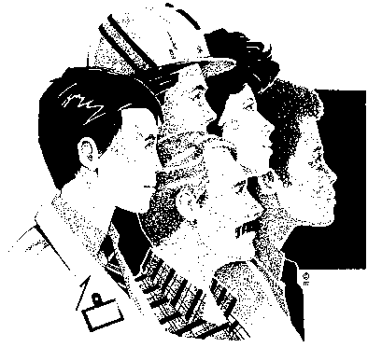Culture can be defined as anything that is learnt in the interaction process in human society. This is a very broad definition and includes such learnt aspects of human social life as language, customs, norms, values and also symbols. Symbols denote characteristics and meanings people give to them, as for example, a flag is a piece of cloth arranged in one manner or another. However, for nationals of a state, the flag indicates several important factors. These may include the identification of a nation, a political party, a company, a team, or any other group that it may represent. The flag could indicate a group of people living within a defined geo‑political area, with a distinct language and unique customs related to the region. It is important to remember that culture is both material and non-material.

No human being is born with culture. All human beings learn their culture through a process of socialisation and interaction with other individuals in society and also with the physical environment. Culture is learnt by individuals as well as being taught by others. The learning of language is one of the most important aspects of culture. It is through language that ideas, values, norms and other facets of culture are transmitted and communicated to others.

**Culture involves values and beliefs.** In most societies today, and especially in Western society, romantic love is the. basis of marriage rather than the arranged form of marriage. However, all societies do place some restrictions on the choice of a marriage partner, although these may differ in intensity from society to society. One of the most universal restrictions is the incest taboo.

Culture is therefore the way of life of a human group, it includes all the learned and standardised forms of behaviour which one uses and which others in one’s group expect and recognise.

#### What are values?

Values are collective standards whereby right and wrong, good and bad and pretty and ugly are separated.

Values are essentially general in nature and provide broad guidelines to groups or peoples.

*For example, a value may be held by a group or people that negotiation and clear debate is the correct manner to resolve differences or conflict. It would therefore be below the collective standard of this group of people, to solve a problem using violent means.*

Of course the opposite will also be true; it may the accepted standard of a group to immediately solve conflict through the application of violence.

Values have always shaped a person's beliefs, and ethics should be concerned with moral rights and wrongs ‑particularly in the context of a person's obligations to the society in which he lives. Ethical rights and wrongs cannot be regarded as inflexible from age to age, because they have a tendency to change with the passing of time. It was accepted as morally defensible to own and treat slaves as commodities just on 200 years ago. Today slavery in nearly all countries in the world does not exist it is looked upon as morally wrong.

An individual, belonging to different cultural group, finds it very difficult to determine another person's ethical code. First and foremost, it is a personal thing, and we tend not to discuss it until some or other crisis demands that we nail our colours to the mast, to show where we personally stand.

#### Source(s) of values and belief systems

The main source of values and belief systems are the people around you for example your parents, family, peers and co-workers. The environment you grew up in plays a very important role. It is unethical to steal something from someone, but wouldn’t be a very strong notion with you if you weren’t taught that it is wrong while growing up.

The community that you group up in, the people that you and your parents associated with, the belief system of these people and your parents are what shaped your values and belief systems. This is why different cultures have such vastly different belief systems.

Our ethics are constantly changing. Not in a sense that for example one day you believe it is wrong to lie and the next day you think it is ok, they simply grow stronger and new ones are added.

Your values directly affect your behaviour. If you believe in something you will either do certain things and others not at all, for example if you believe it is wrong to steal you will never take anything from someone else, or at least not without asking. If you believe it is good to help others in need, you will help where you can instead of turning your back.

### Views and perspective

Why is it important to know that values and belief systems differ? Because your values and belief systems affect your perspective and your point of view.

#### Your attitude

The Merriam-Webster dictionary defines attitude as:

* a mental position with regard to a fact or state, for example a helpful attitude
* a feeling or emotion toward a fact or state

Your attitude is the way you look at things mentally. It has to do with how you think and what you believe about yourself and your situation. Your attitude affects your relationships.

When you are optimistic and hopeful you transmit a positive attitude, which makes people respond positively. When you are pessimistic and expecting the worst, your attitude is usually negative, and people respond negatively to you.

**Your attitude will affect the way you respond to people and situations.**

By controlling what we think and say to ourselves, when confronted by a given situation, we can influence our attitudes positively. Practising positive self-talk will ensure that we handle things well and encourage a positive response.

#### Perception

**Perception is an important principle of communication.**

People differ in important ways. It is impossible to categorise people in fixed ways or stereotypes. We tend to forget that people are different and unique, and no ‘test’ can describe the complexity of each person.

Perception is the act of sensing something and giving it significance. It is how reality is perceived.

People’s behaviour is based on their perceptions; their mental image of what the world is like. It involves the use of previous knowledge in order to interpret the stimuli that are registered by our senses.

Since different frames of reference and filtering systems or conceptual screens come into play, people perceive reality differently. We are all unique and interpret cues or stimuli differently.

We are not cameras or tape recorders. We do not take in, through our five senses, exactly what is ‘out there’ – objective reality. We constantly respond to cues that have meaning for us. Meaning is subjective. We see what we want or need to see to define ourselves or to advance our own aims.

**We do not see people for what they are,**

**we see them for what they mean to us.**

Perceptions are no more than theories or guesses about what the world is like. A good deal of the time our theories work and our perceptions of reality are reinforced. However when someone challenges our view of the world, a great deal of uneasiness and dissonance is created.

## Authors’ views and values

In the same way that our values and belief systems affect our attitudes, views and perspective, it will have an effect on how an author writes articles and books.

It is therefore important to be aware of this as the author’s values and views will have an impact on the meaning of the text as well as the intended target audience.

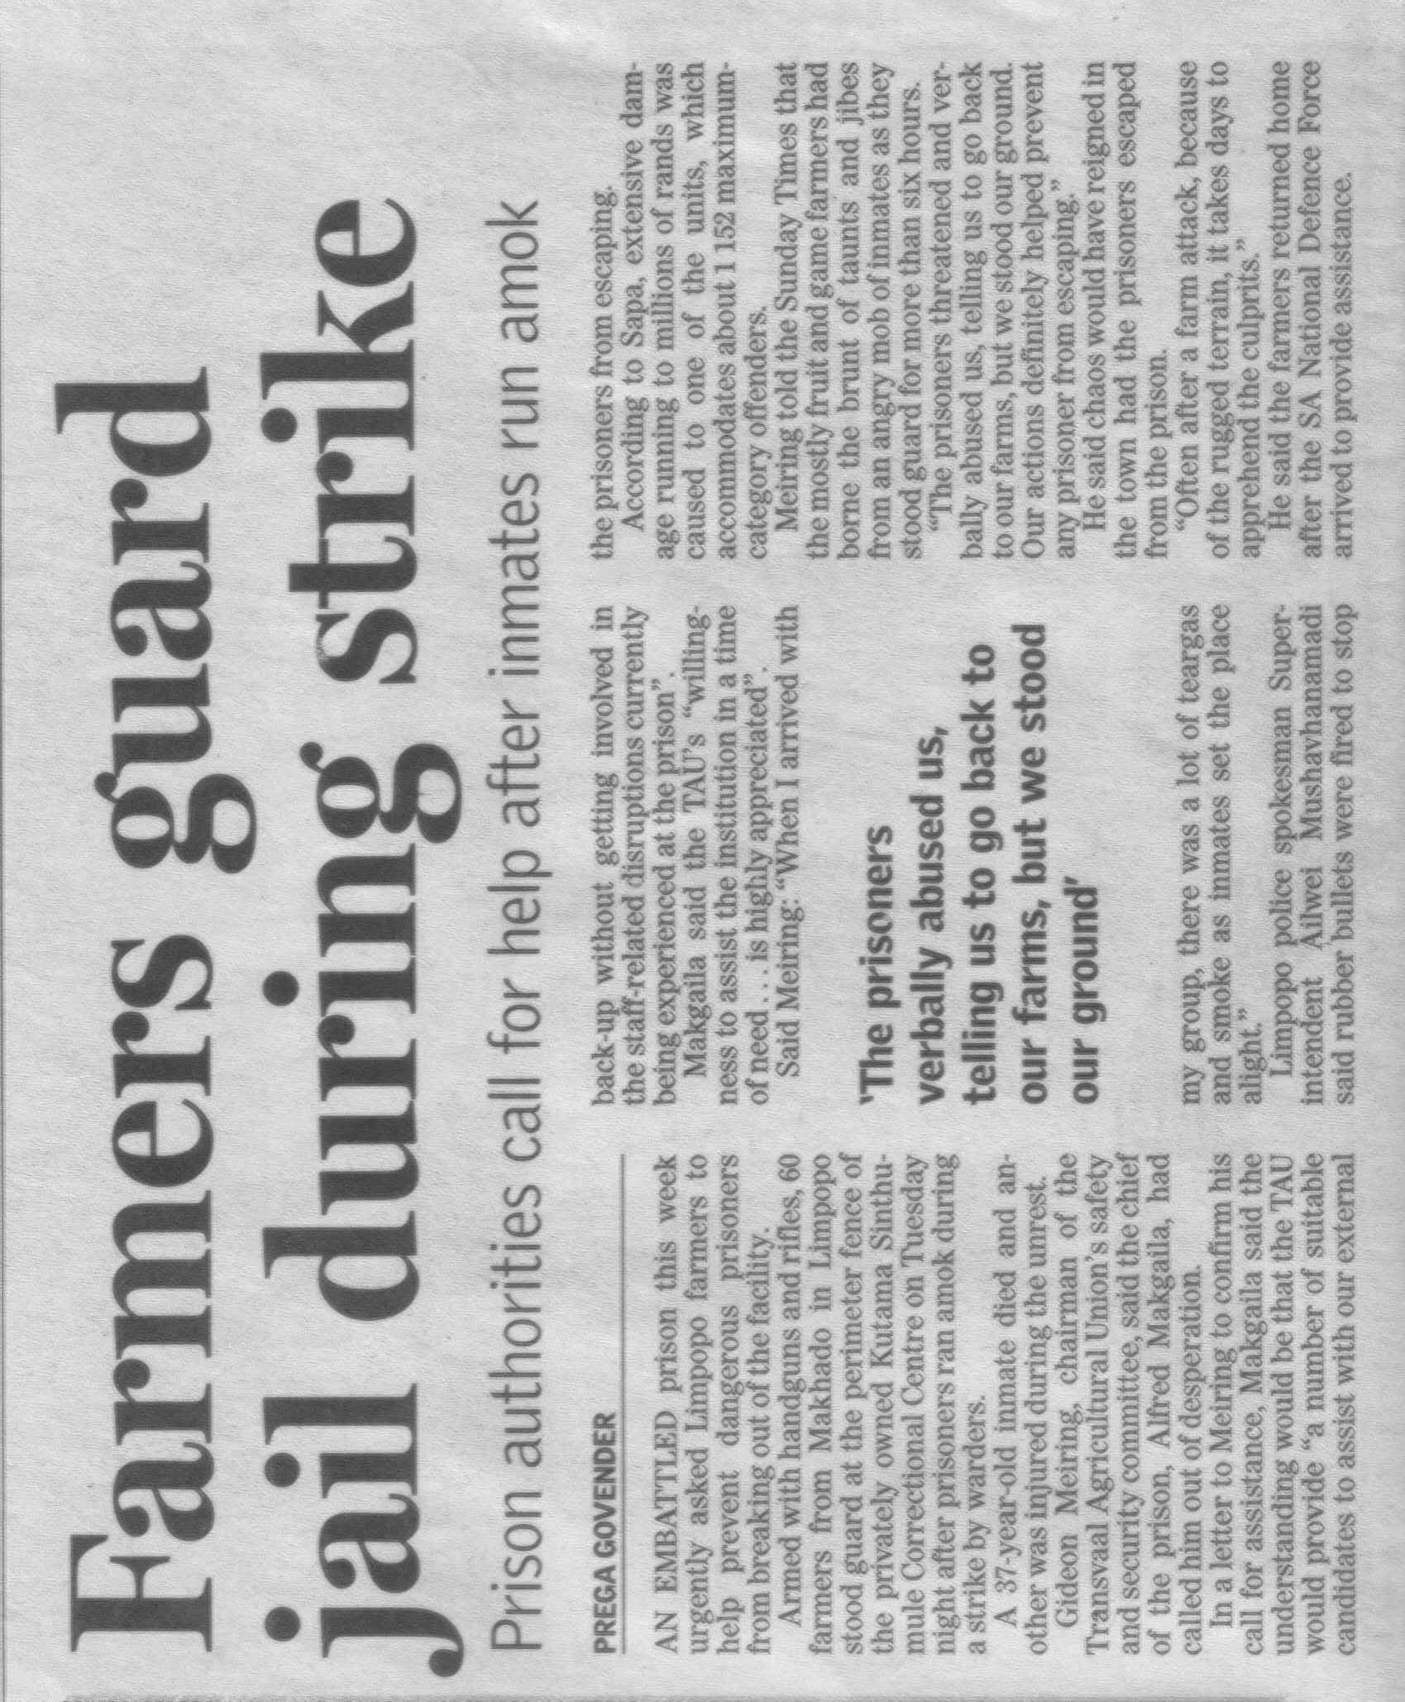

# EFFECTS OF CONTENT, LANGUAGE AND STYLE

#### Specific outcome

Evaluate the effects of content, language and style on readers` responses in specific texts..

#### Assessment criteria

* Outline the content of text and explore its possible effects on different readers.
* Identify and explain the impact of different writing techniques on reader perspective in terms of the particular effect produced by each
* Analyse the influence of specific language structures and features
* Explain the effect of selected production techniques in visuals.

## Outline Content

## Writing Techniques

Authors make use of various writing techniques in order to persuade readers to their point of view. These techniques were discussed during module 1, but will be repeated here.

### Sentence Length

The sentence may be regarded as the core of language communication, because a sentence is a complete thought that conveys (gives) a meaning. In other words, you use a sentence to explain yourself to other people, or to give your opinion about something. The end of a sentence is indicated by a full stop, called a period these days.

A sentence must make sense, therefore a sentence must express a complete thought. In order to do this a sentence must contain a verb (doing something) and a noun ( a subject) and the sentence must contain a thought that includes an idea that is relevant to the subject or the doing.

If you say: *“The accident happened as I crossed the road.”,* it makes sense to everyone who hears it and reads it. If you say: My dog was run over and Vin Diesel visited South Africa.”, it will not make much sense to other people. The two concepts have nothing to do with each other. In an instance like this, you will have to use two or more sentences or even two paragraphs.

A short sentence could be: Thabo takes the dog for a walk.

Authors use short sentences to heighten (increase) tension in a written piece. Longer sentences make a written piece more relaxed and not as filled with tension. If you are writing about strikes and unrest, your sentences would be shorter, while the sentence in a written piece about farming would be longer to create a more relaxed atmosphere.

Generally, we would try to vary the length of sentences in any written piece. A written piece that has only long or short sentences can be tiring to read.

There are three basic types of sentences.

#### Simple Sentences

These have one verb and one subject and object. “The boy is playing with the ball.”

#### Compound Sentences

A compound sentence is made up of two or more thoughts or sentences that are related to each other. The thoughts or sentences are then connected to each other to form one sentence by using the following words: **but, and, or**.

but, and, or

“The boy is playing with the ball, but his mother is calling him.”

“the boy is playing with the ball and some other children are watching.”

Sentences should have the same topic if you want to create a compound sentence. The following two sentences are not related to each other and should not be joined: “It is late.” and “I like reading.” “It is late and I like reading” does not make sense, since they do not share the same topic: lateness and reading do not have anything to do with each other.

“It is late and I am going to bed.” is a better example.

#### Complex Sentences

Consist of one independent sentence with one or more dependent clause that relates to it. The sentence and the clauses are **separated by a comma.**

“Although it is raining, the boy is playing outside.” Can you see that*: “Although it is raining”* is not a full sentence, it does not have a subject, so it is called a clause and has to be added to a sentence.

,

The clauses and the sentence must relate to the same topic if you want to create a complex sentence. “Although it is raining, I like reading.” Is a pointless sentence, since they do not share the same subject. “I have to go to the shop, even though it is raining,” is a better example of a complex sentence.

Remember:

Too many short sentences will make your text appear choppy and curt.

Too many long sentences will have the opposite effect, your text will appear confusing.

Short sentences should be varied with longer sentences to give your text an even flow.

### Diction

Diction refers to the choice and use of words.

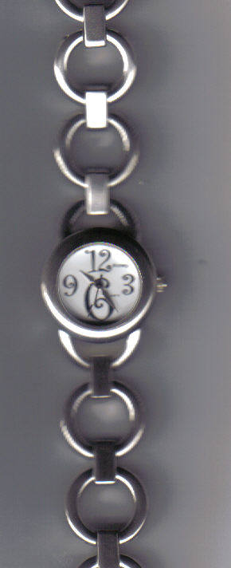In most languages, but especially in English, words can have more that one meaning, depending on the context they are used in.

Watch can mean:

* To **watch** something, in other words to look at something attentively – watch TV or a soccer game or a movie
* It can also mean a **watch** that you wear on your arm and use to tell the time.
* When you **watch out** for something it can mean that you have to be careful. Watch out for that car/rock in the road, etc.
* A **watch** is also used to describe a fixed period of duty, usually four hours, on a ship, or in the Army. Firefighters also divide their **working shifts** into **watches**.

The actual meaning of the word will be determined by the context – the sentence and paragraph that it is used in.

### Figurative Language

**BOVIN005**This is done when we use a word or phrase in a non-literal sense (not to be taken literally) to add interest to speech or writing.

**Food for thought**. We cannot really eat our thoughts. The expression means that it is something to think about.

**He is as strong as an** ox. He is not really as strong as an ox, we only say this in order to illustrate how strong he is

When mothers say to their children “ I am so angry I could kill you…” they usually don’t mean this literally. Most mothers don’t kill their children. It is a figurative expression of how angry the mother is.

### Jargon, Technical Terms, Legalisms

#### Jargon

Words or expressions that are used by a specific trade, business or industry.

* A paper tiger: when a committee or other body is established to investigate an occurrence, and nothing much happens, it is called a paper tiger. It means that the committee is not doing what it is supposed to do, the members of the committee postpone actions and make up imaginary problems as to why they cannot do the work in time.
* In the training environment in South Africa we find a lot of jargon – words that are used in a context not previously used and existing words put together to mean something that is unique to the education and training environment. We talk about Unit Standards, which previously was called training courses, we talk about assessments rather than tests and we have standards generating bodies and standards governing bodies, and so on.

The world of IT (personal computers, etc.) is also full of jargon, even though most of the words do become part of every day use eventually. Every now and then we are bombarded by the latest technology such as Ipod, 3G, etc.

#### Technical Terms

Words or phrases that are complex and usually technical and relate to a specific industry or sector.

* **Electrocardiograph**: monitors the heartbeat
* Government **fiscal** matters: to do with the governments budget and how they spend the money that we pay in taxes.
* The **metallurgist** in charge is Karis Allen, 35, a specialist in fractions and corrosion: a metallurgist is a person who specialises in studying metals, fractions and corrosion in this instance means how metal, such as steel, breaks and corrodes.

#### Legalisms

Legalism can be broadly defined as jargon used in the legal profession. People involved in the legal profession love to quote legal terms in Latin, presumably so that the rest of us cannot understand a word they are saying. ☺

Terms such as:

* **Prima facie**: it appears to be so when first looked at.
* **Sub Judicae**: means the investigation is still ongoing, no judgment has been given yet
* **Crimen Injura:** libel – when you say rude and unpleasant and, usually untrue, things about other people.

You can use jargon, legalisms and technical terms when writing, but only when the readers will understand, for example when they are also involved in your specific industry.

When you are writing for the general public, you have to be careful of using jargon and complex terms, unless you also enclose explanations.

### Slang And Dialect

#### Slang

**Very informal words and phrases** that are more common in speech than in writing and are used by a particular group of people

* My Bra
* Howzit Broe
* Whazzup

Never use slang for:

* Business correspondence.
* Writing to people you don’t know.
* Writing to the press.
* Writing to you local municipality, logal government or central government.
* In fact, not for any formal correspondence.

#### Dialect

A form of language used in a particular region or by a particular social group.

The way we speak English and Afrikaans in Gauteng is different to how it is spoken in the Cape. The people in the Cape have their own unique way of speaking, which is legitimate even though not always grammatically correct. When this happens, it is called a dialect.

A dialect is usually mainly one language, but with a lot of borrowed words and neologisms, and a unique way of pronouncing the words.

If you write in a dialect, most people will not understand you. The only people who will understand you, will be those who speak like that every day. If you send an e-mail to England or Australia and you base your e-mail on a dialect of Afrikaans or English as it is spoken in the Cape, chances are that the receipient of the message will not be able to understand.

Most languages have dialects spoken in certain areas. In the United Kingdom (Britain) the way the Scots and the Welsh people speak English is different to the way we speak English. Even in London you will find more than one dialect of English, the most common one being “Cockney” English. We all find it difficult to understand what they are saying.

### Irony, Humour, Satire, Sarcasm

#### Irony

The expression of meaning through the use of language which normally means the opposite.

When an author uses irony, he states one thing, while meaning the opposite.

sport team lost a game badly over the weekend. On Monday morning you discuss the game with colleagues and you say: “Well, they played really well”, you are being ironic, since you mean the opposite.

#### Sarcasm

Is a way of using words that implies the opposite of what they mean, so as to upset or mock someone.

If you were talking to one of the team players that lost the game badly, and you say to him: “Well, you guys really played well” you are being sarcastic.

#### Humour

In the dictionary, humour is stated as being:” the quality of being amusing”. Jokes are humorous, so can text in an article be humorous or even a novel (long story) or parts of a novel.

#### Satire

When an author uses satire, he portrays human weaknesses and shortcomings in a mocking way, usually in order to encourage people to improve their behaviour. The satirist uses his writing to show people how silly and ridiculous their behaviours and attitudes are. The cartoonist Zapiro is a satirist who uses cartoons to express his views of people in a mocking way in order to emphasize how silly we can be.

The Madam and Eve cartoon also uses satire, sometimes irony and also humour to portray South Africans in all their silly behaviours and beliefs.

## Language Structures And Features

### Bias

Bias is an opinion or tendency to be strongly for or against a person or thing.

We are all biased in some way or other. We feel strongly about certain subjects, such as pornography, schooling in mother language, and many other subjects.

Then there are subjects over which people are biased, but do not necessarily feel too strongly about it, so we don’t get all worked up about it. This could be school uniforms, what to wear to the movies, and so on.

We all have opinions about everything, some opinions are stronger than others. Unfortunately, although we would like it to be so, our opinions and views are not always the right ones and, when we do not want to be convinced otherwise, we are biased.

Unfortunately, not all biases are harmless. Bias can take many forms: it can be based on cultural or religious beliefs, it can show itself in a misrepresentation of facts, it can be discriminatory in terms of race, sex or age. It can also be due to peer preferences.

Recently there was a cartoon of the Prophet Muhammad, who is revered by Muslims, in an overseas newspaper. This cartoon sparked a huge reaction from Muslims and ended in endless debates and even violence. The cartoonist was probably biased, as were the Muslims, as is their right. We all have views that are very precious to us and it is unfair of other people not to think about our views and feelings. In the same way, it would be unfair of a Muslim to draw a cartoon about Jesus, who is very dear to Christians. Luckily, this is not the way of Muslims, so, to my knowledge, it has not yet happened. There is a lot that can be said in favour of the cartoon as well as against the cartoon. In the end, however, nobody has the right to attack a belief or a person that other people hold dear, as happened with the cartoon of the Prophet Muhammad.

Whenever you read a written piece of text, you have to bear in mind that you yourself are biased and also that the author is also probably biased. You must always be able to determine the bias in yourself and the author.

Also, whenever you communicate in writing or verbally, bear in mind your own bias as well as the bias of your audience.

Lastly, remember your painful experience at the hands of some other person and his/her bias, before you treat people with disrespect because they disagree with you.

### Omission And Silence

Two of the tactics most used by journalists who write for newspapers and magazines are omissions and silence. Many people are misquoted in this way.

Omission is something that has been left out.

You can see that omission is dangerous and unethical and can get you into trouble, especially in the workplace.

### Repetition; Hyperbole; Generalisations; Stereotyping

#### Repetition

The saying of the same thing over again in different words. This is incorrect use of grammar.

We tend to get into the bad habit of using more than one word that has the same meaning, to illustrate what we are saying:

* Milk dairy
* Reverse backwards
* I will kill you dead
* They arrived one after the other in succession
* Hurry up quickly
* We smell it in our noses

#### Hyperbole

An exaggerated statement that is not meant to be taken in the strict sense of the words.

“I have told you a thousand times to clean your room.”

#### Generalisation

Make a general or broad statement based on specific cases.

**“Nobody from the Cape eats pap”.**

This is not true, most people from the Cape prefer to eat something else, but some of them do eat pap as much as we do.

When the soccer or rugby team loses two or three games in a row, we tend to say things like: “We can’t play soccer or rugby, we always lose”. This is also not true, since they do win games.

Beware of general statements when you read or write something. Writers should be careful of using general statements, as readers tend to believe what they read.

#### Stereotyping

An over-simplified idea of the typical characteristics of a person or thing.

All blondes are stupid. This is a stereotyping, since not all people with blonde hair are stupid. We just notice it, since blonde women are more noticeable to men, and when a blonde woman does something stupid, all blondes are called stupid.

Similarly, I could stereotype all young black men as women haters, based on their behaviour outside the court during the Zuma rape trial. This is obviously not true, it is even possible that most of those young men do not hate women, they just chose a bad way in which to support their idol and hero.

Be careful of stereotyping people, as we are not all the same.

### Typography And Grammar.

#### Typography

Typography refers to the use of:

* Different font types and sizes.
* **Bold**, *italics* and underline.
* Titles and subtitles.
* The layout of the page.
* Copy breakers.

This was also discussed during exercise 1

#### Grammar

Grammar is the whole structure of a language, including the rules for the way words are formed and their relationship to each other in sentences.

This has to do with the words we use in sentences and also how we use them in those sentences.

Remember that we said that a sentence must make sense, therefore a sentence must express a complete thought. In order to do this a sentence must contain a verb (doing something) and a noun ( a subject) and the sentence must contain a thought that includes an idea that is relevant to the subject or the doing.

If you say: “ My husband and I have been nearly married for two years.” it literally means that for two years you and your husband have been almost married, but have not gotten married yet. You probably mean that for two years you have been thinking about getting married, but cannot make up your minds to actually do it.

If you say: “My husband and I have been married for nearly two years” it means that you and your husband got married nearly two years ago and you are still together.

Below is a quote from an article about slavery, as written by the author.:

Once the Arabs seized the cattle, they moved from hut to hut gathering grain, blankets, salt – and human booty. Deep in the shadows of one hut, they discovered Abuk. Grabbing the terrified woman by her bead necklace, a militiaman growled, “Now you belong to me!” In all, 282 Dinka, including Abuk’s mother, sister and niece were herded up and forced to march north.

If I substitute the word “booty” in the first sentence with “bodies”, it would mean that the slave traders gathered the remains of dead people to take with them.

If I change the word order of the third sentence, I can change the meaning of the sentence as well:

“Grabbing the woman by her bead necklace, a terrified militiaman growled ….”

This, of course, means that the militiaman is terrified, and not the woman.

It is easy to change the meaning of a sentence or paragraph just by changing the order of the words in the sentence or paragraph. You must always be aware of this and ensure that, when you are writing something (especially your summaries) you use grammar correctly. If you don’t you can be misunderstood and this could sometimes have serious consequences.

People can be misquoted simply by changing the word order of the sentences. When you read and write text, you have to be careful of our use of grammar.

You also have to be careful of your choice of words. If you are writing an article about the non-delivery of services such as rubbish removal, you cannot refer to black rubbish bags as: “Bagged issues”. The people who read your article will not understand what you are talking about.

## Styles Of Writing

To express yourself clearly in writing you should pay special attention to:

* Reading and understanding, also called comprehension.
* Assembling fact and constructing prose (text).
* Sentence structure.
* Paragraphing.
* Assembling paragraphs.
* Making a summary.
* Taking notes.
* Expanding notes.
* Paraphrasing.

We have already covered some of these topics, such as reading and understanding, paraphrasing and so on. We will now move on to actual writing of text.

### Narrative

Narrative style means to tell the story without using dialogue.

It is also used to provide a commentary for a film or television programme.

Scared but holding steady, a Brazilian boy offers his arm for vaccination against the mosquito-born yellow fever virus. Bringing misery to the vulnerable, viruses cause diseases ranging from the common cold and measles to hepatitis and AIDS. Viruses appear to infect all living things – yet are not quite alive themselves. Particles of genetic material – the essence of life – they lie as inert as the dead until an opportunity arises to invade a host.

You can see it’s like telling a story, where the emphasis is on the sequence of events. Articles in the newspaper, on the radio, on TV and in news reports are written in a narrative mode. Diary entries, autobiographies, a report, etc are also written in this mode. A narrative is easier to follow because it is easier to visualise.

### Discursive

Write about a topic in detail, similar to when you are having a discussion with friends about a topic. It might also happen that you include unrelated topics in the text.

### Reflective

Thoughtful

In the following text, the person is thinking about growing up.

As my stepfather’s postings and later my own were all at the whim of the Foreign Office, I’d mostly lived those twenty years abroad in scattered three- or four-year segments, some blazing, some boring, from Caracas to Lima, from Moscow to Cairo to Madrid, housed in Foreign Office lodgings from one-bedroom concrete to gilt-decked mansions, counting nowhere home. I was rootless and nomadic, well used to it and content.

### Argumentative

A set of reasons given in support of something.

Following is an extract from National Geographic October 1995, when civil war was raging in Rwanda with devastating effects not only on the people but also on the wildlife.

**A fragile home threatened by war.**

Among the last of its kind, a young gorilla peers from its leafy refuge in Rwanda – a nation bloodied by ethnic slaughter. Conservationists fear that Rwanda’s instability could endanger the gorilla’s survival. Others ask: How should the plight of the world’s rarest ape be weighed against more than 500,000 human dead?

When you are expressing an opinion and giving reasons for it, you are using the argumentative style of writing. The audience may or may not agree with the arguments. An argument can be for persuasive reasons, or it ca be informative or to interact. Always be precise and clear in your reasoning. Consider arguments that could be against your reasoning. Remember:

* People tend to accept factual evidence.
* Work progressively and systematically through your reasoning to reach the point you want to make. This approach could be convincing.
* Take contrary arguments into consideration. In the beginning mention both sides of the argument then focus on your reasoning.
* Explain your reasoning carefully. State your opinion and express your views yet acknowledge the contrary arguments even if you don’t agree.

### Descriptive

Describing without expressing judgement.

In the following passage, the writer does not try to persuade you to buy the item, he merely states the features of the product.

The Nokia HS-12W Wireless Stereo Headset has been designed for people who listen to MP3s on their phones and need to effortlessly switch between music and phone mode in an instant. The display serves to provide music information, caller ID and MMS/SMS notification, while the built-in stereo FM RDS radio provides automatic channel search.

A descriptive text is when you are saying what something looks like. Is used any many different situations such as

* writing about specific events where detail is necessary as in travel writing,
* biographies when you write about specific people and specific events,
* technical and scientific works where detail is very important

### Expository

A full description and explanation of a theory.

Usually used in the media to reveal something discreditable. Any scandal that is reported in the media is written in expository style.

Expository style is also when you are explaining how something works. This writing is concerned with the pattern of things, how things work, how to do something and the underlying reality of a situation. It is clear, logic, ordered and to the point. The focus is on what is practical and useful such as articles on gardening, features in newspapers, articles about institutions, organisations, etc.

### Transactional

Relating to a business transaction. This would usually be invoices, debit and credit notes, notes to purchase and so on. When you complete a deposit slip at the bank to deposit money into your account, and you hand the deposit slip and the money to be deposited to the bank teller, the communication is transactional

### Business correspondence

Will include all business correspondence: letters, faxes, memos, buying orders, invoices, credit notes, debit notes and so on.

### Electronic texts

**Would be sent via e-mail.** There is a specific set of rules regulating e-mails.

#### Sending e-mails: Start Outlook

Once Outlook has been installed on your computer you can start the application double-clicking the Outlook icon .

**OR**

On the Taskbar, click the Start button then select the All Programs menu item.

* 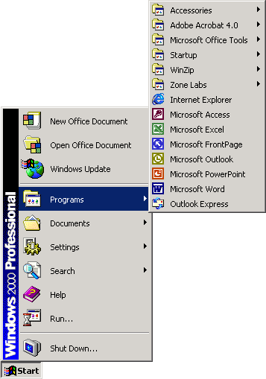The All Programs submenu is displayed.
* Click the Microsoft Office program item

Click the Microsoft Outlook program item

#### Enter Data Into The Mail Window

**To…**

Enter the e-mail address of the recipient in the To… box. You can enter the names of more than one recipient in the To… box, as long as you separate the names with a semicolon(;), for example:

[narina@photography.co.za;albert@hotmail.co.za;yourname@timdutoit.co.za](mailto:narina@photography.co.za;albert@hotmail.co.za;yourname@timdutoit.co.za)

**Cc…**

To enter an e-mail address in the **Cc…** box, follow the same procedure as above. Cc stands for Carbon Copy. CC means that the e-mail is sent to that recipient for information only, the recipient does not have to respond or reply to the message.

**Bcc…**

Bcc stands for Blind Carbon Copy. When you enter a recipient’s address in the **Bcc…** box, the recipients in the **To…** and **Cc…** boxes will not see the names of the recipients in the **Bcc…** box - that is why it’s called Blind Carbon Copy. You will use the Bcc… box when you do not want the recipients in the **To…** and **Cc…** boxes to see that you are sending the message to a specific recipient.

If the **Bcc…** box is not displayed, click the down arrow to the right of the Options... button and select Bcc.

You can use either the **Cc…** or **Bcc…** boxes without using the **To…** box, as long as there is at least one recipient in one of the three boxes the e-mail can be sent.

#### Enter a Subject Heading

Once you start sending and receiving e-mails, you will find that a lot of correspondence and communication is conducted this way. It is possible that you will send and receive up to 300 e-mails daily. You will therefore appreciate it when people who send you e-mails give an appropriate subject heading, as the e-mail will be listed in your Inbox under the subject heading.

Giving the mail a subject heading such as: Thabo’s mail will be silly. When you write or type a document at work for a client or a superior, you always include a subject heading that gives details about the letter. The same principle will apply to an e-mail subject heading.

If the mail is about a weekly or monthly meeting, for example, include the full details of the meeting and the purpose of the e-mail, which could be the agenda or minutes of the meeting:

Agenda for weekly meeting to be held on 25 Jan 06

**OR**

Minutes of meeting held 15 Jan 06

If you only state minutes of meeting and the meeting is held every week, you will end up with about 50 e-mails with the same subject, which will make your life and the lives of the recipients very difficult when you want to find the minutes of a particular meeting.

Think carefully about the subject heading and make sure that it makes sense, conforms to the protocol as prescribed by your organisation and, above all, ensure that it will be easy to find this particular e-mail again.

* to or click in the Subject: box
* Type a subject heading for the message

#### Body of the message

to or click in the main box, where you will enter the message.

Remember that an e-mail is usually an electronic form of a letter. Follow the same format as If you are typing a letter. If it is to a friend, it can be informal, if it is to a manager, it has to be more formal.

#### Attach A File To A Message

* Click the Insert File button on the Message toolbar, **OR** 
* Select the Insert, File menu. The Insert dialogue box will be displayed. Ensure that the Files of type text box is set to All Files. This way you will see all the files that are available.
* Browse to select the file you want to insert and then click the Insert button in the dialogue box. You will usually find the file that you want to attach in the My Documents folder.
* You will see the file attachment in the **Attach...** box underneath the Subject: box.
* If you attached the incorrect file and want to delete the attachment, click the attachment icon in the **Attach...** box and press .
* To attach more files, follow the same procedure for each file.

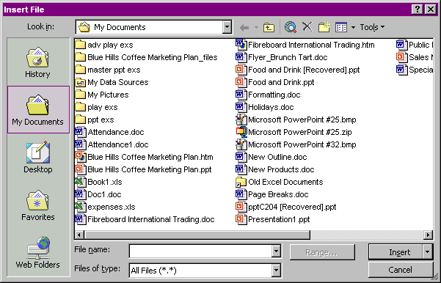

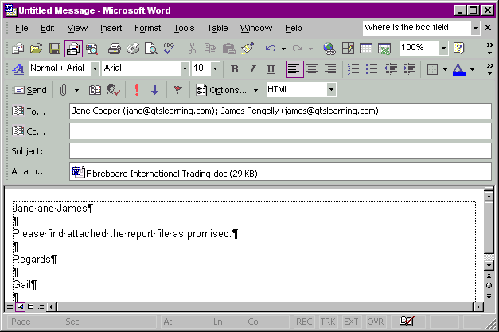

### Multi-media presentations

A multi-media presentation is what it says: **a presentation using more than one visual medium**. In other words, you include a visual presentation on a PC, you can also use a projector or a TV and video combination, or even photos and other visual images posted against the wall, as long as you use more than one medium.

The first medium is usually paper-based in the form of a manual, a book, notes and so on. Multi-media presentations are very effective since they make use of more senses than just our eyes.



|  |  |  |
| --- | --- | --- |
| **PRESENTATION AIDS** | | |
| **PRESENTATION AID** | **ADVANTAGES** | **DISADVANTAGES** |
| Posters.  TEXT135 | * Can be re-used * Used to summarise Colourful * Portable * Easy to prepare * Build up a library * Relatively cheap * No electricity needed * Permanent display | * Can contain too much information * Easily damaged or removed * No movement or sound * Leave marks on walls |
| Overhead Projectors. Projecting transparencies on a screen  AV002 | * Portable * Transparencies can be colourful * Transparencies can be kept (library) * Easy manageable * Can make transparencies yourself * Image sharp enough for daylight use * Presenter does not turn back on students * Presenter has full control over sequence of material * Presenter can point at, write on or make notes on the transparency | * Lamps can fuse * No sound * Time consuming to prepare transparencies * Cord/extension could be in the way * Dependable on electricity * Too many Transparencies or information |
| Microphone  COMMU027 | * Reach large audience * Portable * Cordless * Convenient | * Expensive * Breaks easily * Distortions |
| Pictures  Slide19 | * Good for overall view * Good for describing new processes, machinery, products, etc. * Colourful * Easy to handle * Easy to prepare * Interesting * Pre-planned * Used for individuals and groups * No electricity is necessary | * No sound or movement * Could be too small * Can be lost or damaged * Different interpretations * Cultural context |
| Flipcharts  AV035 | * Making lists of steps or main points * New words, terminology, definitions * Prepared in advance or during presentation * Simple sketches * Calculations * Assignments * Group work, brainstorming * Easy and fast to prepare * Easy to use User-friendly * Used in daylight conditions | * Lose information when pages are flipped over * Leave marks on walls if pasted * Distracting * Bad writing * Can lose eye contact * Spelling mistakes * Tripping hazard * Small audiences only * Back could be turned to group * Eye contact could be broken |
| Slides  AV017 | * Re-usable * Sequential * Mobile * Professional * Colourful | * Electricity * Depend on notebook and data projector. * Needs electricity |
| Television and Video  AV041 | * Professional * Colourful * Sound * Can be repeated / rewind / re- used * Can be stopped / paused * Can build up a library * Brings reality into the training room | * Depend on TV and video machine * Takes time to set up * Needs electricity * Can be lost * Expensive to make * Small screen * Audience must adjust to pace of video * Passivity may develop * Contact is lost with trainer * Dim lights |
| Computer Graphics  B7673 | * Update immediately * Colourful * Professional * Immediate corrections * Pre-planned * Can repeat / look again * Students can work at own pace * Records on stiffy * Can be used again and again * Can be used in business and training presentations * Can be used as alternative for slides or overhead transparencies * They can provide video-like effects, such as wipes, animation, fades, etc. * Portable (Note-book) * Can be used for individual and groups | * Needs electricity * Venue must be appropriate * Need expertise * Time consuming to set up * Expensive * Computer illiterates |

## Production Techniques In Visual Aids

Most of us use visual aids to enhance and explain our writing as well as oral presentations. Visual aids give important visual clues about the text or the presentation and can enhance and emphasize our points of view and also convince the audience of our point of view.

### Photographs And Slides

#### Photographs

One of the most popular techniques used in written communication is photographs. As with any visual representation that is used to supplement written material, photos can have a big impact. The old saying: “A picture paints a thousand words” is very true of photos.

Newspaper photos of the weekend’s sport events illustrate what happened. Photos, of a big natural disaster, such as the tsunami around Christmas 2004, or a hurricane or earthquake, a plane crash or a train that has derailed, sells many newspapers, as people want to see what it looks like after the disaster.

Of course, photos are used in more positive ways than negative ways and it is important for you to consider using photos with your written work. The photo has to add to your writing, please don’t use photos that are not relevant to your written work.

Photos are very effective when you want to persuade readers to your point of view: If you want investors to buy a nice seaside or bushveld property, including a colourful, clear photo of the property will give the reader a positive visual stimulation.

If you want readers to contribute towards a hunger relief fund, showing photos of hungry children will encourage many people to contribute.

If you want voters to vote for you, show them photos of what you have achieved, for example, the houses that have been built, the roads that have been built, and so on.

#### Slides

Slides are photographs taken on positive film. The quality and colour that is given by slides cannot be equalled by any photograph. Unfortunately, slides usually have to be viewed through a slide projector. On the other hand the quality of the image makes up for this disadvantage.

#### Colour Or Black And White?

Printing colour photos in articles is very expensive. Magazines use a lot of colour photos, but they cost more than a newspaper. Newspapers make more use of black and white photos with the occasional colour photo.

If you are going to print your writing in black and white, use black and white photos. If you only have colour photos, change them to greyscale on your PC or ask your printer to change them. You will have a better image.

If you are going to give a presentation on the computer, you will use more colour images than black and white. On the other hand, black and white photos and slides are more dramatic. Think about the photos of Sharpeville and the Soweto uprising. They will not have the same dramatic impact in colour as they have in black and white.

### Transparencies

Transparencies are used with Overhead Projectors and can be in colour or black and white. The facilitator will make use of transparencies during the course of this training. The layout and style of the transparency should be considered carefully, since this is your visual aid.

* How much text are you going to include in the transparency?
* Are you using photos, slides, cartoons, tables, graphs or other pictures to enhance the visual impact of the slide?
* Where are you going to place the text and where are you going to place the picture?

#### Some general rules are:

* Use many pictures, cartoons, drawings, photos, etc to make the presentation interesting.
* Try to alternate text with pictures, as transparencies or any kind of presentation that is made up of text only can become very boring.
* You can even have a picture on the background with text over the picture in the foreground, or the other way around. Refer to the section about captions, where the article was printed over the numbers 1994. The text in the background is a light grey, with the article printed in black over it.
* If you have a coloured background, follow these rules: if the background is dark, the foreground must be light; if the background is light, the foreground must be dark. Dark on dark and light on light does not work.
* Adding borders to your text or visual aids helps to focus attention on the contents inside the borders. This is why paintings and photos are framed before we hang them on the wall. The frame creates boundaries that focus our attention on the content within the frame.
* Always ensure that your pictures relate to the subject. Do not use pictures of people swimming in the sea if you are writing about an earthquake – you will confuse and antagonise the reader.
* Do not use too many small pictures and photos. Enlarge them so that the readers and audience can see them clearly.
* You can also use overlays in transparencies: this is where you have two or more slides about the same subject and you place them on top of each other as you build up your presentation. A good example would be a comparison of pass rates of matriculants. Your first transparency would contain all the details necessary to introduce the subject, as well as the pass rate of matrics in, say 2000. the next transparency would contain the pass rate of matrics for 2001. This only becomes visible to the audience when you place the slide over the first one.

### Posters

There are many examples of posters for us to view every day. Posters about violence against women, AIDS, soccer games, films, TV shows, advertisements, etc.

### Videos and Films

There are many training videos available for use with live presentations, especially about meeting and telephone technique.

However, the best examples of the visual impact that videos and films have on an audience is advertisements. Nando’s are known for making controversial advertisements in order to advertise their products and, if there is some controversy about the ad, it gives them even more free exposure.

Some advertisements are aimed at the general public, such as the Nando’s, KFC and motor car ads. Others are aimed at serious people or people who have to make provision for their families if something happens to them, such as insurance advertisements.

Films (movies) are also used at times to make a statement, such as the film Tsotsi, which recently won an Oscar for the best foreign film.

In advertisements, films and even training videos, a lot of use is made of dialogue (spoken words), pictures and music to emphasize the point of view of the filmmaker and also to dramatise events.

What we all have to be careful of is that any advertisement, film or video usually gives only one side of the story. Expository TV shows such as Special Assignment and Third Degree have to show the point of view of both sides, especially if it is a controversial subject that people feel strongly about. If they don’t, they can be sued for libel.

This is not true of advertisements, films and documentaries. Be aware that, although it is pleasant to watch, it usually still only reflects one point of view. Also, you do not know what the author has left out, so always do some research of your own before you blindly believe what is stated in film and video.