119457 Knowledge Questionnaire
Read through the article and then answer the questions that follow.
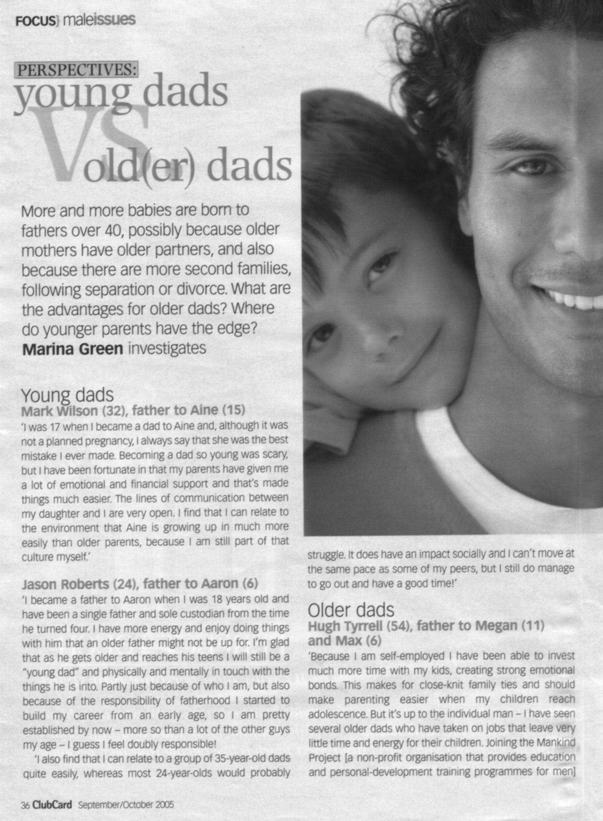

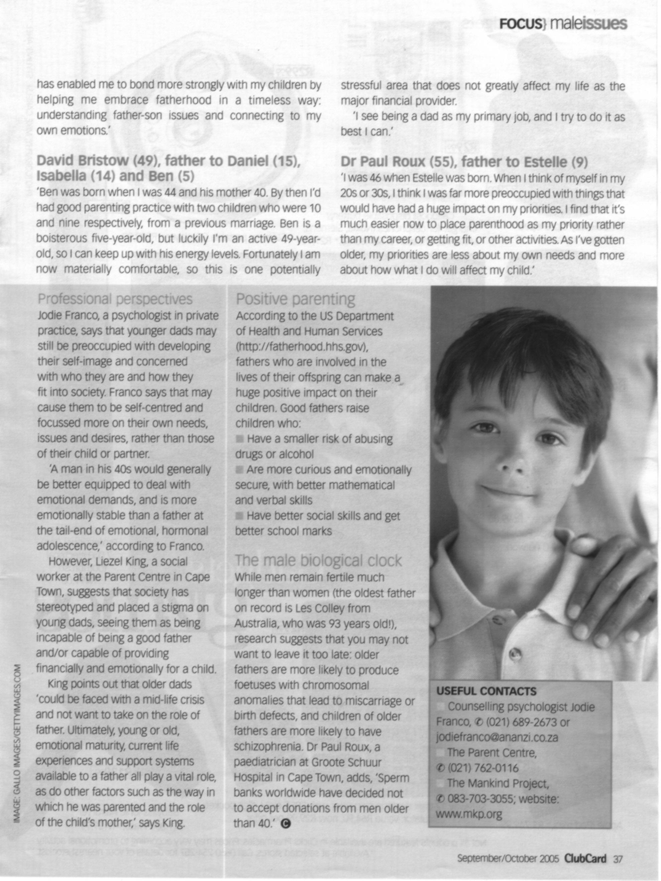
Unit Standard 119457 Specific Outcome 1: Use a range of reading and viewing strategies to understand the literal meaning of specific tests. Assessment criterion: Unfamiliar words are identified. Their meanings are correctly determined by using knowledge of syntax, word-attack skills and contextual clues.
- Underline at least three unfamiliar words. Explain the process you followed to determine their meanings.(6)
- List the words and their meanings. (3)
Assessment criterion: Different options for the meanings of ambiguous words are tested and selected meanings are correct in relation to the context.
- In the paragraph about Mark Wilson, father to Aine, Mark says: ‘she was the best mistake I ever made.” This is an ambiguous phrase, as mistakes are not usually good. What does he mean? Explain how you came to this conclusion. (3)
Assessment criterion: The purpose of visual and/or graphic representations in texts are recognised and explained.
- Why did they include photos of men and boys? (1)
- Do the photos explain the topic of the article? Motivate your answer. (2)
- Did the photos capture your attention? Motivate your answer. (2)
- Did the photos encourage you to read the article? Motivate your answer. (2)

Unit Standard 119457 Specific Outcome 2: Use strategies for extracting implicit messages in texts. Assessment criterion: Source of text is identified and discussed in terms of reliability and possible bias.
- Who is the author of the article? (1)
- Do you think the author is biased? Motivate your answer with at least three quotes from the article. (4)
Assessment criterion: Author’s attitude, beliefs and intentions are explored in order to determine the point of view expressed either directly or indirectly.
- Does the author have a point of view about older or younger fathers? Motivate your answer. (2)
- Is Jason Robert’s view expressed directly or indirectly? Motivate your answer. (2)
Assessment criteria: Author’s techniques are explored and explained in terms of purpose and audience; Promotion of, or support for, a particular line of thought/cause is identified and explained with reference to selection or omission of materials
- What is the purpose of the article? (1)
- Who is the article aimed at? Motivate your answer. (2)
- How does the author vary the length of the sentences? Motivate your answer by stating whether there are long and short sentences and whether there are more short sentences than long sentences. (2)
- Does the author’s diction make the article easy to read? Motivate your answer. (1)
- Identify jargon and technical words. Give at least two. (2)

Unit Standard 119457 Specific Outcome 4: Explore and explain how language structures and features may influence a reader. Assessment criterion: The choice of words, language usage, symbols and pictures and tone is described in terms of how a point of view is shaped or supported
- Does the author discriminate against older fathers? Motivate your answer. (2)
- Do you think the author is biased? Motivate your answer with at least three quotes from the article. (4)

Assessment criterion: Author’s attitude, beliefs and intentions are explored in order to determine the point of view expressed either directly or indirectly.
- Does the author use repetition in the article? Motivate your answer. (2)
- Is the author sarcastic? Motivate your answer. (2)

