FORMATIVE ACTIVITIES

Exercise 1
- In a group, find out what the difference is between prose and novels.
- What is meant by historiography?
- There is a very subtle difference between fairy tales and fables. Find out what the difference is.
- Look at two different magazines and compare the layout of the magazine in terms of: font type and size, the use of bold italics and underline and how titles and subtitles are used. Each magazine has it’s own style and you should be able to recognise it. Note the differences for your assessments.
- In most magazines and newspapers a summary or a short quote from the article is often emphasized by enlarging the quote. This is called a copy break. Compare the use of copy breaks between the two magazines: how many do they use, what font type and style is used, where is it placed in the article, does it arouse interest?

Exercise 2
In a group, discuss the article about farmers guarding a jail and determine the views that the author states clearly – views that are on the surface
Then determine the embedded meaning in the text.

Exercise 3
Write a summary of the author’s point of view, both surface and embedded. Quote evidence from the text to support your statements.
Exercise 4
Read the article below and answer the questions that follow:
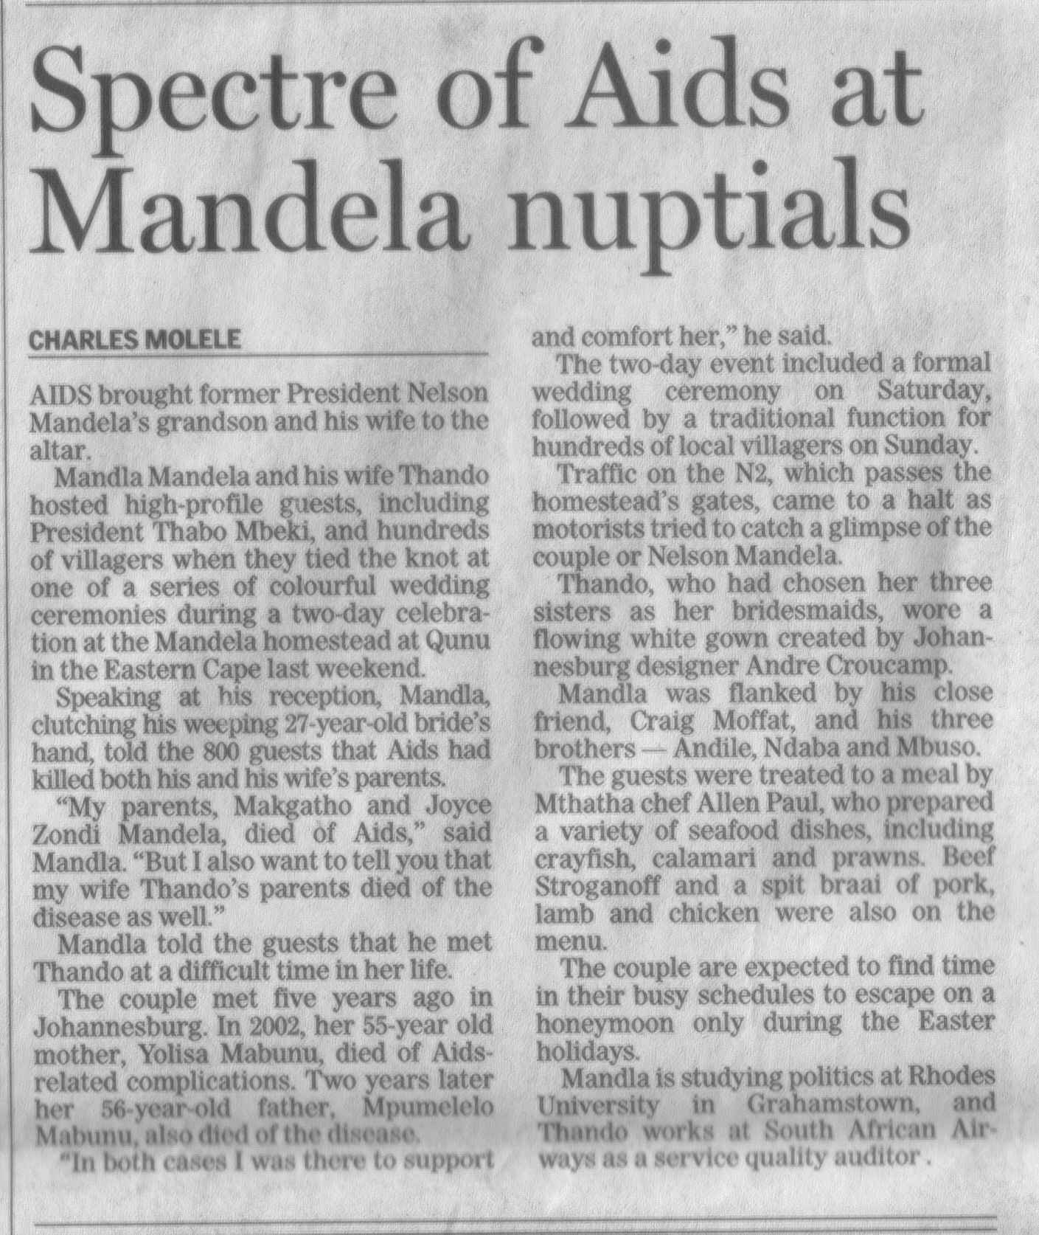

- Who is the author?
- Does the author express any view of his own?
- Who got married?
- When did they meet?
- Who died of AIDS and AIDS related complications?
- Could you find any embedded meaning in the text?

Exercise 5
During exercise 2 and 3 you were asked to analyse the articles
In your own words, describe the effect you think the articles may have on:
- People who have family in jail
- People who know the farmers who guarded the jail
- People suffering from AIDS
- People who know the couple that were married

Exercise 6
In a group, analyse the article about farmers guarding the jail.
- How many short sentences are used in the article?
- How many long sentences?
- Give one example of a complex sentence
- Give one example of a compound sentence.

Exercise 7
Analyse the article called: Spectre of AIDS at Mandela Nuptials.
- How many short sentences are used in the article?
- How many long sentences?
- Give one example of a complex sentence
- Give one example of a compound sentence.

Exercise 8
Refer back the article about the farmers guarding the jail.
- Would you say they are biased against prisoners in general?
- Do you think the behaviour of the prisoners was correct?
- Do you think that stronger action should have been taken against the prisoners?
- What does this tell you about yourself – are you biased in favour of the prisoners or the guards?

Exercise 9
- Refer back to your notes of Exercise 1.
- Which magazine’s layout, titles, copy break and use of typography did you prefer? Explain why you preferred it. in your explanation refer to their use of titles, subtitles, bold, italics, underline, the layout of the page, the font types and sizes and their use of copy breakers. What about this combination made the article pleasing to read?

Exercise 10
Rewrite any paragraph of the article about farmers guarding the jail and leave something out to change the meaning of the article.

