## Assessment 1: Questionnaire

1. Explain Tannenbaum’s definition of leadership by explaining how it applies to the workplace: (4)

*Interpersonal influence exercised in situations and directed through the communication process towards the attainment of goals.*

1. Explain Zaieznik and Moment’s definition of leadership by relating it to the workplace. (5)

*An interaction in which the conscious intentions of one person are communicated in is behaviour, verbal and otherwise, with the consequence that the other person wants to, and does behave, in accordance with the first person's intentions*

1. Explain the roles and qualities of a leader by discussing the following qualities:
   1. Humaneness (1)
   2. Objectivity (1)
   3. Transparency (1)
   4. Accountability (1)
2. In order to achieve his/her goals as well as that of the organisation, a leader must fulfil certain roles. Discuss the following roles that a leader undertakes:
   1. Visionary. (2)
   2. Motivator (2)
   3. Create synergies (2)
   4. Facilitate a developmental environment. (1)
   5. Innovator (1)
   6. A leader must be creative. (2)
3. Give a definition of management. (4)
4. Discuss the differences between a manager and a leader by completing the following statements: (9)
   1. A manager does things right ...
   2. Leaders give guidance while ...
   3. Manager administer...
   4. leaders develop...
   5. Managers control...
   6. Mangers worry about the short term...
   7. Managers ask how and when...
   8. leaders focus on people...
   9. Leadership can be linked to change whereas...
5. Explain what is meant by responsibility in the workplace. (1)
6. Explain what is meant by accountability in the workplace. (1)
7. Blake and Mouton have designed a model that identifies five different leadership styles based on concern for production and concern for people. Each aspects is measured a scale of 1 (low) to 9 (high). Describe the Behaviouristic Approach to leadership by naming each leadership style on Blake and Mouton’s managerial grid. (5)

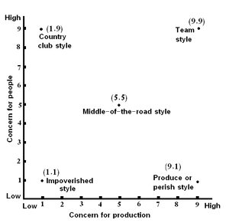

(1.9)

(9.9)

(5.5)

(1.1)

(9.1)

1. Discuss the impoverished style. (4)
2. Discuss the produce or perish style (2)
3. Discuss the team style (2)
4. Explain what is meant by servant leadership. (2)
5. There are ten characteristics that describe the essence of a servant leader. Name five. (5)
6. When does transformational leadership take place. (2)
7. What are the four dimensions of transformational leadership? (4)
8. Name four characteristics of visionary leaders. (4)
9. Describe innovative leadership in your own words. (2)
10. Name the 3 key areas of leadership. (3)
11. Explain what is meant by a role model. (1)

**TOTAL: 74**