ROLES OF A TEAM LEADER
LEARNER GUIDE
_________________________
U/S 13917

CONTACT DETAILS

HEAD OFFICE
Riverside Office Park Hennops Building
1303 Heuwel Avenue
Centurion

Private Bag X 106
Centurion
0046
Tel: 012- 622 9500
Fax: 012 – 663 9585

NATIONAL CONTACTS

Website: www.wrseta.org.za
E-mail: wrseta.org.za
Call Centre: 0860 270 027

TVET CONTACT DETAILS

Website: www.fetcolleges.co.za
Click on “Public FET College” and select ‘click here’ for a list of Public TVET Colleges and their contact details

CONTENTS
Icons ............................................................Pg.4
Registered unit standard: 13917 ……………………………….….......Pg.5
TOPIC 1: Explain the role of a team or group leader in ……………………………….……...Pg.8
a specific organisation
1.1 What is a Team? …………………………………………Pg.9
1.2 What can be expected of a team? …………………………………………Pg.9
1.3 The role of a team leader ………………………………………Pg.9
1.4 Team Leader - Key Roles ………………………………………Pg.9
ACTIVITY 1 ………………………………………Pg.10
1.5 Team leader characteristics ……………………………….……...Pg.10
1.6 Responsibilities of a team leader ……………………………….….......Pg.11
1.7 Accountability ………………………………………Pg.12
ACTIVITY 2 ………………………………………Pg.14
1.8 Advantages and disadvantages of organizing
workers into a team ………………………………….………Pg.15
TOPIC 2 SO 2: Explain the intended purpose of a
specific team or group ……………………………………....Pg.17
2.1 Explain the standards of performance required of a
team ……………………………….……...Pg.18
2.2 Explain the difference between a standard and an
objective ……………………………….……...Pg.18
ACTIVITY 3 ………………………………….….….Pg.19
ACTIVITY 4 ……………………………….……...Pg.20
2.3 Negotiate short term objectives for a team or group ………………………………………Pg.20
2.4 EVALUATING EMPLOYEE PERFORMANCE ………………………………………Pg.21
ACTIVITY 5 ………………………………………Pg.23
ACTIVITY 6 …………………………………..…...Pg.26
2.5 The role of each team member identified. ………………………………………Pg.27
TOPIC 3 Contract with group or team members to
obtain buy in ………………………………….…...Pg.29
3.1 Discuss the performance elements and tasks ………………………………………Pg.30
3.2 Negotiating and allocating tasks to team members
according to strengths and weaknesses. ………………………………………Pg.30
ACTIVITY 7 ………………………………………Pg.31
3.3 Negotiate a system to minimize weaknesses of the
team or individual members. …………………………………………Pg.31
ACTIVITY 8 …………………………………..…..Pg.32
3.4 Agree on realistic benchmarks and timelines for ………………………………..……..Pg.34
achieving individual or group goals through a process
of consultation.
TOPIC 4 Monitor achievement of group objectives or
goals ……………………………….……....Pg.35
4.1 Monitor group objectives or goals ……………………………………….Pg.36
4.2 Anticipate potential difficulties or problems to
minimize the effect of the identified problems. ……………………………………….Pg.38
4.3 Identify difficulties encountered by the team
members to minimize the effect on team performance. ……………………………………….Pg.39
ACTIVITY 9 ……………………………………….Pg.40
References ………………………………………......Pg.41

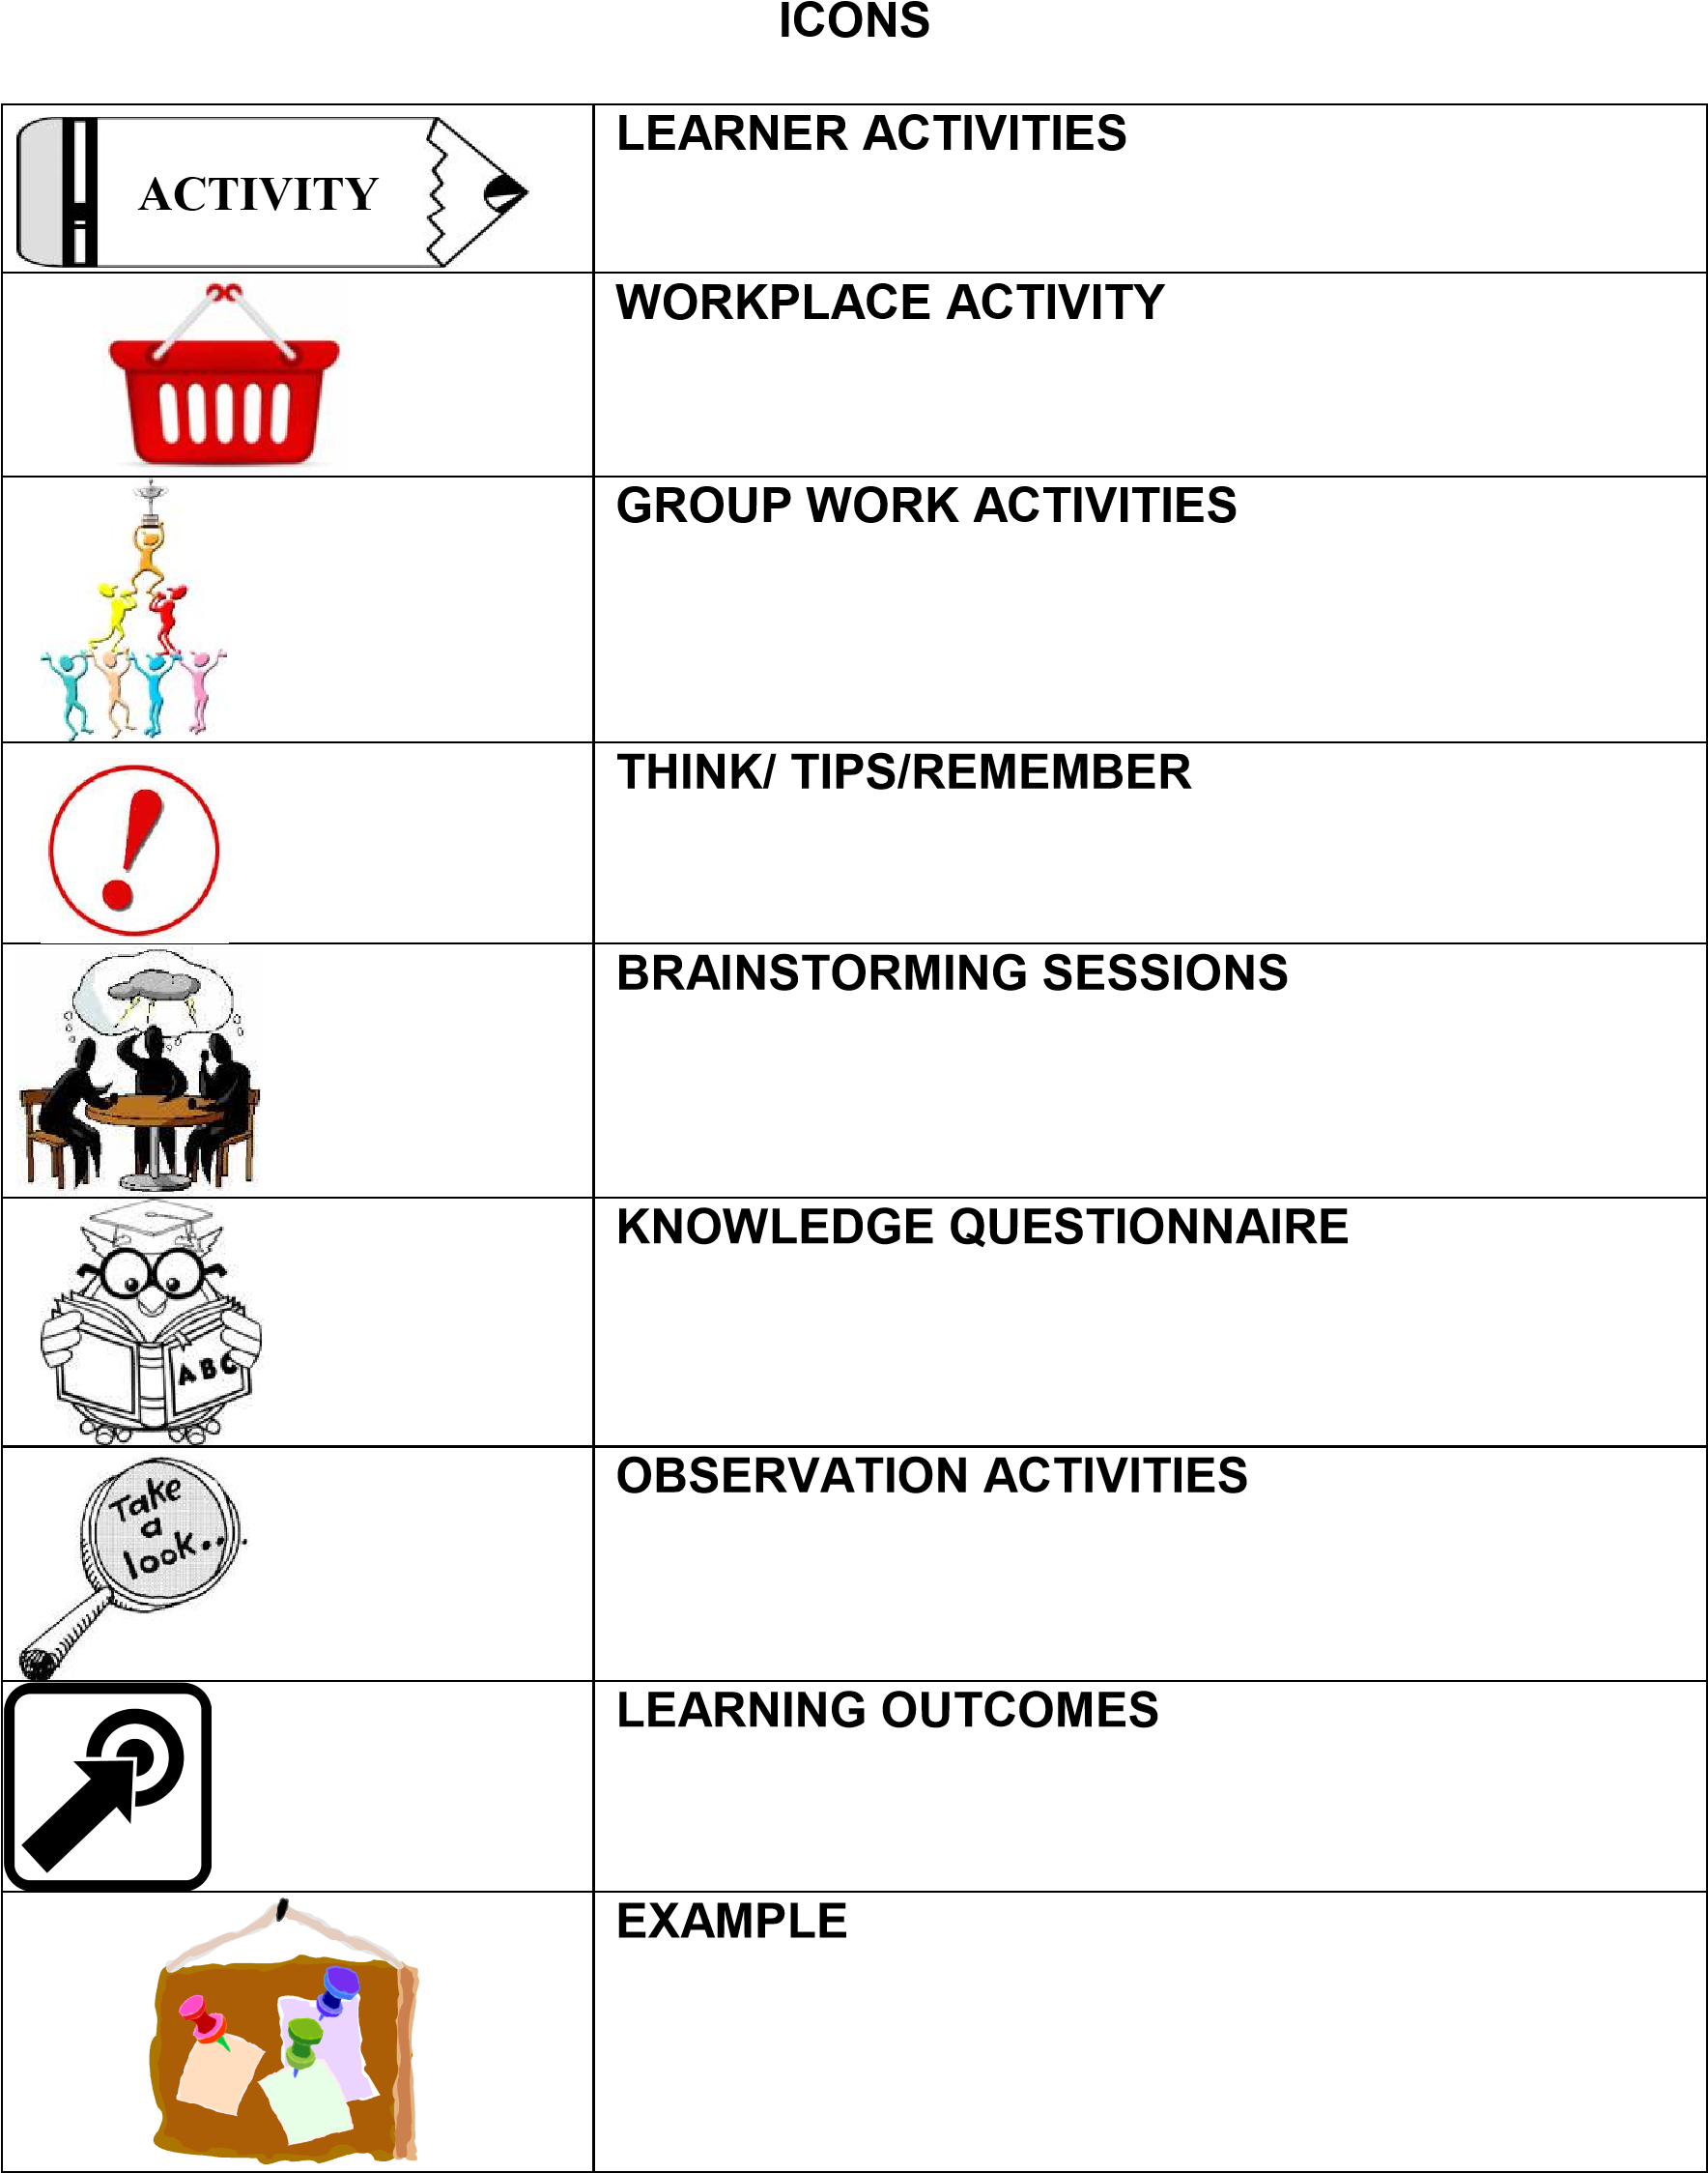

NOTE: All activities must be completed in the LEARNER WORKBOOK and NOT in the Learner Guide.

SOUTH AFRICAN QUALIFICATIONS AUTHORITY
REGISTERED UNIT STANDARD:

Indicate the role of a team leader ensuring that a team meets an organisation`s standards
SAQA US ID | UNIT STANDARD TITLE
13917 | Indicate the role of a team leader ensuring that a team meets an organisation`s standards
ORIGINATOR |  | ORIGINATING PROVIDER
SGB Generic Management
QUALITY ASSURING BODY
-
FIELD |  |  | SUBFIELD
Field 03 - Business, Commerce and Management Studies |  |  | Generic Management
ABET BAND | UNIT  STANDARD TYPE | PRE-2009 NQF LEVEL | NQF LEVEL | CREDITS
Undefined | Regular-  Fundamental | Level 3 | NQF Level 03 | 6
REGISTRATION STATUS |  | REGISTRATION START DATE | REGISTRATION END DATE | SAQA  DECISION  NUMBER
Passed the End Date -  Status was "Reregistered" |  | 2006-03-14 | 2006-11-16 | SAQA  0160/05
LAST DATE FOR ENROLMENT |  | LAST DATE FOR ACHIEVEMENT
2007-11-16 |  | 2010-11-30

Specific Outcomes and Assessment Criteria:
SPECIFIC OUTCOME 1
Explain the role of a team or group leader in a specific organisation

ASSESSMENT CRITERION 1
1. The role of a team or group leader in an organisation is described with reference to a position specification.

ASSESSMENT CRITERION 2
2. The responsibilities of a team leader are indicated and explained within the context of a specific work environment.

ASSESSMENT CRITERION 3
3. The concept of accountability is explained with reference to the learner's own position in an organisation.

ASSESSMENT CRITERION 4
4. The advantages and disadvantages of organising workers in teams are explained with specific reference to the learner's own organisation.

SPECIFIC OUTCOME 2
Explain the intended purpose of a specific team or group

ASSESSMENT CRITERION 1
- The standard of performance required of a team is explained with reference to an organisation's mission and vision.
ASSESSMENT CRITERION 2
- The difference between a standard and an objective is explained with examples.

ASSESSMENT CRITERION 3
3. Short term objectives for a team or group are negotiated within required standards off a specific organisation.

ASSESSMENT CRITERION 4
4. The performance of a team is assessed in relation to the section and/or organisation standard.

ASSESSMENT CRITERION 5
5. The role played by each member of the team or group is identified and an indication is given of the role of each in the functioning of a team.

SPECIFIC OUTCOME 3
Contract with group or team members to obtain buy in

ASSESSMENT CRITERION 1
1. Tasks and performance plans are discussed with a group or team and a strategy is suggested to promote participation.

ASSESSMENT CRITERION 2
2. Tasks are negotiated and allocated to team members according to strengths and weaknesses.

ASSESSMENT CRITERION 3
3. A system to minimise weaknesses of the team or individual member is negotiated with a view to ensuring the team meets the required standards of performance.

ASSESSMENT CRITERION 4
4. Realistic benchmarks and timelines for achieving individual and group goals are agreed through a process of consultation.
SPECIFIC OUTCOME 4
Monitor the achievement of group objectives or goals
ASSESSMENT CRITERIA ASSESSMENT CRITERION 1
1. Group objectives or goals are monitored against agreed benchmarks and timelines.

ASSESSMENT CRITERION 2
2. Potential difficulties or problems are anticipated and strategies are proposed to minimise the effect of the identified problem.

ASSESSMENT CRITERION 3
3. Difficulties encountered by team members are identified and action is taken to minimise the effect on team performance.

Critical Cross-field Outcomes (CCFO):

UNIT STANDARD CCFO IDENTIFYING
The learner is able to identify and solve problems and make decisions in contracting with group members and monitoring performance against the team goals, objectives and standards.

UNIT STANDARD CCFO ORGANISING
The learner is able to organise and manage him/herself in monitoring group goals or objectives against agreed benchmarks.

UNIT STANDARD CCFO COLLECTING
The learner is able to collect, organise and critically evaluate information by monitoring achievement against a benchmark or timelines and identifying the role of the learner and the team within an organisation.

UNIT STANDARD CCFO COMMUNICATING
The learner is able to communicate effectively in negotiating and allocating tasks and discussing performance plans and differences encountered by individual members.

UNIT STANDARD CCFO CONTRIBUTING
The learner is able to see the world as a set of related systems in accepting responsibility for the team`s contribution to the standards required by an organisation and recognising the accountability of the learner in the team and own position in the organisation.

TOPIC 1

LEARNING OUTCOMES

SO 1: Explain the role of a team or group leader in a specific organisation

On completion of the topic you will be able to:

Describe the role of a team leader wrt own team leader’s job description | SO1 AC 1
List and Explain the responsibilities of the team  leader within own department/area of responsibility | SO1 AC 2
Explain the concept responsibility with reference to own position in the business | SO1 AC 3
Explain how workers are organised in teams in own store  Discuss the advantages and disadvantages of working in teams oppose to working as individuals | SO1 AC 4

1.1 What is a Team?
A team is a group of people who share a common objective and need to work together in order to achieve the objective.
E.g.: A group of drama students putting on a play, a group of physicists working on a group research project, or a group of music students putting on a concert share the same common objective. However, they cannot achieve this unless they pool their talents and expertise in a team effort.

1.2 What can be expected of a team?
Teams can help you to approach problems in new ways. They can also help you to learn, as fellow team members may raise ideas which you would never have thought of if you were working on your own. When they are successful, teams are often said to achieve something which is greater than the sum of their individual parts.

1.3 The role of a team leader (SO1 AC1, 2)
A Team Leader - Every Team Needs One!
Team Leaders are responsible for moving the team in the right direction in order to accomplish the task. Team leaders should ensure an environment that helps teams get their work done.

Figure 1: Team leader
To provide resources to the To manage and co team ordinate the team

Team Leader
To link the teams
work to the
organization
To be a contributing
team member
e.g.: The team may need to meet off site, or require work samples, products or other items. The team leader is responsible for obtaining these resources, and if they are unavailable (e.g., no off site meeting space is available), then the team leader must inform the team of the situation and direct the team to consider other options

1.4 Team Leader - Key Roles
Team Leaders may or may not be supervisory/managerial personnel. Most importantly, team leaders should never "pull rank," or apply undue influence on the team. Good team leaders know the lessons learned from experience are stronger and longer lasting than those learned simply by having a supervisor telling someone what to do.

Team leaders need to keep a healthy balance between the team members:
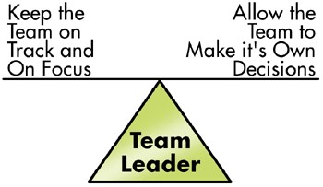

Figure 2: Team leader needs balance

ACTIVITY

1

(SO1 AC1)

1.1 Have you ever been part of a team within your work place?

1.2 Refer to a particular team task that your team had to execute: did the team successfully complete their task? Explain the outcome that your team reached?

1.3 Describe what you think the qualities of a good team leader should be. Include the characteristics and the roles you feel they need to fulfill.

1.4 Provide a general explanation of the role of your own team’s team leader within their given job description

1.5 Team leader characteristics

Team Leader Characteristics

Knows when to act as a facilitator

Good at problem solving

Knows how to develop, maintain and motivate

Is a good listener

Helps

people focus

Knows how to coach and inspire

Develops the team

Has enthusiasm and energy

Figure 3: Characteristics of a team leader

1.6 Responsibilities of a team leader (SO1 AC3)

Team Leader Responsibilities

Attend management meetings

Overseas team operations

Keep open channels of communication

Procure resources for the team

Troublesho
ot to ensure team productivity

Integrate the work of the team with other teams

Ensure the teams meeting are effective

Define boundaries to the team

Figure 4: Responsibilities of a team leader

1.7 Accountability

Accountability, is often not understood. It refers to the obligation a person, group, or organization assumes for the execution of authority and/or the fulfillment or responsibility. This obligation includes:

- Answering – providing, explaining or justifying
- Reporting on the results
- Assuming liability

The word accountability goes hand in hand with the word responsibility.

The five levels of accountability

Personal

Stakehol
d
er
er

Organisational

Team

Individual

Figure 5: Levels of accountability

Let us study each level in detail:

Personal Accountability – This is the accountability one has with oneself. The person looks within to find the answer instead of pointing fingers and placing the blame on external factors. Some of the key concepts of personal accountability are:

Honesty

Integrity

Ethicalness

Morality

Re
liability

I’m a
star

Figure 6: Levels of accountability

Individual accountability – Individual accountability refers the accountability within a workplace. It applies to both parties, with the authority having being responsible and providing adequate direction, guidance and resources. The Worker is responsible to fulfill the responsibilities given to them. Both parties are accountable to each other

Figure 7: Individual accountability

Authority

Worker

Direction

Guidance

Resources

Fulfill responsibilities

Team Accountability:
In a team there is no “I“, there is only “We”. This means that the accountability is shared – the team shares the ownership.

THE TEAM

1)

Has ownership

2)

A
ll members are

a
ccountable

3)

Whole team is
answerable

4)

All team members responsible
for reporting

Figure 8: Team accountability

Organisational Accountability –
There are two types of organizational accountability:

Internal: This is the accountability between the team members and all levels of management within the organization.

External: This is the organizations accountability to the stakeholders.

Stakeholders Accountability –
Stakeholders consist of: Customers, Shareholders, Taxpayers and the General Public.
These stakeholders are not directly involved with the internal organizational accountabilities. It is the stakeholders who provide input into the organizations accountabilities, and it up to the organization to meet the desired outcomes required.

ACTIVITY 2

(SO1 AC2, AC 3, AC 4)

2.1 List the things for which your team leader in your department is responsible for.

2.2 List the things for which you are responsible and accountable for in your own department

Team Leader’s Responsibilities | Own Responsibilities within team

2.3 List the various teams in your own store and briefly state what each team’s area of responsibility is
Team | Area of Responsibility

2.4 Sate what you would say are the advantages and disadvantages of working in teams with reference to the teams in your own store
Advantages | Disadvantages

1.8 Advantages and disadvantages of organizing workers into a team (SO1 AC4)

Improved
communication

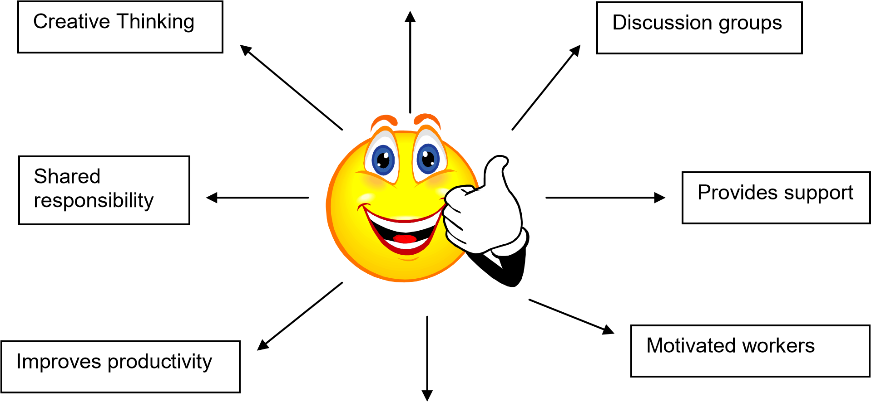
Better work relationships

Figure 9: Advantages of organizing teams

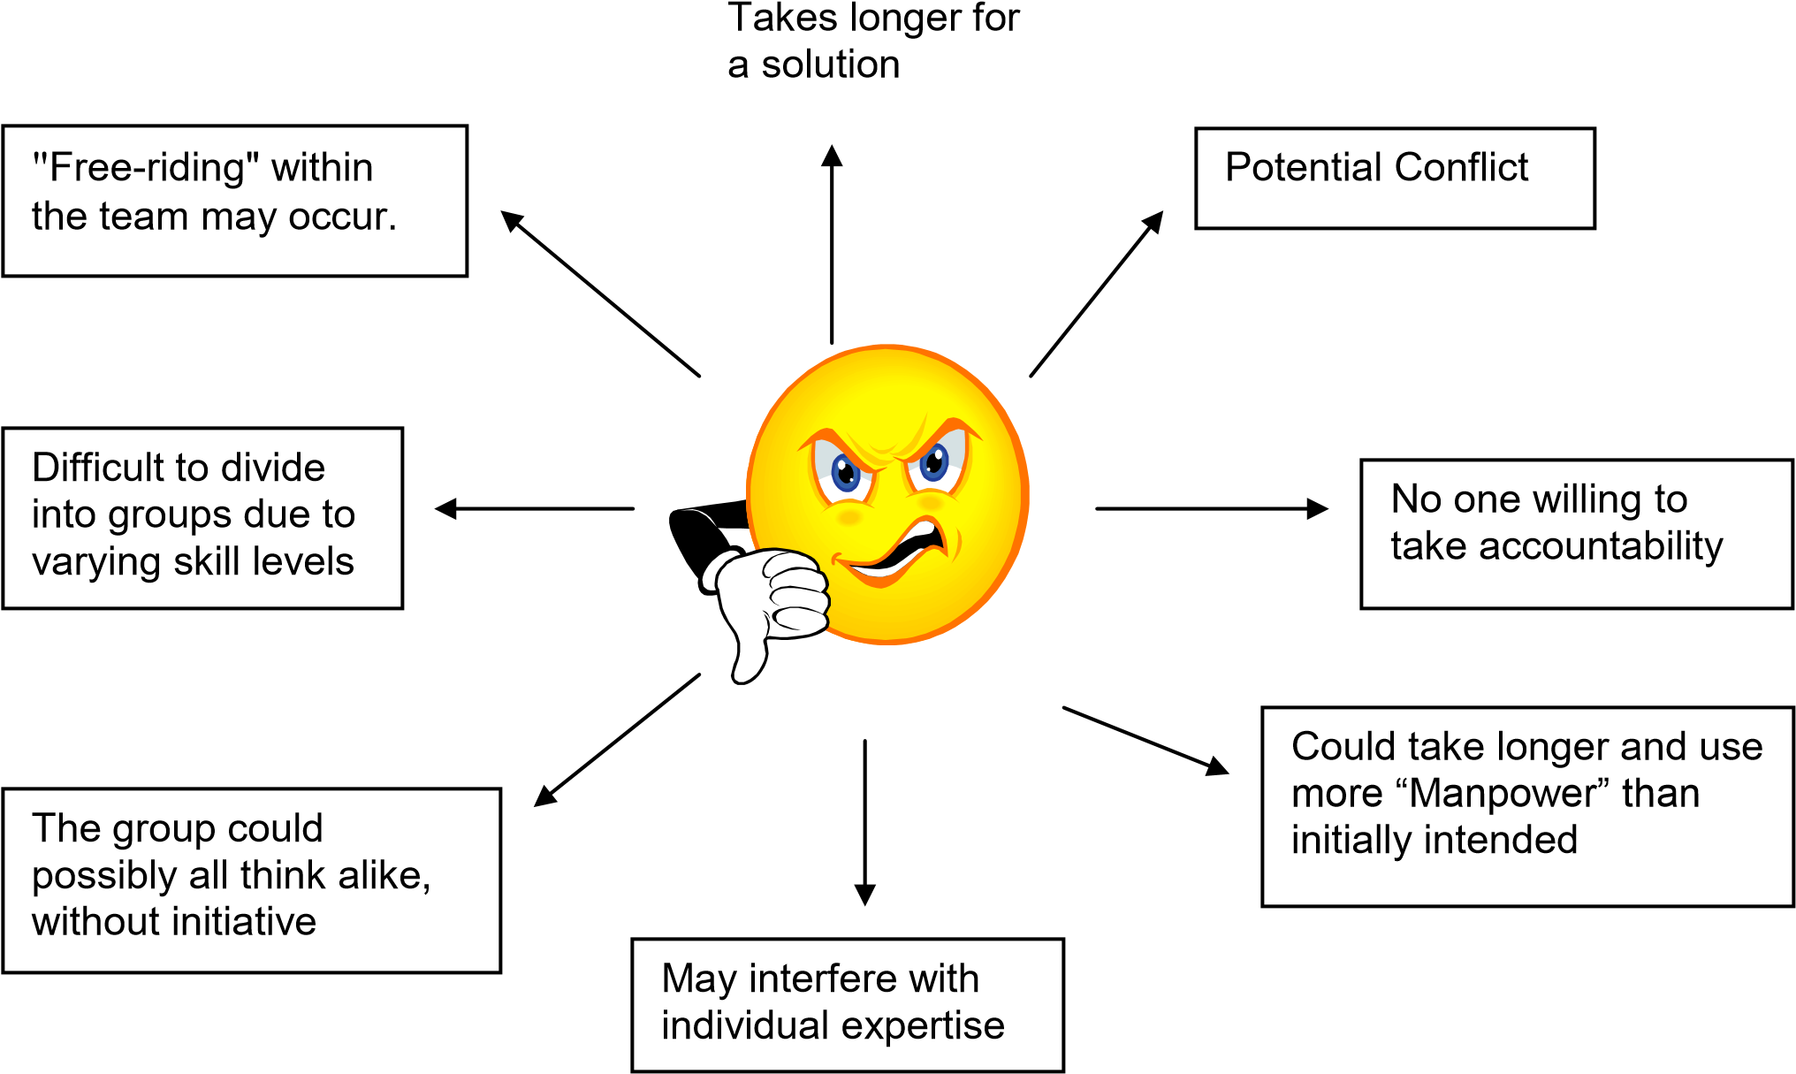

Figure 10: Disadvantages of organizing teams

TEAM ADVANTAGES | TEAM DISADVANTAGES
• Team members have the opportunity to learn from each other. | • Some individuals are not compatible with team work.
• Potential exists for greater work force flexibility with cross-training. | • Workers must be selected to fit the team as well as requisite job skills.
• Opportunity provided for synergistic combinations of ideas and abilities. | • Some members may experience less motivating jobs as part of a team.
• New approaches to tasks may be discovered. | • Organization may resist change.
• Teams membership can provide social  facilitation and support for difficult tasks and situations. | • Conflict may develop between team members or other teams.
• Communication and information exchange may be facilitated and increased. | • Teams may be time-consuming due to need for coordination and consensus.
• Teams can foster greater cooperation among team members. | • Teams can stymie creativity and inhibit good decision-making if "group think" becomes prevalent.
• Interdependent work flow can be enhanced. | • Evaluation and rewards may be perceived as less powerful;
• Potential exists for greater acceptance and understanding of team-made decisions. | • "Free-riding" within the team may occur.
• Greater autonomy, variety, identity, significance, and feedback for workers can occur. | • Less flexibility may be experienced in personnel replacement or transfer.
• Team commitment may stimulate performance and attendance.

Figure 11: Advantages and disadvantages of organizing workers into teams

TOPIC 2

LEARNING OUTCOMES

SO 2: Explain the intended purpose of a specific team or group

On completion of the Module you will be able to:

Quote your store’s mission and vision statements  Explain the standard of your team’s performance with reference to these mission and vision statements | SO 2 AC1
Explain the difference between a standard and an objective | SO 2 AC2
Set short term goals for own team  Negotiate, change if necessary and agree on the set short term goals | SO 2 AC3
Devise an instrument to assess the performance of a team in relation to the section’s set standards  Use the devised instrument and assess the/own team’s performance | SO2 AC 4
List and explain the roles that are played by each member of the selected/own team | SO2 AC 5

2.1 Explain the standards of performance required of a team

Group Activity 1 (SO2 AC 1)

Complete the following questions

- Write down your store’s MISSION and VISION Statements

- What do you think the standards of performance with regards to your team’s mission and vision should be?

Therefore, write a statement that will clarify the standards of performance for your team – it must compliment your mission and vision.

Performance standards should be:
Objective, measurable, realistic, and stated clearly in writing (or otherwise recorded).
The standards should be written in terms of specific measurers that will be used to appraise performance.
  - How well the work is performed and/or how accurate or how effective the final product is.
  - Accuracy, appearance, usefulness, or effectiveness.
  - How quickly, when or by what date the work is produced. The most common error made in setting timeliness standards is to allow no margin for error. • Cost Effectiveness
In a team performance management system there are two main types of measures to be used:

External(results)
Examples of these might be:
- Sales revenue achieved (sales team)
- League position (sports team)
- Recovery rate (health team)

Internal(behaviours)
Measures that are internally oriented, and quantify the team behaviours, involve assessing the means used to achieve the end results, or the way in which the team goes about it's business. Team standards for measurement should be defined and agreed at the start of the Team Performance Management process.

2.2 Explain the difference between a standard and an objective
What is a standard?
Put at its simplest, a standard is an agreed, repeatable way of doing something. It is a published document that contains a technical specification or other precise criteria designed to be used consistently as a rule, guideline, or definition. Standards help to make life simpler and to increase the reliability and the effectiveness of many goods and services we use.

They are intended to be aspirational - a summary of good and best practice rather than general practice. Standards are created by bringing together the experience and expertise of all interested parties such as the producers, sellers, buyers, users and regulators of a particular material, product, process or service.
A standard is a measure for everything we do.

Individual Standards

Personal performance
expectations

Team Standards

Standards set by the team
in order to ac
hieve the
obligations

Stakeholder Standards

Standards set externally by
customer/consumer and
management

STANDARDS

Figure 12: Overlapping Standards

What is an objective?
An objective is a specific, measurable condition that must be attained in order to accomplish a particular program goal. There are many different ways to specify objectives; the program and evaluator should choose the method that works best for each situation. Objectives consist of long term and short term goals.
Objectives are set out within the framework of the organisation’s mission and vision. If the team understands the objective, the effect is reflected in their performance.

(SO2 AC2)
ACTIVITY 3

Complete the task below in your Learner Workbook
3.1 Based on your notes that you made in the Group work Activity, make a poster that summarises your team’s workplace standards
3.2 According to you, how will/does a discussion with your team about their performance standards before your team’s outcome (tasks) were communicated to them, have affected your team’s performance?
3.3 What would you say is a team standard?
3.4 What would you say is a team objective?

(SO 2 AC 3)
ACTIVITY 4

You are required to consider your own team in which you function at work.
4.1 Explain what the main purpose of your team is in at least two sentences?
4.2 What are your individual standards that you are setting for yourself for the purpose of your team? List at least two in the following table
STANDARDS WITHIN MY TEAM:
4.3 Investigate what the standards of your team’s stakeholders are and insert at least two in the table below
STAKEHOLDER STANDARDS:
4.4 State the main role that are played by each of the team members in your own team
Team member | Role within the team

2.3 Negotiate short term objectives for a team or group
Not only should you set useful goals, you should also set both short-term and long-term goals.
- Short-term goals are ones that you will achieve in the near future (e.g., in a day, within a week, or possibly within a few months).
It is important that each team has a set of short term goals which are negotiated with the team leader.
- Long-term goals are ones that you will achieve over a longer period of time (e.g., one semester, one year, five years, or twenty years).
Long-term goals often are our most meaningful and important goals. One problem, however, is that the achievement of these goals is usually far in the future. As a result, we often have trouble staying focused and maintaining a positive attitude toward reaching these goals. This is why it is helpful to set up what we call enabling goals.
- An enabling goal is a special type of shorter-term goal. It is written to help us achieve a long-term goal. Enabling goals are like stepping stones that help us measure our progress toward reaching longer-term goals.

ACTIVITY 4

Activity 4 continues

Team’s Goals

With one of your fellow team members, identify your team’s short term, long term and enabling goals and tabulate it in the table below: (see allocation for each type)

Short Term Goals (at least 4) | Enabling Goals  (at least 2) | Long Term Goals  (at least 3)

2.4 EVALUATING EMPLOYEE PERFORMANCE

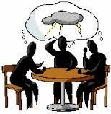
Brainstorm (SO 2 AC4)

Learners must submit as part of their Learner Workbook

Why do you feel it might be necessary to
evaluate performance?

Self
developme
nt
–

positive
outcomes

Recognitio
n

Incentives and
annual increases

Negative
outcomes will
assist in
identifying areas
for enhancement

Monitor progress

Increase performance will
lead to increase
productivity, which will lead
to increased

profitability

Notes:

Performance planning

Set measurable
goals, and
respons
ibilities

Plan what needs to
be done in order to
achieve the goals

Do the work and
continually
monitor the
process

Report on results
on a regular
basis

Evaluate and review
results. Provide
feedback

Figure 13: Performance planning

Tools used to evaluate performance
Self – assessments:
A self assessment is an on-going process. An organization or team leader or team member evaluates themselves. The evaluation is based the organization, leader or team members ability to meet performance objectives, measures that were put in place and the expectations. It can also be used to evaluate your ability to work harmoniously within a team.

The self assessment will allow for control of how progress is being made and will highlight the areas of concentration for improvement in order to achieve the objectives.
(SO2 AC4)

Portf

A
CTIVITY 5

Complete the self- assessment in your Learner Workbook
 |  |  |  | Very  Strong | Moderately Strong | Adequate |  | Moderately Weak | Very Weak
1. |  | I communicate well with all the team members. |  | 5 | 4 | 3 |  | 2 | 1
2. |  | I am honest and fair within the team. |  | 5 | 4 | 3 |  | 2 | 1
3. |  | I make decisions with input from others. |  | 5 | 4 | 3 |  | 2 | 1
4. |  | My actions are consistent. |  | 5 | 4 | 3 |  | 2 | 1
5. |  | I assist other team members with information to do their jobs |  | 5 | 4 | 3 |  | 2 | 1
6. |  | I keep focused through follow-up. |  | 5 | 4 | 3 |  | 2 | 1
7. |  | I listen give feedback and ask questions should I not understand any given task |  | 5 | 4 | 3 |  | 2 | 1
8. |  | I show loyalty to the company and to the team members. |  | 5 | 4 | 3 |  | 2 | 1
9. |  | I create an atmosphere of growth and stay positive. |  | 5 | 4 | 3 |  | 2 | 1
10. |  | I have wide visibility of the tasks on hand |  | 5 | 4 | 3 |  | 2 | 1
11. |  | I criticize constructively and address problems. |  | 5 | 4 | 3 |  | 2 | 1
12. |  | I develop plans and offer solutions |  | 5 | 4 | 3 |  | 2 | 1
13. |  | I have a vision on where we are going and set long term goals. |  | 5 | 4 | 3 |  | 2 | 1
14. |  | I set objectives and follow them through to completion. |  | 5 | 4 | 3 |  | 2 | 1
15. |  | I display tolerance and flexibility. |  | 5 | 4 | 3 |  | 2 | 1
16. |  | I can be assertive when needed. |  | 5 | 4 | 3 |  | 2 | 1
17. |  | I am a Champion of change. |  | 5 | 4 | 3 |  | 2 | 1
18. |  | I treat others with respect and dignity. |  | 5 | 4 | 3 |  | 2 | 1
19. |  | I make myself available for work |  | 5 | 4 | 3 |  | 2 | 1
20. | I want to take charge. |  | 5 |  | 4 | 3 | 2 |  | 1
21. | I accept ownership for my decisions. |  | 5 |  | 4 | 3 | 2 |  | 1
22. | I have full understanding of the objectives for the team |  | 5 |  | 4 | 3 | 2 |  | 1
23. | I coach and motivate team members. |  | 5 |  | 4 | 3 | 2 |  | 1
24. | I determine manpower  requirements for my tasks and write job descriptions for them. |  | 5 |  | 4 | 3 | 2 |  | 1
25. | I determine resources, material, and supply requirements for my department. |  | 5 |  | 4 | 3 | 2 |  | 1
26. | I developed a budget for my planned tasks |  | 5 |  | 4 | 3 | 2 |  | 1
27. | I can respond to an employee who is upset with me or someone else in the organization. |  | 5 |  | 4 | 3 | 2 |  | 1
28. | I react to situations in which the quality of an employee's work goes into a decline. |  | 5 |  | 4 | 3 | 2 |  | 1
29. | I can make a presentation to a group of peers and/or seniors. |  | 5 |  | 4 | 3 | 2 |  | 1
30. | I write reports to be distributed to a group of peers and/or seniors. |  | 5 |  | 4 | 3 | 2 |  | 1
31. | I have a deep-rooted understanding of the functions of my organization. |  | 5 |  | 4 | 3 | 2 |  | 1
32. | I am a good learner. |  | 5 |  | 4 | 3 | 2 |  | 1
33. | I know how to influence people and get support. |  | 5 |  | 4 | 3 | 2 |  | 1
34. | I admit my mistakes and take responsibility for my actions. |  | 5 |  | 4 | 3 | 2 |  | 1
35. | I like to talk to people and I am a great listener. |  | 5 |  | 4 | 3 | 2 |  | 1
36. | I can separate the important issues from inconsequential ones. |  | 5 |  | 4 | 3 | 2 |  | 1
37. | I have integrity and can be trusted. |  | 5 |  | 4 | 3 | 2 |  | 1
38. | I am political only when needed. |  | 5 |  | 4 | 3 | 2 |  | 1
 | TOTAL

Performance reviews / 360 performance reviews

A performance review is based on a team members work performance during a specified period of time, which includes goals, work activities, work objectives and whether performance standards were met (or exceeded) in terms of other employees on the team. The performance review typically includes a performance development plan to address inadequate performance.

The principal purposes of team member reviews are to encourage team members to develop and to strengthen the teams effectiveness Some specific purposes are to:
- Identify specific indicators of achievement
- Pin-point areas of greatest/least effectiveness
- Stimulate improved performance
- Aid in promotion, retention and salary decisions
- Develop mutually established goals
- Increase team members’ communication

The following are examples of a possible performance review questions:

  - Were the original planned objectives met?
  - If not why? And were new plans put into place to meet the objectives?
  - Did you comply with the teams, organisations and stakeholders standards?
  - Were the tasks completed in the designated time frame?
  - Are you functioning as part of the team, able to communicate with all members?
  - Was the mission and vision of the organisation kept in mind at all times?

Feedback is given at the end of the review in order to ensure that the team member is able to learn and develop from the review process. Strengths are also highlighted and often rewarded. The performance review can also be used as a tool to decide on the increase/incentive of a team member.

A
CTIVITY 6

(SO2 AC4)

Use the review table in your Learner Workbook, assess one of your team members for a specific objective/goal that the team member needed to achieve in the past few months. Complete the task in your Learner Workbook.

Name of team member: ___________________________________________________

Role of team member: ___________________________________________________

Objective/Goal: |  | ___________________________________________________
Rating scale: |  | 1 - Very poor
 |  | 2 - Poor
 |  | 3 - Average
 |  | 4 - Good
 |  | 5 - Excellent
 | Questions |  | Answer | Suggestion | Rating(1-5)
 | 1. Did you achieve the individual objectives you set out to achieve?
 | 2. Did the team achieve the objectives that were set by the organization?
 | 3. Have you met all required deadlines timeously?
 | 4. Were the standards set by the stakeholders, organization and team leader met?
 | 5. Were any tasks not met?

Areas of improvement:
______________________________________________________________________________

Strengths:
______________________________________________________________________________

Overall feedback:
______________________________________________________________________________

2.5 The role of each team member identified.
Like players on a strong baseball team or employees in a well-run organisation, team members fill specific, defined roles. People fill these roles in many ways. Some might volunteer for positions, some might be elected by the group, or even appointed by a manager. There are five key team roles:

Team Leader - Every Team Needs One!
Team Leaders are responsible for moving the team to accomplish its objectives. Team leaders should ensure an environment that helps teams get their work done. For example, the team may need to meet off site, or require work samples, products or other items. The team leader is responsible for obtaining these resources, and if they are unavailable (e.g., no off site meeting space is available), then the team leader must inform the team of the situation and direct the team to consider other options.

Team Facilitator-Keeps Everybody on Track
Make things happen with ease. They help the group with the process and help the group with the
“how”decisions. Facilitators are often NOT a member of the team so they can remain neutral in team decision making. When a facilitator is part of the team, the role of facilitator may rotate from member to member.

Team Recorder - Keeps Notes, Documents Decisions
The team recorder is responsible for writing down the team's key points, ideas and decisions.
Sometimes, recorders work from an easel pad. Recorders can also take notes directly to a pad.

Time Keeper - Minute by Minute
"Where did the time go?" In a busy team meeting where members are considering ideas, brainstorming, prioritizing, etc., it is very helpful to assign one person the responsibility of being the timekeeper.
A timekeeper's responsibilities are to:

Monitor how long the
team is

taking to
accomplish its tasks.

Provide regular updates
to the team on how well
or poorly they are using
their time.

Collaborate with the
team leader, facilitator
and others to determine
new time schedules if
the agenda has to be
adjusted.

Figure 14: A timekeeper’s responsibilities
Team Members - Everyone Else!
Team members don't have specific responsibilities, but their participation is critical to the team's success.
Team members must agree to:

Fulfil duties in between meetings.
Respect the opinions and positions of others on the team, even if the person has an opposing view or different opinion.

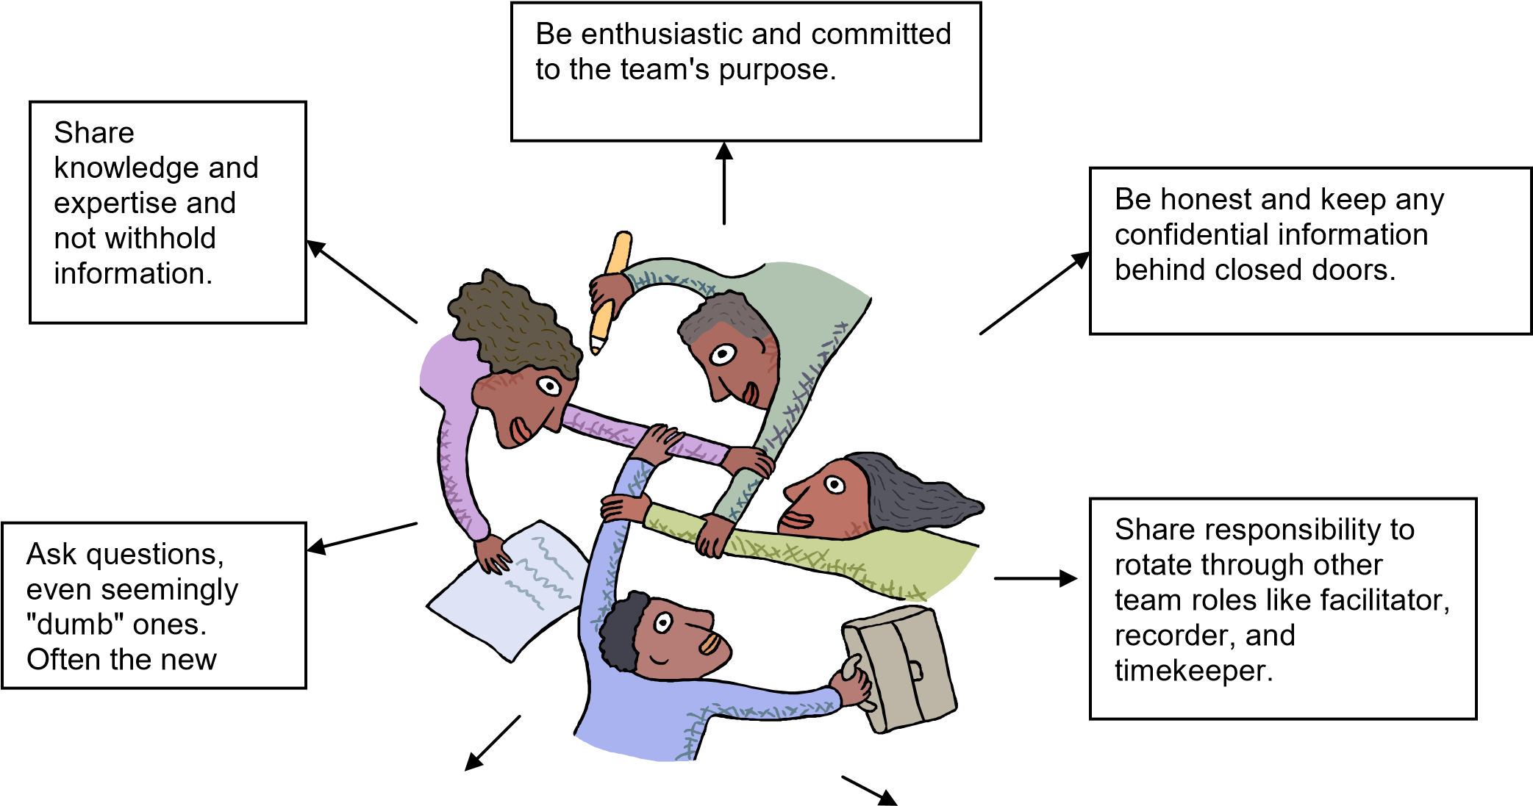
Figure 15: Team members’ agreement

TOPIC 3

LEARNING OUTCOMES

SO 3: Contract with group or team members to obtain buy in

On completion of this topic you will be able to:

Set tasks and performance plans against set goals to promote buy in | SO3 AC1
Determine strengths and weaknesses of own team  Negotiate/Discuss the suggested tasks and allocate the tasks to the team members according to their strengths and weaknesses | SO3 AC2
Discuss and agree on a system to minimise the weaknesses of the team and individuals | SO3 AC3
Consult and then agree on realistic timelines for the set tasks and goals | SO3 AC4

3.1 Discuss the performance elements and tasks

What are performance elements?

Performance elements tell employees what they have to do and standards tell them how well they have to do it to achieve a specific rating. Developing objective elements and standards that are understandable, measurable, attainable, fair, and challenging is vital to the effectiveness of the performance appraisal process.

Well-written objectives and standards will help ensure there are no surprises when it comes time to evaluate an employee’s performance.

What is a Task?
The task is the central focus of a project. A task is something you need to do. A task could be something small like taking out the trash, or something bigger like finding the solution, or creating a plan to improve sales. Larger tasks can be broken up into sub-tasks to be managed more easily.

3.2 Negotiating and allocating tasks to team members according to strengths and weaknesses.
The skills of all the team members need to be identified and tasks need to be allocated according to the team members strengths.
The four-step “BALM” method can be used in order to achieve correct role allocation:
- Break down the broader team goals into specific, individual tasks. List all tasks, and then rank each task in terms of importance;
- Analyze and list the competencies required to perform each task;
- List the competencies of each team member; • Match individuals to task competencies.

Where you have overlaps, you have two choices: Either allotting better qualified individuals to more important tasks, or allocating the task to the person at the lowest organizational level who is qualified to do the job.

Where you have a gap, you may need to train existing team members, or recruit to fill the gap. Often, training is the best option: Not only is it usually cheaper, you also know more about the individual’s talents and working methods.
Having decided which team member will fill each role, you have to communicate the decision to your team.
Each team member should know his or her position within the team. The roles of each person should be clearly defined, with individual responsibilities, authority and accountability clearly spelled out (it’s often best to do this in writing).

(SO 3 AC 1)

ACTIVITY 7

Complete the task in your Learner Workbook.
Scenario: There is a current problem of untidy show room floors. This is causing a high amount of shrinkages due to loss of products and through theft. No accurate stock count can take place.
Select a team in your own store in order to allocate tasks which will need to be completed in order to rectify the current problem faced.
1. Using the BALM method, complete the tables in your Learner Workbook to indicate how you and your team will overcome the problem faced in the above scenario.

Step 1
Tasks which will need to be completed in order to rectify the above problem

Step 2
Team member | Strengths
Step 3
Team Member | Task

3.3 Negotiate a system to minimize weaknesses of the team or individual members.

A weakness is:
• Lack of strength or determination: lack of strength, power, or determination. • Weak point: a weak point in the structure or arrangement of something.

When analysing weaknesses, you can use the following method:

SWOT

To do the analysis, start by dividing a page into four quadrants with a vertical line and a horizontal line.
The top two SWOT analysis quadrants are Strengths and Weaknesses. The bottom two quadrants are Opportunities and Threats.

Strengths | Weaknesses
Opportunities | Threats

Figure16: Quadrants of SWOT Analysis

S – Strength:
List all the strengths of the team in this quadrant. This isn't the time for modesty. One of the strengths you take for granted might be something that your customers or team members value and that your competition doesn't have or do. Brainstorm.

W - Weaknesses
List things you cannot do, things you don't do well. This is the time for brutal honesty - you are not producing a selling document so there is no point in fooling yourself.
O - Opportunities.
List the what would make the difference to the team through new ideas.
T - Threats
List the possible threats that could affect you reaching the desired outcome for your task.

(SO 3 AC 2)

ACTIVITY 8

Conduct a SWOT analysis on your team. List the Strengths, Weaknesses, Opportunities and Threats.

Complete this task in your Learner Workbook in the provided table.

Ensure that all team members receive the required information and tools to complete the task
Ensure that team members are correctly matched.
Ensure that there is an “open door”policy
Ensure that a good support structure is in place
Reassure the team members that they have the ability to complete the task - motivate
Ensure all team member get the necessary training that might be required.
Encourage all team members.

Figure 17: How to minimise weakness in a team

Contracting team members

NOTE TO ALL ROLE PLAYERS:
One of the Workplace Activities for this unit standard is to lead a team in the workplace. The related activities are outlined in the Workplace Logbook.

The team will have a meeting and will agree to tasks and timelines. They will sign in agreement.
This will serve as their team ‘contract’
3.4 Agree on realistic benchmarks and timelines for achieving individual or group goals through a process of consultation.
As a team you need to negotiate the benchmarks in order for the tasks to be achieved.
Benchmarks are measures of performance that can be reduced to an easily understood and easily measured number or percentage. There are four concepts that can be measured and used as part of the benchmarking process: time, quantity, cost, and quality.
Of these, time and quality are the easiest to measure, cost is the most volatile, and quality is the most difficult to quantify. Quality measurements are rated against a performance benchmark as judged by the customer, manager, or general public.
Benchmarks should be measured on a consistent basis and in consistent frequency. They should be mentioned regularly in management team meetings to remind employees in the field, sales, and back office of their progress. The team will know their roles and the roles of their teammates and be more willing to sacrifice when there are mutual goals--and victories.
Timelines:
As a team you need to plan your timelines carefully. You need to ensure that the correct timelines are set in order for the deadline to be met. Ask yourself the following questions:

- What needs to be done?
- What is the expected delivery date?
- What tasks do I need to do in order to complete the task?
- How long is each task going to take?
- What timeframe do I need to gather the necessary information?

Short Timeline

Poor Quality Incorrect information | Low  customer satisfaction

Long Timelines

Staff will become complacent |  | Loss of customers |  | Loss of profit and over investing in manpower

Figure 18: The effect of timelines on customer satisfaction and profit

TOPIC 4

LEARNING OUTCOMES SO 4: Monitor achievement of group objectives or goals

Implement the agreed plan  Monitor the progress as per the set plan | SO4 AC1
Collect feedback from team members during the implementation of the plan  Document possible difficulties in achieving the plan  Compile a memo to inform team members of these possibilities with the purpose of trying to alleviate the challenges whilst implementing | SO4 AC2
Identify and document actual difficulties during the implementation of the plan  Decide on and take action to minimise the effect on the team’s performance | SO4 AC3

4.1 Monitor group objectives or goals

The performance appraisal
"If you can't measure it, you can't manage it", assessment of your team members' level of performance is a vital management task. It is in your mutual interest because those individuals worth having will want feedback on the level of contribution they make to the company's overall goals so that they can improve their performance.
• A performance appraisal is nothing more than a structured discussion with the team member, and is intended to assess his or her performance.
Should the appraisal process be poorly managed, employees will view it in a negative light. It is up to you to allay any fears employees may have that the process will be used "to catch them out" by assuring them that the process will help them maximise their potential
Offer employees who perform well opportunities for advancement. Be mindful of the fact that top performers tend to become frustrated if it appears to them that they have reached a dead end career-wise. This calls for creativity on your part, and a willingness to recognise achievements in a meaningful manner. You could, for example, preview the year ahead and explain how expected growth will create opportunities for advancement.

The appraisal process

Prepare for the appraisal
- Be in a positive frame of mind.
- Map out the points you wish to address.
- Set sufficient time aside.
- Notify the employee in good time.

Once the employee is comfortable, you should start the session
- Kick off by stressing the positive.
- If poor performance needs to be discussed, do so by all means but in a manner that is likely to motivate the employee rather than destroying him or her.

Ask the employee for feedback
- About the company/department.
- What could be done differently and why?

Map out the way forward
- Ask the employee what his or her career plans for the forthcoming year are
- Explore ways in which the employee's career could be advanced.
- Reach consensus on what needs to be done to achieve this and by when it should be completed
- Do not lecture the employee - consensus is needed to ensure buy-in.

Figure 19: The appraisal process
Make notes throughout the session and compile a memorandum of agreement as soon as possible after its completion. Hand the employee one copy and file one in the employee's personnel file.

4.2 Anticipate potential difficulties or problems to minimize the effect of the identified problems.

Step 1: Preparation.
Team members take out sheets of paper and get relaxed in their chairs. They should already be familiar with the plan, or else have the plan described to them so they can understand what is supposed to be happening.
Step 2: Imagine a fiasco.
Look at all the possible scenarios as to why the project could failed. Do not look at the simple failure, think of all the possible devastating failure.
“The people on the team are no longer talking to each other. Our company is not talking to the sponsors. Things have gone as wrong as they could. However, we could only afford an inexpensive model of the crystal ball so we cannot make out the reason for the failure. Then ask, “What could have caused this?”
Step 3: Generate reasons for failure.
The people on the team spend the next three minutes writing down all the reasons why they believe the failure could have occurred. Here is where intuitions of the team members come into play. Each person has a different set of experiences, a different set of scars, and a different mental model to bring to this task. You want to see what the collective knowledge in the room can produce.
Step 4: Consolidate the lists.
When each member of the group is done writing, the team leader goes around the room, asking each person to state one item from his or her list. Each item is recorded in a whiteboard. This process continues until every member of the group has revealed every item on their list. By the end of this step, you should have a comprehensive list of the group’s concerns with the plan as hand.
Step 5: Revisit the plan.
The team can address the two or three items of greatest concern, and then schedule another meeting to discuss ideas for avoiding or minimising other problems.
Step 6: Periodically review the list.
Some project leaders take out the list every three to four months to keep the spectre of failure fresh, and re-sensitise the team to the problems that may be emerging.

By doing this the team can achieve the following:
Saving time

Saving money

Creative
thinking

Productive staff

Prevent Loss

Keep all team
members
informed

No need to hire
additional staff

Anticipating
Potential Difficulties
Helps with:

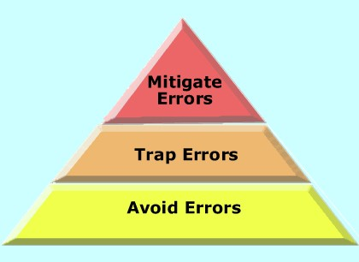

Figure 20: The benefit of anticipating potential difficulties

4.3 Identify difficulties encountered by the team members to minimize the effect on team performance.

When a problem in a team is encountered, it needs to be reported to the team leader. A solution to the problem needs to be identified and discussed with the team member.

The team leader needs to keep a record of all problems encountered and the solution, which offered the best results. This will help with future tasks.

ACTIVITY 9 (SO4 AC1, AC2, AC3)

You will be required to lead a team in a particular set of goals for your Summative Assessment.

The outcomes of the activity will be:
- to lead the team
- monitor the team’s performance
- retrieve and supply feedback
- document and communicate difficulties
- decide on which actions to take to minimise the difficulties on the team

In order to be prepared you are now required to design the following templates to implement when you lead your team in the Workplace.

TEMPLATE 1
MONITOR THE PROGRESS OF THE TEAM AGAINST THE SET PLAN

Required Information:
Template Heading
Set tasks per team member in plan
Progress to that point: which tasks have been achieved within the set timelines and which tasks are not achieved within the set timelines Names and signatures of participating team members

TEMPLATE 2
FEEDBACK FROM TEAM

Required information:
Template Heading
Feedback (positive or negative) against each set task from each team member
Feedback must include progress and difficulties

TEMPLATE 3
DOCUMENTED DIFFICULTIES AND ACTION PLAN

Required information:
Template Heading
Difficulties that occurred to that point of monitoring
Action to be implemented against each difficulty to try and alleviate or eliminate it

TEMPLATE 4
MEMORANDUM TO COMMUNICATE DIFFICULTIES AND ACTION PLANS TO TEAM

Required Information: Template Heading
Memorandum Format
Documented difficulties and action plan as per Template 3
Names and Signatures of team members

OUTCOME FOR THIS ACTIVITY:

Four Templates that depict the required information as listed above.
Your templates can be in any format that will be practical to use whilst leading the team with the particular Goal/s.

REFERENCE

- University Alliance. The responsibilities of a team leader.
http://www.notredameonline.com/resources/leadership-and-management/theresponsibilities-of-a-team-leader/#.VGG68F4Vlxg. Date of access: 5 March 2013

- Mott, A. Role of a team leader in retail. smallbusiness.chron.com › ... › Customer Service Tips. Date of access: 5 March 2013.

- Unknown. Why is teamwork important. http://www.the-happy-manager.com/articles/why-isteamwork-important/. Date of access: 5 March 2013.

- Mathur, U. 2010. Retail Management: Text and Cases. IK International Pvt.

PARTICIPANTS

