NC: Contact Centre Support NQF 2: SAQA ID 71490 LP 73269 – Module 1

Vn 4 (2020) Page 1

# 7480 LEARNER FORMATIVE ASSESSMENT PACK

|  |  |
| --- | --- |
| **Learner Name:** |  |
| **Learner ID Number:** |  |
| **Group:** |  |
| **Date of Completion:** |  |
| **Signature to verify that this is my own work:** |  |

|  |  |  |  |
| --- | --- | --- | --- |
| Assessor Sign Off: |  | Learner Sign Off & Date (Feedback): |  |
| Date: |  | Coach Sign Off & Date: |  |
| Decision |  | Moderator Sign Off & Date: |  |

Feedback/Notes:

|  |
| --- |
|  |

Learner Name: Learner ID:

Learner Signature: Date:

# Activity 1 (SO1, AC 1, 2, 7)

This is an individual activity

Use appropriate algorithms to do the following calculations on your calculator:

1. Find the sum of:

|  |  |  |
| --- | --- | --- |
| 52 | 68 |  |
| 1345 | 65 |  |
| 15.8 | 989 |  |
| 1123.4 | 6598 |  |
| 12.894 | 1345 |  |
| 12.368 | 15.8 |  |
| 0.0012 | 1123.4 |  |
| 68 | 12.894 |  |
| 65 | 12.368 |  |
| 989 | 0.0012 |  |
| 6598 | 15.8 |  |

1. John is a bus driver and travelled the following distances during his first trip for the day:

|  |  |  |  |
| --- | --- | --- | --- |
| **Bus stop** | **Arrive** | **Depart** | **Distance** |
| A | 6:15 | 6:26 |  |
| B | 6:38 | 6:44 |  |
| C | 7:01 | 7:13 |  |
| D | 7:36 | 7:47 |  |
| E | 8:07 | 8:19 |  |

1. How far did he travel from A to C?

|  |
| --- |
|  |
|  |

1. How far did he travel from C to D?

|  |
| --- |
|  |
|  |

1. What was the total distance covered in this trip?

|  |
| --- |
|  |
|  |

1. How long did he spend at bus stop A?

|  |
| --- |
|  |
|  |

1. How long did he spend at stops C and D?

|  |
| --- |
|  |
|  |

1. Calculate the answers:

(3.56 x 2.34) + (2.3 – 1.2)

|  |
| --- |
|  |
|  |

1. (11.2 – 5.6 ) – (2.4 + 4.3)

|  |
| --- |
|  |
|  |

1. (989.21 – 3.4) x (5.3 – 2.3)

|  |
| --- |
|  |
|  |

1. 10.99 + (7.8 x 2.2)

|  |
| --- |
|  |
|  |

1. 414.3 – 298.99 +3.56

|  |
| --- |
|  |
|  |

1. 42.2 x( 5.3 – 4.3)

|  |
| --- |
|  |
|  |

1. 33.1 x( 4.5 + 3.9)

|  |
| --- |
|  |
|  |

1. 0.003 + 2.13 x (4.5 + 4.2)

|  |
| --- |
|  |
|  |

1. Determine the error should you omit the brackets.

|  |
| --- |
|  |
|  |
|  |
|  |
|  |
|  |
|  |
|  |

# 

# Activity 2: (SO1, AC3 – 6)

This is an individual activity

1. What is the value of the ‘6’ in each of the following numbers?

|  |  |
| --- | --- |
| 169 |  |
| 2,016 |  |
| 6,543 |  |

1. The pictures below show whole fruit or pies that have been divided into smaller parts. The orange slice looks like one sixteenth of an orange. Use the picture of the orange that has been cut in half to work out if you agree with me.
2. See if you can divide the fruit and pies into the following:

* Four quarters
* Eight eighths
* Six sixths
* Twelve twelfths

FRUIT014

FRUIT076

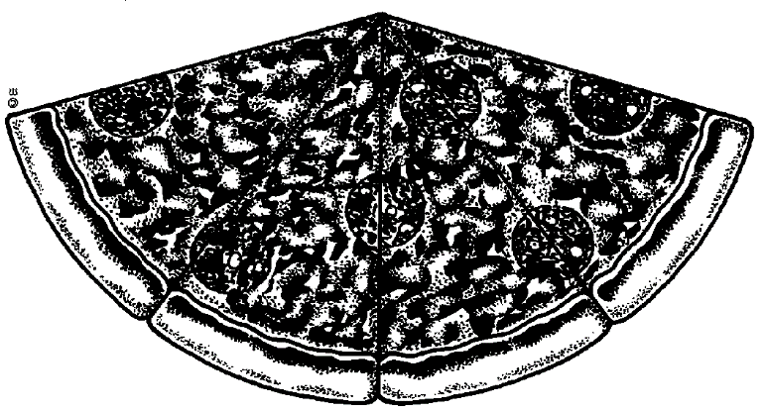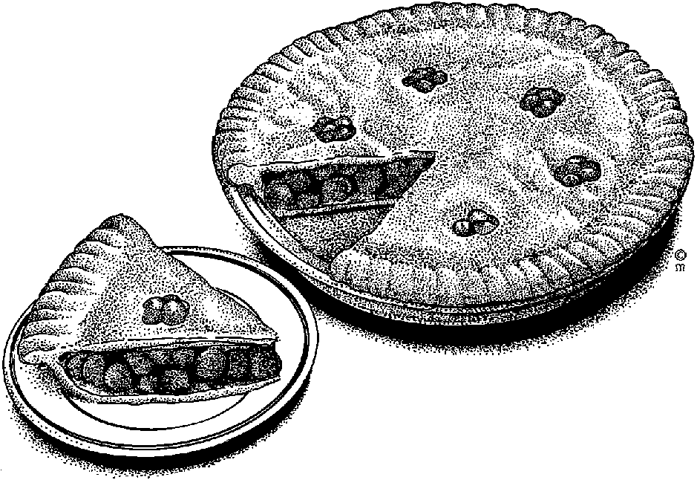

1. Round the values in the table to the term specified. Remember to take the term that you are going to round to, find the digit that corresponds to its position then change that digit according to the digit on its right. Do not start rounding from the right then stop when you reach that position. This will give you the wrong answer! Look again at 198.7630467 and notice that the rounding always used the original number. If the rounding had been ‘rolled-up’, so to speak, the value for ten-thousandth would have been 198.7631 and this value is wrong!

|  |  |  |
| --- | --- | --- |
| Value | Round to (Term) | Result |
| 1.34 | Units |  |
| 1.34 | Tenths |  |
| 34,501 | Tens |  |
| 34,501 | Hundreds |  |
| 34,501 | Thousands |  |
| 34,501 | Ten-thousands |  |
| 34,501 | hundred-thousands |  |
| 74,436 | Tens |  |
| 74,436 | Hundreds |  |
| 74,436 | Thousands |  |
| 74,436 | Ten-thousands |  |
| 74,436 | hundred-thousands |  |
| 198.7630467 | Millionth |  |
| 198.7630467 | hundred-thousandth |  |
| 198.7630467 | Ten-thousandth |  |
| 198.7630467 | Thousandth |  |
| 198.7630467 | Hundredth |  |
| 198.7630467 | Tenth |  |
| 198.7630467 | Units |  |
| 198.7630467 | Tens |  |
| 198.7630467 | Hundreds |  |
| 198.7630467 | Thousands |  |

1. Write 8.4751 correct to

|  |  |
| --- | --- |
| 3 decimal places |  |
| 2 decimal places |  |
| 1 decimal place. |  |

1. Round the following values as indicated

|  |  |  |  |
| --- | --- | --- | --- |
| **Value** | **Round to** | **Minimum** | **Maximum** |
| 250ml | 1ml |  |  |
| 180ml | 10ml |  |  |
| 500ml | 20ml |  |  |

1. What is the difference between rational and irrational numbers? Give an example of each.

|  |
| --- |
| Rational numbers are all numbers that can be represented as a ratio () of two numbers |
|  |
| Irrational numbers are those that cannot be represented as a ratio of two whole numbers |
|  |

# 

# Activity 3: (SO2, AC, 1-5)

1. Round off all the numbers to 3 decimal numbers

|  |  |
| --- | --- |
| 1.256784 = |  |
| 4.3812629 = |  |
| 1.001111 = |  |
| 22.22222 = |  |
| 8.989993 = |  |

1. Convert the following repeating decimals to common fractions:

|  |  |  |
| --- | --- | --- |
| a | 1.45454545 |  |
| b | 1,33333 |  |
| c | 52.535535535 |  |
| d | 909.9090909090 |  |

1. Convert the following fractions to decimal form (9)

|  |  |
| --- | --- |
| 1/2 |  |
| 1/3 |  |
| 1/4 |  |
| 1/5 |  |
| 1/6 |  |
| 1/7 |  |
| 1/8 |  |
| 1/9 |  |
| 1/10 |  |

1. If we say that the rule used to determine the number of significant figures the answer of a calculation should have for multiplication and subtraction is that the number with the least significant figures determines the answer, what is the correct answer for the following: (1)

|  |
| --- |
| 12,345 x 6, 7 = |

1. If we say that the rule used to determine the number of significant figures the answer of a calculation should have for multiplication and subtraction is to retain the smallest number of decimal places, what is the correct answer for the following: (1)

|  |
| --- |
| 10,345 + 9, 9 = |

1. Write the following in scientific notation:

|  |  |  |
| --- | --- | --- |
| a | 0.0009 m |  |
| b | 12cm |  |
| c | 1000 mm |  |
| e | 0.03 m |  |
| f | 1.2 m |  |
| g | 120 m |  |

1. When is the use of scientific notation useful? Give an example.

|  |
| --- |
|  |
|  |

1. A woman is standing near a lorry. Estimate the length and height of the lorry. Assume that the woman is 1.6m tall.

estimate-2

1. A bottle of wine costs 38.95. You want to buy 6 bottles as gifts. Approximately how much will 6 bottles cost? You must estimate your answer and explain your steps. (2)

|  |
| --- |
|  |