3

**LEARNER GUIDE**

**67465 National Certificate:**

**Business Administration Services**

**Level 3**

**Module 6 Organisation Skills**

Unit Standard 13929 Level 3 Credits 3

Co-ordinate meetings, minor events and travel arrangements



# TABLE OF CONTENTS

TABLE OF CONTENTS i

PERSONAL INFORMATION 1

**UNIT STANDARD 13929** 7

**IDENTIFY DATE, TIME AND VENUE OF EVENT** 8

***Provide a range of dates to attendees*** 9

***Determine suitable dates and venues*** 10

***Book meeting/event and confirm with attendees*** 11

***Listening Skills*** 16

***The telephone*** 18

***Sourcing telephone numbers and information*** 20

**ARRANGE VENUE AND CATERING** 21

***Confirm Special Arrangements And Logistics*** 21

***Plan the layout*** 22

***Select a caterer and menu*** 23

***Forward agenda for meeting/event to venue provider and caterers*** 23

***Notify venue and caterers*** 24

***Operate electrical equipment*** 25

***Use the Internet*** 25

***Sending e-mails*** 28

**TRAVEL, CAR HIRE AND ACCOMMODATION ARRANGEMENTS** 31

***Travel, car hire and accommodation requirements*** 31

***Make accommodation, car hire and travel arrangements*** 31

***Process Invoices*** 34

***Advance disbursements*** 37

**DISTRIBUTE DOCUMENTATION** 38

#### Course content

The course content covers all the basics required for learners to achieve the outcomes, however, at times there is information that learners will have to obtain by themselves.

To this end, a glossary is also not included in the course material. It is expected of learners to compile their own glossaries, which will form part of outcomes for communication unit standards. Please encourage them to start compiling glossaries as soon as possible. The glossaries can be simple: they need only quote the word and the meaning, as long as they understand what it means.

Learners are required to start thinking for themselves and take control of the learning process as soon as possible. To this end, research projects will form part of some assessments.

#### Class Activities



During and after the initial training the learner will be required to complete a number of class activities. These activities will be both individual and group activities. The activities are numbered and are to be included in the learner’s portfolio of evidence. These activities will measure the progress of the learner through the programme. For authenticity reasons these activities must be handwritten, unless indicated otherwise.

# PERSONAL INFORMATION

|  |  |
| --- | --- |
| **NAME** |  |
| **CONTACT ADDRESS** |  |
|  |
| **Code** |  |
| **Telephone (H)** |  |
| **Telephone (W)** |  |
| **Cellular** |  |
| **Learner Number** |  |
| **Identity Number** |  |
|  | |
| **EMPLOYER** |  |
| **EMPLOYER CONTACT ADDRESS** |  |
|  |
| **Code** |  |
| **Supervisor Name** |  |
| **Supervisor Contact Address** |  |
|  |
| **Code** |  |
| **Telephone (H)** |  |
| **Telephone (W)** |  |
| **Cellular** |  |

INTRODUCTION

#### Welcome to the learning programme

Follow along in the guide as the training practitioner takes you through the material. Make notes and sketches that will help you to understand and remember what you have learnt. Take notes and share information with your colleagues. Important and relevant information and skills are transferred by sharing!

This learning programme is divided into sections. Each section is preceded by a description of the required outcomes and assessment criteria as contained in the unit standards specified by the South African Qualifications Authority. These descriptions will define what you have to know and be able to do in order to be awarded the credits attached to this learning programme. These credits are regarded as building blocks towards achieving a National Qualification upon successful assessment and can never be taken away from you!

### Programme methodology



The programme methodology includes facilitator presentations, readings, individual activities, group discussions and skill application exercises.

Know what you want to get out of the programme from the beginning and start applying your new skills immediately. Participate as much as possible so that the learning will be interactive and stimulating.

The following principles were applied in designing the course:

* Because the course is designed to maximise interactive learning, you are encouraged and required to participate fully during the group exercises
* As a learner you will be presented with numerous problems and will be required to fully apply your mind to finding solutions to problems before being presented with the course presenter’s solutions to the problems
* Through participation and interaction the learners can learn as much from each other as they do from the course presenter
* Although learners attending the course may have varied degrees of experience in the subject matter, the course is designed to ensure that all delegates complete the course with the same level of understanding
* Because reflection forms an important component of adult learning, some learning resources will be followed by a self-assessment which is designed so that the learner will reflect on the material just completed.

This approach to course construction will ensure that learners first apply their minds to finding solutions to problems before the answers are provided, which will then maximise the learning process which is further strengthened by reflecting on the material covered by means of the self-assessments.

#### Different role players in delivery process

* Learner
* Facilitator
* Assessor
* Moderator

### What Learning Material you should have

This learning material has also been designed to provide the learner with a comprehensive reference guide.

It is important that you take responsibility for your own learning process; this includes taking care of your learner material. You should at all times have the following material with you:

|  |  |
| --- | --- |
| **Learner Guide** | **This learner guide is your valuable possession:**  This is your textbook and reference material, which provides you with all the information you will require to meet the exit level outcomes.  During contact sessions, your facilitator will use this guide and will facilitate the learning process. During contact sessions a variety of activities will assist you to gain knowledge and skills.  Follow along in the guide as the training practitioner takes you through the material. Make notes and sketches that will help you to understand and remember what you have learnt. Take and share information with your colleagues. Important and relevant information and skills are transferred by sharing!  This learning programme is divided into sections. Each section is preceded by a description of the required outcomes and assessment criteria as contained in the unit standards specified by the South African Qualifications Authority. These descriptions will define what you have to know and be able to do in order to be awarded the credits attached to this learning programme. These credits are regarded as building blocks towards achieving a National Qualification upon successful assessment and can never be taken away from you! |
| **Formative Assessment Workbook** | The Formative Assessment Workbook supports the Learner Guide and assists you in applying what you have learnt.  The formative assessment workbook contains classroom activities that you have to complete in the classroom, during contact sessions either in groups or individually.  You are required to complete all activities in the Formative Assessment Workbook.  The facilitator will assist, lead and coach you through the process.  These activities ensure that you understand the content of the material and that you get an opportunity to test your understanding. |

### Different types of activities you can expect

To accommodate your learning preferences, a variety of different types of activities are included in the formative and summative assessments. They will assist you to achieve the outcomes (correct results) and should guide you through the learning process, making learning a positive and pleasant experience.



The table below provides you with more information related to the types of activities.

| **Types of Activities** | **Description** | **Purpose** |
| --- | --- | --- |
| **Knowledge Activities** | You are required to complete these activities on your own. | These activities normally test your understanding and ability to apply the information. |
| **Skills Application Activities** | You need to complete these activities in the workplace | These activities require you to apply the knowledge and skills gained in the workplace |
| **Natural Occurring Evidence** | You need to collect information and samples of documents from the workplace. | These activities ensure you get the opportunity to learn from experts in the industry.  Collecting examples demonstrates how to implement knowledge and skills in a practical way |

### Learner Administration



#### Attendance Register

You are required to sign the Attendance Register every day you attend training sessions facilitated by a facilitator.

#### Programme Evaluation Form

On completion you will be supplied with a “Learning programme Evaluation Form”. You are required to evaluate your experience in attending the programme.

Please complete the form at the end of the programme, as this will assist us in improving our service and programme material. Your assistance is highly appreciated.

### Assessments

The only way to establish whether a learner is competent and has accomplished the specific outcomes is through the assessment process. Assessment involves collecting and interpreting evidence about the learners’ ability to perform a task.

To qualify and receive credits towards your qualification, a registered Assessor will conduct an evaluation and assessment of your portfolio of evidence and competency.

This programme has been aligned to registered unit standards. You will be assessed against the outcomes as stipulated in the unit standard by completing assessments and by compiling a portfolio of evidence that provides proof of your ability to apply the learning to your work situation.

**How will Assessments commence?**

#### Formative Assessments

The assessment process is easy to follow. You will be guided by the Facilitator. Your responsibility is to complete all the activities in the Formative Assessment Workbook and submit it to your facilitator.

#### Summative Assessments

You will be required to complete a series of summative assessments. The Summative Assessment Guide will assist you in identifying the evidence required for final assessment purposes. You will be required to complete these activities on your own time, using real life projects in your workplace or business environment in preparing evidence for your Portfolio of Evidence. Your Facilitator will provide more details in this regard.

To qualify and receive credits towards your qualification, a registered Assessor will conduct an evaluation and assessment of your portfolio of evidence and competency.

### Learner Support

The responsibility of learning rests with you, so be proactive and ask questions and seek assistance and help from your facilitator, if required.





Please remember that this Skills Programme is based on outcomes based education principles which implies the following:

* You are responsible for your own learning – make sure you manage your study, research and workplace time effectively.
* Learning activities are learner driven – make sure you use the Learner Guide and Formative Assessment Workbook in the manner intended, and are familiar with the workplace requirements.
* The Facilitator is there to reasonably assist you during contact, practical and workplace time for this programme – make sure that you have his/her contact details.
* You are responsible for the safekeeping of your completed Formative Assessment Workbook and Workplace Guide
* If you need assistance please contact your facilitator who will gladly assist you.
* If you have any special needs please inform the facilitator

### Learner Expectations

Please prepare the following information. You will then be asked to introduce yourself to the instructor as well as your fellow learners

|  |
| --- |
| Your name: |
| The organisation you represent: |
| Your position in organisation: |
| What do you hope to achieve by attending this course / what are your course expectations? |
|  |
|  |
|  |
|  |
|  |

**UNIT STANDARD 13929**

***Unit Standard Title***

Co-ordinate meetings, minor events and travel arrangements

***NQF Level***

3

***Credits***

3

***Purpose***

Learners will be learning towards obtaining a national qualification at level 3 or are working in an administrative environment, including SMME`s (Small, Medium and Micro Enterprises), where the acquisition of competence against this standard will add value to the learner’s job, or chances of finding employment.

Learners will be well positioned to extend their learning and practice into other areas in the business environment, or to strive towards professional standards and practice at higher levels.

The qualifying learner is capable of:

Identifying a date, venue and time for meeting or event

Liaising or negotiating with meeting attendees regarding availability

Booking venues and catering

Finalising meeting room arrangements

Making travel, car hire and accommodation arrangements

Notifying and confirming arrangements with attendees or stakeholders

Processing and distributing all documentation required for the meeting or event

***Learning assumed to be in place***

Learners accessing this unit standard will have demonstrated competence in numeracy and literacy at NQF Level 2.

***Unit standard range***

Working as part of an office support team includes contributing to the arrangements of meetings from lower level management to executive levels

Principles will include data gathering, liaison and negotiation with outside parties and team members

Details of meeting will include venue, date, reason and time of meeting

***Specific Outcomes and Assessment Criteria***

**Specific Outcome 1:** Identify a date, venue and time for a meeting or event

**Assessment Criteria**

A range of dates for meeting/event are provided to attendees

Suitable dates and venues are determined based on responses to range of dates provided

Meeting/event is booked and confirmed with attendees in writing

All related documentation is forwarded to the attendees

**Specific Outcome 2**: Arrange venue and catering

**Assessment Criteria**

Venue is selected and booked

Process of selecting venue is described

Special arrangements, logistics, meeting room layout and equipment required are confirmed with the venue provider

Process of selecting date, caterer and menu is described, taking into consideration religious and dietary requirements

Agenda for meeting/event is forwarded to venue provider and caterers so that correct times for meals and breaks can be adhered to

Venue and caterers are notified in writing and deposits paid

**Specific Outcome 3**: Make travel, car hire and accommodation arrangements

**Assessment Criteria**

Travel, car hire and accommodation requirements for all attendees are determined

Suitable accommodation is secured and bookings confirmed in writing

Car hire facilities are identified and confirmed in writing

Travel arrangements are made and all necessary documentation forwarded to the attendees

Invoices relating to travel, car hire and accommodation are processed

Any relevant advance disbursements for travel, car hire or accommodation are processed

**Specific Outcome 4**: Make travel, car hire and accommodation arrangements

**Assessment Criteria**

Deadline date for receipt of documentation from contributors is established according to agreed time frames

Deadline date is communicated to contributors

Documents are assembled, copied and collated

Relevant documents are timeously distributed in hard or electronic form to participants.

***Unit Standard Essential Embedded Knowledge***

Use and understanding of directories for telephone, venue and conference centres, restaurants, car rental, travel and accommodation

Telephone techniques

Map book

Use of technology: photocopier, e-mail, fax machines, website for research.

***Critical Cross-field Outcomes (CCFO)***

Identify and solve problems regarding specific meeting requirements.

Work effectively with others liaising and negotiating dates and venues.

Organise oneself and one’s activities to collect and collate information on venues and caterers

Communicate effectively using assertive telephone techniques and negotiating skills.

Use science and technology to communicate meeting details (e-mail, fax and telephone).

**IDENTIFY DATE, TIME AND VENUE OF EVENT**

***Outcome***

Identify a date, venue and time for a meeting or event

***Assessment criteria***

* A range of dates for meeting/event are provided to attendees.
* Suitable dates and venues are determined based on responses to range of dates provided.
* Meeting/event is booked and confirmed with attendees in writing.
* All related documentation is forwarded to the attendees.

***Provide a range of dates to attendees***

Arranging an event can be a long and gruelling process, for the simple reason that you would need to find a date that suits everyone who needs attend the event and a date that “suits the venue”. There are two ways to go about this:

You can either find the venue first and get the dates when the venue will be available, or you can get dates from the attendees when they will be able to attend and find a venue that can accommodate that date. Either way, you could run into problems.

The reason being, if you have 50 attendees who need to attend an event, chances are not all 50 are going to have the same dates available in their diaries. Here’s how to solve the problem:

Send a notice of the event **well before** the event is supposed to take place (at least two months, especially where a year end function is concerned, since most organisations host an end year function and venues will not be freely available). Make a space on the notice for every attendee to put down a suggested date and return those dates to you.

Remember to give the attendees a deadline by which you need their replies.

Once you have the dates, you can count them and arrange a date according to the available date of the majority. This is called democracy, and can hardly ever be disputed, so you’d stay out of the hot seat since the majority wins. Here’s an example of such a notice:

Monday, September 10, 2007

**Year End Function Date**

Dear employees,

We are nearing the end of another wonderfully successful year, so the time is approaching to arrange our annual **year end function.** We would greatly appreciate your input and would therefore like you to tick next to the date you will be able to attend an event that is filled with promises of entertainment and excitement.

We appreciate your input!

|  |  |
| --- | --- |
|  | Saturday 1 December |
|  | Saturday 8 December |
|  | Saturday 15 December |

Note that the dates from 22 December onwards are not available as the organisation is closing on 17 December.

I would appreciate it if I could receive your reply as soon as possible, or before Friday 14 September 2007.

Thank you very much,

*Tip: Try to advertise a little in a case like this so that the employees are motivated not only to fill in the letter, but also to attend the event.*

The next problem you will face is to get the replies back. You might get a lot of excuses such as:” I never received the notice”, or “I haven’t had time to look at it”, etc. To avoid this situation you can do the following:

Design a template with the names of all the employees, a space for a signature and date. Each time a circulation letter or notice is sent out, the employee has to sign that s/he has received it. For each new circulation letter you can simply change the details according to the situation. See the example below.

Secondly you can add a cut-off date to the notice or document. This means the relevant parties has to give you a response before the cut-off date or their opinion simply won’t be taken into account and will have no choice in the matter at hand.

|  |  |  |
| --- | --- | --- |
| **End year function date notice** | | **26 November 2007** |
| **Name** | **Signature** | **Date received.** |
| Me. E Chokwe |  |  |
| Me. N Rautenbach |  |  |
| Mr. S Potgieter |  |  |
| Mr. D Wessels |  |  |

***Determine suitable dates and venues***

Once you have all the responses, you can count them. This could also turn out to be a rather large job, depending on the amount of attendees (for example 500 people), but there are ways to make this easier.

In the example letter we gave three possible dates namely, 1 December, 8 December and 15 December. A good idea would be to get 3 boxes and mark each of them with one of the three dates.

Now you can start sorting the responses, each into its relevant date box. Once you have sorted all the responses into their relevant dates, you can count them to find out which date has been chosen by the majority.

**Box1: 1 Dec**

**Box3: 15 Dec**

**Box2: 8 Dec**

If you get the responses via email, you can use the same system as above. In this case you will paste the responses in the relevant date folder instead of printing them all and then sorting them.

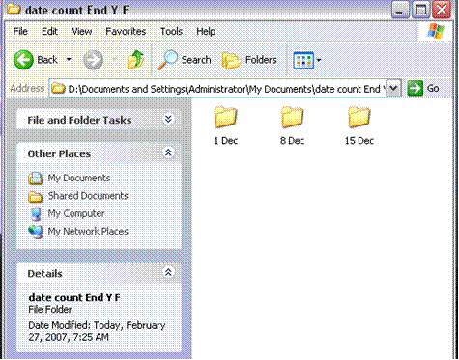

Now you’ve counted the replies and 8 December is the most popular date – 42 out of 50 replies. Finally you have a date that you can start working with.

***Book meeting/event and confirm with attendees***

In our example the date that has been decided on is 8 December. Now you can start looking for a venue.

There are various ways to look for a venue. Some of the resources you could use are:

The Yellow pages

The Internet

Company records of previous events and the venues that were used

**Factors to take into account when deciding on a venue.**

The first thing would be distance. Try to get a venue that is as close to the organisation as possible. This will eliminate transport problems for the individuals who don’t have their own transport.

Secondly, you should make 100% sure that the venue you decide on can accommodate the amount of people who are going to attend the event.

Third, you have to make sure that the venue you choose falls within your budget. You **cannot** book a venue that goes over your budget. You **will** get into big trouble if you book a venue that charges more than the amount allocated to organise the event.

Furthermore, you need to make sure that the venue can supply things that you are going to need such as the catering, tables, chairs, cutlery and drinks.

**It is very important to consider these factors when choosing the venue**

For the purpose of our case study we will use a venue that the organisation has used before: The venue name is Kiewiets Kroon.

Steps to follow when booking an event: contact the venue and

enquire about the availability of the date (8 Dec)

find out if they can host 50 people

find out if they supply the tables, chairs and cutlery

find out if they do the catering

find out if they supply the drinks and if the drinks are included in the price per person

find out what the price per person is

find out when the total amount has to be paid

find out if you need to pay a deposit to secure your event date

If everything is in order and the venue can fulfil all your needs, within your budget

book the date and ask them to send you a letter of confirmation

ask them to send you a roadmap, that you can include in the formal invitation/notice to the attendees

ask them to send you the invoice for company records

In the case of a meeting, many organisations stipulate that the boardroom or meeting room has to be booked as well. This is to prevent double bookings and two groups arriving at the boardroom at the same time. If you are arranging a meeting, be sure to book the boardroom and make sure that it has enough space for the amount of attendees.

*Note: If you’ve never been to the venue you’d like to book or the one that suits your needs, it is a good idea to make an appointment with their events coordinator and view the venue before you book it. This way you can avoid any nasty surprises on the day of the event. You can be sure that it has happened that the telephonic conversation makes the venue sound wonderful and when you get there it is awful. If you cannot get to the venue, go to their website and look for pictures of the venue. If you cannot find any, you will have to personally view the venue.*

Once you have all the information you need, as well as the letter of confirmation from the venue, you can start sending out the notice or invitations of the event to the people who will attend the event, which in this case are your fellow employees. Below you will find an example of such an invitation.

***Note:*** *You can either email such an invitation or print them and hand them out. This example has been created in MS Publisher.*

**First page**

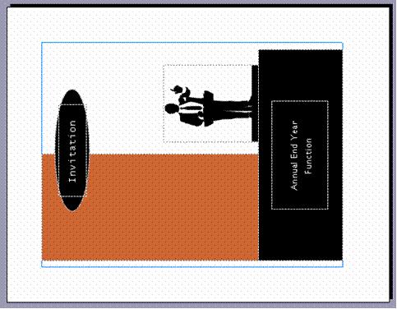

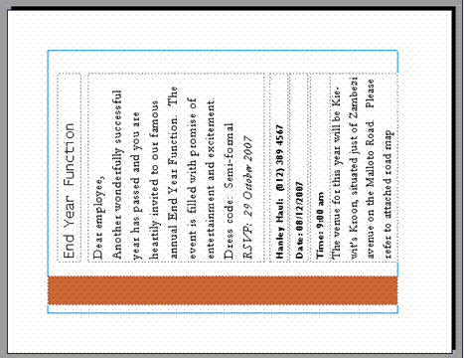

**Second page**

**Third page** 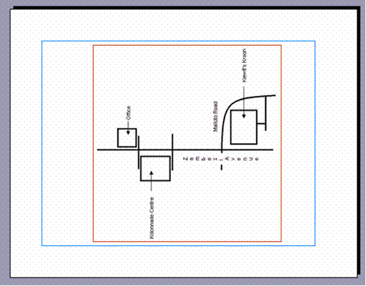

**Last page**



If you plan on printing and folding the invitations, this is what the final page will look like:

You need to fold these invitations in half horizontally and then again vertically.

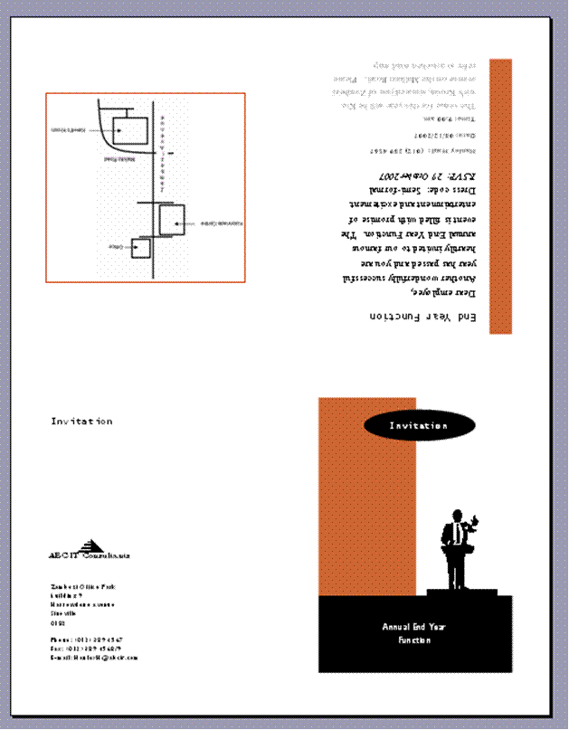

Vertical

Fold

Horizontal

Fold

By sending these invitations, you have given all the employees a **written invitation** or in another case a **written notice** if it was for a meeting. For a meeting you would simply change the headings and contents.

Once again, apply the system that we have discussed before, and get the recipients **to sign** that they have received the invitation. It is a good idea to send everyone a **reminder** a week before the RSVP due date to ensure that you receive replies are on time.

**Details**

The following details must be included in the invitation

Name of event

Date and time of event

Instructions on how to get there

A date by which the attendee must advise whether s/he will attend or not

***Listening Skills***

The most important thing to bear in mind when you think about your listening skills is to always remember that you cannot hear what is being said when you yourself are talking.

We have TWO ears and ONE mouth: use them in that order, in other words, listen more than you talk.

The importance of listening skills should not be underestimated. The words that people use give us clues as to the concepts and criteria that are important to those people, and these can only be explored through listening.

**Levels of listening**

When others speak, we listen at one of five levels:

**Ignoring:** Making no effort to listen.

**Pretend listening:** Making believe or giving the appearance you are listening.

**Selective listening:** Hearing only the parts of the conversation that interest you.

**Attentive Listening:** Paying attention and focusing on what the speaker says and comparing that to your own experiences.

**Empathetic listening / Active listening**

People who listen at the first four levels often pursue personal motives. People who practice the fifth level of listening, empathic listening, try to discover what the other person really means and feels from his or her point of view.

**Active listening**

!!

Is a **skill** and is as important as giving orders in obtaining results.

Give your full attention to what is being said.

Make sure that you really understand.

Listen between the lines.

Look for non-verbal clues.

Mentally summarise and evaluate objectively.

Be empathetic.

Determine whether the caller expects:

- guidance

- support

- motivation

- action or

- silence

**What makes a good listener?**

This is actually a question of feedback. Good listeners use a variety of non-verbal and minimal cues to keep the other person talking. These include the use of phrases such as:

“Yes”

“I understand”

“And then what”

“Tell me more”

“If I understand you correctly…”

**In addition good listeners also use a lot of the following:**

Use the 66:33 rule, that is, they **listen for 66% of the time** and **only talk for 33%** of the time

66%/33%

Use acknowledgement: they give **verbal recognition** that they have heard what the talker has said

**Show interest**, that is, they use non-verbal means to show they are engaged

**Ask more than they tell**, that is, they use open questions to gain information without specifying the answer.

**Communication factors**

When you communicate, there are four critical factors to consider:

**What you meant to say – the message in your thoughts**

**What you actually say – the words, tone of voice and body language**

**What the other person hears – words, tone and body language**

**What the other person thinks he heard**

When you feel good, you sound good too! The customer cannot see your smile on the other side of the telephone, but he can hear your smile – and it is a lovely sound!

**Remember**

Normal face-to-face communication

***55% of a message is conveyed by body language and facial signals***

**38% of a message is determined by your tone of voice**

***7% of a message is conveyed by the words you use***

Telephonic communication

On the telephone, however, the percentages change:

**38% of a message is conveyed by the words you use**

***55% of a message is determined by your tone of voice***

**7% of a message is conveyed by body language and facial signals**

***The telephone***

Irrespective of whether you are involved in administrative duties or if you are senior in the organisation, there are times when you will be making or receiving telephone calls. You may even find that you will have to handle the switchboard on occasions.

The telephone is the most significant tool for making an impression on clients or other stakeholders.

It is a communication tool, which enables you and your clients or stakeholders to speak to each other and to transfer information.

The person on the line will assess your organisation based on the person answering or calling on the phone.

We all know how frustrating it is when we call an organisation and the person who answers the phone is:

Unhelpful

Grunts

Refuses to take a message

Will not try to put us in touch with someone who can deal with our problem

Can hardly communicate with us effectively in the approved business language

It does not matter if you are working in a Corporate Office, a Government Department, a Non-Profit Organisation or a Community Project, the rules of good telephone etiquette remain the same.

**Telephone Etiquette**

Hold the telephone with your non-writing hand. Try not to tuck the phone under your chin while you are typing or doing something else. This will affect the quality of your voice and the caller will be able to tell that something is wrong.

Hold the telephone 2.5 cm in front of your mouth

Have a pen and paper ready so you can take notes. NB: Your office may have a system of message books or notelets. If this is the case, ensure that the message is put in the accepted format.

Know how to use your telephone system correctly so that you are able to transfer calls, put callers on hold etc. without creating the impression that you do not know what you are doing.

Be familiar with the list of extensions in your office, so that you can transfer calls with ease.

Answer promptly within three rings if possible or apologise for any delay

Put a smile in your voice

Do not shout down the phone or whisper so that the caller cannot hear you

In an office environment, use the official language of your area. If the caller wishes to talk in his or her own local language and you are able to do so, then assist the caller in the language of preference.

Do not use slang or jargon but speak clearly

Make sure there is no disturbing background noise. If you are playing a radio while you are working. Turn the sound down when you answer the phone so that the caller can hear you clearly

Greeting – company name – offer of assistance

Find out why the caller is calling and take the appropriate cause of action timeously.

If the call is for someone else, do not scream out the other person’s name or call out to enquire if your colleague is in the office. If you cannot put the caller on hold, cover up the mouthpiece before you talk to someone else.

Acknowledge the caller’s request and take responsibility for actioning it

Do what you say you’re going to do. If you promise to get a colleague to phone the caller back, check to see that this is done. This is really important as there is nothing more frustrating for a caller than to sit and wait for someone to phone back and nothing happens.

If the desired course is to put the person through to a colleague make sure that your colleague receives the call. Sometimes a caller is put through and an answer machine picks up the message. This is very annoying for the caller who then has to phone a second time to find out if someone else can help him or her.

Be friendly and polite and courteous at all times

Use the caller’s name when possible. This is both courteous and friendly and will make the caller feel that you are taking a personal interest in him or her.

If a person telephones who is unknown to you, you should address him or her as “Mr. / Ms Mabena”

Always remember to write the message in the message book

End the conversation on a positive note which leaves the caller with a good impression of the organisation

The following statements will conclude your call in a professional manner

*“Thank you for calling, enjoy the rest of your day”*

*“Thank you for your enquiry”*

*“Good bye and thank you for calling”*

*“Thank you for calling, I will certainly get Sipho to call you as soon as he comes in”*

*“If you have any questions, please call me”*

“If Sipho does not get back to you by this afternoon, please do not hesitate to contact me again”

**Making a call**

***When to call***

This question can be split into two parts. When should you call to fit in with your schedule and when should you call to fit in with the schedule of the person you are trying to contact? The first question is entirely up to you, but remember the following hint: group your calls together wherever and whenever possible. This will help you manage your time effectively

Fitting in with someone else’s schedule is more difficult. If you phone someone and they tell you that they cannot take your call because they are in a meeting, ask politely when it will be convenient for you to call back.

***Preparation***

It is important to prepare for a phone call. Think about what you want to say and any queries you may have. It is useful if you jot these down in point form. Always have a pen and paper and any documents you may want to refer to close at hand.

***Getting through***

If you know who you want to speak to, just ask for them by name. If you do not know who you want to speak to by name, be as helpful as possible to the person on the other side in giving details of the department you want.

Always be polite to the switchboard operator, the secretary or anyone else who answers your call before you are transferred to the person you wish to speak to. Politeness costs nothing, but it brings rich rewards in people wanting to help you.

***The conversation***

The quality of the call will depend on the quality of your preparation and the quality of the way you speak. Ensure you never mumble your words or mispronounce them and be sure to state the reason for calling the person. Listen to the tone of voice of the person you have called and if you sense that you have rung at an inconvenient time, offer to call back, suggesting alternative times for ringing back.

***Making notes***

If you agree to do something as a result of the call, then write down what you have agreed to do. Reinforce what has been agreed by summarising the points at the end of the telephone call.

“Mr Phiri, I have agreed to come back to you by 4 pm today with the information you require. Thank you so much for your time”

***Leaving messages***

If you cannot reach the person you would like to speak to and you have something important you need to communicate, you may have to leave a message, but do not assume it will be delivered. The best thing to do is find out when the person you are need to talk to will be available and say that you will call back at that time, leaving your name, organisation and telephone number in case they wish to ring you back.

If you do call again, do not get angry with the switchboard because no one phoned you back, as it will not help the situation.

***Sourcing telephone numbers and information***

It is important that you know how and where to find information as quickly as possible.

Make sure that you have a list of internal telephone numbers so that you are able to transfer calls timeously.

It is also useful to have a list of other useful numbers that you can refer callers to if necessary. If you have a computer, you can set up your own telephone number directory on an Excel spreadsheet.

Other important sources of information are the telephone directory (White Pages) and the Yellow Pages.

But, when and how would you use them?

**The White Pages**

This directory provides you with the following information:

All business contact numbers in your region

All residential numbers

Emergency services (ambulance, fire brigade, police, hospitals, etc.)

Telkom’s various telephone services

How to report telephone faults

Call charges

Various products offered by Telkom

National and international dialling codes

List of the National Government of your region

**The Yellow Pages**

This is a business directory and lists all the various type of businesses and professions under the correct heading, in alphabetical order. However, you can also find the following information in the front of certain big cities’ directories:

Tourism Bureau

Various Sport Associations

What is happening in your city

Museums

Fun things to do

All the listings in both these two books are in alphabetical order. In the White Pages, all the abbreviated companies such as **ABC** Ltd, **DVD** Vision are listed in the beginning of each alphabetical section. Business names and surnames are all listed together in each alphabetical section, e.g. under E, F, G, etc.

The surnames of people are listed first, with the particular initials afterwards.

Remember, each area has its own directory, e.g. there are directories for Johannesburg, Pretoria, Cape Town, etc. These directories are free of charge, for your own area only, at your local Post Office and new versions are published every year.

**Formative assessment 1 telephone technique and directories group activity**

**ARRANGE VENUE AND CATERING**

***Outcome***

Arrange venue and catering

***Assessment criteria***

Special arrangements, logistics, meeting room layout and equipment required are confirmed with the venue provider.

Process of selecting date, caterer and menu is described, taking into consideration religious and dietary requirements.

Agenda for meeting/event is forwarded to venue provider and caterers so that correct times for meals and breaks can be adhered to.

Venue and caterers are notified in writing and deposits paid.

***Confirm Special Arrangements And Logistics***

In the previous section, we looked at how to find and book a venue. We are now going to take a more in-depth look at what has to be done after the booking and the invitations have been sent out.

You now have to start planning the events at the end year function.

You can start by:

Finding out who will be speaking at the event

What they are going to need

If any departments wants to do a presentation of their highlights of the year

What they are going to need for the presentation

If you can arrange a band or some sort of entertainment if it falls within the budget

Once you have all this information you can organise a meeting with your contact person at the venue to discuss what you are going to need and to plan the layout of the event and the seating arrangement.

Make a list of your findings and take it with to the meeting:

CEO wants to do the welcoming speech – he will need a podium a microphone (sound system)

The Sales and Marketing department would like to do a presentation of the highlights of the year – they are going to need a projector for a slide show and a sound system

A band will be performing – they need a stage

Once at the meeting, find out if the venue can supply all the equipment you are going to need. It is very likely that they will be able to supply the equipment, especially if they often host corporate functions. If the venue cannot supply things such as a stage, you will have to arrange for one yourself, and confirm the delivery and placement of the stage with the supplier as well as the organisation in charge of the venue.

***Plan the layout***

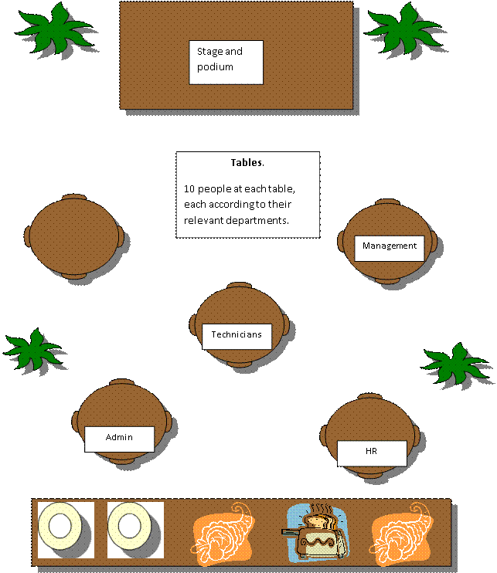In the meeting with the venue event planner, you will have to discuss the layout and seating. Since the function is in the summer, you and the planner has decided to host the event outside under a large tent. The best way to do the layout planning is with pictures.

See example below:

**Entertainment Area From Above:**

Marketing

Bathrooms are separate from the tent in a building.

***Select a caterer and menu***

Planning a menu could get very tricky because of preference, religion and allergies. Luckily caterers are professional (or most of them, so be careful when you choose one) and are aware of these factors.

Since our case study event is in the morning, there will be a brunch. This could include “breakfast food” as well as “lunch food”. To expand the case study a little, let’s add some ethnic groups. The people attending will be:

Indian

Black

White

And a few Chinese.

***Forward agenda for meeting/event to venue provider and caterers***

As discussed earlier, the CEO would like to do the welcoming speech, and marketing would like to do a presentation. You need to find out from both how long the speech and presentation will be, so you can include it in the planning of the events.

The CEO needs 30 minutes to open the event and welcome everyone

The marketing team needs 45 minutes for the presentation

Once you have these times, you can prepare a schedule.

|  |  |
| --- | --- |
| **Time** | **Activity** |
| 9:00 | Everyone arrives |
| 9:15 | The CEO - welcome speech |
| 9:45 | Drinks |
| 10:00 | Presentation by Marketing team |
| 10:45 | Bathroom break |
| 11:00 | Brunch is served |
| 11:10 | Band plays while everyone dishes and eats |
| 11:20 | Second round of drinks are served and fresh water placed on tables |
| 12:00 | Dishes are collected from tables once everyone is done eating |
| 12:15 | You (or whoever planned the event) thanks everyone for coming and wishes them a good holiday (closing speech and invitation to stay on) |
| 12:25 | Event is coming to an end, although guests may stay on and enjoy each other’s company and the cash bar. |

Once you have completed a schedule like the example above, you need to forward it to the relevant person at the venue (most probably your venue event coordinator). If you are not making use of the caterers offered by the venue, you also need to forward the schedule to the caterer you’ve chosen. You can do this via fax or email, **but do a follow up to be 100% sure that they have received it!**

**The Agenda**

The Agenda is a list, or programme of the items of business to be discussed at a meeting. The items of business are set out in the order in which they are to occur.

Setting the agenda is a crucial task, as it defines the boundaries of the discussion that will proceed during the course of a meeting. A carefully prepared and managed agenda will keep the group focused on achieving the desired outcomes. It can serve as a route map of the meeting that everyone can refer to.

***General notes regarding Agendas***

* Next to each item on the agenda, briefly describe what is to be discussed so that its purpose is clear to member who will be attending the meeting.
* The Agenda should be kept as short as possible, it should be consistent (reliable), and unambiguous (clear, no double meanings)
* Any relevant additional papers should accompany the Agenda and they should be clearly referred to in the Agenda. These are known as Agenda papers.
* When drawing up the Agenda, think about what information can be presented in the form of appendices, such as additions and attachments, and agenda papers, rather than having lengthy description in the Agenda itself.

***Agenda layout***

The layout of the Agenda is very important, as the order of the Agenda normally determines the order that discussions will take place in during the meeting

***Notify venue and caterers***

Most of the time, the venue and caterer will need a deposit on the day of confirmation or at least two to three weeks before the event/meeting. The amount they charge varies from 10%, 25% and sometimes 50% of the total cost due.

If the venue charges R5000 for the venue hire, including chairs and tables and wants a 50% deposit, you will have to pay R2500.

A caterer works a little differently, since they charge “per head”. In other words, the organisation will be charged a certain price per person attending the function. Let’s use say the caterer charges R150 pp and 50 people will be attending, you need to do the following: 150 times 50 = R7500. R7500 is the total cost of the catering, and your deposit will be worked out accordingly. If the caterer wants 25% of the total cost as a deposit, you’ll need to pay R1875.

You will have to request invoices from the venue and the caterer in order to process the payment.

Payments can be made by depositing a cheque in the service provider’s account, by making a transfer via the Internet or by making payment with a credit card.

When such payments are made electronically, you have to print out the proof of payment and fax it to the relevant person at the venue and caterers. Also, phone them and make sure that they have received the fax. This is very important. If the venue or caterer are not aware of the payment, they will not proceed with the arrangements.

Also ensure that they fax or email confirmation of the arrangements to you.

*Note: When the arrangements for the deposit are made, you should also make the arrangements for the final payment. The final payment is normally done after the event. This is done so that payment can be withheld if you are unhappy with the service. For example, when a venue has double booked the same space for the day of your event; or the caterer brings diner instead of brunch. Do not try to withhold final payments with silly excuses such as there were not enough waiters or something similar. You are going to run into trouble.*



***Operate electrical equipment***

Every person working for the organisation should be able to operate the electrical equipment available in the organization.

You have to be able to send and receive your own faxes, as well as those of other people working in the organization. You must also know how to make your own photo copies and print your own documents.

Waiting for someone else to do these things for you is a waste of time that not your or your organization can afford in the 21st century, where the speed of getting information to clients could determine whether the organization lands a big contract or loses out on it.

Customers are entitled to good and speedy service and will take their business elsewhere if they don’t get it from your organisation. Losing big contracts or customers can cause a business to downsize or even go bankrupt and this results in job losses.

By giving good customer service you are protecting your job and ensuring a steady monthly income for yourself.

**How To Send A Fax**

The procedure for sending faxes varies from manufacturer to manufacturer, but the basic procedure is:

Place the document face down in the paper holder

Dial the number that the fax has to be sent to

Press the send button

Always read the instruction manual to ensure that you understand the specific procedure.

**How To Receive A Fax**

Ensure that there are no obstructions in front of the paper feeder

Some faxes require that the fax receive button be pressed in order to receive a fax

If the fax paper is continuous, tear off the fax as soon as it has been sent

Always read the instruction manual to ensure that you understand the specific procedure.

**How To Make Photo Copies**

Place the document face down on the glass surface

Select the number of copies you require

Press the copy button

Always read the instruction manual to ensure that you understand the specific procedure.

***Use the Internet***

**Start Internet Explorer**

On the Windows Taskbar, click Start 

Select the Internet Explorer item at the top of the Start Menu



**Browsing the Web**

A website is made up of pages, similar to a book. When you move around between the pages in a website or from one website to another, it is called browsing (or navigating, or sometimes "surfing the web").

You can browse web pages in several different ways.

***Hyperlinks***

Almost all web pages have hyperlinks. They connect:

One page to another part of the same page (useful if it is a really large page)

One page to another page somewhere on the web

A page to a file, such as a sound clip, video, a spreadsheet or a Word document

These links to other pages can be links to things stored anywhere on the internet. Hypertext links are indicated by underlined text highlighted in blue (usually). Hyperlinks are also frequently in the form of buttons, graphics or pictures.

**How Search Engines Work**

Search engines are constantly browsing the WWW, looking for links embedded in various websites. They then follow those links. They use indexing software to add the information to a huge database that contains text, addresses and links.

When you enter a query into the search engine, you are searching in their database and not the WWW. The search engine gives you a list of URL’s in response to your query. The response from the search engine is based on how relevant the website is to the text you typed in your query.

There are many different search engines and they use different rules to determine the relevance of a specific page to your query.

Most search engines are very good, as they are in competition with each other. The owners of search engines get their money from advertisers who put advertisements on their website. This means that they make sure that their search engine is easy to use and up to date.

***Use the Search Assistant***

On the Standard toolbar, click Search

Or Select the View menu, Explorer Bar menu and then click Search

The Explorer bar will show with the Search Assistant loaded.

In the Find a Web page containing: box, type a few words that describe the type of pages you want to find

What you type in the Search box will determine the kind of response you get.

Click the Search button

You will be required to connect to the internet, if you are not already connected.

The Search Assistant will perform your search and display the results. The sites that most closely match your query are listed first.

If you do not see what you want, click the Next hyperlink in the search pane (not the button on the Explorer bar) to move down the list of matches

Click the link you want

On the Explorer bar, click New to start another search

The Search Assistant also lets you look up a word using Microsoft's Encarta encyclopaedia and search for a map or a newsgroup.

From the Choose a category for your search panel, select the relevant option button

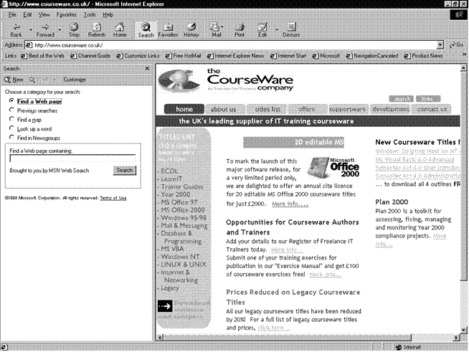

***Sending e-mails***

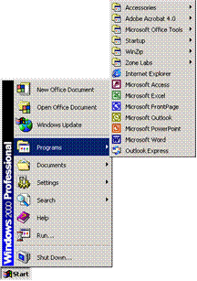**Start Outlook**

Once Outlook has been installed on your computer you can start the application double-clicking the Outlook icon.

**OR**

On the Taskbar, click the Start button then select the All Programs menu item.

The All Programs submenu is displayed.

Click the Microsoft Office program item

Click the Microsoft Outlook program item

**Enter Data Into The Mail Window**

**To…**

Enter the e-mail address of the recipient in the **To…** box. You can enter the names of more than one recipient in the **To…** box, as long as you separate the names with a semicolon(;), for example:

[narina@photography.co.za;albert@hotmail.co.za;yourname@timdutoit.co.za](mailto:narina@photography.co.za;albert@hotmail.co.za;yourname@timdutoit.co.za)

**Cc…**

To enter an e-mail address in the **Cc…** box, follow the same procedure as above. Cc stands for Carbon Copy. CC means that the e-mail is sent to that recipient for information only, the recipient does not have to respond or reply to the message.

**Bcc…**

Bcc stands for Blind Carbon Copy. When you enter a recipient’s address in the **Bcc…** box, the recipients in the **To…** and **Cc…** boxes will not see the names of the recipients in the **Bcc…** box - that is why it’s called Blind Carbon Copy. You will use the **Bcc…** box when you do not want the recipients in the **To…** and **Cc…** boxes to see that you are sending the message to a specific recipient.

If the **Bcc…** box is not displayed, click the down arrow to the right of the Options... button and select Bcc.

You can use either the **Cc…** or **Bcc…** boxes without using the **To…**box, as long as there is at least one recipient in one of the three boxes the e-mail can be sent.

***Enter a Subject Heading***

Once you start sending and receiving e-mails, you will find that a lot of correspondence and communication is conducted this way. It is possible that you will send and receive up to 300 e-mails daily. You will therefore appreciate it when people who send you e-mails give an appropriate subject heading, as the e-mail will be listed in your Inbox under the subject heading.

Giving the mail a subject heading such as: Thabo’s mail will be silly. When you write or type a document at work for a client or a superior, you always include a subject heading that gives details about the letter. The same principle will apply to an e-mail subject heading.

If the mail is about a weekly or monthly meeting, for example, include the full details of the meeting and the purpose of the e-mail, which could be the agenda or minutes of the meeting:

Agenda for weekly meeting to be held on 25 Jan 06

**OR**

Minutes of meeting held 15 Jan 06

If you only state minutes of meeting and the meeting is held every week, you will end up with about 50 e-mails with the same subject, which will make your life and the lives of the recipients very difficult when you want to find the minutes of a particular meeting.

Think carefully about the subject heading and make sure that it makes sense, conforms to the protocol as prescribed by your organisation and, above all, ensure that it will be easy to find this particular e-mail again.

to or click in the Subject: box

Type a subject heading for the message

***Body of the message***

to or click in the main box, where you will enter the message.

Remember that an e-mail is usually an electronic form of a letter. Follow the same format as If you are typing a letter. If it is to a friend, it can be informal, if it is to a manager, it has to be more formal.

***Attach A File To A Message***

Click the Insert File button on the Message toolbar, **OR** 

Select the Insert, File menu. The Insert dialogue box will be displayed. Ensure that the Files of type text box is set to All Files. This way you will see all the files that are available.

Browse to select the file you want to insert and then click the Insert button in the dialogue box. You will usually find the file that you want to attach in the My Documents folder.

You will see the file attachment in the **Attach...** box underneath the Subject: box.

If you attached the incorrect file and want to delete the attachment, click the attachment icon in the **Attach...** box and press .

To attach more files, follow the same procedure for each file. 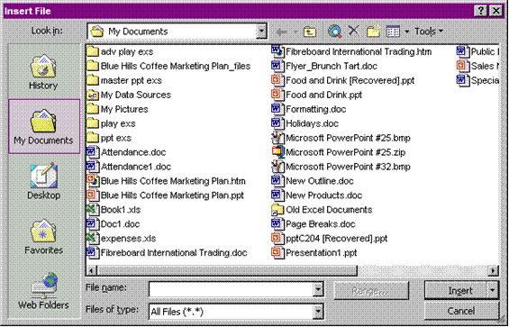

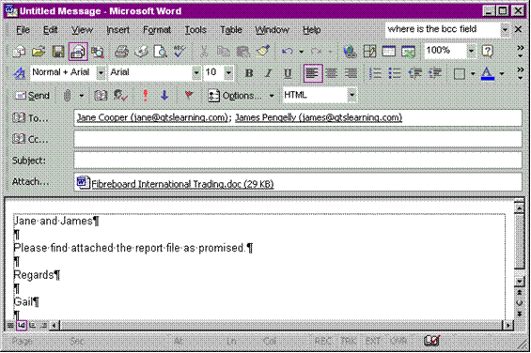

**Formative assessment Use of technology individual activity**

After practising sending and receiving faxes, explain the procedure to your group

Practice the procedure for making photo copies. Explain the procedure to your group

Explain the procedure for sending e-mails. If possible, send e-mails to each other about the event you are planning

Explain the procedure for searching on the Internet. If possible, look op suitable venues on the Internet

**Formative assessment SO2, AC1-6 individual and group activities**

**TRAVEL, CAR HIRE AND ACCOMMODATION ARRANGEMENTS**

***Outcome***

Make travel, car hire and accommodation arrangements

***Assessment criteria***

Travel, car hire and accommodation requirements for all attendees are determined

Suitable accommodation is secured and bookings confirmed in writing

Car hire facilities are identified and confirmed in writing

Travel arrangements are made and all necessary documentation forwarded to the attendee

Invoices relating to travel, car hire and accommodation are processed

Any relevant advance disbursements for travel, car hire or accommodation are processed

***Travel, car hire and accommodation requirements***

Once you have determined the number of people who will attend and when and where the event will be held, you have to make arrangements for attendees from out of town. You will have to make arrangements for:

accommodation

car rental

air travel

travel from the hotel to the venue and back

Information that you need to have to hand when making bookings include:

Initials and surname of attendees

Air travel: when and at what time they have to travel to attend the event, as well as the date and time of the return flight

Car rental: when they will collect the car and when and where the car will be returned

Accommodation: when they will arrive and when they will depart

Now you can make the bookings.

***Make accommodation, car hire and travel arrangements***

Find a suitable place of accommodation for the attendees. Ideally, the place of accommodation should be as close to the venue as possible. This makes travel to and from the venue easier and less costly. Depending on the company policy, you would normally book single rooms – one for each attendee. If possible, book rooms that are close to each other so that attendees can easily contact each other.

Where more than one attendee from out of town is attending, you can also arrange that only one car is rented and all the attendees travel together from the airport to the venue and so on.

If more than one attendee is flying in, arrange for all of them to fly on the same flight. If they are flying from different locations, try to arrange the arrival times of the flights as close together as possible, especially if everyone has to travel with the same rental car.

Bookings for accommodation, air travel and car rental can be made by telephone, fax, e-mail or on the Internet, depending on the system used by the service provider.

Many establishments in the hospitality industry make use of Internet-based booking systems such as Galileo. This booking system is used by SAA and many hotels and other establishments. Galileo allows access to accurate global travel inventories, schedules, pricing information, and transaction processing systems.

Airline Products: Galileo provides choices from almost every published schedule in the world, thereby giving the biggest choice regarding flight schedules. The system searches

Examples of the AVIS, SAA and City Lodge websites that enable you to obtain quotes and make bookings online are shown. Note the information that has to be entered.

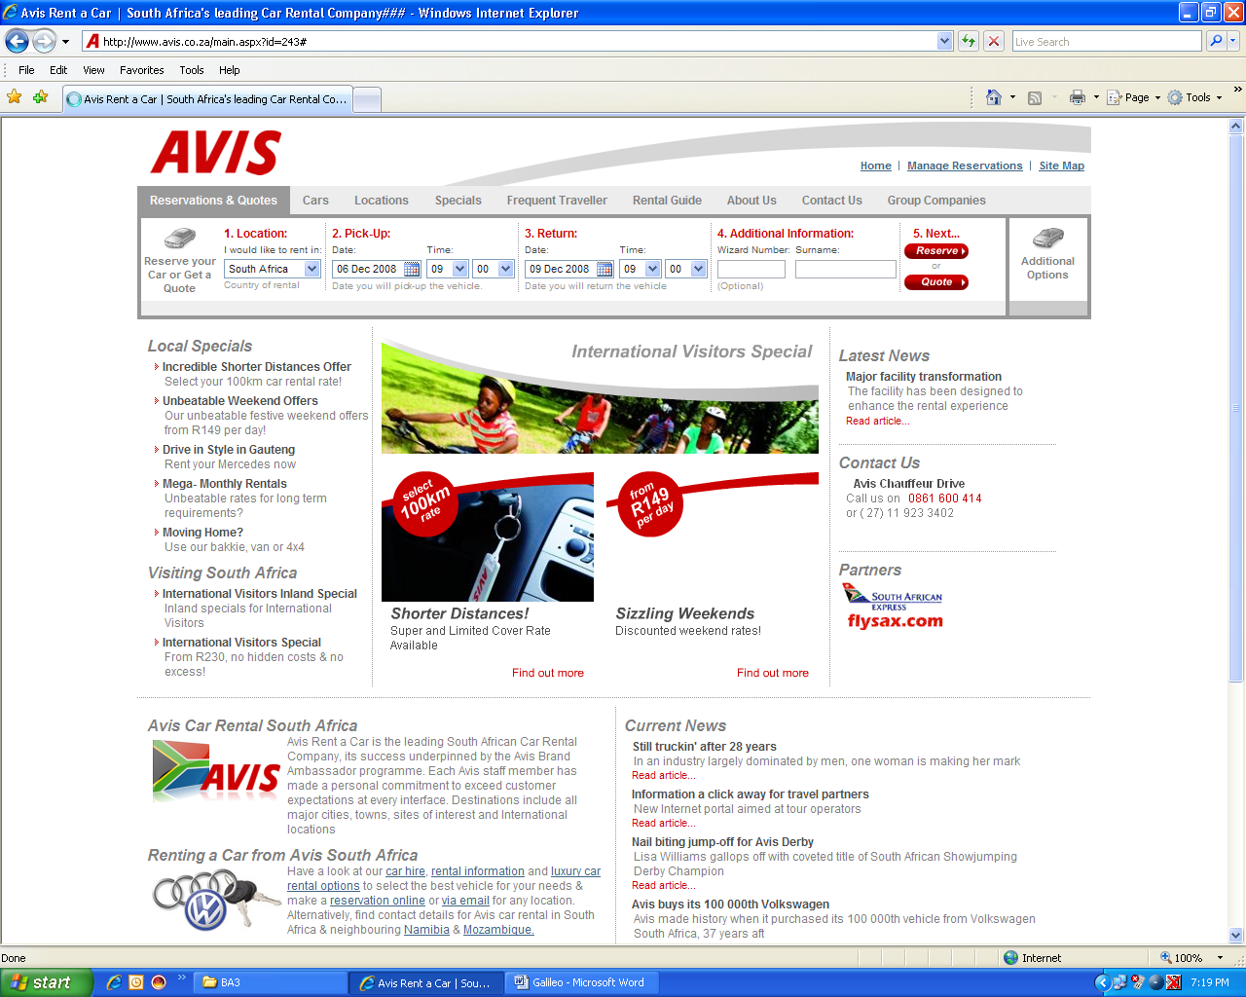

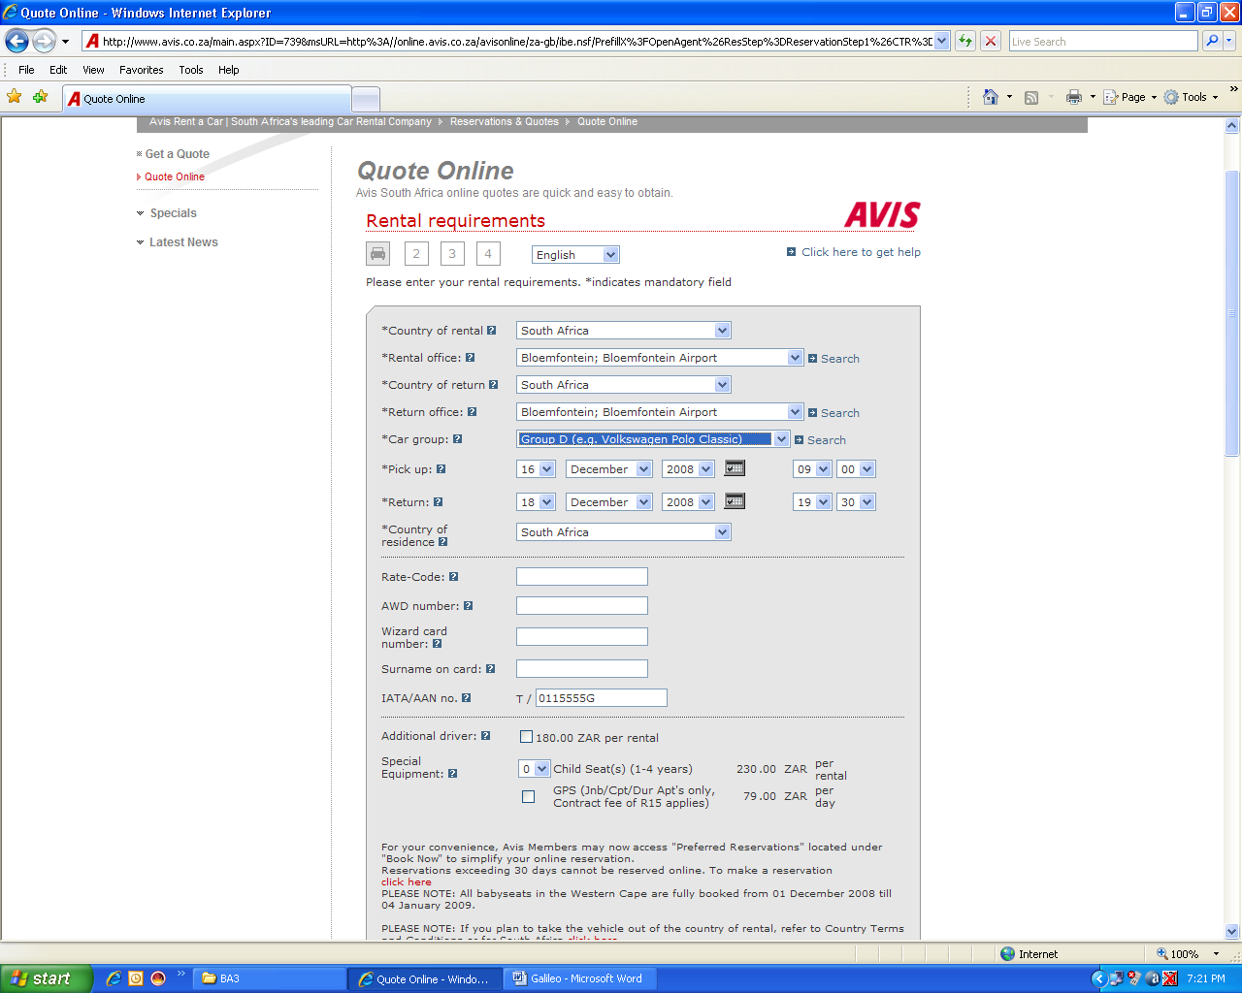

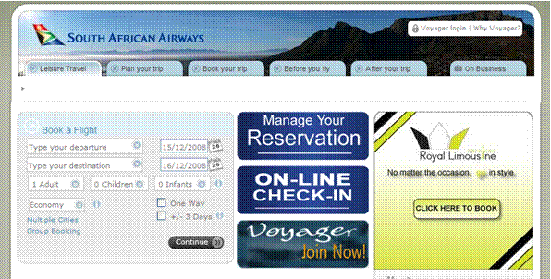

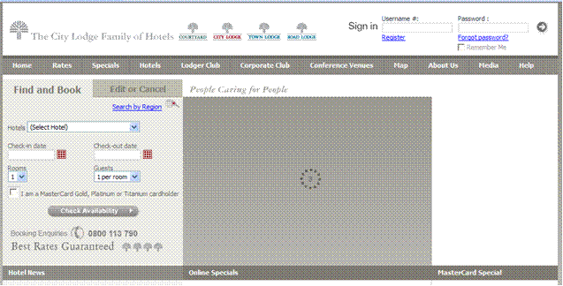

Most establishments have some sort of confirmation form that is given to the client. These may be handed out over the counter, faxed or emailed to a client. It is a simple form that states that their booking has been made. The details of their booking are also included on the form

These details would contain things such as their room number, the hall or conference facility they booked etc. depending on the type of booking that’s been made.

An example of such a form is shown

**HERRIOT HOTEL**

54 16th Avenue

Sea View

1686

**Booking Confirmation**

Dear Mr. Farling

This is a confirmation letter of your booking at the HERRIOT HOTEL ® for room 109 from the 16th of December 2008 till the 20th of December 2008.

Thank you for using out facilities and please feel free to call us with any further enquiries.

Best wishes,

Trudy Crump

Booking Coordinator

Tel: 041 8069856

Fax: 041 8069855

Email: [TrudyC@theherriot.co.za](mailto:TrudyC@theherriot.co.za)

***Process Invoices***

Invoices relating to travel, accommodation and car rental can be sent to your organisation by e-mail, fax or post. These invoices should be processed quickly, especially when a deposit has to be paid.

Depending on the size of the organisation, invoices or quotes are usually authorised by the finance department. Once authorised, you can process the invoices for payments.

Smaller companies usually have a company credit card that they use for payments such as bookings etc. If you have access to the credit card, you can pay the relevant companies and then the receipts should be sent to the bookkeeper.

As you would have found in your research assignment, one of the obstacles to overcome when booking airline tickets is that you have to pay with a credit card if you are booking online or on the telephone. It is the only way to secure your ticket; otherwise you have to get to the nearest outlet of the airline you have decided to use for example SAA and pay the tickets cash.

All the bookings can also be made through travel agents, who will then consolidate the air travel, accommodation and car rental fee and send you one invoice. This makes it easier for you to process the payment, as only one invoice has to be processed.

***Invoices relating to car rental will show the following details:***

Date and time the car will be available

Name of person collecting the car

The type of car

Conditions for car rental, such as rate per day, per kilometre, where the car will be available, drop-off time and place

Deposit required and how and when deposits should be paid

After the car has been returned, a final invoice will be sent which will show the above, as well as the actual number of kilometres travelled and how and when final payments should be made

***Invoices relating to accommodation will show the following details:***

Name of person who will be staying at the place of accommodation

Check in date and time

Check out date and time

Services included and not included, e.g. meals

Deposit required and how and when deposits should be paid

The final invoice will be generated when the attendee checks out of the hotel or guest house. This invoice will show:

The name of the attendee

The check in and check out date and time

Services the person made use of, e.g. telephone, room service, mini bar

Total amount payable

Deposit that was paid

Balance due

How and when final payments should be made

***Deposits and final payments can be paid as follows:***

By cheque

By direct bank deposit

By Internet transfer

By credit card

*Note:* ***Even if you pay the entire trip in cash, it is very important to hand the receipts over to the finance department or the organisation’s bookkeeper. Ensure that whoever receives the receipts signs to acknowledge that they have received them***

Payments should only be made against an invoice or other relevant document – proof that payment is required. The relevant document must also show who the beneficiary is and what the amount of the payment should be.

Only authorised employees may sign cheques or make electronic payments.

Two signatures are usually required on cheques

In the case of electronic payments, the clerk would access the computer system, enter the payments in the system and log off. The supervisor/manager will then access the system, using his/her password, check the payments and then process the payments.

When processing payments made as deposits, make sure that the amounts on the invoice are the same as the amounts quoted

* When processing final payments, make sure that your company is not being charged for services that were not used. Also make sure that payments made as deposits are deducted from the final payment.

**Financial controls**

It is important that at least two people be involved in processing payments:

In the case of cheque payments, there must be at least two signatures

In the case of electronic transfers, one person loads the payment and another person releases the payment

In the case of credit card and cash payments, one person must authorise the payment and another processes the payment

***No payments must ever be made without supporting documentation!***

***Always ensure that two people are involved in the processing of payments: one person to process and another to check that all the details are correct!***

**Deposit slips and deposit books**

Deposit slips are available from the bank and will usually be found in the main hall of the bank. A typical deposit slip will have three copies: two are kept by the bank for their internal procedures and the third copy will be given back to the customer, for the records of the organisation.

The deposit slip will have the details of the bank printed on it, but not the details of the branch of the bank.

When you use deposit slips to make deposits, make sure that you enter the following details:

The branch where the account of the organisation is held

The six-digit branch code number, if required by the bank

The date of the deposit

The amount of cash that is deposited

The details and the amounts of cheques that you are depositing

The name of the account that must be credited with the deposit

The account number that must be credited with the deposit

The deposit reference number, for your record purposes

Finally, the deposit must be signed.

Below is an example of a deposit slip

Your Bank

Your Bank Limited, Reg No 1999/00789/09

|  |  |  |
| --- | --- | --- |
|  |  | **Date** |
| **Credit ­** |  |  |

|  |  |  |  |  |  |  |  |  |  |  |  |  |  |  |  |  |  |  |  |  |  |  |  |  |  |  |  |  |  |  |  |  |  |  |  |  |  |  |  |
| --- | --- | --- | --- | --- | --- | --- | --- | --- | --- | --- | --- | --- | --- | --- | --- | --- | --- | --- | --- | --- | --- | --- | --- | --- | --- | --- | --- | --- | --- | --- | --- | --- | --- | --- | --- | --- | --- | --- | --- |
|  | | | Acc. no |  | |  | |  |  | |  |  | |  | |  | |  | | |  |  | | |  | | |  | | |  | | |  | | |  | | |
| Instruments delivered for collection by the customer or on his behalf shall be made available as cash only after payment thereof. Any payment against uncleared effects allowed by the Bank shall be at the Bank’s discretion and no claim arising from this practice shall be brought against the Bank and furthermore the Bank shall, at its discretion, be entitled to debit the Customer’s account with the amount of dishonoured instruments. The Bank shall not be held responsible from errors resulting from incorrect information furnished by the customer or on his behalf. Furthermore the Bank does not accept responsibility for ensuring that the Customer has lawful title to instruments handed in for collection | | | | | | | | | |  | | | | | | | | | | | | | | | | **R** | | | | | | | | | | | | **c** | | | |
| Notes | | | | | | | | | | | | | | | |  | | | | | | | | | | | |  | | | |
| Nickel | | | | | | | | | | | | | | | |  | | | | | | | | | | | |  | | | |
| Bronze | | | | | | | | | | | | | | | |  | | | | | | | | | | | |  | | | |
| MO/PW and PO | | | | | | | | | | | | | | | |  | | | | | | | | | | | |  | | | |
| **Subtotal** | | | | | | | | | | | | | | | |  | | | | | | | | | | | |  | | | |
| No cheque exceeding R5 million can be accepted | Drawer’s name | | | Bank | | | | | | Branch name/code | | | | | | | | | | | | | | | |  | | | | | | | | | | | |  | | | |
| 1 | | |  | | | | | |  | | | | | | | | | | | | | | | |  | | | | | | | | | | | |  | | | |
| 2 | | |  | | | | | |  | | | | | | | | | | | | | | | |  | | | | | | | | | | | |  | | | |
| 3 | | |  | | | | | |  | | | | | | | | | | | | | | | |  | | | | | | | | | | | |  | | | |
| **Details of depositor** | | | |  | |  | | |  | | | | | | | | |  | | | | |  | |  | | |  | | |  | | |  | | |  | | | |  | |
| **Signature** | | | | **Total** | | | | | | | |  | |  | |  | | |  | | |  | | |  | | | |  | | |  | | |  | | | | |  | |
| **Telephone** ( ) | | | |  | |  | | |  | | | | | | | | |  | | | | |  | |  | | |  | | |  | | |  | | |  | | | |  | |
|  | | | |  | | | | | | | | | | | | | | | | | | | | | |  | | | | | | | | | | | | | | | |

***Advance disbursements***

It is normal practice to pay living out expenses to employees who attend meetings and events from out of town. This is done to cover expenses such as meals, travel to and from airports, and so on. The organisation will have a fixed rate that is payable per day, for example R250 per day if the attendee’s travel and accommodation fees are paid directly to the service provider by the organisation.

These expenses have to be paid to the employee before s/he leaves for the trip. Payment can be made by direct bank deposit or Internet transfer, depending on the procedures of the organisation. These payments are usually not made by cheque as the funds will only be available 7 days after the cheque has been deposited. Living out expenses are usually calculated on nights away from home of full days away from home.

Let us suppose that the organisation pays R250 per day for living out expenses and the employee flies in on Monday morning and returns on Wednesday afternoon, the amount would be calculated as follows: Monday and Tuesday are full days, so the employee will be paid R500. Wednesday is not a full day, so the employee will not be entitled to living out expenses.

If the employee travels to the event with his/her own car, an amount per kilometre travelled will also be payable to the employee. Let us suppose the organisation pays R1.20 per kilometre and the employee travels 250km to the venue and another 250km to return, the amount payable to the employee will be 500km X R1.20 = R600. Should the employee be entitled to living out expenses, this will be added to the amount due to the employee.

Payment of living out expenses must follow the same procedures as any other payment made by the organisation.

**Formative assessment SO3 AC1-6**

**Road Maps**

Road maps can be countrywide, for a specific region or for a specific city or town. It stands to reason that countrywide road maps will only show major roads such as national roads (freeways), major provincial routes, minor provincial roads, etc.

National roads or freeways are indicated with the colour blue, major provincial roads with a thick red line and minor provincial roads with a thin red line.

Each map will have a legend explaining the colour coding of the roads, the signs and other relevant information.

The legend below, taken from the Reader’s Digest Book of the Road, has the following information:

|  |  |
| --- | --- |
| National road | National route |
| Dual carriageway | Major provincial route |
| Minor provincial road | Link road |
| Toll road | Interchange with number |
| Point to point distance | Aggregate distance |
| Mountain pass | Scenic drive |
| International boundary | Provincial boundary |
| Lighthouse | Wreck |
| National Sea Rescue Institute | Battlefield |
| Spot height | Airport |
| Landing strip | A legend giving details about facilities available at towns |

Of course, there is more information than quoted above.

**See hand-out 6-7 for a legend of a map**

All road maps typically divide the area into sections, which are called pages. At the back of the map, you will find an index to street names, as well as an index to suburb names. Once you have the address of the place you want to go to, you look up the street name(s) in the index, where you will find the following information: page number and grid reference numbers. The grid reference numbers are quoted numerically for longitudinal references and alphabetical for latitudinal references:

If you are looking for Ben Steyn Street in Boksburg West, the references will be quoted as follows:

Ben Steyn Street Boksburg West 113 DV 124

Street suburb page grid ref

If we look at page 1 of handout 6, which is also page 1 of the road map of the Witwatersrand, issued by Map Studio, 12th edition, you will find a full explanation of how to use the road map.

**Reference panel**

At the top is an explanation of the reference panel found on the top of all the pages of the map. This map, incidentally, divides the Witwatersrand area into pages from 2 to 207, in total 206 pages, and covers the following area: from Midrand in the north, Nigel in the west, Randfontein in the east and Lenasia in the south. This is a very large area, that is why 206 pages are necessary to give a detailed and readable road map.

**Key plan**

The key plan is a plan of all the pages that cover the entire area, an example is found on page 4 of the hand-out, included to give you an example of a key plan.

**GPS coordinates**

The GPS (Global Positioning System) coordinates are quoted at the top and bottom of the pages. The GPS system is based on the Cartesian coordinates. The grid lines are at an interval of half a minute, which makes it easy to work out co-ordinates on the map.

**Index**

There is an explanation of how to use the index pages.

**Grid reference system**

An explanation, also quoted above, of how the grid reference system works.

**Legend**

Once again, a legend that explains the colour coding of the roads and the symbols used in the maps.

There is also an indication of the scale of the map, in this case 1:20 000 (one to twenty thousand). Next to the scale indication is a scale legend, which gives you an indication of distance of the map compared to actual distance. In our map, every 5mm equals 100m or 1cm equals 200m.

**Formative assessment (Mapwork) individual activity**

**DISTRIBUTE DOCUMENTATION**

***Outcome***

Assemble and distribute documentation for meeting or event in good/sufficient time to attendees

***Assessment criteria***

* Deadline date for receipt of documentation from contributors is established according to agreed time frames.
* Documents are assembled, copied and collated.

**Deadline For Receipt**

Attendees have to confirm that they will attend before you make any bookings for them. You will have to communicate with attendees about the latest date you need confirmation from them that they will attend the meeting. The confirmation should be received as soon as possible, or you may find that accommodation or the intended date and time of flights are no longer available.

Set a deadline as early as possible and follow up with attendees so that you receive their confirmations in time for you to make the appropriate bookings.

You also need receipts from service providers to confirm that deposits have been paid. As mentioned before, you need to hand the receipt over to the relevant parties in your organisation. The only thing that was left out is arranging a time that you can expect the receipt from the relevant organisation. You need to make it clear to them that if you pay online or via telephone, that you need the receipt **as soon as possible.** Not only for financial reasons, but these types of things are quite easy to forget, so try to settle the entire matter in one go. Make the booking, confirm the booking, pay the booking, get the receipt, hand over the receipt and get the person who you hand it over to be it the finance department, accounting department or a bookkeeper, to sign that they have received it.

**Assemble, copy and collate documents**

Documents that have to be sent to attendees include:

details of accommodation and travel arrangements such as car rental and flight details

agenda for the event including the venue and the starting time, as well as the time the event should end

This should be sent to the attendees as soon as the final arrangements have been made. You could send this information by means of a memo or e-mail, depending on the procedure in the organisation.

Documents regarding arrangements for the event also have to be assembled and collated. Before you hand over papers (and have recipients sign for them) it is a good idea to copy them first so there is a spare copy, and you have a copy to file for record purposes.

Once you have copied all the documentation from the caterer, venue, flight tickets to the rental car; collate the documents according to the system your organisation uses.

A suggested way to do this is to arrange the documents in sequence of contact for example:

First will be the quote from the venue

Second will be the deposit papers such as your copy of proof that you have paid, such as a printed page if you have done an electronic payment and then the receipt that you received from the venue, stating that you have paid the deposit.

Third will be the event planning with the relevant party from the venue

Fourth will be the final payment. Your evidence as well as the receipt you received from the venue.

Once you have collected all the paperwork, you can file it.

**Formative assessment SO4, AC1-4 group activity**