**LEARNER GUIDE**



**67465 National Certificate:**

**Business Administration Services**

**Level 3**

**Module 5 Administration Skills**

Unit Standard 13933 Level 3 Credits 3

Plan, monitor and control an information system in a business environment

# TABLE OF CONTENTS

TABLE OF CONTENTS 1

PERSONAL INFORMATION 2

INTRODUCTION 3

UNIT STANDARD 13933 7

PLAN A STORAGE AND RETRIEVAL SYSTEM 9

Why have a Filing System? 9

What Is A Good Filing System? 9

Archive storage 9

Classification methodologies 12

MONITOR THE FILING SYSTEM 15

The Process Of Filing 15

Transfer, Archive And Disposal 16

Follow Procedures For Manual Or Electronic Filing 16

Maintain Up-To-Date And Accurate Records 16

CONTROL THE FILING SYSTEM 17

Equipment and Accessories 17

Incorrectly Filed Documents 18

Communicate Areas for improvement 18

Update The Filing And Archiving System 19

# PERSONAL INFORMATION

|  |  |
| --- | --- |
| **NAME** |  |
| **CONTACT ADDRESS** |  |
|  |
| **Code** |  |
| **Telephone (H)** |  |
| **Telephone (W)** |  |
| **Cellular** |  |
| **Learner Number** |  |
| **Identity Number** |  |
| **EMPLOYER** |  |
| **EMPLOYER CONTACT ADDRESS** |  |
|  |
| **Code** |  |
| **Supervisor Name** |  |
| **Supervisor Contact Address** |  |
|  |
| **Code** |  |
| **Telephone (H)** |  |
| **Telephone (W)** |  |
| **Cellular** |  |

# **INTRODUCTION**

#### Welcome to the learning programme

Follow along in the guide as the training practitioner takes you through the material. Make notes and sketches that will help you to understand and remember what you have learnt. Take notes and share information with your colleagues. Important and relevant information and skills are transferred by sharing!

This learning programme is divided into sections. Each section is preceded by a description of the required outcomes and assessment criteria as contained in the unit standards specified by the South African Qualifications Authority. These descriptions will define what you have to know and be able to do in order to be awarded the credits attached to this learning programme. These credits are regarded as building blocks towards achieving a National Qualification upon successful assessment and can never be taken away from you!

### Programme methodology

The programme methodology includes facilitator presentations, readings, individual activities, group discussions and skill application exercises.

Know what you want to get out of the programme from the beginning and start applying your new skills immediately. Participate as much as possible so that the learning will be interactive and stimulating.

The following principles were applied in designing the course:

* Because the course is designed to maximise interactive learning, you are encouraged and required to participate fully during the group exercises
* As a learner you will be presented with numerous problems and will be required to fully apply your mind to finding solutions to problems before being presented with the course presenter’s solutions to the problems
* Through participation and interaction the learners can learn as much from each other as they do from the course presenter
* Although learners attending the course may have varied degrees of experience in the subject matter, the course is designed to ensure that all delegates complete the course with the same level of understanding
* Because reflection forms an important component of adult learning, some learning resources will be followed by a self-assessment which is designed so that the learner will reflect on the material just completed.

This approach to course construction will ensure that learners first apply their minds to finding solutions to problems before the answers are provided, which will then maximise the learning process which is further strengthened by reflecting on the material covered by means of the self-assessments.

#### Different role players in delivery process

* Learner
* Facilitator
* Assessor
* Moderator

### What Learning Material you should have

This learning material has also been designed to provide the learner with a comprehensive reference guide.

It is important that you take responsibility for your own learning process; this includes taking care of your learner material. You should at all times have the following material with you:

|  |  |
| --- | --- |
| **Learner Guide** | **This learner guide is your valuable possession:**  This is your textbook and reference material, which provides you with all the information you will require to meet the exit level outcomes.  During contact sessions, your facilitator will use this guide and will facilitate the learning process. During contact sessions a variety of activities will assist you to gain knowledge and skills.  Follow along in the guide as the training practitioner takes you through the material. Make notes and sketches that will help you to understand and remember what you have learnt. Take and share information with your colleagues. Important and relevant information and skills are transferred by sharing!  This learning programme is divided into sections. Each section is preceded by a description of the required outcomes and assessment criteria as contained in the unit standards specified by the South African Qualifications Authority. These descriptions will define what you have to know and be able to do in order to be awarded the credits attached to this learning programme. These credits are regarded as building blocks towards achieving a National Qualification upon successful assessment and can never be taken away from you! |
| **Formative Assessment Workbook** | The Formative Assessment Workbook supports the Learner Guide and assists you in applying what you have learnt.  The formative assessment workbook contains classroom activities that you have to complete in the classroom, during contact sessions either in groups or individually.  You are required to complete all activities in the Formative Assessment Workbook.  The facilitator will assist, lead and coach you through the process.  These activities ensure that you understand the content of the material and that you get an opportunity to test your understanding. |



### Different types of activities you can expect

To accommodate your learning preferences, a variety of different types of activities are included in the formative and summative assessments. They will assist you to achieve the outcomes (correct results) and should guide you through the learning process, making learning a positive and pleasant experience.

The table below provides you with more information related to the types of activities.

| **Types of Activities** | **Description** | **Purpose** |
| --- | --- | --- |
| **Knowledge Activities** | You are required to complete these activities on your own. | These activities normally test your understanding and ability to apply the information. |
| **Skills Application Activities** | You need to complete these activities in the workplace | These activities require you to apply the knowledge and skills gained in the workplace |
| **Natural Occurring Evidence** | You need to collect information and samples of documents from the workplace. | These activities ensure you get the opportunity to learn from experts in the industry.  Collecting examples demonstrates how to implement knowledge and skills in a practical way |

### Learner Administration



#### Attendance Register

You are required to sign the Attendance Register every day you attend training sessions facilitated by a facilitator.

#### Programme Evaluation Form

On completion you will be supplied with a “Learning programme Evaluation Form”. You are required to evaluate your experience in attending the programme.

Please complete the form at the end of the programme, as this will assist us in improving our service and programme material. Your assistance is highly appreciated.

### Assessments

The only way to establish whether a learner is competent and has accomplished the specific outcomes is through the assessment process. Assessment involves collecting and interpreting evidence about the learners’ ability to perform a task.

To qualify and receive credits towards your qualification, a registered Assessor will conduct an evaluation and assessment of your portfolio of evidence and competency.

This programme has been aligned to registered unit standards. You will be assessed against the outcomes as stipulated in the unit standard by completing assessments and by compiling a portfolio of evidence that provides proof of your ability to apply the learning to your work situation.

**How will Assessments commence?**

#### Formative Assessments

The assessment process is easy to follow. You will be guided by the Facilitator. Your responsibility is to complete all the activities in the Formative Assessment Workbook and submit it to your facilitator.

#### Summative Assessments

You will be required to complete a series of summative assessments. The Summative Assessment Guide will assist you in identifying the evidence required for final assessment purposes. You will be required to complete these activities on your own time, using real life projects in your workplace or business environment in preparing evidence for your Portfolio of Evidence. Your Facilitator will provide more details in this regard.

To qualify and receive credits towards your qualification, a registered Assessor will conduct an evaluation and assessment of your portfolio of evidence and competency.

### Learner Support

The responsibility of learning rests with you, so be proactive and ask questions and seek assistance and help from your facilitator, if required.

Please remember that this Skills Programme is based on outcomes based education principles which implies the following:

* You are responsible for your own learning – make sure you manage your study, research and workplace time effectively.
* Learning activities are learner driven – make sure you use the Learner Guide and Formative Assessment Workbook in the manner intended, and are familiar with the workplace requirements.
* The Facilitator is there to reasonably assist you during contact, practical and workplace time for this programme – make sure that you have his/her contact details.
* You are responsible for the safekeeping of your completed Formative Assessment Workbook and Workplace Guide
* If you need assistance please contact your facilitator who will gladly assist you.
* If you have any special needs please inform the facilitator

### Learner Expectations

Please prepare the following information. You will then be asked to introduce yourself to the instructor as well as your fellow learners

|  |
| --- |
| Your name: |
|  |
|  |
| The organisation you represent: |
|  |
|  |
| Your position in organisation: |
|  |
|  |
| What do you hope to achieve by attending this course / what are your course expectations? |
|  |
|  |
|  |

# UNIT STANDARD 13933

#### Unit Standard Title

Plan, monitor and control an information system in a business environment

#### Unit Standard ID

13933

#### NQF Level

3

#### Credits

3

#### Purpose

Learners will be learning towards obtaining a national qualification at level 3 or are working in an administrative environment, including SMME`s (Small, Medium and Micro Enterprises), where the acquisition of competence against this standard will add value to the learner`s job, or chances of finding employment.

Learners will be well positioned to extend their learning and practice into other areas in the business environment, or to strive towards professional standards and improved performance.

The qualifying learner is capable of:

Planning and implementing a storage and retrieval system

Monitoring the booking of items in and out of systems

Classifying and cross-referencing complex information

Updating storage and retrieval systems

#### Learning assumed to be in place

Learners will have demonstrated competence in communication at NQF level 2 or equivalent.

#### Unit standard range

Storage and retrieval types include paper based or electronic which are:

Numerical

Alphabetical

Chronological

Geographical (areas)**.**

Subject

Storage and retrieval includes paper based and electronic systems.

#### Specific Outcomes and Assessment Criteria

**Specific Outcome 1:** Plan storage and retrieval system

**Assessment Criteria**

Structural and operational needs are identified

Procedures for the storage and retrieval of manual and computerised records are determined according to organisational policies and procedures.

Methodologies and quality control procedures for checking, tracking, securing and maintaining the storage and retrieval system are determined.

Archiving processes are identified and procedures for archive storage are planned accordingly.

Classification methodologies are determined.

**Specific Outcome 2**: Monitor the implementation of the filing and retrieval system

**Assessment Criteria**

Quality control to monitor sorting, filing and retrieval of documentation is carried out according to organisational requirements.

Organisational policy for transfer, archive and disposal is followed.

Procedures for ensuring manual or computerised records are followed.

The importance of maintaining up-to-date and accurate records of paper-based documentation is explained.

**Specific Outcome 3**: Control the implementation of a filing and retrieval system

**Assessment Criteria**

Filing is complete, accurate, in the required format, location and time frame.

Incorrectly filed documents are identified and filed correctly.

Areas for improvement are communicated to the staff responsible.

Procedures for improving storage and retrieval system are planned and updated on an ongoing basis.

#### Essential Embedded Knowledge

Techniques for monitoring and controlling

Comprehensive understanding of organisational filing system

Numerical, alphabetical, chronological, geographical and subject sequence

#### Critical Cross-field Outcomes (CCFO)

Identify and solve problems pertaining to the standards and effectiveness of the filing and retrieval system.

Work effectively with others to ensure that the filing and retrieval system is maintained.

Collect, analyse, organise and critically evaluate information in order to simplify a filing and retrieval system.

Communicate effectively with personnel to ensure efficient information storage and retrieval.

# PLAN A STORAGE AND RETRIEVAL SYSTEM

#### Outcome

Plan storage and retrieval system

#### Assessment criteria

Structural and operational needs are identified

Procedures for the storage and retrieval of manual and computerised records are determined according to organisational policies and procedures.

Methodologies and quality control procedures for checking, tracking, securing and maintaining the storage and retrieval system are determined.

Archiving processes are identified and procedures for archive storage are planned accordingly.

Classification methodologies are determined.

## Why have a Filing System?

Every organisation has to process, store and analyse information. How effectively this is done depends on how efficient the filing system is. There is nothing worse than having paper all over the office or paper pushed into cupboards or drawers. This makes it very difficult to find a document when you need it and you will waste time trying to remember and searching for where you put that important piece of paper.

## What Is A Good Filing System?

A good filing system complies with all or most of the following requirements:

|  |  |
| --- | --- |
| 1. Simplicity: the system should be easy to use | 1. Appropriate classification: the classification system should suit the information that has to be retrieved. |
| 1. Accessibility: the people who need the information must be able to access it. | 1. Selection of suitable equipment: the equipment should suit the format in which filing is done |
| 1. Safe: loss of information should be minimised. | 1. Damage by fire, water, dust or even sunlight must be avoided |
| 1. The information should be confidential – unauthorised people should not have access to the information | 1. The filing system should not use more space than is required |
| 1. Elasticity – it must be able to expand if required | 1. Speed of retrieval: users must be able to access information quickly |

### Policies and Procedures

Now that you know what the special needs of your organisation is, you have to find out the policy is regarding the storage and retrieval of information. You also have to know what procedure must be followed to retrieve and store information efficiently.

Most organisations will have simple document called a standard operating procedure. This document will explain how the information system is handled: how to file information and also how to retrieve information. .

The advantage of a standard operating procedure is:

Everyone in the organisation knows what procedure to follow

Information will be easier to find

When new people come into the organisation they will be able to get to know the job and what is expected of them more quickly

If the original management and staff eventually leave and new people come into the organisation, they will be able to continue to run the organisation efficiently and your clients will not be affected negatively

## Archive storage

Archiving is the process where old files and documents that are not needed on a regular basis are stored.

The SA Revenue Services requires that organisations store information and data (especially financial information) for at least five years. In fact, most organisations keep information for much longer periods. Banks usually do not destroy any information.

Normally these files are kept in a separate cabinet or separate storage room or even storage facility, as they will only be in the way amongst currently used files.

The archiving system will be the same as the daily filing system, but it will consist of old and outdated documents that are not needed regularly.

In past years banks and other big corporate organisations used a system called microfiche to archive information. These days the information can be archived on CD-ROM disks. The advantage of these archiving systems is that they uphold the integrity of the information but take up far less space than filing cabinets and other paper filing systems.

Archived documents must also be recorded, and the index of archived files must be kept in a safe place so that the information can be accessed by employees who need information from the archives.

|  |  |  |
| --- | --- | --- |
| **File** | **Reference Number** | **Location** |
| Sales | Sales 2001  Sales 2002  Sales 2003 | Storage Room 1;  Storage boxes.  A2001 - 2003  Top shelf, south wall |

### Large archives

Normally there will be a person who is in charge of an archive, depending on the size of the organisation and archive.

Their responsibilities would include:

To inform and advise employees who have to archive a document on how the archiving filling system works (if it is different to the rest of the organisation),

Taking care of the physical aspects of the archive such as fire hazards and keeping the space neat and clean

Have a general idea of where types of documents could be found (depending on the type of system being used, for example if its alphabetical, he could give you the general direction where to find documents starting with P or whatever the case may be).

An example of an archiving procedure would be:

The accounting department has a paid-up and closed account older than one year

All the records are printed out and the hardcopy records are added

The accounting department sends the information to the archive, already filed in a folder with the clients name

The folder is received and signed for at the archive

The person in charge of the archive files the folder in the relevant space, for example if the client’s name is XYZ Transport the folder will be alphabetically sorted with all the other documents or folders of clients under X.

### Archiving documents on your computer

Fortunately, if a computer has sufficient memory it is able to store a lot of information. Folders and files must be clearly labelled so that items can be found easily.

Here’s an example of how to give simple file names: You’ve sent an invoice to a client named ABC Books on 15 February 2007. Before you archive the file, give a file name related to the document such as ABCBKS 15Feb07, or 150207ABC INV or even the invoice number followed by ABCBKS 15Feb07. It is a good idea to keep file names short, since an Operating System such as Windows gives you a limited number of spaces for file names.

It is also important to keep using the same naming system once you have decided on one. This avoids confusion when you want to find a file again.

Here are the steps you should follow when you want to archive an electronic file:

Right click on the file or folder with your mouse and select add to archive

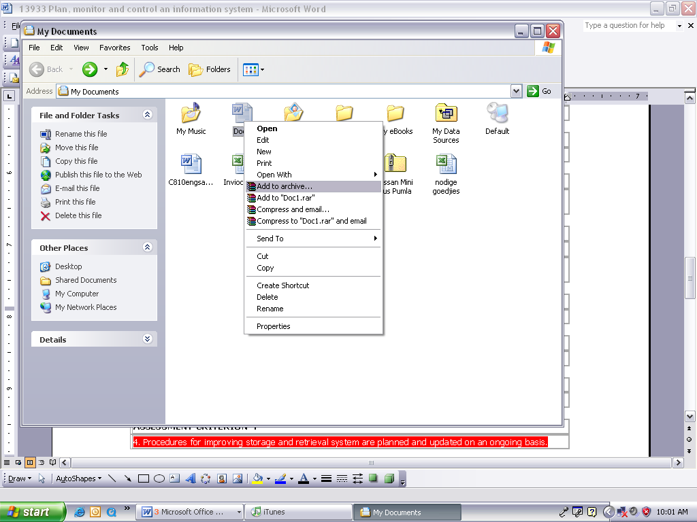

Once you have clicked on Add to archive, the Archive name and parameters dialogue box will appear:

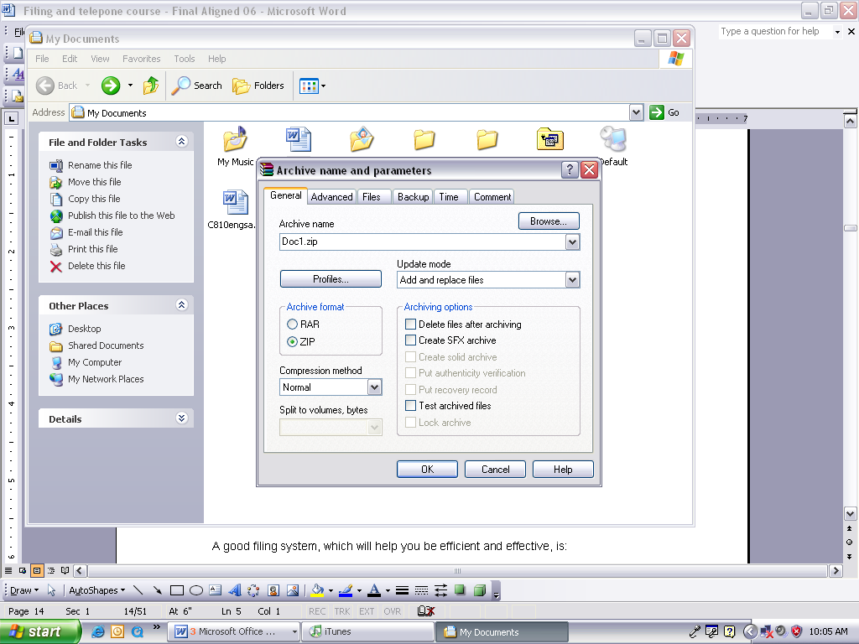

Click on ZIP to archive the file or folder.

Then click OK. This will add your document to a zipped folder in My Documents. A great advantage of zipped folders is that it takes up less space on your computer.

**Remember!**

A good filing system, which will help you be efficient and effective, is:

Simple

Tidy

Items are clearly and logically classified

Easily accessible

Documents are easy to find

Storage units are not over crowded

Secure

## Classification methodologies

Can you imagine what would happen if only one person knows how the filling system works in an organisation and that person is off sick for a week? It would be a disaster, therefore it is important to agree on a classification system so everyone knows how to find a file if they need it.

If you are not sure how document is supposed to be classified, be sure to ask! The relevant person in most cases would be your supervisor. Remember that your supervisor won’t know if you have a problem if you don’t tell them. It is your responsibility to ask.

### What type of filing system should you use?

Information can be filed in one of the following ways:



Numerical

Alphabetical

Chronological

Geographical (Area)

Subject

#### Numerical

A number is allocated to each client, regardless of surname and initials. This is how banks file our records.

Files are then arranged numerically

As it is not possible to remember each client’s number, a separate card index is kept to record clients’ personal details and file numbers

New clients receive the very next number after the last allocated number. The new file is placed last in the drawer.

#### Alphabetical

Files are grouped alphabetically

The file for Mahotsi would be placed before that for Ndengwe, because m comes before n. Baker would be placed before Barker, as bak comes before bark

Should more than one client have the same name, their files would be arranged in order of initials: Mahotsi, C would be placed before Mahotsi T

Short before long: if all the other letters in a name are the same, you arrange the shorter name in front of the longer: Cole will be placed before Coleman.

Prefixes before surnames, such as de der le van von O, etc are considered part of the name: du Plessis will be placed alphabetically with D and not P, so will van der Merwe be placed with V.

Should more than one client have the same name and initials, a number could be added after the initials: Mahotsi T1 would be followed by Mahotsi T2

Impersonal names, such as company names are placed in the order they are written: Gilbert Enterprises will be filed with G and Tiger Brands with T.

Official or descriptive names: the most important word is the first filing unit: The Hotel Shelly will be filed as Hotel (The) Shelly and City of Durban will be filed as Durban City (of).

#### Chronological

A chronological system is where data is filed according to date. This is only useful if you are filing publications or contracts

This could be useful if you have to file magazines, newspapers, contracts or if the organisation wants the filling to be done according to the jobs of the day for example a panel beater but it is very rare.

#### Geographical

A geographic system is when the filling is done according to location.

This could be according to country, state, town, city or address.

An example would be a property investor. If he/she needs information about a certain property they own, they simply pull the file according to the address of the property.

Another example would be an organisation that has branches all over the country. They might store things according to branch location; like Cape Town branch 1, Cape Town branch 2, Durban branch 1, Johannesburg branch 2, Johannesburg branch 2, Johannesburg branch 3 etc.

#### Subject

In these systems information is filed according to the particular subject.

For example Hospitals, Clinics, Boats, Aeroplanes etc

#### Electronic

This is where information is filed by creating folders and files on a computer.

It is important to ensure that you clearly label your folders and use consistency.

Files can have sub-files

For example:

Sales: Returns

2004 2004

2005 2005

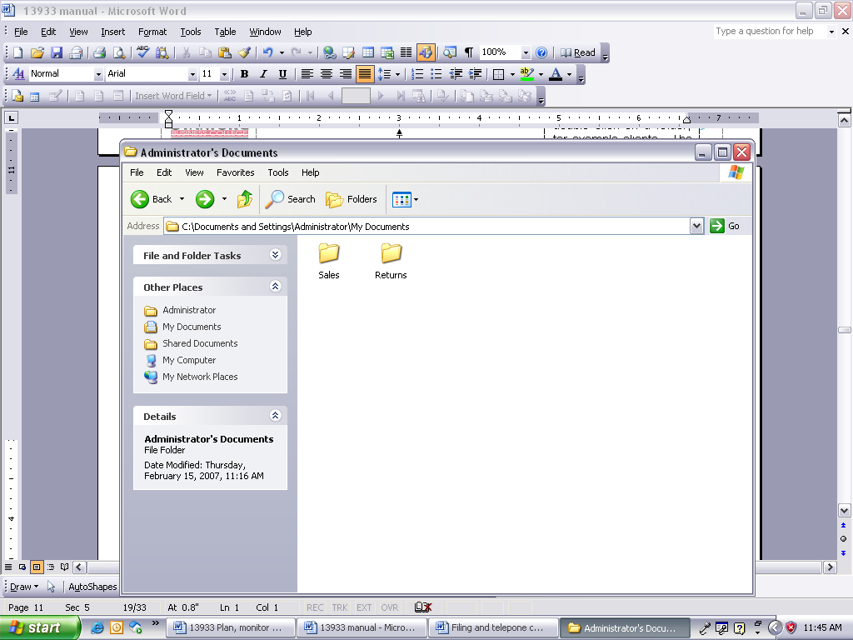

Open My Documents; double click on a folder, for example Sales. The “subfolders” will be inside Sales under 2004 and 2005.

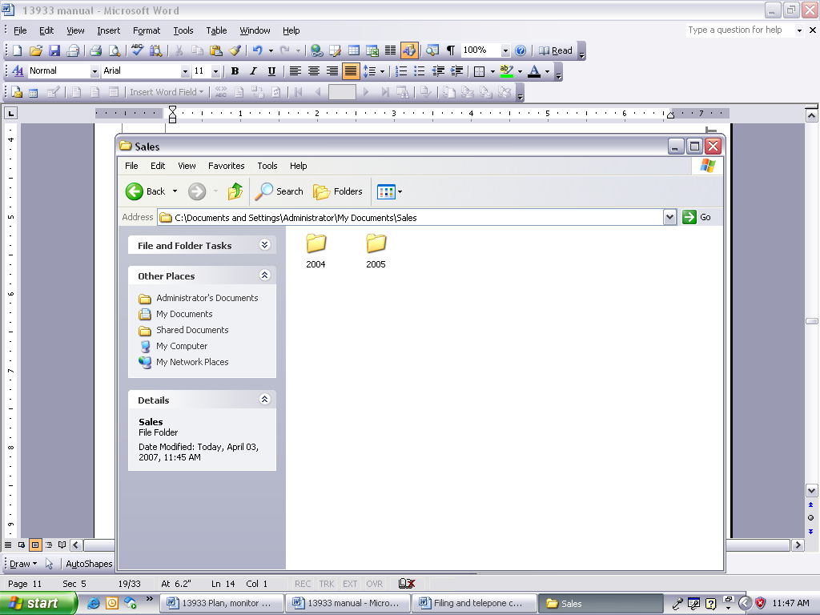

Note the file path. If you aren’t sure exactly where you are in My Documents, just read the file path.

It might happen that the organisation you work for makes use of an electronic filing system. In a case like this, it will most probably be your responsibility to collect the information that has to be filed, or ensure that the filling has been done correctly if filing is done on a network location.

You will usually have to collect the documentation from more than one type of location. The different sources are:

A network location, such as a file server

A stiffy (which is highly unlikely since they are outdated)

A CD

If the source is a file server, you will need proper training on the system that is in use on the server. Once you understand the procedure and system, you will have to see to it that everything on the server is filled properly, since more than one person will be saving documents to the server and this creates the possibility for documents being filed incorrectly.

If it is your responsibility to collect information, for example on a CD, and file it on the file server, the procedure will be like saving a document using the File, Save As menu. In this case, you will save to a location other than My Documents, as determined by your organisation.

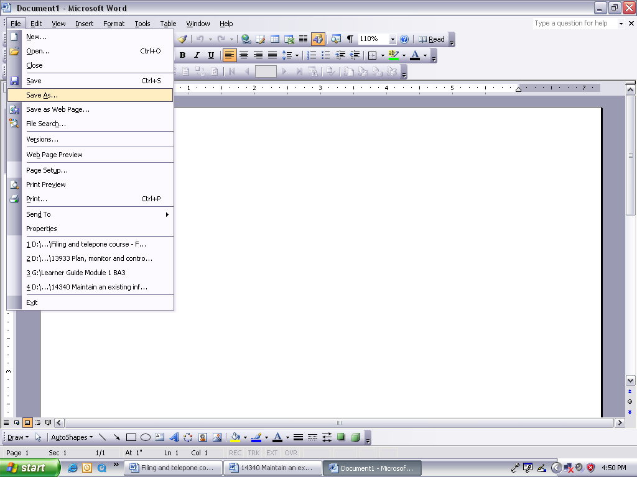

Formative assessment 1

# MONITOR THE FILING SYSTEM

#### Outcome

Monitor the implementation of the filing and retrieval system

#### Assessment criteria

Quality control to monitor sorting, filing and retrieval of documentation is carried out according to organisational requirements.

Organisational policy for transfer, archive and disposal is followed.

Procedures for ensuring manual or computerised records are followed.

The importance of maintaining up-to-date and accurate records of paper-based documentation is explained.

## The Process Of Filing

There are eight basic steps in a typical filing routine.



1. **Collecting the items to be filed.**

If this is your responsibility, ensure that you collect the filing every day.

1. **Inspecting.**

Make sure that the items are intended for filing.

Also ensure that confidential items do not lie around for everyone to see, they should preferably be placed in a separate folder and filed immediately.

1. **Indexing.**

Which indexing system is used, where will the correspondence be placed?

Allocating a file reference number to the correspondence, according to the recognized filing system used by your organisation.

Make very sure that you allocate the correct reference to correspondence, as a document that was indexed incorrectly can be lost for a long period of time.

Certain files and correspondence will be confidential and only certain staff members will be allowed access to these files. Ensure that they are coded correctly and also that a notation is made on the outside of the file.

1. **Cross referencing.**

If the correspondence refers to more than one file, use a cross-referencing system,

or, depending on the procedure in your company, add a copy of the correspondence to the other file as well.

1. **Sorting.**

Sort the filing in the method of classification used by your organization – alphabetical, numerical, alpha-numerical.

Having the filing sorted in the correct order will speed up the filing process.

There are various types of sorters that can be used to help you sort the correspondence for filing:

**Concertina file**: - it has 26 partitions, one for each letter of the alphabet. It is convenient for temporary sorting or storing as the file can expand when it becomes fuller.

**Pigeon hole**: this is a shelf with 26 pigeon holes, one for each letter of the alphabet. It is mainly used in a mail room for sorting mail and is seldom used for general filing.

**Flap sorter**, also known as an alphabetical sorter: this commonly called Long John Sorter. It is a thick cardboard strip with 26 flaps, one for each letter of the alphabet. Correspondence is sorted in the flaps before being placed in file folders.

1. **Filing.**

File the correspondence, ensuring that you place the documents in the correct file.

 Looking for correspondence that has been misfiled is a big waste of time for you and your co-workers looking for the information.

Ensure that you file confidential documents first

Documents must be filed chronologically, with the most recent date on top.

Ensure that you file the documents with their attachments and enclosures.

1. **Lending of files and file contents.**

Ensure that the “out” cards are completed and signed for before handing over the files.

It will also be your responsibility to ensure that the file is returned. Follow up on outstanding files on a weekly or daily basis, depending on the procedure in your organization. This is especially important when confidential files are signed out.

When the file is returned, remember to sign it in again.

Make sure that confidential correspondence is not handed to unauthorized personnel.

|  |  |  |  |
| --- | --- | --- | --- |
| **OUT CARD** | | | |
| NAME OR SUBJECT | DATE | TAKEN BY | DATE RETURNED AND INITIALS |
| Smith James | 15/05/05 | NDP | 31/05/05 NDP |
| Tiger Brands | 15/05/05 | BJP | 26/05/05BJP |
| ABC Trading Co | 26/05/05 | ISN |  |

## Transfer, Archive And Disposal

Exercise 1

Find a policy that includes transfer, archiving and disposal of files or documentation. Bring the policy with to class and discuss it with your facilitator and peers. Also include the policy in your POE.

Write your own policy in terms of transfer, archiving and disposal of data, files or documentation.

## Follow Procedures For Manual Or Electronic Filing

Exercise 2

Research the procedure for filing in your organisation. Write a report about the procedure. Discuss the research in your groups.

## Maintain Up-To-Date And Accurate Records

Why do you think it is important to keep accurate records of paper-based documentation? Write down four reasons, discuss them in your class with your facilitator and peers.

If you keep accurate records of incoming and out going paper-based documentation it is much easier to track documents. If the person who is in charge of filing does not keep a record and is not present when someone needs information, it would be chaos.

No one will know what has been filed and who has which files.

An easy way of keeping track of who has which files is out cards. An out card is a simple card that the person taking a file from the system has to complete. Here’s an example of one:

|  |  |  |  |
| --- | --- | --- | --- |
| **File Name** | **Date Taken** | **Date Returned** | **Signature** |
| Sales 2006/01 | 17/06/07 |  | Me. S.Podmore |

The File name and Date returned will be filled in by the person in charge of the files, the rest is completed by the person taking the file from the system.

# CONTROL THE FILING SYSTEM

#### Outcome

Control the implementation of a filing and retrieval system

#### Assessment criteria

Filing is complete, accurate, in the required format, location and time frame.

Incorrectly filed documents are identified and filed correctly.

Areas for improvement are communicated to the staff responsible.

Procedures for improving storage and retrieval system are planned and updated on an ongoing basis.

**Filing must always be**

Complete,

Accurate,

In the required format,

Location and

Time frame

Filling is something that has to be done on a daily basis. It is the only way of keeping the filing system up to date and accurate. If you do your filing every day, you won’t run the risk of missing the deadline of any time frame.

As for the format, every organisation will have its own rules and procedures that should be included in the policy. How you file it will be up to the system that you use, for example an alphabetical system.

It is important to file accurately. If you file the documentation for XYZ transport in the file that contains documents and information about The Station Furniture Shop, nobody will know where the invoice is.

### Some tips to remember when filing

Check all papers are completed and can be filed

Check attachments are firmly fixed to the correct document

Check that there are no extra papers attached to the document

Sort into order

File away carefully in the filing cabinet in the correct place

File regularly, preferably each day

Check for any missing files and locate these (use an outcard system)

Make sure your files are clearly marked with tags, preferably typed tags

Make sure that the key people understand how your filing system works

## Equipment and Accessories

A variety of filing equipment and accessories are available to assist you with the filing process. The type used will depend on the space available and type of information to be stored. There are four ways in which files can be stored:

|  |  |
| --- | --- |
| Vertical | **Filing Cabinet**  Files behind each other |
| **Lateral** | **Cabinet with no drawers**  Files side by side |
| **Horizontal** | **Narrow Drawers**  Files on top of each others |
| **Circular** | **Carousel**  Files placed in circular arrangement on layers of shelves which rotate |

### Tips for using filing equipment…

A file drawer or shelf should be filled to no more than 90% of it capacity. Tightly packed files slow filing and finding files down

Folders tabs should be visible immediately when opening the drawer

Folder tabs should be typed

Standard folders are scored to hold 25mm of material – no more than this should be placed in the folder

Always make a list of the files inside the cupboard or shelf. This way a person can immediately see when a file is missing or whether the file is in the cupboard. This list can be placed on the inside of the cupboard

Torn papers should be mended before they are filed

All documents should be placed with the tops to the left as you face the folder – this is easier as we read from left to right

Certain fax machines use the fax paper rolls. Any of these types of faxes to be filed must be photocopied first as the printing disappears after a while

## Incorrectly Filed Documents

If you come across a file that has been misfiled, you should take it out immediately. Make sure all the documentation that should be there, is present and then file it in the correct location immediately.

Misfiling often happens when too many people have access to the filing system and do not know how the system works.

A way to avoid this is by giving a copy of the filing policy to everyone who has access to the filing system. This will ensure that everyone is well informed.

Another good idea to avoid misfiling is to do spot checks weekly. You can do this by browsing through different filing locations every week.

## Communicate Areas for improvement

Case study

You have been put in charge of a small filing system. Currently it is a numerical system but you believe that an alphabetical system will be better.

Write a report about your suggestion. To whom must you address your report?

Describe the shortcomings of the present filing system

Make suggestions for the improvement of the system

Motivate your suggestions and recommendations

## Update The Filing And Archiving System

You will rarely find the perfect filing system. One reason for this is the human factor. Human errors will always creep in and you can monitor the types of mistakes that people make when filing documents. An example of such a mistake could be misfiling. A way to solve this is to place dividers with labels between files.

This way everyone can see where each file is supposed to go.

Before you update, improve or in any way change the filing system, first do research to find out what the problems are. Remember to ask fellow employees for their suggestions to improve the filing system.

Once you have the results of your research, write a report to make recommendations.

After the changes have been approved, remember to advise all the people who make use of the filing system about the changes to the system. If necessary, run training sessions to make sure that everyone understands the new system and will be able to store and retrieve information from the system.

The filing and archiving system should be monitored, controlled and updated regularly and especially if it becomes apparent that the current system is not working. Many misfiles or incorrect classifications of files can be an indicator of problems with a filing system.