**LEARNER GUIDE**

**Solve problems, make decisions and implement solutions**

Unit Standard 242817

Level 4 Credits 8

# TABLE OF CONTENTS

TABLE OF CONTENTS 2

FORMATIVE ASSESSMENT 4

Formative Assessment: Group activity SO1 AC 1 – 4 4

Formative Assessment SO 2 AC 1 – 2; SO 3 AC 1-3 5

Formative Assessment SO4 AC 1 – 3, SO5 AC 1 - 3 7

PERSONAL INFORMATION 9

INTRODUCTION 10

Structure 11

Programme methodology 11

What Learning Material you should have 12

Different types of activities you can expect 13

Learner Administration 14

Assessments 14

Learner Support 15

Learner Expectations 16

Programme Structure And Strategy 17

UNIT STANDARD 20

DEFINE THE PROBLEM 22

Decisions And Problems 22

Problems and Opportunities 23

What is a Problem? 23

The Steps Involved In Problem Solving 24

Problems And Decision Making 25

Define the problem 25

Steps in defining a problem 25

Collect facts 26

Collect facts to meet the requirements of the problem 26

Verify the information 28

Formulate the problem 30

Formative Assessment: Group activity SO1 AC 1 – 4 30

INVESTIGATE THE PROBLEM AND GENERATE SOLUTIONS 31

Introduction 31

Problem Solving Techniques 32

Brainstorming 33

Mapping 34

Computer Modelling 35

Observation 35

Questionnaires 36

Experiments 36

Establishing Root Cause 36

Use How To… 38

Turn the problem around 39

5W’s and 1 H 40

Delphi Technique 40

Evaluate Solutions Against The Criteria 43

Feasibility 43

Duration (Time) 43

Costs 43

Resource implications 43

Stakeholder commitment 44

Logistics 44

Causes 44

Effects 44

Formative Assessment SO 2 AC 1 – 2; SO 3 AC 1-3 45

Ineffective Ways Of Handling Problems 45

It’s Not My Problem 45

The Real Problem Is 45

As If I Didn’t Have Enough Problems 46

Critical Thinking 46

Suggestions To Improve Your Individual Critical Thinking Ability 47

IMPLEMENT THE SOLUTION 49

Select The Solution 49

Things That Can Influence Your Decision 49

Selecting a solution 49

Decision Making Pitfalls To Avoid 50

Stakeholders Are Consulted 50

Develop an action plan 51

Scheduling 51

Delegating 52

EVALUATE THE SOLUTION 53

Monitor Implementation 53

Duration 53

Implication And Effects 54

Review The Solution 54

Formative Assessment SO4 AC 1 – 3, SO5 AC 1 - 3 54

# FORMATIVE ASSESSMENT

Formative Assessment: Group activity SO1 AC 1 – 4

#### Case study 1

A supervisor of a supermarket had just turned off the lights in the store, when a man appeared and demanded money. The supervisor opened the cash register. The contents of the cash register were scooped up and taken, and the man sped away.

In a group, define the problem

The story seems simple enough. But look at it very carefully.

Are the following statements true or false?

1. A man appeared after the owner had turned off his store lights.

2. The robber was a man.

3. While the cash register contained money, the story does not say how much.

4. The police were called in to investigate.

5. The man sped away with money taken from the cash register.

In a group, think of more scenarios to the above case study.

#### Refer to Case study 1

For the sake of this Formative Assessment, we will say that a robbery took place. Answer the following questions:

* What happened?
* Where did it occur?
* What did we want to happen?
* What should have happened?
* Is that a problem?
* How bad is the problem?
* What else is involved? Who or what is affected by it now?
* Who or what was responsible?
* Is it an isolated incident or is it likely to happen again
* What are the consequences of ignoring the problem?
* How else can the problem be stated?
* Have similar problems existed ‑ how were they solved?
* Why does it have to be solved?
* When does it have to be solved?
* What will it cost to solve the problem?
* Who should solve it?
* What is likely to happen when the problem is solved?
* Who will be affected?
* Are you being influenced by your own feelings about the situation?
* Is it a problem, or just a symptom?
* Is this problem linked to other situations?
* What other external factors should you take into account?

Determine who the stakeholders are and explain why they should be involved in the problem-solving process.

Formative Assessment SO 2 AC 1 – 2; SO 3 AC 1-3

#### Refer back to Case Study 1 and restate the problem

To get the creative processes flowing, do the following Formative Assessments:

* Using the brainstorming technique, list as many uses for a paper clip as you can in two minutes. The facilitator will lead the discussion
* Use mapping to link at least four uses

#### Refer to Case Study 1

* In a group, consider the possible courses of action that can be taken. Use the brainstorming technique. List eight of the possible solutions.

Use mapping to link the solutions. Do it in the form of a flow chart.

Draw up a questionnaire of six questions. List the problem and at least six solutions to the problem. Number them from one to six and request the other party to rank them from 1 to 6, with 1 being the best solution and 6 the worst. Also leave space for the other party to give you their solution to the problem.

Your group gives your questionnaires to another group for completion and you complete a different group’s questionnaires.

|  |  |
| --- | --- |
| Problem: | |
| Possible solutions. | |
| 1. |  |
| 2. |  |
| 3. |  |
| 4. |  |
| 5. |  |
| 6. |  |
|  | |

When everybody has completed the questionnaires, hand them back to the original groups. Collate the questionnaires, ranking the solutions as according to the replies received.

|  |  |
| --- | --- |
| Number of positive replies: | |
| Solution 1 |  |
| Solution 2 |  |
| Solution 3 |  |
| Solution 4 |  |
| Solution 5 |  |
| Solution 6 |  |
| Alternative solutions |  |

Now, evaluate the possible courses of action.

* Advantages
* Disadvantages
* Duration
* Effects
* Which factors do you think influenced your decision?

Refer back to Case Study 1 and your notes on that case study.

In a group, answer the following questions:

* List as many options (solutions) to the problem as you can.
* What are the likely end results of each of the above options?
* Which option seems to be the best from all angles? Motivate your answer.

Formative Assessment SO4 AC 1 – 3, SO5 AC 1 - 3

#### Refer to Case Study 1

* Develop an action plan to implement the solution
* Determine who the stakeholders are that have to be consulted
* Decide how long you will monitor the implementation of the solution
* Decide how you will monitor the implementation

#### Case study 2

Study the following case situation and then answer all the questions that follow.

Jerry Davids is the supervisor of an association of more than 50 000 members. Along with standards and professional development, one of the prime services the association provides to its members is information like referrals, pamphlets, brochures, books, videos and other materials.

As seen on the flow chart, requests for information are handled first by the member Services Department, where they are separated according to type and the necessary internal forms are completed. These forms are then sent to the appropriate departments for sorting, boxing and mailing

There is evidence of a backlog in the Members Services Department. Videos are not being sent on time and delivery dates are as much as four weeks after the receipt of the request.

Jerry has checked with the despatch department and found that they receive the paperwork and then deliver the goods the same day.

Jerry has decided to call a meeting with David Wagner, who is in charge of the Member Services Department, to iron out the problem.

The following is their conversation:

Jerry: David, I am sure you are wondering why I called you in. It seems you have a rather serious backlog in processing requests for member information.

David: Well, I understand that, of course. As a matter of fact it is quite timely, because I was going to talk to you about it. One of the real problems we have is that we are getting tons of requests that we simply cannot handle.

Jerry: Our total volume hasn't increased in over eight months. What seems to be the hold up?

David: Well, typically a request will come in from one of our members asking for more than one item. Let's use video for example. We sort an order for a video that goes to the audio visual library and, if the request also includes such things as pamphlets, we make the order for pamphlet packaging. Usually, it also takes some kind of correspondence back to the member because they invariably ask for other kinds of information they can't provide.

Jerry: I see. Well, what do you feel is the solution.

David: Because of the increasing volume of this type of order we simply have to have another employee if we are going to keep up with the demand.

Answer all the following questions. Show the process you followed with each step. Ensure that you follow all the steps and consider all the options as per the learner guide. Indicate your steps and processes.

* Define the apparent problem
* List at least three symptoms of the problem
* Analyse the problem
* From the information given in the case situation, list at least three facts about this problem
* Restate the problem
* Determine possible causes of action
* Which problem solving techniques would you use? Why?
* Establish the criteria and evaluate possible solutions against the criteria. List at least three possible solutions other than taking on an additional person.
* Evaluate the solutions
* If you were the departmental supervisor, what would your decision be to solve the problem? State your reasoning for this decision.
* How would you Implement the solution?

PERSONAL INFORMATION

|  |  |
| --- | --- |
| **NAME** |  |
| **CONTACT ADDRESS** |  |
|  |
| **Code** |  |
| **Telephone (H)** |  |
| **Telephone (W)** |  |
| **Cellular** |  |
| **Learner Number** |  |
| **Identity Number** |  |
|  | |
| **EMPLOYER** |  |
| **EMPLOYER CONTACT ADDRESS** |  |
|  |
| **Code** |  |
| **Supervisor Name** |  |
| **Supervisor Contact Address** |  |
|  |
| **Code** |  |
| **Telephone (H)** |  |
| **Telephone (W)** |  |
| **Cellular** |  |

INTRODUCTION

#### Welcome to the learning programme

Follow along in the guide as the training practitioner takes you through the material. Make notes and sketches that will help you to understand and remember what you have learnt. Take notes and share information with your colleagues. Important and relevant information and skills are transferred by sharing!



This learning programme is divided into sections. Each section is preceded by a description of the required outcomes and assessment criteria as contained in the unit standards specified by the South African Qualifications Authority. These descriptions will define what you have to know and be able to do in order to be awarded the credits attached to this learning programme. These credits are regarded as building blocks towards achieving a National Qualification upon successful assessment and can never be taken away from you!

## Structure

### Programme methodology



The programme methodology includes facilitator presentations, readings, individual activities, group discussions and skill application exercises.

Know what you want to get out of the programme from the beginning and start applying your new skills immediately. Participate as much as possible so that the learning will be interactive and stimulating.

The following principles were applied in designing the course:

* Because the course is designed to maximise interactive learning, you are encouraged and required to participate fully during the group exercises
* As a learner you will be presented with numerous problems and will be required to fully apply your mind to finding solutions to problems before being presented with the course presenter’s solutions to the problems
* Through participation and interaction the learners can learn as much from each other as they do from the course presenter
* Although learners attending the course may have varied degrees of experience in the subject matter, the course is designed to ensure that all delegates complete the course with the same level of understanding
* Because reflection forms an important component of adult learning, some learning resources will be followed by a self-assessment which is designed so that the learner will reflect on the material just completed.

This approach to course construction will ensure that learners first apply their minds to finding solutions to problems before the answers are provided, which will then maximise the learning process which is further strengthened by reflecting on the material covered by means of the self-assessments.

#### Different role players in delivery process

* Learner
* Facilitator
* Assessor
* Moderator

### What Learning Material you should have

This learning material has also been designed to provide the learner with a comprehensive reference guide.

It is important that you take responsibility for your own learning process; this includes taking care of your learner material. You should at all times have the following material with you:

|  |  |
| --- | --- |
| **Learner Guide** | **This learner guide is your valuable possession:**  This is your textbook and reference material, which provides you with all the information you will require to meet the exit level outcomes.  During contact sessions, your facilitator will use this guide and will facilitate the learning process. During contact sessions a variety of activities will assist you to gain knowledge and skills.  Follow along in the guide as the training practitioner takes you through the material. Make notes and sketches that will help you to understand and remember what you have learnt. Take and share information with your colleagues. Important and relevant information and skills are transferred by sharing!  This learning programme is divided into sections. Each section is preceded by a description of the required outcomes and assessment criteria as contained in the unit standards specified by the South African Qualifications Authority. These descriptions will define what you have to know and be able to do in order to be awarded the credits attached to this learning programme. These credits are regarded as building blocks towards achieving a National Qualification upon successful assessment and can never be taken away from you! |
| **Formative Assessment Workbook** | The Formative Assessment Workbook supports the Learner Guide and assists you in applying what you have learnt.  The formative assessment workbook contains classroom activities that you have to complete in the classroom, during contact sessions either in groups or individually.  You are required to complete all activities in the Formative Assessment Workbook.  The facilitator will assist, lead and coach you through the process.  These activities ensure that you understand the content of the material and that you get an opportunity to test your understanding. |

### Different types of activities you can expect

To accommodate your learning preferences, a variety of different types of activities are included in the formative and summative assessments. They will assist you to achieve the outcomes (correct results) and should guide you through the learning process, making learning a positive and pleasant experience.



The table below provides you with more information related to the types of activities.

| **Types of Activities** | **Description** | **Purpose** |
| --- | --- | --- |
| **Knowledge Activities** | You are required to complete these activities on your own. | These activities normally test your understanding and ability to apply the information. |
| **Skills Application Activities** | You need to complete these activities in the workplace | These activities require you to apply the knowledge and skills gained in the workplace |
| **Natural Occurring Evidence** | You need to collect information and samples of documents from the workplace. | These activities ensure you get the opportunity to learn from experts in the industry.  Collecting examples demonstrates how to implement knowledge and skills in a practical way |

### Learner Administration



#### Attendance Register

You are required to sign the Attendance Register every day you attend training sessions facilitated by a facilitator.

#### Programme Evaluation Form

On completion you will be supplied with a “Learning programme Evaluation Form”. You are required to evaluate your experience in attending the programme.

Please complete the form at the end of the programme, as this will assist us in improving our service and programme material. Your assistance is highly appreciated.

### Assessments

The only way to establish whether a learner is competent and has accomplished the specific outcomes is through the assessment process. Assessment involves collecting and interpreting evidence about the learners’ ability to perform a task.

To qualify and receive credits towards your qualification, a registered Assessor will conduct an evaluation and assessment of your portfolio of evidence and competency.

This programme has been aligned to registered unit standards. You will be assessed against the outcomes as stipulated in the unit standard by completing assessments and by compiling a portfolio of evidence that provides proof of your ability to apply the learning to your work situation.



**How will Assessments commence?**

#### Formative Assessments

The assessment process is easy to follow. You will be guided by the Facilitator. Your responsibility is to complete all the activities in the Formative Assessment Workbook and submit it to your facilitator.

#### Summative Assessments

You will be required to complete a series of summative assessments. The Summative Assessment Guide will assist you in identifying the evidence required for final assessment purposes. You will be required to complete these activities on your own time, using real life projects in your workplace or business environment in preparing evidence for your Portfolio of Evidence. Your Facilitator will provide more details in this regard.

To qualify and receive credits towards your qualification, a registered Assessor will conduct an evaluation and assessment of your portfolio of evidence and competency.

### Learner Support

The responsibility of learning rests with you, so be proactive and ask questions and seek assistance and help from your facilitator, if required.



Please remember that this Skills Programme is based on outcomes based education principles which implies the following:

* You are responsible for your own learning – make sure you manage your study, research and workplace time effectively.
* Learning activities are learner driven – make sure you use the Learner Guide and Formative Assessment Workbook in the manner intended, and are familiar with the workplace requirements.
* The Facilitator is there to reasonably assist you during contact, practical and workplace time for this programme – make sure that you have his/her contact details.
* You are responsible for the safekeeping of your completed Formative Assessment Workbook and Workplace Guide
* If you need assistance please contact your facilitator who will gladly assist you.
* If you have any special needs please inform the facilitator

### Learner Expectations

Please prepare the following information. You will then be asked to introduce yourself to the instructor as well as your fellow learners



|  |
| --- |
| Your name: |
|  |
|  |
| The organisation you represent: |
|  |
|  |
| Your position in organisation: |
|  |
|  |
| What do you hope to achieve by attending this course / what are your course expectations? |
|  |
|  |
|  |
|  |
|  |

|  |  |  |  |  |  |  |  |  |
| --- | --- | --- | --- | --- | --- | --- | --- | --- |
| Programme Structure And Strategy | | | | | | | | |
| **UNIT STANDARD 242817 Level 4** | | | | | | | | |
| **Credits 8: notional hours 80, classroom training 24 hours, workplace hours 56** | | | | | | | | |
| **Programme Outcomes** | **Page2** | **Outcomes** | **Time Allocation** | **Delivery strategy** | **EEK** | **CCFO** | **Formative Assessment** | **Summative Assessm: total time 56 hours** |
| INTRODUCTION | 3 |  | Introductory activities:  60 minutes | Discussion |  |  |  |  |
| Programme Overview | 3 |  |  |  |  |  |
| Personal Objectives And Expectations | 4 |  |  |  |  |  |
| **UNIT STANDARD 242817** | 5 |  |  |  |  |  |
| **Section 1: DEFINE THE PROBLEM** | 7 | SO1 | 240 minutes | Discussion & slide show |  | Identify and  solve problems |  | Questionnaire |
| Decisions And Problems | 8 | AC1 |  |  |  |  | Workplace Research Assessment |
| The Steps Involved In Problem Solving | 10 | AC2 |  |  |  |  | This assessment activity has to take place in the workplace regarding a real problem. It will therefore take a couple of weeks to complete.  You have to identify a problem in the workplace and then take the necessary steps to solve the problem, make decisions and implement solutions |
| Define the problem | 11 | AC3 |  |  |  |  |
| Collect facts | 12 | AC4 |  |  | Work effectively with others |  |
| Formulate the problem | 16 | AC5 |  |  |  |  |
| Group activity SO1 AC 1 - 4 | 17 |  | 90 minutes |  |  | Group activity: Case study |
| **Section 2: INVESTIGATE THE PROBLEM AND GENERATE SOLUTIONS** | 19 | SO2 | 240 minutes | Discussion & slide show |  |  |  | Select a technique in line with the context of the problem  Investigate a problem to ascertain the various components  Generate possible solutions  Identify and weigh criteria and then propose solutions.  Evaluate possible solutions against the established criteria in order to determine suitability  Select the optimum solution(s) selected in accordance with given criteria |
| Introduction | 20 | AC1 |  |  |  |  |
| Problem Solving Techniques | 21 | AC2 |  |  |  |  |
| Evaluate Solutions Against The Criteria | 32 |  |  |  | Organise and  manage |  |
| Formative Assessment SO 2 AC 1 - 2; SO 3 AC 1-3 | 33 |  | 90 minutes |  |  | Group activity: Restate problem |
| Ineffective Ways Of Handling Problems | 35 |  |  |  |  |  |
| **Section 3: IMPLEMENT THE SOLUTION** | 39 | SO3 | 240 minutes | Discussion & slide show |  | Collect, analyse organise |  | Consult with stakeholders prior to implementation, so as to obtain commitment  Implement the selected solution (s) according to organisational constraints  Identify criteria for the measurement of the effectiveness of the solution according to the problem definition. Criteria must include: feasibility, suitability, acceptance, return on investment and alignment to role or strategy  Evaluate the effectiveness of the solution against the criteria  Identify and apply corrective action |
| Select The Solution | 40 | AC1, 2 |  |  |  |  |
| Stakeholders Are Consulted | 41 | AC3 |  |  |  |  |
| Develop an action plan | 42 | AC4 |  | N/A |  |  |
| **EVALUATE THE SOLUTION** | 44 | SO4 | 240 minutes |  |  |  | You will have to provide proof of your actions in the form of minutes of meetings, notes made during problem-solving sessions and any other documentation that will verify your actions. |
| Monitor Implementation | 45 | AC1, 2 |  |  |  |  |
| Review The Solution | 46 | AC3 |  |  |  |  |
| Formative Assessment SO4 AC 1 - 3, SO5 AC 1 - 3 | 46 |  | 90 minutes |  |  | Individual activity: Action plan |
| **Revision** |  |  | **60 minutes** |  |  |  |  |  |
| **Summative questionnaire** |  |  | **90 minutes** |  |  |  |  |  |
| **Notional Hours** |  |  | **24** |  |  |  |  | **56** |

# UNIT STANDARD

#### Unit standard number

242817

#### Unit standard title

Solve problems, make decisions and implement solutions

#### Nqf level

4

#### Credits

8

#### Purpose of unit standard

This Unit Standard is intended for junior managers of organisations. The Unit Standard specifies the knowledge and skills required to solve problems and make decisions

#### Learning assumed to be in place

Learners should be competent in Communication and Mathematical Literacy at NQF Level 3

#### Unit standard range

* 'Area of responsibility' includes, but is not limited to, cost centre, section, department or team
* 'Junior managers' include, but are not limited to, team leaders, supervisors, foremen and section heads
* 'Standard Operating Procedures' (SOPs) may comprise formal written documents or accepted practices in the organisation
* 'Organisation' includes but is not limited to, workplace, work context, work unit, company, department or section

#### Specific outcomes and assessment criteria

**Specific outcome one:** Define the problem

**Assessment criteria**

* Problems are defined according to the verified information. Information includes, but is not limited to, facts and opinions (positive or negative), future implications of no action, and emotions
* The rationale for consulting with stakeholders and role-players is explained to ensure that they contribute to the various stages of the problem-solving process
* Techniques in the formulation of the problem definition are explored and explained, according to theory and practice
* A technique is selected in line with the context of the problem

**Specific outcome two:** Investigate the problem

**Assessment criteria**

* A problem is investigated to ascertain the various components
* Further information is obtained, if required, and all information is critically examined for its relevance to the problem

**Specific outcome three:** Generate problem solutions

**Assessment criteria**

* Possible solutions are generated by using a range of problem-solving techniques. Includes, but is not limited to: Delphi Technique, Mapping, Computer Modelling, Observation, Questionnaires, Experiments, Brainstorming and other creative thinking techniques
* Criteria are identified and weighted to enable the ranking of proposed solutions. Includes, but is not limited to: Feasibility, time, cost, resource implications, stakeholder commitment, and logistics
* Possible solutions are evaluated against the established criteria in order to determine suitability

**Specific outcome four:** Implement solution

**Assessment criteria**

* The optimum solution(s) is (are) selected in accordance with given criteria
* Stakeholders are consulted prior to implementation, so as to obtain commitment
* The selected solution (s) is (are) implemented, according to organisational constraints

**Specific outcome five:** Evaluate the effectiveness of the solution

**Assessment criteria**

* Criteria for the measurement of the effectiveness of the solution are identified according to the problem definition. Criteria include, but is not limited to, feasibility, suitability, acceptance, return on investment and alignment to role or strategy
* The effectiveness of the solution is evaluated against the criteria
* Corrective action is identified and applied, where possible

#### Critical Cross-field Outcomes (CCFO):

* Work effectively with others as a member of an organisation by obtaining stakeholder involvement in generating solutions to problems
* Organise and manage him/her self and his/her activities responsibly and effectively in using the criteria for selection of optimum solution
* Collect, analyse, organise, and critically evaluate information to ensure accurate problem definition valuate information in order to apply leadership techniques within own work context

# DEFINE THE PROBLEM

#### Specific outcome one

Define the problem

#### Assessment criteria

* Problems are defined according to the verified information
* Information includes, but is not limited to, facts and opinions (positive or negative), future implications of no action, and emotions
* The rationale for consulting with stakeholders and role-players is explained to ensure that they contribute to the various stages of the problem-solving process
* Techniques in the formulation of the problem definition are explored and explained, according to theory and practice
* A technique is selected in line with the context of the problem

The best way to escape from a problem is to solve it

—Alan Saporta

## Decisions And Problems

One thing is for certain in an ever-changing world: There will always be problems to solve. You solve problems every day of your life. Without realizing it, you’ve probably developed quite a few problem-solving skills.

For example, say you plan to take the bus to work, but you miss it. You know you’re in trouble. And that’s one problem-solving skill - **the ability to identify the problem**.

Immediately you consider your options. You could walk the five miles to work. You could ride your bicycle or use in-line skates. You could use your car, your friend might pick you up, or you could ask a family member for a ride. **Coming up with lots of possible solutions** is another problem-solving skill.

You dash to the car (you can still make it to work on time), jump in, and turn the key in the ignition. Nothing happens. The car won’t start. You consider the possibilities and form a theory that the problem may be caused by a weak battery. Your son is famous for leaving the inside car light on. Sure enough, you check it out and find the light still turned on. You’ve successfully **researched, formed a hypothesis, and confirmed your theory** - all problem-solving skills.

Now you can fix the problem with another problem-solving skill - **an action plan**. You pull out the jumper cables and jump start the car. In minutes you’re on your way, thanks to problem-solving skills you didn’t even know you possessed.

A decision is a choice between options and is a component of problem solving.

A decision is also the action a manager or supervisor must take when the information is so incomplete that the answer does not suggest itself.

When thinking about problems, always remember the following:

* **A problem is a deviation from what ought to be.**
* **As far as problems are concerned, we should always be proactive and not just reactive.**
* **Where there is no problem there can be no improvement.**

### Problems and Opportunities

It is often said that ‘there are no problems, only opportunities’

This is of course not always true, but it does emphasize the point that a problem should lead to positive thinking about what is to be done now, rather than to naming and blaming. By naming and blaming I mean that we should look at solutions to problems rather than looking for someone to blame.

**Naming and blaming is actually a waste of time and energy.**

If a mistake has been made, the reasons for it should be analysed, to ensure that it does not happen again.

It sometimes happens that you will be faced with a continuous flow of problems and decisions. When this happens, you may feel utterly confused. This happens to all of us, that is why we all work at solving problems by following a plan.

### What is a Problem?

When the course of action towards a desired objective is not easy or routine, then we say we have a 'problem'.

The traditional method for problem solving is to find the cause of the problem and then to seek to remove that cause. If you hear an unusual rattling noise when you are driving your car, you would seek out the cause and then remove it.

This may involve identifying several possible causes and then checking them out one by one.

* When did I first notice it?
* Is it only when the car is moving, or does it happen when it is stationery?
* Can I only hear it with the window open?

With all problems we have to go through a process which will lead us to the **root cause** before making a decision about next steps.

If we cannot solve a problem by removing the cause, then we have to design a way forward, reducing the effect as much as possible. However, if the cause stays in place we are always in danger of the effect being repeated. We either act to prevent the cause or we respond to the effect.

Before trying to solve any problem, it is necessary to have a very clear understanding of what the real problem is.

#### Problems you may have had before you left home today

1. Alarm didn’t go off

2. Fell back asleep

3. Sister hogged the bathroom

4. No milk or cereal in the house

5. Nothing for lunch (

6. Brother tells you that he won’t take you to work

7. Storm knocked out power (no lights, hair dryers, curling irons, etc.)

8. Favourite shirt is too wrinkled to wear

9. Shoelace breaks

10. Forgot that you had to go in early to finish a report

## The Steps Involved In Problem Solving

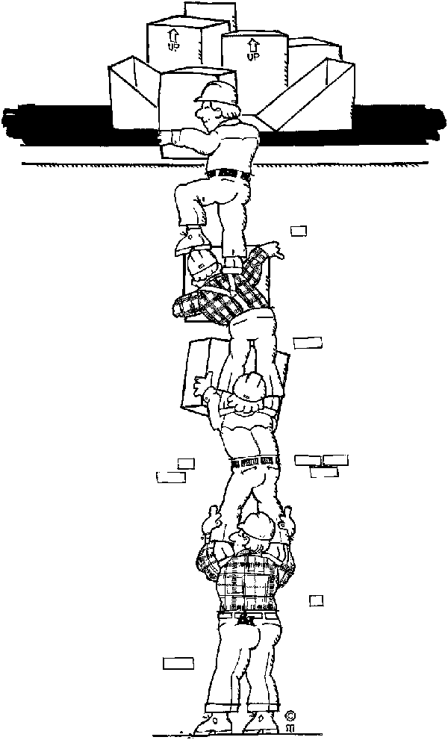**Define the problem**

**Analyse it**

**Restate the problem**

**Identify alternative solutions**

**Evaluate alternatives**

**Select optimum solution**

**Implement it**

**Evaluate outcome**

**Modify solution or restate problem if desired outcome not achieved**

### Problems And Decision Making

In order to identify and analyse a problem, you have to examine and identify the problem in terms of **problem type, problem parameters and possible causes**.

In the workplace, problems occur almost daily. Some of these problems are relatively simple and can be handled with available tried and tested solutions, while others will take more effort and skill. Sometimes you will have to face a once-off unique problem. Such problems demand competent and effective solutions.

Effective and competent decision-making should be based on a systematic problem-solving approach, and this is a skill that has to be learnt.

You also have to take sufficient trouble to identify the **real** problem; instead of solving an **apparent** problem. If you do not identify the **real** problem at an early stage, you could make a bad decision and this could lead to serious trouble.

Some people make things happen. Some people watch things happen, and some people say what happened

—Casey Stengel, Hall-of-Fame baseball manager

## Define the problem

The first step in decision making is called 'define the apparent problem'.

Why do we call it the **apparent problem**? It is always difficult to see a problem as it really is – and not as we perceive it to be, based on our emotions, state of mind, subjectivity, prejudice, guesswork, or as we would 'like' to see it.

### Steps in defining a problem

#### Understand the problem

The first step to take in generating problem-solving ideas is to have a clear understanding of where you are now. Write it on a flipchart and stick the pages on the walls of the room.

* Identify what is happening...
* Identify what should be happening...
* What is the discrepancy?

The description of the discrepancy is the problem definition

When you're defining your present situation, use as many different devices as you can (put each one on a separate card or sheet).

You could use the following headings, for example:

* Background
* Need
* Time parameters
* Financial situation
* Resources available
* Resources not available

#### Analyze the Severity of the Problem

Assess the severity of the problem in order to assign a priority level.

* **Seriousness** - What would be the impact on the customer now if I do nothing?
* **Urgency** - How much time do I have to act?
* **Growth** - How much will the situation improve or worsen if action is delayed?

#### Identify the problem

Do some research: **Has this happened before? and Do I already know how to fix it?**

There's so much information out there, just waiting to be useful to you!

* Use the Knowledge Management System available in the organisation
* Don't forget other people who may be able to help

**Most problems have been solved before by someone, somewhere.**

The person who is best at defining the nature of a problem, will be the one who will be the most successful at solving it.

## Collect facts

### Collect facts to meet the requirements of the problem

You need to collect facts that meet the requirements of the problem.

A fact can be defined as a piece of verified information.

#### Facts are obtained from the following sources:

* Judicious **questioning** of eye witnesses.
* **Reading** reports, memoranda and letters, and interpreting them intelligently, seeking clarification if necessary.
* **Investigating** the problem where it is found, for instance, overcrowding could result in an unequal allocation of office space.
* **Opinions** are important. This is because the investigating person is not always able to obtain all the facts required. Opinions from trusted people who have credibility are a distinct advantage in problem‑solving.
* **Feelings** fall into much the same category as opinions. We often get a feeling that we should defer judgement on a particular problem for a short time, although the facts clearly show that we could take legitimate action immediately. Later we realise that the feeling was right as the problem solved itself in a completely different and more satisfactory way.
* Find out **what is happening** now and or what is likely to happen in the future. If different people are involved, get both sides of the story and, where possible, check with a third party. Obtain written evidence wherever relevant. Do not rely on hearsay.
* Define **what is supposed to be happening** in terms of policies, procedures or results and contrast this with what is actually happening.
* Try to understand the **attitudes and motivation** of those concerned. Remember that people will see what has happened or happening, in terms of their own position. Obtain information about internal or external constraints that affect the situation
* What would happen if you took **no action** – is the problem likely to occur again, and, if so, would it be worse next time or not?

#### Consult with stakeholders and role players

During the process of collecting facts, it is necessary to consult with all the stakeholders and role players – everyone who will be affected by the problem and the way you choose to resolve the problem.

Stakeholders could include:

* Team members
* Other departments
* Supervisors and managers
* Customers
* Suppliers

The reason for consulting with stakeholders is to obtain their inputs into the possible causes of the problem as well as possible solutions as they have to approve and implement the solutions to the problems.

#### What questions should you ask?

To define a problem, you need to stop and ask yourself and any witnesses at least as many of the following questions as you can.

?

* What happened?
* Where did it occur?
* What should have happened?
* Is that a problem?

?

* How bad is the problem?
* What else is involved? Who or what is affected by it now?
* Who or what was responsible?
* Is it an isolated incident or is it likely to happen again
* What are the consequences of ignoring the problem?
* How else can the problem be stated?
* Have similar problems existed ‑ how were they solved?
* Why does it have to be solved?

?

* When does it have to be solved?
* What will it cost to solve the problem?
* Who should solve it?
* What is likely to happen when the problem is solved?
* Who will be affected?
* Are you being influenced by your own feelings about the situation?
* Is it a problem, or just a symptom?
* Is this problem linked to other situations?
* What other external factors should you take into account?

#### When do you have enough facts?

One of the dilemmas of making decisions is knowing when you have enough facts

People go one of only two ways:

* Either they rush in and make a decision before they have collected all the facts,
* Or they waste too much time gathering information when a good decision could have been made without wasting too much time.

### Verify the information

After you have gathered information, you have to verify the information. When you have the answers to most or all the questions, think it trough.

* Analyse the facts. Determine what is relevant and what is irrelevant.
* Establish the cause or causes of the problem.
* Do not be tempted to concentrate on symptoms rather than the causes. Dig into what lies behind the problem.
* Identify the extent of the problem – not all problems are of equal importance and the minor, single-incident problem has to be distinguished from the major, recurrent problem.
* Develop theories about the possible causes.
* You must be objective at this stage. Don't solve a problem that does not exist! Nothing can be more embarrassing than jumping to a conclusion based on misconceptions.

The key is which facts are relevant and which are incidental

To examine the facts adequately, be sure to separate what you **know** to be true from what you **think** is true. Always try to gather facts from more than one source. Check your information for accuracy and truthfulness.

We all have a tendency to want to solve a problem immediately because the pressure is on.

* A machine is down.
* A key person is absent or leaves suddenly.
* Materials don't arrive as promised from the supplier.
* Your neck is on the line!

#### Symptoms VS Causes

The most difficult task when defining a problem is being able to separate the **symptom** from the **cause.**

Headaches and fever are symptoms of flu, not the cause of the flu.In fact, it is the other way around – the flu causes headaches and fever! Doctoring the symptoms, in this case headache and fever, might make you feel better for a little while, but it will not make the flu go away.

Solving problems also works this way – if you try to solve the symptom, it might work for a little while, but the problem will still be there. The problem will not go away unless you solve the problem itself.

For example, if your telephone lines are always engaged, you may try to solve the problem by adding more phone lines. You could be treating the symptom. The real problem may be too many personal calls. Treating symptoms will never solve problems.

When you are responsible for solving problems, it will be your job to sort through the symptoms in order to find the **real, underlying cause of the problem**.

One way is to **list all the potential causes of the problem**. You may need to be somewhat creative, as the cause could be buried deep.

* When you feel that you have a comprehensive list of causes to a problem, sort through them. Use your intuition and experience, and select the most likely causes to the problem.
* You have to be open minded, because often among the causes there may be some that are embarrassing or difficult for you to handle. A natural human tendency would be to put them aside and look for another cause with an easier solution.

#### Examples

**Situation 1**: there is an increasing number of errors in handling of claims by the claims department. You have listed the following probable causes:

* There has been an increase in the number of claims that have to be processed daily
* There are many new staff members in the department.
* Care is not being taken when claims are checked for errors.
* Or perhaps it is that the same number of errors have always been made, but are only now being noticed!

**Situation 2:** Absenteeism rate abnormally high for last month.

* Flu
* Low morale and motivation
* Increased workload*.*

Be careful when trying to solve absenteeism problems. Absenteeism is a frequently occurring symptom of a problem and not the problem itself. The problem usually lies somewhere else. Interestingly, many supervisors think of it as a problem in itself

Most people feel an obligation to go to work. They do not stay away for no reason, so there must be an underlying cause.

Take some time and thought to examine the facts first

**Peter Drucker**, one of the most eminent and respected authors in management science, says,

Effective decisions result from a systematic process, with clearly defined elements, that are handled in a distinct sequence of steps.

When making decisions you must take rational, logical action. You must not rush. You must pause, stand back and look at the problem from all angles.

However, this does not mean that you should use more time than necessary.

The size and urgency of the problem will probably dictate the length of time you would need to reach a decision.

#### Analyze the Severity of the Problem

Assess the severity of the problem in order to assign a priority level.

* **Seriousness - What would be the impact on the customer now if I do nothing?**
* **Urgency - How much time do I have to act?**
* **Growth** - How much will the situation improve or worsen if action is delayed?

## Formulate the problem

#### Restate The Problem

Once you have gathered all the facts and analysed them and you are sure you are addressing a problem and not a symptom, restate the problem.

**Why?**

Once you have analysed the facts, the nature of the problem may have changed. By restating the problem, you will ensure that you are addressing the problem and not a symptom.

**The problem statement**

A problem statement is a clear concise description of the issues that need to be addressed by a problem solving team and should be presented to them at (or created by them) before they try to solve the problem. When bringing together a team to achieve a particular purpose efficiently provide them with a problem statement.

Earlier we said that a problem definition should state the following

* Identify what is happening...
* Identify what should be happening...
* What is the discrepancy?

The description of the discrepancy is the problem definition.

The primary purpose of a problem statement is to focus the attention of the problem solving team.

Formative Assessment: Group activity SO1 AC 1 – 4

# INVESTIGATE THE PROBLEM AND GENERATE SOLUTIONS

#### Specific outcome two:

Investigate the problem

#### Assessment criteria

* A problem is investigated to ascertain the various components
* Further information is obtained, if required, and all information is critically examined for its relevance to the problem

#### Specific outcome three

Generate problem solutions

#### Assessment criteria

* Possible solutions are generated by using a range of problem-solving techniques. Includes, but is not limited to: Delphi Technique, Mapping, Computer Modelling, Observation, Questionnaires, Experiments, Brainstorming and other creative thinking techniques
* Criteria are identified and weighted to enable the ranking of proposed solutions
* Includes, but is not limited to: Feasibility, time, cost, resource implications, stakeholder commitment, and logistics
* Possible solutions are evaluated against the established criteria in order to determine suitability

## Introduction

**Nature operates by profusion. Think of the nearly infinite number of seeds that fall to earth, only a fraction of which take root to become trees; of the millions of sperm competing so fiercely to fertilize one small egg. Similarly, human beings engaged in the creative process explore an astronomical number of possible patterns before settling on an idea.**

—Gabriele Lusser Rico in Writing the Natural Way

Once you have identified the components of the problem, you can consider possible courses of action. List the possible courses of action in the light of the factual analysis.

* What are the possible options? List as many as you can
* What are the likely end results of each of these?
* Which of them seems to be the best from all angles?

Now it’s time to generate ideas - lots of ideas. The more possible solutions you are able to generate, the better your final selection will be.

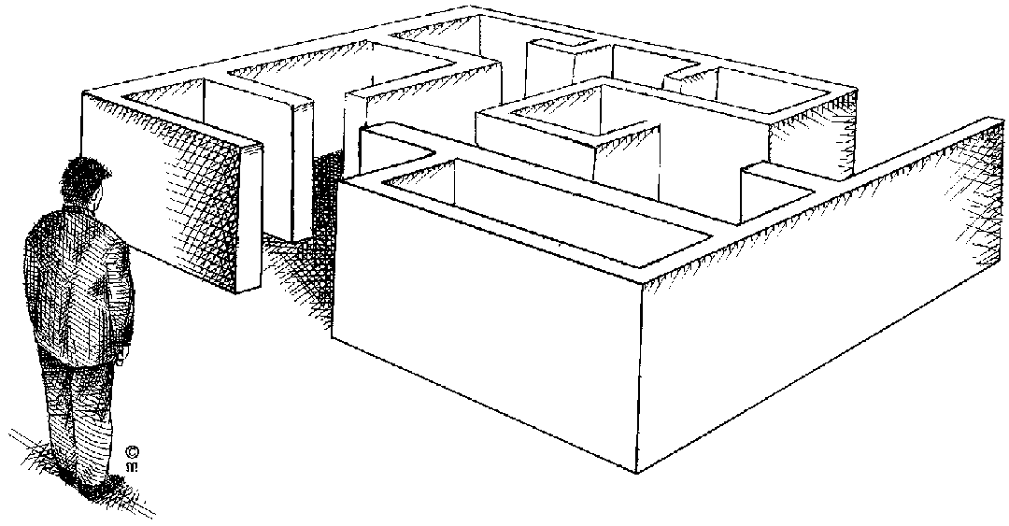

If the only tool you have is a hammer, you tend to see every problem as a nail.

—Abraham Maslow, U.S. author and psychologist

Are you one of those people who never feel creative? Perhaps you feel that you lack originality and that you’re just not the creative type. Creativity and originality are essentials for any problem solver, and your employer will expect you to bring a degree of creativity to your work.

Don’t panic. Creativity is within your reach if you’re willing to practice coming up with multiple choices. You can learn to generate lots of ideas.

## Problem Solving Techniques

The purpose of using problem solving techniques is to organise the information you have gathered so that you can assess, compare and contrast solutions.

All the techniques described require you to ask questions such as:

* Why did it happen?
* Why did it happen at this office and not the other office?
* Why did it happen at the specific time and not a different time?
* What would happen if we do this?
* What would happen if we do that?

And any other questions you can think of.

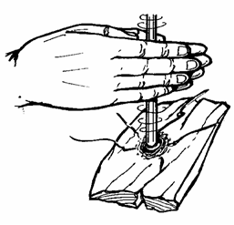When you are involved in problem-solving, you will find the following barriers to the problem-solving process:

* Tradition: we have always done things this way
* Competition: individual competition can stand in the way of creative problem-solving
* Lack of effort: it is not my problem
* Complacency: settling for the first easy solution that presents itself
* Insecurity: can lead to procrastination, where the problem is not addressed and solved.

**Another purpose of problem solving techniques is to overcome these barriers.**

### Brainstorming

This is a highly effective way of finding solutions to problems, provided you implement the process correctly.

It involves the generation of a large number of unconventional ideas whilst eliminating the usual tendencies to criticise or prematurely reject these unusual ideas.

#### The Brainstorming Process

#### Selection

Select a topic for brainstorming and the members of the group. This would of course be the statement of the problem.

#### The Problem

The group is given advance notice of the problem in the form of a brief description of one or two sentences. The group facilitator discusses with the group a limited amount of background information relating to the problem.

#### Warm-up session

Members are introduced to the concepts of brainstorming in a relaxed manner.

The group discussion should try to identify the barriers of creative thinking and show how they can be overcome.

The purpose of brainstorming is to generate as many ideas as possible in a short period of time. It does not matter if the ideas are silly, this is actually the purpose of brainstorming.

When using brainstorming, creative thinking is very important, as is overcoming the barriers to creative problem-solving.

The actual brainstorming process is explained, together with the four rules of brainstorming:

* Free association: participants must state the first idea that came into their heads, no matter how silly or absurd it may seem.
* Clarification: the person whose idea it was can elaborate on the idea, or someone else can, as one idea leads to another. No evaluation of the idea is allowed at this time.
* Suspension of judgement: nobody is allowed to pass any comment on anyone else’s ideas. This is not the purpose of brainstorming at all.
* Speed: brainstorming should happen as quickly as possible.

Short practice-runs will demonstrate how little time it takes to produce 50 to 100 ideas. At the end of the warm-up session, the original problem is restarted in as many ways as possible. For example, the problem of reduced profit could be redefined as how to beat competitors, or how to improve marketing. All statements are written down by the leader.

It should develop in a light-hearted, easy-going atmosphere. Brainstorming is a fun thing to do and it should be so for everyone.

#### Brainstorm

The facilitator reads out the statements and calls for ideas. As they flow, they are numbered and written up on a large flipchart with a large felt-tip pen.

Each sheet is torn off when full and displayed elsewhere in the room. Freedom of expression should be encouraged. The ideas may number from 150 to 600, or more.

There should be pre-set timescale for this session.

Now the solutions can be considered for practicality and so on.

Abide by this ground rule: No judgments should be made during brainstorming.

#### Generate ideas in a creative way

The idea is to generate as many ideas as you possibly can in a short period of time. The value of ideas can be discussed later. During the generating phase, emphasis is on generating many ideas.

This is achieved by:

* Not allowing any criticism
* Freewheeling: letting the ideas flow freely
* Go for quantity of ideas, not quality. Research has shown that up to 15% of ideas that are generated this way can be used practically
* Association: when one member of the meeting or workshop voices an idea, it stimulates someone else to enlarge on the idea or come up with another idea
* Don’t write the ideas under each other – avoid recording the ideas in a linear fashion. Rather write the ideas down in the form of a mind map. This helps to stimulate even more idea.



### Mapping

Mapping or clustering is similar to using a flow chart to generate solutions. You ask questions about the problem in order to generate ideas for solutions to the problem.

Your questions should also highlight any relationships that may exist between the root cause of the problem, the problem itself and any symptoms that may occur.

In clustering, you write a trigger word in the centre of your paper. Circle the word. Then, as fast as you can, write the words or ideas that pop into your head. Circle each word and connect word balloons that come together. When that thought process slows, start another chain of word balloons.

Write down the questions and possible solutions. Then look for links between problems and solutions as well as symptoms and connect them with lines.

Mapping is best done on a big piece of paper and is usually done in groups.

Incidentally, some of the most innovative products that have been created and produced was as a result of a combination between brainstorming and mapping. The waterbed was “invented” after a brainstorming session, where twenty ideas were written down in two columns of ten each, and lines used to link the ideas. One of the links was between water and bed and that is how a waterbed came into existence.

The cluster of ideas on the next page focuses on possible directions for a magazine to take on a wedding issue. When you finish the cluster, look it over carefully - not just for words, but for the clusters, the relationships between words. You may have released a complex design or connection you can put to good use



### Computer Modelling

Enter all the data that you have collected into a spreadsheet and sort the data in order to determine whether there are logical ways that connect them.

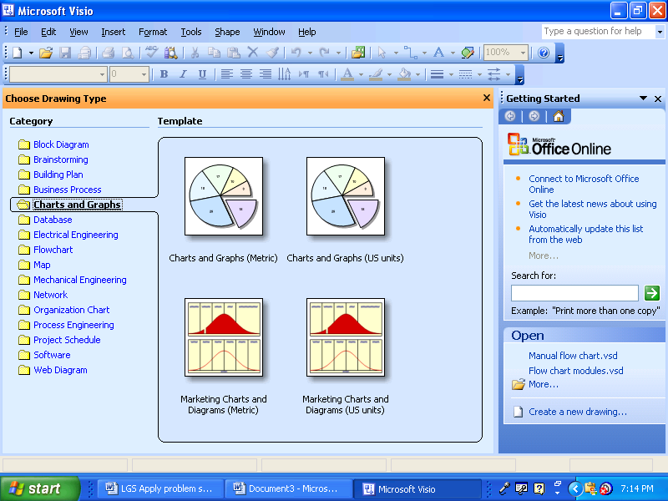When you do this in a computer spreadsheet, the aim is to get a graphical representation of the sequence of events that lead to the problem. This can help you to understand where in the work process things started to go wrong.

You would sort the data according to the questions you asked and compare the possible solutions, possibly in the form of a graph.

### Observation

This entails observing the work process. You would watch the workers performing on a line where there are no problems as well as on a line where there are problems. Or if the vacuum cleaner is always breaking down, you would watch while the cleaner is using it. It might be something simple such as handling the vacuum cleaner too roughly or it might be the plug that is not connected properly.

Observing the process would give you a better idea about the problem and possible solutions.

While observing, you would write down possible solutions to the problem. Once back in the office, you can consider the solutions.

### Questionnaires

Draw up a questionnaire and circulate it to all the relevant parties, asking them for possible solutions to the problem.

Your questionnaire would contain possible solutions that you have already thought of. You could then ask the relevant parties to nominate one or two of the solutions, or you could ask them to rank the solutions in order of importance.

Once you get all the questionnaires back, you would collate all their answers and rate them according to the rankings.

You could also leave a blank space for the parties that you send the questionnaire to where they can also give possible solutions to the problem.

### Experiments

This technique is more appropriate to a laboratory or a production line. When you conduct an experiment, you change what the workers are doing and then observe the consequences of the changes you implemented.

This technique will not be used often in an office environment.

### Establishing Root Cause

A problem tree analysis is a rapid and effective way of analysing a problem. This analysis identifies the causes and symptoms of a problem and presents them in a logical cause-effect sequence. The question why is asked several times consecutively, in order to discover the root causes of the problem. These causes are then arranged into a cause-effect relationship.

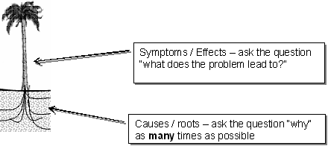

Example of a Problem Analysis Tree

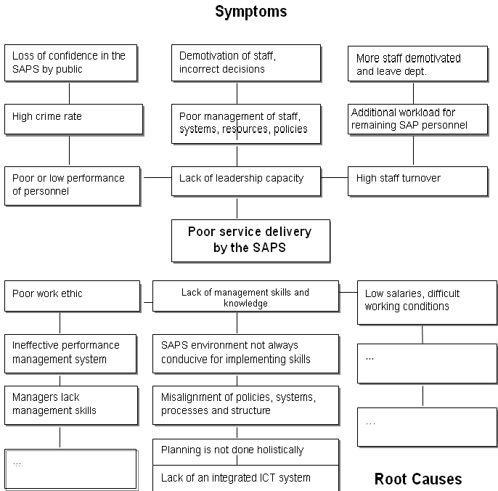

The Root Cause is the cause, which, if eliminated would prevent the problem from happening again. It is possible to generate options for each of these levels until you have found the root cause by using the Fishbone diagram.

For example, there are many potential reasons for actual or perceived 'incompetence'

* To find Root Cause keep asking the question "What could cause this?..."
* for each answer - ask the question "What could cause this?..."
* until there is no answer, just an action; then you have found the root cause.

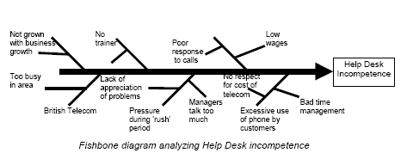

The fish-bone diagram is similar to the problem tree analysis. An example of this problem analysis technique applied to analyse the problem of the poor quality of service in clinics in Limpopo Province is reflected below.

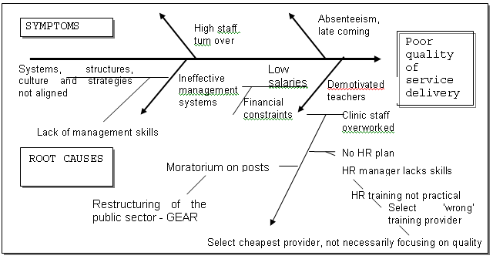

### Use How To…

When a problem has to be solved creatively, do not ask” What is the problem?” What you will get is one person’s idea of what the problem is.

When you use the words how to… or how do we… you open the situation for more creative solutions and ideas.

* How to improve team spirit
* How to increase production
* How to improve customer service

When you change the verb, it also changes the problem statement:

* How to develop team spirit
* How to improve quality of production

Record the ideas as a mind maps and then connect the ideas to obtain a different perspective on the situation:

Improve

Develop

According to needs/ requirements

Questionnaire

The ideas that are connected in our visual are to develop a questionnaire according to needs or requirements.

In this way you can carry on restating the problem:

* How to share team spirit
* How to combine team spirit
* How to rearrange team spirit
* How to challenge team spirit
* How to schedule team spirit, etc.

It is important that the verb – the doing of something – is given more attention than the object.

In the example used above, place the emphasis on changing the verb that is associated with the object or subject. It is the verb – the doing of something – that generates the ideas, not the subject – team spirit.

### Turn the problem around

Don’t ask : “How to improve team spirit”. Ask :”How not to improve team spirit”

* How not to lose weight
* How not to increase production
* How not to improve customer service, etc.

The statement of the problem can now be expanded as follows:

* How not to lose weight by exercising les
* How not to lose weight by eating more chocolates
* How not to lose weight by eating midnight snacks

When you use this method, you will get to the bottom of the problem and to focus on the problem from a different viewpoint:

If you want to lose weight and your problem is eating too many chocolates, ideas can be generated to find a solution to the problem.

### 5W’s and 1 H

Ask the following:

* What
* When
* Why
* Where
* Who
* How

This technique leads to the essence of the problem as well as creative ways of solving problems and generating ideas:

Team spirit:

* What are the advantages of team spirit?
* Where does team spirit develop?
* How does team spirit develop?
* Why does team spirit develop?
* Who develops team spirit, etc?

### Delphi Technique

The Delphi Technique is a technique in which a group of participants assign ratings to a list of items. Participants rate items again, while aware of the previous ratings of the entire group. The Delphi Technique was originally developed by the Rand Corporation for the Polaris Missile Project, where it was used to forecast war strike scenarios and how to best react to them.

In a problem solving situation, the delphi techniquecan be used to:

* Develop a number of alternatives
* Assess the impact of the problem
* Explore underlying assumptions or background information leading to different judgments
* Seek out information on which agreement may later be generated
* Correlate informed judgments on a subject involving many disciplines

#### Recommended Use

Use the Delphi Technique:

* to reach consensus for policy, decision, and goal setting,
* when consensus is required from a disparate audience with a wide divergence of opinion.

#### Method: how to conduct the Delphi technique session

Follow the guidelines below to conduct the Delphi Technique session:

* Assemble participants.
* Brainstorm to assemble a list of items to be rated by the group.
* Rate each item: Instruct participants to assign a rating to each item. There are many different approaches for rating items. One approach is to assign participants points. The participants then rate items from most important, being assigned the number one, to the least important being assigned the number equal to the number of items in the list. For example, for a list of six items, rate the most important item number one down to the least important number six.
* Record each participant’s ratings in a spreadsheet.

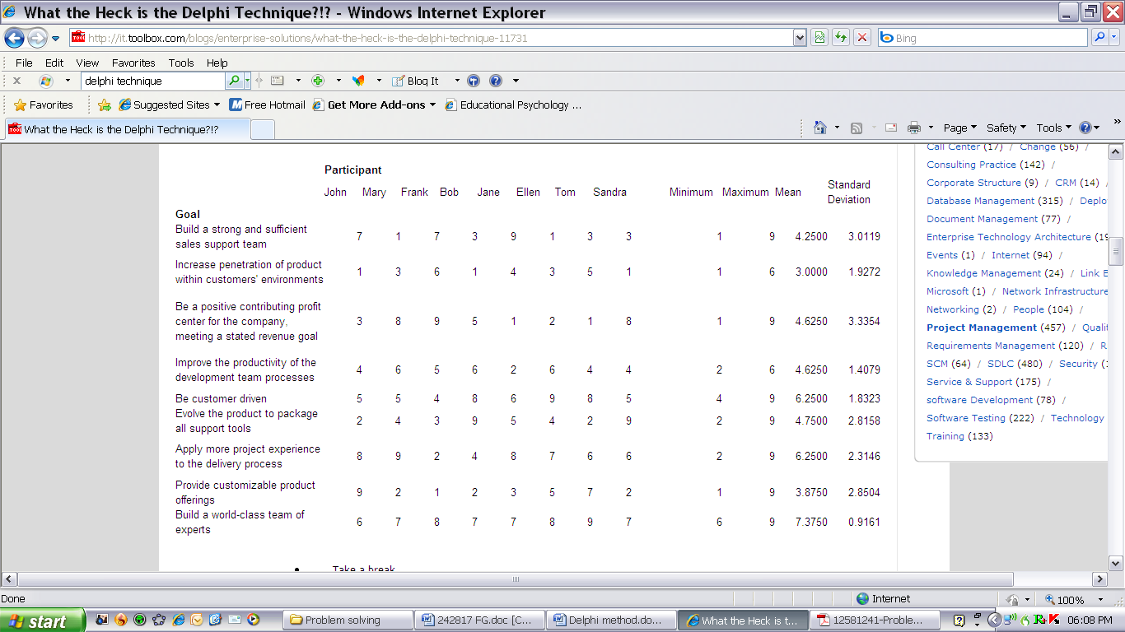

* Take a break: Take a 15 minute break while the facilitator calculates the mean, minimum, maximum, and standard deviation for each item in the list.
* Hand out the statistics to all participants.
* Allow time for discussion. The discussion is important because it gives those who have strong opinions the opportunity to speak. Participants also have the opportunity to explain to the group why they agree or disagree with the ratings.
* Rate items again: After the discussion, instruct participants to rate items again. Notice the second time that the mean may or may not change but what is important is that the standard deviation will start to converge as participants are influenced by the opinions of others. In this example, the standard deviations are decreasing as participants are influenced by the opinions of others to change their ratings.

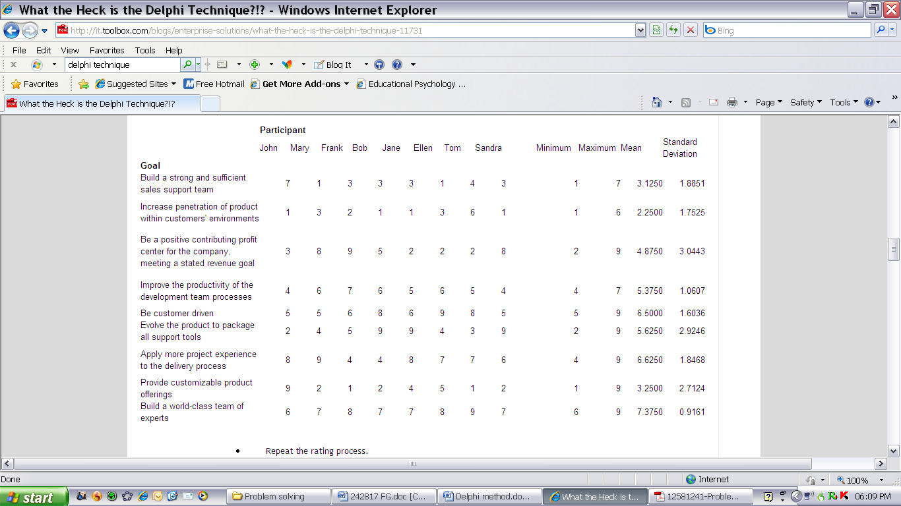

Repeat the rating process: Repeat the rating process (bullet points 3 to 6) until the standard deviations are very low. The low standard deviations result from people's tendency to vote with the majority. In this example spreadsheet, most standard deviations are less than one after the third rating.

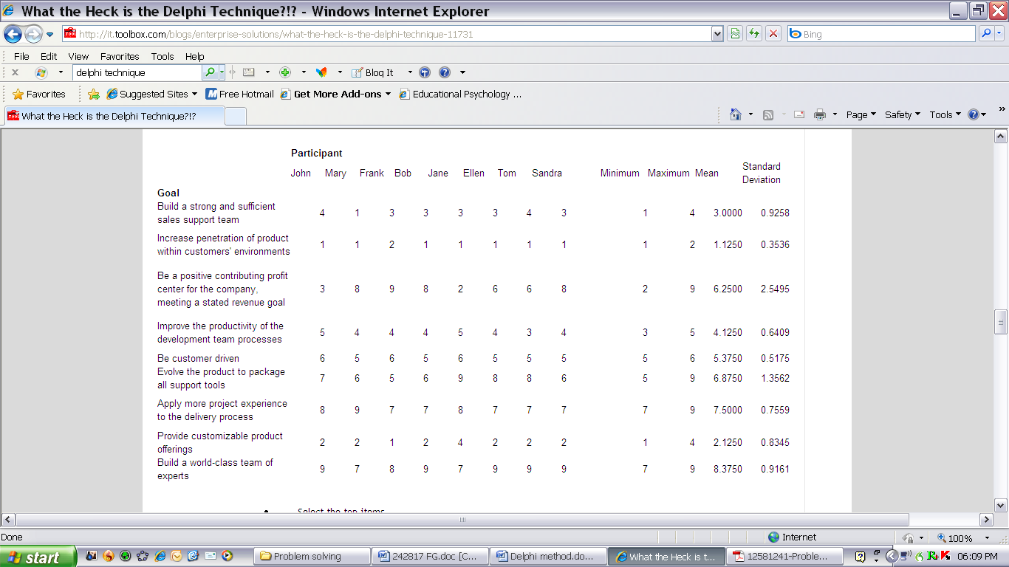

Select the top items: Select the top items (i.e., the ones with the highest mean) to focus work efforts. Note that we focused on the standard deviations to help determine whether we were closer to reaching consensus. It is, however, ultimately the mean that is used to determine the top items. Once the final spreadsheet is sorted in ascending order of mean, we can determine the top items. In this case, the participants agree that their top priority is to increase penetration of the product within the customers' environments.

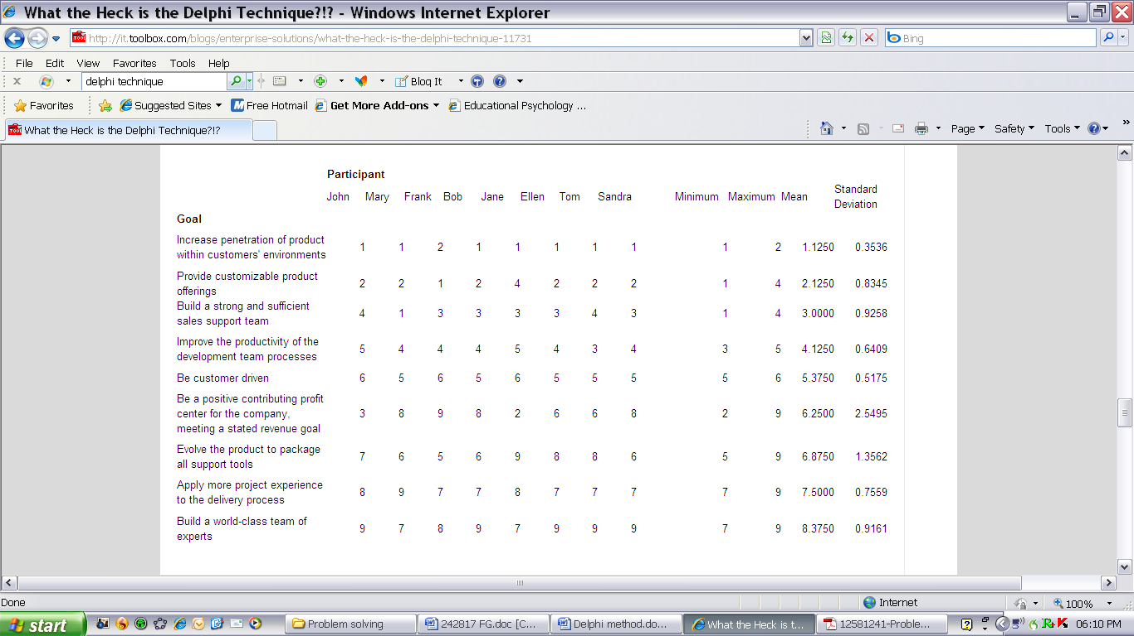

## Evaluate Solutions Against The Criteria

Once you have generated possible solutions by any of the previously mentioned methods, you have to establish the criteria for the solution.

Consider the possibilities, listing **advantages and disadvantages**

### Feasibility

Feasible means **possible to do easily or conveniently** – make sure that your solution can be implemented by the organisation with the least amount of disruption and cost.

### Duration (Time)

* How quickly do you have to find and implement a solution
* How long will it take to implement the solution

### Costs

A business wishes to make a profit and the only way to do that is to cut costs where possible. If extra costs are involved, make sure that you weigh the benefits of the solution against the costs involved.

### Resource implications

Do you have the resources to implement the solutions? You have to consider all possible resources:

* Manpower
* Machines
* Money
* Time
* Equipment

### Stakeholder commitment

Without the commitment from stakeholders, it would be difficult to implement any solution effectively. Make sure that the stakeholders are committed to the solution selected.

### Logistics

Logistics is the activity of moving goods and services along the supply chain from your section or department to the customer. You have to consider how the solution will affect the logistic system that is in place in the organisation and whether changes to logistics will have to be made.

### Causes

* Will the solution cause other problems to appear?
* How will these problems be addressed?

### Effects

* Consider cross-cultural implications for example dress code, religious holidays, type of food and drink.
* Evaluate the immediate and future consequences both inside and outside the organization.
* Compare the cost of the solution with the benefits of implementing the solution.
* Assess how far the needs of those involved will be met and the extent to which your decisions will be acceptable.
* Be careful of creating precedents: will this solution create a situation where other departments will also want to implement the process, even when it does not really apply to that department.
* Consider also the implications of any internal and external constraints that might exist: is there anything in the company policy or legislation that might limit or restrict the implementation of the proposed solution.
* Ensure that all concerned participate in the evaluating and decision-making process. Note, however, that the degree of participation will depend on the nature of the problem and the participation procedures and management style of the organisation.
* Resources: when a solution is evaluated you have to consider its impact on scarce resources. A maximum payoff solution will not be an optimum solution if it requires the consumption of excessive staff time and attention, money, space, raw materials, and IT resources.
* The degree of disruption: an excellent theoretical solution may cause too much disruption within the organisation. Hence the organisation must appraise the consequences of implementing various solutions. Only when the benefits exceed the disruption costs should the solution be pursued

**In the process of considering several possible solutions, you have to weigh all the options and rank the solutions in terms of the criteria as discussed above. Evaluate every solution against the criteria in order to determine the best possible solution.**

Formative Assessment SO 2 AC 1 – 2; SO 3 AC 1-3

## Ineffective Ways Of Handling Problems

**The creative person wants to be a know-it-all. He wants to know about all kinds of things—ancient history, nineteenth-century mathematics, current manufacturing techniques, flower arranging, and hog futures—because he never knows when these ideas might come together to form a new idea. It may happen six minutes later or six months, or six years down the road. But he has faith that it will happen.**

—Carl Ally, American advertising copywriter

### It’s Not My Problem

This is one of the most popular way that most people handle a problem – it’s not mine, so I don’t have to do anything about it. then, of course, they turn around and forget all about it. They do not see the need of advising someone else, such as their supervisor, of the problem.

This method of handling a problem is very damaging to the organisation that you work for. Eve if it is not your specific problem, if the problem has been brought to your attention you have to ensure that it is brought to the attention of whoever is responsible.

Imagine that your mother or father is ill and has to get to a hospital urgently. Your neighbour has a telephone but will not let you use it to call an ambulance, since it is not his problem. What would the consequences of his action be?

Now, imagine you have a problem with your salary which has not been paid into the bank. You approach the wages clerk who tells you that she had paid the money into the bank electronically. It’s not her problem, you must go to the bank to sort it out. You go to the bank, where the cashier says it’s not his problem, the money does not show on your account and they can’t help you, you must go to the wages clerk at your organisation. And so you go back and forth, and nobody wants to help you sort out the problem. Not a pleasant situation at all.

In the same way that you would like to be helped, the customers of your organisation would also like to be helped, whether it’s your problem or not.

### The Real Problem Is

What do we mean when we say this? Often, it means that we think our way of looking at the situation is correct, and should prevail over other people’s views. We describe our view as “real” to imply that other views are not, and that everyone should accept our view.

This is of course incorrect, as our point of view could be totally wrong. That is why a problem has to be analysed and thought through properly before a decision is made.

We know that different specialists have different perceptions of the same situation. If a person takes the same problem to a friend, to a counsellor, to a doctor, to a tutor or to priest, each of those people will hear different problems in what that person says.

In the same way, in a company, if the same data are given to the marketing director, the finance director and the production director, they will see different problems in them. They have different backgrounds, training and responsibilities, different ways of learning and knowing, and they are looking for different things. Which of these people is seeing the real problem? In the view of organizing the whole idea of a “real” problem is misleading.

Problems are neither real nor unreal; they are a view of a situation, just as a landscape painting represents one person’s interpretation of a landscape. Complete objectivity is not available.

### As If I Didn’t Have Enough Problems

Problems do not always get solved, nor do we always want them to be. There can be situations that are problematic. The person with the problem is not sure what to do, and they feel anxious as to whether they will be able to deal with the situation at all.

**But at the same time they may not really want to lose the problem: A problem can be a way of giving meaning to our situation.**

### Critical Thinking

People take many natural bodily functions such as eating, sleeping, drinking etc. for granted. It is only rarely that we pause to consider how we think. There are times when we feel that our thinking is muddled, or we feet that we should have given more thought to handling a situation that did not turn out the way we anticipated. It pays to pause and consider how we think, because we can learn and apply patterns of thinking to advantage.

#### Analytical Thinking

When analysis is used as a thinking process, people take apart the item under consideration, and study the parts to determine how they work together as a whole.

Analysts assume that the whole is equal to the sum of the parts and, furthermore, assume that the whole can be explained in its parts. This is a valid argument when thinking about engines, mathematical and scientific problems with rigid cause and effect rules. But, when working with people this does not work. However, analysis can go a long way in developing a systematic approach towards the varied problems a manager encounters daily in his work situation.

#### Synthesis when thinking

Synthesis is the opposite of analysis. Instead of taking something apart, through synthesis we combine things to form a complex whole.

In synthetic thinking something that needs to be understood is not viewed in isolation, but as part of a larger system or environment. Thinking this way brings

appreciation of the larger picture. We view the whole stage to gain understanding, not only of the individual player, but of how the role of that individual fits in with all the other roles. This complements analytical thinking.

#### How to think when solving problems

in tackling problems we need a mixture of both types of thinking. Viewing the unknown through analysis may give us most of the answers, but through synthesis, we view this answer against a larger, more complex backdrop.

When tackling a problem a judicious blend of both types of thinking raises various questions. Problem-solving tries to provide effective answers to the questions emerging from the analysis and synthesis. We should learn to be discriminating in answering the correct questions.

Peter Drucker has pointed out that the most common source of mistakes in making decisions is in the emphasis on finding the **correct answer, rather than the correct questions.**

### Suggestions To Improve Your Individual Critical Thinking Ability

* **Information based on your own direct perceptions is usually more reliable than other sources.** However, your perceptions may be wrong due to your own preconceived ideas or prejudices. Things may not be what they seem, so keep an open mind and try to see thing from the viewpoint of those who disagree with you.
* **Be careful about your assumptions.** You may have adopted them when you were less astute in your observations but you continue to use them, despite the availability of new evidence. You may use them so automatically that you are not aware they have slipped into your reasoning processes. “We can’t let Mavis handle this assignment, she’s just a kid.”
* **Test assumptions whenever possible.** Facts can only be deduced from facts. If your premise is wrong, your conclusions are likely to be wrong. “No family in this township is impoverished; we don’t need a welfare program.”
* **Avoid generalizations, particularly hasty ones or those based on to too few observations or facts.** “There is no serious unemployment problem, just look at all job ads in the daily paper.”
* **Be sensitive to the difference between facts and opinions.** Facts can be proven: the best ones repeatedly. Opinions, regardless of how strongly held and sincerely expressed, cannot be relied on. “I’II stake my reputation and my next pay cheque on this information; this source has been one hundred percent reliable in the past”
* **Logic may be the best tool we have for inferring the truth from facts.** Unfortunately, using logic can often lead to error because some words more than one meaning and will be interpreted differently by various team members.
* **Don’t jump to conclusions**. Get all the pertinent facts firs; if the facts are insufficient, go get more facts before making a decision. “The boss didn’t object when I suggested we leave early, so it must be okay with her.”
* **Tend to suspect precedents, rules, generalizations, or dictums** that seem to have truth all wrapped up.
* **Use quantifiable terms whenever possible because numbers can more accurately and more easily manipulated than words.** However, numbers can also be used to confuse and hide facts. Remember the warning about there being three major types of lies: lies, damn lies, and statistics.
* **Beware of analogies, similes, and metaphors.** They cannot prove; they can only illustrate someone’s opinions. “He’s as innocent as a new born babe.”
* **Watch for illogical leaps.** An example of this is a statement such as “The most terrible wars in history have occurred since women gained the right to vote. “The events are not connected; event though one preceded the other.
* **Consider the source of the information**. The source person may consciously or subconsciously present opinions as through they were facts or have his or her objectivity clouded by his or her own system of values. “He wouldn’t lie, he belongs to my church.”
* **Question everything to uncover and validate facts**. Facts are essential to understand a problem, to evaluate proposed solutions, and to test results.
* **Strongly held value and benefits can alter perceptions and inhibit objective analysis and synthesis of facts.** “The captain just wouldn’t make a mistake like that; he’s a West Point graduate.”
* **Break big problems into smaller**, more manageable ones and solve the parts until the entire problem is solved

Although you may start out with a hypothesis, when testing it, use Rudyard Kipling’s **six honest serving men:**

**I keep six honest men serving**

**(They taught me all I knew)**

**Their names are What and Why and When**

**And How and Where and Who**

# IMPLEMENT THE SOLUTION

#### Specific outcome four

Implement solution

#### Assessment criteria

* The optimum solution(s) is (are) selected in accordance with given criteria
* Stakeholders are consulted prior to implementation, so as to obtain commitment
* The selected solution (s) is (are) implemented, according to organisational constraints

## Select The Solution

The significant problems we face cannot be solved at the same level of thinking we were at when we created them.

—Albert Einstein, physicist

### Things That Can Influence Your Decision

* Tradition
* Cultural differences
* Self-interest
* Organisational factors, policy and precedents, legal aspects, practices and expectations
* Political views vs. logic
* Ease of execution
* Personality factors, attitudes, emotions, prejudices
* Time/urgency, organisational need, political need, personal need
* Pressure from peer group, need to please others
* Authority, expert opinion
* Generalisations, opinions, insufficient evidence or knowledge
* Facts
* Creativity and/or an urge to do something differently
* Experience: successful or unsuccessful

### Selecting a solution

Intelligence is derived from two words—inter (meaning “between”) and legere (meaning “to choose”). An intelligent person is one who learns to choose between or among options.

When you select a solution, you should ensure that:

* You have generated all the possible solutions
* You have removed the solutions that are obviously not workable
* You have considered all the consequences
* The solution meets the established criteria in terms of budget, resources available to you to implement the solution and also any legislative requirements.

Often, there will be only one solution that meets all the criteria. When this is not the case, you should decide

* Whether to choose the solution that meets the most important criteria, or
* Whether you have to generate more solutions

Do not expect the process to always produce a black and white solutions. Remember that Drucker says:

**A decision is a judgement.**

**It is a choice between alternatives.**

**It is rarely a choice between right and wrong.**

**It is at best a choice between almost right and probably wrong- but much more often a choice between two courses of action neither of which is more nearly right than the other.**

### Decision Making Pitfalls To Avoid

* Deciding alone. There are many benefits to consulting with others on a decision: gaining different perspectives, more resources to draw upon and more commitment to the decision by those consulted.
* Every decision a major decision? Not every decision requires a lengthy decision-making process. Don’t get bogged down with minor problems. If they are minor, make a reasonable decision and move on.
* “The last time I was wrong was when I thought I made a mistake”. No one is always right. If you have made a bad decision, admit it and get started on fixing it. Remember – it is impossible to force a bad decision into being a good one.
* “Boy! I sure wish I hadn’t”. Just the opposite of pitfall number 3. Because no one can be right all the time, don’t waste your energy regretting bad decisions. Get on to current issues.
* Failing to use past precedent. Maybe the same problem has come up before and been effectively solved. Perhaps, if it has come up enough, there is a company policy that covers it.

## Stakeholders Are Consulted

A problem has not been solved until the decision has been implemented.

Before you implement a solution, you have to discuss the matter with all the people involved, called the stakeholders.

This could include

* The people doing the work,
* Their supervisor(s),
* Their manager,
* Your manager
* The finance department
* The HR department
* The people who helped you to determine the solution
* And anyone else that may be involved.

No solution will be implemented successfully without the approval and commitment of all the stakeholders. You need their cooperation if you want to ensure that the implementation of the solution will work.

You also have to assign duties and responsibilities. Think carefully not only about how a thing is to be done (by whom, with what resources and then by when) but also about its impact on the people concerned and the extent to which they will cooperate.

You will get less cooperation if you impose a solution. The best method is to arrange things so that everyone arrives jointly at a solution freely agreed to be the one best suited to the situation (the law of the situation again).

Make sure that everyone who needs to know about the decision is informed.

## Develop an action plan

Once the solution is settled on, everyone should set to work on detailing the plan. Here’s where you need your skills at setting goals and objectives. Break down the larger into smaller goals and objectives

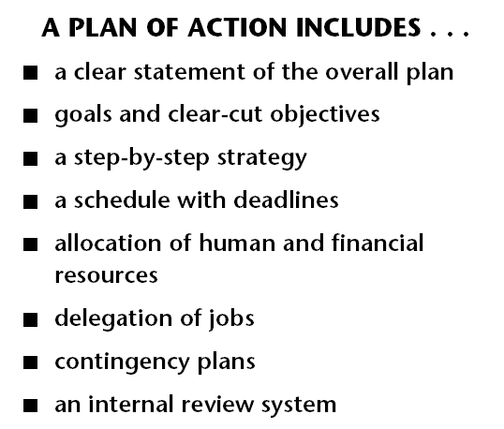

### Scheduling

A time line of action is an integral part of forming a plan of action. Each objective should have its own deadline or deadlines. And those deadlines have to be coordinated with all other objectives and the stakeholders

### Delegating

Once all the individual parts of the plan of action have been detailed, with goals and objectives in place and a time line established, it’s time to delegate the work, deciding who does what. A good manager or team leader will delegate wisely. Work should be as evenly distributed as possible. And team members should be working in areas of their strengths.

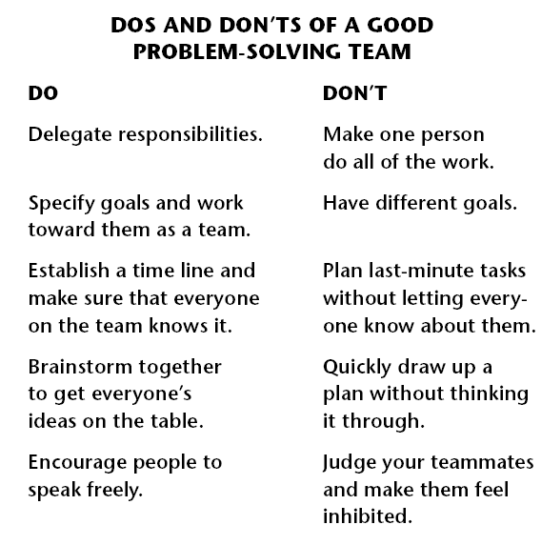

# EVALUATE THE SOLUTION

#### Specific outcome five

Evaluate the effectiveness of the solution

#### Assessment criteria

* Criteria for the measurement of the effectiveness of the solution are identified according to the problem definition. Criteria include, but is not limited to, feasibility, suitability, acceptance, return on investment and alignment to role or strategy
* The effectiveness of the solution is evaluated against the criteria
* Corrective action is identified and applied, where possible

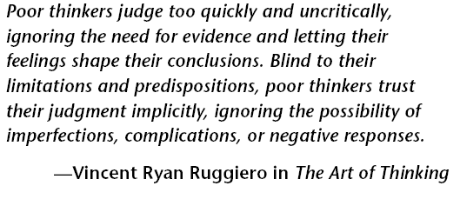

## Monitor Implementation

The implementation of the solution must always be monitored. You have to:

* Check on how effectively the decision is being implemented.
* Obtain the reactions of those affected.
* Take corrective action where necessary.

This implies that you will have to develop a control system whereby you can monitor the implementation of the solution.

### Duration

Before you implement the solution, you have to decide

* How long you are going to monitor the implementation: one week, one month, three months, etc.
* How often will you monitor the implementation: hourly, daily, weekly
* When will you review the monitoring process: after one week, two weeks, one month

Just as every problem will have its own unique solutions, the way you monitor the solutions will also vary. Some solutions will indeed have to be monitored hourly or daily, while others will require monthly monitoring.

### Implication And Effects

The purpose of monitoring the implementation of the solution is to determine whether the solution you selected is working.

* How will you monitor the implementation?
* Has the problem been solved?
* How can you prove this?
* Have other problems appeared as a result of the solution?
* Are the stakeholders committed to implementing the solution?
* Is the process working for them or has it led to unhappiness?

## Review The Solution

If the solution is not solving the problem, you have to repeat the problem-solving process in order to find a solution that works.

If the solution that you implemented is solving the problem, you have to determine:

* Whether the solution will work in similar instances in the rest of the organization
* Whether new systems have to be developed in order to implement the solution across the entire organization
* What practices and procedures have to be committed to paper for the implementation of the process across the organization?
* What records are required in order to report on the successful implementation of the solution?
* What records will be required to standardize the new process?

Most of the documentation, procedures and records required for the implementation of the new process will already be in place in the organization. You will have to find out what they are and then use them in your process.

If the organization does not have a system for implementing new processes, you will have to develop such a system.

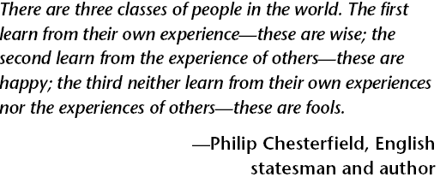

Formative Assessment SO4 AC 1 – 3, SO5 AC 1 - 3