LEARNER GUIDE

Describe the Relationship of Junior Management to Other Roles

Unit standard 242818
Level 4 Credits 5

TABLE OF CONTENTS
TABLE OF CONTENTS 1
FORMATIVE ASSESSMENT 3
Formative Assessment SO1, AC 1-2 3
Formative assessment SO1 AC1-4 3
PERSONAL INFORMATION 5
INTRODUCTION 5
Structure 7
Programme methodology 7
What Learning Material you should have 8
Different types of activities you can expect 9
Learner Administration 10
Assessments 10
Learner Support 11
Learner Expectations 12
Programme Structure And Strategy 13
UNIT STANDARD 15
ORGANISATION STRUCTURE 17
Introduction 17
Organisation Structure 17
Marketing Function 18
Production / Operational Department / Function 18
Purchasing Department / Function 18
Financial Department / Function 19
Sales Department / Function 19
Administration Department / Function 20
Human Resources Department / Function 20
Public Relations Department / Function 20
Quality Control Department / Function 20
Bringing it together 21
Smaller Business 21
Organisation Hierarchy 22
Top Management 22
Middle Management 23
First Line Management 23
Practical application of the levels in an organisation 24
Summary 25
Types Of Organisation Structures 26
Functional organisation structure 26
Divisional structure 26
Combination of functional and divisional groupings 27
Line organisational structure 28
Matrix organisational structure 29
Changing structures in organisations 30
Organogram 32
Formative Assessment SO1, AC 1-2 32
MANAGEMENT ROLES 36
The Management Process 36
The Four Basic Management Functions 37
Planning 37
Organising 39
Activating/Leading 40
Controlling 42
Practical Application Of The Four Management Functions 45
The Six Additional Management Functions 46
Decision-making 46
Communication 46
Motivation 46
Coordination 47
Delegation 48
Discipline 50
Junior Managers 50
What Is Supervision? 50
Formative assessment SO1 AC1-4 51

FORMATIVE ASSESSMENT

Formative Assessment SO1, AC 1-2
- Draw an organogram of the structure of your organisation
- Compare this to any of the organisation structures discussed in the learner guide, listing the advantages and disadvantages of both types of structure
- Discuss the advantages and disadvantages of the following organisation structures:
- Matrix
- Functional
- Divisional

Formative assessment SO1 AC1-4
- Describe the planning function of a manager in your own words.
- Describe the organising function of a manager in your own words
- Describe the activating function of a manager in your own words
- Describe the controlling function of a manager in your own words
- Discuss how the HR Department works together with the other departments to ensure that wages, bonuses and overtime is paid on time in order to avoid low staff morale and labour unrest.
- You are the wages clerk and have to ensure that the time sheets for employees are signed off by the supervisors or team leaders every Thursday afternoon, so that employees can be paid on Friday afternoons. When you get the time sheets late, it makes your job more difficult, since you also work against deadlines and, as has happened in the past, when the incorrect payments were not make to employees they threatened to strike. Management has threatened disciplinary action if this happens again.
You have to get time sheets from the following departments:
- Purchasing
- Production
- Despatch
- Finance
- Administration
- How would you organize and coordinate your efforts to get the cooperation of the various departments?
- Name the steps in the delegation process.

- What is the difference between accountability and responsibility?
- Explain the difference between tactical plans and operational plans.
- Describe the decision-making function of a manager in your own words
- Describe the communication function of a manager in your own words
- Describe the motivation function of a manager in your own words
- Describe the coordination function of a manager in your own words
- Describe the delegation function of a manager in your own words
- Describe the discipline function of a manager in your own words
- Explain what is meant by the following resources: Man
  - Material
  - Machinery
  - Methods
  - Money
- Explain how the planning function and decision-making go together when goals and objectives are set.
- Explain how the organising function and decision-making work together to ensure that the standards set by the organisation are met.
- Explain how planning and communication work hand-in-hand to inform the relevant parties about decisions that were made and now have to be implemented. Also explain how delegation is also part of this process.
- How do the controlling function and discipline relate to each other?
- Explain how planning and controlling can lead to changes being implemented.
- A lot has been said about management, their functions and responsibilities. Discuss how management contributes to the success of an organisation.
- What do you think will happen if there was no management structure in an organisation and everyone was left to do their own thing without any control or measurement of their activities?

PERSONAL INFORMATION
NAME
CONTACT ADDRESS
Code
Telephone (H)
Telephone (W)
Cellular
Learner Number
Identity Number
EMPLOYER
EMPLOYER CONTACT ADDRESS
Code
Supervisor Name
Supervisor Contact Address
Code
Telephone (H)
Telephone (W)
Cellular

INTRODUCTION

Welcome to the learning programme
Follow along in the guide as the training practitioner takes you through the material. Make notes and sketches that will help you to understand and remember what you have learnt. Take notes and share information with your colleagues. Important and relevant information and skills are transferred by sharing!



This learning programme is divided into sections. Each section is preceded by a description of the required outcomes and assessment criteria as contained in the unit standards specified by the South African Qualifications Authority. These descriptions will define what you have to know and be able to do in order to be awarded the credits attached to this learning programme. These credits are regarded as building blocks towards achieving a National Qualification upon successful assessment and can never be taken away from you!

Structure

Programme methodology


The programme methodology includes facilitator presentations, readings, individual activities, group discussions and skill application exercises.
Know what you want to get out of the programme from the beginning and start applying your new skills immediately. Participate as much as possible so that the learning will be interactive and stimulating.
The following principles were applied in designing the course:
- Because the course is designed to maximise interactive learning, you are encouraged and required to participate fully during the group exercises
- As a learner you will be presented with numerous problems and will be required to fully apply your mind to finding solutions to problems before being presented with the course presenter’s solutions to the problems
- Through participation and interaction the learners can learn as much from each other as they do from the course presenter
- Although learners attending the course may have varied degrees of experience in the subject matter, the course is designed to ensure that all delegates complete the course with the same level of understanding
- Because reflection forms an important component of adult learning, some learning resources will be followed by a self-assessment which is designed so that the learner will reflect on the material just completed.
This approach to course construction will ensure that learners first apply their minds to finding solutions to problems before the answers are provided, which will then maximise the learning process which is further strengthened by reflecting on the material covered by means of the self-assessments.

Different role players in delivery process
- Learner
- Facilitator
- Assessor
- Moderator

What Learning Material you should have
This learning material has also been designed to provide the learner with a comprehensive reference guide.
It is important that you take responsibility for your own learning process; this includes taking care of your learner material. You should at all times have the following material with you:
  Learner Guide | This learner guide is your valuable possession:  This is your textbook and reference material, which provides you with all the information you will require to meet the exit level outcomes.  During contact sessions, your facilitator will use this guide and will facilitate the learning process. During contact sessions a variety of activities will assist you to gain knowledge and skills.  Follow along in the guide as the training practitioner takes you through the material. Make notes and sketches that will help you to understand and remember what you have learnt. Take and share information with your colleagues. Important and relevant information and skills are transferred by sharing!  This learning programme is divided into sections. Each section is preceded by a description of the required outcomes and assessment criteria as contained in the unit standards specified by the South African Qualifications Authority. These descriptions will define what you have to know and be able to do in order to be awarded the credits attached to this learning programme. These credits are regarded as building blocks towards achieving a National Qualification upon successful assessment and can never be taken away from you!
  Formative Assessment Workbook | The Formative Assessment Workbook supports the Learner Guide and assists you in applying what you have learnt.  The formative assessment workbook contains classroom activities that you have to complete in the classroom, during contact sessions either in groups or individually.  You are required to complete all activities in the Formative Assessment Workbook.  The facilitator will assist, lead and coach you through the process.  These activities ensure that you understand the content of the material and that you get an opportunity to test your understanding.

Different types of activities you can expect
To accommodate your learning preferences, a variety of different types of activities are included in the formative and summative assessments. They will assist you to achieve the outcomes (correct results) and should guide you through the learning process, making learning a positive and pleasant experience.

The table below provides you with more information related to the types of activities.
Types of Activities | Description | Purpose
Knowledge Activities   | You are required to complete these activities on your own. | These activities normally test your understanding and ability to apply the information.
Skills Application Activities   | You need to complete these activities in the workplace | These activities require you to apply the knowledge and skills gained in the workplace
  Natural Occurring Evidence | You need to collect information and samples of documents from the workplace. | These activities ensure you get the opportunity to learn from experts in the industry.  Collecting examples demonstrates how to implement knowledge and skills in a practical way

Learner Administration


Attendance Register
You are required to sign the Attendance Register every day you attend training sessions facilitated by a facilitator.

Programme Evaluation Form
On completion you will be supplied with a “Learning programme Evaluation Form”. You are required to evaluate your experience in attending the programme.
Please complete the form at the end of the programme, as this will assist us in improving our service and programme material. Your assistance is highly appreciated.

Assessments
The only way to establish whether a learner is competent and has accomplished the specific outcomes is through the assessment process. Assessment involves collecting and interpreting evidence about the learners’ ability to perform a task.
To qualify and receive credits towards your qualification, a registered Assessor will conduct an evaluation and assessment of your portfolio of evidence and competency.
This programme has been aligned to registered unit standards. You will be assessed against the outcomes as stipulated in the unit standard by completing assessments and by compiling a portfolio of evidence that provides proof of your ability to apply the learning to your work situation.



How will Assessments commence?

Formative Assessments
The assessment process is easy to follow. You will be guided by the Facilitator. Your responsibility is to complete all the activities in the Formative Assessment Workbook and submit it to your facilitator.

Summative Assessments
You will be required to complete a series of summative assessments. The Summative Assessment Guide will assist you in identifying the evidence required for final assessment purposes. You will be required to complete these activities on your own time, using real life projects in your workplace or business environment in preparing evidence for your Portfolio of Evidence. Your Facilitator will provide more details in this regard.
To qualify and receive credits towards your qualification, a registered Assessor will conduct an evaluation and assessment of your portfolio of evidence and competency.

Learner Support
The responsibility of learning rests with you, so be proactive and ask questions and seek assistance and help from your facilitator, if required.


Please remember that this Skills Programme is based on outcomes based education principles which implies the following:
- You are responsible for your own learning – make sure you manage your study, research and workplace time effectively.
- Learning activities are learner driven – make sure you use the Learner Guide and Formative Assessment Workbook in the manner intended, and are familiar with the workplace requirements.
- The Facilitator is there to reasonably assist you during contact, practical and workplace time for this programme – make sure that you have his/her contact details.
- You are responsible for the safekeeping of your completed Formative Assessment Workbook and Workplace Guide
- If you need assistance please contact your facilitator who will gladly assist you.
- If you have any special needs please inform the facilitator

Learner Expectations
Please prepare the following information. You will then be asked to introduce yourself to the instructor as well as your fellow learners


Your name:
The organisation you represent:
Your position in organisation:
What do you hope to achieve by attending this course / what are your course expectations?

Programme Structure And Strategy
UNIT STANDARD 242818 Level 4
Credits 5: notional hours 50, classroom training 15 hours, workplace hours 35
Programme Outcomes | Page2 | Outcomes | Time Allocation | Delivery strategy | EEK | CCFO | Formative Assessment | Summative Assessm: total time 28 hours
Introduction: | 4 |  | Introductory activities:  60 minutes | Discussion
Unit standard | 4 |  | Introductory activities:  60 minutes | Discussion
Outcome 1: Explain the Relationship Between the Type, Ownership and Size of an Organisation and its Management Structure | 5 | SO1 | 225 minutes | Discussion & slide show |  |  |  | Questionnaire  Workplace: Develop an organisation structure for your own organisation; Explain how the division of tasks has been done; Explain how middle and first line managers interact with each other in your organisation; Reflect on the structure of your organisation and discuss at least one advantage and disadvantage of the structure; Draw organograms to illustrate the following organisation structures: functional, matrix, divisional and hierarchical (line); Discuss the advantage and disadvantages of each type of structure.
Introduction | 5 |  |  | Discussion & slide show
Organisation structure | 5 | AC1 |  | Discussion & slide show |  | Collect, organise, and evaluate
Organisation hierarchy | 9 | AC2 |  | Discussion & slide show
Types of organisation structures | 13 | AC3 |  | Discussion & slide show |  |  | Individual activity: Organogram of structure of organisation learner works for | Workplace: Develop an organisation structure for a small business  Explain why the structure for a small and a larger organisation is different
Formative Assessment | 18 |  | 120 minutes | Discussion & slide show
Outcome 2: Explain the Relationship Between Various Management Roles | 22 | S02 | 225 minutes | Discussion & slide show |  |  |  | Questionnaire  Workplace: Describe your responsibilities as a first line manager  How do your responsibilities as a first line manager interact with other first line managers?  How do your responsibilities as a first line manager interact with middle managers?
The management process | 22 | AC1 |  | Discussion & slide show |  | Communicate
The four basic management functions | 23 | AC2 |  | Discussion & slide show
The six additional management functions | 30 |  |  | Discussion & slide show |  | Understanding  of the world as  a set of related  systems
Junior managers | 34 |  |  | Discussion & slide show |  |  | Group / Individual activity: Questionnaire covering all criteria
Formative Assessment |  |  | 120 minutes | Discussion & slide show
Revision |  |  | 60 minutes
Summative questionnaire |  |  | 90 minutes
Notional Hours |  |  | 12 |  |  |  |  | 28

UNIT STANDARD

Unit standard number
242818

Unit standard title
Describe the relationship of junior management to other roles

NQF level
4

Credits
5

Purpose of unit standard
This Unit Standard specifies the knowledge and skills required to understand the relationship between junior management and other management roles in the organisation. This Unit Standard is intended for junior managers of organisations

Learning assumed to be in place
Learners should be competent in Communication and Mathematical Literacy at NQF Level 3

Unit standard range
Management roles` include, but are not limited to, human resources, finance, marketing, sales, production, operations, distribution and logistics.
- `Technical skills` relate to making a product or providing a service.
- `Area of responsibility` includes, but is not limited to, cost centre, section, department or team.
- `Junior managers` include, but are not limited to, team leaders, supervisors, foremen and section heads.
- `Standard Operating Procedures` (SOPs) may comprise formal written documents or accepted practices in the organisation.
- `Organisation` includes but is not limited to, workplace, work context, work unit, company, department or section.

Specific outcomes and assessment criteria
Specific outcome one: Explain the relationship between the type, ownership, size of an organisation and its management structure.
Notes: Explain the different types of management structure in an organisation
Range: The range shall include, but not limited to, functional, matrix, divisional and hierarchical
Assessment criteria
- Different types of management structures are investigated and illustrated in organograms
- The advantages and disadvantages of the different types of management structures are explained according to type, size and type of entity
- The management structure in own organisation is identified and analysed in relation to the different types of management structures
Specific outcome two: Explain the relationship between various management roles
Assessment criteria
- Management roles are explained with examples from own workplace
- The relationship between the various management roles is explained with reference to own organisational context. The relationship between the various roles includes, but is not limited to, human resources, finance, marketing, public relations, funding and production
- The role of the junior manager in managing own area of responsibility is explained within the organisational context
- The interaction between a junior manager`s own area of responsibility and other functions is explained according to the organisational context

Critical Cross-field Outcomes (CCFO):
- Learners are able to collect, organise and evaluate information when identifying the tasks of management
- Learners are able to communicate effectively and responsibly when explaining management activities
- Learners are able to demonstrate an understanding of the world as a set of related systems recognising how own position fits into the management of an organisation

ORGANISATION STRUCTURE

Outcome 1
Explain the relationship between the type, ownership and size of an organisation and its management structure
Notes: Explain the different types of management structures in an organisation. Range: The range shall include, but not limited to, functional, matrix, divisional and hierarchical

Assessment criteria
- Different types of management structures are investigated and illustrated in organograms
- The advantages and disadvantages of the different types of management structures are explained according to type, size and type of
- The management structure in own organisation is identified and analysed in relation to the different types of management structures
Introduction
In any organisation, big or small, there has to be a division of labour, as no one person is able to do all the work. So, all the work that has to be done is broken into individual tasks. Similar tasks are then grouped together to form sections or departments. This is called departmentalisation. Departmentalisation is, therefore, the basis on which individual workers are grouped into departments and departments into total organisations. The way in which the work is divided amongst departments will then determine the structure of the organisation.
Tasks could be divided as follows:
Functional - by common skills and work tasks – for example, where everything to do with production falls under the production department or where everything to do with sales falls under the sales department
Divisional - common product, programme or geographical location – for example, with clothing stores the division would be geographical and the location of the store
Team - to accomplish specific tasks – this is common with projects that have a limited lifespan, but is also increasingly used in departments. Each team has specific tasks that have to be completed, for example they are responsible for manufacturing one product or arranging transport for one specific area.
Organisation Structure
The dictionary explains an organisation as an organised group of people with a particular purpose, e.g. a business. In the transport industry, the purpose of the business will be transport of either passengers or goods or both. Every business, from the smallest to the very large ones, has an organisation structure, also called a hierarchy. The hierarchy explains the ranking of the people who work there as well as how the employees of the organisation or business is organised . It also explains the levels of work, the power and the authority that the employees have, from top management to middle management to supervisors to workers.
Organisational structure exists, but we cannot see it. It is not a chart hanging in the personnel office; it is not the physical walls or the layout of the factory, store or offices, though they are part of it. By organisational structure is meant the tasks people are assigned, who they have to report to, whom they work with and with whom they must interact to get their jobs done.
When we think of an organisation, we usually take its structure for granted. If it is a small organisation, it will probably have just a few departments. If it is a large organisation, it will have many departments, sub-departments and maybe even a few divisions. Large organisations have many individuals with titles such as senior vice-president, director, and executive assistant. However, an organisational structure should be the result of considerable forethought.
In small businesses one person will do more than one job, such as purchases, stock keeping, sales and issuing of invoices, while in bigger businesses the work will be more specialised. For example, purchases will be a department on their own, with people doing only that.
The business term for dividing work is called functions. We will talk about the purchasing function, the sales function, etc. This then means that when we talk about the purchasing function, it means that the work people do has to do with purchases.
In businesses today, even small ones, the work is divided along the following lines:

Marketing Function
The marketing function must find out what the needs of the customers are, which products or services they need and then work out a plan so that your business can fulfil the need of the customers. This is why you have to do a marketing plan.
The marketing function entails the marketing of the products or services of the organization. This includes:
- Assessment of the market
- Assessment of needs of consumers
- Development of strategy to satisfy those needs profitably

Production / Operational Department / Function

The production department is where the physical production of products takes place, where goods are made, packed, etc.. it stands to reason if you are going to make goods, such as car parts, the first thing that has to happen is the production line must be planned, so that the making of the car parts can flow from start to finish. In the production department, raw materials and semi-finished products are converted into finished products for the market.
The Operations Department is more than just the production department.
Operations must also plan, organise, co-ordinate and control the process so that a product or service of the proper quality is provided in the right place at the right time to the right customer.
The production or operations management function includes that group of activities concerned with the physical production of products, namely
- The establishment and layout of the production unit
- The conversion of raw materials and semi-finished products into finished products for the market.
- The examination of problems related to the supply of services.

Purchasing Department / Function
The purchasing department has to ensure that goods and services of the right quality are purchased. The purchasing department is also responsible for buying all the materials, equipment, machinery as well as services such as maintenance, installation and transport services. The purchasing function is therefore responsible for purchasing goods and services
- of the right quality,
- in the right quantities,
- at the right time,
- at the right price,
- from the right supplier
- and delivered to the proper destination.
In the transport industry, the purchasing function will be responsible for buying vehicles, parts for the vehicles, the petrol or diesel that the vehicles run on, etc.
The purchasing function entails:
- The acquisition of all products and materials required by the business to function profitably, namely:
- Raw materials
- Components
- Tools
- Equipment and
- In the case of a dealer, the inventory.
- Be in contact with suppliers
- Being aware of new products
- Know the prices at which goods can be bought
- Keep the inventory up to date to ensure continuity of functioning

Financial Department / Function
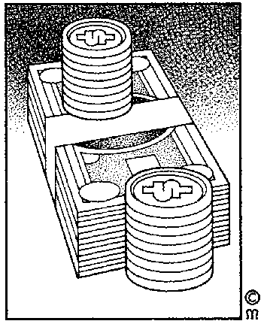
The financial function spends the money that is available in the business in such a way that the business can operate. So, while the purchasing function has to find out where to get the best deal for vehicles and parts, the financial function has to make sure that there is money available to buy the vehicles, service them, buy spares for the vehicles, etc. if the business has to borrow money, ;the financial function has to draw up the cash flow statements, budgets and balance sheets that are needed to apply for loans.
The financial function also has to make sure that the other departments do not spend too much money and that the money for goods or services that were provided by the business comes into the business. In other words, they check that invoices are paid and make sure that the money is deposited into the bank account,
The financial function includes: The acquisition, utilization and control of the money the organization needs to finance its activities and to buy materials and equipment

Sales Department / Function

The sales department ensures that the products are sold to the customer, by making contact and building relationships with customers.

Administration Department / Function

The administration function controls the information systems within the business.
The administration department, for example, processes invoices, sends out statements, takes telephone calls and refers the caller to the correct department, files the business documents, sends letters to clients, etc.
The administration department, therefore:
- obtains information
- processes information
- and makes the information available for the management of the business.

Human Resources Department / Function
The Human Resources function must appoint employees to do the work, they must ensure that the employees have the necessary skills and knowledge to do the work, they have to ensure that employees attend training, etc.
The human resource function entails:
- The appointment
- The development and
- The maintenance of the human resources in the organization
To enable the organization to make a profit, the human resource manager must
- Appoint the right people
- Provide them with the right training in order to make the best use of them

Public Relations Department / Function
The public relations function must bring the business to the attention of the general public, for example by placing advertisements, holding promotions, and so on. It the job of PR to make sure that the world outside the business has a good impression of the business.
The public relations function of an organization is to
- Create a favourable objective image of the organization
- Establish good relations with
- Those directly concerned with the business and its products
- Those indirectly concerned with the business and its products

Quality Control Department / Function

The quality control department must make sure that the quality of the product or service is good. In other words, that the products that are made by the business is of a high quality and that quality standards are applied at all times.
If you open a packet of crispy chips and they are soggy and tasteless, it means that the quality control department of the business that made the chips, did not do their work.
In transport, it will be the duty of the quality control function to ensure that buses run on time, that buses are road worthy and have enough fuel. They will, of course, not do the work themselves, that will be the job of purchasing and operations. Quality control will give production and purchasing guidelines about when buses have to be serviced, for example, and then they will ensure that the buses are serviced on time.

Bringing it together
We will now look at examples of how the different functions work together to form a complete whole: an effectively run business.
- The HR function will determine the salaries for employees, while the administration function will ensure that the salaries and wages are paid on time and the financial department must make sure that there is enough money to pay the salaries and wages.
- The purchasing department will find out where to buy to goods and services needed, they will place the order, finance will make sure that there is money to pay for the goods and administration will make the payment.
The top management of an organisation will usually structure the organisation: divide the work into different functions or departments. The structure of the organisation must be done before the organisation can employ and train people for the work that has to be done.
Before top management determines what the hierarchy of the organisation will look like, they will first determine the strategy, vision and mission of the organisation. From the vision and mission statements, top management then identify the core business processes of the organisation, for example:
- To transport passengers or goods between identified points.
- To maintain vehicles in accordance with manufacturers specifications.
- To employ and train staff with specific skills and knowledge.
- To expand the business according to the opportunities provided by the market
Only then can a structure for the organisation be done.
If you are in the business of transporting passengers, it means that your business will have an operations department. The business will also need drivers and, if there are many buses and drivers, supervisors to manage the operations side of the business will be needed.
The vehicles have to be maintained, so the business will possibly have workshop facilities and staff to service the vehicles. If the workshop is large, supervisors will be required to manage the workshop.
And so the process carries on until all the functions in the business, as well as the number of employees, supervisors, middle and top managers are shown on the hierarchy or organisation structure.

Smaller Business
It is not profitable for a small business to employ many managers and workers to do all the work. In smaller businesses, functions are grouped together where it may happen that the purchasing function, the sales function and the marketing and financial functions are all done by the owner of the business. In this case someone is employed only to do the administration, and/or production. The business owner can also outsource consultants to assist with the HR function as well as certain functions of the financial department. How the small business owner sets up his business will vary according to the knowledge and skills that the business owner has.
He/she will normally outsource expertise of the knowledge and skills that he lacks, or employ one or more employees to assist him in those areas where he lacks the expertise.

Organisation Hierarchy
An organisation is structured to show the various relationships between individuals and the different departments.
The structure of the organisation also shows the channels of reporting and communication as well as the channels of command in the organisation: who makes the decisions and who reports to who.
Everyone needs to know what they have to do and who they have to report to. Each person is responsible for a particular function or job. Each individual is given a position with responsibilities, so that everyone knows who is doing what.
This structure is sometimes called an organisational chart or organogram. The reason for having structure in a business is to ensure that there is a framework within which the various functions or departments can work effectively.
The hierarchy of the organisation is also known as the chain of command: instructions are passed from top management to middle management to junior management to workers by following the hierarchy (chain of command) of the organisation.
We use the term manager to include anyone who carries out the four fundamental functions of management:
- Planning
- Organising
- Leading and
- Control
The four management functions must be performed in all organizations, albeit projects or the business, governmental or community environments.
Therefore managers are responsible for different departments; they work at different levels and meet different requirements.
Managers are usually classified in two categories:
- According to their level in organization (top/middle/first-line) and by
- Area of management for which they are responsible (the functional managers).

Top Management
This management level is responsible for the organisation as a whole.
Top management consists of the board of directors, the managing director, the chief executives. They will determine the organisation’s mission, goals and strategies. They will be responsible for:
- the long term planning of the organisation,
- designing the broad structure of the organisation and
- leading and controlling the organisation in the sometimes difficult business environment.
Top management will look at trends in the business world and adjust the organisation’s goals and objectives accordingly. Top management will not usually become involved in the day-to-day activities of production and sales, etc.
For example, if the organisation is a bus transport company and commuters are starting to make more use of bus services than travelling by train, it is top management’s job to see this trend and to make arrangements for the organisation to be able to transport more passengers. They could introduce additional routes, more buses, and so on.
Top management therefore spend
- Most of their time on strategic planning,
- A reasonable amount of time on management planning and
- Little of their time on operations planning.

Middle Management
Is responsible for specific departments in the organisation.
Refer to the next section, where different departments will be discussed. Each such a department will be headed by a manager. These managers have to implement the policies, plans and procedures that are formulated by top management.
Managers at middle management level are responsible for short to medium term planning. They have to organise their functional areas (departments), they usually lead through department heads and they control the activities of their own departments.
Middle managers also monitor the business environment to see how it will affect their department.
If we use the same example as above, middle management will get the new plans for more routes and buses from top management. Middle management then has to implement these plans by ensuring that the routes will be cost-effective. Middle management also has to plan and organise the resources: drivers, buses, ticket offices, people to service the buses, etc. These plans are then handed to the first line managers.
Middle management is mainly concerned with
- medium and short term planning: three months to a year, sometimes longer. This planning is called tactical planning.
- organising, activating and controlling so that the work in their department gets done the way it should
- and makes less important decisions following the guidelines set by top management.
Middle management therefore spends:
- Most of their time on management planning
- A reasonable amount of time on operations planning
- Some time on strategic planning

First Line Management
Are also called supervisors, foremen junior managers or team leaders.
They will be responsible for sub-sections within departments.
In the marketing department, for example, you could find product managers, promotions managers and sales managers. In the operations department you would find foremen.
The managerial functions of first line managers revolve around the daily activities of the various departments. They are responsible for short-term planning and for implementing the plans of middle management.
Their main concern is to apply rules and procedures so that maximum productivity takes place. They will provide technical assistance to employees, motivate subordinates and ensure that daily tasks are completed.

First line managers are directly in control of productivity and play a vital role in the relationship between management and employees.
A first line manager must implement the objectives of middle management and see to it that workers who are responsible to them perform satisfactorily.
First line management is also a link between workers and higher levels of management. A first line manager focuses on short term goals: the day-to-day operation of his/her section, weekly and monthly planning so that the job gets done the way it should. This is called operational planning.
Supervisors therefore spend:
- Most of their time on operations planning
- Some time on management planning
- Normally no time on strategic planning, except to pass strategic information on to higher levels of management
Top Management
Middle Management
Junior Management
Frontline Staff

Practical application of the levels in an organisation
So, first line managers get their medium and short term plans from middle management. This would include production targets for the day, the week, the month and so on. The first line manager then has to plan the activities of his/her section for the day, week and month in such a way that the targets are met.
Once the manager has worked out a short term plan, he has to allocate resources so that the target is met: people to do the work, machinery, equipment and raw materials must be at the right place at the right time so that the job can be done. This is his organising function.
As soon as the work is in progress, due to the planning and organising of the first line manager, he must control that the work is being done on time. If there are problems he has to adjust his plan and reorganise the resources so that the work can continue with minimum disruption. While the work is being done, he must also lead the employees: motivate them to work smoothly together as a team, as this is the only way the work will be done on time.
If we look at the bus transport company:
- One supervisor will be in charge of the drivers on a specific route, so if there are ten routes, there might be ten supervisors reporting to one middle manager. Each supervisor has to ensure that he has enough drivers for the routes allocated to him, he must ensure that he has buses, he must ensure that the buses are in good working order, and so on. If there are problems, he has to sort them out with the minimum delay so that the passengers are not inconvenienced. His planning will be short term: daily, weekly, monthly.
- Another supervisor will be in charge of ticket sales and he also has to plan, organise, control and lead.
- There will be a supervisor in charge of the mechanics, and so on.
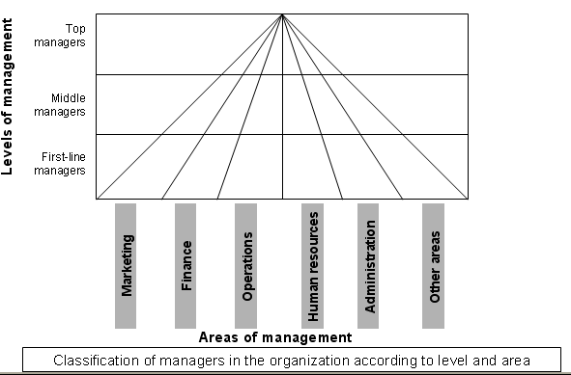

Summary
- Top management will focus on the strategic matters, such as the equity partners, which tenders to tender for and what strategy to be followed in the tender process.
- Middle management will focus on the planning of the service, vehicles required, service specifications, budgets, and so on.
- Junior management (supervisors) will focus on the detailed operational planning – the day-to-day operation of the bus or transport service in terms of the parameters provided by middle and top management.

Types Of Organisation Structures

Functional organisation structure
The activities of the business are grouped on the basis of functions in order to form complete components. Activities are divided into specific categories of the same kind. The activities must be grouped in such a way that if each worker in the different units does his allocated task, the co-ordinated total effort will ensure the realisation of the enterprise’s strategic goals. These units are then the different functional divisions within the enterprise, usually called departments.
Most businesses are divided into departments, with a Manager to take responsibility for each one. Each of the levels from Directors downwards, are usually represented in each department in a business.

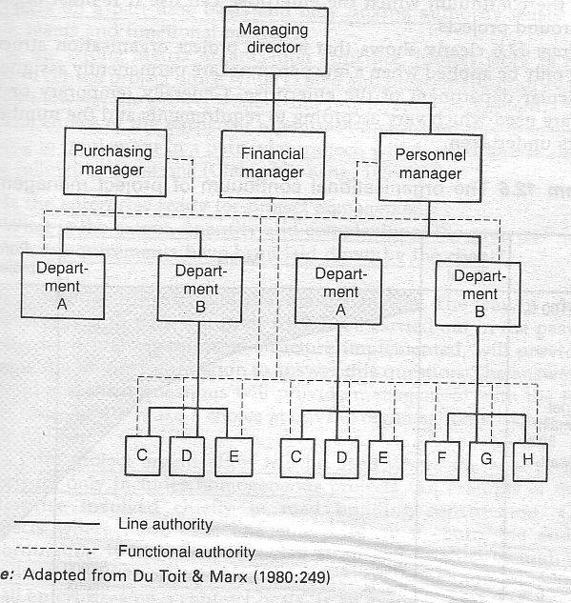

Divisional structure
Initially a business is organised along functional lines. The functional unit forms the building blocks with which other kinds of organisation structures are developed. As the business grows and opens more branches (divisions), the structure of the organisation develops further along divisional lines.
A divisional organisation structure is mainly made up of functional units and therefore all the advantages of a functional organisation remain, for example expertise and skills.
When an organisation is further developed along divisional lines, the organisation of activities will centre around a dominant factor:

Geographical division
Geographical areas are the criteria for the structure. This is used when the organisation has activities in different places. All the activities that take place in a specific geographical area are put together. The biggest advantage of a geographical division is that supervision takes place at the point where the activities are carried out.

Product and service division
Each department produces and independent product and/or service. The activities are organised around the product and/or service being produced. this is common in large organisations where special products or services are organised, for example banks and hospitals. For many years, Groote Schuur Hospital in Cape Town was the place people went to for heart surgery, for example.

Customer/client division
This division emphasises the service offered with the product in order to make provision for particular consumer behaviour. An airline would have two separate sales departments, one for passenger services and one for air freight services.

Combination of functional and divisional groupings
As a business grows, it will usually be necessary to combine the functional and divisional grouping of activities, as this ensures a greater degree of flexibility. Each enterprise is unique and needs a unique organisation structure that satisfies its needs and suits its circumstances and task division.
The following diagram illustrates the combination of organisation structures of an integrated steel factory:

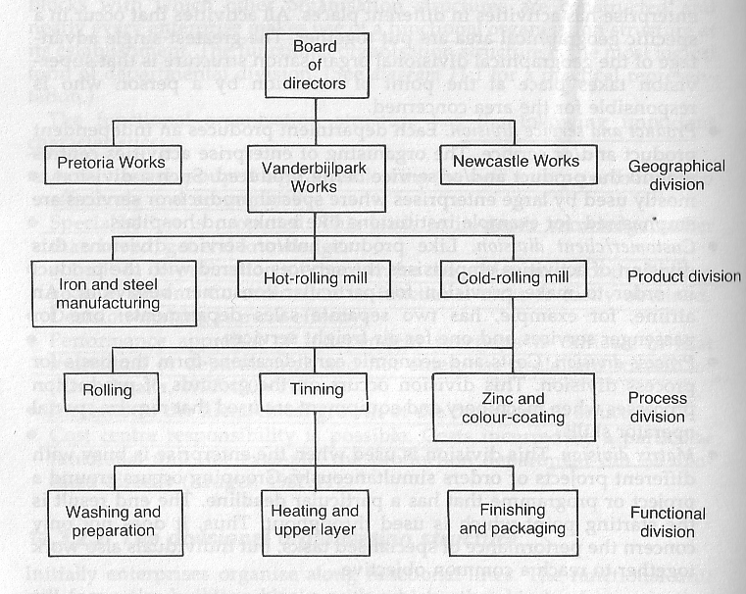

Line organisational structure
The line organisation is that part of the enterprise where the primary functions of the business are performed. The line organisation is established around the functions that are needed to manufacture ad distribute primary consumables, so that survival and the realisation of goals are ensured. It is a simple form of structure that only emphasises the basic functions.
Enterprises often start off as small businesses and enterprise activities are divided functionally. The line organisation structure is ideally suited to this.
The most important characteristic of the line organisation is the authority line that runs from top to bottom in the hierarchy.
The most important shortcoming of this organisational structure is the reduced effectiveness when the business grows.

Advantages
- It is a simple and inexpensive organisation structure in which unity of command and management is possible.
- The authority and responsibility lines are clear and strictly vertical
- It is a stable organisation structure that ensures quick decision making
- Relationship problems are reduced to a minimum

Disadvantages
- The organisation structure is inflexible and unelastic, and this hinders adaptation to change
- A lack of specialist knowledge exists and department heads are overloaded with a variety of tasks
- The enterprise becomes overly dependent on multi-faceted heads of departments who are difficult to replace
- The fact that there are too many managerial levels hinders communication
Managing Director
Marketing Manager
Production Manager
Walk-in Sales Supervisor
External Sales Supervisor
Counter Sales
Telephonic Sales
Gauteng Sales Reps
After Sales Service
Limpopo Sales Reps
Free State Sales Reps
Stores Supervisor
Purchases Supervisor
Production Line Supervisor
Orders out
New stock in
Purchases clerks
Payment clerks
Production Line A workers
Production Line B workers
Production Line C workers

Matrix organisational structure
In a matrix organisation structure, people with similar skills are grouped together for work assignments. For example, all the engineers may be in one engineering department and report to an engineering manager, but these same engineers may be assigned to different projects and report to a project manager while working on that project. Therefore, each engineer may have to work under several managers to get their job done

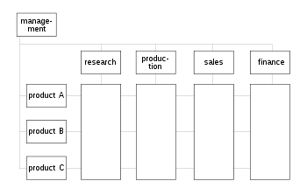
Some organizations fall somewhere between the fully functional and fully projectised organizational structure. These are matrix organizations.
There are 3 basic matrix structures:

Weak/Functional Matrix
A project manager (often called a Project Administrator under this type of organization) with only limited authority is assigned to oversee the cross-functional aspects of the project. The functional managers maintain control over their resources and project areas. The project administrator’s role is to enhance communication between functional managers and track overall project progress, making them more of an expediter or coordinator.

Balanced Matrix
A project manager is assigned to oversee the project. Power is shared equally between the project manager and the functional managers. Proponents of this structure believe it strikes the correct balance, bringing forth the best aspects of functional and projectised organizations. However, this is the most difficult system to maintain as the sharing of power is a very delicate proposition. This is also the most complex organizational structure to maintain.

Strong/Project Matrix
A project manager is primarily responsible for the project. Functional managers provide technical expertise and assign resources on an as-needed basis. Because project resources are assigned as necessary there can be conflicts between the project manager and the functional manager over resource assignment. The functional manager has to staff multiple projects with the same experts.

Changing structures in organisations
In the past, the structure (hierarchy) of an organisation was very vertical, with many departments and sections.
From the example on the previous page, you can see that the hierarchy and reporting lines are very steep – workers report to supervisors, who report to departmental managers, who report to the managing director. The managing director then reports to top management such as the board of directors.
Because all departments in an organisation are dependent on each other the idea of work teams rather than sections headed by a supervisor was developed. The work team is then responsible for many functions, including purchasing, stock holding, manufacturing of a product or products, quality control of the product and delivery of the product.
This means that the work team is dependent on skills within the team to produce a product. Rather than having a stores department, a purchasing department and a production department, an organisation would have a team that is responsible for purchasing raw material on a just-in-time basis (buying only when needed), manufacturing the product and delivering the product to the client.
For example, in a freight forwarding company, one team, Team A, will be responsible for incoming air cargo, another team, Team B, will be responsible for outgoing air cargo.
This means that Team A is responsible for all the work that has to be done for incoming air freight – customs clearance, liaison with the client, making all the necessary payments and delivery to the client.
Team B, on the other hand, will be responsible for collecting the goods from clients, booking air freight space, payments that have to be made, customs clearance and checking that the goods were actually loaded.
This means that the structure of the organisation will be more flat, as can be seen from the example.

Managing director
Production Manager
Sales and Marketing Manager
Team product A
Team product B
Team product C
External sales team
Internal sales team
Marketing team

There are many advantages to flatter organisation structures:
- The chain of command is shorter and this means that communication takes place more effectively
- Teams are responsible for making their own decisions, staying within their own budgets and achieving their own goals. This means that decisions are made where the work is done and where the information sources are. Decisions are therefore made more quickly.
- Team members are involved in the entire process of a product – from purchasing through production to final delivery. This gives team members a better sense of the purpose of the organisation and more pride in their work.
- When working in a team, team members feel as though they make a worthwhile contribution – they take ownership of the quality of the product or service in order to achieve their goals.
- All team members participate in team decision making. This means that decisions are made by consensus and all the team members support the decision
- Information flows freely up and down in a team so all team members are fully informed
- People relationships in teams are trusting, respectful, collaborative and supportive
- Motivation in teams are high and this leads to commitment to the team goals by team members

Organogram
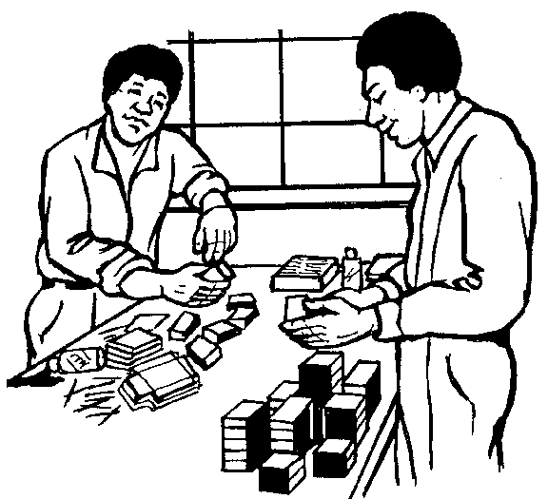
The following pages show examples of the hierarchy of a big, corporate organisation, a small one man business and how the hierarchy and structure of a business changes as it grows bigger.
The organogram shows top management, middle management, junior managers and workers, for the different sized businesses.
This organogram also shows some functions or departments typically found in business:
- Sales and marketing
- Production
- Stores and transport
- Finance
- Administration
- Human Resources
- Other departments that can be found are:
- Purchasing
- Marketing
- Sales
- Quality control

Formative Assessment SO1, AC 1-2

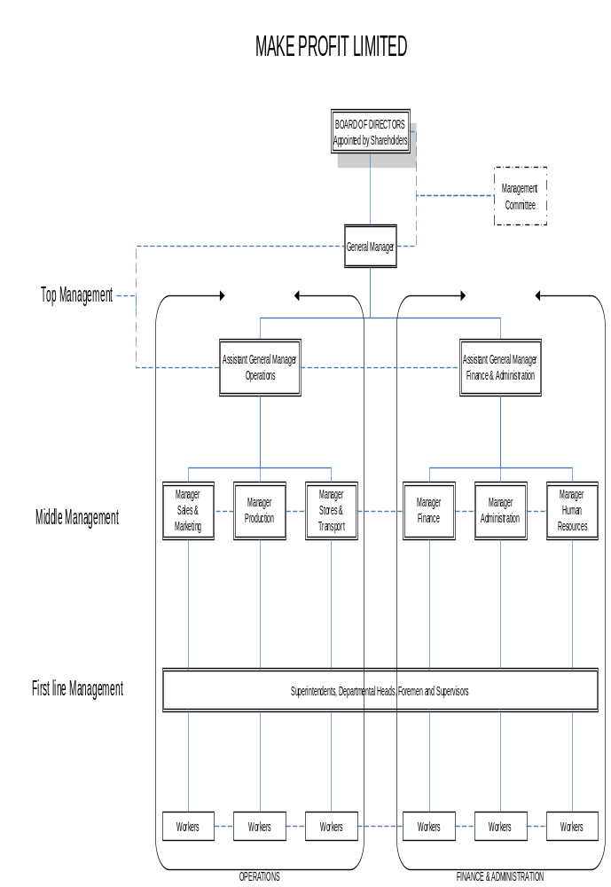

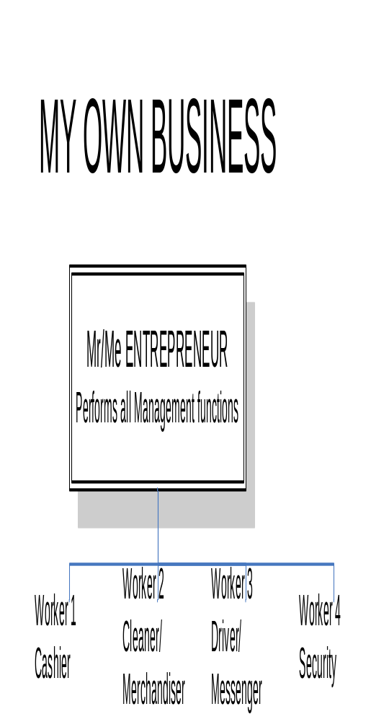

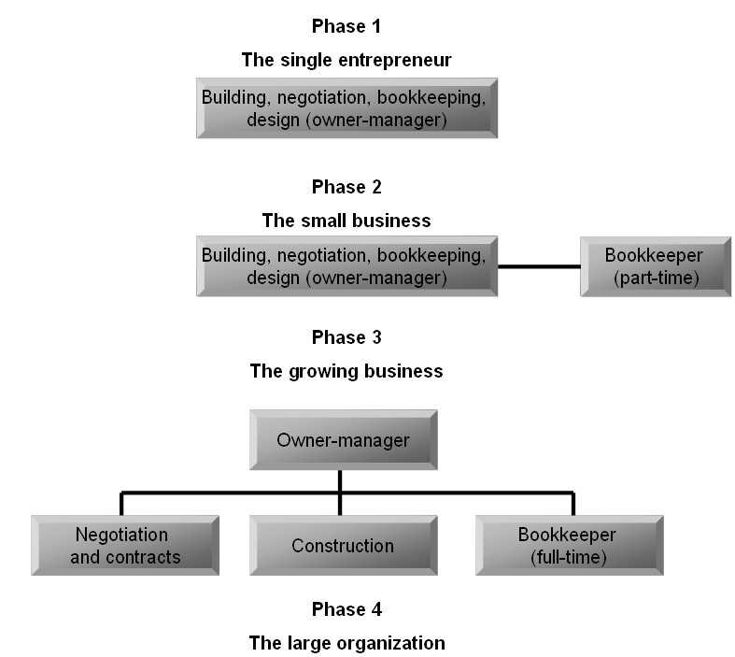
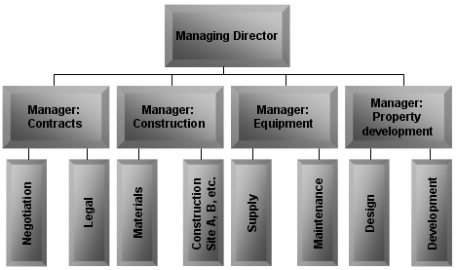
The evolution of specialization

MANAGEMENT ROLES

Outcome 2
Explain the relationship between various management roles

Assessment criteria
- Management roles are explained with examples from own workplace
- The relationship between the various management roles is explained with reference to own organisational context. The relationship between the various roles includes, but is not limited to, human resources, finance, marketing, public relations, funding and production
- The role of the junior manager in managing own area of responsibility is explained within the organisational context
- The interaction between a junior manager`s own area of responsibility and other functions is explained according to the organisational context
The Management Process
Management can be seen as the process whereby people in leading positions use human and other resources to produce products or services, thereby fulfilling specific needs and to achieve the goals set described in the company’s business plan. In other words, management makes use of human resources and other resources to produce products or services. Management also ensures that the products or services are aligned to the goals set out in the business plan.
In order to be effective, any manager, irrespective of his level of management, performs the four basic functions of management namely
- Planning
- Organising
- Activating/ Leading
- Controlling
In addition to these functions they also make use of the six additional management functions namely
- Decision-making
- Communication
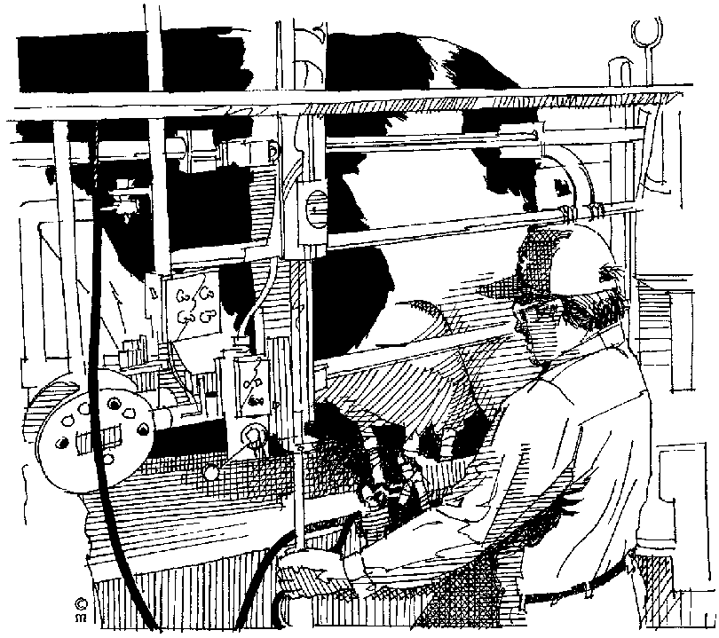

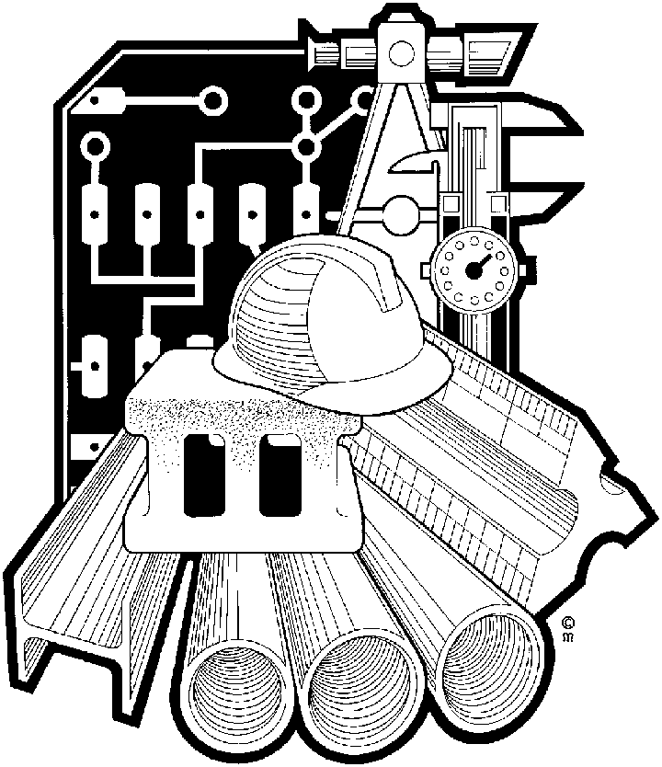
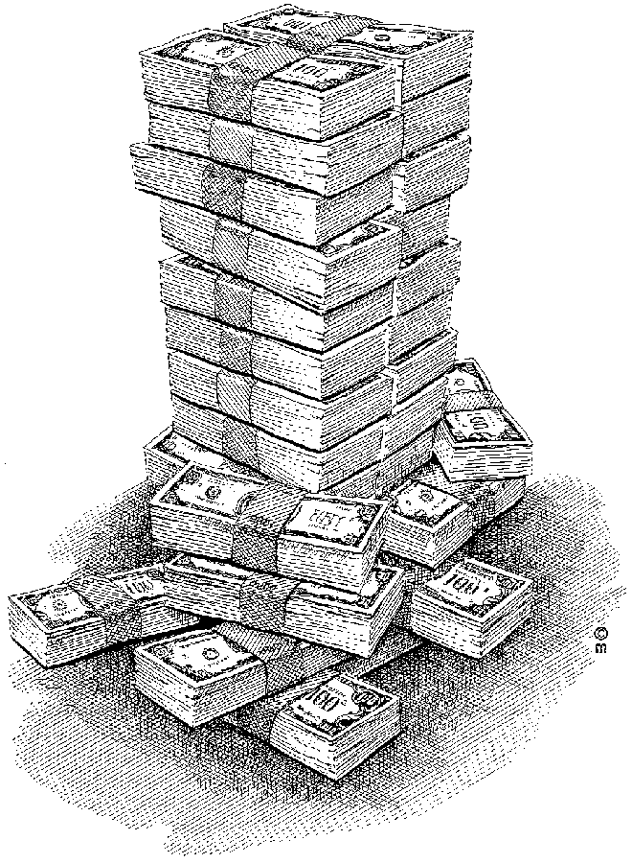
- Motivation
- Coordination
- Delegation
- Discipline
The resources that they use are referred to as the six M’s,
- Man
- Material
- Machinery
- Methods
- Money
- Markets
Managers use all the functions and resources in combination to deliver products or services.
The diagram illustrates the basic management process.
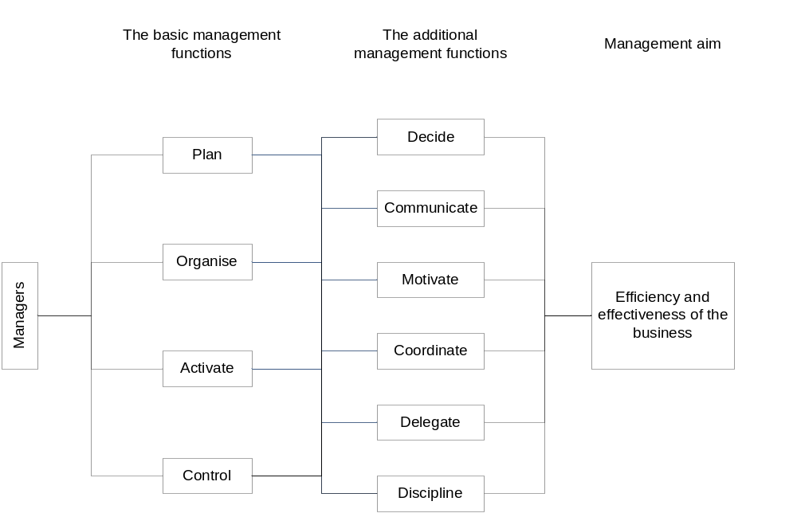

The Four Basic Management Functions

Planning
Determines the organisation’s mission and goals. How is the organisation going to achieve it’s goals and objectives and what resources are required to achieve these objectives?
The second phase of planning involves the formulation of a realistic plan, outlining what resources and activities are going to be utilised to achieve success. Programmes, budget, standards of production and service delivery, due dates, and rules and regulations are also formulated during the planning process.
The nature of the planning function is such that making decisions works hand-in-hand with planning. Top management plans the overall objectives and goals and makes a decision to implement these goals and objectives.
Middle management get the overall organisational plans and formulate goals and objectives that apply to their own departments or divisions. The goals and objectives for the department is formulated in a plan and it will include the proposed utilisation of resources, timelines, standards of production and service deliveries. The decision is then made to implement these plans so that the goals and objectives are met.
Why is planning necessary?
If You Are Not Sure Where You Are Going, You Are Liable To End Up Somewhere Else!

Strategic planning
Is sometimes called overall corporate planning. It relates to the general objectives of the organisation, the corporate mission, the present and proposed markets of the organisation, growth plans, divestment, acquisition or diversification. Strategic plans are formulated by top management and focus on the entire organisation. These plans are long term and look at how the organisation should use its resources according to the opportunities and threats in the external environment as well as how it can gain a competitive advantage.

Functional planning
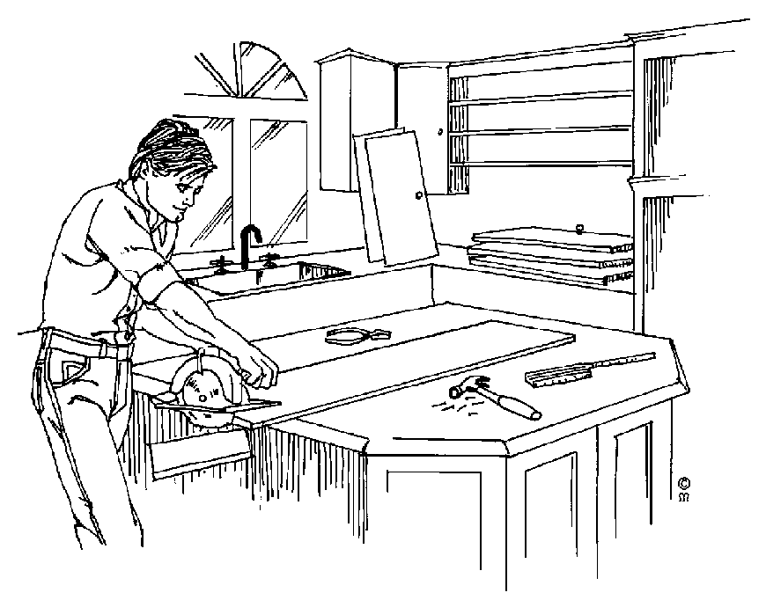
Relates to a particular function such as marketing or production. Middle management formulates plans within the function and are concerned with the attainment of short or medium term objectives.
Functional plans are made in the light of short term corporate objectives. The attainment of long term strategic objectives will normally depend upon the attainment of a succession of short term functional objectives.
Functional plans can take many forms, two of which are:

Tactical Plans
Focus on specific areas of management such as marketing, financial, human resources. Tactical plans are specific: resource allocation, timelines, human resource commitments. These plans are usually drawn up by middle management in consultation with other middle level managers, as the tactical plans for different departments have to complement each other. Middle management will usually also consult with first level managers.

Operational Plans
Are formulated by first level managers in consultation with middle management. These plans focus on carrying out tactical plans. They have a narrow focus and a short time span. These plans govern the day-to-day activities of the department and section.
Junior managers get the plans, including goals and objectives, that have bearing on their sections. They then draw up their short-term plans that will give them the indication of what has to be done on a day-to-day basis in order to achieve their goals and objectives. They then make the decision to implement these short-term plans. Junior managers are very involved in the management of resources, especially machinery and equipment, workers, materials, and methods – how to get the job done on time at the required standards and in the required quantity.
Once the decision has been made, it must be communicated to the relevant parties. If they don’t know what they are supposed to do, how will they be able to do it? This applies to all levels of management, all levels of planning and all levels of decision-making.
Of course, making the decision and communicating it to the people who have to do it also involves delegating the tasks to the people who have to do the work.
So we see that the planning function, the decision-making function, communicating and delegating the work go together.

Organising
During this process the organisational structure emerges, establishing the
- Structures: the structure of the organisation
- Divisions: or departments
- Responsibility: who should do what
- Standards: how should it be done
- Channels of communication: to regulate the flow of information
- And the levels of management: according to tasks and departments
This function also handles staffing: the recruitment, placement, induction, etc. of human resources.
The organising function also works closely with decision-making. A manager has to organise his section or department. He has to decide who is going to do what, which equipment and machinery must be used, what materials are going to be used, how soon must the task be done and to what standard must the job be done.
Plans have to be put into action. This is the purpose of the organising function of management. It has been said that organising is the process of allocation of resources.
When senior and top management determine the structure of the organisation, they are also organising. The organisation structure is the basic framework of formal relationships among responsibilities, tasks and people in the organisation – the various departments, in the organisation in other words. The structure will give middle and junior management an idea of how resources must be allocated.
When the structure of the organisation is determined, the work that has to be done is usually divided into tasks that can be performed by individuals or groups. Departments are formed, based on the grouping of work activities that belong together: sales, production, administration.
Top management determines the basic overall structure of the organisation. They provide the guidelines along which middle management and junior management operate.
Middle management will fulfil the organisation function in their own departments, the allocation of :
- human resources,
- furniture,
- equipment,
- machinery,
- raw products in such a way that the strategic and functional plans can be met.
Junior managers will organise their sections:
- ensure that the human resources that have been allocated to the section are used for tasks that suit them best,
- ensure that enough human resources are allocated to a specific task,
- ensure that the raw product reaches the destination in time,
- ensure that the equipment and machinery is in peak working condition and
- ensure that functional plans are met.
These are not all the organisational functions of middle and junior management, we have quoted examples of these functions for you in explanation of the term organisation.

Activating/Leading
Activating is the process where people are led to contribute towards the activities of the operation in order to achieve the goals effectively and efficiently.
As people are different, the task of the manager is to keep these differences in mind and motivate individuals to achieve their own goals and also the goals of the business. This is the function where people are motivated to work according to the standards required. The activating and motivating functions of management are closely aligned.
Once the manager has decided what has to be done, by whom it must be done and how it must be done, he has to communicate the decision to all the people involved. So activating, motivation and communication are closely related.
can make all the plans you want, if they are not implemented and communicated to the appropriate parties, nothing will happen.
If your mother at home wants you to wash the dishes, she has to tell or ask you to do it. if she doesn’t, the dishes will not be washed. The workplace is the same: decisions have to be communicated!

Leading
Leadership is the process of directing people towards accomplishing certain goals. Leading people should bridge the gap between planning and actually achieving the objectives. It involves influencing, giving orders, motivating, conflict management and communicating.
When you lead, you direct the activities and performance (in other words the work) of other people so that the objectives and goals of the organisation can be attained.

Components of leadership
Authority
Authority is the formal and legitimate right of a manager to make decisions, issue orders, and allocate resources to achieve organisationally desired outcomes.
Responsibility
Responsibility is the duty to perform the task or activity you have been assigned
Accountability
Accountability is the fact that the people with authority and responsibility are subject to reporting and justifying task outcomes to those above them in the chain of command
Delegation
Is the process of subdividing tasks and passing a smaller part of it to a subordinate along with the authority required to actually do the job. As an example, if you want your little sister to help you bake the cake, you have to decide what you are going to let her do. If she must help you pour the batter in the pans and put the pans in the oven, you must let her do this.
You must then also allow her to switch the oven on – giving her the job and then telling her she must not switch on the oven or open the oven door to put the pans into the oven, is to give her the job without also giving her the authority to do the job. In the end she will not be able to do the job properly, since you did not give her the appropriate authority.
Power
Is the ability to influence the behaviour of others without necessarily using his authority. Power is not earned through the position that a person is in but he has to earn it. Without power a manager wouldn’t be able to get his subordinates to voluntarily perform their duties.
You have to use your powers of persuasion to convince your little sister to help you bake the cake. This is a form of power. Coaches of sport teams have authority to do certain things, but they need power in order to convince team members to play according to a specific strategy. While they may have the authority to get rid of certain players, they also need power to get the team to play as a team and not 11 or 15 individual players.
Good leaders have both power and leadership abilities.

Why Is Leadership Important?
You can buy someone’s physical presence, but you cannot buy loyalty, enthusiasm or devotion. These you must earn. Successful organisations have leaders who focus on the future rather than cling to the past. Leaders bring out the best in people. They spend time developing people into leaders.

Manager vs. Leader
Leadership is a part of the management function. Management has a much broader scope than leadership – in other words, a manager has to do more than just be a leader. A good leader should possess the courage to accept responsibility and can probably infuse the same into those around him.
Leaders have to motivate their subordinates to do the work to the best of their abilities day after day. There are many theories regarding motivation, however it is agreed that people work to fulfil needs.
- Needs are the mainsprings of motivation: The supervisor who wishes to motivate his people, must be aware of each person's individual needs. There are two basic types of needs: innate needs and acquired needs.
- Innate needs: Innate needs are also called primary or inborn needs. These are the need to eat, sleep, drink water, be safe and so on. Generally speaking, they are not conditioned by experience. Therefore, there is not much a supervisor can do to satisfy these needs.
- Acquired needs: are also called secondary needs. These needs, unlike the innate needs, are dependent upon experience. That is, they are learned needs. This would include the need to drive to work in your own car rather than making use of public transport, the need to dress expensively, the need to own a house with a pool, etc. These needs vary from person to person.
Part of the leading function of a manager is to find out what motivates his subordinates. An employee can easily sense when his boss disapproves of him.
If a manager makes it clear by his attitude and actions, that he dislikes one of his people, this will cause anxiety, tension and frustration in that person. This is called management by expectation.
On the other hand, if the supervisor makes it clear by his attitude and actions that he is willing to help his people, that group will become motivated.
Effective managers are those who have made a commitment to improve their ability to influence and to motivate others. In being expressive and supportive, they make room for their own humanity, continuing to learn and grow along with the people they work with. They do not always do things perfectly, but they do things! They do not always say profound things, but they say something! They can laugh and be serious; they can be inconsistent and still know how to follow through on important priorities. They can be firm and, at times, flexible. They don’t have to be anything; they are able to be effective and realistic.
Never let the freedom and challenge to grow become an obligation to be perfect. There is no such thing as a perfect manager!

Controlling
This is the process by which the plans and instructions are carried out and controlled and measured by means of feedback. This feedback is compared with what was planned and any deviations from the original plan can be identified and the necessary corrective action can be taken to rectify the problem.
If the feedback indicates that deviations occur regularly, this may indicate that the original plan was not realistic or practical. With this information available, changes can be made to the original plan to prevent further deviations.
This is where the manager controls the way the employees are doing their work. When the work is not done according to the standards that were laid down and within the time, action has to be taken. At times, disciplinary steps also have to be taken. Controlling and discipline are therefore closely aligned.
Controlling and planning also go hand-in-hand. You have a plan from which you work, your control activities come from the planning process, where it was decided what to do, how it should be done and by when it should be done. The purpose of control is to monitor the progress of work against what was planned. If things are not going according to plan, you need to know as soon as possible.
Taking corrective action can include disciplinary action, but it can also include changing the methods or the materials or the workers or even the time lines, which mean that the original plan has to be adjusted.
So we can see that controlling, planning and disciplinary action go together.
Control is the process whereby management ensures that the work activities fit in with the goals and objectives.
Once the plans have been laid and the resources allocated, the actual work starts. Now managers have to control the work in order to ensure:
- that everything goes according to plan,
- that the goals and objectives of the organisation are met and
- that the resources are being used properly.
If you have to control the work activities, it stands to reason that you have to know what you have to control – the specific work process, how you will know if the work is being done correctly and how you will know if there are errors in the work process.

Establish Standards Of Performance
The actual performance should be the same as the planned performance. So, the standards of performance are determined during the planning phase. The standards have to be realistic, attainable and measurable to ensure that the actual performance and the planned performance are the same.
I can compare this to baking a cake or planting mealies. If you have to bake a chocolate cake for a function, and you bake an orange flavoured cake instead, you have not performed according to the planned standards. The cake might be perfect, but a chocolate cake was required, not an orange flavoured cake.
If you planned on planting mealies and you plant sunflower or peanuts instead, you have not performed according to the standards. The standards required you to plant mealies.

The purpose of control is to ensure that mistakes do not happen and, if they do happen, that you can recognise the error in time to do something about it.

You need to realise that you are baking the wrong cake before the cake has been baked and is ready for icing. You have to realise during the mixing of ingredients or the pouring of the mixture into the pans that you are doing the wrong thing. The same principle applies with the planting of mealies – when you only realise at harvesting time that you have planted sunflowers and not mealies, it is a bit late. The sooner you realise you are doing something wrong, the better. This is the purpose of control.

Measure actual performance
The performance variables must be measurable against the standards of performance and they must be reliable. The methods of measuring performance must be specified and must take place at specific times during the work process.
In other words, when planting mealies you have to make sure that you have the right seeds before planting, you have to check what the plants look like at a certain height – do they look like mealies, etc. when baking a cake, who checks that the right ingredients are being used, who checks the colour of the batter, who tastes whether it taste like chocolate cake, and so on.

Evaluate Deviations
When there is a difference between the actual performance and the planned performance, the difference is analysed. What are the deviations, what caused them and what should I do to put it right?
You have now determined that you are baking an orange flavoured cake and not a chocolate cake. How did this happen, what systems can you put in place to ensure that it does not happen again and what can you do right now to remedy the situation?
You have to explore everything that could be responsible for the deviation during the evaluation process, to ensure that an error does not slip in again without you noticing. You also need to know all the causes of the error in order to work out a plan to take corrective action.

Take Corrective Action
This is the action you take to correct the difference between the standards of performance and the actual performance – how you are going to fix the problem so that it does not happen again.
What are you going to do with the batter of the orange flavoured cake: are you going to bake the cake and try to sell it to someone else, are you going to make fairy cakes (little cakes each in their own paper cup) out of the batter, are you going to add cocoa and sugar to the orange flavoured batter and sell it as an orange flavoured chocolate cake? What are you going to do in future to ensure that this does not happen again?
Once you have worked out the corrective action to be taken, you must implement the action and then start the control process all over again.

What Do You Control During The Control Process?
Physical Resources
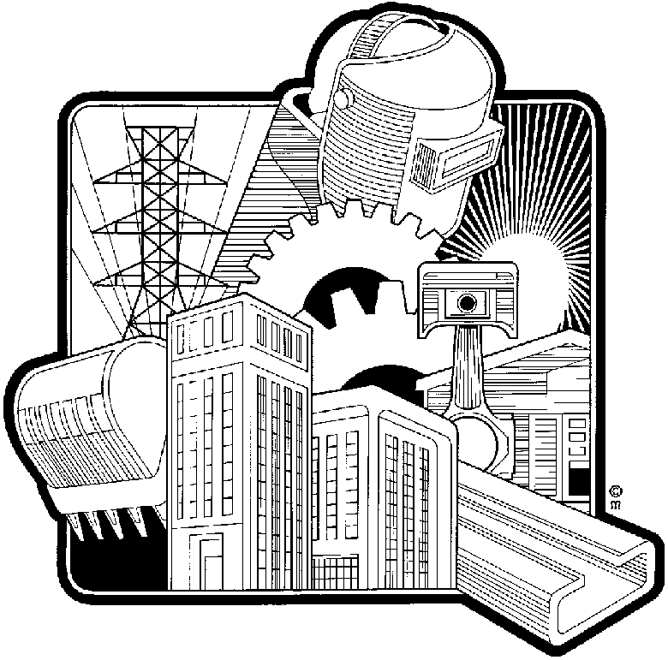
Are the tangible assets such as:
- buildings,: where the work takes place.
- office equipment: used by employees, includes electronic equipment such as faxes, computers, telephones, etc.
- furniture: used by the employees.
- vehicles: usually for delivery purposes.
- manufacturing machinery and equipment: used to produce finished products.
- trading stock: finished items kept in stock for immediate sale.
- raw materials: used to produce the finished product.
- work in progress: an item that is being produced but is not yet finished.
- and finished products.
All these resources have to be organised and controlled: the manager has to ensure that there is enough raw materials to produce the final products, the machinery and equipment must be in place, storage space for the finished products, etc.
If you want to bake a cake, you need:
- the raw ingredients such as flour, sugar, butter, milk, flavourants and colourants.
- a place where you can mix the ingredients.
- pans to pour the batter into.
- a working oven in which to bake the cake.
- a place where you can tip out the cake so that it can cool down.
- a place where you can put the icing on the cake.
- ingredients for the icing.
All the above are physical resources that you need in order to bake a cake. In the same way physical resources are required for the production of products or services.
The first line supervisor will be responsible for controlling all physical resources used on a day by day basis in his section. He will have to ensure that the machinery and equipment is maintained: serviced when due, parts replaced and so on, that enough stock of raw materials are available, he will bring any requirements regarding physical resources to the attention of his manager.
Middle managers will ensure that all the physical resources in the sections in their departments are controlled, they will authorise repairs and replacements on machinery and equipment up to a certain amount and bring further requirements to the attention of top management.
Top management will be responsible for the overall control of physical resources: big and expensive machinery and equipment, latest trends in production, and so on.
Financial Resources
This is one of the most important controls that a manager has to apply. A certain amount of money is allocated for the production of the final products and the manager has to produce final products within the budget. The budget is a formal plan, expressed in financial terms, which shows how resources are allocated to different activities, departments and subordinates.
Managers are not allowed to use more money than allocated in the budget to produce final products.
If you only have R30 with which to bake a cake, you cannot bake a cake that costs you R40 – where is the extra R10 going to come from? It especially becomes important if you sell the cake for R50. If the cake costs R30 to bake, you make a profit of R20. If you go over your budget you only make a profit of R10. Would baking the cake still be worthwhile? Probably not. What can be even worse is if you don’t plan, organise and control the process of baking the cake and the cake costs you R60 to bake and you sell for only R50 – this means you have paid in or worked at a loss.
Financial controls fulfil a vital role in any organisation and they must always be adhered to as failure to do this can result in the business failing (going bankrupt) and everyone losing their jobs.
Top management will be responsible for the overall budget and financial control of the organisation, middle managers will be responsible for the budget and financial control of their departments, while supervisors are responsible for the financial control of their sections.
Information Resources
The flow and availability of information is usually centred in the administration departments. The manager of all the other departments or functions rely on accurate information given to them on time in order to control their own departments.
Information should be relevant and on time. Managers can only implement effective plans and ensure that production is happening according to the plan if they get accurate and timely information.
If you want to bake a cake, you need the instructions before you start mixing the ingredients, this is accurate information given on time.
The flow of operational information usually works from sections, where first line managers are in control, to departments, where middle managers are in control, to top management. Information that has to come from top management, will flow from top management to middle management to junior management.

Human Resources
Usually the Human Resources Department is responsible for the control of human resources. However, every department and section is also responsible for controlling human resources allocated to them.
It is the first line supervisor and departmental manager’s job to ensure that people arrive for work, don’t take longer lunch breaks than allowed, don’t leave earlier than they are supposed to, overtime figures are given to HR Department, names of employees who are entitled to bonuses are given to HR Department, and so on.
The first line supervisor will be responsible for the employees on his team and the departmental manager will be responsible for controlling his first line supervisors.

Practical Application Of The Four Management Functions
So, first line managers get their medium and short term plans from middle management. This would include production targets for the day, the week, the month and so on. The first line manager then has to plan the activities of his/her section for the day, week and month in such a way that the targets are met.
Once the manager has worked out a short term plan, he has to allocate resources so that the target is met: people to do the work, machinery, equipment and raw materials must be at the right place at the right time so that the job can be done. This is his organising function.
As soon as the work is in progress, due to the planning and organising of the first line manager, he must control that the work is being done on time.
If there are problems he has to adjust his plan and reorganise the resources so that the work can continue with minimum disruption.
While the work is being done, he must also lead the employees: motivate them to work smoothly together as a team, as this is the only way the work will be done on time.
If we look at the bus transport company:
- One supervisor will be in charge of the drivers on a specific route, so if there are ten routes, there might be ten supervisors reporting to one middle manager. Each supervisor has to ensure that he has enough drivers for the routes allocated to him, he must ensure that he has buses, he must ensure that the buses are in good working order, and so on. If there are problems, he has to sort them out with the minimum delay so that the passengers are not inconvenienced. His planning will be short term: daily, weekly, monthly.
- Another supervisor will be in charge of ticket sales and he also has to plan, organise, control and lead.
There will be a supervisor in charge of the mechanics, and so on.
The Six Additional Management Functions
These six functions are usually performed in some or other combination to interact with the four basic management functions.

Decision-making
The process of seeking the best workable alternative solution to a problem. Alternatives should be carefully considered before a decision is made
Programmed or routine decisions are repeated and made on the basis of established procedures, following predetermined guidelines.
Unprogrammed decisions, on the other hand, are usually non-recurrent and less structured than programmed decisions but demand special attention as they are usually more complex than programmed decisions.
During the planning process, certain goals and objectives are stated. By making a programmed (routine) decision the manager specifies that, e.g. the productivity of the business is to increase by 10% over the next three years and to reduce production costs by 2% during the same time in order to achieve the goals set during planning.
As previously stated, part of the organising function is to set standards. These standards must reflect the objective to be achieved, and serve as a management tool to compare actual performance with what is required to achieve the objective. Management makes a programmed decision and specifies the exact number of items to be produced by a specific section or the exact measurement of the items produced.
During the planning process, certain goals and objectives are stated. By making a programmed (routine) decision the manager specifies that e.g. the productivity of the business is to increase by 10% over the next three years and to reduce production costs by 2% during the same time.

Communication
It is the transfer of a message, related to the activities of the business and the relationship between two or mare persons involved. It plays an important part in all management functions as it provides the information necessary for work performance.
When management make decisions or delegate tasks and responsibilities, these decisions must be communicated to and discussed with all parties concerned. This not only gets the participation of the parties concerned, but also creates confidence with workers by involving them in the decision-making process.

Motivation
Motivation can be seen as the action perfumed by a manager to get his subordinates to willingly strive to do their best. There are no standard methods to motivate people as their values and attitudes differ. The manager should know his subordinates well enough to know what will motivate them and then adapt the method of motivation which is most suitable.
Communication plays a vital role in any organisation as this is the manner in which information is transferred, both upwards and downwards. Part of the activating function of a manager is to motivate subordinates. Management often make mistakes during downward communication by only telling subordinates what they must know in order to carry out tasks. They do not pay attention to what personnel want to know about themselves and the work they do. This can be demoralising. If workers know what to do and how to do it and are also informed about the importance of their job, no matter at what level, this will serve to motivate them as they can now attach a value to what they are doing.

Coordination
It is the manager’s attempt to get the work done by different individuals and departments in order to achieve the company goals together. This function should be kept in mind during all stages of management to ensure that the operation functions as a unit.
Coordination is the efforts by management to harmonise the work performed by individual employees and different sections so that complete co-operation is obtained and thereby put the enterprise in a position to achieve its objectives.
The purchasing department must work closely with the production department and the finance department so that:
- the correct types of raw material is purchased.
- in time for production to use them.
- enough raw material is purchased to ensure a smooth flow in production.
- at the right price, so that the organisation does not pay too much for raw materials and reduce the profitability of the organisation.
In the same way the HR department must work together with the other departments to ensure that employees are correctly remunerated at the right time, HR must also work together with shop stewards and unions to prevent labour unrest.
The finance and administration departments must work together with all the other departments to ensure that goods are paid on time, that goods are purchased and sold at the right price, that finished goods that have been sold are paid on time and so the cycle carries on.

Factors that impede coordination
- Low worker morale.
- Poor motivation by managers may lead to workers seeing cooperation with others as too much trouble or even not really necessary.
- Some people are by nature opposed to cooperation; they prefer to work alone. Unfortunately, this attitude undermines the efforts of other employees and can waste everyone’s time.
- Sometime poor relations between departments or sections occur or exist due to differences between the managers.
- One department feeling that their efforts are more important than the efforts of other departments.
- Poor planning can have the effect that the tasks that individuals or departments have to perform are not coordinated.
- Poor communication between individuals, sections and departments can jeopardise co-ordination.
- Inability or refusal of individuals or departments to implement new methods, procedures and equipment can also hamper coordination.
So obviously, to promote coordination between employees in a department and between sections and departments in an organisation, you would have to do the opposite of the above:
- Ensure that the morale of the workers is high.
- Motivate workers to cooperate with other employees and departments.
- Ensure that your department or section is on good terms with all the other departments and sections.
- When you plan your department’s activities, ensure that you plan for coordination in the department and between departments as well.
- Ensure that new methods, procedures and equipment are adopted and accepted by all the employees.

Delegation
A manager’s function is so demanding that he cannot always cope with everything himself. To reduce this burden he allocates duties, authority and responsibilities to subordinates to distribute the work more evenly, thus working towards more effective performance.
Delegation is the process through which a manager assigns a portion of his workload to others. The main reason for delegation is to get more work done.
If the delegation process is followed closely, the assigning of a manager’s work to a subordinate through delegation will take place successfully.

Step One: Assign Functions
The manager assigns tasks and activities relating to the work to a subordinate for implementation and completion. If a manager wants a letter to be typed, he will assign this task to his secretary.
When a task is assigned, the manager must ensure that the employee knows exactly what is required. This is usually done by means of a job description and the identification of critical responsibility functions.
It is not enough for the manager to say: “Type a letter to ABC Company. The secretary has to know the content of the letter, who at ABC Company the letter should be addressed to, when the manager requires the letter and so on. If you want someone to cut your hair, you should be specific regarding the style your require, otherwise the hairdresser might do something that you don’t like and then it does not help to blame the hairdresser – you are to blame.
During step one you do not assign responsibility, step one is regarded as training. You are monitoring the employee’s work in order to ensure that he can do the work on his own. Once he has shown you that he can do the work on his own, it is time for step two.
The marketing manager requests another employee to do market research for a new product. First the employee is fully briefed, then the employee approaches one or two customers while the manager monitors what the employee does: how does he approach the customers, how does he ask the questions, etc.

Step Two: Assign Authority
The delegation process gives a subordinate the power to act on behalf of management. Once the employee is sure of the specifics of the job that has to be done, you have to give the employee the authority to do the job. If the marketing manager requests another employee to do market research for a new product, the manager must give the researcher full authority to do effective research, once the manager is satisfied that the employee knows what is required and is able to do the job.
It would be pointless to ask someone to do market research and then that person is not allowed to make phone calls, or allowed to phone customers and ask questions. All the authority that is required to do the job must be assigned to the employee.

Once the authority has been assigned, the manager must abide by decisions the employee makes. This is why the delegation process has to be monitored by the manager all the time, especially during the first two phases.

Step Three: Assign Responsibility
The employee has now been assigned the function, he can do the job and he has been assigned the authority to do the job. The manager monitors the progress of the employee, because the job has been assigned and with the authority certain rights have been assigned. Now it is time to assign responsibility as well. Responsibility places an obligation on the employee to complete the tasks as required within the specified time limits. Failure to do so, will reflect badly on the employee.
In other words, responsibility is the obligation the employee has to carry out the instructions – the work becomes the employee’s responsibility.

Step Four: Creating Accountability
Accountability is the obligation of the manager and the employee to ensure that the instruction is carried out with satisfactory achievement of goals – the work must be done in such a manner that the goals of the organisation are achieved.
Accountability ultimately rests with the manager – if the job is not done correctly, he will be in trouble. However, the employee should also be held accountable for work not done correctly. This means that when things are done correctly or incorrectly, both the employee and the manager will be held accountable.
If a subordinate makes a mistake and it costs the organisation five million rand, the employee, his manager, usually the first line supervisor, the middle manager as well as the senior manager in the top management structure will be held accountable for the error. Everybody will be in trouble.
The opposite is also true: if the subordinate saves the organisation a lot of money, everybody will get the credit: the employee, junior manager, middle manager and senior manager.

Tasks That Cannot Be Delegated
Although most of the tasks of a manager can be delegated, certain tasks can never be delegated to junior employees:
- Top management cannot delegate the strategic planning function to middle and junior management. The lower management levels of an organisation can be made a part of the strategic planning process, but it still remains the function of top management.
- Middle managers remain responsible for the smooth running of their departments, they cannot blame someone else if their departments do not make deadlines and so on.
- Junior managers cannot really delegate their staff admin responsibilities to juniors, since this would include confidential information.

Discipline
Discipline shapes the subordinate’s behaviour to motivate him to perform in such a way as to achieve the set goals. Positive discipline entails motivation such as praise for good work. It helps to develop the sense of responsibility. Negative discipline involves warning or punishment and serves as a reprimand as well as a deterrent to other employees not to indulge in the same behaviour.
When deviations from set standards are identified during the controlling process, the necessary corrective and/or remedial action must be taken to avoid these deviations from recurring. The procedures to be followed when implementing corrective and/or remedial action must be specified in the disciplinary policy.
These six functions are usually performed in some or other combination with the four basic management functions.
Junior Managers
There are many names and titles for junior managers:
First line supervisor
Junior manager
Team leader
Whatever the name, the duties and responsibilities remain the same: supervision so that the goals and objectives are met and this is done through the utilisation of resources.

What Is Supervision?
Let us first look at some simplified examples and definitions.
When a person says: “I will supervise my child's homework, I will supervise the moving of the furniture, I will supervise the football or sports training,” what do they really mean?
Very simply, they mean they will look after.
When supervising, you look after your child's homework, the moving of your household furniture, the football or sports training, or any other type of work.
To continue with our simplified definition, let's ask the simple and again seemingly obvious question of Why do you need to look after it?
You need to look after all these jobs, or activities, to see that they are well done.
So, our complete and simple description of what supervision is should read:
To look after a job to see that it is well done.
This basic meaning of supervision may be enlarged upon, or made more specific for the working world as:
Supervision is the function of working with and through people to achieve specific production objectives.
Junior managers are usually appointed from employees working on the floor. he/she goes from being one of the workers to being one of the bosses. This transition can, at times, be very difficult – for the supervisor as well as the employees.
One of the many problems supervisors face is to stop doing production work and start doing managing work.
THE SUPERVISOR - A THINKER OR A DOER?
The transition from being an operator, tradesman, technician, etc. to becoming a supervisor is often difficult. We expect a supervisor to be a leader – a thinker rather than a doer. Here is a list of the various activities that a supervisor may be involved in. Tick those that you think a supervisor may do under normal circumstances.

- Operating equipment |  | - Planning work.
- Keeping records |  | - Interviewing
- Assigning work |  | - Going for coffee
- Budgeting |  | - Conducting meetings
- Writing memos |  | - Answering the telephone
- Setting goals and targets |  | - Coordinating work activities
- Instructing/training |  | - Fooling around
- Appraising performance |  | - Administering performance
- Ordering materials/supplies |  | - Handling grievances
- Assisting with worker's personal problems |  | - Conducting safety inspections.

Supervision and management are not exact sciences like mathematics and science, where there is only one right answer. Remember, when we deal with people, there is never only one right answer, in the same way that there is never someone who is completely right, or someone who is completely wrong in an argument!
You are now going to have to deal with people. You are going to need judgement, tact and experience.
Is it OK for a supervisor to operate equipment? There will be times when a supervisor must roll up his sleeves and pitch in to help with some emergency orders. But this should, of course, be the exception rather than the rule.
There are only two activities on the list that are clearly not jobs for a supervisor. They are, operating equipment and fooling around.
You may have responded with a 'no' for the activity of answering the phone or ordering supplies. Well, a supervisor must obviously answer his own phone, but he should not get into the habit of using the phone when it is not important.

Formative assessment SO1 AC1-4

