252040 FORMATIVE ASSESSMENTS WORKBOOK

Formative Assessment 1: SO1 AC1
Explain the Accounting Cycle
Complete the following in small groups / individually as per the instructions from your facilitator:
Explain the accounting cycle by drawing a diagram: 10 steps

Place any extra evidence after this page, clearly marked for easy reference.

Formative Assessment 2: SO1 AC2
Role of Budgeting and Forecasting in Strategic Planning
Complete the following in small groups / individually as per the instructions from your facilitator:
Explain the role of budgeting and forecasting in the strategic planning process with reference to your business unit:

Formative Assessment 3: SO1 AC3
Explain Accounting Conventions applied in Financial Management
Complete the following in small groups / individually as per the instructions from your facilitator:
Explain the following accounting conventions applied in the financial management of your unit and give examples:

Convention | Explanation | Example from my business unit

Place any extra evidence after this page, clearly marked for easy reference.

Formative Assessment 4: SO1 AC4
Financial Reports Published in the Organisation
Complete the following in small groups / individually as per the instructions from your facilitator:
Explain the following financial reports published by the organisation and give examples:
Financial Report | Explanation and example
Audit reports
Statement of Comprehensive Income (Income Statement)
Statement of Cash Flows
Statement of Financial Position (balance sheet)

Place any extra evidence after this page, clearly marked for easy reference.

Formative Assessment 5: SO2 AC1
Analyse Financial Statements
Complete the following in small groups / individually as per the instructions from your facilitator:
  - Study the flowchart in 2.1 in your Learner Guide and then fill in the table below by answering the questions posed in relation to your business unit/ section/ division:

Steps in financial analysis
Select (What is the purpose of the financial analysis?)

Compare (With whom or what?)

Evaluate (Good or bad? Expected result? Who is responsible?)

Predict (What will happen if I do not take action? What improving action is possible?)

  - Explain how you, as the business unit manager, can use the results of financial analysis to enhance the operations of your business unit/ section/ division:

  - Explain how the results of your business unit/ section/ division impact on the whole organisation:

Place any extra evidence after this page, clearly marked for easy reference.

Formative Assessment 6: SO2 AC2, 3 & 4
Apply Ratios
Complete the following in small groups / individually as per the instructions from your facilitator:
Study the “Balance Sheet” presented below and then answer the questions that follow:

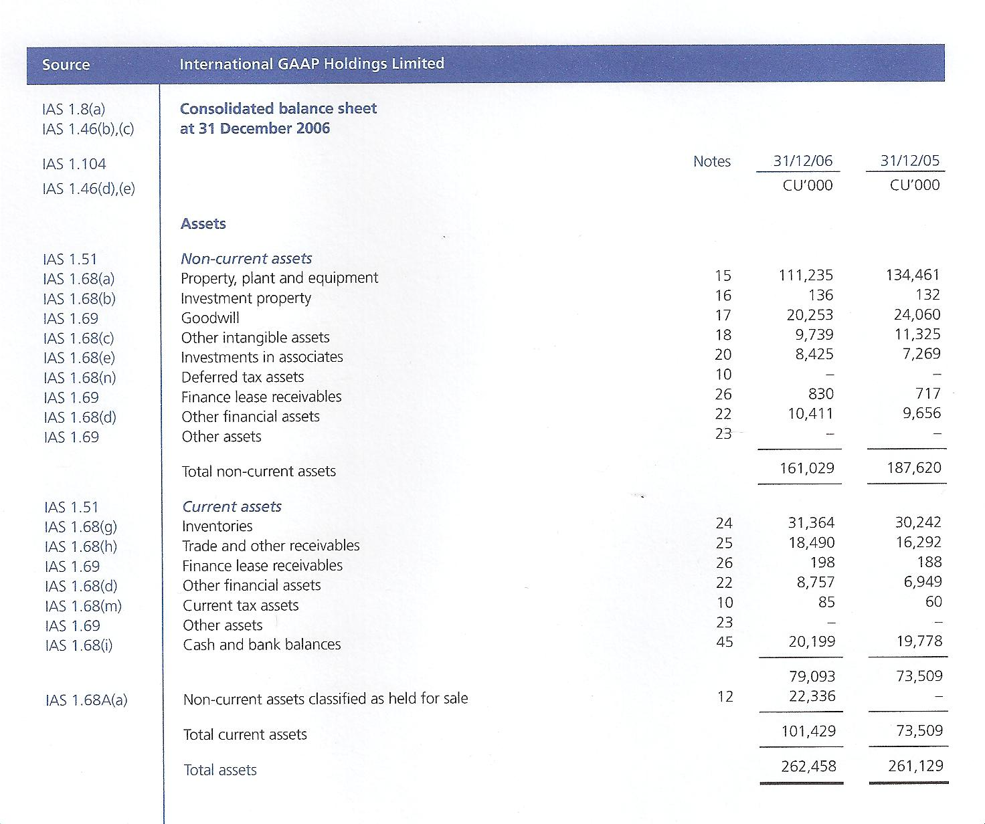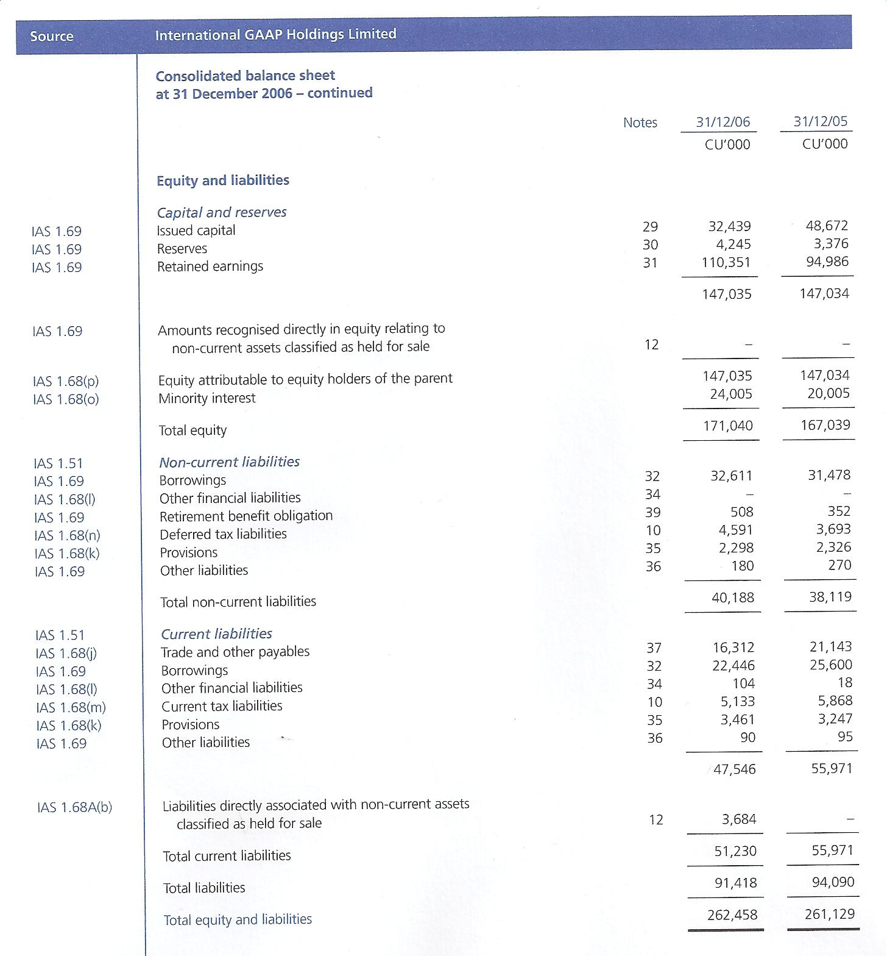

6.1 The name of this document has changed with the IFRS – what should the name be now?

6.2 Determine the following as on 31/12/ 20X6, using the figures supplied in the Statement of Financial Position (balance sheet) above:

- Total assets
- Total liabilities
- Stock
- Cash and bank balances

6.3 What conclusions can you draw about the liquidity and viability of the company based on the Statement of Financial Position (balance sheet) information?

Place any extra evidence after this page, clearly marked for easy reference.

Formative Assessment 7: SO2 AC2, 3, 4 & 5
Make Recommendations based on Ratio Analysis
Complete the following in small groups / individually as per the instructions from your facilitator:
Study the following Statement of Comprehensive Income (Income Statement) and Statement of Financial Position (balance sheet), before answering the questions that follow:

Electrical Products International
Statement of Comprehensive Income (Income Statement)
For the year ended Dec. 31, 2XX6 (R 000’s)

 | 2XX6 % | 2XX6 | 2XX5% | 2XX5
Sales | 100% | 3900.00 | 100% | 3500.00
COGS | 83.33% | 3250.00 |  | 2864.00
Gross Profit | 16.67% | 650.00 |  | 636.00
SGA expenses |  | 330.30 | 6.86% | 240.00
Fixed expenses | 2.56% | 100.00 | 2.86% | 100.00
Depreciation expense | 0.51% | 20.00 | 0.54% | 18.90
EBIT | 5.12% | 199.70 | 7.92% | 277.10
Interest expense | 1.95% | 76.00 | 1.79% | 62.50
Earnings before taxes | 3.17% |  |  | 214.60
Taxes @ 40% | 1.27% | 49.48 | 2.45% | 85.84
Net Income | 1.90% |  | 3.68% | 128.76

- Statement of Comprehensive Income (Income Statement) restates all expenses as a percentage of sales
- Analysts can quickly see which expenses have increased or decreased relative to sales

Electrical Products International
Statement of Financial Position (balance sheet)
As of Dec. 31, 2XX6 (R 000’s)

Assets | 2XX6 % | 2XX6 | 2XX5% | 2XX5
Cash and Equivalents | 3.03% | 50.00 | 3.92% | 57.60
Accounts Receivable | 24.35% | 402.00 | 23.91% | 351.20
Inventory | 50.76% | 838.00 | 48.69% | 715.20
Total Current Assets | 78.14% |  | 76.53%
Plant and equipment | 31.92% | 527.00 | 33.43% | 491.00
Accumulated Depreciation | 10.07%% | 166.20 | 9.95% | 146.20
Total Assets | 100% |  | 100%
Liabilities and Owner’s Equity
Accounts Payable | 10.61% | 175.20 | 9.91% | 145.60
Short-term Notes Payable | 13.63% | 225.00 | 13.62%% | 200.00
Other Current Liabilities | 8.48% | 140.00 | 9.26% | 136.00
Total Current Liabilities | 32.72% | 540.20 | 32.79% | 481.60
Long-term Debt | 25.72% | 424.61 | 22.02% | 323.43
Total Liabilities | 58.45% | 964.81 | 54.81% | 805.03
Common Stock | 27.87% | 460.00 | 31.32% | 460.00
Retained Earnings | 13.69% | 225.99 | 13.87% | 203.77
Total Shareholder’s Equity | 41.55% | 685.99 | 45.19% | 663.77
Total Liabilities and Owner’s Equity | 100% | 1650.80 | 100% | 1468.80
- Statement of Financial Position (balance sheet) restates all assets and liabilities as a percentage of total assets
- Analysts can quickly see which accounts have increased or decreased relative to total assets

7.1 Complete the Statement of Comprehensive Income (Income Statement) and Statement of Financial Position (balance sheet) by filling in the missing figures.
7.2
- Calculate the Current Ratio (CR) for EPI for 20X6.
- What does the CR tell you about EPI’s liquidity?

7.3
- Calculate the Acid/ Quick Ratio (QR) for EPI for 20X6.
- What does the QR tell you about EPI’s liquidity?

7.4
- Calculate the Inventory Turnover Ratio (QR) for EPI for 20X6.
- What does the Inventory Turnover Ratio tell you about EPI’s efficiency?

7.5
- Calculate the Debtors collection period for EPI for 20X6.
- What does this result tell you about EPI’s efficiency?

Place any extra evidence after this page, clearly marked for easy reference.

Formative Assessment 8: SO3 AC1
Types and Formats of Financial Forecasts
Complete the following in small groups / individually as per the instructions from your facilitator:
Trend analysis: study the data in the following table and discuss the trend that you can discern and possible consequences in the last column:
Performance Area | 2XX6 | 2XX5 | 2XX4 | 2XX3 | Trend
Leverage:
Debt % Tot Assets | 25.7 | 33.2 | 28.9 | 30.6
Interest Coverage | 269.7 | 395.8 | 318.4 | 195.4
Liquidity:
Current Ratio | 2.3 | 2.6 | 2.8 | 2.2
Quick Ratio | 1.0 | 1.3 | 1.6 | 1.3
Interval Measure (days) | 63.8 | 90.8 | 115.3 | 86.4
Profitability:
Profit Margin (%) | 23.1 | 27.7 | 24.7 | 22.0
Return on Assets (%) | 19.3 | 24.0 | 21.7 | 20.4
Return on Equity (%) | 26.0 | 36.0 | 30.6 | 29.4
Efficiency:
Asset Turnover | .835 | .868 | .878 | .926
Receivables Turnover | 7.5 | 7.0 | 6.1 | 6.4
Inventory Turnover | 5.7 | 5.2 | 4.4 | 4.1
Market Value:
Price/Book Value | 8.41 | 5.92 | 6.37 | 3.83

Place any extra evidence after this page, clearly marked for easy reference.

Formative Assessment 9: SO3 AC2
Sources of Financial Forecasts
Complete the following in small groups / individually as per the instructions from your facilitator:
Identify sources of financial forecasts as per the organisation's standard practice

Place any extra evidence after this page, clearly marked for easy reference.

Formative Assessment 10: SO3 AC3 & 4
Factors in Preparing Financial Forecasts
Complete the following in small groups / individually as per the instructions from your facilitator:
Explain how the following factors play a role in preparing financial forecasts:

Place any extra evidence after this page, clearly marked for easy reference.

Formative Assessment 11: SO3 AC5
Analyse Financial Forecasts to Determine Viability
Complete the following in small groups / individually as per the instructions from your facilitator:
11.1 Explain the concept of “viability of an organisation”.

11.2 Explain the role of cash flow in the sustainability of an organisation:

Place any extra evidence after this page, clearly marked for easy reference.

Formative Assessment 12: SO4 AC1, 2, 3 & 4
Link Budget Plans to Operational Objectives
Complete the following in small groups / individually as per the instructions from your facilitator:
12.1 You are a sole trader operating under the name Spice Co. You produce the chemical flavours used to flavour foodstuffs. You have been in operation since 1998. You produce Annual Financial Statements, so that interested parties, such as the bank, clients and suppliers who do business with you and SARS, the Receiver of Revenue, may review these financial statements and make decisions on the results accordingly.
Spice Co.
Statement of Income and Expenditure
For the period 1 September 2XX5 to 31 August 2XX6
 | R
Income
Sales | 1,500,000
Less: Purchases | 700,000
Gross Profit | 800,000
Less: Expenditure
Accounting Fees | 1,200
Cleaning Materials | 5,000
Computer Expenses | 20,000
Motor & Travel | 50,000
Rental of Factory Premises | 200,000
Stationery & Office Expenses | 20,000
Staff Refreshments | 10,000
Salaries | 400,000
Staff Training | 1,000
UIF | 4,000
Workman’s Compensation | 4,000
Net Profit | 84,800

Draw up a simple budget for the three-month period from 1 September 2XX6 to 30 November 2XX6. You may work on the assumption that all the costs have gone up by 10% across the board due to higher inflation and increases in the prime lending rate. Your annual income has increased by 15%.
Expense item | September | October | November | Total
Accounting Fees | 110 | 110 | 110 | 330
Computer Expenses | 173.61 | 173.61 | 173.61 | 1770.83
Motor & Travel | 166.67 | 166.67 | 166.67 | 5500.01
Rental of Factory Premises | 4583.33 | 4583.33 | 4583.33 | 13749.99
Stationery & Office Expenses | 18 333.33 | 18 333.33 | 18 333.33
Staff Refreshments | 1833.33 | 1833.33 | 1833.33
Salaries | 916.67 | 916.67 | 916.67
Staff Training | 36 666.67 | 36 666.67 | 36 666.67
Total expenses | 91.67 | 91.67 | 91.67
 | 62 875.28 | 62 875.28 | 62 875.28

12.2 Explain how operational objectives of the unit are established in line with the unit’s strategic plan:

Place any extra evidence after this page, clearly marked for easy reference.

Formative Assessment 13: SO5 AC1, 2 & 3
Monitoring Systems
Complete the following in small groups / individually as per the instructions from your facilitator:
13.1 Explain the standard operating procedures for agreeing and adhering to monitoring systems

13.2 Explain how expenditure reports are monitored for the year for each team within the unit against specific criteria

13.3 Explain when corrective actions would need to be implemented

Place any extra evidence after this page, clearly marked for easy reference.

