7570 Formative Assessments

Formative Assessment 1

1. Open the document **TIME MANAGEMENT**
2. Select the first heading “Why Time Management”
3. Use the **Style**list box or the **Styles and Formatting**task pane to apply **Heading 1**style
4. Apply **Heading 2**style to the following headings: Prioritising Your Work; Organising Your Diary;
5. The Year Planner; Update Your Goals And Objectives Every Week; Write Down Your Longer-Term Goals : Monthly Or Quarterly Or Yearly
6. Apply **BodyText**style to the paragraphs under all the heading 2s
7. Apply **BodyList**style to the paragraphs under the heading: Phone Calls
8. Apply **Heading 3**style to the headings under “TIME WASTERS”
9. Apply **BodyTextIndent**to the paragraphs under the heading Personal Phone Calls
10. Select a few key phrases in the document and apply the **emphasis**character style
11. Save and close the document

Formative Assessment 2

* Open the document **TIME MANAGEMENT**
* From the **View** menu, select **Header and Footer**
* To edit the footer, on the **Header and Footer** toolbar, click **Switch Between Header and Footer**
* On the **Formatting** toolbar, click **Center** and press Ctrl + I to apply italic format
* Type **Page** with a space after it then on the **Header and Footer** toolbar, click **Insert Page Number**
* On the **Header and Footer** toolbar, click **Format Page Number**
* Select the Arabic format (i, ii, iii) and click **OK** then copy the formatting from "Page" to the number
* Click to edit the header and from the **File** menu, select **Properties...**
* In the **Title** box, type **My** **Time Management** and in the **Author** box, type **MS Word learner**
* From the **Insert** menu, select **Field...** then choose the **Title** field and click **OK**
* Press Tab twice to move to the right-hand tab stop then press Ctrl + Alt + C to insert a © symbol
* From the Insert menu, select Field... then choose the Author field and click OK
* On the Header and Footer toolbar, click Insert Date
* Click in the date field and press **Shift + F9** to edit it
* Change the field contents so that it reads: **{ DATE \@ "yyyy" }** - do not delete the curly braces!
* Press **F9** to update the field then double-click the document body to return to normal editing mode
* View the document and its header and footer in print preview then save and close it
* Insert a Section Break (Next Page) before the "Organising Your Diary" title
* Change the footer so that the company name is **R Grayson Ltd**
* Break the link between sections **1** and **2**
* Remove the footer in the first section
* Add page numbers to the footer in the second section so that it looks like this
* Save and close the document

**Create a new document based on the Resume Wizard**

* Complete each step of the wizard by entering details as prompted
* Add finishing touches to the document created
* Save the document as **MYRESUME**
* If you have time, create a new document based on a **Memo** template
* Write a memo to your instructor raising any questions you have about Word from the course so far
* Save the document as **WORD QUESTIONS**

Browse the templates in the Office Online gallery

* Download a template and install the related help topics
* Complete the document with some appropriate information
* Save the document as **ONLINE TEMPLATE followed by your name** and close it
* Create a new document based on the **Blank Document** template
* Create the letter shown below - do not worry if the line breaks do not match

Victoria Dean

General Manager

Courtyard Restaurant

Yorebridge House

Bainbridge

Leyburn

DL8 3PB

BENEFIT FROM EXTRA DISCOUNTS

I'm writing to thank you for the support you've given Joe Chilli's over the last six years. As one of our most faithful and long-standing customers, I thought you'd appreciate the chance to try new additions to our range of Chilli Meals at a specially discounted price.

As you know, Chilli Meals combine the best home-cooked flavours with total ease of preparation for you and your staff. For our new meals, we've been inspired by the freshness and simplicity of Mediterranean cooking.

* Chicken and Garlic Pasta
* Tomato, Basil and Garlic Tart
* Brunch Tart
* Ham and Onion Cream Tart

There's more information on the enclosed flyers. For the next 4 weeks, you can benefit from a further 5% discount on your Preferred Customer Rates for any of the products listed above - just quote this letter when ordering.

Yours sincerely,

David Martin

* Turn the **Show/Hide** button on and off to reveal and hide the hidden characters
* Display the document in **Normal View**, then change back to **Print Layout View**
* Practise viewing the document at different magnifications
* On the **Standard** toolbar, click **Print**
* On the **Standard** toolbar, click **Save** then in the dialogue box, click the **Save** button
* From the **File** menu, select **Close**
* Create a new document based on the **Blank Document** template
* Create the memo shown below - do not worry if the line breaks do not match

ALTERATIONS TO STATIONERY BROCHURE

After a long discussion with our sales team, I have decided to make several alterations to the terms and conditions set out in our stationery brochure.

There is one particular passage within our terms and conditions that seems to be unclear to most of our customers and I feel that this term must be re-worded to avoid further disruption between our customers and delivery company.

**Stock**

1. If we do not have all ordered goods in stock and the order is placed before 2pm, we will deliver what goods we have in stock, the remainder will be forwarded as soon as it arrives at our warehouse.

2. Damaged stock delivered must be reported to us immediately. We cannot accept responsibility after 48 hours.

**Delivery**

1. We will endeavour to achieve next day delivery only if orders are received over the telephone before 2pm Monday to Thursday. If the order is received 2pm on a Friday then delivery can only be met the following Monday so long as the date is a not a Bank Holiday.

2. Orders received after 2pm will take up to three working days to deliver. No specific assurance of delivery time can be given. Priority will be given to orders before 2pm.

No orders should have to wait more than a week if stock is available. If the full order has not been delivered within 7 working days, a discount of 10% of the overall order will be given.

If there are any queries with these new conditions please contact Miss Blackthorn who is now dealing directly with our catalogues. We are having new catalogues produced now and we will mailshot these to all our customers immediately.

If you require new brochures for your customer list, please speak to Miss Blackthorn as soon as possible as we want to start the printing of the second set of catalogues as quickly as is feasible.

* On the **Standard** toolbar, click **Save**
* In the dialogue box, click the **Save** button
* From the **File** menu, select **Close**

Formative Assessment 3

* Open your PRACTICE document
* Enter the text shown below

You will find the people who accomplish more than average do not have any more stamina than the rest of us.

* Convert the case of the paragraph you just typed to title case
* Insert the date and time
* Undo the insertion of the date and time
* Using the Redo command, redo the insertion of the date and time
* Turn on Insert mode
* Before the last paragraph, insert the following text:

Are those high achievers wizards? Do they have a magical formula?

* Correct any spelling errors (if displayed) by right-clicking and selecting the appropriate option
* Practise selecting the text in the letter using the mouse and the keyboard
* Save the changes to the document and close the document

Formative Assessment 4

In a new blank document, type the following

* Word provides many exciting features including the following:
* Press Enter twice then type 1 followed by a full stop
* Press the Tab key then type "Indents"
* Press Enter and note how the next paragraph is automatically numbered
* Type "Paragraph Numbering"
* Press Enter
* After the next paragraph number, type "Bulleted Lists"
* Press Enter
* Press Backspace to remove the paragraph number from point number 4
* Save the file as NUMBERS then close it
* Open INDENTS
* Number all the paragraphs
* Add the following paragraph between Majorca and Italy
* RHODES - A gift from Zeus to the sun god Helios, Rhodes is blessed with everything from ancient temples to Crusader castles, fabulous beaches to lively nightlife. Bustling Rhodes Town is the best-preserved walled city in Greece.
* Move the Mainland Spain paragraph to the beginning of the document
* Use the Bullets and Numbering dialogue box to change the number style for the whole document
* Change all the numbers to bullets
* Use the Bullets and Numbering dialogue box to change the bullet style for the
* whole document
* Remove all the bullets
* Remove all the bullets
* Add a picture bullet of your choice to the paragraphs
* Modify the indent settings so that the text is set away from the bullet
* Save the file and close it

Formative Assessment 5

Create a table and enter the following text:

|  |  |  |  |
| --- | --- | --- | --- |
| **Learner Name** | **Demographic Form** | **Copy of Licence** | **Copy of PrDP** |
| Rasephya M.A. | Yes | Yes | No |
| Khoza C | Yes | Yes | No |
| Modise P | Yes | Yes | Yes |
| Makgatho J.S | Yes | Yes | Yes |

Save your table as: table practice followed by your name.

Adding a cell to a table

On the **Table** menu, point to **Insert**, and then click **Cells**.

Formative Assessment 6

Open your table document and do the following:

* Add four rows to your table
* Insert a column to the right of the Demographic form column
* Insert a column to the right of the copy of PrDP column
* Complete the table as below, leaving the last column blank
* Save and close the table document

|  |  |  |  |  |  |
| --- | --- | --- | --- | --- | --- |
| Learner Name | Demographic Form | Copy of ID | Copy of Licence | Copy of PrDP |  |
| Rasephya M.A. | Yes | Yes | Yes | No |  |
| Khoza C | Yes | Yes | Yes | No |  |
| Modise P | Yes | Yes | Yes | Yes |  |
| Makgatho J.S | Yes | Yes | Yes | Yes |  |
| Mogoane A.M | Yes | Yes | Yes | Yes |  |
| Golele H.A | Yes | Yes | Yes | Yes |  |
| Duma T.P | Yes | Yes | Yes | Yes |  |
| Gabathole G.S | Yes | Yes | Yes | Yes |  |

Delete text in a cell, row or column

Select the text you want to delete, or just drag across the row or column and press Delete. This deletes all the entries in the cell, row or column, but leaves the table structure

Delete a cell

On the Table menu, point to Delete, and then click **Cells**. If you are deleting cells, click the option you want.

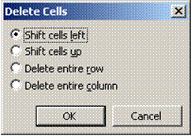

Deleting a row or a column

Just as you can add rows and columns, you can also delete them. But when you delete a row or column that contains data, you also delete all the entries.

If you have rows that you no longer want to include, you can delete them. Remember that, if a row contains data, you also delete all the entries in that row.

* Select the row you want to delete using the Table Select Row command. If you just put the insertion point in the row, you can delete only the cell, not the entire row. Be sure to highlight the entire row.
* Open the Table menu and select the Delete Rows command. The row (along with any data in the row) is deleted.
* If you want to keep the row but simply clear its contents, select the row by dragging across it. Then press the Delete key.
* Follow the same steps to delete a column, using the Select Column and Delete Column commands

Deleting the entire table

Deleting a table is tricky. You might think that you just drag across it and press Delete. This deletes all the entries in the table but leaves the table structure. So, how do you get rid of the entries and the table?

* Select the table using the Table, Select Table menu.
* Open the Table menu and select the Delete Rows command. Word deletes the entire table.

Formative Assessment 7

Open your table document and do the following:

* Delete the last two rows of the table
* Delete the blank column on the right
* Delete the information of the last row
* Delete the information in the cell Demographic form and undo your last action so that the information appears again
* Delete the table and undo your action, so that the table appears in the document again
* Delete the cell called Learner name and undo your action, so that the information appears again

|  |  |  |  |  |
| --- | --- | --- | --- | --- |
| Learner Name | Demographic Form | Copy of ID | Copy of Licence | Copy of PrDP |
| Rasephya M.A. | Yes | Yes | Yes | No |
| Khoza C | Yes | Yes | Yes | No |
| Modise P | Yes | Yes | Yes | Yes |
| Makgatho J.S | Yes | Yes | Yes | Yes |
| Mogoane A.M | Yes | Yes | Yes | Yes |
|  |  |  |  |  |

Move or copy items in a table

Select the cells, rows, or columns you want to move or copy.

* To move or copy text to a new location without changing the text that is already there, select only the text within a cell, and not the end-of-cell mark.

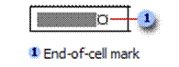

* To replace the existing text and formatting in the new location, select the text you want to move or copy and select the end-of-cell mark.

Do one of the following:

* To move the selection, drag it to the new location.
* To copy the selection, hold down CTRL while you drag the selection to the new location.

Note You can also select rows, columns, or the entire table by clicking in the table and then using the Select commands on the Table menu, or by using keyboard shortcuts.

Formative Assessment 8

Open your table document and do the following:

Move the information of the Khoza C cell to the last row

Copy the information of the Khoza C cell to the third row

|  |  |  |  |  |
| --- | --- | --- | --- | --- |
| Learner Name | Demographic Form | Copy of ID | Copy of Licence | Copy of PrDP |
| Rasephya M.A. | Yes | Yes | Yes | No |
| Khoza C | Yes | Yes | Yes | No |
| Modise P | Yes | Yes | Yes | Yes |
| Makgatho J.S | Yes | Yes | Yes | Yes |
| Mogoane A.M | Yes | Yes | Yes | Yes |
| Khoza C |  |  |  |  |

Number the cells in a table

* Select the cells you want to number. To number the beginning of each row, select only the first column in the table.
* Click the Numbering button on the Formatting toolbar

Formative Assessment 9

In your table document, do the following:

* Add a column to the left of the first column
* Insert numbers from the first row
* Delete the last row

|  |  |  |  |  |  |
| --- | --- | --- | --- | --- | --- |
|  | Learner Name | Demographic Form | Copy of ID | Copy of Licence | Copy of PrDP |
|  | Rasephya M.A. | Yes | Yes | Yes | No |
|  | Khoza C | Yes | Yes | Yes | No |
|  | Modise P | Yes | Yes | Yes | Yes |
|  | Makgatho J.S | Yes | Yes | Yes | Yes |
|  | Mogoane A.M | Yes | Yes | Yes | Yes |
|  | Khoza C |  |  |  |  |

Insert a tab in a table cell

* Press CTRL+TAB.

Use the Convert Table menu to create a table

* Select the text you want to convert to a table
* Select the **Table**, **Convert Text to Table** menu
* Make your selections

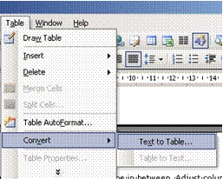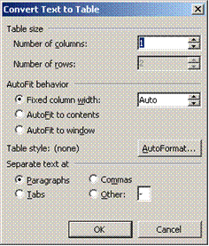

Note a comma, full stop or tab will start a new cell. If this is not what you want, remove commas, full stops and tabs from text.

Draw A Table

Use the Draw Table tool to quickly create a more complex table, for example, one that contains cells of different heights or a varying number of columns per row.

Using Draw Table is similar to drawing a rectangle on graph paper: first, draw a line from one corner of the table to the corner diagonally opposite in order to define the boundary of the entire table, and then draw the column and row lines inside.

* Click where you want to create the table.
* On the Tables and Borders toolbar, click Draw Table
* The pointer changes to a pencil.
* To define the outer table boundaries, draw a rectangle. Then draw the column and row lines inside the rectangle.
* To erase a line or block of lines, click **Eraser** and then drag over the line.
* When you finish creating the table, click a cell and start typing or insert a graphic.

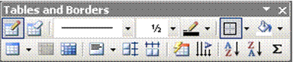

Tip: Hold down CTRL to automatically apply text wrapping while you draw the table.

Formative Assessment 10

* In your table document, draw a table and add the following information:

|  |  |  |  |  |
| --- | --- | --- | --- | --- |
| Learner Name | Demographic Form | Copy of ID | Copy of Licence | Copy of PrDP |
| Golele H.A | Yes | Yes | Yes | Yes |
| Duma T.P | Yes | Yes | Yes | Yes |
| Gabathole G.S | Yes | Yes | Yes | Yes |
| Khanji H.R | Yes | Yes | Yes | Yes |
| Baloyi P. | Yes | Yes | Yes | Yes |
| Dhlamini G.M | Yes | Yes | Yes | Yes |

* Draw a line in the first column from the second to the last rows and move the initials from the firs column to the second column

|  |  |  |  |  |  |  |
| --- | --- | --- | --- | --- | --- | --- |
| Learner Name | | | Demographic Form | Copy of ID | Copy of Licence | Copy of PrDP |
| Golele | | H.A | Yes | Yes | Yes | Yes |
| Duma | | T.P | Yes | Yes | Yes | Yes |
| Gabathole | | G.S | Yes | Yes | Yes | Yes |
| Khanji | H.R | | Yes | Yes | Yes | Yes |
| Baloyi. | P | | Yes | Yes | Yes | Yes |
| Dhlamini | G.M | | Yes | Yes | Yes | Yes |

Format A Table

Merge cells into one cell in a table

You can combine two or more cells in the same row or column into a single cell. For example, you can merge several cells horizontally to create a table heading that spans several columns.

* Select the cells and then select the Table Merge Cells menu
* You can quickly merge multiple cells by selecting them and clicking Merge Cells on the Format menu

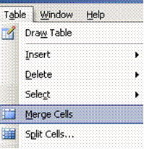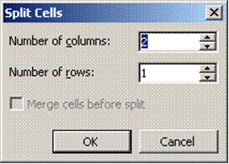

Split a cell into multiple cells in a table

* Select the cells and then select the Table Split Cells menu
* To quickly split multiple cells, select them, and then click Split Cells
* Select the options you need

Change the column width in a table

* Rest the pointer on the column boundary you want to move until it becomes, and then drag the boundary until the column is the width you want.
* To change a column width to a specific measurement, click a cell in the column. On the Table menu, click Table Properties, and then click the Column tab. Choose the options you want.
* To make the columns in a table automatically fit the contents, click a table, point to AutoFit on the Table menu, and then click AutoFit to Contents.

Change the row height in a table

* 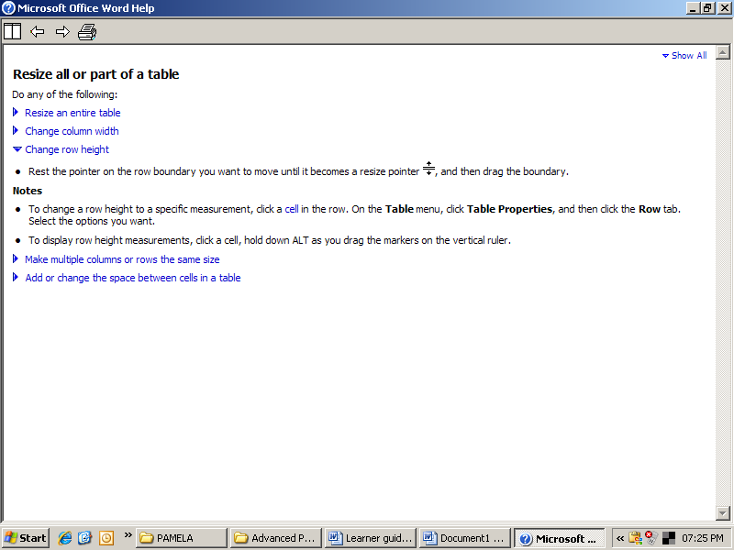Rest the pointer on the row **boundary** you want to move until it becomes a resize pointer, and then drag the boundary.
* To change a row height to a specific measurement, click a cell in the row. On the Table menu, click **Table Properties**, and then click the **Row** tab. Select the options you want.

Tip To display row height measurements, click a cell, hold down ALT as you drag the markers on the vertical ruler

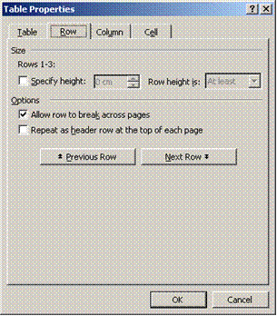

Make multiple columns or rows the same size

* Select the columns or rows you want to make the same size.
* On the Tables and Borders toolbar, click Distribute Columns Evenly or Distribute Rows Evenly

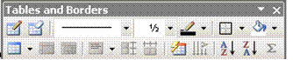

Formative Assessment 11

In your table document, do the following:

* Merge the cells containing the surname and initials of Golele
* Merge the cells containing the surname and initials of Duma

|  |  |  |  |  |  |  |
| --- | --- | --- | --- | --- | --- | --- |
| Learner Name | | | Demographic Form | Copy of ID | Copy of Licence | Copy of PrDP |
| Golele  H.A | | | Yes | Yes | Yes | Yes |
| Duma  T.P | | | Yes | Yes | Yes | Yes |
| Gabathole | | G.S | Yes | Yes | Yes | Yes |
| Khanji | H.R | | Yes | Yes | Yes | Yes |
| Baloyi. | P | | Yes | Yes | Yes | Yes |
| Dhlamini | G.M | | Yes | Yes | Yes | Yes |

* Split the cells containing the details of Golele and Duma into two cells each

|  |  |  |  |  |  |  |  |
| --- | --- | --- | --- | --- | --- | --- | --- |
| Learner Name | | | | Demographic Form | Copy of ID | Copy of Licence | Copy of PrDP |
| Golele | H.A | | | Yes | Yes | Yes | Yes |
| Duma | T.P | | | Yes | Yes | Yes | Yes |
| Gabathole | | | G.S | Yes | Yes | Yes | Yes |
| Khanji | | H.R | | Yes | Yes | Yes | Yes |
| Baloyi. | | P | | Yes | Yes | Yes | Yes |
| Dhlamini | | G.M | | Yes | Yes | Yes | Yes |

* Change the column width of the Golele and Duma cells to fit the cells below
* If necessary, change the column width of the copy of PrDP column to accommodate all the text

|  |  |  |  |  |  |  |
| --- | --- | --- | --- | --- | --- | --- |
| Learner Name | | | Demographic Form | Copy of ID | Copy of Licence | Copy of PrDP |
| Golele | H.A | | Yes | Yes | Yes | Yes |
| Duma | T.P | | Yes | Yes | Yes | Yes |
| Gabathole | | G.S | Yes | Yes | Yes | Yes |
| Khanji | H.R | | Yes | Yes | Yes | Yes |
| Baloyi. | P | | Yes | Yes | Yes | Yes |
| Dhlamini | G.M | | Yes | Yes | Yes | Yes |

* Change the row height of the cells to 2cm

|  |  |  |  |  |  |  |
| --- | --- | --- | --- | --- | --- | --- |
| Learner Name | | | Demographic Form | Copy of ID | Copy of Licence | Copy of PrDP |
| Golele | H.A | | Yes | Yes | Yes | Yes |
| Duma | T.P | | Yes | Yes | Yes | Yes |
| Gabathole | | G.S | Yes | Yes | Yes | Yes |
| Khanji | H.R | | Yes | Yes | Yes | Yes |
| Baloyi. | P | | Yes | Yes | Yes | Yes |
| Dhlamini | G.M | | Yes | Yes | Yes | Yes |

Add a border to a table

* To add a border to a table, click anywhere in the table.
* To add borders to specific cells, select the cells, including the end-of-cell mark.
* On the **Format** menu, click **Borders and Shading**, and then click the **Borders** tab.
* When you insert a table, it has a black ½-pt solid single-line border by default. Use the **Style, Colour**, and **Width** options to add a different border.
* Make sure the correct option — Table or Cell — is selected under Apply to. Select the other options you want.
* To specify that only particular sides get borders, click **Custom** under **Setting**. Under **Preview**, click the diagram's sides, or use the buttons to apply and remove borders.
* To specify the exact position of the border relative to the text, click **Paragraph** under **Apply to**, click **Options**, and then select the options you want.

Add shading to a table, a paragraph, or selected text

* You can use shading to fill in the background of a table, a paragraph, or selected text.
* To add shading to a table, click anywhere in the table. To add shading to specific cells, select the cells, including the end-of-cell marks.
* To add shading to a paragraph, click anywhere in the paragraph. To add shading to specific text, such as a word, select the text.
* On the **Format** menu, click **Borders and Shading**, and then click the **Shading** tab.
* Select the options you want.
* Under **Apply to**, click the part of the document you want to apply shading to. For example, if you clicked a cell without selecting it in step 1, click Cell. Otherwise, Word applies the shading to the entire table.

Change the orientation of text in a cell

* 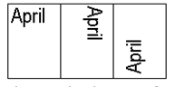Click the table cell that contains the text you want to change.
* On the **Format** menu, click **Text Direction**.
* Click the orientation you want.

Change the alignment of text in a table cell

* Click the cell that contains text you want to align.
* On the **Tables and Borders** toolbar, select the option for the horizontal and vertical alignment you want

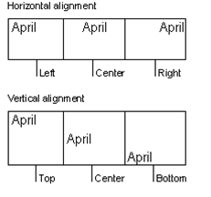

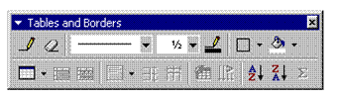

Change the space between cells in a table

* Click the table.
* On the **Table** menu, click **Table** **Properties**, and then click the **Table** tab.
* Click **Options**.
* Under **Default** cell spacing, select the **Allow** **spacing** between cells check box and enter the measurement you want.

Change the cell margins in a table

* Click the table.
* On the **Table** menu, click **Table** **Properties**, and then click the **Table** tab.
* Click **Options**.
* Under **Default** cell margins, enter the new values you want.

Note You can also change the margins in an individual cell. Click the cell. In the Table Properties dialog box (Table menu, Table Properties command), click the Cell tab, and then click Options. Clear the Same as the whole table check box, and then enter the new margin values.

Change the text colour in a table

* Select the text either in a cell, row or column. You can also select the entire table
* From the **Format Font** menu, select the required font colour
* Click **OK**

OR

* Select the text and click the **Font Colour** button on the formatting table
* Select the colour you need.

Formative Assessment 12

In your table document, add a border to the table

* Add shading to the table
* Change the text colour of the name column to dark blue

Resize a table

* Rest the pointer on the table until the table move handle appears on the upper-left corner of the table.
* Rest the pointer on the table resize handle until a double-headed arrow appears.
* Drag the table boundary until the table is the size you want.

Move a table

* Rest the pointer on the table until the table move handle appears on the upper-left corner of the table.
* Rest the pointer on the table move handle until a four-headed arrow appears.
* **Drag** the table to the new location.

Table move handle and resize handle

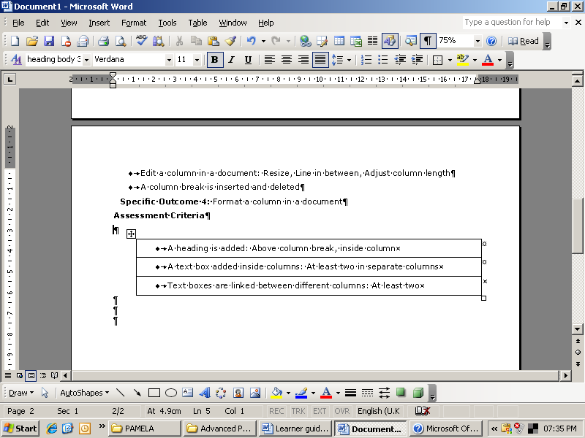Use the table move handle to move the table to another place on a page, and use the table resize handle to change the size of a table.

Break a table across pages

* Click the row you want to appear on the next page.
* Press **CTRL+ENTER**.

Automatically format a table

* Click the table.
* On the **Table** menu, click **Table AutoFormat**.
* In the **Formats** box, click the format you want.
* Select the options you want.

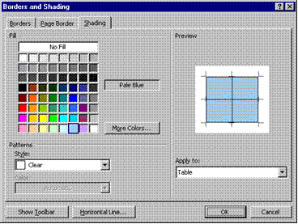

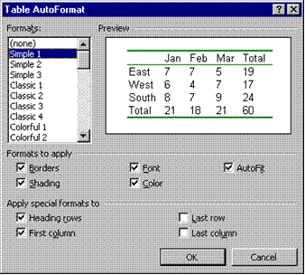

Formative Assessment 13

In your table document, select your first table and automatically format the table to table list 6

Nested Tables

If you use a table to lay out a page, and you want to use another table to present information, you can insert a nested table: a table within a table.

* On the Tables and Borders toolbar, click Draw Table
* The pointer changes to a pencil.
* Position the pencil in the cell where you want the nested table (or a table inside another table).
* Draw the new table. To define the table boundaries, draw a rectangle. Then draw the column and row lines inside the rectangle.
* When you finish creating the nested table, click a cell, and start typing or insert a graphic.

Working With Long Tables

When you work with a very long table, it must be divided wherever a page break occurs.

You can make adjustments to the table to make sure that the information appears as you want it to when the table spans multiple pages.

Repeat headings on every page

* Select the row or rows that you want to use as a table heading. The selection must include the first row of the table.
* On the Table menu, click Heading Rows Repeat.
* Microsoft Word automatically repeats table headings on new pages that result from automatic page breaks. Word does not repeat a heading if you insert a manual page break within a table.
* Repeated table headings are visible only in print layout view or when you print the document.

Control where the table is divided

* To prevent a table row from breaking across pages:
* Click the table.
* On the Table menu, click Table Properties, and then click the Row tab.
* Clear the Allow row to break across pages check box.

To break a table across pages:

* Click the row you want to appear on the next page.
* Press CTRL+ENTER.

Using Tables As Spreadsheets

You can use tables to perform some of the tasks you might use a spreadsheet for, for example, you can sort table entries in alphabetical, numeric, or date order. You can also total a row or column of numbers in a table, as well as perform other calculations, such as averaging.

Total the numbers in a row or column

* Click the cell in which you want the sum to appear.
* On the **Table** menu, click **Formula**.
* If the cell you selected is at the bottom of a column of numbers, Microsoft Word proposes the formula =SUM(ABOVE). Click OK if this is correct.
* If the cell you selected is at the right end of a row of numbers, Word proposes the formula =SUM(LEFT). Click OK if this is correct.
* If you see codes between braces, for example, {=SUM(LEFT)}, instead of the actual sum, Word is displaying field codes. To display field code results, press SHIFT+F9.
* If your column or row contains blank cells, Word will not total the entire column or row. To total the entire row or column, type a zero in each blank cell.
* To quickly total a row or column of numbers, click the cell where you want the sum, and then click AutoSum on the Tables and Borders toolbar.

Perform calculations in a table

* Click the cell in which you want the result to appear.
* On the **Table** menu, click **Formula**.
* If Word proposes a formula that you do not want to use, delete it from the Formula box.
* In the Paste function box, click a function. For instance, to add numbers, click SUM.
* To reference the contents of a table cell, type the cell references in the parentheses in the formula. For instance, to add the numbers in cells A1 and B4, the formula would read =SUM(a1,b4)
* In the Number format box, enter a format for the numbers. For example, to display the numbers as a decimal percentage, click 0.00%.

Note: Word inserts the result of the calculation as a field in the cell you selected. If you change the referenced cells, you can update the calculation by selecting the field and then pressing F9.

Sort a single column in a table

* Select the column or cells you want to sort.
* On the **Table** menu, click **Sort**.
* Select the sort options you want.
* Click **Options**.
* Select the Sort column only check box.

Tip If you want to individually sort columns of information that aren't in a table, first convert the text to a table.

Sort a list or table

* Select the list or table you want to sort.
* On the **Table** menu, click **Sort**.
* Select the sort options you want.

Formative Assessment 14

* In your table document, type the following text:

Subject Marks

Afr 80

Eng 81

Science 76

Biology 65

Maths 67

Accounting 56

* Remember to add a tab between the subject and the mark
* Convert the text to a table
* Resize the columns to fit the text
* Add a row to the bottom of the table
* Add the total of the marks column
* Sort the information in alphabetical order

|  |  |
| --- | --- |
| Subject | Marks |
| Accounting | 56 |
| Afr | 80 |
| Biology | 65 |
| Eng | 81 |
| Maths | 67 |
| Science | 76 |
|  | 425 |

Creating Excel Worksheets

Microsoft Excel is a program used to create spreadsheets. These spreadsheets are similar to tables in Microsoft Word, but have additional functions, for example working out formulas and formatting cells.

Word provides several ways to insert Microsoft Excel data into a Word document. For example, you can easily copy and paste a worksheet or chart. Or you can insert the worksheet or chart as a linked object or embedded object. The main differences between linking and embedding are where the data is stored and how it is updated after you place it in the document:

#### Linked worksheets

A linked worksheet or chart appears in your document, but its information is stored in the original Excel workbook. Whenever you edit the data in Excel, Word can automatically update the worksheet or chart in your document. Linking is useful when you want to include information that is maintained independently, such as data collected by a different department, and when you need to keep that information in Word up-to-date. Because the linked data is stored in another location, linking can also help minimize the file size of your Word document.

#### Embedded worksheets

An embedded worksheet or chart stores its information directly in the Word document. You can create an embedded object from an existing Microsoft Excel worksheet or chart or you can create a new embedded Microsoft Excel worksheet or chart. To edit the embedded object, just double-click it to start Excel, make your changes, and then return to Word. You can embed an existing worksheet or chart, or start from scratch by embedding a new, blank worksheet or chart. Because the information is totally contained in one Word document, embedding is useful when you want to distribute an online version of your document to people who don't have access to independently maintained worksheets or charts.

Inserting a Worksheet

* In the Standard toolbar you can use the Microsoft Excel Worksheet button to insert an Excel worksheet. The procedure is similar to that of inserting a table.

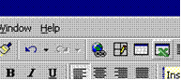 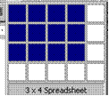

* Click on the **Insert MS Excel Worksheet** Button and insert a worksheet of 3 rows by 4 columns.
* After selecting the number of rows and columns, the worksheet will be inserted on the document. The working area may be increased by dragging it bigger
* 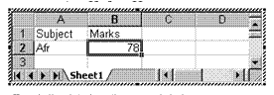Type in the data from the example below:

Subject Marks

Afr 78

Eng 81

Science 76

Biology 65

Maths 67

Accounting 56

* When you have finished typing in the information in the cells, click outside the worksheet to apply the data to your document. Notice that the background has a grey colour.
* To make changes to the worksheet, you can double-click on it to make it active again.

When you create an embedded Microsoft Excel object, an entire workbook is inserted into your document — although you can display only one worksheet at a time. To display a different worksheet, double-click the embedded object, and then click a different worksheet.

Worksheet functions

* When the worksheet is active, you will notice that the default toolbars of Word are replaced by the toolbars of Excel. This means that you have full control over your worksheet, just as if you are working in Excel itself.
* Most of the functions that you get when you right-click in a table are the same when working on a worksheet in Word. A big advantage of an Excel worksheet is that the formulas get updated automatically when data is changed.

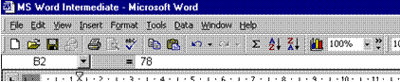

Create a linked object from an existing Microsoft Excel worksheet or chart

* Open both the Word document and the Microsoft Excel workbook that contains the data you want to create a linked object from.
* Switch to Microsoft Excel, and then select the entire worksheet, a range of cells, or the chart you want. Click Copy
* Switch to the Word document, and then click where you want to insert the linked object.
* On the Edit menu, click Paste Special. Click Paste link.
* In the As box, click the option you want.
* If you're not sure which one to choose, click an option and read the description in the Result box.

Formative Assessment 15

* Create an Excel worksheet containing the following information:

Subject Marks

Afr 80

Eng 81

Science 76

Biology 65

Maths 67

Accounting 56

* Create a linked object from the Excel worksheet to your table document

Formative Assessment 16

* Create a new file and save it as **PICTURES**
* Start with a blank page, slide, or worksheet
* On the **Drawing** toolbar, click **Insert Clip Art** Insert Clip Art button
* From the **Search in:** list box, uncheck all the boxes then expand the **Web Collections** category and check the categories such as **Concepts** and **Emotions**
* From the **Results should be** box, uncheck **Photographs**, **Movies**, and **Sounds**
* Type the keywords **cartoon** and **confused** then click **Go**
* Browse the results for this clip then click it to insert it



* Change the search text to **cartoon** **happy** and click **Go**
* Insert the clip shown below



* Close the **Clip Art** task pane
* Select the first picture then on the **Picture** toolbar, click the **Crop** tool Crop button
* Crop to remove the bomb part of the picture
* From the **Tools** menu, select **Options**
* When the dialogue box is displayed, press +
* Press to close the dialogue box then press + to paste the graphic

Tips To move and resize a picture, click-and-drag it. To resize a graphic, click-and-drag the handles on its border. If you want one picture to appear in front of another, right-click it and select **O**r**der** then **Bring to Fron**t.  
To flip the puzzled man picture, use the D**raw** button on the **Drawing** toolbar. If you are using Word and the pictures appear with black handles, click each picture then on the **Picture** toolbar, click **Text Wrapping** Text Wrapping button and select **I**n **Front of Text**.

* Save and close the file
* Create another blank file and save it as **FALCON**
* On the **Drawing** toolbar, click **Insert Clip Art** Insert Clip Art button
* Using the **Web Collection** again, search the **Animals** category for **Photographs**
* Insert the picture of a falcon
* Select the picture then on the **Picture** toolbar, click the **Crop** tool
* Point to each handle in turn and click-and-drag to crop the picture as shown
* 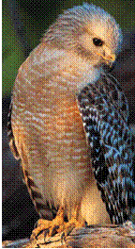Save and close the document

Formative Assessment 17

Open your practice document and add the following text:

Why is it that some people can finish 57 assorted tasks in any given day while others only finish two or three tasks and then complain that they were too busy or did not have enough time to finish the rest?

* Save your document as a Word document
* Save your document as a text only document
* Close the document
* Close Word
* Go to Windows Explorer or My Computer to find your text only document
* Open the document to see what the text looks like now.
* Save and close the document