LEARNER GUIDE

67465 National Certificate
Business Administration Services
Level 3

Module 9 General Business Skills

Unit Standard 8000 NQF Level 3 Credits 9
Applying basic business principles

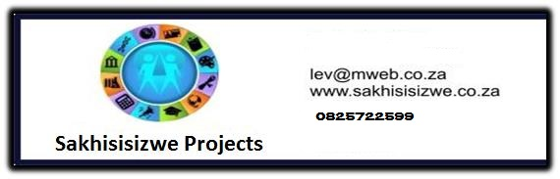

TABLE OF CONTENTS

TABLE OF CONTENTS i
PERSONAL INFORMATION 4
INTRODUCTION 5
Programme methodology 5
What Learning Material you should have 5
Different types of activities you can expect 6
Learner Administration 7
Assessments 7
Learner Support 8
Learner Expectations 9
UNIT STANDARD 8000 10
SECTION ONE: UTILISE RESOURCES 11
What is supervision? 11
Manage resources 12
Exercise 1 13
SECTION TWO: IDENTIFY AND APPLY GOALS 13
Goals and objectives 13
Exercise 2 13
The difference between a goal and an objective 13
Setting objectives 14
General rules when writing goals and objectives: 14
Exercise 3 15
Action plans 15
Exercise 4 15
SECTION THREE: CUSTOMER SERVICE 16
Customer care 16
What is a customer? 16
What a customer is not 16
What customers expect 17
What if we don’t satisfy their needs? 17
What customers want 17
What customers hate 18
Key Questions Pertaining To Customer Service 19
Who is responsible for customer satisfaction? 19
The customer has a wider choice 20
Exercise 5 20
Internal And External Customers 20
Customers and stakeholders 20
Exercise 6 21
Identify customer service needs 21
The Cost of Poor Service 21
Exercise 7 21
SECTION FOUR: BUSINESS SOLUTIONS 22
Business types 22
Sole trader 22
Partnership 22
Close corporation 23
Private company 23
Public company 23
What Is A Business? 23
Costs 24
Cost saving within a business 24
Income from Sales 25
What is profit? 25
What are profits used for? 26
How the business manages the money 26
Cash flow 28
Supply and demand 29
Technology 29
Work Ethic 30
General Code Of Ethics And Conduct 30
A definition of ethics 31
Business ethics 32
Unethical Practices in the workplace 33
Good Work Ethics 33
Cost Of Poor Ethics 34
Contributing to an ethical work environment: 34
Exercise 8 34
Decision Making 34
Define The Problem or goal 34
Collect facts to meet the requirements of the problem 35
Verify the information 35
Analyse The Facts or problem 35
Determine possible courses of action 35
Establish criteria and evaluate possible solutions against the criteria 35
Things that can influence your decision 36
Select the solution 36
Decision making pitfalls to avoid 37
Implement the solution 37
Monitor implementation 38
Review the solution 38
Exercise 9 38

PERSONAL INFORMATION
NAME
CONTACT ADDRESS
Code
Telephone (H)
Telephone (W)
Cellular
Learner Number
Identity Number
EMPLOYER
EMPLOYER CONTACT ADDRESS
Code
Supervisor Name
Supervisor Contact Address
Code
Telephone (H)
Telephone (W)
Cellular


INTRODUCTION

Welcome to the learning programme
Follow along in the guide as the training practitioner takes you through the material. Make notes and sketches that will help you to understand and remember what you have learnt. Take notes and share information with your colleagues. Important and relevant information and skills are transferred by sharing!
This learning programme is divided into sections. Each section is preceded by a description of the required outcomes and assessment criteria as contained in the unit standards specified by the South African Qualifications Authority. These descriptions will define what you have to know and be able to do in order to be awarded the credits attached to this learning programme. These credits are regarded as building blocks towards achieving a National Qualification upon successful assessment and can never be taken away from you!


Programme methodology

The programme methodology includes facilitator presentations, readings, individual activities, group discussions and skill application exercises.
Know what you want to get out of the programme from the beginning and start applying your new skills immediately. Participate as much as possible so that the learning will be interactive and stimulating.
The following principles were applied in designing the course:
- Because the course is designed to maximise interactive learning, you are encouraged and required to participate fully during the group exercises
- As a learner you will be presented with numerous problems and will be required to fully apply your mind to finding solutions to problems before being presented with the course presenter’s solutions to the problems
- Through participation and interaction the learners can learn as much from each other as they do from the course presenter
- Although learners attending the course may have varied degrees of experience in the subject matter, the course is designed to ensure that all delegates complete the course with the same level of understanding
- Because reflection forms an important component of adult learning, some learning resources will be followed by a self-assessment which is designed so that the learner will reflect on the material just completed.
This approach to course construction will ensure that learners first apply their minds to finding solutions to problems before the answers are provided, which will then maximise the learning process which is further strengthened by reflecting on the material covered by means of the self-assessments.

Different role players in delivery process
- Learner
- Facilitator
- Assessor
- Moderator

What Learning Material you should have
This learning material has also been designed to provide the learner with a comprehensive reference guide.
It is important that you take responsibility for your own learning process; this includes taking care of your learner material. You should at all times have the following material with you:
  Learner Guide | This learner guide is your valuable possession:  This is your textbook and reference material, which provides you with all the information you will require to meet the exit level outcomes.  During contact sessions, your facilitator will use this guide and will facilitate the learning process. During contact sessions a variety of activities will assist you to gain knowledge and skills.  Follow along in the guide as the training practitioner takes you through the material. Make notes and sketches that will help you to understand and remember what you have learnt. Take and share information with your colleagues. Important and relevant information and skills are transferred by sharing!  This learning programme is divided into sections. Each section is preceded by a description of the required outcomes and assessment criteria as contained in the unit standards specified by the South African Qualifications Authority. These descriptions will define what you have to know and be able to do in order to be awarded the credits attached to this learning programme. These credits are regarded as building blocks towards achieving a National Qualification upon successful assessment and can never be taken away from you!
  Formative Assessment Workbook | The Formative Assessment Workbook supports the Learner Guide and assists you in applying what you have learnt.  The formative assessment workbook contains classroom activities that you have to complete in the classroom, during contact sessions either in groups or individually.  You are required to complete all activities in the Formative Assessment Workbook.  The facilitator will assist, lead and coach you through the process.  These activities ensure that you understand the content of the material and that you get an opportunity to test your understanding.

Different types of activities you can expect
To accommodate your learning preferences, a variety of different types of activities are included in the formative and summative assessments. They will assist you to achieve the outcomes (correct results) and should guide you through the learning process, making learning a positive and pleasant experience.

The table below provides you with more information related to the types of activities.
Types of Activities | Description | Purpose
Knowledge Activities   | You are required to complete these activities on your own. | These activities normally test your understanding and ability to apply the information.
Skills Application Activities   | You need to complete these activities in the workplace | These activities require you to apply the knowledge and skills gained in the workplace
  Natural Occurring Evidence | You need to collect information and samples of documents from the workplace. | These activities ensure you get the opportunity to learn from experts in the industry.  Collecting examples demonstrates how to implement knowledge and skills in a practical way

Learner Administration


Attendance Register
You are required to sign the Attendance Register every day you attend training sessions facilitated by a facilitator.

Programme Evaluation Form
On completion you will be supplied with a “Learning programme Evaluation Form”. You are required to evaluate your experience in attending the programme.
Please complete the form at the end of the programme, as this will assist us in improving our service and programme material. Your assistance is highly appreciated.

Assessments
The only way to establish whether a learner is competent and has accomplished the specific outcomes is through the assessment process. Assessment involves collecting and interpreting evidence about the learners’ ability to perform a task.

To qualify and receive credits towards your qualification, a registered Assessor will conduct an evaluation and assessment of your portfolio of evidence and competency.
This programme has been aligned to registered unit standards. You will be assessed against the outcomes as stipulated in the unit standard by completing assessments and by compiling a portfolio of evidence that provides proof of your ability to apply the learning to your work situation.

How will Assessments commence?

Formative Assessments
The assessment process is easy to follow. You will be guided by the Facilitator. Your responsibility is to complete all the activities in the Formative Assessment Workbook and submit it to your facilitator.

Summative Assessments
You will be required to complete a series of summative assessments. The Summative Assessment Guide will assist you in identifying the evidence required for final assessment purposes. You will be required to complete these activities on your own time, using real life projects in your workplace or business environment in preparing evidence for your Portfolio of Evidence. Your Facilitator will provide more details in this regard.
To qualify and receive credits towards your qualification, a registered Assessor will conduct an evaluation and assessment of your portfolio of evidence and competency.

Learner Support
The responsibility of learning rests with you, so be proactive and ask questions and seek assistance and help from your facilitator, if required.
Please remember that this Skills Programme is based on outcomes based education principles which implies the following:
- You are responsible for your own learning – make sure you manage your study, research and workplace time effectively.
- Learning activities are learner driven – make sure you use the Learner Guide and Formative Assessment Workbook in the manner intended, and are familiar with the workplace requirements.
- The Facilitator is there to reasonably assist you during contact, practical and workplace time for this programme – make sure that you have his/her contact details.
- You are responsible for the safekeeping of your completed Formative Assessment Workbook and Workplace Guide
- If you need assistance please contact your facilitator who will gladly assist you.
- If you have any special needs please inform the facilitator

Learner Expectations
Please prepare the following information. You will then be asked to introduce yourself to the instructor as well as your fellow learners


Your name:
The organisation you represent:
Your position in organisation:
What do you hope to achieve by attending this course / what are your course expectations?

UNIT STANDARD 8000

Unit Standard Title
Applying basic business principles

Unit Standard Id
8000

NQF Level
3

Credits
9

Purpose
A learner accredited with this standard will be able to understand and effectively apply basic business principles in order to improve productivity and efficiency of practice within the Freight Handling Environment

Learning Assumptions
NQF 1 or General Education and Training Certificate

Range
The applied competence expressed in this standard will enable the learner to select and implement the most effective business solution/s to familiar problems within own operational environment, with partial responsibility for quality under limited guidance

Specific Outcomes And Assessment Criteria
Specific Outcome 1: Utilise machinery, equipment, materials and time allocated to the individual cost effectively and productively
Assessment Criteria:
- Identify and explain methods for ensuring cost-effective utilisation of allocated resources
Specific Outcome 2: Identify and apply goals aligned to the work situation which reflect the organisational goals.
Assessment Criteria:
- Suggest methods to be used to combat cost overruns with respect to a given budget
- Explain how an individual`s actions impact on organisational profit and/or loss and cashflow
Specific Outcome 3: Maintain and enhance organisational image and customer service (both internal and external).
Assessment Criteria:
- Demonstrate an understanding of the impact of quality customer service on profitability
- Explain how an individual`s actions impact on organisational profit and/or loss and cashflow
Specific Outcome 4: Identify and anticipate customer`s requirements, and meeting those requirements within budget constraints
Assessment Criteria:
- Describe relationships between the stakeholders in a business and how that will impact on an organisations` success
Specific Outcome 5: Select and implement the most effective business solution to problems within his/her own operational environment and level of authority
Assessment criteria
- Generate and consider options and possibilities for improving the profitability of an operation within a simulated environment, making recommendations on new methods and/or technologies which will enhance competitiveness
- Suggest methods to be used to combat cost overruns with respect to a given budget
- Describe the impact of new technologies on the budget of an organisation

Unit Standard Essential Embedded Knowledge
- Different business entities and the legal relationships and responsibilities that exist in such entities
- The principles of supply and demand, and the effect of these principles on an organisation (e.g. remaining globally competitive).
- The relationship between "accountability" and "responsibility" in a corporate environment
- The principles of profit and loss, and the factors which impact on this (e.g. interest rates, fixed costs).
- Availability and effectiveness of new technologies on the profitability of an organisation
- Business ethics, a quality customer service and current labour legislation within an industry context and how this impacts on operations and profitability

Critical Cross-Field Outcomes
- Identify and solve problems by taking proactive measures to prevent or eliminate problems that impact on organisation
- Demonstrate initiative in developing personal interactions with customers designed to enhance corporate image and quality of service, by working effectively with others and in teams
- Collect, analyse, organise and critically evaluate information to make suggestions for business improvement
- Demonstrate initiative in analysing impact of own actions (or lack thereof) on budget, by managing and organising oneself

SECTION ONE: UTILISE RESOURCES

Specific outcome
Utilise machinery, equipment, materials and time allocated to the individual cost effectively and productively

Assessment criteria
Identify and explain methods for ensuring cost-effective utilisation of allocated resources

What is supervision?
Let us first look at some simplified examples and definitions.
When a person says: “I will supervise my child's homework, I will supervise the moving of the furniture, I will supervise the football or sports training,” what do they really mean?
Very simply, they mean they will look after.
When supervising, you look after your child's homework, the moving of your household furniture, the football or sports training, or any other type of work.
To continue with our simplified definition, let's ask the simple and again seemingly obvious question of Why do you need to look after it?
You need to look after all these jobs, or activities, to see that they are well done.
So, our complete and simple description of what supervision is should read:
To look after a job to see that it is well done
This basic meaning of supervision may be enlarged upon, or made more specific for the working world as:
Supervision is the function of working with and through people to achieve specific production objectives.

Manage resources
We are all familiar with the word resource. However, it is still one of those words that may have different meanings to different people. (1 hope that you can see that 1 am alert to good communications!)
A resource refers to available assets. That is, simply the things that are available for us to use. A country's resources are its people, minerals, etc. like gold, oil or agriculture.
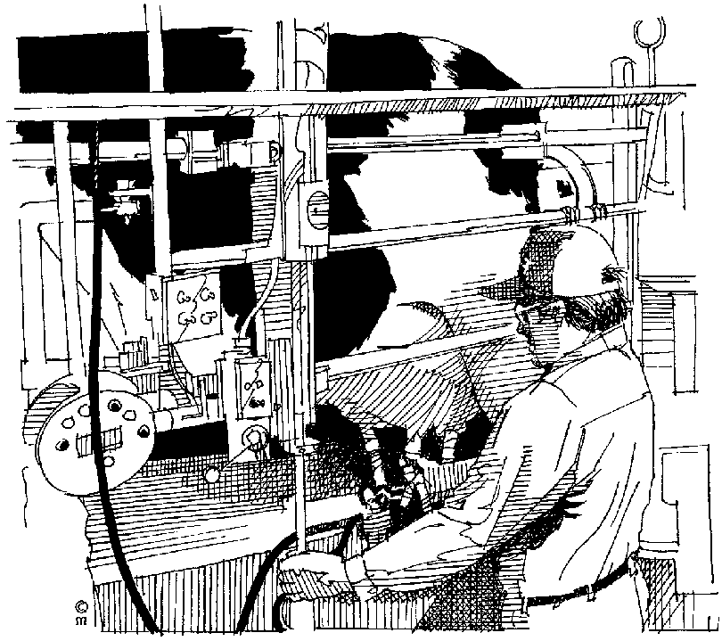

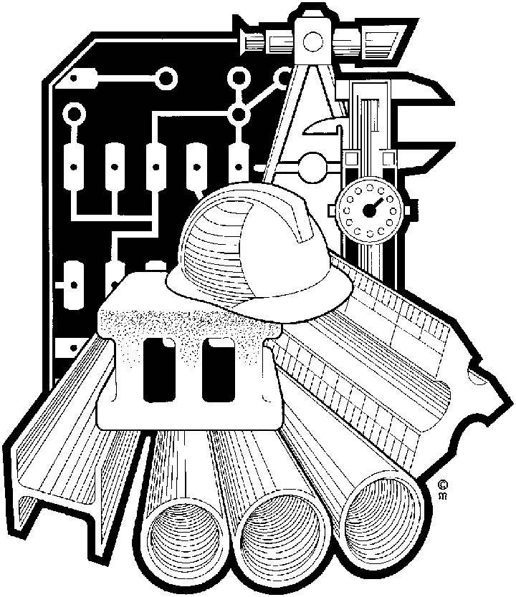
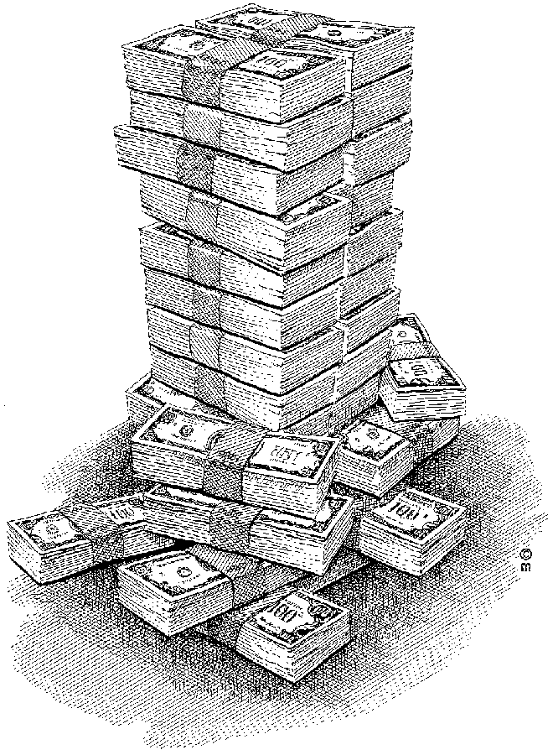
As far as a supervisor is concerned, resources are all the things that help him do a job of work. To a supervisor, resources are:
- Minutes/time
- Men/people
- Machines
- Materials
- Money

The aim of allocating and using resources is to use them in such a way that productivity is improved. This is the supervisor's ultimate goal.
It is important to note that each resource is not used on its own. They are the 'ingredients' that are used together. For example, when stocktaking for materials, you are also using men and time.

Minutes/time
Whenever the topic of resources is introduced everyone mentions machines, tool, men and materials. They invariably either forget, or are not aware of the value of time, and what an important resource it is.
This is probably because it is not as tangible as materials, men, machines and money. It is an intangible, but is probably the most important of all.
Without any doubt, time is everyone's most valuable resource. We all have the same amount of time – twenty four hours a day. It is up to the supervisor to be aware of it, and make the most of it. If he forgets about it, he will end up running in circles and not achieving anything at the end of the day.

Men/people
Most of the supervisor's time is used up in directing the work activities of his human resource, his people. People are a very valuable resource.
Remember that computers need people to program and operate them. Automatic machines need people to set and check them. They all need electronics experts to service and repair them. Buses and trucks need people to drive them. It is a fact of life that in essence, nothing has changed. People are just as important, and in some areas, even more important now than they ever were.

Machines
When we talk about machines as a resource, we do not only mean the big drills, presses, cutting machines, we also mean all the tools that are used, like spanners, hammers, saws, screwdrivers, etc.

Materials
Materials are also referred to as consumables, or things that are used up. This would include things like our raw materials such as wood (furniture), rolls of yarn (clothing), sheets or coils of steel (engineering) or sand (building), etc.
The supervisor usually entrusts his materials to the store for safekeeping and requisitions them out only when needed. The store's job is to look after and keep track of all the materials.

Money
The last resource is money. As we know, this is very important to all of us, especially when times are hard.
Generally the supervisor does not have that much to do with money. He is given a budget and he must stay within that budget for his section. If he goes over budget, he will have to explain why.
As a supervisor or junior manager, you will have to organise the resources in your department to that as little time, money etc is wasted. In the transport business, you will have to organise your resources in such a way that drivers do not sit around with nothing to do because the truck has gone in for a service or a truck or bus standing idle because the driver is off sick.
This means that you have to plan ahead for unexpected things that can happen.

Exercise 1

SECTION TWO: IDENTIFY AND APPLY GOALS

Specific outcome
Identify and apply goals aligned to the work situation which reflect the organisational goals.

Assessment criteria
- Suggest methods to be used to combat cost overruns with respect to a given budget
- Explain how an individual`s actions impact on organisational profit and/or loss and cashflow

Goals and objectives
A supervisor will receive plans from his/her manager. These plans contain the goals and objectives for the department/section and have to be put into action.
As a junior manager, whatever your position is called, you will be given goals and objectives to achieve. It is your responsibility to implement these objectives, even if you were not consulted when they were determined. This is your job, this is what you are paid for and YOU HAVE TO DO IT!
Right, so you get the goals and objectives from your manager. Now you have to implement these goals and objectives:
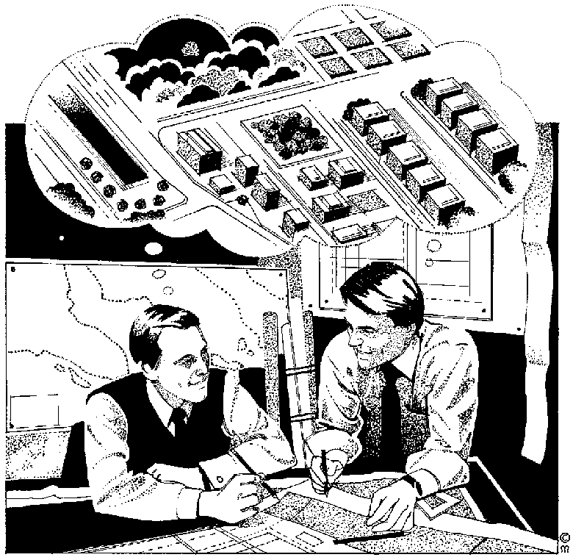
You have to plan how you are going to achieve the goals and objectives given to you. You do this by setting the goals and objectives for your department and then developing an action plan from the goals and objectives.
- Formulate goals and objectives for your department/section, according to the strategic and tactical plans received from your manager
- Ensure that goals are formulated in line with the vision and mission of the organisation
- While you formulate goals and objectives, you also set the standards for key performance areas where performance can be monitored continually. Key performance areas are performance areas in businesses that are important and that can be checked on all the time. For example, sales figures can be monitored continually as can the number of buses or trucks that are operational.

Exercise 2

The difference between a goal and an objective
A Goal is a general outcome statement.
An Objective spells out clearly and in measurable terms, what the goal or aim will look like when met.
You first decide on a goal that can be achieved, to enable you to focus more accurately on the objective. It would be difficult to develop an objective without some idea [the goal] of what the goal is.
Therefore, the goal is decided upon first. Then we write our SMART objectives, is such a way that it will help everyone involved with it to attain it. This is why the goal always comes before the objective.
Example
- The Goal: Improve production in the assembly plant,
- The Objective: by 10% before January 15, by upgrading the machinery involved.
The goal is usually only the action or activity. That is, to diet, to stop smoking, to devote time to the children, to paint the house, or tidy the garage, etc. These goals are adequate for home and sport activities, but do not contain enough substance to enable anyone to really become seriously motivated to actually attain them.

Setting objectives
Objectives must always be SMART:
- Specific
- Measurable
- Attainable
- Relevant
- Time bound

Specific
Objectives must be specific. Don’t say, “I want to bake more cakes per day,” rather say: “I want to bake 50 cakes per day”.

Measurable
You must be able to measure the objective if you want to use it as a control system. How can you check if you are achieving goals and objectives if you don’t know against what you should check them?
Include as many of the following as possible:
- Quality: To SABS standard 1076; without any rejects; as per maintenance schedule rules, etc.
- Quantity: reduce rejects by 5%; tidy up all the scrap; a minimum of six bottles per case, etc.
- Cost/Value: reduce the overheads by 5%; cut the comptetitors price by at least Rl, etc.

Attainable
You have to set objectives that can be reached. If you set objectives that cannot possibly be reached, you are wasting time and you and your staff will become discouraged. You cannot possibly start baking 1500 cakes per day, if you have been baking 50 cakes per day.

Relevant:
The objective must be relevant to the specific goal as well as the goals of the business. Don’t set an objective that has no relevance to the goal: “I want to make 45 meat platters per day” has no relevance to baking cakes. If your objectives are not relevant to the goal, you will confuse yourself and your staff.

Time
You have to set a date by when you want to achieve the objective. “ I want to bake 70 cakes per day by the end of February.” Examples could be: Within the next two weeks; by January 15; before lunch break/stocktaking/home time, etc.
An objective without a time parameter is like an athlete running a race without being timed. He may win, but how good is that?

General rules when writing goals and objectives:
- Always commit goals and objectives to paper. We tend to try and achieve goals once we have written them down.
- It is obvious that objectives must be clearly understood by all those who will be involved with them, so always use clear and simple language.
- Test the objectives on someone else first. If they express the slightest hint of doubt, don't argue - fix it!
- Communicate both in writing and verbally, if you can.
- Clarify and confirm understanding: ensure that the people who have to do the work to achieve the goals understand what is expected of them. When you have to clarify understanding, ask the person to repeat in his/her own words what is expected of them. Then you can listen to what they are saying and check if they really understand.

Exercise 3

Action plans

Developing The Action Plan
Once you have written down your goals and objectives you have to develop plans for the realisation of the objectives. These plans are called action plans.
In the action plan you must specify and explain clearly WHAT has to be done, WHY it must be done, WHEN it should be done, WHO must do it and HOW it should be done.
An action plan is like a map that you will use to find out if things are being done the way you want it done.

Writing Objectives
Here’s a handy tool to use when writing objectives. Use this format and your objectives should always be SMART. remember to align all your goals and objectives with the strategic and tactical plans as made by top and middle management, as well as the vision statement of your organisation and department.

Objective | Target Date | Responsibility | Action Steps | Resources
What must be done | By when it should be done | Who should do it | How should they do it | What resources will they need to do it
An example can be found in handout 1

Implement An Action Plan
The previous steps in the planning process concerned the thought process. These ideas and goals, as well as the manner in which they are to be achieved must now be brought into operation and must be evaluated continuously.
Plans do not mysteriously activate themselves. You must put the plans into effect. One of the problems about planning is that too often the planners are not the doers. As a result, detailed plans running to hundreds of pages may do no more than gather dust.
Planning, no matter how carefully and painstakingly done, is useless and a waste of time without commitment and action.
This means that you have to start doing the things that must be done according to the action plan, or see that the people who must do it, are doing it. This is the activating process. You have to communicate your goals and objectives to the people involved, you have to delegate roles and responsibilities and you have to coordinate the efforts of your staff and other sections or departments.
You also have to organise your resources:
- Man: Human Resource
- Material:
- Machinery:
- Money:
- Time

Exercise 4

SECTION THREE: CUSTOMER SERVICE

Specific Outcome
Maintain and enhance organisational image and customer service (both internal and external).
Identify and anticipate customer’s requirements and meet those requirements within budget constraints

Assessment Criteria
- Demonstrate an understanding of the impact of quality customer service on profitability
- Explain how an individual’s actions impact on organisational profit and/or loss and cashflow
- Describe relationships between the stakeholders in a business and how that will impact on an organisations` success

Customer care
Customer care actually involves two distinct terms, namely the customer and care. Let us briefly explore these terms within the context of our programme.
Customers are often defined as those people who buy our products and services. Customers are therefore those people without whom a business cannot survive. They are directly responsible for our income, which is essential in rendering the service.
The Oxford Dictionary defines care as “Feel concern or interest for or about. Feel regard, deference (compliance), affection, for, be concerned. Be willing or wishful to.
In simple terms customer care therefore refers to those positive and critical attitudes, actions and behaviour towards the people without whom we cannot stay in business.
Let us focus briefly on the caring side of customer care. If you care about your children, you show interest in their whereabouts and you are concerned about their well-being. You show affection for them.
We should apply customer care principles in the same manner. Although customers will never be the same as your children, they are significant in your and your children’s future. Treat them with dignity and respect and show them that you and the company at large care about them.
The way we look as customers or define and view them may give us an indication of our commitment to customer care. The following views may give us an indication of our own mindset pertaining to those people who pay our salaries:

What is a customer?
The customer is the most important person in the business. Whatever we do in the framework of our business should be directed with the customer in mind.
Without customers there is no business. With this simple but true reality, we should walk the extra mile to serve our customers.
The customer is a friend and not an enemy. The customer can never be an enemy and is always a friend that should be treated as a friend at all times
The customer pays your salary. This reality should never be overlooked, especially in a fiercely competitive market.
The customer should be served and supported by ALL members of an organisation and not just by the marketing or technical staff. Every single activity in an organisation should be planned and structured with the customer in mind.

What a customer is not
The customer is not a number. Some organisations have a central complaints division and allocate you with a customer number. A customer does not want to be a number but an important person.
The customer is not an interruption. A customer can never interrupt and has the right to be listened to and attended to.
The customer does not delay the normal flow of work. Although customers demand the time and attention of staff, they should never be viewed as delaying the work.
The customer is not an ordinary person. A customer is not someone ordinary but a special person.
The customer does not add cost to the company. Although customer care may be costly, it should never be viewed as such. Calculate the cost of ignorance and the result will be clear. Without serving their needs, there may not be a cash generating business.

What customers expect
In general customers want the following:
- Safe reliable and affordable service
- Information
- Open communication
- The opportunity to air their views
- Prompt reply
- Value for money
- A real satisfying and positive experience
- Walking the extra mile.

What if we don’t satisfy their needs?
- They will make use of other alternatives where their needs are satisfied. Using alternatives have become common practice today. If a problem or query is not resolved in a satisfactory manner, the customer will simply seek greener pastures.
- We will lose market share. Every customer we lose is detrimental to the future existence of the company.
- Retrenchments will be unavoidable. Most companies experienced the negative side of business due to retrenchments. Some of the retrenched people are still unemployed today. It is simply not possible to survive without retrenchments, especially if our share of the market is declining.
- The company may have no other choice than to close the business. If the loss of market share continues, there is no other choice than closing the business.

What customers want
- Courtesy. Customers really require courteous and polite behaviour from us.
- Cleanliness. Cleanliness is of the utmost importance and gives an indication of a well-organised and well-managed business.
- Comfort. Our customers also treasure comfort. Most customers work long hours and deserve travel comfort.
- They want to be pampered and spoiled. Customers really want to feel special.
- Professionalism. Nothing beats a professional service. Professionalism actually means that the total service reflects a professional image.
- Being attended to immediately. Nobody wants to wait. They want to be attended to now, not later, not tomorrow, not next week, BUT NOW.
- Enthusiasm. Enthusiasm of all staff members portrays a wanted feeling among customers. They must see and feel the enthusiasm, and also become enthusiastic about our company and its outstanding service.
- An explanation. Explaining at the right time may just keep a customer for life. Failing to explain may imply that we lose a customer for life.
- Empathy. Putting yourself in the other person’s shoes is what empathy actually means. Don’t react on your own frame of reference, but imagine yourself in his or her position.
- Easy-to-read signs and directions. Life itself is complicated enough. People require clear and simple directions and signs.
- An assurance of quality. Quality of the service is of the utmost importance and customers should be assured of the quality during every trip or moment of truth. Like a good rugby of soccer player, your CV and past experiences are of no importance now. Sportspeople are selected on current form. Companies are judged by the same criteria. If we do not render a good service today, there may be fewer customers as early as tomorrow. They must get reassurance of our quality service every time they get in contact with the company or its products and services. REMEMBER “The customer is a rear-view mirror, not a guide to the future.” (George Colony). We are only as good as we are right now.
- Knowing whom they’re talking with. Personal attention and knowing you by name as key official are important. Nothing can replace personal contact.
- A pleasant surprise. People, and especially customers, like pleasant surprises. This does not imply costly exercises such as free gifts. You can surprise people by your friendly and helpful attitude.
In understanding the customer it is also essential to know what they dislike or hate. The following are items that customers normally dislike:

What customers hate
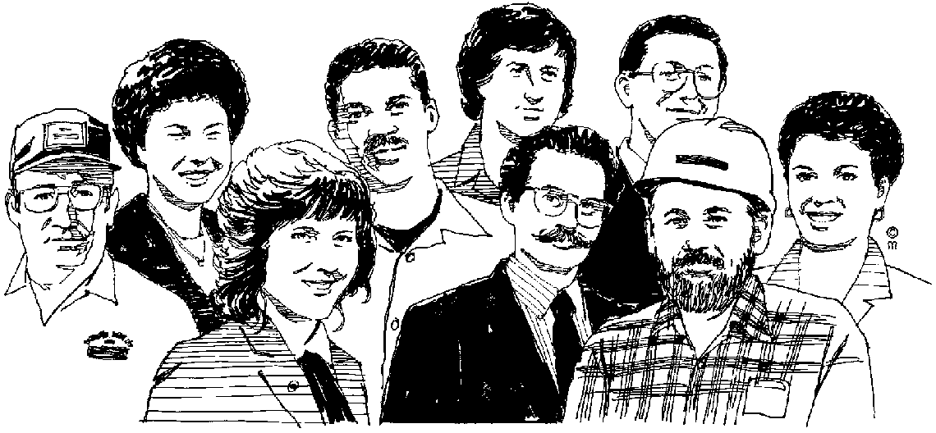
It’s not my job. Sometimes customers expect every member of the organisation to assist them with whatever complaint they have. You may not know all the answers, but the least you should be able to do is to direct customers to those people who can help them. As far as the direct customer interface is concerned, every member of the organisation should be in a position to assist every customer with the routine business issues such as information, prices, availability, etc.

- I only work here, or I am not paid to do that. If a customer gets this reply, he or she is automatically upset. This is a severe blockage in the customer relationship and no reply of this nature should ever be made by any responsible staff member.
- Come back tomorrow. People like to be helped immediately. Telling them to come back tomorrow will not make friends.
- Please stand in the complaints queue. People hate queues.
- Dealing with more than one person. Customers prefer to deal with one person, and especially the person that helped them initially.
- Put your queries on paper or fill in a form. Customers hate writing and want their complaints settled verbally.
- Broken promises. Nothing upsets a customer more than a broken promise. This is a sure response to ensure that the customer will lose faith and trust in the company. Never make a promise unless you can live up to it.
- Eating. Eating while dealing with customers is a sign of disrespect and should be avoided at all times.
- Chewing gum is also a sign of disrespect.
- Private phone calls. A private call while dealing with a customer may give the impression that the customer is not important. Customers always want to feel that they are important and special.
- Smoking. Smoking while dealing with customers and the public is also a sign of disrespect.
- When a job is not done properly. Imagine you service your car at a specific dealer and half of the instructions have not been carried out. Everything should be done as expected by the customer.
- Queues. Standing in long queues is frustrating and a waste of time. Although it is not possible to avoid queuing, every effort should be made to reduce the frustration of long queues. Even a friendly word when the customer reaches the counter can have a very positive effect on the customer.
- Lack of punctuality. Punctuality is a key aspect of the service industry. Punctuality is therefore of critical importance to ensure lasting customer relationships. People tend to remember the single unfortunate incident and tend to forget the hundred times the service was good.
- Excuses tend to break down the customer relationship. Rather apologise and accept the blame if the complaint is legitimate, but don’t try to rectify the situation by providing handy excuses.
- Red tape is also detrimental to the customer relationship. Imagine you tell a person that his complaint will be forwarded to the customer relations department and that they will look into the matter if they have time.
- Lies and false promises destroy faith and trust. Never lie to any person. Rather tell the person the truth, although it may not be the easiest way out. Sometimes people tend to lie just to get the other person off his back. Lying to a customer is a sure way to lose him or her forever.
- Arguments and rudeness. Never enter into man argument with a customer. Rather listen to the complaint and try to solve the problem than to argue. You may win the argument on technical grounds but you may lose a loyal customer forever.
- Waiting. Finally people don’t want to wait. As far as possible, attend to customers immediately.

Key Questions Pertaining To Customer Service
Consider the following:
How good (or bad) is the service that we are rendering? It is of the utmost importance that you know whether your company is rendering a good service or not. If you don’t know about problems, you cannot rectify them.
How do we know? There are many ways to find out if customers are satisfied or not. You can conduct a customer survey, where customers are randomly interviewed and a report is compiled of the findings. Surveys are normally very costly, as it may involve contracting market research specialists, e.g. Markinor.
Another way is to collect and record feedback from “frontline personnel”, people in direct contact with customers, like switchboard operators, receptionists, sales staff, operational staff, e.g. drivers & controllers. These people interact with customers on a permanent basis and is therefore an invaluable source of information as to how customers perceive your company’s delivery of service.
Who are our customers? Know who your potential customers are going to be and identify their needs accurately and with empathy towards these needs.
What are our company’s objectives? These are formulated in the company’s mission statement, e.g. to provide a professional, cost effective and reliable service.

What makes our customers happy?
Good Customer Service Makes Any Customer Happy!!! Very often customers will pay more for the same product/service, providing they get Good Customer Service during service delivery and thereafter.

What makes our customers unhappy?
Bad Customer Service Makes Any Customer…*!@#*‡€!!! (unhappy and/or disgruntled) To avoid having unhappy customers, it is essential for us to know if, and when customers are unhappy, and most importantly, for what reason!

How do we compare with our competitors in the market?
To be competitive in the market, we need to know who and what we are up against. In any race you keep your eye on your competitors all the time. This allows you to adjust your own performance to stay ahead of your competitors.

What makes our company special?
Look at your company critically from a customer’s point of view, comparing it with competitors. Would you, as a potential customer, wish to make use of the services that your company offers?

Who is responsible for customer satisfaction?
The South African consumer has been fighting a losing battle against poor customer satisfaction or -service for too many years.
The reasons for this state of affairs are too many to discuss here, but it suffices to say that consumers are increasing their demands for good and effective customer service in exchange for their money. Money which is eventually going to pay the salary of the person(s) who provide the service, good or bad.
It is therefore necessary for both the public- and private sectors to implement and maintain customer satisfaction policies and objectives.
Customer care is everyone in the business’ responsibility. The person cleaning the workshop of a bus depot makes sure that the mechanics work in a clean and safe environment, enabling them to service the buses effectively and timeously, having them back in service in good order to deliver a good service to passengers. Although this cleaner doesn’t have direct contact with the passengers, he still contributes to the smooth running of the operation.

The customer has a wider choice
The modern day consumer has a much greater variety of services/products to choose from as well as more and more service providers every day.
- Competition for the same market has increased vastly. Due to many SMME’s entering the marketplace, the consumer is no longer limited to a few service providers to choose from.
- More people own their own mode of transport, giving them an alternative to public transport. This has a definite effect on the number of people utilising public transport.
To retain the existing customer base, and increase it, we have to implement and maintain a well-planned customer care programme.
By being creative and open minded a business can influence consumers to make use of their service instead of exploring other avenues.
Never forget that the consumer has a choice and that your actions can influence that choice positively or negatively.

Exercise 5

Internal And External Customers
The customer is normally viewed as a customer external to the company. The customer is the most important customer, but is not employed by the company. As a company we are dedicated to serving the customer.
It is also necessary to have customer relationships inside an organisation. If we follow customer care principles inside an organisation, we are better geared to serve our primary and most important customer, namely the customer.
Let us look at a few examples of internal customer relationships:
- The Human resource Department serves the entire staff compliment of the company in terms of remuneration, industrial relations and training services. All employees are therefore clients or customers of the HR department.
- The technical department provides high quality vehicles to their customers, namely the operations or manufacturing department.
- Accountants provide financial statements and management information to their clients, namely management and other users.
- Administrative staff members render a service to their customers, who may be various other people in the organisation.
- Security officers protect the assets of their customers, namely all people working for the company, as well as other external stakeholders.
It is clear that the internal customer relationships play a key role in serving the external customers. The message is therefore clear: If we strengthen the internal customer relationships, we add value to our customers.
Each and every person in the organisation should actively participate in creating value. If someone does not contribute to the customer, either directly or indirectly, we cannot afford to keep such a person on the payroll.

Customers and stakeholders
With the customer defined it is also important to briefly review the key stakeholders of the organisation or industry.
A stakeholder is defined as any
- individual,
- group,
- company or
- organisation
that has an interest or stake in the company. Surely the customer or customer is the most important stakeholder of any business.
We as officials of the company have an important role to play in ensuring that our stakeholders as well as customers are served in the most effective way.
It is also important to note that most stakeholders are also very influential from a customer perspective. For example, community leaders such as school principals and chiefs are very influential in their statements, remarks and comments to our customers. If they have any unjustified perception about the company, it may result in a lost of customers. On the other hand, if they have a very positive opinion of the company, it may result in an increased customer base.
Other examples are as follows:
- Government officials have a direct impact on policy that may affect our customers.
- Suppliers have influence in the market, which may to some extent influence our customer relationships.
- Other providers have considerable influence in the market in terms of competitive elements.
It is therefore necessary that we know our key stakeholders, their expectations and more importantly, their influence.

Exercise 6

Identify customer service needs
The service requirement of customers will differ, depending on their need. Customers therefore have to be grouped into market segments according to their needs.
- You will have to identify the key components of customer service: what do customers require from your organisation.
- Establish the relative importance of those components to customers: how important is it that their needs are met exactly. School children who are taking a bus to school want to be on time for school and then when school is out they would like a ride home as soon as possible. Pensioners, on the other hand, would prefer a bus service later in the day that can take them into town to do shopping and then take them back again at a convenient time. This means that a bus service for school children should run exactly on time in the morning, while a bus leaving fifteen to thirty minutes after school closes will still meet the needs of the school children. Pensioners do not like waiting for buses that run late, but they will not mind travelling at the times indicated on the bus schedules.
- Identify the segments of customers according to similarity of service preferences. This is where you classify your customers as school children, adults travelling to work and back in the morning and afternoon and pensioners who make use of the bus service at the scheduled times during the day.
What the above means, in essence, is that some customers may be very sensitive to time, while others may prefer a cheaper service. It might be necessary to do some market research in order to determine what the exact needs of your customers are.

The Cost of Poor Service
- For every customer who bothers to complain, 26 remain silent
- Satisfied customers tell between 3 and 5 people
- The average “wronged” customer will tell between 11 and 15 other people
- 91% of unhappy customers will never buy from you again
- If you make an effort to remedy the complaint, more than 82% will stay with you
- It costs about 5 times as much to attract a new customer as it costs to keep an existing one
- Almost 5 times as many customers switch because of poor service than because of poor product quality or pride

Exercise 7

SECTION FOUR: BUSINESS SOLUTIONS

Specific outcome
Select and implement the most effective business solution to problems within your own operational environment and level of authority

Assessment requirements
- Generate and consider options and possibilities for improving the profitability of an operation within a simulated environment, making recommendations on new methods and/or technologies which will enhance competitiveness
- Suggest methods to be used to combat cost overruns with respect to a given budget
- Describe the impact of new technologies on the budget of an organisation

Business types
There are various legal business types:

Sole trader
A sole trader is a small business that is owned by one person. Examples of sole traders are: hawker, mechanic, plumber, electrician, painter, spaza, hairdresser, welder, bricklayer. The owner of a sole trading business uses his own money to set up business.
The sole trader does everything himself. It can happen that the sole trader employs people to help him, but he still makes all the decisions, and is responsible for the success of the business.
Most business types have a separate legal personality, but this is not the case when you operate as a sole trader. He is personally liable for all the debts incurred in the business. This means that he is personally held responsible if the business cannot pay it’s debt. The creditors will then sue the owner of the business for the monies outstanding. This means that the sole trader can lose everything he owns if the business is not successful

Partnership
People usually become partners when they trust each other. They will then share the responsibility for running the business, share the risks and also share the work, ideas and skills.
Examples include professional people like doctors, lawyers, consultants, or service organisations
A partnership is an agreement (legal relationship )between at least two people, but no more than twenty people. There has to be a formal agreement between the partners. This agreement will say what each partner will do in the business and also what each partner will bring into the business.
For example, one partner can be responsible for servicing vehicles and ensuring that vehicles are always roadworthy and ready when they are needed. Another partner can be responsible for the marketing, where he has to sell the business and bring in clients. Another partner can be responsible for the administration side of the business: ensuring that invoices go out on time and payments received on time, etc.
Each partner must also bring something into the business: this can be money, goods or even a client list of clients that wish to do business with him.
A partnership has an unlimited personal liability because it is not a separate legal entity. All the owners are personally responsible for business debts. If the partnership goes bankrupt, the partner with the most assets will lose the most.
A partnership cannot have property registered in its name, it cannot be sued or sue in the name of the partnership. Any property belongs to the partners but not the partnership itself.

Close corporation
Doctors, lawyers, consultants or other professional people usually choose this option of starting a business.
A close corporation has members. The minimum number of members is two and the maximum number of members is ten. A close corporation has members only, not shareholders or directors. The role of a member is very much like a Managing Director, nut he will be called a managing member.
All members may participate in the business, and have equal say in the management of the business. Every member has the right to vote and the number of votes of each member is proportional to the percentage of his interest in the corporation. Some members may have a 20% interest and others only 10% and their votes are counted accordingly.
The members contribute money, skills and expertise. Each member has equal rights and is involved in the management of the business. Decisions are made by consultation.
The business is a separate legal entity doing business in its own name apart from the members. Members are protected from any liability of the CC. This means that, if someone wants to take legal action, he must take action against the CC – he cannot take action against the members of the CC.
A CC has limited liability, if one of the members is battling financially it does not influence the business and vice versa.

Private company
Companies always have (Pty) Ltd at the end of their names. Examples include BMW (South Africa) (Pty) Ltd, Caltex Oil (Pty) Ltd, Denel (Pty) Ltd, Enterprise Foods (Pty) Ltd, Grindrod (Pty) Ltd, Imperial Car Rental (Pty) Ltd, Sales House (Pty) Ltd.
A company is usually associated with large business operations,
The membership is limited to fifty natural persons, and it can be started by one person.
A private company has a legal personality, and can therefore sign contracts and do business it its own name

Public company
Examples include SASOL Ltd, Teltron Ltd, Bonnita Holdings Ltd, Illovo Sugar Ltd, Engen Ltd, Malbak Ltd, Stocks & Stocks Ltd, Wooltru Ltd, SA Breweries Ltd.
There are more than seven shareholders and it may have an unlimited amount of shareholders. The name of a public company ends with Ltd, Limited.
The company has a limited liability and legal personality, and unlimited continuity of the company.

What Is A Business?
Our purpose in business is to create wealth, to make money. For this to be possible, we must please our customers and enjoy the confidence of our shareholders and employees. We must make good profits, so that, after providing for taxes and dividend (and in present circumstances, financing inflation), there is enough money available to keep our factories and equipment modern and enable us to grow in strength and maintain or improve our market position. We endeavour to provide good, satisfying employment for our people. Creating wealth and building a better company is our contribution to a better standard of living.
The Corporate Report
A business is an organisation/undertaking in which the owner/partners sell goods or render services to customers in order to gain a profit.
Business exist:
- because a gap in the market is identified
- to meet needs and wants of potential customers
- to make a profit and create wealth
Business contributes tremendously to the wealth creation process in our land. Wealth is created through the processing of resources into products and services, which are sold to customers who have a need for the product or service.
For example, a contractor builds houses (a process) using bricks, sand and cement (resources), and these houses are sold to people who have a need for houses (market).
Businesses also create job opportunities, which is very important for the economic state of any country.

Costs
Costs are payments that have to be made while a business is in operation. The business must know the costs to determine how much money is needed to run a business, how much money is needed through income from sales, how much the business should charge for the products/services, the budget, and the estimated cash flow.
Costs will be influenced by:
- whether the business sells one product or many;
- whether the business offers one service or a number of services;
- whether the business pays staff hourly, weekly and/or monthly;
- whether the business actually produces goods or only sells them; and
- what is regarded as fixed or variable costs in the business.

Fixed Costs (Indirect Costs)
Fixed costs are the proportion of a business expenditure which does not change in direct proportion to the quantity that is manufactured, bought or sold. No matter how many products are manufactured, the fixed costs remain the same.

COSTS
UNITS
FIXED COSTS
VARIABLE COSTS
TOTAL COSTS
Fixed costs for a business are similar to your fixed expenses that you calculated during the previous section.
Fixed costs are sometimes referred to as overhead costs or indirect costs, and can include rent, water and lights, advertising, transportation, telephone, printing, postage, interest on loan repayments, depreciation, repairs and maintenance, wages and salaries, and the like.
Fixed costs are calculated by dividing the total fixed cost by the number of units produced. The fixed cost will decrease if the number of units produced increases.

Variable Costs (Direct Costs)
Variable costs make up the proportion of the business expenditure that changes in direct relation to the number of products manufactured, bought or sold. This is similar to your variable expenses as calculated in the previous section.
Variable costs are also referred to as manufacturing costs, and can include raw materials, petrol, cost of goods purchased for release, commission.
Variable cost is determined by dividing the total variable cost by the number of products, and by how much of each is produced.

Total Costs
The fixed and variable costs may be different for different types of businesses, and depending on the type of product or service offered.
Total costs are the sum total of variable and fixed costs.

Cost saving within a business
Budgets need to be compiled in order to determine the profitability (whether or not the company will make a profit) of the business. These budgets have to be adhered to, to ensure that the company does not run at a loss, or that it does not go insolvent.
A budget is a prior estimation of income and expenditure. All businesses estimate their income for the year and plan their expenditure around that. Businesses are also compelled to stick to their budgets, just as good money managers would.
Having a budget also helps us to cut back on spending and save costs. If we ensure high productivity and quality within the business, we will ensure efficiency.
Let's look at ways of cost saving within a business.
- Increase productivity
- Make everyone aware of quality and improve quality
- Decrease wastage
- Be pro-active in finding ways to improve efficiency
- Decrease unnecessary absenteeism
- Stimulate motivation

Income from Sales
Income from sales is the income received from the number of items that are sold, or services rendered.
Once sales have been worked out for a period of time, say one week or one month, the sales can be compared with the budget, and/or estimated sales.
Sales can be increased by:
- Selling more to the customers.
- Finding more customers.
- Changing prices

What is profit?
Profit is the reward companies reap from high levels of productivity, quality, customer satisfaction, cost saving, investment in training, etc. Because companies make profit, reward systems can be put into place to benefit employers and employees. Profit is also invested by companies, to ensure that money works for them and to secure future existence in the market place. Shareholders have to share in the profits of a company as well.
The price at which you sell, the selling price, should always be more than the total cost price otherwise the business will only be breaking even. In other words, that means that there is no reward/returns to the business owners for investing their money in the business.
Profit is determined by the following equation:

Profit = Margin x Volume - Expenses

Margin The difference between the price at which each item is sold and the cost of the item. The cost includes raw materials, sales commissions (if salesmen are used) and packaging.
Volume The number of units sold over a given period of time. The more units sold, the higher the profit.
Expenses Costs like rent, wages, water and electricity, transport, replacement of machinery, etc. The greater the expenses are, the lower the profit will be. Reducing expenses is one way of achieving a bigger profit.
Earlier we concluded that purpose of doing business is to make profit. To be able to make profit, there will be expenses (expenditure). If the income (generated from sales or services) is more than the expenses, a profit was generated.

A profit can only be generated if the expenses are managed carefully with the use of a budget.

Gross Profit
Gross profit is the profit after cost of sales (purchases) has been deducted from income from sales, but before fixed costs have been deducted, and before tax and dividends have been paid to shareholders.

Net Profit
Net profit is the amount of money made during the period after all expenses have been deducted.

What are profits used for?

Repay loans
One use of the profits of a business is to pay back any loans, and or to reduce any overdrafts with the bank. The business may have entered into an agreement to pay the interest on a monthly basis and the capital amount loaned at the end of a period.

Reserves
Reserves and undistributed profits represent the amount of money that otherwise would have been paid out to shareholders in the form of a dividend. This money assists the business to engage in self-financing. The business can use reserves for emergencies, expanding the business, buying new machinery, repaying loans, increasing working capital, and paying bonuses.

Dividends
Shareholders own the business and risk their money when starting a business, or allocating shares for growth. These shareholders could have done many other things with their money rather than investing it in the business. For example, they could have invested the money in the bank and earned interest.
The money that is paid to the shareholder every six to twelve months is called a dividend. It is important to note that shareholders are the last group to get money from the profits. They first look after the needs of the business and the people of the business before they take any money for themselves. The proportion of the total net profit that gets paid out to the shareholders is usually the smallest, if compared to salaries, reserves and income tax.

How the business manages the money
The business manages its money by using budgets and financial statements. These are all roadmaps that assist Management in keeping track of money at all times.
- The Past: Financial Accounts
- The Present: Management Accounts, Actual Cash Flow Statements
- The Future: Plans, Budgets

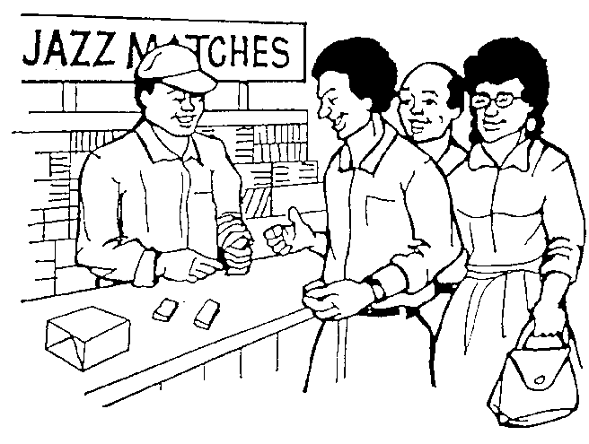
Budgeting
A budget is a written document that expresses management’s goals and forecasts in financial terms for a specific future. There are various budgets in a business, like
- sales,
- production
- administration,
- materials,
- labour,
- capital expenditure,
- financial,
- cash, and
- master budgets.

When you have money available you need to think about how you are going to use it, otherwise you may spend it and then not have any left, and you may not know what you have done with it. This process of planning how to spend money is called budgeting.

A budget is a plan of how you intend to spend your money. Everything you intend to spend the money on is noted or itemised.

It is the way in which you estimate how much it will cost you to run a business over a certain period of time. This period can be short (such as monthly), or longer (annually).

In your private life, it will be working out in advance what you will be spending in that month. It will help you see if you have or will be getting in enough money for the things you need to buy/pay for.
Budgets are used to plan and control expenses (expenditure). It is crucial that persons, businesses, governments (local and national) and all business ventures budget to plan and control expenditure according to projected income.
Costs that are budgeted do not always stay the same. Sometimes you spend more on some things and less on others. For example: electricity and water can be more expensive in the winter than in the summer if you use a heater. Groceries can be more expensive and if you have family staying with you and if you have to provide for their meals. If you have a car, and it goes to the garage for repairs and/or a service, your transportation costs will be higher for that month.
It is the same in business. If your organisation manufactures matches they may have to buy more raw materials in winter because people need to stay warm. So customers are going to buy more matches to make more fires. But this also means that the income will be more because people will buy more matches.
On the other hand, you may spend more on raw materials in summer if you are in the business of making ice-cream. However, your income as a business should increase because people are likely to buy more ice-cream.
When an organisation draws up a budget, the person who does this takes an average of what things will cost to cater for the ups and downs in cost. In the months when the business has few expenses the money that is left over must be kept to cover the costs in months when the expenses are heavy.

Organisations use budgets:
- To provide detailed plans to aid the planning of annual operations.
- To guide managers in an effort to co-ordinate actions which are part of the common plan.
- To communicate the policies and constraints to which departments and individuals are expected to conform.
- To provide a measurement tool by which managers are motivated to achieve
- To serve as a control measure against actual results to manage the exceptions.
- Managers' performances are often measured by their ability to meet budgeted objectives.
With careful budgeting, production and financial problems can be overcome before they escalate into major disasters. Production output can be adjusted to the expected market demand by increasing or decreasing production in certain seasons or if necessary additional equipment can be purchased timeously to cope with increased demand.
A major benefit of budgeting is that it requires management to review and coordinate most aspects of their operations.
This, in itself, prevents, or at least helps management anticipate, many crises. Another benefit of budgeting is that management can compare actual costs with the costs allotted in the budget.
If substantial variances are noted, management can take the necessary remedial action.
This is a key aspect in the control of costs and the evaluation of the relative effectiveness of various departments of a firm.
Following is an example of a budget report that gives a breakdown of monthly expenses. The management budget report is compiled from various such smaller reports that give breakdowns of expenses per department, purchases per department, etc.

March 2007
 | Payments and Expenses | Budget | Actual | Over | Under
1 | Vehicle Licence | R54 | R54 | - | -
2 | Vehicle Loan | R300 | R300 | - | -
3 | Petrol | R200 | R250 | R50 | -
4 | Owner’s Salary | R600 | R600 | - | -
5 | Wages | R346 | R596 | R250 | -
6
7
8
9
10
11
Totals |  | 1 500 | 1 800 | 300 | -

Cash flow
A business may be very successful and make good profits, just to find that at some stage the business does not have enough money available to cover certain expenses. Money flows in and out of the business, sometimes it flows out faster than it flows in, and sometimes it flows in faster than it flows out. This is called cash flow.
A cash flow is the way in which money moves through the business. It comes in through loans, sales and payments to the business.
It goes out through payments to the suppliers and creditors. At home, or in your private life, cash flow is your salary that you earn, or any other money that you get in, and all the money that you pay out during the month.

Supply and demand

Supply is the amount of a product or services that a business provides to the customers at a certain time and a given price.
If you are a hawker selling packets of tomatoes you would expect to sell maybe 50 to 100 packets a day. This will then also be your supply: you will prepare between 50 and 100 packets of tomatoes every day.
A big vegetable shop, on the other hand, will expect to sell perhaps 500 packets of tomatoes, 300 packets of onions, 450 packets of carrots, etc. per day. They will then ensure that they have enough products to sell to their customers.
Demand is the amount of a product or service that customers want to buy and have money for at a given time at a given price.
The housewife who wants only one packet of tomatoes, will not buy three or four, even if the hawker tells her that she can get three for the price of two. She only wants one and that is all she will buy.
The big restaurant will probably be interested in buying more than one packet of tomatoes if they can get good quality at a cheaper price.

Technology
We live in a world where technology is constantly changing. Technology affects most places of work where the advantages of installing new technology to simplify working processes and improve production and customer services has to be considered against the expense of the technology.
For example, installing "EE" (electronic information and ticket equipment) to sell bus tickets saves the time of the bus driver and also minimises the risk of theft. On the other hand, what does such a machine cost and would you have to install it in all the buses?
Or issuing bus drivers with cell phones could speed up the process of reporting incidents but what would the cost be?
Installing automatic loading/unloading equipment would speed up the delivery of goods, but this advantage has to be considered against the cost of installing something like this in all the trucks.
The normal process to follow would be:
- Find out what the equipment costs. You would contact more than one supplier to make sure that you get the best price for the equipment
- Find out what the advantages are in terms of cost saving per vehicle – include time saving
- Calculate whether the cost saving would justify the expense
- Write a report to make a recommendation
- If the recommendation is approved, include the new equipment in your budget to make provision for the purchasing of the equipment
- As soon as the budget is approved, purchase the equipment

Work Ethic

General Code Of Ethics And Conduct
As in introduction to this section, we will discuss a general code of ethics and conduct that should apply to workplaces throughout South Africa.
Although many more things than are highlighted here have changed for the better in the New South Africa, this is a summary of ethics applicable to the workplace that should be in place in all businesses.
The general code of ethics is done in line with the Constitution

Equality
The state may not unfairly discriminate directly or indirectly against anyone on one or more grounds, including race, gender, sex, pregnancy, marital status, ethnic or social origin, colour, sexual orientation, age, disability, religion, conscience, belief, culture, language and birth.
We all know that in the old South Africa, discrimination on the basis of race and sex was practiced in all aspect of the working world. This is no longer allowed and people should be appointed, promoted and remunerated according to their capabilities.

Human dignity
Everyone has inherent dignity and the right to have their dignity respected and protected.
Non one may make fun of you because you are a woman or of a different race and your employers must respect your dignity as a human being. Telling racist or sexist jokes in the workplace is no longer acceptable. You must also respect the human dignity of others, including women, children and even people whose political or religious beliefs differ from yours!

Freedom and security of the person
to be free from all forms of violence from either public or private sources;
not to be treated or punished in a cruel, inhuman or degrading way.
When disciplinary action is taken, you may not be treated in a cruel, inhuman or degrading way and no violence is allowed when disciplining is applied. Police may not resort to brutality when they arrest you or when you are in custody. Similarly, you may also not attach someone else, resist arrest by violent means or treat anyone else in a cruel, inhuman or degrading way. This includes women and child abuse.

Slavery, servitude and forced labour
No one may be subjected to slavery, servitude or forced labour.
Your employer may no longer expect you to work for food and a place to stay. It may be part of your salary or wage package but you must also be paid money for your work.

Privacy
Everyone has the right to privacy, which includes the right not to have their possessions seized
This means that no one may take what belongs to you – not in the workplace, not at home. Your property is your property and no one else may claim it or steal it.

Freedom of religion, belief and opinion
Everyone has the right to freedom of conscience, religion, thought, belief and opinion.
Everyone has the right to freedom of expression, which includes freedom of the press and other media;
The right in subsection (1) does not extend to
- propaganda for war;
- incitement of imminent violence; or
- advocacy of hatred that is based on race, ethnicity, gender or religion, and that constitutes incitement to cause harm.
You are allowed to the religious belief of your choice. In the old South Africa, when you applied for a job, you were questioned about your religious beliefs. Employers are no longer allowed to ask you about your religious beliefs.

Labour relations
Everyone has the right to fair labour practices.
You are allowed to join trade unions and seek legal advice regarding labour matters. Of course, the employer also has this right. You have to be treated fairly and the correct procedures have to be followed in case of disciplinary action. You have the right to view the disciplinary code of the organisation and you have the right to institute grievance procedures. Your employer has the right to expect you to treat his property with respect, to do your job as laid down, to follow orders relating to the job and not to steal from him, be it goods or time. the employer has the right to institute disciplinary action against you if you do not abide by the rules.

Environment
Everyone has the right to an environment that is not harmful to their health or well-being
Organisations should not dump potentially hazardous waste of any kind in areas not designated for such waste products.

Children
Every child has the right not to be required or permitted to perform work or provide services that are inappropriate for a person of that child's age; or
place at risk the child's well-being, education, physical or mental health or spiritual, moral or social development
Employers may no longer make use of child labour or force parents to send their children to work. Similarly, parents may not force their children to go to work if the above conditions are not met.

Just administrative action
Everyone has the right to administrative action that is lawful, reasonable and procedurally fair.
People in positions of power may not ask for a bribe or some other form of remuneration in order to award contracts or do their jobs that they are paid for. When you are stopped by a traffic officer, he may not accept a gift from you in order not to give you a ticket. When you are in a position of power, you may not solicit bribes, gifts or any other form of remuneration with which you can enrich yourself, in exchange for favours, awarding contracts, etc.
In general, your employer may not expect you to do something that is against your religion and your own personal code of ethics, such as: lying to clients, industrial espionage, dump hazardous waste in inappropriate places, etc. Similarly, you may not damage your employers good name, business relationships, property, etc. due to your lack of ethics.

A definition of ethics
Ethics is also called moral philosophy.
How should we live? Shall we aim at happiness or at knowledge, virtue, or the creation of beautiful objects? If we choose happiness, will it be our own or the happiness of all?
And what of the more particular questions that face us: is it right to be dishonest in a good cause? Can we justify living in opulence while elsewhere in the world people are starving?
Is going to war justified in cases where it is likely that innocent people will be killed? What are our environmental obligations, if any, to the generations of humans who will come after us and to the nonhuman animals with whom we share the planet?
Ethics deals with such questions at all levels. Its subject consists of the fundamental issues of practical decision making, and its major concerns include the nature of ultimate value and the standards by which human actions can be judged right or wrong.
Therefore, we can say that ethics concerns itself with what is morally good or bad and what is right or wrong.
The word ethics is derived from the Greek word ethos. Ethics deal with the morality of persons as individuals and also that of groups of individuals. Ethics assess not only what people are seen to be doing, but also examines what they think is right, fitting and just.
People are often judged by what they do or are seen to be doing, but their actions do not necessarily reflect their thoughts or feelings, or what they are often saying.
People often act within the context of traditions and customs, but, and this is important, ethics always involve 'reflective evaluation', that is, a serious thought process takes place before action takes place. In other words, individuals like to feel that what they do is right, just and/or accepted as correct.

Business ethics
A company’s ethics refers to the norms and principles of the company. This promotes a culture in an organisation where unethical conduct is not tolerated and unacceptable behaviour eliminated.
Positive business ethics include the following organisational norms and principles
Mission statement and company values
Ethics
Code of Conduct

Business ethics is about a business doing business in a fair and just way, without lying, cheating, bribing, or hiding information from customers.

Business ethics examine ethical principles and moral or ethical problems that arise in a business environment in an attempt to do business in a fair and just way.

It applies to all aspects of business conduct and takes into account and applies to the conduct of all the employees of a business and the business as a whole. Many organisations therefore have an official code of ethics.
A code of ethics typically sets out what behaviour is acceptable, for example are employees allowed to receive gifts from suppliers or give gifts to customers, as well as the punishment of employees who violate the code.
Historically, there are several examples of codes of ethics being set for professional groups. Some such examples include medical doctors, lawyers and other legal professionals, ministers of religion and accountants.
An old example is the application of the Hippocratic Oath to doctors. This code was first administered during the time of the Greek physician, Hippocrates, and requires all doctors to pledge themselves to the preservation of human life and the service of humanity on the whole.
Apart from the medical profession, several other organisations today prescribe a code of ethics and professional conduct in order to enhance the prestige of the organisation and to preserve honestly and good service.
Society is now expecting more from organisations, so an organisation’s ethics will reflect a code of behaviour which will be in line with what the public expect of the organisation. Society expects business to show
- social responsibility,
- show that it cares for the environment and is protecting the environment
- show that it cares for consumers
Organisational ethics demand that companies:
- Be more honest and less secretive in their dealings with society. The consumer must be provided with more and better information regarding the total market offering. By an increased emphasis on communication, the organisation can provide the consumer with useful and reliable information, thereby ensuring that the consumer is better informed.
- That they go beyond their legal obligations. Another dimension is the authority within which the organisation operates. Should it try to evade its responsibilities by, for example, disregarding prevalent moral and ethical values, it may provoke a reaction in the form of legal or legislative action.
- That they do not market products which contain an unknown degree of risk,
- And that they refrain from activities which waste scarce resources, or pollute or irreparably damage the environment.
- These days organisations must accept responsibility for the welfare of society. In other words, it must accept greater responsibility for possible harmful effects of its products. This is called corporate social responsibility. (refer to TBL in the previous section)
Consequently, it can happen that a manager's code of ethics can have a considerable influence on many aspects of the organisational life of a business - from making decisions on internal matters to his behaviour outside, with clients especially, and also with other members of his community.

Unethical Practices in the workplace
Unethical behaviour in the workplace is common and should be managed on a continuous basis.
There are more and more opportunities for unethical people to manipulate various systems in the workplace. Typical examples which can be added to the statistics are hackers who steal information from the software on computers.
- The one that is most prevalent in South Africa today is bribery.
- Industrial espionage where information is leaked to competitors in return for payment
- Invoice fraud - the amounts which are owing to the creditors are fictionalised or they are inflated. This would fall under accounting ethics.
- Product fraud - poor quality products are released on to the market. When this happens, the company is acting unethically in its production, marketing and social responsibility
- Advertising fraud - misleading or invalid claims are made for the products.
- Favouritism - the staff are promoted on the basis of favours, gifts and nepotism.
- Contracts and tenders are fraudulently granted.
- Stealing of computer time for one's own benefit.
- Discrimination in any form
- Conflict of interest – where employees engage in outside employment and private practice by stealing the company’s customers and doing work for them privately
- Accepting gifts and benefits from suppliers in return for the allocation of contracts or tenders
- Misuse of company equipment and assets.
From the above it can be seen that the greatest threat to the organisation comes from within when the conditions are supposed to be normal. Waste, accidents and errors take a large bite out of the profits of the organisation.

Good Work Ethics
These elements of the work ethic apply to all those working within an organisation and this ethic must be witnessed by that organisation’s clients.
- Employees must be honest with and loyal to clients.
- Total quality management would result in sub-standard products not being released onto the market
- Be on time for work, as arriving late or leaving early means you are stealing from your employer
- Do not accept bribes and gifts from suppliers
- Do not use company equipment for your own benefit
- Loyalty. Successful organisations have loyal employees. These employees are motivated to always carefully consider the interests of the organisation. This loyalty should not however be a blind loyalty and employees should still be free to question decisions.
- Honesty. Someone who is honest is truthful, law abiding and incorruptible. Dishonest people lie, cheat and steal.
- Do not commit accounting fraud in any form
- Avoid favouritism
- Make sure advertising is truthful
- Do not abuse company property and machinery
- Be proud of your work and do your best every day

Cost Of Poor Ethics
- Loss of trust which leads to poorer relationships and less effective team work
- Loss of confidentiality,
- Limited communication,
- Lack of self-esteem, of commitment and less loyalty
- Loss of your/the organisation’s good name
- The organisation can be blacklisted, meaning that no contracts or tenders will be allocated to it
- Customers can lose faith in the organisation, leading to a loss of customers to competitors
- Organisations can be fined for certain unethical practices

Contributing to an ethical work environment:
- Make the decision to commit to ethics
- Recognise that you are a role model by your actions and values
- Assist others by instilling ethical behaviour
- Discuss ethical practices
- Articulate your values
- Talk to people
- Be consistent

Exercise 8

Decision Making
'The cause of lightning ,'Alice said very decidedly, for she felt quite sure about this, 'is the thunder - no, no,’ she hastily corrected herself, 'I meant the other way.'
'It's too late to correct it,’ said the Red Queen.’ When you've once said a thing, that fixes it, and you must take the consequences.'
Through the Looking Glass - Lewis Carroll.
A supervisor can only be as good as his ability to make decisions. When a supervisor gets into a situation where a decision is required and there is no one else to turn to, it is up to him and him alone. After all, that's what he's being paid for!
'”Take an educated guess.” and “Toss a coin.” sounds simple enough, but not the best way of making a decision.
The steps involved in decision making actually seem very obvious. But in the job situation, you will have to follow them in a real, complex, company setting. Decisions will become compounded by so many other factors, such as emotions, misunderstandings, defensiveness, prejudices and many more.
To some degree, your success as a supervisor will depend on how well you make your decisions. This will be a very powerful skill to have as you climb the management ladder. So, get to grips with it and keep practising it as much as you can now.

Define The Problem or goal
To try to bypass most of the human failings that come to the fore when making decisions, you must follow the above steps.
Peter Drucker, one of the most eminent and respected authors in management science, says,
Effective decisions result from a systematic process, with clearly defined elements, that are handled in a distinct sequence of steps.


When making decisions you must take rational, logical action. You must not rush. You must pause, stand back and look at the problem from all angles.
However, this does not mean that you should use more time than necessary.
The size and urgency of the problem will probably dictate the length of time you would need to reach a decision.

Collect facts to meet the requirements of the problem
The person who is best at defining the nature of a problem, will be the one who will be the most successful at solving it.
You need to collect facts that meet the requirements of the problem.
A fact can be defined as a piece of verified information.

Verify the information
After you have gathered information, you have to verify the information.
The key is which facts are relevant and which are incidental.
To examine the facts adequately, be sure to separate what you know to be true from what you think is true. Always try to gather facts from more than one source. Check your information for accuracy and truthfulness.
Take some time and thought to examine the facts first

Analyse The Facts or problem
When you have the answers to most or all the above questions, think it trough. Analyse the facts. Determine what is relevant and what is irrelevant.

Determine possible courses of action
Once you have identified the components of the problem or all the facts, you can consider possible courses of action. List the possible courses of action in the light of the factual analysis.
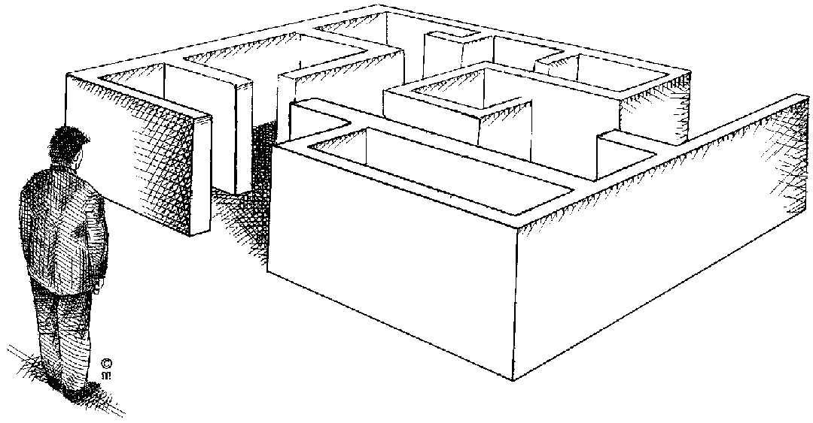
- What are the possible options? List as many as you can.
- What are the likely end results of each of these?
- Which of them seems to be the best from all angles?

Where appropriate, use brainstorming and creative-thinking techniques to identify courses of action that may not be immediately evident.

Establish criteria and evaluate possible solutions against the criteria
Once you have generated possible solutions by any of the previously mentioned methods, you have to establish the criteria for the solution.
Consider the possibilities, listing advantages and disadvantages

Duration
- How quickly do you have to find and implement a solution?
- How long will it take to implement the solution?

Causes
- Will the solution cause other problems to appear?
- How will these problems be addressed?

Effects
- Consider cross-cultural implications, for example dress code, religious holidays, type of food and drink.
- Evaluate the immediate and future consequences both inside and outside the organisation.
- Compare the cost of the solution with the benefits of implementing the solution.
- Assess how far the needs of those involved will be met and the extent to which your decisions will be acceptable.
- Be careful of creating precedents: will this solution create a situation where other departments will also want to implement the process, even when it does not really apply to that department?
- Consider also the implications of any internal and external constraints that might exist: is there anything in the company policy or legislation that might limit or restrict the implementation of the proposed solution.
- Ensure that all concerned participate in the evaluating and decision-making process. Note, however, that the degree of participation will depend on the nature of the problem and the participation procedures and management style of the organisation.
- Resources: when a solution is evaluated you have to consider its impact on scarce resources. A maximum payoff solution will not be an optimum solution if it requires the consumption of excessive staff time and attention, money, space, raw materials, and IT resources.
- The degree of disruption: an excellent theoretical solution may cause too much disruption within the organisation. Hence the organisation must appraise the consequences of implementing various solutions. Only when the benefits exceed the disruption costs should the solution be pursued.

Things that can influence your decision
- Tradition.
- Cultural differences.
- Self-interest.
- Organisational factors, policy and precedents, legal aspects, practices and expectations.
- Political views vs. logic.
- Ease of execution.
- Personality factors, attitudes, emotions, prejudices.
- Time/urgency, organisational need, political need, personal need.
- Pressure from peer group, need to please others.
- Authority, expert opinion.
- Generalisations, opinions, insufficient evidence or knowledge.
- Facts.
- Creativity and/or an urge to do something differently.
- Experience: successful or unsuccessful.

Select the solution
When you select a solution, you should ensure that:
- You have generated all the possible solutions.
- You have removed the solutions that are obviously not workable.
- You have considered all the consequences.
- The solution meets the established criteria in terms of budget, resources available to you to implement the solution and also any legislative requirements.
Often, there will be only one solution that meets all the criteria. When this is not the case, you should decide:
- Whether to choose the solution that meets the most important criteria, or
- Whether you have to generate more solutions.
Do not expect the process to always produce a black and white solutions. Remember that Drucker says:

A decision is a judgement.
It is a choice between alternatives.
It is rarely a choice between right and wrong.
It is at best a choice between almost right and probably wrong- but much more often a choice between two courses of action neither of which is more nearly right than the other.

Decision making pitfalls to avoid
- Deciding alone. There are many benefits to consulting with others on a decision: gaining different perspectives, more resources to draw upon and more commitment to the decision by those consulted.
- Every decision a major decision? Not every decision requires a lengthy decision-making process. Don’t get bogged down with minor problems. If they are minor, make a reasonable decision and move on.
- “The last time I was wrong was when I thought I made a mistake”. No one is always right. If you have made a bad decision, admit it and get started on fixing it. Remember – it is impossible to force a bad decision into being a good one.
- “Boy! I sure wish I hadn’t”. Just the opposite of pitfall number 3. Because no one can be right all the time, don’t waste your energy regretting bad decisions. Get on to current issues.
- Failing to use past precedent. Maybe the same problem has come up before and been effectively solved. Perhaps, if it has come up enough, there is a company policy that covers it.

Implement the solution

Stakeholders Are Consulted

A problem has not been solved until the decision has been implemented.
Before you implement a solution, you have to discuss the matter with all the people involved, called the stakeholders. This could include

The people doing the work. | Your manager.
Their supervisor(s). | The finance department.
Their manager. | The HR Department.
The people who helped you to determine the solution. | And anyone else who may be involved.
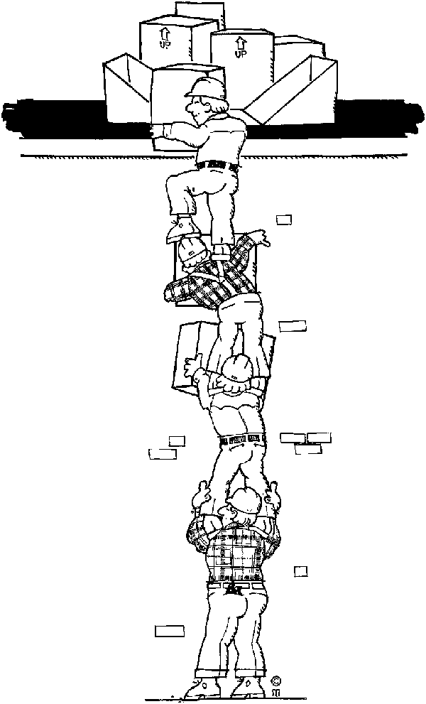
No solution will be implemented successfully without the approval and commitment of all the stakeholders. You need their cooperation if you want to ensure that the implementation of the solution will work.
You also have to assign duties and responsibilities. Think carefully not only about how a thing is to be done (by whom, with what resources and then by when) but also about its impact on the people concerned and the extent to which they will cooperate.
You will get less cooperation if you impose a solution. The best method is to arrange things so that everyone arrives jointly at a solution freely agreed to be the one best suited to the situation (the law of the situation again).

Make sure that everyone who needs to know about the decision is informed.

Monitor implementation
The implementation of the solution must always be monitored. You have to:
- Check on how effectively the decision is being implemented.
- Obtain the reactions of those affected.
- Take corrective action where necessary.
This implies that you will have to develop a control system whereby you can monitor the implementation of the solution.

Duration
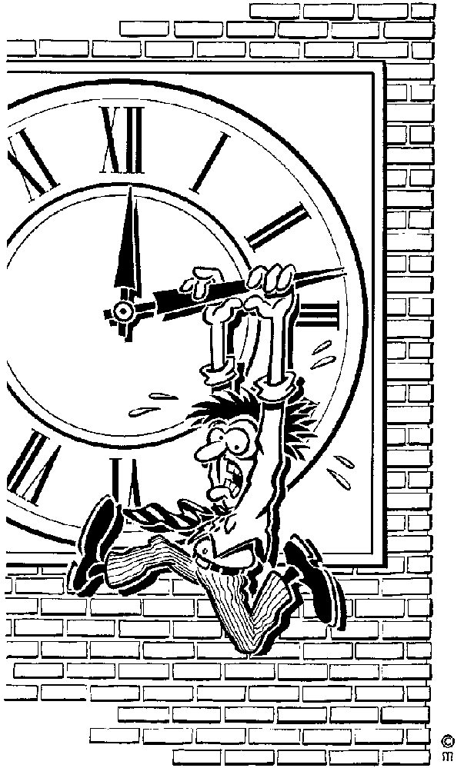
Before you implement the solution, you have to decide
- How long you are going to monitor the implementation: one week, one month, three months, etc.?
- How often will you monitor the implementation: hourly, daily, weekly?
- When will you review the monitoring process: after one week, two weeks, one month?
Just as every problem will have its own unique solutions, the way you monitor the solutions will also vary. Some solutions will indeed have to be monitored hourly or daily, while others will require monthly monitoring.

Implication And Effects
The purpose of monitoring the implementation of the solution is to determine whether the solution you selected is working.
- How will you monitor the implementation?
- Has the problem been solved?
- How can you prove this?
- Have other problems appeared as a result of the solution?
- Are the stakeholders committed to implementing the solution?
- Is the process working for them or has it led to unhappiness?

Review the solution
If the solution is not solving the problem, you have to repeat the problem-solving process in order to find a solution that works.
If the solution that you implemented is solving the problem, you have to determine:
- Whether the solution will work in similar instances in the rest of the organisation.
- Whether new systems have to be developed in order to implement the solution across the entire organisation.
- What practices and procedures have to be committed to paper for the implementation of the process across the organisation?
- What records are required in order to report on the successful implementation of the solution?
- What records will be required to standardize the new process?
Most of the documentation, procedures and records required for the implementation of the new process will already be in place in the organisation. You will have to find out what they are and then use them in your process.
If the organisation does not have a system for implementing new processes, you will have to develop such a system.

Exercise 9

