13928 FORMATIVE ASSESSEMENT WORKBOOK

Exercise 1 SO1, AC1-4 research activity

Work in pairs
Look at the two pictures of untidy offices and make notes of everything that has to be attended to.
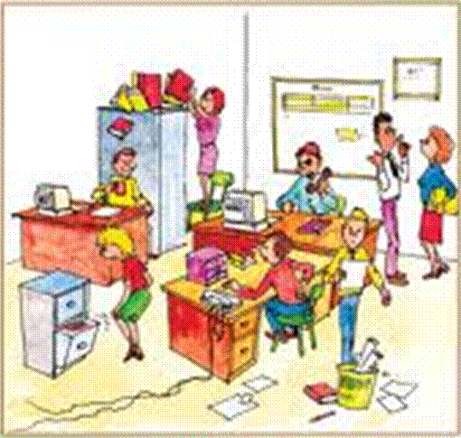

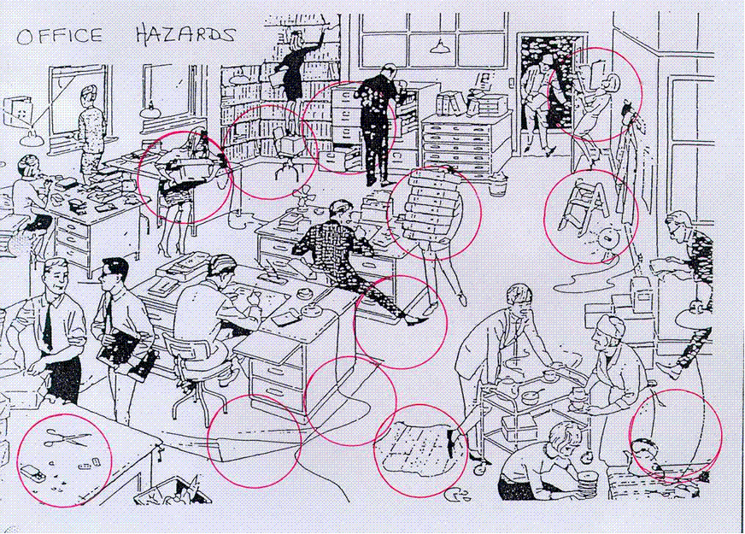
Go to at least three places that have reception areas such as the bank, post office and a lawyers firm and take note of the reception area.
Write down all the things that you think can be improved and ask the following questions:
- Who is responsible for the cleanliness of the reception area.
- If it is not up to standard, what procedures will be followed to correct the problem.
- What problems does the receptionist experience in general in terms of cleanliness.
Be sure to do this assignment during a quiet time of the day so you don’t disturb the secretary. Be sure to explain what it is that you are doing and that it is a practical assignment for your studies.

Exercise 2 SO2, AC1-4 group research activity
Now that you have done a field assignment, break the class into groups of 5 and do the following:
- Develop a checklist to monitor the maintenance of reception at the college or your place of work
- Who should non-conformances be reported to?
- Hold group discussions on what remedial actions should be taken when there are areas of non-conformance
- How would each of you communicate the problem to the person involved and responsible for the problem?
- Also discuss how you felt when you walked into the reception areas you visited. Were they clean? Did you feel welcome? Was it neat etc?
Make notes for yourself

Exercise 3 SO3, AC1-4 individual research activity
Find out what the security procedures at the college or your place of work are. You may also question a friend or family member who is employed about security procedures at their place of work.
- Who is allowed to enter the premises?
- What is the procedure to follow when an unauthorised person wants to gain access to the premises?
- What are the procedures that need to be followed before a visitor’s card is issued?
- What procedures are followed if a visitor is carrying a firearm?
- Who do they report to if there is a problem?
- What is done about a problematic situation other than reporting it to the relevant person?
Be sure to take notes while doing the assignment.
Once you have finished the interview, discuss what you have found with your group of five in class and write down the different answers from your peers in the following categories:
- Who may and may not enter
- Procedures followed before the issuing of a visitor’s card
- Procedures that are followed when a visitor is carrying a firearm
- Different people who are reported to
Also discuss:
- How you felt while doing the interview in terms of:
- Did you feel welcome?
- Were the personnel friendly and helpful?
- Do you think the people working at the premises you went to are safe in their work environment?
- Were the security personnel aware of the procedures they should follow if they have a problem?

